TITCHFIELD PARK, HUCKNALL

MANAGEMENT PLAN

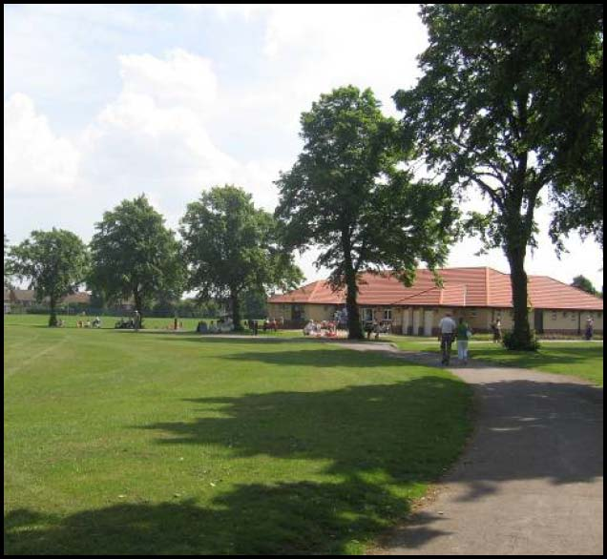

January 2018 – December 2022
(Refreshed November 2021)

Disclaimer

This document or some parts of it may not be accessible when using adaptive technology.

If you require assistance with accessing the content of the document, please contact:

email: place@ashfield.gov.uk and quote the document name and web page you found it on.

Aerial view of the park and surrounds

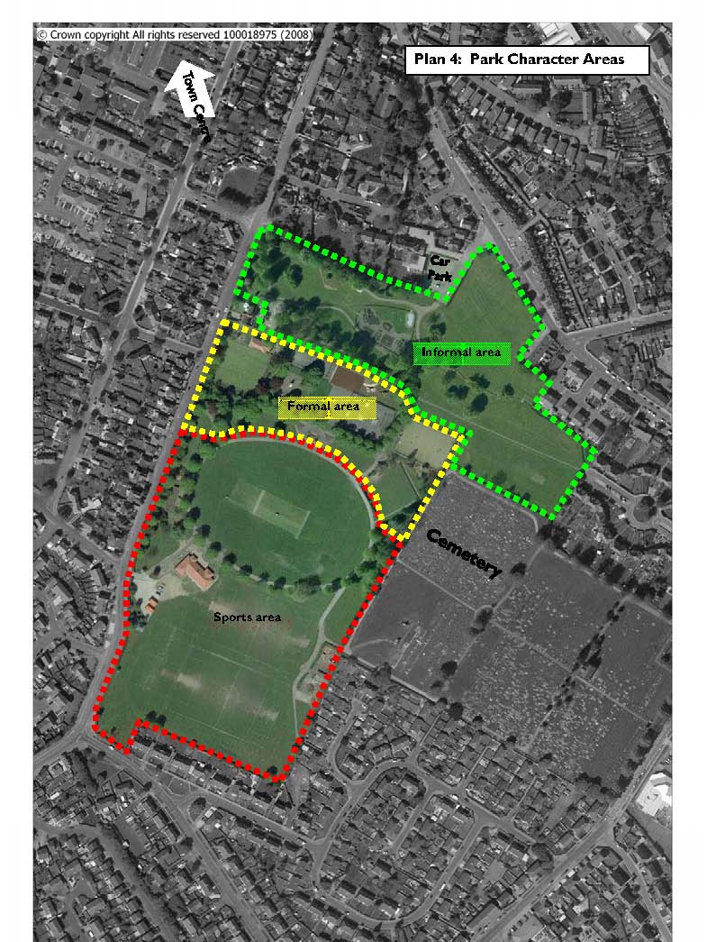

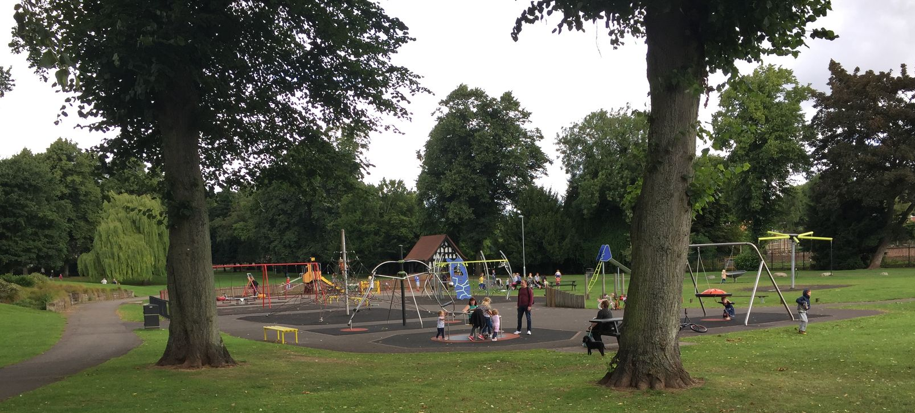
Zachariah Green monument
Play area

Section of the brook re-naturalised
Play area
The Pavilion
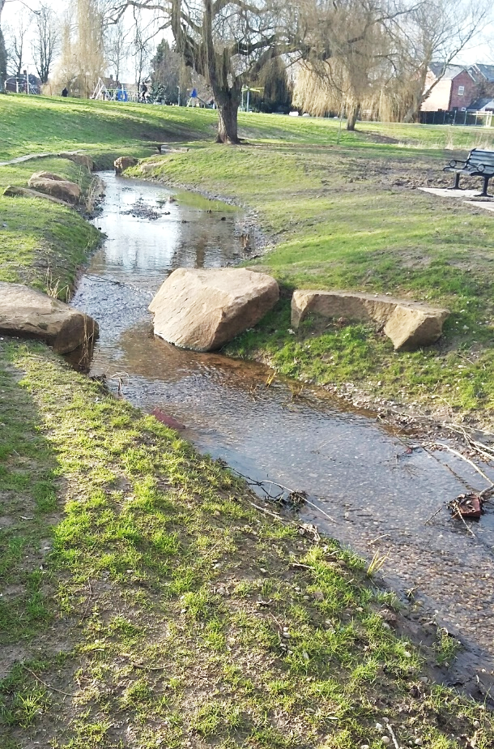
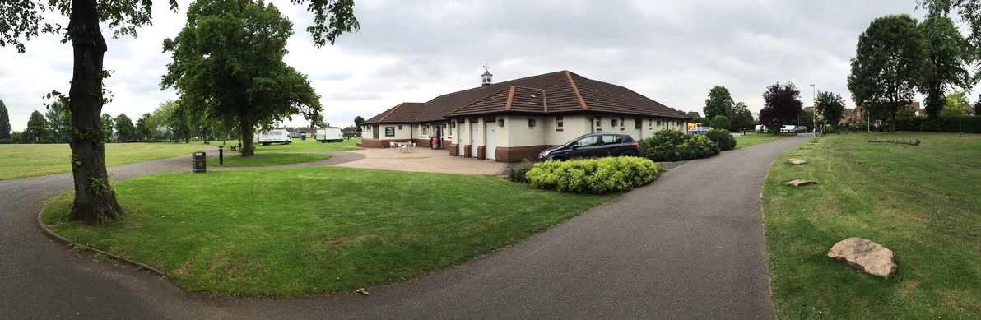
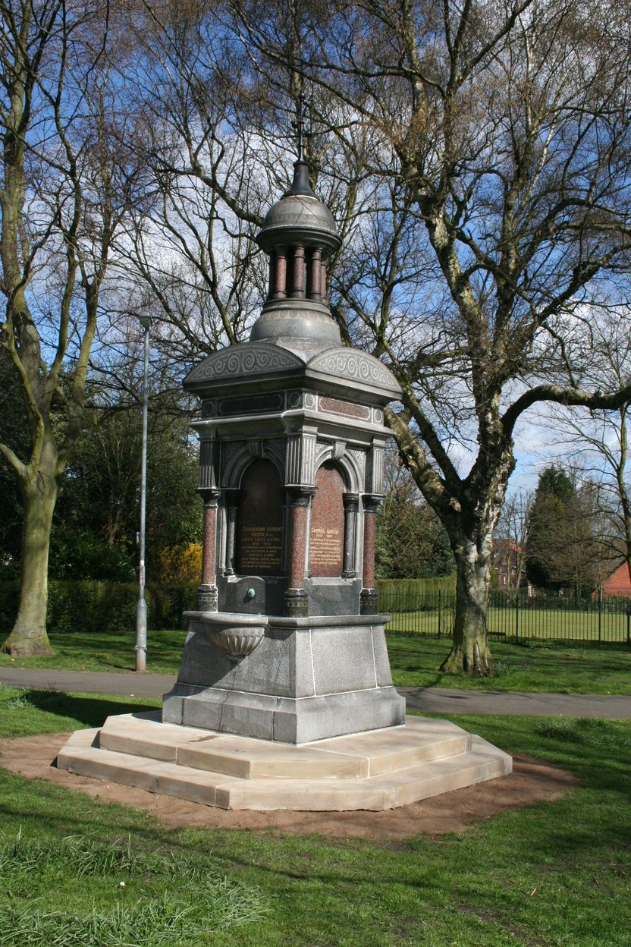

CONTENTS page

- OVERVIEW

1.1 Introduction 5

1.2 Park facilities 5

1.3 Investment 6

1.4 Heritage 7

1.5 Community Involvement 8

1.6 Landscape and Ecology 8

1.7 Green Flag criteria 11

- DELIVERY/ IMPLEMENTATION

2.1 Action Plan 14

3 MONITORING/ REVIEW

3.1 Monitoring and Review 20

3.2 Contacts 20

OVERVIEW

1.1 Introduction

This management plan has been developed by Ashfield District Council in partnership with the Friends of Titchfield Park. It is intended that the plan will help to improve general maintenance of the site, plan for the future and as part of this process retain the Green Flag Award, which the park has held since 2009. Details of the Council’s policies and procedures for green space management are contained within the document: ‘Management Plan Overview and Supporting Information.’

Titchfield Park is 11 hectares in size and is located to the south of Hucknall town centre and is surrounded by large areas of housing. The park is bounded by a residential road to the west (Park Drive), the rear gardens of houses to the north and south, and Broomhill Cemetery to the east.

There are three main character areas within the park;

- To the south lie the main sports facilities, comprising football pitches, a cricket pitch and Sports Pavilion. This area is open in nature, dominated by a tree-lined cricket oval and the main pavilion building, with planting largely limited to the park boundaries. This area also contains the park’s storage compound and entrances through to the adjoining cemetery
- Bordering this is a central band of more formal park features. These include the bowling green and pavilion, a war memorial (Grade 2 listed), and formal planting beds commemorating VE/VJ day, a memorial to Zachariah Green (Grade 2 listed), youth area/skate park and a synthetic pitch. This band forms a visual break between the two ends of the park, with two main routes passing between them
- The third area is less formal in nature, sloping down to the north of the park. This area comprises a landscaped valley area, a fenced play area, a brook and meadow areas and an historic boathouse. This area also contains a public car park, separated from the park by fencing.

1.2 Park facilities Users

Main pavilion with changing rooms and café | The café is run by a private operator
Cricket pitch | Used by Hucknall Cricket Club
Football pitches; adult x1, junior x1 | Public hire by local teams
Bowling green and bowls pavilion | Hucknall Titchfield Park Bowls Club
Multi use games area | Open access
Skate/ BMX park | Floodlit facility with open access
Youth area | Open access
Play area and play trail | Open access, the play trail is near to the café
Car park x2 | Open access
Synthetic pitch | Open access, can be used for football and tennis

1.3 Investment

In September 2002, a study of Titchfield Park and a Development Plan were commissioned by Ashfield District Council. The project, managed by Groundwork included a physical appraisal and consultation process. The development plan highlighted areas for improvement and proposed a concept plan for improvements.

This plan formed the basis for initial capital investment towards the regeneration of the park, informing council decisions to allocate capital expenditure to the building of two new pavilions and the reintroduction of perimeter fencing. It also informed successful funding bids for a Skate Park and extensive drainage works to the football pitches (Sport England). Section 106 funding was used for a synthetic pitch with floodlights, restoration of the cenotaph and footpath resurfacing.

Consultation events undertaken as part of the Development Plan led to the establishment of the Friends of Titchfield Park in 2003.

A detailed master-plan was developed which addressed outstanding issues identified in the Development Plan as well as specific issues revealed through more detailed and on-going consultation. The masterplan informed further works which included the replacement of all benches and bins, installation of a youth activity area and MUGA and clearance of redundant structures. Funding was secured from English Heritage (to replace a missing plaque on the war memorial) and WREN (towards the new playground), restoration of the boathouse and provision of a heritage trail (Heritage Lottery Fund).

The site has benefited from over £1.8 million of capital investment since 2002. More recent works have included the provision of a play trail near to the café, extension and resurfacing of the car park off Park Drive, naturalisation of part of the brook which is within a concrete channel, additional planting within the meadow areas, further works to the play area and the restoration of the Zachariah Green monument.

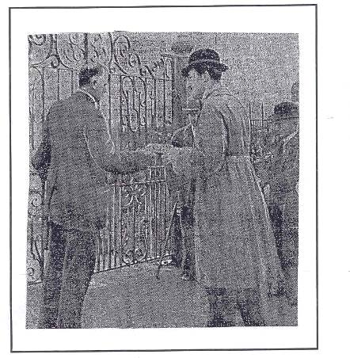
1.4 Site Heritage/ History

The Duke of Portland gave 11 acres of land, then known as Caddow Park, to the town of Hucknall in 1914, in honour of the 21st birthday of his son, The Marquis of Titchfield. At the same time the Duke also gifted land for Titchfield Park and Portland Park in Kirkby in Ashfield.

In addition to the Duke’s land the Hucknall Miners Welfare Committee decided to further the development of Titchfield Park from funds raised to provide facilities for the local miners. They purchased another 13 acres and funded a bandstand, tearooms, pavilions and shelters. The Council purchased a further 2 acres and laid out lakes and erected a caretaker’s lodge, a bowling green, tennis courts and cricket pitches.

Nottingham Guardian, 10.7.1922
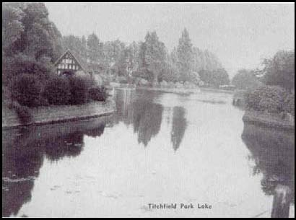
Hucknall Torkard District Council appointed a sub-committee, which selected tendered proposals drawn up by Mr. J.W. Bardill. The original brief of the committee was that the park should be ‘set out to provide for cricket, football, bowls and tennis courts with trees, shrubs and flowers planted all around.’

The works were held up by the outbreak of the First World War and the Marquis finally performed the opening ceremony in July 1922. In a photograph from the Nottingham Guardian the Marquis is shown accepting a golden key from Mr. Bardill.

A local architect T.C. Howitt designed the tearoom and cricket pavilion, shelters and bandstand. Howitt also designed the Cenotaph erected to commemorate the soldiers from Hucknall who died in the First World War. This was unveiled in September 1922 and is now Grade 2 listed. Of the original buildings only two remain, the Keeper’s House, now a private dwelling and no longer included within the park, and the ‘Boathouse’ which used to lie at the side of the lake before it was drained and filled.

The lake and boathouse
A memorial to Zachariah Green, which is a Grade 2 listed monument, was built in memory of this local healer and philanthropist who died in 1897. The memorial originally stood in the town’s market place but was relocated to the park.

The Second World War saw a reduction in staff and the gradual decline of the park for the rest of the 20th century. The boundary railings were removed, leaving the park open and increasing antisocial use at night. Over time, many original features were either removed (including the team rooms, pavilion and bandstand), while others were left in a poor state of repair due to lack of investment (including the boathouse and tennis courts).

The boating lake seems to have been a constant problem and the complaint of 1938 quoted in the Hucknall Dispatch explains this: “It is quite impossible to use the lake for boating because of the growth of vegetation and there is insufficient depth. It has also been realised that the lake leaks badly”. A cut in the Council’s budget finally led to the lake being filled in.

1.5 Community Involvement

Friends of Titchfield Park

The park is supported by the Friends of Titchfield Park which works with the council in the development and management of the park. The Friends group was set up in 2003 and meets every two to three months. The group take part in events, for example wetland planting and created and look after a bee garden which is within a fence area adjacent to the bowling green.

Hucknall Junior Park run is held on Sunday mornings at the park and attracts an average of 45 runners, covering a distance of 2km.

1.6 Landscape and Ecology
A Phase I Habitat Survey of the site, found no significance to the park in ecological terms. The dominant habitat type is ‘Amenity Grassland’ although the football fields and the cemetery are classified as ‘Improved Grassland’. The adjacent cemetery contains a few small patches of ‘Semi-improved Grassland’ containing Self-Heal and Mouse-Eared Hawkweed.

The other habitats noted are ‘Scattered Trees’ and ‘Lines of Trees’, the latter referring to the planted avenues that are a particular feature of the park. Many of these avenue trees are mature Limes, Tilia spp. ‘Species Poor Hedgerow’ and ‘Species Poor Hedgerow with Trees’ were noted around the boundaries of the park, while ‘A Line of Coniferous Trees’ is located along the boundary with the cemetery.

Vegetation Types
• Mature Trees and Amenity Grass

The majority of the park is mown amenity grassland with mature trees. Tree species are predominantly Tilia spp. e.g. most of the original avenues. Other species such as Betula pendula, Salix x chrysocoma, Populus nigra italica’ and Prunus spp. are also present.

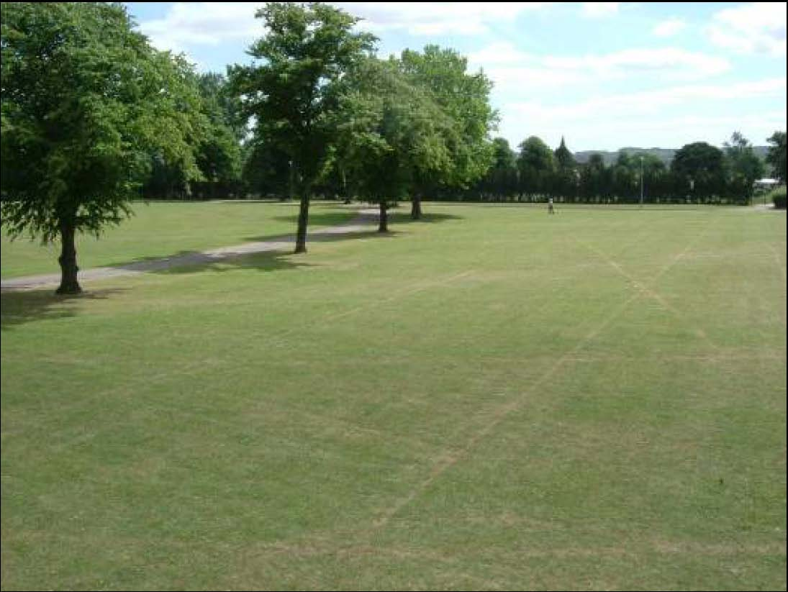

• Ornamental Shrubs and Bedding Formal shrub planting and bedding is largely confined to the main valley area of the park and the formal area immediately to it’s south. The bedding areas are concentrated around the entrances and main paths and are usually planted with seasonal annuals from Spring to Autumn. The shrub planting consists of a mixture of evergreen and deciduous species such as Prunus ‘Otto Lukyen’, Bereberis spp., Cornus spp.and a number of coniferous species (especially in the rock garden near the northern Park Drive entrance).
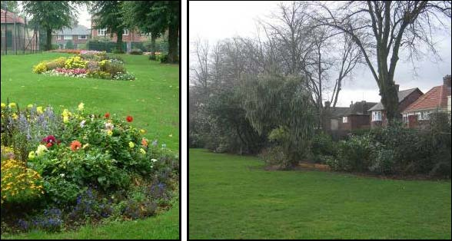
• Hedgerows The hedgerows surrounding much of the site possibly date back to the original layout of the park. Much of the railings were removed during the Second World War and the hedges may have been planted at this time to replace them. The hedges around the boundary of the park are mainly Crataegus monogyna and those surrounding the bowling greens and disused tennis courts are clipped privet, Ligustrum spp.
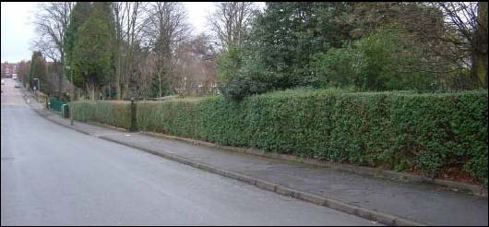

1.7 Green Flag criteria
The Green Flag Award is the benchmark national standard
for parks and green spaces in the UK. In order to achieve the
award green spaces need to meet eight key criteria. The table
below shows how the park meets the criteria.

1. A welcoming place
Good and safe access | There are a number of gated entrances to the park.
Good signage to and in the park/green space | Entrance signs and directional signage within the park
Equal access for all members of the community | The site is generally level and access around the park is good on tarmaced paths. Disabled bays are provided within the car parks. The pavilion is fully accessible with a disabled toilet.

2. Healthy, safe and secure
Equipment and facilities must be safe to use | Comprehensive inspection regime- detailed in the Management Overview
It must be a secure place for all members of the community to use or traverse | The park is locked at dusk and lighting is therefore limited within the park.  Sightlines are maintained across the park.
Dog fouling must be adequately addressed | Policy information is within the Management Overview
Health and safety policies should be in place, in practice and regularly reviewed | The Council has up to date policies which are regularly reviewed, further information is within the Management Overview
Toilets, drinking water, first aid, public telephones and emergency equipment where relevant (e.g. life belts by water) should be available in or near the park/green space, and be clearly signposted | Toilets are provided at both pavilions.

3. Clean and well maintained
Litter and other waste management | Green waste is composted on the site, further policy information is within the Management Plan Overview
The maintenance of grounds, buildings, equipment and other features | Policy information on asset management is provided within the Management Plan Overview
A policy on litter, vandalism and maintenance should be in place, in practice and regularly reviewed | Policy information on asset management is provided within the Management Plan Overview

4. Sustainability
An environmental policy or charter and management strategy in place, which is in practice and regularly reviewed | The Council has a policy in place (within the Management Plan Overview)
Minimise and justify pesticide use | Pesticides are used infrequently
Eliminate horticultural peat use | Horticultural peat is not used on the park
Recycle waste plant material | There is a green waste facility in the works compound within the park
Demonstrate high horticultural and arboricultural standards | The park is maintained to the Council’s standards, details are provided within the Management Plan Overview
Have energy conservation, pollution reduction, waste recycling, and resource conservation measures | Further details are within the Management Plan Overview

5. Conservation and heritage
Particular attention should be paid to the conservation and appropriate management of:  Natural features, wildlife and fauna | Extensive areas of meadow have been established towards the north east side of the park. A 50 metre stretch of the brook was naturalised in 2017, with the brook wall broken out and shallows created for wetland planting. Bird boxes have been provided around the park.
Landscapes | The main heritage feature of the park in landscape terms is the Cricket Oval and lime trees planted around its perimeter.
Buildings and structural features | The only original structure within the park is the boathouse. This was restored with an HLF grant and in 2017 rebuilt again after an arson attack badly damaged the structure.

6. Community involvement
The park/green space management should actively pursue the involvement of members of the community who represent as many park/green space user groups as possible. The following should be demonstrated: | The park has an active Friends group and several local groups use the park, such as Sure Start. There is also a weekly 2k Junior Park Run held at the park.
Knowledge of user community and levels and patterns of use | A user survey is carried out every two years which informs the action plan for the park
Evidence of community involvement in management and/or developments and results achieved | The Friends group are involved in the review of the management plan which takes place every two years
Appropriate levels of provision of recreational facilities for all sectors of the community | There are a wide range of facilities within the park; café, football pitches; bowls, skate/ BMX, walking routes, heritage trail, play etc. A junior park run is held on the park every Sunday.

7. Marketing
A marketing strategy should be in place, which is in practice and regularly reviewed | The Council has a parks and green spaces marketing strategy (Management Plan Overview)
There should be good provision of information to users, e.g. about management strategies, activities, features, ways to get involved | Information is available on the Council’s website
The park/green space should be promoted as a community resource | Information is available on the Council’s website

8. Management
A management plan or strategy should be in place | The management plan is reviewed every two years
The plan must be actively implemented and regularly reviewed | The management plan is reviewed every two years
A financially sound management of the park/green space must also be demonstrated | The park is managed as part of the Council’s green space assets and does not have separate budgets

  - Titchfield Park Action Plan
KEY:
PT: Place Team AI: Assets & Investments S106: Developer Contributions ● To be completed
NE: Neighbourhoods & Environment CS: Community Safety Complete Incomplete/ in progress
FoTP: Friends of Titchfield Park

VOL: Volunteers TBI To be identified

AIM 1: CREATE A WELCOMING PARK

Objectives | Action | Delivery |  |  |  |  |  | Resources |  | Lead
A Welcoming Place |  | 18 | 19 | 20 | 21 | 22
Welcoming | Undertake a conditions survey of the park boundary fence and develop a five-year cycle of repair, maintenance and painting as required |  |  |  |  | ● | Revenue |  | NE
 | Paint vehicle access gates to staff car park and park including knee rail tubes around car park on a 5-year cycle as required |  |  |  |  |  | Revenue |  | NE
 | Reduce use of seasonal bedding plants, replace with perennial planting and bulb planting where appropriate |  |  |  |  | ● | Revenue |  | NE
Good and safe access | Refresh parking bays and cross hatching in car park on a 5-year cycle |  |  |  |  |  | Revenue |  | NE
 | Develop proposals for refurbishing stone steps down to bottom area of the park |  |  |  |  | ● | S106 / Revenue |  | PT / NE
 | Undertake a conditions survey of the footpaths around the park and develop a five-year cycle of repair, maintenance and resurfacing as required |  |  |  |  | ● | S106 / Revenue |  | PT / NE
 | Repair and re-lay resin bound gravel around the café to provide a consistent surface |  |  |  |  |  | Revenue |  | AI
Signage | Refresh and replace all entrance signage at all 9nr entrances into the park including 2nr from the cemetery |  |  |  |  |  | S106 |  | PT
 | Explore options for installing vehicle speed limit signs at main entrance |  |  |  |  | ● | Revenue |  | NE
Equal access for all | Refresh access audit for the park and implement recommendations where appropriate |  |  |  |  | ● | S106 |  | PT

AIM 2: ENSURE THAT THE PARK HAS GOOD FACILITIES THAT ARE SAFE AND SECURE

Objectives | Action | Delivery |  |  |  |  |  | Resources | Lead
Healthy, Safe & Secure |  | 18 | 19 | 20 | 21 | 22
Appropriate provision of quality facilities and activities | Old Tarmac Playing Court  Remove redundant facility and path including all fencing and surfacing |  |  |  |  |  | Revenue |  | NE
 | Play & Youth Area  Relocate play and youth equipment from bottom of the park to the area adjacent to the café and skate park respectively |  |  |  |  |  | NCC |  | PT
 | Play & Youth Area  Install new play and junior equipment to complement the existing adjacent to the café |  |  |  |  |  | S106 |  | PT
 | Pitch Lighting  Upgrade the floodlighting on the synthetic pitch to LED to reduce carbon emissions, running costs and improve the playing experience |  |  |  |  | ● | TBC |  | PT
Safe equipment and facilities | Sports Pitches  Continue to improve the quality of the sward and drainage of the football pitches |  |  |  |  | ● | Revenue |  | NE
 | Defibrillator  Secure funding, install defibrillator and provide training course for all site users |  |  |  |  |  | Revenue |  | PT
 | 5-a-side Court  Replace fencing to secure so that it can be used as a bookable facility |  |  |  |  | ● | S106 |  | PT
Personal Security | Continue to liaise with police, community protection officers regarding issues that arise |  |  |  |  | ● | n/a |  | NE / CS
 | Continue to improve and maintain sight lines across the park to increase natural surveillance |  |  |  |  | ● | Revenue |  | NE
Control of dogs / dog fouling | Ensure current Public Space Protection Orders are in place and signage displayed |  |  |  |  | ● | Revenue |  | NE
 | Continue regular patrols and issue fines to offenders |  |  |  |  | ● | n/a |  | CS
 | Continue to monitor dog fouling and continue to top up free dog poo bags on site |  |  |  |  | ● | Revenue |  | NE

AIM 3: ENSURE THAT THE PARK IS WELL MAINTAINED AND CLEAN

Objectives | Action | Delivery |  |  |  |  |  | Resources | Lead
Well Maintained and Clean |  | 18 | 19 | 20 | 21 | 22
Litter and waste management | Review the number and condition of the bins on site |  |  |  |  |  | n/a |  | NE
 | Develop and implement a bin replacement strategy for the park |  |  |  |  | ● | Revenue |  | NE
 | Develop compound into a recycling and green waste composting area, rationalise areas and create designated bays for different materials |  |  |  |  | ● | Revenue |  | NE
Horticulture maintenance | Review the condition, quality and age of planting throughout the park |  |  |  |  | ● | n/a |  | NE
 | Develop and implement a horticulture strategy for the park prioritising key visual impact areas – i.e key entrances, around flagpole, cenotaph and VE planting bed |  |  |  |  | ● | Revenue |  | NE
Arboricultural maintenance | Undertake a detailed arboricultural survey of all trees on the park complete with management recommendations for 6mths / 1 yr / 2 yrs |  |  |  |  | ● | Revenue |  | NE
Building and infrastructure maintenance | Continue essential building maintenance to café, bowls pavilion, changing rooms and toilets |  |  |  |  | ● | Revenue |  | AI
Equipment maintenance | Continue with annual independent / fortnightly in-house inspections of play and youth facilities |  |  |  |  | ● | Revenue |  | NE
 | Inspect, maintain and repair sports equipment such as football goals, sports fencing and MUGA |  |  |  |  | ● | Revenue |  | NE
AIM 4: ENSURE APPROPRIATE MANAGEMENT OF BIODIVERSITY, LANDSCAPE AND HERITAGE FEATURES

Objectives | Action | Delivery |  |  |  |  | Resources |  | Lead
Biodiversity, Landscape & Heritage |  | 18 | 19 | 20 | 21 | 22
Management of natural features, wild fauna and flora | Wildflowers  Improve the quality of wildflower areas by treating and eradicating perennial weeds and re-seed with wildflowers – areas to be cut once a year |  |  |  |  | ● | Revenue | NE
 | Wetland  Undertake works to bring culverted brook to surface, create a retention basin and re-orientate stream away from residential properties |  |  |  | ● |  | NCC | PT
 | Trees  Plant new trees as part of the wider brook improvement project |  |  |  | ● |  | NCC | PT
 | Nest boxes  Explore options for installing bird / owl / bat boxes around the park; encourage involvement from local schools and community groups |  |  |  |  | ● | S106 | PT
 | Hedgerows and plantation blocks  Produce a maintenance / replanting plan for hedgerows on a 5-year cycle to include screening off compound area |  |  |  |  | ● | Revenue | NE
Conservation of buildings & structures | Inspect the boathouse, Zachariah Green monument and Cenotaph a minimum of 1x per year and carry out any necessary repairs |  |  |  |  | ● | Revenue | NE / AI
 | Re-vamp heritage trail for the park’s 100 yrs anniversary in July 2022 |  |  |  |  | ● | n/a | PT

AIM 5: ENCOURAGE AND SUSTAIN COMMUNITY USE AND INVOLVEMENT

Objectives | Action | Delivery |  |  |  |  | Resources | Lead
Community Involvement |  | 18 | 19 | 20 | 21 | 22
Community involvement  in management & development | Volunteers  Attract new volunteers to the park, identify volunteer activities and carry out practical tasks |  |  |  |  | ● | n/a | PT / NE
 | Events  Plan events for the Queen’s Platinum Jubilee and the Park’s 100 yrs anniversary in July 2022 |  |  |  |  | ● | n/a | PT / NE
Appropriate provision for community | Undertake a user survey before and after the completion of the play improvement project to gain valuable insight in community provision and use |  |  | ● |  | ● | n/a | PT

AIM 6: ENSURE THE PARK IS MARKETED AS A DESTINATION SITE

Objectives | Action | Delivery |  |  |  |  | Resources | Lead
Marketing and Communication |  | 18 | 19 | 20 | 21 | 22
Marketing and promotion | Develop a marketing and promotional strategy for the park – to be included in the District wide digital information offer |  |  |  |  | ● | n/a | PT / NE
Educational and interpretational information | Refresh the historical and interpretational displays for the park and display within the new building as a celebration of the Queen’s Platinum Jubilee and the Park’s 100 yrs anniversary in July 2022 |  |  |  |  | ● | S106 | PT

3 MONITORING/ REVIEW

3.1 Monitoring and Review

The management plan will be reviewed every two years with a review of the action plan carried out annually to monitor progress. This process will be carried out in September to feed into the Council’s business plan cycle. The results of the process will give the opportunity to assess the overall success of the management plan and whether additional funding and resources are required. A site inspection will be carried out during August/ September to check whether any additional works are required, which will then be added to the work programme/ Action plan, as appropriate.

3.2 Contacts

Email: environment@ashfield.gov.uk
0800 183 8484 / 01623 457 857

www.ashfield.gov.uk

Friends of Titchfield Park
On Facebook @FriendsOfTitchfieldParkHucknall

Hucknall Junior Park Run
http://www.parkrun.org.uk/hucknall-juniors/course/

Hucknall Titchfield Park Bowls Club

The club can be contacted via Facebook
or phone: 0115 953 8341

Titchfield Park, Park Drive, Hucknall, Nottinghamshire, NG15 7LS

Grid reference: SK 536 486

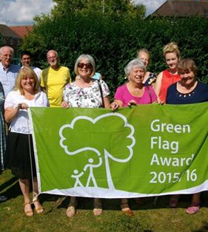

20

