Greater Nottingham and Ashfield Green Belt Assessment Framework

February 2015

CONTENTS

1.0 Purpose

2.0 Background

3.0 Planning Policy Context

4.0 Why Review the Green Belt Boundaries?

5.0 Overall Approach

Figure 1: Assessment Criteria Figure 2: Assessment Matrix
Appendix 1: List of settlements / locations considered under this framework

Context Map: Showing the extent of the Nottingham-Derby Green Belt Glossary of Terms and Abbreviations

Greater Nottingham and Ashfield Green Belt Assessment Framework

Purpose

  - Ashfield, Broxtowe, Gedling and Nottingham City Councils are working jointly to prepare evidence to support their emerging Local Plans within their authorities. This document will help inform part of that evidence base by providing a framework to enable all involved to undertake a robust assessment of Green Belt boundaries within their area. If required, more detailed methodologies, informed by local circumstances, will be set out by each local authority in their Green Belt review documents.

  - Rushcliffe are more advanced in their Development Plan preparation and have produced their own Green Belt Review (Nov 2013). Erewash are not at this stage looking to amend their Green Belt boundaries. As such, these Councils are not included in this Framework.

  - The purpose of the framework is to establish a common means of assessing the purposes of Green Belt as set out in Part 9 of the National Planning Policy Framework (NPPF). In particular it will help the Councils reach a view on whether there are specific areas of land that could be considered for release from the Green Belt. In some instances these areas may be allocated for development to meet identified needs. Any release of land from the Green Belt, would need to demonstrate exceptional circumstances; this is the subject of consideration in separate documents.

Background

  - A Strategic Green Belt Review for Ashfield (excluding Hucknall) was completed in August 2013 as part of their Local Plan process. However, following the submission of their Local Plan to the Planning Inspector in December 2013, and the subsequent Exploratory Meeting, the Inspector raised a number of questions. Therefore it was considered necessary to revisit this work.

  - Broxtowe, Gedling and Nottingham City are in a similar position to Ashfield, in that they will also be undertaking further Green Belt reviews (strategic assessment already undertaken, see paragraphs 2.4 - 2.7 below) as part of their emerging Part 2 Local Plans. It is considered that a joint approach provides a robust evidence base to support future Development Plan Documents whilst satisfying the Duty to Co-operate.

  - A strategic assessment of the Nottingham-Derby Green Belt has already been undertaken as part of the production of the Broxtowe Borough Council, Gedling Borough Council and Nottingham City Council Aligned Core Strategies. This process is described in section 6.0 of the Aligned Core Strategy Green Belt Review Background Paper (June 2013) and will form the basis of any subsequent Green Belt review for Broxtowe, Gedling and Nottingham City. Ashfield District is not included in this Background Paper.

  - The Green Belt Review Background Paper (June 2013) was based on three previous documents:

    - Nottingham-Derby Green Belt Review (August 2006);
    - Appraisal of Sustainable Urban Extensions (June 2008);
    - Greater Nottingham Sustainable Locations for Growth (February 2010).

  - The Nottingham-Derby Green Belt Review (2006) provided strategic guidance as to the relative importance of different areas of the Green Belt around Greater Nottingham in relation to the five purposes of the Green Belt identified below. Overall it found that the areas between Nottingham and Derby were the most important area of Green Belt. Areas north of Nottingham and Derby are also important, while areas to the south and east of Nottingham are of lesser importance.

  - The Appraisal of Sustainable Urban Extensions report assessed locations against a number of criteria, including Green Belt, accessibility and environmental constraints. The Study was focussed on the edge of the main built up area (the Principal Urban Area) as well as the edges of other urban areas (the Sub-Regional Centres of Hucknall and Ilkeston). This reflects the point that it was prepared in the context of the Regional Strategy which steered development to these locations.

  - The Sustainable Locations for Growth Report (2010) assessed the appropriateness of development in and around key settlements across Greater Nottingham other than those addressed by the SUE Study. It used similar assessment criteria to the SUE Study including consideration of Green Belt policy.

Planning Policy Context

National Planning Policy Framework (NPPF)

  - Paragraph 79 of the NPPF states that the Government attaches great importance to Green Belts and stresses that the fundamental aim of Green Belt policy is to prevent urban sprawl by keeping land permanently open; the essential characteristics of Green Belts are their openness and their permanence.

  - The five purposes of including land in Green Belts, as set out in paragraph 80 of the NPPF, are:

    - to check the unrestricted sprawl of large built-up areas;
    - to prevent neighbouring towns from merging into one another;
    - to assist in safeguarding the countryside from encroachment;
    - to preserve the setting and special character of historic towns; and
    - to assist in urban regeneration, by encouraging the recycling of derelict and other urban land.

  - Paragraph 83 of the NPPF identifies that once established, Green Belt boundaries should only be altered in exceptional circumstances, through the preparation or review of the Local Plan. At that time, authorities should consider the Green Belt boundaries having regard to their intended permanence in the long term, so that they should be capable of enduring beyond the plan period.

  - Paragraph 84 of the NPPF states that:
“When drawing up or reviewing Green Belt boundaries local planning authorities should take account of the need to promote sustainable patterns of development. They should consider the consequences for sustainable development of channelling development towards urban areas inside the Green Belt boundary, towards towns and villages inset within the Green Belt or towards locations beyond the outer Green Belt boundary.”

  - The NPPF in paragraph 85 provides that when defining boundaries, local planning authorities should:
    - ensure consistency with the Local Plan strategy for meeting identified requirements for sustainable development;
    - not include land which it is unnecessary to keep permanently open;
    - where necessary, identify in their plans areas of ‘safeguarded land’ between the urban area and the Green Belt, in order to meet longer- term development needs stretching well beyond the plan period;
    - make clear that the safeguarded land is not allocated for development at the present time. Planning permission for the permanent development of safeguarded land should only be granted following a local plan review which proposes the development;
    - satisfy themselves that Green Belt boundaries will not need to be altered at the end of the development plan period; and
    - define boundaries clearly, using physical features that are readily recognisable and likely to be permanent.

Why Review Green Belt Boundaries?

  - The NPPF (paragraph 47) requires local authorities to identify and provide sufficient housing land to meet the objectively assessed needs of a growing population. As part of the plan making process, local authorities should identify specific sites, realistically capable of development. The conclusions of the most recent Strategic Housing Land Availability Assessment (SHLAA) for each authority (Ashfield, Broxtowe, Gedling and Nottingham City) have found that there is insufficient land available within the exiting built-up area¹ to meet the objectively assessed need for housing. The Councils have therefore been duty bound to look beyond existing settlement boundaries to accommodate future housing needs.

  - The provisions of the Planning and Compensation Act 1991 placed a mandatory requirement on local authorities to define detailed Green Belt boundaries as part of the Local Plan preparation process. This is reinforced by NPPF paragraph 83, which sets out that the appropriateness of existing Green Belt boundaries should only be considered when a Local Plan is being prepared or reviewed (see paragraph 3.3 above).

  - A Green Belt review does not itself determine whether or not land remains or is included in the Green Belt. It is the role of the council’s emerging Local Plan to formally revise Green Belt boundaries and to allocate land for development, having taken into account all relevant planning considerations. This includes whether there are, in the first instance, exceptional circumstances for altering existing boundaries. It is not the role of any review to establish whether or not such exceptional circumstances exist, but as there is a need to alter Green Belt boundaries, the review is intended to inform how this might best be done. A review is therefore a technical document that is used to aid decisions on where the Green Belt may be amended to accommodate future development requirements.

Overall Approach

  - Subsequent to the previous strategic work (as outlined in Section 2), this Framework sets out a two step Green Belt review process, as described below.

Assessment 1
(This will apply in all cases.)

  - Land around settlements (see Appendix 1) will be divided into broad areas (such as north, south, east and west of the settlement) based on their similar characteristics in terms of size, structure and form. The boundaries of these broad areas will be chosen using Ordnance Survey maps, topographical maps, aerial photographs and professional judgment.

¹ The term ‘built-up areas’ relates to all settlements listed in Appendix 1 of this document.

  - These broad areas will then be assessed using the Assessment Criteria (figure 1), and Assessment Matrix (figure 2) which is based on the five purposes of the Green Belt as set out in the NPPF (see paragraph 3.2). The assessments will be made using Ordnance Survey maps, topographical maps, aerial photographs, professional judgment and site visits.

  - The Assessment Matrix is to be used as a guide to inform the 1st stage Green Belt assessment and is intended to allow flexibility within an agreed framework for sound planning judgments to be made by each authority. The matrix allows the broad area of Green Belt to be graded when assessed against the five purposes of Green Belt.

  - At the end of this stage an Authority may remove an area from further assessment (Assessment 2), either because the whole area is of particularly high Green Belt importance, or because there are no suitable defensible boundaries which would allow for part/all of the area to be removed without significant detriment to the overall purposes of the Green Belt.

Assessment 2
(Whether this step is required will depend on the specific circumstances relating to Assessment 1.)

  - It is recognised that the authorities involved are at different stages in their Development Plan preparation, and therefore if Assessment 2 is required, either of the following approaches may be utilised:

- The broad areas from Assessment 1 will be split into smaller sites, using defined physical feature such as roads, railways, watercourses, tree belts, woodlands, ridgelines or field boundaries to determine suitable sites for assessment. This will be done in the first instance using Ordnance Survey maps, topographical maps, aerial photographs and professional judgement.
- Specific sites identified through the Strategic Housing Land Availability Assessment (SHLAA) process will be assessed, in order to compare the Green Belt characteristics of alternative sites.

  - Sites will then be assessed again, using the Criteria and Matrix, in the same way as at Assessment 1. An integral part of Assessment 2 will be on-site appraisal. It may be necessary, following an on-site appraisal, to amend a sites boundary to reflect what is actually on the ground.

  - The outcome of the assessments will inform any future Green Belt boundary alteration as part of the Development Plan process.

Figure 1: Assessment Criteria

NPPF Purpose of the Green Belt | Assessment Criteria
To check the unrestricted sprawl of large built-up areas² | - The extent to which the site/location is contained by existing built-up areas, and therefore the extent to which development would ‘round off’ these areas.  - The extent to which the site/location is contained by physical features which can act as defensible boundaries,  e.g. motorways, roads, railways, watercourses, tree belts, woodlands and field boundaries.  - The extent to which the site/location appears to be visually connected with existing built-up areas, taking into account topographical features.
To prevent neighbouring towns² merging into one another | - The extent to which development would reduce the size of the gap between settlements.  - The extent to which development would result in the perception of reducing the gap between settlements.
To assist in safeguarding the countryside from encroachment | - The extent to which the site/location contains inappropriate development.  - The extent to which the character of the site/location is ‘urban fringe’ as opposed to ‘open countryside’.
To preserve the setting and special character of historic towns² | - The degree of harm that may be caused to the setting or special character of the settlement, taking into account designated and non-designated heritage assets such as Conservation Areas, Listed Buildings, Historic Parks and Gardens, Scheduled Monuments or important heritage features.
To assist in urban regeneration, by encouraging the recycling of derelict and other urban land | It is considered that all land in the Green Belt assists in urban regeneration to the same extent and therefore no criteria are proposed to distinguish between the values of various sites/locations.

² Note: Because of the nature and locations of the built-up areas in Ashfield and Greater Nottingham, the Councils consider that this purpose should relate to all settlements (rather than only to ‘large built- up areas’ and ‘towns/historic towns’), as listed in the ‘Accessible Settlements Study for Greater Nottingham February 2010’ (see Appendix 1). Settlements will be considered on the basis of their built form and not on the basis of town or parish boundaries.

Figure 2: Assessment Matrix

The Matrix provides a grading system for the assessment of sites (as set out in paragraph 5.4) and will be used at both assessment stages. Higher scoring sites are generally the most important in Green Belt terms. (NB. The term ‘site’ is used for consistency and includes broad locations)

Purpose / Impact | ★ |  |  |  | 
Check the | The site has two or more |  | The site has two or more boundaries |  | The site does not adjoin a
unrestricted sprawl of settlements | boundaries adjoining a settlement  or rounds off an existing settlement. The site is well contained by strong physical |  | adjoining a settlement but is not well  contained and there are weak or no features to act as defensible boundaries. |  | settlement, or has only one  boundary with a settlement, or forms a long limb into open countryside. There are weak or no
 | features which can act as |  |  |  | features to act as defensible
 | defensible boundaries and does |  |  |  | boundaries. The site is visually
 | not extend over topographical |  |  |  | disconnected from any settlement.
 | features.
Prevent | Development would not reduce |  | Development would result in a |  | Development would result in a
neighbouring  settlements from merging into one | the size of the gap between  settlements, or would result in only very limited reduction. |  | moderate reduction in the size of a  gap between settlements. |  | complete or virtually complete  merging of settlements.
another
Assist in | The site includes a large amount |  | The site includes some existing |  | The site does not have any
safeguarding the countryside from encroachment | of existing inappropriate  developments which have caused  a significant degree of encroachment. |  | inappropriate developments which  have caused some encroachment. |  | inappropriate developments and  therefore no encroachment.
Preserve the | The site will have no adverse impact on one or more conservation areas or designated or non-designated heritage  assets associated with settlements. |  | The site will have a moderate adverse impact on one or more conservation areas or designated or non- designated heritage assets associated with settlements. |  | The site will have a significant adverse impact on one or more conservation areas or designated or non-designated heritage assets associated with settlements.
setting and
special character
of historic
settlements
Assist in urban regeneration | It is considered that all sites in the Green Belt assist in urban regeneration. This is not considered to be a matter of difference between Green Belt sites and therefore this Green Belt purpose is not scored as part of the Framework.

APPENDIX 1

List of settlements / locations considered under this framework

This list includes all settlements / locations that are within or adjacent to the Green Belt in the authorities concerned. It is based on the list in Table A1.1 of the Accessible Settlements Study for Greater Nottingham (February 2010). A map showing these settlements within the context of the Nottingham-Derby Green Belt is shown below.

Ashfield
Annesley/Annesley Woodhouse Brinsley (part)
Hucknall Jacksdale
Kirkby-In-Ashfield Selston Underwood

Broxtowe Awsworth
Beeston/Bramcote/Chilwell/Attenborough/Toton Brinsley
Cossall Eastwood/Giltbrook/Newthorpe Kimberley/Nuthall/Watnall Stapleford
Strelley Trowell

Gedling Bestwood Village Burton Joyce Calverton Carlton/Arnold Lambley
Linby Newstead Papplewick Ravenshead Stoke Bardolph Woodborough

Nottingham City
Main urban area of the city including Clifton.

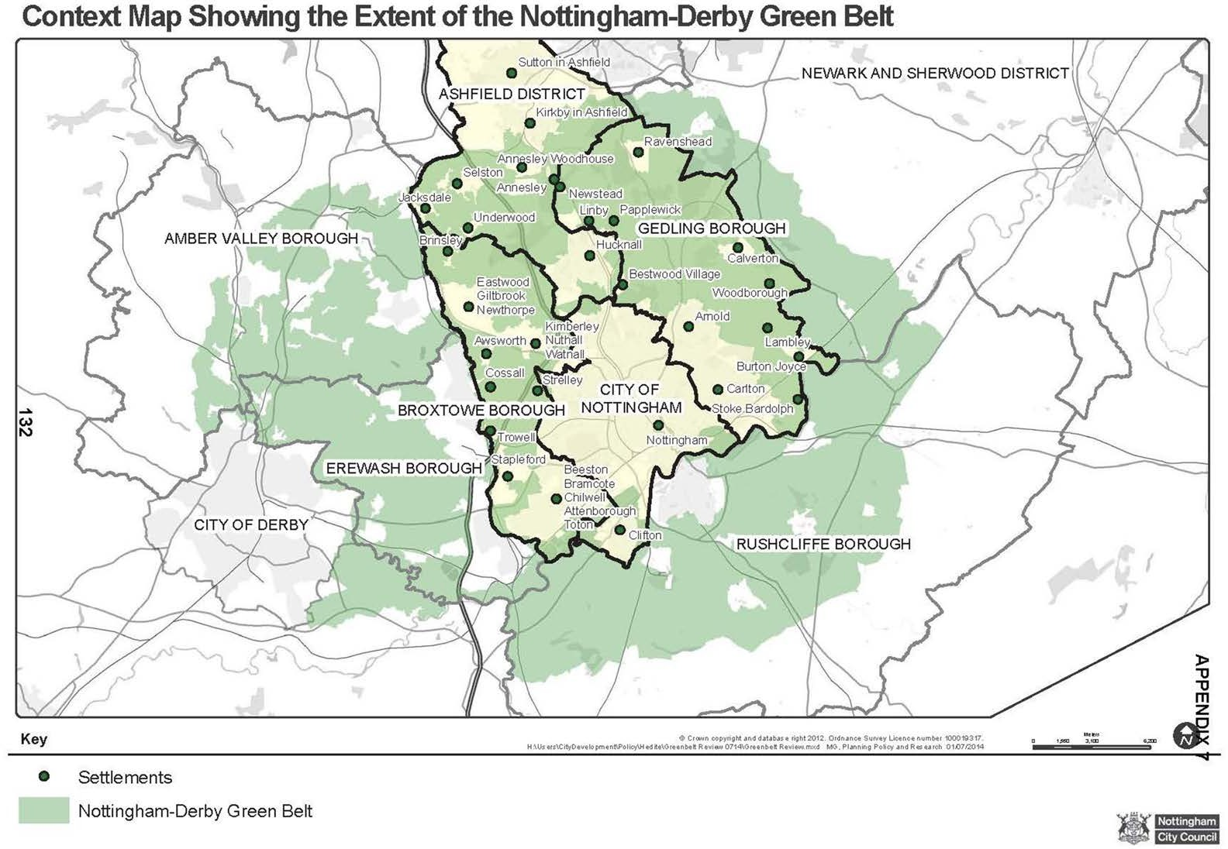

9

Glossary of Terms and Abbreviations

Conservation Area: An area designated by Local Planning Authority under Section 69 of the Planning (Listed Buildings and Conservation Areas) Act, 1990, regarded as being an area of special architectural or historic interest, the character or appearance of which is desirable to preserve or enhance.

Development Plan: Documents (taken as a whole) which set out the local planning authority's policies and proposals for the development and use of land and buildings in the authority's area.

Duty to cooperate: The duty to cooperate, as set out in paragraphs 178 and 179 of the NPPF, is a requirement by the Government for public bodies to work together on planning issues that cross administrative boundaries, particularly those which relate to strategic priorities. Local Planning Authorities must work with neighbouring authorities and other bodies, where necessary, to ensure that the development requirements of both the authority and the surrounding areas are met.

Greater Nottingham - Area covered by the Aligned Core Strategies. Includes the whole council areas of Broxtowe, Erewash, Gedling, Nottingham City and Rushcliffe, together with the Hucknall part of Ashfield.

Green Belt: A designation for land around certain cities and large built-up areas, which aims to keep this land permanently open or largely undeveloped. The purposes of the Green Belt are set out in paragraph 3.2 of the Framework. Green Belts are defined in local planning authority’s development plans.

Inappropriate Development: As defined in paragraphs 87 to 91 of the NPPF.

Listed Building: A building or structure of special architectural or historic interest included on a list prepared by the Secretary of State for Culture, Media and Sport under Section 1 of the Planning (Listed Buildings and Conservation Areas) Act, 1990. Consent is normally required for its demolition in whole or part, and for any works of alteration or extension (both internal and external) which would affect its special interest.

Local Plan: Comprises a Written Statement and a Policies Map. The Written Statement includes the Authority’s detailed policies and proposals for the development and use of land together with reasoned justification for these proposals.

Local Planning Authority: The local authority that is empowered by law to exercise planning functions.

National Planning Policy Framework: The National Planning Policy Framework sets out the Government’s planning policies for England and how these are expected to be applied. It provides a framework of polices within which local people and their accountable council can produce their own distinctive local and neighbourhood plans, which reflect the needs and priorities of their communities.

Open Countryside: The largely undeveloped countryside that separates cities, towns and villages.

Planning and Compulsory Purchase Act 2004: Government legislation which sets out the main elements of the planning system.

Regeneration: The economic, social and environmental renewal and improvement of urban and rural areas to provide long term and sustainable improvements.

Settlements: Built-up areas as listed in the ‘Accessible Settlements Study for Greater Nottingham February 2010’ (see Appendix 1 of this document). Settlements will be considered on the basis of their built form and not on the basis of town or parish boundaries.

Strategic Housing Land Availability Assessment (SHLAA): A SHLAA identifies and assesses potential sites for new housing development. Government planning guidance (SHLAA Practice Guidance, CLG (2007)) now requires local authorities to undertake a SHLAA in order to provide evidence for the Local Plan.

Sustainable Development: Development that achieves the following three inter– related and equally important objectives.
- social progress which recognises the needs of everyone;
- effective protection of the environment; and
- prudent use of natural resources.
Achieving sustainable development is therefore about achieving a balance of these three objectives.

Sound/Soundness: Under the National Planning Policy Framework 2012 paragraph 182 a local planning authority should submit a plan for examination which it considers is “sound” – namely that it is:
- Positively prepared – the plan should be prepared based on a strategy which seeks to meet objectively assessed development and infrastructure requirements, including unmet requirements from neighbouring authorities where it is reasonable to do so and consistent with achieving sustainable development;
- Justified – the plan should be the most appropriate strategy, when considered against the reasonable alternatives, based on proportionate evidence;
- Effective – the plan should be deliverable over its period and based on effective joint working on cross-boundary strategic priorities; and
- Consistent with national policy – the plan should enable the delivery of sustainable development in accordance with the policies in the Framework.

Urban Fringe: Land under the influence of the urban area.

