

Ashfield Local Plan 2023 to 2040:

Consultation on Additional
Housing Site Allocations

February 2025

Table of Contents

1. Introduction: Additional consultation on Ashfield Local Plan 2023-2040 1
2. Why are the Council now proposing additional housing sites? 2
3. Ashfield District Council’s response to the Inspectors’ initial findings letter 3
4. Extent of Ashfield’s unmet housing need 2023-2040 5
5. The potential for new housing sites 6
6. New proposed housing allocations 7
H1Kl Central Avenue, Kirkby – 16 dwellings 8
H1Km Abbey Road, Kirkby – 38 dwellings 9
H1Kn Southwell Lane, Kirkby – 60 dwellings 10
H1Ko Former Kirkland’s Care Home, Fairhaven, Kirkby – 20 dwellings 11
H1Kp Pond Hole, Kirkby – 54 dwellings 12
H1Kq Former Wyvern Club site, Lane End, Kirkby – 12 dwellings 13
H1Kr Ellis Street, Kirkby - 24 dwellings 14
H1Sai Pendean Way – 12 dwellings 15
H1Saj Between Redcliffe Street & Leyton Avenue, Sutton – 18 dwellings 16
H1Sak Rookery Lane, Sutton – 78 dwellings 17
H1Sal Newark Road/ Coxmoor Road – 300 dwellings 18
H1Sam – Beck Lane South, Skegby - 106 dwellings 19
H1San - Radford's Farm, Dawgates Lane, Skegby – 90 dwellings 20
Appendix 1: Extract from Ashfield Draft Local Plan 2023 – 2040, updated to reflect new proposed housing sites (and updated yields where relevant) 21
Appendix 2: Alternative housing sites not selected 43

Introduction: Additional Consultation on Ashfield Local Plan 2023-2040

  - Ashfield District Council is undertaking an additional public consultation under Regulation 19 of the Town and Country Planning (Local Planning) (England) Regulations 2012 to ensure the adequacy of its own housing land supply for the entire Local Plan period 2023-2040.

  - The consultation is running for 6 weeks from 20th February 2025 to 3rd April 2025. Consultation documentation includes:

- Ashfield Local Plan 2023-2040 Consultation on Additional Housing Site Allocations, February 2025;
- Policies Map (North);
- Sustainability Appraisal (SA) Addendum;
- Habitats Regulations Assessment (HRA) Addendum;
- Equalities Impact Assessment Update Statement;
- Representation Forms, Guidance Notes and FAQs.

  - The above documentation can be found on the Council’s website here.

Why are the Council now proposing additional housing sites?

  - The Ashfield Local Plan 2023-2040 was submitted to the Secretary of State for Examination in April 2024. Initial hearing sessions were held for Matters 1-3 held on 12-14 November 2024.

  - A letter detailing the Inspectors’ initial findings (INS 05) was received by the Council on 6th January 2025 (dated 3rd December 2024), with a deadline of 10th January 2025 by which the Council had to provide a response (ADC.09). Both letters and a timetable (ADC.10) are published on the Local Plan examination website here: Ashfield Local Plan Examination latest news

  - The letter sets out the Inspectors’ decision to postpone the January hearing sessions for Matters 4 -12 and schedule in further hearing sessions at a suitable time once the Council has addressed the matters raised, given the importance of establishing a sound spatial strategy to set the context for the rest of the examination.

  - Key concerns raised by the Inspectors were:

- The appropriateness of the Plan’s Spatial Strategy and the role that the Sustainability Appraisal (SA) played in determining that strategy. Concerns centre upon the effectiveness and soundness of this strategy as the Council is currently unable to identify sufficient homes to meet the housing requirement in the submitted plan, with a shortfall of 882 homes to 2040.

- The justification for the release of Green Belt land. The National Planning Policy Framework (NPPF) sets out the Government’s expectations on the exceptional circumstances that must exist before altering the Green Belt boundary. The Framework expects that before concluding that exceptional circumstances exist to justify changes to the Green Belt boundary, the strategic policy-making authority should be able to demonstrate that it has examined fully all other reasonable options for meeting its identified need for housing development. By focussing on sites of fewer than 500 dwellings, there may be other potential sites of over 500 dwellings which may result in the Council not needing to release land from the Green Belt. It appears from the representations that such sites may exist. Therefore, there is currently insufficient evidence to justify that exceptional circumstances exist to remove land from the Green Belt at the strategic level.

- Significant concerns that even if it was concluded exceptional circumstances exist to alter the Green Belt boundary based on the submitted plan, the current shortfall in housing would likely result in the need for further alterations to the Green Belt before the end of the plan period. The Framework seeks to avoid this scenario.

  - On the basis of the above, the Inspectors ask:

- Whether the Council can identify any further sites for allocation in accordance with the submitted plan’s spatial strategy to meet housing needs? If not, could any sites of greater than 500 dwellings be identified for allocation whilst maintaining the dispersed approach?

- If further sites cannot be identified, then how could the Plan and its spatial strategy be modified to make it effective, justified and sound in seeking to meet housing needs in full over the plan period.

  - Attention was also drawn to the letter from the Housing Minister to the Planning Inspectorate Housing Minister Letter 30 July 2024 which sets out the Government’s expectations on the pragmatism that Inspectors should apply when pauses to Local Plan examinations may be required. Pragmatism should not be used to address fundamental issues with the soundness of a plan, which would be likely to require pausing or delaying the examination process for more than six months overall. Any extensions to the six-month pause (and therefore more time for additional work) should only be allowed at the Inspectors’ discretion to deliver adopted local plans under the current system.

Ashfield District Council’s response to the Inspectors’ initial findings letter

  - The Council responded to the Inspectors’ letter ADC.09 setting out the intention to undertake immediate work in identifying further sites of less than 500 dwellings, in accordance with the submitted plan’s spatial strategy. A timetable for the additional work was also provided to the Inspectors (ADC.10). Attention was also drawn to the extremely tight 4-day response period and the limited time to engage with Councillors for any formal decisions to be taken. As such, the Council reserved the right to change its approach subject to the outcome of future Council meetings.

  - At the Local Plan Development Committee (LPDC) meeting of 5th February 2025 Council Members were asked to consider various options to address the Inspectors’ concerns and recommend to Cabinet a way forward. These are summarised as:

- Approve additional potential housing sites, which are consistent with the existing Spatial Strategy, for allocation in the submitted Local Plan in order to meet the identified level of need for the entire Plan period.

- To not consider and recommend additional housing sites for allocation in line with the existing agreed spatial strategy, noting that the Inspectors consider that Main modifications will be required to address the supply of housing and make the Plan effective.

- To undertake a new ‘call for sites’ in order to assess the potential of any new available sites not previously submitted to the Strategic Housing and Economic Land Availability Assessment (SHELAA). Whilst the SHELAA is a ‘live’ document and new sites can be submitted to the Council at any point in time, a new ‘call’ could yield new sites. This exercise would typically involve a period of 3 to 6 weeks for submission of new sites, followed by assessment of constraints and consultation with relevant bodies and subsequent consideration by Council Members. A key risk to this approach is that the Planning Inspectorate could determine that the pause in the Local Plan Examination is unacceptably extended (to more than 6 months), and that a new Local Plan should instead be delivered under the new NPPF 2024 (as in point 4 below).

- To consider progressing with a new Spatial Strategy which does not limit the scale of site allocations to less than 500 dwellings. This could include the re-introduction of the 2 new settlements of Cauldwell Road and Whyburn Farm (previously consulted on at Regulation 18 stage), or the consideration of other sustainable urban extensions. This would provide an opportunity to consider large scale sites previously excluded under the agreed strategic approach and could potentially provide for a moderate ‘buffer’ to help future proof the Local Plan and reduce the need for future green belt release. This option would present a significant change to Member’s preferred strategy for growth and may entail significant changes throughout the Local Plan, sustainability appraisal and supporting documents which could risk delaying the Plan Process further. This work would not be able to be completed within the Inspectors six-month timeframe.

- To withdraw the submitted Local Plan from Examination and embark on a new style Local Plan under the December 2024 National Planning Policy Framework (NPPF). This would involve planning for higher housing targets (currently 535 dwellings per annum as opposed to 446 dwellings per annum). This approach is not recommended as it is important for the Council to direct development to plan positively for our residents. The key risks associated with this approach will be a continued vulnerability to unplanned development due to a lack of housing land supply, significant additional cost with the potential of intervention. There would also be a reliance on other outdated local planning policy which could jeopardise successful sustainable development, for instance, affordable housing and other developer contributions.

  - LPDC Members recommended that Cabinet: Consider the options and endorse the ‘additional sites’ option (as set out in 17th February 2025 Cabinet report).

  - Cabinet was held on 17th February 2025 and recommended that full Council approve the following:

- Approve additional potential housing sites, subject to site H1Sam, Land North of Fackley Road (Phase 2), Teversal being withdrawn from the list for allocation in the submitted Local Plan in order to meet the identified level of need for the entire Plan period and commend it to Council for approval for the purposes of public consultation and submission to the Secretary of State for Housing, Communities and Local Government in accordance with provisions of the Town and Country Planning (Local Planning) (England) Regulations 2012, as amended and the Planning and Compulsory Purchase Act 2004;

- Recommend to Council approval of proposals for a 6-week public consultation on additional potential housing sites.

  - A full Council meeting was held in the evening of 17th February 2025 and approved the Cabinet’s recommendations.

  - Note that for the purposes of this consultation and following the Full Council decision, the reference numbering for sites H1San and H1Sao have been updated to reflect the deletion of the site as set out above (para. 3.4).

Extent of Ashfield’s unmet housing need 2023-2040

  - Strategic Policy S7 in the submitted Ashfield Local Plan 2023-2040 set out a commitment to providing a minimum housing supply of 7,582 new dwellings over the entire 17 year Plan period, based on the Government’s standard method for assessing housing need. However, at that time the proposed allocations (in Policy H1) together with small site supply (as calculated at April 2023) was estimated to provide for approximately 13 years’ worth of housing supply post adoption (15 years in total).

  - The Council considered that this was consistent with the National Planning Policy Framework (NPPF) which requires policies to identify a sufficient supply and mix of sites, (taking into account their availability, suitability and likely economic viability), with specific, deliverable sites for years one to five of the plan period, and specific, developable sites or broad locations for growth, for years 6-10 and, where possible, for years 11-15 of the plan.

  - However, as set out in paragraphs 2.4 and 2.5 above, the Inspectors have raised concerns over the under-identification of homes over the full Plan period compared with the Local Housing Need (LHN) requirement under the standard method. In particular they considered that the current shortfall in housing would likely result in the need for further alterations to the Green Belt before the end of the plan period.

  - The Inspector’s interim findings referred to the overall supply of housing in the submitted Local Plan 2023-2040. This identified a shortfall of 882 dwellings against an identified need figure of 7582 dwellings and was based on the most up to date housing monitoring data (April 2023) alongside new proposed sites at the point of submission. However, housing monitoring is undertaken annually, with a base date of 1st April each year. As such, the most recent information is dated April 2024 and includes any completions, changes to yield, or new permissions since April 2023.

  - The housing allocations have subsequently been revised accordingly to give a more accurate position in respect of housing supply. This also includes any changes to yields on non-permissioned sites where additional information has been received by the Council. If the new sites proposed in Section 6 are also included, this will give a small over provision of 136 dwellings, or the equivalent of around 2% buffer on the balance of housing need.

The potential for new housing sites

  - The Council has examined the potential for new housing site allocations for consideration. These have been drawn from:

- New permitted sites (post Local Plan submission);
- Sites with a resolution to grant permission subject to signing a s106 legal agreement;
- Sites previously not selected from the Strategic Housing and Economic Land Assessment (SHELAA), including consideration of any new sites submitted to this process since the submitted Local Plan was finalised;
- Ashfield District Council and partnership pipeline projects.

  - Several sites have been identified as having potential to deliver additional housing which conform with the current Spatial Strategy as set out in Policy S1 of the submitted Local Plan. New Green Belt SHELAA sites have not been considered, reflecting the concerns of the Inspector’s interim findings. The one exception is a relatively small site at Abbey Road, Kirkby (H1Km) which has been resolved to grant planning permission subject to the signing of a section 106 legal agreement for developer contributions, and also the referral to the Secretary of State. Details of all additional proposed housing sites and location plans are included in Section 6.

  - Appendix 1 includes an extract from the submitted Local Plan illustrating the proposed update to Policy H1 and its supporting text.

  - Appendix 2 includes a list of sites considered but not put forward as additional potential housing allocations, together with the reason for rejection.

New proposed housing allocations

  - The following sites are proposed as additional housing allocations to be included in the submitted Ashfield Local Plan 2023-2040.

New Site Ref. | Site Name | Greenfield/ Brownfield | Planning Permission | Potential Yield (Dwellings)
H1Kl | Central Avenue, Kirkby | B | Yes | 16
H1Km | Abbey Road, Kirkby | G | No^ | 38
H1Kn | Southwell Lane, Kirkby | B | No | 60
H1Ko | Former Kirkland’s Care Home, Fairhaven, Kirkby | B | No | 20
H1Kp | Pond Hole, Kirkby | B | No | 54
H1Kq | Former Wyvern Club site, Lane End, Kirkby | B | No | 12
H1Kr | Ellis Street, Kirkby | B | No | 24
H1Sai | Pendean Way | G | Yes | 12
H1Saj | Between Redcliffe St & Leyton Avenue, Sutton | B | No^ | 18
H1Sak | Rookery Lane, Sutton | G | No^ | 78
H1Sal | Newark Road/ Coxmoor Road | G | Yes | 300
H1Sam | Beck Lane South, Skegby | G | No | 106
H1San | Radford's Farm, Dawgates Lane, Skegby | G | No^ | 90
Total |  |  |  | 828

^ Site has had a resolution to grant planning permission subject to the signing of a section 106 legal agreement in respect of developer contributions

H1Kl Central Avenue, Kirkby – 16 dwellings

  - This is a brownfield site which has the benefit of Full planning permission for 16 dwellings. It forms part of Ashfield Council’s Housing Strategy and will be developed for 100% affordable housing.

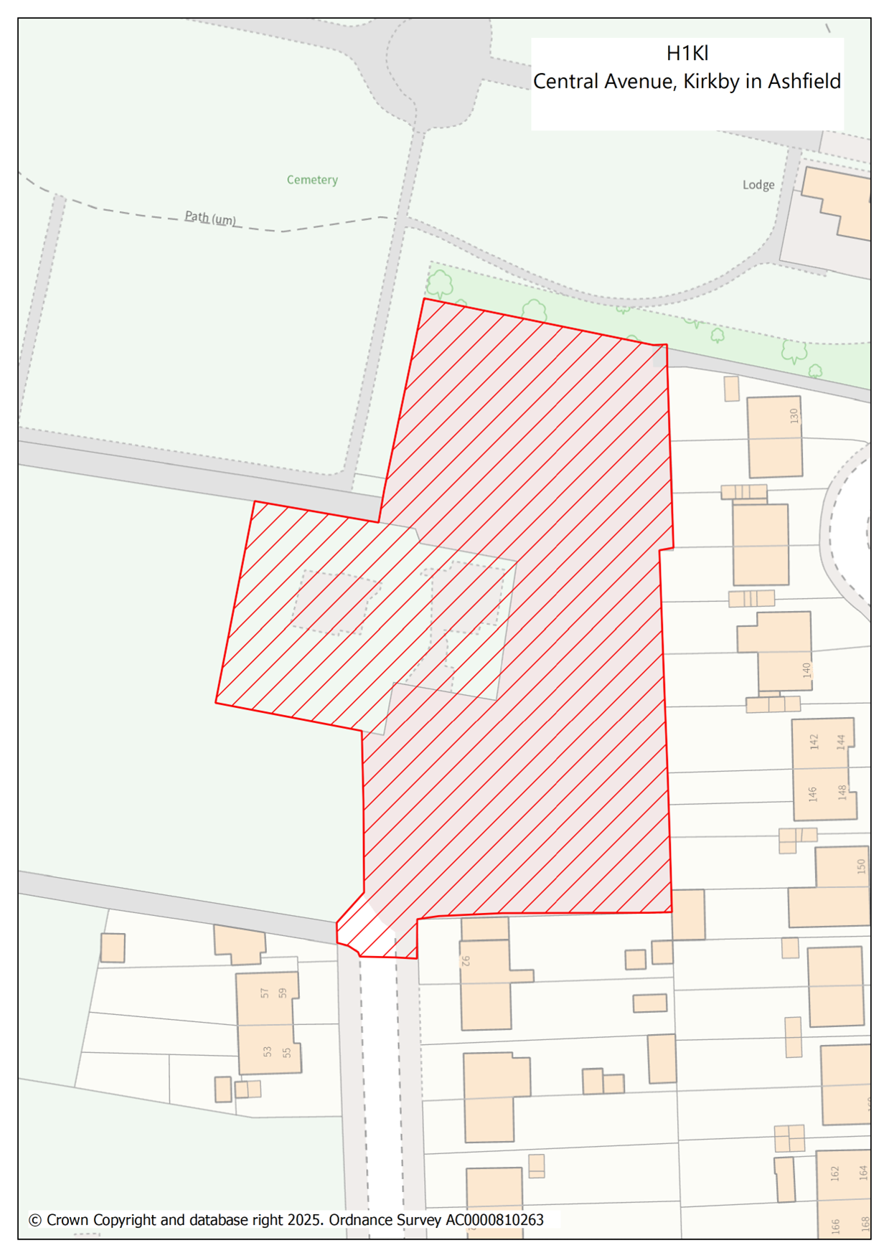

H1Km Abbey Road, Kirkby – 38 dwellings

  - This Greenfield site is located adjacent to the existing urban area of Kirkby- in-Ashfield and has been assessed as available, potentially suitable, and potentially achievable in the SHELAA (ref. KA024). The site has a resolution to grant planning permission for residential development, subject to the signing of a Section 106 legal agreement for developer contributions (V/2023/0312). It is subject to referral to the Secretary of State due to its current Green Belt status.

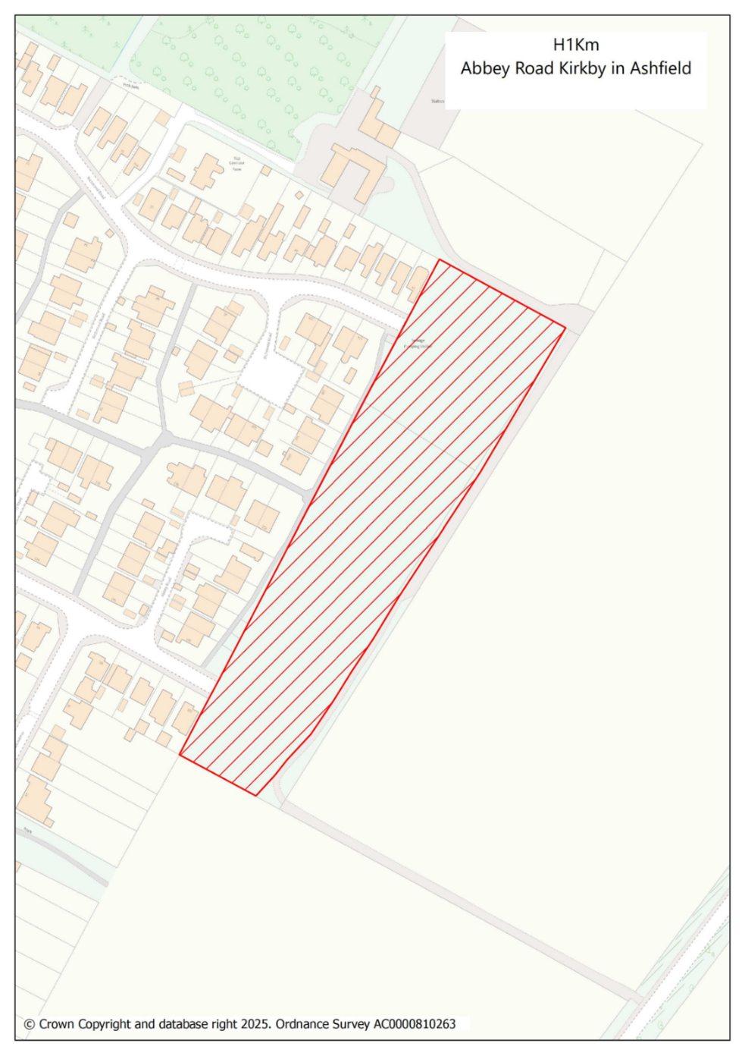

H1Kn Southwell Lane, Kirkby – 60 dwellings

  - This brownfield site is identified on the Brownfield Register (BFR 12) and has been assessed as available, potentially suitable, and potentially achievable in the SHELAA (ref. KA057). It is located within the Main Urban Area and occupies a former reclaimed employment site.

  - The potential yield for this site is based on historic lapsed permissions and sketch layout.
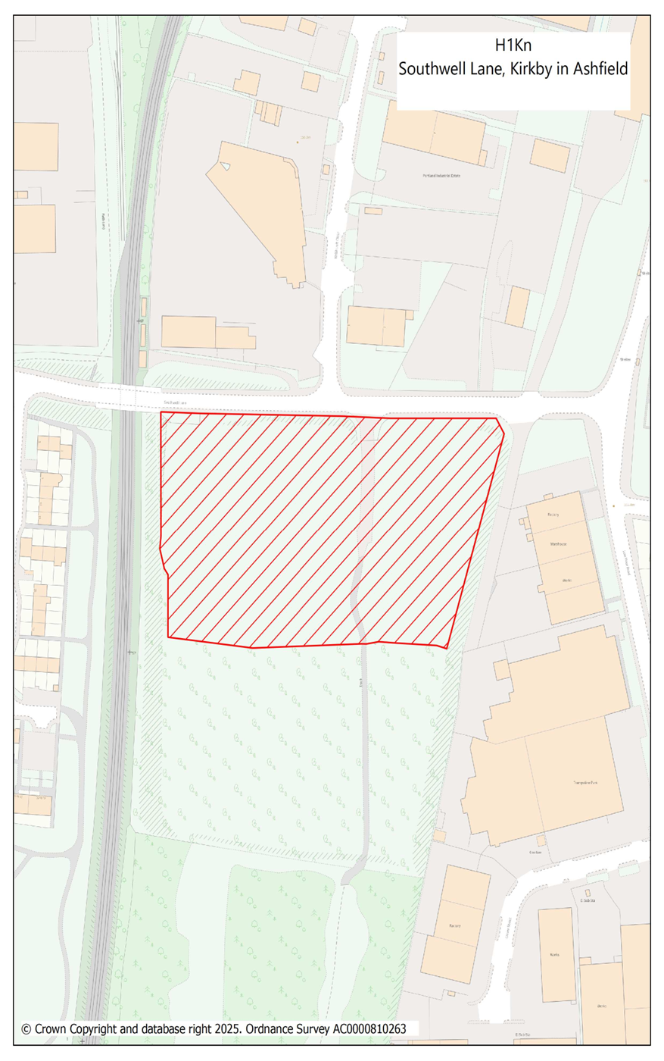

H1Ko Former Kirkland’s Care Home, Fairhaven, Kirkby – 20 dwellings

  - This vacant brownfield site has been assessed as available, potentially suitable, and potentially achievable in the SHELAA (ref. KA058). It is located within the Main Urban Area and occupies the site of a former nursing home now demolished.

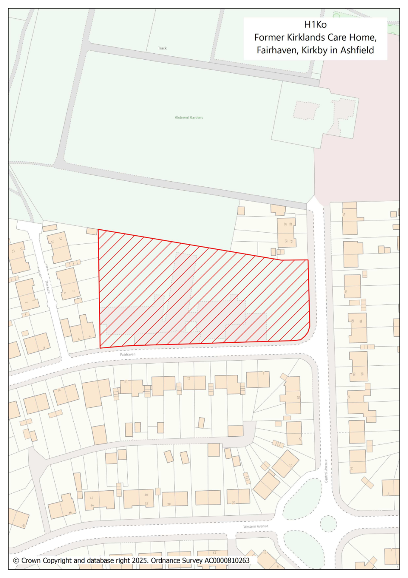

H1Kp Pond Hole, Kirkby – 54 dwellings

  - This vacant brownfield site has been assessed as available, potentially suitable, and potentially achievable in the SHELAA (ref. KA059). It is located within the main Urban area, in particular Kirkby town centre and is currently used for storage purposes.

  - The site is identified as part of Priority Project A3 in the Kirkby Town Centre Spatial Masterplan: Shaping Kirkby’s Future (2021), alongside Site H1Kr Ellis Street. The Key opportunity for the entire ‘A3’ project is to redevelop for residential led mixed use to capitalise on the town centre location.

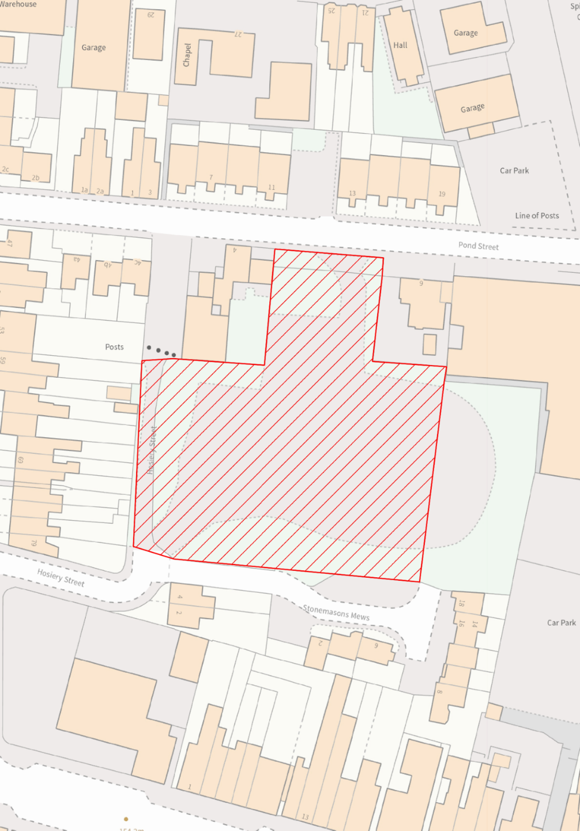
© Crown Copyright and database right 2025. Ordnance Survey AC0000810263

H1Kp
Pond Hole, Kirkby in Ashfield

H1Kq Former Wyvern Club site, Lane End, Kirkby – 12 dwellings

  - This vacant brownfield site has been assessed as available, potentially suitable, and potentially achievable in the SHELAA (ref. KA060). It is located within Kirkby Town Centre and is identified as Medium-Term Project B1 in the Kirkby Town Centre Spatial Masterplan: Shaping Kirkby’s Future (2021). It forms part of the western ‘station’ gateway to the town centre where there is an opportunity to redevelop and reconfigure the area to enhance access to/from the station, to provide a focus to the gateway, and to develop vacant land on the edge of the town centre.
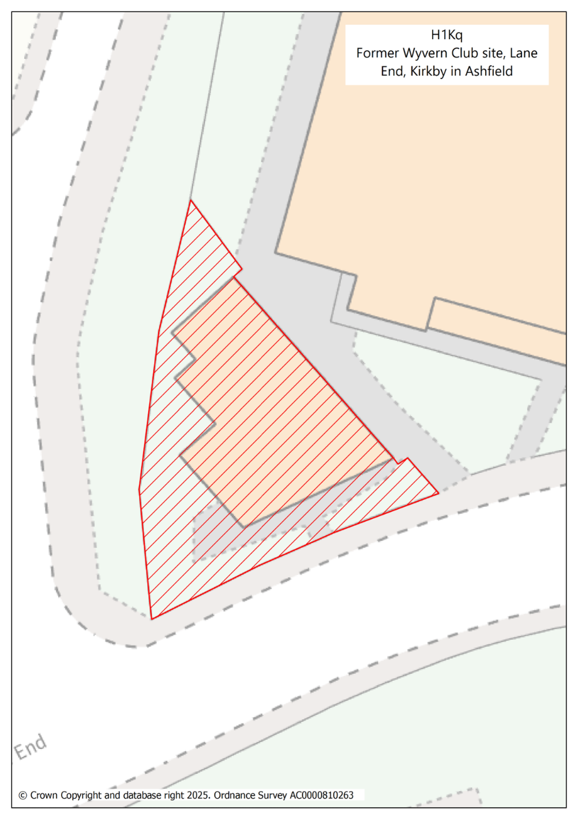

H1Kr Ellis Street, Kirkby - 24 dwellings

  - This brownfield site has been assessed as available, potentially suitable, and potentially achievable in the SHELAA (ref. KA061). It is located within Kirkby town centre and is currently used as a car park, leisure and commercial units.

  - The site is identified as part of Priority Project A3 in the Kirkby Town Centre Spatial Masterplan: Shaping Kirkby’s Future (2021), alongside Site H1Kp Pond Hole. The Key opportunity for the entire ‘A3’ project is to redevelop for residential led mixed use to capitalise on the town centre location. This should include uses to promote an active frontage on to Ellis Street to redefine the west side of the Civic Square, for example, service, commercial, community/leisure uses appropriate to a town centre location.
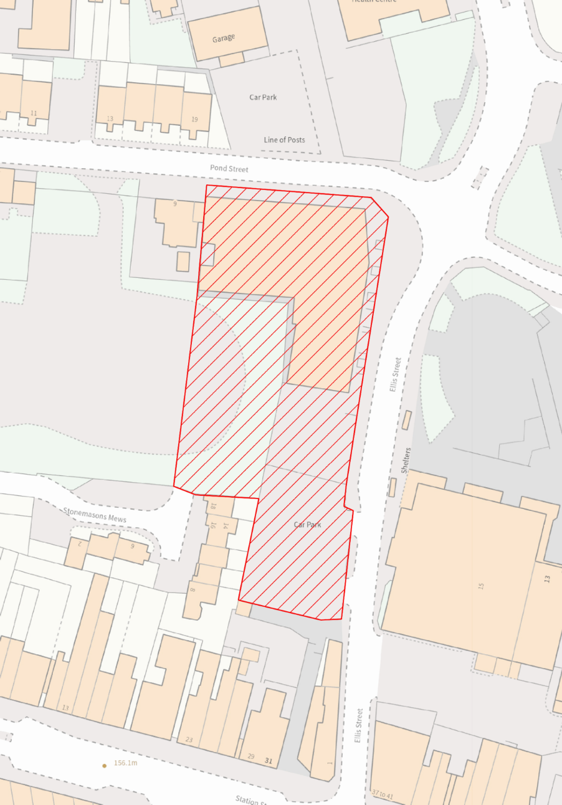
H1Kr
Ellis Street, Kirkby in Ashfield

© Crown Copyright and database right 2025. Ordnance Survey AC0000810263

H1Sai Pendean Way – 12 dwellings

  - This site currently has Full planning permission for 12 dwellings (V/2023/0156) and is enclosed by existing residential development within the main urban area of Sutton in Ashfield. Progress on this site includes the completion of street naming and numbering.

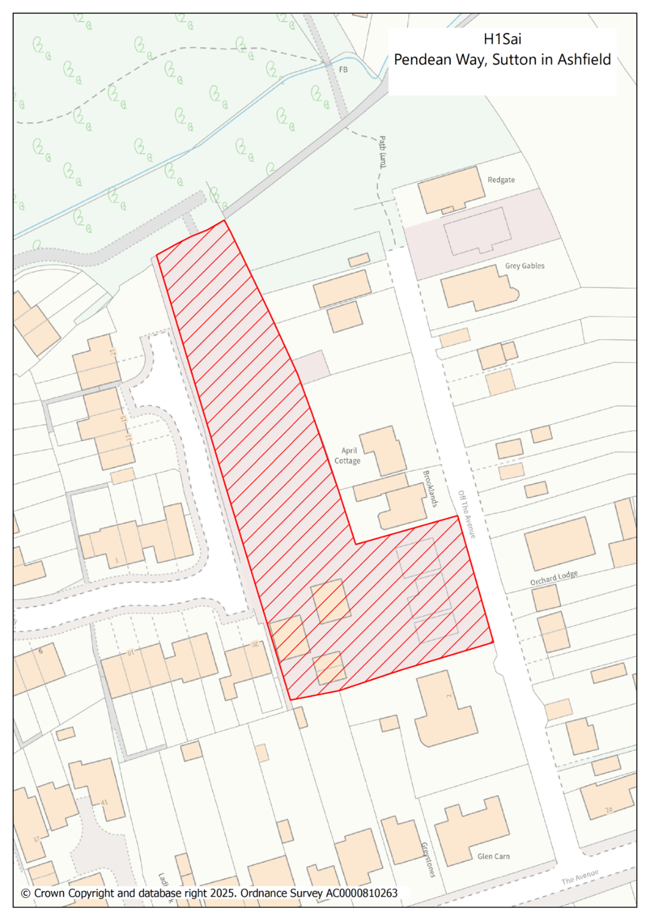

H1Saj Between Redcliffe Street & Leyton Avenue, Sutton – 18 dwellings

  - This brownfield site is located within the Main Urban Area. It is predominantly currently occupied by commercial buildings and is enclosed on all sides by existing residential development. The site has a resolution to grant planning permission for residential development, subject to the signing of a Section 106 legal agreement for developer contributions.
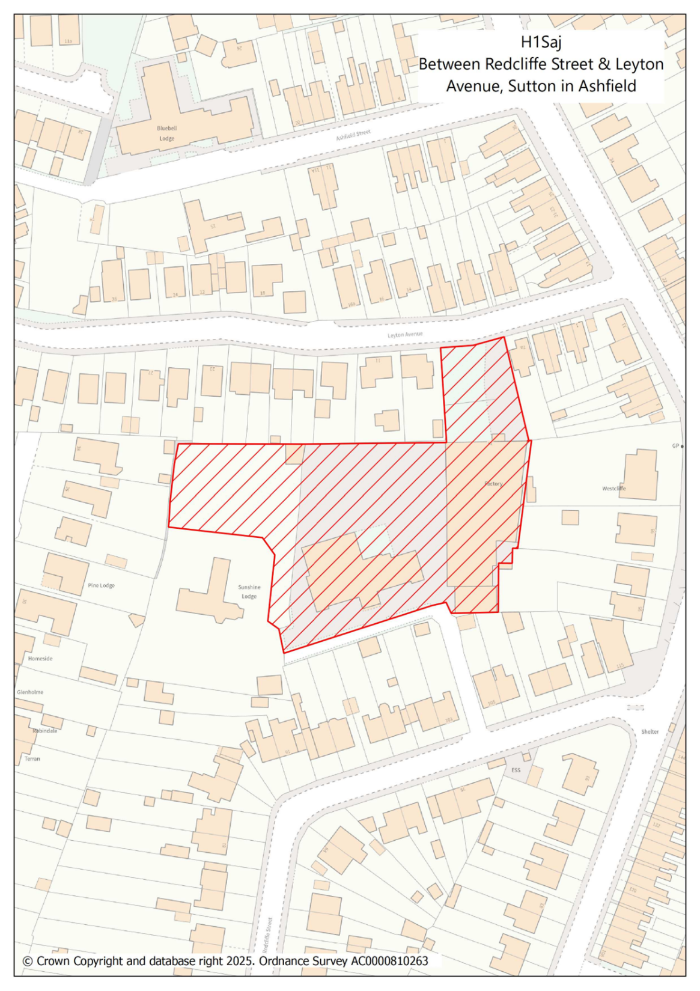

H1Sak Rookery Lane, Sutton – 78 dwellings

  - This greenfield site has been assessed as available, potentially suitable, and potentially achievable in the SHELAA (ref.SA092). It is located within the Main Urban Area and will form Phase 2 of the adjacent residential development H1Sx. The site has a resolution to grant planning permission for residential development, subject to the signing of a Section 106 legal agreement for developer contributions (V/2022/0612).
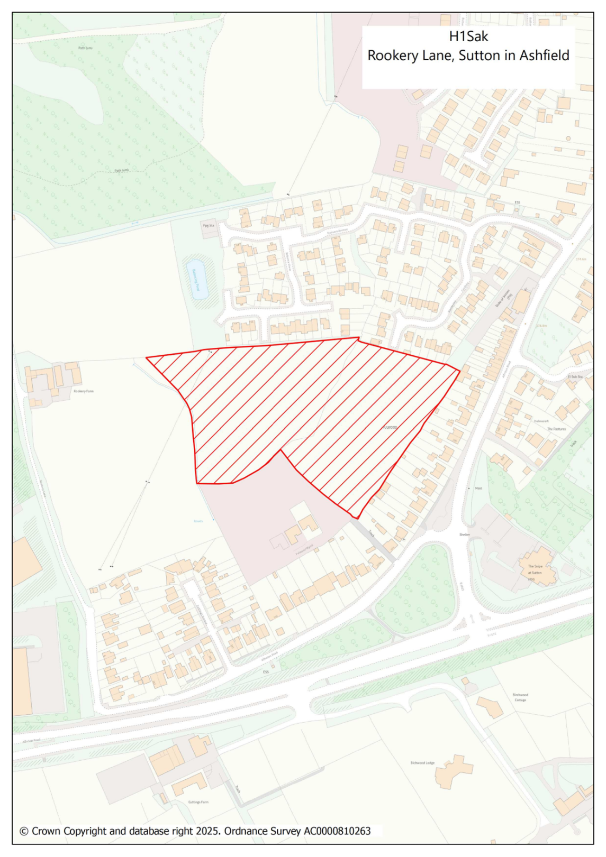

H1Sal Newark Road/ Coxmoor Road – 300 dwellings

  - This site currently has Outline planning permission for up to 300 dwellings (V/2022/0629). It is located adjacent to the urban area east of Sutton in Ashfield and is well contained by development to the north and west, and by Coxmoor Road to the east.
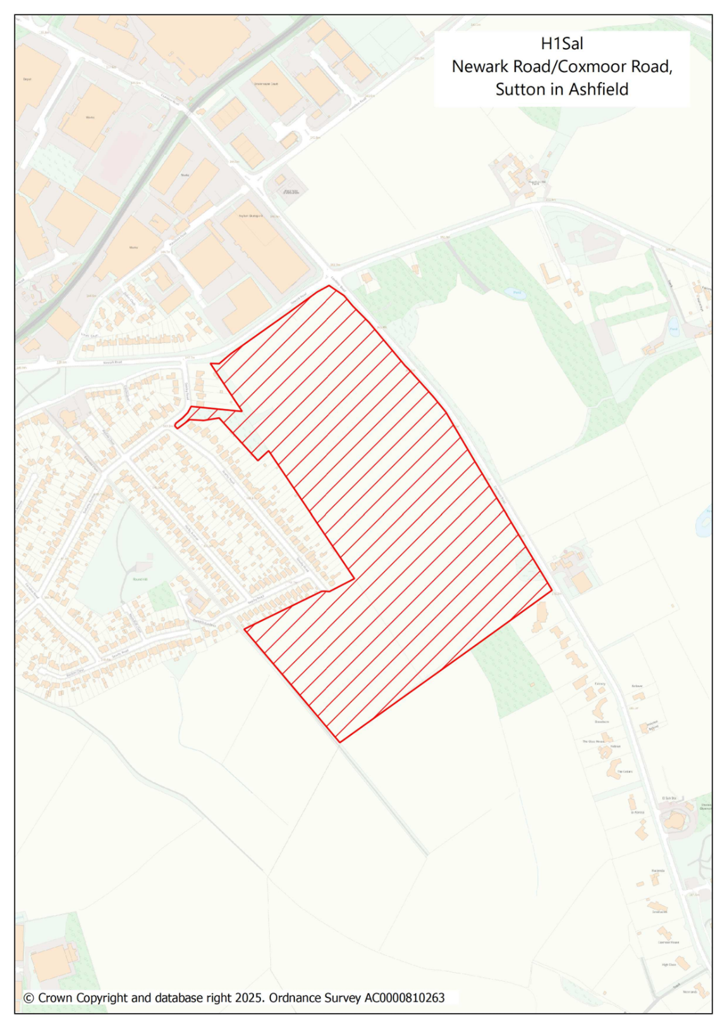

H1Sam – Beck Lane South, Skegby - 106 dwellings

  - This greenfield site has been assessed as available, potentially suitable, and achievable in the SHELAA (ref.SA008). It is located adjacent to the existing urban area of Skegby, directly south of site allocation H1Saa which is currently being developed for new homes. The smaller site allocation H1Sf abuts this site to the south-east.

  - The site was not previously taken forward as a proposed housing allocation due to access constraints However, further investigations are progressing regarding the provision of a suitable access to the site which may potentially result in little or no further capacity being required from Beck Lane and the junction directly off. It is therefore envisaged that the land would be available in the medium term, subject to a satisfactory position being reached with a third party and the County Council’s Highways Department.
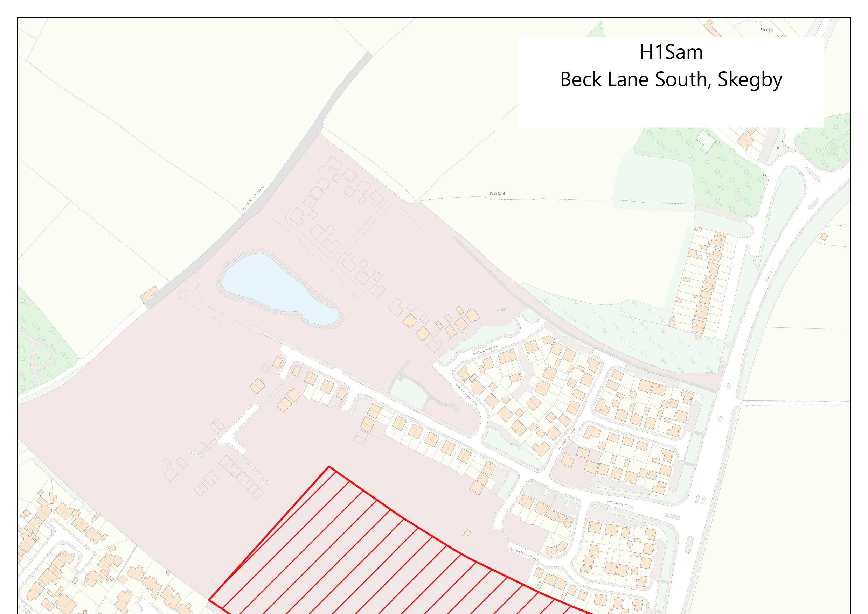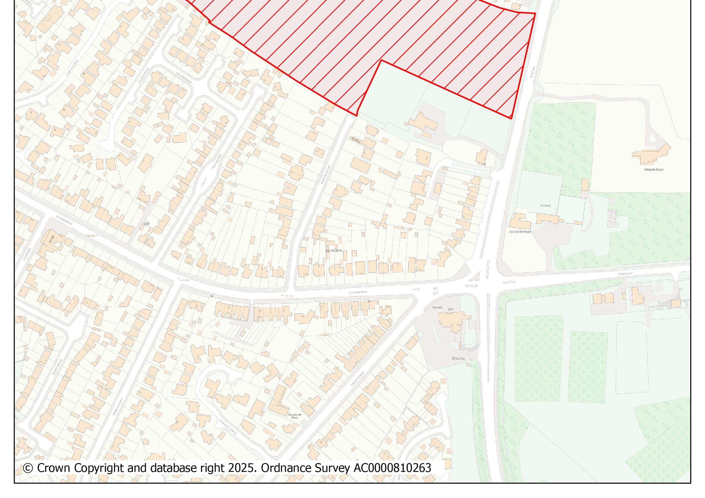

H1San - Radford's Farm, Dawgates Lane, Skegby – 90 dwellings

  - This greenfield site is located north of Skegby and has a resolution to grant Outline planning permission for residential development, subject to the signing of a Section 106 legal agreement for developer contributions (V/2024/0489).

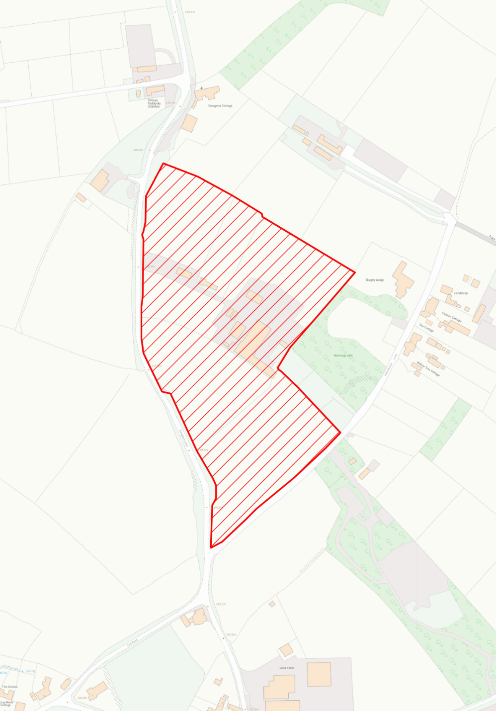
H1San
Radford’s Farm, Dawgates Lane, Skegby
© Crown Copyright and database right 2025. Ordnance Survey AC0000810263

Appendix 1: Extract from Ashfield Draft Local Plan 2023 – 2040, updated to reflect new proposed housing sites (and updated yields where relevant)

The following policy wording and supporting text are taken from the submitted Ashfield Local Plan 2023-2040. The blue underlined text represents proposed new wording predominantly in relation to the new proposed housing sites which are being considered. There are also updates to some site yields as a result of dwelling completions or re-plans. Proposed text deletions are indicated with a strikethrough. These generally reflect a change in circumstance such as sites gaining planning permission, or whole site completions.

Policy H1: Housing Site Allocations

  - Policy H1 allocates large housing sites (those capable of accommodating ten or more dwellings) which will contribute towards providing the assessed housing need identified in Strategic Policy S7.

  - Where appropriate, concise Masterplans will be available for larger housing allocations which currently do not have the benefit of planning permission. These will set out essential requirements expected by the Council and provide more detailed advice and guidance specific to that site.

Policy H1: Housing Allocations
Strategic Objectives
SO3, SO5, SO11, SO12, SO13
Residential development will be permitted on the sites listed below as shown on the Policies Map, subject to detailed planning consent where it has not already been granted, or where it has lapsed.

Hucknall Area

Site Ref. | Site Name | Greenfield/ Brownfield | Planning Permission* | Potential Yield (Dwellings)
H1Ha | Seven Stars PH, West Street / Ogle Street, Hucknall | B | No | 28
H1Hb | Linby Boarding Kennels, East of Church Lane, Hucknall | G/B | Part | 43 34
H1Hc | Land north of A611 / South of Broomhill Farm, Hucknall | G | No | 499
H1Hd | Land adjoining Stubbing Wood Farm, Watnall Road, Hucknall | G | No | 198
H1He | Phase 5b, land at Rolls Royce, Watnall Road, Hucknall | B | Yes | 150
H1Hf | Phase 9, land at Rolls Royce, Watnall Road, Hucknall | B | Yes | 101
H1Hg | Hucknall Town football Club, Watnall Road | G | Yes | 82
H1Hl | Land at, Shepherd Street (Rolls Royce site) | B | Yes | 42
H1Hn | (Phase 2) Land at, Broomhill Farm | G | Yes | 168 97
 |  |  |  | 1311 1189

Site Ref. | Site Name | Greenfield/ Brownfield | Planning Permission* | Potential Yield (bedrooms)
H1Ca | Former Hucknall Police Station, Watnall Road, Hucknall | B | Yes | 73

Kirkby Area

Site Ref. | Site Name | Greenfield/ Brownfield | Planning Permission* | Potential Yield (Dwellings)
H1Ka | Beacon Farm, Derby Road, Kirkby-In Ashfield | G/B | No | 41
H1Kb | Land off Millers Way, Kirkby-In Ashfield | G | Yes | 54 39
H1Kc | Land at Doles Lane, Kirkby-In Ashfield | B | No | 54
H1Kd | Off Walesby Drive | G | No Yes | 196
H1Ke | Land off Diamond Avenue, Kirkby-In-Ashfield | G | No | 63
H1Kf | Warwick Close, Kirkby-In-Ashfield | B | Yes | 34
H1Kg | Land behind 126 Skegby Road, Kirkby-In-Ashfield | G | No | 15
H1Kh | Land Off Hucknall Road, Newstead | G | No | 47
H1Kk | Land off Laburnum Avenue, Kirkby | G | No | 38
H1Kl | Central Avenue, Kirkby | B | Yes | 16
H1Km | Abbey Road, Kirkby | G | No^ | 38
H1Kn | Southwell Lane, Kirkby | B | No | 60
H1Ko | former Kirkland’s care home, Fairhaven, Kirkby | B | No | 20
H1Kp | Pond Hole, Kirkby | B | No | 54
H1Kq | Former Wyvern Club site, Lane End, Kirkby | B | No | 12
H1Kr | Ellis Street, Kirkby | B | No | 24
 |  |  |  | 542 717

Sutton Area

Site Ref. | Site Name | Greenfield/ Brownfield | Planning Permission* | Potential Yield (Dwellings)
H1Sa | Rear 211 Alfreton Road | G | Yes | 110 66
H1Sb | South of Vision West Nottinghamshire College, Cauldwell Road, Sutton | G | No^ | 208 235
H1Sc | West of Fisher Close, Skegby | G | Yes | 84
H1Sd | Adj Oakham Business Park, off Hamilton Road | G | No | 225 250
H1Se | Priestic Road, Sutton | G | No | 19
H1Sf | Rear 23 Beck Lane, Skegby | G | No | 23
H1Sg | Former Miner’s Welfare Sports Ground, Stanton Hill | G | No^ | 85 112
H1Sh | Pasture Farm, Alfreton Road | G | No | 34
H1Si | Rear Kingsmill Hospital | G | No | 264
H1Sj | Clegg Hill Drive, Huthwaite | G | No | 104
H1Sk | Sunnyside Farm, Blackwell Road, Huthwaite | G | No | 283 350
H1Sl | North of Fackley Road, Teversal | G | No Yes | 124
H1Sm | Land adjacent 88 High Hazels Drive | G | No Yes | 11 18
H1Sn | Adj Molyneux Farm, Fackley Road, Teversal | G | No | 14
H1So | Off Fackley Road, Teversal | G | No | 12
H1Sq | Hardwick Lane Recreation Ground | G | No Yes | 40
H1Sr | Land off Clare Road | G | Yes | 69
H1Ss | Land East of A6075 Beck Lane, Skegby | G | No | 212 230
H1St | Land off Blackwell Road/Main Street, Huthwaite | G | No Part | 99
H1Su | Rear 113 to 139 Beck Lane, Skegby | G | No Part | 100 91
H1Sw | Off Gillcroft Street/St Andrews Street & Vere Avenue, Skegby | G | Yes | 206 168
H1Sx | rear 249, 251 Alfreton Road | G | Yes | 43 6
H1Sy | off Brand Lane, Stanton Hill | G | Yes | 71 53
H1Sz | Junction of Outram Street/Park Street | B | Yes No | 24
H1Saa | Land at, Beck Lane, Skegby | G | Yes | 322 293
H1Sac | The Quarry, 57, Stoneyford Road | G | Yes | 47
H1Sad | The Pattern House, Crossley Avenue, Huthwaite | B | Yes | 23 16
H1Sae | Ashland Road West | G | Yes | 300
H1Saf | North of Midland Road | G | Yes | 20
H1Sag | Quantum clothing Site, North Street, Huthwaite | B | No | 71 61
H1Sah | Land adjacent 208 Mansfield Road, Sutton in Ashfield | B | No | 36
H1Sai | Pendean Way | G | Yes | 12
H1Saj | Land Between Redcliffe Street & Leyton Avenue, Sutton in Ashfield | B | No^ | 18
H1Sak | Rookery Lane, Sutton | G | No | 78
H1Sal | Newark Road/Coxmoor Road | G | Yes | 300
H1Sam | Beck Lane South, Skegby | G | No | 106
H1San | Radford's Farm, Dawgates Lane, Skegby | G | No^ | 90
 |  |  |  | 3283 3846

Selston Jacksdale and Underwood Area

Site Ref. | Site Name | Greenfield/ Brownfield | Planning Permission* | Potential Yield (Dwellings)
H1Va | Land at Plainspot Farm, New Brinsley, Underwood | G | No | 42
H1Vb | Off Westdale Road, Jacksdale | G | No | 49 64
H1Vc | Land adj. Bull & Butcher PH, Selston | G | No | 149
H1Vd | Adj 149 Stoney Lane, Selston | G/B | No | 6
H1Ve | Land off Park Lane/ South-West M1, Selston | G | No | 169 137
H1Vg | Land North of Larch Close, Underwood | G/B | No | 52
H1Vh | Rear of 64-82 Church Lane, Underwood | G | No | 10
H1Vi | Westdale Road/Rutland Road, Jacksdale | G | No | 22
H1Vj | Land off Main Road, Jacksdale | G | No Yes | 81
 |  |  |  | 580 557

* Sites with planning permission at 31st August 2023 11th February 2025
^ Site has had a resolution to grant planning permission subject to the signing of a section 106 legal agreement in respect of developer contributions

Evidence Base
- Strategic Housing and Economic Land Availability Assessment (SHELAA). Ashfield District Council
- Background Paper 1: Spatial Strategy and Site Section 2023, Ashfield District Council
- Background Paper 2: Housing 2023, Ashfield District Council.
- Sustainability Appraisal, 2023. WSP UK Limited.
National Planning Policy and Guidance
- NPPF 2023, Part 2: Achieving sustainable development.
- NPPF 2023, Part 5: Delivering a sufficient supply of homes.
- Planning Practice Guidance: Effective use of land.
- Planning Practice Guidance: Housing and Economic Land Availability Assessment.
- Planning Practice Guidance: Housing supply and delivery as of July 2019.

  - Potential housing allocations have been selected from a ‘pool’ of sites which are assessed as being ‘available’, ‘suitable’ and ‘deliverable’ in the Strategic Housing Land and Economic Availability Assessment (SHELAA). The Sustainability Appraisal (SA) has further assessed these sites. The purpose of the SA is to promote sustainable development through the efficient use of existing infrastructure, whilst protecting landscape and biodiversity assets and facilitating social and economic benefit. The SA is therefore an essential tool in the selection of deliverable sites and provides part of the evidence base for the housing site allocations. Further details on the approach to allocating sites can be found in the Council’s Background Paper 1: Spatial Strategy and Site Selection 2023.

  - Allocations include sites both with and without planning permission. Where these are under construction, only the remaining dwellings have been identified in Policy H1. Appendix 2 illustrates the anticipated delivery of housing on each site over the plan period, together with a summary of small site provision.

Housing Allocations in the Hucknall Area

  - Site H1Ha: Seven Stars PH, West Street /Ogle Street, Hucknall This brownfield site is located within the main urban area of Hucknall. The Public House is identified as a Local Heritage Asset and could be converted into residential accommodation. The remainder of the site is suitable for residential development subject to good quality design. Due to previous site uses, contamination may be present and there is also evidence of some surface water flooding within the boundary of the site. The site has been identified as being available, potentially suitable, and potentially achievable in the SHELAA (Ref. HK009)

  - Site H1Hb: Linby Boarding Kennels, East of Church Lane, Hucknall. This mixed brownfield/greenfield site has been identified as being available, potentially suitable, and achievable in the SHELAA (Ref. HK013). The northern section has the benefit of outline planning permission for 9 dwellings at the time of writing. The site is located adjacent to the existing urban area of Hucknall on land previously designated as Green Belt, and is contained by Church Lane to the west, and Hayden Lane to the east. Church Lane is a narrow rural road that will require upgrading prior to development.

  - A Local Wildlife Site is located adjacent to the site to the north, within Gedling Borough, and any potential development will need to take into account the scope to avoid or mitigate any impacts on biodiversity. There is also a small area of high and medium risk surface water to the south-eastern part of the site which will require mitigation.

  - The site adjoins Linby Conservation Area in Gedling Borough to the North and forms part of the visual influence area of the conservation area, which is the setting for the Grade II* Listed Church of St Michael. Consideration will need to be given to this aspect and the layout of the site prior to submitting a planning application. In addition, given the site’s location on the periphery of a medieval village and the existence of medieval terracing to the north, the presence of medieval remains cannot be completely ruled out. Further archaeological evaluation work will be required, beginning with a Desk Based Assessment (DBA), to ascertain the extent and level of survival of archaeological remains within the site. Depending on the results of the DBA further archaeological investigations may be warranted, including a geophysical survey and targeted trial trenching, where necessary. This work will inform the need for mitigation.

  - To support the Council’s Playing Pitch Strategy (2023) and the long-term future of sports provision in Hucknall, there will be a requirement for a cricket/junior football pitch to be provided on the site. Hucknall Cricket Club which adjoins the site to the south have a good club infrastructure and facilities, however they lack the pitches needed to expand and grow. At the time of writing the club is using pitches outside of the district to facilitate demand.

  - A concise masterplan will be available to identify essential requirements expected by the Council and provide more detailed advice and guidance specific to the site.

  - Site H1Hc: Land north of A611 / South of Broomhill Farm, Hucknall. This is an amalgamation of 4 parcels of land submitted individually for assessment through the SHLAA (ref. HK016, HK034, HK043, HK050). As a whole (SHELAA ref. HK051), it has been assessed as being available, potentially suitable, and potentially achievable. The site is located adjacent to the existing urban area on land previously designated as Green Belt. The site is well contained by the A611 Hucknall by-pass and the estimated yield has been reduced to allow for a buffer between the road and new development.

  - The allocation is located within an SSSI Impact Risk Zone and includes a Local Wildlife Site within the site boundary, any potential development will need to take into account the scope to avoid or mitigate any impacts on biodiversity. The site is within Flood Zone 1, however, Farley Brook runs to the south and south-west of the Hucknall Bypass. Primary access to the site will be taken from the A611 with a secondary access from Nottingham Road.

  - There will be a requirement for the supply of allotments on the site to serve the demand for allotments within the Hucknall area.

  - A concise masterplan will be available to identify essential requirements expected by the Council and provide more detailed advice and guidance specific to the site.

  - Site H1Hd: Land adjoining Stubbing Wood Farm, Watnall Road, Hucknall. This is a greenfield site which has been assessed as available, potentially suitable, and achievable in the SHELAA (ref. HK022). The site is located adjacent to the existing urban area of Hucknall on land previously designated as Green Belt and extends to the boundary with Broxtowe Borough in the west. The site is well contained by Watnall Road and existing residential development to the north and east, and a water course to the west.

  - The site will require a master-planned access strategy with 2 points of access onto Long Lane and Lancaster Road. The main road corridor should be looped suitable for buses and interconnected throughout. The southern part of the site close to Watnall Road identifies a significant area at a high risk of surface flooding. Consequently, mitigation measures will be required. Severn Trent have also identified that network improvements to the foul sewers is likely to be required.

  - Starth Wood adjacent to part of the site is identified as an ancient and semi natural woodland and it is also a Local Wildlife Site. Any potential development will need to take into account the scope to avoid or mitigate any impacts on biodiversity.

  - The Grade II Listed ‘Hucknall Battle Headquarters’ to Hucknall aerodrome is located to the northeast of the site, which comprises a below-ground command post and tunnel with a three-storey above ground observation tower. The asset sits on high ground, surrounded by residential development and farmland. The open fields to the southwest and the tower’s prominent position provide an understanding of its purpose as a lookout point. The Battle Headquarters must be preserved in situ with an agreed appropriate buffer around the tower. Investigations will also be required to understand the extent of subterranean chambers beneath the tower.

  - Within the north of the site, there is a high potential for buried archaeological remains associated with the Battle Headquarters. The southern portion of the site has a low to moderate potential for buried archaeology. Further archaeological evaluation work will be required, beginning with a Desk Based Assessment (DBA), to ascertain the extent and level of survival of archaeological remains within the site. Depending on the results of the DBA further archaeological investigations may be warranted, including a geophysical survey and targeted trial trenching, where necessary. In particular, ground-penetrating radar is recommended, along with a metal detecting survey, in the vicinity of the military infrastructure. This work will inform the need for mitigation.

  - It is proposed that development is sited away from the Listed heritage asset which will be enhanced with greater visibility and interpretation, and new buffer planting will complement the existing green infrastructure at Starth Wood and create a green corridor. A concise masterplan will be available to identify essential requirements expected by the Council and provide more detailed advice and guidance specific to the site.

  - Sites H1He to H1Hn (inclusive). The remaining Hucknall area housing allocations all have the benefit of planning permission at the time of writing. Further details on these sites can be found in the Housing Trajectory in Appendix 2 which gives information on the type of permission, planning application reference and estimated delivery timescales.

  - Site H1Ca has planning permission for a 73 bedroom care home (C2 class). Planning practice guidance is clear that residential institutions in Use Class C2 should count towards overall housing land supply. In determining the dwelling equivalent for the purposes of the housing trajectory in Appendix 2, and the overall supply in Table 2, a ratio of 1 dwelling for every 1.8 bedrooms has been applied as set out in the Housing Delivery Test Rule Book.

Housing Allocations in the Kirkby Area

  - H1Ka: Beacon Farm, Derby Road, Kirkby-In Ashfield. This greenfield/ brownfield site has been assessed as available, potentially suitable and potentially achievable in the SHELAA (ref. KA002). It is located adjacent to the existing urban area on land previously designated as Green Belt and is currently occupied by a single dwelling and several redundant poultry farm buildings, alongside a large, grassed area and remnants of a hard standing to the south of the site. The site is well contained by mature trees and hedgerows to the north (beyond which is the narrow one-way Balls Lane) and west (beyond which is existing residential development), with Derby Road (A611) forming the eastern boundary. The southern boundary abuts existing residential development.

  - There is likely to be existence of some land contamination. A railway tunnel runs beneath the most southern part of the site, and a parcel of land around this area was formerly used for railway maintenance operations. The majority of site was used as poultry farm since c.1960.

  - Potential access will require significant highway improvements on the A611 in the form of signalised dedicated right turn lane into the site, which will require road widening into the site and reduce yield. Access is also likely to require Traffic Regulation Order (TRO) to reduce speed limit.

  - The site lies with 400m of the Sherwood Forest possible potential Special Protection Area (ppSPA). Mitigation will be necessary to demonstrate that development can be delivered with no adverse impact on the integrity of the ppSPA. Policy EV4: Green Infrastructure, Biodiversity and Geodiversity provides further details.

  - H1Kc: Land at Doles Lane, Kirkby-In Ashfield. This brownfield site has been assessed as available, potentially suitable, and potentially achievable in the SHELAA (ref. KA011). It is located adjacent to the urban area of Kirkby, with residential development adjoining the eastern boundary, Kirkby bridleway 1 to the north (also Mowlands farm access), and field boundaries to the west and south.

  - There is likely existence of contamination on the site which was formerly the location of Mowlands County Secondary and Primary Schools. The land was extensively covered by buildings; however, reclamation work was undertaken in 1980, and it has since greened over. Seven Trent Water have assessed the potential impact on surface water sewer infrastructure and have identified that network improvements are likely to be required as part of any future development scheme.

  - The site lies to the northwest of Kirkby Cross Conservation Area, Market Cross Scheduled Monument, and No 2 & 6 Church Street and adjoining stable Grade II Listed Building. Development must be sensitively designed and/or suitable tree screening along the southern boundary of the site, in order to mitigate any potential harm, the significance or setting of the assets. It is also likely that buried archaeological remains could survive within the site and therefore further archaeological evaluation work will be required, beginning with a Desk Based Assessment (DBA), to ascertain the extent and level of survival of archaeological remains within the site. Depending on the results of the DBA further archaeological investigations may be warranted, including a geophysical survey and targeted trial trenching, where necessary. This work will inform the need for mitigation

  - H1Kd: Off Walesby Drive This greenfield site has been assessed as potentially available, potentially suitable, and achievable in the SHELAA (ref. KA012). It is located adjacent to the urban area of Kirkby, with residential development adjoining the southern boundary. There has been a resolution to grant detailed planning permission on this site, subject to the signing of a Section 106 legal agreement between the developer and the Council.

  - H1Ke: Land off Diamond Avenue, Kirkby-In-Ashfield This greenfield site it has been assessed in the SHELAA (ref. KA026) as available, potentially suitable, and achievable. It is located within the Main Urban Area of Kirkby and is surrounded by existing residential development. The site contains several trees and would require an appropriate design scheme that protects those of retention. The site has good access to the public highway and has previously benefitted from residential planning permission.

  - H1Kg: Land to the rear of 126 Skegby Road, Kirkby-In-Ashfield This greenfield site has been assessed as available, potentially suitable, and achievable in the SHELAA (ref. KA038). It is located within the Main Urban Area at Annesley and is surrounded by existing residential development to the west, south and east, with a primary school to the north. The site will require highway infrastructure improvements related to access and visibility which may be mitigated without the need for third party land. There have been incidents of surface water flooding within the site boundary which will require mitigation.

  - H1Kh: Land Off Hucknall Road, Newstead. This greenfield site has been assessed as available, potentially suitable, and potentially achievable in the SHELAA (ref. KA046). It is located adjacent to the existing urban area of Newstead village on land previously designated as part of the Green Belt. It is well contained by Hazelford Way to the north, Hucknall Road to the west, existing residential development to the east, and a play area to the south. The substantial Annesley Forest plantation to the west will provide a strong defensible long-term boundary for the green belt in this area.

  - The site has extensive tree cover with open grassed areas, and the land slopes steeply in parts (southwards from Hazelford Way) and westwards from Tilford Road. It is likely that levelling may be necessary in order to accommodate a residential development. Part of the side was formerly used as railway sidings and there is also likely to be colliery spoil made ground, meaning potential for contamination at this site. As such it will be necessary to undertake investigations to identify the nature of any contamination. A subsequent risk assessment will determine what remediation is required to enable the site to be developed.

  - H1Kk: Land off Laburnum Avenue. This site has a resolution to approve Full planning permission for 38 dwellings subject to the signing of a s106 legal agreement for agreed developer contributions.

  - H1Km: Abbey Road, Kirkby. This Greenfield site is located adjacent to the existing urban area of Kirkby- in-Ashfield and has been assessed as available, potentially suitable, and potentially achievable in the SHELAA (ref. KA024). The site has a resolution to grant planning permission for residential development, subject to the signing of a Section 106 legal agreement for developer contributions (V/2023/0312).

  - H1Kn: Southwell Lane, Kirkby. This brownfield site is identified on the Brownfield Register (BFR 12) and has been assessed as available, potentially suitable, and potentially achievable in the SHELAA (ref. KA057). It is located within the Main Urban Area and occupies a former reclaimed employment site.

  - Likely existence of contamination and possible ground stability issues will require further investigation as part of any proposed housing scheme. Town Fund cycling and walking route S10 crosses the site north to south and will also need to be considered as part of any future planning application.

  - H1Ko: Former Kirkland's care home, Fairhaven, Kirkby. This vacant brownfield site has been assessed as available, potentially suitable, and potentially achievable in the SHELAA (ref. KA058). It is located within the Main Urban Area and occupies the site of a former nursing home now demolished.

  - The site is located in Floodzone 1 with a low level of flood risk. There are no historic records of surface water flooding on site, however there are areas of low/medium/high risk surface water flooding on Fairhaven Road.

  - H1Kp: Pond Hole, Kirkby. This vacant brownfield site has been assessed as available, potentially suitable, and potentially achievable in the SHELAA (ref. KA059). It is located within the main Urban area, in particular Kirkby town centre and is currently used for storage purposes.

  - The site is identified as part of Priority Project A3 in the Kirkby Town Centre Spatial Masterplan: Shaping Kirkby’s Future (2021), alongside Site H1Kr Ellis Street. The Key opportunity for the entire ‘A3’ project is to redevelop for residential led mixed use to capitalise on the town centre location. This should include uses to promote an active frontage on to Ellis Street to redefine the west side of the Civic Square, for example, service, commercial, community/leisure uses appropriate to a town centre location.

  - The site borders a former local landfill site, as such a remediation plan will be required.

  - H1Kq: Former Wyvern Club site, Lane End, Kirkby This vacant brownfield site has been assessed as available, potentially suitable, and potentially achievable in the SHELAA (ref. KA060). It is located within Kirkby Town Centre and is identified as Medium-Term Project B1 in the Kirkby Town Centre Spatial Masterplan: Shaping Kirkby’s Future (2021). It forms part of the western ‘station’ gateway to the town centre where there is an opportunity to redevelop and reconfigure the area to enhance access to/from the station, to provide a focus to the gateway, and to develop vacant land on the edge of the town centre.

  - The site has a low level of flood risk, being located in Flood Zone 1. However, an area of Flood Zone 3 adjoins the south-east corner of the site.

  - H1Kr: Ellis Street, Kirkby This brownfield site has been assessed as available, potentially suitable, and potentially achievable in the SHELAA (ref. KA061). It is located within Kirkby town centre and is currently used as a car park, leisure and commercial units.

  - The site is identified as part of Priority Project A3 in the Kirkby Town Centre Spatial Masterplan: Shaping Kirkby’s Future (2021), alongside Site H1Kp Pond Hole. The Key opportunity for the entire ‘A3’ project is to redevelop for residential led mixed use to capitalise on the town centre location. This should include uses to promote an active frontage on to Ellis Street to redefine the west side of the Civic Square, for example, service, commercial, community/leisure uses appropriate to a town centre location.

  - The site borders a former local landfill site, as such a remediation plan will be required

  - Sites H1Kb, H1Kd, H1Kf, H1Kk and H1Kl. The remaining Kirkby area housing allocations have the benefit of planning permission at the time of writing. Further details on these sites can be found in the Housing Trajectory in Appendix 2 which gives information on the type of permission, application reference and estimated delivery timescales.

Housing Allocations in the Sutton Area

  - Site H1Sb: South of Vision West Notts College, Cauldwell Road, Mansfield. This greenfield site has been assessed as available, potentially suitable, and achievable in the SHELAA (ref. S0009). It is located adjacent to the Mansfield urban area south of West Notts College and is well contained by the A617 (MARR route) to the south, Derby Road to the west, Cauldwell Road to the north and Nottingham Road to the east. Some surface water flooding has been recorded on areas of the site. Appropriate on-site green space will be required to help minimise potential recreational disturbance at Thieves Wood which forms part of the Sherwood Forest possible potential Special Protection Area (ppSPA). A small section of the sites is located within Mansfield District Council area. The yield of 208 is based on land located within Ashfield District only.

  - Site H1Sd: Adj Oakham Business Park, off Hamilton Road, Sutton-In-Ashfield. This greenfield site has been assessed as available, potentially suitable, and potentially achievable in the SHELAA (Refs SA016, SA044). It is located adjacent to the existing urban area of Mansfield and comprises an agricultural field which includes a former railway cutting and is enclosed by employment development to north and east, a railway with Kingsmill reservoir beyond to the west, and countryside with employment development beyond to the south.

  - The site is located c.240m north of Hamilton Hill Scheduled Monument and contributes positively to the asset’s historical rural setting. Due to the proximity of the site to the asset and the relatively flat topography of the area, site lines are direct and careful building design needs to be undertaken to reduce any potential harm. The most sensitive area is the western end of the site, which allows direct views of Kings Mill Reservoir from Hamilton Hill. Any development in this area should not obstruct these views.

  - There is also a moderate potential for archaeological remain on the site. Further archaeological evaluation work will be required, beginning with a Desk Based Assessment (DBA), to ascertain the extent and level of survival of archaeological remains within the site. Depending on the results of the DBA further archaeological investigations may be warranted, including a geophysical survey and targeted trial trenching, where necessary. This work will inform the need for mitigation.

  - There is the likely existence of contamination and land stability issues on the site which will require investigation.

  - Site H1Se Priestic Road Road/ Northern View, Sutton. This brownfield site is located within the main urban area of Sutton and has previously had the benefit of outline planning permission. The site is a former railway cutting and licenced landfill which is surrounded by residential development. Contamination is suspected as a consequence of previous uses. There is evidence of surface water flooding within the boundary of the site, particularly along the northern boundary. The site has been assessed as available, potentially suitable, and potentially achievable in the SHELAA (ref. SA017).

  - Site H1Sf: Rear 23 Beck Lane, Skegby. This brownfield/greenfield site has been assessed as available, potentially suitable, and achievable in the SHELAA (ref. SA022). It is located adjacent to the urban area of Sutton and comprises a paddock with an industrial style building. The site is contained by existing residential development in the south, Beck Lane to the east, and mature hedgerows to the west and north.

  - Dalestorth House, a Grade II Listed Building, is located c.26m to the south-east of the site. Trees should be planted along the road boundary to help maintain a green approach to the asset and mitigate harm. There is also a moderate potential for the survival of archaeological remains within the site. Consequently, further archaeological evaluation work will be required, beginning with a Desk Based Assessment (DBA), to ascertain the extent and level of survival of archaeological remains within the site. Depending on the results of the DBA further archaeological investigations may be warranted, including a geophysical survey and targeted trial trenching, where necessary. This work will inform the need for mitigation.

  - There is likely existence of contamination from a former horticultural nursery which was historically located on the south-eastern part of site.

  - Site H1Sg: Former Miner's Welfare Sports Ground, Stanton Hill, Sutton-In-Ashfield. This brownfield/greenfield site has been assessed as available, potentially suitable, and achievable in the SHELAA (ref.SA023). It is located adjacent to the urban area of Sutton and comprises a combination of rough scrubland and a small hardstanding associated with the previous use of the site. The site is contained by a combination of existing residential development, proposed residential development (H1Sw) which has planning permission, a mature tree belt and allotments to north-west.

  - Stanton Hill Grasslands Local Wildlife Site is located in the south-east of the site and, as such, any potential development will need to take into account the scope to avoid or mitigate the impacts on biodiversity.

  - The site has a resolution to grant planning permission for residential development, subject to the signing of a Section 106 legal agreement for developer contributions (V/2023/0540).

  - Site H1Sh: Pasture Farm, Alfreton Road, Sutton-In-Ashfield. This greenfield site has been assessed as available, potentially suitable, and potentially achievable in the SHELAA (ref.SA025). It is located within the urban area of Sutton and comprises grazing land with several mature trees. The site is well contained by residential development to the north, employment land and buildings to the east, the A38 duel carriageway to the south, and The Snipe Public House to the west.

  - There are likely ground stability issues with approximately 60% of the site falling within a Coal high risk area. A geological fault line is also indicated across centre of site (south-west to north-east). Possibility of land contamination associated with former farm buildings originally located in the west of the site. As such further investigation will be required prior to a scheme of development.

  - Site H1Si: North of Kingsmill Hospital. This greenfield site has been assessed as potentially deliverable in the SHELAA (ref. SA033). It is located adjacent to the main urban area of Sutton. It is well contained by built form on three sides and is well connected to Sutton and Mansfield in terms of services and facilities, including public transport. Any development proposal for this site will need to retain an open break between Sutton and Mansfield Urban Area, which could be achieved through the incorporation of public open space. The site falls within the SSSI Impact Risk Zone for Teversal Pastures. There is evidence of surface water flooding within the site boundary.

  - The site is located across the road from the Grade II Listed Dalestorth House, c. 55m to the south. The trees to the south of Skegby Lane should be retained and supplemented where necessary in order to provide an important green buffer between the site and the asset. In addition, depending on the scale of proposed development within the northern and the eastern fields, further archaeological evaluation work may be required, beginning with a Desk Based Assessment (DBA), to ascertain the extent and level of survival of archaeological remains within the site. Depending on the results of the DBA further archaeological investigations may be warranted, including a geophysical survey and targeted trial trenching, where necessary. This work will inform the need for mitigation.

  - A concise masterplan will be available to identify essential requirements expected by the Council and provide more detailed advice and guidance specific to the site.

  - Site H1Sj Clegg Hill Drive, Huthwaite. This greenfield site It is considered to be potentially deliverable in the SHELAA (ref. SA041). It is located adjacent to the urban area of Sutton and is well contained by existing residential development to the north, south and west, with neighbours including a shooting club and a boarding kennels. Records indicate that surface water flooding occurs within the site boundary. Level changes occur on Chesterfield Road where the access road has been proposed. The existing recreation ground off Pennine Close is of poor quality and development of this site will provide an opportunity to deliver an improved facility as part of a well-designed scheme.

  - Site H1Sk: Sunnyside Farm, Blackwell Road, Huthwaite. This greenfield site, which has been assessed as available, potentially suitable, and potentially achievable in the SHELAA (ref.SA057). It is located adjacent to the urban area of Huthwaite at two points; to the north at Strawberry Bank (residential development), and to the south at Blackwell Road (employment development). The site slopes steeply in the north and the estimated yield from this site has been reduced to take this into account.

  - There is likely existence of contamination on part of the site from a former Brick Yard and filled clay pits in centre of site. A former Colliery and Spoil Tip is also located on the southern part of the site. Ground stability issues are likely, with geological fault lines across centre of site and northern part of site. The southern part of the site is largely located in a Coal High Risk Area. As such, topsoil testing and geotechnical investigations will be required. There are also limited areas of high and low risk surface water flows which will require mitigation.

  - Right of way Sutton in Ashfield Footpath 29 crosses the site from east to west. Local Wildlife Sites, (Huthwaite Grassland, Strawberry Bank Meadow and Blackwell Road Grassland) are located on the site, with a further 3 LWS adjacent to the site. Any potential development will need to take into account the scope to avoid or mitigate any impacts on biodiversity. Mature hedgerows and trees are an important characteristic of the site and form a number of boundaries, these should be retained wherever possible.

  - There is a potential for buried archaeological remains within the site, as such a Desk Based Assessment (DBA) should be carried out to ascertain the extent and level of survival of archaeological remains. Depending on the results of the DBA further archaeological investigations may be warranted, including a geophysical survey and targeted trial trenching, where necessary. This work will inform the need for mitigation.

  - A concise masterplan will be available to identify essential requirements expected by the Council and provide more detailed advice and guidance specific to the site.

  - Site H1Sl: North of Fackley Road, Teversal. This greenfield site has been assessed as available, potentially suitable, and potentially achievable in the SHELAA (ref.SA058). It is located adjacent to existing residential development in the small settlement of Fackley, being separated from the main urban area at Skegby predominantly by a livery stables and golf driving range. The southern site boundary is formed by a water course and mature tree belt, with hedgerows to the north-east and north-west (beyond which are sports pitches), and residential development to the south-west. There is an opportunity to provide wider community benefits in the way of improvements/redevelopment of the adjacent sports facilities.

  - Surface water flooding has been identified on the site which will require mitigation. Right of way Sutton in Ashfield footpath 97 adjoins the north-west boundary of the site running between Crompton Street and Coppywood Close.

  - Site lies with the Teversal, Stanton Hill and Skegby Neighbourhood Plan area - Particular regard should be had to Policy NP4: Protecting the Landscape Character, which identifies this area as a sensitive open gap between Teversal and Stanton Hill. Development is required to maintain this sense of openness.

  - Site H1Sm: Land adjacent 88 High Hazels Drive, Sutton-In-Ashfield. This greenfield site has been assessed as available, potentially suitable, and potentially achievable in the SHELAA (ref. SA061). It is located within the urban area at Huthwaite and is well contained on all sides by existing residential development. It is a relatively small parcel of overgrown scrubland and was formerly allotment gardens in use until around 1959. There is potential for contamination of topsoil as a result of the site’s former use and as such this will need to be tested. The site has previously been granted outline planning permission for residential development in 2014, although this has since lapsed.

  - Site H1Sn: Adj Molyneux Farm, Fackley Road, Teversal. This greenfield site has been assessed as available, potentially suitable, and achievable in the SHELAA (ref. SA064). It is located adjacent to existing residential development in the small settlement of Fackley and is currently used for grazing horses. The site is enclosed by hedgerows, with residential curtilages adjacent to the north and western boundaries. This site should be brought forward as part of a comprehensive development with site H1So to the east, in order to enable an acceptable access strategy and highway design.

  - There is likely colliery spoil adjacent to southwest boundary, and small watercourse shown along north-east boundary. A geological fault line is shown along north-east boundary of site. A significant part of the site to the north-east is subject surface water flows which will require mitigation.

  - Site H1So: Off Fackley Road, Teversal. This greenfield site The site has been assessed as available, potentially suitable, and achievable in the SHELAA (ref.SA065). It is located adjacent to existing residential development in the small settlement of Fackley, is currently used for grazing horses, and is enclosed by hedgerows. This site should be brought forward as part of a comprehensive development with site H1Sn to the east, in order to enable an acceptable access strategy and highway design.

  - A geological fault line is shown along south-west boundary of site. The whole site is subject to surface water flows which will require advice from the Lead Local Flood Authority and mitigation.

  - Site H1Sq: Hardwick Lane Recreation Ground, Sutton-In-Ashfield. This greenfield site The site has been assessed as available, potentially suitable, and achievable in the SHELAA (ref.SA069). It is located within the urban area of Sutton, and is surrounded by existing residential development to the south and west, with retail to the east, and employment to the north. The site is currently used as a recreation ground and has good access to a wide range of services. Severn Trent have identified that network improvements to accommodate surface water is likely to be required.

  - Site H1Ss: Land East of A6075 Beck Lane, Skegby. This greenfield site has been assessed as available, potentially suitable, and potentially achievable in the SHELAA (ref.SA074). It is located close to the existing urban area of Skegby, directly opposite housing site allocation H1Saa which currently has planning permission for residential development.

  - The site will require at least 2 points of access, to assist with dispersing concentration of traffic flows. Future mitigation at key junctions along the MARR will be high cost engineering works and are likely to require acquisition of third party land.

  - Right of way Sutton in Ashfield Footpath 73 crosses the site from east to west. There is an area of high risk surface water flooding over and adjacent to the access track to Ashfields Farm, and areas of surface water on other parts of the site which will require mitigation. Severn Trent have also identified that network improvements to accommodate surface water is likely to be required.

  - There is a high potential for buried archaeological remains within the site. Consequently, further archaeological evaluation work is required, beginning with a Desk Based Assessment (DBA). Depending on the results of the DBA further archaeological investigations may be warranted, including a geophysical survey and targeted trial trenching, where necessary. This work will inform the need for mitigation.

  - A concise masterplan will be available to identify essential requirements expected by the Council and provide more detailed advice and guidance specific to the site.

  - Site H1St: Land off Blackwell Road/Main Street, Huthwaite. This greenfield site is located adjacent to the urban area of Sutton and has been assessed as deliverable in the SHLAA (ref. SA082). The site is well contained by development to the north, south and east, and access to the public highway can be achieved via Blackwell Road or Main Street. Due to previous site uses (brick yard and scrap storage areas) contamination may be present and there is also evidence of some surface water flooding within the boundary of the site. The site includes 10 Main Street, a Local Heritage Asset. A small parcel of land in the south of this site has planning permission for 9 dwellings (V/2022/0601).

  - Site H1Su: Rear 113 to 139 Beck Lane, Skegby. This greenfield site has been assessed as potentially available, potentially suitable, and achievable in the SHELAA (ref.SA084). It is located close to the existing urban area of Skegby, directly north of site allocation H1Saa which currently has planning permission for residential development. A small parcel of land in the south of this site has planning permission for 9 dwellings (V/2023/0054).

  - The site comprises an agricultural field, with rough grassland and scrub to the east. One building is presently on site. Right of Way Sutton in Ashfield Footpath 1 crosses the centre of the site from west to east.

  - There are access constraints which will need to be resolved. Access may be possible via the adjacent site signalised junction (subject to capacity figures). A developer would be expected to increase the connectivity of the site via cycleways/footways and also potentially dissipate a percentage of this site traffic onto the service road to the front of 113-139, providing it meets the public highway.

  - Severn Trent have identified that network improvements to accommodate surface water is likely to be required.

  - Site H1Sag: Quantum Clothing Site, North Street, Huthwaite. This brownfield site has been identified through the Brownfield register (BFR14) and is located within the Main Urban Area. The former textiles factory has been demolished and there is a current planning application for residential development pending.

  - Site H1Sah: Land adjacent to 208 Mansfield Road, Sutton. This vacant brownfield site has been identified through the Brownfield register (BFR14) and is located within the Main Urban Area. The former textiles factory has been demolished and there is a current planning application for residential development pending.

  - Site H1Saj: Land Between Redcliffe Street & Leyton Avenue, Sutton. This brownfield site is located within the Main Urban Area. It is predominantly currently occupied by commercial buildings and is enclosed on all sides by existing residential development. The site has a resolution to grant planning permission for residential development, subject to the signing of a Section 106 legal agreement for developer contributions.

  - Site H1Sak: Rookery Lane, Sutton. This greenfield site has been assessed as available, potentially suitable, and potentially achievable in the SHELAA (ref.SA092). It is located within the Main Urban Area and will form Phase 2 of the adjacent residential development H1Sx. The site has a resolution to grant planning permission for residential development, subject to the signing of a Section 106 legal agreement for developer contributions (V/2022/0612).

  - Site H1Sam: Beck Lane South, Skegby. This greenfield site has been assessed as available, potentially suitable, and achievable in the SHELAA (ref.SA008). It is located adjacent to the existing urban area of Skegby, directly south of site allocation H1Saa which is currently being developed for new homes. The smaller site allocation H1Sf abuts this site to the south-east.

  - There are access constraints which will need to be resolved. Direct access from Beck Lane will not be supported by Nottinghamshire County Council Highways authority and opportunities should be taken to develop the land comprehensively with the adjacent site(s).

  - Severn Trent have identified that network improvements to accommodate surface water is likely to be required.

  - Site H1San: Radford's Farm, Dawgates Lane, Skegby. This greenfield site is located north of Skegby and has a resolution to grant Outline planning permission for residential development, subject to the signing of a Section 106 legal agreement for developer contributions (V/2024/0489).

  - The remaining Sutton area housing allocations Sites H1Sa, H1Sc, H1Sl, H1Sm, H1Sq, H1Sr, and H1Sw to H1Saf inclusive, H1Sai and H1Sal all have the benefit of planning permission at the time of writing. Further details on these sites can be found in the Housing Trajectory in Appendix 2 which gives information on the type of permission, application reference and estimated delivery timescales.

Selston, Jacksdale, Underwood Area

  - H1Va: Land at Plainspot Farm, New Brinsley, Underwood. This greenfield site has been assessed as available, potentially suitable, and potentially achievable in the SHELAA (ref. SJU001). It is located adjacent to the Named Settlement of Brinsley on land previously designated as green belt. The site abuts the district boundary with Broxtowe Borough and comprises agricultural fields. Right of way Selston footpath 39 is within the site and follows the south-eastern boundary.

  - Primary vehicular access should be formed off Main St, Broxtowe with new turning facility provided for Francis Street. There are likely ground stability issues, with a potential former mine entry at the entrance off Frances Street. A small area of low risk surface water flooding has been identified, which will require mitigation. Severn Trent have also identified that network improvements to accommodate surface water is likely to be required.

  - H1Vb: Off Westdale Road, Jacksdale This greenfield site has been assessed as available, potentially suitable, and potentially achievable in the SHELAA (ref. SJU003). It is located within the Named Settlement of Jacksdale and forms a logical infill. The site is located within a residential area and has reasonable access to a range of services. This is an area where potential land stability and other safety risks associated with former coal mining are likely, for example areas of suspected shallow coal mining, recorded mine entries and areas of former surface mining. There is evidence of some surface water flooding within the boundary of the site.

  - H1Vc: Land adj. Bull & Butcher PH, Selston. This greenfield site has been assessed as potentially available, potentially suitable, and potentially achievable in the SHELAA (ref. SJU014). It is located adjacent to the existing built area of Selston on land previously designated as Green Belt. The site is well contained by existing residential development to the west and east and has the potential capacity to deliver a small amount of commercial development. The site is in an area where potential land stability and other safety risks associated with former coal mining are likely, for example areas of suspected shallow coal mining, recorded mine entries and areas of former surface mining. There is evidence of some surface water flooding within the boundary of the site.

  - H1Vd: Adj 149 Stoney Lane, Selston. This is a small greenfield site has been assessed as available, potentially suitable, and potentially achievable in the SHELAA (ref. SJU016). It is located adjacent to the existing built area of Selston on land previously designated as Green Belt and contains several sheds and outbuildings associated with a small holding. The site is well contained by a mature hedgerow to the west and south, by residential development to the east, and agricultural buildings to the north.

  - There is likely existence of contamination due to previous land uses and a former tramway which ran along the north-western site boundary. There are also likely to be some ground stability issues as the site is located within a high risk coal area. A small area in the north of the site is subject to medium risk of surface water flooding.

  - H1Ve: Land off Park Lane/ South-West M1, Selston. This greenfield site has been assessed as available, potentially suitable, and potentially achievable in the SHELAA (refs. SJU018, SJU020). It is located adjacent to the existing built area of Selston on land previously designated as Green Belt. The site is well contained by the M1 motorway to the east and existing residential development to the west. Due to the proximity of the M1 motorway a noise impact assessment will be required to inform mitigation measures for development proposals where necessary. Contamination is suspected due to previous uses. The site also lies within an SSSI Impact Risk Zone. There is evidence of some surface water flooding within the site boundary.

  - H1Vg: Land North of Larch Close, Underwood. This is predominantly a greenfield site has been assessed as available, potentially suitable, and achievable in the SHELAA (ref. SJU031 & SJU043). It is located adjacent to the existing built area of Underwood on land previously designated as Green Belt, and is well contained by trees/mature hedgerows, with existing residential development to the south-west. The site currently comprises stables, a manege, grazing land, areas of heavy tree cover in the north and a dwelling (99 Mansfield Road). The estimated yield from this site has been reduced to account for retention of mature trees of significance.

  - There is likely existence of contamination from a small spoil tip which will require investigation. Problems with ground gas are known to have existed on the site and as such the risk of any ground gas migrating onto the site will need to be investigated further. An area of low risk surface water flooding has been identified, which will require mitigation.

  - There are existing highways issues in the wider area, primarily concerning heavy goods vehicles cutting through the narrow Sandhills Road (to the south of the site) coming from further north and heading towards the M1 motorway Junction 27. This arises from the inability of the junction at Alfreton Road/ Mansfield Road to enable turning of large vehicles. Development of this site will need to offer the benefit of improving the highway network in this location by providing a new high category link road which will also benefit local residents.

  - H1Vh: Rear of 64-82 Church Lane, Underwood. This greenfield site has been assessed as available, potentially suitable, and achievable in the SHELAA (ref. SJU032). It is located within the settlement of Underwood. The site contains several mature trees and there is evidence of some surface water flooding on the western boundary. The relatively low approximate site yield takes account of the potential need to accommodate trees worthy of retention.

  - H1Vi: Westdale Road/Rutland Road, Jacksdale. This greenfield site is located within the Named Settlement of Jacksdale and forms a logical infill. The site is located within a residential area and has reasonable access to a range of services. The site is an area where potential land stability and other safety risks associated with former coal mining are likely, for example areas of suspected shallow coal mining, recorded mine entries and areas of former surface mining. There is evidence of some surface water flooding within the boundary of the site.

  - The site has been assessed as potentially available, potentially suitable, and potentially achievable in the SHELAA (ref. SJU035).

  - H1Vj: Land off Main Road, Jacksdale. This site has a resolution to approve Full planning permission for 81 dwellings subject to the signing of a s106 legal agreement for agreed developer contributions. This site currently has the benefit of planning permission. Further details on these sites can be found in the Housing Trajectory in Appendix 2 which gives information on the type of permission, application reference and estimated delivery timescales.

  - Site H1Vf Main Road Underwood was included as a housing site allocation in the previous version of the draft Local Plan. However, this now has the benefit of planning approval for 8 dwellings and as such is included within the summarised ‘small’ sites with planning permission, summarised in the Housing Trajectory in Appendix 2.

Appendix 2: Alternative housing sites not selected

Strategic Housing and Economic Land Availability Assessment (SHELAA) sites not originally selected at point of submission, but which were consistent with the spatial strategy have been re-visited to re-assess their potential for the supply of additional housing land. Details of these sites and the justification for not including them as housing allocations in the submitted Local Plan can be found in Background Paper 1 paras 8.17-8.18 (BP.01).
Where there has been some progress or change of circumstance, this has enabled the inclusion of additional sites. Table A1 sets out those sites which remain unselected and the justification for that decision.

Table A1: Alternative housing sites reconsidered and reasons for non-selection
SHELAA Site  Ref: | Site Address | Justification for non-selection
KA035 | Land east of Sutton Parkway, Lowmoor Road, Kirkby in Ashfield | Not selected - Located in the countryside on the Main Urban Area fringe. This site incorporates sites KA027 (allocated for employment). The entire site had a potential capacity for housing of around 532, however after subtracting the allocated employment area, this falls to 177 dwellings. This additional area has not been put forward for housing because of the incompatible future use of the adjacent land for employment purposes, and associated access which would be through the new industrial estate. The Council continues to drive local growth through innovation via its ambitions of skills, employment, businesses and investment. The development of the Automated Distribution and Manufacturing Centre (ADMC) and associated Innovation Park is part of that drive and may include future expansion of opportunities in the vicinity.
SA026 | Rookery Lane (western parcel only), Sutton | Partially selected as of SA092 – The eastern section of this site has been proposed as a new housing allocation H1Sak (SA092) and has full planning permission for 78 dwellings. However, the remaining part of the site (63 dwellings) has no identified means of access and therefore is not considered to be deliverable at this time.
SA083 | Land north of Fackley Road (Phase 2), Teversal | Not selected - The site extends into open countryside and encroaches into a highly valued green corridor as identified in the Teversal, Stanton Hill and Skegby Neighbourhood Plan (Policy NP4). The site remains isolated from the services and facilities at Stanton Hill Local Shopping Centre and Sutton town centre beyond.
In addition to the above review of known sites, a number of new submissions to the SHELAA process have been received since the Regulation 19 consultation in November - December 2023. All sites which did not score ‘red’ were considered for their potential to contribute to future housing supply. Some of these sites are now proposed as additional housing allocations, however, Table A2 sets out those which have not been selected and the reasons for non-selection.

Table A2: New SHELAA Sites considered post Regulation 19 and reasons for non-selection
SHELAA Site  Ref: | Site Address | Justification for Rejection
KA056 | Land between Derby Road and Kingsway Cemetery, Kirkby in Ashfield | Not Selected - The site is located in the countryside on the Main Urban Area fringe. The site serves a Green Belt function, and it is not considered there is a justification for exceptional circumstances to take the site out of the Green Belt.
SA091 | Bellever, Coxmoor Road, Sutton in Ashfield | Not Selected - The site is located in the countryside and is isolated from the settlement of Sutton in Ashfield and its services.
SJU045 | Land at Toll Bar Farm, Annesley Road, Selston | Not Selected - The site is located in the countryside on the Named Settlement fringe. The site serves a Green Belt function, and it is not considered there is a justification for exceptional circumstances to take the site out of the Green Belt.
SJU046 | Land at Shipton Hill, East of Nottingham Road, Bagthorpe | Not Selected - The site is located in the countryside on the Named Settlement fringe. The site serves a Green Belt function, and it is not considered there is a justification for exceptional circumstances to take the site out of the Green Belt.

https://www.gov.uk/guidance/housing-supply-and-delivery#counting-other-forms-of-accommodation

