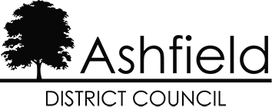

General Needs Block – The Oval, Sutton in Ashfield

Period Covered: April 2022 to March 2023
Running Costs (eligible for Housing Benefit and Universal Credit) | Weekly Charge Per Unit
1. Communal Cleaning | £1.51
2. Communal Window Cleaning | £0.16
3. Communal Electric Supply | £0.94
4. Administrative Charge @15% | £0.39
**Total Weekly Service Charge | £3.00

Breakdown of costs
1. Communal Cleaning
For the cost of cleaning the communal areas in the block. A specification can be provided upon request.
2. Communal Window Cleaning
For the cost of cleaning windows to communal areas on a routine basis in line with the agreed contract specification. This does not include individual residents’ property windows. A specification can be provided upon request.
3. Communal Electric Supply
For the cost of providing lighting within the communal areas of the block.
5. Administrative Charge
The Administrative charge is for administration costs incurred when organising and managing the services above.
** Please note that the total charge above is not the full costs incurred in delivering the services to you. The service charge you pay is only a contribution towards the full costs.

