Ashfield District Council

Infrastructure Funding Statement 2020/21
November 2021

Contents Page no
- Introduction
1.1 About this statement 2
1.2 Key headlines from the statement 4

- Section 106 Contributions
2.1 Section 106 (S106) obligations 4
2.2 Ashfield Local Plan Review 2002 5
2.3 S106 Process for offsite financial contributions 7
2.4 Governance structure for infrastructure delivery 8
2.5 S106 Contributions Received in Previous Years 9
2.6 S106 Agreements signed in 2020/21 11
2.7 S106 Contributions Received in 2020/21 12
2.8 S106 Contributions allocated but not spent in 2020/21 13
2.9 S106 Contributions spent in 2020/21 17
  - Planned expenditure for future years 22

3. Conclusions 27

- Appendices 27 - 33

1: The total amount of money to be provided under any planning obligation which was entered into during 2020/21

2: S106 Contributions received 1st April 2020 – 31st March 2021
3: Information links

1. Introduction

1.1: About this statement
Welcome to Ashfield District Council’s Infrastructure Funding Statement (IFS). This document sets out the 2020/21 (1st April 2020 – 31st March 2021) income and expenditure relating to Section 106 (S106) agreements.
Local authorities, such as Ashfield, are required to produce an infrastructure funding statement on an annual basis, because of recent changes to government legislation¹. This document is the Council’s infrastructure funding statement. For reporting S106 developer contributions, infrastructure can be defined as the following forms:
PHYSICAL
Transport | Strategic & local highway networks, bus rail, airports, travel management, cycle and pedestrian facilities, car parking.
Affordable Housing | Houses and flats.
Energy | Gas and electricity generation and distribution, renewable energy projects.
Water | Water supply, water treatment, drainage, flood defences, water quality.
Digital | Including broadband and wireless connections.
Waste | Collection and disposal, recycling.
Minerals | Reserves.

SOCIAL
Education | Primary, secondary, further education, and adult education.
Health | Health centres, GP and dental surgeries, hospitals.
Emergency Services | Police, Fire, Ambulance, community support.
Community Services | Community centres and centres for children, young people, elderly, and those with additional needs. Cemeteries, post offices.
Culture and Leisure | Museums, theatres, cinemas, sport centres, swimming pools, libraries, public art and realm, heritage assets.
Community Projects | Including community groups, local community led projects, training, and volunteering.

GREEN
Open Space | Parks and country parks, children’s play areas, sport pitches and grounds, allotments.
Forestry | Urban forest, woodland.
Biodiversity | Local wildlife sites, local nature reserves, private nature reserves, Sites of Special Scientific Interest, geological sites.

BLUE
Waterways | Main rivers, small watercourses, canals..
Table 1: Forms of infrastructure

S106 (known as ‘planning obligations’ or ‘developer contributions’) income is used to help fund the provision of supporting infrastructure in association with development and maximise the benefits and opportunities from growth, such as town centre regeneration and affordable homes. This can be onsite, off site or involve financial contributions known as commuted sums, in lieu of provision. Contributions for transport, affordable housing, education, open space, public realm, regeneration, and health are most commonly requested for new infrastructure in Ashfield. Further information on this can be found in Section 2. S106 Contributions.
Developer contributions are normally a key component of any authority’s approach to developing and delivering an infrastructure strategy for their area. Effective infrastructure planning, prioritisation, and governance of spend are critical to supporting the delivery of sustainable development and growth². The Local Plan (Ashfield Local Plan Review 2002), prepared by the Council, is a plan for the future development of the District. The Local Plan (Ashfield Local Plan Review 2002) guides decisions on whether or not planning applications can be granted and details the requirements under which development contributions can be sought. Work is also underway on a replacement plan which, once adopted, will replace the Ashfield Local Plan Review 2002.
This report contains a summary of the financial contributions secured by the Council through S106 agreements from new developments for onsite provision of infrastructure, off-site infrastructure works and affordable housing. This report does not include highway works completed as part of Section 278 agreements (as this is within the remit of Nottinghamshire County Council as the highway authority) or Community Infrastructure Levy (CIL) Tariff payments. The Community Infrastructure Levy (the ‘levy’) is a charge which can be levied by local authorities on new development in their area. Ashfield District Council does not currently operate this charge as part of its development management processes.
Where S106 financial obligations have been secured and received on behalf of Nottinghamshire County Council (NCC) for highways, education or library infrastructure or the NHS Nottingham and Nottinghamshire Clinical Commissioning Group (CCG) for healthcare provision, the obligations will be recorded as spent within this document. NCC or CCG will explain, within their own IFS / reporting, details of how the funding has been used.
The information in this report will be published on the Council’s website and updated annually. https://www.ashfield.gov.uk/planning-building-control/planning-applications/section-106/
The information is correct at date of publication. However, committed works for future years may be subject to change due to prevailing economic conditions, new legislation, and revised corporate priorities.

¹ Community Infrastructure Levy (Amendment) (England) (No. 2) Regulations 2019
² Developer contributions. Start with the spend in mind. PAS February2020. https://www.local.gov.uk/pas/delivery/developer-contributions

1.2: Key headlines from the statement

Monetary contributions
Total Money to be provided through planning obligations agreed in 2020/21 | £700,549.80
Total Money received through planning obligations (whenever agreed) in 2020/21 | £4,846,500.72
Total Money received through planning obligations (whenever agreed) spent in 2020/21 | £1,114,565.86
Total Money received through planning obligations (whenever agreed) retained at the end of 2020/21 (excluding “commuted sums” for longer term maintenance) | £4,432,484.66
Total Money received through planning obligations (whenever agreed) retained at the end of 2020/21 (excluding “commuted sums” for longer term maintenance) | £51,122.60

Non- Monetary Contributions
Total number of affordable housing units to be provided through planning obligations agreed in 2020/21 | 52
Total number of affordable housing units which were provided through planning obligations (whenever agreed) in 2020/21 | 49
Total number of school places for pupils to be provided through planning obligations agreed in 2020/21 | 3
Total number of school places for pupils which were provided through planning obligations (whenever agreed) in 2020/21 | Refer to Nottinghamshire County Council’s Infrastructure Financial Statement

2. S106 Contributions

2.1 Section 106 (S106) obligations
A Local Planning Authority can seek obligations, both physically on-site for a development and contributions for off-site, under Section 106 (S106) of the Town and Country Planning Act 1990. The obligations assist in mitigating the impact of otherwise unacceptable development to make it acceptable in planning terms. Obligations should only be used where it is not possible to address unacceptable impacts through a planning condition. The obligations must be:
- Necessary to make the development acceptable in planning terms.
- Directly related to the development; and
- Fairly and reasonably related in scale and kind to the development.
As part of the planning process, the development of new housing requires the provision of additional social, physical, and economic infrastructure to avoid a detrimental effect on the surrounding area and the lives of residents. Planning obligations assist in mitigating the impact of development which benefits local communities and supports the provision of local infrastructure.³
S106 obligations can include:
- Requirements for parts of a development to be used in certain ways (“in-kind” contributions), for example for affordable housing.
- Requirements for certain works to be undertaken or for other requirements and /or restrictions on the form of the development, for example requiring the development to be car free.
- Financial contributions to address the impacts of development (“off-site contributions”) – usually limited to those cases where it is not feasible to meet policy requirements on site and / or to mitigate specific development impacts, for example the carbon emissions from development.
However, there are specific circumstances where contributions through planning obligations should not be sought from developers. These are:
Planning obligations for affordable housing should only be sought for residential developments that are major developments…For residential development, major development is identified in the National Planning Policy Framework (2019) as development where 10 or more homes will be provided, or the site has an area of 0.5 hectares or more. For non-residential development, it means additional floor space of 1,000 square metres or more, or a site of 1 hectare or more.
Planning obligations should not be sought from any development consisting only of the construction of a residential annex or an extension to an existing home.
Planning Practice Guidance 2019 Paragraph 023 ‘Planning Obligations’
https://www.gov.uk/guidance/planning-obligations

Monitoring fees can be secured as part of a S106, but the amount secured must fairly and reasonably relate to the development and must be applied to monitoring costs.

2.2 Ashfield Local Plan Review 2002
The previous Ashfield Local Plan was adopted by Ashfield District Council in December 1995 with a plan period to 2001. Following adoption of the Nottinghamshire Structure Plan Review in November 1996, work commenced on the Ashfield Local Plan Review with a plan period to 2011. The Council resolved on 5th September 2002, to formally adopt the Local Plan in its modified form. The Council publicly advertised its decision to adopt the Plan (Ashfield Local Plan Review 2002), on the 22nd November 2002.

3 Guidance Planning Obligations 2019 Paragraph 004 https://www.gov.uk/guidance/planning-obligations
Local Planning Authorities such as Ashfield District Council are required under the Planning and Compulsory Purchase Act 2004 to prepare and maintain an up-to-date Local Development Scheme which helps project manage the ongoing production of the Local Plan. As part of the production of a new local plan, the Council prepared a revised Local Development Scheme (LDS) adopted 2018
The LDS represents a public statement of the programme for the preparation of the Local Plan, identifying key milestones and preparation arrangements. It also ensures that infrastructure planning forms an integral part of the evidence base for a new local plan.
The Council prepared an Infrastructure Delivery Plan (IDP)as an evidence base document for the Local Plan in 2016 and was submitted for Examination (Feb 2017). The Infrastructure Delivery Plan brings together infrastructure requirements and information relating to the policies and proposals contained in the development plan. In doing so, infrastructure planning may reveal gaps in public funding for infrastructure provision, which will be assisted by developer contributions.
In 2018, the decision was made to withdraw the Local Plan (2016) and start work on a new Local Plan which, at the time of publication of this document is ongoing.
Planning applications must take into account the saved development plan policies of the Ashfield Local Plan Review (2002) until such time as a new plan is adopted. The saved policies, as identified in the table below (Table 2), set out the Council’s priorities on planning obligations in the context of negotiations on planning applications, with the highest priority given to affordable housing and education. Other priorities include public open space and public realm improvements, healthcare provision and transport infrastructure such as cycle lanes / routes, bus service improvements and traffic flow improvements.
Local Plan Policy Reference | Policy Title
HG1 | Housing Land Allocations
HG4 | Affordable Housing
HG6 | Public Open Space in New Residential developments
TR6 | Developer contributions to Transport Improvements
RC3 | Formal Open Space
Table 2: Ashfield Local Plan Review 2002 Policies
The policies are supplemented by a number of adopted strategies such as the Public Open Space Strategy (2016) which considers the open space requirements for Ashfield for the period 2016 – 2026 and the Playing Pitch Strategy (2017) The Playing Pitch Strategy provides an overview of the provision for various sports in Ashfield for the period 2017 – 2020, which set standards and guide requests for developer contributions.
Ashfield District Council continues to work proactively with infrastructure and service providers (Nottinghamshire County Council for Education and Highways, healthcare providers such as NHS Mansfield and Ashfield & Newark & Sherwood Clinical Commissioning Groups, etc.) to determine the needs arising from the anticipated growth of the District, and to coordinate the requirements with other neighbouring authorities. A significant amount of expenditure for the delivery of services, including healthcare, education, police, and waste management, is determined based on funding formulae, underpinned by population forecasts.

2.3 S106 process for offsite financial contributions
As part of the planning application process, the Council will hold discussions with the developer to ascertain whether onsite infrastructure and/or affordable housing can be provided. If it is determined that onsite provision is not feasible, then a financial contribution will be negotiated with the developer, in the form of obligations in a S106 agreement. The Assistant Director of Planning and Regulatory Services works with development management case officers, developers, and the council’s legal team to instruct S106 agreements for new developments, as required.
The Council will liaise with Nottinghamshire County Council to determine the level of primary and secondary education/ library/ and / or transport infrastructure contribution required to meet the needs (or also in the case of transport, mitigation works to minimise the impact) that would be generated by the development. Similar liaison will also take place with NHS Nottingham and Nottinghamshire Clinical Commissioning Group regarding health care contributions required for additional general practitioner service needs generated by the development. The Council’s internal Place Team will be consulted to determine the level of public open space or public realm contribution required to meet the needs of the new development.
Once all the contributions have been collated, the requested sums are discussed with the developer and reviewed with regard to the overall viability of the proposed development. The various contributions are set out as time limited or staged payments (known as triggers) in the S106 agreement and will be due for payment by the developer such as on commencement of the works or at occupation of a specific number of houses.
The financial contribution requirement and planning for education is set by Nottinghamshire County Council. Their “Pupil Place Planning and School Capital Strategy” Nov 2017 can be accessed on the link below.
https://www.nottinghamshire.gov.uk/media/127734/pupil-place-planning-and-new-school-funding-route-policy.pdf
The requirement for affordable housing is set by the Ashfield Local Plan Review 2002, Saved Policy HG4, p.76 of the Local Plan – see link below:
https://www.ashfield.gov.uk/media/8d84ff980f87003/full-document-_text_.pdf
The financial contribution requirement for public open space and public realm is agreed with the developer to be what is proportionate to mitigate the impact of the development on the local area.
The S106 agreement is usually signed by all parties on the same day as the grant of planning permission. It then becomes an obligation which is registered as a land charge which stays with the land, binding future owners until the terms are fulfilled. The agreement will only be realised however if the planning permission is implemented, and the trigger points are reached.
Many of the S106 projects will be identified as priorities through the Corporate Plan and the Infrastructure Delivery Plan (IDP). The current IDP is being reviewed and updated as part of the work on the new emerging Local Plan. Developers will be required to contribute to the wider infrastructure, which looks to achieve the planning objective of sustainable development, responding to projected population growth and the need for new homes and jobs.

2.4 Governance structure for infrastructure delivery
Ashfield District Council has a governance and decision-making structure to ensure that infrastructure is delivered and the community benefits from S106 funding are realised. The governance arrangements are shown in the table below:
Decision making mechanism | Frequency | Purpose
Cabinet  Chair: Council Leader | As and when required | Under the Ashfield District Council constitution’s scheme of delegation, the Cabinet provides Member oversight for capital spending. The functions reserved to the Cabinet collectively are:  - Proposing the Budget and Policy Framework and Capital Programme to the Council and discharging Executive Functions in accordance with the Budget and Policy Framework agreed by Council.  - Approval to the carry forward of underspends in excess of £15,000.  - In-year budget re-allocations up to £100k (change from £50k).  - Reallocation of capital budgets which do not exceed the overall capital programme.  The Cabinet approves the Capital Programme in February. Updates to project programme can be taken to Cabinet throughout the year. Project performance is reported back to Cabinet.
Council  Chair: Vice Chairman | Monthly | Capital Programme for new financial year approved at full Council, following approval at Cabinet.
Corporate Leadership Team (CLT)  Chair: Chief Executive Officer | Weekly | The Capital Strategy and programme is reviewed in October. Next year’s financial budgets are reviewed in November and the draft budget is approved in December.
Regeneration Board  Chair: Director of Place and Communities | Bi- Monthly | Projects are generated for development in the regeneration pipeline, in line with the corporate plan objectives and departmental service plans. Project business cases are prepared for approval by the Regeneration Board. Project delivery is monitored by the Council’s Performance Team using the Pentana project management system (quarterly updates) and at the regeneration board meetings
Capital programme review  Extended Leadership Team (ELT) / CLT/ Finance | Monthly | S106 and grant funding project spend are circulated by the Finance team for comment and review.
Table 3: Ashfield District Council governance and decision-making structure

The diagram (Figure 1) below sets out the decision-making process:
Stage 1: Corporate Leadership Team.
- October: The Capital Strategy and programme is reviewed.
- December: Next year’s financial budgets are reviewed.
- January: Draft budget is approved in January.

Stage 2: Cabinet
February: Capital Programme considered and recommended for approval by Council for the new financial year, including the allocation of received S106 contributions to specific projects.

Stage 3: Council
February/ March: Capital Programme for new financial year approved at Full Council, following recommendation by Cabinet.

Stage 4: Regeneration Board
Throughout the year: projects are generated for development in the regeneration pipeline, in line with the corporate plan objectives and departmental service plans. Project business cases are prepared for approval by the Regeneration Board. Project delivery is monitored by the Council’s Performance Team using the Pentana project management system (quarterly updates) and at the Regeneration Board meetings

Stage 5: Capital programme review
Throughout the year: S106 and grant funding project spend are circulated by the Finance team for comment and review. Service are required to provide details of forecast S106 and grant funding usage to the end of the financial year.

2.5 S106 Contributions Received in Previous Years
As set out in Section 2.2, Ashfield Local Plan Review 2002, the Council’s IDP sets out the Council’s approach to ensuring the delivery of infrastructure to support anticipated levels of growth. Developer contributions and planning obligations are the main means of delivering local infrastructure.
The table below shows that as of 31st March 2021, a net S106 total of £1,114,565.86 was spent. A large portion of the funding (£337,052.30) was transferred to Nottinghamshire County Council to fund education places in the district and support a new bus service in Hucknall. The full detail of the education spend will be reported in Nottinghamshire County Council’s 2020/21 IFS. Public open space, new affordable homes, transport, health, libraries, and public realm projects in the district made up the balance.
S106 monies | Amount
Total S106 monies received as at 31 March 2020 | £4,846,500.72
Total record of S106 contributions received from 1st April 2020 to 31st March 2021 | £700,549.80
Total contributions available | £5,547050.52
Total Spend of S106 from 1st April 2019 to 31st March 2021 | £1,114,565.86
Total S106 contributions available after 2019/20 spend (as of 31st March 2021) | £4,432,484.66
Balance held for longer term maintenance obligations (included in above) | £51,122.60
Table 4: Total S106 monies
The above table shows that as of 31st March 2021, a net S106 total of £4,432,484.66 was available to fund public open space, education, healthcare, transport, public realm, and affordable housing projects in the district. S106 contributions received from the Larwood residential development at Twickenham Road, Kirkby-in-Ashfield were used to fund affordable homes on the Davies Avenue site (renamed Froghopper Lane) in Sutton in Ashfield. In partnership with social housing and care organisation EMH group and Homes England, 22 new homes are being constructed including six three-bed houses, ten two-bed houses, four two-bed apartments and two bungalows. One of the bungalows is wheelchair adaptable.
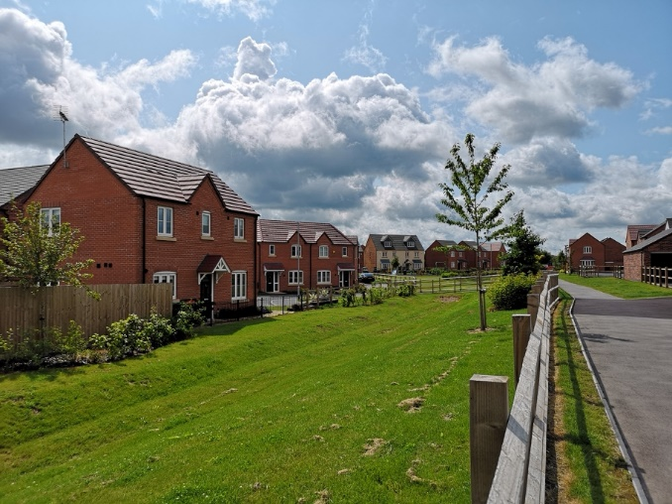
The Larwood residential development in Kirkby-in-Ashfield. With kind permission of W Westerman Ltd.

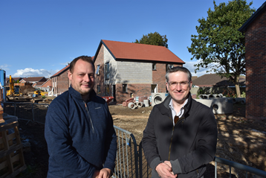
The Council Leader and the Portfolio Holder for Planning and Regeneration at the affordable housing scheme on Froghopper Lane in Sutton -in-Ashfield

2.6 S106 Agreements signed in 2020/21
In the period 1st April 2020 to 31st March 2021, Ashfield District Council entered into planning obligations to the sum of £ 2,058,539.25. Developments with S106 agreements signed in the last financial year (2020/21) are listed below with their planning application reference:
V/2018/0212. The Pattern House, Crossley Avenue, Huthwaite: Demolition of existing industrial premises and construction of up to 23 dwellings with associated access and parking.

V/2020/0061. Former Wild Orchid Public House, Kirkby-in-Ashfield: Redevelopment of the site to provide 12 affordable dwellings.

V/2020/0362. Land adjacent to Twickenham Road, Kirkby in Ashfield: 6 dwellings to be provided.

V/2017/0329. Land adjacent The Blue Bell, Carsic Lane, Sutton in Ashfield: Two storey apartment block consisting of 14 apartments for supported living. Deed of variation to original deed signed 25/06/2018.

V/2017/0022. Land relating to Willow Drive, Annesley Woodhouse: Counterpart deed of discharge

V/2013/0123. Land relating to Watnall Road, Hucknall: Supplemental deed

V/2013/0123. Land relating to Watnall Road, Hucknall: Deed of variation

V/2019/0483. Land at Broomfield Farm, Nottingham: Residential development of 217 no. dwellings and associated infrastructure and works, including the removal of two groups and three individual trees with designated Tree Preservation Orders.
S106 agreements and other relevant documentation for each of the above planning applications (8 in total) can be viewed online on the Council’s planning portal at:
https://www2.ashfield.gov.uk/cfusion/Planning/plan_findfile.cfm
S106 agreements can also be viewed online at:
https://www.ashfield.gov.uk/planning-building-control/planning-applications/section-106/view-section-106-agreements
Please see appendix 1 for details of:
- The total amount of money to be provided under any planning obligation which was entered into during 2020/21
- Summary details of any non-monetary contributions to be provided under planning obligations entered into during 2020/21 including details of –
- In relation to affordable housing, the total number of units which will be provided
- In relation to educational facilities, the number of school places for pupils which will be provided and the category of school at which they will be provided.

2.7 S106 Contributions Received in 2020/21
In 2020/21, a total of £700,549.80 was received in S106 contributions. The table and bar chart below shows the contributions received by infrastructure type:

Infrastructure Financial Statement: 01 April 2020 to 31 March 2021
Infrastructure type | S106 Contributions received
Public Open Space | £85,035.77
Primary Education | £176,056.00
Secondary Education | £91,652.03
Transport | £247,647.10
Health | £51,703.34
Libraries | £9,513.12
Public Realm | £32,977.08
Interest | £5,965.36
TOTAL | £700,549.80
Table 5: Total S106 contributions received

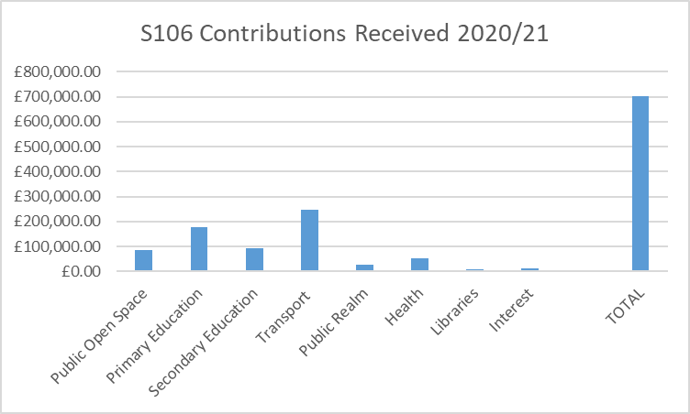
Figure 2: Total S106 contributions received
Total receipts in 2020/21 came from 7 sites, however most of the contributions came from the following sites:
- V/2016/0198 King Edward Street, Hucknall - £115,707.08
- V/2016/0208 Plot N, Brierley Park Close, Sutton In Ashfield – £283,311.73
Additional detail for the contributions received is shown in Appendix 2.

2.8 S106 Contributions allocated but not spent in 2020/21
Within the reported year, S106 funds received by the Council and allocated to a specific project, but not spent as of 31/03/2021 totals £4,432,484.66. These contributions comprise the following items:

PUBLIC OPEN SPACE
Planning application / Development site location | S106 Funds secured | Project Allocation
Hucknall POS* | £15,090.22 | Hucknall area – Titchfield Park
Kirkby POS* | £153,837.00 | Kirkby area – Nuncargate Recreation Ground
Sutton POS* | £129,517.46 | Sutton area – Projects in development
Rurals POS* | £0
TOTAL | £290,370.60

TRANSPORT
Planning application / Development site location | S106 Funds secured | Project Allocation
Hucknall TR6* | £81,029.48 | Hucknall area – Projects in development
Rolls Royce, Hucknall V/2013/0123 | £124,585.76 | To be paid to Nottinghamshire County Council for bus service contribution
Kirkby TR6* | £108,615.42 | Kirkby area – Projects in development
Sutton TR6* | £426,122.85 | Sutton area – Projects in development
V/2016/0208 Residential development on land at Brand Lane, Stanton Hill, Sutton | £100,747.26 | To be paid to Nottinghamshire County Council for highways improvements in the Brand Lane area of Stanton Hill
Rurals TR6* | £10,671.50 | Rurals area – Projects in development
TOTAL | £851,772.27

AFFORDABLE HOUSING
Planning application / Development site location | S106 Funds secured | Project Allocation
Source applications  V/2004/0484  V/2011/0560  V/2013/0656 |  | Projects include family home on Stoney Street in Sutton and two new bungalows at The Beeches in Skegby two more bungalows are proposed at The Poplars in Sutton.  In Hucknall, plans to redevelop four garage sites at Chatsworth Drive, Chestnut Grove, Barbara Square and Hawthorne Avenue will see a total of 15 new homes built.
TOTAL | £997,887.99

SPECIFIC PROJECT ALLOCATIONS
Planning application / Development site location | S106 Funds secured | Project Allocation
V/2003/1094 Land at Studfold Lane, Kirkby | £82,723.24 | Kirkby - Regeneration of the town centre
V/2005/0886 Annesley Colliery, Kirkby | £276,297.17 | Regeneration of the Woodhouse ward
V/2003/1094 Lindleys Lane, Kirkby | £103,758.86 | Sorrel Drive Play area – New play area and play equipment
V/2005/0886 Annesley Colliery, Kirkby | £31,150.46 | Art Feature Annesley -bespoke artwork features and street furniture across the Annesley area to link the new estate and site of former colliery with the existing miners’ cottages.
V/2013/0493 Washdyke Lane, Hucknall | £13,878.85 | Washdyke Recreation Ground – General landscape improvements.
V/2004/0356 Papplewick Lane, Hucknall | £1,012.09 | Commission and install art features within the Papplewick Development
V/2019/0005 Royal Foresters, Sutton | £47,116.88 | Improvements to Cowpasture Recreation Ground improvements (£15576.16) and Sutton Town Centre Public Realm (£31152.21)
V/2017/0329 Land Adj. The Bluebell, Carsic Lane, Sutton | £8,000 | Improvements at Sutton Lawn
Land Adj. The Bluebell, Carsic Lane, Sutton V/2017/0329 | £16,000 | Improvements at Portland Square and or / Low Street or another Public Realm project
Land South of Mansfield Road, Sutton V/2017/0049 | £37,541.01 | Improvements to Low Street or another Public Realm project
The Twitchell V/2014/0045 | £34,566.47 | Improvements to Low Street or other Public Realm project (transferred from revenue to capital)
TOTAL | £652,045.03

HEALTH
Planning application / Development site location | S106 Funds secured | Project Allocation
Fire Station Watnall Road, Hucknall V/2019/0129 | £26,966.00 | To be paid to the Local Clinical Commissioning Group towards the enhancement of capacity and/ or infrastructure in local practices
Annesley Miners Welfare V/ 2018/0393 | £24,737.34 | To be paid to the Local Clinical Commissioning Group towards the enhancement of capacity and/ or infrastructure in local practices
Interest | £46.33
TOTAL | £51,749.87

LIBRARIES
Planning application / Development site location | S106 Funds secured | Project Allocation
V/2016/0208 Residential development on land at Brand Lane, Stanton Hill, Sutton | £9521.68 | To be paid to Nottinghamshire County Council towards the provision of new stock at Sutton library
TOTAL | £9521.68

OBLIGATIONS TOTAL
Obligation | Total
Public Open Space | £290,370.60
Transport | £851,772.27
Affordable Housing | £997,887.99
Specific Project Allocations | £652,045.03
Health | £51,749.87
Libraries | £9521.68
Total | £2,853,347.46

EDUCATION
Planning application / Development site location | S106 Funds secured | Project Allocation
Source applications  V/2017/0344, V/2013/0123, V/2004/0356, V/2017/0049 V/2016/0198 V/2018/0393 V/2015/0537 V/2016/0208 | £1,337,966.47 | To be paid to Nottinghamshire County Council for education provision in the District.
TOTAL | £1,337,966.47

REVENUE
Planning application / Development site location | S106 Funds secured | Project Allocation
V/2005/0396 Land Off Lindleys Lane, Kirkby | £11,217.94 | Employment Opportunities
V/2003/0845 Land off, Prospect Place, Sutton | £5,710.23 | The Old Mill, Silk Street –improvements to open space around the mill
V/2010/0433 Former Annesley Colliery, Hucknall Road, Annesley | £28,139.97 | Integrated transport initiatives within the district of Ashfield
V/2014/0045 The Twitchell,  Sutton | £33,008.08 | Public Realm works in the vicinity of the development
Grange Farm, Moor Road, Papplewick V/2011/0188 | £11,430.70 | Integrated transport initiatives within the district of Ashfield
S106 Interest payment | £113.42 | Kirkby Regeneration
Broomhill Farm, Land to West of, Nottingham Road,  Hucknall/2013/0409 | £48,674.49 | Hucknall – Maintenance of Unadopted land
Annesley Colliery V/2005/0886 | £41,013.99 | Annesley Regeneration
V/2005/0396 Land off Lindleys Lane, Kirkby | £10,739.32 | Revenue contributions for feasibility studies
Public Open Space S106 agreements | £51,122.60 | Maintenance commuted sums district wide
TOTAL | £241,170.74

ALL OBLIGATIONS: S106 BALANCE
Obligation | Total
Obligations total | £2,853,347.46
Education | £1,337,966.47
Revenue | £241,170.74
ALL OBLIGATIONS: S106 BALANCE TOTAL | £4,432,484.66
Table 6: Contributions allocated but not spent in 2020/21. *= source planning application reference to be added at later date.

2.9 S106 Contributions Spent in 2020/21
In most cases, S106 agreements contain clauses detailing specific criteria as to how and where the contributions must be spent. Occasionally, clauses can be less prescriptive, and the associated funding is known as “unrestricted” funds. If there is no pressing need for the area to which the agreement refers, these funds may be held by the Council for a period of up to five years following the grant of planning permission until such time as a suitable need is identified.
Within the reported year, the total amount of S106 funds received by the Council that have been both allocated and spent, or transferred to another party amounts to £1,114,565.86
Of the funded schemes, many of them are at different stages of delivery. The schemes are detailed below under obligation type headings:
- Housing

The Council spent £284,000 of S106 affordable housing contributions during 2020/21 on the Davies Avenue site (now renamed Froghopper Lane) in Sutton in Ashfield. In partnership with social housing and care organisation emh group and Homes England, the site will see 22 new homes built, including six three-bed houses, ten two-bed houses, four two-bed apartments and two bungalows. One bungalow is wheelchair adaptable.

- Education
Ashfield District Council made Education payments totalling £107,052.30 to Nottinghamshire County Council in 2020/21. Of this sum, £97,052.30 came from the Rippon Homes development on Mansfield Road, Skegby (V/2012/0556) and £10,0000 came from The Twitchell housing development V/2014/0045. Nottinghamshire County Council will report separately on the spend of this funding as part of their Infrastructure Financial Statement.
- Transportation

Ashfield District Council made payments of £429,602 Transport (TR6) to Nottinghamshire County Council in 2020/21. The funding came from the development on land at Broomhill Farm (V/2013/0409) and the Rolls Royce housing development (V/2013/0123), both located in Hucknall. Nottinghamshire County Council will report separately on the spending of this funding as part of their Infrastructure Financial Statement.

The Council completed delivery of the Kirkby footpaths/cycle ways project which comprised works to improve footpaths in the vicinity of Larwood Park housing development. Approximately 1.7km of existing footpath were cleared to the original width and resurfaced, with approximately 600m of new footpath constructed. Six pedestrian access points were improved and made more accessible as part of the works. The funding for the works came from planning application Larwood Park V/2013/0656. A S106 contribution of £30,469.72 was spent on the works. £766.84 TR6 funding was also spent on works at Sutton Lawn.

- Business employment and skills

The Retail Improvement Scheme through a variety of grants helped 10 businesses within Ashfield. Eight grants were given for business start-ups and assistance with business growth. One grant was given for shop front improvements, along with one vacant shop grant. The S106 funding came from V/2010/0433 Former Annesley Colliery.

- Parks and open spaces
The following projects as set out in the Table below were delivered across the district as a result of secured S106 monies:

HUCKNALL
Planning application / Development site | S106 Contribution Spent 2019/20 | Project delivered
Capital receipts funding | 14,200.93 | Tichfield Park. New Play equipment / Youth equipment and associated works
Planning application* | £691.30 | Nabbs Lane: release of retention from landscape contract works

SUTTON - IN - ASHFIELD
Planning application / Development site | S106 Contribution Spent 2019/20 | Project delivered
Planning application* | £7,363.08 | Brierley Forest Park Management Plan: Actions as identified in the park management plan / Green Flag award requirements
Planning application* | 19,818.80 | Brierley Forest Park Car Park Extension and Entrances: Disabled car park improvements at Skegby Road and main car park extension. Accessibility improvements to the Oval, Stoneyford Road and Brand Lane entrances.
V/2017/0329 Land Adj. The Bluebell, Carsic Lane, Sutton in Ashfield | 49.49 | Sutton Lawn Management Plan: Actions as identified in the park management plan / Green Flag award requirements
V/2017/0344 Land fronting Unwin Road, Sutton | 717.35 | Sutton Lawn Play area: improvement works
V/2013/0656 Larwood Park, Kirkby – in-Ashfield | 1,059.45 | Ashfield Estate Footpaths: Additional footpath improvements. Release of retention for contract works.
All Capital receipts | £34,971.52 | Healdswood Recreation Ground: Equipment replacement and new teenage equipment
V/2015/0537 Residential development at Roundhill Farm, Kirkby-in-Ashfield | 14,338.42 | Roundhill Recreation Ground: Installation of new play equipment
V/2017/0344 Land fronting Unwin Road, Sutton  V/2017/0049 Draycott’s Motor Company, Eastfield Side, Sutton | £20,000.00 | Kings Mill Reservoir: For actions as identifed in the management plan, including footpaths and signage improvements. Heritage Lottery Fund bid to undertake desilting works, ecological and environmental improvements and develop potential for heritage trails with community support.

KIRKBY – IN- ASHFIELD
Planning application / Development site | S106 Contribution Spent 2019/20 | Project delivered
Planning application* | £17,354.35 | Kingsway Park: implementation of management plan
V/2013/0656 Larwood Park, Kirkby – in-Ashfield | £30,469.72 | Kirkby footpaths/cycleways: Footpath and access improvements on open space adjacent the Larwood development.
V/2003/1094  Land at Studfold Farm, Lindley’s Lane, Kirkby-in-Ashfield | £70,843.95 | Lindleys Lane – Sorrel Drive Play Area: Provision of new play equipment and access paths at Hornbeam Park
Capital receipts and S106 funding planning application* | £11,164.00 | Glen View/ Warwick Close: Play equipment and safety surfacing
Planning application* | £560.84 | Morven Park Play Area: Supply and install new toddler and junior swings new topsoil, turf, and grass matt safety surfacing
V/2005/0396 Land off Lindleys Lane | £3000.00 | Kirkby Leisure Centre: Consultancy services for the landscape design, including hard and soft landscaping of the outside space to the new leisure centre.
Capital receipts and planning applications* | £34,563.76 | Green Space Improvements: play equipment, signage, gates, and plant material for open spaces across the district.

RURALS
Planning application / Development site | S106 Contribution Spent 2019/20 | Project delivered
Planning application* | £1228.55 | Friezeland Scooter Park & Jacksdale MUGA: Release of retention
Planning application* | £703.72 | Jacksdale Car Park: Release of retention. At Jacksdale car park the car park was rationalised to increase the number of parking spaces from to 46nr regular spaces and 4nr disabled spaces.  The access onto Wharf Green was also improved and made more accessible to all users
Table 7: Contributions spent on Parks and Open Spaces. Planning application* = source planning application reference for S106 agreement and details to be added.
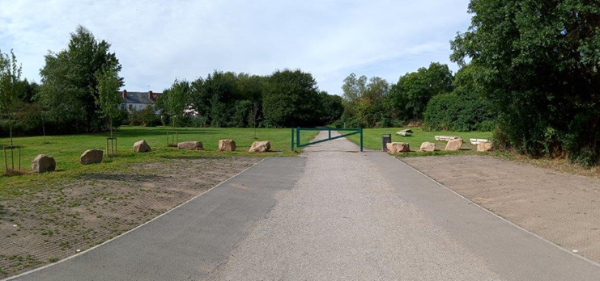
Brierley Forest Park: Car park improvements

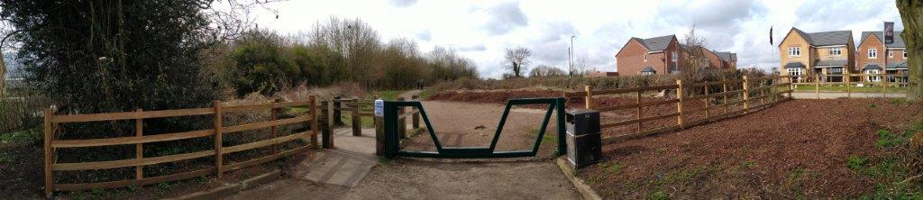
Brierley Forest Park: Brand Lane Entrance Improvements
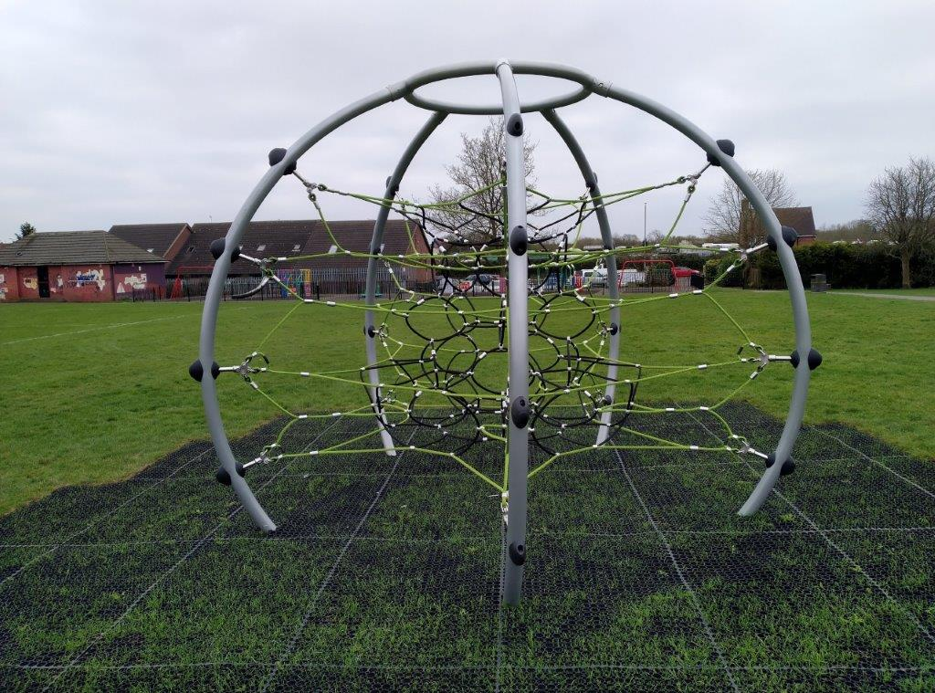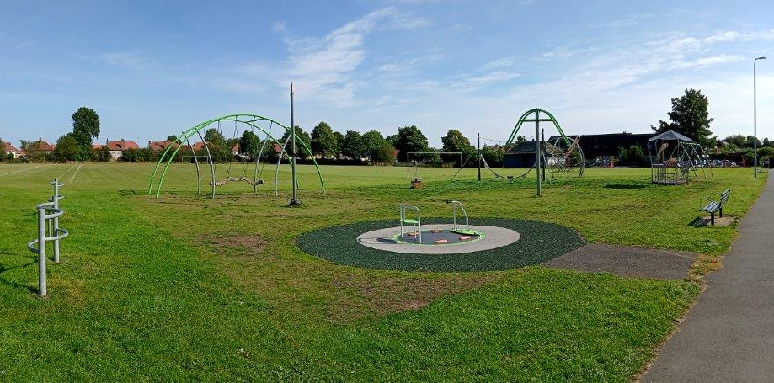
Healdswood Recreation Ground: New play equipment

- Regeneration
The main regeneration project the Council progressed during 2020/21 is the ongoing Leisure Transformation Programme. The programme includes the development of a new Leisure Centre in Kirkby to replace the Festival Hall facility. Funding for the works came from planning application Land at Lindleys Lane in Kirkby V/2005/0396. A S106 contribution of £3,000 was spent on this programme during 2020/21.

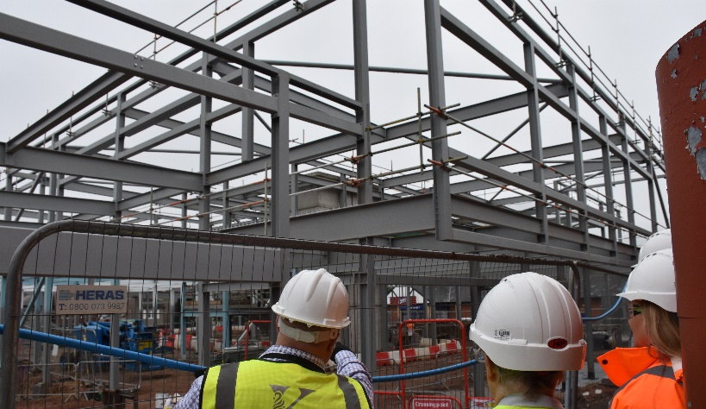
Leisure Centre steelwork
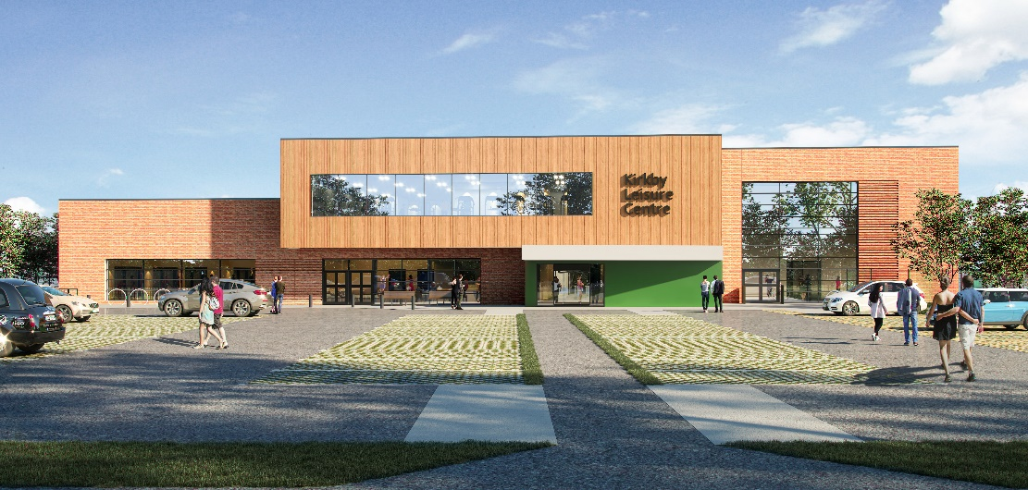
A visualisation of new Leisure Centre. The overall project is due for completion in Autumn 2022.

2.10 Planned expenditure for future years
This section sets out how S106 income will be spent in the District of Ashfield. It is difficult to forecast future S106 income and expenditure exactly as contributions are negotiated on a site-by-site basis and depend on several considerations such as viability. S106 funding is often closely linked to the phasing of the development as set out in the terms of the legal agreement and can contain clauses relating to the timing (triggers) of the spending. The impact of the current pandemic has had an effect on delivery and the longer-term impacts on the construction industry are unclear.
Once complete, the Infrastructure Delivery Plan accompanying the Local Plan will also set out the required infrastructure to deliver the identified site allocations. Whilst this will not detail specifically the cost of various infrastructure items, it will provide an overview to developers and the community of the expected contributions.
Planned expenditure for future years sets out how unallocated funds should be spent.
The information below sets out the planned expenditure and funds remaining for the current S106 balance. With regard to the following funds :
- Transport: Spend on projects undertaken by Nottinghamshire County Council will be reported seperately as part of their Infrastructure Financial Statement).
- Affordable Housing: £200,000 Planned expenditure, £ 797,887.99 remaining to be allocated to specific projects.
- Education: £1,337,966.47 remaining to be paid to Nottinghamshire County Council on confirmation of suitable projects. Spend will be reported by Nottinghamshire County Council as part of their Infrastructure Financial Statement).

The table below sets out project information in more detail:

PUBLIC OPEN SPACE: HUCKNALL
Location | Estimated Cost | S106 / Other public contribution | Required works | Status / funding source
Tichfield Park | £148,000 | £70,000 Capital Receipts | New Play equipment / Youth equipment and associated works | Capital Receipts Funding. Works to be completed by October 2021
Washdyke Recreation Ground | £18,000 | £18,000 S106 | New Play equipment and associated works | To be implemented 2022/23

PUBLIC OPEN SPACE: SUTTON – IN- ASHFIELD
Location | Estimated Cost | S106 / Other public contribution | Required works | Status / funding source
Ashfield Estate Footpaths | £5,000 | £5,000 S106 | Additional footpath improvements have been identified / possible match funding contribution to NCC highways access improvements | To be implemented 2022/23
Brierley Forest Park Management Plan | £8,000 | £3,000 S106, £5,000 Rural Payments Agency | Actions as identified in the park management plan / Green Flag award requirements | Ongoing implementation of works
Brierley Forest Park Car Park Extension and Entrances | £81,000 | £62,000 S106 | Disabled car park improvements at Skegby Road and main car park extension.Accessibility improvements to the Oval, Stoneyford Road and Brand Lane entrances | To be completed on site by March 2021
Football Changing Rooms | Details to be confirmed | £15,000 | Replacement changing rooms to be provided | S106 funding to potentially be allocated for works at a destination park
Kingsmill Reservoir footpath links | £1,000 | £1,000 | Footpath improvements are identified in the Heritage Lottery funded works programme | To be allocated to the Kings Mill Reservoir HLF project budget.
Sutton Lawn Management Plan. | £14,000 | £6,000 S106, £8,000 NCC Supporting Local Communities Fund | Actions as identified in the park management plan / Green Flag award requirements | To be implemented
Taylor Crescent Recreation Ground | To be confirmed | £10,000 | Project to be reviewed | No plan to implement project
Healdswood Recreation Ground | £35,000 | Capital receipts and £6000 S106 | Equipment replacement and new teenage equipment | Capital receipts and S106 funding. Works to be completed by September 2021.
Riley Recreation Ground | £24,300 | Capital receipts and £10,000 S106 | Play equipment and surfacing replacement | Works to be completed by Sept 2021.

PUBLIC OPEN SPACE: KIRKBY – IN- ASHFIELD
Location | Estimated Cost | S106 / Other public contribution | Required works | Status / funding source
Annesley Art Project | £29,000 | £29,000 S106 | Construction of paths across open space | Not on current 2020/21 work programme. Future works
Forest Road Nature Area | £30,000 | £30,000 | General improvements to cycle network as part if Towns Fund programme | 2021/22 work programme.
Kingsway Park: implementation of management plan | £32,000 | £16,000 | Actions as identified in the park management plan | Ongoing implementation of works
Kirkby footpaths/cycle ways | £31,000 | £15,000 TR6 | Phase 2 of path from Rowan Drive to Sutton Middle Lane | Completed February 2021
Lindleys Lane – Sorrel Drive Play Area | £178,000 | £32,000 S106  £75,000 Towns Fund | Provision of new play equipment and access paths | S106 and Towns Fund Accelerated Programme. To be completed December 2021
Nuncargate Recreation Ground | £146,000 | £45,000 S106  £8,000 Capital Receipts | New play equipment, entrance feature,surfacing,footpaths and planting | Works to be completed by April 2021.
Sports pavilion, Titchfield Park | To be confirmed | £39,000 S106 | Provision of new pavillion | Funding to be transferred to Kingsway Park

GREEN SPACE IMPROVEMENTS
Location | Estimated Cost | S106 / Other public contribution | Required works | Status / funding source
Green Space Improvements | £20,000 | £20,000 S106 | General improvements play equipment, signage, gates, and plant material for open spaces across the district. | Works to be identified and completed by March 2022.

TRANSPORT
Location | Estimated Cost | S106 / Other public contribution | Required works | Status / funding source
Hucknall Car Park – Titchfield Street | To be confirmed | £93,000 S106, £22,000 Capital Reciepts | Provision of new car park, as part of the Hucknall Inner Relief Road programme of works. | Project on hold, land not in ADC ownership

AFFORDABLE HOUSING
Location | Estimated Cost | S106 / Other public contribution | Required works | Status / funding source
Sutton Infill scheme on Stoney Street, The Poplars and The Beeches in Sutton in Ashfield | £200,000 | £200,000 | Projects include family home on Stoney Street in Sutton and two new bungalows at The Beeches in Skegby two more bungalows are proposed at The Poplars in Sutton.  In Hucknall, plans to redevelop four garage sites at Chatsworth Drive, Chestnut Grove, Barbara Square and Hawthorne Avenue will see a total of 15 new homes built. | To be implemented 2021/22.S106 allocation to be agreed.

PUBLIC REALM
Location | Estimated Cost | S106 / Other public contribution | Required works | Status / funding source
Sutton Town Centre Improvements | £70,000 | £70,000 | Fox Street area, Portland Square improvements. | Scheduled for completion in September 2022.

ART
Location | Estimated Cost | S106 / Other public contribution | Required works | Status / funding source
 | £0 | £0 | Art contributions have not been specifically identified. Contributions may be requested as part of the Towns Fund work development which is currently ongoing. | Completion date dependant on Towns Fund development work.

EDUCATION
Location | Estimated Cost | S106 / Other public contribution | Required works | Status / funding source
 | £1,337,966.47 | £1,337,966.47 | For spend by Nottinghamshire County Council. Please see Nottinghamshire County Council Infrastructure Funding Statement 2020/21. | Awaiting confirmation of schemes in accordance with S106 agreements.

HEALTH
Location | Estimated Cost | S106 / Other public contribution | Required works | Status / funding source
 | £51,749.87 | £51,749.87 | Health contributions have not been specifically identified at this stage. | The Clinical Commisioning Group is currently working on an Estates Strategy.

LIBRARIES
Location | Estimated Cost | S106 / Other public contribution | Required works | Status / funding source
 | £9,521.68 | £9,521.68 | Please see Nottinghamshire County Council Infrastructure Funding Statement 2020/21.

MAINTENANCE
Location | Estimated Cost | S106 / Other public contribution | Required works | Status / funding source
 | £51,122.60 | £51,122.60 | Maintenance of adopted open spaces | Funded from S106 sites to be adopted by the Council. Figures to be reviewed nearer to dates of adoption

EMPLOYMENT
Location | Estimated Cost | S106 / Other public contribution | Required works | Status / funding source
 | £11,217.94 | £11,217.94 | Business support grants | Grant applications being accepted and processed by ADC
Table 8: Planned S106 expenditure 1st April 2020 onwards

3. Conclusions
Ashfield District Council is working to ensure that as part of the planning process, the added value, and opportunities that new development can bring such as affordable homes, jobs and environmental improvements are maximised for the wellbeing and benefit of local communities.
If you have any further queries or comments about this statement, please contact the Forward Plans Team via email: localplan@ashfield.gov.uk or phone 01623 457379

4. Appendices
Appendix 1: The total amount of money to be provided under any planning obligation which was entered into during 2020/21
Appendix 2: S106 Contributions received 1st April 2020 – 31st March 2021
Appendix 3: Information links

Appendix 1: The total amount of money to be provided under any planning obligation which was entered into during 2021/21
Application no | Description | Detailed information and funds secured | Total amount of money to be provided under any planning obligation which was entered into during 2019/20 | Summary details of any non-monetary contributions to be provided under planning obligations entered into during 2019/20 including details of –
 |  |  |  | Affordable housing - total number of units which will be provided | Educational facilities - Total number of school places for pupils which will be provided and the category of school at which they will be provided
 |  |  |  |  | Primary | Secondary | Contribution only: spend location
V/2018/0212 | The Pattern House, Crossley Avenue, Huthwaite | Outline application for demolition of existing industrial premises and construction of up to 23 dwellings with associated access and parking. Public Open Space Improvements at Huthwaite Welfare: £5600. Primary education: £34365  3 school places in the Sutton Planning area.  Transport: £8000 for a Traffic Regulation Order revocation. | £47,965.00 | 0 | 3 | 0 | Sutton Planning area
V/2020/0061 | Former Wild Orchid Public House | 12 dwellings. Transport: £8000 Public open space: £14,500 | £22,500.00 | 12 | 0 | 0
V/2020/0362 | Land adjacent to Twickenham Road, Kirkby in Ashfield | 6 dwellings and access Public Open Space: £7000 | £7,500.00 |  | 0 | 0
V/2017/0329 | Land adjacent The Blue Bell, Carsic Lane, Sutton in Ashfield | Two storey apartment block consisting of 14 apartments for supported living. Deed of variation to original deed signed 25/06/2018. | £0.00 | 0 | 0 | 0
V/2017/0022 | Land relating to Willow Drive, Annesley Woodhouse | Counterpart deed of discharge | £0.00 | 0 | 0 | 0
V/2013/0123 | Land relating to Watnall Road, Hucknall | Supplemental deed | £0.00 | 0 | 0 | 0
V/2013/0123 | Land relating to Watnall Road, Hucknall | Deed of variation | £0.00 | 0 | 0 | 0
V/2019/0483 | Land at Broomfield Farm, Nottingham | The residential development of 217 no. Dwellings and associated infrastructure and works, including the removal of two groups and three individual TPO trees included in the Ashfield District Council Tree Preservation Order, TPO 168. S106 Monitoring: £2,500  Bus service contribution: £29,000  Public Open Space: £35,000  Healthcare: £117,695.25  Maintenance: £5,700  Highways Infrastructure: £33,000  Maintenance: £11,871  Maintenance: £25,887  Public Open Space: £75,000  Primary Education: £801,596.00  Residents travel plan / travel plan coordinator /Travel information pack  Secondary Education: £835,625.00  Travel Plan monitoring fee: £7,700 | £1,980,574.25 | 40
 |  | TOTAL | £2,058,539.25 | 52 | 3 | 0

Appendix 2: S106 Contributions received 1st April 2020 – 31st March 2021
Ashfield District Council
Infrastructure Financial Statement 01 April 2020 to 31 March 2021 |  |  |  | Contributions received
Payment date | Payment type | Developer | Amount | Application no | Description
20-Apr-20 | Education | Platform Housing Group | £68,730.00 | V/2016/0198 | F J Bamkin & Son Ltd, King Edward Street, Hucknall
20-Apr-20 | Public Open Space | Platform Housing Group | £14,000.00 | V/2016/0198 | F J Bamkin & Son Ltd, King Edward Street, Hucknall
20-Apr-20 | Public Realm | Platform Housing Group | £28,000.00 | V/2016/0198 | F J Bamkin & Son Ltd, King Edward Street, Hucknall
20-Apr-20 | Interest | Platform Housing Group | £4,977.08 | V/2016/0198 | F J Bamkin & Son Ltd, King Edward Street, Hucknall
28- Jul-20 | Health | Countryside Property | £26,966.00 | V/2019/0129 | Fire Station Watnall Road, Hucknall
18-Aug-20 | Public Transport | Muse | £124,585.76 | V/2013/0123 | Rolls Royce, Watnall Road, Hucknall
23- Oct-20 | Health | Taggart Homes | £24,737.34 | V/ 2018/0393 | Land at Annesley Road, Hucknall
23- Oct-20 | Education | Taggart Homes | £68,961.86 | V/ 2018/0393 | Land at Annesley Road, Hucknall
02 -Nov-20 | Transport | Clowes Developments (UK) Ltd | £22,404.67 | V/2018/0217 | Development of Units 5 & 7 (Plots 2 &3) Castlewood Business Park, Farmwell Lane, Sutton-in-Ashfield.
17-Nov- 20 | Education | NMCN PLC | £22,910 | V/2015/0537 | Residential development at Roundhill Farm, Kirkby-in-Ashfield,
17-Nov- 20 | Public Open Space | NMCN PLC | £5,000 | V/2015/0537 | Residential development at Roundhill Farm, Kirkby-in-Ashfield,
15 -Mar-21 | Public Open Space | Harron Homes | £66,035.77 | V/2016/0208 | Residential development on land at Brand Lane, Stanton Hill, Sutton-in-Ashfield
15 -Mar-21 | Transport | Harron Homes | £10,905.37 | V/2016/0208 | Residential development on land at Brand Lane, Stanton Hill, Sutton-in-Ashfield
15 -Mar-21 | Transport | Harron Homes | £83,510.50 | V/2016/0208 | Residential development on land at Brand Lane, Stanton Hill, Sutton-in-Ashfield
15 -Mar-21 | Libraries | Harron Homes | £9,513.12 | V/2016/0208 | Residential development on land at Brand Lane, Stanton Hill, Sutton-in-Ashfield
15 -Mar-21 | Transport | Harron Homes | £3,433.51 | V/2016/0208 | Residential development on land at Brand Lane, Stanton Hill, Sutton-in-Ashfield
15 -Mar-21 | Education | Harron Homes | £49,819.14 | V/2016/0208 | Residential development on land at Brand Lane, Stanton Hill, Sutton-in-Ashfield
15 -Mar-21 | Education | Harron Homes | £57,287.03 | V/2016/0208 | Residential development on land at Brand Lane, Stanton Hill, Sutton-in-Ashfield
15 -Mar-21 | Transport | Harron Homes | £2,807.29 | V/2016/0208 | Residential development on land at Brand Lane, Stanton Hill, Sutton-in-Ashfield
 |  |  | £5,965.36 |  | Interest on above contributions calculated at year end
 |  | TOTAL RECEIVED | £700,549.80

Appendix 3: Information links

Ashfield District Council Corporate Plan 2019 -2023 - PDF
https://www.ashfield.gov.uk/media/8d84458b550cb95/corporate-plan-2019-2023-final-to-publish.pdf
Ashfield District Council Adopted Local Plan 2002 - PDF
https://www.ashfield.gov.uk/media/8d84ff980f87003/full-document-_text_.pdf
Infrastructure Delivery Plan - PDF
https://www.ashfield.gov.uk/media/8d85025a8aa55c4/infrastructure-delivery-plan.pdf
Playing Pitch Strategy 2017 - (Overview of the provision for various sports in Ashfield for the period 2017 – 2020) - PDF
https://www.ashfield.gov.uk/media/8d850ab1f08d9d2/ashfield-playing-pitch-strategy-2017-2020.pdf
Public Open Space Strategy 2016 (Considers the open space requirements for Ashfield for the period 2016 – 2026) - PDF
https://www.ashfield.gov.uk/media/8d850ab97b714fe/public-open-space-strategy.pdf

https://www.ashfield.gov.uk/media/8d843791e0527f8/lds-sept-2018.pdf
https://www.ashfield.gov.uk/media/8d85025a8aa55c4/infrastructure-delivery-plan.pdf

