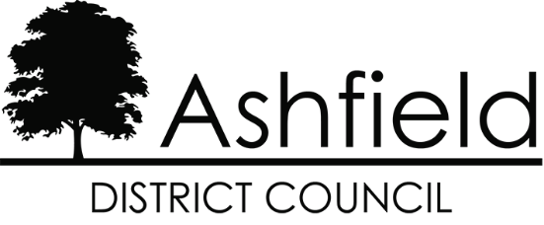

Duty to Cooperate Statement of Compliance
for the
Ashfield Local Plan 2023 to 2040

Town & Country Planning (Local Plan) (England) Regulations 2012, as amended – Regulation 19 Consultation

April 2024

Contents
1.0 Introduction and Context 1
2.0 Legislative and Policy Context 1
3.0 Ashfield District 2
Map 1: The district of Ashfield and surrounding area 3
Map 2: Extent of Green Belt in Ashfield District 4
Housing Market Areas 5
Table 1: Housing Market Areas 6
Map 3: Nottingham Outer and Nottingham Core Housing Market Areas 6
Functional Economic Market Area (FEMA) 7
4.0 Joint Working 7
Collaboration on Evidence Base 12
Strategic Priorities and Cross Boundary Matters 14
The quantity and location of housing development 15
Gypsy, Traveller and Travelling Showpeople provision 18
Employment provision 21
The scale and location of retail development. 25
Green Belt 26
Infrastructure Delivery 28
Sustainable Transport Modes and Connectivity 32
Flooding and Water Quality 33
Nature conservation and enhancement 35
Conserving the Historic Environment 38
Settlement Hierarchy/Urban area boundaries 40

Introduction and Context

  - Local planning authorities, county councils (in two-tier areas) and other prescribed bodies are under a duty to cooperate with each other. They have a legal duty to engage constructively, and on an ongoing basis to address strategic matters that cross administrative boundaries. A key legal test which the Plan will be assessed against when it is considered at Examination is whether or not a local planning authority has brought forward a Plan in line with the Duty to Co-operate.

  - This Duty to Cooperate Statement has been prepared in relation to the Ashfield Local Plan 2023 to 2040. It forms part of the Council’s evidence to demonstrate how the Council has engaged with the prescribed bodies, the progress made and the confirmed points of agreement, or otherwise, regarding relevant strategic cross boundary matters in relation to Ashfield’s geographic area.

  - The structure of local government varies from across the country. Nottingham City Council adjoins Ashfield on the southern boundary of the district and is a unitary authority and is responsible for all local government services. For the county, there is a two-tier structure where the responsibility for council services is split between the two tiers. In broad terms, Nottinghamshire County Council cover schools, social services, public transportation, highways, waste disposal and trading standards. Each district within Nottinghamshire covers a smaller area and provides more local services, including council housing, local planning, recycling and refuse collection and leisure facilities.

Legislative and Policy Context

  - The Localism Act 2011 introduced the Duty to Cooperate as set out in Section 33A of the Planning and Compulsory Purchase Act 2004. The Act requires local authorities to cooperate with prescribed bodies to maximise the effectiveness of local plans through addressing strategic matters relating to the Local Plan. Strategic matters are defined in the Act as:

- sustainable development or use of land that has or would have a significant impact on at least two planning areas, including (in particular) sustainable development or use of land for or in connection with infrastructure that is strategic and has or would have a significant impact on at least two planning areas, and

- sustainable development or use of land in a two-tier area if the development or use is a county matter or has, or would have, a significant impact on a county matter.

  - The Town and Country Planning (Local Planning) (England) Regulations 2012 (as amended) set out a list of prescribed bodies that the Duty to Cooperate applies to. Those relevant to the preparation of the Ashfield Local Plan are:
- Local Planning Authorities, either neighbouring or making up the Housing Market Area
- Environment Agency
- Historic England
- Natural England
- Civil Aviation Authority
- Homes England
- Clinical Commissioning Groups (now NHS Integrated Care Board)
- Office of Rail and Road
- National Highways
- Nottinghamshire County Council and Derbyshire County Council as highways authorities
- D2N2 Local Enterprise Partnership

  - National Planning Policy Framework, 2023 (NPPF) paragraphs 24-27 emphasise the duty to cooperate and the importance of effective and on-going joint working. Paragraph 35 of the NPPF seeks to ensure that the Local Plan is ‘Effective’ i.e., deliverable over the plan period, and is based on effective joint working on cross-boundary strategic matters that have been dealt with rather than deferred, as evidenced by the statement of common ground.

Ashfield District

  - Ashfield District is located on the western side of Nottinghamshire in the East Midlands Region. The District is central to England and benefits from a number of high-quality transport links (Map 1), with the M1 dissecting the District providing communities and businesses with access to the motorway network via Junctions 27 and 28 (adjacent to the District). The A38 offers a major east-west route across the District, providing access to the freeport at East Midlands airport, and the A611 links the District to the City of Nottingham. For cycling, the National Cycle Route runs through the District. In addition, there are also heavy and light rail connections that link Ashfield with the wider area. The Robin Hood Line runs through the District from Worksop to Nottingham train station (which has a direct link to Kings Cross/St Pancras), with stations at Hucknall, Kirkby-in-Ashfield and Sutton Parkway. The Nottingham Express Transit (NET) runs from Hucknall into Nottingham and other parts of Greater Nottingham including Clifton and Beeston. Within Ashfield, the proposed HS2 route is subject to safeguarding directions to the east of the M1.

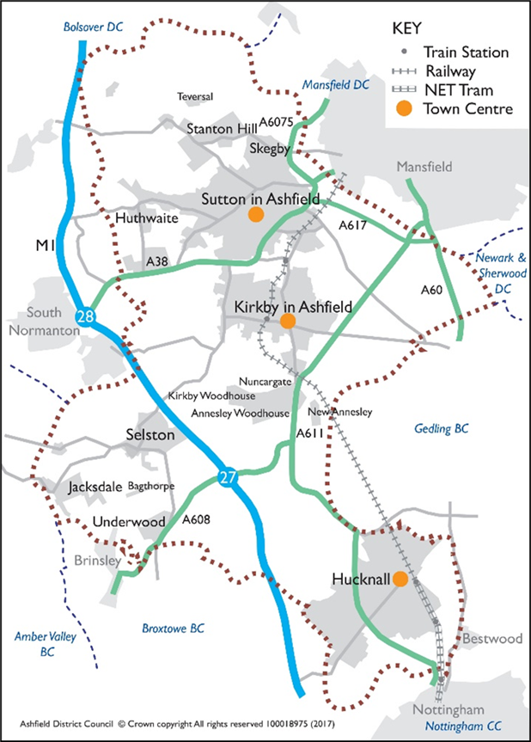

Map 1: The district of Ashfield and surrounding area
Source: Ashfield District Council
  - Map 2 shows the extent of the Nottingham and Derby Green Belt within Ashfield. It is largely confined to the south of the District and equates to approximately 41% of Ashfield. This includes land around Hucknall, land to the south and east of Kirkby-in-Ashfield and land surrounding the rural villages of Selston, Jacksdale, Underwood and small parts of Brinsley and Bestwood. The village of Bagthorpe is ‘washed over’ by the Green Belt.

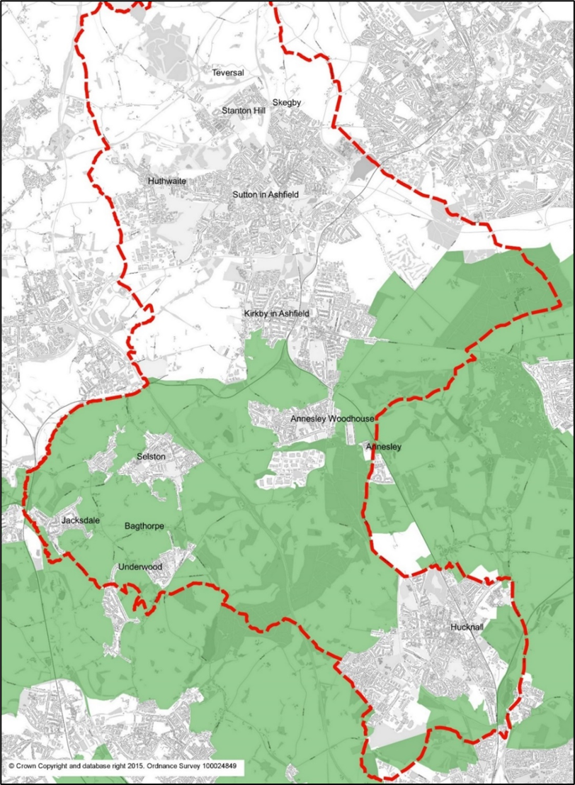

Map 2: Extent of Green Belt in Ashfield District
Source: Ashfield District Council

Housing Market Areas

  - Work undertaken by DTZ Pieda initially identified the housing market area for Nottinghamshire. Evidence on the housing market areas is set out in the GL Hearn Nottingham Outer 2015 Strategic Housing Market Assessment . It concludes that ‘Ashfield, Mansfield and Newark and Sherwood in view of all the current and historic evidence, as well as the existing ties, comprise a single Housing Market Area.’ (HMA). However, it is also acknowledged that Hucknall has a strong relationship with the Greater Nottingham Area and the Nottingham Core HMA authorities.

  - A 2018 study by consultancy ORS was commissioned by the Nottingham Core HMA comprising Broxtowe, Gedling, Erewash, Nottingham City and Rushcliffe to confirm the Nottingham Core Housing Market Area (HMA) boundary. This Study concluded that:
“There is no single correct definition of an HMA and FEMA, but the CURDS (Centre for Urban & Regional Development Studies) HMA analysis, ONS (Office for National Statistics) Travel to Work Areas, and BRMAs (Broad Rental Market Areas) all indicate that the Nottingham Core HMA authorities of Broxtowe, Gedling, Erewash, Nottingham City and Rushcliffe are all located within the same HMA and FEMA. The migration and commuting data also supports a Nottingham Outer HMA and FEMA containing Ashfield, Mansfield and Newark and Sherwood.”

  - The report goes on to add:
“…… the town of Hucknall being in the administrative area of Ashfield, but within the functional HMA and FEMA for Nottingham Core HMA, while areas of Broxtowe, Erewash, Gedling, and Rushcliffe lie inside of other functional HMAs and FEMAs. However, from an administrative and practical point of view it is necessary for HMAs and FEMAs to follow local authority boundaries and the five authorities in the Nottingham Core HMA and FEMA remain the most appropriate grouping.”

  - Table 1 and Map 3 illustrate the extent of the Nottingham Outer and Nottingham Core Housing Market Areas (HMAs).

Housing Market Area | Districts within Housing Market Area
Nottingham Core | Nottingham, Rushcliffe, Gedling, Erewash, Broxtowe
Nottingham Outer | Ashfield, Mansfield, Newark & Sherwood.

Table 1: Housing Market Areas
Source: Ashfield District Council

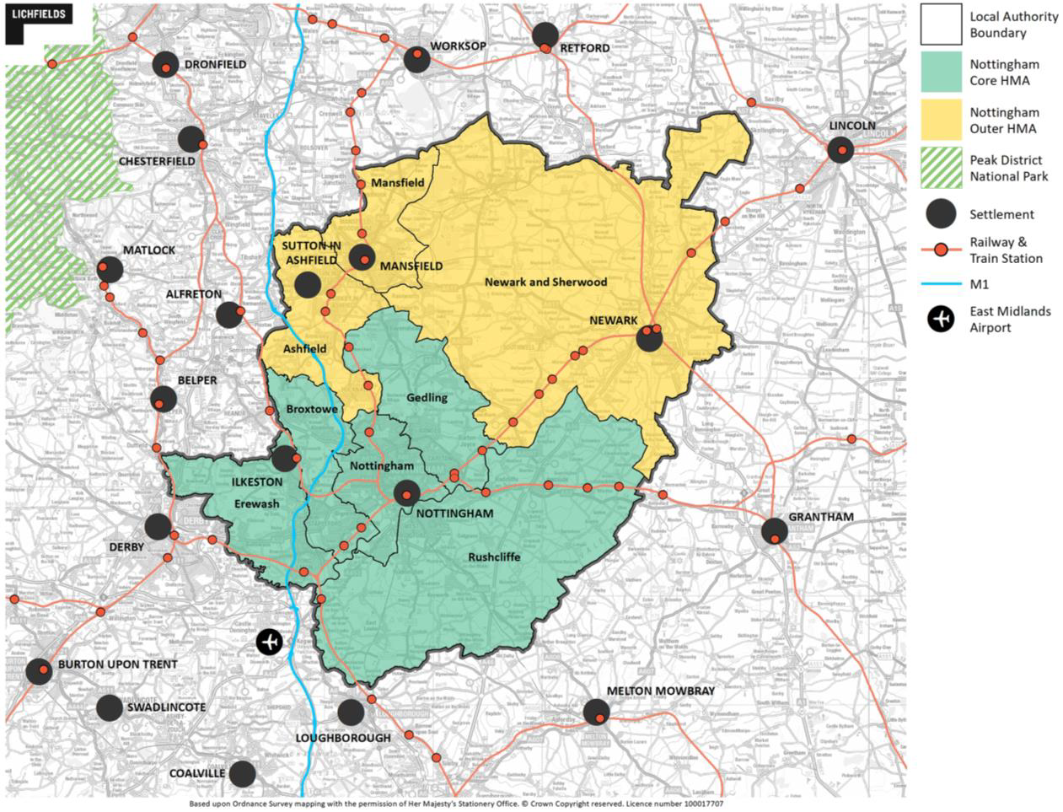
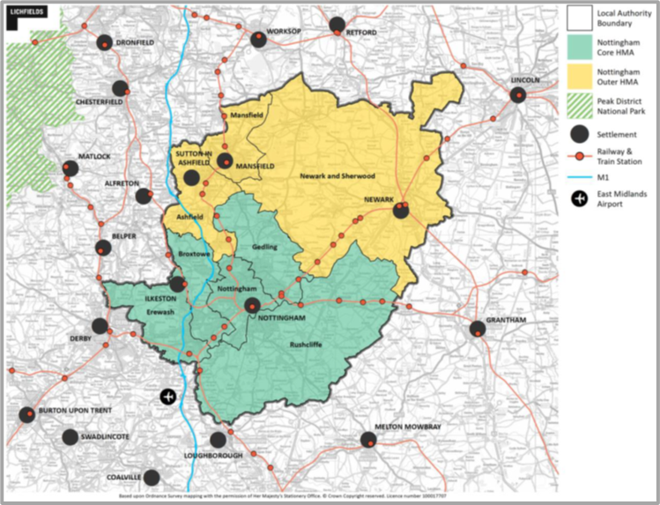

Map 3: Nottingham Outer and Nottingham Core Housing Market Areas
Source: Nottingham Core HMA and Nottingham Outer HMA Employment Land Needs Study 2021

Functional Economic Market Area (FEMA)

  - Planning Practice Guidance (PPG) formally identified a FEMA as follows:

‘‘The geography of commercial property markets should be thought of in terms of the requirements of the market in terms of the location of premises, and the spatial factors used in analysing demand and supply – often referred to as the functional economic market area.” (ID:2a-012-20140306).

  - In 2015, the councils comprising the Nottingham Outer Housing Market Area (HMA) and the Nottingham Core Housing Market Area commissioned Nathanial Litchfield & Partners to undertake an Employment Land Forecasting Study, (ELF Study) which identified the future quantity of land or floorspace required for economic development uses. The ELF Study identified that:

- The Nottingham Core HMA is a strong Functional Economic Market Area (FEMA);
- For the Nottingham Outer HMA this is slightly less clear cut, but it can be made out that the Nottingham Outer HMA is self-contained, however, Hucknall has strong links with the Nottingham Core HMA.

In the Nottingham Core HMA and Nottingham Outer HMA Employment Land Needs Study 2021, Lichfield confirms that this remains the case. Hucknall has a strong relationship with the Nottingham Core HMA. Both Kirkby-in-Ashfield and Sutton in Ashfield link in with the Mansfield area and the employment areas of Bolsover around Junction 28.

Joint Working

  - Ashfield has a history of joint working with neighbouring authorities and statutory consultees on strategic planning matters. It has a close working relationship with the authorities in both the Nottingham Outer HMA and Nottingham Core HMA.

  - Ashfield is one of the constituent authorities of the D2N2 Local Enterprise Partnership (LEP) which covers Nottinghamshire, Nottingham, Derby, and Derbyshire. The purpose of the LEP is to lead and support economic growth across Derby, Derbyshire, Nottingham, and Nottinghamshire. It is identified by national planning policy that the D2N2 Local Industrial Strategy should inform local policies for economic development and regeneration.

  - There are a number of established joint working groups in Nottinghamshire of which Ashfield is a member. These are set out in the Table below.

D2N2 Local Enterprise Partnership Board | Nottinghamshire local authorities are represented at the D2N2 Partnership Board. Regular meetings between Nottinghamshire Leaders help to ensure that issues relating to D2N2 are discussed as and when necessary.
The City of Nottingham and Nottinghamshire Economic Prosperity Committee | The Committee is a joint committee of Nottingham City Council, Nottinghamshire County Council, and all District Councils in Nottinghamshire. It is a decision-making body on strategic economic development issues. It aims to drive future investment in growth and jobs by prioritising, commissioning, and monitoring money available to Nottingham and Nottinghamshire via the D2N2 Local Enterprise Partnership and makes recommendations to D2N2 on its investment priorities. The Committee is made up of one councillor from each local authority.
Nottinghamshire Local Government Leaders Group | A group made up of all the leaders of the County and District Councils in Nottinghamshire.
Nottinghamshire Policy Officers Group  meetings | Nottinghamshire Policy Officers Group consists of all Nottinghamshire Councils. Planning Officers from each Nottinghamshire Council meet on a quarterly basis to discuss and, where necessary, take action on strategic priorities.
Nottinghamshire Development  Management Liaison Group Meetings | Development Management officers meet on a regular basis to discuss any issues arising from a development management aspect.
Nottinghamshire Ecological and Geological Data Partnership Meetings | The Nottinghamshire Ecological and Geological Data Partnership consists of all the Nottinghamshire Councils and officers from the Nottinghamshire  Biological and Geological Records Centre (NGBRC). The group meets twice a year to discuss biodiversity issues, including all local environmental data. The NGBRC, operated by the Museums and Galleries  Service of Nottingham City Council, on behalf of the Partnership, is Nottinghamshire’s local record centre. As such it is the local node in the UK-wide National Biodiversity Network.
Greater Nottingham Joint Planning Advisory Board (JPAB) | JPAB was established in 2008. It is an advisory body and therefore any decisions it makes must be ratified by the relevant executive bodies of each member Council. It is made up of Councillors responsible for planning and transport matters within the constituent authorities. It meets every few months and oversees the preparation of strategic plans in the Greater Nottingham area. Other Duty to Cooperate bodies are invited to attend as observes, and the meetings held in public. Its membership consists of Ashfield DC, Broxtowe BC, Erewash BC, Gedling BC, Nottingham City, Rushcliffe BC, Nottinghamshire Council and Derbyshire County Council.
Greater Nottingham Planning Partnership –Officer Group | This officer group meets on a weekly basis to consider all aspects of local plan(s). Its membership consists of Ashfield DC, Broxtowe BC, Erewash BC, Gedling BC, Nottingham City, Rushcliffe BC, Nottinghamshire Council and Derbyshire County Council.
Nottingham Core HMA Monitoring Group | Attended by Ashfield DC as well as the Nottingham Core Councils. Considers all aspects on monitoring the local plans and progress with delivery.
Ashfield Major Projects Group | Considers major planning application in Ashfield. Comprises Ashfield DC, Highways Authority Nottinghamshire County Council representatives, Nottingham and Nottinghamshire Integrated Care Board representative.
The Local Nature Recovery Strategy (LNRS) Strategic Oversight Group | The LNRS Strategic Oversight Group ensures that the Local Nature Recovery Strategy is developed in accordance with government guidance, and that it reflects the strategic priorities for nature recovery in Nottinghamshire and Nottingham. Membership includes  • Nottinghamshire County Council  • Nottingham City Council  • Ashfield District Council  • Bassetlaw Borough Council  • Broxtowe Borough Council  • Gedling Borough Council  • Mansfield District Council  • Newark & Sherwood District Council  • Rushcliffe Borough Council  • Natural England  • Forestry Commission  • Environment Agency  • National Farmers Union  • Country Land and Business Association  • Nottinghamshire Wildlife Trust  • National Trust  • Woodland Trust  • RSPB  • Canal and River Trust  • Trent River Trust  • Nottingham Trent University  • University of Nottingham  • Business Representative  • Health Representative  • Community Representative
BNG Implementation Working Group | This group supports the LNRS Co-ordinator in the production of the LNRS for Nottinghamshire. Provides direction for the working group and provides regular progress reports to the Strategic Oversight Group. It includes officers from LAs and Defra organisations, officers from nature orgs and local partnership groups, and representatives from other sectors (health and wellbeing, farming, development, transport)
LNRS Planning Group | This is a working group made up of local authority development Management and Policy planning officers. The group feeds into the BNG Implementation Working Group and meets on an ad-hoc basis.
Nottinghamshire Biodiversity Action Group (BAG) | A partnership of voluntary, statutory and community groups working together to conserve and enhance the wildlife of Nottinghamshire to the benefit of people.  ADC is a partner of the group which meets 3 times a year.
Bus Service Improvement Plan (BSIP) Stakeholder Reference Group | Ashfield District Council is a member of the Notts Stakeholder Reference Group, comprising Nottinghamshire local authorities and bus service providers. The Council has signed a Memorandum of Understanding with regards to the BSIP.

  - In addition to those established working groups listed above, Ashfield and Erewash and Bolsover authorities are working jointly in the following ways:

- All councils are represented on the Robin Hood Line Community Rail Partnership (CRP) which aims to connect local communities with their railway, delivering social benefit and increasing rail use within this area through strategic activities. The partnership enables Councils to actively advise the CRP of district priorities and maximise funding / joint working opportunities.

- Erewash and Bolsover were key supporting partners in the Council’s Restoring your Railways bid. The bid, submitted in 2021, set out the feasibility of re-opening the current freight-only line between the Robin Hood Line in Nottinghamshire and the Pye Bridge junction of the Erewash Valley Line in Derbyshire (between Kirkby Lane End and Ironville Junctions), to convert it to carry passenger trains on a regular basis. It also looked at the reopening of a station at Selston and creating a station platform at Kings Mill in Sutton-in Ashfield. Mansfield, D2N2, East Midlands Councils, Derby City Council, Sherwood Forest Hospitals NHS Foundation Trust, Selston parish Council all wrote letters of support for the bid.

  - Ashfield District Council have liaised and co-operated with other prescribed bodies, such as the Environment Agency, Historic England, Natural England, Nottingham & Nottinghamshire Integrated Care Board, National Highways, and other adjoining authorities as and when appropriate to develop an approach to planning for strategic issues. This is demonstrated through the various Statements of Common Ground as listed in Appendix 1, and the summary of Duty to Co-operate bodies and methods of engagement in Appendix 2.

Collaboration on Evidence Base

  - Ashfield has worked with neighbouring authorities to produce the evidence base for Local Plan. Joint studies are identified in the Table below.
The Nottingham Core HMA and Nottingham Outer HMA Employment Land Needs Study, 2021. Lichfield. | Nottingham Core HMA & Nottingham Outer HMA Councils.
Employment Land Forecasting Study, Nottingham Core HMA & Nottingham Outer HMA 2015 - Nathaniel Litchfield & Partners. | Nottingham Core HMA & Nottingham Outer HMA Councils.
Nottinghamshire Core & Outer HMA Logistics Study Final Report. Iceni Projects Limited with MDST Transmodal Limited (2022) | Nottingham Core HMA & Nottingham Outer HMA Councils and Nottinghamshire County Council.
Strategic Distribution and Logistics Sites  Background Paper 2023. | Nottingham Core HMA & Ashfield District Council.
Nottingham Outer HMA Self-Build and Custom Build Register (ongoing). | Nottingham Outer HMA Councils.
Ashfield and Mansfield - A Plan for Growth 2016 (Joint Economic Masterplan Update). | Ashfield District Council & Mansfield District Council.
Maid Marian Rail Extension Economic Impact Analysis 2020. Lichfields. | Ashfield District Council & Mansfield District Council.
Maid Marian Rail Extension - Ashfield Masterplan Report 2020. Ryders. Ashfield District Council and Mansfield District Council. | Ashfield District Council & Mansfield District Council.
Greater Nottingham & Ashfield Housing Needs Assessment Final Report 2020 - Iceni Projects Limited on behalf of the Greater Nottingham Planning Partnership.  N.B. An update of this assessment has been commissioned by the partner authorities to reflect the 2021 Census data. The final report is anticipated in Spring 2024. | Nottingham Core HMA Councils and Ashfield District Council.
First Homes Assessment Greater Nottingham, September 2022. Iceni Projects Limited. | Ashfield District Council, Broxtowe Borough Council, Gedling Borough Council, Nottingham City Council and Rushcliffe Borough Council.
Greater Nottingham and Ashfield District Council Gypsy and Traveller Accommodation Assessment, 2021. RRR Consultancy Ltd. | Nottingham Core HMA Councils and Ashfield District Council.
Greater Nottingham (including Ashfield) accessibility of settlements study 2010 | Nottingham Core HMA Councils and Ashfield District Council.
Strategic Green Belt Assessment Framework 2014 | Ashfield District Council, Broxtowe Borough Council, Gedling Borough Council, and Nottingham City Council.
Ashfield Strategic Housing and Economic Land Availability Assessment (SHELAA) – Ongoing. | Produced by ADC with input from NCC in relation to highways, public transport, heritage, ecology, and local services.
Ashfield Strategic Transport Study, 2023 (Systra). | Commissioned by ADC with input from NCC Highways and National Highways.
Ashfield District Council and Nottinghamshire County Council Education Technical Paper 2023 | Produced by ADC and NCC in relation to educational requirements in Ashfield.
Ashfield Heritage Impact Assessment 2023. Rocket Heritage & Archaeology Ltd. | Commissioned ADC with input from NCC and Historic England.
Ashfield Strategic Flood Risk Assessment Level 1, 2023 | Produced by ADC with input from NCC, The Environment Agency and Seven Trent.
Biodiversity Opportunity Mapping Project, 2016 | Produced by the Nottm Biodiversity Action Group, with input from Nottinghamshire County Council.

Strategic Priorities and Cross Boundary Matters

  - National Planning Guidance on Plan Making, identifies that co-operation is required on matters that the strategic policies should make provision for. It also sets out that this is linked to matters set out in sections 19(1B to 1E) and 33A(4) of the Planning and Compulsory Purchase Act 2004. A strategic matter is linked by national planning guidance to strategic policies and is considered to be an aspect that would have a significant matter on two or more authorities. However, there may also be cross boundary issues where local authorities have worked together but this is not necessarily a strategic matter.

  - The following areas are considered to be strategic matters for Ashfield:

- Quantity and Location of Housing Development
- Gypsy, Traveller and Travelling Showpeople provision
- Provision of jobs and employment land to meet Ashfields needs and to contribute to the wider functional economic market area
- The scale and location of retail development
- Green Belt
- Infrastructure delivery arising from the development needs
- Flooding and water quality both within and outside of Ashfield
- Sustainable Transport Modes and connectivity, including the Maid Marian Railway Line Scheme
- Nature conservation and enhancement
- Conserving the historic environment
- Settlement hierarchy/ Urban Area boundaries

  - Ashfield Council have prepared a number of Statements of Common Ground (SoCG) to inform the Inspector of the Ashfield Local Plan and other interested parties about the areas of agreement, or otherwise, between the Council and the prescribed bodies in respect of strategic planning matters. A list of these signed SoCGs and where to find them is included in Appendix 1 of this statement. The SoCGs set out any issues and the Council’s position in greater detail, however, key points are outlined below.

The quantity and location of housing development

  - Ashfield District falls within the Nottingham Outer Housing Market (HMA) authorities together with Mansfield and Newark & Sherwood District Councils. However, it is acknowledged that the southern part of Ashfield District around Hucknall has close links with Nottingham City and the Nottingham Core HMA. This is reflected in the evidence on the Functional Economic Market Area Evidence.

  - Ashfield Council has applied the Standard Method for determining Local Housing Needs as set out in Planning Policy Guidance to arrive at a requirement of 446 dwelling per annum. The Local Plan identifies a supply of sites under Policy H1: Housing Allocations to contribute towards this requirement. The proposed allocations together with small site supply are estimated to provide for approximately 13+ years’ worth of housing supply post adoption (to year 2038/39), and further details are set out in Background Paper 1: Spatial Strategy and Site Selection.

  - A number of the proposed housing sites are located in the Green Belt and paragraph 146 of NPPF (2023) therefore applies. This paragraph states that before concluding that exceptional circumstances exist to justify changes to Green Belt boundaries, the local planning authority must take into account whether a neighbouring authority could accommodate some of the identified need for development. However, the majority of neighbouring local planning authorities also have significant areas of land within their districts which are identified as part of the Nottingham-Derby Green Belt.

  - Ashfield Council approached neighbouring authorities in May 2022 in respect of their capacity to accommodate some of Ashfield’s identified housing need. All authorities responded to advise they were not in a position to meet any of Ashfield’s local housing need at that stage. This position has subsequently been reiterated at officer meetings.

  - The current position in relation to the other Nottingham Outer Authorities is as follows:

- Mansfield District Council adopted the Mansfield District Local Plan 2013-2033 in September 2020 and are currently consulting on the first stage of the Local Plan review - the Mansfield District Local Plan Issues and Opportunities Report.
- Newark & Sherwood District Council adopted a Review of the Newark & Sherwood Local Development Framework Core Strategy & Allocations Amended Core Strategy in March 2019.

  - The Nottingham Core HMA authorities have adopted Core Strategies which set out the planning for housing needs across the Nottingham Core HMA. The councils have also adopted Part 2 Local Plans, with the exception of Erewash BC which has submitted a Core Strategy for Examination. The remaining councils are working toward a publication local plan consultation (Regulation 19) for a revised Core Strategy and consulted on their ‘Greater Nottingham Strategic Plan Preferred Approach’ between 3rd January and 14th February 2023. The revised Core Strategy is taken forward through JPAB, and there are regular officer meetings which include Ashfield. Ashfield DC has not been requested to meet any unmet needs which may arise within the Nottingham Core HMA.

  - Gedling Borough Council’s Aligned Core Strategy (Part 1 Local Plan) 2014 allocated Sustainable Urban Extensions at Top Wighay Farm (1000 homes) and at North of Papplewick Lane (up to 300 homes), both adjacent to Hucknall and as such are anticipated to need to contribute towards infrastructure requirements in Hucknall. In this context Gedling Borough Council have in place a Planning Obligations Protocol for dealing with development within Gedling which would have an impact on the services and facilities in a neighbouring District.

  - The revised Greater Nottingham Strategic Plan Preferred Approach consultation (Jan 2023) has subsequently identified approximately 1,650 homes in Gedling, adjoining Hucknall, which includes Sustainable Urban Extensions at:
i) North of Papplewick Lane (83 homes remaining); and
ii) Top Wighay Farm (805 homes remaining, plus a further 640 homes).

  - The Ashfield Local Plan does not allocate any strategic sized sites which would impact directly on settlements within any adjoining authority. However, at the Ashfield Local Plan Regulation 18 (2021) consultation, Broxtowe Borough Council (BBC) submitted an objection to the potential allocated site H1Va, Land at Plainspot Farm, New Brinsley, Underwood for 42 dwellings. Although the site is not of strategic scale, it is located directly adjoining the district boundary with Broxtowe and would therefore impact on a settlement within their administration boundary. Concerns were raised that further development on the edge of the village could lead to coalescence with surrounding Green Belt villages and add further pressure to the existing local services and infrastructure. ADC have worked with Nottinghamshire County Council Highways in respect of potential access constraints and no concerns were raised in this respect. The site selection reflects the spatial approach taken by ADC, and further details can be found in Background Paper 1: Spatial Strategy and Site Selection.

  - The neighbouring authorities in Derbyshire are Amber Valley Borough Council and Bolsover District Council, both of which are in different housing market areas. No requirement for any of their housing need to be met within Ashfield has been identified by these authorities

  - Regarding housing delivery, the key areas of agreement are:

- Ashfield is forms part of the Nottingham Outer Housing Market Area (HMA), but Hucknall has close links with Nottingham City and the Nottingham Core HMA.

- Bolsover district forms part of the neighbouring North Derbyshire and Bassetlaw HMA. Amber Valley borough forms part of the neighbouring Derby HMA. While there are some links between the HMAs, they are separate areas, and for each authority they remain the appropriate for the purposes of planning for housing requirements.

- The Ashfield Local Plan proposes to meet the District’s local housing needs, as informed by the standard methodology, to 2038/39 (as demonstrated by the Local plan site allocations), with a review at least every 5 years. It is not proposed that any of this requirement will be met by neighbouring local planning authorities.

- All Nottinghamshire Outer HMA authorities will seek to meet their own local housing need as informed by the standard methodology.

- The Ashfield Local Plan is not required to accommodate any unmet housing requirements which may arise within the Nottingham Core Housing Market Area.

- Bolsover District Council is committed to meeting their own assessed level of housing need within their own district through the Local Plan for Bolsover District (March 2020) and has made no request to Ashfield to accommodate any unmet housing requirements.

- Amber Valley Borough Council considers that it can meet its own assessed level of need to 2040, and that this is demonstrated by the approach taken and site allocations within the Pre-Submission Draft Amber Valley Local Plan. As a result, it is not proposed that any of this requirement will be met by neighbouring local planning authorities.

- Engagement will continue to take place between Ashfield and all neighbouring authorities, including the consideration of cross-boundary issues as necessary.

- The parties will continue to share evidence and information to ensure that adequate infrastructure is provided to meet the scale and location of housing need.

  - Outstanding areas of disagreement regarding housing delivery:

- Broxtowe Borough Council have a standing objection to housing allocation H1Va, Land at Plainspot Farm, New Brinsley, Underwood for 42 dwellings.

Engagement and Governance Arrangements

  - Appendix 2 sets out the methods of engagement with the various Duty to Co-operate bodies, and section 4 of this statement gives greater detail in respect of the established working groups.

  - In addition to the regular joint working groups, the Council meets with the neighbouring authorities on an ad-hoc basis throughout the preparation of the respective Local Plans.

  - Ashfield is a member of the Greater Nottingham Planning Partnership Officer Group which meets on a weekly basis, with quarterly reports to the Joint Planning Advisory Board (JPAB). Along with the other Council’s in the Nottingham Outer HMA and Nottingham Core HMA, Ashfield monitors housing land to identify any issues. Should issues arise they are brought up at the Nottinghamshire Planning Policy Officers Group Meeting or at the meeting held between the HMA groups.

  - All authorities will continue to meet on a regular basis to address cross boundary issues, including delivery of development to meet the identified objectively assessed development needs. Cross boundary strategic matters are also considered by the Council’s Statements of Common Ground which will be updated as and when considered appropriate

Gypsy, Traveller and Travelling Showpeople provision

  - The requirement for gypsy and traveller accommodation is assessed in the Greater Nottingham and Ashfield District Council Gypsy and Traveller Accommodation Assessment March 2021 (GTAA) shared evidence base. The study used 3 different approaches to establishing need as follows:

- Based on the ethnic identity definition;
- Based on the needs of families who have not permanently ceased to travel (i.e., based on the PPTS 2015 definition);
- Based on the ‘travel to work’ interpretation of PPTS 2015.

  - The GTAA study recommended that the local authorities’ Local Plans seek to meet the PPTS need (as required) with ‘ethnic’ need (potential need) covered by a criteria-based policy.

  - Government’s Planning Policy for Traveller Sites (PPTS) 2015 required travellers to demonstrate that they have not ceased to travel in order to be defined as such. However, due to the ambiguity around demonstrating this and various court challenges to it, the Council took the decision to use the higher level of assessed need based on the ‘ethnic definition’, as opposed to the Traveller definition set out in national policy PPTS 2015. In December 2023, the PPTS was amended to revert back to the PPTS 2012 definition which includes travellers who on grounds only of their own or their family’s or dependants’ educational or health needs or old age have ceased to travel temporarily or permanently. This endorses the approach taken by Ashfield. The assessed requirements for Ashfield are as follows:

Ashfield Future Pitch/Plot Requirements 2020 to 2038
Period | Gypsy/Traveller Pitches | Showpeople’s Plots/Yards
2020 to 2025 | 1 | 9
2025 to 2030 | 1 | 2
2030 to 2035 | 1 | 2
2035 to 2038 | 1 | 1
Total 2020 to 2038 | 4 | 14

  - The Ashfield Local Plan seeks to meet the above needs through land allocations under Policy H2a. It is acknowledged that there is a slight mismatch in the evidence base timeframe, i.e., for the period 2020-2038, rather than 2023-2040. However, since the quantum of assessed need is minimal it is considered appropriate that any additional need will be addressed via the planning application process, using criteria-based policy H2 alongside site allocations within Policy H2a.

  - Within the Nottingham outer Housing Market Area (HMA), all parties will each meet the gypsy, traveller and show person accommodation needs within their respective areas.

  - The Nottingham Core HMA Authorities will be meeting their own gypsy, traveller and showperson needs within the HMA.

  - The requirement for Bolsover is set out in the Local Plan for Bolsover District (March 2020). Bolsover District Council will be meeting their own gypsy, traveller and show person needs.

  - The Derbyshire Gypsy and Traveller Accommodation Assessment identified a need to provide for two pitches arising from an unauthorised development, for which the Amber Valley Local Plan allocates two pitches. There is also a need for a further two pitches arising from households in housing and the draft policy sets out criteria to be applied in determining planning applications to address that need

  - Regarding Gypsy, Traveller and Travelling Showpeople Provision, the key areas of agreement are:

- Ashfield District Council proposes to meet the District’s gypsy, traveller and show person accommodation needs, with a review at least every 5 years. It is not proposed that any of this requirement will be met by neighbouring local planning authorities.

- The Ashfield Local Plan is not required to accommodate any unmet gypsy, traveller and show person accommodation needs which may arise within any adjoining authority area, or Housing Market Area (HMA).

Employment provision

  - The authorities comprising the Nottingham Core HMA and the Nottingham Outer HMA have worked together on the development of the Employment Land Needs Study 2021. This forms a common evidence base for the future employment land requirements for each authority. The Study included identifying the Functional Economic Market Areas (FEMA) which has informed the employment land requirement for each area.

  - Ashfield Local Plan Policy S8 identifies a demand for approximately 81 hectares of land for employment purposes in Ashfield over the Plan period. This demand will be met through:

- Policy S6 strategic employment allocations of approximately 40.92 hectares at M1 Junction 27, removing the site out of the Green Belt in order to meet future logistic and distribution needs, and
- Employment land allocations in Policy EM2 which provide approximately 43.94 hectares.
  - Ashfield District Council considers that it can meet its own assessed level of need to 2040, and that this is demonstrated by the approach taken and site allocations under policies S6 and EM2 of the Ashfield Local Plan. The allocated strategic sites will make a significant contribution towards the regional logistics requirements along the M1 in Nottinghamshire. As a result, it is not proposed that any of Ashfield’s assessed employment requirements will need to be met by neighbouring local planning authorities.

Nottingham Outer HMA Authorities

  - For the Nottingham Outer HMA, each authority has agreed that:

- They are all part of the Nottingham Outer Functional Economic Market Area (FEMA), with all authorities having influences beyond the administrative area.

- Nottingham Outer HMA Authorities will meet or exceed employment land requirements within their respective planning authority area and that there are no outstanding unresolved strategic issues / unmet needs relating to employment development.

- The proposed employment site allocations under Policies S6 and EM2 are suitable and deliverable and will help to meet identified needs.

Nottingham Core HMA Authorities

  - The Nottingham Core HMA Authorities have agreed that:

- Ashfield forms part of the Nottingham Outer Functional Economic Market Area (FEMA), with the Hucknall area having close links with the Nottingham Core FEMA. All authorities have influences beyond their administrative area.

- Nottingham Core HMA Authorities support Ashfield’s approach in contributing towards the wider regional need for logistics/distribution sites along the M1 corridor.

Other Adjoining Authority – Amber Valley Borough

  - The Employment Land Review for Amber Valley BC (May 2021) identified that the Functional Economic Area (FEMA) for Amber Valley principally covers the authority areas of Derby City, Erewash, Derbyshire Dales, Bolsover, and North East Derbyshire. In Nottinghamshire, the strongest connections are with the City of Nottingham followed by the neighbouring local authority areas of Ashfield and Broxtowe.

  - Ashfield and Amber Valley authorities have agreed that:

- Ashfield forms part of the Nottingham Outer Functional Economic Market Area (FEMA), whilst Amber Valley has identified its own FEMA. Both authorities recognise that the FEMA of most authorities have influences beyond their administrative area.

- Amber Valley Borough Council considers that it can meet its own assessed level of need to 2040, and that this is demonstrated by the approach taken and site allocations within the Pre-Submission Draft Amber Valley Local Plan (Reg 19, February 2024). As a result, it is not proposed that any of this requirement will be met by neighbouring local planning authorities, including Ashfield District Council.

Other Adjoining Authority – Bolsover

  - The Local Plan for Bolsover District was adopted by the Council on 4th March 2020. The supporting evidence from The Economic Development Needs Assessment (EDNA) (October 2015) identified that the Functional Economic Area (FEMA) for Bolsover District principally covers the authority areas of Chesterfield, North East Derbyshire, Amber Valley, Bassetlaw, Mansfield, and Ashfield. Consequently, there are some differences in the identification of the two FEMAs that Ashfield District lies within, with some overlapping between different areas and with employment land studies typically identifying a number of scenarios.

  - Ashfield and Bolsover authorities have agreed that:

- Ashfield forms part of the Nottingham Outer Functional Economic Market Area (FEMA), whilst Bolsover has identified its own FEMA which extends beyond its own district in several locations where travel to work data supports this. Both authorities recognise that the FEMA of most authorities have influences beyond their administrative area.

- Bolsover District Council is committed to meeting its own employment land requirements within their own district through the Local Plan for Bolsover District (March 2020) and has made no request to ADC to accommodate any unmet employment land requirements

Other Nottinghamshire Authority (not adjoining Ashfield District) – Bassetlaw

  - Along with a number of other councils, Ashfield entered into a Statement of Common Ground with Bassetlaw District Council regarding the Bassetlaw A1 Corridor Logistic Assessment Property Market Area Authorities. The purpose of the Statement was to set out the confirmed points of agreement, or otherwise, regarding Apleyhead Junction Strategic Employment site allocation.

  - The allocation comprised 118.7 hectares of land at Apleyhead at the junction of the A1 and A57, to the east of Worksop. The proposed employment use is Class B8 to meet the needs for large scale sub-regional and regional logistics only in the plan period (100,000 sq. ft - 1,000,000 sq. ft or more rather than final mile distribution).

  - The Statement of Common Ground set out that the A1 property market area authorities:
- Agree that this scale of operations is appropriate in the context of the scale of Apleyhead.
- Acknowledge that Bassetlaw intends to meet the housing needs in the district over the plan period.
- Agree that the defined property market area is appropriate to consider sub-regional/regional logistics needs for the purposes of the Bassetlaw Local Plan. (See Map below of The Bassetlaw A1 Corridor Logistics Assessment 2021 identifies a logistics property market area).
- Agree that Apleyhead could make an appropriate contribution to addressing a sub-regional/regional need for large scale logistics by 2038.
- Agree that the Apleyhead site will be identified in that study as a potential site allocation.
- Agree that the Apleyhead site will be identified in that study as a potential site allocation. (Nottingham Core and Outer HMA Logistics Study 2022).
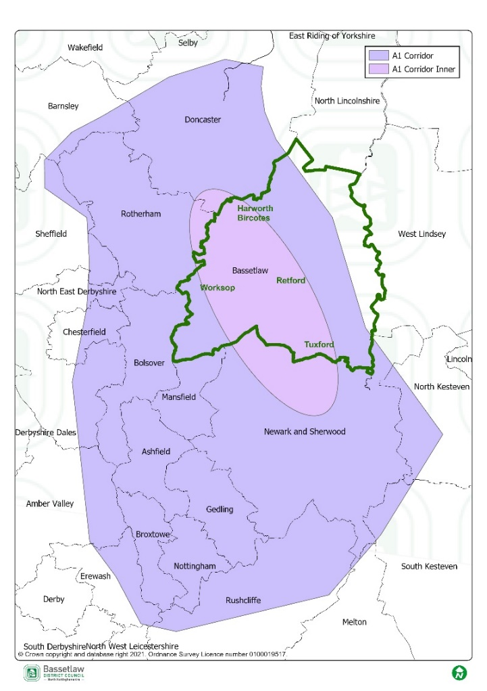
Statement of Common Ground Bassetlaw A1 Corridor Logistics Assessment Property Market Area Authorities, June 2022 Source: Bassetlaw District Council

Engagement and Governance arrangements

  - Appendix 2 sets out the methods of engagement with the various Duty to Co-operate bodies, and Section 4 of this statement gives greater detail in respect of the established working groups.

  - In addition to the regular joint working groups, the Council meets with the neighbouring authorities on an ad-hoc basis throughout the preparation of the respective Local Plans.

  - Ashfield is a member of the Greater Nottingham Planning Partnership Officer Group which meets on a weekly basis, with quarterly reports to the Joint Planning Advisory Board (JPAB). Along with the other Council’s in the Nottingham Outer HMA and Nottingham Core HMA, Ashfield monitors employment land to identify any issues. Should issues arise they are brought up at the Nottinghamshire Planning Policy Officers Group Meeting or at the meeting held between the HMA groups.

  - All authorities will continue to meet on a regular basis to address cross boundary issues, including delivery of development to meet identified development needs. Cross boundary strategic matters are also considered by the Council’s Statements of Common Ground which will be updated as and when considered appropriate.

The scale and location of retail development.

  - The Ashfield Retail and Leisure Study (2016) considered the requirements for retail and leisure development in Ashfield to inform the emerging Local Plan. The Covid pandemic has subsequently led to a high degree of uncertainty in this area in relation to future requirements. As such a Town Centre/Local Centre Study (Nexus - Examination Library ref. SEV/32) was commissioned to provide the Council with an up‐to‐date, objective assessment of the health of centres in the Council area and consider possible strategic policy responses to emerging issues.

  - Chapter 3 of the Draft Local Plan considers “Sustainable Development” and Policy S13 sets out a number of strategic objectives including the retail hierarchy. Chapter 8 of the Draft Local Plan is titled “Placing vibrant town and local centres at the heart of the community”. Within this chapter there are three town centre policies:
- Policy SH1: Retail, Leisure, Commercial and Town Centre Uses
- Policy SH2: Local Shopping Centres, Shopping Parades and Single Shops
- Policy SH3: Shopfronts

  - A limited response was received in relation to the above draft policies at the Regulation 19 consultation (see Regulation 19 Statement of Consultation – Examination Library Ref. SD/08) The Town Centre/Local Centre Study was completed in November 2023 and did not recommend significant changes to the draft retail and town centres Policies. The Council note the recommendations for possible amendments to Policy SH1 which will be reviewed and included in a schedule of suggested changes if deemed necessary and appropriate.

Engagement and Governance arrangements

  - The Nottingham Outer Authorities will continue to meet on a regular basis, to address cross boundary issues, including delivery of development to meet the identified needs. Ashfield is a member of the Greater Nottingham Planning Partnership–Officer Group which meets on a regular basis and there are quarterly reports to JPAB.

Green Belt

  - Ashfield DC, Broxtowe BC, Gedling BC and Nottingham City Council worked jointly to prepare evidence to support their emerging Local Plans, including a Green Belt Assessment Framework (Exam Library Ref EV07B).

  - Throughout the preparation of the Local Plan, the Council proposed to allocate a new settlement, Whyburn Farm in the Green Belt to the north of Hucknall. It was anticipated to provide up to 3,000 dwellings and an employment allocation. This was located close to the district boundary with Gedling Borough Council and was located to the edge of the boundary to the Annesley Hall Registered Park and Garden. Further to the consultation responses received to the Draft Local Plan 2021 (Regulation 18), the Cabinet determined at its meeting of 13th December 2022 that the New Settlement would not proceed as a proposed allocation in the Local Plan. Therefore, this is no longer a strategic aspect of the Plan.

  - Strategic employment sites to meet future logistics needs along have been identified at land to the north-east and south-east of Junction 27 of the M1 Motorway. These sites will require Green belt release and are also subject to pending planning applications (V/2022/0246 and V/2022/0360). Discussions regarding the applications have been undertaken with National Highways and Historic England.

  - The economic evidence for the Local Plan identifies that there is a significant demand for strategic logistics, particularly along the M1 Motorway corridor in Nottinghamshire, and a shortage in the supply to meet the needs of major logistics operators. The Council considers that currently there are no sites in the District which would provide a realistic alternative with the necessary attributes that the sites at Junction 27 possess which are well placed to meet demand for logistics in terms of scale, access to the motorway network and deliverability. The proposed strategic employment allocations provide a major economic opportunity for Ashfield, providing investment to boost the local economy and jobs, and helping to address local deprivation issues. It is considered, on balance, the public benefits of the proposed allocation in relation the exceptional circumstances for release of Green Belt provide the justification for allocation in the Local Plan.

  - A number of other sites for non-strategic residential development located in the Green Belt are proposed to be allocated in the Local Plan. However, other than the combined implications for highways, which are considered through the Transport Study 2023, they do not have strategic cross boundary implications.

  - Background Paper 1: Spatial Strategy and Site Selection sets out the exceptional circumstances for Green Belt release at Chapter 9.

  - The Nottingham Core HMA Authorities have agreed that:

- Nottingham Core HMA authorities support Ashfield’s approach in contributing towards the wider regional need for logistics/distribution sites along the M1 corridor and the associated need for green belt release to accommodate this economic growth.

- Nottingham Core HMA authorities acknowledge the justification for exceptional circumstances to release green belt sites to accommodate proportionate housing growth adjacent to existing settlements. (Notwithstanding the objection by Broxtowe Borough Council to a site for 42 dwellings at Brinsley – see para 5.12).

  - Outstanding areas of disagreement regarding specific Green Belt release:

- Broxtowe Borough Council have a standing objection to green belt housing allocation H1Va, Land at Plainspot Farm, New Brinsley, Underwood for 42 dwellings (see para. 512).

Engagement and Governance arrangements

  - Appendix 2 sets out the methods of engagement with the various Duty to Co-operate bodies, and section 4 of this statement gives greater detail in respect of the established working groups.

  - In addition to the regular joint working groups, the Council meets with the neighbouring authorities on an ad-hoc basis throughout the preparation of the respective Local Plans.

  - Ashfield is a member of the Greater Nottingham Planning Partnership Officer Group which meets on a weekly basis, with quarterly reports to the Joint Planning Advisory Board (JPAB). Along with the other Councils in the Nottingham Outer HMA and Nottingham Core HMA, Ashfield monitors housing and employment land to identify any issues. Should issues arise, they are brought up at the Nottinghamshire Planning Policy Officers Group Meeting or at the meeting held between the HMA groups.

  - All authorities will continue to meet on a regular basis to address cross boundary issues, including delivery of development to meet the identified objectively assessed development needs. Cross boundary strategic matters are also considered by the Council’s Statements of Common Ground which will be updated as and when considered appropriate (See Appendix 1).

Infrastructure Delivery

  - The Local Plan is supported by an Infrastructure Delivery Plan which addresses the infrastructure requirements for the District based on the level of planned growth (Examination Library Ref. SEV/36). This is a live document which will be updated on a regular basis to reflect changes in circumstances or new information.

  - The Council has also worked with a number of authorities in relation to the Strategic Housing & Economic Land Availability Assessment (SHELAA) including the Highways Authority, other Nottinghamshire County Council departments and Severn Trent Water.

  - There have been discussions with infrastructure providers regarding the Local Plan proposals including (but not limited to) the following:

Highways & Transport | - Nottinghamshire County Council – Highway Authority  - National Highways – responsible for M1.  - Network Rail  - HS2  - Nottingham Express Transit
Utility undertakers | - Severn Trent Water  - National Grid  - British Telecom  - Western Power Distribution  - Broadband Providers – Vodaphone, O2, EE, Three
Community Infrastructure | - Nottinghamshire County Council – Education, care homes other forms of community infrastructure  - NHS Nottingham and Nottinghamshire Integrated Care Board
Blue and Green Infrastructure | - Ashfield Regeneration Officers  - Officers from neighbouring authorities in relation to the strategic green infrastructure
Waste | Nottinghamshire County Council
Minerals | Nottinghamshire County Council

  - The Council commissioned the Ashfield Strategic Transport Study (2023) to assess the impact of proposals in the Local Plan on the Highway network. This examined impact on key junctions and identified mitigation where possible. A Strategic Transport Modelling Assessment has been undertaken to support the Ashfield Local Plan using the East Midlands Gateway Model. This included the planned level of growth by neighbouring authorities. The Assessment was undertaken in conjunction with Nottinghamshire County Council as the Highway Authority and National Highways. It identified that:

- the proposed level of growth has the potential to result in direct and indirect implications for the strategic and local transport network both within and beyond the administrative boundaries of Ashfield District;
- transport modelling has not identified any insurmountable constraints arising from the policies and proposals in the Ashfield Local Plan;
- no ‘show-stopping’ transport constraints have been identified by these organisations.

  - The findings have fed into the IDP which supports the Plan. Working with Mansfield District Council and other partners, opportunities are also being considered regarding improving the connectivity of the district through the Local Plan with the potential opening of the Maid Marian Line and additional railway stations.

  - The Nottingham and Nottinghamshire Integrated Care Board (ICB) is the statutory NHS organisation responsible for developing a plan for meeting the health needs of the population and arranging for the provision of health services in Ashfield. The ICB has been consulted at the different stages of the Ashfield Local Plan preparation process and have provided comments and input on proposed policies and site allocations.

  - Nottinghamshire County Council is the Local Education Authority for Ashfield.
Ashfield District Council and Nottinghamshire County Council has worked closely regarding meeting future education needs to ensure that there is both the availability and choice in relation to school places. This is reflected in the Ashfield District Council and Nottinghamshire County Council Education Technical Paper 2023, which considers the impact of the proposed housing in the Local Plan and identifies the future needs for the expansion of schools in Ashfield.

  - Regarding infrastructure delivery, the key areas of agreement are:

- The East Midland Gateway Model (EMGM) is an appropriate model to understand the implications of growth on the highway network.

- Ashfield have assessed the transport implications of planned levels of growth within their Local Plan and shared the information with the HMA partners, the Local Highway Authority (Nottinghamshire County Council) and National Highways England. No ‘show-stopping’ transport constraints have been identified by these organisations

- The Transport modelling has identified that some junctions within Ashfield District would still be operating above capacity as a result of the development proposals contained in the Local Plan. However, the policies in the Local Plan would deliver viable options to mitigate impacts, including measures to encourage modal shift

- The Ashfield Local Plan will seek mitigation measures for required transport improvements to which developer contributions and/or developer led schemes (i.e. Sec.278s) will be sought. These are included in the Infrastructure Delivery Schedule within the Ashfield Infrastructure Delivery Plan (IDP).

- There will need to be improvements in health care facilities as a result of the proposed new housing within and adjacent to Ashfield District. Ashfield Council has agreed a formula with NHS Nottingham and Nottinghamshire Integrated Care Board (ICB) as part of their off-site financial contributions for the infrastructure liaison process (as set out in the Statement of Common Ground).

- The notional yield rates for new primary and secondary school places have been agreed with the Education Authority (NCC) and no insurmountable school capacity issues have been identified as a result of the proposed levels of growth in the Local Plan. All proposed Local Plan allocations will be required to contribute towards the cost of school places, relative to their pupil yield, where additional capacity is required to meet planned growth

- Any planning obligations sought as part of new development will be directed to infrastructure improvements where mitigation measures have been identified. This includes the provision or enhancement of cross-boundary infrastructure to help deliver and mitigate the effects of development, for instance, transport improvements, educational and health requirements, and tackling climate change including flooding. Contributions will be informed by the Infrastructure Delivery Plan (IDP) 2023, or subsequent updated information where fully justified and appropriate.

- Co-operation will continue to take place between Ashfield and the various infrastructure providers as necessary. In order to maintain a flexible approach, at planning application stage, parties will continue to engage to identify the most appropriate solution and contributions.

Engagement and Governance arrangements

  - The Council will contact/arrange meetings with infrastructure providers as required.

  - Ashfield works with the County Council and other organisations to secure appropriate funding for transport infrastructure projects to unlock new housing and employment development.

  - The Council has a Major Projects Group which meets three times per annum to discuss major planning applications and any implications that arise from the emerging Local Plan. Infrastructure providers are invited including representatives of the Highway Authority, the County Council’s Developer Contributions Practitioner (representing education) and representatives of the Integrated Care Board.

Sustainable Transport Modes and Connectivity

  - Ashfield Local Plan Strategic Policy S10: Improving Transport Infrastructure seeks to promote travel choice and reduce the reliance on the private car. In respect of cross boundary issues with Bolsover and Erewash authorities, part 2a includes the potential re-opening of the freight only Maid Marian Line between the Robin Hood Line and the Erewash Valley Line to carry passengers, and the reopening of a station at Selston.

  - Selston Station is ideally located to serve Pinxton, South Normanton and Broadmeadows and potentially Tibshelf, Blackwell and Newton. The need for land in Bolsover District to provide a second platform and parking facilities was also considered. The reopening of the Maid Marian Line remains a long-term aspiration for all three authorities and partnership working will continue in this respect.

  - Strategic Policy S10 part 3 safeguards land for the Nottingham Express Transit System from Hucknall Station to the boundary with Gedling Borough. While current proposals do not include the development of a NET station, the safeguarding widens transport choices in the area in future.

  - Policy S10 also aims to improve connectivity to a comprehensive network of high-quality pedestrian and cycle networks. The main routes to be upgraded and/or created are shown on the Ashfield Local Plan Policies Map and include routes which cross the boundary with Bolsover District. It is noted that the Local Plan Policies Map for Bolsover identifies trails under Policy ITCR2 which aims to ensure that the Multi-User Trails Network in the District is protected and enhanced by the creation of new routes. Both councils need to ensure that the connectivity of these trails will be preserved/enhanced as cross boundary strategic networks.

  - Regarding sustainable transport and connectivity, the key areas of agreement are:

- Ashfield, Mansfield, Bolsover, Erewash, and Nottinghamshire County Councils will continue to work together to secure improvements in sustainable transport modes, in particular supporting the re-opening of the Maid Marian railway line and stations.

- Ashfield and Bolsover councils will continue to work together to secure the improvement of multi-user routes within and beyond district boundaries.

- Ashfield Council will continue to safeguard additional land for the Nottingham Express Transit System as identified on the Ashfield Local Plan Policies Map.
Engagement and Governance arrangements

  - Meetings between the local planning authorities at an officer level are and will be held as and when considered appropriate to address cross boundary matters, including delivery of development to meet the identified needs.

  - Ashfield is a member of the Greater Nottingham Planning Partnership–Officer Group which meets on a regular basis and there are quarterly reports to Greater Nottingham Joint Planning Advisory Board (JPAB). JPAB is made up of Councillors responsible for planning and transport matters within the constituent authorities and oversees the preparation of strategic plans in the Greater Nottingham area.

  - Statements of Common Ground have been agreed and will be updated as and when considered appropriate (See Appendix 1).

Flooding and Water Quality

  - Nottinghamshire County Council, as the Lead Local Flood Authority (LLFA) for Nottinghamshire, is responsible for managing flood risk from local sources, i.e., groundwater, surface water and ordinary watercourses. In this context NCC were consulted on the emerging Local Plan and the Council’s 2023 Strategic Flood Risk Assessment (SFRA).

  - The Strategic Flood Risk Assessment (SFRA) and Water Cycle Study (WCS) identify that there are limited areas in Ashfield that are at risk of flooding. However, additional work undertaken by Nottingham Core Authorities has identified that there are flooding risks to Nottingham arising from additional water going into the River Leen and its tributaries. Policies and land allocations in the draft Ashfield Local Plan seek to mitigate this risk.

  - Strategic policy S3: Meeting the Challenge of Climate Change sets out that no development is put at risk of flooding, nor does it increase the risk of flooding to the surrounding areas, directing development and infrastructure to areas at the lowest risk of flooding in the District. This is to be achieved by applying a sequential approach to minimise flood risk; achieving greenfield run-off rates within the catchment of the River Leen to minimise the risk of flooding to Hucknall and the City of Nottingham: and utilising Sustainable Drainage Systems (SuDS) among other provisions. Detailed Development Management Policies on these aspects are set out in Policy CC2: Water Resource Management and Policy CC3: Flood Risk.

  - In its consultation response to the Ashfield Pre Submission Draft Local Plan, Nottingham City Council requested that Strategic Policy S3 2d (iv) be amended to refer to run off rates of greenfield or lower if possible due to the significant implications for flooding downstream in Nottingham. This reflects the existing text supporting development management Policy CC3: Flood Risk and SuDS. Consequently, additional text will be suggested for Policy S3 in a schedule of proposed changes to the Regulation 19 Local Plan.

  - The Council has sought the advice of the Environment Agency where any part of a site put forward to the SHELAA is located in Flood Zone 2 or 3. The EA has also reviewed the Draft Ashfield Local Plan and supporting evidence and considers that it does not raise any issues of soundness in relation to its areas of responsibility covering flood risk, biodiversity and the protection of water resources and quality.

  - Regarding flood risk and water quality, the key areas of agreement are:

- Additional text will be included in a schedule of suggested changes for Policy S3 (d) to refer to lower than greenfield run-off rates where possible to minimise the risk of flooding to Hucknall and the City of Nottingham.

- The Council’s updated Strategic Flood Risk Assessment (SFRA) Level 1, 2023 which informed the selection of site allocations, detailed criteria for sites, and Policy CC1 Flood Risk is robust.

- None of the sites allocated for housing are situated in fluvial flood zones 2 or 3.

- Policy CC3 of the Publication Ashfield Local Plan on Flood Risk and Sustainable Drainage Systems provides the framework for ADC and the EA to work together through the development management system to bring forward and implement a comprehensive range of solutions across river catchments including measures to reduce run off rates.

- Ashfield Council has taken a proactive approach to mitigating and adapting to climate change in accordance with the NPPF as set out under Policy S3: Meeting the Challenge of Climate Change.

- That there has been engagement with Severn Trent Ltd in reaching an understanding on wastewater treatment and supply and the additional infrastructure capacity required for allocated sites.

- ADC will continue to work with Nottinghamshire County Council (as Lead Local Flood Authority), Severn Trent Water Ltd, The Environment Agency and neighbouring authorities to reduce the risk of fooling and maximise opportunities to improve water quality.

Engagement and Governance arrangements

  - The Council engages and seeks advice from various stakeholders as and when considered appropriate. These include:

- The Environment Agency.
- Lead Local Flood Authority (Nottinghamshire County Council).
- Severn Trent Water.

Nature conservation and enhancement

  - Ashfield has a substantial number of local wildlife sites as well as a number of SSSIs. In addition, parts of the district are within a possible potential Special Protection Area (ppSPA) for Sherwood Forest for its breeding birds (nightjar and woodlark). As yet, no decision has been made as to whether it should be designated. Consequently, Natural England recommends a precautionary approach should be adopted by local planning authorities which ensures that reasonable and proportionate steps have been taken in order to avoid or minimise, as far as possible, any potential adverse effects from development on the breeding populations of nightjar and woodlark in the Sherwood Forest area.

  - In considering the proposals in the draft Local Plan, the Council has engaged with Natural England in preparing a Habitat Regulation Assessment (HRA) to provide an assessment of the potential effects of the Local Plan on European Union designated sites, and to identify whether proposals in the Plan have a negative impact on the integrity of any existing or potential sites (Special Protection Areas and Special Areas of Conservation). There are two EU designated sites within 15 kilometres of the District boundary and one possible potential site within the District boundary:

- The Birklands and Bilhaugh Special Area of Conservation located at Sherwood Forest within Newark & Sherwood District Council’s administrative boundary.

- The South Pennine Moors Special Area of Conservation and Special Protection Area located in the counties of Cheshire, Derbyshire, Lancashire, Staffordshire and Yorkshire.

- The Sherwood Forest possible potential Special Protection Area (ppSPA) falls partially within Ashfield District’s boundary, with importance for breeding woodlarks and nightjar.

  - The only matters of strategic importance raised by Natural England related to two proposed new settlement allocations included in the Regulation 18 Draft Local Plan. These were at Wyburn Farm, Hucknall and Cauldwell Road, Sutton In Ashfield, and both located (in part) within 400m of the Sherwood Forest ppSPA. The Regulation 19 Local Plan has adopted a revised strategic approach and consequently both of these new settlement sites have been removed as allocations. As such this is no longer an issue in respect of any concerns from Natural England.

  - The Council has engaged and worked with Nottinghamshire County Council on many aspects in relation to Green Infrastructure (GI) and biodiversity, including the District’s Biodiversity Opportunity Maps, the Biodiversity Net Gain Framework for Nottinghamshire, the Nottinghamshire Ecological and Geological Data Partnership and more recently the Nottinghamshire Local Nature Recovery Strategy.

  - Ashfield is also a member of the LNRS Strategic Oversight Group which ensures that the Local Nature Recovery Strategy is developed in accordance with government guidance, and that it reflects the strategic priorities for nature recovery in Nottinghamshire and Nottingham. This group meets at least every quarter.

  - The natural environment, including green and blue infrastructure corridors and assets will be protected, conserved, and enhanced, in order to maintain the integrity of Ashfield District’s overall Green Infrastructure network. The Green and Blue Infrastructure and Biodiversity Strategy 2022 -2032 examines the connectivity of green and blue infrastructure and identifies key strategic and local corridors and assets.

  - Strategic Policy S13 seeks to enhance biodiversity by protecting, connecting, and enhancing important habitats, (informed by the District’s Biodiversity Opportunity Maps); and promoting native tree planting, street trees and well targeted woodland creation on appropriate sites, and encouraging retention and sensitive management of trees, with a view to enhancing biodiversity. Local Plan Policy EV4: Green Infrastructure, Biodiversity and Geodiversity provides more detailed development management requirements to deliver, conserve and enhance GI. It will also protect and enhance biodiversity and geodiversity, through the protection of SSSIs, Local Nature Reserves, Local Wildlife Sites and sites supporting Priority Habitats and Priority Species.

  - The approach taken by Ashfield is considered to be consistent with National Planning Guidance and legislation and respects the cross boundary nature of Green and Blue Infrastructure.

  - Regarding nature conservation and enhancement, the key areas of agreement are:

- The HRA sets out a comprehensive assessment of the Ashfield Local Plan impacts (both alone and in-combination) on the identified Habitats Sites, including the Sherwood Forest ppSPA.

- The conclusions of the HRA identify that the Local Plan will have no adverse impact on site integrity of the Habitats sites, or upon the ppSPA, either alone or in-combination.

- That the plan’s approach to safeguarding biodiversity in Policy EV4 sets out a positive basis for more detailed work to address the impact upon habitats and species.

- The approach to Green and Blue infrastructure recognises the strategic nature of planning for green corridors. The approach taken by Ashfield is considered to be consistent with that undertaken by the Nottingham Core authorities and respects the cross-boundary nature of Green and Blue Infrastructure.

- The Council will continue to work with the Environment Agency, Nottinghamshire County Council, and other appropriate agencies to conserve and improve Green Infrastructure and Biodiversity and ensure development proposals enhance biodiversity and create new green spaces for local communities to enjoy.

Engagement and Governance arrangements

  - The Council engages and seeks advice from various stakeholders as and when considered appropriate. These include (but are not limited to):

- Natural England.
- Nottinghamshire County Council – Planning and Environment
- Local Nature Recovery Strategy (LNRS) Strategic Oversight Group

Conserving the Historic Environment

  - Ashfield benefits from a variety of formally designated historic assets, including:
- 6 Conservation Areas
- 100 Listed Buildings (approximately)
- 9 Scheduled Ancient Monuments
- 2 Registered Parks and Gardens of Special Historic Interest, namely Hardwick Hall Grounds (that part within Ashfield) and Annesley Hall.

  - The Grade 1 listed building Hardwick Hall and the Old Hall is located just beyond the Council’s district northern boundary with the listed historic gardens being partly located in Ashfield. The Natural Trust produced the Hardwick Hall Setting Study 2016 (Examination library SEV/10) which has informed the draft Local Plan in relation to potential residential development.

  - Ashfield District Council and Bolsover District Council have worked together to ensure that Hardwick Hall and its Registered Park and Garden are sufficiently protected, conserved and where possible enhanced. Through ongoing co-operation between the authorities, Bolsover District Council has identified that the wording of Strategic Policy S14 could be improved by deleting several words in the first sentence of the policy that could infer heritage assets not ‘within’ the district would not be conserved and enhanced.

  - Ashfield Council has engaged and worked with Historic England and Nottinghamshire County Council in preparing a Heritage Impact Assessment (HIA) in order to provide an assessment of the potential effects of the Local Plan on designated and non-designated heritage assets and their setting.

  - The HIA (Examination Library Ref. SEV/17) identified twelve Local Plan allocation sites for detailed assessment based upon Historic England’s consultation comments and/or initial assessment. The findings have highlighted that the two Strategic Employment Allocations (Policy S6a and S6b) north-east and south-east of Junction 27 of the M1 Motorway, would cumulatively cause substantial harm. Nottinghamshire County Council concur with these findings. However, Ashfield Council consider that on balance, the public benefits of the proposed allocations provide a major economic opportunity for Ashfield (See para 5.05 and also Background Paper 1: Spatial Strategy and Site Selection, Chapter 9).

  - Ashfield Local Plan Strategic Policy S14 and Development Management Policy EV9 aim to conserve and enhance all heritage assets within the District in a manner appropriate to their significance. This approach is consistent with national planning guidance and legislation.
  - Key areas of agreement regarding conservation of the historic environment are:

- The Heritage Impact Assessment is a robust evidence base document to support the emerging Local Plan.

- The Local Plan Policies are appropriate for the future protection and management of designated and non-designated heritage assets and their setting.

- The wording of Strategic Policy S14 will be included in a schedule of proposed changes to the Regulation 19 Local Plan as follows:
“The Council will ensure that all heritage assets within the District are conserved and enhanced, in a manner appropriate to their significance, to ensure the continued protection and enjoyment of the historic environment. This includes designated and non-designated heritage assets, archaeological sites and historic landscapes, and their setting in accordance with legislation and national policy.”

  - Outstanding areas of disagreement regarding conserving the historic environment:

- The HIA has identified that cumulatively the two Strategic Employment sites at Junction 27 of the M1 Motorway would cause substantial harm, and as such Historic England and Nottinghamshire County Council (Heritage Team) does not support these allocations.

Engagement and Governance arrangements

  - The Council engages and seeks advice from various stakeholders as and when considered appropriate. These include (but are not limited to):

- Historic England
- Nottinghamshire County Council Heritage Officers.

Settlement Hierarchy/Urban area boundaries

  - The Ashfield Local Plan Policies Map identifies the Main Urban Areas in relation to strategic Policy S1: Spatial Strategy to Deliver the Vision. These are essentially the towns of Sutton in Ashfield (including Huthwaite, Stanton Hill, and Skegby), Kirkby- in-Ashfield (including Annesley Woodhouse, Kirkby Woodhouse and Nuncargate) and Hucknall. Development has also been proposed adjacent to the urban area of Mansfield which is located in the adjoining authority of Mansfield District Council. As such, it has been agreed with Mansfield District Council that Local Plan Policy S1: Spatial Strategy to Deliver the Vision part (a) will identify the following:
Main Urban Areas:
Sutton in Ashfield (Sutton)
Kirkby-in-Ashfield (Kirkby)
Hucknall
Areas in the District adjacent to the Mansfield Urban Area

  - Policy S1 part (d) identifies Blenheim Industrial Estate to accommodate existing and future employment uses in the event of redevelopment.

  - Blenheim Industrial Estate largely falls within Nottingham City Council area. However, the north-eastern section crosses the boundary into Ashfield District to the south of Hucknall. The area adjoining Nottingham City is not a focus for future development within Ashfield and performs an important strategic Green Belt role in the segregation of Hucknall and Nottingham. However, this particular area is already comprehensively developed for employment uses and is protected for such under Policy EM1. Consequently, it is excluded from the ‘Remainder of the District’ and is identified on the Policies map with its own designation. This approach has been agreed with Nottingham City Council.

  - Key areas of agreement regarding settlement hierarchy/ urban area boundaries are:
- The Ashfield Local Plan Policies Map will identify areas allocated for housing/employment sites and located on the boundary of Ashfield/Mansfield as ‘Main Urban Areas’ in the settlement hierarchy under strategic Policy S1 part (a).

- The Ashfield Local Plan Policies Map will identify that part of Blenheim Industrial Estate which falls within Ashfield District with its own designation to reflect the hierarchy as set out in Strategic Policy S1 part (d).

APPENDIX 1:

Statements of Common Ground between Ashfield DC and prescribed bodies
The purpose of a Statement of Common Ground (SoCG) is to inform the Inspector of the Ashfield Local Plan and other interested parties about the areas of agreement, or otherwise, between the Council and the prescribed bodies in respect of strategic planning matters.
It is one mechanism by which the Council can demonstrate it has met its legal obligation under the Duty to Cooperate. The table below provides a list of the completed SoCGs with the respective bodies and where they can be found in the Examination library.

Examination Library Ref. | Prescribed Body | Outstanding Areas of Disagreement
SCG/04 | NHS Nottingham & Nottinghamshire Integrated Care Board | None.
SCG/03 | Environment Agency | None.
SCG/05 | National Highways | None.
SCG/06 | Natural England | None.
SCG/07 | Nottinghamshire County Council | From Heritage Team Only:  Strategic Employment allocations under Policy S6 and their cumulative impacts on heritage assets:  a) Land to the North-east of Junction 27 and west of Sherwood Business Park comprising a gross site area of approximately 20.47 hectares.  b) Land South-east of Junction 27 comprising a gross area of approximately 25 hectares towards the latter end of the Plan Period.
SCG/02 | Nottingham Core HMA Authorities:  - Nottingham City Council  - Rushcliffe Borough Council  - Broxtowe Borough Council  - Erewash Borough Council  - Gedling Borough Council | Standing objection to housing allocation H1Va, Land at Plainspot Farm, New Brinsley, Underwood for 42 dwellings from Broxtowe Borough Council.
SCG/01 | Nottingham Outer HMA Authorities:  - Mansfield District Council  - Newark & Sherwood District Council | None.
SCG/08 | Historic England | Not yet signed off. Outstanding issues to date as follows:  Strategic Employment allocations under Policy S6 and their cumulative impacts on heritage assets:  a) Land to the North-east of Junction 27 and west of Sherwood Business Park comprising a gross site area of approximately 20.47 hectares.  b) Land South-east of Junction 27 comprising a gross area of approximately 25 hectares towards the latter end of the Plan Period.
SCG/09 | Bolsover District Council | None.
SCG/10 | Amber Valley Borough Council | None.

APPENDIX 2:

Summary of Duty to Co-operate bodies and methods of engagement

Prescribed Body | Method(s) of Engagement | Strategic Matters
Nottingham Core HMA Authorities:  (Nottingham City Council, Rushcliffe Borough Council, Broxtowe Borough Council, Erewash Borough Council, Gedling Borough Council) | - Statement of Common Ground between Ashfield District Council and the Nottingham Core HMA.  - D2N2 Partnership Board  - The City of Nottingham and Nottinghamshire Economic Prosperity Committee  - Nottinghamshire Local Government Leaders  - Nottinghamshire Policy Officers Group meetings  - Nottinghamshire Development Management Liaison Group Meetings  - Greater Nottingham Joint Planning Advisory Board (JPAB)  - Greater Nottingham Planning Partnership –Officer Group  - Nottingham Core HMA Monitoring Group  - Nottinghamshire Ecological and Geological Data Partnership Meetings  - Bus Service improvements Plan Stakeholder Reference Group  - Ashfield Major Projects Group  - Numerous joint evidence base studies  - Nottinghamshire Biodiversity Action Group (BAG) Meetings | Quantity and Location of Housing Development  Gypsy, Traveller and Travelling Showpeople provision.  Provision of Employment Land  Green Belt  Infrastructure delivery  Flooding  Ecology and Heritage  Blenheim Industrial Estate boundary
Nottingham Outer HMA Authorities:  (Mansfield District Council, Newark & Sherwood District Council) | - Statement of Common Ground between Ashfield District Council and the Nottingham Outer HMA  - D2N2 Partnership Board  - The City of Nottingham and Nottinghamshire Economic Prosperity Committee  - Nottinghamshire Local Government Leaders Group  - Nottinghamshire Policy Officers Group meetings  - Nottinghamshire Development Management Liaison Group Meetings  - Nottinghamshire Ecological and Geological Data Partnership Meetings  - Ashfield Major Projects Group  - Joint Self- Build and Custom Build Register with Ashfield administering on behalf of the three councils.  - Numerous joint evidence base studies | Main Urban Area Boundaries  Quantity and Location of Housing Development  Gypsy, Traveller and Travelling Showpeople provision.  Provision of Employment Land  Infrastructure delivery
Bolsover District Council | - Statement of Common Ground between Ashfield District Council and Bolsover District Council  - Meetings between the two local planning authorities at an officer level are held as and when needed to address cross boundary matters, including delivery of development to meet the identified needs. | Quantity and Location of Housing Development  Gypsy, Traveller and Travelling Showpeople provision.  Provision of Employment Land  Infrastructure delivery  Sustainable Transport Modes and Connectivity  Flooding  Ecology and Heritage
Amber Valley Borough Council | - Statement of Common Ground between Ashfield District Council and Amber Valley  - Meetings between the two local planning authorities at an officer level are held as and when needed to address cross boundary matters, including delivery of development to meet the identified needs. | Quantity and Location of Housing Development  Gypsy, Traveller and Travelling Showpeople provision.  Provision of Employment Land  Infrastructure delivery  Sustainable Transport Modes and Connectivity  Flooding  Ecology
Environment Agency | - Statement of Common Ground between Ashfield District Council and the Environment Agency | Flood risk  Biodiversity  Protection of water resources and quality
Historic England | - Statement of Common Ground between Ashfield District Council and Historic England  - Officer meetings to discuss the Heritage Impact Assessment and outstanding issues. | The Local Plan’s approach to the protection and enhancement of the Historic Environment.  The conclusions of the Ashfield Heritage Impact Assessment, with particular regard to the allocation of two Strategic Employment Sites under Policy S6: Land to the North-east of Junction 27, and Land South-east of Junction 27.
Natural England | - Statement of Common Ground between Ashfield District Council and Natural England  - Consulted Natural England on the preparation of the Habitat Regulation Assessment | Ashfield Habitat Regulation Assessment  Strategic land use policies relating to the conservation, enhancement and management of the natural environment
Civil Aviation Authority | Consulted at Regulation 18 and Regulation 19 stages of the emerging Local Plan | No issues raised
Homes England and Regulator of Social Housing | Consulted at Regulation 18 and Regulation 19 stages of the emerging Local Plan | No issues raised
NHS Nottingham & Nottinghamshire Integrated Care Board | - Statement of Common Ground between Ashfield District Council and the NHS Nottingham & Nottinghamshire Integrated Care Board  - Collaboration and liaison on the Infrastructure Delivery Plan (IDP) to inform the preparation of the Ashfield Local Plan 2023-2040  - Attend ADC Major Project Group Meetings (3 per annum) | The key strategic matters in relation to health care provision, including strategic land use polices  The level of financial contributions needed in order to deliver the necessary health care infrastructure to meet the housing growth and population increase proposed in the Ashfield Local Plan 2023-2040  Partnership and collaboration between ADC and NHS Nottingham and Nottinghamshire Integrated Care Board on priority spending on health care provision
Office of Rail and Road | Consulted at Regulation 18 and Regulation 19 stages of the emerging Local Plan | No issues raised
National Highways | Statement of Common Ground between Ashfield District Council and National Highways | All matters relating to the impact on the Strategic Highway Network (M1 Motorway) resulting from proposals in the emerging Local Plan.  Ashfield Local Plan Strategic Transport Assessment  Ashfield Local Plan Infrastructure Delivery Plan
Nottinghamshire County Council (as the highways authority) | - Statement of Common Ground between Ashfield District Council and Nottinghamshire County Council  - The Maid Marian Line Steering Group  - D2N2 Local Enterprise Partnership Board  - The City of Nottingham and Nottinghamshire Economic Prosperity Committee  - Nottinghamshire Local Government Leaders Group  - Greater Nottingham Joint Planning Advisory Board (JPAB)  - Greater Nottingham Planning Partnership – Officer Group  - Ashfield Major Projects Group  - The LNRS Strategic Oversight Group  - Bus Service Improvement Plan - Nottinghamshire Enhanced Partnership Stakeholder Reference Group  - The Community Rail Partnership (CRP)  - Engagement meetings to discuss the Nottinghamshire and Nottingham Waste Local Plan and subsequent Statement of common Ground between Nottinghamshire County Council and Ashfield District Council | Transport – mitigation and the delivery of key infrastructure  Education provision and contributions arising from proposed growth.  Employment provision  Protection and enhancement of Heritage Assets  Protection and enhancement of Green Infrastructure and Biodiversity  Local Nature Recovery Strategy  Flood Risk and Management  Minerals matters.  Waste matters
Derbyshire County Council (adjoining highways authority) | - Consulted at Regulation 18 and Regulation 19 stages of the emerging Local Plan  - Greater Nottingham Joint Planning Advisory Board (JPAB)  - Greater Nottingham Planning Partnership –Officer Group | Transport – mitigation and the delivery of key infrastructure
D2N2 Local Enterprise Partnership | - D2N2 Local Enterprise Partnership Board  - The City of Nottingham and Nottinghamshire Economic Prosperity Committee | Low carbon economic growth

DTZ Pieda (2003) Identifying the Sub-Regional Housing Markets of the East Midlands for East Midlands Regional Assembly.
GL Hearn Nottingham Outer 2015 Strategic Housing Market Assessment, Section 2 Reviewing the definition of the housing market area.
Nottingham Outer HMA comprises Ashfield District Council, Mansfield District Council and Newark & Sherwood District Council.
Nottingham Core HMA comprises Broxtowe Borough Council, Erewash Borough Council, Gedling Borough Council, Nottingham City Council and Rushcliffe Borough Council.
Nottingham Core HMA and Nottingham Outer HMA Employment Land Needs Study 2021, Section 4. Lichfields
Planning Practice Guidance Plan Making - Paragraph: 014 Reference ID: 61-014-20190315 Revision date: 15 03 2019
Amber Valley DC is within a housing market area with South Derbyshire and Derby City. Bolsover DC is within a housing market are with North East Derbyshire, Chesterfield and Bassetlaw
Nottingham Core HMA and Nottingham Outer HMA Employment Land Needs Study 2021. Lichfields
Advice Note to Local Planning Authorities regarding the consideration of likely effects on the breeding population of nightjar and woodlark in the Sherwood Forest region. March 2014. Natural England. Hardwick Setting Study National Trust, March 2016 . Atkins

