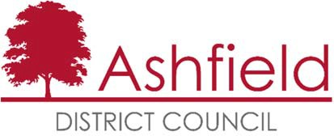

Ashfield Workforce Report 2020



# Table of Contents

**Page**

Executive Summary 1

Actions for 2020 1

Workforce Profile 2020 2

* Ashfield Workforce 2
* Workforce Diversity **4**
* Maternity/Paternity **6**
* Pay **7**
* Training **7**
* Recruitment **8**

Gender Pay Gap 2019 12

The Equality Act 2010 and the Public Sector Equality Duty requires all public authorities to publish equality information on their workforce to demonstrate that they are compliant and transparent in their practices. This report builds on the previous year’s reporting and forms part of the information that we collate, monitor and publish to help us ensure that equality considerations are embedded within our employment policies and practices and they meet our responsibilities under the duty.

## Executive Summary

Ashfield District Council workforce has slightly increased over the past year, at January 2020 there were 589 employees at the council, in January 2019 there were 578.

58.2% of the workforce is male and 41.8% female. Part time working is predominately female.

Just under half of the work force, 47.5%, falls within the age range 45 – 59, a small decrease on last year, although, thanks to increased availability and appointment of apprentices and trainees positions, the 16 -25 age group continues to increase from 6.2% in 2017 to 6.8%. This is a positive movement in line with the councils ongoing priorities.

The proportion of the workforce who consider themselves disabled has decreased slightly but remains higher than the proportion of the workforce in receipt of either the Disability Living Allowance or a Personal Independence payment.

The working age ethnic profile of Ashfield from the Census 2011 is predominately White British, 97.8% and Christian, 56.1% or no religion, 36.1%. At 97.8% White British the Ashfield workforce profile does not, however, adequately represent the BME profile of the district which will have become more diverse since 2011. The Council is aware that the recruitment process should continue to encourage and enable employees from minority ethnic and religious belief groups to join the workforce.

Although the median gender pay gap has increased, there is a mean pay gap which suggests that ranges of pay are spread fairly equally across the organisation but that the average pay for women is higher. In comparison to last year, this figure has changed from 0.45% to -0.44% suggesting that measures implemented to reduce this have had an effect.

## Actions for 2020

Continue the implementation of our Recruitment & Selection Strategy and our work towards becoming a more attractive employer for young people.

Continue to use on line adverts and jobs boards to advertise vacancies as widely as possible so that they are accessible to all possible candidates and therefore not advertise via routes that could attract traditional genders.

To actively encourage a more diverse workforce within the organisation and ensure BME representation across all levels of the organisation.

## Ashfield Workforce

In January 2020 there were 589 employees at the council, in 2019 there were 578 and in 2018 (612); an increase of 2% from 2019.

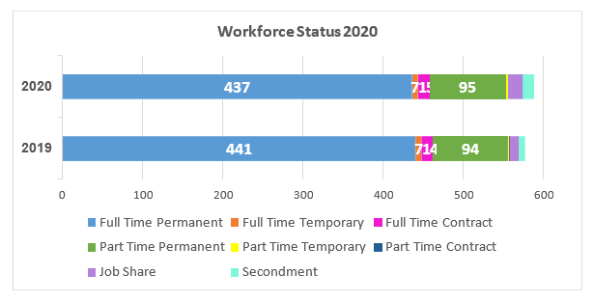

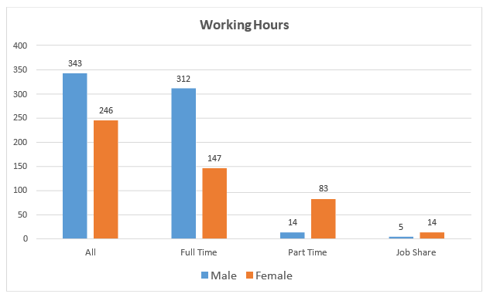

The proportion of males and females working for the council has remained relatively static e.g. males 58.2% from 58.8% last year.

**Age Range**

60.0%

50.0%

47.5%

40.0%

30.0%

28.9%

20.0%

10.0%

6.8%

8.8%

6.1%

1.9%

0.0%

16‐24

25‐29

30‐44

45‐59

60‐64

65+

% of Workforce 2018

% of Workforce 2019

% of Workforce 2020

The majority of people working for the council fall within the 45 – 59 age range. The proportion of employees under 24 continues to increase, there has also been an increase in the 60-65+ age range. Over all, there has been a continued increase in the proportion of under 30 year olds working at Ashfield District Council.

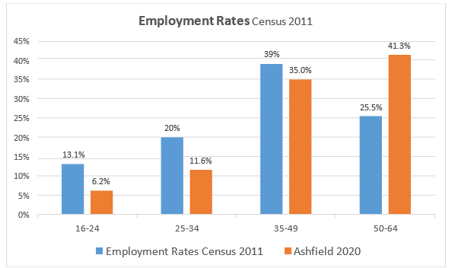

The number of people in each age band resident in Ashfield who were in employment at the time of the census and Ashfield Council 2018 employment figures

## Workforce Diversity

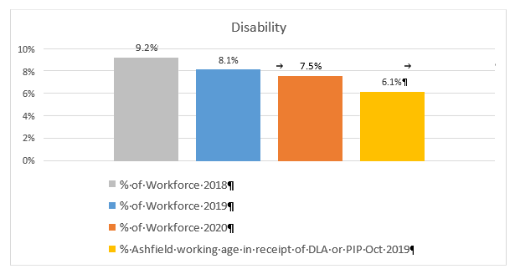

Census data does not directly relate to disability but whether health is limited. The DLA figure refers to Ashfield working age residents in receipt of a Disability Living Allowance or a Personal Independence Payment.

|  |  |  |  |  |
| --- | --- | --- | --- | --- |
| **Ethnicity** | **% of Workforce 2020** | **% of Workforce 2019** | **% of Workforce 2018** | **Ethnicity working age Census 2011** |
| **White** | 97.8% | 98.1% | 98.0% | 97.8% |
| **Asian** | 0.2% | 0.2% | 0.33% | 0.8% |
| **Black** | 0.5% | 0.7% | 0.49% | 0.5% |
| **Mixed** | 1.4% | 1.0% | 1.15% | 0.6% |
| **Chinese** | 0.2% | 0 | 0 | 0.2% |
| **Other** | 0 | 0 | 0 | 0.1% |

Ashfield’s population is predominately white British. The BME working age population of the district from the Census 2011 was 4.1%, this is likely to have increased since then. The BME proportion of the council’s workforce is 2.2%, a very slight increase on the previous year.

This will continue to be a key action; encourage applications from minority ethnic groups.

Since the 2011 Census there has been an increasing number of Eastern European migrants moving into the area, predominantly in Sutton in Ashfield and Hucknall.

However, the number of new registrations have declined over the past three years overall, but risen again in the past year. The table below shows National Insurance Registrations of Nationals from Overseas (NiNO).

NINO Registrations To Adult Overseas Nationals

300

250

244

200

150

100

59

50

28

0

0

EU

Non EU

Asia

Rest of World

2017 2018 2019

*DWP*

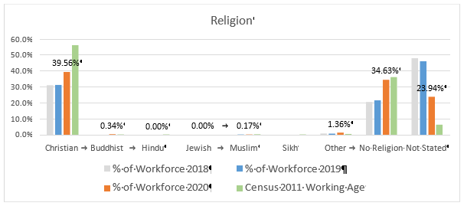

The number of employees who do not state their religions has declined in the past year whilst the number or employees who identify as ‘no religion’ or ‘Christian’ has risen.

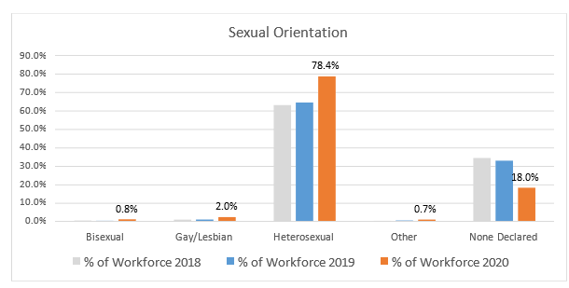

There is no district wide data available for sexual orientation but the proportion of the workforce stating that they are lesbian, gay or bisexual has remained similar on the previous year. The number of people who do not declare their sexual orientation have fallen, and those declaring themselves heterosexual has risen.

## Maternity/Paternity

In 2019 six employees took maternity leave and two paternity leave.

## Pay

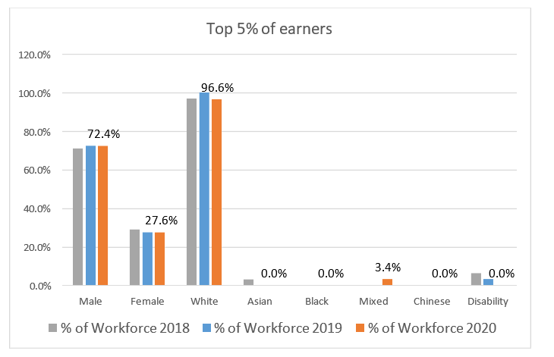

The number of top 5% of earners being male or female has stayed the same. 3.4% of the top 5% are BME and none are disabled.

The above figures of the top 5% of earners excludes CEO, Directors and Assistant Directors, they are NJC posts only. For JNC posts including CEO, Directors and Assistant Directors; 67% are female, an increase from 60% in 2019.

## Training

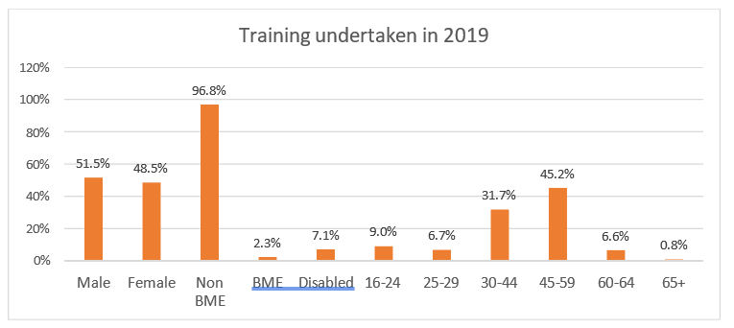

Ashfield has embedded an online training portal containing a wide variety of training opportunities, this is making access to training more accessible for all employees resulting in a significant increase in participation across all monitored protected characteristics.

## Recruitment

The Authority is committed to creating a diverse workforce that is fair and free from discrimination. Reasonable adjustments are made to support disabled people throughout the recruitment process and continue into their role if they are successful. The Authority retains its accreditation to the Disability Confident Scheme and the Mindful Employer Charter in 2019.

Turnover of staff across the year was 8.4% a decrease on 2019 (13.9 %).

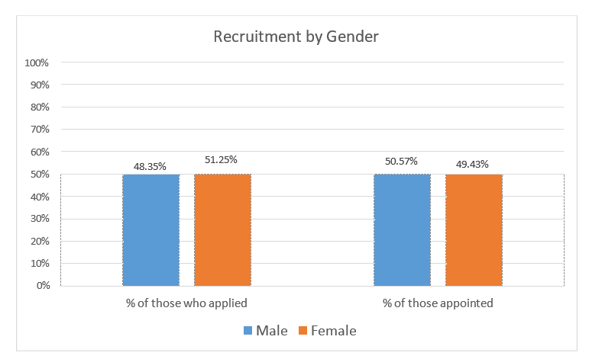

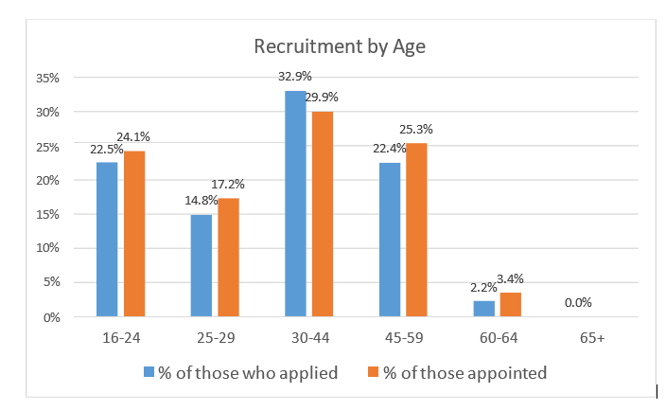

The % of overall applications from under 30’s continues to increase as does the appointments. This recognises work undertaken to increase awareness, availability and attractiveness of vacancies and the Council as an Employer of Choice, to young people such as apprenticeships and traineeships.

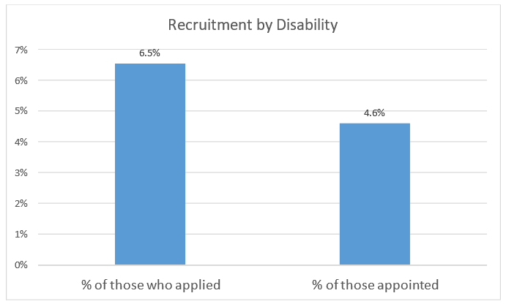

The % of applications from candidates stating a disability continue to increase; from 5.7% (2019) to 6.5% (2020), this increase continues amongst those appointed

from.2.2% (2019) to 4.6% (2020).

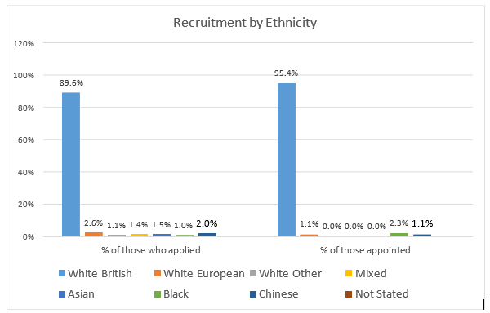

Recruitment has seen a slight increase within the White British cohort (88.9% to 89.6%) and percentage of those appointed (92.3% to 95.4%) with a corresponding decrease in other ethnicities.

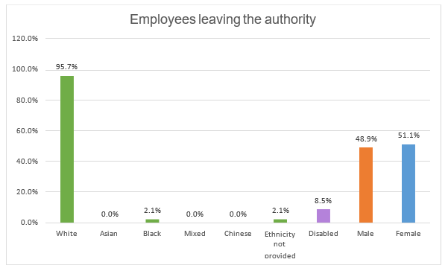

Figures based on permanent staff voluntarily leaving the Authority

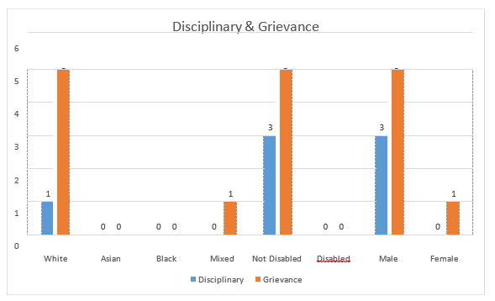

There has been a significant reduction in the number of disciplinary and grievance cases in 2019/20 across all monitored protected characteristics.

# Ashfield District Council - Gender Pay Gap Information – 2019

## Introduction

Under the Equality Act 2010 (Gender Pay Gap Information) Regulations 2017 the Council is required by law to publish an annual gender pay gap report. The information contained within this report is for the snapshot date of 31 March 2019.

## Summary of data

* + The mean gender pay gap is -0.44%
  + The median gender pay gap is -6.09%

Table 1. Comparison Female to Male in each salary range quartile

|  |  |  |  |
| --- | --- | --- | --- |
| **Quartile** | **Females** | **Males** | **Salary range** |
| Lower | 46% | 54% | £17173 - £19819 |
| Lower Middle | 29% | 71% | £19819 - £23111 |
| Upper Middle | 50% | 50% | £23111 - £29055 |
| Upper | 41% | 59% | £29055 and above |

Table 2. Breakdown splits of Female & Male percentage’s across the quartiles

|  |  |  |  |
| --- | --- | --- | --- |
| **Quartile** | **Females** | **Males** | **Salary range** |
| Lower | 28% | 23% | £17173 - £19819 |
| Lower Middle | 17% | 30% | £19819 - £23111 |
| Upper Middle | 30% | 21% | £23111 - £29055 |
| Upper | 25% | 25% | £29055 and above |
| Total | 100% | 100% |  |

The mean is defined as the average of the figures and is calculated by adding up all the figures and diving by the number there are. The median is defined as the salary that lies at the midpoint and is calculated by ordering all salaries from highest to lowest and the median is the central figure. The quartile information is calculated by listing all salaries from highest to lowest and the splitting that information into four equal quarters to determine the percentage of male / female employees in each quartile.

All the figures set out above have been calculated using the standard methodologies used in the Equality Act 2010 (Gender Pay Gap Information) Regulations 2017. Although reporting of the salary ranges for the quartiles is not required, this has been provided for additional information.

## Analysis of data

In comparison with other similar organisations, the gender pay gaps identified do not appear to be large and are therefore not significantly concerning. The hourly rate differential based on the mean is 6 pence per hour and the median differential is 63 pence per hour.

Although the median gender pay gap has increased, there is a mean pay gap which suggests that ranges of pay are spread fairly equally across the organisation but that the average pay for women is higher. In comparison to last year, this figure has changed from 0.45% to -0.44% suggesting that measures implemented to reduce this have had an effect. The mean gender pay gap is likely to be due to the change in the organisational profile as there is a reduction in number of employees with a higher reduction of men to women and in addition there has been an increase in the percentage of men in the lower middle quartile.

The quartile data also outlines that there is an increase, since 2018 in the percentage of females in both the lower quartile and the upper middle quartile, increasing by 1.44% and 3.14% respectively as illustrated in Table 2.

Further analysis of the data indicates that the lower middle quartile which has seen a the greatest increase for males with 71 % in this quartile being male, as detailed in Table 1, one of the key reasons for this is that it contains a high proportion of trade posts such as joiners, painters etc as well as Refuse Drivers. This would suggest that the disparity continues to be due to employment of men and women in posts that traditionally attract specific genders. The Council recognises that although actions are in place to try to address this, it will take time to change these social and historical norms.

The Council remains committed to the principle of equal opportunities and equal treatment for all employees and has a clear procedure to ensure employees are paid equally for the same or equivalent work, regardless of their sex or any other protected characteristic. In 2014 the Council implemented job evaluation and undertook a comprehensive review of pay and allowances to address a number of factors which significantly improved the gender pay gap position. As part of that scheme the Council also evaluates job roles as necessary to ensure a fair structure. In 2016 the Council brought the ALMO back into the Council which included the transfer of a large number of craftworkers. Service reviews are still ongoing, and as these progress all employees, including craftworkers, are likely to transfer onto Council terms and conditions. Although a number have transferred onto the Councils terms and conditions, the impact of this on the gender pay gap is yet to be fully determined.

## Action to be undertaken to address the gender pay gap

Although the gender pay gap is not significant enough to be a cause for concern the organisation will continue to implement actions as detailed below to address the disparities.

* + Continue to use on line adverts and jobs boards to advertise vacancies as widely as possible so that they are accessible to all possible candidates and therefore not advertise via routes that could attract traditional genders.
  + The Council is still involved in an initiative to promote flexible working, particularly in more senior posts / professional posts, and will continue build on the work of this initiative to ensure that all vacancies are advertised as flexible and encourage applicants to approach managers to discuss flexible working requirements at appointment stage. As part of promotion of flexible working managers undertook training in 2018 to encourage them to analyse vacancies before appointment to

determine if the post could be redesigned more flexibly, in addition vacancies are reviewed at CLT to challenge managers when reviewing vacancies.

* + The competency framework has been embedded which looks at values and behaviours. This is supported by selection exercises in recruitment, and in combination these aim to reduce any in built bias to recruit people from a specific gender into traditional gender dominated posts. In 2018 managers have received training about using selection exercises in recruitment and selecting appropriate exercises depending on the vacancy being advertised.
  + Engaging young people early on (for example via apprenticeships) to try and encourage applications from under-represented groups in traditional gender dominated posts.