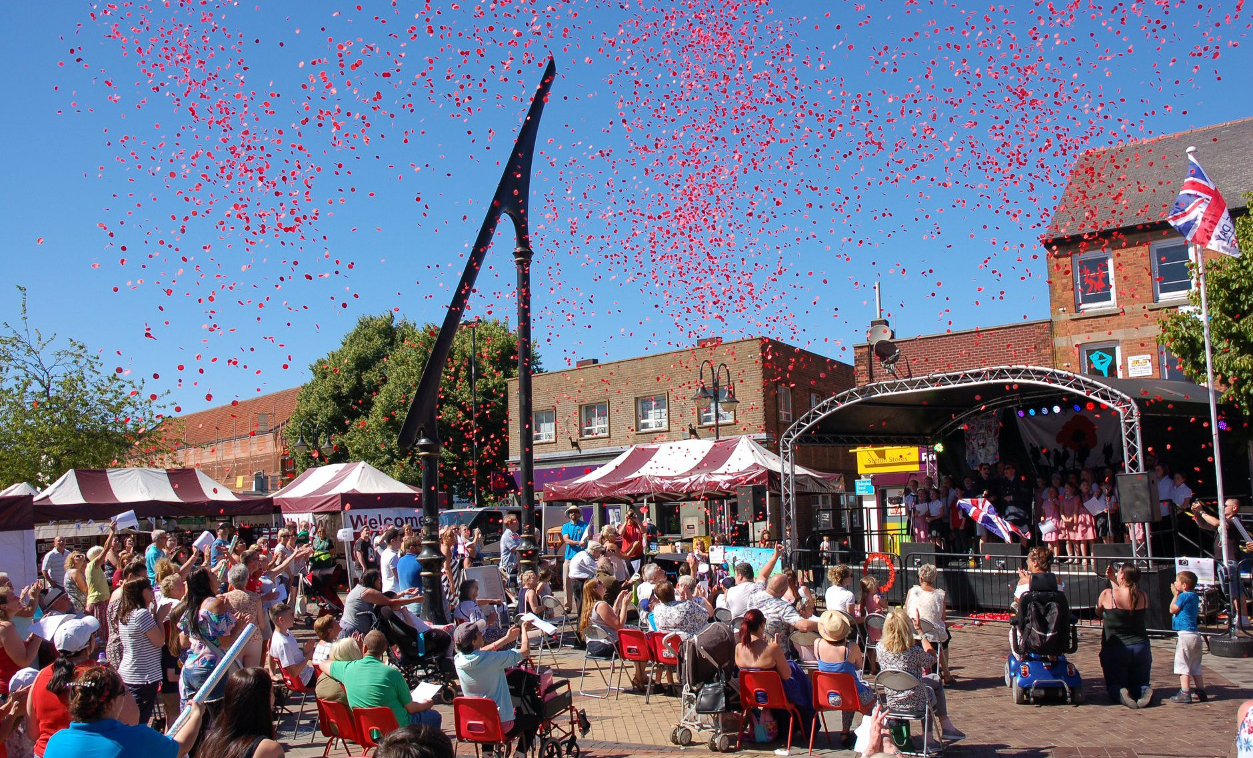
A Tenant’s Guide to Moving Home
Sutton Town Centre Spatial Masterplan
March 2019

2

Contents
PREFACE 5
Chapter 1. Introduction 7
  - Economic Overview
  - Purpose of the Spatial Masterplan
  - Sutton and its Geographical Context
  - Study Area
  - Vision Statement
  - Concept Plan

Chapter 2. Planning Policy 15
  - National Planning Policy Framework
  - National Planning Policy Guidance
  - Local Development Documents

Chapter 3. Baseline Summary 17
  - Historical Evolution
  - Retail Provision
  - Employment Provision
  - Housing Provision
  - Transport and Accessibility
  - Public Realm, Community Services and Leisure

Chapter 4. Principal Challenges 22
  - Prinicpal Challenges

Chapter 5. Spatial Masterplan Principles 23
  - Maintain and Enhance Character and Identity
  - Improve the Quality of the Public Realm
  - Promote Ease of movement
  - Improve Legibility
  - Ensure Adaptability
  - Maintain and Improve Diversity
  - Support Sustainability

Chapter 6. Town Centre Spatial Masterplan 27
  - Town Centre Core
  - Historic Core
  - Gateways

Chapter 7. Spatial Masterplan Delivery 37
  - Delivery Partners
  - Funding Delivery
  - Delivery Mechanism
  - Next Steps

Appendix 1 39
SWOT Analysis 3

PREFACE

“Our priority is to build community pride and aspiration across Ashfield. We want residents to be proud of where they live and see our town centres as a safe place to shop and visit.
Increasing visitors and inward investment into the town centre is also important. The Sutton Town Centre Spatial Masterplan will be a key document in achieving this.”

Councillor Jason Zadrozny, Leader of the Council

The Council has a Place Enhancement Programme, part of which is to create the ‘Ashfield Story’ identifying what makes the area distinctive to build community pride and encourage inward investment.
The Discover Ashfield brand has been developed by private and public sector bodies to promote Ashfield, increase pride and aspirations in our communities, improve the vibrancy of our town centres, encourage and promote inward investment and support tourism and the visitor economy in the Ashfield area. Sutton town centre has been identified as a priority.

The Spatial Masterplan forms one strand of the Place Enhancement Programme.

“As someone who not only lives in Ashfield but chooses to run their business from Ashfield, I am very excited to be involved with the Discover Ashfield initiative and the development of the Sutton Town Centre Spatial Masterplan.

This is a great chance for people from within Sutton and externally to see what I have known for years. The people we employ from within the local community have a great can do attitude and this is
reflected within their commitment and ability to deliver. Sutton Town Centre has businesses with a national recognised brand as well as numerous indepentant retailers and business providers who are really part of the working heart of the town centre.

The demise the traditional industries of mining and textiles has had a great impact locally, but it’s time to look ahead with a renewed optimism. To me Discover Ashfield and the Sutton Town Centre Masterplan will provide the necessary framework for our community and businesses to look ahead and seize the opportunities we have, so we can really make this a fantastic place to grow your business, to live, and visit.”

Martin Rigley,
Board Chair for Discover Ashfield

Chapter 1. Introduction

Economic Overview

We are living in a time of dramatic structural change in our town centres, brought about by factors largely out of local control:

    - Out of town retail parks, with free parking and which offer a broad mix of retail and leisure, continue to create new destinations to the detriment of traditional centres;

    - Technological changes have over the past few years, seen a major shift to on-line shopping, in many cases, negating the need for bricks and mortar. This is likely to continue;

    - The national business rates’ regime has hampered start-ups and has driven other retailers from the high street;

    - Prevailing economic conditions since 2008 have led to many high profile national retailers either going into administration or undertaking financial restructuring at a cost of thousands of jobs;

    - Consequently the number and type of shops being occupied in town centres has continued to decline and/or change at a faster rate than ever before. The structure of town centres has changed from a simple goods’ transaction to a more complex mix of retail, leisure, food and drink, events, commercial, residential, health and education.

What does this mean for Sutton?

Sutton is a traditional small town centre with a good mix of national and independent retailers, along with an indoor shopping centre and a market. It is the largest centre within the Ashfield District and is generally well used by the resident population. It has convenient and cost effective car parking and is surrounded by residential areas.

Ashfield District Council has recently prioritised investment into Sutton, ie:

    - £1.4m refurbishment of the Idlewells Indoor Market to create a modernised market offer;

    - Successful relocation of the outdoor market on to Portland Square, to create a more coherent town centre offer;

    - Acquisition and demolition of the former Conservative Club on Fox Street, to create a development opportunity;

    - Demolition of the redundant Fox Street Council offices to create a development site;

    - Investment in a shop front improvement grant scheme. 7

Despite this, Sutton Town centre is still dependant on a few large retailers and is not diversified economically. At the time of writing vacancy rates stand at 15%, which is above the national average of 9%. Its retail spreads out beyond the core centre on to Outram Street and this dilutes the offer. There is little night-time economy (eg. bars, restaurants, events or entertainment space) to bring people in in the evening. This means that it is largely deserted after the shops have closed. Sutton is therefore in danger of being left behind and becoming irrelevant unless action is taken.

Place Shaping - Re-thinking Sutton Town Centre

We want Sutton Town Centre to have a bright and successful future. For this to happen, there is a need to proactively rethink its purpose, both physically and economically. The Spatial Masterplan sets out the framework for future investment and development by identifying a common understanding of Sutton Town Centre as a physical Place. In addition to the Masterplan, a range of supplementary economic initiatives are considered to be essential in bringing a new purpose to Sutton Town Centre.

Ashfield District Council has recently facilitated a private sector led partnership “Discover Ashfield” to lead on the repurposing of the district and its town centres. This work provides a great opportunity to develop a true and sustainable partnership approach to Sutton’s future.

The following list sets out some high level ideas to make Sutton Town Centre fit for the future. Most of these ideas cannot be delivered by the Council working alone. They (and any others subsequently proposed) will need a broad mix of other public, private, voluntary and community sector partners to shape and lead on delivery; including landowners, proprietors, funders and statutory agencies.

- Consideration of the appropriate mix of retail: nationals, local boutique style independents, markets, incentives for start-ups;

- Other leisure uses to encourage more footfall and a greater length of stay: choice of food and beverage (cheap and cheerful, family friendly, trendy, gourmet), health and beauty, leisure and community facilities;

- More events to draw people in;

- High quality public realm and street furniture. Agree and provide a consistent palette of materials;

- Digital connectivity and investment into Smart town/city concepts - Free Wi-Fi;

- A vibrant and safe night-time economy, which again links to a greater choice of food and beverage, events and leisure activities. This will need to be linked to measures to combat any threat of anti-social behaviour;

- A high quality environment and greenspace offer, e.g. an urban park, green trail, public art. Care will be taken to design out crime and anti-social behaviour;

- Encouragement for commercial businesses to locate in Sutton in low cost office accommodation. Possibility for the Council/Local Enterprise
Partnership (LEP) to provide start up workspace accommodation: following on from the success of Ada Lovelace House in Kirkby, a similar development for Sutton Town Centre could improve the number of professional workers and business owners using the town centre;

- Where necessary, the Council will continue to take strong enforcement action to deal with dereliction and blight in retail, commercial and industrial premises;

- The Council will utilise new Supplementary Planning Guidance on conversions of vacant retail units into residential properties (where appropriate) and work with owners of other vacant premises to bring them back into productive use;

- The Council will encourage repurposing long term vacant retail premises in secondary or tertiary locations in order to protect the integrity of the Town Centre;

- The Council will develop (through the LEP or via the Future High Street Fund) opportunities for future grants for: shop front improvements; conversions to other purposes, and; to bring derelict properties back into productive use. This will require an element of match funding by proprietors;

- The Council will pursue more opportunities for residential developments in order to boost town centre living;

- Collaborative working with the owners of the Idlewells Shopping Centre and the National Association of British Market Authorities (NABMA) to develop a 21st Century market, encouraging such things as make to sell, artisan food, fashion and other niche offers not available elsewhere;

- Through the Council’s ‘Place’ agenda:

  - Work with all proprietors to facilitate a great customer experience, which will give Sutton Town Centre a positive reputation;

  - Use the newly re-established ‘Town Teams’ to develop and deliver a high standard of customer care, attractive shop fronts and windows, use of
IT and social media. They will build on existing initiatives in Ashfield in terms of Dementia Friendly and the Have a Seat campaigns;

  - Develop a Business Improvement District (BID) if this is required by businesses;

  - Consider what community aspirations exist with regard to town centre facilities, in particular making use of vacant sites or buildings;

  - Ensure high levels of public safety and usage of Public Space Protection Orders (PSPOs) where required to deter anti-social behaviour;

Purpose of the Spatial Masterplan
The Masterplan provides a refresh and update of the 2007 Masterplan for Sutton in Ashfield (and Kirkby in Ashfield) undertaken by ARUP.

The new Spatial Masterplan for Sutton Town Centre will help to realise the Council’s key priorities:

“to ensure the economy, and community pride and aspiration are key areas for development for the District”

“to enhance the identity of Ashfield and raise its profile as a place to live, visit and work”

The Spatial Masterplan aims to provide a framework for future
investment and development which maximises the opportunities for Sutton and capitalises on its existing assets.

In particular it:
- Provides a consensus and common understanding of Sutton Town Centre as a place.

- Establishes a clear Vision for Sutton Town Centre to guide its development and improvements to 2029.

- Provides clear design principles for subsequent new development/projects with an emphasis on sustainability.

- Identifies sites and building where redevelopment and improvements will be encouraged.

- Aims to improve links to and within the Town Centre for pedestrians, cyclists and public transport users.

- Sets out how developments/projects and initiatives could be delivered, who would be involved in delivery, how they might be funded and by what mechanism.

- Provides an evidence base for the emerging Local Plan.

The Spatial Masterplan is not inflexible or prescriptive, nor does it represent a commitment to funding by the District Council.

Sutton and its Geographical Context
Sutton-in-Ashfield (or Sutton) is the largest of Ashfield’s three town centres and is at the top of the District’s town centre hierarchy, being identified as a sub-regional centre1. The town performs an important role as a retail and service destination for the local area, as well as the nearby smaller centres. The 2011 Census sets out that Sutton has a population of circa 46,000 people, and is the location of a significant amount of the District’s employment.

Sutton is located approximately 5km to the west of Mansfield, 12km to the north west of Hucknall and 26km to the north west of Nottingham. The town is easily accessed from the A38 which connects Derby to Mansfield, and from Junction 28 of the M1 motorway. Figure 1 below shows the geographical context of the town.

Figure 1: Context Map
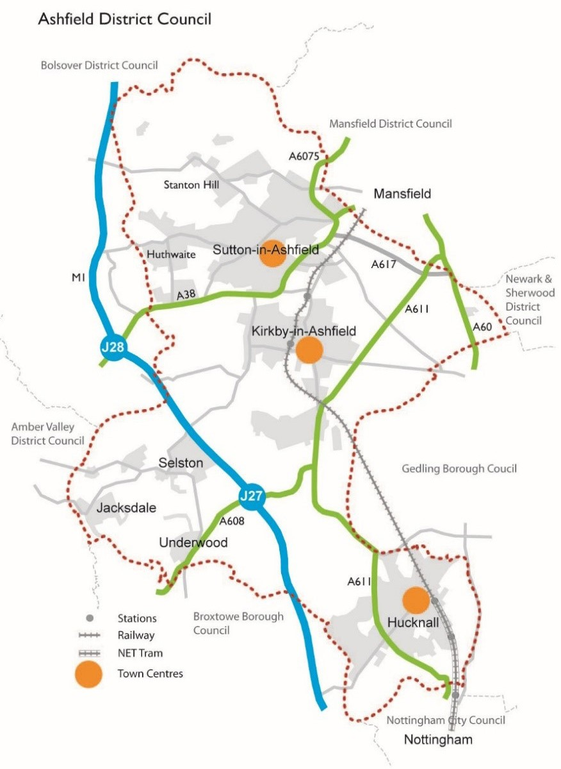

Whilst Sutton cannot directly compete with its adjacent competitors; Mansfield and Nottingham, it is important that the town centre continues to provide an attractive environment and retail/leisure offer that appeals to a more local catchment. The town needs to take full advantage of its assets including its history and heritage, the attractive indoor market and Idlewells Shopping Centre, the presence of Asda as a major attractor and its walkable centre.

1Ashfield District Retail and Leisure Study, August 2016 - Nexus Planning 11

Study Area
The boundary of the study area is shown in figure 2 below, and reflects the Town Centre boundary as identified in the adopted Ashfield Local Plan Review 2002.
Figure 2: Boundary of Study Area

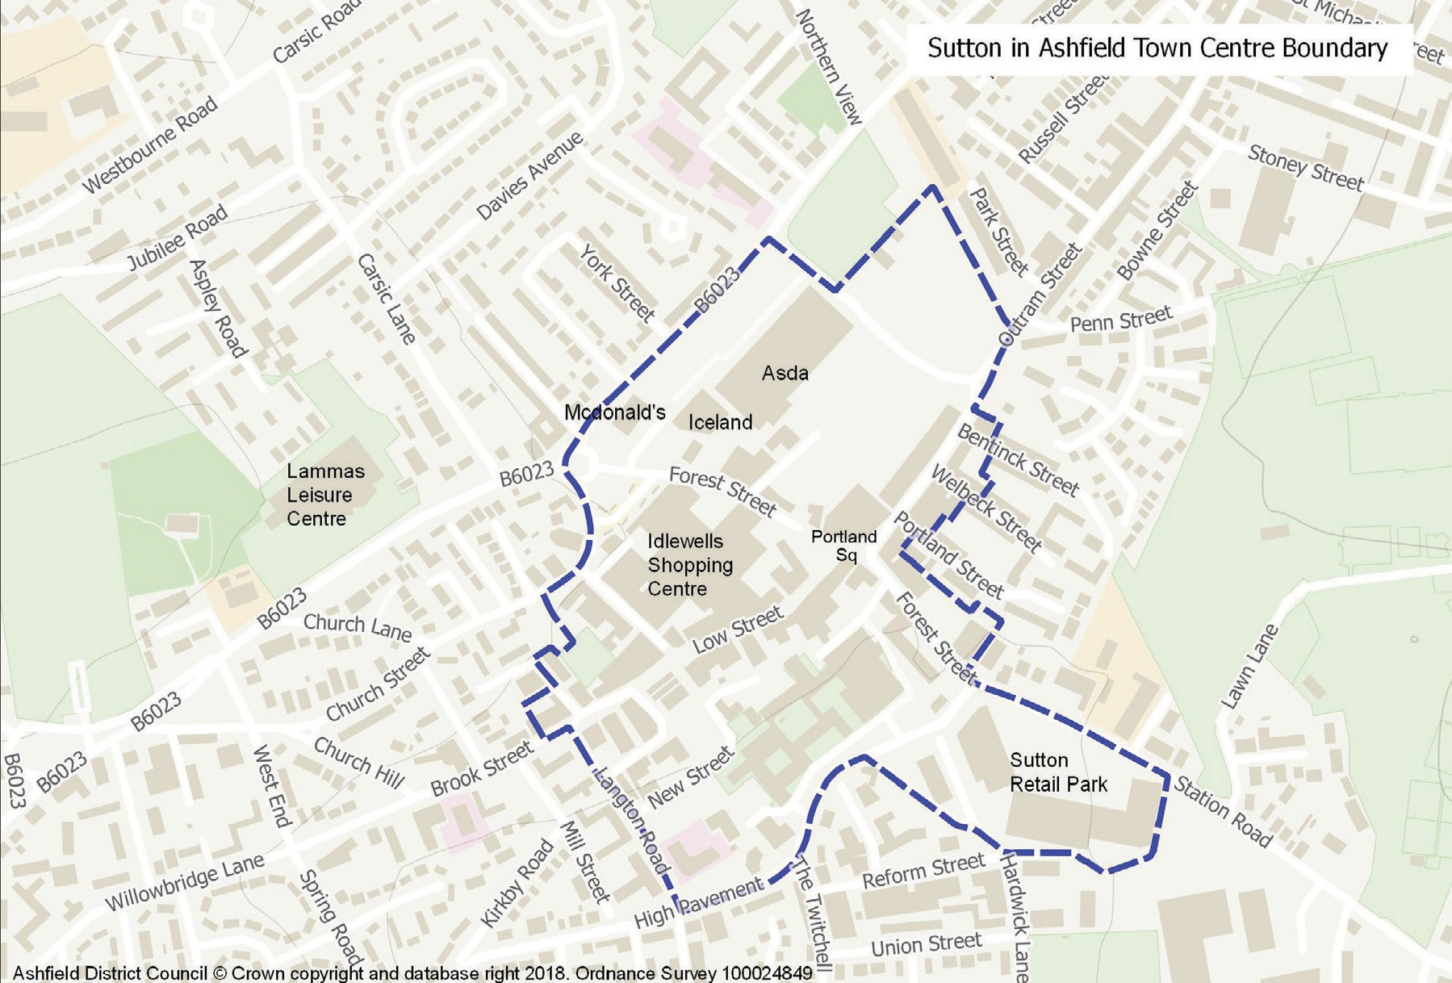

Sutton’s central shopping area falls into two distinct areas divided by the pedestrianised Portland Square and Forest Street. To the south side is the Idlewells Shopping Centre and the pedestrianised areas of Low Street, Brook Street and the Market Place. To the north side is Outram Street to Northern Bridge and the Asda complex containing McDonald’s and Iceland. Two markets operate within the town including an open market at Portland Square and an indoor market hall at the Idlewells Centre.

Vision Statement
The vision statement below has developed from a combination of relevant matters taken from the first Masterplan (2007) and the pertinent points of more recent work undertaken by consultants, workshops, officer walkabouts and SWOT analysis (Appendix 1). This vision has guided the development of the Spatial Masterplan.

A Vision for Sutton Town Centre
“To create an active and vibrant town centre through encouraging a mix of uses that will increase the number of people living, working and visiting the centre, set in an environment residents are proud of.”

To strengthen connections across the town centre linking key destinations and promoting activity.

To enhance the townscape by ensuring that new development respects the town’s heritage around Brook Street, Market Square, Portland Square and Fox Street, and offers high quality design.

To promote the towns brand, attract visitors and enliven the town centre through events and activities.”

Concept Plan
The Concept Plan shown on the next page has evolved through the Master Planning
process and shows key opportunity for improvements, pedestrian linkages, key intersections and barriers to the town centre. It is from this Concept Plan that the Illustrative Masterplan in Chapter 6 has been developed.

SUTTON IN ASHFIELD
TOWN CENTRE MASTERPLAN - CONCEPT PLAN

OUTRAM STREET LOCAL CENTRE
Rev B. February 2019 . NTS
Priestsic Road

LAMMAS LEISURE CENTRE

GATEWAY
Devonshire Square

ASDA SUPERSTORE

ASDA
Car Park

OUTRAM STREET (SOUTH)

Station House
Fox Street
GATEWAY
Northern Bridge

SUTTON CONSERVATION AREA
KEY

Gateway Entrance Civic Space Primary Street Secondary Street Pedestrian Linkage Node / Intersection Barrier
Town Centre Core

Historic Core

Development Opportunity Site

Primary Shopping Area
Low Street

Bus Station

Indoor Market

Market Place Car Park

Albert Square

IDLEWELLS SHOPPING ARCADE

Portland Square

TOWN CENTRE CORE

SUTTON COMMUNITY ACADEMY

PRIMARY SHOPPING AREA
Forest Street

GATEWAY
Forest Street
Station Road

HISTORIC CORE
High Pavement

GATEWAY
Brook Stree t

Car Park

THE BROAD CENTRE RETAIL PARK

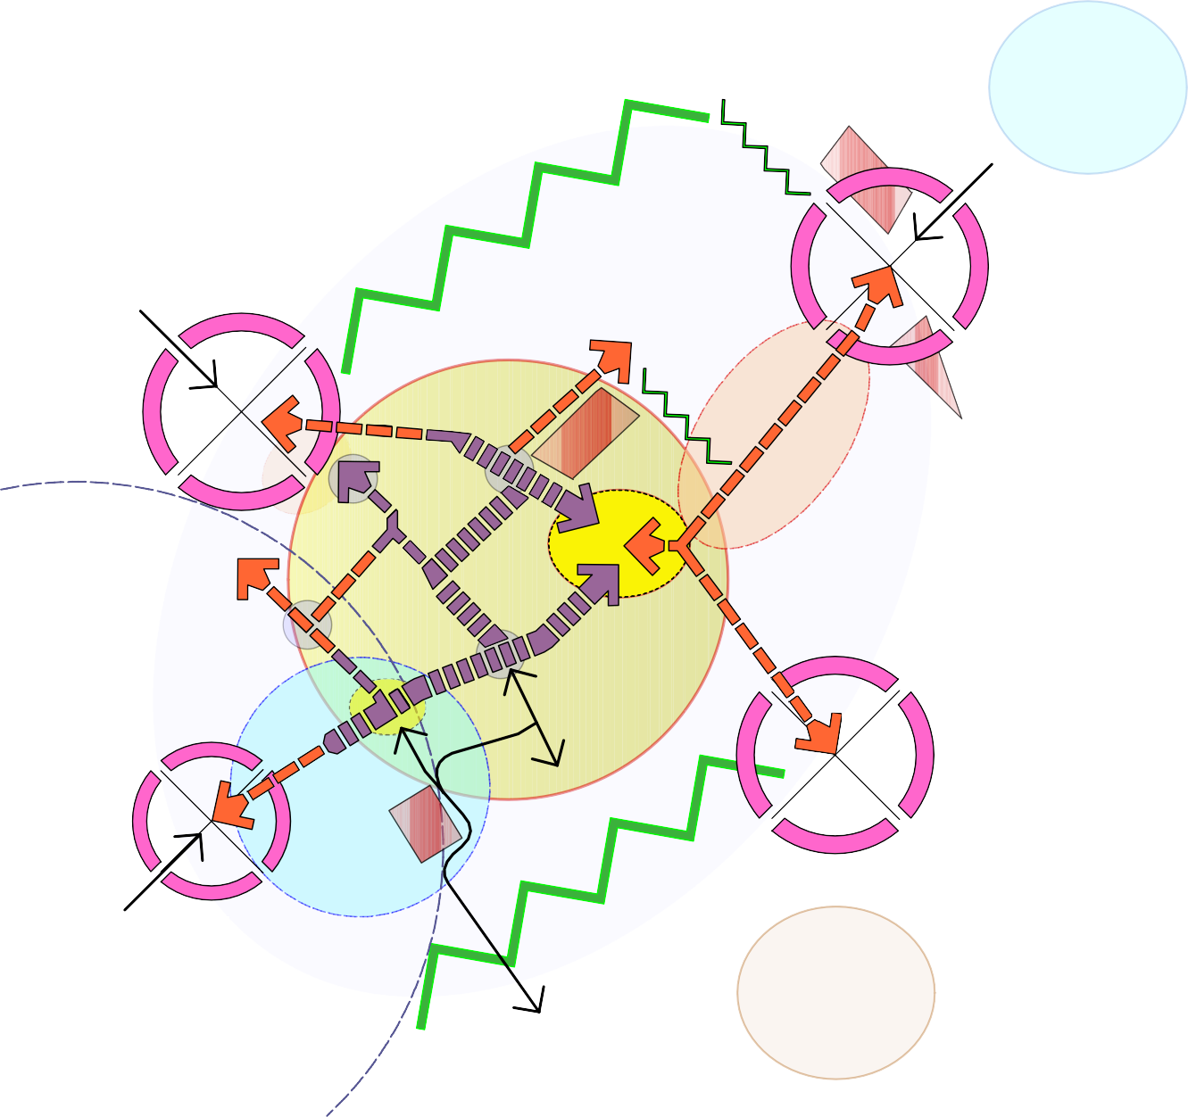

14

Chapter 2. Planning Policy

National Planning Policy Framework
The National Planning Policy Framework, 2018 (NPPF) sets out the Government’s planning policies for England and how these should be applied.

The Framework recognises and stresses the importance of promoting the vitality and viability of town centres. It identifies that planning policies and decisions should support the role that town centres play at the heart of local communities, by taking a positive approach to their growth, management and adaptation.

National Planning Policy Guidance
National Planning Policy Guidance (NPPG) adds further context to the NPPF and, as such, the two documents should be read together.

The NPPG entitled ‘Ensuring the Vitality of Town Centres’ was published in March 2014 and an online tool provides a synopsis of how retail and main town centre planning policy should be applied in practice.

The NPPG supports councils in planning effectively for new development supporting town centres and states that:
“Local planning authorities should plan positively, to support town centres to generate local employment, promote beneficial competition within and between town centres, and create attractive, diverse places where people want to live, visit and work.”

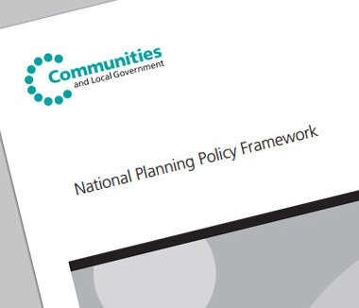

Local Development Documents

Ashfield Local Plan Review (ALPR)

The Council’s current Local Plan was adopted in 2002, prior to the enactment of the NPPF. Despite its age, the Local Plan still includes a number of planning policies that are largely compliant with guidance set out NPPF and NPPG in that they encourage the promotion of town centres. Notably, the adopted Local Plan identifies and sets out a
hierarchy of the District’s centres, identifies the boundaries of primary shopping areas, and includes policies that seek to promote its town centres competitive performance.

Emerging Ashfield Local Plan

At the time of writing (2019), the Council is taking the preliminary steps necessary to prepare a new Local Plan consistent with the requirements of the NPPF. Housing growth, the local economy and the health of town centres, are amongst the issues to be addressed through the new Local Plan.

Sutton in Ashfield Church & Market Place Conservation Area Appraisal & Management Plan

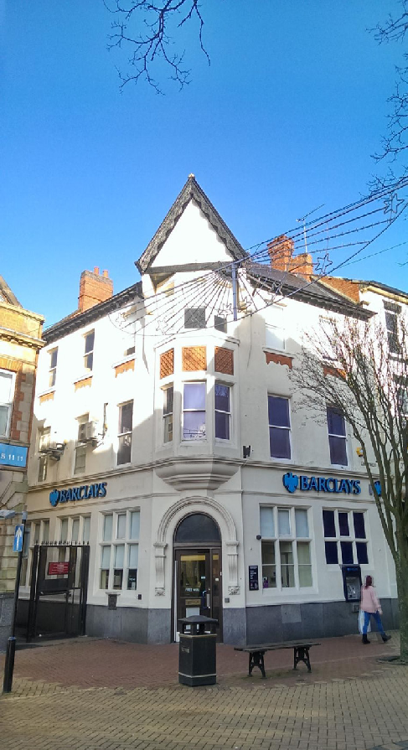
The Council formally adopted the Sutton Conservation Area in July 2015. The Conservation Area Appraisal forms part of the evidence base for the Masterplan and is a material consideration in planning decision making. The Appraisal document will be one of the most direct and effective means of managing the conservation area in the long term. For example, it helps define the plan form, scale of building, materials, traditional detailing, important views and trees etc. These elements need to be considered when looking at any development proposal within the Conservation Area.
July 2015
Sutton in Ashfield Church and Market Place Conservation Area Appraisal &
Management Plan
There will be a presumption against
demolition or loss of any feature that is identified as contributing positively to the significance of the conservation area. The appraisal can be viewed on the Council’s website: www.ashfield.gov.uk
Administrator
Bassetlaw District Council
[Pick the date]

Chapter 3. Baseline Summary

Historical Evolution
Below is a brief history of how Sutton in Ashfield has grown into the town we know today:

Prehistoric and Roman: Historically considered to have been a remote wooded area of little interest to early settlers, not much can be said about the pre-historic and Roman landscape. There is, however, evidence of early human activity in the area. It is recorded that whilst foundations were being dug at St Michael’s Street in 1892, eight skeletons were discovered.

Medieval: The name ‘Sutton’ certainly suggests that there was a settlement during the Anglo-Saxon period as ‘ton’ is an Anglo-Saxon suffix meaning a place fenced around or an enclosure. This enclosure was no doubt within the forest which the additional name ‘Ashfield’ infers. The underlying geology of magnesian limestone allows trees to grow well and ash trees were prolific in this part of the country.

Post Medieval (16th – 19th century): The forest land increasingly becomes turned over for farming in the 17th century through the process of enclosure with the Enclosure Act of 1801 leading to full enclosure of the land. By the early 17th century the main roads that are shown around Sutton on the enclosure map (Figure 3) are already in existence.

Figure 3: The 1801 Enclosure Map
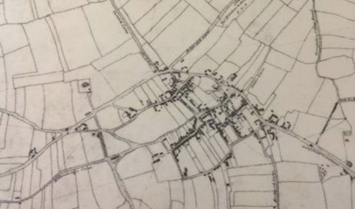

During the 17th century the town becomes identified with the textile and hosiery industry when looms and frames were introduced into houses. These frames and looms were the turning point in the character of Sutton in Ashfield, although it was the Unwin family who settled here in 1705 who can be accredited for taking Sutton from an agricultural village to an industrial town. Unwin’s mill attracted people to the town in search of work, as a result houses sprang up everywhere under little or no control creating areas of slum housing (which was subsequently cleared from the 1930s).

The growth of industry in the town is reflected by the population figures. In 1295 the population was estimated at approximately 400 people2 and only approximately 500 people by the beginning of the 18th century. A hundred years later the Parliamentary Census of 1801 recorded a total of 2,801 people living in the town. The population steadily increased through the 1800s and by 1891 it was recorded at 10,552 residents, a
five-fold increase. Today the population is approximately 46,000. Figure 4 below show the town’s growth between 1875 and 2018.

Figure 4: Sutton’s growth between 1875 - 2018
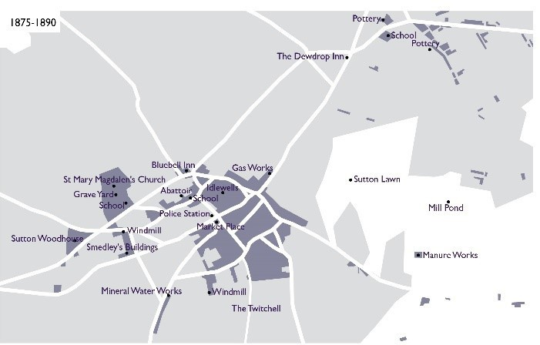
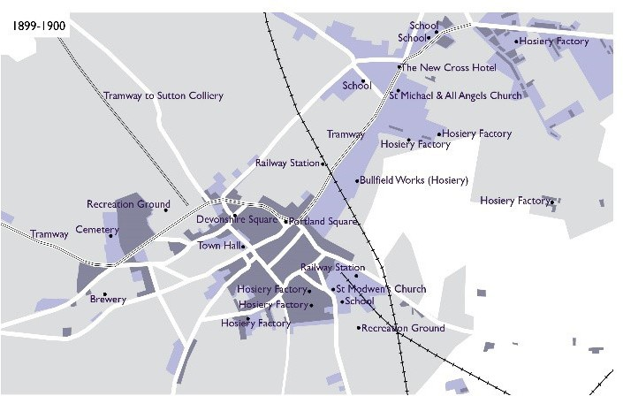

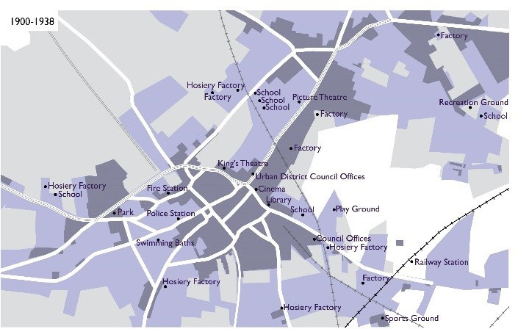
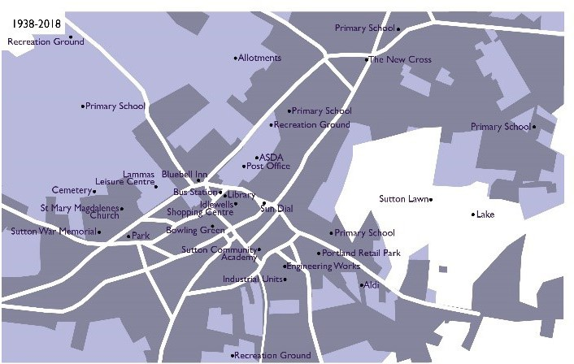

The textile and hosiery industry continued to be the principal employer in the town throughout the 19th century. The well-known hosiery firm ‘Pretty Polly’ was established in Sutton in Ashfield in 1919.

By the end of the 19th century the sinking of the collieries introduced the new industry of coal mining to the area, with each colliery employing up to 1500 people. The pits created a need for new housing and brought greater economic prosperity to the area during the 20th century until their closure in the 1980s and 1990s.

Sutton’s industrial heritage brought many new people to the town, however it was the forming of the ‘Local Board’ in 1866 (which later became the Urban District Council in 1894) that resulted in new infrastructure and civic spaces being created. The Local Board and District Council introduced (alongside private enterprise) and implemented many changes to the town including;
- Opening of Junction Station in 1850.
- First public library established in 1857.

2Bonser G.C. 1949. A history of Sutton-in-Ashfield 18

- Establishment of markets in 1868.
- Approval of plans for the laying out of the district around New Cross in 1869.
- Purchase of the Gas Works in 1877 and approval of the new Outram Street.
- New water works to supply the town opened in 1884.
- Building of Town Hall on Brook Street in 1888.
- Opening of town cemetery on Huthwaite Road in 1892.
- Opening of Midland Railway Station on Forest Street in 1893.
- Opening of Great Northern Railway Station on Outram Street in 1898.
- Opening up and redevelopment of the Market Place in 1905.

The 20th Century: The 20th Century witnessed the continued growth and development of Sutton, new commercial premises were built throughout the town notably along Outram Street during the 1920s and 1930s. Much new development occurred during the 1960s and 70s with the most notable change happening in the 1970s with the building of the Sutton Centre (Sutton Community Academy) which provided educational and recreational facilities for the town and the construction of the Idlewells shopping centre, built on the site of former slum housing. This provided the town with a new shopping area, library, indoor market and bus station. New investment followed shortly such as the new Fine Fare supermarket (now ASDA) however frequently new development has resulted in the loss of both architecturally and historically significant buildings in the town.

Retail Provision
Sutton is the most commonly visited centre in Ashfield and is a town centre facing challenges. The town has a high proportion of independent traders and high vacancy rates. Key attractor multiple retailers are present in proportion to the centre’s size, with Asda serving as the key retailer within the centre. Nevertheless there is an over-representation of convenience retailing (10.3% against the national average of 8.6%), building societies and travel agencies and an under-representation (13.2% compared to the national average of 22.7%) of restaurants, cafes, bars, cinemas and hotels3 . The centre also faces significant competition from major centres within and outside the region.

Employment Provision
Sutton accommodates substantial industrial and distribution sites with large clusters of manufacturing firms close to Junction 28 of the M1 and alongside the A38, such as
Castlewood Business Park and Fulwood Industrial Estate. It is likely that large firms have been attracted by the proximity to strategic transport links (M1 and the A38), combined with a competitive labour market. A number of smaller units are located around the edge of the Town Centre in the area of Stoney Street and Reform Street service a more local market.

3Ashfield District Retail and Leisure Study, August 2016 - Nexus Planning
4Nomis Labour Market Statistics –Ashfield – Employee jobs (2017) 19

The Council’s Employment Land Forecasting Study5 sets out that commercial agents identified a limited demand for office space, particularly in the Town Centres. However, this may result from existing office premises which do not meet occupier requirements in terms of size, specification and location. There has been little speculative office development in the Town Centre, which is typically held back by rental levels that offices could currently command in the area. A recent market analysis6 has identified that whilst Sutton’s market would perhaps not support a large purpose built managed office block just yet, there is the possibility that in the future demand for Grade A7 serviced office accommodation could arise in the locality. Accommodation could be delivered through mixed use or stand-alone premises, incorporating small flexible office suites the key to building performance.

The construction sector and health sector are other large-scale employers in Ashfield with King’s Mill Hospital being located towards the eastern fringe of Sutton. However, neither of these sectors are anticipated to have a significant impact on Town Centre employment opportunities.

Housing Provision
Average house prices in Sutton are substantially lower than the national average, however, this is a common factor across the midlands and northern regions, with national averages influenced heavily by southern markets. Whilst the cost of market housing in Ashfield generally is comparatively low compared with some neighbouring Districts, lower than average earnings means there is still a demand for affordable housing, in particular for newly forming households. Consequently there may be a level of demand for low cost housing in the most sustainable locations for those on low incomes and younger members of population for whom entry on to the housing market as a first time buyer is becoming increasingly delayed.

It is widely acknowledged that the improvement of retail zones within a town centre location has a direct correlation with increased pedestrian flow, and therefore improves with an influx of population. Consequently, residential development within the locality of the town centre could be considered for higher density schemes and is particularly suitable for housing for those with access needs. Good access to services/employment opportunities within walking distance will not only assist with the cost of living for occupiers, but also reduce reliance on motor vehicles (hence an environmental benefit) and ultimately help to boost the town centre economy.

5Nottingham Core HMA and Nottingham Outer HMA Employment Land Forecasting Study 2015 Nathaniel Litchfield and Partners
6Pygott & Crane Commercial Market Review – Sutton in Ashfield 2018
7The Building Owners and Managers Association identifies that a Grade A building has ‘high quality standard finishes, state of the art systems, exceptional accessibility
and a definite market presence.’ 20

Transport and Accessibility
Sutton enjoys an excellent location with good access to the national road network (see Figure 1: Context Map in Chapter 1). It also has good parking provision within the town centre and a bus station close to the major areas of retail activity. The town centre is not directly connected to the rail network.

Pedestrian connectivity across the town centre is considered poor. Barriers are visual and physical. Improvements to the public realm can assist in guiding movement, but there are opportunities as a result of redevelopment to ‘mend’ the broken links and connect the key attractions across the centre, weaving them together and creating a unified centre which is easier to navigate, more attractive to the pedestrian and more sustainable as a centre. The Concept Plan in Chapter 1 identifies some of the key linkages and barriers across the centre.

Public Realm, Community Services and Leisure
There are two main areas of public realm within the town centre, Portland Square and the Old Market Place. Portland Square is used for events but space is limited and the square is in need of refurbishment. The Old Market Place is currently used for car parking and is occasionally used for events.

Lammas Leisure Centre is located north-west of the town centre, a short walk from Idlewells Shopping Centre, providing a range of activities including swimming, ice skating and a gym. The town centre has a strong tradition of dance, with several dance schools located in the town centre, featuring a range of styles including ballroom and modern.

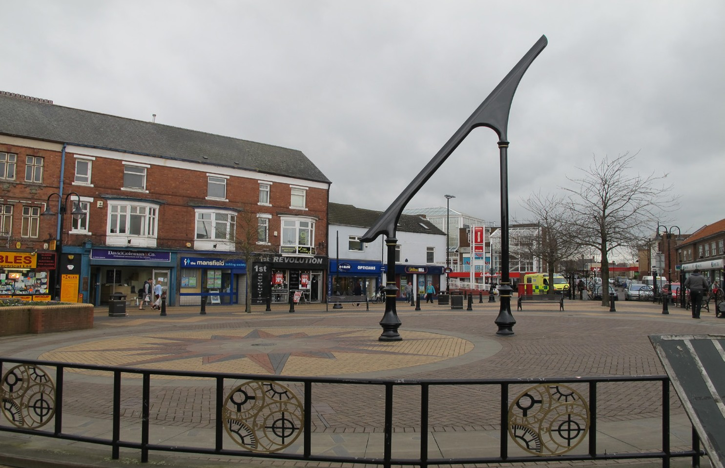
Sundial, Portland Square

Chapter 4. Principal Challenges

Principal Challenges
Drawing on the SWOT analysis (summarised in Appendix 1), it is clear that Sutton Town Centre is currently facing challenges that must be addressed if it is to be sustainable in the long term. Principal challenges include:
    - Competition from nearby towns and city centres, and out of town retail parks (with free parking).

    - Town centre perception – the range of uses and services, the quality of shop frontages and public realm, access to the town centres, safety in the town centre and physical environment can strongly influence success.

    - Socio economic profile – the indicators for education, health and income point to the need to integrate the Spatial Masterplan with socio-economic regeneration strategies and initiatives to improve educational attainment, reduce crime and improve the health and wealth of the local community.

    - Accessibility and movement - efficient and safe movement to, through and around the town centre from a range of transport modes is crucial to ensuring regular patronage.

    - Complementary roles - as a result of the close proximity of the town centre to neighbouring towns, such as Kirkby in Ashfield, they will inevitably have
overlapping catchments. It will be essential to ensure that their future roles are complementary, not competing.

    - Attract new public / private investment funding.

    - Appropriate mix of uses - retail, services, leisure and residential are all key componants to encourage more footfall and a greater length of stay within the town centre, both day and night.

Chapter 5. Spatial Masterplan Principles
Seven broad principles have been identified to achieve the Vision for Sutton Town Centre (as set out on page 13). The principles are interrelated and in combination they will help guide future development and projects in order to create an active and vibrant town centre. The key opportunities identified in chapter 6 will need to take account of these principles.

Maintain and Enhance Character and Identity | Respond to and reinforce locally distinctive patterns of development and landscape, and creating a sense of place.
Improve the Quality of the Public Realm | Create public spaces and routes that are lively and pleasant to use.
Promote Ease of Movement | Develop a town centre which is easy to get to and move through.
Improve Legibility | Develop a clear image and a place that is easy to understand.
Ensure Adaptability | Achieve a place that can change easily.
Maintain and Improve Diversity | Create a place with variety and mixed uses.
Support Sustainability | Achieve a place designed to minimise required inputs of energy, water, food, waste, and outputs of heat, air and water  pollution.

Maintain and Enhance Character and Identity
The character of a place is formed by the pattern of development, its scale and massing, by the mix of uses, architectural styles and details and by the underlying topography. Sutton’s character is what makes it unique and has evolved through time, shaped by the people who have lived and worked in the town.

In creating a sense of place (placemaking), new development and public realm projects should take
    - Distinctive townscapes/landscapes

    - Natural features such a water courses, topography, distinctive soft landscaping and trees

    - Locally distinctive buildings, including listed buildings and those of local heritage value

    - Special spaces, both public and private where they are visible and contribute to
the character of the area 23

    - Skylines and roofscapes

    - Good quality design

    - Good quality and sustainable building materials to ensure longevity and environmental responsibility

    - Respect and acknowledge local culture and traditions, and incorporate into scheme design where appropriate

    - Avoid standard solutions

Improve the Quality of the Public Realm
Improvements to the public realm are essential to improving the image and attractiveness of Sutton town centre. Quality public spaces contribute enormously to people’s health, happiness and wellbeing.

In order to create a place with lively and pleasant to use public spaces and routes, schemes should:
    - Undertake a town centre-wide approach to public realm

    - Achieve a sense of safety and security

    - Create uncluttered and easily maintained surroundings

    - Pay careful attention to detailing, with integrated well-designed public art

    - Be Inclusive - suited to the needs of everyone, including young families, disabled and older people

    - Include well-designed lighting which accentuates key buildings and vistas, and assists with the sense of safety and security, whist minimising light pollution

    - Include well-designed street furniture which assists in creating and enhancing identity

    - Create healthy environments which are sociable (a place to meet friends and feel comfortable interacting with strangers), easy to access and easy to use, encouraging activity.

Promote Ease of Movement
When considering movement within the town centre, there is a need to take account of the primary users of a particular space. The town centre needs to be a place that is easy to get to and move through.

To create a connective and permeable town centre, development should ensure that:
    - Roads, footpaths, cycleways and public services are connected into well-used routes and connect proposed and existing nodes of activity

    - Public areas are easily accessible for all users, including mobility scooter/ wheelchair/pushchair users and cyclists where appropriate

    - Designs incorporate direct routes that lead to where people want to go

    - Schemes provide a choice of safe, high quality routes to assist with permeability 24

Improve Legibility
The town centre needs to provide a welcoming image, and be easy to understand for all users. Visitors should be able to orientate themselves and establish a clear direction, achieved through the use of effective signage.

In order to help create a place that is easy to understand development and public realm schemes should:
    - Create new or capitalise on existing landmarks and focal points and vistas

    - Incorporate clear and easily navigable routes, utilising appropriate and distinguishable hard surfacing

    - Create new or enhance existing ‘gateways’ to key areas which enable users to identify with that particular area

    - Include well-designed lighting which accentuates key buildings and vistas, assists with the sense of safety and security, and leads the user to legible routes

    - Incorporate legible signage and way markers for all users whilst minimising highway/public realm clutter

Ensure Adaptability
The function of town centres has changed markedly in recent years with technological advances and the emergence of internet shopping. It is anticipated that the role of town centres will continue to evolve and as such Sutton town centre needs to be a place that can respond to change.

In creating an adaptable town centre, development and public realm schemes should:
    - Incorporate flexible areas which support a variety of uses

    - Incorporate buildings adaptable to a variety of present and future uses

    - Promote the re-use of important historic buildings and other heritage assets, whist conserving their historic importance

Maintain and Improve Diversity
Sutton town centre is, at present, a predominantly retail area, with limited office, leisure (restaurants, café, cultural uses) and residential accommodation. There is an opportunity to improve and diversify the town centre offer. This can be realised through changes to the activities undertaken within existing premises, but more significantly from the development
of sites that will arise over the next 10 years. There is a need to provide a broader mix of uses in the town centre (beyond shopping) to create areas that are active throughout the day and night, generating additional footfall, and therefore expenditure.

In order to create a place with a variety and mix of uses development (and public realm schemes where appropriate) should:
    - Plan for a mix of compatible uses and tenures

    - Provide a variety of layout and building form

    - Aim to achieve diverse communities and cultures

    - Explore a variety of architectural styles whilst respecting the local character, vernacular and neighbouring uses

    - Increase and protect biodiversity

Support Sustainability
New development should seek to raise the environmental performance of buildings through the incorporation of high quality designs that encourage behavioural changes with regard to energy use and conservation. Higher density development within town centres, high standards of construction, and requirements for the use of renewables, will be pursued.

In order to achieve a sustainable town centre for Sutton, development should include:
    - Efficient use of resources

    - Utilise local materials to reduce transport and hence, carbon emissions. This also has the benefit of supporting the local economy

    - Minimising energy and waste consumption through high quality design

    - Encourage higher densities (in respect of housing development) in the town centre. Good access to a wide range of services and employment opportunities will reduce the need to travel

    - Incorporate electric vehicle charging points

Chapter 6. Town Centre Spatial Masterplan
The Town Centre Spatial Masterplan for Sutton has been developed taking into account the Masterplan Principles identified in Chapter 5 and considering how they can be best utilised to realise the Vision (see page 13) for the town centre.

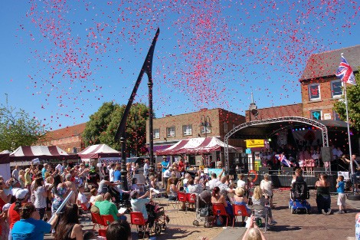
“To promote the towns brand, attract visitors and enliven the town centre through events and activities”
Armed Forces Day 2018, Portland Square

In order to acheive the Vision it is important to look at different areas of the town in terms of how they function, what their role is, and how these areas can be improved in order to support and enhance the overall vitality and viability of the town centre. Taking lead from the Concept Plan in Chapter 1, this has been broken down into three topic areas:
- Town Centre Core;
- Historic Core; and
- Gateways.

The three topic areas are identified below and shown on the Illustrative Masterplan on the following page. These provide a number of key opportunities for improvements from which more detailed schemes can be developed. The opportunities identified below do not provide an exhaustive list as additional improvements may be identified in the future.

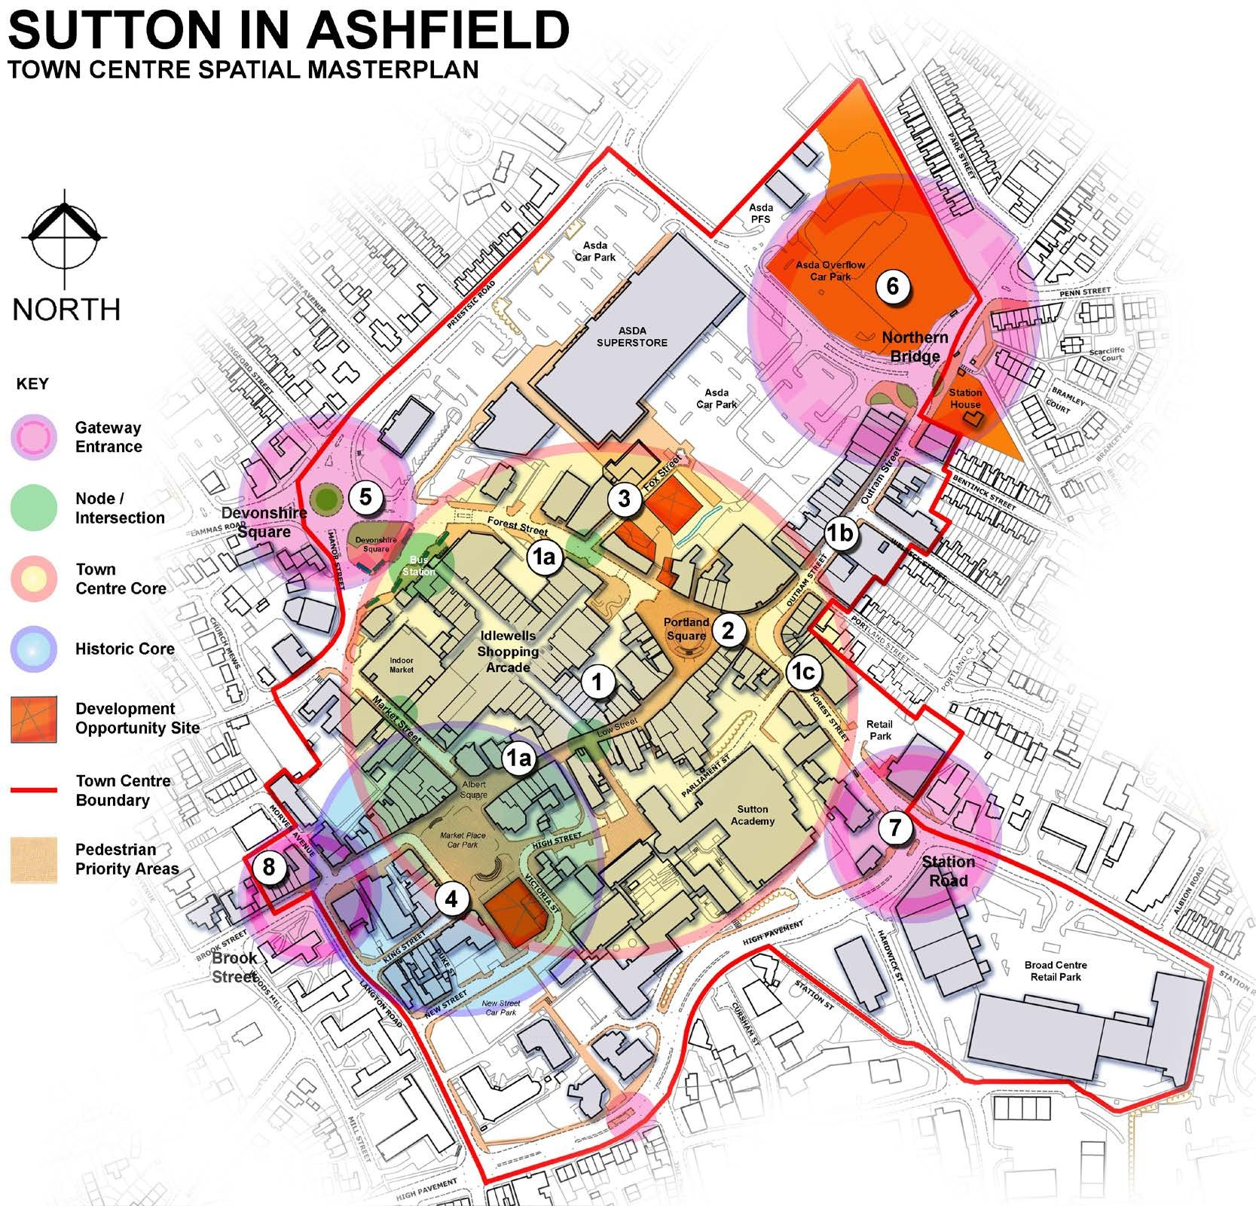
Opportunities

- Town Centre Core
The core is the heart of the existing town centre. Place making improvements will be focused to unify and reinvigorate this central area to maximise opportunities for regeneration and capturing external investment. Ensuring a strong and vibrant core is the foundation for safeguarding the town centre as a local destination.

1a. Low Street & Forest Street (West)
Opportunities exist to develop retail opportunities along an improved primary retail corridor. Improvements to the public realm will assist in rejuvenating the streets’ character and identity.

1b. Outram Street
Aspirations are to develop the secondary shopping streets by supporting existing independent retailers and attracting new ones to the area.

1c. Forest Street (East)
Opportunities exist to rethink the use of vacant leisure / retail units and promote a variety of mixed use developments on the approach to the Town Centre.

- Portland Square
Place making opportunities exist to re-purpose this as the primary civic space. The vision is to provide a contemporary public space, centrally located and accessible to all, which can be utilised for a variety of exciting community activities, events & weekly market.

- Fox Street
Improve pedestrian linkage between Asda and the Town Centre to increase footfall and encourage combined journeys. Opportunities exist to develop the Fox Street site as a mixed use development or urban pocket park.

- The Historic Core
Conserve and improve the quality of the existing building facades and public realm in order to strengthen and enhance the historic character of the area. Opportunities exist to develop the Market Place Car Park site as a mixed use ‘cultural hub’ for performing / visual arts / SME incubation workspace etc.

- Devonshire Square Gateway: improve this key arrival point through enhancement of the frontage to the Idlewells Shopping Centre.

- Northern Bridge Gateway: improve and demarcate threshold between the town centre and Outram Street local shopping area.

- Station Road Gateway: improve pedestrian priority and arrival experience to the town centre e.g. Frontage along High Pavement.

- Brook Street Gateway: improve the Post Office sorting office building at the corner of Brook Street/Langton Road.

Town Centre Core (1)

The core is the heart of the existing town centre. Place making improvements will be focused to unify and reinvigorate this central area to maximise opportunities for regeneration and capturing external investment. Ensuring a strong and vibrant core is the foundation for safeguarding the town centre as a local destination.

Low Street and Forest Street (West) (1a)
The vision for Low Street and Forest Street (West) is to revitalise them as the primary shopping streets for the town centre. Opportunities exist to attract high street retailers and new high street users along an improved primary retail corridor, linking the Historic Core to the Town Centre Core and gateways beyond. Improvements to the public realm will assist in rejuvenating the streets’ character and identity.

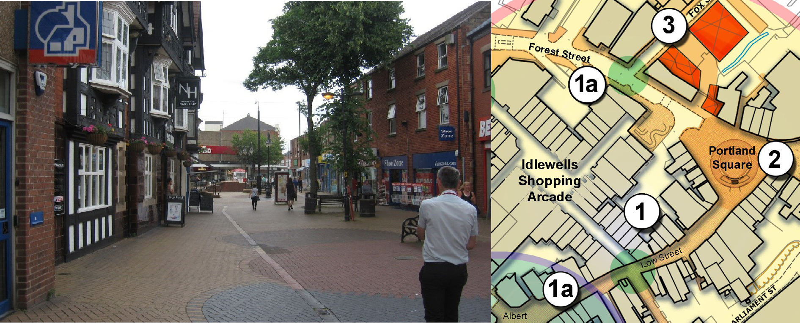
Low Street - looking towards Portland Square

Key Opportunities

    - Low Street – improve primary retail corridor/link along this pedestrianised route between the Historic Core and Town Centre Core

    - Forest Street (west) - returning priority to the pedestrian

    - Attract and improve retail and leisure offer, and reduce vacancies

    - Improve public realm and identity

    - Improve legibility, e.g., improved signage and navigable routes

    - Improve entrances to Idlewells Shopping Centre

    - Improve links between Sutton Academy and Town Centre Core

    - Improve street furniture and lighting

    - Improve shop frontages
29

Outram Street (1b)

Outram Street is the key link between the Town Centre Core and the Northern Bridge Gateway. This street comprises trafficked routes with block paved pedestrian footways.

The vision for Outram Street is to develop it as a secondary shopping street for the town centre through supporting existing independent retailer and attracting new ones to the area.

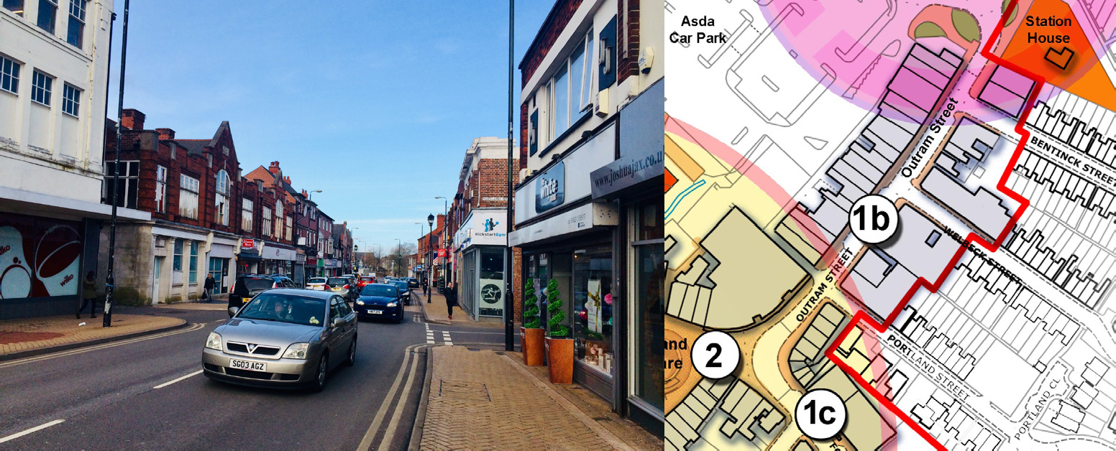

Key Opportunities:
Outram Street

      - Attract and improve independent retail offer and reduce vacancies

      - Improve public realm and identity

      - Improve legibility, e.g., improved signage and navigable routes

      - Improve shop frontages

Forest Street (East) (1c)
Forest Street (East) is a key link between Station Road Gateway and the Town Centre Core. Whilst this is a short link beyond the junction with High Pavement and Station Road it acts as an important arrival space into the Town’s Core and leads directly into the main civic space, Portland Square. At the time of writing this part of Forest Street is flanked by a mix of vacant commercial units, part of a smaller retail park, with parking and traditional style properties such as the former PH, ‘The Crown & Woolpack’ opposite. St Joseph’s Church sits as a prominent landmark building on the corner.

There are opportunities to rethink the Town’s retail offer along this part of Forest Street. The newer commercial units and mix of traditional properties allow for a diverse and flexible range of uses, such as: leisure, commercial, residential and smaller retail or flexible
workspaces. The smaller traditional units may be considered appropriate for independent retailers which would help blend the transition leading onto Outram Street South (1b).

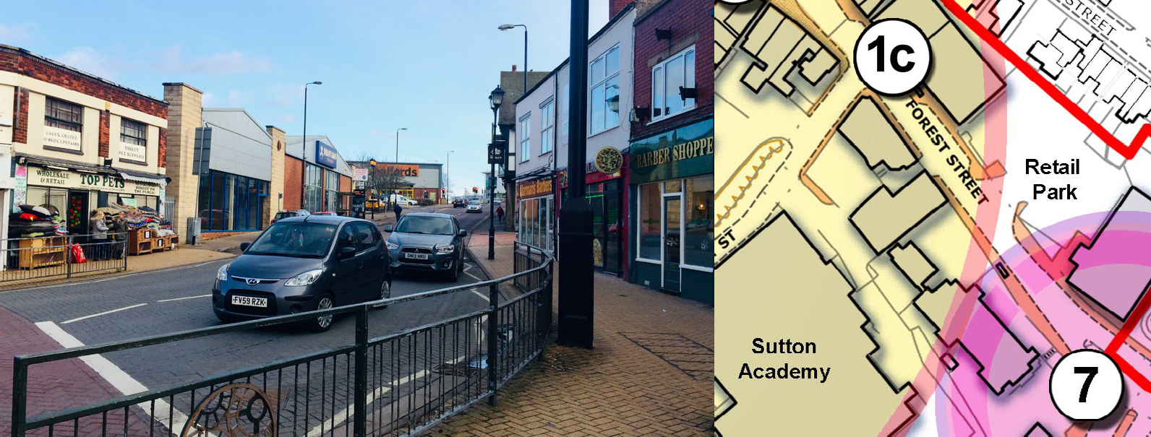
30
Forest Street

Key Opportunities:
      - Promote a range of mixed and diverse uses for commercial units, consider combining smaller units to create a larger size retail space for attracting main high street brands.

      - Conserve and promote re-development of the former PH ‘The Crown & Woolpack’ building for residential use

      - Attract and improve mixed retail offer to reduce vacancies

      - Improve public realm and identity along the street scene linking with Portland Square

      - Improve legibility, e.g improved signage, bus stops and navigable routes on to Parliament Street / Portland Square

      - Promote and improve shop frontages and signage.

Portland Square (2)

Portland Square is the main civic space within the town centre. It is located at the junction of a number of key routes across the town centre and is home to a market on several weekdays. There is an array of existing street furniture and hard/soft
landscaping features, which does not assist with legibility, identity and permeability of this large space.

The vision for Portland Square is for a high quality public space, centrally located and accessible to all, which can be utilised for a variety of community activities and events.
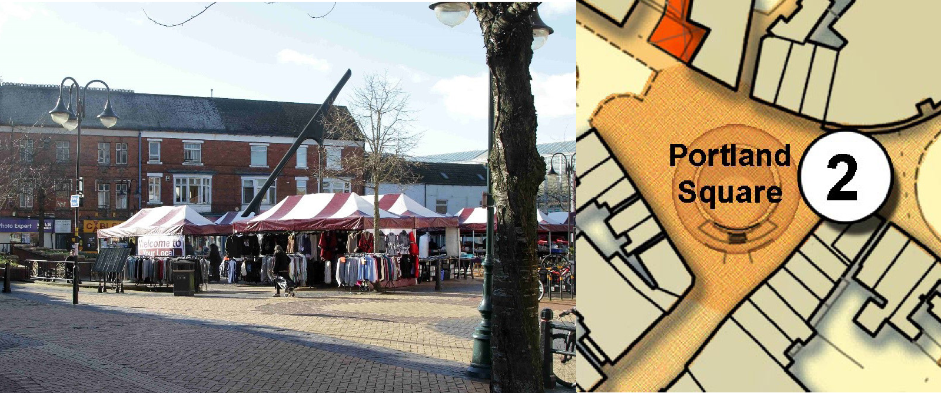
Portland Square

Key Opportunities:
- Rationalisation/replacement of existing street furniture, lighting and hard/soft landscaping features

- Rationalise the market layout

- Improve public realm which allows the Square to perform its role as the key node within the centre
- Improve legibility, e.g., improved signage and navigable routes 31

Fox Street (3)
Asda is a key anchor store and a main attractor to Sutton town centre. As such the vision for Fox Street is to improve it as a pedestrianised link between Asda and the Town Centre Core, increasing footfall and encouraging combined journeys. Opportunities exist to develop the Fox Street site (as identified on the Illustrative Masterplan) as a mixed use development or Urban Park.

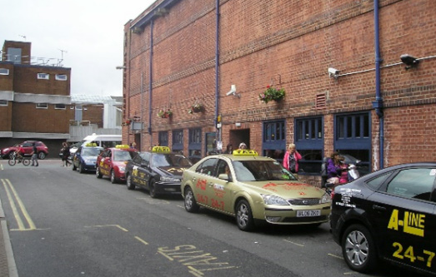
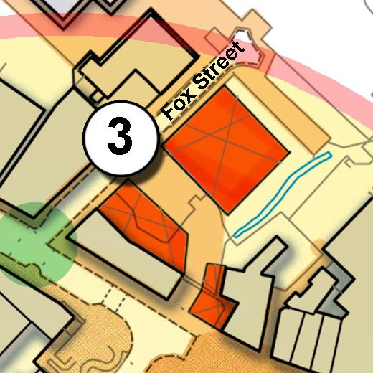
Fox Street, taxi rank

Key Opportunities:
- Relocate taxi rank drop off area

- Improve pedestrian link between Asda and Town Centre Core through a scheme of pedestrianisation.

- Mixed use sustainable development of Fox Street site or the creation of an Urban Park as identified on the Illustrative Masterplan.,

- Improve public realm and identity

- Improve legibility eg. improved signage and navigable routes.

Historic Core (4)
Much of the Historic Core lies within the designated Sutton in Ashfield Church and Market Place Conservation Area. An appraisal and management plan for the conservation area was formally adopted in July 2015. Figure 5 below shows the extent of the conservation area in relation to the masterplan study area.

Figure 5: Sutton Conservation Area and Town Centre Boundary
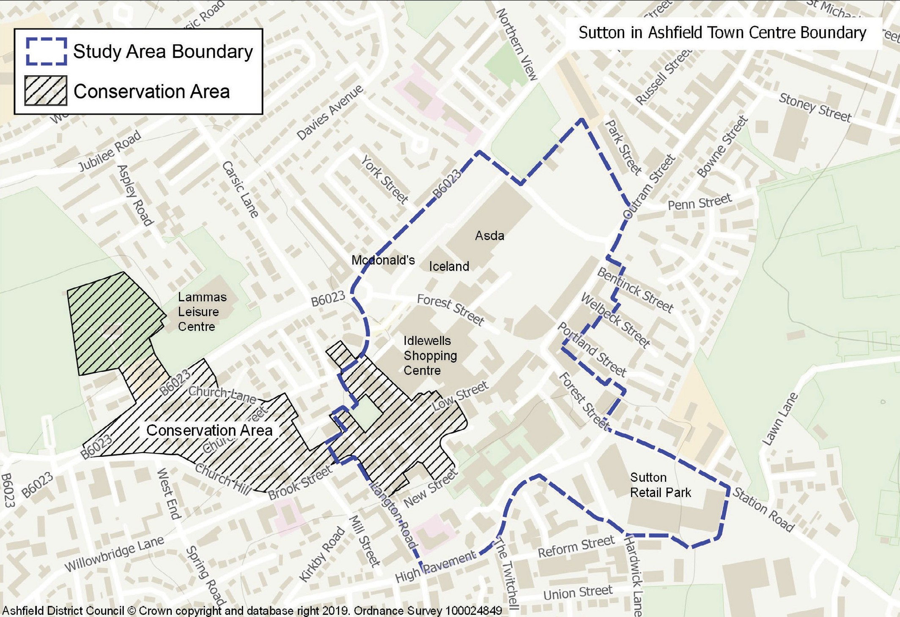

The Conservation Area Appraisal and management plan will ensure that there is an understanding of what is worthy of preservation. It will be used to formulate policies for the preservation and enhancement of the area as a whole and to provide material information for decision makers regarding future development. The Appraisal can be viewed at the Council’s website: www.ashfield.gov.uk

The vision for the Historic Core (including the Market Place, Brook Street and King Street Area) is to improve the quality of the existing buildings and public realm in order to strengthen
and enhance the historic character of the area. The area should comprise of a mixture of service industries, cultural and residential uses, to compliment and support the town’s primary shopping streets within the Town Centre Core.

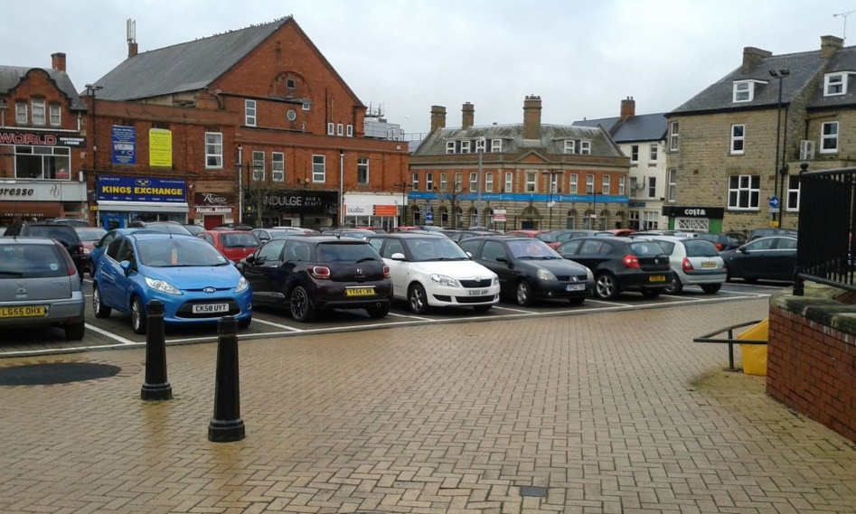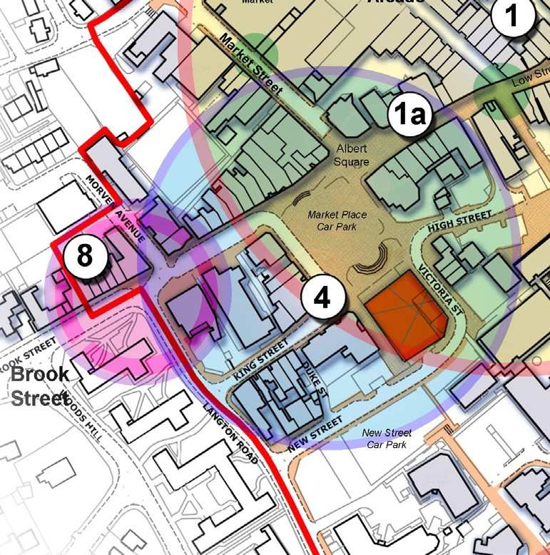
Old Market Place, public car park

Key Opportunities:
- Improve public realm and identity

- Improve legibility e.g., improved signage and navigable routes

- Improve street furniture and lighting

- Improve business and shop frontages

- Attract new users and reduce vacancies

- Improve pedestrian links between both Sutton Academy and High Pavement to the Historic Core and Town Centre Core

- Enhance historic cultural references

- Mixed use sustainable development of land south/east of Market Place, (as identified on the Illustrative Masterplan)

Gateways

Devonshire Square Gateway (5)

This is the eastern gateway to the town centre where people enter by road and bus. It is located on the junction of Lammas Road, Manor Road, Forest Street and Priestsic Road. The gateway includes the Sutton in Ashfield bus station. Much of the land in this area is owned by Nottinghamshire County Council.

There is an opportunity to improve this key arrival point in the town centre through enhancement of the frontage to the Library and Idlewells Shopping Centre, and public realm improvements to Forest Street (west) to give visual priority back to pedestrians – the main users of this area.

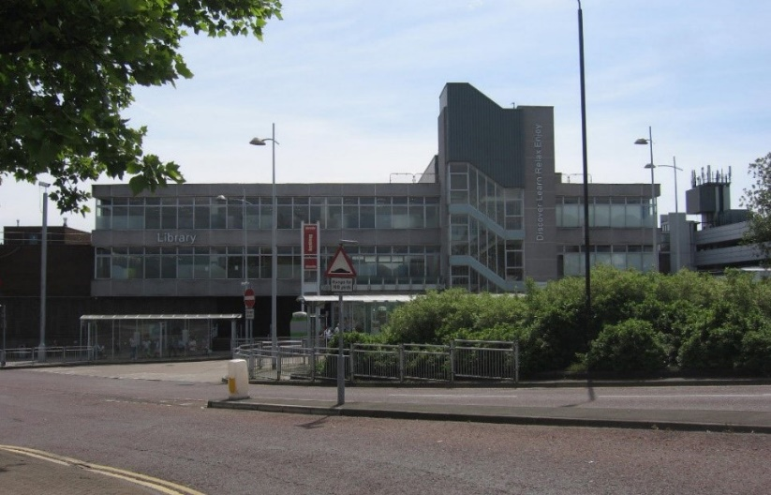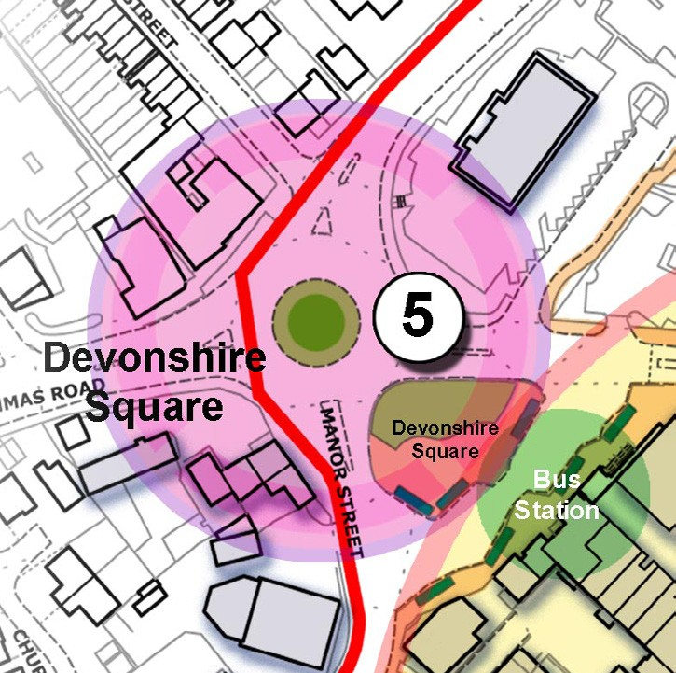
Devonshire Square - Library/Idlewells frontage

Key Opportunities:
    - Creating an active, pedestrian friendly gateway which announces arrival and entry to the town centre

    - Improvements to the frontage of the Idlewells Shopping Centre and public library

    - Public realm improvements to Forest Street (west) - giving priority back to pedestrians

Northern Bridge Gateway (6)

This is the northern gateway to the town centre. There is a need to clearly demarcate between the main town centre and the local shopping centre immediately to the north-west (Outram Street North).

Key Opportunities:
    - Improve public realm and identity, including themed gateway feature/ public art

    - Mixed use sustainable development of land at Station House and Northern Bridge sites, (as identified on the Illustrative Masterplan)

    - Improve legibility e.g., improved signage and navigable routes

Station Road Gateway (7)

This is the south-eastern gateway to the town centre. This area connects the Town Centre Core to the Broad Centre Retail Park and carries heavy pedestrian flows along a route which gives them little priority. The current junction between High Pavement/ Forest Street and Station Road is wide and the phasing of the lights result in long waits for pedestrians. This priority needs to be redressed.

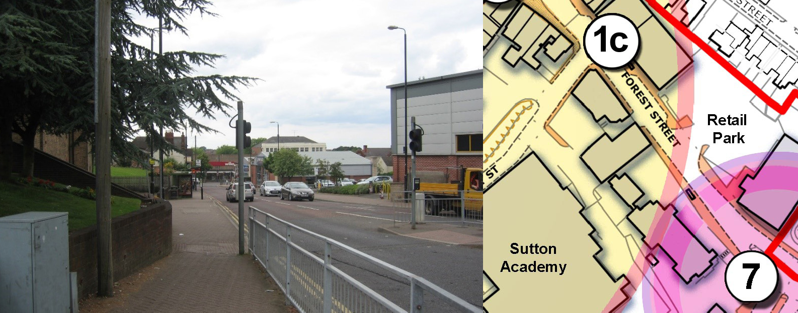
Forest Street (East)

Key Opportunities:
    - Redress the existing priority given to the car over the pedestrian

    - Improve legibility e.g., improved signage and navigable routes

Brook Street Gateway (8)

This is the south western gateway to the town centre where people enter by car and on
foot. It is one of the main entrances to the Market Place car parks and the Town Centre Core beyond. It is located at the junction of Brook Street and Langton Road. There are many buildings along Brook Street which contribute positively to the Conservation Area, however the Post Office sorting office building at the corner of Brook Street/Langton Road detracts from the Historic Core and does not provide an attractive arrival point.

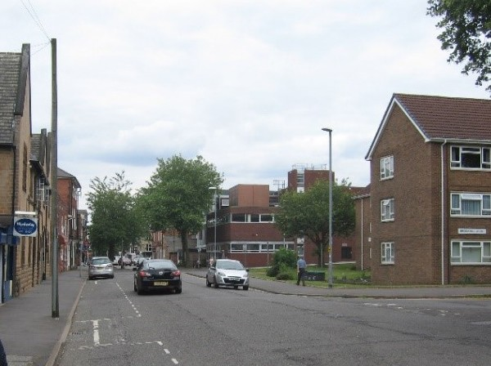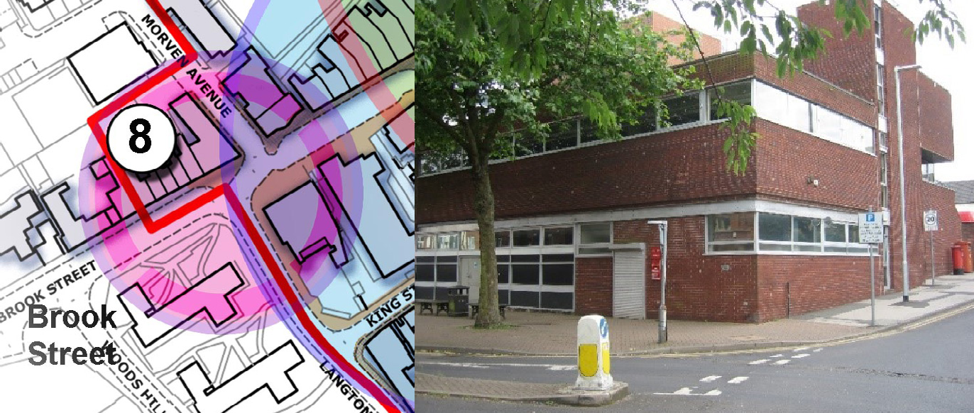

Brook Street - looking
towards Old Market Place
Brook Street - Post Office Building

Key Opportunities:
    - Creating an active, pedestrian friendly gateway, which announces arrival and entry to the town centre.

    - Potential redevelopment of the Post Office site

    - Improve public realm and identity

    - Improve legibility e.g., improved signage and navigable routes

Chapter 7. Delivery

The Spatial Masterplan illustrates the vision for Sutton Town Centre and potential for change over the next 10 years. To be an effective masterplan however, there needs to be a clear understanding of how projects and initiatives could be delivered, who would be involved in delivery, how they might be funded and by what mechanism.

Delivery Partners
The delivery of the Masterplan will need to be supported by activity from a wide range of stakeholders, delivery partners and agencies – both public and private. While the Council is expected to perform a key role, other agencies will be involved with enabling, funding and delivering projects which may include:

    - Ashfield Place Board;
    - Sutton Town Team;
    - Ashfield and Mansfield 2020;
    - D2N2 Partnership;
    - Nottinghamshire County Council;
    - Clinical Commissioning Group (CCG);
    - Community organisations;
    - Registered social landlords;
    - Landowners;
    - Developers;
    - Businesses;
    - Utility suppliers;
    - Sutton Community Academy and other education bodies;
    - Private and philanthropic sponsors;
    - Other public sector organisations - including the police, NHS and English Heritage;
    - Transport bodies - such as bus operators.

Funding Delivery
Whilst the Masterplan does not identify costed projects, it is important to recognise that funding sources should be examined at an early stage in the development process. Not all of the proposals contained in the masterplan are commercial in nature. Project delivery is fully expected to be secured using a combination of public and private sector investment, with the balance of need for funding varying depending on the type, nature, cost and commercial viability of the project. These funds might include:
    - Local Enterprise Partnership (LEP) administered grants and funding streams;
    - Future High Street Fund;
    - Prudential borrowing;
    - Section 106 Agreements / Community Infrastructure Levy (CIL) / developer contributions;
    - Housing revenue;
    - Rolling Investment Funds;
    - Ashfield District Council’s Capital Programme;
    - Lottery funding; and / or
    - Transport funds.

Crucially, funding opportunities continue to evolve and will undoubtedly do so over the lifetime of the masterplan. Funding opportunities must be refreshed and reviewed as time progresses.

Delivery Mechanisms
A number of delivery mechanisms could potentially be used to deliver areas for improvement identified in the masterplan. Once fully detailed schemes have been prepared these can be delivered through three core approaches:

    - Private sector delivery - where a private sector company delivers a scheme without the need to enter into a property or development agreement with a Council. This typically occurs where the developer controls all the land needed, and the Council does not have land or property interest;

    - Public sector delivery - where the Council (or other public sector body) owns the land, has fully specified the development and procures a construction firm to undertake the development to that specification; and

    - Public / private development partnerships the most common form of delivery mechanism used to procure more complex urban regeneration schemes by Councils. The key characteristic is some form of ‘core’ development agreement in place between a developer and Council (or other public sector body). The development agreement
is a legal document which sets out what the scheme will comprise, the roles and responsibilities of the parties, preconditions which must be discharged to enable the development and the financial return to each party on completion of the scheme.

The delivery of the masterplan will also require support through planning mechanisms, such as:
      - Local Development Plan Policies;
      - Supplementary Planning Guidance;
      - Development and Design Briefs; and
      - Action Plans.

Next Steps

There will be further consultations on individual projects as they come forward and we will review the Spatial Masterplan after the first five years.

We will pursue feasibility studies, design and planning work for individual projects and bid for funding to enable delivery.

For further information about the Spatial Masterplan, project delivery or governance arrangements, please visit our website: www.ashfield.gov.uk, or call the Forward Planning Team on 01623 457381 / 457382 / 457383 or email localplan@ashfield.gov.uk

Appendix 1

This SWOT analysis draws on the information from the 2007 Masterplan where relevant, together with more recent information gathered at key stakeholder workshops.

SWOT Analysis of the Town Centre
STRENGTHS | WEAKNESSES
- Proximity to major arterial roads i.e. A38 & M1 junction 28  - Public transport links;  - Thriving library in town centre;  - Newly refurbished indoor market;  - Indoor shopping centre with 40 retail units;  - Adequate parking capacity;  - One hours free parking in Local Authority owned car parks;  - Good representation of national ‘anchor’ brands;  - Tenant mix which serves the local demographic;  - Town Centre is level, giving accessibility for all;  - Lammas Leisure Centre attracting approx. 1 million customer visits per year;  - Green Flag park within 750m of town centre. | - Perception as a socially and economically challenged area limits high spend;  - Vacant units;  - Condition of shop fronts;  - Lack of customer focus and service skills in retail outlets;  - Poorly presenting/ lack of merchandising skills in retail shops;  - Lack of aesthetic appeal in town centre;  - Tenant mix and wider perception of a high number of charity shops/ takeaways;  - Very limited leisure offer (restaurants etc.);  - Anti-social behaviour prevalent at certain times, and limited availability of local police;  - Town centre identification poor;  - Limited youth shoppers.
OPPORTUNITIES | THREATS
- Discover Ashfield – district place making strategy;  - Introduce Electric Vehicle charging to town centre car parks and Idlewells car park;  - Cohesive working of all stakeholders through Sutton Town Centre Group;  - Community engagement;  - Development of a Sutton brand;  - Creation of a Sutton Town Centre website;  - Creation of social media channels for Sutton Town Centre;  - Participation in/ involvement with Idlewells ‘ Thanks’ campaign;  - Long term: Entry to The Great British High Street awards and identification of other town centre awards;  - Adaption of town’s market to include ‘niche’ offers e.g. artisan market;  - Primary catchment = 48,000, secondary catchment = 69,372 (excluding Mansfield);  - Develop maker-seller offer;  - 5G technological advances;  - Introduce services in place of retail;  - Maximise appropriate residential opportunities in the town centre;  •HS2 rail investment. | - Potential future retail developments near to M1 Juncition 28;  - Vacant units at The Broad Centre retail park and wider town centre;  - Lack of ‘local people pride’ in their town centre;  - Future of the high street/ impact of online shopping;  - Stability of independent retailers;  - Local competition i.e. Four Seasons Shopping Centre at Mansfield and East Midlands Designer Outlet;  - Growth of online shopping;  - 5G technological advances;  - Changes in business rates; benefits caps.

A Tenant’s Guide to Moving Home

Ashfield District Council Urban Road
Kirkby in Ashfield Nottinghamshire NG17 8DA

