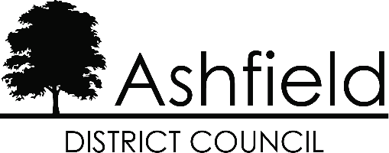

COUNCIL TAX - SINGLE PERSONS DISCOUNT APPLICATION

(Where a property is occupied by one adult)

Council Tax Account No:
Full Name:
Address:

A discount of 25% can be awarded, where a property is only occupied by one adult. Please complete either section (1) or (2) below as applicable and return it by [return_date]

- I am the new occupier of this address and confirm that I have been the sole occupant over 18 at this address since moving in.

Signed: Date:

- I am now the sole occupant over 18 at this address.

Please state the date that the Single Person Discount should start (ie the date that the 2nd person aged 18 left the property) 2

Please state the name(s) of the person(s) who has/have moved out and give their forwarding address(es):

Name | Date Moved Out | Forwarding Address

I declare that the information given on this form is true and accurate to the best of my knowledge and belief. Signed: Date:
WARNING - If you knowingly give false information you may be prosecuted.

If, after you have completed this form, you cease to live on your own, you must notify Revenue Services within 21 days of the change in circumstances.

If you have any query in respect of this letter, please contact Revenue Services on 01623 457400.

