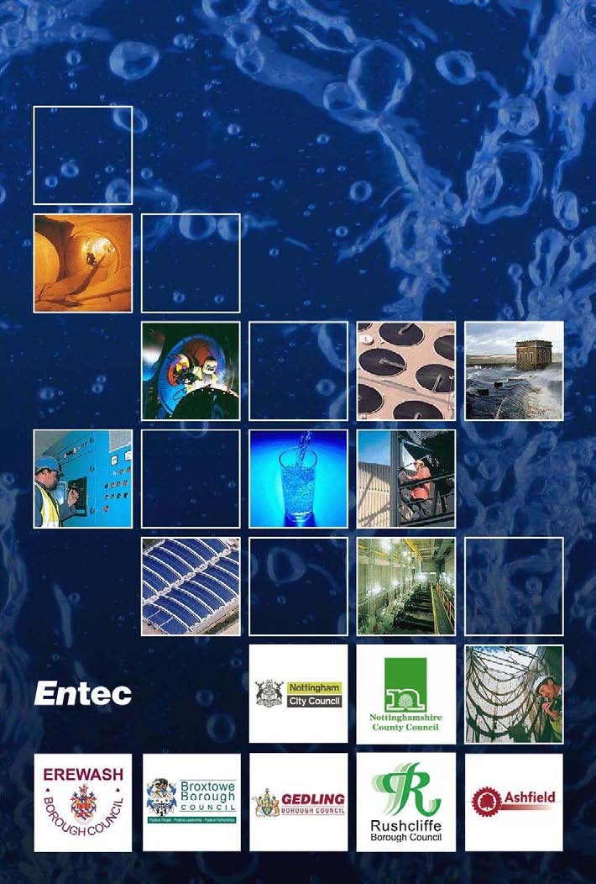
Greater Nottingham and Ashfield Outline Water Cycle Study
Final Report February 2010

Creating the environment for business

Copyright and Non-Disclosure Notice
The contents and layout of this report are subject to copyright owned by Entec (© Entec UK Limited 2010) save to the extent that copyright has been legally
assigned by us to another party or is used by Entec under licence. To the extent that we own the copyright in this report, it may not be copied or used without our prior written agreement for any purpose other than the purpose indicated in this report.
The methodology (if any) contained in this report is provided to you in confidence and must not be disclosed or copied to third parties without the prior written agreement of Entec. Disclosure of that information may constitute an actionable breach of confidence or may otherwise prejudice our commercial interests. Any third party who obtains access to this report by any means will, in any event, be subject to the Third Party Disclaimer set out below.

Third-Party Disclaimer
Any disclosure of this report to a third-party is subject to this disclaimer. The report was prepared by Entec at the instruction of, and for use by, our client named on the front of the report. It does not in any way constitute advice to any third-party who is able to access it by any means. Entec excludes to the fullest extent lawfully permitted all liability whatsoever for any loss or damage howsoever arising from reliance on the contents of this report. We do not however exclude our liability (if any) for personal injury or death resulting from our negligence, for fraud or any other matter in relation to which we cannot legally exclude liability.

Document Revisions

No. | Details | Date
1 | First Issue | 28/10/09
2 | Draft Final Report | 11/12/09
3 | Final Report | 19/02/10

Doc Reg No. 26458 R029i3

Page ii
© Entec UK Limited February 2010

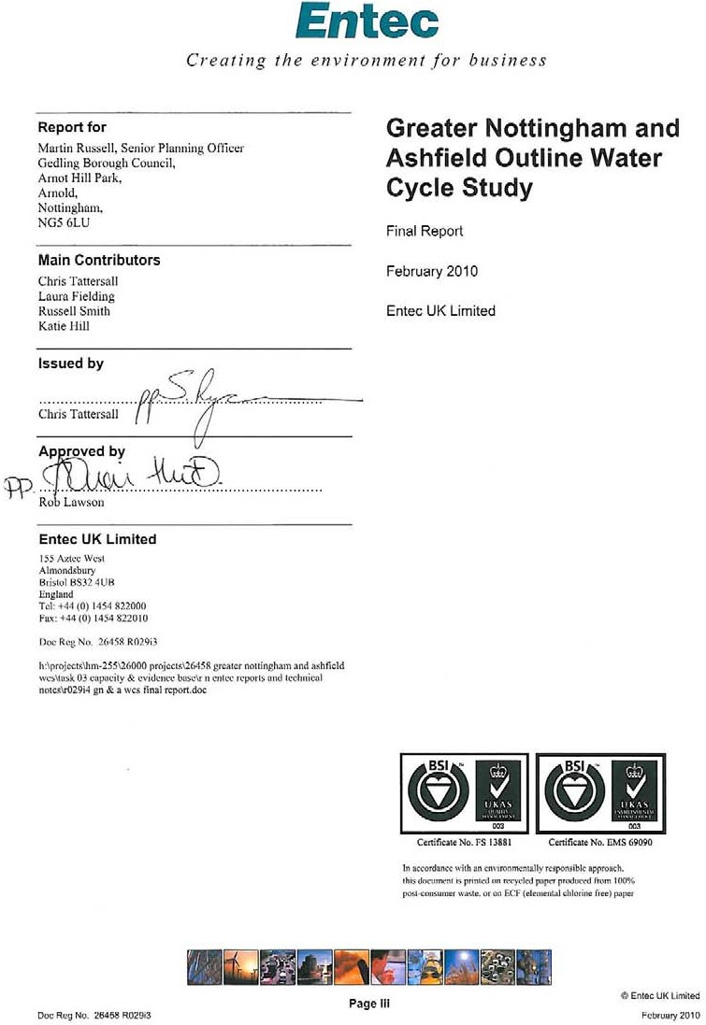

Executive Summary

Purpose of this Report

1.1.1 This report has been produced for the purpose of providing strategic level advice on water infrastructure and environmental capacity to the Councils, to inform their Local Development Frameworks and strategic site allocation. The study area has been defined as the six local authority boundaries of Ashfield, Broxtowe, Erewash, Gedling, Rushcliffe and Nottingham City.

    - The aims and objectives of the Greater Nottingham and Ashfield Outline Water Cycle Study are as follows:

      - Assess the capacity of the current water infrastructure to accommodate growth without adversely affecting the environment by considering:

        - The availability of water resources;

        - The capacity of the drainage network;

        - The capacity of existing wastewater infrastructure;

        - Sustainable Flood Risk Management measures; and

        - The environmental capacity of receiving watercourses;

      - Determining the potential impact of the proposed development in the context of the requirements of the Water Framework Directive, Habitats Directive, Pitt Review and emerging Floods and Water Bill and any other relevant Water Cycle policy and the predicted effects of climate change;

      - Identifying the infrastructure necessary to achieve the proposed growth within the constraints of the environment and legislation;

      - Developing a strategy for a phased approach to development that allows key growth targets to be met whilst providing sufficient time for the identified infrastructure to be adopted;

      - Provide high level cost estimates of infrastructure requirements identified; and

      - Highlight where a more detailed study may be required.

    - The study has been prepared in accordance with the guidance prepared by the Environment Agency on Water Cycle Studies, complying with the Scoping and Outline stages to clearly outline the impact of projected growth on the water cycle in the Greater Nottingham HMA and in Ashfield and highlight any potential problems that may need addressing in order to achieve this growth sustainably.

    - A Water Cycle Scoping Study for the Greater Nottingham and Ashfield area was produced in May 2009. This study comprises the Outline stages of the Water Cycle Study, and builds on the Scoping Study with the purpose of providing the evidence base for the Councils’ Local Development Frameworks. The focus of the Scoping and Outline stages is gathering and assessing available data; identifying environmental and major infrastructure constraints; and deciding whether further detailed assessment is needed. As part of this work strategic level assessments have been undertaken to provide a general overview of issues across the study area. The need for a further Detailed Study has been identified. The Detailed study could be delivered as a follow-on study, addressing the areas identified for further work within this Outline Water Cycle Study. If this approach is preferred, it is recommended that this is not undertaken until the preferred locations and timing of developments are confirmed. As this study has identified no absolute constraints to growth and has identified that in most cases, detailed site-specific water supply and wastewater infrastructure investigations are required, an alternative approach would be to undertake a series of developer-led site-specific assessments.

Data Provision and Growth Scenarios

    - Data for this study has been collated from Severn Trent Water, the Environment Agency (EA), Natural England, the six Councils listed above and Nottinghamshire County Council. The report has been informed by the most up to date environmental and infrastructure data that could be made available from the Environment Agency and Severn Trent Water in November 2009 (and therefore represents a ‘snapshot’ in time). This information has been provided solely for use in this Water Cycle Study and should not be used for any other purpose. The reader is directed to the Third Party Disclaimer at the front of this report limiting the uses to which the information in this report can be put. The findings of this report are dependant on the information provided for use in this study. Developers should prepare their own site specific assessments to determine the suitability of a site with regard to the water cycle elements.

    - This study is required to form part of the evidence base to inform the development of Core Strategies and associated development plan documents. The study considers a number of scenarios for growth but it does not necessarily follow or imply that development of some or all of these sites will take place or that development of any of these sites will be supported by the local planning authorities. The report provides the local planning authorities with a technical evidence base to consider future options for housing allocations. It should be noted that the cumulative area of land considered for development in this report is likely to exceed that needed to fulfil the requirements of the East Midlands Regional Plan; however, all locations have been reviewed to enable the Councils to understand the water related constraints to growth across the study area.

    - The growth scenarios used in this study relate to housing growth scenarios and do not explicitly include allowances for non-residential development. Allowances for the latter are included within Severn Trent Water’s long term water resource planning, whilst individual site developments are assessed by the company when approached by developers.

    - The key findings of the report are set out below.

Water Resources and Water Supply

    - The water resource situation in the East Midlands is significantly constrained. There is little opportunity to develop new water resource schemes; current licensed abstractions may be curtailed in order to protect the environment; and climate change is expected to reduce resource availability further. This situation reinforces the importance of managing the demand for water in this area.

    - Severn Trent Water forecast a shortfall of supply against demand if no interventions are made. The company plans a programme of measures that will maintain a surplus of supply over demand. This should not constrain growth at the strategic level, provided that strategic water resources infrastructure is implemented in a timely manner in relation to growth.

    - As a result of the constraint in the region on water resources, it is recommended that all new homes are built to the water consumption standards of the Code for Sustainable Homes Level 3/4 as a minimum in order to reduce demand from new households; and that the Councils include policies to support the water company’s water efficiency activities to help reduce demand from existing development.

    - Information available in Severn Trent Water’s Water Resources Management Plan is of insufficient detail to draw conclusions concerning the likelihood of water supply infrastructure constraining growth. This requires detailed assessment using hydraulic network models, which the company would provide at the detailed stage of a Water Cycle Study.

Flooding and Drainage

    - New development in Greater Nottingham and Ashfield should be guided toward the lowest flood risk zones. The urban areas of Erewash, Nottingham City, Broxtowe, Gedling and Rushcliffe are concentrated along the River Trent valley, which has been mapped as being at medium to high probability of flooding. The flood zones should be used by the Councils to allocate new residential development outside of zones 2 and 3 where possible to reduce future risks. Ashfield is located upstream of the Trent valley on the River Leen tributary, where the flood zones are not as extensive and less of a constraint to development. Only minor parts of Sutton in Ashfield, Annesley Woodhouse and Hucknall are mapped as being medium to high probability of flooding. In all cases, development options should favour sites in Flood Zone 1.

    - Surface Water Flooding is a particular issue in Nottingham and the City of Nottingham has been allocated
£200,000 of funding by Defra to develop a Surface Water Management Plan.

    - The study area comprises significant areas, identified in the main growth centres, that are in the lower flood risk zones and these should be used in preference for new development wherever possible. Development may be located in areas of higher flood risk where proposals are justified by the Exception

Test in Planning Policy Statement 25. The effect of climate change should also be taken into consideration when making planning decisions, which is likely to increase the extent of the flood zones, to understand the flood risk throughout the development lifetime.

    - Surface water flooding should also be a material planning consideration. New developments should apply sustainable drainage techniques to control flood risk, whilst also providing benefit in terms of water quality, amenity value and green infrastructure targets.

Water Quality and Wastewater

    - Much of the study area, like large parts of central England, currently fails the WFD standard for phosphorus.

    - Severn Trent Water have highlighted wastewater treatment works (WwTW) where there is spare hydraulic capacity available to accommodate additional dwellings, those with minimal capacity and those where existing flows already exceed the consent flow. There are some issues associated with current performance of some WwTW although Severn Trent Water has indicated that they perceive no quality issues in the future. There is certainly sufficient scope to improve the effluent quality towards concentrations that can be achieved using best available technology to mitigate against an increase in wastewater flows above consent conditions to ensure no deterioration in the quality of the receiving water. However, it is important to note that this is a high-level desk based assessment that has not been supported by detailed hydraulic, wastewater treatment or river / catchment water quality modelling. This more detailed analysis is required to identify the most sustainable solutions to manage and treat the additional wastewater flows generated through growth, whilst improving receiving water quality to meet the objectives of the Water Framework Directive. More site specific housing growth and phasing data will facilitate a more focused analysis and in particular highlight capacity issues associated with the sewerage network that could act as a barrier to growth in specific locations.

    - The only potential constraint relating to wastewater treatment highlighted by the data provided by Severn Trent Water is at Huthwaite WwTW. Here there is limited or no existing hydraulic capacity and limited scope to extend the WwTW due to the footprint of the site close proximity of an industrial development. This has the potential to limit growth at the potential development site at Area C around Huthwaite in Ashfield District, as this site is wholly contained within the sewerage catchment and there is little scope to convey flows to an alternative WwTW.

    - Ofwat’s recently published final determination (discussed in Section 5.2) will provide clarification on Severn Trent Water’s planned investment in wastewater assets between 2010 and 2015 and future capacity to accommodate growth.

    - Sewerage infrastructure may be a major constraint to growth in the Edwalton, Gamston and West Bridgford areas (including Gamston Sustainable Urban Extension site) due to the scale of the growth proposed and the capacity of the existing sewerage network. Severn Trent Water has identified a solution that would resolve the constraint, pumping additional flows direct to Stoke Bardolph WwTW,

approximately 6 km distant. Severn Trent Water has indicated that this likely to be expensive to implement (although they cannot confirm the cost at this stage).

    - A summary of the constraints identified within this study is presented in Table A. It is strongly recommended that the reader refers to the relevant sections of this report for further details to avoid taking these comments out of context.

Table A: Summary of Constraints Identified within this Study

Summary of constraints

Water Quality Water quality throughout the study area is currently failing the WFD standards at many locations. This is particularly the case for phosphorus, where the standard is exceeded extensively.
This does not necessarily form a constraint to development in any of these areas, provided that ‘no deterioration’ in water quality will result from wastewater treatment. However, upgrades to meet tighter consent conditions to meet WFD or other EU or National statutory requirements could influence the phasing of development.
Water Resources Severn Trent Water has included plans to resolve the potential deficit in supply, mainly through increasing the capacity of the existing sources and through demand management and metering in existing homes.
It will be important that the Council encourages water efficiency in new homes to support Severn Trent Water’s resource management plans over the growth period
Flooding The flood zones provided in the Strategic Flood Risk Assessments for each Council area should be used in conjunction with the Environment Agency’s flood map to review flood risks for individual site allocations.
The main flooding constraint from natural sources is from the River Trent, whose floodplain extends into Long Eaton, Stapleford, Beeston, West Bridgford and parts of Nottingham City. In these areas, the Environment Agency is likely to object to residential development in line with the requirements of PPS25.

Water Supply Infrastructure

Wastewater Infrastructure

Sewer flooding and surfacewater drainage
Severn Trent Water consider that the information provided in the WRMP is sufficient for the purposes of completing an Outline Water Cycle Study and that assessment of the water supply network requirements to meet demand from new developments should be included in a Detailed Water Cycle Study. It has therefore not been possible to undertake a detailed assessment of the infrastructure requirements in this study.
Wastewater treatment and sewerage infrastructure could constrain the phasing of the growth across Nottingham and Ashfield and it is imperative that continued dialogue is maintained between the councils, Severn Trent Water and the Environment Agency. This will facilitate the identification of the most sustainable wastewater management options and ensure the infrastructure is appropriately sized and in place prior to development.
One potential absolute barrier to development has been identified at Huthwaite WwTW, where existing hydraulic capacity is limited as is the scope to provide additional capacity. Further investigation and dialogue with Severn Trent Water will be required to determine if there a sustainable alternative to convey and treat additional wastewater outside the existing catchment of Huthwaite WwTW.
Sewer flooding incidents are recorded by Severn Trent Water in many areas of the Study Area. Detailed hydraulic modelling will be required to determine the impacts of the proposed development on the sewerage network and to define the level of constraint. Severn Trent Water has highlighted that the scale of the growth in Gamston, Edwalton and West Bridgford areas of Rushcliffe (including the Gamston SUE site) could present a potential barrier to growth due to the capacity of the existing sewerage network. A potential solution to this issue has been identified, but would be expensive to implement.
Surface Water Flooding arises from a number of mechanisms. Where surface water drains are at capacity, blocked or are poorly maintained, flooding can occur during heavy rainfall events. This is a particular issue in Nottingham City and may represent constraints to development with regard to attenuation of run-off. Recently, Defra has awarded funding to Nottingham City to prepare a Surface Water Management Plan to identify the risks from surface water flooding and prepare a plan to mitigate this where possible.
The Greater Nottingham SFRA advises that ‘opportunities should be taken to work with other authorities in the Greater Nottingham conurbation to share best practice and knowledge in terms of flooding and sustainable surface water management with the common goal of reducing overall flood risk’.

Sustainable Urban Extensions

    - The Councils have identified twelve Sustainable Urban Extension (SUE) sites that may be developed within Greater Nottingham and Ashfield. Specific assessments have been undertaken on these sites to identify whether there are any high-level water cycle constraints to the development of these sites.

    - The assessment has concluded that for all sites, water resource availability will not constrain development. It will be important that the Council encourages water efficiency in new homes to support Severn Trent Water’s resource management plans over the growth period. Enhancements to the water supply network may be required, although it is not possible to determine the extent of these enhancements without detailed water supply network modelling. Severn Trent Water has confirmed that they would expect this to be undertaken as part of a Detailed Water Cycle Study.

    - Five SUE sites have been identified at being at risk of flooding and requiring further investigation to determine the extent that flood risk poses to development at these sites. Parts of the North of Papplewick Lane SUE site in Gedling Borough, and parts of the Gamston and Clifton Pastures sites in Rushcliffe Borough have been identified as being located within Flood Zone 2 and Flood Zone 3 of the River Leen and River Trent. Small parts of the SUE sites in Erewash at Stanton Ironworks and West of Ilkeston have been identified as being at risk of flooding from the Nut Brook. Providing that the requirements of PPS25 are met, cumulative impacts of such developments should not result in increased flood risk.

    - Failure to achieve good ecological status against Water Framework Directive standards is not considered to be a barrier to development at SUE sites where it can be demonstrated that growth would not contribute to deterioration in the status of the receiving water.

    - Based on the information available to this study, wastewater treatment works capacities are not expected to constrain growth at SUE sites. Potential sewerage infrastructure constraints to development of SUE sites have been identified at a number of SUE sites, where new development could exacerbate known sewer flooding capacity and flooding issues. Detailed assessment to determine the extent of these potential constraints should be undertaken as part of a Detailed Water Cycle Study.

Contents
- Introduction 1
  - Background and Aims 1
  - National Guidance on Water Cycle Studies 3
  - How to Use this Water Cycle Study 3
- Development and Growth 7
  - Planning Policy Context 7
  - National Policy 7
  - Regional Policy 8
  - Local Policy 9
  - Housing Growth Trajectories 12
- The Water Cycle 19
  - Introduction 19
  - Legislation and Guidance 21
  - Other Relevant Policy and Guidance 23
  - Integrated Catchment Management 23
  - Catchment Flood Management Plans 24
- Baseline Conditions 27
  - The Study Area 27
  - River Basin and Geology 27
  - Water Quality 29
  - Wastewater and Sewerage 36
  - Water Resources 39
  - Drainage and Flood Risk 45
  - Local Water Cycle Studies 48
- Constraints 51
  - Environmental Constraints 51
  - Infrastructure Constraints 70
  - Constraints at SUE Sites 89
  - Cumulative Impacts of SUE Sites 95

6. Opportunities and Capacity for New Development | 97
6.2 Water Quality and Wastewater | 97
6.3 Water Supply | 100
6.4 Flooding and Drainage | 103
6.5 Cost of Infrastructure Requirements | 109
7. Climate Change | 111
7.1 Background | 111
7.2 Climate Change Modelling and UKCP09 | 111
7.3 Climate Change and the Study Area | 112
7.4 Assessment of Environmental Capacity and Water Infrastructure Provision | 114
8. Conclusions and Recommendations | 119
8.2 Water Quality | 120
8.3 Wastewater and Sewerage Infrastructure | 120
8.4 Water Resources and Supply | 122
8.5 Flooding and Drainage | 123
8.6 Assessment of SUE Sites | 124
8.7 Cumulative Impacts from Growth Outside the Study Area | 125
8.8 Development Strategy and Phasing of Growth | 126
8.9 Recommendations for Future Work | 130
9. References | 133
Table 1.1 ‘Traffic Light’ Assessment used in this Study | 4
Table 2.1 Summary of Relevant National Policies | 7
Table 2.2 RSS Housing Targets by District, 2006-2026 | 9
Table 2.3 Potential Sustainable Urban Extension (SUE) Sites Identified in the Tribal Urban Studio Study | 11
Table 2.4 RSS Target, Housing Completions, Housing Assessed and Apportionment in this Study | 14
Table 3.1 Primary Water Related Legislation | 21
Table 3.2 Summary of Main CFMP Actions for LPAs in Burton, Derby and Nottingham (Policy Unit 5) | 25
Table 3.3 Summary of Main CFMP Actions for Ashfield District Council in Sherwood Policy Unit 2 | 26
Table 4.1 Summary Current Status and Objectives of Rivers within the Nottingham Study Area | 30
Table 4.2 Summary of Relevant Measures included in the Humber RBMP to Improve Water Bodies in the Study Area | 30
Table 4.3 WwTW that could be Influenced by Growth in the Greater Nottingham and Ashfield Study Area (provided by Severn Trent Water) 38
Table 4.4 Water Resources Status in Greater Nottingham and Ashfield Study 41
Table 4.5 Areas Susceptible to “Other Sources of Flooding” Identified within the SFRAs 47
Table 4.6 European and Internationally Designated Sites relevant to the Greater Nottingham and Ashfield Outline WCS 49
Table 4.7 Status of Neighbouring Water Cycle Studies 49
Table 5.1 Water Quality Constraints 52
Table 5.2 River Water Quality Upstream and Downstream of Key WwTW 55
Table 5.3 Water Resources Constraints 61
Table 5.4 Flooding Constraints 63

Table 5.5 | Water Supply Infrastructure Constraints | 70
Table 5.6 | Allocation of Development to Wastewater Treatment Works Catchments | 71
Table 5.7 | Comparison of Estimated Spare Hydraulic Capacity and Additional Dwellings Under Option 1 and Option 2 | 73
Table 5.8 | Strategic / High-level Response from Severn Trent Water on WwTW Capacity | 74
Table 5.9 | Wastewater Treatment Constraints | 79
Table 5.10 | Sewer Flooding and Surface Water drainage Constraints | 81
Table 5.11 | Potential Constraints to Development at SUE Sites | 90
Table 6.1 | Summary of Water Efficiency Scenarios Used in Sensitivity Analysis | 100
Table 6.2 | Examples of SuDS Techniques | 106
Table 7.1 | Impact of Climate Change on Deployable Output | 115
Figure 2.1 | Planning Context of Water Cycle Studies | 12
Figure 2.2 | Cumulative New Dwellings based on the Scenarios Developed for this Study, 2006-7 to 2025-26 | 16
Figure 3.1 | Traditional View of the Water Cycle without Artificial Influence | 19
Figure 3.2 | Schematic of the Urban Water Cycle | 20
Figure 4.1 | The Greater Nottingham and Ashfield Study Area – Hydrological Context and SSSI Designations | 28
Figure 4.2 | Compliance Risk against WFD Standard - Phosphorus | 33
Figure 4.3 | Compliance Risk against WFD Standard - Ammonia | 34
Figure 4.4 | Compliance Risk against WFD Standard – Biochemical Oxygen Demand | 35
Figure 4.5 | WwTW Catchments within the Greater Nottingham and Ashfield Study Area | 37
Figure 4.6 | The East Midlands Water Resource Zone and Principal Severn Trent Sources | 42
Figure 4.7 | Water availability in catchments relevant to the East Midlands water resource zone | 43
Figure 4.8 | Flood Risk Management Plans | 48
Figure 5.1 | East Midlands Zone – Final WRMP Supply/Demand Balance (baseline scenario) | 58
Figure 5.2 | East Midlands Zone – Final WRMP Supply/Demand Balance (final planning scenario) | 59
Figure 5.3 | Flood Risk Constraints – Erewash Borough Council | 64
Figure 5.4 | Flood Risk Constraints – Nottingham City Council | 65
Figure 5.5 | Flood Risk Constraints – Broxtowe Borough Council | 66
Figure 5.6 | Flood Risk Constraints – Gedling Borough Council | 67
Figure 5.7 | Flood Risk Constraints – Rushcliffe Borough Council | 68
Figure 5.8 | Flood Risk Constraints – Ashfield District Council | 69
Figure 5.9 | Potential constraints to development due to WwTW capacity | 78
Figure 5.10 | Sewerage Constraints – Erewash Borough | 83
Figure 5.11 | Sewerage Constraints – Nottingham City | 84
Figure 5.12 | Sewerage Constraints – Broxtowe Borough | 85
Figure 5.13 | Sewerage Constraints – Gedling Borough | 86
Figure 5.14 | Sewerage Constraints – Rushcliffe Borough | 87
Figure 5.15 | Sewerage Constraints – Ashfield District | 88
Figure 6.1 | Summary of Alternative Growth Rate and Demand Scenario Forecasts | 102
Figure 6.2 | Potential for Infiltration SuDS within the Study Area | 107
Figure 7.1 | Change in Annual Average Daily Temperature for the 2050’s under the Medium Emissions Scenario (UKCP09) | 113
Figure 7.2 | Change in Summer Mean Precipitation for the 2050’s under the Medium Emissions Scenario (UKCP09) | 113
Figure 7.3 | Change in Winter Mean Precipitation for the 2050’s under the Medium Emissions Scenario (UKCP09) | 114
Figure 8.1 | Checklist for Developers | 129

Appendix A Glossary of Terms
Appendix B Derivation of Growth Scenarios
Appendix C Water Dependant Sites of Special Scientific Interest Appendix D Water Resources and Water Supply
Appendix E Review of Local Water Cycle Studies Appendix F Tables D.2 and D.3 from PPS 25 Annex D Appendix G Planned Growth in Adjacent Areas

Page xiv
© Entec UK Limited

Introduction

1.1 Background and Aims
    - The partner councils of Greater Nottingham and Ashfield have commissioned this Outline Water Cycle study to inform the emerging Local Development Frameworks within Greater Nottingham and Ashfield. The partner councils are:

      - Erewash Borough Council;

      - Nottingham City Council;

      - Broxtowe Borough Council;

      - Gedling Borough Council;

      - Rushcliffe Borough Council;

      - Ashfield District Council; and

      - Nottinghamshire County Council.

    - The work will be used to inform options for the most sustainable locations for new development and will identify constraints and opportunities related to flood risk and the provision and capacity of existing and future water supply, sewerage and wastewater treatment infrastructure. The Outline Water Cycle Study (WCS) provides an effective and customised planning tool allowing the local authorities to effectively develop the proposed growth sites, whilst targeting the management of infrastructure investment and providing useful, sustainable targets for developers. The following aims have been identified for this Outline WCS:

      - Assess the capacity of the current water infrastructure to accommodate growth without adversely affecting the environment by considering:

        - The availability of water resources;

        - The capacity of the drainage network;

        - The capacity of existing wastewater infrastructure;

        - Sustainable Flood Risk Management measures; and

        - The environmental capacity of receiving watercourses;

      - Determining the potential impact of the proposed development in context with the requirements of the Water Framework Directive, Habitats Directive, Pitt Review and emerging Floods and Water Bill and any other relevant Water Cycle policy and the predicted effects of climate change;

      - Identifying the infrastructure necessary to achieve the proposed growth within the constraints of the environment and legislation;

      - Developing a strategy for a phased approach to development that allows key growth targets to be met whilst providing sufficient time for the identified infrastructure to be adopted;

      - Provide high level cost estimates of infrastructure requirements identified; and

      - Highlight where a more detailed study may be required.

    - The brief for this Outline WCS and the recommendations of the Scoping Study are aligned with the above. Additional areas identified specifically within the Greater Nottingham and Ashfield Scoping Study as requiring further study in the Outline WCS includes:

      - An assessment regarding the potential need for a Surface Water Management Plan (SWMP) should be made for the whole of the study area, especially following the announcement by Defra that Nottingham should undertake a SWMP and will have access to £200,000 funding to do so. As identified in the Greater Nottingham and River Leen and Day Brook Strategic Flood Risk Assessments (SFRAs), this is particularly important for development in Hucknall and Gedling to avoid increasing flood risk to the City of Nottingham through increasing flows in the River Leen and Day Brook, and in Hucknall to avoid increasing flows (and associated flood risk) to Baker Lane Brook. In addition, the Outline study should take account of the Left Bank Flood Alleviation Scheme on the River Trent and any detailed flood risk studies in the area;

      - An assessment of the likely surface water storage and potential sustainable drainage system (SuDS) requirements for proposed development; and

      - An assessment of the effects of climate change on the water cycle within the Greater Nottingham study area.

    - Flood risk in the district has been considered within the Strategic Flood Risk Assessments (SFRA) for Greater Nottingham, Ashfield District and the River Leen and Day Brook. The WCS therefore only summarises flood risk, using the evidence supplied in the SFRAs to avoid repetition of work.

    - A WCS can be undertaken in three stages: an initial scoping study, an outline study and a detailed study leading to a Water Cycle Strategy. This study comprises an outline study (the Scoping Study was completed in May 2009), and aims to clearly outline the impact of projected growth on the water cycle in the Greater Nottingham and Ashfield study area and highlight any potential problems that may need addressing in order to achieve this growth sustainably. The study has involved consultation with key stakeholders in the Water Companies, the Environment Agency and the local authorities.

1.2 National Guidance on Water Cycle Studies
    - The Environment Agency has issued a National Guidance document to ensure that WCSs are carried out in a consistent way¹. This guidance outlines the required approach for the Scoping, Outline and Detailed phases of WCSs:

      - Scoping: The primary aim of the Scoping Phase is to collate and review existing information (e.g. previous studies and monitoring data) on the water environment within the study area, identify development plans and engage with key stakeholders, including the Environment Agency, water companies and drainage authorities, to identify key issues that require consideration in the following stages of the work. The Scoping Phase should clarify the principles and objectives to be followed throughout the rest of the process.

      - Outline: The primary aim of the Outline Phase is to identify potential environmental and water infrastructure constraints to development to provide an evidence base to support the Core Strategy and identification of preferred sites for development. The study should identify areas of uncertainty that may require further detailed studies.

      - Detailed: The Detailed Phase aims to resolve areas of uncertainty identified in the Outline Phase through further more detailed studies. It identifies what water cycle management measures and infrastructure are needed, where and when they are needed, who is responsible for providing the systems, and by what deadline. This may involve an assessment of the costs and benefits of options. It also provides guidance to the local authorities to facilitate implementation and funding of the Strategy.

1.3 How to Use this Water Cycle Study
    - This study is required to form part of the evidence base to inform the development of Core Strategies and associated development plan documents. The study considers a number of scenarios for growth but it does not necessarily follow or imply that development of some or all of these sites will take place or that development of any of these sites will be supported by the local planning authorities. The report provides the local planning authorities with a technical evidence base to consider future options for housing allocations. It should be noted that the cumulative area of land considered for development in this report is likely to exceed that needed to fulfil the requirements of the East Midlands Regional Plan; however, all locations have been reviewed to enable the Councils to understand the water related constraints to growth across the study area.

    - A WCS provides recommendations, backed up with evidence, for providing integrated solutions to sustainable management of the water cycle, whilst meeting any additional demands associated with growth. This document brings together environmental and water infrastructure asset information that has

¹ (http://publications.environment-agency.gov.uk/pdf/GEHO0109BPFF-e-e.pdf)

been provided by the Environment Agency and the water companies. It sets out the current capacity of existing infrastructure (where this information is available), highlighting where the main pressure points are and identifies the environmental constraints to growth and sets out the areas for further investigation in any future detailed WCSs.

    - To aid interpretation of the information presented in this study, a ‘traffic light’ assessment has been developed. This enables the reader to readily understand where there may be water cycle constraints to development within the study area. The traffic light assessment categories are shown in Table 1.1.

Table 1.1 ‘Traffic Light’ Assessment used in this Study

Definition
Development ok, no constraints identified at this stage

Development may be ok, minor constraints identified at this stage, minor mitigation required to meet growth targets
Constraints identified at this stage, development may be ok with major mitigation to meet growth targets

    - The data and analyses presented in Outline study provide the evidence base for making planning decisions at a strategic level. It highlights areas where further analysis is required as a result of access to relevant data from either the water companies or the local authorities. This evidence should be used to consider which options will best support the LDF Core Strategy for each Council area and related policies. It is not meant to be used for determining planning applications.

    - It is important to understand the different scales at which the elements of the water cycle (water supply, sewerage and drainage) are managed, and the impacts this has on assessing constraints to growth. The different legislative and regulatory frameworks used to manage water resources, wastewater, sewerage, water quality, floods and drainage also need to be considered.

    - Detailed information on the methods used to assess the environmental constraints, and on sustainable development features, such as demand management measures and sustainable drainage techniques, are included within a series of appendices.

    - In Section 8, integrated conclusions have been drawn from the study, with recommendations for the partner councils and developers to ensure sustainable delivery of the proposed development in the study area. A glossary of terms is provided in Appendix A.

    - This WCS has been developed through a project steering group comprising the Greater Nottingham and Ashfield authorities, Severn Trent Water and the Environment Agency.

    - This WCS has been developed based on information that is in the public domain, and on information made available through the project steering group. Although every effort has been made to ensure that this information is current and accurate at the time of publication, these data may be subject to review and reassessment at any time. It is important to recognise this limitation when interpreting the findings of this study.

Development and Growth

2.1 Planning Policy Context
2.1.1 National, regional, sub regional and local planning policy sets out guidance and requirements for delivering sustainable development and therefore addresses, amongst other things: housing and employment growth and its distribution; water management and protection; infrastructure provision; and flood risk management. The following sections outline the relevant planning policy in which these issues are framed and the current and emerging development plan for the partner councils for Greater Nottingham and Ashfield.

2.2 National Policy
2.2.1 Government guidance is provided through a series of Planning Policy Statements (PPSs), the most relevant of which are summarised in Table 2.1.

Table 2.1 Summary of Relevant National Policies

PPS1 Delivering Sustainable Development and the Supplement to PPS1: Planning and Climate Change.
Policy Overview
Policy
PPS1 requires regional planning bodies (RPBs) and local planning authorities (LPAs) to prepare development plans which ensure that development is pursued in line with the principles for sustainable development and promote outcomes in which environmental, economic and social objectives are achieved together over time. This should be achieved using a spatial planning approach.
Specifically, planning authorities should identify land suitable for meeting housing and other types of development taking into account the need to provide essential infrastructure and avoid flood risk. In addition they should address the issue of climate change; the management of pollution; and the minimisation of impacts from the management and use of resources based upon sound science. PPS1 advises that regional planning authorities and local authorities should promote amongst other things the sustainable use of water resources and the use of sustainable drainage systems in the management of runoff.
The PPS1 supplement advises local planning authorities that when deciding suitable locations for development, and for what type and intensity, they should take into account the capacity of existing and potential infrastructure including water supply, sewage and sewerage, to service the site or area in ways consistent with successfully adapting to likely changes in the local climate. In addition, they could consider physical and environmental constraints such as sea level rises, flood risk and stability, and take a precautionary approach to increases in risk which may arise as a result of potential changes to the climate.

PPS3 Housing PPS3 underpins the delivery of the Government's strategic housing policy objectives where the goal is to ensure that everyone has the opportunity to live in a decent home, which they can afford in a community where they want to live. Most future development within the six authorities will be for housing. PPS3 emphasises that Local Planning Authorities should continue to make effective use of land by re-using land that has been previously developed. PPS25 reiterates this requirement in its Exception Test.

PPS4 Sustainable Economic Growth
PPS4 sets out planning policies for economic development. This also emphasises that Local planning Authorities should ensure that their development plans make the most effective use of land, prioritising previously developed land which is suitable for re-use.

PPS 12 – Creating Strong, Safe and Prosperous Communities through Local Spatial Planning
Policy Overview
Policy
PPS25 Development and Flood Risk (CLG, 2006)
PPS 12 outlines the nature of local spatial planning and the key components of local spatial plans and how they should be prepared. It should be taken into account by local planning authorities in preparing Local Development Frameworks (LDFs) which include development plan documents (DPDs) and other local development documents (LDDs).

PPS25 sets out Government policy on development and flood risk. It aims to ensure that flood risk is taken into account at all stages in the planning process to avoid inappropriate development in areas at risk of flooding, and to direct development away from areas of highest risk. It also aims to ensure that new development does not increase the risk of flooding elsewhere. Where, in exceptional circumstances, new development is necessary in such areas then the aim is to make it safe without increasing flood risk elsewhere and, where possible, to reduce flood risk overall.
PPS25 stipulates that all planning applications for developments greater than 1 hectare must be accompanied by a Flood Risk Assessment detailing SWMP to demonstrate that runoff does not increase from the proposed development once it has been built and that runoff is not simply moved elsewhere. An updated edition of PPS 25 best practice guidance was published in December 2009 and is available online².
This approach is supported in the Government’s Pitt Review of the summer 2007 flooding, in which the importance of ensuring developments comply with the aims of PPS25 is reiterated. It makes it clear that developments within flood zone 2 and 3 should not be allowed to proceed unless there is clear proof that they pass the PPS25 Sequential and (if required) Exception Tests, and can therefore - with appropriate flood risk mitigations - be considered compatible developments for these zones. The review also makes recommendations for LPAs to improve their understanding of flood risk in their areas, their flooding emergency response plans and arrangements for responding to events and working with other agencies (i.e. the Environment Agency, the emergency services and utility companies). This and other Pitt Review recommendations, are likely to be implemented as legislation via the Floods and Water Bill, which is passing through parliamentary review, following its announcement in the November 2009 Queen’s Speech

2.3 Regional Policy
    - The East Midlands Regional Plan is the Regional Spatial Strategy (RSS) relevant to Greater Nottingham and Ashfield. The RSS was published in March 2009 and establishes the broad development strategy for the region (GOEM, 2009). It provides a regional framework within which Local Planning Authorities can prepare their Local Development Frameworks (LDFs) for the period to 2026. It also sets out the Three Cities Sub Regional Strategy which supports the growth planned for the Greater Nottingham and Hucknall area. The rest of Ashfield is located in the Northern Sub Regional Strategy area where the priority is economic, social and environmental regeneration.

    - Policy 13a of the East Midlands Regional Plan sets a target for housing provision of 60,600 dwellings for the Nottingham Core Housing Market Area up to 2026 and a target of 7,600 dwellings for the remainder of Ashfield District (which is within the Nottingham Outer Housing Market Area). This results in a total RSS Housing target for the study area of 68,200, as presented in Table 2.2. The Councils will be planning to deliver these housing targets within their Core Strategies.

² http://www.communities.gov.uk/publications/planningandbuilding/pps25guideupdate

    - It is understood that approximately 6,200 dwellings have already been completed and therefore the emerging Core Strategy Development Plan Documents (DPDs) will need to plan for a minimum of approximately 62,000 dwellings across the study area over the period to 2026.

    - The RSS identifies Nottingham, Hucknall and Ilkeston as priority areas for regeneration. Greater Nottingham is identified as a preferred location in which to consider the need for a rail freight distribution centre. Rural areas are targeted for economic diversification.

Table 2.2 RSS Housing Targets by District, 2006-2026

District | Target
Erewash | 7,200
Nottingham City | 20,000
Broxtowe | 6,800
Gedling | 8,000
Rushcliffe | 15,000
Ashfield (within Hucknall) | 3,600
Ashfield (rest of District) | 7,600
Total | 68,200

    - The RSS sets out policies relating to the regional approach to water management and protection, green infrastructure provision, and flood risk management which indicate how LPAs can deliver this as part of their LDFs. Policy 32: A Regional Approach to Water Resources and Water Quality requires LPAs to work with key partners to ensure there is timely provision of appropriate additional infrastructure for both supply and waste water treatment and to ensure sustainable water abstraction is achieved. Furthermore, the policy requires LPAs to promote the use of sustainable drainage and water efficiency techniques especially in new development. Policy 35: A Regional Approach to Managing Flood Risk requires LDFs to incorporate policies which ensure inappropriate development is not located in flood risk areas.

2.4 Local Policy Adopted Local Plans
    - The Outline Water Study area includes the administrative areas of Ashfield, Broxtowe, Erewash, Gedling, Nottingham City and Rushcliffe Councils. Each authority (except Rushcliffe) has an adopted local plan which sets out policies used to determine development applications within their respective authority boundaries. The WCS will form part of the evidence base to inform the development of the emerging

local plan LDF policies, in particular developing each authority’s Core Strategy Development Plan Document (DPD). Under the transitional arrangements outlined in PPS12, Local Plans expired on the 27th September 2007 or three years after the date of adoption of the Plan, and only policies saved by the Secretary of State under a direction continue to be part of the Development Plan. These policies will be updated and replaced by Local Development Framework policies for each authority. The WCS will form part of the evidence base to inform the development of emerging LDF policies, in particular developing each authority’s Core Strategy Development Plan Document (DPD).

Emerging Local Development Frameworks
    - As required by the Planning and Compulsory Purchase Act 2004, the local authorities are reviewing their adopted local plans and currently preparing Local Development Frameworks (LDF) containing a suite of Development Plan Documents (DPDs) and Supplementary Planning Documents (SPDs) which outline the development strategy for the Greater Nottingham and Ashfield area in accordance with the RSS.

    - The Core Strategy is the key document of each LDF and sets out each Council’s vision and spatial strategy for future development to 2026. The Greater Nottingham and Ashfield councils have agreed to work in partnership on their Core Strategies. This will mean the preparation of an aligned Core Strategy for Greater Nottingham and Ashfield outlining the spatial context, the jointly agreed strategic objectives and policies of the area, and those locally distinct policies specific to each authority. As Ashfield District is only covered partly by the Greater Nottingham Growth Point they are preparing a separate Core Strategy DPD which incorporates the jointly agreed strategic objectives and policies of the wider Core Strategy. Joint working has meant the alignment of timetables for the preparation and consultation of the Core Strategies. The councils recently consulted on their Core Strategy Issues and Options documents in June/July 2009 with Ashfield undertaking an additional consultation on the growth options in the District. They are expected to consult on the next stage of their emerging Core Strategies in early 2010 with a further consultation on the proposed submission versions Core Strategy in September 2010.

    - Issues raised in the emerging Core Strategies include the accommodation of growth which has considered the amount and distribution of this growth in terms of housing. In accordance with the RSS the majority of the housing targets (approximately 40,800) will need to be met within or adjoining the Principal Urban Area (PUA). Some development (19,800 homes) can be located outside the PUA for Greater Nottingham. In the northern part of Ashfield District 7,600 dwellings will need to be located in Sutton- in-Ashfield, Kirby-in-Ashfield, and the villages of Selston, Jacksdale and Underwood. Employment allocations will also be made to support the regeneration of Greater Nottingham and Ashfield and to provide for the development requirements of East Midlands Airport.

    - Some of the development may be provided as Sustainable Urban Extensions. The Councils commissioned a Sustainable Urban Extension (SUE) study, which identified 12 potential urban extension sites within or adjoining the PUA which are predominantly in the west of the study area (Tribal Urban Studio, 2008). The potential SUE sites considered in the Tribal study are presented in Table 2.3.

Table 2.3 Potential Sustainable Urban Extension (SUE) Sites Identified in the Tribal Urban Studio Study

SUE Site | Local Authority | Potential Housing Provision (Lower) | Potential Housing Provision (Upper)
Top Wighay Farm | Gedling | 1,625 | 2,735
North of Papplewick Lane | Gedling | 500 | 600
North of Redhill (New Farm) | Gedling | 900 | 1,300
Rolls Royce | Ashfield | 600 | 800
Whyburn House Farm | Ashfield | 3,700 | 5,500
Gamston* | Rushcliffe | 4,250 | 8,000
Clifton Pastures | Rushcliffe | 5,000 | 7,500
Between Toton and Stapleford | Broxtowe | 1,400 | 1,900
Toton Sidings | Broxtowe | 600 | 800
North of Stapleford | Broxtowe | 3,800 | 5,700
West of Ilkeston | Erewash | 1,700 | 2,300
Stanton Ironworks | Erewash | 1,900 | 7,300
Total |  | 25,975 | 44,435

Taken from Table 1, Page 168, Tribal Urban Studio (2008) except (*), provide directly by Rushcliffe Borough Council.

    - There have been a number of changes to how these SUE sites may be delivered since the publication of the Tribal report in June 2008. These changes are reflected in this study, as summarised in Section 2.5 and detailed further in Appendix B.

    - The WCS will inform the opportunities and constraints of potential locations for growth and provide evidence to inform options for growth for the Core Strategies to be consulted on in early 2010.

    - The outcomes of this WCS will also inform the options for the provision and delivery of new water related infrastructure to support planned growth, green infrastructure and climate change discussed in the emerging Core Strategies. In particular it will provide the evidence base to assist in developing policies relating to water, flood risk and infrastructure provision in a timely and structured manner with appropriate funding and delivery mechanisms in place.

    - Figure 2.1 presents how the various stages of a WCS fit in with the LDF phases.

Figure 2.1 Planning Context of Water Cycle Studies
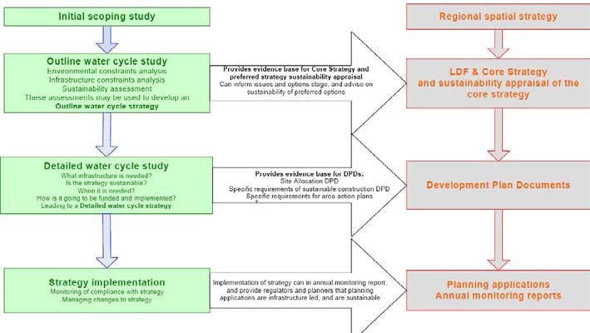

Based on diagram presented in Water Cycle Study Guidance Document (Environment Agency, 2009a, p13)

2.5 Housing Growth Trajectories
    - Annual housing growth forecasts have been developed to enable the assessment of the impact of growth on water infrastructure. The growth forecasts have been developed based on information provided by the partner councils, and are described briefly in this section, with further information including the growth trajectories provided in Appendix B.

    - For Gedling, Broxtowe, Rushcliffe, Erewash and Nottingham City councils, growth scenarios used in this study have been developed based on achieving the RSS growth targets. In Ashfield District a different approach has been adopted at the request of the Council. Ashfield District Council has a housing provision from the East Midlands Regional Plan, March 2009 of 3,600 new homes in the Hucknall area and 7,600 in the rest of the District by 2026. The Council undertook a consultation on Area Based Spatial Options for Hucknall, Kirkby in Ashfield/Sutton in Ashfield and the rural area over the period the WCS was undertaken. The options included a potential mix of all or part of a number of sites. Therefore, the WCS considered the number of houses it was anticipated could be brought forward in each of the areas identified in the spatial options. The purpose was to determine whether there were water related constraints to development. Consequently, the housing numbers considered in the WCS exceed the RSS

housing provision. It is emphasised that it does not mean that the development of all of these sites will take place or that development of any specific site will be supported by the Council.

    - The housing growth trajectories considered in this study are based on the outputs of a ‘workshop’ meeting held with the partner councils. At this meeting the principal approaches to estimating housing trajectories were agreed, as follows:

      - Housing completions for the period 2006-07 to 2008-9 were to be provided by the Councils;

      - Completions to date were to be subtracted from RSS targets to provide a forecast housing completion target for the period 2009-10 to 2025-26;

      - For each Council, the housing capacity of SUEs and large development sites and were identified. These were to be subtracted from the forecast housing completion; and

      - Following completion of the above steps, any shortfall against the RSS target for each Council was to be apportioned by Ward. The apportioning factors would be derived using the percentage of housing land identified in the Strategic Housing Land Availability Assessment (SHLAA) for each area.

    - Following data provision by the Councils and further discussions, some Councils expressed preferences for factoring down the capacity of certain large sites and SUE sites, reflecting the uncertain nature of the location of development within the study area at the current time. It should be noted that there is also uncertainty about the temporal delivery of development sites. Where the councils provided indicative timescales for development, these have been included within the growth scenarios used in this study. Where no information has been provided, development has been distributed evenly over the period 2009- 10 to 2025-26. Whilst actual development scenarios may vary, the approach used in this study ensures that the overall scales of growth required by the RSS are considered. The approach also ensures that potential development at large strategic sites is considered at a strategic level.

    - The approach taken for each council is summarised in Table 2.4, whilst further detail is provided in Appendix B. Figure 2.2 shows the cumulative growth scenario for the whole of the study area. Based on information provided by the partner councils, growth has been assigned to Wards. Where development sites are located in more than one Ward, it has been necessary to apportion growth to Wards.

Table 2.4 RSS Target, Housing Completions, Housing Assessed and Apportionment in this Study

Council | RSS  Growth Target | Completions (2006-07 to  2008-09) | Housing assessed 2009-  10 to 2025-2026 | Total growth assessed in this study | Comment on derivation of forecast housing numbers
Erewash | 7,200 | 1,223 | 5,977 | 7,200 | Council provided completions by Ward 2006-07 to 2008-9 inclusive and estimates of housing supply by Ward for the period 2009-16 and 2016-26. Forecast growth distributed pro rata over each of these periods. Estimate includes allowances for the Stanton and West of Ilkeston SUE sites.
 |  |  |  |  | Resulted in total housing of 8,266, exceeding the RSS housing target for the period by 1,066. Forecast Ward housing numbers have been factored down proportionally to meet the RSS target using the total housing supply by constituted by each Ward as a percentage of total housing supply in the Borough 2009- 10 to 2025-26.
Nottingham City | 20,000 | 3,044 | 16,956 | 20,000 | Council provided completions by Ward 2006-07 to 2008-9. The total delivered to date (3,044) was subtracted from the RSS target of 20,000. The remainder (16,956) were distributed by Ward using the proportion of total housing capacity by Ward in Nottingham City, identified in the SHLAA. These were distributed pro-rata over the period 2009-10 to 2025-26. At Council level, growth allowances include capacities of large sites identified at Waterside/Trent Basin, Extended Island Site, Boots site, Chalfont Site and Stanton Tip.
Broxtowe | 6,800 | 1,035 | 5,765 | 6,800 | Council provided the number of housing completions by Ward for the period 2006-07 to 2008-9 inclusive and estimates of housing supply by Ward for to 2025-26. Estimate includes allowances for SUE sites at North of Stapleford, Toton Sidings and development between Stapleford and Toton. Forecast growth distributed pro rata over this period.
 |  |  |  |  | Total housing (7,597) exceeded the housing target in the RSS by 797. Forecast Ward housing numbers have been factored down proportionally to meet the RSS target using the total housing supply by constituted by each Ward as a percentage of total housing supply in the Borough 2009-10 to 2025-26.

Council | RSS  Growth Target | Completions (2006-07 to  2008-09) | Housing assessed 2009-  10 to 2025-2026 | Total growth assessed in this study | Comment on derivation of forecast housing numbers
Gedling | 8,000 | 947 | 7,053 | 8,000 | The council provided the number of housing completions by Ward for the period 2006-07 to 2008-9 inclusive. Capacities for three SUE sites and 25 other ’large sites’ were identified and assigned to Ward.
 |  |  |  |  | The total capacity of the large sites and SUE sites (9,480) and completions to date (947) exceeded the RSS target of 8,000 by 2,427. The capacity of the SUE and large sites have been factored down proportionally (as advised by the Council) to meet the RSS target of 8,000 new homes by 2026. These have been distributed pro rata over the period 2009-10 to 2025-26.
Rushcliffe | 15,000 | 948 | 14,052 | 15,000 | The council provided the number of housing completions by Ward for the period 2006-07 to 2008-9 inclusive (949). Upper and Lower Growth forecasts were provided for the SUE sites at Gamston and Clifton, and other large sites.
 |  |  |  |  | Under lower growth scenario capacity for all sites within Rushcliffe was 15,169 homes by 2025-26. The capacity of SUE and large sites has been factored down proportionally to meet the RSS target of 15,000 new homes within Rushcliffe Borough by 2026 (taking account of completions to date). Rushcliffe Borough Council provided indicative timescales for delivery of housing over to 2025-26 for most sites, Where no timescales for delivery were provided, growth was distributed pro rata.
Ashfield (within Hucknall) | 3,600 | 611 | 7,308 | 7,919 | At the request of the Council, a different approach has been adopted. Ashfield District Council has a target housing provision of 3,600 new homes in the Hucknall. The Council provided information on the number of housing completions for Hucknall area to 2008-09 (611). Over the period of the WCS the Council undertook a consultation on Area Based Spatial Options for Hucknall. The estimate of housing numbers reflects the options put forward for consideration. These figures have been distributed pro rata over the period 2009-10 to 2025-26. The growth forecasts include allowances for the SUE sites at Whyburn Farm and Rolls Royce in the Hucknall area.
Ashfield (rest of District) | 7,600 | 899 | 10,639 | 11,538 | Ashfield District Council has a target housing provision of 7,600 new homes for the District outside the Hucknall Area. The Council provided information on the number of housing completions for this area to 2008-09 (899). Over the period of the WCS the Council undertook a consultation on Area Based Spatial Options for Kirby in Ashfield, Sutton in Ashfield and the rural area. The estimate of housing numbers reflects the options put forward for consideration. These figures have been distributed pro rata over the period 2009-10 to 2025-26.
Total | 68,200 | 8,707 | 67,750 | 76,457

New dwellings

Figure 2.2 Cumulative New Dwellings based on the Scenarios Developed for this Study, 2006-7 to 2025-26

90,000

80,000

70,000

60,000

50,000

40,000

30,000

20,000

10,000

0
Ashfield Rushcliffe Gedling Broxtowe Nottingham City Erewash

    - The scenarios developed for this study are aligned with the RSS targets for each Council (apart from Ashfield). It is important to recognise that the RSS targets are a minimum target and that the number of new dwellings delivered over the period to 2026 could exceed this target. However, by using the RSS targets as the growth scenarios in this study, potential water cycle constraints can be identified under the minimum levels of growth that could be expected. It should be recognised that growth above the RSS targets may result in further constraints that are not identified as part of this study.
2006-2007
2007-2008
2008- 09
2009-2010
2010-2011
2011-2012
2012-2013
2013-2014
2014-2015
2015-2016
2016-2017
2017-2018
2018-2019
2019-2020
2020-2021
2021-2022
2022-2023
2023-2024
2024-2025
2025-2026
20

    - It is important to emphasise that the development trajectories have been produced for use in this study based on information provided by the partner councils to enable an assessment of the potential impact on the water cycle. It does not follow or imply that development of some or all of these sites will take place or that development of any of these sites will be supported by the local planning authorities.

The relevant National Planning Policies are PPS1, PPS3, PPS4, PPS12 and PPS25
The East Midlands RSS was published in March 2009 and establishes a broad development strategy for the region The housing target for Greater Nottingham and Ashfield District is a total of 68,200 between 2006 and 2026
The majority of housing (approx 40,800) is to be located in the PUA
This WCS will provide the evidence to inform the choice of preferred options for accommodating growth.
Housing growth trajectories have been developed in consultation with the Councils for use in this study. The scenarios are aligned with the RSS targets for each council (except in Ashfield District, where the council requested that a different approach was adopted to reflect their Area Based Spatial Options)
Section Summary – Development and Growth
Box 1

The Water Cycle

3.1 Introduction
    - The water cycle describes the pathways and processes through which the water we use moves through the natural and built environment, as well as through the above and below ground infrastructure on which the domestic population and industry depend. Figure 3.1 illustrates the traditional image of the water cycle showing how water enters a river catchment, how it runs through and over the land, before returning to the river system and ultimately returning to the sea.

Figure 3.1 Traditional View of the Water Cycle without Artificial Influence
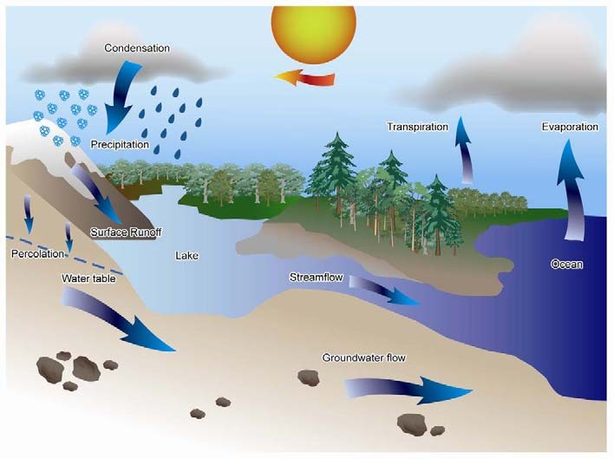

    - Figure 3.2 illustrates the added complexities within the urban water cycle (in schematic form) as a result of housing development and the infrastructure required to support it. The main differences between the natural and the urbanised water cycle relate to the rate of surface runoff (and percolation in to the ground), and river flows. In the urbanised cycle water is captured and stored for use, and this water only re-enters the river network once it has been used and then treated at wastewater treatment works. During or following periods of heavy rainfall, hard surfaces and drainage systems can cause surface runoff to enter water courses rapidly. Hence, the timing and quality of water entering the river network can be significantly different to a natural system.

Figure 3.2 Schematic of the Urban Water Cycle

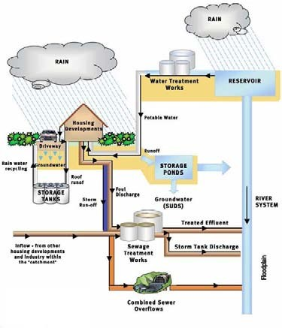
Rainfall (and groundwater) is collected and treated to potable standard and pumped to homes and other non- domestic properties.

Surface runoff from roads and other hard surfaces can exacerbate localised flooding and introduce pollutants in to streams and rivers.

Waste water and foul effluent is collected, treated and removed from settlements. Treated effluent is usually discharged into the river system or to long sea outfalls

Combined sewers carry storm water and sewer water. During heavy rainfall increased flows can exceed capacity and sewage is forced to overflow into streams and rivers through outfalls.

The floodplain absorbs excess water spilling from rivers during flood events.

Based on diagram presented in Environment Agency Water Services Infrastructure Guide (Environment Agency, 2007a)
    - The capacity of the water infrastructure needs to be sized appropriately to ensure the sufficient supply of clean water to homes and industry and to receive foul drainage, whilst preventing the discharge of polluted runoff and untreated foul drainage to protect the quality of the receiving water and any dependant habitats, whilst also reducing the risk of flooding.

3.2 Legislation and Guidance
    - Legislation, guidance and supporting evidence for water related issues, such as water quality, flood risk management and urban drainage, have a significant impact on the water cycle and are often the cause of changes in water infrastructure, as much as development pressures. Any adaptations to the water cycle must be compliant with such legislation and some are undertaken within the regulatory framework.

    - There is currently an unprecedented level of change in the legislation and guidance for water related issues. Some of these changes are driven by European directives; others are in response to national pressures, from the 2007 summer floods for instance. These changes are either currently being implemented, soon to be applied or likely to change in next five to ten years. Given that the timetable for the Water Framework Directive spans the next 18 years in three six-year cycles, the water companies expect to use the first period to carry out the majority of investigations to establish the necessary investment. This will provide an opportunity to assess the improvements delivered through other quality investments.

    - The primary legislation which set the context relating to the water cycle are summarised in Table 3.1 below.

Table 3.1 Primary Water Related Legislation
The Water Framework Directive sets out a requirement to achieve good ecological status in rivers, estuaries and coastal waters, together with good status of groundwater by at least 2027. It presents a unique opportunity for holistic environmental management for all users of the water environment. A cross body Technical Advisory Group (UKTAG) has recently published a set of environmental standards. Whilst there is no certainty that these standards will become statutory in the current form, they form the best current knowledge of how the standards may change. These standards have now been adopted (see www.wfduk.org for further details).
The Water Framework Directive (WFD) is European legislation that aims to consolidate existing national and European legislation relating to water quality in all types of inland and coastal surface-water and groundwater bodies. It came into force in December 2000, and was transposed into UK law in 2003. It introduces some new environmental standards that will help to improve the ecological health of inland waters to achieve ‘good status’. The main aims of the WFD are to prevent deterioration and enhance the status of the water environment, including groundwater. This will be achieved within a framework of River Basin Planning by:
- Reducing pollution;
- Promoting sustainable water use; and
- Contributing to mitigating the effects of floods and droughts.
Water Framework Directive
Description
Legislation

Legislation Description

Habitats Directive As people make increasing demands on the environment our wildlife habitats are coming under more and more pressure. The Habitats Directive recognises this and aims to protect the wild plants, animals and habitats that make up our diverse natural environment. The Directive created a network of protected areas of national and international importance. These are called ‘Natura 2000’ sites and include Habitats Directive Special Areas of Conservation (SACs).
The Habitats Directive has been transposed into English law as the Conservation (Natural Habitats &c) Regulations 1994, now known as the Habitats Regulations.
Existing and future water management has the potential to affect a number of these designations and the Environment Agency Review of Consents process has identified a series of amendments that will be required to existing abstraction licences and discharge consents if adverse effects on the European Sites are to be avoided.

Urban Wastewater Treatment Directive
The Urban Wastewater Treatment Directive (UWWTD) regulates the collection and treatment of wastewater from residential properties and industry. Under this Directive receiving waters can be designated as ‘Sensitive' where additional levels of treatment are required at significant contributing discharges. These can either be direct discharges or those upstream of the designated reach / water body that serve a population equivalent in excess of 10,000. One type of sensitive area is the ’Sensitive Area [Eutrophic]’, where elevated nutrient concentrations, mainly nitrogen or phosphorus, present a risk to the ecological status of the receiving water. In these areas, larger sewage discharges must be treated to reduce nutrient loads.

Nitrates Directive Adopted by the European Union in 1991, this directive aims to reduce water pollution caused by nitrogen from agricultural sources and to prevent such pollution occurring in the future. The directive requires Defra and the Welsh Assembly Government to identify surface or groundwaters that are, or could be high in nitrate from agricultural sources. Nitrogen is one of the nutrients that can effect plant growth. Surface waters also have to be identified if too much nitrogen has caused a change in plant growth which affects existing plants and animals and the use of the water.
Once a water body has been identified, all land draining to that water is designated as a Nitrate Vulnerable Zone. Within these zones, farmers must observe an action programme of measures which include restricting the timing and application of fertilisers and manure, and keeping accurate records.
The Water Act The Water Act received Royal Assent on 20th November 2003, which amended previous legislation including the Reservoirs Act 1975, the Water Industry Act 1991 and the Water Resources Act 1991. The Act had four broad aims including promoting the sustainable use of water resources, strengthening the voice of consumers, increasing competition in the water industry and promotion of water conservation.
Under the Act, water companies have a statutory duty to publish and maintain Water Resources Management Plans (used within this WCS) and promote water conservation.
Floods Directive The Floods Directive is designed to help Member States prevent and limit floods and their damaging effects on human health, the environment, infrastructure and property. The Floods Directive came into force on 26 November, 2007 and is due to be transposed into UK law through the Floods and Water Management Bill (see below). The Directive requires Member States to first carry out a preliminary assessment by 2011 to identify the river basins and associated coastal areas at risk of flooding. For such zones they would then need to draw up flood risk maps by 2013 and establish flood risk management plans focused on prevention, protection and preparedness by 2015. The Directive applies to inland waters as well as all coastal waters across the whole territory of the EU.

Floods and Water Management Bill
The draft Flood and Water Management Bill was published for consultation in April 2009 (Defra, 2009). It is designed to improve how the UK prepares for and responds to flood emergencies and better protect water supplies during drought and will implement the key recommendations made in Sir Michael Pitt’s independent review into the summer 2007 floods. The draft Floods & Water Management Bill includes provisions that will transpose the requirements of the Flood Directive into law in England and Wales. The second reading debate for the Bill took place in December 2009³.

³ http://www.defra.gov.uk/environment/flooding/policy/fwmb/index.htm

3.3 Other Relevant Policy and Guidance
    - The Department for Environment, Food and Rural Affairs (Defra) is the Government department responsible for aspects of water policy in England relating to water supply and resources, and the regulatory systems for the water environment and the water industry. These include drinking water quality; the quality of water in rivers, lakes and estuaries, coastal and marine waters; sewage treatment; and reservoir safety. Defra works with other government organisations such as the Environment Agency (which manages water resources and enforces water quality standards), the Drinking Water Inspectorate (which regulates the quality of drinking water), and Ofwat (which is responsible for economic regulation of the water industry).

    - Defra published its strategy for water in the document Future Water in February 2008 (Defra, 2008). The strategy sets out a framework for water management in England and covers issues such as sustainable delivery of secure water supplies, an improved and protected water environment, fair, affordable and cost- reflective water charges, reduced water sector greenhouse gas emissions and more sustainable and effective management of surface water.

    - The Environment Agency is the statutory body with a duty to manage water resources in England. This is done primarily through the water abstraction licensing process and also through regulating the water companies by reviewing their Water Resources Management Plans (further information is provided in Section 4.1. The Environment Agency published its new water resources strategy ‘Water for People and the Environment – Water Resource Strategy for England and Wales’ in spring 2009, setting out how the Agency believes water resources should be managed to 2050 and beyond (Environment Agency, 2009b).

    - Both Future Water and the Environment Agency’s water resource strategy are important to this WCS because they set out government policy concerning the management of water resources in the short, medium and long term.

3.4 Integrated Catchment Management
    - The urban water cycle is complex and highly integrated with many feedback mechanisms. Advanced planning and appropriate management helps to ensure that the water cycle contributes to a safe, clean and healthy environment, rather than being a source of long term problems.

    - The capacity of the receiving water environment and thus development in the study area may be constrained by WFD environmental quality objectives enforced by UK and European legislation.

    - Sustainable drainage systems that encourage infiltration and slow down the movement of rainfall runoff in the catchment can reduce the amount of urban pollutants entering watercourses, encourage infiltration into groundwater sources and mitigate the impact of intense rainfall events on surface water flooding.

    - Implementing water efficiency measures to reduce the amount of potable water that is wasted will help to:

      - reduce abstraction pressures on river flows;

      - reducing the impacts on aquatic ecosystems;

      - increase the volume of water available for diluting both point source and diffuse pollution; and

      - reduce flow in the sewer network.

3.5 Catchment Flood Management Plans
    - The Environment Agency’s draft Trent Catchment Flood Management Plan (CFMP) covers the whole catchment of the Trent and all its tributaries and fully encompasses the study area. It sets policies across the whole catchment which will achieve long-term sustainable flood risk management over the next 5 to 10 years,

    - The objectives for this CFMP area are:

      - Sustain and improve the status of environmentally designated areas through appropriate frequency, extent and duration of flooding, including the utilisation of rivers and floodplains for the benefit of nature conservation;

      - Reduce soil erosion resulting from surface water run-off;

      - Support and encourage land management and land use that will reduce run-off rates from upland areas;

      - Return watercourses to a more natural state, increasing biodiversity and opening up green corridors through urban areas;

      - Sustain and increase the amount of Biodiversity Action Plan (BAP) habitat in the catchment;

      - Support and encourage land management that will protect and improve water quality;

      - Sustain and protect cultural and social heritage in the catchment;

      - Reduce the number of people at risk from deep and fast flowing flood waters or fast onset of flooding;

      - Minimise disruption to people, property and communities caused by flooding, taking into account future pressure resulting from climate change, sea level rise, population growth or land use change;

      - Reduce the disruption caused by flooding to transport and infrastructure;

      - Reduce the cost of flood damage where it is high and economically viable to do so;

      - Reduce the cost of flood risk management and implement more sustainable methods of flood risk management; and

      - Minimise the increase in the cost of flood damage, taking into account future pressures which may increase flood risk.

    - To set policies and objectives, the catchment is divided into ten Policy Units, of which the Greater Nottingham area mainly lies in Policy Unit 5: Burton, Derby and Nottingham. The selected policy for this unit is Policy 5 – Take further action to reduce flood risk (now and / or in the future). A number of actions are associated with this Policy Unit to meet the selected policy and ensure sustainable flood risk management. A summary is provided in Table 3.2 below.

Table 3.2 Summary of Main CFMP Actions for LPAs in Burton, Derby and Nottingham (Policy Unit 5)

Action | Principal Organisation | Timescale | Objectives
Increase green corridors through urban areas, | Environment Agency, | 2014-2029 | Return watercourses to a more natural
particularly on the River Erewash through | local authorities, |  | state, increasing biodiversity and
strategic planning and building partnerships with | Natural England. |  | opening up green river corridors
local authorities, to help ensure appropriate |  |  | through Derby and the towns of Langley
development controls are applied. |  |  | Mill, Ilkeston, Sandiacre and Long
 |  |  | Eaton.
Identify locations within the urban areas where | Environment Agency, | 2010-02015 | Sustain and increase the amount of
BAP habitats may be created, expanded or | local authorities, |  | BAP habitat in the catchment by
improved through links with other flood risk | Natural England. |  | opening up green spaces within the
management schemes or initiatives. |  |  | built environment.
Identify locations and opportunities where we can | Environment Agency, | 2011 -2015 | Return watercourses to a more natural
work with the aggregate extraction companies to | aggregates |  | state, increasing biodiversity and
improve planning for and restoration of gravel | companies, Natural |  | opening up green river corridors
workings, - particularly in relation to providing | England. |  | through Derby and the towns of Langley
additional flood storage. |  |  | Mill, Ilkeston, Sandiacre and Long
 |  |  | Eaton.
Produce an integrated urban drainage strategy, | Local Authorities, | 2009-2012 | Support and encourage land and
for principal urban areas within the policy unit. | Environment Agency, |  | drainage management that will protect
 | Severn Trent Water |  | and improve water quality, particularly
 | Ltd, Internal Drainage |  | from disused mines and derelict areas
 | Boards (IDBs). |  | as well as heavily urbanised areas.
Implement Integrated Urban Drainage strategies – | Local Authorities, | 2012 -2020
priority for principal urban areas, to reduce the | Environment Agency,
incidence of surface water and foul water flooding | Severn Trent Water
through greater involvement of Severn Trent | Ltd, IDBs.
Water Ltd in flood risk management.
Develop a SWMP that will ensure an appropriate | Local Authorities, | 2009 -2012 | Reduce the cost of flood damage where
approach is adopted to surface water drainage. | Environment Agency, |  | it is high and economically viable to do
 | Land owners, IDBs. |  | so.

    - Ashfield District Council area falls within Policy Unit 2 (Sherwood) and within Policy Unit 5 (see above). The proposed policy for this unit is to continue with existing or alternative actions to manage flood risk at the current level (accepting that flood risk will increase over time from this baseline). A summary of the actions proposed relevant to the local authorities, water company and government bodies for this unit area is presented in Table 3.3.

Table 3.3 Summary of Main CFMP Actions for Ashfield District Council in Sherwood Policy Unit 2

Action | Principal Organisation | Priority and Timescale | Consequence
Investigate locations and ways to return river | Environment Agency, | Medium | Development of a strategy for river
channel to more natural state – particularly | local authorities, | 3 – 8 years | restoration aimed at returning the river
Retford, Mansfield, Worksop, and the middle Idle | Natural England, land |  | to a natural state.
where the channel has been heavily engineered | owners, local
through mining activities. | authorities
Identify opportunities to maximise the use and | Environment Agency, | Medium | Clear guidance for planners, developers
benefits of SuDS, particularly in areas where the | local authorities, | 0 – 3 years | and home owners regarding best
sandstone geology will support extensive use, |  |  | practice for drainage, and a practical
and where a strategy for retro-fitting SuDS may |  |  | guide for implementation.
be developed.
Develop a strategy for implementing measures | Environment Agency, | Medium | Clear guidance to drive appropriate
and schemes that will encourage land | local authorities, | 2 – 5 years | land management, and encourage
management practices and land drainage that will |  |  | collaborative schemes.
reduce run-off.

The urban water cycle is complex and highly integrated. Advanced planning and appropriate management ensures that the water cycle contributes to a safe, clean and healthy environment.
Urban development alters the timing and quality of water entering the river network.
Water infrastructure needs to be sized appropriately to ensure supply of clean water and receive foul drainage, prevent the discharge of polluted runoff and drainage, reduce flood risk and protecting the environment.
The primary water-related legislation includes the Water Framework Directive, Habitats Directive, Urban Wastewater Treatment Directive, Nitrates Directive, Floods Directive and the forthcoming Floods and Water Management Bill.
The Water Cycle – Section Summary
Box 2

Baseline Conditions

4.1 The Study Area
    - The study area remains unchanged from that of the Scoping Study, and is defined by the boundaries of the Greater Nottingham area and the whole of Ashfield District (see Figure 4.1).

    - In order to advise on the most sustainable approach water management, an understanding of the existing natural environment and drainage infrastructure is required. The Greater Nottingham and Ashfield Water Cycle Study Scoping Report (Scott Wilson, 2009) establishes the baseline conditions for the study area.
It is not the purpose of this report to repeat the information from the Scoping Study, and the reader should refer to that report for more information.

    - In the following sections the key findings of the Scoping Report relating to baseline conditions are summarised. The Scoping Report identified additional information that should be sought to inform the Outline WCS, and this has been presented below. Where appropriate, further relevant information has been identified and presented to support this study.

4.2 River Basin and Geology
4.2.1 For the Water Framework Directive, the Environment Agency has divided England and Wales into 9 river basin catchments in order to manage targets on both surface water and groundwater quality. The study area is located within the Humber River Basin District, one of the largest river basin districts which include the rivers Trent and Humber. The main watercourses in the study area are the River Trent, which flows through the centre of Nottingham, and the Rivers Erewash, Leen, Soar, Derwent and Smite. These are shown in Figure 4.1. The Scoping Study summarised the key features and the geology of the study area and these are not repeated in detail here. Box 3 summarises the key findings of the Scoping Study in relation to river basin and geology.
Annual average rainfall for Greater Nottingham and Ashfield is 620mm, less than the average for England (897mm). The main watercourses in the study area include River Trent, Erewash, Leen, Soar, Derwent and Smite.
Permo-Triassic Sandstone and Permian Magnesian Limestone underlies much of the north of the study area. Both are important aquifers. The study area lies entirely within the Humber River Basin District.
River Basin and Geology: Key findings of the Scoping Study
Box 3

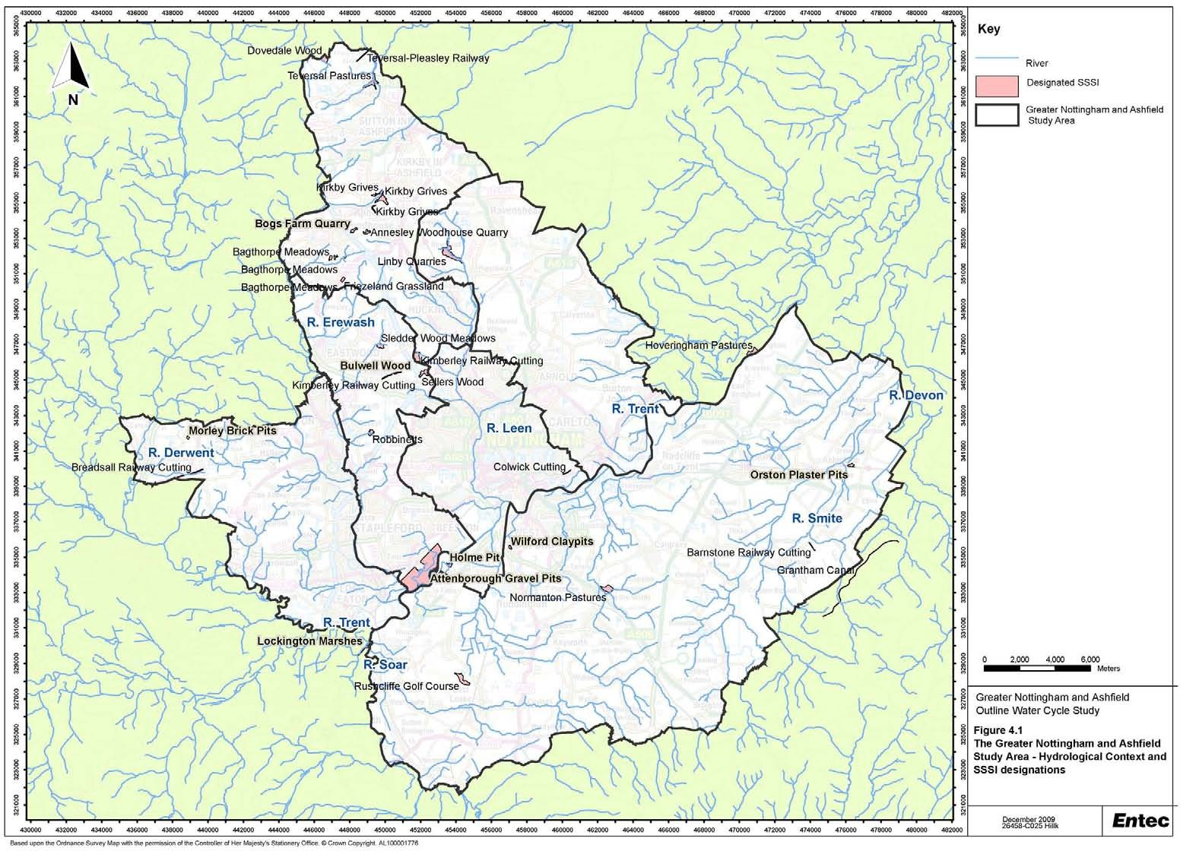

4.3 Water Quality
    - The quality of a receiving water course can act as a barrier to growth if there is limited capacity to assimilate an increase in the discharge of treated wastewater due to housing growth, without a resulting deterioration in water quality or impacting the conservation status of a water dependant habitat. The Scoping Study provided an overview of the baseline conditions for the study area, these are summarised in Box 4. This overview highlighted existing water quality issues in many receiving waters, particularly surrounding elevated nutrient concentrations (Nitrate and Phosphates).
2007 GQA assessment in the Nottingham area indicates Nitrate and Phosphate concentrations are high in most watercourses, Chemistry and Biological grades are poor in some rivers.
Greater Nottingham falls within the Lower Trent and Erewash catchment, in the Humber River Basin District (RBD). Currently 5% of this catchment surface water bodies are in good or potentially good status, with the objective that this will increase to 66% by 2027. This is the target that the Environment Agency aims to achieve through the River Basin Planning process by identifying measures aimed all sectors contributing to a failing or at risk water body.
River Trent is a designated cyprinid fishery under EC Freshwater Fish Directive, with specific targets. Consents may tighten further under the Water Framework Directive (WFD).
Water Quality: Key Findings of the Scoping Study
Box 4

    - The Humber RBMP provides details of the current status and future objectives of these rivers, as well as identifying the pollution control measures aimed at achieving these objectives. Objectives are set following a risk based assessment of the pressures and impacts as well as the characteristics of the water body itself. A summary of the key elements salient to an Outline WCS are provided below. For further details including risk and classification maps of the full Humber River Basin Management plan are available on the internet⁴. The current status of the majority of rivers in the study area are designated Moderate Status. Table 4.1 presents a summary of the current status and 2015 objectives for the study area catchments. Full details of the current status of all watercourses in the study area are available in Annex B of the Humber RBMP.

    - Although Table 4.1 appears to illustrate little or no overall improvement in water body status WFD requires all elements (both physio-chemical and biological) to achieve good status following the ‘one out all out’ principle.

⁴ see: http://www.environment-agency.gov.uk/research/planning/33106.aspx

Table 4.1 Summary Current Status and Objectives of Rivers within the Nottingham Study Area

River and Lake Water River Trent and Erewash Derbyshire Derwent River Soar Bodies
Now 2015 Now 2015 Now 2015
Percentage at good status | 6 | 6 | 28 | 30 | 9 | 9
overall (chemical and
ecological)
Percentage improving for one |  | 12 |  | 24 |  | 2
or more elements in rivers)

    - One of the key actions for this catchment from the RBMP (December 2009) is to work with Severn Trent Water Ltd to reduce the number of sewerage misconnections within the catchment. Table 4.2 provides a summary of the further catchment specific measures included in the Humber RBMP.

Table 4.2 Summary of Relevant Measures included in the Humber RBMP to Improve Water Bodies in the Study Area

Catchment Summary of Pressures
Lower Trent Pressures - Diffuse pollution from agriculture and point source pollution from wastewater treatment works are and Erewash both identified as playing a key role in determining the status of rivers and lakes in this catchment.

Specific measures include:
- Applying phosphate removal at a number of wastewater treatment works (WwTW) to reduce phosphate concentrations / loads in the River Trent sensitive areas designation.
- Work with Severn Trent water to reduce the number of misconnections within the catchment.
- Keep up the work on the OnTrent Initiative to improve the heritage value of the River Trent and its floodplain
- Actions under PR09 Water Industry Investment Programme to improve ammonia levels at Newthorpe WwTW, to comply with Freshwater Fish Directive.
- Actions to meet Urban Waste Water Treatment Directive Sensitive area Designation to include P removal at Stoke Bardolph WwTW.
- Ensure no deterioration of receiving water quality due to increased consent discharge flows at the following WwTW: Aslockton, Flintham and Nether Broughton in the study area.
Derbyshire Pressures - Point source pollution from industry and wastewater treatment works both play a key role in Derwent determining the status of rivers and lakes. Physical modifications for the supply and storage of water and flood protection are also key reasons for failures as they also impede movement of fish.

Specific measures include:
- Work with Severn Trent Water Ltd to reduce the number of misconnections within the catchment.
- Ensure no deterioration of receiving water quality due to increased consent discharge flows at WwTWs.
- Undertaking works management to achieve favourable conditions at SSSIs

Catchment Summary of Pressures
Soar Pressures - Diffuse pollution from agriculture is considered to be the key reason for failures in the Soar catchment. Physical modifications due to urbanisation and for water storage and supply and barriers to fish movement also play a key role in determining the status of rivers and lakes in this catchment.

Specific measures include:
- Improve wastewater works at locations throughout the catchment to reduce the input of nutrients and improve water quality; and
- Work with Severn Trent Water Ltd to reduce the number of misconnections within the catchment.
- Amend discharge consents and undertaking works management to achieve favourable conditions at SSSIs
- Actions under PR09 Water Industry Investment Programme to improve ammonia Levels at WwTWs
- Ensure no deterioration of receiving water quality due to increased consent discharge flows at WwTWs.

    - Table 4.2 shows that measures identified in the Humber RBMP include ensuring no deterioration of receiving water quality. The objectives of the Water Framework Directive are to achieve Good Ecological Status (or Ecological Potential), thereby aspiring to improve water quality and not just ensure no deterioration from current conditions.

    - The map of historic water quality data, for the period 2000-2004 across the study area (Figure 4.2) clearly illustrates the elevated phosphorus concentrations across most of the study area highlighted in the Scoping Study. Many sites already fail the WFD standard, as indicated by the red dots. The only exception is the headwaters of the River Leen where the green dots indicate mean concentrations are least 20% below the WFD standard. Figure 4.3 to Figure 4.4 illustrate compliance with standards for the other key WFD water quality determinands that could be influenced by an increase in wastewater discharges.

    - The high phosphorus concentrations in the rivers across the study area have historically resulted in poor GQA grades and present a risk of not meeting the WFD objectives. The majority of rivers in the study area meet the standards for ammonia and biochemical oxygen demand (BOD), with the exception of the urban areas.

    - Housing growth could result in increased loads of phosphorus, ammonia and BOD, as a resulted of higher volumes of wastewater entering the water environment. Housing growth therefore could increase the risk of failure against phosphorous standards, as compliance with WFD standards is measured using the specific ‘type’ of phosphorous to which treated effluent from wastewater treatment works can make a significant contribution. Therefore, WFD water quality objectives may present a constraint to growth if development is predicted to result in a deterioration of river water quality.

    - Ammonia and BOD standards are likely to present less of a constraint than phosphorous when the impact of development on river water quality is considered. There may of course be locally important issues,

particularly in relation to the capacity of the sewerage network and WwTW considered further in Section 4.4.

    - European legislation exists to protect receiving waters and their dependant habitats that are considered particularly sensitive. There are no Special Areas of Conservation designated under the EU Habitats Directive within the study area, but several nationally important SSSIs are present, as illustrated in Figure
4.1 (and discussed further in Section 4.7). It is important that current environmental conditions are maintained or improved at these locations. If growth is likely to have a detrimental influence on water quality at these sites then this could also constrain development.

    - River reaches within the study area are also designated under the Freshwater Fish Directive, and two of these reaches are currently failing:

      - Gilt Brook downstream of Newthorpe WwTW; and

      - an area of standing open water within Attenborough Gravel Pits SSSI.

    - In summary the current water quality of the many of the rivers draining the study area are already in moderate to poor status. This is partly due to wastewater treatment discharges but contributions of pollutants from other sources including agriculture and urban runoff are also important. Some of the measures identified in the Humber RBMP, as presented in Table 4.2 are likely to contribute to baseline water quality improvements.

    - Tackling urban runoff by separating clean and foul drainage (e.g. incorporating SuDS as part of new developments) offers a significant potential to improve water quality in urban catchments. Measures aimed at other sectors, particularly agriculture may also return a significant improvement in water quality, particularly in headwater catchments.

    - Not achieving good status / failure of a water quality standard alone does not necessarily present a barrier to development. For example, an increase in effluent flow could be mitigated through treating effluent to a higher standard to reduce the overall effluent load or achieve load standstill in line with the WFD ‘no deterioration’ policy.

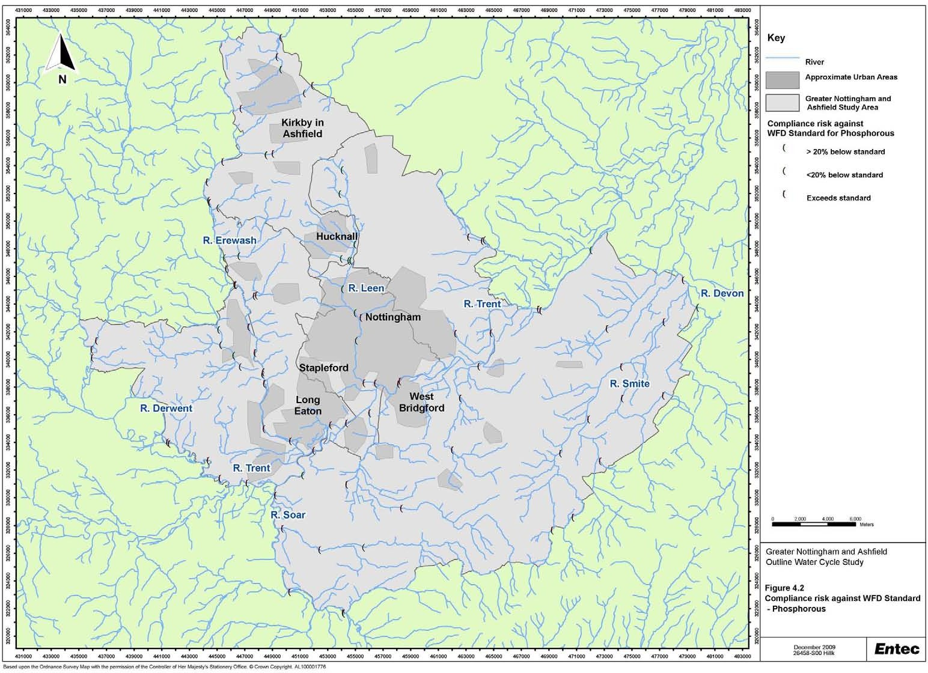

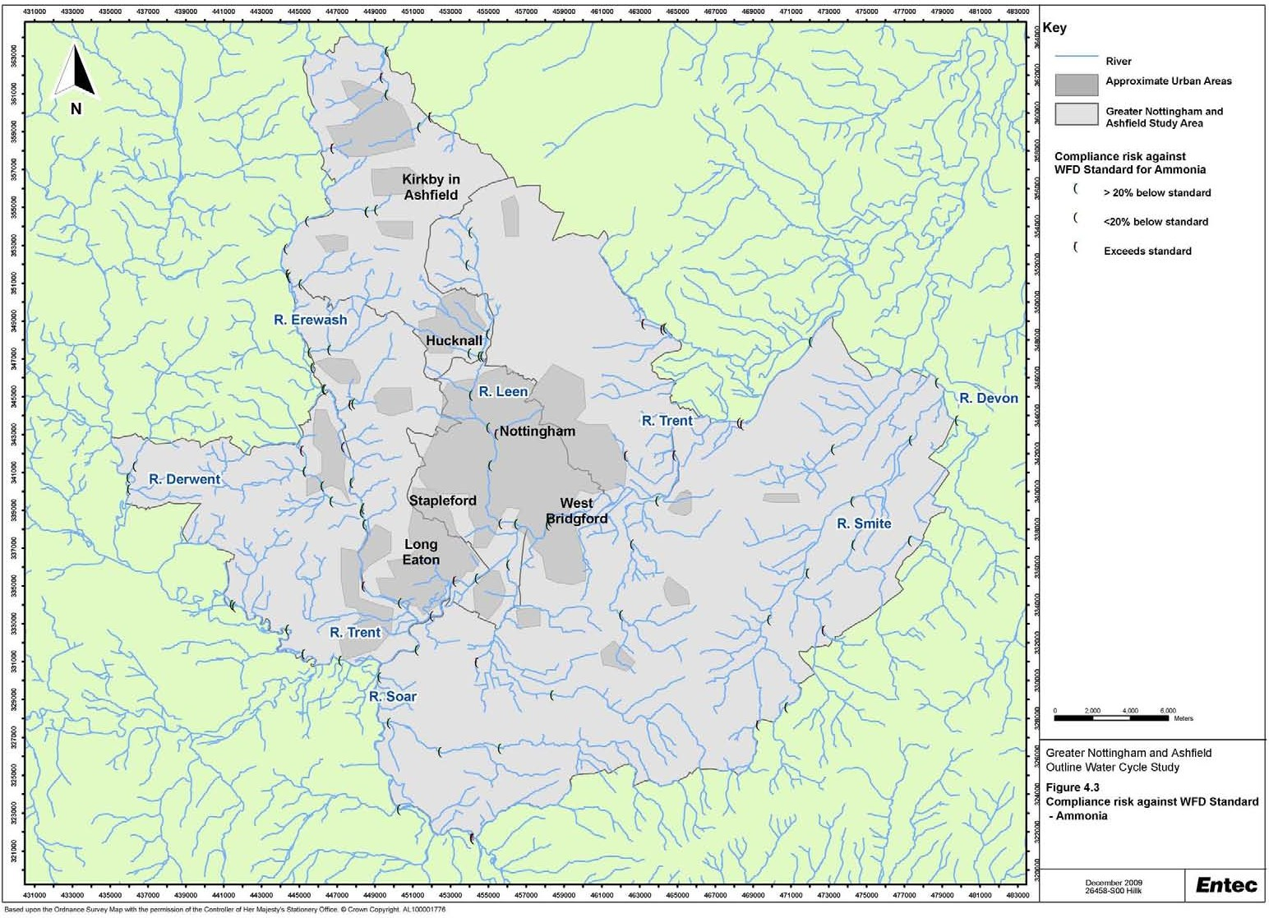

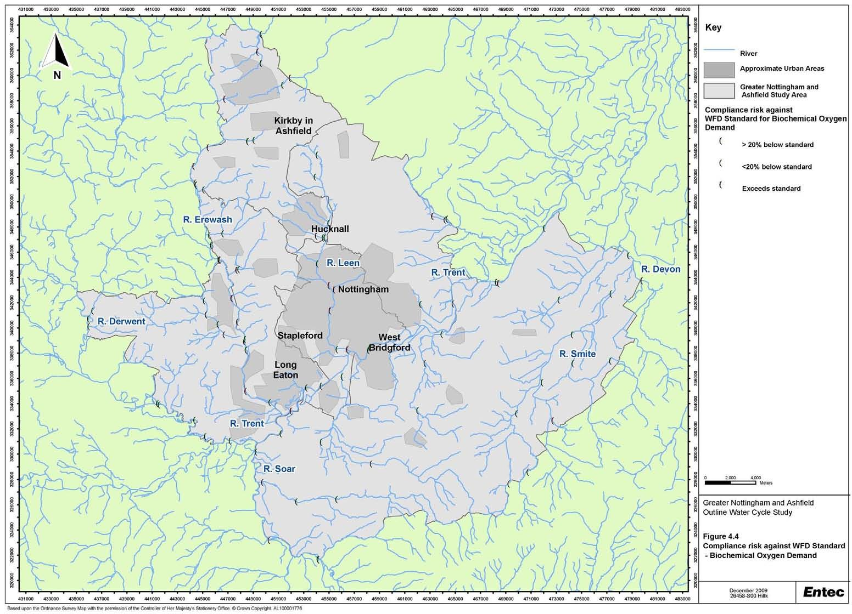

Creating the environment for business

4.4 Wastewater and Sewerage
    - The Scoping Study provided an overview of the baseline conditions for the study area. The findings of the study are summarised in Box 5 and are not repeated in detail here. The Scoping Study recommended that further information be provided in the Outline WCS regarding specific aspects. Where possible, these are addressed below.
There are over 30 significant WwTW in the Greater Nottingham and Ashfield study area; the principal one being Stoke Bardolph WwTW, serving a population of more than 200,000, and discharging to the River Trent.
In the scoping study Severn Trent Water stated “They do not anticipate any particular issues with the waste water systems but key to future performance is management of surface water runoff”.
An East Midlands Regional Assembly (EMRA) review of the capacity of WwTWs in East Midlands concluded there are potential regional and site specific constraints.
Population growth in some WwTW catchments may increase the population equivalent over a key Urban Waste Water Treatment Directive (UWWTD) thresholds and thus require tighter effluent quality, and investment in new sewerage treatment infrastructure (e.g. phosphate removal).
Wastewater and Sewerage: Key Findings of the Scoping Study
Box 5

    - The scoping study identified the need to gain a better understanding of the capacity and size of the WwTWs within the study area. Severn Trent Water has provided information on the spatial extent of wastewater catchments (Figure 4.5) and the current and consented flow volumes at wastewater treatment works, as well as upgrades planned over the next 5 years. This has been used to provide an analysis of the implications of the proposed growth at each WwTW. There are a total of 42 WwTWs in or bordering the study area, but those WwTWs with a Population Equivalent (PE) of 5,000 or less are not considered further in this assessment. These are excluded due to limited data being made available for these WwTW to facilitate a thorough assessment. These are small WwTW, commonly located in rural or isolated areas, and hence are unlikely to be affected by significant growth. All the WwTWs with a PE greater than 5,000 that may be influenced by growth within the study area are listed in Table 4.3 along with the current consent conditions.

Doc Reg No. 26458 R029i3
Page 36

February 2010

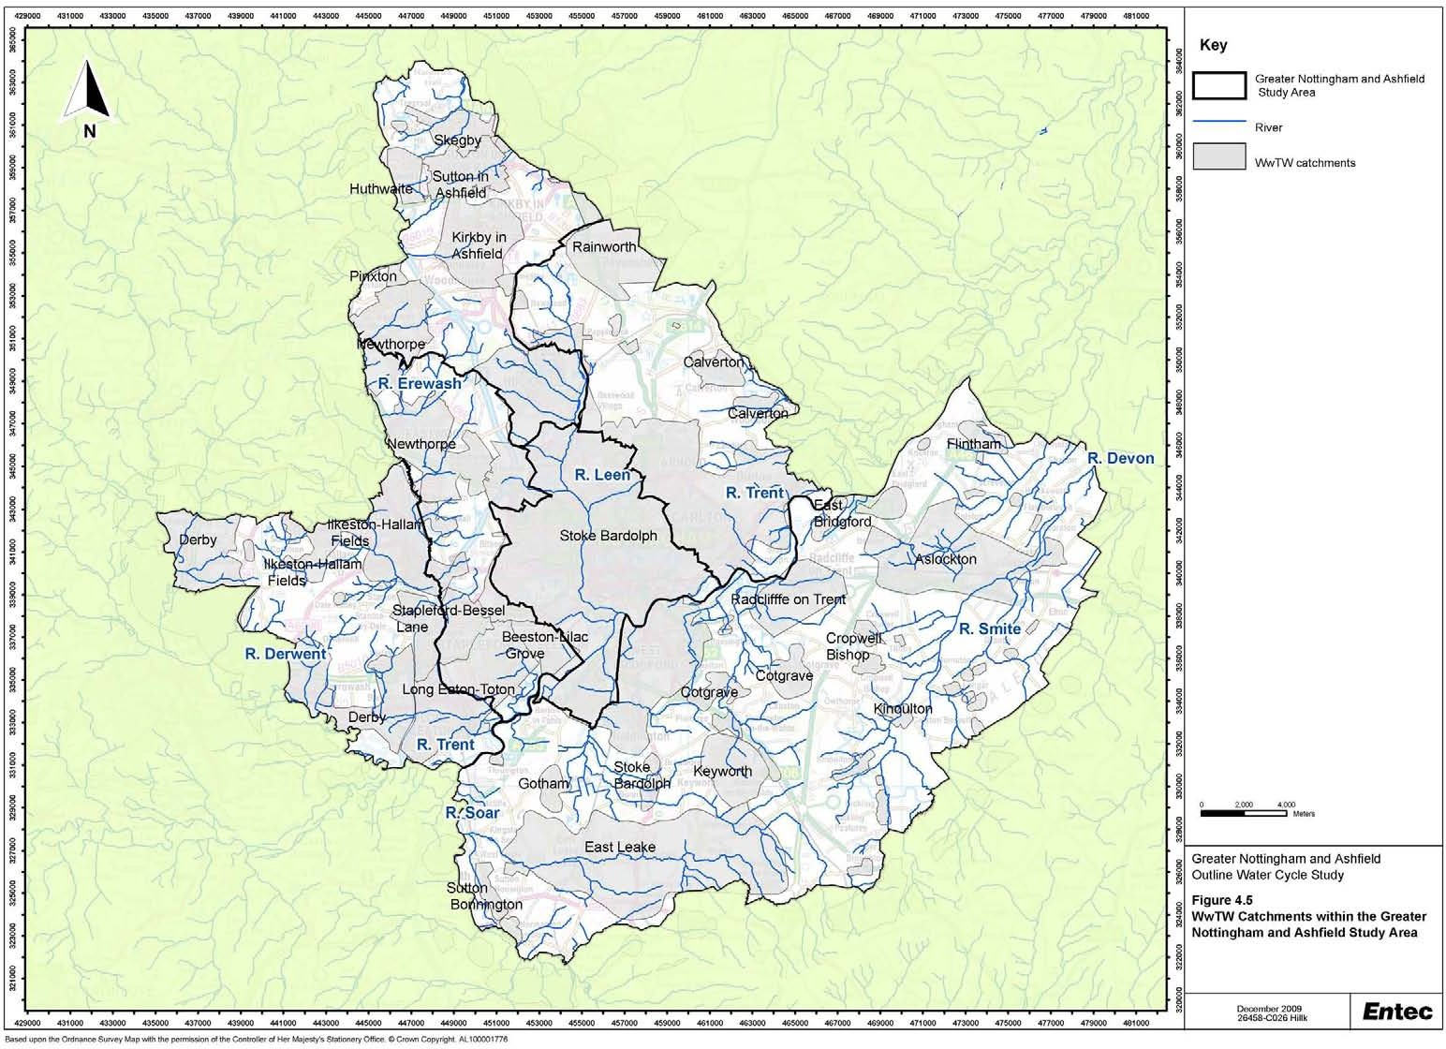

Table 4.3 WwTW that could be Influenced by Growth in the Greater Nottingham and Ashfield Study Area (provided by Severn Trent Water)

Wastewater Current Receiving Current Consent Information Treatment PE Watercourse
Works Name
DWF Amm Amm BOD SS (mg/l) P (mg/l) (m³/day) (Summer) (Winter) (mg/l)
Aslockton | 12202 | Car Dyke | 3637 | 5 | 10 | 20 | 30
Beeston - Lilac | 20042 | Pasture Lane | 9100 | 5 | 10 | 20 | 30
Grove |  | Dyke
Calverton | 8859 | Grimesmoor | 1825 | 3 |  | 10 | 20
 |  | Dyke
Cotgrave | 9732 | Cotgrave Brook | 2090 | 10 |  | 20 | 30
Derby | 374106 | River Derwent | 91500 | 3 | 5 | 20 | 30 | 1
East Leake | 8866 | Kingston Brook | 1729 | 5 | 10 | 15 | 30
Huthwaite | 5810 | Alfreton Brook | 1222 | 5 |  | 20 | 40
Ilkeston - Hallam | 48433 | River Erewash | 10800 | 5 |  | 10 | 20 | 2
Fields
Keyworth | 7370 | Trib Of Fairham | 1301 | 10 |  | 20 | 30
 |  | Brook
Kirkby in Ashfield | 26728 | River Erewash | 5790 | 5 | 5 | 15 | 25 | 2
Long Eaton - Toton | 68472 | River Erewash | 23608 | 5 |  | 15 | 25 | 1
Newthorpe | 48395 | Gilt Brook | 12949 | 5 |  | 10 | 20 | 2
 |  |  |  | (3 by 2014)
(3 by 2014) |  | 10 | 20 | 2
Radcliffe on Trent | 8489 | Trib Of Polser | 1902 |  |  | 25 | 45
 |  | Brook
Rainworth | 26170 | Rainworth Water | 4492 | 5 | 10 | 15 | 25 | 2
Skegby | 10535 | Skegby Brook | 2023 | 10 |  | 25 | 45 | 2
Stapleford - Bessell | 27976 | Stapleford | 7760 | 5 |  | 15 | 25 | 2
Lane |  | Grange Brook
Stoke Bardolph | 602779 | River Trent | 148000 | 10 | 20 | 25 | 45 | (1 by
 |  |  |  |  |  |  |  | 2014)
Sutton in Ashfield | 31062 | River Maun | 7109 | 3 | 0 | 10 | 15 | 2
Pinxton* | 8894 | River Erewash | 2263 | 5 |  | 15 | 25

Note Pinxton not included in Severn Trent Water strategic statement/assessment

    - The Scoping Study provided an overview of the baseline conditions for the study area. Severn Trent Water has provided further details of 17 WwTWs. These include Derby and Pinxton WwTWs, which although just outside the study area could be influenced by the proposed growth.

    - The fundamental factor used to describe the hydraulic or flow capacity of a WwTW is the ‘Dry Weather Flow’ (DWF). DWF is an estimate of the flow-rate of wastewater arriving at the treatment works under ‘normal’ conditions. Changes to how DWF is estimated, based on flow measurement data, may mean that Severn Trent Water has to re-negotiate discharge consents at four wastewater treatment works in the study area, namely:

      - Sutton in Ashfield;

      - Skegby;

      - Huthwaite; and

      - Aslockton.

    - The implications for the above works would be dependent on the outcome of discussions between the Environment Agency and Severn Trent Water concerning the requirement for new consents or additional treatment. Renegotiating the consent conditions could lead to a pro-rata reduction in effluent quality in order to achieve load standstill flow to prevent deterioration of the downstream water quality, however, this should be investigated further in any future detailed WCSs.

    - Figure 4.5 illustrates where WwTW catchments extend beyond the boundary of the study area, and could therefore be influenced by growth in neighbouring districts. Where the neighbouring authorities have commissioned separate WCSs, the key findings from these WCSs are presented in Section 4.7.

4.5 Water Resources
    - Water resources are regulated by the Environment Agency in England and Wales through the abstraction licensing system. Once water has been abstracted from the environment the responsibility for public water supplies is transferred to the water undertakers who have a statutory duty to provide water supplies to household properties. Severn Trent Water operates as the water undertaker across the study area. Water companies manage their supply areas in units known as water resource zones (WRZs). The Greater Nottingham and Ashfield area lies entirely within Severn Trent Water’s East Midlands WRZ. The extent of the WRZ in relation to the study area is shown in Figure 4.6, along with the principal surfacewater (SW) and groundwater (GW) sources used by Severn Trent Water for public water supply purposes.

    - On a five yearly basis the water companies in England and Wales set out their long term requirements for maintaining and enhancing their water supply and wastewater infrastructure in their Strategic Business

Plans. These plans are submitted to the financial regulator, the Water Service Regulation Authority (Ofwat). In addition to the Strategic Business Plans, the water companies must also submit a Water Resources Management Plan (WRMP) to Defra. These plans set out in detail how the water companies plan to balance supply and demand for water in their supply area over a 25 year period and take into account the economic, environmental and social implications of these plans. The water companies prepared and published their draft WRMPs for consultation in May 2008, and in February 2009 published their Statement of Response to consultations. The Statement of Response presents the comments received on the WRMP, and whether the company will change their plans as a result of the comments received. Severn Trent Water received direction from Defra in December 2009 to publish its final WRMP.

    - The Environment Agency assesses water resource availability at a regional and local (catchment) level. The Environment Agency has developed Catchment Abstraction Management Strategies (CAMS) which set out how much water is available for additional abstraction taking into account the needs of the environment, and abstraction for public water supply and other uses. The results are used to inform future water abstraction licensing strategies and so provide a useful context in which to understand the environmental constraints affecting the water supply options available to Severn Trent Water. The Scoping Study provided an overview of water availability in the study area. The findings of the study are summarised in Box 6, whilst Appendix C provides further details about the CAMS resource availability status. The Scoping Study recommended that further information be provided in the Outline WCS regarding specific aspects. These are discussed further below.

    - The CAMS status of the water resources management units within the boundaries of the study was shown in the Scoping Study. This is reproduced in Table 4.4. A wider review of CAMS assessments relevant to the East Midlands WRZ has been completed as part of this study, and is shown in Figure 4.7. This shows that in most catchments there is little or no further water available for abstraction.

Table 4.4 Water Resources Status in Greater Nottingham and Ashfield Study

Water Resources or Groundwater Resources Management Unit | Main River | Individual WRMU status | Integrated WRMU status
WRMU1 – River Trent | River Trent | Water available | Water available
WRMU 3- Wollaton Groundwater | Wollaton SS GWMU | Over-licensed | Over-licensed
WRMU2 – Dover Beck | Dover Beck and Ravenshead South SS GWMU | Over-abstracted | Over-abstracted
WRMU4 – Leen and Limestone | River Leen and Hucknall PML GWMU | No water available | No water available
WRMU4 – River Idle | River Idle | Over-abstracted | Over-abstracted
WRMU1 – River Upper Meden | River Upper Meden | Water available | No water available
WRMU1 – Upper Derwent | River Derwent | Over-licensed | Over-licensed

Reproduced from Scott Wilson (2009), Table 5-2, p32. Information taken from Environment Agency (2007b) and Environment Agency (2008a).

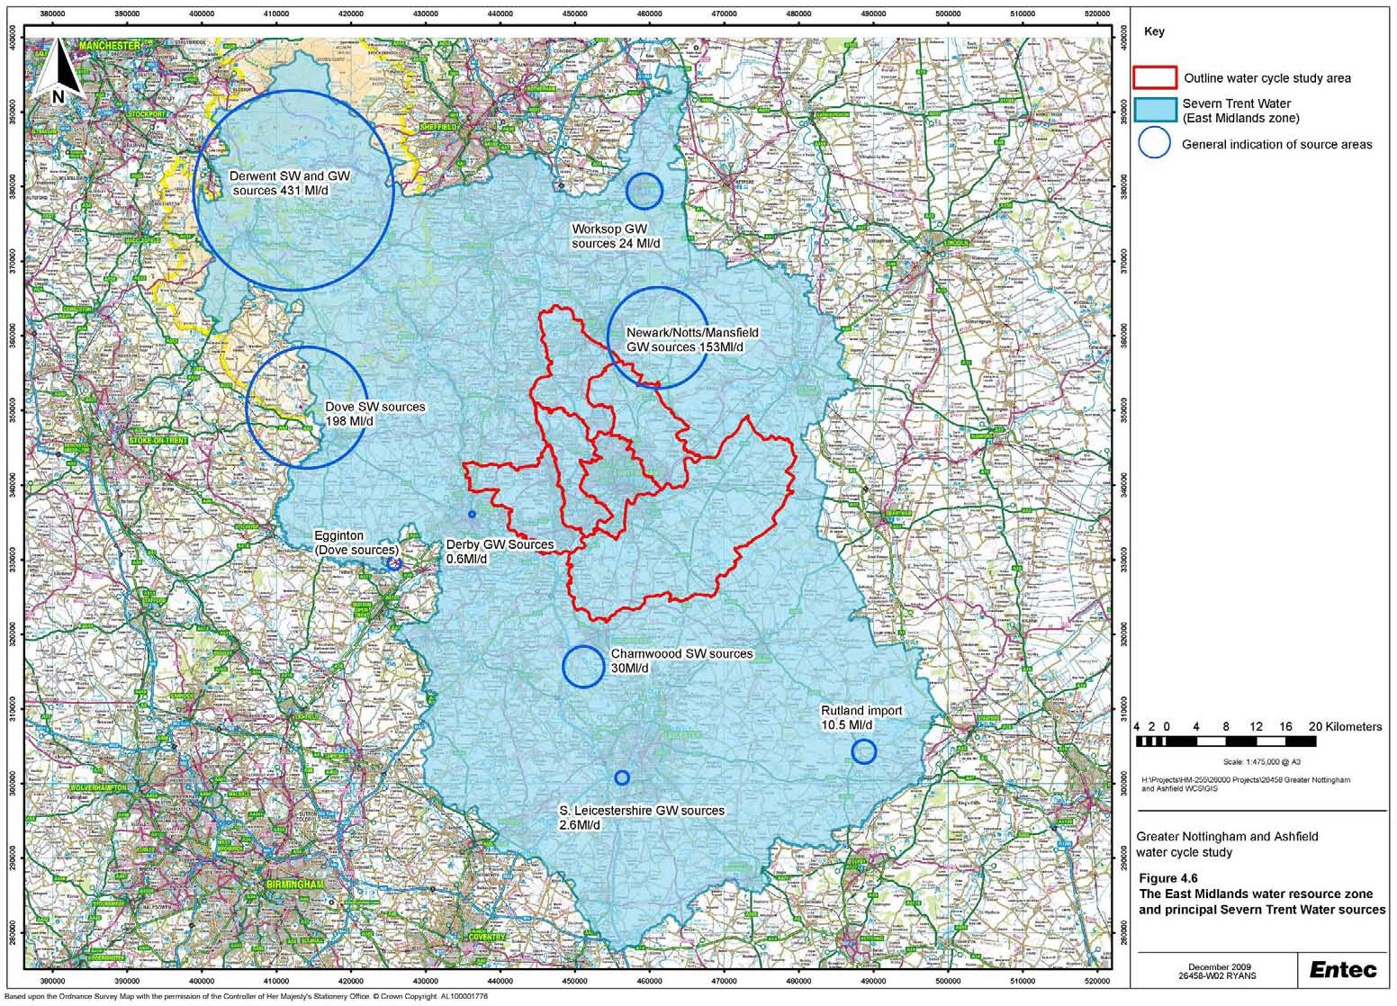

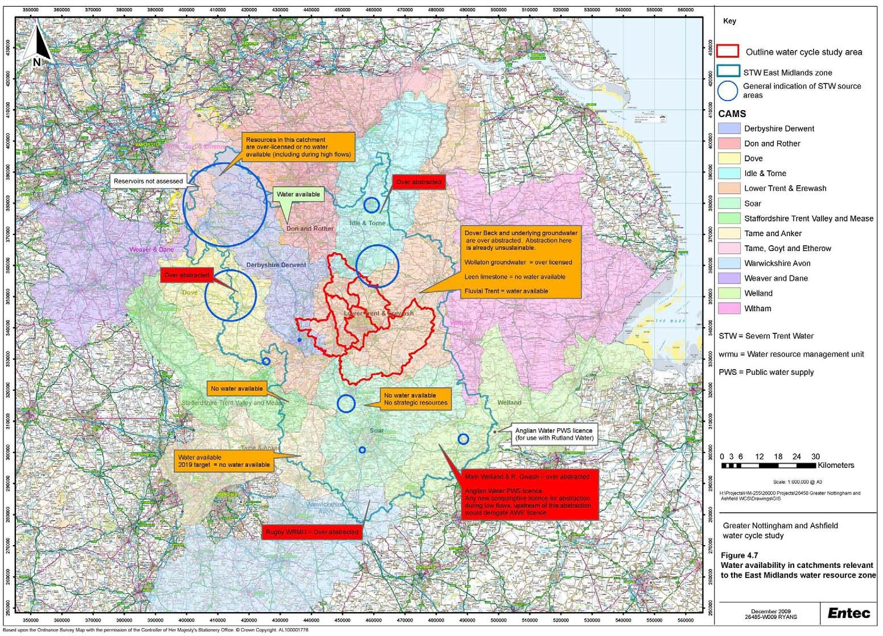

Greater Nottingham lies within an area classified by the Environment Agency as being of ‘moderate’ water stress.
The majority of the study area is within the Lower Trent and Erewash CAMS area. The North of Ashfield District is within the Idle and Torne CAMS area.
The River Trent is assessed as having ‘Water Available’ at low flows. All other water management units are assessed as ‘No Water Available’, ’Over Licensed’ or ’Over Abstracted’ at low flows (further information on water availability status is provided in Appendix C).
Severn Trent is the public water supply company for the study area. The study area lies within Severn Trent Water’s East Midlands Water Resource Zone.
Severn Trent Water’s supplies are derived approximately 50% from groundwater and 50% from surfacewater. Nitrate in groundwater supplies is a key issue affecting Severn Trent Water.
Potential risks to Severn Trent Water supply resources are identified as groundwater quality within aquifers and rising groundwater levels.
Water Resources: Key Findings of the Scoping Study
Box 6

    - The Scoping Study recommends that further information should be sought regarding the development of a groundwater model in the study area. The East Midlands-Yorkshire groundwater model has been developed by the Environment Agency to improve the Environment Agency’s ability to make abstraction licence decisions. The model is based on the Sherwood Sandstone over a large area stretching from Nottingham as far North as York. In relation to this WCS, the model has little direct relevance at this stage. However, in future it will help to inform the Environment Agency in determining resource availability within the model area. For example, it will help to inform investigations to identify whether changes are required to abstractions under the Water Framework Directive for the Humber River Basin to ensure that ‘good’ ecological status can be achieved and it will be used to inform the assessment of resource availability in the next round of the CAMS process. It will also be used to improve understanding of the impact of climate change.

    - The Scoping Study also recommends that further information is sought on the impacts of climate change on water resources. In its Strategic Direction Statement, Severn Trent Water states that climate change is one of the most significant uncertainties facing the Company over the next 25 years (Severn Trent Water, 2007). Severn Trent Water has assessed the impact of climate change at the various stages of the WRMP process, and predicts a loss in water supply resources (known as deployable output) of 38.8 Ml/d by 2034-35 (Severn Trent Water, 2009a). This is equivalent to 4.4% of the existing water supply resources.

    - Severn Trent Water has forecast the impact of climate change on sources and customers’ consumption using the most recently available climate change projections which, at the time the draft WRMPs, was the United Kingdom Climate Impact Programme 2002 (UKCIP02) data. The impacts of climate change on supply and demand, and the uncertainty associated with climate change have been considered by the water companies using industry standard methods. It should be noted that new climate change predictions have been issued in June 2009 by UKCIP. These supersede the previous predictions that the water companies have used in their most recent water resource plans.

4.6 Drainage and Flood Risk
    - To date there are a number of studies already completed on flood risk in the study area. These are listed below:

      - Scoping Water Cycle Study (Scott Wilson, 2009);

      - Trent Catchment Flood Management Plan (Environment Agency, 2008b);

      - Lower Derwent Strategy (Environment Agency, 2008c);

      - Fluvial Trent Strategy (Environment Agency, 2005);

      - River Leen and Day Brook Strategic Flood Risk Assessment (Black and Veatch, 2008a);

      - Greater Nottingham Strategic Flood Risk Assessment (Black and Veatch, 2008b); and

      - Ashfield District Council Strategic Flood Risk Assessment Level 1 (Ashfield District Council, 2009)

    - The Greater Nottingham Strategic Flood Risk Assessment (SFRA) covers all the districts in the study area except Ashfield, which is covered by the Ashfield SFRA. It assess all forms of flood risk and the implication of this on and from development put forward in the Core Strategies through the application of the Sequential Test. The key findings from the SFRAs were presented in the Scoping Study (Table 5-4, Scott Wilson, 2009).

    - The main source of flooding in the study area is from the River Trent and its tributaries, mainly the River Derwent and the River Soar. A summary of the Scoping Study findings is presented in Box 7.

    - In Ashfield, the main risk of flooding from watercourses is the Baker Lane Brook and the River Leen in Hucknall. Additional surface water flows into the River Leen and its tributaries will significantly increase the risk of flooding downstream in the City of Nottingham. With climate change it is anticipated that surface water flooding will be an increasing sources of flooding in the urban areas of Ashfield.

    - The SFRA covering the River Leen and Day Brook (Black and Veatch, 2008a) was prepared for the Environment Agency, Nottingham City Council and Nottingham Regeneration Ltd. It was planned for the hydraulic model from this study to be integrated into the Greater Nottingham SFRA (River Leen and Day Brook SFRA, Black and Veatch, 2008a). The main source of flooding is identified as urban run-off and it is recommended that the study’s partners engage with neighbouring authorities and Severn Trent Water to manage flood risk holistically.

    - Flood Defences are present along the River Trent, and recently the Environment Agency has progressed with the West Bridgford and the Nottingham Trent Left Bank flood alleviation schemes to further reduce flood risk. The latter of these two is due for completion in 2011.

    - The Greater Nottingham SFRA and the Ashfield SFRA identify ‘other sources’ of flooding within the study area. These include flooding from land, highways, watercourses and sewers, and are identified in records of historical events provided by Severn Trent Water, Local Planning Authorities and Parish Councils. Within both documents, maps identifying the locations of these flooding events are provided with accompanying descriptions. The maps have not been reproduced here and for further information the reader should refer to the relevant SFRA. Issues identified within the maps include groundwater flooding of basements in properties within the Basford area (Nottingham City Council), attributed to rising groundwater levels following a reduction in groundwater abstraction for industrial use. Extensive areas of land within Erewash Borough are identified as having limited spare drainage capacity, whilst a number of locations are identified within the study area (e.g. West Bridgford) where capacity of drainage has been exceeded in the past, causing flooding following periods of heavy rain. The studies state that these sources of flooding need to be taken into account in site allocations and planning applications.
The main sources of flooding in the study area are from the Rivers Trent, Derwent and Soar.
Other sources include the River Erewash, River Leen, River Smite and other smaller brooks and dykes.
Surface water flooding is a serious issue in built up areas within Greater Nottingham due to the extensive coverage of impermeable area.
Flood Zones 2 and 3 of the River Trent affect Nottingham City and the settlements of Long Eaton, Toton, Attenborough, Rylands, Beeston, Clifton, Wilford, West Bridgford, Lenton, Adbolton, Colwick, Netherfield, Radcliffe on Trent, Stoke Bardolph and Burton Joyce.
The River Soar poses a risk of flooding to agricultural land and settlements including Sutton Bonington, Normanton on Soar and Stanford on Soar.
Kingston Brook, a tributary of the River Soar flows westwards through Rushcliffe posing a particular flood risk to areas of East Leake and Kingston on Soar.
The Nottingham, Erewash, Beeston and Grantham canals can present a potential flood risk but at present the risk is not quantified. Records of flooding from overtopping of the Nottingham Canal have previously been recorded in Cossall (in Broxtowe).
The management of surface water has the potential to act as a constraint to development within Greater Nottingham and Ashfield (Hucknall) due to space requirements and the need to reduce runoff rates and volumes to limit discharges. The Scoping Study identifies that an Outline study should address this issue in further detail.
Drainage and Flood Risk: Key Findings of the Scoping Study
Box 7

    - Since completion of the Scoping Study, Defra has announced 77 Councils in the UK that are to receive funding to undertake SWMPs. Nottingham City is listed as receiving up to £200,000 for the SWMP to address the risk of flooding from urban run-off. Defra also has a further fund available to Councils not listed in the 77 that may be considered for use for the neighbouring authorities.

    - A SWMP is a framework through which key local partners with responsibility for surface water and drainage in their area work together to understand the causes of surface water flooding and agree the most cost effective way of managing surface water flood risk. SWMPs will build on SFRAs and provide the vehicle for local organisations to develop a shared understanding of local flood risk including setting out priorities for action, maintenance needs ands links to LDF and emerging plans

    - The Defra guidance on preparing SWMPs shows the process to comprise of four stages:

      - Preparation – This stage includes the identification of key stakeholders and their roles and responsibilities, as well as setting the objectives of the SWMP. Information relating to flood risk is collated and analysed;

- Risk Assessment – Areas at risk of flooding are mapped, and flood risk in areas currently at risk of flooding is assessed;
      - Options Assessment – Options for mitigating flood risk are identified, shortlisted and assessed through cost benefit analysis. Drainage strategies are developed and implemented for new developments;

Implementation and Review.

    - In conjunction with the SFRAs, this WCS informs Phases 1 and 2 of the SWMP. Figure 4.8 illustrates how the WCS and the other flood risk strategies fit against each other and in the planning context.

    - The records of historic flooding presented in the SFRAs can be used to identify locations where SWMPs may be required. Based on these maps, the areas outside Nottingham City (where SWMP requirement has already been identified) where clusters of historic flooding events are recorded are shown in Table
4.5. This assessment is indicative and based purely on these maps. Further discussion between the Environment Agency, Local Planning Authorities and Severn Trent Water would be required to determine the location and scope of any SWMP.

Table 4.5 Areas Susceptible to “Other Sources of Flooding” Identified within the SFRAs

Areas Susceptible to ‘Other Sources’ of Flooding
Erewash | South Erewash including Breaston, Long Eaton, Draycott and
 | Borrowash.
 | North Erewash including Ilkeston, West Hallam and Kirk Hallam.
Broxtowe | Eastwood, Stapleford
Gedling | Woodthorpe, Daybrook, Lambley, Caverton, Ravenshead, Bestwood
 | Village
Rushcliffe | West Bridgford, Ruddington, Radcliffe-on-Trent, Aslockton, Orston
Ashfield | Hucknall, Kirkby in Ashfield, Sutton in Ashfield, Selston

Figure 4.8 Flood Risk Management Plans
Strategies (e.g. Lower Derwent Strategy) – More detailed action plan
SWMP – More detailed study into surface water flooding and partnership working and mitigation
SFRA – Ensure growth adheres to PPS25 with regard to flood risk (historically fluvial and tidal)
WCS – Ensure growth can be met with sustainable water services
CFMP - Provides approach to be followed in each unit
Evidence Base for LDF
Evidence Base for Flood Risk Management
Local Planning Authority
Environment Agency

4.7 Designated conservation sites
    - The Greater Nottingham and Ashfield Scoping WCS identified that there are no European or internationally designated conservation sites located within the study area. However, growth within the study area could potentially impact on such sites located outside elsewhere. Councils are required to undertake a Habitats Regulations Assessment (HRA) of their emerging Core Strategies to investigate potential impacts of their development plans on the conservation interests of European-protected areas in the vicinity of the local authority area. This is a requirement of regulation 85 of the Habitats Regulations 2007 (as amended).

    - In order to identify such sites, all European and internationally designated sites located either within the East Midlands Water Resource Zone or located downstream of the study area on the River Trent are shown in Table 4.6. European and internationally designated sites located within the East Midlands Water Resource Zone have been identified here because changes in water abstraction as a result of new development within the zone could potentially impact upon these sites. Similarly, sites located downstream on the River Trent could potentially be affected by changes in water quality as a result of new development within the study area.

    - In addition to the European and internationally designated sites, a significant number of nationally designated Sites of Special Scientific Interest (SSSIs) are located within the study area, as illustrated in

Figure 4.1. Eight water dependant SSSIs have been identified, further details of which can be found in Appendix C.

Table 4.6 European and Internationally Designated Sites relevant to the Greater Nottingham and Ashfield Outline WCS

Site Name | European and international designation | Relevance to this Outline WCS
Peak District Dales | SAC | Located in East Midlands WRZ (Dove, Derbyshire Derwent
 |  | CAMS)
River Mease | SAC | Located in East Midlands WRZ (Staffordshire Trent Valley and
 |  | Mease CAMS)
South Pennine Moors | SAC | Located in East Midlands WRZ (Tame, Goyt and Etherow,
 |  | Weaver and Dane, Don and Rother CAMS),
Peak District Moors (South Pennine | SPA | Located in East Midlands WRZ (Derbyshire Derwent CAMS)
Moors Phase 1)
Birklands and Bilhaugh | SAC | Located in East Midlands WRZ (Idle and Torne CAMS)
Rutland Water | Ramsar and SPA | Located in East Midlands WRZ (Tame, Goyt and Etherow
 |  | CAMS),
Humber Estuary | Ramsar, SPA and SAC | Located downstream of study area (on River Trent)

4.8 Local Water Cycle Studies
    - WCSs are in the process of being completed for local authorities adjacent to Greater Nottingham and Ashfield. The studies and their current status are listed in Table 4.7.

Table 4.7 Status of Neighbouring Water Cycle Studies

Water Cycle Study | Study Stage
Derby Housing Market Area Water Cycle | Scoping and Outline study completed in November 2009
Study
North West Leicestershire Water Cycle | Scoping and Outline being undertaken, scheduled to complete by January
Study | 2010
Newark Water Cycle Study | Final version of detailed study completed in September 2009.
Mansfield Water Cycle Study | Scoping study completed June 2009

    - Growth within adjacent districts could result in cumulative impacts on water cycle infrastructure. Further details about the neighbouring WCSs, including a summary of key findings, is presented in Appendix E. The main potential for cumulative impacts arises from the following:

      - The majority of growth in these study areas will occur in the same water resources zone as Greater Nottingham and Ashfield (Severn Trent Water’s East Midlands WRZ). The neighbouring studies in Derby and North West Leicestershire have made recommendations for the Councils to include a policy in their Core Strategies for all new homes to reach the Code for Sustainable Homes Level 3/4 equivalent to 105 litres per head per day to support the water companies demand management schemes and forecasts;

      - New development within Greater Nottingham and Ashfield and adjacent districts could drain to the same wastewater treatment works (and vice versa), however a high level review of the neighbouring areas has indicated that where catchments overlap there is capacity at the wastewater treatment works, based on data provided by Severn Trent Water, and / or the overlapping areas are predominantly rural with limited growth forecast. The Ashfield and Erewash districts share wastewater treatment works with Derby City and Amber Valley Borough;

      - Districts upstream of the Greater Nottingham Study area have the potential to impact on water quality targets in Greater Nottingham through breaching of discharge consents or agricultural pollution incidents. Similarly pollution incidents in greater Nottingham have the potential to reduce water quality targets in the study area and downstream. The Environment Agency produced their final River Basin Management Plans at the end of 2009 detailing actions for a range of organisations to help achieve the Water Framework Directive standards, which will require a partnership and integrated catchment approach;

      - New development in Greater Nottingham and Ashfield has the potential to impact on flood risk in adjacent areas (and vice versa) if appropriate mitigation measures are not implemented. Of consideration is Newark on Trent directly downstream on the River Trent. In most WCSs and strategic flood risk assessments, recommendations are made in support of PPS25 and the Pitt Review for all new development to implement SuDS to manage flood risk. The neighbouring districts are all predominantly located in the Trent catchment and through implementation of SuDS and flood risk assessments there is the potential to reduce flood risk from both rivers and surface water run-off.

Constraints

This section presents the potential constraints to development based on the state of the existing environment and water infrastructure, as assessed in Chapter 4 from data provided by third parties. The constraints for development are presented below in a traffic light context, for each topic area. The key for the traffic light system is as follows:

Development ok, no constraints identified at this stage
Development may be ok, minor constraints identified at this stage, minor mitigation required to meet growth targets
Constraints identified at this stage, development may be ok with major mitigation to meet growth targets

The assessment of water cycle constraints is focussed at the district level. A separate assessment has been prepared for potential Sustainable Urban Extension sites identified in discussions with the councils.

5.1 Environmental Constraints Water Quality
    - An overview of the water quality in the rivers across the study area is provided in Section 4.3. This illustrates the current status of the receiving waters and the pressures acting upon them. WFD objectives for 2015 are also presented along with specific measures that will be used to achieve them. Section 4.3 also highlights that current phosphorous levels in rivers across the study area already exceed the WFD standards.

    - The extent to which this could constrain growth depends on site specific issues relating to particular river reaches, the quality of existing wastewater discharges and the ability to improve existing treatment facilities (discussed further in Section 5.2). The WFD requires that there is ‘no deterioration’ in water quality. This means that rivers that are currently achieving ‘Good Status’ do not necessarily provide a ‘green light’ for growth if this would lead to deterioration in status. Conversely, rivers that are currently failing to achieve Good Status do not necessarily provide a constraint to growth provided that additional wastewater from development would not lead to further deterioration.

    - Through the River Basin Planning process the Environment Agency will work with all stakeholders and co-delivery partners, including the water companies to ensure catchment and water quality planning achieves a sustainable balance between meeting our needs in terms of water supply and wastewater treatment and those of water environment (i.e. dependant flora and fauna). In treating wastewater to meet ever tighter standards the wider sustainability implications should also be considered, in terms of additional carbon, energy and the use of raw materials, and balanced against the ecological benefits in the receiving water.

    - The Scoping Study identified the importance of making an assessment of the upstream and downstream quality relating to specific WwTWs. The water quality at any point on the river will be influenced by all sources within the upstream catchment and only reflect the hydrological conditions under which the samples were collected, so interpretation of water quality data should be treated with caution. In addition there is no historic water quality monitoring data representative of the quality downstream of some of the larger wastewater treatment works, such as Sutton-in-Ashfield and Toton. In addition, the nearest water quality sampling location upstream of Nottingham WwTW is nine kilometres upstream, so is unlikely to be representative. Consequently, it was not possible to conduct a complete and robust assessment.

    - Modelling would facilitate a more robust assessment of the implications of an increase in the effluent flow and / or load on the quality of the receiving water. Severn Trent Water and the Environment Agency are currently co-funding a project to update a catchment water quality model that encompasses the study area. This modelling tool, ‘SIMCAT’ is used by the Environment Agency as the basis of catchment scale water quality planning and the setting of discharge consents. This updated version will better represent the water company assets, compared to the existing national model, and would provide a robust basis for assessing the implications of an increase in effluent flow and possibly load on the quality / status of the receiving water both within and outside current consent conditions. This model will be available at the end of March 2010 in good time to inform any future detailed WCSs. This should therefore be used as the basis for testing the sustainability of different wastewater treatment options, in terms of status of the receiving water, once the preferred growth scenarios have been identified.

    - The extent to which water quality may constrain growth in each of the Council areas is summarised in Table 5.3, whilst an overview of potential water quality constraints in the study area is provided in Box 8.

Table 5.1 Water Quality Constraints

District/Borough | Water Quality Constraints
Erewash | Water quality throughout the study area is currently failing the WFD standards at many locations. This is particularly the case for phosphorus, where the standard is exceeded extensively.  This does not necessarily form a constraint to development in any of these areas, provided that ‘no deterioration’ in water quality will result from wastewater treatment. However, upgrades to meet tighter consent conditions to meet WFD or other EU or National statutory requirements could influence the phasing of development.
Nottingham City
Broxtowe
Gedling
Rushcliffe
Ashfield

Much of the study area, like large parts of central England, currently fails the WFD standard for phosphorus.
Failure to meet a particular WFD standard may not present a barrier to growth, provided growth will not cause further deterioration in environmental quality and does not prevent measures to improve water quality to meet the WFD chemical objectives.
Summary of Water Quality Constraints
Box 8

Table 5.2 River Water Quality Upstream and Downstream of Key WwTW

Discharge District Dry P (mean-mg/l) BOD (90%ile-mg/l) Ammonia(90%ile-mg/l) Comments Weather

Flow
(m3/d) Up- Down- % Up- Down- % Up- Down- %
stream stream change stream stream change stream stream change
Kirkby in Ashfield WwTW Sutton in Ashfield WwTW | Ashfield Ashfield | 5,790  7,109 | 0.11 | 0.75 | 582 | 3.95 | 5.53 | 40 | 0.31 | 0.58 | Deterioration in river quality downstream for all three determinands. The largest increase in concentration, and hence deterioration was P. Located within the headwaters of the River Erewash, WwTW discharge would undergo  87 less river dilution, increasing river concentrations.
 |  |  | 0.49 |  |  | 8.73 |  |  | 0.68
Stapleford (Bessell Lane) WwTW | Broxtowe | 7,760 | 2.05 | 4.67 | 128 | 4.51 | 14.32 | 218 | 0.47 | 5.26 | Improvement in the quality of the River Erewash downstream could be due to reductions in concentrations due to dilution from a tributary between the WwTW and the downstream monitoring point. Upstream of the WwTW and on the incoming tributary the river qualities are within 20% or failing the standard  1019 for BOD and Ammonia.
Ilkeston (Hallam Fields) WwTW | Erewash | 10,800 | 2.62 | 0.1 | -96 | 4.83 | 2.92 | -40 | 0.43 | 0.26 | -40
Toton (Long Eaton) WwTW | Broxtowe | 23,608 | 2.18 |  |  | 3.86 |  |  | 0.5
Nottingham (Stoke Bardolph) WwTW* | Gedling | 148,000 | 1.25 | 1.15 | -8 | 2.62 | 3.38 | 29 | 0.36 | 0.58 | All determinand concentrations increase downstream in the River Trent. Results must be treated with caution as the upstream location was over 9km upstream so would not be representative of direct impact of the WwTW. An additional tributary input from the River Leen upstream of the WwTW would cause dilution of river concentrations. The River Leen already fails the P and  61 Ammonia standard.

*Upstream WQ point over 9 km from the WwTW.

Red indicates already failing Good Status. Amber indicates at risk (within 20%) of standard. Green indicates greater than 20% below standard

Water Resources
    - Water resources can constrain development at two levels. At a strategic level, the overall balance between demand for water and the amount of water that is available for supply must be managed to ensure that existing and new homes can continue to be supplied. More locally, the extent and condition of the existing supply infrastructure affects the water companies’ ability to distribute water. The strategic constraints in relation to the Greater Nottingham and Ashfield study area are discussed in this section, whilst the supply infrastructure constraints are discussed further in Section 5.2.

    - As part of the Statement of Response Severn Trent Water issued it’s ‘Latest Assessment of the Supply- Demand Balance’ and this data is used in this WCS. Severn Trent’s final WRMP is due to be published in early 2010, and is therefore not available for this study. More detailed information describing the water resource planning process, including the Ofwat periodic review of pricing is available in Appendix D.

    - The information presented in Severn Trent Water’s draft WRMP and Statement of Response includes forecasts of how the balance between supply and demand will change in the East Midlands water resource zone over the 25 years from 2010 to 2035. These forecasts are based upon theoretical planning scenarios that all water companies use in their WRMPs which effectively consider the ‘worst case’ (dry year⁵) situation. Companies first derive a ‘baseline forecast’ showing how supply and demand is expected to change without any intervention by the water company.

    - Severn Trent’s latest baseline forecast indicates a deficit in supply, starting in 2015-16. This means that in the East Midlands supply zone demand is forecast to start exceeding supply in 2015-16 and water available for use (supply) would be 60 megalitres per day (Ml/d) less than demand in 2034-35. This is driven by diminishing supplies coinciding with increased demand.

    - In response to the potential deficit the company proposes a number of measures to limit increases in demand and to provide more supplies of water (shown in Table D.3 in Appendix D), so that in its final planning scenario, the Company forecasts a continual surplus in the East Midlands water resource zone for all of the next 25 years to 2034-35. The key supply and demand facts and figures for the East Midlands water resource zone taken from the water company’s draft WRMP and updates from the Statement of Response are summarised in Box 9. Figure 5.1 and Figure 5.2 illustrate the differences between Severn Trent’s supply and demand forecast in the baseline and final planning scenarios. It has not been possible to obtain the data from which these graphs are drawn and thereby simplify the graphs. Explanation of the terms is provided in Box 10.

⁵ the dry year is a period of low rainfall and unconstrained demand and is the basis of a water company’s Water Resource Management Plan

Total dry year supply (annual average deployable output) 2010 = 845Ml/d, 2014 = 865Ml/d Range of sources from across the zone:
Surface water sources = 75% of public water supply (major reservoirs in the Derwent and Dove valleys)
Groundwater sources = 25% of public water supply (majority of groundwater abstracted from the Mansfield, Nottingham, and Worksop areas)
Population forecast to increase by 335,000 between 2006-07 and 2030-31*
Environmental pressures forecast to reduce supply: 39Ml/d lost due to climate change by 2030-31 (surface water). The draft WRMP included no sustainability reductions for this zone, and this is confirmed in the Statement of Response.
A baseline surplus of approximately 30Ml/d in 2007-08* A baseline deficit of approximately 60Ml/d by 2030-31*
No deficit in final planning scenario* Takes account of measures to secure supply and manage demand.
Severn Trent Water - East Midlands Water Resource Zone Key Facts
Box 9

*based on Severn Trent Water latest assessment of supply demand balance and reported in the Statement of Response

Figure 5.1 East Midlands Zone – Final WRMP Supply/Demand Balance (baseline scenario)
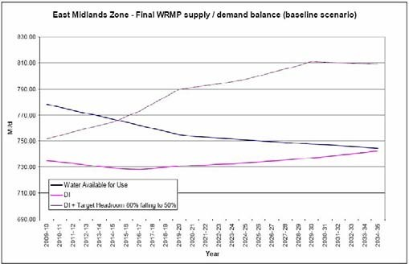
DEFICIT
SURPLUS

Source: Severn Trent Water Statement of Response (Severn Trent Water, 2009a)

The following terms have specific definitions agreed for use within the water industry. However, for the purposes of thus study the lines on these graphs can be defined as:
Water Available for Use Forecast of water supply
DI Forecast of demand (DI stands for Distribution Input)
DI + Target Headroom 80% falling to 50% Forecast of demand including an allowance for uncertainty in the supply and demand
forecasts (e.g. uncertainty of the impact of climate change on supply and demand)
Explanation of the terms used in Figure 5.1 and Figure 5.2
Box 10

Figure 5.2 East Midlands Zone – Final WRMP Supply/Demand Balance (final planning scenario)
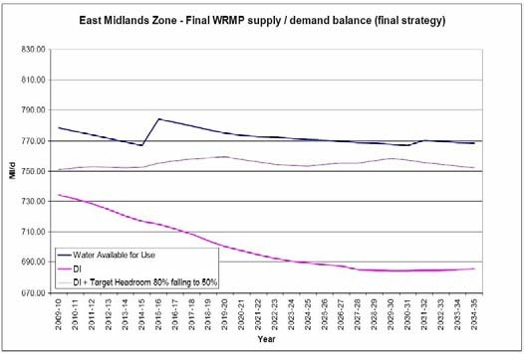
SURPLUS
SURPLUS

Source: Severn Trent Water Statement of Response (Severn Trent Water, 2009a)

    - Severn Trent Water recognises the drive from national Government to dramatically increase the supply of new housing. The company states that ‘Under the current economic situation and the housing market it is not certain how much of this will take place’. In terms of planning for future growth, Severn Trent Water used the RSS growth plans that were available at the time the draft WRMP was prepared in 2008. Due to

the economic situation, the company used a central best estimate of housing delivery in the short term (i.e. to 2015), recovering to meet RSS targets in the longer term⁶.

    - Severn Trent Water states that where there is reasonable certainty over the future growth plans of local government it will build infrastructure ahead of planned development to ensure that water from new resources may be deployed to the right place at the right time. In its Final Business Plan, Severn Trent Water has identified strategic reinforcements in areas where there is sufficient detail in the local development framework housing growth numbers to enable the hydraulic impact to be assessed (Severn Trent Water, 2009b).

    - The Environment Agency has recognised that future trends indicate a decline in water availability within the Humber river basin district, in which the Greater Nottingham and Ashfield study area lies. There is no further surface water available for large-scale abstraction during periods of low flow in several areas. There are only limited water resources available for further large scale abstraction (Environment Agency, 2009c). Many important wildlife sites depend on a good supply of water and water management is vitally important for public water supply, agriculture and industry.

    - The Environment Agency is currently drafting the Humber RBMP but has already pointed out that there are very limited water resources available for further large scale abstraction and that water efficiency measures will need to be implemented to accommodate the expected demand growth in the river basin district (Environment Agency, 2009c). Additional abstraction in the wider area is unlikely to be an option to meet the water demand of the future population expected within the study area. The Environment Agency has stated that in order to accommodate sustainable growth more efficient use of water resources is needed including restoration of sustainable abstraction (as discussed in Appendix C). This is reflected in many of the measures that Severn Trent Water plan to implement (see Section 6.3).

    - The review of the CAMS assessments relevant to the study area presented in the Scoping Study (and summarised in Table 4.4) shows that the vast majority of catchments have either no water available, are over licensed, or are even over abstracted. In these cases the Environment Agency’s licensing strategy is to close the catchments to further abstraction at low flows, or seek to reduce licence volumes in over abstracted catchments. There are some exceptions, where the CAMS resource assessment concludes that there is some water available.

    - Where water company abstractions are suspected to be contributing to pressure on habitats protected under the Habitats Directive, the abstractions and their impact on river flows and /or groundwater levels are investigated, and if determined necessary, a reduction in the volume that can be abstracted is sought by the Environment Agency. This type of reduction in abstraction quantities is called a ‘sustainability

⁶ Personal communication from Severn Trent Water, dated 23/11/09

reduction’. The reduction of any public water supply abstraction licences would require provision of alternative water resources.

    - In September 2008 the Environment Agency provided Severn Trent Water with indicative reductions to be included in the final WRMP. However, Severn Trent Water has not included any sustainability reductions in its draft WRMP as the sites are still under investigation and any reductions are still uncertain. No additional information is available from the Environment Agency to confirm the presence and volumes of any potential reductions in abstraction in order to comply with the Habitats Directive Review of Consents.

    - Under the Review of Consents process, the Environment Agency should have identified whether the European designated sites listed in Section 4.7 are being impacted by current abstractions and whether any mitigation measures are required to reduce these abstractions. Any future changes to abstraction licences, for example applications to abstract additional volumes of water to meet demand from new development, would be subject to the normal Environment Agency abstraction licence application procedures. Such abstraction would not be allowed unless the applicant can demonstrate that there are no likely significant adverse effects.

    - In conclusion, the resource situation in the East Midlands is significantly constrained. There is little opportunity to develop new water resource schemes; current licensed abstractions may be curtailed in order to protect the environment, and climate change is expected to reduce resource availability further. This situation reinforces the importance of managing demand in this area.

Table 5.3 Water Resources Constraints

District/Borough | East Midland Water Resource Zone
Erewash
Nottingham City
Broxtowe | Severn Trent Water has included plans to resolve the potential deficit in supply, mainly through increasing the capacity of the existing sources and through demand management and metering in existing homes.
Gedling | It will be important that the Council encourages water efficiency in new homes to support Severn Trent Waters resource management plans over the growth period
Rushcliffe
Ashfield

Box 11 Summary of Water Resources Constraints

The Greater Nottingham and Ashfield study area lies within Severn Trent Water’s East Midlands water resource zone. Severn Trent Water forecast a shortfall of 60 M/d by 2035 if no interventions are made.
Severn Trent Water has a programme of measures that will maintain a surplus of supply over demand. There are limited resources available for further large-scale abstraction in the study area.
Existing resources will need to be used more efficiently to accommodate further growth.

Flooding
    - The fluvial flood zones identified in the SFRAs form the main environmental flooding constraints to development in the study area. The SFRAs’ Flood Zone 3 should only permit limited development in this zone. According to PPS25, only Water Compatible and Less Vulnerable development types should be permitted within this zone (CLG, 2006). These categories include shops, restaurants, cafes, waste treatment, mineral workings, water and sewage works.

    - Residential development is classified as More Vulnerable, therefore to comply with the Sequential Test this type of development should not be permitted in Flood Zone 3, unless it can pass the Exception Test. To pass the Exception Test, developments should demonstrate that:

      - The development provides a wider sustainability benefit to the community that outweighs flood risk;

      - The development is on previously developed, or developable land; and

      - The development will be safe from flooding without increasing flood risk elsewhere.

    - A list of the PPS25 vulnerability classifications is provided in Appendix F.

    - The study area comprises significant areas, identified in the main growth centres, that are in the lower flood risk zones and these should be used in preference for new development wherever possible. The effect of climate change, such as increases in the extent of the flood zones, should also be taken into consideration when making planning decisions to understand the flood risk throughout the development lifetime.

    - The extent of flood risk constraint to development is shown in Figure 5.3 to Figure 5.8 for each Council area. These maps show the extent of Flood Zones 1 to 3 in relation to Ward boundaries and SUE sites. The findings of this assessment are also summarised in Table 5.4.

Table 5.4 Flooding Constraints

District/Borough | East Midland Water Resource Zone
Erewash | Development in the Wards of Wilsthorpe, Nottingham Road, Long Eaton Central and Sawley Wards highly constrained by the fluvial flood zones of the River Trent and the River Erewash. Development may also be constrained in the Wards located adjacent to the River Erewash. The flood zones should be used by the Councils to allocate new residential development outside of the zones unless the proposals are justified by the exception test in PPS25. The SUE sites at West of Ilkeston and Stanton Ironworks will need to be designed to avoid areas of medium to high probability of flooding.  Development in the Wards of Dales, Bridge, Dunkirk and Lenton, Clifton North and Clifton South highly constrained by the fluvial flood zones of the River Trent. Development may also by constrained in the Wards located adjacent to the River Leen. The flood zones should be used by the Councils to allocate new residential development outside of the zones unless the proposals are justified by the exception test in PPS25.  Development in the Wards of Beeston Central, Beeston Rylands and Attenborough highly constrained by the fluvial flood zones of the River Trent. Development may also by constrained in the Wards located adjacent to the River Erewash on the West side of the Borough. The flood zones should be used by the Councils to allocate new residential development outside of the zones unless the proposals are justified by the exception test in PPS25. Toton and Chilwell Meadows and Stapleford North SUE sites are away from areas identified as major flooding constraint.  Development in the Wards of Netherfield and Colwick and Burton Joyce and Stoke Bardolph highly constrained by the fluvial flood zones of the River Trent. The flood zones should be used by the Councils to allocate new residential development outside of the zones unless the proposals are justified by the exception test in PPS25. The SUE sites at Top Wighay Farm, North of Papplewick Lane and New Farm are not identified as being constrained by flood risk.  Development in the Wards of Trent, Manvers, Gamston, Lady Bay Bridge, Abbey Compton Acres and Clifton Pastures constrained by significant areas lying in Flood Zone 2 and 3. The flood zones should be used by the Councils to allocate new residential development outside of the zones unless the proposals are justified by the exception test in PPS25. The SUE sites at Clifton Pastures and Gamston are largely outside the flood zones.
Nottingham City
Broxtowe
Gedling
Rushcliffe
Ashfield | Ashfield is located in the headwaters of the River Erewash, Leen and Meden and Maun tributaries of the River Trent. The flood zones are not as extensive as in the other boroughs and less of a constraint to development. Minor parts of Sutton in Ashfield, Kirkby in Ashfield, Annesley Woodhouse and Hucknall are mapped as being medium to high probability of flooding, which may constrain development at these specific locations. Flood risk is not identified as constraining development at the SUE sites at Rolls Royce or Whyburn Farm.

The flood zones provided in the Strategic Flood Risk Assessments for each Council area should be used in conjunction with the Environment Agency’s flood map to review flood risks for individual site allocations.
The main flooding constraint from natural sources is from the River Trent, in which the floodplain extends into Long Eaton, Stapleford, Beeston, West Bridgford and parts of Nottingham City. In these areas, the Environment Agency is likely to object to residential development unless it is in line with the requirements of PPS25.
Summary of Flooding Constraints
Box 12

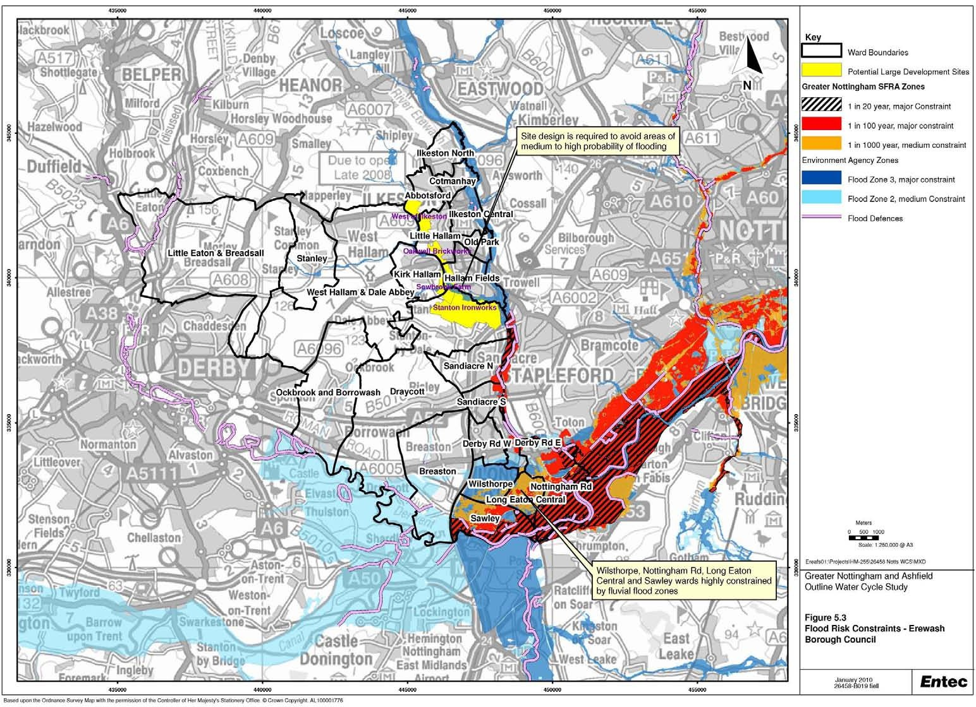

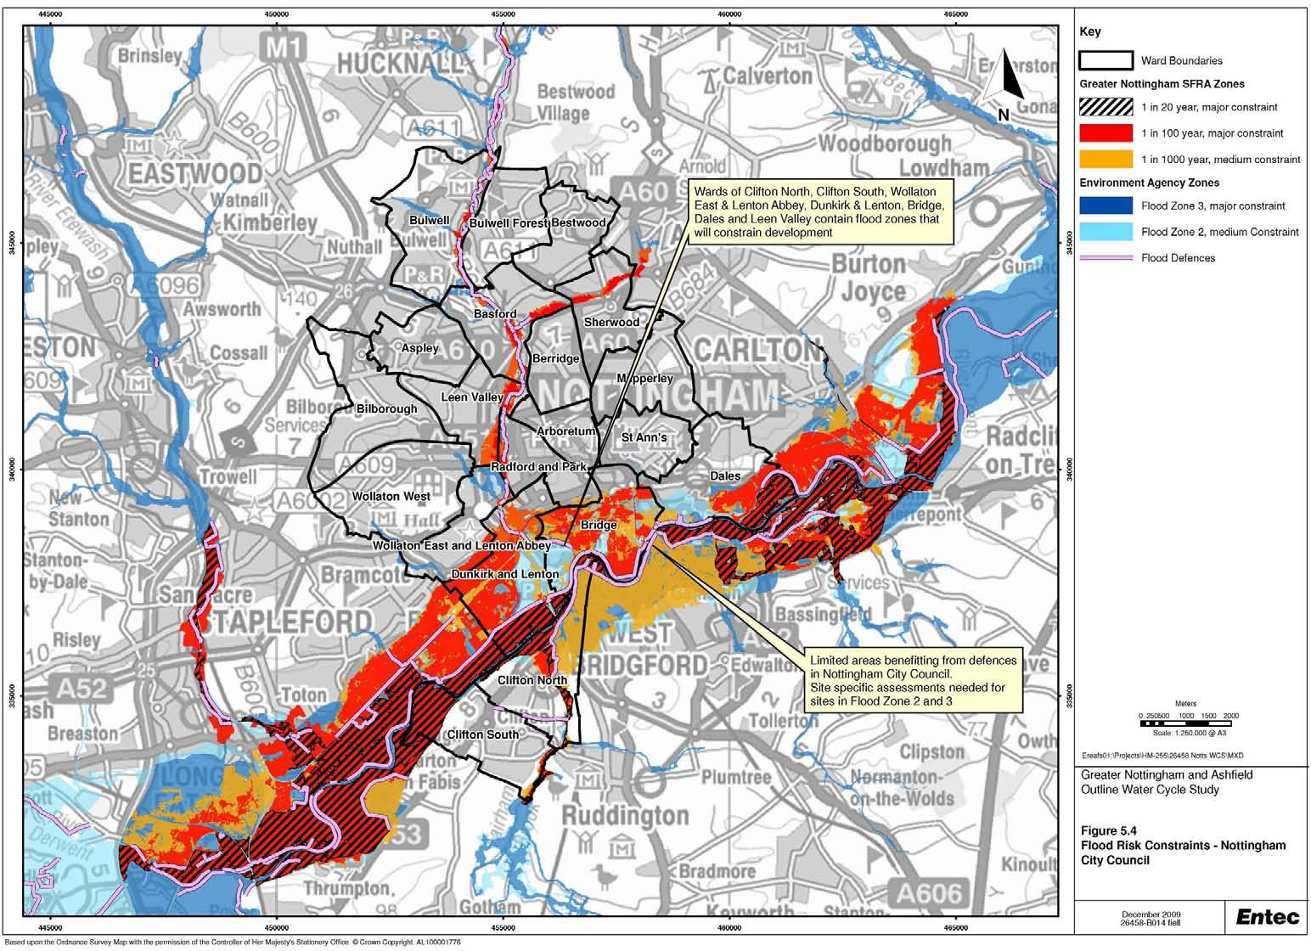

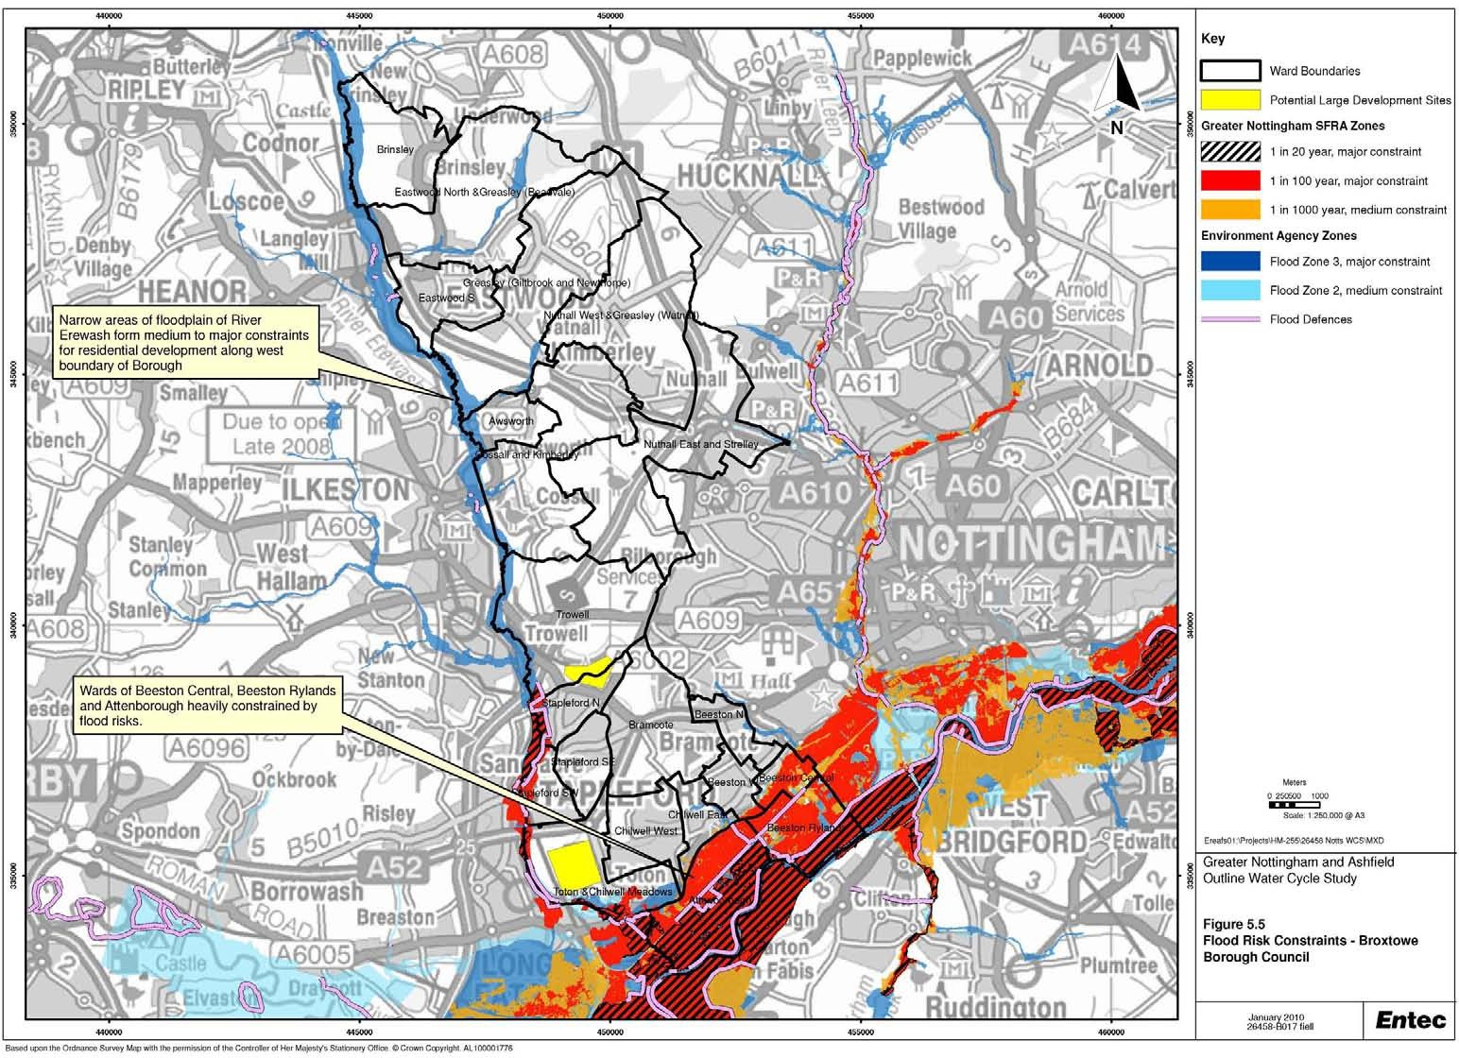

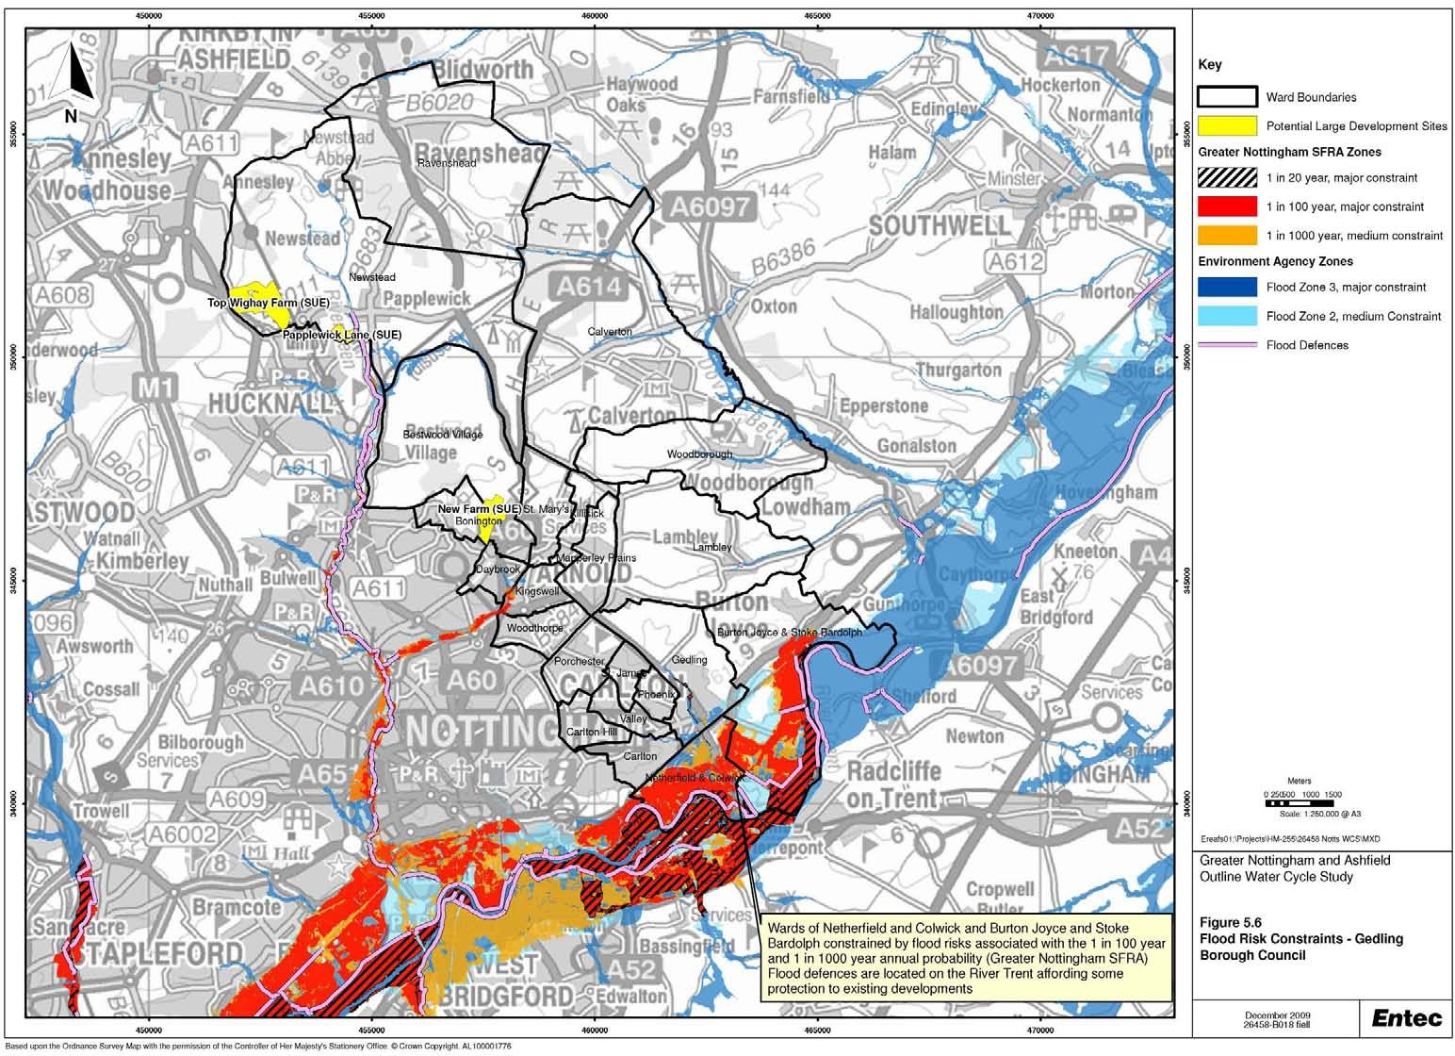

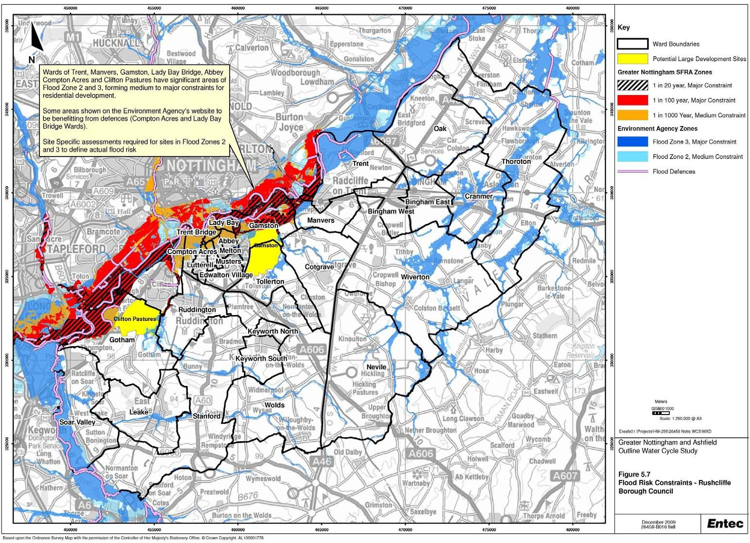

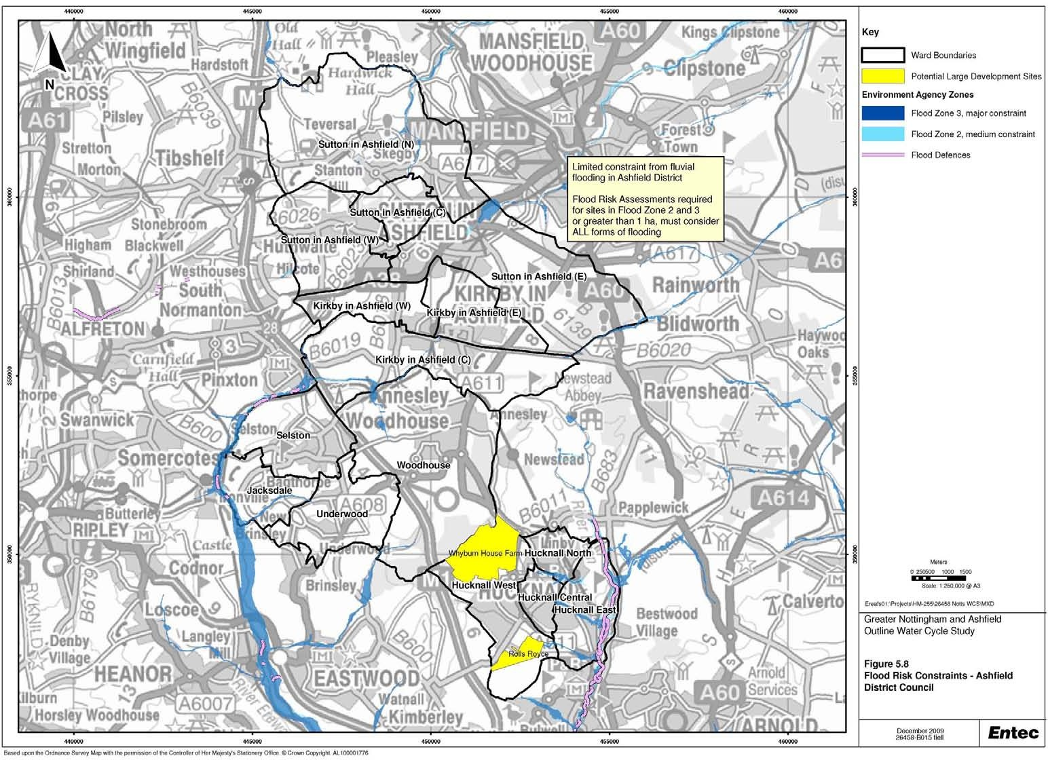

5.2 Infrastructure Constraints

Water Supply
    - Severn Trent Water consider that the information provided in the WRMP is sufficient for the purposes of completing an Outline WCS and that assessment of the water supply network requirements to meet demand from new developments should be included in any future detailed WCSs. It has therefore not been possible to undertake a detailed assessment of the infrastructure requirements in this study (see Table 5.5).

    - Severn Trent Water provided GIS shapefiles showing the spatial extent of its water supply network within the study area. This information is confidential and cannot be reproduced in this report. However, using this information it is possible to comment that the water supply network currently extends to most of the SUE sites. SUE sites that are located on Greenfield sites on the outskirts of existing development (including Top Wighay Farm, Whyburn Farm) are located on the periphery of the existing water supply network. These sites are likely to require more extensive network enhancements than brownfield sites such as land between Stapleford and Toton or Rolls Royce, where network infrastructure has previously been installed. For the same reason, infill development should not require extensive new mains in order to connect to the network.

    - Where additional mains are required to service specific developments, Severn Trent Water would seek to recover the costs from developers. Developer contributions will also be sought when development triggers the need for new infrastructure that will benefit existing communities.

    - This assessment should be considered as indicative, and does not consider the hydraulic capacity of the distribution system. The water supply infrastructure requirements of development in the study area should be considered further in any future detailed WCSs.

Table 5.5 Water Supply Infrastructure Constraints

District/Borough | Water supply infrastructure
Erewash
Nottingham City
 | Assessment cannot be completed at this stage. Water supply network currently extends to
Broxtowe | most of the SUE sites. Development on greenfield sites is likely to require more extensive
 | network enhancement that development at brownfield sites where network infrastructure
Gedling | has previously been installed. Further information would be required from Severn Trent
 | Water to complete this assessment.
Rushcliffe
Ashfield

Wastewater Treatment
    - The growth scenarios described in Section 2.5 were provided to Severn Trent Water to enable the company to undertake a high level assessment of the impact of development on wastewater treatment works within the study area. This assessment estimated the capacity of wastewater treatment works to accept additional wastewater from new development, in terms of number of additional dwellings.

    - To identify potential constraints, it is necessary to map the growth scenarios to the wastewater treatment works catchments described in Section 4.4. However, wastewater treatment works catchments do not match ward boundaries and in some cases more than one wastewater treatment works catchment can intersect the same ward. Therefore a common sense approach was adopted to identify possible impact of the proposed growth as follows:

      - Option 1 represents growth only from wards that are entirely contained within a WwTW catchment. In some WwTW catchments this option not applicable; whilst

      - Option 2 identified a ‘worst-case’ option where in addition to growth in entirely contained wards, growth from intersecting wards is also included. In cases where two WwTW catchments intersect the same ward, both WwTWs are assessed with each ward’s growth under this option.

    - Table 5.6 provides the allocation of proposed growth to each WwTW on a Ward basis under the two growth options.

Table 5.6 Allocation of Development to Wastewater Treatment Works Catchments

WwTW Name | Districts Covered by WwTW Catchment | Potential Additional Dwellings  Option 1 Option 2
Stoke Bardolph | Nottingham City, Ashfield, Rushcliffe, | 42245 | 42257
 | Broxtowe, Gedling
Pinxton | Ashfield |  | 741
Kirkby in Ashfield | Ashfield | 1851 | 7954
Sutton in Ashfield | Ashfield |  | 6103
Skegby | Ashfield | 1290
Huthwaite | Ashfield | 654
Newthorpe | Ashfield, Broxtowe | 1322 | 2063
Calverton | Gedling | 877
Beeston - Lilac Grove | Broxtowe | 824 | 866
Long Eaton-Toton | Broxtowe, Erewash | 2135 | 2165

WwTW Name | Districts Covered by WwTW Catchment | Potential Additional Dwellings  Option 1 Option 2
Derby | Erewash | 270 | 447
Ilkeston-Hallam Fields | Erewash, Broxtowe | 3525 | 3540
Stapleford-Bessell Lane | Erewash | 226
Aslockton | Rushcliffe | 1310
Cotgrave | Rushcliffe | 600
East Leake | Rushcliffe | 1100
Keyworth | Rushcliffe | 200
Radcliffe-on-Trent | Rushcliffe | 264
Rainworth | Gedling | 260

    - Table 5.7 shows the outcome of this assessment using a traffic light system to highlight the potential constraints on growth. The table compares estimated spare hydraulic capacity (expressed in number of dwellings) with proposed additional dwellings under the growth options:

      - Red highlights a potentially significant risk where the proposed growth in a ward or wards contained entirely within the WwTW catchment exceeds the spare hydraulic capacity. Works identified in this category include Aslockton, Calverton, East Leake, Huthwaite, Radcliffe on Trent and Skegby;

      - Amber highlights a potential risk where the proposed growth in the wards contained and within and/or intersecting the WwTW catchment exceeds the spare hydraulic capacity. Works identified in this category include Kirkby in Ashfield and Sutton in Ashfield (as assessed using growth option 2);

      - Green indicates where the potential growth with wards located in or intersecting with the existing WwTW catchment could be accommodated within the existing spare hydraulic capacity.

    - It is important to recognise that the assessment presented in Table 5.7 does not necessarily constrain growth at these locations. Other factors need to be taken into account including current water quality performance and whether future water quality performance is expected to be an issue and whether there is physical capacity to expand wastewater treatment works. Consideration of these issues for each of the works listed in Table 5.7 is presented in Table 5.8 and discussed further below.

    - When interpreting the findings of this assessment it is important to recognise that the information presented is a high-level response based on a desk top assessment of the growth data provided and has not employed any detailed hydraulic modelling. This would be required to provide a more robust assessment of the capacity of the wastewater treatment infrastructure. It is therefore recommended that this

information is revisited in any future detailed WCSs when further information relating to the location and timing of development can be attributed to specific sites.

    - It is also important to recognise that allocating growth data based on ward boundaries does not account for Severn Trent Water’s long-term wastewater management plans. These could include diverting flows to an alternative WwTW, concentrating treatment effort at the larger works to reduce compliance risk or abandoning the less sustainable WwTW in terms of cost, compliance risk or limited scope to increase capacity. The growth options presented in Table 5.6 should therefore be treated as a high-level assessment of the potential impacts of the proposed growth and has not been ratified by Severn Trent.

    - Ofwat published its Final Determination on water company prices for the next five years in November 2009, covering the period from April 2010 to March 2015. This sets out the regulator’s decisions on the Final Business Plans submitted by all water companies, including Severn Trent Water. The Final Determination will provide the basis of asset management planning and clarify the funding available to Severn Trent Water over the next 5 years (2010 – 2015). This is a complex document containing large amounts of information that will take some time for Severn Trent Water to analyse, although improvements in effluent quality are included in the Company’s strategic response. The final determination will help Severn Trent Water to identify where best to invest in water and wastewater infrastructure assets to both increase capacity to meet growth and ensure the water environment doesn’t deteriorate or improves to meet national and European objectives.

Table 5.7 Comparison of Estimated Spare Hydraulic Capacity and Additional Dwellings Under Option 1 and Option 2

Wastewater Treatment Works | Current Population Equivalent* | Current observed DWF  m³/day | Estimated sp capacity | are hydraulic | Additional proposed dwellings
 |  |  | Population Equivalent* | Dwellings at  2.4 persons/ dwelling | Option 1 Option 2
Aslockton | 12,202 | 4,585 | Nil | Nil | 1,310
Beeston - Lilac Grove | 20,042 | 9,383 | 5869 | 2450 | 824 866
Calverton | 8,859 | 1,633 | 1200 | 500 | 877
Cotgrave | 9,732 | 1,401 | 4306 | 1790 | 600
Derby | 374,106 | 77,621 | 86746 | 36140 | 270 | 447
East Leake | 8,866 | 1,897 | Nil | Nil | 1100
Huthwaite | 5,810 | 1,149 | 456 | 190 | 654
Ilkeston - Hallam | 48,433 | 9,105 | 10591 | 4410 | 3525 3540
Fields

Wastewater Treatment Works | Current Population Equivalent* | Current observed DWF  m³/day | Estimated spare hydraulic capacity |  | Additional proposed dwellings
 |  |  | Population Equivalent* | Dwellings at  2.4 persons/ dwelling | Option 1 | Option 2
Keyworth | 7,370 | 1,205 | 599 | 250 | 200
Kirkby in Ashfield | 26,728 | 4,436 | Extra capacity available |  | 1851 | 7954
Long Eaton - Toton | 68,472 | 19,063 | Extra capacity available |  | 2135 | 2165
Newthorpe | 48,395 | 11,464 | 9239 | 3850 | 270 | 447
Radcliffe on Trent | 8,489 | 1,834 | 402 | 170 | 264
Rainworth | 26,170 | 3,677 | 5093 | 2120 | 260
Skegby | 10,535 | 1,805 | Further assessment needed |  | 1290
Stapleford - Bessell | 27,976 | 5,783 | 12295 | 5120 | 226
Lane
Stoke Bardolph | 602,779 | 96,984 | Further assessment needed |  | 42245 | 42257
Sutton in Ashfield | 31,062 | 7,085 | 147 60 |  |  | 6103

* Note that Population Equivalent is an industry standard term to express the capacity of a wastewater treatment works in a standard unit. It is NOT a measure of the population served, and consequently it is incorrect to add population and Population Equivalent values.

Table 5.8 Strategic / High-level Response from Severn Trent Water on WwTW Capacity

Wastewater Treatment Works Name | Current Population Equivalent* | Current observed DWF  (m³/day) | Estimated headroom based on current quality performance | Future quality issues | Physical constraints regarding provision of additional treatment capacity (
Aslockton | 12,202 | 4,585 | Significant | Not expected to be an issue | No land or other constraints preventing expansion
Beeston - Lilac Grove | 20,042 | 9,383 | Minimal | Not expected to be an issue | Limited potential to provide additional capacity
Calverton | 8,859 | 1,633 | Significant | Not expected to be an issue | No land or other constraints preventing expansion
Cotgrave | 9,732 | 1,401 | Limited | Not expected to be an issue | No land or other constraints preventing expansion
Derby | 374,106 | 77,621 | Limited | Not expected to be an issue | No land or other constraints preventing expansion
East Leake | 8,866 | 1,897 | Limited | Not expected to be an issue | No land or other constraints preventing expansion

Wastewater Treatment Works Name | Current Population Equivalent* | Current observed DWF  (m³/day) | Estimated headroom based on current quality performance | Future quality issues | Physical constraints regarding provision of additional treatment capacity (
Huthwaite | 5,810 | 1,149 | Significant | Not expected to be an issue | Limited potential to provide additional capacity
Ilkeston - Hallam Fields | 48,433 | 9,105 | Significant | Not expected to be an issue | No land or other constraints preventing expansion
Keyworth | 7,370 | 1,205 | Limited | Not expected to be an issue | No land or other constraints preventing expansion
Kirkby in Ashfield | 26,728 | 4,436 | Significant | Not expected to be an issue | No land or other constraints preventing expansion
Long Eaton - Toton | 68,472 | 19,063 | Limited | Not expected to be an issue | Limited potential to provide additional capacity
Newthorpe | 48,395 | 11,464 | Minimal | Not expected to be an issue | No land or other constraints preventing expansion
Radcliffe on Trent | 8,489 | 1,834 | Limited | Not expected to be an issue | No land or other constraints preventing expansion
Rainworth | 26,170 | 3,677 | Significant Significant Significant Significant  Significant | Not expected to be an issue  Not expected to be an issue  Not expected to be an issue  Not expected to be an issue  Not expected to be an issue | No land or other constraints preventing expansion  No land or other constraints preventing expansion  No land or other constraints preventing expansion  No land or other constraints preventing expansion  No land or other constraints preventing expansion
Skegby | 10,535 | 1,805
Stapleford - Bessell Lane | 27,976 | 5,783
Stoke Bardolph | 602,779 | 96,984
Sutton in Ashfield | 31,062 | 7,085

    - The assessment presented in Table 5.7 shows that for many of the works identified in Table 5.7 where growth may exceed the hydraulic capacity, Severn Trent water do not perceive wastewater treatment works to be a constraint to growth due to the capability to upgrade or expand the treatment works. Table
5.8 shows that based on current quality performance, there is minimal remaining headroom (i.e. capacity to accept additional flows from new development) at Beeston Lilac Grove and Newthorpe WwTW. There is also limited remaining capacity at a further six WwTW including Cotgrave, Derby, East Leake, Keyworth, Long Eaton-Toton and Radcliffe on Trent. However, at most of these works Severn Trent do not see this as a long term constraint to growth due to the potential to expand or enhance treatment facilities at the works.

    - Exceptions are identified at each of the following sites (also identified in Figure 5.9):

      - Beeston – Lilac Grove (draining South East Broxtowe);

      - Huthwaite (draining the Huthwaite area of Ashfield); and

      - Long Eaton – Toton (draining areas of South East Erewash and South Broxtowe Boroughs).

    - At each of these locations, there is a physical constraint related to the footprint or the location of the WwTW, which means that there is limited potential to expand the works to receive additional wastewater flows. Despite these physical constraints, Table 5.7 shows that there is some existing hydraulic capacity to accommodate additional flows at Beeston and Huthwaite of around 2450 and 190 dwellings respectively. There is also existing hydraulic capacity at Long Eaton – Toton although this has not been quantified by Severn Trent Water in the information made available for this study.

    - The assessment shows that under the growth options presented in Table 5.7 the hydraulic capacity would be exceeded at Huthwaite, where an additional 654 dwellings may be developed under Option 1 (i.e. within the existing WwTW catchment) compared to an estimated hydraulic capacity of 190 dwellings. If there is no alternative sustainable options for treating additional flows generated by growth within this catchment this could constrain growth in Area C around Huthwaite in Ashfield District. At Beeston Lilac Grove the additional growth is within the existing hydraulic capacity of the works. It is not possible to conclude whether Long Eaton –Toton works can accommodate the additional wastewater flow from new development at this stage.

    - Although there is significant hydraulic capacity at Beeston Lilac Grove it will be important to consider the implications of Severn Trent Water’s long-term plans to divert flows from this WwTW to Stoke Bardolph WwTW. The infrastructure needed to transfer these flows could create an opportunity to accommodate additional flows from growth areas that could be transferred to both WwTW catchments.

    - It is important to recognise that Severn Trent has provided this analysis based on the scenarios provided to the company as part of this study. The assessment has looked at these impacts in isolation, and does not include impacts from growth outside of the study area. For example, in this assessment Derby

WwTW is identified as receiving additional flows from between 270 and 447 new homes in Erewash Borough. Derby WwTW will receive additional flows from new development within Derby, which may reduce the spare capacity of the WwTW. These issues are discussed further in Section 4.7.

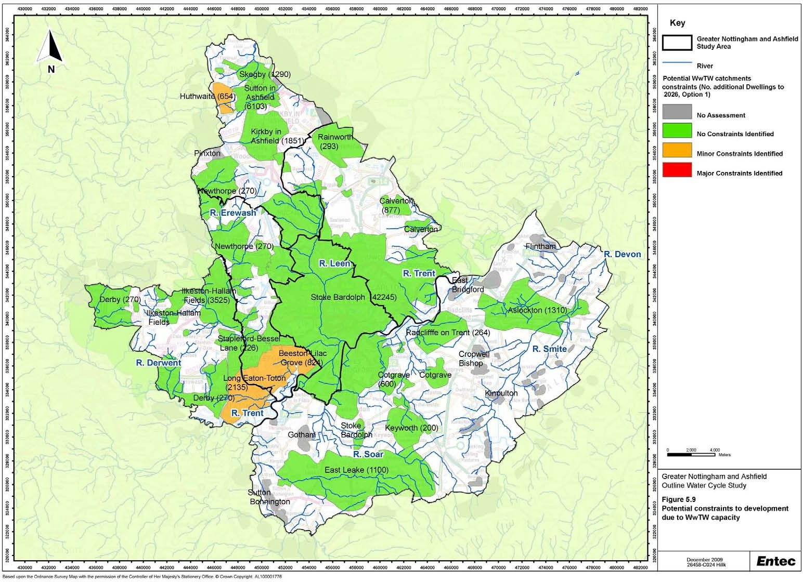

    - Growth in or adjacent to some sewerage catchments could push population equivalents at specific WwTW above thresholds outlined in the Urban Waste Water Treatment Directive. This would necessitate investment to treat effluent to a tighter standard and could therefore have an implication for both the phasing and location of growth within the study area. Under the Directive, additional treatment for phosphorus removal is required for wastewater treatment works with a population equivalent 10,000 or above that discharge upstream of rivers that are identified as eutrophic or at risk of becoming eutrophic. Within the five years from April 2010 Stoke Bardolph WwTW is required to introduce phosphorus stripping to achieve and effluent quality standard of 1 mg/l. This is not due to an increase in the population equivalent but follows the 2007 designation of the River Trent as a sensitive area [eutrophic] under the Urban Wastewater Treatment Directive.

    - It is clear from Table 5.7 that the several of the wastewater treatment works are approaching the population equivalent threshold and could be affected by this legislation (e.g. Cotgrave, Calverton, East Leak and Radcliffe on Trent). The extent to which this could constrain growth is uncertain. Whilst the required upgrades could influence the phasing of growth, Severn Trent Water’s long-term waste water management plans could influence the location of growth through strategic decisions to concentrate tertiary treatment requirements at the larger WwTW and thus keep the population equivalent at others below the 10,000 threshold. This issue is beyond the scope of this study, and should be explored further, in conjunction with Severn Trent Water as part of any future detailed WCSs.

    - Other legislation that may impact on the ability of the wastewater treatment works to receive additional flows from new development includes the EU Freshwater Fisheries Directive. Tighter consent standards for Ammonia, from 5 mg/l to 3 mg/l, are required at Newthorpe WwTW to address a failure for an existing designation under the EU Freshwater Fisheries Directive. Improvements at the works are due to be delivered by 2014, and could constrain growth in the north of Broxtowe and south west of Ashfield district prior to this.

    - The wastewater treatment constraints are summarised in Table 5.9 and Box 13.

Table 5.9 Wastewater Treatment Constraints

District/Borough | Wastewater treatment
Erewash | Limited potential to expand Long Eaton-Toton works. Assessment by Severn Trent indicates that there is existing hydraulic capacity at works to accommodate growth, although this has not been quantified.
Nottingham City | No constraints identified. Potential to expand works if required
Broxtowe | Limited potential to expand Long Eaton-Toton and Beeston (Lilac Grove) works. Assessment by Severn Trent indicates that there is existing hydraulic capacity at Long Eaton – Toton works to accommodate growth, although this has not been quantified.
Gedling | No constraints identified. Potential to expand works if required

District/Borough | Wastewater treatment
Rushcliffe Ashfield | No constraints identified. Potential to expand works if required
 | Potential growth exceeds available hydraulic capacity at Huthwaite WwTW. Limited potential to expand works. Severn Trent would need to be consulted to determine if options for diverting flows to alternative works are available.

Wastewater treatment and sewerage infrastructure could constrain the phasing of the growth across Nottingham and Ashfield and it is imperative that continued dialogue is maintained between the councils, Severn Trent Water and the Environment Agency. This will facilitate the identification of the most sustainable wastewater management options and ensure the infrastructure is appropriately sized and in place prior to development.
From the above analysis there is only one potential absolute barrier to development in Area C around Huthwaite if there is no sustainable alternative to convey and treat additional wastewater outside the existing catchment of Huthwaite WwTW as existing hydraulic capacity is limited as is the scope to provide additional capacity.
Summary of Wastewater Constraints
Box 13

Sewer Flooding and Surfacewater Drainage
    - Using the growth scenarios developed for this study, Severn Trent Water has provided a high-level assessment of the capacity of the sewerage network to receive additional flows from new development. At this stage in the assessment the location of all developments within the study area was not sufficiently detailed to enable the identification of all potential sewerage network constraints. In addition this assessment is not based on detailed hydraulic modelling. It is recommended that this assessment is revisited as part of any future detailed WCSs and in conjunction with the SWMP once specific sites and housing numbers have been identified. Table 5.10 provides a summary of the locations where the growth may have an impact on the sewerage network. These are also shown by Council area in Figure 5.10 to Figure 5.15. As shown in Table 5.10, further detailed hydraulic modelling of the capacity of the network would be required to confirm the capacity of the network in relation to specific development. This would need to be undertaken by Severn Trent Water in response to developer enquiries or as part of any future detailed WCSs.

    - Table 5.10 shows that within Rushcliffe, a potential major constraint has been identified in relation to the capacity of the sewerage network. Development in Gamston, Edwalton and West Bridgford will drain to the same sewage pumping station located in West Bridgford. From this point, sewage would be pumped north across the River Trent and join two large gravity sewers that drain to Stoke Bardolph WwTW. The capacity of the two large gravity sewers to accept these additional flows has not been modelled by Severn Trent Water at this stage. If the large gravity sewers cannot accept the additional flows from these new development sites the alternative would be to pump additional flows directly from the sewage pumping

station in West Bridgford to Stoke Bardolph WwTW. This is approximately 6 km and Severn Trent Water has indicated that this likely to be expensive to implement (although they cannot confirm the cost at this stage).

    - Clifton Pastures will drain to a different sewage pumping station at Clifton. From here, it will be pumped northwards across the River Trent via a different crossing to the sewage from Gamston, Edwalton and West Bridgford, and will join the two large gravity sewers that drain to Stoke Bardolph WwTW. Severn Trent Water has indicated that detailed modelling will be required to determine the need for local sewerage infrastructure enhancements, but these are not expected to be a major constraint to development. As noted above, if hydraulic modelling determines that the capacity of the large gravity sewers is insufficient to accept additional flows, Severn Trent Water may need to pump sewage from the Gamston, Edwalton and West Bridgford area directly to Stoke Bardolph WwTW. Consequently, the capacity of sewerage infrastructure is assessed as being a more significant potential constraint to development in Gamston, Edwalton and West Bridgford area than in the Clifton area.

    - It is important to note that although these potential constraints have been identified within this study, the water companies have a rolling programme of upgrades and maintenance for sewers, so that some of the flooding incidents previously recorded may now have been mitigated or removed. This means that the assessment should be considered as indicative only. Where additional sewerage infrastructure is required to service specific developments, Severn Trent Water would seek to recover the costs from developers. Developer contributions will also be sought when development triggers the need for new infrastructure that will benefit existing communities.

Table 5.10 Sewer Flooding and Surface Water drainage Constraints

District/Borough Surface Water Drainage
Erewash  Nottingham City  Broxtowe | Sewerage infrastructure may constrain development in North Cotmanhay and Abbotsford Wards without investment to increase capacity of sewers. Other potential sewerage infrastructure constraints identified in Kirk Hallam and Draycott Wards. Development at on the SUE sites at West of Ilkeston and Stanton Ironworks may be constrained without increases in capacity of sewerage network.  New sites to implement SuDS to prevent increasing runoff  Sewerage infrastructure may constrain development in Clifton North, Clifton South, Bridge and St Anns Ward. Detailed hydraulic modelling is required to confirm constraints. There are known sewer flooding issues in Bestwood Ward, where a further 543 dwellings are proposed in the growth scenarios within this study.  A SWMP will review existing problems. New development must comply with PPS25 to prevent increasing the problem. New sites to implement SuDS to prevent increasing runoff  Historic sewer flooding incidents in the Nuthall West and Greasley and Beeston Central Ward indicate potential sewerage capacity constraints to further development.  At this stage development at the SUE sites in this Borough have not been identified as being constrained by sewerage capacity. New sites to implement SuDS to prevent increasing runoff

District/Borough Surface Water Drainage
Gedling  Rushcliffe  Ashfield | Sewerage infrastructure may constrain development in Newstead and Carlton Wards and in the Arnold area. Severn Trent Water identify that further detailed hydraulic modelling is required to assess the capacity in these areas.  These constraints may potentially affect development at all three SUE sites within Gedling. New sites to implement SuDS to prevent increasing runoff
 | Sewerage infrastructure may be a major constraint to growth in the Edwalton and Gamston (including Gamston SUE site) areas due to the scale of the growth proposed. Sewerage infrastructure capacity may also be a minor constraint to development in Gotham Ward (e.g. Clifton Pastures SUE site). Detailed hydraulic modelling is required to assess the capacity of the network in relation to these developments.
Sewerage network capacity is identified as a potential constraint to growth in both the Hucknall area and in the north of the District.
Development at the Whyburn Farm SUE sites would drain through central Hucknall, where historical sewer flooding events have occurred. Further detailed hydraulic modelling is required.

Sewer flooding incidents are recorded by Severn Trent Water in many areas of the Study Area. Detailed hydraulic modelling will be required to determine the impacts on the sewerage network from the proposed development and to define the level of constraint. Severn Trent Water have highlighted that the scale of the growth in Rushcliffe could present a potential barrier to growth due to the capacity of the sewerage network.
Surface Water Flooding arises from a number of mechanisms. Where surface water drains are at capacity, blocked or are poorly maintained, flooding can occur during heavy rainfall events. This is a particular issue in Nottingham City and may represent constraints to development with regard to attenuation of run-off. Recently, Defra has awarded funding to Nottingham City to prepare a SWMP to identify the risks from surface water flooding and prepare a plan to mitigate this where possible.
The Greater Nottingham SFRA advises that ‘opportunities should be taken to work with other authorities in the Greater Nottingham conurbation to share best practice and knowledge in terms of flooding and sustainable surface water management with the common goal of reducing overall flood risk’.
Summary of sewer flooding and surfacewater drainage constraints
Box 14

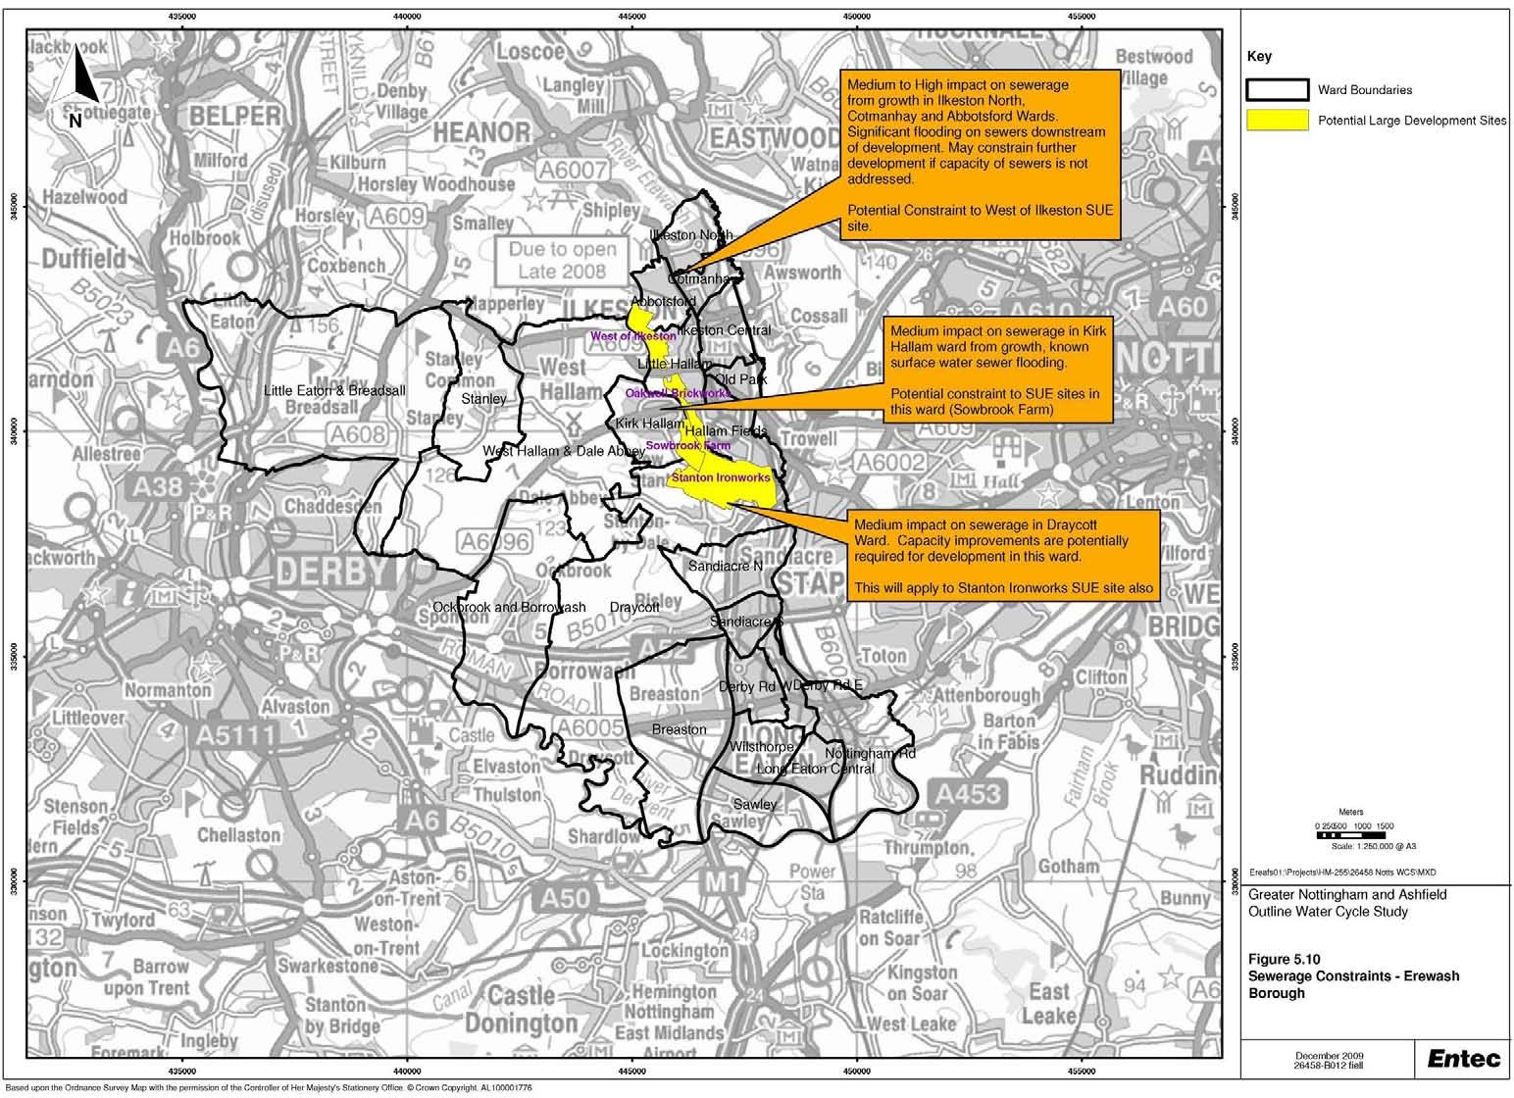

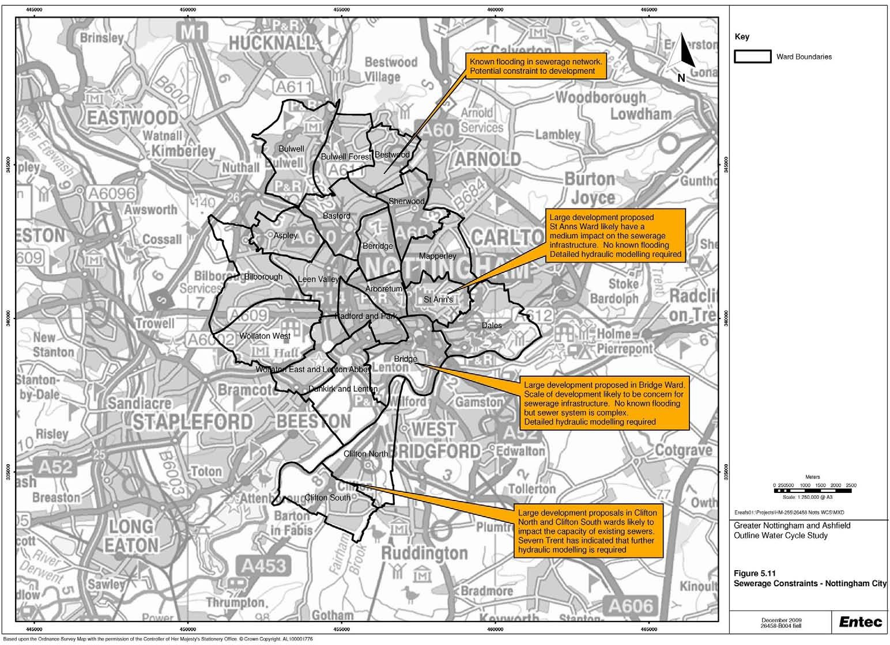

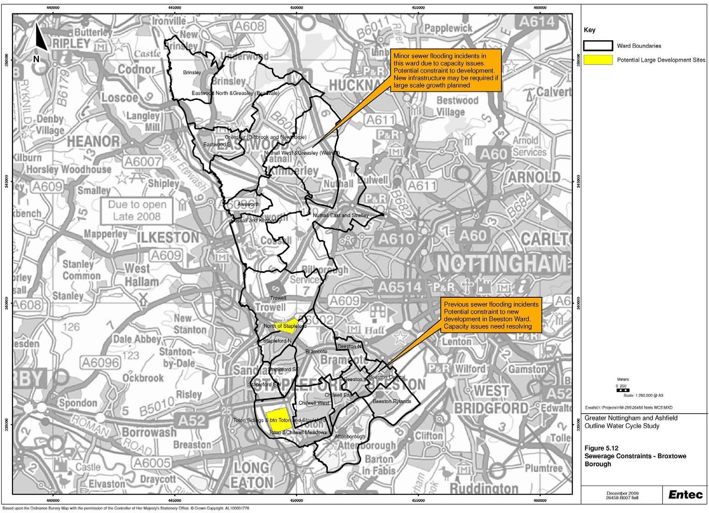

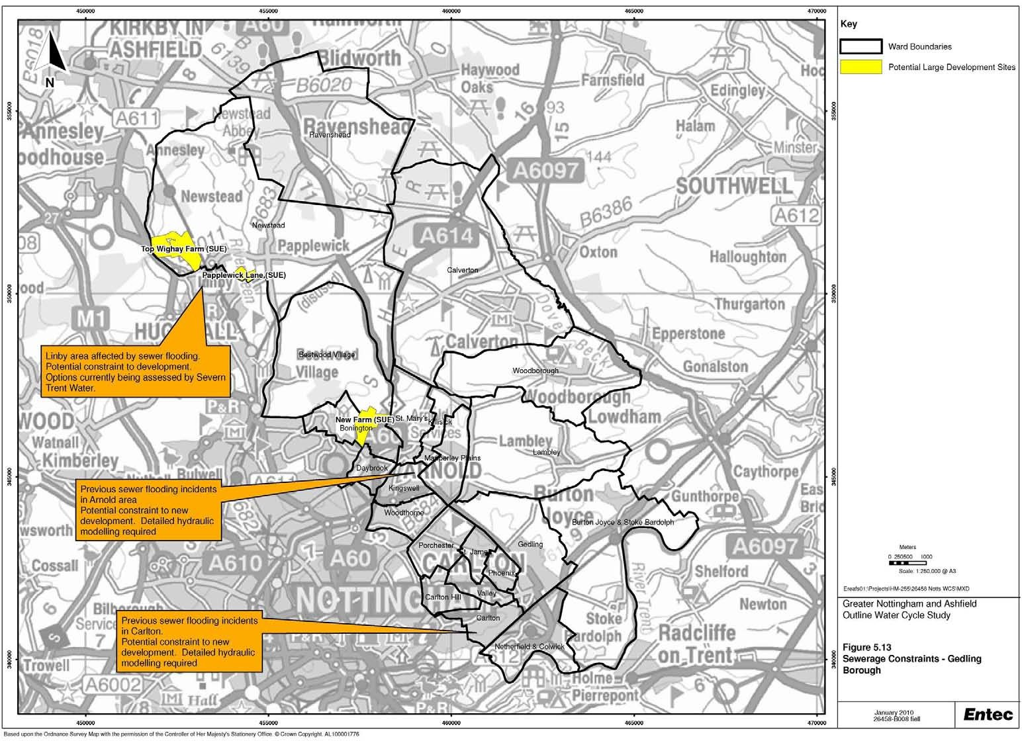

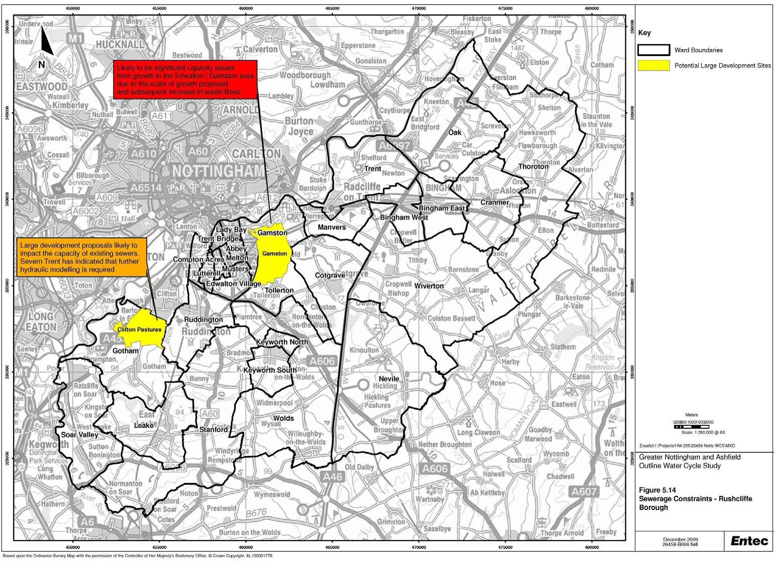

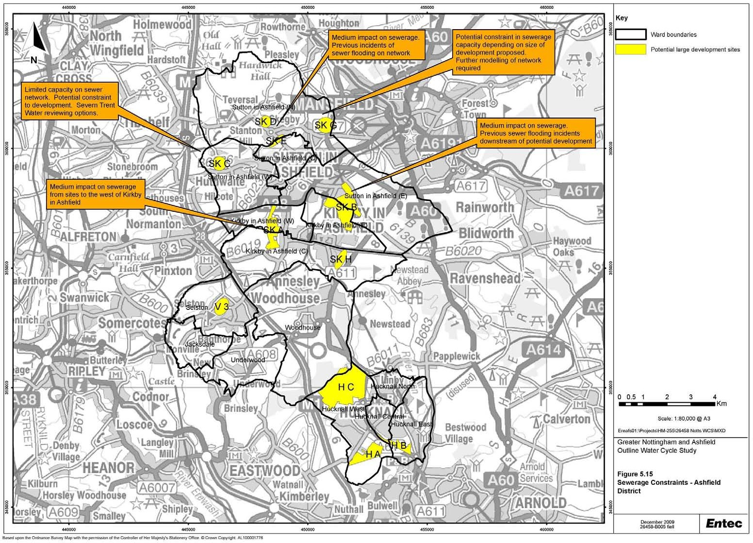

Creating the environment for business

5.3 Constraints at SUE Sites
5.3.1 An assessment has been undertaken of the potential water cycle constraints to development at SUE sites identified by the partner councils. This is presented in Table 5.11. It should be noted that this is a high- level assessment undertaken to provide an indication of whether water resources and water supply, wastewater and sewerage and flood risk and drainage are likely to constrain development at these locations. More detailed assessment (such as a site specific Flood Risk Assessments) and detailed consultation with Severn Trent Water will need to be undertaken when further details about the nature of developments at these sites become available. A summary assessment is presented in the right hand column. For each site, this has currently been assessed as ‘amber’, since the assessment is high level and further detailed modelling is required.

Doc Reg No. 26458 R029i3
Page 89

February 2010

Table 5.11 Potential Constraints to Development at SUE Sites

SUE Site | Local Authority | Water Resources and Water Wastewater and sewerage Supply |  | Water Quality | Flood risk and drainage | Summary assessment
Top Wighay Farm | Gedling | No absolute constraints identified. Stoke Bardolph WwTW has no perceived Consultation with Severn Trent Water constraint in terms of hydraulic capacity to required concerning water supply accommodate growth or possible WwTW infrastructure provision. expansion. Upgrades to treatment required  It will be important that the Council to meet a tighter phosphorus consent by encourages water efficiency in new 2014 but this is unlikely to be influenced by homes to support Severn Trent additional flows. Known downstream flooding Water’s resource management plans issues, but potential solutions (therefore  over the growth period. amber). |  | Current water quality exceeds WFD chemical objectives for phosphorus | Site is located in fluvial Flood Zone 1, therefore low probability of flooding. SuDS should be implemented where possible. | No absolute constraints to development identified in this high-level review.  Detailed modelling required to assess requirements for water supply and wastewater infrastructure (hence amber).
North of Papplewick Lane | Gedling | No absolute constraints identified. Consultation with Severn Trent Water required concerning water supply infrastructure provision.  It will be important that the Council encourages water efficiency in new homes to support Severn Trent Water’s resource management plans over the growth period. | Stoke Bardolph WwTW has no perceived constraint in terms of capacity to accommodate growth or possible WwTW expansion. Upgrades to treatment required to meet a tighter phosphorus consent by 2014 but this is unlikely to be influenced by additional flows. Perceived low impact on the Sewerage network. | Current water quality exceeds WFD chemical objectives for phosphorus | Site is partly located in fluvial Flood Zone 2 and 3 of River Leen. Masterplanning of site should guide development into the parts of the site in Flood Zone 1. SuDS should be implemented where possible. Site specific FRA will be required | No absolute constraints to development identified in this high-level review.  Detailed modelling required to assess requirements for water supply and wastewater infrastructure (hence amber)
North of Redhill (New Farm) | Gedling | No absolute constraints identified. Consultation with Severn Trent Water required concerning water supply infrastructure provision.  It will be important that the Council encourages water efficiency in new homes to support Severn Trent Water’s resource management plans over the growth period. | Stoke Bardolph WwTW has no perceived constraint in terms of capacity to accommodate growth or possible WwTW expansion. Upgrades to treatment required to meet a tighter phosphorus consent by 2014 but this is unlikely to be influenced by additional flows. Some localised issues possible with the sewerage network (hence amber) | Current water quality exceeds WFD chemical objectives for phosphorus | Site is located in fluvial Flood Zone 1, therefore low probability of flooding. SuDS should be implemented where possible. | No absolute constraints to development identified in this high-level review.  Detailed modelling required to assess requirements for water supply and wastewater infrastructure (hence amber)

SUE Site | Local Authority | Water Resources and Water Supply | Wastewater and sewerage | Water Quality | Flood risk and drainage | Summary assessment
Rolls Royce | Ashfield | No absolute constraints identified. Consultation with Severn Trent Water required concerning water supply infrastructure provision.  It will be important that the Council encourages water efficiency in new homes to support Severn Trent Water’s resource management plans over the growth period. | Stoke Bardolph WwTW has no perceived constraint in terms of capacity to accommodate growth or possible WwTW expansion. Upgrades to treatment required to meet a tighter phosphorus consent by 2014 but this is unlikely to be influenced by additional flows.  Site located to West of Hucknall. No significant capacity issues expected provided surface water drainage is not linked to foul sewers (hence green) although detailed hydraulic modelling required to confirm whether local upsizing may be required. . | Current water quality exceeds WFD chemical objectives for phosphorus | Site is located in fluvial Flood Zone 1, therefore low probability of flooding. SuDS should be implemented where possible. | No absolute constraints to development identified in this high-level review.  Detailed modelling required to assess requirements for water supply and wastewater infrastructure (hence amber)
Whyburn House Farm | Ashfield | No absolute constraints identified. Consultation with Severn Trent Water required concerning water supply infrastructure provision.  It will be important that the Council encourages water efficiency in new homes to support Severn Trent Water’s resource management plans over the growth period. | Stoke Bardolph WwTW has no perceived constraint in terms of capacity to accommodate growth or possible WwTW expansion. Upgrades to treatment required to meet a tighter phosphorus consent by 2014 but this is unlikely to be influenced by additional flows. Site upstream of known Sewerage network flooding issues in Hucknall. Development of this scale draining into Hucknall sewerage system likely to require capacity upgrades which would need to be confirmed by detailed hydraulic modelling (hence amber) | Current water quality exceeds WFD chemical objectives for phosphorus | Site is located in fluvial Flood Zone 1, therefore low probability of flooding. SuDS should be implemented where possible. | No absolute constraints to development identified in this high-level review.  Detailed modelling required to assess requirements for water supply and wastewater infrastructure (hence amber)

SUE Site | Local Authority | Water Resources and Water Supply | Wastewater and sewerage | Water Quality | Flood risk and drainage | Summary assessment
Gamston | Rushcliffe | No absolute constraints identified. Consultation with Severn Trent Water required concerning water supply infrastructure provision.  It will be important that the Council encourages water efficiency in new homes to support Severn Trent Water’s resource management plans over the growth period. | Stoke Bardolph WwTW has no perceived constraint in terms of capacity to accommodate growth or possible WwTW expansion. Upgrades to treatment required to meet a tighter phosphorus consent by 2014 but this is unlikely to be influenced by additional flows. Capacity issues envisaged within the sewerage network. Solutions have been identified but could require significant investment. Detailed modelling required to determine extent of network enhancements. | Current water quality exceeds WFD chemical objectives for phosphorus | Site is partly located in fluvial Flood Zone 2 and 3 of River Trent, north of the A52.  Masterplanning of site should guide development into the southern parts of the site in Flood Zone 1. Site is bordered to west by Polster Brook. Grantham Canal bisects the site and will be a source of residual flood risk. SuDS should be implemented where possible. Site specific FRA will be required | No absolute constraints to development identified in this high-level review.  Detailed modelling required to assess requirements for water supply and wastewater infrastructure.  Severn Trent Water has indicated that significant investment could be required in the wastewater network, but not envisaged to be absolute constraint to development (hence amber).
Clifton | Rushcliffe | No absolute constraints identified. | Stoke Bardolph WwTW has no perceived constraint in terms of capacity to accommodate growth or possible WwTW expansion. Upgrades to treatment required to meet a tighter phosphorus consent by 2014 but this is unlikely to be influenced by additional flows. Further capacity assessment of sewerage network needed depending on the size of the site (hence amber) | Current water quality | Minor part of site is located in | No absolute constraints to
Pastures |  | Consultation with Severn Trent Water |  | exceeds WFD chemical | fluvial Flood Zone 2 and 3 of | development identified in
 |  | required concerning water supply |  | objectives for | River Trent, west of the A453. | this high-level review.
 |  | infrastructure provision. |  | phosphorus | Eastern border overlies | Detailed modelling
 |  | It will be important that the Council encourages water efficiency in new homes to support Severn Trent Water’s resource management plans over the growth period. |  |  | Fairham Brook flood zones. Majority of site in Flood Zone  1. Masterplanning of site should guide development into this zone. SuDS should  be implemented where | required to assess requirements for water supply and wastewater infrastructure (hence amber)
 |  |  |  |  | possible. Site specific FRA
 |  |  |  |  | will be required

SUE Site | Local Authority | Water Resources and Water Wastewater and sewerage Supply |  | Water Quality | Flood risk and drainage | Summary assessment
Between Toton and Stapleford | Broxtowe | No absolute constraints identified. Long Eaton-Toton WwTW has capacity to Consultation with Severn Trent Water accommodate the growth, but has potential required concerning water supply constraint in terms of scope for WwTW infrastructure provision. expansion (hence amber). Perceived low risk It will be important that the Council in terms of Sewerage Network capacity encourages water efficiency in new  homes to support Severn Trent Water’s resource management plans over the growth period.  No absolute constraints identified. Long Eaton-Toton WwTW has capacity to Consultation with Severn Trent Water accommodate the growth, but has potential required concerning water supply constraint in terms of scope for WwTW infrastructure provision. expansion (hence amber). Perceived low risk It will be important that the Council in terms of Sewerage Network capacity encourages water efficiency in new  homes to support Severn Trent Water’s resource management plans over the growth period. |  | Current water quality exceeds WFD chemical objectives for phosphorus. WwTW discharge also short distance upstream of SSSI  Current water quality exceeds WFD chemical objectives for phosphorus. WwTW discharge also short distance upstream of SSSI | Site is located in fluvial Flood Zone 1, therefore low probability of flooding. SuDS should be implemented where possible. | No absolute constraints to development identified in this high-level review.  Detailed modelling required to assess requirements for water supply and wastewater infrastructure (hence amber)
Toton Sidings | Broxtowe |  |  |  | Site is located in fluvial Flood Zone 1, therefore low probability of flooding. SuDS should be implemented where possible. | No absolute constraints to development identified in this high-level review.  Detailed modelling required to assess requirements for water supply and wastewater infrastructure (hence amber)
North of Stapleford | Broxtowe | No absolute constraints identified. Consultation with Severn Trent Water required concerning water supply infrastructure provision.  It will be important that the Council encourages water efficiency in new homes to support Severn Trent Water’s resource management plans over the growth period. | Stapleford-Bessell Lane WwTW has capacity to accommodate the growth, or possible WwTW expansion. Perceived low risk in terms of Sewerage Network capacity | Current water quality exceeds WFD chemical objectives for phosphorus, BOD and Ammonia (BOD and Ammonia downstream of WwTW only). WwTW discharge also short distance upstream of SSSI | Site is located in fluvial Flood Zone 1, therefore low probability of flooding. SuDS should be implemented where possible. | No absolute constraints to development identified in this high-level review.  Detailed modelling required to assess requirements for water supply and wastewater infrastructure (hence amber)

SUE Site | Local Authority | Water Resources and Water Supply | Wastewater and sewerage | Water Quality | Flood risk and drainage | Summary assessment
West of Ilkeston | Erewash | No absolute constraints identified. Consultation with Severn Trent Water required concerning water supply infrastructure provision.  It will be important that the Council encourages water efficiency in new homes to support Severn Trent Water’s resource management plans over the growth period.  No absolute constraints identified. Consultation with Severn Trent Water required concerning water supply infrastructure provision.  It will be important that the Council encourages water efficiency in new homes to support Severn Trent Water’s resource management plans over the growth period. | Ilkeston Hallam Field WwTW has no perceived constraint in terms of capacity to accommodate growth from this site or possible WwTW expansion. Possible sewerage Network issues locations and numbers of growth need to be confirmed (hence amber)  Ilkeston Hallam Field WwTW has no perceived constraint in terms of capacity to accommodate growth from this site or possible WwTW expansion. Growth from Stanton Iron Works could go to Stapleford WwTW. Possible sewerage Network issues, to confirm when locations and numbers confirmed (hence amber) | Current water quality exceeds WFD chemical objectives for phosphorus  Current water quality exceeds WFD chemical objectives for phosphorus | Very minor part of site at risk of flooding from Nut Brook. Site specific FRA will be required  Very minor part of site at risk of flooding from Nut Brook. | No absolute constraints to development identified in this high-level review.  Detailed modelling required to assess requirements for water supply and wastewater infrastructure (hence amber)  No absolute constraints to development identified in this high-level review.  Detailed modelling required to assess requirements for water supply and wastewater infrastructure (hence amber)
Stanton Ironworks | Erewash

5.4 Cumulative Impacts of SUE Sites
    - The assessment in the preceding section identifies potential constraints relating to SUE sites in isolation. At this stage, there is no certainty of delivery for any of the SUE sites. However, it is possible that several SUE sites could be approved for development in the future. It is therefore important to consider where there may be potential cumulative constraints to growth from SUE sites.

    - In the Hucknall area, two SUE sites have been identified at Whyburn House Farm (Ashfield District) and Top Wighay Farm (Gedling Borough), adjacent to the North and East of the urban fringe of Hucknall. A third SUE site has also been identified at Rolls Royce, to the South of Hucknall. Similarly, SUE sites have been identified in close proximity in Broxtowe (Toton Sidings, between Toton and Stapleford and north of Stapleford. In Erewash, SUEs at West of Ilkeston and Stanton Ironworks are located in close proximity. In Rushcliffe, the SUE sites at Gamston and south of Clifton are not immediately adjacent to each other.

    - The cumulative impact of these sites may require improvements to the water supply network. Severn Trent Water would need to be consulted on detailed site plans should adjacent SUE sites be developed. This study has shown that sufficient water resources should be available to meet demand from these developments, and that water efficient homes should be encouraged to support Severn Trent Water’s demand management strategies.

    - The construction of large sustainable extensions to the urban environment presents a risk to flooding of downstream locations. All developments will have to comply with the requirements of PPS25 to ensure that no increase in surface run-off and flood risk results from the introduction of buildings and roads on previously undeveloped land, and from changes in footprint on existing brownfield sites. This will be monitored through the planning applications that will be required to be accompanied by site specific Flood Risk Assessments, and strategies for implementing SuDS and restricting run-off to existing rates and volumes. Providing the requirements of PPS25 are met, cumulative impacts of these developments should not result in increased flood risk.

    - In relation to the SUE sites the sewerage network could cause a potential barrier to significant growth, but the constraint will depend on confirmation of the numbers and specific locations of growth. Cumulative growth at a number of SUE sites is unlikely to be constrained by the capacity of the WwTWs to receive the additional Dry Weather Flow.

    - The chemical status of receiving rivers downstream of all SUE sites already fail to meet the WFD standard, particularly for phosphorus. However, as mentioned in previous chapters this alone does not constrain growth as there is sufficient scope to further tighten the consented quality to ensure no deterioration or where required improve the chemical status of the receiving water. In addition, tighter treatment could be required to ensure SSSIs meet conservation status and to reduce the nutrient loading to the Trent, since its designation as a Sensitive Area (eutrophic) (SA[E]) in 2007.

Opportunities and Capacity for New Development

6.1.1 This section assesses the future capacity of the water cycle to accommodate growth. The demands of the proposed level of growth on the existing water environment and water services infrastructure are reviewed and demand management scenarios are discussed. A sensitivity analysis is included on the growth options to account for uncertainty in the planned housing trajectory.

6.2 Water Quality and Wastewater
    - The majority of rivers across the study area currently fail to achieve ‘Good Status’ with only a marginal improvement in the overall status expect in the Derbyshire Derwent by 2015 though existing planned measures. The Humber River Basin Management Plan highlights the need through this first six year WFD planning cycle to work with Severn Trent Water to reduce the number of misconnections and improve the effluent quality at WwTW throughout the study area to reduce the nutrient inputs, particularly phosphorus. Measures focused on wastewater discharges have the potential to return significant benefits in terms of the chemical status of the receiving water. Although it is important to note that measures identified in the RBMP will also target diffuse and point source contributions from other sectors and technical feasibility and the proportionality of the costs of measures will also be considered.

    - Agreement is needed between the Environment Agency, Severn Trent Water and other key stakeholders, including councils, regarding how best to deliver the proposed growth whilst improving in the quality of the receiving water to meet the objectives of the Water Framework Directive. The maps included in Section 4 illustrate of the extent of WFD compliance risk across the study area for the key contaminants that could be influenced by growth (i.e. a component of treated wastewater). These could be used as the basis of the following pragmatic approach to highlight the most sustainable locations:

      - Ecological Status sensitive to growth (growth constrained by technology) - Water quality currently far exceeds the statutory targets as set out in WFD. Achieving these thresholds/targets may not be possible within the limits of conventional treatment technology. Growth would further deteriorate the quality of the receiving water and may also have a negative impact on the ecology;

      - Ecological Status sensitive to growth (failing targets, investment required) - Water quality is currently failing the required thresholds/targets but improvement in wastewater treatment is possible through planned investment. Growth could make it more difficult to achieve, or prevent the achievement of the targets;

      - Ecological Status sensitive to growth (achieving targets, investment required) - Water quality is currently achieving the thresholds/targets but growth may result in failure to meet these targets. For

example, where there is limited scope to mitigate an increase in effluent flow as wastewater effluent already treated to a high standard;

      - Ecological Status is unlikely to be sensitive to growth - Water quality is currently achieving the thresholds/targets and impact of planned growth can be mitigated as there is plenty of scope to further tighten consent conditions with regard to the quality of the effluent.

    - The above categorisation looks at the impact of growth on a particular river stretch. Those categorised in the 2nd or 3rd bullets are most sensitive to growth, either due to marginally passing or failing the required target / threshold, and as such are those which need to be protected from the effects of growth. The 1st bullet captures river stretches that are currently failing targets / thresholds, but investing in the WwTW alone is thought to be insufficient to achieve these targets / thresholds. Further work must be done to address these areas through identifying wider measures to address the contribution from all sources / pressures through the river basin planning process.

    - Based on the above, possible implications to planning decisions of impacts of growth are listed below:

      - Growth cannot be accommodated without significant risk of harm to the ecology of the wetland or river even when possible water infrastructure improvements are taken into account. Changes to the RSS allocation and distributions should be considered;

      - The capacity of river or dependant habitats (i.e. SSSI) to receive additional wastewater flows associated with planned growth and the degree to which water infrastructure improvements can mitigate the impact of growth is uncertain. In this case a detailed assessment should be carried out as part of any future detailed WCSs to reduce this uncertainty. It may be necessary to revise the allocations and distributions at the core strategy stage if sustainable solutions cannot be found;

      - The planned growth can be accommodated and no action required.

    - From high level analysis of the data provided by Severn Trent Water there is significant scope to treat effluents across the study area to meet tighter standards since most current and proposed consent conditions exceed those that can be achieved using best available technology (BAT). Traditional wastewater treatment uses natural biological processes to reduce organic material including BOD and ammonia by providing optimum conditions for microbial activity. Older WwTWs generally use ‘biological filters’ in which wastewater is allowed to trickle over stones which are coated with a microbial layer. Biological filter works have low energy consumption but a large spatial footprint and their performance deteriorates in cold weather.

    - Modern treatment mainly uses the ‘activated sludge process’ in which the active organisms are maintained suspended in a large tank and provided with air mechanically. This process has a lower footprint than biological filters and will remove a higher proportion of organic matter but has higher power consumption.

    - Improved water quality thresholds/targets set by WFD are likely to require the removal a higher proportion of organic matter and lower effluent concentrations of phosphorus. Phosphorus is not removed efficiently by traditional wastewater treatment processes so modifications to the microbial treatment processes or tertiary chemical treatment may be required, many WwTW already meet a tighter consent for phosphorus. Increased flows from new development will require increased hydraulic capacity and improvements in treatment to avoid increases in pollution loads to the receiving waters. Generally, tighter effluent standards are met by additional process units, where space allows, or, if necessary by complete replacement of an existing works by an activated sludge plant. The highest quality effluent obtainable from such a plant with an acceptably low risk of consent failure is:

      - 8 mg BOD/l (95 percentile);

      - 1 mg ammN/l (95 percentile); and

      - Phosphorous is generally removed through chemical precipitation using iron salts. The performance limit of this technology is 1 mg/l as P (annual average basis).

    - These limits are based on using a new activated sludge plant. It may not be possible to achieve such tight standards at many of the existing wastewater treatment works subject to development. Replacing the existing treatment processes is also not necessarily a sustainable option. In order to achieve more stringent effluent consent standards (under the current regulatory framework), potable water treatment process technologies would be required which have a high carbon footprint both with respect to construction and operation, for example ozone followed by activated carbon filtration.

    - As an alternative, effluent may be transferred lower down the catchment where there is greater dilutive capacity. However, this is only viable where the scale of development justifies the high capital and carbon cost of the necessary infrastructure.

    - In summary, growth has the potential to further exacerbate the existing water quality issues (particularly elevated phosphorus concentrations) in rivers both within and downstream of the study area. Mitigation measures will therefore be required, in the form of tighter consent conditions, where growth will cause the wastewater flows to exceed current consent conditions to avoid deterioration in the receiving water quality. In addition further measures are also likely to be required to achieve the chemical objectives of the Water Framework Directive. These measures will tackle wider sources, particularly agriculture, but it is likely tighter discharge consents will also be required in the future. Since there is scope to tighten the existing consent conditions for most parameters at the majority of WwTWs the risk of failing good status alone should not constrain growth, although the extent of the infrastructure improvements to mitigate the impact of growth is uncertain.

    - The only constraint identified relating to wastewater treatment is within the catchment of Huthwaite WwTW due to the physical constraints of the wastewater treatment works site limiting an increase in the hydraulic capacity.

6.3 Water Supply
    - Forecast demand is a critical component of the Water Resource Management Plan. Severn Trent Water plans to secure supplies based on projections of population growth and per capita consumption (pcc) and states that the demand forecast uses the growth projections set out by the Regional Spatial Strategy.

    - The per capita consumption forecast is based on the assumption that water efficiency policies and activities will successfully reduce individuals’ demand for water. The per capita consumption forecasts (measured and unmeasured customers and per capita consumption in new homes) are available in Appendix D.

    - A sensitivity analysis has been undertaken to test the implications of alternative growth scenarios and per capita consumption levels on household demand in the study area. The growth scenarios are based on those described in Appendix B and these have been totalled to produce a preferred growth rate for the study area. In order to account for uncertainty in delivery of housing growth, an upper and lower projection was calculated (20% above and below the preferred growth rate respectively). To each of these growth rates, ten alternative demand scenarios were applied (ranging from business as usual, to very water efficient).

    - A suite of 33 results were produced covering a demand spectrum deviating from Severn Trent Water’s forecast, as presented in Table 6.1 below. The sensitivity analysis uses the forecast occupancy rates within Severn Trent Water’s WRMP. This may lead to an overestimate of demand as it assumes that population grows linearly with housing growth, which is unlikely in reality.

Table 6.1 Summary of Water Efficiency Scenarios Used in Sensitivity Analysis

BUSINESS AS USUAL
pcc in existing households is as per the water company baseline forecast*
pcc in forecast households is as per existing measured customers baseline forecast*
HIGHLY WATER EFFICIENT
pcc in existing households is 10% below the water company final planning forecast* Forecast households:
1a. 35% at 80 l/h/d | 65% at 105 l/h/d | The most water efficient scenario. All new homes reach CSH level 4 as a minimum
1b. 35% at 105 l/h/d | 65% at 120 l/h/d | A third of new homes reach CSH level 4
1c. 35% at 125 l/h/d | 65% at 130 l/h/d | Demand in new homes misses CSH levels but demand is in line with Defra pcc target.
MODERATELY WATER EFFICIENT
pcc in existing households is as per the water company final planning forecast* Forecast households:
2a. 25% at 80 l/h/d | 75% at 105 l/h/d | All new homes reach CSH level 4 as a minimum

2b. 25% at 105 l/h/d | 75% at 120 l/h/d | A quarter of new homes reach CSH level 4
2c. 25% at 125 l/h/d  Represents Severn Trent Water and Defra policy forecasts | 75% at 130 l/h/d | Demand in new homes misses CSH levels but demand is in line with Defra pcc target.
LEAST WATER EFFICIENT
pcc in existing households is 10% above the water company final planning forecast* Forecast households:
3a. 45% at 105 l/h/d | 55% at 120 l/h/d |  | Over half of new homes reach CSH level 1
3b. 45% at 120 l/h/d | 55% at 125 l/h/d |  | Less than half of new homes reach CSH level 1
3c. 45% at 130 l/h/d | 55% at 150 l/h/d |  | pcc in new homes is significantly higher than CSH levels, and Defra target
*See Appendix D
l/h/d = litres per household per day

    - Figure 6.1 illustrates a summary of the results. By applying the Company pcc forecasts and occupancy rates to the existing housing stock, and the housing growth scenarios identified in Appendix B (68,200 new homes by 2025-26 taking account of completions to 2009), demand in the study area is expected to increase from 56.7 Ml/d to approximately 71.0 Ml/d.

    - Higher growth combined with increasing pcc (i.e. unsuccessful demand management strategies) could increase this to 83.6 Ml/d, although this inherently assumes an increase in population.

    - In contrast, lower growth combined with very effective demand management (that is pcc 10% less than forecast, and new homes reaching Code For Sustainable Homes level 3/4 and 5/6 for water consumption) could lead to household demand in 2025-26 of 58.1 Ml/d.

    - In summary, this section emphasises that there is uncertainty in housing (and population) growth and in the way that water use by people may change into the future. The sensitivity analysis undertaken here shows that demand in the study area could fluctuate by approximately ± 13 Ml/d from the water company estimate. Severn Trent Water includes an allowance in its demand forecast (known as target headroom), to allow for uncertainties in future housing growth, population, and per capita consumption (and supply uncertainties). For the East Midlands Water Resource Zone this allowance is approximately 15 Ml/d in 2009-10, increasing to just over 60 Ml/d by 2034/35 (Severn Trent Water, 2009c). The inclusion of this allowance should mean that there is sufficient resource in the company’s plans to allow for unexpected higher demands. However, there are 32 local authority areas within the East Midlands zone (see Appendix G) and the headroom provision is unlikely to allow for unexpected higher demands in all areas, as well as allowing for the supply uncertainties. The analysis presented here therefore emphasises the need to ensure that new development is delivered to a high standard of water efficiency.

Demand (Ml/d)

Figure 6.1 Summary of Alternative Growth Rate and Demand Scenario Forecasts
90
80
70
60
50
40
30
Preferred Growth: Business as usual
Upper growth: most efficient
Upper growth: least efficient
Lower growth: least efficient
Lower growth: most efficient

    - The water companies are responsible for maintaining public water supply across a 25 year planning horizon. When faced with an actual or forecast deficit the water company is required to identify and select options to resolve it. In simple terms the options are; to increase the volume of water available to supply (either by developing new resources or making more effective use of the resources currently available); and/or to actively manage (reduce) demand to levels that can be met by existing resources. In practice the preferred solution usually consists of a mixture of options, led by demand management, but supported by resource development where justified to guarantee secure supplies.
2007-08
2008-09
2009-10
2010-11
2011-12
2012-13
2013-14
2014-15
2015-16
2016-17
2017-18
2018-19
2019-20
2020-21
2021-22
2022-23
2023-24
2024-25

    - The WCS highlights Severn Trent Water has a baseline deficit throughout the growth period. The measures planned by the company to resolve this deficit include an upgrade to the capacity of a strategic water transfer main and a programme of leakage reduction and water efficiency measures. The measures are listed in Table D,3 in Appendix D. Further information on these options and detailed information on the options appraisal and selection process is available in the Company’s WRMP.

Water Neutrality
    - Water neutrality is a relatively new concept that has emerged in the last 3-4 years to provide a different way of thinking about how significant levels of water efficiency may be delivered. There is an established definition of water neutrality that states that ‘…total demand for water should be the same after new development is built, as it was before. That is, the new demand for water should be offset in the existing community by making existing homes and buildings in the area more water efficient’ (Therival et al, undated in Environment Agency, 2009d) .

    - Water neutrality may be achieved by making new homes and other buildings water efficient, retrofitting water efficient devices into existing homes and buildings and increasing rates of metering. The relevance of water neutrality in any particular area is highly dependent on the water resource situation in the area; for example if water resources are seriously stressed and there are limited opportunities for further resource development. The feasibility of achieving water neutrality is dependent on a number of factors, including the number of new homes to be built relative to the numbers of existing homes in an area, the existing levels of per capita consumption in the area and whether the reduction required is realistically possible.

    - A full water neutrality assessment is outside the scope of this WCS, and it is not an aspiration of the councils to achieve water neutrality in new developments. Based on the preferred growth business as usual demand calculation presented in Figure 6.1, the demand from new households that would have to be offset to achieve water neutrality would be approximately 14.3 Ml/d.

6.4 Flooding and Drainage
    - Whilst there are existing constraints from fluvial and surface water flood risks in the study area, the current guidance for managing flood risk presents one of the best opportunities in recent times to manage all forms of flood risk holistically and prepare for all future flooding events.

    - Strategic Flood Risk Assessments have been prepared for the councils, as required under PPS25, to support the site allocations in the LDF and place, where possible, new development in the lowest areas of flood risk. The SFRAs have used the most recent data from the Environment Agency to map and understand the extent and hazards of fluvial flood risk. Climate change is also taken into consideration, to recognise that flood risk may increase in the future as a result of the changing climate and rainfall patterns.

    - The SFRA for Greater Nottingham recommends that the LDF process should further develop the following issues:

      - opportunities should be taken to work with other authorities in the Greater Nottingham conurbation to share best practice and knowledge in terms of flooding and sustainable surface water management with the common goal of reducing overall flood risk;

      - the need to engage key stakeholders (highways, sewerage undertakers and emergency planners) in the development of policies in LDD to plan and design for the type of flood and to ensure safe and sustainable communities;

      - the need to work with developers to ensure that the design of buildings in the future take into account flood resilience and resistance and the ability of people to safely access and exit buildings;

      - the need to engage all those involved in drainage issues to investigate the adoption of surface water management measures in the future and make sure that approaches to surface water management are effective and deliverable; and

      - the need to work with emergency planners and utilise their liaison opportunities with the emergency services to guarantee the safety of buildings and people within them and ease of evacuation during flooding events.

    - In the Ashfield SFRA (February 2009), it is recommended that:

      - Any development needs to take account of the potential risk of flooding to area outside the District. Additional water into the River Leen at Hucknall has major implications for flooding in Nottingham. Flooding on the River Erewash can also be seen outside the [Ashfield] District boundary;

      - There are opportunities in the District to enhance local biodiversity in relation to meeting flood risk and through the use of SUDS;

      - Where possible opportunities should be taken to enhance biodiversity through SUDS. Any SUDS scheme should take into account the Nottinghamshire Biodiversity Action Plan, the Council’s Green Infrastructure Strategy (once completed) and the Council’s Green Space Strategy; and

      - All new development in flood risk areas is appropriately flood resilient and resistant, including safe access and escape routes where required, and that any residual risk can be safely managed.

    - These issues should be covered in a SWMP. Following the flooding events in the summer of 2007, the Pitt Review made 92 recommendations concerning flood prediction, reducing flood risks and impacts, responding to flood events, maintaining essential services, improving advice and help for the public and health and recovery. The review emphasized the need to manage surface water flood risks, and as a result of this local authorities are advised to take the lead on management of all local flood risk. The Environment Agency and Defra have reviewed the susceptibility of surface water flooding at a national scale to inform which councils should focus on the issue and prepare a SWMP.

    - The implementation of sustainable drainage systems (SuDS) will contribute to reducing the rate and volume of rainfall run-off from urbanised areas. Appropriately designed, constructed and maintained

SuDS are more sustainable than conventional drainage methods because they can mitigate many of the adverse effects of urban stormwater runoff on the environment. They achieve this through:

      - reducing runoff rates;

      - reducing the additional runoff volumes that tend to be increased as a result of urbanisation;

      - encouraging natural groundwater recharge;

      - reducing pollution concentrations in stormwater;

      - reducing the volume of surface water runoff discharging to combined sewer systems;

      - contributing to enhanced amenity and aesthetic value of developed areas;

      - providing opportunities for habitat and biodiversity enhancement.

    - The type of land on which development is to be located dictates the amount of runoff that is permitted from development, and how it must be managed. Developments on brownfield, or developed sites, that have conventional drainage infrastructure, are permitted to discharge to the existing drainage system provided flows do not increase. It is likely that development will increase runoff and therefore the additional runoff would need to be managed on site before being discharged into existing drains. However, the surface water runoff rate after development on greenfield, or undeveloped sites, must not be greater than the runoff rate from the undeveloped site.

    - The primary purpose of SuDS is to reduce flood risk and alleviate pressures on drainage systems. Where surface drainage is conveyed to combined drainage systems the use of SuDS and separate surface water systems also reduces pressures on wastewater treatment works. Furthermore, SuDS can be designed to form part of the green infrastructure network, providing additional ecological and amenity benefits.

    - The draft Flood and Water Management Bill was published for consultation in April 2009. The final version will implement the key recommendations made in Sir Michael Pitt’s independent review into the summer 2007 floods and will transpose the requirements of the Flood Directive into law in England and Wales. As part of the draft consultation, the Bill proposes that Local Planning Authorities at the county level become responsible for all local flooding incidents, including surface water flooding from ordinary watercourses.

    - Developments should implement SuDS in preference to traditional drainage systems to contribute to the overall flood risk management in the study area. Examples of SuDS techniques are presented in Table 6.2, whilst an overview of the potential locations for SuDS within the study area is presented in Figure
6.2. As noted in Figure 6.2, site specific assessments for SuDs need to consider Groundwater Source Protection zones. These are areas defined by the Environment Agency to protect groundwater sources (wells, boreholes and springs) used for public water supply. The Environment Agency uses these zones

to establish pollution prevention measures and monitor the activities of potential polluters nearby. The Environment Agency website includes a facility to enable the user to check the location of Source Protection Zones by postcode⁷.

Table 6.2 Examples of SuDS Techniques

SuDS technique | Description | Attenuation / Infiltration
Soakaways | Grassed trenches that store and dispose of water through infiltration | Infiltration
Permeable Paving | Paving that will permit rainwater to infiltrate into the soil or constructed layers | Both
 | beneath the surface
Infiltration Basins | Depressions that store and dispose of water through infiltration when required | Both
 | during heavy rainfall events. During dry periods the basins remain dry
Infiltration Trench | Vegetated strips of gently sloping ground that allow infiltration through the | Both
 | base and sides, as well as filtering out silt and pollutants.
Filter Strips | Vegetated strips of gently sloping ground to drain water from impermeable | Both
 | surfaces and filter out pollutants, silt and suspended sediments.
Swales | Shallow vegetated channels that conduct and/or retain water, and allow | Attenuation
 | filtering of particulates through the vegetation. If unlined these features allow
 | infiltration into the underlying ground.
Ponds | Permanently wet basins designed to store water and attenuate peak flows, | Attenuation
 | with permanent bankside and emergent vegetation
Detention Basin | Dry basins designed to attenuate peak flows and store water for specific | Attenuation
 | retention times
Wetlands | Shallow pond systems with aquatic vegetation that allow water to be stored | Attenuation
 | and passed through vegetation for filtration of pollutants
Green Roofs | Vegetated roofs that reduce runoff volumes and rates | Attenuation

⁷ www.environment-agency.gov.uk/homeandleisure/37833.aspx

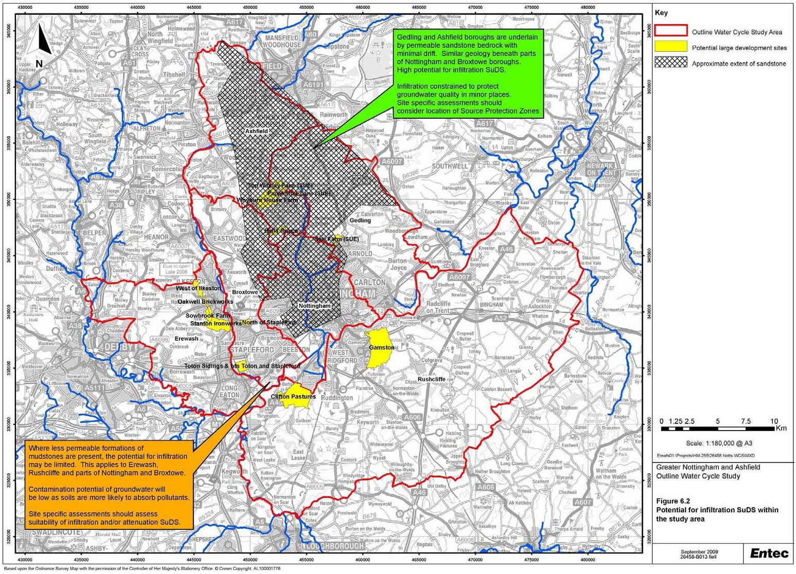

    - Where there is a requirement to implement SuDs, the local planning authority has two routes available to ensure that the SuDs are properly implemented and maintained. These are:

- . Through an agreement under S106; or

- By a condition of planning permission.

    - Where the development is larger or the SuDs scheme complex, the S106 approach would be used. The S106 route requires negotiations and legal preparatory work in advance of the development taking place, but offers more security as it may only be varied by agreement. It also allows for financial contributions in the form of a bond or a periodic payment.

    - There are alternative methods as to whether the maintenance agreement is included as part of the S106 agreement or is stand alone (discretion of the LPA). The choice is governed by the degree of control the LPA would like to have over the maintenance issues - greater control maintenance framework as part of S106.

    - It is essential that the ownership and responsibility for maintenance of every SuDS element is clear; the scope for dispute kept to a minimum; and durable, long-term accountable arrangements made, such as management companies. Where the surface water system is provided solely to serve any particular development, the construction and ongoing maintenance costs should be fully funded by the developer. S106 agreements may be appropriate to secure this.

    - Authorities may wish to consider entering into an agreement under S106 to ensure the developer carriers out the necessary works and that future maintenance commitments are met. They may also apply planning conditions which would require completion of the necessary works before the rest of the development can proceed.

    - The Ashfield SFRA (February 2009) states that:

      - where the surface water system is provided solely to serve any particular development, the construction and on-going maintenance costs should be fully funded by the developer. A Section 106 agreement under the Town and Country Planning Act is an appropriate means to secure developer funding; and

      - Developers and the Council should engage with the local community and potential occupiers in relation to the use and function of SUDS on proposed developments.

    - The proposed Floods and Water Management Bill makes reference to adoption of SuDS, stating that an approving body proposing to adopt SuDS must notify the developer that they are adopting the drainage system. The approving body – in this case the County Council would then become responsible for maintenance and publicise the adoption to the sewerage undertaker, the land owner and any other body considered relevant.

    - The Planning and Reform Bill (2008) seeks the establishment of the Community Infrastructure Levy (CIL) which will give local authorities the ability to charge developers to help fund new infrastructure provision. The CIL is likely to be introduced from April 2010.

    - CIL will enable local authorities to apply a levy to all new developments (residential and commercial) in their area, subject to a low de minimis threshold. Where appropriate the local planning authority would use a CIL to supplement a negotiated agreement, which may be required for site specific matters, including affordable housing.

    - The CIL should be based on a costed assessment of the infrastructure requirements arising specifically out of the development considered by the development plan for the area, taking account of land values and potential uplifts. Standard charges would be set, which may vary from area to area and according to the nature of development proposed. Further work would be required to investigate the cost of required infrastructure, to inform a potential Greater Nottingham CIL.

    - CIL payments could be collected for the delivery of water infrastructure and for maintenance arrangements of SuDs for example, however, if the Council seeks to use CIL for collecting contributions, analysis of all infrastructure requirements and costs will be required to ensure that an appropriate level of contributions is sought.

6.5 Cost of Infrastructure Requirements
    - As noted in Section 1.1, an objective of this study is to provide high level cost estimates of infrastructure requirements identified. However, Severn Trent Water does not want to release cost information into the public domain as part of this study. The company seeks developer contributions to infrastructure enhancements. The study is a ‘snapshot’ in time, and the infrastructure identified as being required to service a development (and thus the cost of this infrastructure, and the contributions from developers) will be subject to assessments made at the time of the developer enquiry.

    - The cost of improvements to wastewater treatment works to meet environmental requirements or as part of ongoing operations or maintenance are funded through the Periodic Review process (further description of this process is provided in Appendix D). The costs of these improvements are borne by all customers of the water company and are reflected in water service charges agreed by Ofwat.

Climate Change

7.1 Background
    - Climate change is likely to have major direct impacts on the water cycle as a result of changes in rainfall patterns and temperature/evaporation. Furthermore, climate change will affect patterns of water usage and have wider impacts on land use. Current climate change modelling broadly indicates that there will be wetter warmer winters and drier hotter summers and that some of these impacts will become evident within the timescale of the revised Regional Spatial Strategy up to 2026. Climate change has also been identified as a key issue in the East Midlands Plan and the National WCS guidance.

    - In particular, climate change may have the following impacts:

      - Reduction of water resources availability due to reduced annual rainfall and increased temperature - increased evapo-transpiration may reduce aquifer recharge;

      - Increased intensity and frequency of storms. This is likely to increase the intensity and frequency of fluvial flooding and urban drainage related flood events;

      - Changes to water usage particularly in relation to irrigation of gardens and parkland using potable water. The benefits of rainwater harvesting and storage will also be affected. Demand for summer irrigation water for agriculture is also likely to increase;

      - Changes in water table levels may also affect infiltration and leakage of water from the sewerage system;

      - Reduced summer rainfall will result in lower river flows which would reduce dilution of wastewater discharges. Compliance with environmental quality standards is, in some cases, based on 90 percentile values which tend to occur during the summer period; reduced river flows may have a magnified impact on compliance; and

      - Stress on wetlands. Consequently, these systems are likely to become less resilient to other perturbations such as impacts of abstractions and discharges.

    - The potential impacts outlined above change the context in which impacts of housing growth on the water cycle occur and should therefore be considered as part of the WCS process.

7.2 Climate Change Modelling and UKCP09
    - Assessment of climate change impacts is based on global climate models which include a representation of land, air, ocean, ice, hydrological cycle and the carbon cycle. Detailed scenarios for the UK are generated using a regional climate model. This is a high resolution model which is part of the full global

climate model. This model produces the output that forms the basis of the climate change predictions produced by the UK Climate Programme (UKCP). The climate range models have been run for a range of scenarios to account for uncertainty regarding future carbon emissions.

    - The first set of scenarios was produced in 1998 and is known as UKCIP98. These were superseded in 2002 by UKCIP02, which are still used in some guidance documents, such as PPS25 and in water company plans. Recently, in June 2009 new output has been released, known as United Kingdom Climate Projections 2009 (UKCP09). The latest output uses the same climate change models but in contrast to previous output, probabilistic output has also been produced based on a range of model set ups and referencing output from other climate change models. The output is also at a higher resolution than previous UK scenarios, with data being available at a 25km resolution. This provides much greater spatial detail but also means that topographic features, such as air flow over hills and descriptions of catchments, should be more accurate.

    - For the first time, daily and sub daily data will be available thanks to the use of a weather generator. This is a tool which provides information on future climate which is statistically consistent with the probabilistic climate projections.

7.3 Climate Change and the Study Area
    - Figure 7.1 to Figure 7.3 show predicted changes in average annual temperature, summer precipitation and winter precipitation for the Medium Emissions scenario.

    - The key findings for the East Midlands in the 2050s under the medium emissions scenario are listed below and are taken from the UKCP website⁸:

      - The central estimate of increase in winter mean temperature is 2.2ºC; it is very unlikely to be less than 1.1ºC and is very unlikely to be more than 3.4ºC;

      - The central estimate of increase in summer mean temperature is 2.5ºC; it is very unlikely to be less than 1.2ºC and is very unlikely to be more than 4.2ºC;

      - The central estimate of change in winter mean precipitation is 14%; it is very unlikely to be less than 2% and is very unlikely to be more than 29%; and

      - The central estimate of change in summer mean precipitation is –16%; it is very unlikely to be less than –36% and is very unlikely to be more than 6%.

⁸ (http://ukclimateprojections.defra.gov.uk/content/view/2166/528)

Figure 7.1 Change in Annual Average Daily Temperature for the 2050’s under the Medium Emissions Scenario (UKCP09)
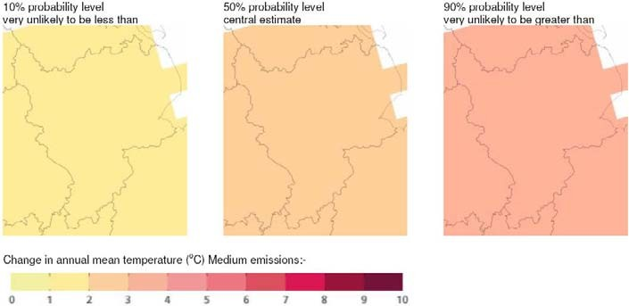

Figure 7.2 Change in Summer Mean Precipitation for the 2050’s under the Medium Emissions Scenario (UKCP09)
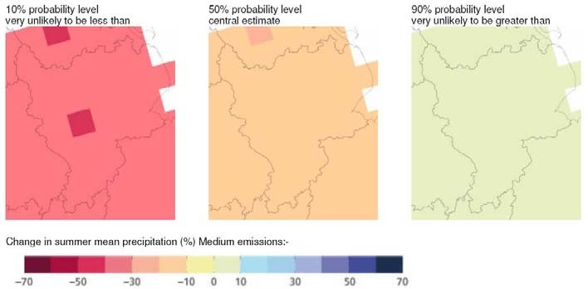

Figure 7.3 Change in Winter Mean Precipitation for the 2050’s under the Medium Emissions Scenario (UKCP09)
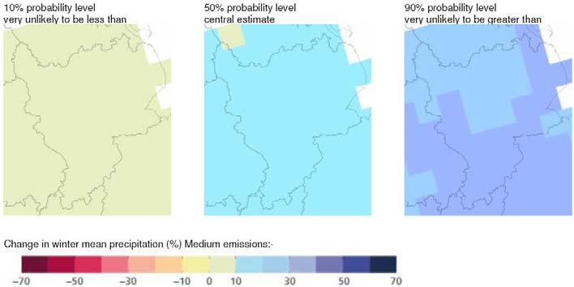

    - The rainfall patterns in the study area and high percentage of surface water resources are likely to be particularly vulnerable to climate change impacts in the immediate term. Furthermore, agricultural demand for water will be increased as temperature rises in addition to reduced summer rainfall; this is likely to affect some rural parts of the study area, particularly where restrictions to the supply of water exist to protect low flows. Increased winter rainfall and more intense summer storms will increase flood risk. The climate change flood zones presented in the SFRAs should be considered to take account of future risks.

7.4 Assessment of Environmental Capacity and Water Infrastructure Provision
    - Assessment of climate change issues by the Environment Agency and water infrastructure operators is mostly based on a national guidance produced by the regulators (Ofwat, Defra and Environment Agency) and water industry (e.g. UKWIR). This ensures that a consistent approach is followed to the complex issue of climate change. This Section presents information on national guidance and the assessments carried out in the study area.

Water Resources
    - Severn Trent Water’s PR09 Business Plan (April 2009) outlines the company’s strategy toward climate change. Assessment of options and proposals for the period 2010-2015 has been carried out using Defra’s ‘social cost of carbon’. The key elements of Severn Trent Water’s plan to reduce their carbon footprint are:

      - Measures to achieve significant efficiencies in energy use;

      - Taking into account carbon impacts in assessing the case for further quality and environmental improvements; and

      - Additional electricity generation projects, in particular using sewage sludge as a renewable energy source.

    - The document outlines Severn Trent Water’s approach of small, incremental adaptation measures which are generally viewed as preferable to large one-off changes, due to the uncertainty relating to climate change effects. In addition, changes which contribute to climate change mitigation are likely to be preferred to those which add to the water company’s carbon impact. Severn Trent Water state that they will continue to review solutions in the light of the latest climate change research, such as the UKCP09.

    - Severn Trent Water has forecast the impacts on its sources and customers’ consumption using the UKCIP02 climate change data based on methodologies developed by the Environment Agency, as this was the latest data available during the assessments.

    - The impact of climate change on water resources will vary depending on the nature of the sources in a particular zone. It is generally considered that surface water sources will be more vulnerable than groundwater sources to changes in rainfall patterns in the shorter term. Surface water dominated resource systems may need to be changed to respond to more extreme weather events (heavy downpours, prolonged dry periods). Severn Trent Water has reassessed the impact of climate change and now predicts a loss of just under 40Ml/d. In its Strategic Direction Statement, Severn Trent Water states that climate change is one of the most significant uncertainties facing the Company over the next 25 years.

Table 7.1 Impact of Climate Change on Deployable Output

Water Resource Zone | Deployable Output (Ml/d) (2007-08) | Reduction due to climate change (2034-35) | Reduction as percentage of 07-08 DO
East Midlands zone | 892 Ml/d | 38.8 Ml/d | 4.4%

Flood Risk
    - Guidance on assessment of climate change impacts on flood risk from part of Planning Policy Statement 25 (Annex B of PPS25, 2006). This provides guidance on how to make allowances for climate change impacts in the application of the recommended methodologies to assess flood risk taking into account the expected shift in the seasonal pattern of rainfall.

    - With regard to fluvial flooding precautionary sensitivity ranges are provided on peak rainfall intensities and peak river flows. Table B.2 of PPS25 recommends a 10% increase in peak flow is allowed for, for the period 1990 to 2025 and an allowance of 20% beyond this. PPS25 advocates that the analysis is incorporated into Strategic Flood Risk Assessments. A recent review of the UKCIP09 climate change impacts has been undertaken by the Environment Agency, and they have recommended that the climate change allowances within PPS25, based on the UKCIP02 climate change projections, should still be used for assessing flood risks.

    - In the Greater Nottingham SFRA, the 20% increase in peak flows has been added to the 1 in 100 year flood event in order to model and map the impact of climate change on flooding in the River Trent.

    - Volume 2 and 6 of the Greater Nottingham SFRA covering Broxtowe and Erewash Boroughs notes that the 1 in 100 year plus 20% increase is not available for the River Erewash from the model previously built by Jeremy Benn Associates Ltd in 2005.

    - The 1 in 100 year flood event plus 20% in flows has been modelled for the Ouse Dyke in Gedling Borough Council (Volume 3 of the Greater Nottingham SFRA, June 2008). The model was constructed for the SFRA and covers the stretch of watercourse between Gedling village and the confluence with the River Trent at Stoke Bardolph. During the climate change event, an increase in properties at risk of flooding is observed where Main Road crosses the watercourse (Volume 3, Greater Nottingham SFRA, June 2008).

    - Volume 4 for Nottingham City Council notes that with the 20% increase in flow that: flooding is more extensive as the flood embankment on the right bank of Fairham Brook close to The Downs within the Silver Dale Estate overtops at a low spot. Most of the properties in Wilford to the west of Clifton Boulevard are at risk. Flows would also pass through the subways underneath Clifton Boulevard and Clifton Lane. Most significantly, this would flood the ambulance station and its access road. Other properties near Bradbourne Drive and off Ruddington Lane are shown to flood.

    - The model constructed for the River Leen and Day Brook SFRA (Black and Veatch, 2008a) includes the climate change event (1 in 100 year annual probability plus 20%). This climate change outline is included in the mapping outputs of the study, but the report does not specifically comment on the impact of the increase in river flows on flood risk.

    - It is noted in the Ashfield SFRA (February 2009) that heavy rainfall events may become more frequent with climate change, and that this may impact on the absorption of rainwater by restored spoil heaps from former colliery sites within the District. These areas are now mainly used as parkland, agriculture or golf courses and can potentially be a source of flooding due to their low permeability. Climate change may increase the risk or frequency of flooding from these sites. The report advises that taking account of the 20% increase in peak flows “the topography of the District would indicate that climate change is unlikely to have a major impact of Flood Zones 2 or 3”.

    - Ofwat Letter PR09/12 provides an instruction to water companies of their planning requirements for assessment of resilience of their assets to flood hazards. Guidance is provided in a supporting document that takes into account assessment of climate change impacts. Severn Trent Water has followed this guidance in assessing flood resilience of their assets.

Wastewater and Receiving Waters
    - Severn Trent Water carries out climate change analysis in their design of the hydraulic capacity of wastewater infrastructure by applying additional rainfall allowances in their sewer network modelling. Additional flows are also factored into analysis of the frequency and magnitude of their assessments of combined sewer overflows. Ofwat recommend that sewerage flooding should not occur more frequently than 1 in 20 years and that no net increase in sewerage flooding should occur. Sewerage systems for new development should not occur with a return period of less than 1 in 30 years in accordance with the requirements for Sewers for Adoption (Atkins, 2008).

    - Investment should be based on a risk assessment approach based on the frequency of flooding and the sensitivity of the properties affected. It is recommended by Ofwat that climate change sensitivity analysis should be prepared, and that in the absence of more accurate guidance each sewerage company should take account of increasing rainfall intensity in line with Defra’s guidance on climate change in planning and designing sewerage systems. The assessment should take into account the entire asset life (e.g. over the next 100 years).

    - Climate change will also affect the capacity of waters to receive wastewater flows particularly during low flow periods which are expected to increase. Impacts from combined sewer overflows’ first flush of sewer sediments, due to intense rainfall following a long antecedent dry weather flow, may also become more pronounced as low river flows may be unable to provide sufficient dilution. Moreover, the strength of raw wastewater arriving at treatment works in dry weather may increase due to less surface water entering combined sewers; this may in turn affect the operation of certain wastewater treatment processes.

    - At present these impacts are not considered in the setting of wastewater quality and flow consents or in future asset planning. Analysis of these impacts could be carried out by sensitivity analysis using existing

water quality models (e.g. reducing Q95⁹ flows by 20%) or by using hydrological models to simulate changes in river flow based on output from UKCP09. Such analysis would be undertaken by (or on behalf of) the Environment Agency and carried out at the river catchment scale rather than the WCS area.

Mitigation
    - Sustainability and carbon accounting should form part of the options appraisal and cost benefit analysis that is likely to form part of any future detailed WCSs. Carbon accounting for direct carbon emissions and embedded carbon have developed greatly in recent years and Ofwat has required water companies to report on green house gas emissions as part of their PR09 submissions (Part C8 of company guidance information requirements). UKWIR have also recently produced guidance documents for operational carbon production (UKWIR 2005) and embedded carbon (UKWIR 2008). Severn Trent Water has followed this guidance and monitors its carbon emissions and carries out carbon accounting as part of the options appraisal and cost benefit analysis related to the provision of water infrastructure. Guidance on carbon accounting and mitigation are also available from the Carbon Research Centre and Carbon Trust.

    - Approaches to carbon budgeting will vary greatly between stakeholders and it will be important to develop a consistent approach particularly in relation to indirect emissions which may rely on information along supply chains. Adaptation of the water industry approach to other sectors such as drainage would provide the most straightforward way to achieve this.

⁹ The flow that is exceeded 95% of the time, representing the most common flow rate

Conclusions and Recommendations

    - The Outline WCS has reviewed the existing environment with regard to the natural and urban water cycle. This ‘baseline’ data has informed where there are likely to be constraints to development from both the water environment and water services infrastructure. Potential phasing and capacity issues have been identified in the study. This section provides recommendations for the Council’s Core Strategies and some technical areas that require further assessment.

    - A summary of the key findings of the development and growth and water cycle chapters is presented below. This is followed by more detailed conclusions of the study in respect of water quality, wastewater and sewerage infrastructure, water resources and supply and flooding and drainage within the study area. The conclusions in relation to the SUE sites, the cumulative impact of growth, the impacts of climate change and phasing of growth are also presented. Recommendations for future work through any future detailed WCSs are made, along with recommendations for the Local Planning Authorities and for the potential locations for Surface Water Management Plans.

8.2 Development and Growth
    - This Outline WCS reviewed the development and growth plans for the study area, considered the local, regional and national planning context and developed growth scenarios for use within this study. The key findings of this section were:

      - The relevant National Planning Policies are PPS1, PPS3, PPS4, PPS12 and PPS25;

      - The East Midlands RSS was published in March 2009 and establishes a broad development strategy for the region;

      - The housing target for Greater Nottingham and Ashfield District is a total of 68,200 between 2006 and 2026, the majority of which (approx 40,800) is to be located in the PUA; and

      - Housing growth trajectories have been developed in consultation with the Councils for use in this study. The scenarios are aligned with the RSS targets for each council (except in Ashfield District, where the council requested that a different approach was adopted to reflect their Area Based Spatial Options).

8.3 The Water Cycle
    - The study summarised the water cycle and how this is modified in an urban environment. Relevant water legislation, policy and guidance were also reviewed. The key findings of this section were:

      - The urban water cycle is complex and highly integrated. Advanced planning and appropriate management ensures that the water cycle contributes to a safe, clean and healthy environment;

      - Urban development alters the timing and quality of water entering the river network;

      - Water infrastructure needs to be sized appropriately to ensure supply of clean water and receive foul drainage, prevent the discharge of polluted runoff and drainage, reduce flood risk and protecting the environment; and

      - The primary water-related legislation includes the Water Framework Directive, Habitats Directive, Urban Wastewater Treatment Directive, Nitrates Directive, Floods Directive and the forthcoming Floods and Water Management Bill.

8.4 Water Quality
    - Most of the rivers except the headwaters of the River Leen, currently fail the chemical objectives required to achieve good status under the Water Framework Directive, particularly for phosphorus. In addition there are current failures for Ammonia under the Freshwater Fish Directive in the Gilt Brook and a stretch of the River Trent was designated as a Sensitive Area [eutrophic] in 2007 under the Urban Wastewater Treatment Directive.

    - As the only pristine river within the study area the headwaters of the River Leen should retain its ’good’ status, inline with the WFD no deterioration policy. Improvements in effluent quality programmed in AMP5 should help mitigate current failures in Gilt Brook and reduce eutrophication risk in the River Trent. Failing to achieve good status alone however, is not considered to be a barrier to development where it can be demonstrated that growth would not contribute to deterioration in the status of the receiving water. Derogations can also be applied where it is considered disproportionately costly or technically infeasible to achieve good status by 2027. Therefore a pragmatic approach is required to identify locations where growth can be sustainably achieved and if possible create an opportunity to improve the current status of the receiving water. This can be achieved through ongoing collaborative catchment scale water quality planning between the Environment Agency and Severn Trent Water.

8.5 Wastewater and Sewerage Infrastructure
    - There are a total of 42 WwTWs in or bordering the study area, but those WwTWs with a Population Equivalent (PE) of 5,000 or less have not been considered within this study. These are small WwTW, commonly located in rural or isolated areas, and hence are unlikely to be affected by significant growth. Severn Trent Water should be consulted when applications for development within such catchments are made to ensure that there is sufficient capacity at these works to accept additional flows.

    - Severn Trent Water highlighted WwTW where there is spare hydraulic capacity available to accommodate additional dwellings, those with minimal capacity and those where existing flows already

exceed the consent flow. There are some issues associated with current performance of some WwTW although Severn Trent Water has indicated that they perceive no quality issues in the future. Severn Trent Water will need to be consulted on specific developments to ensure that upgrading of sewage treatment works at or nearing capacity is aligned with growth. There is sufficient scope to tighten the consented quality towards concentrations that can be achieved using best available technology to mitigate an increase in wastewater flows associated with growth. However, it is important to note that this is a high- level desk based assessment that has not been supported by detailed hydraulic, wastewater treatment or river / catchment water quality modelling.

    - The only potential constraint highlighted through the above assessment is at Huthwaite WwTW. Here there is limited or no existing hydraulic capacity and limited scope to extend the WwTW due to the footprint of the site and close proximity of an industrial development. This has the potential to limit growth at the potential development site at Area C around Huthwaite in Ashfield District, as this site is wholly contained within the sewerage catchment and there is little scope to convey flows to an alternative WwTW.

    - By 2015 improvements to treatment processes are required at Newthorpe (Ammonia) and Stoke Bardolph (Phosphorus). Neither of these issues has been identified by Severn Trent Water as being an absolute constraint to growth in the period before these improvements are completed.

    - Severn Trent Water has also highlighted potential issues in the sewerage network, the most significant being around Edwalton, West Bridgford and Gamston. This is due to the size and specific location of these developments as an increase in sewerage flow, due to growth, would likely exceed the capacity of the existing network. If the downstream sewerage system is unable to accept flows from these new development sites the alternative would be to pump additional flows direct to Stoke Bardolph WwTW. This is approximately 6 km and Severn Trent Water has indicated that this likely to be expensive to implement (although they cannot confirm the cost at this stage).

    - Severn Trent Water have highlighted other potential issues associated with the capacity of the sewer network but require more site specific allocations to confirm the extent of the constraint using detailed hydraulic modelling

    - In assessing the spatial distribution of development in relation to the available and future capacity of the wastewater infrastructure the following factors should be considered:

      - Existing spare capacity available;

      - The scope to upgrade the existing infrastructure;

      - Investment cost and carbon footprint if new development requires upgrades to existing wastewater treatment infrastructure and or revised consent conditions, particularly when required to meet very tight effluent consent standards; and

      - Opportunity to direct development to areas with WwTW with additional capacity and/or greater scope to upgrade.

8.6 Water Resources and Supply
    - As a result of the constraint in the region on water resources, it is recommended that all new homes are built to the water consumption standards of the Code for Sustainable Homes Level 3/4 to reduce demand from new households. The capacity assessment in this study (Section 6.3) has shown that even with a 20% increase in the predicted growth rate, demand could be 13 Ml/d less than company forecast if all new homes were built to a minimum consumption level of 105 l/h/d.

    - Severn Trent has forecast that there will be a surplus in supply over the growth period, dependent on a combination of demand management (achieving an efficient level of consumption per head) and increasing abstraction where available. To reduce the pressure on water resources in the region and to support the water company’s management plans, it is key that the Council brings forward recommendations for all new homes to be water efficient in the Core Strategy. Basic water efficiency measures (6/4 litre dual flush toilets, standard rather than powershowers, restrained flow bathroom taps etcetera) have been found to be feasible in terms of performance and customer satisfaction, and are sufficient to enable all types of new households to reach Level 3/4 of the Code for Sustainable Homes.

    - It is important to recognise that fitting a new home with water using devices that allow it to meet Level 3/4 of the Code for Sustainable Homes does not necessarily mean that this consumption rate will be achieved once the home is occupied. Effort is required by a number of stakeholders required to promote water efficient behaviours and Local Authorities have an important role supporting the efforts of the water companies in this regard. They can help to raise awareness of the need to use water wisely, and help to distribute information to customers explaining how they can use water more efficiently and what the benefits are to them. The Environment Agency has highlighted that the planning authorities have a key role in managing water resources via spatial plans that contain policies promoting the efficient use of water resources.

    - It is recommended that alongside the policy for new homes to be Level 3/4, the Councils include policies to support the water company’s water efficiency activities to help reduce demand from existing development, alongside the water companies metering strategies and other water efficiency activities.

    - Ongoing communication with the water companies will be essential to ensure that the Local Development Plan, the WRMP and operational plans are aligned. Housing growth figures are subject to regular change as development plans and applications are received and processed. The water companies are obliged to develop their forecasts in line with the best available information. Currently these plans are based on the target figures presented in the Regional Spatial Strategy. By providing regular development plan updates the Local Authorities can significantly help the water companies to refine and implement their plans more effectively.

    - A significant issue that Severn Trent Water is keen to address is the impact that the growth point status will have compared to historical growth patterns. The water company manages its supplies, and its infrastructure development policies based on assumptions that are equally applicable across the whole water resource zone. The impact of the current economic climate on general housing development, combined with the emphasis of development in the growth point areas has the potential to create a step change in the way that resources, and particularly new infrastructure needs to be planned and delivered at a local level.

    - A full water neutrality assessment is outside the scope of this WCS. Based on the preferred growth business as usual demand calculation, the demand from new households that would have to be offset to achieve water neutrality would be approximately 14.3 Ml/d. The relevance of water neutrality in any particular area is highly dependent on the water resource situation in the area; for example if water resources are seriously stressed and there are limited opportunities for further resource development. In the case of the Greater Nottingham and Ashfield study area, Severn Trent Water plans a programme of resource development and demand management that will ensure sufficient supplies to 2035. To support the management of water resources, emphasis should be placed on ensuring new development achieves a high level of water efficiency. Further study would be required to ascertain the costs and benefits of water neutrality within the study area.

8.7 Flooding and Drainage
    - Flood risk to people and property can arise from various different sources, including fluvial (from rivers), tidal, surface water run-off (or pluvial), sewers & drains, culverted watercourses, groundwater, as well as though breaching/overtopping of flood defences and from artificial sources such as canals and reservoirs. The risk of flooding can never be totally removed, however through good planning, management and use of sustainable flood mitigation and drainage approaches, the risk and consequences of flooding in many areas can be reduced.

    - All sources of flood risk are considered to be a material planning consideration. PPS25 is the overarching planning guidance for taking account of flood risk in development. It promotes ‘positive planning at all levels to deliver appropriate sustainable development in the right places, taking full account of flood risk’. The key message is to avoid inappropriate development and to locate development away from flood risk through the Sequential Test. The policies within PPS25 should inform both Regional Spatial Strategies and local authorities’ local development documents, so that flood risk is taken into account at all stages throughout the planning process.

    - New development in Greater Nottingham and Ashfield should be guided toward the lowest flood risk zones. The urban areas of Erewash, Nottingham City, Broxtowe, Gedling and Rushcliffe are concentrated along the River Trent valley, which has been mapped as being at medium to high probability of flooding. The flood zones should be used by the Councils to allocate new residential development

outside of the zones unless the proposals are justified by the exception test in PPS25. Ashfield is located upstream of the Trent valley on the River Leen and Erewash tributaries. The flood zones are not as extensive and less of a constraint to development. Only minor parts of Sutton in Ashfield, Kirkby in Ashfield, Annesley Woodhouse and Hucknall are mapped as being medium to high probability of flooding. In all cases, development options should favour sites in Flood Zone 1.

    - Surface water flooding should also be a material planning consideration, and new developments should be located outside areas identified as being susceptible to surface water flooding. New developments should apply sustainable drainage techniques to control flood risk, whilst also providing benefit in terms of water quality, amenity value and green infrastructure targets. The forthcoming SWMPs should be used to identify locations at risk of surface water flooding and potential mitigation measures.

    - The Greater Nottingham SFRA and the Ashfield SFRA identify ‘other sources’ of flooding within the study area, based on record of historical events provided by Severn Trent Water, the Local Planning Authorities and Parish Councils. Groundwater flooding has been recorded in Basford, whilst extensive areas within Erewash are identified as having limited spare drainage capacity. Throughout the study area locations are identified where the capacity of drainage has been exceeded in the past causing flooding following periods of heavy rain (e.g. West Bridgford).

    - Based on these historic records of surface water flooding events available in the SFRAs, a number of locations that may benefit from a SWMP have been identified outside of Nottingham City (where SWMP requirement has already been identified). These are listed in the recommendations below. Information presented in this Outline WCS, in conjunction with the SFRAs can be used to inform Phase 1 and Phase 2 of the SWMP, where stakeholders are identified and flooding data are collated, areas at risk of flooding are mapped and flood risk in areas at risk of flooding are assessed.

8.8 Assessment of SUE Sites
    - A high-level assessment of potential constraints at SUE sites has been undertaken as part of this study. The assessment has concluded that for all sites, water resource availability will not constrain development. It will be important that the Council encourages water efficiency in new homes to support Severn Trent Water’s resource management plans over the growth period. Enhancements to the water supply network may be required, although it is not possible to determine the extent of these enhancements without detailed water supply network modelling. Severn Trent Water has confirmed that they would expect this to be undertaken as part of the detailed WCSs.

    - Five SUE sites have been identified at being at risk of flooding and requiring further investigation to determine the extent that flood risk poses to development at these sites. Parts of the North of Papplewick Lane SUE site in Gedling Borough, and parts of the Gamston and Clifton Pastures sites in Rushcliffe Borough have been identified as being located within Flood Zone 2 and Flood Zone 3 of the River Leen and River Trent. Small parts of the SUE sites in Erewash at Stanton Ironworks and West of Ilkeston have

been identified as being at risk of flooding from the Nut Brook. Providing that the requirements of PPS25 are met, cumulative impacts of such developments should not result in increased flood risk.

    - Failure to achieve good status against Water Framework Directive standards is not considered to be a barrier to development where it can be demonstrated that growth would not contribute to deterioration in the status of the receiving water.

    - Wastewater treatment works capacities are not expected to constrain growth at SUE sites. Potential sewerage infrastructure constraints to development have been identified at a number of SUE sites, where new development could exacerbate known sewer flooding capacity and flooding issues. Further hydraulic modelling is required when further details about the nature of developments at these sites becomes available. Detailed modelling is required to confirm whether gravity sewers to the north of the River Trent can accept additional flows from development in the Gamston, Edwalton and West Bridgford areas (including the Gamston SUE site). If the sewers cannot accept additional flows, an alternative solution involving direct pumping of wastewater to Stoke Bardolph wastewater treatment works could be implemented. Severn Trent Water has indicated that this likely to be expensive to implement (although they cannot confirm the cost at this stage).

8.9 Cumulative Impacts from Growth Outside the Study Area
    - The study has reviewed WCSs in the neighbouring Local Authority areas including the Derby Housing Market Area, North West Leicestershire, Newark and Mansfield. The potential for cumulative impacts are identified as follows:

      - The majority of growth in these study areas will occur in the same water resources zone as Greater Nottingham and Ashfield (Severn Trent Water’s East Midlands WRZ). The neighbouring studies in Derby and North West Leicestershire have made recommendations for the Councils to include a policy in their Core Strategies for all new homes to reach the Code for Sustainable Homes Level 3/4 equivalent to 105 litres per head per day to support the water companies demand management schemes and forecasts;

      - New development within Greater Nottingham and Ashfield and adjacent districts could drain to the same wastewater treatment works (and vice versa), however a high level review of the neighbouring areas has indicated that where catchments overlap there is capacity at the wastewater treatment works, based on data provided by Severn Trent Water, and / or the overlapping areas are predominantly rural with limited growth forecast. The Ashfield and Erewash districts share wastewater treatment works with Derby City and Amber Valley Borough;

      - Districts upstream of the Greater Nottingham Study area have the potential to impact on water quality targets in Greater Nottingham through breaching of discharge consents or agricultural pollution incidents. Similarly pollution incidents in greater Nottingham have the potential to reduce water quality targets in the study area and downstream. The Environment Agency produced their final River Basin Management Plans at the end of 2009 detailing actions for a range of organisations to help

achieve the Water Framework Directive standards, which will require a partnership and integrated catchment approach; and

      - New development in Greater Nottingham and Ashfield has the potential to impact on flood risk in adjacent areas (and vice versa) if appropriate mitigation measures are not implemented. Of consideration is Newark on Trent directly downstream on the River Trent. In most WCSs and SFRAs, recommendations are made in support of PPS25 and the Pitt Review for all new development to implement SuDS to manage flood risk. The neighbouring districts are all predominantly located in the Trent catchment and through implementation of SuDS and flood risk assessments there is the potential to reduce flood risk from both rivers and surface water run-off.

8.10 Impacts on designated conservation sites
    - There are no European-designated Special Protection Areas or Special Areas of Conservation within the study area, but several nationally important Sites of Special Scientific Interest (SSSIs) are present. Of the SSSIs, eight have been identified as being water dependant (Appendix C). The ‘no deterioration’ policy of the Water Framework Directive will ensure that current environmental conditions are maintained or improved at these locations, since the objectives are not only to ensure ‘no deterioration’ but also to achieve improvement in ecological status.

    - Six European designated sites have been identified either in the East Midlands WRZ, or downstream of the study area on the River Trent. The Environment Agency has undertaken the Review of Consents process to identify where abstractions and discharges are impacting on such sites. Changes to abstraction and discharge regimes as a result of new development would not be permitted unless the applicant can demonstrate that there are no likely significant effects upon the designated sites.

8.11 Impacts of Climate Change on the Water Cycle
    - Climate change is likely to have major direct impacts on the water cycle as a result of changes in rainfall patterns and temperature/evaporation. Climate change will also affect patterns of water usage and wider impacts on land use. The latest UK Climate Programme key findings for the East Midlands in the 2050s under the medium emissions scenario are:

      - Central estimate of increase in winter mean temperature by 2.2ºC;

      - Central estimate of increase in summer mean temperature by 2.5ºC;

      - Central estimate of change in winter mean precipitation by +14%; and

      - Central estimate of change in summer mean precipitation by –16%;

    - The changes in rainfall patterns and the high percentage of surface water resources means that surface water resources in the study area are likely to be vulnerable to climate change. Increased summer

temperatures and reduced summer rainfall are likely to increase agricultural demand for water. Severn Trent Water has included a 4.4% reduction in water resource availability in the East Midlands Water Resource Zone in its Water Resources Management Plan, and has also included allowances for changes in customer demand.

    - Increased winter rainfall and more intense summer storms will increase flood risk. The Greater Nottingham SFRA includes a 20% increase in peak flows (added to the 1 in 100 year flood event) to model and map the impact of climate change on the River Trent, although the same scenario was not available for the River Erewash. In Nottingham City, properties in Wilford to the west of Clifton Boulevard are shown to be at risk of flooding with a 20% increase in flows. No specific comments on the impact of the increase in river flows of flood risk are made in the River Leen and Day Brook SFRAs.
The Ashfield SFRA considers that the topography of the District would indicate that climate change is unlikely to have a major impact on Flood Zones 2 or 3.

    - Severn Trent Water includes additional rainfall allowances in their sewer network modelling when designing the hydraulic capacity of wastewater infrastructure. Additional flows are also factored into analysis of the frequency and magnitude of their assessments of combined sewer overflows. The company follows industry guidance in monitoring its carbon emissions and carries out carbon accounting as part of the options appraisal and cost benefit analysis related to the provision of water infrastructure.

    - Climate change will affect the capacity of waters to receive wastewater flows particularly during low flow periods. Changes in the strength of wastewater arriving at the works may also occur. These changes are not currently considered in the setting of consents or in future asset planning. Analysis of these impacts would be undertaken by (or on behalf of) the Environment Agency at the river catchment scale.

8.12 Cost of Infrastructure Improvements
    - An objective of this study was to provide high level cost estimates of infrastructure requirements identified. It has not been possible to obtain this information for this Outline WCS. Severn Trent Water does not want to release cost information into the public domain as part of this study. The company seeks developer contributions to infrastructure enhancements. The study is a ‘snapshot’ in time, and the infrastructure identified as being required to service a development (and thus the cost of this infrastructure, and the contributions from developers) will be subject to assessments made at the time of the developer enquiry.

    - The cost of improvements to wastewater treatment works to meet environmental requirements or as part of ongoing operations or maintenance are funded through the Periodic Review process. The costs of these improvements are borne by all customers of the water company and are reflected in water service charges agreed by Ofwat.

8.13 Development Strategy and Phasing of Growth
    - The assessment presented in this study shows that there may be water cycle constraints to new development within Greater Nottingham and Ashfield. Due to the uncertainty associated with the development scenarios at the present time it is difficult to draw firm conclusions over the need to phase development to ensure that the capacity of the water cycle is not exceeded.

    - The study has demonstrated that there may be constraints to development from wastewater infrastructure capacity and treatment capacity. However, the study has also highlighted that these are unlikely to cause absolute constraints to growth in the study area. The study has highlighted issues that would benefit from further investigation in detailed WCSs (see Section 8.14). The development strategy will also be informed by the forthcoming SWMPs, which will identify areas at risk from Surface Water flooding and how these risks may be mitigated.

    - Figure 8.1 supplies a checklist for individual developers for planning applications and development design.

Figure 8.1 Checklist for Developers

<1ha
>1ha
Appropriate scale Flood Risk Assessment (PPS25 compliant)
New development site

For sites <1ha refer to relevant SFRA to determine if a site specific Flood Risk Assessment is required. Consider surface water management and SuDS at earliest opportunity
- Topography;
- Existing watercourses and water bodies/wetlands;
- Water quality;
- Ecology;
- Groundwater;
- Environmental enhancement opportunities;
- Groundwater abstraction;
- Land Take;
- Health and Safety;
- Amenity;
- Joint schemes with other developments.

All new households designed to meet CSH Level 3 (105 l/h/d) water consumption standards.
Use infiltration methods in preference to discharge to watercourse for surface water run-off. If infiltration not feasible, discharge to watercourse following treatment. Otherwise discharge to separate surface water only system to reduce urban flood risk of combined sewers. Contact sewerage undertaker for design of foul drainage
Design to attenuate flows from existing site for 100 year storm critical duration event plus 30% increase rainfall to allow for climate change (refer to PPS25 Annex B).

Identify adoption and maintenance/funding mechanism for SuDS.

8.14 Recommendations for Future Work

Recommendations for detailed studies
    - This Outline WCS has collated available information at a strategic level to determine potential constraints to development targets within Greater Nottingham and Ashfield. As the location of development is not yet confirmed, it is only possible to draw indicative conclusions at this stage. The study has highlighted areas that require further analysis.

    - Two possible approaches for delivery of the Detailed WCS are identified:

      - A series of developer-led site-specific assessments. The study has identified no absolute constraints to growth but that in most cases, detailed site-specific water supply and wastewater infrastructure investigations are required. These could be delivered and funded by developers; or

      - A follow-on study could be produced, addressing the areas identified for further work within this Outline WCS study. The Detailed WCS would build on the areas identified for further assessment within this study, which are summarised below.

    - In both cases it is recommended that any future detailed WCSs are not undertaken until the preferred locations and timing of developments are confirmed. It is recommended that detailed WCSs are undertaken for each of the SUE sites. Other large sites may also require a detailed study, and it is recommended that Severn Trent Water are consulted to gain an initial view on the extent of assessment (impacts on water and wastewater infrastructure) to determine the need for a study.

    - The requirements for any future detailed WCSs will vary depending on the sites in question. Based on the findings of this Outline study, any future detailed WCS should include:

      - Detailed modelling to assess the extent of proposed developments on water supply infrastructure including distribution mains. This is essential once specific development sites and related growth numbers become available;

      - Detailed modelling to assess the full extent of proposed developments on the hydraulic capacity of wastewater treatment and sewerage infrastructure including pumping stations and Combined Sewer Overflows (CSOs). The Environment Agency requires evidence that extra foul sewage entering the sewerage network must not cause an increase in spill frequency or volume from combined sewer overflows;

      - The detailed studies should build on the need for water efficiency measures complying with CSH Level 3/4 in new developments identified within this study. At the detailed stage site specific assessments can be made for implementing and maintaining water efficiency measures, for example through combined site rainwater harvesting and grey water re-use systems;

      - An assessment of flood risk where required (in accordance with the requirements of PPS25);

      - Detailed studies should build on the high level assessment presented in this Outline study showing the potential for the implementation of SuDS across the study area. In the detailed studies, assessments of areas that require integrated surface water management can be achieved, with the aim of aligning outputs with the SWMPs for the preferred site allocations, as recommended in the Pitt Report; and

      - Assessments of the impact of new development on downstream water quality. Upgrades to the National SIMCAT model for the Trent catchment, co-funded by the Environment Agency and Severn Trent Water, should be available by April 2010. The co-funding of this project illustrates existing collaboration in catchment / water quality planning. The upgraded model would also form the ideal basis to test growth scenarios a different WwTW across and bordering the study area to determine the impact of the receiving water downstream. This could then be used to test potential growth and wastewater treatment scenarios and be used to identify where upgrades could accommodate growth whilst also help to improve the existing water quality towards good chemical status. The upgraded model could also be used to estimate the influence of measures aimed other sectors to determine the in-combination effects.

Recommendations for Local Planning Authorities
    - This Outline WCS recommends that the Local Planning Authorities in Greater Nottingham and Ashfield should:

      - Encourage developers to undertake detailed WCSs to inform development of major sites/SUEs;

      - Continue communication with Severn Trent Water to monitor growth rates. This is especially relevant to monitor how the impact of the economy and the RSS deadline affect development rates;

      - Continue dialogue with Severn Trent Water and the Environment Agency to ensure that new development is delivered within the capacity of the water cycle;

      - Consider policies that encourage the uptake of SuDs in new developments;

      - Consider policies that promote the design of new developments to achieve a high standard of water efficient design; and

      - Direct development to areas that are in the lower flood risk zones unless proposals are justified by the Exception Test in Planning Policy Statement 25.

Recommendations for Surface Water Management Plans
    - Based on a review of the historic records of surfacewater flooding events available in SFRAs, the following locations have been identified in the wider study area (outside of Nottingham City) for SWMPs:

      - Erewash Borough: Breaston, Long Eaton, Draycott, Borrowash and Ilkeston, West Hallam and Kirk Hallam;

      - Broxtowe Borough: Eastwood and Stapleford;

      - Gedling Borough: Woodthorpe, Daybrook, Lambley, Caverton, Ravenshead and Bestwood Village;

      - Rushcliffe Borough: West Bridgford, Ruddington, Radcliffe-on-Trent, Aslockton and Orston; and

      - Ashfield District: Hucknall, Kirkby in Ashfield, Sutton in Ashfield and Selston.

    - This assessment should be considered indicative and further discussion between the Environment Agency, Local Planning Authorities and Severn Trent Water would be required to determine the location and scope of any SWMP.

    - The information presented in this Outline WCS should be used in conjunction with the SFRAs to inform Phases 1 and 2 of the Nottingham SWMP, and any further SWMPs that are undertaken within the study area.

References

    - Ashfield District Council (2009) Ashfield District Council Strategic Flood Risk Assessment Level 1. Ashfield District Council, Kirkby-in-Ashfield.

    - Atkins Ltd (2008) Development of guidance for sewerage undertakers on the implementation of drainage standards. Atkins, Bristol.

    - Black and Veatch (2008a) River Leen and Day Brook Strategic Flood Risk Assessment. Black and Veatch, Nottingham. Partnership report produced by Environment Agency, Nottingham City Council, Nottingham Regeneration Limited, Greater Nottingham Partnership and Nottingham University Hospitals NHS Trust.

    - Black and Veatch (2008b) Greater Nottingham Strategic Flood Risk Assessment. Black and Veatch, Nottingham.

    - Communities and Local Government (2006) Planning Policy Statement 25: Development and Flood Risk. The Stationery Office, Norwich.

    - Department for Environment Food and Rural Affairs (2008) Future Water – The Government’s water strategy for England. Defra, London.

    - Department for Environment Food and Rural Affairs (2009) Draft Flood and Water Management Bill. Defra, London.

    - Environment Agency (2003). The Trent Corridor Catchment Abstraction Management Strategy. Environment Agency, Solihull.

    - Environment Agency (2005). The Fluvial Trent Strategy. Environment Agency, Nottingham.

    - Environment Agency (2007a). Water Services Infrastructure Guide. A planning framework. Environment Agency, Bristol.

    - Environment Agency (2007b). The Idle and Torne Catchment Abstraction Management Strategy. Environment Agency, Solihull.

    - Environment Agency (2008a). The Lower Trent and Erewash Catchment Abstraction Management Strategy. Environment Agency, Solihull.

    - Environment Agency (2008b) Trent Catchment Flood Management Plan. Environment Agency, Bristol.

    - Environment Agency (2008c) Lower Derwent Strategy. Environment Agency, Solihull.

    - Environment Agency (2008d) The Water Resources Planning Guideline. Environment Agency, Bristol

    - Environment Agency (2009a) Water Cycle Study Guidance. Environment Agency, Bristol.

    - Environment Agency (2009b) Water for People and Environment. Water Resources Strategy for England and Wales. Environment Agency, Bristol

    - Environment Agency (2009c). Water for life and livelihoods. River basin planning: summary of significant water management issues Humber River Basin District. Environment Agency, Bristol.

    - Environment Agency (2009d) Water Neutrality: An improved and expanded water resources management definition. Environment Agency, Bristol

    - Government Office for the East Midlands (2009) East Midlands Regional Plan - March 2009. The Stationery Office, Norwich.

    - Scott Wilson (2009) Greater Nottingham Scoping Water Cycle Study. Scott Wilson.

    - Severn Trent Water (2007) Focus on water. Strategic Direction Statement 2010 to 2035. Severn Trent Water. Birmingham.

    - Severn Trent Water (2008) Water Resources Management Plan 2009 – Draft Version May 2008. Volume 1 – Main Document. Severn Trent Water. Birmingham.

    - Severn Trent Water (2009a) Draft Water Resources Management Plan – Statement of Response. Severn Trent Water, Birmingham.

    - Severn Trent Water (2009b) Final Business Plan. Part A – Company Strategy April 2009. Severn Trent Water. Birmingham

    - Severn Trent Water (2009c) Latest Assessment of the supply / demand balance. Severn Trent Water, Birmingham.

    - Tribal Urban Studio (2008) Appraisal of Urban Extensions. Final Report June 2008. Tribal Urban Studio, London.

    - UK Water Industry Research (2005) Workbook for Estimating Operational GHG Emissions. UKWIR, London.

    - UK Water Industry Research (2008) Carbon accounting in the UK Water Industry: Guidelines for dealing with embodied carbon and whole life carbon accounting. UKWIR, London.

Appendix A Glossary of Terms

AMP | Asset Management Plan
BREEAM | Building Research Establishment Environmental Assessment
 | Method
CAMS | Catchment Abstraction Management Strategy
CLG | Communities and Local Government
CFMP | Catchment Flood Management Plan
CSH | Code for Sustainable Homes
CSO | Combined Sewer Overflow
EA | Environment Agency
EIA | Environmental Impact Assessment
EMDA | East Midlands Development Agency
GIS | Geographical Information System
GNA | Greater Nottingham and Ashfield
HMA | Housing Market Area
IUD | Integrated Urban Drainage
LDF | Local Development Framework
P | Phosphorus
pcc | Per capita consumption
PPS25 | Planning Policy Statement 25
PR | Periodic Review (for water companies’ investment plans)
RBMP | River Basin Management Plan
RSS | Regional Spatial Strategy
SA[E] | Sensitive Area (eutrophic)
SAC | Special Area of Conservation
SFRA | Strategic Flood Risk Assessment
SPA | Special Protection Area
SSSI | Site of Special Scientific Interest
STW | Severn Trent Water Ltd
SuDS | Sustainable Drainage Systems

WCS | Water Cycle Study
WFD | Water Framework Directive
WRMP | Water Resource Management Plan
WwTW | Wastewater Treatment
UKCIP | United Kingdom Climate Change Impacts Programme
UKCP09 | United Kingdom Climate Projections 2009

Appendix B

Derivation of Growth Scenarios

This appendix presents the housing growth scenarios for derived for each council, and describes how each housing growth scenario was derived for use in this study.

It should be noted that the study considers these scenarios for growth but it does not necessarily follow or imply that development of some or all of these sites will take place or that development of any of these sites will be supported by the local planning authorities.

Erewash Borough Council
The housing growth scenario for Erewash Borough Council is presented in Table B.1.

The council provided the number of housing completions by Ward for the period 2006-07 to 2008-9 inclusive and estimates of housing supply by Ward for the period 2009-16 and 2016-26. Forecast growth has been distributed pro rata over each of these periods. This estimate includes allowances for the Stanton and West of Ilkeston SUE sites. This resulted in total housing of 8,266, exceeding the RSS housing target for the period by 1,266. In the housing forecast presented in Table B1, Ward numbers have been factored down proportionally to meet the RSS target of 7,200 new homes within the Borough by 2026. The factoring has used the total housing supply by constituted by each Ward as a percentage of total housing supply in the Borough 2009-10 to 2025-26.

Nottingham City Council
The housing growth scenario for Nottingham City Council is presented in Table B.2.

The council provided the number of housing completions by Ward for the period 2006-07 to 2008-9. The total delivered to date (3044) was subtracted from the RSS target of 20,000. The remainder (16,956) were distributed by Ward using the proportion of total housing capacity by Ward in Nottingham City, identified in the SHLAA. These were distributed pro-rata over the period 2009-10 to 2025-26.

There are no SUE sites within Nottingham City, although a number of large sites have been identified for development including:

- Waterside/Trent Basin (4000 dwellings in Dales/Bridge Ward);

- Extended Island site (1900 dwellings in Dales/Bridge Ward);

- Boots site (600 dwellings in Dunkirk and Lenton Ward);

- Chalfont Drive (413 dwellings in Leen Valley Ward); and

- Stanton Tip (500 dwellings in Bulwell Ward).

Comparison of the capacity of these sites and the Ward housing trajectories derived by the method described above (shown in Table B2) shows that in all cases except Bulwell Ward, the forecast housing trajectory exceeds the capacity of these large development sites. In the case of Bulwell Ward, the housing trajectory identifies a capacity of 329 dwellings, a shortfall of 171 dwellings against the capacity identified for Stanton Tip. However, overall the total housing numbers are aligned with the RSS targets.

Broxtowe Borough Council
The housing growth scenario for Broxtowe Borough Council is presented in Table B.3.

The council provided the number of housing completions by Ward for the period 2006-07 to 2008-9 inclusive and estimates of housing supply by Ward for to 2025-26. Estimate includes allowances for SUE sites at North of Stapleford, Toton Sidings and development between Stapleford and Toton. Forecast growth distributed pro rata over this period. The total housing derived this way (7,597) exceeded the housing target in the RSS by 797. In the housing forecast presented in Table B3, Ward numbers have been factored down proportionally to meet the RSS target of 6,800 new homes within Broxtowe Borough by 2026.

Gedling Borough Council
The housing growth scenario for Gedling Borough Council is presented in Table B.4.

The council provided the number of housing completions by Ward for the period 2006-07 to 2008-9 inclusive. Three SUE sites have been identified in Gedling Borough with the following capacities:

Papplewick Lane (SUE) | 500
New Farm (SUE) | 900
Top Wighay Farm (SUE) | 1,625

Twenty five other ‘large sites’ were identified in the SHLAA with potential housing capacity exceeding 100 homes. The total capacity of the large sites and SUE sites (9,480) and completions to date (947) exceeded the RSS target of 8,000 by 2,427. In the housing forecast presented in Table B4, the capacity of SUE and large sites has been factored down proportionally to meet the RSS target of 8,000 new homes within Gedling Borough by 2026. The council advised over which sites should be factored down. These have been distributed pro rata over the period 2009-10 to 2025-26.

Rushcliffe Borough Council
The housing growth scenario for Rushcliffe Borough Council is presented in Table B.5.

The council provided the number of housing completions by Ward for the period 2006-07 to 2008-9 inclusive (949). Upper and Lower Growth forecasts were provided for the SUE sites at Gamston and Clifton, and other large sites identified in Table B.5.

The total capacity for all sites within Rushcliffe provided by the Council in the Lower Growth Scenario was 15,169 homes by 2025-26. In the Upper Growth the capacity is 29,710. These exceed the RSS growth target of 15,000 homes by 169 and 14,710 respectively. In the housing forecast presented in Table B.5, the capacity of SUE and large sites has been factored down proportionally to meet the RSS target of 15,000 new homes within Rushcliffe Borough by 2026 (taking account of completions to date). Rushcliffe Borough Council provided indicative timescales for delivery of housing over to 2025-26 for most sites, and the housing growth scenario presented in Table B.5 reflects this. Where no timescales for delivery were provided, growth was distributed pro rata.

Ashfield District Council
The housing growth scenario for Ashfield District Council is presented in Table B.6.

In Ashfield District a different approach has been adopted at the request of the council. Ashfield District Council has a target housing provision from the East Midlands Regional Plan March 2009 of 3,600 new homes in the Hucknall area and 7,600 in the rest of the District by 2026. Over the period the WCS was being undertaken the Council undertook a consultation on Area Based Spatial Options for Hucknall, Kirkby in Ashfield/Sutton in Ashfield and the rural areas The options included a potential mix of all or part of a number of sites. Therefore, the WCS took into account the number of houses it was anticipated could be brought forward in each of the areas identified in the spatial options. The purpose was to determine whether there were any water related constraints to development related to these potential areas for development. Consequently, the housing numbers considered in the WCS exceed the RSS housing provision. It is emphasised that it does not mean that the development of all of these sites will take place or that development of a specific site will be supported by the Council.

The council provided information on the number of housing completions over for Hucknall (611) and for the rest of the district (899) over the period 2006-07 to 2008-09. The Council provided capacities for the delivery of new homes for the locations identified in Table B.6. Where the Council provided indicative timescales for sites, housing numbers have been distributed pro rata over the period. Where delivery timescales are uncertain, delivery has been distributed pro rata over the period 2009-10 to 2025-26.

Table B.1 Erewash Borough Council Housing Growth Scenario

Area | 2006-  07 | 2007-  08 | 2008-  09 | 2009-  10 | 2010-  11 | 2011-  12 | 2012-  13 | 2013-  14 | 2014-  15 | 2015-  16 | 2016-  17 | 2017-  18 | 2018-  19 | 2019-  20 | 2020-  21 | 2021-  22 | 2022-  23 | 2023-  24 | 2024-  25 | 2025-  26 | Total
Kirk Hallam | 15 | 24 | 17 | 2 | 2 | 2 | 2 | 2 | 2 | 2 | 34 | 34 | 34 | 34 | 34 | 35 | 35 | 35 | 35 | 35 | 416
Sandiacre North | 28 | 24 | 7 | 9 | 9 | 9 | 9 | 9 | 9 | 9 | 2 | 2 | 2 | 2 | 2 | 2 | 2 | 2 | 2 | 2 | 141
Sandiacre South | 28 | 24 | 7 | 10 | 10 | 10 | 10 | 10 | 10 | 10 | 8 | 8 | 8 | 7 | 7 | 7 | 7 | 7 | 7 | 7 | 201
Sawley | 15 | 31 | 34 | 0 | 0 | 0 | 0 | 0 | 0 | 0 | 0 | 0 | 0 | 0 | 0 | 0 | 0 | 0 | 0 | 0 | 81
Stanley & Stanley Common | 0 | 4 | 8 | 4 | 4 | 4 | 3 | 3 | 3 | 3 | 0 | 0 | 0 | 0 | 0 | 0 | 0 | 0 | 0 | 0 | 36
West Hallam & Dale Abbey | 8 | 16 | 3 | 2 | 2 | 1 | 1 | 1 | 1 | 1 | 0 | 0 | 0 | 0 | 0 | 0 | 0 | 0 | 0 | 0 | 36
Little Eaton & Breadsall (inc. Morley) | 8 | 1 | 6 | 3 | 3 | 2 | 2 | 2 | 2 | 2 | 0 | 0 | 0 | 0 | 0 | 0 | 0 | 0 | 0 | 0 | 30
Ockbrook & Borrowash | 13 | 33 | 58 | 16 | 16 | 16 | 16 | 16 | 16 | 16 | 0 | 0 | 0 | 0 | 0 | 0 | 0 | 0 | 0 | 0 | 216
Old Park | 15 | 24 | 17 | 19 | 18 | 18 | 18 | 18 | 18 | 18 | 0 | 0 | 0 | 0 | 0 | 0 | 0 | 0 | 0 | 0 | 184
Hallam Fields | 15 | 24 | 17 | 22 | 22 | 22 | 21 | 21 | 21 | 21 | 0 | 0 | 0 | 0 | 0 | 0 | 0 | 0 | 0 | 0 | 207
Wilsthorpe | 15 | 31 | 34 | 24 | 24 | 24 | 24 | 24 | 24 | 24 | 2 | 2 | 2 | 2 | 2 | 2 | 2 | 2 | 2 | 2 | 273
Derby Road West | 15 | 31 | 34 | 3 | 3 | 2 | 2 | 2 | 2 | 2 | 0 | 0 | 0 | 0 | 0 | 0 | 0 | 0 | 0 | 0 | 97
Nottingham Road | 15 | 31 | 34 | 34 | 34 | 34 | 34 | 34 | 34 | 33 | 12 | 12 | 12 | 12 | 12 | 12 | 12 | 12 | 12 | 12 | 438
Breaston | 2 | 4 | 12 | 14 | 14 | 13 | 13 | 13 | 13 | 13 | 3 | 3 | 3 | 3 | 3 | 3 | 3 | 3 | 3 | 3 | 141
Draycott & Church Wilne | 100 | 41 | 21 | 83 | 83 | 83 | 83 | 83 | 83 | 83 | 135 | 135 | 135 | 135 | 135 | 135 | 135 | 135 | 135 | 135 | 2,093
Long Eaton Central | 15 | 31 | 34 | 37 | 37 | 37 | 36 | 36 | 36 | 36 | 2 | 2 | 2 | 2 | 2 | 2 | 2 | 2 | 2 | 2 | 356
Derby Road East | 15 | 31 | 34 | 55 | 55 | 55 | 55 | 55 | 55 | 55 | 6 | 6 | 6 | 6 | 6 | 6 | 6 | 7 | 7 | 7 | 529
Ilkeston Central | 15 | 24 | 17 | 3 | 2 | 2 | 2 | 2 | 2 | 2 | 0 | 0 | 0 | 0 | 0 | 0 | 0 | 0 | 0 | 0 | 72
Ilkeston North, Cotmanhay, Abbotsford | 15 | 24 | 17 | 98 | 98 | 98 | 98 | 98 | 98 | 98 | 91 | 91 | 91 | 91 | 91 | 91 | 91 | 91 | 92 | 92 | 1,655
Total | 355 | 456 | 412 | 438 | 436 | 432 | 429 | 429 | 429 | 428 | 295 | 295 | 295 | 294 | 294 | 295 | 295 | 296 | 297 | 297 | 7,200

Table B.2 Nottingham City Council Housing Growth Scenario

Area | 2006-  07 | 2007-  08 | 2008-  09 | 2009-  10 | 2010-  11 | 2011-  12 | 2012-  13 | 2013-  14 | 2014-  15 | 2015-  16 | 2016-  17 | 2017-  18 | 2018-  19 | 2019-  20 | 2020-  21 | 2021-  22 | 2022-  23 | 2023-  24 | 2024-  25 | 2025-  26 | Total
Arboretum | 68 | 68 | 68 | 15 | 15 | 15 | 15 | 15 | 15 | 15 | 15 | 15 | 15 | 15 | 15 | 15 | 15 | 15 | 15 | 15 | 460
Aspley | 21 | 21 | 21 | 10 | 10 | 10 | 10 | 10 | 10 | 10 | 10 | 10 | 10 | 10 | 10 | 10 | 10 | 10 | 10 | 10 | 228
Basford | 60 | 60 | 60 | 21 | 21 | 21 | 21 | 21 | 21 | 21 | 21 | 21 | 21 | 21 | 21 | 21 | 21 | 21 | 21 | 21 | 532
Berridge | 94 | 94 | 94 | 49 | 49 | 49 | 49 | 49 | 49 | 49 | 49 | 49 | 49 | 49 | 49 | 49 | 49 | 49 | 49 | 49 | 1,108
Bestwood | 25 | 25 | 25 | 32 | 32 | 32 | 32 | 32 | 32 | 32 | 32 | 32 | 32 | 32 | 32 | 32 | 32 | 32 | 32 | 32 | 618
Bilborough | 1 | 1 | 1 | 25 | 25 | 25 | 25 | 25 | 25 | 25 | 25 | 25 | 25 | 25 | 25 | 25 | 25 | 25 | 25 | 25 | 428
Bridge | 240 | 240 | 240 | 270 | 270 | 270 | 270 | 270 | 270 | 270 | 270 | 270 | 270 | 270 | 270 | 270 | 270 | 270 | 270 | 270 | 5,310
Bulwell | 49 | 49 | 49 | 19 | 19 | 19 | 19 | 19 | 19 | 19 | 19 | 19 | 19 | 19 | 19 | 19 | 19 | 19 | 19 | 19 | 475
Bulwell Forest | 38 | 38 | 38 | 18 | 18 | 18 | 18 | 18 | 18 | 18 | 18 | 18 | 18 | 18 | 18 | 18 | 18 | 18 | 18 | 18 | 416
Clifton North | 22 | 22 | 22 | 24 | 24 | 24 | 24 | 24 | 24 | 24 | 24 | 24 | 24 | 24 | 24 | 24 | 24 | 24 | 24 | 24 | 471
Clifton South | 6 | 6 | 6 | 44 | 44 | 44 | 44 | 44 | 44 | 44 | 44 | 44 | 44 | 44 | 44 | 44 | 44 | 44 | 44 | 44 | 759
Dales | 23 | 23 | 23 | 208 | 208 | 208 | 208 | 208 | 208 | 208 | 208 | 208 | 208 | 208 | 208 | 208 | 208 | 208 | 208 | 208 | 3,597
Dunkirk and Lenton | 20 | 20 | 20 | 49 | 49 | 49 | 49 | 49 | 49 | 49 | 49 | 49 | 49 | 49 | 49 | 49 | 49 | 49 | 49 | 49 | 892
Leen Valley | 17 | 17 | 17 | 46 | 46 | 46 | 46 | 46 | 46 | 46 | 46 | 46 | 46 | 46 | 46 | 46 | 46 | 46 | 46 | 46 | 834
Mapperley | 35 | 35 | 35 | 28 | 28 | 28 | 28 | 28 | 28 | 28 | 28 | 28 | 28 | 28 | 28 | 28 | 28 | 28 | 28 | 28 | 574
Radford and Park | 87 | 87 | 87 | 38 | 38 | 38 | 38 | 38 | 38 | 38 | 38 | 38 | 38 | 38 | 38 | 38 | 38 | 38 | 38 | 38 | 898
Sherwood | 31 | 31 | 31 | 24 | 24 | 24 | 24 | 24 | 24 | 24 | 24 | 24 | 24 | 24 | 24 | 24 | 24 | 24 | 24 | 24 | 502
St Anns | 160 | 160 | 160 | 71 | 71 | 71 | 71 | 71 | 71 | 71 | 71 | 71 | 71 | 71 | 71 | 71 | 71 | 71 | 71 | 71 | 1,680
Wollaton East and Lenton Abbey | 1 | 1 | 1 | 1 | 1 | 1 | 1 | 1 | 1 | 1 | 1 | 1 | 1 | 1 | 1 | 1 | 1 | 1 | 1 | 1 | 12
Wollaton West | 19 | 19 | 19 | 9 | 9 | 9 | 9 | 9 | 9 | 9 | 9 | 9 | 9 | 9 | 9 | 9 | 9 | 9 | 9 | 9 | 206
Total | 1,015 | 1,015 | 1,015 | 997 | 997 | 997 | 997 | 997 | 997 | 997 | 997 | 997 | 997 | 997 | 997 | 997 | 997 | 997 | 997 | 997 | 20,000

Table B.3 Broxtowe Borough Council Housing Growth Scenario

Area | 2006-  07 | 2007-  08 | 2008-  09 | 2009-  10 | 2010-  11 | 2011-  12 | 2012-  13 | 2013-  14 | 2014-  15 | 2015-  16 | 2016-  17 | 2017-  18 | 2018-  19 | 2019-  20 | 2020-  21 | 2021-  22 | 2022-  23 | 2023-  24 | 2024-  25 | 2025-  26 | Total
Beeston North | 12 | 12 | 12 | 2 | 2 | 2 | 2 | 2 | 2 | 2 | 2 | 1 | 1 | 1 | 1 | 1 | 1 | 1 | 1 | 1 | 61
Beeston Central | 21 | 21 | 21 | 11 | 11 | 11 | 11 | 11 | 11 | 11 | 11 | 11 | 11 | 11 | 11 | 10 | 10 | 10 | 10 | 10 | 244
Beeston Rylands | 37 | 37 | 37 | 37 | 37 | 37 | 37 | 37 | 37 | 36 | 36 | 36 | 36 | 36 | 36 | 36 | 36 | 36 | 36 | 36 | 728
Beeston West | 72 | 72 | 72 | 2 | 2 | 2 | 2 | 2 | 2 | 2 | 2 | 2 | 2 | 2 | 2 | 2 | 1 | 1 | 1 | 1 | 246
Bramcote | 10 | 10 | 10 | 1 | 1 | 1 | 1 | 1 | 1 | 1 | 1 | 1 | 1 | 1 | 1 | 0 | 0 | 0 | 0 | 0 | 41
Stapleford South East | 1 | 1 | 1 | 3 | 3 | 3 | 3 | 3 | 3 | 3 | 3 | 3 | 3 | 3 | 3 | 3 | 2 | 2 | 2 | 2 | 55
Chilwell West | 12 | 12 | 12 | 1 | 1 | 1 | 1 | 1 | 1 | 1 | 1 | 1 | 0 | 0 | 0 | 0 | 0 | 0 | 0 | 0 | 45
Attenborough | 1 | 1 | 1 | 1 | 1 | 1 | 1 | 1 | 1 | 1 | 1 | 1 | 1 | 1 | 0 | 0 | 0 | 0 | 0 | 0 | 13
Chilwell East | 31 | 31 | 31 | 14 | 14 | 13 | 13 | 13 | 13 | 13 | 13 | 13 | 13 | 13 | 13 | 13 | 13 | 13 | 13 | 13 | 317
Stapleford North | 3 | 3 | 3 | 25 | 25 | 25 | 25 | 25 | 25 | 25 | 25 | 25 | 25 | 25 | 25 | 25 | 24 | 24 | 24 | 24 | 430
Stapleford South West | 5 | 5 | 5 | 3 | 3 | 3 | 3 | 3 | 3 | 3 | 3 | 3 | 2 | 2 | 2 | 2 | 2 | 2 | 2 | 2 | 57
Toton And Chilwell Meadows | 43 | 43 | 43 | 54 | 54 | 54 | 54 | 54 | 54 | 54 | 54 | 54 | 53 | 53 | 53 | 53 | 53 | 53 | 53 | 53 | 1,040
Awsworth | 1 | 1 | 1 | 5 | 5 | 5 | 5 | 5 | 5 | 5 | 5 | 4 | 4 | 4 | 4 | 4 | 4 | 4 | 4 | 4 | 78
Brinsley | 3 | 3 | 3 | 9 | 9 | 9 | 8 | 8 | 8 | 8 | 8 | 8 | 8 | 8 | 8 | 8 | 8 | 8 | 8 | 8 | 149
Eastwood South | 27 | 27 | 27 | 15 | 15 | 15 | 15 | 15 | 15 | 15 | 15 | 15 | 14 | 14 | 14 | 14 | 14 | 14 | 14 | 14 | 327
Eastwood North And Greasley (Beauvale) | 2 | 2 | 2 | 22 | 22 | 22 | 22 | 22 | 22 | 22 | 22 | 21 | 21 | 21 | 21 | 21 | 21 | 21 | 21 | 21 | 372
GREA - Greasley (Giltbrook And Newthorpe) | 8 | 8 | 8 | 30 | 30 | 29 | 29 | 29 | 29 | 29 | 29 | 29 | 29 | 29 | 29 | 29 | 29 | 29 | 29 | 29 | 519
Nuthall West And Greasley | 1 | 1 | 1 | 88 | 88 | 88 | 88 | 88 | 88 | 88 | 88 | 87 | 87 | 87 | 87 | 87 | 87 | 87 | 87 | 87 | 1,489
Trowell | 0 | 0 | 0 | 1 | 1 | 1 | 1 | 1 | 1 | 1 | 1 | 1 | 1 | 0 | 0 | 0 | 0 | 0 | 0 | 0 | 11
Cossall And Kimberley | 6 | 6 | 6 | 25 | 25 | 25 | 25 | 24 | 24 | 24 | 24 | 24 | 24 | 24 | 24 | 24 | 24 | 24 | 24 | 24 | 430
Nuthall East And Strelley | 49 | 49 | 49 | 0 | 0 | 0 | 0 | 0 | 0 | 0 | 0 | 0 | 0 | 0 | 0 | 0 | 0 | 0 | 0 | 0 | 147
Total | 345 | 345 | 345 | 349 | 349 | 347 | 346 | 345 | 345 | 344 | 344 | 340 | 336 | 335 | 334 | 332 | 329 | 329 | 329 | 329 | 6,800

Table B.4 Gedling Borough Council Housing Growth Scenario

Area | 2006-  07 | 2007-  08 | 2008-  09 | 2009-  10 | 2010-  11 | 2011-  12 | 2012-  13 | 2013-  14 | 2014-  15 | 2015-  16 | 2016-  17 | 2017-  18 | 2018-  19 | 2019-  20 | 2020-  21 | 2021-  22 | 2022-  23 | 2023-  24 | 2024-  25 | 2025-  26 | Total
Arnold | 92 | 134 | 40 | 104 | 104 | 104 | 104 | 104 | 104 | 104 | 104 | 104 | 104 | 104 | 104 | 104 | 104 | 104 | 104 | 104 | 2,027
Bestwood | 0 | 42 | 32 | 38 | 38 | 38 | 38 | 38 | 38 | 38 | 38 | 38 | 38 | 38 | 38 | 38 | 38 | 38 | 38 | 38 | 725
Burton Joyce | 13 | 7 | 2 |  |  |  |  |  |  |  |  |  |  |  |  |  |  |  |  |  | 22
Calverton | 33 | 72 | 18 | 52 | 52 | 52 | 52 | 52 | 52 | 52 | 52 | 52 | 52 | 52 | 52 | 52 | 52 | 52 | 52 | 52 | 1,000
Carlton | 147 | 186 | 78 | 104 | 104 | 104 | 104 | 104 | 104 | 104 | 104 | 104 | 104 | 104 | 104 | 104 | 104 | 104 | 104 | 104 | 2,185
Lambley | 2 | 3 | 0 | 4 | 4 | 4 | 4 | 4 | 4 | 4 | 4 | 4 | 4 | 4 | 4 | 4 | 4 | 4 | 4 | 4 | 81
Linby | 0 | 0 | 0 | 81 | 81 | 81 | 81 | 81 | 81 | 81 | 81 | 81 | 81 | 81 | 81 | 81 | 81 | 81 | 81 | 81 | 1,382
Newstead | 0 | 0 | 0 |  |  |  |  |  |  |  |  |  |  |  |  |  |  |  |  |  | 0
Papplewick | 0 | 0 | 2 | 16 | 16 | 16 | 16 | 16 | 16 | 16 | 16 | 16 | 16 | 16 | 16 | 16 | 16 | 16 | 16 | 16 | 273
Ravenshead | 7 | -2 | 28 | 15 | 15 | 15 | 15 | 15 | 15 | 15 | 15 | 15 | 15 | 15 | 15 | 15 | 15 | 15 | 15 | 15 | 293
Stoke Bardolph | 0 | 3 | 0 |  |  |  |  |  |  |  |  |  |  |  |  |  |  |  |  |  | 3
Woodborough | 2 | 2 | 4 |  |  |  |  |  |  |  |  |  |  |  |  |  |  |  |  |  | 8
Total | 296 | 447 | 204 | 415 | 415 | 415 | 415 | 415 | 415 | 415 | 415 | 415 | 415 | 415 | 415 | 415 | 415 | 415 | 415 | 415 | 8,000

Table B.5 Rushcliffe Borough Council Housing Growth Scenario

Area | 2006-  07 | 2007-  08 | 2008-  09 | 2009-  10 | 2010-  11 | 2011-  12 | 2012-  13 | 2013-  14 | 2014-  15 | 2015-  16 | 2016-  17 | 2017-  18 | 2018-  19 | 2019-  20 | 2020-  21 | 2021-  22 | 2022-  23 | 2023-  24 | 2024-  25 | 2025-  26 | Total
West Bridgford |  |  |  | 51 | 51 | 51 | 51 | 51 | 51 | 51 | 51 | 51 | 50 | 50 | 50 | 50 | 50 | 50 | 50 | 50 | 859
Clifton |  |  |  |  |  |  |  | 50 | 150 | 250 | 350 | 350 | 350 | 350 | 350 | 350 | 350 | 350 | 350 | 350 | 3,950
Edwalton |  |  |  |  | 50 | 100 | 150 | 150 | 150 | 150 | 150 | 150 | 150 |  |  |  |  |  |  |  | 1,200
Gamston |  |  |  |  |  |  |  | 50 | 150 | 350 | 350 | 350 | 350 | 350 | 350 | 350 | 350 | 350 | 350 | 350 | 4,050
Bingham | 44 | 44 | 44 | 51 | 51 | 51 | 51 | 51 | 51 | 51 | 51 | 51 | 51 |  |  |  |  |  |  |  | 641
Cotgrave | 0 |  |  | 20 | 20 | 20 | 20 | 20 |  |  |  |  |  |  |  |  |  |  |  |  | 100
Cotgrave Colliery |  |  |  |  |  |  | 50 | 50 | 50 | 50 | 50 | 50 | 50 | 50 | 50 | 50 |  |  |  |  | 500
East Leake | 37 | 37 | 37 | 17 | 17 | 17 | 17 | 17 | 17 | 17 | 17 | 17 | 17 | 17 | 16 | 16 | 16 | 16 | 16 | 16 | 394
Keyworth | 6 | 6 | 6 | 20 | 20 | 20 | 20 | 20 | 20 | 20 | 20 | 20 | 20 |  |  |  |  |  |  |  | 217
Radcliffe on Trent | 13 | 13 | 13 | 16 | 16 | 16 | 16 | 16 | 16 | 16 | 16 | 16 | 15 | 15 | 15 | 15 | 15 | 15 | 15 | 15 | 302
Ruddington | 70 | 70 | 70 | 31 | 31 | 31 | 31 | 31 | 31 | 31 | 31 | 31 | 30 | 30 | 30 | 30 | 30 | 30 | 30 | 30 | 728
Other Rural | 47 | 47 | 47 | 49 | 48 | 48 | 48 | 48 | 48 | 48 | 48 | 48 | 48 | 48 | 48 | 48 | 48 | 48 | 48 | 48 | 958
Newton |  |  |  |  |  |  | 100 | 100 | 100 | 100 | 100 | 100 | 100 | 100 |  |  |  |  |  |  | 800
Total | 316 | 316 | 316 | 255 | 304 | 354 | 554 | 654 | 834 | 1,134 | 1,234 | 1,234 | 1,231 | 1,010 | 909 | 909 | 859 | 859 | 859 | 859 | 15,000

Table B.6 Ashfield District Council Housing Growth Scenario

Area | 2006-  07 | 2007-  08 | 2008-  09 | 2009-  10 | 2010-  11 | 2011-  12 | 2012-  13 | 2013-  14 | 2014-  15 | 2015-  16 | 2016-  17 | 2017-  18 | 2018-  19 | 2019-  20 | 2020-  21 | 2021-  22 | 2022-  23 | 2023-  24 | 2024-  25 | 2025-  26 | Total
Completions (Northern Area) | 387 | 363 | 149 |  |  |  |  |  |  |  |  |  |  |  |  |  |  |  |  |  | 899
Selston |  |  |  | 29 | 29 | 29 | 29 | 29 | 29 | 29 | 29 | 29 | 29 | 29 | 29 | 29 | 29 | 29 | 29 | 29 | 500
SITE A West Kirkby South A38 |  |  |  |  |  |  |  |  | 42 | 42 | 42 | 42 | 42 | 42 | 42 | 42 | 42 | 42 | 42 | 42 | 500
other additional sites at Site A |  |  |  | 59 | 59 | 59 | 59 | 59 | 59 | 59 | 59 | 59 | 59 | 59 | 59 | 59 | 59 | 59 | 59 | 59 | 1000
SITE B EAST KIRKBY off Lowmoor Road |  |  |  |  |  |  |  |  | 250 | 250 | 250 | 250 | 250 | 250 | 250 | 250 | 250 | 250 | 250 | 250 | 3,000
Area C around Huthwaite |  |  |  |  |  |  |  |  | 54.5 | 54.5 | 54.5 | 54.5 | 54.5 | 54.5 | 54.5 | 54.5 | 54.5 | 54.5 | 54.5 | 54.5 | 654
Area D North of Stanton Hill |  |  |  |  |  |  |  |  | 34 | 34 | 34 | 34 | 34 | 34 | 34 | 34 | 34 | 34 | 34 | 34 | 413
Area E Gap between Stanton Hill/Skegby & Sutton |  |  |  |  |  |  |  |  | 23 | 23 | 23 | 23 | 23 | 23 | 23 | 23 | 23 | 23 | 23 | 23 | 270
Area F Mixture of Open Areas within Sutton & Kirkby |  |  |  |  |  |  |  |  | 83 | 83 | 83 | 83 | 83 | 83 | 83 | 83 | 83 | 83 | 83 | 83 | 998
Area G North of Sutton |  |  |  |  |  |  |  |  | 51 | 51 | 51 | 51 | 51 | 51 | 51 | 51 | 51 | 51 | 51 | 51 | 607
Area H Green Belt Areas along A611 |  |  |  |  |  |  |  |  | 29 | 29 | 29 | 29 | 29 | 29 | 29 | 29 | 29 | 29 | 29 | 29 | 351
Planning permission (rural) |  |  |  | 5 | 5 | 5 | 5 | 5 | 5 | 5 | 5 | 5 | 5 | 5 | 5 | 5 | 5 | 5 | 5 | 5 | 77
Planning Permission (Sutton/Kirkby) |  |  |  | 104 | 104 | 104 | 104 | 104 | 104 | 104 | 104 | 104 | 104 | 104 | 104 | 104 | 104 | 104 | 104 | 104 | 1,771
SHLAA site (rural) |  |  |  | 16 | 16 | 16 | 16 | 16 | 3 | 3 | 3 | 3 | 3 | 14 | 14 | 14 | 14 | 14 |  |  | 164
SHLAA site (Sutton/Kirkby) |  |  |  | 59 | 59 | 59 | 59 | 59 | 8 | 8 | 8 | 8 | 8 |  |  |  |  |  |  |  | 334
Sub total (Northern Area) | 387 | 363 | 149 | 272 | 272 | 272 | 272 | 272 | 774 | 774 | 774 | 774 | 774 | 777 | 777 | 777 | 777 | 777 | 763 | 763 | 11,538
Completions (Hucknall Area | 247 | 232 | 132 |  |  |  |  |  |  |  |  |  |  |  |  |  |  |  |  |  | 611
Whyburn Farm SUE |  |  |  | 265 | 265 | 265 | 265 | 265 | 265 | 265 | 265 | 265 | 265 | 265 | 265 | 265 | 265 | 265 | 265 | 265 | 4,500
SHLAA development (Rolls Royce) |  |  |  |  |  |  |  | 180 | 180 | 180 | 180 | 180 |  |  |  |  |  |  |  |  | 900
SHLAA development (including bypass) |  |  |  | 77 | 77 | 77 | 77 | 77 | 33 | 33 | 33 | 33 | 33 | 8 | 8 | 8 | 8 | 8 |  |  | 590
Housing with PP |  |  |  | 78 | 78 | 78 | 78 | 78 | 78 | 78 | 78 | 78 | 78 | 78 | 78 | 78 | 78 | 78 | 78 | 78 | 1,318
Sub total (Hucknall Area) | 247 | 232 | 132 | 419 | 419 | 419 | 419 | 599 | 555 | 555 | 555 | 555 | 375 | 350 | 350 | 350 | 350 | 350 | 342 | 342 | 7,919
Total (Northern Area and Hucknall) | 634 | 595 | 281 | 691 | 691 | 691 | 691 | 871 | 1,329 | 1,329 | 1,329 | 1,329 | 1,149 | 1,127 | 1,127 | 1,127 | 1,127 | 1,127 | 1,105 | 1,105 | 19,457

Table B.7 Summary of Potential Growth within Greater Nottingham and Ashfield

Area | 2006-  07 | 2007-  08 | 2008-  09 | 2009-  10 | 2010-  11 | 2011-  12 | 2012-  13 | 2013-  14 | 2014-  15 | 2015-  16 | 2016-  17 | 2017-  18 | 2018-  19 | 2019-  20 | 2020-  21 | 2021-  22 | 2022-  23 | 2023-  24 | 2024-  25 | 2025-  26 | Total
Erewash | 355 | 456 | 412 | 438 | 436 | 432 | 429 | 429 | 429 | 428 | 295 | 295 | 295 | 294 | 294 | 295 | 295 | 296 | 297 | 297 | 7,200
Nottingham City | 1,015 | 1,015 | 1,015 | 997 | 997 | 997 | 997 | 997 | 997 | 997 | 997 | 997 | 997 | 997 | 997 | 997 | 997 | 997 | 997 | 997 | 20,00
Broxtowe | 345 | 345 | 345 | 349 | 349 | 347 | 346 | 345 | 345 | 344 | 344 | 340 | 336 | 335 | 334 | 332 | 329 | 329 | 329 | 329 | 6,800
Gedling | 296 | 447 | 204 | 415 | 415 | 415 | 415 | 415 | 415 | 415 | 415 | 415 | 415 | 415 | 415 | 415 | 415 | 415 | 415 | 415 | 8,000
Rushcliffe | 316 | 316 | 316 | 255 | 304 | 354 | 554 | 654 | 834 | 1,134 | 1,234 | 1,234 | 1,231 | 1,010 | 909 | 909 | 859 | 859 | 859 | 859 | 15,000
Ashfield | 634 | 595 | 281 | 691 | 691 | 691 | 691 | 871 | 1,329 | 1,329 | 1,329 | 1,329 | 1,149 | 1,127 | 1,127 | 1,127 | 1,127 | 1,127 | 1,105 | 1,105 | 19,457
Total (annual) | 2,961 | 3,174 | 2,572 | 3,145 | 3,192 | 3,237 | 3,433 | 3,712 | 4,350 | 4,648 | 4,615 | 4,611 | 4,424 | 4,179 | 4,077 | 4,076 | 4,023 | 4,024 | 4,003 | 4,003 | 76,457
Total (cumulative) | 2,961 | 6,135 | 8,707 | 11,852 | 15,044 | 18,281 | 21,714 | 25,425 | 29,775 | 34,422 | 39,038 | 43,649 | 48,073 | 52,252 | 56,329 | 60,405 | 64,428 | 68,451 | 72,454 | 76,457

Appendix C
Water Dependant Sites of Special Scientific Interest

A list of the water dependant SSSI sites within the study area and their reasons for designation are presented in Table C.1.

Table C.1 Water Dependant SSSI Sites

Type of Designation | Name | Reason for Designation
Site of Special Scientific Interest (SSSI) | Morley Brick Pits | The site consists of a series of flooded pits, originally dug for clay and which now contain acidic water colonised by a range of plants and animals several of which are becoming rare in Derbyshire.
 | Lockington Marshes | The site comprises one of the largest remaining areas of willow carr woodland in Leicestershire and a diverse complex of wetland habitat supporting an important invertebrate fauna with many nationally scarce species. Lockington Marshes includes willow carr woodland, inundation meadow and pools lying in the floodplains of the Rivers Soar and Trent.
 | Attenborough Gravel Pits  Bulwell Wood | Attenborough Gravel Pits SSSI is a nationally important site for its lowland eutrophic open waters with emergent vegetation, wet floodplain woodland, unimproved floodplain grassland, a rich assemblage of breeding birds associated with lowland open waters and their margins.  The site is of Regional importance and contains good examples of ancient semi-natural woodland and unpolluted open water. A valuable complement to the wood is the adjacent Bulwell Wood Hall Pond, a clean-water pool having a well-developed aquatic plant and animal community.
 | Bogs Farm Quarry | The site comprises unimproved acid-loam grassland, marsh, flushes, open water pools and a wooded dumble and is of Regional importance.
 | Wilford Claypits | The site contains one of the best remaining areas of marsh in Nottinghamshire and is representative of marsh communities on somewhat base-rich soils in Central and Southern England.
 | Holme Pit | The site contains some of the best remaining areas of marsh, reedswamp and open water in Nottinghamshire and is of Regional importance.

The site comprises one of the best mixed-habitat sites in Nottinghamshire and contains examples of neutral and calcareous grassland and eutrophic open water communities which are representative of these habitats in central and
eastern England.
Orston Plaster Pits
Reason for Designation
Name
Type of Designation

Appendix D
Water Resources and Water Supply

Water Resources Management
In order to identify the potential constraints of water supply and the water environment it is necessary to understand how water resources are managed. Severn Trent Water is responsible for providing water supplies in this area.
The following section introduces and summarises the planning process undertaken by water companies. It describes how water resources are managed at a strategic rather than local scale, which explains why sources and environmental pressures that may be a considerable distance from the study area are relevant.

Water Company Water Resource Management Plans
On a five yearly basis the water companies in England and Wales set out their long term requirements for maintaining and enhancing their water supply and wastewater infrastructure in their Strategic Business Plans. These plans are submitted to the financial regulator, the Water Service Regulation Authority (Ofwat). In addition to the Strategic Business Plans, the water companies must also submit a Water Resources Management Plan (WRMP) to Defra. These plans set out in detail how the water companies plan to balance supply and demand for water in their supply area over a 25 year period and take into account the economic, environmental and social implications of these plans. These plans, previously known as Water Resources Plans (WRPs) are reviewed and updated on a five yearly basis and are now submitted to Defra for approval. The last WRP was produced in April 2004. Since that time the plans have become a statutory requirement under the Water Act 2003. The next WRMP is due to be in late 2009/early 2010, although the water companies prepared and published their draft WRMPs for consultation in May 2008.

The Strategic Business Plans form part of the Periodic Review (PR) process whereby Ofwat, in consultation with other organisations including Defra, the Environment Agency, Natural England and consumer organisations, determines the expenditure that the water companies can make to maintain and enhance their infrastructure. The outcome of this determination is an Asset Management Plan (AMP) for the following five-year period.

The current (fourth) AMP period finishes in 2009 and the water companies are currently reviewing the effect of Ofwat’s Final Determination on their Strategic Business Plans covering the next AMP Period (AMP5), setting out their funding requirements for the period 2010 to 2015. Further information on this process is available on the Ofwat website (www.ofwat.gov.uk).

Levels of Service, Water Resource Zones and Water Company Planning
When planning future water resources the water companies aim to achieve ‘levels of service’ for customers, which are agreed with the water regulator, Ofwat. Each company has its own level of service, which states how frequently it expects to impose water use restrictions during periods of water shortage. For example, Severn Trent Water plans to impose hosepipe bans no more frequently three times a century (Severn Trent Water, 2008). Levels of service are important as they determine the investment required to maintain secure supplies of water and prevent more frequent restrictions than the companies’ stated levels of service.

In the WRMPs, the water companies set out their plans for water resource provision at the sub-company level, in areas called water resource zones (WRZs). A WRZ is defined as “the largest possible zone in which all resources, including external transfers, can be shared and hence the zone in which all customers experience the same risk of supply failure from a resource shortfall” (Environment Agency, 2008d, Section 5.5).

It is important to be aware that the water company plans are based on theoretical circumstances. For each water resource zone the water companies produce plans under a ‘dry year’ scenario, ensuring that demand for water can be met for the agreed levels of service during a dry or drought period. All water companies produce plans to ensure that the annual average demand for water can be met during a dry year. The water companies use records of actual demand data and carry out a statistical process to ‘normalise’ this data and then they apply uplift factors to create a theoretical dry year annual average (in which the same demand is planned for every day of the year). Where water companies identify that the ability to meet short-term peaks in demand in a dry year is a driver for additional water supply investment, companies may also submit plans for a WRZ under peak or ‘critical period’ conditions.

The forecast situation, constrained by existing policies and supply sources, is known as the ‘baseline’. Where a shortfall in supply capability is identified in the baseline, the water company identifies schemes to resolve the situation. These schemes are generally a combination of demand management and resource development, in line with the ‘twin-track’ approach to water management. It should be noted that, to ensure secure water supply, the water companies take uncertainties into account in their Water Resource Management Plans. These uncertainties include, for example, how climate change may affect demand and resource availability in the future.

Low Flow Problems and Restoring Sustainable Abstraction (RSA)
Where water company abstractions are suspected to be contributing to pressure on habitats protected under the Habitats Directive, the abstractions and their impact on river flows and /or groundwater levels are investigated, and if determined necessary, a reduction in the volume that can be abstracted is sought by the Environment Agency.
This type of reduction in abstraction quantities is called a Sustainability Reduction. The reduction of any Public Water Supply abstraction licences would require provision of alternative water resources.

In September 2008 the Environment Agency provided Severn Trent Water with indicative reductions to be included in the final WRMP. However, Severn Trent Water has not included any sustainability reductions in its

draft WRMP as the sites are still under investigation and any reductions are still uncertain. No additional information is available from the Environment Agency to confirm the presence and volumes of any potential reductions in abstraction in order to comply with the Habitats Directive Review of Consents.

CAMS Status
The Environment Agency has developed a classification system for use in the CAMS documents, which can be used to provide an overview of the resource availability status in a catchment. The resource availability status indicates the relative balance between committed and available resources within a catchment. It can be used to gain an indication of whether new water abstraction licences are likely to be available within a catchment, although it should be noted that all abstraction licence applications would be assessed using the Environment Agency’s licence determination process. Table D.1 shows the four resource availability status categories that have been developed. The CAMS resource availability status is an indication of availability at periods of low flows.

Table D.1 CAMS Resource Availability Status
Existing abstraction is causing unacceptable environmental impact at low flows. Water may still be available at high flows with appropriate restrictions.
Over-abstracted
Current actual abstraction is resulting in no water available at low flows. If existing licences were used to their full allocation they would have the potential to cause unacceptable environmental impact at low flows. Water may be available at high flows with appropriate restrictions.
Over-licensed
No water available for further licensing at low flows although water may be available at higher flows with appropriate restrictions.
No water available
Water likely to be available at all flows including low flows. Restrictions may apply.
Water available
Definition
Indicative Resource Availability Status

Taken from Environment Agency (2003), Table 1.

Table D.2 below provides a summary of the CAMS status for the catchments within the East Midlands water resource zone.

Table D.2 Summary of CAMS Assessments

CAMS Assessment Restoration of
Sustainable Abstractions Assessments (2010-15)*

Catchments providing a large amount of public water supply:
Derbyshire Derwent >1,000Ml authorised to be abstracted per day for PWS. The sub unit containing the reservoirs = over licensed under all flow conditions. The remaining sub units are over licensed or have No Water Available.

Derwent Valley River Noe River Ashop

Tame, Goyt, and Etherow
The catchments upstream of the reservoirs have not been assessed. These reservoirs are operated by United Utilities but supply water to Severn Trent Water. 81% of all licensed abstraction volumes are for PWS.

Dove This catchment is over abstracted.
Carsington water is a major reservoir used by Severn Trent Water to supply the East Midlands zone (Tittesworth reservoir is outside of the zone).
Egginton is a large surface water source, licensed to abstract 236Ml/d, approximately 15% of the total licensed quantity for the zone. Deployable output of this source is less than the full licensed quantity. Consequently, the impact of a reduction in this licence on the Company’s ability to secure public water supply would depend on the size of the reduction, particularly if this is large enough to reduce its deployable output.
Idle and Torne This catchment is over abstracted.
>50% of the water abstracted is used for PWS. Anglian Water and Yorkshire Water also abstract from this catchment.
The efficient use of water by direct abstractors and public water supply customers will be extremely important to achieve improvements with significant reductions in usage.
The north of Ashfield District lies within this catchment.
Egginton on River Dove
Carsington reservoir Henmore Brook

Rainworth Water
EA will seek to regain as much licensed water as possible for the environment in this area.

Lower Trent and Erewash
Most of this catchment is over abstracted, over licensed or has no water available. There is some water available in the fluvial Trent. The EA intends to maintain the status as ‘Water Available’ and so would grant further abstraction licences subject to appropriate flow conditions. All new licences will have a time limit of 31 March 2015.
New applications for groundwater will be subject to normal determination criteria.
Where a proposed abstraction could impact on a Habitat Directive SPA and/or SAC site, the impact of each licence on that site will be assessed under the Habitats Regulations process.
Most of the study area is within this catchment.
River Greet Dover Beck

Catchments providing a small amount of public water supply:
Soar Most of this catchment has ‘‘water available’ at low flows. However, the EA strategy is to move to No Water Available to enable continued development of water resources without compromising the ecological flow requirements within the catchment.
The Sherwood Sandstone and Charnwood aquifers are classified as major aquifers but with limited outcrops they are not considered to be strategic groundwater resources in a regional context, although they are locally significant. .
Tame and Anker There is ‘no water available’ in the River Mease (including the Measham groundwater unit). There is some water available in the wider area from the rivers Tame, Anker, Cole, Rea, Bourne and the River Trent from the Tame to the Dove (and the Birmingham, Sutton, Nuneaton, Coleorton and Warton groundwater units). However, much of this is outside of the East Midlands zone.

Charnwood reservoir

River Blythe (outside of East Midlands zone)

CAMS Assessment Restoration of
Sustainable Abstractions Assessments (2010-15)*

Staffordshire Trent Valley and Mease
Abstractions within this catchment are predominantly for industrial and agricultural use. The catchment is a net importer of water from the Elan Valley for PWS and is discharge dominated and impacted greatly by the large sewage treatment works at Minworth (approx 16km west of the study area).
Six miles of the River Sence are managed as a trout fishery.

Don and Rother Some water available in upper and lower Rother catchments. Abstraction in this area accounts for only a small amount of the total licensed volume in the catchment and most of this is for industrial use.
Welland The sub catchments lying within the East Midlands resource zone are over abstracted.
Import from Rutland Water which is the dominant PWS feature in the Welland catchment. Any new consumptive licence for abstraction during low flows, upstream of this abstraction, would derogate AWS’s PWS licence.
Catchments with no significant public water supply abstractions by Severn Trent Water

Staffordshire Trent Valley and Mease
Abstractions within this catchment are predominantly for industrial and agricultural use. The catchment is a net importer of water from the Elan Valley for PWS and is discharge dominated and impacted greatly by the large sewage treatment works at Minworth (approx 16km west of the study area).
Six miles of the River Sence are managed as a trout fishery.

Don and Rother Some water available in upper and lower Rother catchments. Abstraction in this area accounts for only a small amount of the total licensed volume in the catchment and most of this is for industrial use.
Welland The sub catchments lying within the East Midlands resource zone are over abstracted.
Import from Rutland Water which is the dominant PWS feature in the Welland catchment. Any new consumptive licence for abstraction during low flows, upstream of this abstraction, would derogate AWS’s PWS licence.
Warwickshire Avon Rugby, Upper Avon and R. Swift catchment = over abstracted. The strategy for this WRMU is to move to over-licensed by encouraging reduction in licensed quantities for public water supply licences that are not fully used. The influence of the reservoirs and public water supply licences are the main factors impacting on the licensing strategy in this unit. A more detailed modelling study of the reservoirs is required before it would be justified to pursue more drastic measures in terms of taking back resources.
Public water supply and industrial use account for 88% of the water abstracted in the whole catchment (outside of East Midlands zone).

Water Resource Zone Forecast Supply-Demand Balance
The water companies’ draft WRMPs set out how the companies intend to balance supply and demand over the next 25 years. The plan is based on forecasts of demand and supply. The demand forecast takes account of expected levels of per capita consumption and forecast population at a zonal level.

The baseline supply forecast takes account of the existing available sources, expected losses due to climate change and environmental pressures, and future additional sources which were approved in the previous WRP. Therefore, before exploring the potential environmental constraints within which future growth needs to be accommodated, it is necessary to identify the baseline situation (i.e. to identify any deficits in the forecast supply-demand balance) in each water resource zone.

The draft plan included a significant deficit in the East Midlands zone (up to 100Ml/d by 2030-31 in the baseline). However, in its Statement of Response Severn Trent Water says that in the Final WRMP (yet to be published) the Company has removed the headroom deficit by the end of AMP 5 (2014-15) and beyond that target headroom will be maintained until the end of the planning period (2034-35). Since publishing its draft WRMP Severn Trent Water has recalculated deployable output and it has reduced from 892 Ml/d to 889 Ml/d in the East Midlands zone. This is forecast to remain constant at 892 Ml/d across the planning period. In its Business Plan the Company says there will be small changes to modelled baseline deployable output in the final plan. During the consultation on the draft WRMP, Natural England pointed out that the uncertainties in resource availability due to Restoring Sustainable Abstraction, the WFD, time limited licences, and CAMS are potentially huge. Severn Trent Water has said that it has removed the deficit in the Final Plan, and that the revised deployable output does not include yield from sites that are affected by RSA.

Severn Trent Water reports that pressure from population and demand is increasing as the population continues to grow, households become smaller (water use in smaller households is less efficient that in larger family based households), and population demographics change. The Company has experienced a significant reduction in industrial demand and has attributed this as the result of the recession. Future demand for water is affected by the depth and duration of the economic recession and long term projections forecast a greater reduction in commercial consumption than in the draft plan (which forecast approximately 20Mld reduction over the planning period). The Company reports that the recent decline has been extreme and this is projected to continue in 2009-10, and to be felt through AMP5. In its Statement of Response Severn Trent Water forecasts commercial consumption will be approx 25Ml/d less in 2010 than originally forecast in the draft WRMP. By 2025-26 commercial use could be up to 60Ml/d less than in the draft WRMP.

The key elements of Severn Trent Water’s proposed supply demand balance strategy for the East Midlands WRZ are shown in Table D.3.

Table D.3 Severn Trent Water Proposed Supply Demand Balance Strategy for East Midlands WRZ
Additional household metering
River support from Milton groundwater source
Household and non-household water efficiency programme
Leakage control through combination of active leakage control, mains replacement and pressure control
AMP9
2030-2035
Additional household metering
Household and non-household water efficiency programme
Leakage control through combination of active leakage control, mains replacement and pressure control
AMP8
2025-2030
Additional household metering
Household and non-household water efficiency programme
Leakage control through combination of active leakage control, mains replacement and pressure control
AMP7
2020-2025
Additional household metering
Household and non-household water efficiency programme
Leakage control through combination of active leakage control, mains replacement and pressure control
AMP6
2015-20
Additional household metering
Household and non-household water efficiency programme
Leakage control through combination of active leakage control, mains replacement and pressure control
Derwent Valley Aqueduct (DVA) duplication – Kings Corner (near Derby) to Hallgates (near Leicester), enabling maximisation of production capacity of water treatment works located in the Derwent Valley..
AMP5
2010-15
Proposed Intervention
AMP Period

Sourced from Severn Trent Water (2009c).

Per Capita Consumption Forecasts – Draft WRMP
Table D.4 shows the dry year per capita consumption forecasts from Severn Trent Water’s dWMRP. The company has reassessed its pcc forecast for issue in the Final WRMP, although this has not been made available to this study. ‘Measured’ and ‘unmeasured’ refer to the values for metered and non-metered household customers.

Table D.4 East Midland WRZ Per Capita Consumption Forecasts, taken from the Draft WRMP

Year | Baseline measured pcc (l/h/d) | Final strategy measured pcc (l/h/d) | Baseline unmeasured pcc (l/h/d) | Final strategy unmeasured pcc (l/h/d) | Baseline Average pcc (l/h/d) | Final Strategy Average pcc (l/h/d)
2006-07 | 123.15 | 123.15 | 145.43 | 145.43 | 139.36 | 139.36
2007-08 | 124.24 | 124.24 | 144.89 | 144.89 | 138.98 | 138.98
2008-09 | 125.33 | 125.33 | 144.36 | 144.36 | 138.66 | 138.66
2009-10 | 126.34 | 126.34 | 143.79 | 143.79 | 138.34 | 138.34
2010-11 | 127.24 | 127.81 | 143.23 | 141.69 | 138.03 | 137.14
2011-12 | 128.16 | 128.87 | 142.63 | 140.82 | 137.74 | 136.73
2012-13 | 128.96 | 129.77 | 142.02 | 139.91 | 137.44 | 136.29
2013-14 | 129.71 | 130.56 | 141.40 | 138.96 | 137.16 | 135.84
2014-15 | 130.40 | 131.30 | 140.74 | 137.99 | 136.86 | 135.41
2015-16 | 131.04 | 131.93 | 140.06 | 136.96 | 136.57 | 134.95
2016-17 | 131.63 | 132.49 | 139.36 | 135.91 | 136.28 | 134.49
2017-18 | 132.39 | 133.21 | 138.87 | 135.03 | 136.21 | 134.26
2018-19 | 133.12 | 133.87 | 138.36 | 134.13 | 136.15 | 134.02
2019-20 | 133.81 | 134.47 | 137.84 | 133.18 | 136.10 | 133.77
2020-21 | 134.47 | 135.03 | 137.30 | 132.20 | 136.04 | 133.52
2021-22 | 135.10 | 135.56 | 136.75 | 131.20 | 136.00 | 133.29
2022-23 | 135.70 | 136.02 | 136.17 | 130.13 | 135.95 | 133.03
2023-24 | 136.28 | 136.46 | 135.59 | 129.04 | 135.92 | 132.79
2024-25 | 136.83 | 136.85 | 134.98 | 127.89 | 135.88 | 132.53
2025-26 | 137.37 | 137.22 | 134.37 | 126.71 | 135.86 | 132.29
2026-27 | 137.91 | 137.59 | 133.76 | 125.51 | 135.86 | 132.07
2027-28 | 138.46 | 137.98 | 133.16 | 124.31 | 135.90 | 131.90
2028-29 | 139.00 | 138.34 | 132.56 | 123.05 | 135.96 | 131.73
2029-30 | 139.54 | 138.71 | 131.94 | 121.76 | 136.03 | 131.58
2030-31 | 140.02 | 138.99 | 131.27 | 120.35 | 136.05 | 131.38
2031-32 | 140.47 | 139.24 | 130.56 | 118.86 | 136.07 | 131.16
2032-33 | 140.89 | 139.46 | 129.89 | 117.50 | 136.12 | 131.02
2033-34 | 141.29 | 139.65 | 129.05 | 115.61 | 136.10 | 130.70
2034-35 | 141.67 | 139.82 | 128.24 | 113.84 | 136.10 | 130.44

Appendix E
Review of Local Water Cycle Studies

A summary of WCSs being undertaken for neighbouring local authorities is presented below.

Newark Water Cycle Strategy
The Newark Water Cycle strategy is at Detailed Strategy stage, and a final document (dated September 2009) has been made available to this study. Information relating to this study is presented in Table E1. Newark and Sherwood District eastern boundary forms the western boundary of Gedling District.

Table E1 Newark Water Cycle Strategy – Summary and Implications for Greater Nottingham and Ashfield

Element Description

Study Name Newark Water Cycle Strategy
Study Stage Detailed study (Final Report)
Study Area Newark and Sherwood District
Housing Target Newark and Sherwood District awarded New Growth Point Status. 14,800 new homes in the District between 2006 and 2026, including:
Approximately 5,000 new homes at Newark and Balderton by 2026 and associated new employment development.
Approximately 3,900 built to date.
Key Findings The study identified the location and availability of water resources and the capacity of sewerage treatment facilities as elements of the water cycle that were of particular importance to the growth targets within the District.
The study identified five proposed development sites which were considered to have the potential for adverse effects or comparatively larger water related infrastructure needs above and beyond those already planned for in present investment commitments.
The main constraints identified were relating to drainage infrastructure and sewerage and wastewater treatment facilities. However, the study concluded that the selection of future growth sites under the LDF process is materially unaffected by the findings of the WCS, since these constraints could be largely overcome by timely delivery of infrastructure The study discusses the ongoing developments in legislation for the implementation of SuDS.
The proposed development areas most at risk from flooding are identified as being South of Newark from the River Devon and Middle Beck.

Implications for Greater Nottingham and Ashfield WCS
Description
Element
The majority of growth in Newark and Sherwood District will be located within the East Midland Water Resource Zone, the same Water Resource Zone as that Greater Nottingham and Ashfield are located within. This means that growth within both areas will increase demand on the same resources.
There are no wastewater treatment work overlaps identified based on the data provided to Entec by Severn Trent Water.
Newark is located downstream on the River Trent from Nottingham. Development in the Greater Nottingham and Ashfield study area has the potential to increase flood risk downstream in Newark on Trent and surrounding areas if developments are not compliant with PPS25. This further strengthens the need for SuDS where possible particularly in Nottingham City, Gedling Borough and Rushcliffe Borough, and for ongoing maintenance of flood defences and management schemes in these three boroughs.

Derby Housing Market Area Water Cycle Study
The Derby Housing Market Area WCS has reported at Scoping and Outline stage, and a final document (dated October 2009) has been made available to this study. Information relating to this study is presented in Table E2. The Councils of Erewash, Broxtowe and Ashfield border the Derby HMA. Erewash borders Derby City and Amber Valley, and Broxtowe and Ashfield border Amber Valley Borough.

Table E2 Derby Housing Market Area Water Cycle Study – Summary and Implications for Greater Nottingham and Ashfield
Policy 13a of the RSS sets a target for housing provision across the HMA of 36,600 dwellings between 2006-2026 with 14,400 dwellings within the Derby City area; 12,000 dwellings within the South Derbyshire District and 10,200 dwellings within the Amber Valley Borough. The policy requires 21,400 of these dwellings to be within or adjoining the Derby Principal Urban Area (PUA), which includes Derby City and its immediate surrounding areas.
Housing Target
Derby Housing Market Area (Derby City Council, South Derbyshire District, Amber Valley Borough)
Study Area
Scoping and Outline Study
Study Stage
Derby HMA Water Cycle Study
Study Name
Description
Element

Element Description

Key Findings The study identifies that water resources are significantly constrained within the East Midlands, and that in the draft WRMP Severn Trent identify a baseline supply demand deficit. The company plans to implement a programme of investment to maintain a supply demand surplus, which includes demand management and assumes that the average consumption rate will be 132 litres per head per day. To reduce the pressure on water resources in the region and support Severn Trent Water’s plans, the study recommends that the Councils include policies for all new homes to achieve the water consumption levels equivalent to the Code for Sustainable Homes Level 3/4 as a minimum. This is equivalent to 105 litres per head per day for the new housing stock. An overview of the need to achieve water neutrality was included in the report. As the water company have forecast a surplus in demand over the growth period, the driver for water neutrality is not as strong as in other areas of the country. Nevertheless the study advises that water efficiency must be promoted across the Housing Market Area.
High- level assessments indicate potential capacity issues at some wastewater treatment works within the growth period (Fritchley, Duffield, Coton Park and Findern already at capacity). Works at Stanton, Kilburn and Melbourne will potentially exceed their consented flow by 2015 based on the predicted growth used in this study based on the RSS targets.
The capacity of the foul sewer network is highlighted as a constraint to development within Derby City. Derby City is served by one wastewater treatment works located north of the River Trent. Capacity of the sewerage network to the south of the river is limited and also constrained by the pumping station that conveys flow across the river. To alleviate this issue, the study reports that Severn Trent will be considering alternative options that may include diverting sewerage from existing and proposed homes in the south of the City, towards wastewater treatment works in the adjacent district of South Derbyshire.
The River Mease is designated as a Special Area of Conservation. The river has an issue with elevated nutrients and is currently failing to meet its Water Framework Directive and Habitats Directive objectives. The Environment Agency’s current position (dated August 2009) on the River Mease is to object to any new development that will discharge surface run-off or effluent into the Mease. For the Derby HMA this issue affects the Netherseal and Overseal areas within the South Derbyshire District. The study recommends that South Derbyshire District Council should restrict the development of market housing in these areas.
The main sources of flood risk in the study area have been identified as fluvial, from the rivers Derwent and Trent and their tributaries and from surface water run-off. The Environment Agency has produced a Lower Derwent Strategy that recommends a Blue Corridor Vision through Derby City. The flood defences along the Derwent are nearing the end of their design life in some places and the Blue Corridor Vision sees a realignment of the flood defences to create a wider area for conveying flows through the City. Strategic housing sites at Wilmorton College and Boulton Moor contain areas at risk of surface water flooding.
The WCS study makes recommendations for SuDS to be implemented and for green corridors to be encouraged through opening up of culverts.

Element Description

Implications for Greater Nottingham and Ashfield WCS
The majority of growth in Derby HMA will be located within the East Midland Water Resource Zone, the same Water Resource Zone as that Greater Nottingham and Ashfield are located within. This means that growth within both areas will increase demand on the same resources. The recommendation for new homes to be built to CSH Level 3 in the Derby HMA will contribute to the demand management for the zone. This should be supported by the other councils including the Greater Nottingham study area to support demand management in the resource zone.
Development located to the East of Derby HMA study area may be within the same wastewater catchments as those in the West of the Greater Nottingham and Ashfield study area. For example based on the catchments provided by Severn Trent Water for the Greater Nottingham Study, the Ilkeston – Hallam Fields wastewater treatment works is shown to serve Ilkeston in Erewash and parts of the Shipley area in Amber Valley Borough. Severn Trent Water has advised that there is significant headroom available at the works and that the growth in the wastewater treatment works catchment should not be constrained by the capacity of the works. Similarly the Pinxton wastewater treatment works are shown to serve parts of Somercotes in Amber Valley and the Selston area in Ashfield District, but the works is considered to have capacity and the growth proposed in these areas is minimal. The Borrowash area and parts of Erewash neighbouring Derby City are shown as lying within the Derby WwTW catchment. The works is considered to have capacity in the Derby WCS, based on the DWF data provided by Severn Trent Water.
The Derby HMA is located upstream on the River Trent from Nottingham. Development in the Derby and surrounding districts has the potential to increase flood risk in the Greater Nottingham and Ashfield study area and any pollution incidents or failure in quality consent at treatment works could have implications on quality targets in the Greater Nottingham Study area if accidental pollution occurs. However, development control through PPS25 should ensure new developments control run-off to prevent increases in flood risk and monitoring should ensure quality consents at treatment works are not breached. Through encouraging green infrastructure in the Derby HMA, flood risk and water quality can be improved in the upstream area to the Nottingham Study area. The Blue Corridor Vision seeks to improve conveyance of flow through Derby City, but has advised that it will not significantly increase flood risk elsewhere.

North West Leicestershire Water Cycle Study
The Scoping and Outline North West Leicestershire WCS is currently under preparation (expected to be completed in January 2010. A draft report (dated November 2009) has been made available to this study. Information relating to this study is presented in Table E3. North West Leicestershire borders Rushcliffe Borough between Kegworth and Normanton on Soar along the River Soar

Table E3 North West Leicestershire Water Cycle Study – Summary and Implications for Greater Nottingham and Ashfield

Element | Description
Study Name | North West Leicestershire Water Cycle Study
Study Stage | Scoping and Outline
Study Area | North West Leicestershire District Council
Housing Target | 11,000 new homes in the District by 2026

Element Description

Key Findings The District lies almost entirely within the East Midlands Resource Zone. Although the zone is significantly constrained (as indicated by the CAMS in which little or no additional water is available for abstraction) Severn Trent has forecast that there will be a surplus in supply over the growth period. This surplus is dependent on a combination of demand management (achieving an efficient level of consumption per head) and increasing abstraction where available. To reduce the pressure on water resources in the region and to support the water company’s management plans, it is recommended in the study that the Council includes policies in its Core Strategy for all new homes to be built to the Code for Sustainable Homes level 3/4 and for all new and existing homes to be water efficient.
Elevated nutrient levels contribute to the water quality issues in the area, with particular regard to phosphorous that can arise from agricultural sources and from sewage discharges. The River Mease Special Area of Conservation has reached capacity for the level of sewage it can receive, as a result of elevated ortho phosphate. The Council are considering four spatial options for reaching their growth target, and the Outline WCS recommends that Option 1 focussing development in Coalville should be favoured to prevent increased wastewater discharges in the Mease catchment.
It has been identified that Severn Trent will need to focus their investment at the Snarrow works (Coalville) to prevent capacity being exceeded in around 2014. Previous sewer flooding events have been recorded in Measham and Coalville.
The findings of the Council’s Strategic Flood Risk Assessment are summarised in the study. The greatest risk of flooding is from fluvial sources, particularly in the Kegworth and Castle Donnington area that lay in the floodplain of the River Trent and its tributary the River Soar. The WCS study recommends that the Council includes policies in its Core Strategy for new developments to implement SuDS to improve run-off management and water quality.

Implications for Greater Nottingham and Ashfield WCS
The majority of growth in North West Leicestershire will be located within the East Midland Water Resource Zone, the same Water Resource Zone that Greater Nottingham and Ashfield are located within. This means that growth within both areas will increase demand on the same resources.
It is considered that there are no implications on wastewater treatment works from North West Leicestershire. Although the district borders Rushcliffe Borough, according to the indicative wastewater treatment works catchments provided by Severn Trent Water the two authorities do not have overlapping wastewater treatment works catchments.
North West Leicestershire is located upstream of Nottingham in the River Trent catchment. Development in North West Leicestershire has the potential to increase flood risk in the Greater Nottingham and Ashfield study area. However through development control and compliance with PPS25 new development must be built and approved by the Environment Agency so that flood risk is not increased elsewhere.
The catchment of the River Soar overlaps NW Leicestershire and Rushcliffe authority areas and along the authority boundaries the river has elevated phosphate levels, according to the General Quality Assessment data in the NW Leicestershire study. The two councils will need to work in tandem and support other partner organisations and land owners to improve rural land management with regard to reducing agricultural sources of phosphorous.

Mansfield Water Cycle Study
A Scoping WCS was completed for Mansfield in June 2009 and has been made available to this study. Information relating to this study is presented in Table D4. Mansfield lies adjacent to Ashfield District along the western boundary of Ashfield.

Table E4 Mansfield Water Cycle Study – Summary and Implications for Greater Nottingham and Ashfield

Element Description

Study Name Mansfield Water Cycle Strategy
Study Stage Scoping
Study Area Mansfield District Council
Housing Target 10,600 new homes over the period 2006-2026
Key Findings The study is at the Scoping Stage, consequently the findings are presented at a high level.
Mansfield is located within the catchments of the River Maun and the River Meden, which flow into the River Idle. This drains to the North East, flowing into the River Trent near Retford.
Mansfield District is located within the East Midlands WRZ.
Wastewater is treated that the Severn Trent Water sewage treatment works at Bath Lane (Mansfield), Market Worsop and Rainsworth. These are identified as being near capacity and wastewater treatment is identified as a major constraint to growth in Mansfield District.
It is recommended that new developments implement SuDS to minimise run-off and flood risks.

Implications for Greater Nottingham and Ashfield WCS
Mansfield District is located within a catchment that does not drain into the Greater Nottingham and Ashfield study area. Development in Mansfield District is highly unlikely to impact on fluvial flood risk in Greater Nottingham. However, development in Ashfield District may occur within the upper reaches of the River Meden (e.g. near Skegby) and could potentially impact on flood risk within Mansfield if development do not comply with the requirements of PPS25.
Growth in Mansfield District will be located within the East Midland Water Resource Zone, the same Water Resource Zone that Greater Nottingham and Ashfield are located within. This means that growth within both areas will increase demand on the same resources.
Development in the upper reaches of the River Meden (i.e. in Ashfield District) could have cumulative impacts on downstream water quality in Mansfield District. Ashfield District Council, the Environment Agency, Natural England, landowners and other rural organisations will need to ensure that the actions from the River Basin Management Plan are followed to prevent deterioration and where possible improve water quality in the District’s rivers. The encouragement of SuDS and green infrastructure will contribute to reducing flood risk and improving water quality both in Ashfield and downstream in Mansfield.

Appendix F
Tables D.2 and D.3 from PPS 25 Annex D

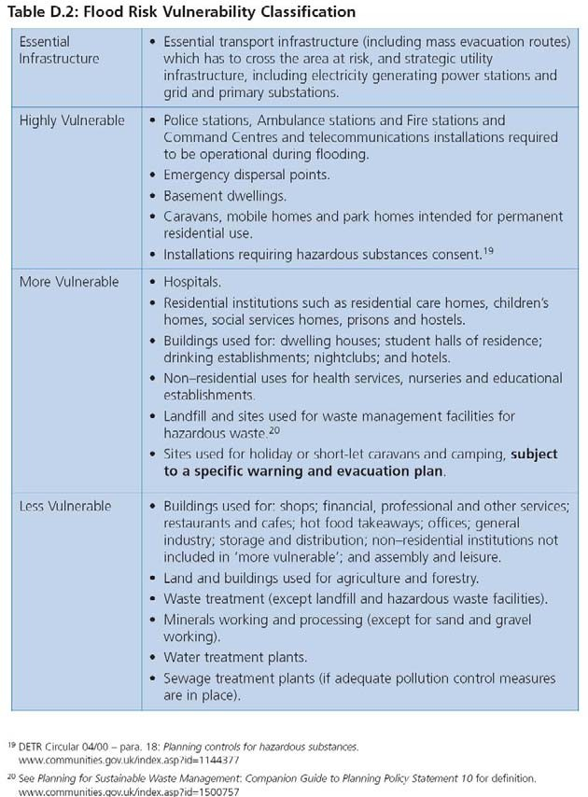

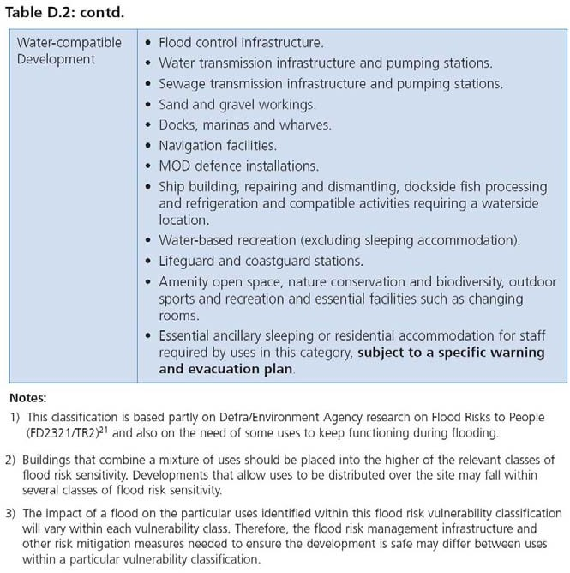

In August 2009 Communities and Local Government published a consultation paper on proposed amendments to PPS25. These included some recommendations for changes to the classifications of Essential Infrastructure, Water Compatible development and Less Vulnerable development in Table D.2. The proposed changes for these three vulnerability types are presented in coloured text below:

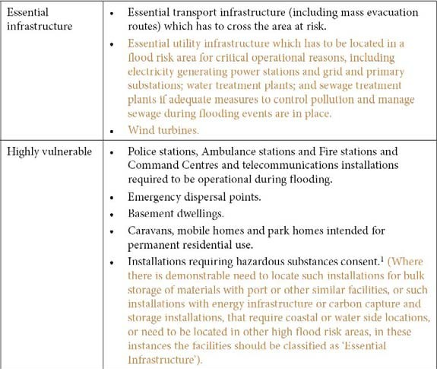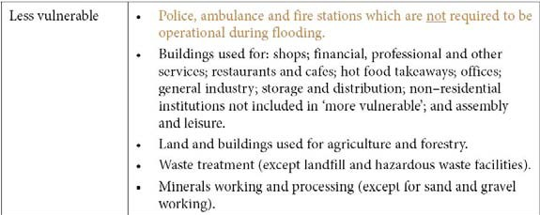

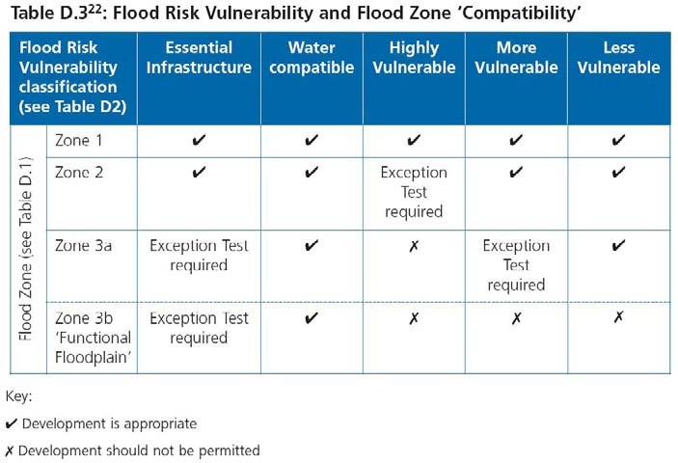

Appendix G
Planned Growth in Adjacent Areas

Planned Growth in East Midlands Resource Zone
Other major towns and cities in the East Midlands zone, sharing the resources that are available include Chesterfield, Worskop, Mansfield, Newark on Trent, Nottingham, Derby, Loughborough, and Leicester. Figure G1 shows the other local authority areas which are supplied by the East Midlands water resource, with the annual growth rate taken from the East Midlands Plan (March 2009). Table G1 presents this in comparison with the growth figures taken from Severn Trent Water’s draft WRMP.

The figures in Table G1 suggest a shortfall in the East Midlands zone housing forecast. Severn Trent Water calculated its forecast using the data that was available in early 2008. It should also be considered that the relationship between housing numbers and demand is not linear. The increase in the number of houses is not expected to translate into an equal increase in the number of people living in the area. Severn Trent Water forecast its population based on population data from the Office of National Statistics. The impact of changing household projections is expected to affect occupancy rate rather than population (although occupancy rate has an impact on per capita consumption).

The water company monitors housing numbers and population annually and reviews its demand and supply forecast every five years. In the longer term uncertainty around new housing numbers and resultant water consumption has been included in the headroom assessment.

Table G1 New Homes Planned in East Midlands Resource Zone

Local Authority | Annual Growth Rate* | Growth between 2006-  2016 | Growth between 2006-  2016
Rutland | 150 | 1500 | 3000
Nottingham Outer HMA | 1830 | 18300 | 36600
Ashfield (inc Hucknall) | 560 | 5600 | 11200
Mansfield | 530 | 5300 | 10600
Newark & Sherwood | 740 | 7400 | 14800
Northern HMA | 1510 | 15100 | 30200
Bolsover | 400 | 4000 | 8000
Chesterfield | 380 | 3800 | 7600
NE Derbyshire | 380 | 3800 | 7600
Bassetlaw | 350 | 3500 | 7000

Local Authority | Annual Growth Rate* | Growth between 2006-  2016 | Growth between 2006-  2016
Peak, Dales & Park HMA | 500 | 5000 | 10000
Derbyshire Dales | 200 | 2000 | 4000
High Peak | 300 | 3000 | 6000
Derby HMA | 1830 | 18300 | 36600
Derby | 720 | 7200 | 14400
Amber Valley | 510 | 5100 | 10200
South Derbyshire | 600 | 6000 | 12000
Leicester & Leicestershire | 4020 | 40200 | 80400
HMA
Leicester | 1280 | 12800 | 25600
Blaby | 380 | 3800 | 7600
Charnwood | 790 | 7900 | 15800
Harborough | 350 | 3500 | 7000
Hinckley & Bosworth | 450 | 4500 | 9000
Melton | 170 | 1700 | 3400
NW Leicestershire | 510 | 5100 | 10200
Oadby & Wigston | 90 | 900 | 1800
Nottingham Core HMA | 2850 | 28500 | 57000
Erewash | 360 | 3600 | 7200
Nottingham (city) | 1000 | 10000 | 20000
Broxtowe | 340 | 3400 | 6800
Gedling | 400 | 4000 | 8000
Rushcliffe | 750 | 7500 | 15000
Sum: | 12,690 | 126,900 | 253,800
Severn Trent Water East | Approx 11,400 | 102,610 | 216,301
Mids zone

* East Midlands Regional Plan, March 2009

Figure G1 Local Authority Areas in the East Midlands Resource Zone
