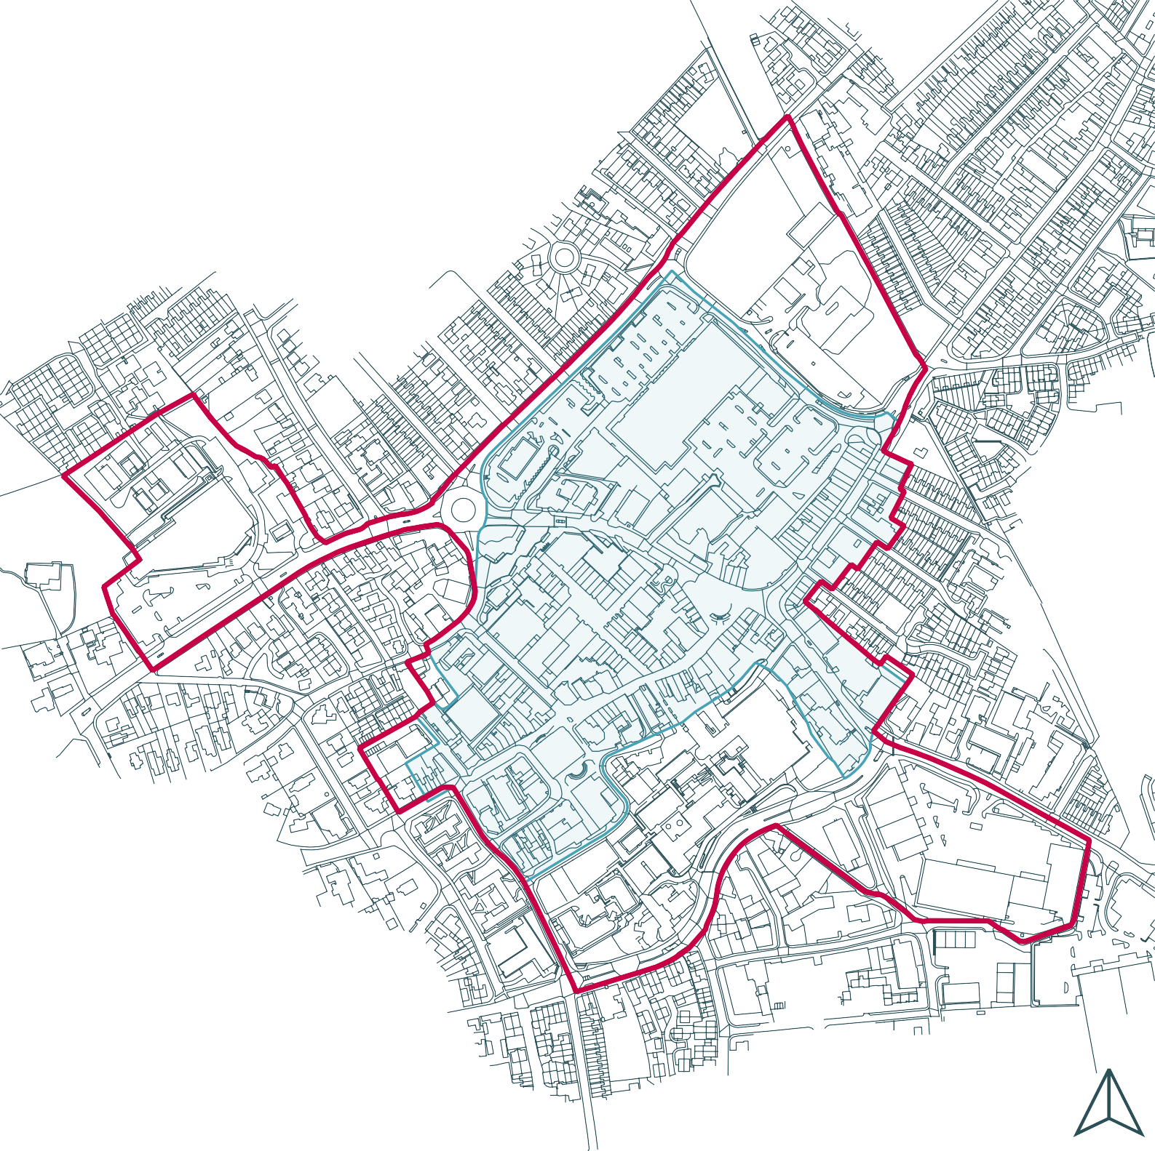

Proposed Town Centre Boundary
Proposed Primary Shopping Area

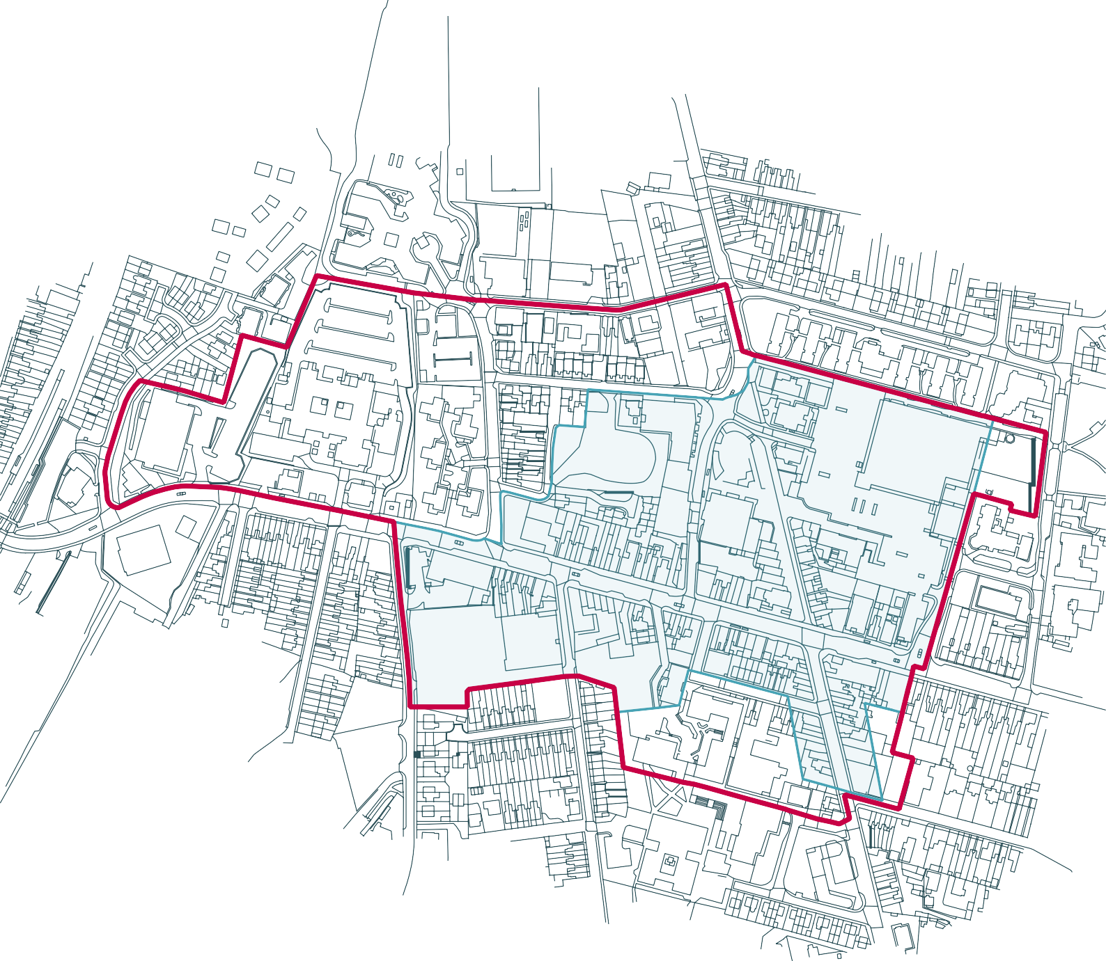

Proposed Town Centre Boundary
Proposed Primary Shopping Area

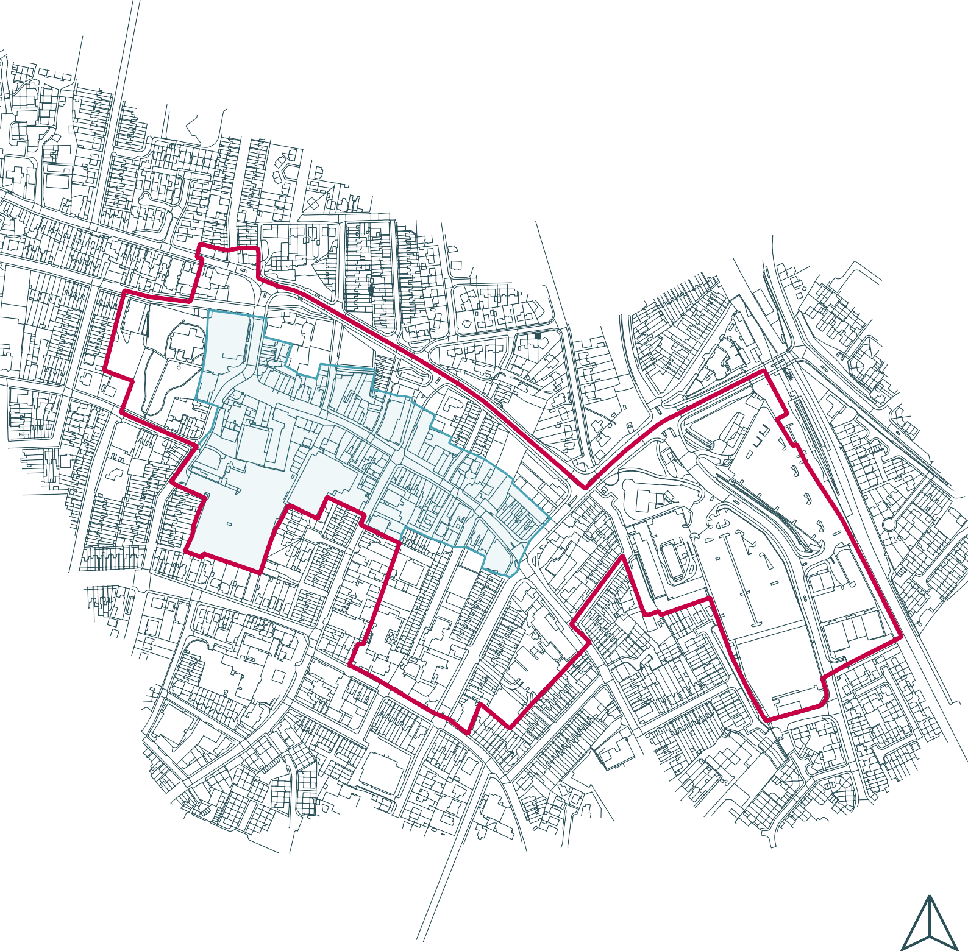

Proposed Town Centre Boundary
Proposed Primary Shopping Area

