Statement of Common Ground for the

Ashfield Local Plan 2023 to 2040

Regulation 19 Pre-Submission Draft Local Plan

Between

Ashfield District Council
and
National Highways

September 2023

- Introduction

  - This Statement of Common Ground (SoCG) has been prepared in relation to the Ashfield Local Plan 2023 to 2040: Regulation 19 Pre-Submission Draft (subsequently referred to as the ‘Local Plan’ throughout the remainder of this Statement).

  - The purpose of the SoCG is to inform the Inspector of the Ashfield Local Plan and other interested parties, about the areas of agreement or otherwise between Ashfield District Council and National Highways with regard to Strategic Planning Matters.

  - Ashfield District Council is the Local Planning Authority (LPA) for Ashfield District. National Highways is the responsible authority for the Strategic Road Network (SRN) within and around Ashfield. The only highway within the district of Ashfield that forms part of the Strategic Road Network for which National Highways is responsible is the M1 Motorway (see Map 2 on the next page). All other adopted roads within Ashfield fall within the responsibility Nottinghamshire County Council as the Highway Authority.

  - Local planning authorities, county councils and other prescribed bodies are under a duty to cooperate with each other on strategic matters that cross administrative boundaries. (Section 33A of the Planning and Compulsory Purchase Act 2004). Specific Consultees and Duty to Cooperate Bodies are identified in the Town and Country Planning (Local Planning) (England) Regulations 2012, as amended. This approach is also a requirement of the National Planning Policy Framework, 2021 (NPPF) in paragraphs 24 to 27 inclusive. Paragraph 35 of the NPPF seeks to ensure that the Local Plan is ‘Effective’ i.e. deliverable over the plan period, and is based on effective joint working on cross-boundary strategic matters that have been dealt with rather than deferred, as evidenced by the statement of common ground.

  - The Statement sets out the confirmed points of agreement between the parties with regards to:

- The findings and conclusions of the Ashfield Strategic Transport Study, October 2023

- The findings and conclusions of the Ashfield Infrastructure Delivery Plan, November 2023

- Background and Governance

  - Ashfield District is located on the western side of Nottinghamshire in the East Midlands Region. The District benefits from a number of high-quality transport links (Map 1), with the M1 dissecting the District providing communities and businesses with access to the motorway network via Junction 27 and Junction 28 (adjacent to the District). The A38 provides a major east-west route across the District and the A611 links the District to the City of Nottingham. The National Cycle Route runs through the District. In addition, there are heavy and light rail connections that link Ashfield with the wider area. The Robin Hood Line runs through the District from Worksop to Nottingham with stations at Hucknall, Kirkby-in-Ashfield and Sutton Parkway. The Nottingham Express Transit (NET) runs from Hucknall into Nottingham and other parts of Greater Nottingham including Clifton and Beeston. Within Ashfield, the proposed HS2 route is subject to safeguarding directions to the east of the M1.

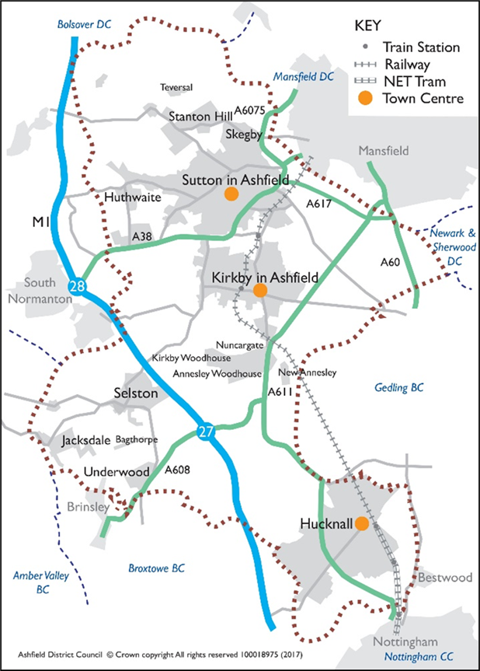

Map 2: National Highways Strategic Road Network
(Extract Nottinghamshire)
Source: National Highways
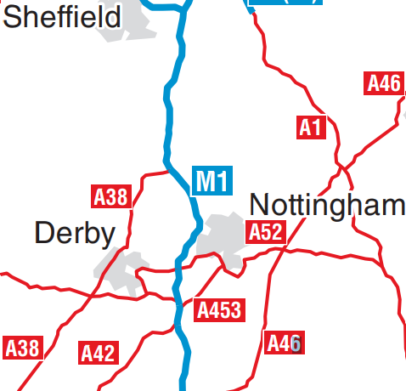

Map 2: National Highways Strategic Road Network

Source: National Highways

Map 1: The District of Ashfield.
Source: Ashfield District Council.

  - The respective parties have worked together to ensure that strategic planning matters are appropriately addressed. This has principally been through the Ashfield Strategic Transport Study, undertaken by Consultants Systra Ltd on behalf of the Council, to consider the impact on the Strategic Transport network in the District.

  - Representations were submitted by National Highways to the Draft Local Plan Consultation 2021 (Regulation 18). These have been considered and informed the development of Local Plan.

  - This Statement of Common Ground reflects the agreed position between National Highways and Ashfield DC and will be updated as and when required.

- Areas of Common Ground

  - National Highways identified in their response to the Draft Local Plan Consultation 2021 that the combination of the proposed strategic employment sites adjacent to M1 J27 and the Whyburn Farm housing development north west of Hucknall would be expected to result in a combined significant traffic impact on the M1, particularly at M1 J27. The Regulation 19 Local Plan does not include the new Settlement at Whyburn Farm. Two planning applications (V/2022/0246 and V/2022/0360) have been submitted on the majority of the land proposed to be allocated under Policy S8 of the Draft Local Plan 2021. Following National Highway’s comments on the applications, additional work is being undertaken in relation to the Strategic Road Network.

  - National Highways are supportive of Policy SD10 (Transport Infrastructure), whereby:

- the Council states that new development should demonstrate that sufficient measures are proposed to ensure that the transport network is not compromised, and where additional demands are placed on transport infrastructure, appropriate mitigation will be required; and

- That Transport Assessments should be submitted alongside applications for large scale development.

- Policy SD10, paragraph 9.105 acknowledges the need to understand the cumulative impacts of the proposed growth across the district, and through working in partnership with highway authorities, ensure the infrastructure needs are investigated and delivered as required.

  - The Council has brought forward a Strategic Transport Assessment to understanding the scale of traffic impacts and scope of highway infrastructure needed to accommodate the growth. Ashfield DC and National Highways agreed to the approach for undertaking the Strategic Transport Study and its conclusions.

  - Parties have agreed that:

Transport modelling has not identified any insurmountable constraints in Ashfield District and along the Strategic Road Network, in particular Junctions 27 and 28 of the M1 Motorway, arising from the policies and proposals in the Ashfield Local Plan.

The Ashfield Local plan will seek mitigation measures for required transport improvements to which developer contributions and/or developer led schemes (i.e Sec.278s) will be sought. These are included in the Infrastructure Delivery Schedule within the Ashfield Infrastructure Delivery Plan (IDP), November 2023.

Any planning obligations sought as part of new development will be directed to infrastructure improvements where mitigation measures have been identified.

- Outstanding Areas of Disagreement
  - There are no identified areas of disagreement at present.

5.0 Governance arrangements

5.1 Ashfield District Council and National Highways will continue to work together and share relevant information during the preparation of any additional work.

5.2 Ashfield District Council and National Highways will continue to work together on matters of joint interest in respect of the Strategic Road Network

5.3 Ashfield District Council will continue to work with the National Highways, the County Council and other organisations to secure appropriate funding for transport infrastructure projects to unlock new housing and employment development.

AGREEMENT
Both parties agree that this statement is an accurate representation of matters
discussed and issues agreed upon.

Signed on behalf of Ashfield District Council

Name: Christine Sarris

Position: Assistant Director - Planning

Dated: 16/01/2024

Signed on behalf of National Highways

Name: Catherine Townend

Position: Spatial Planner

Dated: 12/01/2024

