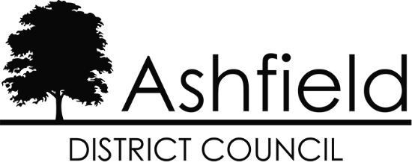

Statement of Common Ground for the Ashfield Local Plan 2023 to 2040 Regulation 19 Pre-Submission Draft
Between Ashfield District Council
and
The Nottingham Core Housing Market Area Authorities
(Broxtowe Borough Council, Erewash Borough Council, Gedling Borough Council, Nottingham City Council and Rushcliffe Borough Council)

February 2024

Introduction

  - This Statement of Common Ground (SoCG) has been prepared in relation to the Ashfield Local Plan 2023-2040 Regulation 19 Pre-submission Draft (subsequently referred to as the ‘Local Plan’ throughout the remainder of this statement).

  - The purpose of the SoCG is to inform the inspector of the Ashfield Local Plan and other interested parties about the areas of agreement between Ashfield District Council and Nottingham Core Housing Market Area Authorities (comprising Broxtowe Borough Council, Erewash Borough Council, Gedling Borough Council, Nottingham City Council and Rushcliffe Borough Council) with regard to strategic planning matters.

  - The structure of local government varies from area to area - in Nottinghamshire there is a two-tier structure. In broad terms, Nottinghamshire County Council have responsibility for schools, social services, public transport, highways, waste disposal and minerals. Each district/borough council covers a smaller area and provides local services including council housing, planning, recycling and refuse collection and leisure facilities. Nottingham City Council is a unitary authority and is responsible for all local government services within its boundaries.

  - Local planning authorities, county councils and other prescribed bodies are under a duty to cooperate with each other on strategic matters that cross administrative boundaries. (Section 33A of the Planning and Compulsory Purchase Act 2004). Specific Consultees and Duty to Cooperate Bodies are identified in the Town and Country Planning (Local Planning) (England) Regulations 2012, as amended. This approach is also a requirement of the National Planning Policy Framework, 2023 (NPPF) in paragraphs 24 to 27 inclusive. Paragraph 35 of the NPPF seeks to ensure that the Local Plan is ‘Effective’ i.e., deliverable over the plan period, and is based on effective joint working on cross-boundary strategic matters that have been dealt with rather than deferred, as evidenced by the statement of common ground.

  - This statement sets out the confirmed points of agreement between the parties with regard to:

    - Quantity and Location of Housing Development
    - Gypsy, Traveller and Travelling Showpeople provision
    - Provision of Employment Land
    - Green Belt
    - Infrastructure delivery
    - Sustainable Transport Modes and connectivity
    - Flooding
    - Ecology and Heritage
    - Blenheim Industrial Estate boundary

Background

  - Ashfield District is located on the western side of Nottinghamshire in the East Midlands Region. The District benefits from a number of high-quality transport links (Plan 1), with the M1 providing communities and businesses with access to the north-south motorway network via Junctions 27 and 28, the A38 providing a major east-west route across the District, and the A611 linking the District to the City of Nottingham. The National Cycle Route runs through the District. In addition, there are heavy and light rail connections that link Ashfield with the wider area. The Robin Hood Line runs through the District from Worksop to Nottingham with stations at Hucknall, Kirkby-in-Ashfield and Sutton Parkway. The Nottingham Express Transit (NET) runs from Hucknall into Nottingham and other parts of Greater Nottingham including Clifton and Beeston. Within Ashfield, the proposed HS2 route is subject to safeguarding directions to the east of the M1.
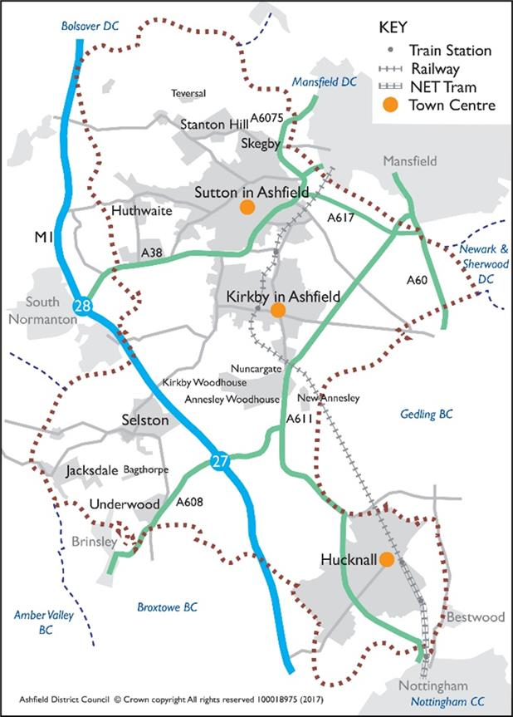

Map 1: The District of Ashfield and Surrounding Area
Source: Ashfield District Council

  - Map 2 shows the extent of the Nottingham and Derby Green Belt within Ashfield. It is largely confined to the south of the District and equates to approximately 41% of Ashfield. This includes land around Hucknall, land to the south and east of Kirkby-in- Ashfield and land surrounding the rural villages of Selston, Jacksdale, Underwood and small parts of Brinsley and Bestwood. The village of Bagthorpe is ‘washed over’ by the Green Belt.

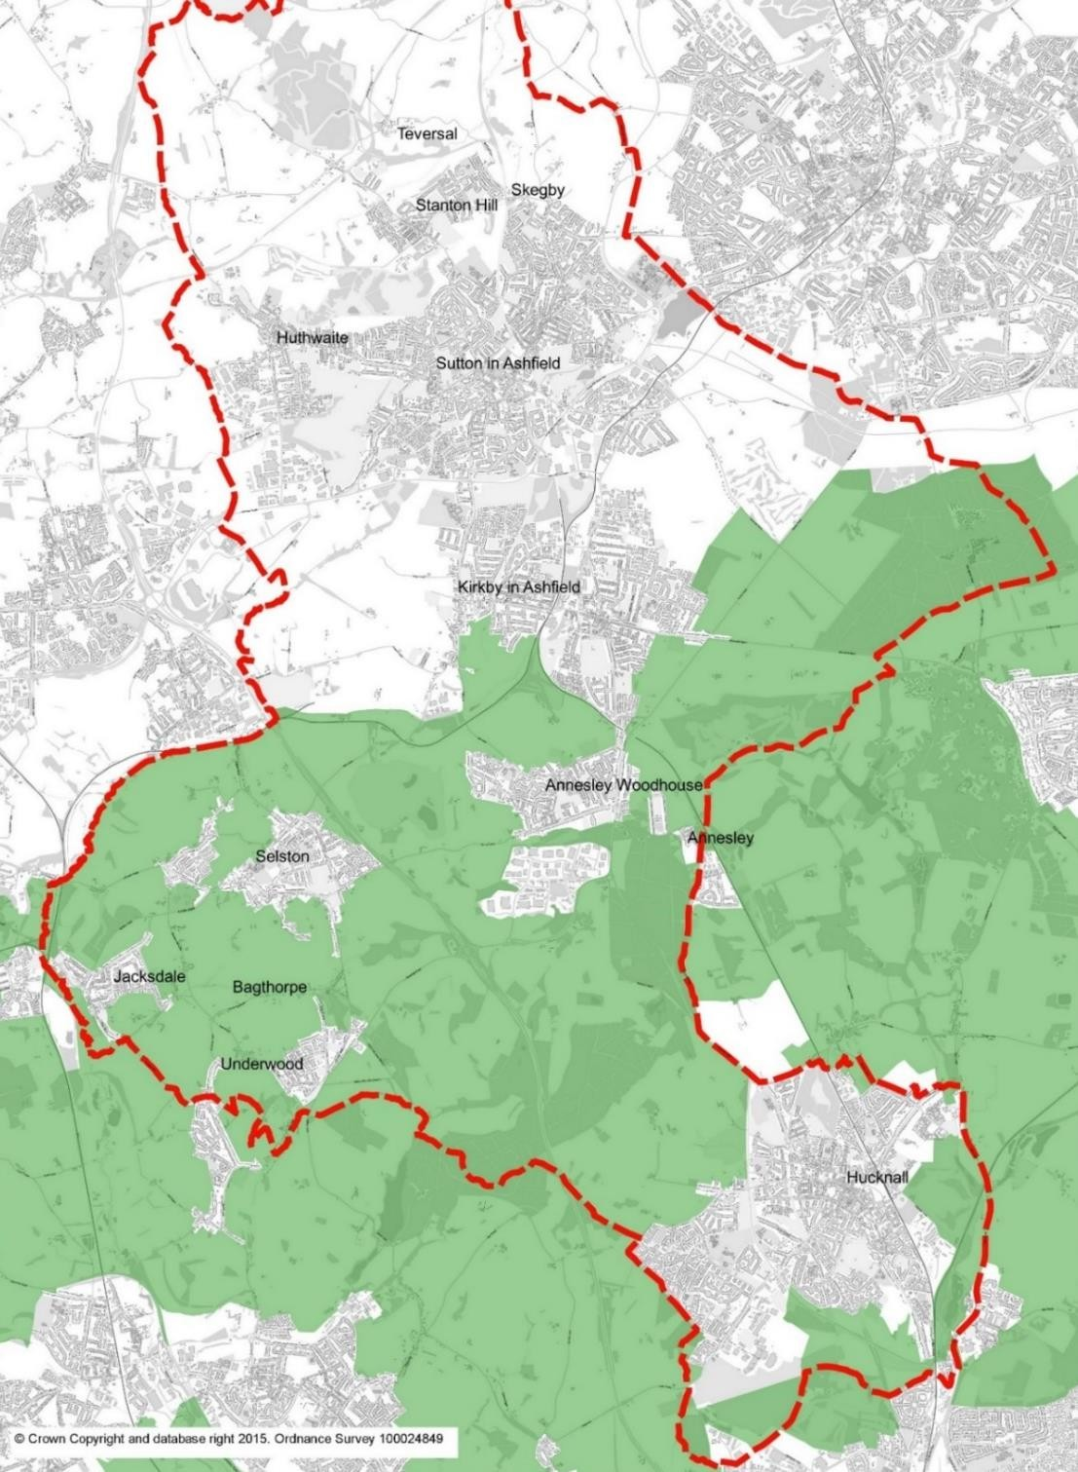

Map 2: Extent of Green Belt in Ashfield District
Source: Ashfield District Council

Housing Market Areas

  - Work undertaken by DTZ Pieda1 initially identified the housing market areas (HMAs) for Nottinghamshire as set out in Table 1. Evidence set out in the GL Hearn Nottingham Outer 2015 Strategic Housing Market Assessment2 concludes that ‘Ashfield, Mansfield and Newark and Sherwood, in view of all the current and historic evidence, as well as the existing ties, comprise a single housing market area.’ However, it is also acknowledged that Hucknall has a strong relationship with the Greater Nottingham Area and the Nottingham Core HMA authorities.
  - A 2018 study by consultancy ORS was commissioned by the Nottingham Core HMA comprising Broxtowe, Gedling, Erewash, Nottingham City and Rushcliffe to confirm the Nottingham Core Housing Market Area (HMA) boundary. This Study concluded that:
“There is no single correct definition of an HMA and FEMA, but the CURDS HMA analysis, ONS Travel to Work Areas and BRMAs (Broad Rental Market Areas) all indicate that the Nottingham Core HMA authorities of Broxtowe, Gedling, Erewash, Nottingham City and Rushcliffe are all located within the same HMA and FEMA. The migration and commuting data also supports a Nottingham Outer HMA and FEMA containing Ashfield, Mansfield and Newark and Sherwood.”

  - The report goes on to add:
“the town of Hucknall being in the administrative area of Ashfield, but within the functional HMA and FEMA for Nottingham Core HMA, while areas of Broxtowe, Erewash, Gedling, and Rushcliffe lie inside of other functional HMAs and FEMAs. However, from an administrative and practical point of view it is necessary for HMAs and FEMAs to follow local authority boundaries and the five authorities in the Nottingham Core HMA and FEMA remain the most appropriate grouping.”

Housing Market Area | Local Authorities within Housing Market Area
Nottingham Core | Nottingham City, Rushcliffe, Gedling, Erewash, Broxtowe
Nottingham Outer | Ashfield, Mansfield, Newark & Sherwood.

Table 1 - Housing Market Areas
Source: Ashfield District Council

1 DTZ Pieda (2003) Identifying the Sub-Regional Housing Markets of the East Midlands for East Midlands Regional Assembly.
2 GL Hearn Nottingham Outer 2015 Strategic Housing Market Assessment, Section 2 Reviewing the definition of the housing market area.

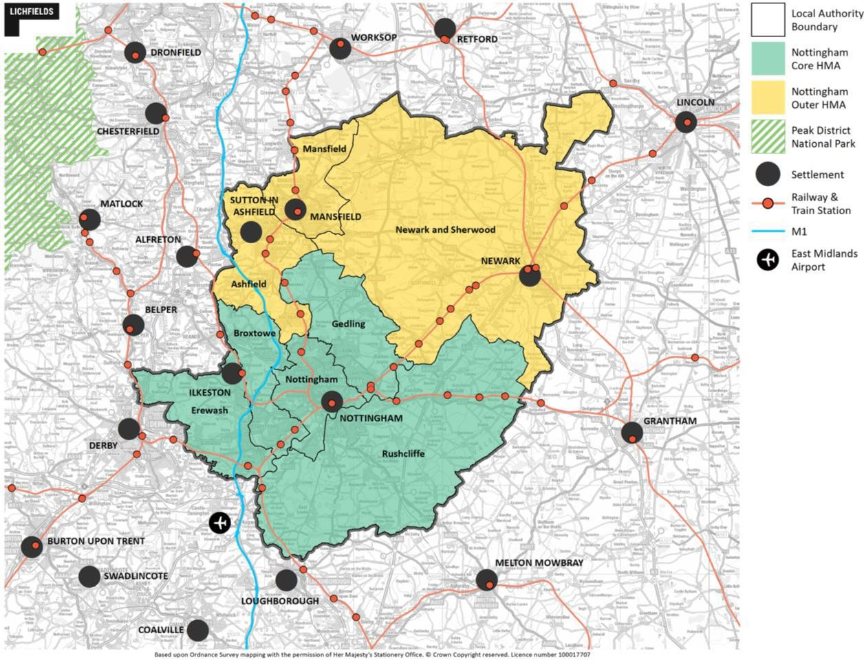

Plan 2: Nottingham Outer and Nottingham Core Housing Market Areas
Source: Nottingham Core HMA and Nottingham Outer HMA Employment Land Needs Study 2021

Functional Economic Market Area (FEMA)

  - Planning Practice Guidance (PPG) formally identified a FEMA as follows:

‘‘The geography of commercial property markets should be thought of in terms of the requirements of the market in terms of the location of premises, and the spatial factors used in analysing demand and supply – often referred to as the functional economic market area.” (PPG ID:2a-012-20140306).

  - In 2015 the councils comprising the Nottingham Outer Housing Market Area and the Nottingham Core Housing Market Area commissioned Nathanial Litchfield & Partners to undertake an Employment Land Forecasting Study, (ELF Study) which identified the future quantity of land or floorspace required for economic development uses. The ELF Study identified that:

    - The Nottingham Core HMA is a strong functional economic market area;
    - For the Nottingham Outer HMA this is slightly less clear cut, but it can be considered that the Nottingham Outer HMA is self-contained;
    - Hucknall has strong links with the Nottingham Core HMA.

  - The Nottingham Core HMA and Nottingham Outer HMA Employment Land Needs Study 20213 confirms that this remains the case, setting out that Hucknall has a strong relationship with the Nottingham Core HMA, and both Kirkby-in-Ashfield and Sutton in Ashfield link with Mansfield area and the employment areas of Bolsover around Junction 28.

Joint Working

  - Ashfield has a history of joint working with neighbouring authorities and statutory consultees on strategic planning matters. It has a close working relationship with the authorities in both the Nottingham Outer HMA and Nottingham Core HMA.

  - Ashfield is one of the constituent authorities of the D2N2 Local Enterprise
Partnership (LEP) which covers Nottinghamshire, Nottingham, Derby and Derbyshire. The purpose of the LEP is to lead and support economic growth across Derby, Derbyshire, Nottingham and Nottinghamshire. It is identified by national planning policy that the D2N2 Local Industrial Strategy should inform local policies for economic development and regeneration.
  - There are a number of established joint working groups in Nottinghamshire of which Ashfield is a member. Those pertinent to the Nottingham Core HMA authorities are set out in the Table below.

D2N2 Local Enterprise Partnership Board | Nottinghamshire local authorities are represented at the D2N2 Partnership Board. Regular meetings between Nottinghamshire Leaders help to ensure that issues relating to D2N2 are discussed as and when necessary.
The City of Nottingham and Nottinghamshire Economic Prosperity Committee | A joint committee of Nottingham City Council, Nottinghamshire County Council and all District Councils in Nottinghamshire. It is a decision-making body on strategic economic development issues. It aims to drive future investment in growth and jobs by prioritising, commissioning and monitoring money available to Nottingham and Nottinghamshire via the D2N2 Local Enterprise Partnership and makes recommendations to D2N2 on its investment priorities. The Committee is made up of one councillor from each local authority.
Nottinghamshire Local Government Leaders Group | A group made up of all the leaders of the County and District Councils in Nottinghamshire.

3 Nottingham Core HMA and Nottingham Outer HMA Employment Land Needs Study 2021, Section 4. Lichfields

Nottinghamshire Policy Officers Group meetings | Planning Officers from each Nottinghamshire Council meet on a quarterly basis to discuss and, where necessary, take action on strategic priorities.
Nottinghamshire Development Management Liaison Group Meetings | Development Management officers meet on a regular basis to discuss any issues arising from a development management aspect.
Greater Nottingham Joint Planning Advisory Board (JPAB) | JPAB was established in 2008. It is an advisory body and therefore any decisions it makes must be ratified by the relevant executive bodies of each member Council. It is made up of Councillors responsible for planning and transport matters within the constituent authorities. It meets every few months and oversees the preparation of strategic plans in the Greater Nottingham area. Other Duty to Cooperate bodies are invited to attend as observers, and the meetings held in public. Its membership consists of Ashfield DC, Broxtowe BC, Erewash BC, Gedling BC, Nottingham City, Rushcliffe BC, Nottinghamshire County Council and Derbyshire County Council.
Greater Nottingham Planning Partnership – Officer Group | This officer group meets on a weekly basis to consider all aspects of the local plan(s). Its membership consists of Ashfield DC, Broxtowe BC, Erewash BC, Gedling BC, Nottingham City, Rushcliffe BC, Nottinghamshire County Council and Derbyshire County Council.
Nottingham Core HMA Monitoring Group | Attended by Ashfield DC as well as the Nottingham Core Councils. Considers all aspects for monitoring the local plan and progress with delivery.
Nottinghamshire Ecological and Geological Data Partnership Meetings | The Nottinghamshire Ecological and Geological Data Partnership consists of officers representing all Nottinghamshire Councils, along with officers from the Nottinghamshire Biological and Geological Records Centre (NBGRC). The group meets twice a year to discuss biodiversity issues, including all local environmental data. The NBGRC, operated by Nottingham City Council on behalf of the Partnership, is Nottinghamshire’s local record centre.
Ashfield Major Projects Group | Considers major planning application in Ashfield. Comprises Ashfield DC, Highways Authority Nottinghamshire County Council representatives, Nottingham and Nottinghamshire Integrated Care Board representative.

  - In addition to those groups listed above, Ashfield and Erewash authorities are working jointly in the following ways:

    - Both councils are represented on the Robin Hood Line Community Rail Partnership (CRP) which aims to connect local communities with their railway, delivering social benefit and increasing rail use within this area through strategic activities. The partnership enables Councils to actively advise the CRP of district priorities and maximise funding / joint working opportunities.
    - Erewash was a key supporting partner in the Council’s Restoring your Railways bid. The bid, submitted in 2021, set out the feasibility of re-opening the current freight-only line between the Robin Hood Line in Nottinghamshire and the Pye Bridge junction of the Erewash Valley Line in Derbyshire (between Kirkby Lane End and Ironville Junctions), to convert it to carry passenger trains on a regular basis. It also looked at the reopening of a station at Selston and creating a station platform at Kings Mill in Sutton-in Ashfield.

Evidence Base

  - Ashfield has worked with neighbouring authorities to produce the evidence base for the Local Plan. Joint studies involving Nottingham Core HMA authorities are identified in the Table below.

The Nottingham Core HMA and Nottingham Outer HMA Employment Land Needs Study 2021, Lichfields | Nottingham Core HMA & Nottingham Outer HMA authorities.
Employment Land Forecasting Study, Nottingham Core HMA & Nottingham Outer HMA 2015, Nathaniel Lichfield & Partners | Nottingham Core HMA & Nottingham Outer HMA authorities
Nottinghamshire Core & Outer HMA Logistics Study  Final Report, Iceni Projects Limited with MDST Transmodal Limited | Nottingham Core HMA, Nottingham Outer HMA authorities, and Nottinghamshire County  Council.
Strategic Distribution and Logistics Sites Background Paper 2023. | Nottingham Core HMA & Ashfield District Council.
Greater Nottingham & Ashfield Housing Needs Assessment Final Report 2020 - Iceni Projects Limited on behalf of the Greater Nottingham Planning Partnership.  N.B. An update of this assessment has been commissioned by the partner authorities to reflect the 2021 Census data. The final report is anticipated in early 2024. | Nottingham Core HMA Councils and Ashfield District Council.

First Homes Assessment Greater Nottingham, September 2022. Iceni Projects Limited. | Ashfield District Council, Broxtowe Borough Council, Gedling Borough Council, Nottingham City Council and Rushcliffe Borough Council.
Greater Nottingham and Ashfield District Council Gypsy and Traveller Accommodation Assessment, 2021. RRR Consultancy Ltd. | Nottingham Core HMA Councils and Ashfield District Council.
Greater Nottingham (including Ashfield) Accessibility of Settlements Study 2010 | Nottingham Core HMA Councils and Ashfield District Council.
Strategic Green Belt Assessment Framework, 2014 | Ashfield District Council, Broxtowe Borough Council, Gedling Borough Council,  and Nottingham City Council.

Areas of Common Ground

The quantity and location of housing development
  - Ashfield DC does not form part of the Nottingham Core HMA but is within the Nottingham Outer HMA with Mansfield and Newark & Sherwood District Councils. However, it is acknowledged that the southern part of Ashfield District around Hucknall has close links with Nottingham City and the Nottingham Core HMA. This is reflected in the evidence on the Functional Economic Market Area Evidence.
  - Ashfield Council has applied the Standard Method for determining Local Housing Needs as set out in Planning Policy Guidance to arrive at a requirement of 446 dwelling per annum. The Local Plan identifies a supply of sites under Policy H1: Housing Allocations to contribute towards this requirement. The proposed allocations together with small site supply are estimated to provide for approximately 13+ years’ worth of housing supply post adoption (to year 2038/39), and further details will be set out in Background Paper 1: Spatial Strategy and Site Selection.

  - A number of the proposed housing sites are located in the Green Belt and paragraph 146 of the NPPF therefore applies. This paragraph states that before concluding that exceptional circumstances exist to justify changes to Green Belt boundaries, the local planning authority must take into account whether a neighbouring authority could accommodate some of the identified need for development. However, the majority of neighbouring local planning authorities also have significant areas of land within their districts which are identified as part of the Nottingham-Derby Green Belt.

  - Ashfield Council approached neighbouring authorities in May 2022 in respect of their capacity to accommodate some of Ashfield’s identified housing need. All authorities responded to advise they were not in a position to meet any of Ashfield’s local housing need at that stage. This position has subsequently been reiterated at officer meetings.

  - The Nottingham Core HMA authorities have adopted Core Strategies which set out the planning for housing needs across the Nottingham Core HMA. The councils have also adopted Part 2 Local Plans, with the exception of Erewash BC which has submitted a Core Strategy for Examination. The remaining councils are working toward a publication local plan consultation (Regulation 19) for a revised Core Strategy, and consulted on their ‘Greater Nottingham Strategic Plan Preferred Approach’ between 3rd January and 14th February 2023. The revised Core Strategy is taken forward through JPAB, and there are regular officer meetings which include Ashfield. Ashfield DC has not been requested to meet any unmet needs which may arise within the Nottingham Core HMA.

  - Gedling Borough Council’s Aligned Core Strategy (Part 1 Local Plan) 2014 allocated Sustainable Urban Extensions at Top Wighay Farm (1000 homes) and at

North of Papplewick Lane (up to 300 homes), both adjacent to Hucknall and as such are anticipated to need to contribute towards infrastructure requirements in Hucknall. In this context Gedling Borough Council have in place a Planning Obligations Protocol for dealing with development within Gedling which would have an impact on the services and facilities in a neighbouring District.

  - The revised Greater Nottingham Strategic Plan Preferred Approach consultation (Jan 2023) has subsequently identified approximately 1,650 homes in Gedling, adjoining Hucknall, which includes Sustainable Urban Extensions at:
- North of Papplewick Lane (83 homes remaining); and
- Top Wighay Farm (805 homes remaining, plus a further 640 homes).

  - The Ashfield Local Plan does not allocate any strategic sized sites which would impact directly on settlements within Nottingham Core authorities. However, it is acknowledged that 4 smaller sites border on neighbouring authorities within the Nottingham Core HMA as follows:

    - H1Kh Hucknall Road, Newstead (47 dwellings) - adjacent to Gedling BC
    - H1Hb Linby Boarding Kennels (43 dwellings) – adjacent to Gedling BC
    - H1Hd Stubbing Wood Farm (198 dwellings) – adjacent to Broxtowe BC
    - H1Va Plainspot Farm (42 dwellings) - adjacent to Broxtowe BC
  - At the Ashfield Local Plan Regulation 18 (2021) consultation, Broxtowe Borough Council (BBC) submitted an objection to the potential allocated site H1Va, Land at Plainspot Farm, New Brinsley, Underwood for 42 dwellings. Although the site is not of strategic scale, it is located directly adjoining the district boundary with Broxtowe and would therefore impact on a settlement within their administration boundary. BBC considered it unsuitable due to access constraints, traffic congestion and the urban sprawl of the village in the context of its Green belt location, when taking account of the 155 dwellings already permitted in Broxtowe. Concerns were raised that further development on the edge of the village could lead to coalescence with surrounding green belt villages, and add further pressure to the existing local services and infrastructure. ADC have worked with Nottinghamshire County Council Highways in respect of potential access constraints and no concerns were raised in this respect. The site selection reflects the spatial approach taken by ADC, and further details can be found in Background Paper 1: Spatial Strategy and Site Selection.

  - Any future cross boundary infrastructure provision requiring the involvement or endorsement of neighbouring authorities would be subject to separate discussions and agreement.

  - The parties have agreed that:

Ashfield is located outside of the Nottingham Core Housing Market Area (HMA), but Hucknall has close links with Nottingham City and the Nottingham Core HMA.
The Ashfield Local Plan proposes to meet the District’s local housing needs, as informed by the standard methodology, to 2038/39 with a review at least every 5 years. It is not proposed that any of this requirement will be met by neighbouring local planning authorities.
The Ashfield Local Plan is not required to accommodate any unmet housing requirements which may arise within the Nottingham Core Housing Market Area.
Engagement will continue to take place between Ashfield and the Nottingham Core HMA Authorities, including the consideration of cross-boundary issues as sites progress.
The parties will continue to share evidence and information to ensure that adequate infrastructure is provided to meet the scale and location of housing need.

Gypsy, Traveller and Travelling Showpeople Provision

  - The requirement for gypsy and traveller accommodation is assessed in the Greater Nottingham and Ashfield District Council Gypsy and Traveller Accommodation Assessment March 2021 (GTAA) shared evidence base. The study used 3 different approaches to establishing need as follows:

    - Based on the ethnic identity definition;
    - Based on the needs of families who have not permanently ceased to travel (i.e., based on the PPTS 2015 definition);
    - Based on the ‘travel to work’ interpretation of PPTS 2015.
  - The GTAA study recommended that the local authorities’ Local Plans seek to meet the PPTS need (as required) with ‘ethnic’ need (potential need) covered by a criteria-based policy.

  - Government’s Planning Policy for Traveller Sites (PPTS) 2015 required travellers to demonstrate that they have not ceased to travel in order to be defined as such. However, due to the ambiguity around demonstrating this and various court challenges to it, the Council took the decision to use the higher level of assessed need based on the ‘ethnic definition’, as opposed to the Traveller definition set out in national policy PPTS 2015. In December 2023, the PPTS was amended to revert back to the PPTS 2012 definition which includes travellers who on grounds only of their own or their family’s or dependants’ educational or health needs or old age

have ceased to travel temporarily or permanently. This endorses the approach taken by Ashfield. The assessed requirements for Ashfield are as follows:

Ashfield Future Pitch/Plot Requirements 2020 to 2038
Period | Gypsy/Traveller Pitches | Showpeople’s Plots/Yards
2020 to 2025 | 1 | 9
2025 to 2030 | 1 | 2
2030 to 2035 | 1 | 2
2035 to 2038 | 1 | 1
Total 2020 to 2038 | 4 | 14

  - The Ashfield Local Plan seeks to meet the above needs through land allocations under Policy H2a. It is acknowledged that there is a slight mismatch in the evidence base timeframe, i.e., for the period 2020-2038, rather than 2023-2040. However, since the quantum of assessed need is minimal it is considered appropriate that any additional need will be addressed via the planning application process, using criteria based policy H2 alongside site allocations within Policy H2a.

  - The Nottingham Core HMA Authorities will be meeting their own gypsy, traveller and showperson needs within the HMA.

  - The parties have agreed that:

Ashfield District Council proposes to meet the District’s gypsy, traveller and show person accommodation needs, with a review at least every 5 years. It is not proposed that any of this requirement will be met by neighbouring local planning authorities.
The Ashfield Local Plan is not required to accommodate any unmet gypsy, traveller and show person accommodation needs which may arise within the Nottingham Housing Market Area.

Employment provision

  - The authorities comprising the Nottingham Core HMA and the Nottingham Outer HMA have worked together on the development of the Employment Land Needs

Study 20214 (ELNS). This forms a common evidence base for the future employment land requirements for each authority. The Study included identifying the Functional Economic Market Area (FEMA) which has informed the employment land requirement for each area.

  - The ELNS highlighted that there were potential issues in relation to a regional demand for logistics which was not reflected in the Study. Nottinghamshire County Council with the support of the Nottingham Core and Nottingham Outer HMA authorities, commissioned a Logistics Study across the housing market areas. The Study findings highlight a substantial demand for logistics along the M1 Motorway in Nottinghamshire. However, this is a complex issue as the M1 is largely located within the Green Belt in Nottinghamshire.

  - Ashfield Local Plan Policy S8 identifies a demand for approximately 81 hectares of land for employment purposes in Ashfield over the Plan period. This figure is based on an adjusted past take up rate scenario and takes account of the demand for space from the logistics sector. This approach will facilitate the priority sectors identified in D2N2’s Strategic Economic Plan which aims to tackle the productivity gap for the D2N2 area to remain a competitive business location and deliver long term prosperity.

  - This demand will be met through:
    - Policy S6 strategic employment allocations of approximately 40.92 hectares at M1 Junction 27, removing the site out of the Green Belt in order to meet future logistic and distribution needs, and
    - Employment land allocations in Policy EM2 which combined provides for in excess of 84 hectares.
  - The allocated strategic sites will make a significant contribution towards the regional logistics requirements along the M1 in Nottinghamshire.

  - At the 2021 Regulation 18 consultation, Gedling BC raised whether Whyburn Farm employment allocation could saturate the local market when combined with Gedling’s allocation at Top Wighay Farm. As this proposal no longer forms part of Ashfield’s spatial approach to growth, the comment is no longer relevant.

  - The parties have agreed that:

4 Nottingham Core HMA and Nottingham Outer HMA Employment Land Needs Study 2021. Lichfields

Ashfield forms part of the Nottingham Outer Functional Economic Market Area (FEMA), with the Hucknall area having close links with the Nottingham Core FEMA. All authorities have influences beyond their administrative area.
Nottingham Core HMA Authorities support Ashfield’s approach in contributing towards the wider regional need for logistics/distribution sites along the M1 corridor.

Green Belt

  - Ashfield DC, Broxtowe BC, Gedling BC and Nottingham City Council worked jointly to prepare evidence to support their emerging Local Plans, including a Green Belt Assessment Framework.

  - Ashfield Council originally proposed to allocate a new settlement, Whyburn Farm in the Green Belt to the north of Hucknall as part of the Regulation 18 Draft Local Plan. It was anticipated to provide up to 5,000 dwellings and an employment allocation, located close to the district boundary with Gedling Borough Council and the edge of Annesley Hall Registered Park and Garden. Further to the consultation responses received to the Draft Local Plan 2021 (Regulation 18), the Cabinet determined at its meeting of 13th December 2022 that the New Settlement would not proceed. Therefore, this no longer forms part of the Plan’s strategic approach.
  - Strategic employment sites to meet future logistics needs along have been identified at land to the north-east and south-east of Junction 27 of the M1 Motorway. These sites are subject to pending planning applications (V/2022/0248 and V/2022/0360). Discussions regarding the applications have been undertaken with National Highways and Historic England.

  - A number of other smaller Green Belt sites are proposed for allocation in Ashfield. However, other than the combined implications for highways, which are considered through the Transport Study 2023, they do not have strategic cross boundary implications.

  - Background Paper 1: Spatial Strategy and Site Selection sets out the exceptional circumstances for Green Belt release at Chapter 9.

  - The parties have agreed that:

Nottingham Core HMA authorities support Ashfield’s approach in contributing towards the wider regional need for logistics/distribution sites along the M1 corridor and the associated need for green belt release to accommodate this economic growth.
Nottingham Core HMA authorities acknowledge the justification for exceptional circumstances to release green belt sites to accommodate proportionate housing growth adjacent to existing settlements.

Infrastructure Delivery

  - The emerging Local Plan is supported by an Infrastructure Delivery Plan (IDP) which addresses the infrastructure requirements for the District based on the level of growth planned.

  - The Council has also worked with a number of authorities in relation to the Strategic Housing & Economic Land Availability Assessment (SHELAA) including the Highways Authority, other Nottinghamshire County Council departments and Severn Trent Water.

  - The Council commissioned the Ashfield Strategic Transport Study (2023) to assess the impact of proposals in the Local Plan on the Highway network. This examined impact on key junctions and identified mitigation where possible. The findings have fed into the IDP which supports the Plan.

  - There have been discussions with infrastructure providers regarding the Local Plan proposals including (but not limited to) the following:

Highways & Transport | - Nottinghamshire County Council – Highway Authority  - National Highways – responsible for M1.  - Network Rail  - HS2
Utility undertakers | - Severn Trent Water  - National Grid  - British Telecom
Community Infrastructure | - Nottinghamshire County Council – Education, care homes and other forms of community infrastructure  - NHS Nottingham and Nottinghamshire Integrated Care Board
Blue and Green Infrastructure | - Ashfield Place & Community Officers

- Officers from neighbouring authorities in relation to the strategic green infrastructure
- Environment Agency
Waste | - Nottinghamshire County Council
Minerals | - Nottinghamshire County Council

  - The parties have agreed that:

Ashfield have assessed the transport implications of planned levels of growth within their Local Plan and shared the information with the HMA partners, the Local Highway Authority (Nottinghamshire County Council) and National Highways England.
A Strategic Transport Modelling Assessment has been undertaken to support the Ashfield Local Plan using the East Midlands Gateway Model. This included the planned level of growth by neighbouring authorities (identified in Figure 2 of the Assessment Area of Influence). The Assessment was undertaken in conjunction with Nottinghamshire County Council as the Highway Authority and National Highways. It identified that:

- the proposed level of growth has the potential to result in direct and indirect implications for the strategic and local transport network both within and beyond the administrative boundaries of Ashfield District;
- transport modelling has not identified any insurmountable constraints arising from the policies and proposals in the Ashfield Local Plan;
- no ‘show-stopping’ transport constraints have been identified by these organisations.
Any planning obligations sought as part of new development will be directed to infrastructure improvements where mitigation measures have been identified. This includes the provision or enhancement of cross-boundary infrastructure to help deliver and mitigate the effects of development, for instance, transport improvements, educational and health requirements, and tackling climate change including flooding. Contributions will be informed by the Infrastructure Delivery Plan (IDP) 2023, or subsequent updated information where fully justified and appropriate.

Sustainable Transport Modes and Connectivity

  - Ashfield Local Plan Strategic Policy S10: Improving Transport Infrastructure seeks to promote travel choice and reduce the reliance on the private car. Part 2a includes the potential re-opening of the freight only Maid Marian Line between the Robin Hood Line and the Erewash Valley Line to carry passengers, and the reopening of a station at Selston. The reopening of the Maid Marian Line remains a long-term aspiration for Ashfield and Erewash authorities and partnership working will continue in this respect.

  - Strategic Policy S10 part 3 safeguards land for the Nottingham Express Transit System from Hucknall Station to the boundary with Gedling Borough. While current proposals do not include the development of a NET station, the safeguarding widens transport choices in the area in future.

  - The parties have agreed that:

Ashfield and Erewash councils will continue to work together to secure improvements in sustainable transport modes, in particular supporting the re- opening of the Maid Marian railway line and stations.
Ashfield Council will continue to safeguard additional land for the Nottingham Express Transit System as identified on the Ashfield Local Plan Policies Map.

Flooding

  - The Strategic Flood Risk Assessment (SFRA) and Water Cycle Study (WCS) identify that there are limited areas in Ashfield that are at risk of flooding. However, additional work undertaken by Nottingham Core Authorities has identified that there are significant flooding risks to Nottingham City arising from additional water feeding into the River Leen and its tributaries. Policies and land allocations in the draft Ashfield Local Plan seek to mitigate this risk.

  - Strategic policy S3: Meeting the Challenge of Climate Change sets out that no development is put at risk of flooding, nor does it increase the risk of flooding to the surrounding areas, directing development and infrastructure to areas at the lowest risk of flooding in the District. This is to be achieved by applying a sequential approach to minimise flood risk; achieving greenfield run-off rates within the catchment of the River Leen to minimise the risk of flooding to Hucknall and the City of Nottingham: and utilising Sustainable Drainage Systems (SuDS) among other provisions. Detailed Development Management Policies on these aspects are set out in Policy CC2: Water Resource Management and Policy CC3: Flood Risk.

  - In its consultation response to the Ashfield Pre Submission Draft Local Plan, Nottingham City Council requested that Strategic Policy S3 2d (iv) be amended to refer to run off rates of greenfield or lower if possible due to the significant implications for flooding downstream in Nottingham. This reflects the existing text supporting development management Policy CC3: Flood Risk and SuDS. Consequently, additional text will be included for Policy S3 in the proposed modifications schedule to be submitted alongside the Regulation 19 Local Plan.

  - The Council has sought the advice of the Environment Agency where any part of a site put forward to the SHELAA is located in Flood Zone 2 or 3.

  - The parties have agreed that:

Policies included within the Ashfield Local Plan seek to address flooding issues within and outside of the District.
Additional text will be included in a proposed schedule of modifications for Policy S3 (d) as follows:
iv) Achieving greenfield and, where possible, lower run-off rates within the catchment of the River Leen to minimise the risk of flooding to Hucknall and the City of Nottingham.

Ecology & Heritage

  - Ashfield has a substantial number of local wildlife sites as well as a number of SSSIs. In addition, parts of the District are within a possible potential Special Protection Area (ppSPA) for Sherwood Forest for its breeding birds (nightjar and woodlark). As yet, no decision has been made as to whether it should be designated. Consequently, Natural England recommends a precautionary approach5 should be adopted by Local Planning Authorities which ensures that reasonable and proportionate steps have been taken in order to avoid or minimise as far as possible, any potential adverse effects from development on the breeding populations of nightjar and woodlark in the Sherwood Forest area.
  - In considering the proposals in the draft Local Plan, the Council has liaised with Natural England regarding particular sites and their possible impact on the ppSPA. The Council has engaged and worked with Natural England in preparing a Habitat Regulations Assessment (HRA) in order to provide an assessment of the potential effects of the Local Plan policies and land allocations. The conclusions of the HRA

5 Advice Note to Local Planning Authorities regarding the consideration of likely effects on the breeding population of nightjar and woodlark in the Sherwood Forest region. March 2014. Natural England.
Hardwick Setting Study National Trust, March 2016 . Atkins

identify that the Local Plan will have no adverse impact on site integrity of the Habitats sites, or upon the ppSPA, either alone or in-combination.
  - The natural environment, including green and blue infrastructure corridors and assets will be protected, conserved and enhanced, in order to maintain the integrity of Ashfield District’s overall Green Infrastructure network. Strategic policy S13 seeks to enhance biodiversity by protecting, connecting and enhancing important habitats, (informed by the District’s Biodiversity Opportunity Maps6); and promoting native tree planting, street trees and well targeted woodland creation on appropriate sites, and encouraging retention and sensitive management of trees. The Green & Blue Infrastructure and Biodiversity Strategy 2022 -2032 examines the connectivity of green and blue infrastructure and identifies key strategic and local corridors and assets. Strategic corridors connect key green infrastructure resources and/or run between settlements and across district boundaries. Policy EV4: Green Infrastructure, Biodiversity and Geodiversity provides more detailed development management requirements in this respect. The approach taken by Ashfield is considered to be consistent with that undertaken by the Nottingham Core authorities, and respects the cross boundary nature of Green and Blue Infrastructure.
  - Ashfield Local Plan Strategic Policy S14 and Development Management Policy EV9 aim to conserve and enhance all heritage assets within the District in a manner appropriate to their significance. This approach is in line with national planning guidance and legislation.

  - The Council has engaged and worked with Historic England in preparing a HIA in order to provide an assessment of the potential effects of the Local Plan on designated and non-designated heritage assets. Matters of strategic importance raised by Historic England were in regard to the proposed two Strategic Employment Allocations (S8) North-east and South-east of Junction 27 of the M1 Motorway. However, it is considered, on balance, the public benefits of the proposed allocation providing a major economic opportunity for Ashfield, investment to boost the local economy and jobs, and helping to address local deprivation issues provide the justification for the allocation to be taken forward in the Local Plan – this is discussed in Background Paper 1: Spatial Strategy and Site Selection chapter 9.

  - As identified in paragraph 3.8 of this statement, housing allocation H1Hb Linby Boarding Kennels (43 dwellings) is located adjacent to the boundary with Gedling Borough Council. The northern section of this site currently benefits from planning permission for 9 dwellings. Linby Conservation Area is located within Gedling Borough immediately to the north of this site. Consequently, given the proximity of the Conservation Area and as per the agreement at paragraph 3.11, there will be

6 Ashfield Biodiversity Opportunity Mapping Project 2016. Nottinghamshire Biodiversity Action Group

ongoing dialogue between the two councils via the development management process.
  - The parties have agreed that:

The HRA sets out a comprehensive assessment of the Ashfield Local Plan impacts (both alone and in-combination) on the identified Habitats Sites, including the Sherwood Forest ppSPA. The conclusions of the HRA identify that the Local Plan will have no adverse impact on site integrity of the Habitats sites, or upon the ppSPA, either alone or in-combination.
The approach to Green and Blue infrastructure recognises the strategic nature of planning for green corridors. The approach taken by Ashfield is considered to be consistent with that undertaken by the Nottingham Core authorities, and respects the cross boundary nature of Green and Blue Infrastructure.
There are no cross-boundary implications between Ashfield District and the Nottingham Core authorities arising from the Heritage Impact Assessment of the Draft Local Plan.

Blenheim Industrial Estate Boundary – Cross boundary matter

  - Ashfield Local Plan Strategic Policy S1: Spatial Strategy to Deliver the Vision sets out a settlement hierarchy to accommodate future growth. Part d) identifies Blenheim Industrial Estate to accommodate existing and future employment uses in the event of redevelopment.

  - Blenheim Industrial Estate largely falls within Nottingham City Council area. However, the north-eastern section crosses the boundary into Ashfield District to the south of Hucknall. The area adjoining Nottingham City is not a focus for future development within Ashfield and performs an important strategic Green Belt role in the segregation of Hucknall and Nottingham. However, this particular area is already comprehensively developed for employment uses and is protected for such under Policy EM1. Consequently, it is excluded from the ‘Remainder of the District’ and is identified on the Policies map with its own designation. This issue has been subject to liaison with Nottingham City Council and agreed upon at officer level.

  - The parties have agreed that:
The Ashfield Local Plan Policies Map will identify that part of Blenheim Industrial Estate which falls within Ashfield District with its own designation to reflect the hierarchy as set out in Strategic Policy S1 part d)

Outstanding Areas of Disagreement

4.1 Standing objection to housing allocation H1Va, Land at Plainspot Farm, New Brinsley, Underwood for 42 dwellings from Broxtowe Borough Council.

Governance arrangements
  - Ashfield is a member of the Greater Nottingham Planning Partnership officer group which meets on a regular basis with quarterly reports to JPAB.

  - The Nottingham Outer HMA and Nottingham Core HMA local planning authorities monitor housing and employment land to identify any issues. Should issues arise they are brought up at the Nottinghamshire Planning Policy Officers Group Meeting or at the meeting held between the HMA groups.

  - Meetings between the Nottingham Core HMA local planning authorities will be held as and when considered appropriate to address cross boundary issues, including delivery of development to meet the identified needs.

  - These matters will be considered by the Councils and Statements of Common Ground will be prepared and entered into/updated as and when considered appropriate.

AGREEMENT

All parties agree that this statement is an accurate representation of matters discussed and issues agreed upon.

Signed on behalf of Ashfield District Council

Name: Christine Sarris
Position: Assistant Director – Planning and Regulatory Services
Dated: 18/04/2024

Signed on behalf of Broxtowe Borough Council

Name: Ryan Dawson
Position: Head of Planning and Economic Development Dated: 02/04/24

Signed on behalf of Erewash Borough Council

Name: Steve Birkinshaw
Position: Head of Planning and Regeneration Dated: 18/04/2024

Signed on behalf of Gedling Borough Council

Name: Mike Avery
Position: Head of Development and Place Dated: 02/04/24

Signed on behalf of Nottingham City Council

Name: Matt Gregory
Position: Head of Planning Strategy and Geographic Information Dated: 02/04/24

Signed on behalf of Rushcliffe Borough Council

Name:
Position: Planning Policy Manager Dated: 08/04/24

