Ashfield Local Plan Sustainability Appraisal Scoping Report 2020

February 2020

Contents

 | Page
Non - Technical Summary | 4
Section 1 – Introduction | 10
- Local Plan | 10
- Sub Regional Context | 11
- Sustainability Appraisal | 13
Section 2: Approach to SA | 14
- Legislative Framework | 14
- What is the Purpose of Sustainability Appraisal | 17
- The Relationship between SA and SEA | 19
- Scoping Methodology | 21
- Integrating with other Assessments | 24
Section 3: Identification of other relevant Plans, Policies and Programmes and sustainability objectives | 25
- Key messages –Table 5 | 27
Section 4: Baseline data and characteristics of Ashfield District and identifying sustainability issues | 53
- Summary of the Characteristics of Ashfield District | 56
- Population | 59
- Delivering a Sufficient Supply of New Homes | 65
- Building a Stronger Competitive Economy and Supporting High Quality Communications | 71
- Ensuring the Vitality of Town Centres | 76

- Promoting Healthy & Safe Communities | 81
- Promoting Sustainable Transport | 87
- Making Effective Use of Land and Achieving Well Designed Places | 90
- Meeting the Challenge of Climate Change Flooding and Coastal Change (Including Water Quality) | 88
- Conserving and Enhancing the Natural Environment and Protecting Green Belt Land | 104
- Conserving and Enhancing the Historic Environment | 116
- Minerals and Waste | 122
Section 5: Developing the SA framework | 123
- SA Objectives | 123
- SA Assessment | 125
- Definition of Significance | 126
- Alternatives | 128
- The Sustainability Framework (Table 17) | 130
- Consideration of Significance for Strategic Options and Policies (Table 18) | 141
- Compatibility | 152
Section 6: Consultation | 155
Appendices
Appendix 1: Review of Plans, Policies and Programme
Appendix 2: The Requirements of the SEA in Relation to the SA Scoping Report Review. Including:
- Definitions;
- How the requirements of SEA are met in the SA Scoping Report Review; and
- SEA Quality Assurance Checklist.

Appendix 3: Glossary of Terms and Abbreviations
Appendix 4: Consultation Questions

AA | Appropriate Assessment
DPD | Development Plan Document
EAPP | The Environmental Assessment of Plan & Programmes Regulations 2004
ELFS | Nottingham Core HMA & Nottingham Outer HMA Employment Land Forecasting Study 2015
NPPF | National Planning Policy Framework
PPG | Planning Practice Guidance
SA | Sustainability Appraisal
SHELAA | Strategic Housing and Economic Land Availability Assessment
SHMA | Strategic Housing Market Assessment
SEA | Strategic Environmental Assessment
SPD | Supplementary Planning Document.

Non -Technical Summary Introduction
This Non -Technical Summary (NTS) provides an overview of the Scoping Report produced as part of the Sustainability Appraisal (SA) of the new Local Plan for the District of Ashfield. The SA Scoping Report has been undertaken by Ashfield District Council but has been subject to a critical review by Wood Environment and Infrastructure Solutions Ltd.
The SA of the Local Plan will be undertaken on behalf of the Council by Wood Environment and Infrastructure Solutions Ltd. The SA will appraise the environmental, social and economic performance of the Local Plan and any reasonable alternatives, helping to ensure it contributes towards sustainability.

The Scoping Report sets out the proposed approach to undertaking the SA of the emerging Local Plan. It provides an opportunity for statutory consultees (Natural England, the Environment Agency and Historic England) as well as other bodies and the public to comment on the scope of the SA and the level of detail that should be included within the appraisal and subsequent SA Reports.

The following sections of this NTS:

- provide an overview of the Local Plan for the District of Ashfield;
- describe the SA process together with how it is to be applied to the emerging Local Plan;
- summarise the key economic, social and environmental issues relevant to the appraisal of the Local Plan;
- outline the proposed approach to undertaking the appraisal of the Local Plan; and
- set out the next steps in the SA process.

What is the Local Plan for the District of Ashfield?
The Local Plan for Ashfield will be a single planning policy document. It will set out the vision and objectives for the District out to 2037 as well as the spatial strategy in terms of how much new development will be accommodated in the District over the plan period and where in the District this growth will be located.

The vision, objectives and spatial strategy will be delivered through the Local Plan’s key planning policies and land allocations.

Development of the Local Plan will be informed by ongoing consultation, evidence gathering and assessment (including SA) before it is submitted for Examination in Public by a Planning Inspector acting on behalf of the Secretary of State. The Council anticipates the Local Plan will be adopted in 2022. The Council’s timetable for

preparation of the Local Plan is set out in the Local Development Scheme, which is available on the Council’s website.

Further information in respect of the preparation of the Local Plan is set out from Section 1.1 of the Scoping Report.

What is Sustainability Appraisal?
National planning policy states that local plans are key to delivering sustainable development and that they must be prepared with the objective of contributing to the achievement of sustainable development¹. Sustainable development aims to strike a balance between economic, environmental and social factors to enable people to meet their needs without compromising the ability of future generations to meet their own needs².

It is therefore very important that the Local Plan for the District of Ashfield contributes to a sustainable future for the District. To support this objective, the Council is required to carry out a Sustainability Appraisal (SA) of the Local Plan³.

SA is a means of ensuring that the likely social, economic and environmental effects of the Plan are identified, described and appraised and also incorporates a process set out under a European Directive⁴ and related UK regulations called Strategic Environmental Assessment (SEA)⁵. Where negative effects are identified, measures will be proposed to avoid, minimise or mitigate such effects. Where any positive effects are identified, measures will be considered that could enhance such effects.

SA will also help to inform the selection of plan options by appraising reasonable alternatives in respect of, in particular, different levels of growth that could be accommodated in the District over the plan period, the distribution of growth between the District’s settlements and site allocations. SA will therefore be an integral part of the preparation of the Local Plan for Ashfield.

National Planning Practice Guidance identifies that there are five key stages in the SA process, which are shown in Table 4: Sustainability Appraisal and the Local Plan of the Scoping Report. The preparation of, and consultation on, the Scoping Report is the first stage of the SA process (Stage A). The scoping stage itself comprises a number of stages, which are set out below:

- Identifying other relevant plans, programmes and environmental protections objectives. Policies within the Local Plan will be influenced by other relevant international and national legislation. Therefore, the Scoping Report lists relevant legislation and policies and their key objectives and details how future Local Planning policies considers these objectives.

¹ Planning and Compulsory Purchase Act 2004, section 39 (2) & National Planning Policy Framework 2019, Paragraph 16.
² Reflecting the Brundtland Commission Report – Our Common Future (Word Commission on Environment and Development) 1987
³ Planning and Compulsory Purchase Act 2004, section 19(5).
⁴Directive 2001/42/EC on the assessment of the effects of certain plans and programmes on the environment.
⁵ Environmental Assessment of Plans and Programmes Regulations 2004 (statutory instrument 2004 No. 1633).

- Baseline information refers to the existing environmental, economic and social characteristics of the area likely to be affected by the Local Plan and their likely evolution without implementation of new policies. This data will be used as the baseline to provide the basis for identifying issues and determining objectives for the Local Plan.
- Developing SA objectives and testing their compatibility, which will be used to appraise the policy options as the Local Plan Review progresses. The SA objectives provide the opportunity to compare the potential effects of all reasonable options considered.

- Consultation as required by national regulations. The Scoping Report will be informed through consultation with statutory bodies and other relevant stakeholders across the district and the wider plan area.

Based on the review of other plans and programmes, baseline analysis and identification of key sustainability issues, the Scoping Report sets out the proposed SA Framework to be used to appraise the effects of the Local Plan (and any reasonable alternatives). Following the conclusion of scoping consultation, the SA Framework will be amended to take into account consultation responses as appropriate.
The revised SA Framework will be used to appraise the effects of the emerging Local Plan (Stage B). This stage will involve the development and refinement of the Local Plan by testing the sustainability strengths and weaknesses
of the emerging Plan options. In this respect, SA will be undertaken throughout the preparation of the Local Plan with the findings presented in a series of interim SA Reports.

At Stage C, a final SA Report will be prepared to accompany the submission draft Local Plan. This will be available for consultation alongside the draft Local Plan itself prior to consideration by an independent planning inspector (Stage D).

Following an Examination in Public, and subject to any significant changes to the draft Local Plan that may require appraisal, the Council will issue a Post Adoption Statement as soon as reasonably practicable after the adoption of the Local Plan. This will set out the results of the consultation and SA processes and the extent to which the findings of the SA have been accommodated in the adopted Local
Plan. During the period of the Local Plan, the Council will monitor its implementation and any significant social, economic and environmental effects (Stage E).

What are the Key Sustainability Issues for the Local Plan?
Based on a review of other plans and programmes relevant to the Local Plan and an analysis of the District’s characteristics, a number of key sustainability issues relevant

to the Local Plan have been identified. The Scoping Report in Section 4 sets out the baseline position for Ashfield under a number of headings, which reflect the various chapter of the National Planning Policy Framework. For example ‘Delivering a sufficient supply of homes’. It identifies ‘Issues and Problems’ together with the ‘Potential implications of not having a new Local Plan’. Table 5: Key messages sets out the key messages from plans and programmes, the source of the message, implications for the SA Framework and the issues arising from the evidence base.

The key sustainability issues listed in Table 5 have informed the framework that will be used to appraise the effects of the Local Plan.

Section 3 of the Scoping Report summarises the review of plans and programmes relevant to the Local Plan that is contained at Appendix A. Section 4 presents the socio-economic and environmental baseline conditions for the District of Ashfield, along with how these are likely to change in the future without the Local Plan.

What is the Proposed SA Framework?
The main purpose of the scoping stage of the SA is to identify the framework for the appraisal of the Local Plan. The framework contains a series of objectives and guide questions developed to reflect both the current socio-economic and environmental issues which may affect (or be affected by) the Plan and the objectives contained within other plans and programmes. Table 17: The Sustainability Framework and Table 18: Consideration of Significance for Strategic Options and Policies presents the proposed SA Framework for the Local Plan.

How will the SA be Undertaken?
The SA will appraise the following key parts of the Local Plan (and reasonable alternatives where these exist):

- Vision and Objectives;
- Spatial Strategy (in respect of the level and distribution of development);
- Policies (including strategic policies and detailed development management policies); and
- Site Allocations (including strategic sites and smaller scale allocations).

It is proposed that each part of the Local Plan will be appraised using the SA Framework set out in Table 17, Significance set out in Table 18 and the Sustainable Appraisal Matrix set out below .

Key
Significant positive effect
Minor Positive effect Neutral
Uncertain effects
Minor negative effect
Significant negative effect
No relationship
++
+
0
?
‐
‐‐
~

Table 16: Proposed matrix to be utilised by the Sustainability Appraisal

The SA Framework set out in Tables 17 will be used to appraise the key components of the Plan. The definitions of significance outlined in Table 18 will be used to guide the assessment of the strategic options and the policies. This can be seen to have a number of broad aspects:

- The Local Plan will set out the spatial strategy for the District in terms of the quantum and broad distribution of future development. The spatial strategy, including considering reasonable alternatives, which will be appraised against the SA objectives that comprise the SA Framework using as a basis the appraisal matrix. Commentary will be provided.
- The plan policies (including strategic and detailed development management policies) will be appraised using the SA Framework and the matrix. Commentary will be provided including any mitigation or enhancements measures to enhance the performance of the policies.

- In relation to sites, it is anticipated that the Council will review and screen out those sites, based on constraints and on the identification of those sites that do not generally support its chosen preferred options for the spatial strategy of the Local Plan. The remaining potential site allocation options will then be appraised using the tailored appraisal criteria with associated thresholds of significance to determine the type and magnitude of effect against each SA objective. Reflecting their importance to the delivery of the Local Plan and capacity to generate significant effects

Section five of the Scoping Report sets out the proposed approach to the SA of the key components of the Local Plan including the SA Framework, Significance and matrices that will be used. The Framework sets out the detailed site appraisal criteria.

What are the Next Steps in the SA Process?
This Scoping Report is being issued for consultation for an approximately 6 week Comments and responses will be considered by the Council and used to finalise the approach to the SA of the Local Plan.

The appraisal will involve the development and refinement of the Local Plan by testing the sustainability strengths and weaknesses of the emerging Plan options with the findings presented in a series of SA Reports. The SA Reports are anticipated to consist of:
- A Non-Technical Summary;
- The scope and purpose of the appraisal and including an overview of the emerging Local Plan;
- The evolution of the Local Plan to-date.
- A summary of the key objectives of other plans and programmes and socio- economic and environmental issues relevant to the Local Plan;
- The approach to appraisal and any difficulties encountered;
- An outline of the likely effects of the implementation of the Local Plan and reasonable alternatives, including cumulative effects, mitigating measures, uncertainties and risks. The reasons for selecting the preferred Local Plan options and rejection of alternatives will be explained;
- The likely effects of strategic policies, development management policies and sites.
- Views on implementation and monitoring.

The Council is currently working towards the consideration of reasonable alternatives and a consultation on a draft Local Pan.

Difficulties Encountered in Compiling the Scoping Report
No significant difficulties have been encountered in compiling this Scoping Report.

SECTION: INTRODUCTION

Local Plan
  - Ashfield District Council is preparing a Local Plan which, when adopted, will guide future development of the District for a period of 15 years and beyond. The details are provided in Table 1.

Ashfield District Council Local Plan

Responsible Authority Ashfield District Council

Plan or programme Ashfield District Local Plan

What prompted the plan or programme
The Local Plan is a Local Development Document prepared in accordance with the Planning and Compulsory Purchase Act 2004 and the Town and Country Planning (Local Plan)(England) Regulations 2012, as amended

Plan or programme period To 2037

Updates Under regulation 10A of The Town and Country Planning (Local Planning) (England) Regulations 2012 (as amended) local planning authorities must review local plans at least once every 5 years from their adoption date.

Area covered The administrative district of Ashfield.
Purpose of the plan or programme • To establish the spatial strategy and set out
strategic policies for the District;
- Identify land allocations for housing, employment and other appropriate forms of development to meet needs to 2037;
- To set out development management policies against which development proposals can be determined.

Table 1: Ashfield District Council Local Plan
Source: Ashfield District Council

  - The Local Plan is informed by an evidence base of the key aspects of the social, economic and environmental characteristics of the District, which secures baseline information and support its policy positions and specific proposals for development.
  - The Local Plan will be the statutory development plan for the District replacing the Ashfield Local Plan Review 2002, saved policies. Together with any neighbourhood plans that have been made, it will provide the basis for

determining planning applications and outlines the main criteria that the Council will employ in assessing planning proposals within the District.

  - The Local Plan Publication 2016 was submitted for examination on 24th February 2017. Included in the submission documents was the sustainability appraisal report. A Main Modifications consultation of the Local Plan was undertaken and the Plan had reached a stage whether the Inspector’s Report was anticipated in the near future. However, on 6th September 2018, the Council resolved to withdraw the Local Plan from examination. It is anticipated that the Council will build on the sustainability appraisal work already undertaken. However, the SA will need to consider the emerging evidence, which informs the Local Plan and the alternative options to be considered as part of any emerging Plan.

Sub Regional Context
  - Strategic policy making authorities are required to cooperate with each other and with other bodies in bring forward policies, which address strategic matters. In this context:
    - Ashfield forms part of the Nottingham Outer Housing Market Area along with Mansfield District Council and Newark and Sherwood District Council. Plan 1.
    - Given its geographic location, Ashfield is a member of Joint Planning Advisory Board for Greater Nottingham. Its purpose is to facilitate the sustainable development and growth of Greater Nottingham by discharging the Duty to Cooperate (S110 of the Localism Act) on key Strategic Planning issues, and advising the constituent Councils on the alignment of planning work across the Greater Nottingham area and other spatial planning and transport matters of mutual concern. Key partners/stakeholders are Ashfield District Council, Broxtowe Borough Council, Derbyshire County Council – Planning & Transport, Erewash Borough Council, Gedling Borough Council, Nottingham City Council – Planning & Transport, Nottinghamshire County Council – Planning & Transport and Rushcliffe Borough Council, Plan 2
    - Ashfield undertake extensive consultation with infrastructure bodies in relation to physical, social and green infrastructure.

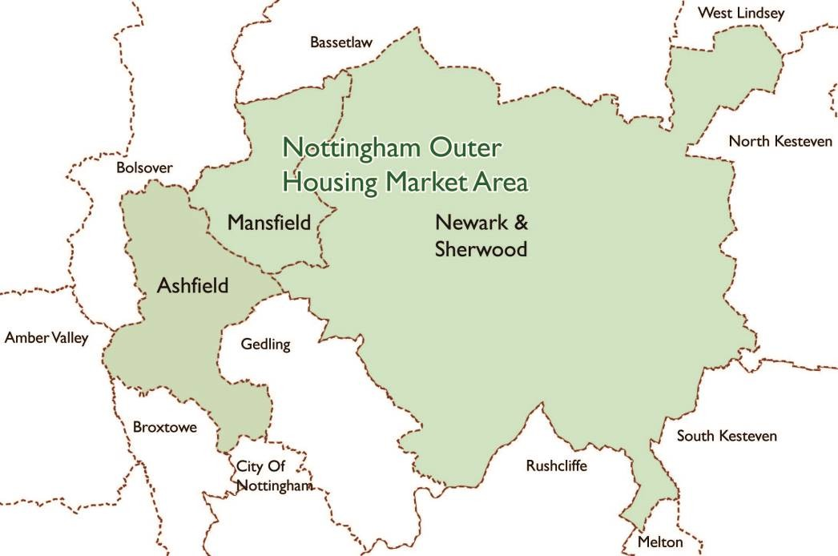

Plan 1: Nottingham Outer Housing Market Area.
Source: Ashfield District Council.
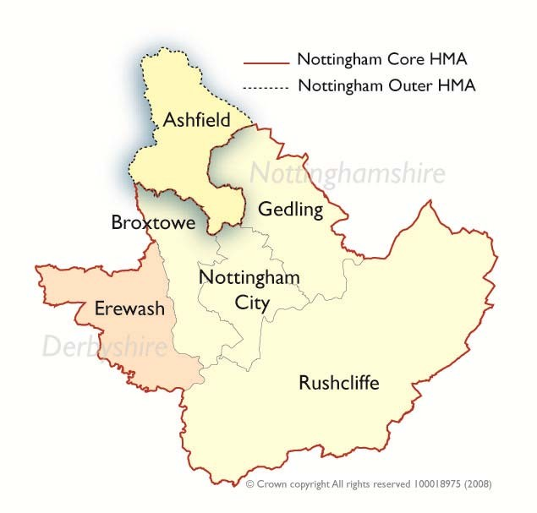

Plan 2: Nottingham Core Housing Market Area.
Source: Ashfield District Council.

Sustainability Appraisal
  - An integrate part of bringing the Local Plan forward is sustainability appraisal, which identify how sustainable development is being addressed through the Plan.

“Local plans and spatial development strategies should be informed throughout their preparation by a sustainability appraisal that meets the relevant legal requirements. This should demonstrate how the plan has addressed relevant economic, social and environmental objectives (including opportunities for net gains). Significant adverse impacts on these objectives should be avoided and, wherever possible, alternative options which reduce or eliminate such impacts should be pursued. Where significant adverse impacts are unavoidable, suitable mitigation measures should be proposed (or, where this is not possible, compensatory measures should be considered)”. National Planning Policy Framework 2019, paragraph 32
(A footnote to the NPPF paragraph 32 identifies that the reference to relevant legal requirements refers to Strategic Environmental Assessment).

  - The SA Scoping Report is the first stage of undertaking Sustainability Appraisal. It draws together information about Ashfield and the wider area to establish a SA Framework against which the effect of the Local Plan proposals and policies will be assessed. This includes:
    - Identify environmental, social and economic objectives contained in other plans and programmes that are relevant to the Local Plan;
    - Sets out ‘baseline information’ on the existing environmental, economic and social characteristics of Ashfield and its links to the wider area;
    - In the context of these reviews, consider key issues and problems that the Local Plan should address in the interest of sustainable development;
    - Setting out an appropriate framework for carrying out an SA assessment, including objectives against which draft policies and options may be assessed, and indicators against which progress towards meeting those objectives can be monitored in future.
    - Identified whether proposals have a positive or negative impact and what mitigations may be available to reduce any negative impacts.

Section 2: Approach to SA
Legislative Framework
  - The Planning and Compulsory Purchase Act 2004 identifies a number of requirements in relation to sustainable development and SA:

    - Under section 19 of the Act “The local planning authority must:
      - carry out an appraisal of the sustainability of the proposals in each development plan document;
      - prepare a report on the findings of the appraisal.” (I.e the sustainability appraisal).
    - Section 39 requires that in preparing the local plan a council “must exercise the function with the objective of contributing to the achievement of sustainable development” having regarding under S39 to national policies and advice contained in guidance issued by the Secretary of State.
Under the Town and Country Planning (Local Planning) (England) Regulations 2012, Regulation 22 sets out a list of prescribed documents for the purpose of Section 20(3) of the Planning and Compulsory Purchase 2004 Act including the sustainability appraisal report.
  - In undertaking the requirement for SA, local planning authorities must also meet the requirements of European Union Directive 2001/42/EC (commonly referred to as Strategic Environmental Assessment or SEA). The Directive was translated into legislation in the United Kingdom through the Environmental Assessment of Plan and Programmes Regulations 2004 (EAPP). The EAPP requires that local authorities undertake an ‘environmental assessment’ of any plans and programmes they prepare that are likely to have a significant effect upon the environment. The specific requirements are set out in Table 2.

THE SEA DIRECTIVE REQUIREMENTS
The preparation of an environmental report | Preparation of an environmental report in which the likely significant effects on the environment of implementing the plan or programme, and reasonable alternatives taking into account the objectives and geographical scope of the plan or programme are identified, described and evaluated. The information to be given is:  - An outline of the contents, main objectives and geographical; scope of the plan or programme, and relationship with other relevant plans and programmes;  - The relevant aspects of the current state of the environment and the likely evolution thereof without implementation of the plan or programme;  - The environmental characteristics of the areas likely to be significantly

 | affected;
 | d) Any existing environmental problems which are relevant to the plan or programme including, in particular, those relating to any areas of a particular environmental importance, such as areas designated pursuant to Directives 79/409/EEC (SPA’s) and 92/43/EEC (SAC’s);
 | e) The environmental protection objectives, established at international, community or national level, which are relevant to the plan or programme and the way those objectives and any environmental considerations have been taken in account during its preparation;
 | f) The likely significant effects on the environment, including on issues such as biodiversity, population, human health, fauna, flora, soil, water, air, climatic factors, material assets, cultural heritage including architectural and archaeological heritage, landscape, and the interrelationship between the above factors. (These affects should include secondary, cumulative, synergistic, short, medium and long-term permanent and temporary, positive and negative effects);
 | g) The measures envisaged to prevent, reduce and as fully as possible offset any significant adverse effects on the environment of implementing the plan or programme;
 | h) An outline of the reasons for selecting the alternatives dealt with, and a description of how the assessment was undertaken including any difficulties ( such as technical difficulties or lack of know-how) encountered in compiling the required information;
 | i) A description of measures envisaged concerning monitoring in accordance with Article 10;
 | j) A non-technical summary of the information provided under the above headings.
 | The report shall include the information that may reasonably be required taking into account current knowledge and methods of assessment, the contents and level of detail in the plan or programme, its stage in the decision-making process and the extent to which certain matters are more appropriately assessed at different levels in that process to avoid duplication of the assessment
Consultation | - Authorities with environmental responsibility, when deciding on the scope and level of detail of the information to be included in the environmental report.
 | - Authorities with environmental responsibility and the public shall be given an early and effective opportunity within appropriate time frames to express their opinion on the draft plan or programme and the accompanying environmental report before the adoption of the plan or programme.
 | - Other EU Member States, where the implementation of the plan or programme is likely to have significant effects on the environment of that country
Consideration | Taking the environmental report and the results of the consultations into account in decision-making.
Provision of information on the decision | When the plan or programme is adopted, the public and any countries consulted shall be informed and the following made available to those so informed:  - The plan or programme as adopted;
 | - A statement summarising how environmental considerations have been

integrated into the plan or programme and how the environmental report pursuant to Article 5, the opinions expressed pursuant to Article 6 and the results of consultations entered into pursuant to Article 7 have been taken into account in accordance with Article 8, and the reasons for choosing the plan or programme adopted, in light of the other reasonable alternatives dealt with; and
- The measures decided concerning monitoring
Monitoring of the significant environmental effects of the plan’s or programme’s implementation
Environmental reports should be of a sufficient standard to meet the requirements of the SEA Directive
Quality Assurance
Monitoring

Table 2: The SEA Directive Requirements

  - There are no statutory requirements on the form of an SA. However, the EAPP requires that an assessment must be in the form of a report and the report shall identify, describe and evaluate the likely significant effects on the environment of:

- Implementing the plan or programme.

- Reasonable alternatives taking into account the objectives and the geographical scope of the plan or programme. (Reg 12(2)).

- The likely significant effects on the environment, including short, medium and long-term effects, permanent and temporary effects, positive and negative effects, and secondary, cumulative and synergistic effects, on issues such as:

  - biodiversity;
  - population;
  - human health;
  - fauna;
  - flora;
  - soil;
  - water;
  - air;
  - climatic factors;
  - material assets;
  - cultural heritage, including architectural and archaeological heritage;
  - landscape; and
  - the inter-relationship between the issues referred to in sub-paragraphs
    - to (l).

SEA and SA are similar processes that involve a comparable series of tasks. The main difference is that SEA focuses on environmental effects, whereas SA covers environmental, social and economic matters.

What is the Purpose of Sustainability Appraisal?
  - The purpose of SA is to promote sustainable development through integration of sustainability considerations into the preparation and adoption of documents. SA is a systematic process undertaken during preparation of a plan or strategy. Its role is to promote sustainable development by assessing the extent to which the emerging plan will help to achieve relevant environmental, economic and social objectives. As such, it provides an opportunity to identify adverse, as well as positive impacts that that the plan or strategy might have on these aims and thereby where applicable to identify potential mitigation measures.

  - The overall aims of the SA process are:
    - To ensure that all aspects of sustainable development are fully integrated into the Local Plan throughout its preparation and revision;
    - To provide an assessment of the potential environmental, economic and social effects of the plan;
    - To enable people who have not been involved in the plan making process to understand what information was considered, and why certain decisions were made;
    - To consult on the SA procedure, allowing the public and stakeholders to have an input into the process; and
    - To meet the requirements of the SEA Directive
  - As stressed in Planning Practice Guidance, both SA and SEA are tools used at the plan making stage to assess the likely effects of the plan when judged against reasonable alternatives. While the SA informs decision-making, it is advisory rather than prescriptive. The role of the SA is to provide information on the likely effects of a plan and any reasonable alternatives. This information is utilised to make informed selections. However, it is the Council, as the plan-maker and not the assessment process that ultimately determines the preferred approach within the Plan. For example, a less than positive environmental alternative may be selected but the assessment process will clarify where adverse environmental effects are likely to occur and identify whether mitigation may be possible.

  - Case law establishes the importance of a reasoned selection and rejection of reasonable options for assessment, comparable assessment of reasonable

alternatives, reasoned rejection of any reasonable alternatives options and the reason for the selection of the preferred approach by the Council.

  - A number of other positive impacts potentially arise from undertaking SA:
    - Improved plans: SA can make plan making more systematic and contribute to an evidence base by providing meaningful social, economic and environmental information;
    - Providing insights: The SA can offer a different perspective on a plan by ensuring that the plan-maker looks at it from different viewpoints;
    - Facilitates communication and transparency: The SA helps to enhance wider understanding of a plan’s social, economic and environmental effects and, through an understanding of those effects, reduce opposition to proposals;
    - Improved environmental protection – It identifies environmental effects and help the plan-maker to avoid potential problems by proposing alternative solutions;
    - Reduced long-term costs: by helping to avoid unforeseen effects.
  - The best-known definition of sustainable development comes from Our Common Future (the “Brundtland Report”), prepared by the World Council on Environment and Development in 1987, which defines sustainable development as ‘development that meets the needs of the present without compromising the ability of future generations to meet their own needs”⁶ .

  - Definitions that are more recent have included social inclusion/progress and economic growth/performance within the definition of sustainability. In 2005 the UK Government published Securing the Future- UK Government sustainable development strategy⁷ (DEFRA, 2005), which identifies sustainable development as having five key principles. These are:

    - Living within Environmental Limits
    - Ensuring a Strong, Healthy and Just Society
    - Achieving a Sustainable Economy
    - Promoting Good Governance
    - Using Sound Science Responsibly
The National Planning Policy Framework 2019 (NPPF) in Paragraph 8 identifies that there are three overaching dimensions to sustainable development economic, social and environmental. Achieving sustainable development means that the planning system has three overarching objectives, which are interdependent and need to be pursued in mutually

⁶ The Brundtland Commission Report – Our Common Future (Word Commission on Environment and Development) 1987
⁷ UK Sustainable Development Strategy, March 2005

supportive ways (so that opportunities can be taken to secure net gains across each of the different objectives):

    - an economic objective – to help build a strong, responsive and competitive economy, by ensuring that sufficient land of the right types is available in the right places and at the right time to support growth, innovation and improved productivity; and by identifying and coordinating the provision of infrastructure;
    - a social objective – to support strong, vibrant and healthy communities, by ensuring that a sufficient number and range of homes can be provided to meet the needs of present and future generations; and by fostering a well-designed and safe built environment, with accessible services and open spaces that reflect current and future needs and support communities’ health, social and cultural well-being; and
    - an environmental objective – to contribute to protecting and enhancing our natural, built and historic environment; including making effective use of land, helping to improve biodiversity, using natural resources prudently, minimising waste and pollution, and mitigating and adapting to climate change, including moving to a low carbon economy.
The Relationship between SA and SEA
  - The SA includes within it Strategic Environmental Assessment (SEA). The SEA provides the opportunity to identify and address the environmental implications of the Plan. Where alternatives with negative environmental effects are selected for other reasons, the SA has a practical role to play in identifying mitigation measures to avoid or reduce these effects as far as possible. The SEA Directive requires ... consideration of 'measures envisaged to prevent, reduce and as fully as possible offset any significant adverse effects on the environment of implementing the plan or programme'.

  - The requirements to carry out SEA and SA are distinct, but the Planning Practice Guidance identifies that sustainability appraisal should meet all of the requirements of the Environmental Assessment of Plans and Programmes Regulations 2004⁸. SA goes further than SEA (which is primarily focused on environmental effects) requiring the examination of all the sustainability- related effects, whether they are social, economic or environmental. Throughout this document, the term SA is used to refer to the joint SA/SEA process.

  - Table 3 identifies how the requirements of SEA are met in the SA.

⁸ Planning Practice Guidance Paragraph; 007 Reference ID: 11-007-20140306

SEA Requirements | Covered in the SA Report
Preparation of an environmental report that identifies describes and evaluates the likely significant effects on the environment of implementing the plan or programme and reasonable alternatives taking into account the objectives and geographical scope of the plan or programme (regulation 12(2)).
The report shall include such of the information referred to in Schedule 2 as may reasonably be required, taking into account current knowledge and methods of assessment, the contents and level of detail in the plan or programme, its stage in the decision-making process and the extent to which certain matters are more appropriately assessed at different levels in the process to avoid duplication of the assessment (regulation 12(3)). Information may be provided by reference to relevant information obtained at other levels of decision- making or through other EU legislation (regulation 12 (4)).
When deciding on the scope and level of detail of information to be included in the environmental report the consultation bodies should be consulted.
a) An outline of the contents, main objectives of the plan or programme, and relationship with other relevant plans and programmes; | The main objectives of the Local Plan will be described in the Sustainability Appraisal report.
b) The relevant aspects of the current state of the environment and the likely evolution thereof without implementation of the plan or programme; | Section 4 of the Scoping Report summarises the characteristics of the Council areas and sets out baseline data. Section 4 identifies what the implication would be without the implementation of the Local Plan  The likely evolution thereof without implementation of the Local Plan will be assessed and reported in the  Sustainability Appraisal report.
c) The environmental characteristics of areas likely to be significantly affected; | Section 4 of the Scoping Report summarises the characteristics of the Council area.  Baseline data will be update as  necessary.
d) Any existing environmental problems which are relevant to the plan or programme including, in particular, those relating to any areas of a particular environmental importance, such as areas designated pursuant to Directives 2009/147/EC (Conservation of Wild Birds) and 92/43/EEC (Habitats Directive).; | These requirements will be considered as part of the SA Report.  A Habits Regulation Assessment Screen Report will be undertaken and, if required, a full Assessment considering the implications of the decision of the Court of Justice of  the European Union (CJEU) in People Over Wind v Coillte Teoranta [2018].
e) The environmental protection, objectives, established at international, Community or national level, which are relevant to the plan or programme and the way those objectives and any environmental, considerations have been taken into account during its preparation; | Section 3 and the SA Framework contains the key messages from the reviews of plans, policies and programmes. Section 4 of the Scoping Report describes the sustainability issues facing the  Council.

Table 3: The Requirements of the SEA Directive Scoping Methodology
f) The likely significant effects on the environment, including on issues such as biodiversity, population, human health, fauna, flora, soil, water, air, climatic factors, material assets, cultural heritage including architectural and archaeological heritage, landscape and the interrelationship between the above factors. These effects should include secondary,  cumulative, synergistic, short, medium and long-term permanent and temporary, positive and negative effects. | The likely significant effects will be assessed and reported in the Sustainability Appraisal report.
g) The measures envisaged to prevent, reduce and as fully as possible offset any significant adverse effects on the environment of implementing the plan or programme; | The measures to prevent, reduce and offset any significant adverse effects  will be reported in the Sustainability Appraisal report.
h) An outline of the reasons for selecting the alternatives dealt with, and a description of how the assessment was undertaken including any difficulties (such as technical deficiencies or lack of know-how) encountered in compiling  the required information; | The reasons for selecting the alternatives and a description of how the assessment was undertaken will be reported in the Sustainability Appraisal report.
i) A description of measures envisaged concerning monitoring in accordance with regulation 10; | The monitoring framework will be  reported in the Sustainability Appraisal report.
j) A non-technical summary of the information provided under the above headings | A non-technical summary will be included in the Sustainability Appraisal report.

  - The approach to undertaking a reviewing of the SA is based upon Planning Practice Guidance. It also utilises A Practical Guide to the Strategic Environmental Assessment Directive⁹. The guidance is designed to ensure compliance with the requirements of the SEA Directive.

  - The SA is anticipated to be carried out in a series of stages, which includes setting the context and objectives for the sustainability appraisal, developing and assessing the effects of policy options and carrying out consultation on a Sustainability Appraisal Report. The stages of preparation are shown below.
  - The scoping report covers Stage A of the SA process. The Sustainability Appraisal report will cover Stages B and C of the SA process. Stage D represents the consultation stage which the Sustainability Appraisal report will be published alongside the publication draft of the Local Plan in order to seek comments. The remaining Stage E will be completed at the adoption stage.

⁹ A Practical Guide to Strategic Environmental Assessment Directive. Office of the Deputy Prime Minister. 2005

Sustainability Appraisal and SEA. |  |  |  | Local Plan
 |  |  | Identify other relevant policies, | Evidence gathering and
 |  | 1 | plans and programmes, and | engagement.
 | Setting the |  | sustainability objectives.
 | context and
 |  | 2 | Collect baseline information.
Stage A | objectives, establishing the  baseline and
 |  | 3 | Identify sustainability issues and problems.
 | deciding on the
 |  | 4 | Developing the SA framework.
 | scope.
 |  | 5
 |  |  | Consult the consultation bodies on
 |  |  | the scope of the SA report.
Stage B | Developing and refining alternatives and assessing effects. | 1 | Test the Local Plan objectives against the SA framework. | Consult on the Local Plan (Town & Country Planning (Local Plan) (England) Regulations 2012, as  amended Regulation 18). Draft Local Plan.
 |  | 2 | Develop the Local Plan options including reasonable alternatives.
 |  | 3 | Evaluate the likely effects of the Local Plan and alternatives.
 |  | 4 | Considering ways of mitigating adverse effects and maximising beneficial effects.
 |  | 5 | Propose measures to monitor the significant effects of implementing the Local Plan (DPDs).
Stage C | Prepare the SA report. |  |  | Prepared the publication version of the Local Plan.  ↓
Stage D | Seek representations on the SA report from consultation bodies and the public. |  |  | Seek representations on the Local Plan Publications (Regulation19).  ↓  Submit Local Plan and supporting evidence for independent examination.  ↓  Outcome of the examination.  ↓
 |  |  |  | Local Plan adopted.
Stage E | Post adoption reporting and monitoring. | 1 | Prepare and publish post-adoption statement. | Monitor and report on the implementation of the Local Plan.
 |  | 2 | Monitor significant effects of implementing the Local Plan.
 |  | 3 | Respond to the adverse effects.

Table 4: Sustainability Appraisal and the Local Plan
Source: Based on National Planning Practice Guidance. Paragraph 013 Reference ID 11- 033-20140306

  - The NPPF attaches great importance to Green Belts.

The fundamental aim of Green Belt policy is to prevent urban sprawl by keeping land permanently open; the essential characteristics of Green Belts are their openness and their permanence.’
  - The Green Belt is designated for five purposes10:
- to check the unrestricted sprawl of large built-up areas;
- to prevent neighbouring towns merging into one another;
- to assist in safeguarding the countryside from encroachment;
- to preserve the setting and special character of historic towns; and
- to assist in urban regeneration, by encouraging the recycling of derelict and other urban land.

The boundary to the Green Belt can be amended through a review of the Local Plan but it should only be altered in exceptional circumstances11.

  - Planning Practice Guidance on Strategic environmental assessment and sustainability appraisal does not specifically address Green Belt in relation to the SA of the Local Plan. However, the PPG sets out :

Baseline information ‘provides the basis against which to assess the likely effects of alternative proposals in the draft plan.’ (Paragraph: 016 Reference ID: 11-016-20190722)

The sustainability appraisal needs to consider and compare all reasonable alternatives as the plan evolves, including the preferred approach, and assess these against the baseline environmental, economic and social characteristics of the area and the likely situation if the plan were not to be adopted. (Paragraph: 018 Reference ID: 11-018-20140306).

The only specific reference to Green Belt and SA is in the Planning Practice Guidance for Waste where Preparing sustainability appraisals for Local Plans (Paragraph: 020 Reference ID: 28-020-20141016) identifies a ‘Table of possible Topics and Issues for the Appraisal Framework which includes:
- Impact on landscapes (urban, rural, urban fringe) and nationally protected landscapes
- Impact on Green Belt (e.g. maintain extent, openness)
Landscape

  - In this context, it is considered that the Green Belt should be taken into account particularly as it is a significant factor in considering the reasonable alternatives and arriving at an appropriate strategy.

¹⁰NPPF, paragraph 134

¹¹The NPPF, paragraph 136

Integration with other Assessments
  - Various other assessments are also carried out on the Local Plan in addition to SA reports. These are not part of the SA process but nevertheless cover sustainability issues:
    - Habitats Regulation Assessment (HRA) is an additional requirement, required under the Conservation of Habitats and Species Regulations 2017. It is being undertaken separated rather than as a component part of the SA.
    - Equalities Impact Assessment (EqIA) - Undertaking Equality Impact Assessments allows the councils to identify any potential discrimination caused by their policies or the way they work and take steps to make sure that it is removed.
    - Health Impact Assessment (HIA) - where it is deemed necessary a HIA will be undertaken. Nottinghamshire County Council has prepared a Planning and Health engagement protocol setting out arrangements for how health partners including Nottinghamshire County Council should be consulted on local plans and planning applications. This initiative to improve engagement between the health partners and local planning authorities builds on the Health and Wellbeing Strategy previously produced by Nottinghamshire County Council which recommended the use of the Planning and Health checklist to assess development proposals.

Section 3: Identification of Other Relevant Plans, Policies and Programmes and Sustainability Objectives

(Stage A1 - Table 4 Sustainability Appraisal and the Local Plan)
  - A key aspect of the SA involves reviewing relevant international, national, regional and local policy guidance, plans and strategies to identify their requirements, and assess their relationship to the Local Plan.

  - The review makes specific reference to any environmental protection objectives, targets or requirements established at the international, European or national level to comply with the SEA Directive.

  - There is no definitive list of plans that must be reviewed. The EAPP Regulation 12(3), Schedule 2 part 6 identifies that plans and programmes should consider likely significant effects on the environment and identifies a number of issues (See Section 2 paragraph 2.3 c ). These issues have been considered in conjunction with the provisions of the NPPF, which sets out that the purpose of the planning system is to contribute towards the achievement of sustainable development. It identifies three overarching objectives, which are interdependent, an economic objective, a social objective and an environmental object. (See Section 2 paragraph 2.11). The combination of the issues in the EAPP and the NPPF objectives has been utilised in determining relevant plans, policies and programme and the baseline information anticipated to form the basis of the Sustainability Appraisal. The various ‘chapters’ in the NPPF have been used as broad basis to consider the sustainability aspects. For example, Delivering a sufficient supply of homes, Building a strong, competitive economy.
  - The analysis of sustainability objectives, targets and indicators derived from the plans, policies and programmes provided in Appendix 1 considers both the implications for Local Plan and for developing the SA Framework. Each of the themes identified relates to sustainable development in Ashfield. Through the analysis of the baseline data, a number of sustainability issues for Ashfield have been identified. The analysis of the implications arising from the plans and programmes and the issues and problems in the baseline have been utilised to determine relevant Sustainability Appraisal Objectives. These aspects have been brought together in Table 5, which sets out the key messages from the reviews of plans, policies and programmes, the source and the implications for the SA framework. The key messages list is split into different themes, however, it should be recognised that these themes are interlinked and overlap.

  - The list of relevant documents will be kept under review during the SA process.

Ashfield District Council
Local Plan Sustainability Appraisal Scoping Report 2020

  - In relation to the SEA requirements, a number of effects on the environment are identified¹² . However, there is no definition in the Directive as to what they encompass. In the context of the Scoping Report, Appendix 2 set out a definition of the various effects. Population is considered to include information on demographics and generic socio-economic issues and can be seen to run across a substantial number of these key messages set out above.

¹² The Environmental Assessment of Plans and Programmes Regulations 2004 Regulation 12(3) Schedule 2 paragraph 6

Table 5: Key messages

Key messages from review of relevant plans, policies and programmes | Source of message | Implications for the SA Framework | Issues in Ashfield from the evidence base
Sustainable Development From a planning perspective NPPF identifies sustainable development has having three Three objectives :  - Economic objective  - Social objective  - Environmental objective  At a high level, the objective of sustainable development can be summarised as meeting the needs of the present without compromising the ability of future generations to meet their own needs. (Reflects resolution 42/187 of the United Nations General Assembly). | - 42/187. Report of the World Commission on Environment and Development  - Johannesburg Declaration on Sustainable Development  - 2009 Review of the EU Sustainable Development Strategy (EU SDS, 2006)  - UK Sustainable Development Strategy  - Securing the Future (Final, HM Government, 2005)  - National Planning Policy Framework (NPPF)  - Planning Practice Guidance (PPG) | Sets out the requirement for sustainable development in planning.
DELIVERING A SUFFICIENT SUPPLYOF NEW HOMES
Housing  Identification that not enough housing is being developed to meet housing needs. The NPPF requires that local planning authorities should significantly boost the supply of housing for market and affordable housing’ are met. | - Fixing our broken housing market (Housing White Paper) 2017  - NPPF  - PPG  - Planning policy for travellers sites  - UK Climate Change Programme  - Self Build and Custom Build Act 2015  - D2N2 Local Enterprise Partnership Vision 2030 Strategic Economic Plan, | Requires objectives to ensure that it meets the housing requirements of the District and, where necessary and appropriate, neighbouring districts and the housing stock is of a high quality and meets the requirements of all sectors of the community. | Issues and Problems  - Understand the level of housing required in Ashfield and the interaction between different areas of the District and the relationship with the Greater Nottingham Area.  - To provide sufficient housing of a type and tenure to meet specific needs and to provide a choice and

Key messages from review of relevant plans, policies and programmes | Source of message | Implications for the SA Framework | Issues in Ashfield from the evidence base
The aims should be to creating ‘sustainable, inclusive and mixed communities’.  Other aspects identified are:  - Reduce homelessness  - Opportunities for self build  - Reduce the number of empty homes  - Improve affordability across the housing market  - Increase the supply of houses  - Provide a supply of high quality, well designed, energy efficient housing appropriate to needs of the community including family homes, homes to meet the needs of the ageing population and social housing  - New homes to be energy efficient, and able to cope with the effects of climate change  - Provide adequate amount of land for gypsies and travellers | - Nationally Described Space Standard, March 2015  - Appraisal of Sustainable Urban Extensions - Nottingham Core HMA (June 2008)  - Nottinghamshire and Erewash Older Peoples Housing Needs Study  - Disabled People's Housing Needs Study - An Assessment of the Housing Needs of People with Physical Disabilities Notts and Derbys Authorities.  - Ashfield Local Plan Review  - Ashfield Corporate Plan  - Nottingham Outer Housing Market Area, Strategic Housing Market Assessment, 2015.  - Ashfield Traveller Accommodation Needs Assessment, 2015  - Ashfield Whole Plan and CIL Viability Assessment 2016 |  | mix of sites.  - Housing in terms of new build has declined in recent years and is not meet the housing need identified by the NPPF Standard Method.  - While the District is perceived as an area of affordable housing, when income levels in Ashfield are taken into account, housing affordability is an issue in the District.  - Changing demographic structure, including an aging population, will impact future household characteristics and will have implications for the provision of housing requirements, employment opportunities and services.  - Given that substantial parts of the District are in Green Belt, there are issues in balancing the housing needs of specific areas against the impact on the Green Belt and the countryside.  - A substantial number of brownfield sites have been developed in Ashfield. The consequence is that limited brownfield sites are available necessitating the utilisation of greenfield sites to meet housing needs.  - Reduce the potential impacts on the environment and social

Key messages from review of relevant plans, policies and programmes | Source of message | Implications for the SA Framework | Issues in Ashfield from the evidence base
infrastructure of Ashfield whilst allocating land to provide for housing requirements.
- Improving the quality of the existing housing stock
BUILDING A STRONGER COMPETATIVE ECONOMY
Business development & the economy  Emphasis upon economic growth and productivity from a variety of policies. The NPPF stresses the importance of considering market and economic signals, together with understanding business needs.  Planning can make a contribution by ensuring that sufficient land of the right type is available in the right places and at the right time to support growth and innovation; and by coordinating development requirements, including the provision of infrastructure’.  Emphasis is upon the local plan supporting sustainable growth and expansion of business and enterprise.  Includes: | - EU Growth Strategy - Europe 2020, Recommendations for the United Kingdom  - NPPF  - PPG  - Industrial Strategy Building a Britain fit for the future 2017 (White Paper)  - Skills for Growth. BIS  - National Infrastructure Plan  - Fixing the foundations: creating a more prosperous nation 2015  - Future Telecoms Infrastructure Review 2018  - The Digital Economy Act 2017  - Digital Connectivity Portal  - Heritage and the Economy Heritage Counts 2019  - The heritage sector in England and its impact on the economy An updated report for Historic England June 2019  - D2N2 Vision 2030 Strategic Economic Plan and supporting evidence base Greater Nottingham Accessibility Strategy | Requires objectives to ensure there is sufficient land for business development; to ensure that businesses are located in the correct places and that local communities (especially deprived communities) benefit from them; to ensure that businesses do not cause harm to the communities in which they are situated; and to encourage diversity and high value, high growth, knowledge intensive economic activities, including tourism.  Requires objectives to improve employment skills and levels. | Issues and Problems  - Meeting the needs of all current and future populations in terms of business and job opportunities.  - Overreliance on the manufacturing sector where employment levels have declined over time.  - Accommodating any employment land and other development opportunities as far as possible within an urban area so as to minimise the impact on greenfield sites.  - Facilitate digital infrastructure to maximise growth opportunities.  - Providing the necessary infrastructure to accommodate current and future development needs in terms of physical green and social infrastructure.  - The need to encourage and accommodate both indigenous and inward investment particularly in

Key messages from review of relevant plans, policies and programmes | Source of message | Implications for the SA Framework | Issues in Ashfield from the evidence base
- Ensure supply of employment land.  - Support efficient, competitive and innovative retail, leisure and other sectors.  - Support digital infrastructure in the District to support growth and technological change.  - Regenerate deprived areas through business development.  - Ensure location of development makes efficient use of existing infrastructure.  - Develop economic capacity and expertise.  - Increase economic diversity.  - Maximise economic benefit from tourism.  - Encourage growth in high value, high growth, high knowledge economic activities.  - Ensure that economic growth goes hand-in-hand with high quality environment.  - Understand future demands | - A report on skills mismatches in Derby, Derbyshire, Nottingham, and Nottinghamshire LEP June 2017  - Ashfield Corporate Plan  - Ashfield & Mansfield a Plan for Growth  - Employment Land Forecasting Study 2015 Nottingham Core and HMA and Nottingham Outer HMA.  - Experian (June 2009) Ashfield and Mansfield Economic Analysis for Ashfield District Council and Mansfield District Council.  - Clayton.N & Wright.J. The Work Foundation (June 2010) Ashfield and Mansfield City Relationships.  - Centre for Local Economic Strategies (June 2010) Understanding the Resilience of Ashfield and Mansfield Economy.  - Roger Tym. (February 2007) The Nottingham City Region Employment Land Study & Update.  - Ove Arup & Partners. (March 2008) The East Midlands Northern Sub Region Employment Land Review, March 2008.  - Innes England (2009) Mansfield and Ashfield Districts Joint Property Strategy. December 2009  - Ashfield IDP  - Greater Nottingham IDP |  | relation to identified sectors, which have the potential for growth.  - Creating an environment that is attractive to future growth sectors to improve performance in comparison with other locations.  - Identifying opportunities for heritage led regeneration.  - There are pockets of deprivation particularly within the urban area. Economic regeneration is particularly important in these areas of the towns to help alleviate poverty.  - To increase incomes and skill levels, particularly in those communities suffering high levels of deprivation.  - The concern is that too many residents currently lack skills at the right level to respond to these labour market changes and will thus struggle to compete effectively.  - With the predicted increase in households there is likely to be an need to expand schools or provide new schools as a significant number of schools in Hucknall, Kirkby-in- Ashfield and Sutton in Ashfield are currently at or near capacity.  - To supporting the provision of appropriate sized schools/colleges

Key messages from review of relevant plans, policies and programmes | Source of message | Implications for the SA Framework | Issues in Ashfield from the evidence base
for land including type of land and location.  - Ensure that the location of industry and commerce brings benefit and not harm to local communities.  - Positive approach to employment opportunities in rural areas should be supported, including through support for tourism where appropriate.  - Encourage inward investment.  Employment  - Reduce worklessness  - Improve skills to help reduce unemployment and deprivation |  |  | and other skill learning facilities at a local level so as to help improve skills and opportunities .  - Potentially, using planning to improving employment prospects and training for local residents.  - The District’s working population has grown over the period 2001 to 2011 but is now showing signs of declining as the population ages.  - Responding to future trends in employment and supporting the growth of self-employment.
Rural  - Prevent decline in some rural communities  - Promote rural renewal  - Development of dynamic, competitive and sustainable economies in the countryside | - NPPF  - PPG  - Natural Environment and Rural Communities (NERC) Act 2006  - National Rural Proofing Defra  - Rural Economy Growth Review, 2011 and updates  - Towards a one nation economy: A 10- point plan for boosting rural productivity (2015) | Requires objectives to ensure sustainable communities in the countryside. | Issues and Problems  - The protection and enhancement of biodiversity, particularly statutory and non-statutory sites of nature conservation interest in Ashfield.  - Provide for jobs in the rural environment.

Key messages from review of relevant plans, policies and programmes | Source of message | Implications for the SA Framework | Issues in Ashfield from the evidence base
ENSURING THE VITALITY OF TOWN CENTRES
Town Centres  - Promote the vitality of town centres by promoting and enhancing existing centres.  - Connectivity within town centres.  - Diversity of uses within town centres  - Take advantage of economic opportunities related to tourism  - Provide centres for the local communities. | - EU Growth Strategy - Europe 2020, Recommendations for the United Kingdom  - NPPF  - PPG  - Heritage and the Economy Heritage Counts 2019  - The heritage sector in England and its impact on the economy An updated report for Historic England June 2019 Cebr  - Ashfield Retail and Leisure Study 2016  - Broxtowe, Gedling, Nottingham City and Rushcliffe Retail Study (2015)  - Sutton Town Centre Masterplan March 2019  - Town Centre Masterplans for Kirkby-in- Ashfield and Sutton-in-Ashfield  - Hucknall Town Centre Masterplan | Requires objects to support growth and diversity of town centres and local centres. | Issues and Problems  - The District has three shopping centres that need to be supported in order to keep them vital and viable.  - Bring forward key opportunities identified in the town centre masterplans within an appropriate timescale.  - Meeting the needs of all current and future populations in terms of business and job opportunities within town centres.  - Providing the necessary infrastructure to accommodate current and future development.  - Creating an environment that is attractive to future growth sectors to improve performance in comparison with other centres.  - Identifying opportunities for heritage led regeneration’ or similar alternative.
PROMOTE HEALTHY & SAFE COMMUNITIES
Health  The ‘Marmot Review’ of health inequalities in England, which concluded that there is ‘overwhelming evidence that | - Healthy people, healthy places briefing Obesity and the environment: increasing physical activity and active travel, 2013  - Ambient Air Quality and Cleaner Air for | Requires objectives to: influence Social determinates of health (a person’s health status and lifestyle, including economic, environmental and social | Issues and Problems  - Residents of Ashfield have a short life expectancy.  - To improve health and well being, and to prevent ill health (e.g.

Key messages from review of relevant plans, policies and programmes | Source of message | Implications for the SA Framework | Issues in Ashfield from the evidence base
health and environmental inequalities are inexorably linked and that poor environments contribute significantly to poor health and health inequalities’. Planning for good health can complement planning for biodiversity (green infrastructure) and climate change mitigation (walking/cycling).  - Improve health and access to quality health facilities  - More opportunities for walking and cycling  - Improve access to open space and leisure opportunities  - Understand the economic benefits of better health in the community | Europe Directive 2008/50/EC (2008)  - Equality Act 2010  - 'Fair Society, Healthy Lives 2010. Strategic review of health inequalities in England post-2010  - NPPF  - PPG  - Wellbeing and the Historic Environment Threats, Issues and Opportunities for the Historic Environment 2018 Historic England  - Planning healthy-weight environments TCPA & Public Health England  - Ashfield Corporate Plan  - Nottinghamshire Sustainability and Transformation Plan 2016-21  - Health & Wellbeing Strategy for Nottinghamshire 2018-2022  - Strategy for Primary Care Transformation Derbyshire and Nottinghamshire Area Team, 2014  - Nottingham North & East Clinical Commission Group Commissioning Plan.  - Mansfield & Ashfield Clinical Commissioning Group A Vision and Strategy for Primary Care  - Mansfield & Ashfield Clinical Commissioning Group and the Newark & Sherwood Clinical Commissioning Group Five Year Health and Social Care Strategy | conditions), health issues as a way to promote good planning and design and raise standards, improve health by providing opportunities for walking, cycling, sport and leisure activities and supports sustainable primary care that delivers high quality, efficient, and accessible primary care | through healthy eating and exercise).  - Health inequalities exist between the most and least deprived areas of the District.  - To provision health services and facilities in relation to the demands arising from new development.  - The Health and Welbeing Board has identified priority areas which they believe will have the biggest impact to help improve health and wellbeing. This includes including ‘losing the gap in educational attainment.’  - Lifestyle indicators are generally worse than the average for England.  - Ashfield performs poorly in the Indices of Multiple Deprivation. Ranked at 79th out of 326 local authority areas (IMD 2015).  - New health, sporting, leisure and recreational facilities should be provided and should encourage walking, cycling and more active lifestyles.  - The development of a high quality multifunctional green infrastructure network should be promoted identifying any opportunities for links with and enhancement of

Key messages from review of relevant plans, policies and programmes | Source of message | Implications for the SA Framework | Issues in Ashfield from the evidence base
 | - An Active Lifestyles Strategy for Ashfield  - Public Open Space Strategy 2016 |  | cultural heritage.  - Potential issue in meeting the needs of an aging population.  - The development of accessible cycle networks to facilitate alternative modes of transport.  - The development of quality green infrastructure should be promoted as part of development, linking to a green infrastructure network.  - Adult participation in sport has decreased in Ashfield in recent years.  - New health, sporting, leisure and recreational facilities should be provided and should encourage walking, cycling and more active lifestyles.
Education.  Education is highlight in relation to life chances, and health/wellbeing. NNPF places emphasis on a choice of school places to meet the needs of communities. Requirement to:  - Improve the quality of educational facilities.  - Improve educational attainment.  - Improvement of life chances and health through educational achievement. | - NPPF  - PPG  - Ashfield Corporate Plan  - Ashfield Community Safety Partnership Strategic Plan 2014 -17  - Nottinghamshire Transport Plan  - Skills for Growth. BIS  - Infrastructure Delivery Plan Ashfield  - Nottinghamshire County Council & Ashfield District Council Joint Statement The provision of School Places to Support Housing Allocations in the Ashfield Local Plan Publication 2016 2018 | Requires objectives that will cover improve educational attainment. | Issues and Problems  - Ashfield has lower than average education attainment levels in schools.  - There is a need to support the extension and/or rebuilding of schools to meet future education needs from development.

Key messages from review of relevant plans, policies and programmes | Source of message | Implications for the SA Framework | Issues in Ashfield from the evidence base
Community safety  Reduce crime and the fear of crime from PPP is reflected in the requirements of the NPPF. This can be seen in relation to the importance of crime and safety in relation to good design and in the promotions of healthy communities. The emphasis is that good design should create safe accessible environments where ‘crime and disorder, and the fear of crime’ are decreased. | - NPPF  - PPG  - Ashfield Community Safety Partnership Strategic Plan 2019 -2022 | Requires objectives to reduce crime and the fear of crime, and change behaviour that is often linked with crime. | Issues and Problems  - To improve safety and security for people and property (e.g. through design intervention) and to reduce fear of crime.  - Good design of development to minimise conflict between road users.
PROMOTING SUSTAINABLE TRANSPORT
Transport and Accessibility  Transport policies are important in ‘contributing to sustainability and health objectives’. Stress placed on ‘sustainable transport’, developments in locations which are or can be made sustainable (making the fullest use of public transport, walking and cycling). Emphasis on facilities be located within walking distance of properties. | - Planning Act 2008  - National Infrastructure Plan  - NPPF  - PPG  - Making Connections DfT  - Healthy people, healthy places briefing Obesity and the environment: increasing physical activity and active travel, 2013  - Transport Investment Strategy 2017  - The future of transport: a network for 2030 DfT  - The Inclusive Transport Strategy: achieving equal access for disabled | Requires objectives to enable the development of sustainable transport infrastructure that reduces overall levels of travel and ensures accessibility to key services (e.g. health services, education, employment sites, and leisure facilities), the provision of safe walking and cycling routes, and safe accessible public transport. | Sustainability Issues and Problems  - Embed accessibility into locational requirements for development and decision making and the access to services (such as health, education and leisure).  - The need to improve the quality and range of services available within communities.  - Ensure that new development has good access to facilities and alternative means of travel.  - Reducing the dependency on the private car.

Key messages from review of relevant plans, policies and programmes | Source of message | Implications for the SA Framework | Issues in Ashfield from the evidence base
Transport infrastructure should provide as far as possible a safe environment with minimal conflict between road users, especially traffic and cyclists or pedestrians.  Includes:  - Embed accessibility in decisions affecting provision, location, design and delivery of services in both urban and rural areas.  - Improve social inclusion by making services more accessible.  - Tackle crime and fear of crime on public transport.  - Improve the quality and safety of pedestrian and cycling networks.  - Improve public transport networks.  - Encourage more people to walk and cycle.  - Reduce impact of travel on the environment.  - Maximise the use of existing roads infrastructure and avoid inappropriate development.  - Reduce traffic and in | people.  - UK Climate Change Programme  - Greater Nottingham Accessibility Strategy  - Reducing emissions from road transport: Road to Zero Strategy  - Nottingham Local Transport Plan: Strategy 2011 – 2026  - Nottinghamshire Local Transport Plan 2011-2026  - Greater Nottingham Accessibility Strategy  - Ashfield Transport Study 2016 |  | - Traffic congestion is an issue in Ashfield reflecting the new development proposed.  - Improvements will be required to specific junctions as part of development as otherwise there will be an adverse impact on congestion and journey times.  - Development close to the M1 motorway at Junction 27 has the potential to encourage car use and increase congestion, particularly around Sherwood Business Park and the roads to the west and east of Junction 27.  - To facilitate alternative forms of transport including encouraging more people to walk and cycle.  - Significant new development will need to facilitate bus services to gives choice of transport mode.  - To work with partners to provide an integrated and efficient transport system including public transport, walking and cycling network in Ashfield.  - Ensure that new development has good access to facilities and alternative means of travel.  - Reducing the dependency on the private car.  - To facilitate alternative forms of

Key messages from review of relevant plans, policies and programmes | Source of message | Implications for the SA Framework | Issues in Ashfield from the evidence base
particular journeys made by car.  - Improve public transport.  - Reduce traffic noise, pollution and congestion.  - Improve the freight network to reduce amount of road freight.  - Promote sustainable transport. |  |  | transport including encouraging more people to walk and cycle.  - A new Transport Study will be required to identify the implications of development  - The implications that over the life of the Plan combustion engines are likely to be increasingly phased out and replaced by ultra-low emission and electric vehicles.
SUPPORTING HIGH QUALITY COMMUNICATIONS
Business development & the economy  Substantial emphasis on improvements to the digital network. to achieve full fibre connectivity and 5G mobile broadband. | - Industrial Strategy Building a Britain fit for the future 2017 (White Paper)  - Future Telecoms Infrastructure Review 2018  - The Digital Economy Act 2017  - Digital Connectivity Portal  - NPPF  - PPG  - D2N2 Vision 2030 Strategic Economic Plan and supporting evidence base Greater Nottingham Accessibility Strategy | Requires objectives that take account of the need to support improvements to the digital infrastructure. | Issues and Problems  - Facilitate digital infrastructure to maximise growth opportunities.
MAKING EFFECTIVE USE OF LAND
Land use  Land use involves decisions on crosscutting and multi-layered | - NPPF  - PPG  - National design guidance | Requires objectives to ensure that best use of land is made prioritising the re-use of land and | Sustainability Issues and Problems  - Protecting better quality agricultural land from development.

Key messages from review of relevant plans, policies and programmes | Source of message | Implications for the SA Framework | Issues in Ashfield from the evidence base
issues that affect air quality, water quality, access to transportation, economic vitality, and quality of life. A key aspect is to use land to meet economic, social and environmental needs. It will include a substantial number of aspects but in the context of planning this will be reflected in:  - Provide an array of types and uses of buildings to meet the needs of residents and businesses.  - Providing housing is a key aspect  - Providing land required for employment purposes.  - Protecting land for environmental purposes  - Promoting education, health and community services with associated land use requirements.  - Maximise the use of brownfield land for housing, business and commercial development.  - Prioritise the re-use of existing buildings.  - Promote good design. | - Historic Landscape Characterisation Historic England.  - Greater Nottingham Landscape Character Assessment 2009  - Ashfield Monitoring Reports  (Substantial cross over with the requirements for housing, business development and infrastructure.) | buildings, (brownfield land) and housing development at higher densities. | - Balancing the needs of agriculture, recreation & access requirements, the need for alternative sources of energy, flood protection etc.  - Providing a framework within which to manage protection of existing habitats and creation of new ones,  - The need to safeguard and improve soil resources.  - Addressing contamination issues relating to previous land uses.  - Past development of brownfield sites means that currently there are limited stocks of vacant brownfield land. By implication, this means that there will be a loss of green field sites and agricultural land.  - Reinforcing the role of the town centres.
Resources | - The Town & Country Planning | Requires objectives to promote | Issues and Problems

Key messages from review of relevant plans, policies and programmes | Source of message | Implications for the SA Framework | Issues in Ashfield from the evidence base
Emphasis on the reuse of previous developed land and achieving appropriate densities. | (Brownfield Land Register) Regulations 2017  - NPPF  - PPG  - Increasing Residential Density in Historic Environments 2018. Historic England  - Ashfield Monitoring Reports | development that, where appropriate brownfield land Is utilised as a priority. | - While there are extensive employment sites in Ashfield these are largely currently occupied.  - The traditional factory sites related to textiles and the coal industry have been redeveloped or green over as part of country parks. Sites that have not been developed, such as North Street, already have planning permission for re-development. Consequently, there is likely to be a very limited supply of brownfield sites of this nature in the future.  - There are extensive ‘modern’ industrial estates but buildings have not reached the end of their economic life. Consequently, they are not suitable or deliverable in terms of national planning policy  - There is limited brownfield land available for development in Ashfield with the consequence that development is likely to be predominantly on greenfield sites.  - Minimum densities are set out by the Ashfield Local Plan Review, saved policies but these do not fully reflect national policy.
ACHIEVING WELL DESIGNED PLACES

Key messages from review of relevant plans, policies and programmes | Source of message | Implications for the SA Framework | Issues in Ashfield from the evidence base
Sustainable communities The NPPF promoting sustainable communities with sustainably accessible local services that reflect the community’s needs and supports its health and well- being:  identify the following:  - Promote social cohesion and inclusion in both urban and rural communities.  - Support vulnerable groups.  - Reduce deprivation, focusing on most deprived areas.  - Tackle poverty in urban and rural areas.  - Increase social interaction.  - Improve social development of children.  - Improve quality of life.  - Create clean, attractive, quality, safe urban spaces.  - Access to quality health, education, housing, transport, shopping and leisure services.  - Ensure equality of opportunity in housing, | - The Aarhus Convention  - 2009 Review of the EU Sustainable Development Strategy (EU SDS, 2006)  - NPPF  - PPG  - Equality Act 2010  - Planning policy for travellers sites  - Increasing Residential Density in Historic Environments 2018 Historic England  - Shaping Place Through Sport  - Ashfield Community Safety Partnership Strategic Plan 2014 -17  - D2N2 Local Enterprise Partnership Strategic Economic Plan and Implementation Plan  - Ashfield Corporate Plan  - Ashfield Playing Pitch Strategy, 2013  - Ashfield Green Space Strategy  - Ashfield Green Infrastructure and Biodiversity Technical Paper | Requires objectives to create attractive, safe, sustainable communities. | Issues and Problems  - Well-designed places can be achieved by taking a proactive and collaborative approach at all stages of the planning process, from policy and plan formulation to development but Local Plan design and density policies are increasing out of date in relation to national guidance.  - To ensure that recreation and leisure facilities including open space meets future demand  - The need to support green infrastructure (i.e. a strategic network of green spaces and recreational corridors)  - There are significant pockets of deprivation in Ashfield.  - Reinforce the role of the town centres by improving urban spaces and accessing social infrastructure.  (There is a substantial cross over with other key messages such as housing employment, biodiversity and cultural heritage).

Key messages from review of relevant plans, policies and programmes | Source of message | Implications for the SA Framework | Issues in Ashfield from the evidence base
employment and access to services.
- Recognise that different people have different needs.
MEETING THE CHALLENGE OF CLIMATE CHANGE AND FLOODING
Climate change  The Climate Change Act 2008 has set targets on reducing greenhouse gas emissions in the UK by at least 80% by 2050 and 34% by 2020. Zero carbon  by 2050.  The NPPF emphasises the key role for planning in securing reductions in greenhouse gas emissions, including in terms of meeting the targets set out in the Climate Change Act 2008. It also requires taking into account climate change through  ‘flood risk, water supply and changes to biodiversity and landscape.  This will include:  - Encourage low or zero carbon communities  - Minimise the effects of | - Kyoto Protocol (Doha Amendment)  - Strategic Environmental Assessment (SEA) Directive 2001/42/EC, on the Assessment of Certain Plans and Programmes on the Environment  - EU Directive 2009/28/EC on the Promotion of the Use of Energy from Renewable Sources  - NPPF  - PPG  - Climate Change Act 2008  - Draft National Flood and Coastal Erosion Risk Management Strategy for England May 2019  - Climate Impacts Tool. 2019 (Environment Agency)  - UK Climate Change Programme  - Understanding the risks: the UK climate change risk assessment (Gov Website)  - Heritage, Climate Change and Environment Historic England (webpage) | Requires objectives to reduce carbon dioxide emissions that contribute to climate change; and to ensure that new development is able to cope with the effects of climate change | Issues and Problems  - Planning for the adaptation of and long-term resilience of Ashfield in relation to all aspects of climate change.  - The Local Plan policies provide opportunities to support adaptation to climate change through appropriate design and layout and incorporation of features to facilitate resilience to the effects of climate change.  Issues and Problems  - Improving energy efficiency and increasing use of low-carbon and renewable energy.  - Balancing the potential amenity and landscape impacts and the need for alternative sources of energy.

Key messages from review of relevant plans, policies and programmes | Source of message | Implications for the SA Framework | Issues in Ashfield from the evidence base
climate change on human health and on the environment  - Ensure that new development is able to cope with climate change  - Spatial planning should contribute to sustainable communities and the reduction of carbon dioxide emissions | - The Code for Sustainable Homes  - Nottingham Declaration on Climate Change  - Climate Change Framework for Action in Nottinghamshire  - Nottinghamshire Sustainable Energy Policy Framework  - Planning for climate change – guidance for local authorities Planning and Climate Change Coalition
Transport and Accessibility  Stress placed on ‘sustainable transport’, developments in locations which are or can be made sustainable (making the fullest use of public transport, walking and cycling). Emphasis on facilities be located within walking distance of properties.  Includes:  - Improve public transport networks.  - Encourage more people to walk and cycle.  - Reduce traffic and in particular journeys made by car. | - NPPF  - PPG  - Healthy people, healthy places briefing Obesity and the environment: increasing physical activity and active travel, 2013  - Reducing emissions from road transport: Road to Zero Strategy  - Nottingham Local Transport Plan: Strategy 2011 – 2026  - Nottinghamshire Local Transport Plan 2011-2026  - Greater Nottingham Accessibility Strategy  - Ashfield Transport Study 2016 | Requires objectives to enable the development of sustainable transport infrastructure that contributes towards reducing climate change. | - Ensure that new development has good access to facilities and alternative means of travel.  - Reducing the dependency on the private car.  - To facilitate alternative forms of transport including encouraging more people to walk and cycle.  - The implications that over the life of the Plan combustion engines are likely to be increasingly phased out and replaced by ultra-low emission and electric vehicles.

Key messages from review of relevant plans, policies and programmes | Source of message | Implications for the SA Framework | Issues in Ashfield from the evidence base
Energy  Emphasis upon renewable energy European Commission sets out that the share of renewable energy grows to 20% by 2020 against a 1990 baseline. Consequently emphasis on:  - Seek secure, clean affordable energy.  - Reduce amount of energy consumed.  - Generate energy at local levels.  - Increase energy efficiency of homes and businesses.  - Increase the amount of renewable energy produced.  - Invest in the energy infrastructure.  - Recover energy from waste. | - Energy Act 2011  - Planning and Energy Act 2008  - National Policy Statements for energy infrastructure  - NPPF  - PPG  - Nottinghamshire Sustainable Energy Policy Framework  - Ashfield Climate Change Strategy and Action Plan  - Planning for climate change – guidance for local authorities. Planning and Climate Change Coalition  - Low Carbon Energy Opportunities and Heat Mapping for Local Planning Areas across the East Midlands Final Report 2011 | Requires objectives to improve energy efficiency of new development and to encourage alternative ways of generating energy. | Issues and Problems  - Improving energy efficiency and increasing use of low-carbon and renewable energy.  - Balancing the potential amenity and landscape impacts and the need for alternative sources of energy.
Flood risk  Emphasis on development to be directed away from areas of the highest risk of flooding. For watercourses a sequential test. Emphasis on:  - Safeguard land used to manage floodwater  - Avoid inappropriate | - EU Water Framework Directive  - EU Directive 2007/60/EC on the assessment and management of flood risks (2007)  - Flood and Water Management Act 2010  - NPPF  - PPG  - Draft National Flood and Coastal | Requires objectives to minimise flood risk by considering where development should take place, and by protecting floodplains. | Issues and Problems  - To take account of the impact of development on water in relation to water quality and flood risk.  - To avoid development within Flood Zones 2 and 3 unless exceptional reasons arise.  - While the risk of flooding from watercourses is relatively low there

Key messages from review of relevant plans, policies and programmes | Source of message | Implications for the SA Framework | Issues in Ashfield from the evidence base
development on floodplains  - Ensure new development does not afford risk elsewhere.  - Flood and Water Management Act 2010 highlights the use of Sustainable Urban Drainage systems (SuDS). | Erosion Risk Management Strategy for England May 2019  - Climate Impacts Tool. 2019 (Environment Agency)  - The River Basin Management Plans Humber River Basin District 2015  - River Trent Catchment Flood Management Plan 2010  - Flooding and Historic Buildings 2015 Historic England  - Nottingham Local Flood Risk Management Strategy  - River Leen and Day Brook Strategic Flood Risk Assessment Sept 2008  - Nottinghamshire Local Flood Risk Management Strategy 2015  - Ashfield Level 1 Strategic Flood Risk Assessment  - Watercycle Study for Greater Nottingham and Ashfield |  | is a risk from flooding is specific area, in particular, Hucknall and Jacksdale.  - The River Leen flows into the City from Ashfield and is identified as respond rapidly in the urban area to rainfall, giving less time to respond. Additional water into the River Leen raises significant flood issues in Nottingham. It is important that neighbouring authorities work in partnership to ensure that activities upstream do not increase flood risk within the City of Nottingham.  - To consider the impacts of other sources and particularly surface water on flood in relation to development.  - To the south and west of Nottinghamshire there are relatively steep areas, including heavily urbanised areas, such as Sutton-in- Ashfield and Mansfield. In these areas there is rapid surface water runoff and complicated interactions with the private sewer and highway drainage networks and culverted and open watercourses which can cause further surface water flooding.  - Groundwater flooding was identified in Hucknall combined with watercourse flooding in the Greater

Key messages from review of relevant plans, policies and programmes | Source of message | Implications for the SA Framework | Issues in Ashfield from the evidence base
Nottingham SFRA 2008
- Ensuring that development contributes towards reducing flooding risk through improvements to the drainage infrastructure and the use of sustainable urban drainage systems.
CONSERVING AND ENHANCING THE NATURAL ENVIRONMENT & PROTECTING THE GREEN BELT
Biodiversity and habitats Emphasis on the requirement to protect important sites, to plan for green infrastructure and to plan for ecological networks at ‘landscape scales’.  National policy sets out the commitment to ‘halt the loss of biodiversity and the degradation of ecosystem services in the EU by 2020’.  This will include:  - Protect and promote biodiversity  - Conserve threatened species  - Ensure that land uses (including agriculture) does | - UNESCO World Heritage Convention (1972)  - Strategic Environmental Assessment (SEA) Directive 2001/42/EC, on the Assessment of Certain Plans and Programmes on the Environment  - EU Biodiversity Strategy to 2020 (2011) 'Our Life Insurance, Our Natural Capital'  - EU Habitats Directive  - EU Birds Directive  - The Bern Convention on the Conservation of European Wildlife and Natural Habitats  - Biodiversity 2020: A strategy for England’s wildlife and ecosystem services Defra  - Natural Environment White Paper 2011 and Implementation Papers | Requires objectives to protect, enhance and improve biodiversity and habitats. | Issues and Problems  - The protection and enhancement of biodiversity, particularly statutory and non statutory sites of nature conservation interest in Ashfield.  - Ensuring that the plan proposals have no adverse effect upon the South Pennines Special Area of Conservation (SAC), the Birklands & Bilhaugh SPC and the Sherwood Forest potential Special Protection Area.  - Safeguarding nationally and locally valued species and habitats.  - Enhancing biodiversity and the natural environment potentially through Biodiversity Opportunity Mapping.  - Identifying opportunities for tree

Key messages from review of relevant plans, policies and programmes | Source of message | Implications for the SA Framework | Issues in Ashfield from the evidence base
not threaten biodiversity  - Protect, restore and improve habitats including woodland, and aquatic ecosystems  - Create and integrate habitats in urban spaces and in the built environment | - Countryside Act 1968  - Natural Environment and Rural Communities Act 2006  - Wildlife & Countryside Act 1981  - The Conservation of Habitats and Species Regulations (2017)  - Environment Bill 2020  - The Agricultural Bill 2020  - A Green Future: Our 25 Year Plan to Improve the Environment 2018  - NPPF  - PPG  - Local Biodiversity Action Plan for Nottinghamshire  - Ashfield Green Infrastructure and Biodiversity Technical Paper, 2013  - The Nottinghamshire Biodiversity Opportunity Mapping Project 2016 (Ashfield) |  | planting facilitating Greenwood Community Forest and faciliating zero carbon targets.
Landscape  The European Landscape Convention defines landscape as: “An area, as perceived by people, whose character is the result of the action and interaction of natural and/or human factors.” It recognises that the quality of all landscapes matters – not just those designated as ‘best’ or ‘most valued’. | - European Landscape Convention 2006  - NPPF  - PPG  - Countryside Act 1968 The Act imposes a duty on local authorities to have regard to the desirability of conserving the "natural beauty and amenity" of the countryside in the exercise of their functions relating to land.  - Countryside and Rights of Way Act 2000 | Requires objectives to protect, manage and enhance the landscape.  The Green Belt has to consideration in relation of the alternatives, policies and site allocations and requires exceptional circumstances if any amendments are proposed to the boundaries. | Sustainability Issues and Problems  - Uncontrolled development could harm local landscape and settlement character.  - Protect and enhance landscapes that contribute to the distinctive local character of areas within the District;  - Maximise the benefits from the landscape character assessment by using landscape character to make choices about the locations for

Key messages from review of relevant plans, policies and programmes | Source of message | Implications for the SA Framework | Issues in Ashfield from the evidence base
The NPPF identifies that planning should contribute to and enhance the natural and local environment by ‘protecting and enhancing valued landscapes.  Includes:  - Conserve and enhance the rural and built landscape  - Open up access to the countryside  - Provide opportunities to value our heritage  - Bring improvements to the physical environment through quality design  - Mitigation against harm to the landscape  The NPPF attached great importance to Green Belt. | - Landscape Character Assessment Guidance for England and Scotland  - Historic Landscape Characterisation Historic England.  - East Midlands Regional Landscape Character Assessment  - Greater Nottinghamshire Landscape Character Assessment 2009  - Ashfield Green Space Strategy  - Ashfield Green Infrastructure and Biodiversity Technical Paper |  | development and the design of proposals.  - Improving the public realm and promoting high standards of design where regeneration is required.  - Potential effects on landscape quality from poor design and layout of new development areas.  - A substantial part of Ashfield is within the Green Belt where exception circumstances are require to justify changes to the Green Belt boundaries.
Pollution  PPP and reflected in the NPPF identifies that planning policies should be compliant with and contribute towards EU limit values and national objectives for pollutants.  Development should be prevented from contributing to, | - EU Directive on ambient air quality management  - Directive 2010/75/EU on industrial emissions (integrated pollution prevention and control) (2010)  - EU Environmental Noise Directive 2002/49/EC  - Environmental Protection Act 1990- Environmental Act 1995 - Clean Neighbourhoods and Environmental | Requires objectives to prevent pollution and protect air quality. | Issues and Problems  - Maintaining and improving air quality in accordance with National Air Quality Standards and best practice.  - Seeking to secure a reduction in emissions from sources which contribute to poor air quality.  - The Local Air Quality Update identifies that a review of air quality

Key messages from review of relevant plans, policies and programmes | Source of message | Implications for the SA Framework | Issues in Ashfield from the evidence base
or being put at unacceptable risk from, or being adversely affected by unacceptable levels of air pollution. | Act 2005  - The Air Quality Strategy for England, Scotland, Wales and Northern Ireland 2007  - The Air Quality Strategy for England, Scotland, Wales and Northern Ireland - Volume 2, 2011  - Air Quality Standards Regulations 2010  - Environment Bill 2020  - A Breath of Fresh Air For Nottinghamshire 2008  - Nottingham Local Transport Plan: Strategy 2011 – 2026.  - Local Air Quality Updating and Screening Assessment for Ashfield District Council September 2015. In fulfilment of Part IV of the Environment Act 1995 Local Air Quality Management. |  | measurement during 2014 has demonstrated that all the air quality objectives continue to be achieved across Ashfield.
There is a requirement to:
- Prevent and reduce the detrimental impact on human health, quality of life and the environment.
- Reduce pollution. Ensure that new development does not reduce air quality.
Water  Requirement to improve water quality with a timetable set out under the Water Framework Directive.  Key evidence base is identified as the Humber River Basin Management Plan.  Requirement to work with infrastructure providers in relation to water supply. Identify: | - EU Water Framework Directive  - EU Directive 91/271/EEC Concerning Urban Waste Water Treatment  - Flood & Water Management Act 2010  - Environment Bill 2020  - NPPF  - PPG  - Water Resources Management Plan 2014. Severn Trent  - Future Water The Governments Water Strategy for England | Requires objectives to improve water efficiency, water quality, protect water systems, and to lessen the effects of flood and drought. | Sustainability Issues and Problems  - To safeguard surface and groundwater resources  - To improve water quality.  - To take account of the impact of development on water in relation to water quality and flood risk.  - Reducing the level of water used given the constrained water supply for Greater Nottingham and Ashfield.  - Consideration should be given to

Key messages from review of relevant plans, policies and programmes | Source of message | Implications for the SA Framework | Issues in Ashfield from the evidence base
- Improve water efficiency  - Reduce amount of water used by domestic properties  - Reduce water pollution  - Enhance and protect aquatic water systems  - Promote the use of SUDS where appropriate | - Water For Life: White Paper (2011)  - Hidden infrastructure - The Pressures on Environmental Infrastructure  - The River Basin Management Plans Humber River Basin District 2015  - Water Resources Strategy Regional Action Plan for the East Midlands. Environment Agency.  - Catchment Extraction Plans. Environment Agency  - Biodiversity 2020: A strategy for England’s wildlife and ecosystem services Defra  - Water Resources Management Plan 2014 Severn Trent Water  - Watercycle Study for Greater Nottingham and Ashfield |  | reducing water consumption below Part G of Building Regulations,which specifies that new homes must consume no more than 125 litres of water per person per day.  - Waste water will need to be effectively managed through development and infrastructure planning.
Resources  There is also an increase emphasis on protection and preservation of soils. The NPPF requires local planning authorities to take account of the economic and other benefits of the best and most versatile agricultural land. | - NPPF  - PPG  - Safeguarding our soils: A strategy for England, 2011  - Government White Paper – The Natural Choice: securing the value of nature  - Standards of Good Agricultural and Environmental Condition  - Agricultural Land Classification: protecting the best and most versatile agricultural land. Natural England  - Standards of Good Agricultural and Environmental Condition DEFRA | Requires objectives to maintain and prevent degradation of soils and protect Best and most versatile agricultural land. | Issues and Problems  - Balancing the needs for protecting better quality agriculture land and development requirements.  - The need to safeguard and improve soil resources.

Key messages from review of relevant plans, policies and programmes | Source of message | Implications for the SA Framework | Issues in Ashfield from the evidence base
CONSERVING AND ENHANCING THE HISTORIC ENVIRONMENT
Historic Environment  Heritage assets should be conserved in a manner appropriate to this significance. Taking account of ‘the wider social, cultural, economic and environmental benefits’ of conservation. Emphasises that new development can make a positive contribution to local character distinctiveness.  Includes:  - Conserve and enhance the rural and built landscape  - Provide opportunities to value our heritage  - Protect historic buildings, Conservation Areas and the historic environment in general  - Protect our archaeological and geological heritage | - European Convention on the Protection of the Archaeological Heritage (Revised) (1992)  - Planning (Listed Buildings and Conservation Areas) Act 1990 S.66, S69, S70 and S72  - Ancient Monuments and Archaeological Areas Act 1979.  - NPPF  - PPG  - Historic Environment Good Practice in Planning Note 1, Note 2 & Note 3.  - The Historic Environment and Site Allocations in Local Plans Historic England Advice Note 3. Historic England  - Boundless Horizons Historic Landscape Characterisation. Historic England.  - Nottinghamshire Heritage at Risk Register  - Ashfield Conservations Area Appraisals for Kirkby Cross, Lower Bagthorpe, Teversal and Sutton in Ashfield Church and Market Place. | Requires objectives to protect, manage and enhance the built heritage; to protect and enhance historic landscapes and the archaeological heritage and to encourage people to enjoy their local heritage. | Sustainability Issues and Problems  - The conservation and enhancement of Ashfield’s heritage and archaeological assets and their setting.  - Four heritage assets are identified on the Heritage at Risk Register (August 2016) Annesley Conservation Area, Annesley Hall, Annesley, Church of St Mary Magdalene, Market Place, Hucknall, and Wansley Hall manorial site, Selston  - The protection of non-designated heritage assets within Ashfield.  - There is a need to actively promote the character and distinctiveness of the Conservation Areas.  - Promote the conservation and enhance of the heritage assets within the District town centres to support the local economy.  - Using the Conservation Area appraisals, to inform choices about development and the design of proposals within and adjacent to those areas.

Key messages from review of relevant plans, policies and programmes | Source of message | Implications for the SA Framework | Issues in Ashfield from the evidence base
FACILITATING THE SUSTAINABLE USE OF MINERALS
Resources  Under NPPF and Planning Practice Guidance district councils have an important role in safeguarding minerals and should take into account minerals safeguarding areas in any decision making. | - NPPF  - PPG  - Minerals Planning - Safeguarding Areas Coal Authority & Nottinghamshire County Council  - Investing in Britain’s future. HM Treasury | Requires objectives to prevent the unnecessary sterilisation of mineral resources of national and local importance. | Issues and Problems  - Avoiding development on safeguarded mineral resources where this needlessly sterilises the minerals resource.
ACHIEVING SUSTAINABLE AND EFFICIENT APPROACH TO RESOURCE USE AND WASTE MANAGEMENT
Waste  National Policy emphasises: waste management in relation to the waste hierarchy; ensuring that waste management is considered alongside other planning matters such as housing.  - Reduce amount of municipal and commercial waste produced  - Recycle, compost or re-use waste  - Minimise harm to the | - EU Waste Framework Directive  - EU Directive 1999/31/EC on the landfill of waste (1999)  - Environment Bill 2020  - NPPF  - PPG  - Review of Waste Policy 2011 Defra  - Waste Management Plan for England 2013.  - National Planning Policy for Waste 2014  - Our Waste, Our Resources: A strategy for England 2018  - Nottinghamshire and Nottingham Waste Local Plan | Requires objectives to reduce or re-use waste, and to prevent harm to human health and the environment from waste. | Issues and Problems  - To follow the ‘waste hierarchy’ and in particular to reduce the growth in waste and increase the amount of waste which is re-used and recycled.  - New development needs to include provision for waste recycling facilities.  - Existing landfill sites have only a limited life (Nottinghamshire Waste Core Strategy).  - Waste Core strategy identifies a 70% recycling target for all wastes by 2025.

Key messages from review of relevant plans, policies and programmes | Source of message | Implications for the SA Framework | Issues in Ashfield from the evidence base
environment and human health from waste treatment and handling  - Disposal of waste to be considered the last option.  - Ensuring the design and layout of new residential/commercial development facilitates waste management. | - Nottinghamshire and Nottingham Waste Core Strategy 2013

Section 4: Baseline data and characteristics of Ashfield District & identifying sustainability issues (Stage A2 & A3)

(Stage A1 - Table 4 Sustainability Appraisal and the Local Plan)
  - The SA requires the collection of baseline information to describe the social, economic and environmental characteristics of Ashfield. This provides the basis for predicting and monitoring effects of the policies within the Local Plan. The baseline information will also help to identify sustainability issues, potential alternatives and if necessary mitigation measures.

  - Understanding geographical differences and constraints across the District assists in developing alternatives related to the needs, character and roles of different areas, and in preparing strategies that are spatially specific in the distribution of development and the management of change. To consider alternatives there is a requirement to understand the environment, community and economy of the different areas within the District, the interconnection between them and their interaction with the wider area.
  - Not all information is currently available but the data will continue to be refined and updated as work on the SA report proceeds.

  - The Local Plan cannot be a means to tackle all issues. Table 6 sets out a summary of the role that it is anticipated that the Local Plan can have in tackling identified issues. It is stressed that it is not exhaustive.

Table 6: Sustainability Issues & the Local Plan
Source: Ashfield District Council

Key issue | Potential influence of the Local Plan | Possible role of the Local Plan
Social
Crime levels | Minor | The Ashfield Local Plan will be able to contribute to safer communities by guiding development which minimises the risk and perception of crime for users of the development. Providing public spaces that are inviting to use, well overlooked and well maintained. Reinvigorating the use of the town centre for all users.
Levels of deprivation across parts of the District | Moderate | The Local Plan will be able to encourage investment to regenerate deprived areas, creating additional employment opportunities and improved physical environment.
Population levels, including aging population | Moderate | The Ashfield Local Plan will be able to contribute to this issue by ensuring an appropriate mix of residential development potentially including the following types of development

Key issue | Potential influence of the Local Plan | Possible role of the Local Plan
- Specialist housing for retired people, both “sheltered” housing and less specialised housing for the “young” retired;
- Nursing homes for very elderly or infirm people;
- Additions to private homes for older people;
- The provision of private housing suitable for older people.
House prices compared to low average income | Moderate | The Ashfield Local Plan will need to identify the objectively assessed need for housing in the District and to play a role in assisting with the provision of new homes to meet local needs for affordable and other housing requirements.
Homelessness | Moderate | Whilst meeting the general housing target is important, the Ashfield Local Plan will also have to work to support successful housing markets where new housing development is integrated with existing communities. New housing will also have to meet local needs in terms of affordability, location, size and type.
Supply of affordable houses | Major
Average life expectancy and infant mortality rate | Moderate | The key issues are increasing the availability of and improving access to health facilities, as well as to other facilities (cultural, leisure and recreational) which contribute to well being.
Healthy Lifestyles | Moderate | The Local Plan should provide policies which support healthy behaviours and reductions in health inequalities. It should enhance the physical and mental health of the community and, where appropriate, encourage:  - Active healthy lifestyles that are made easy through the pattern of development, good urban design, good access to local services and facilities; green open space and safe places for active play and food growing, and is accessible by walking and cycling and public transport.  - The creation of healthy living environments for people of all ages which supports social interaction. It meets the needs of children and young people to grow and develop, as well as being adaptable to the needs of an increasingly elderly population and those with dementia and other sensory or mobility impairments.
New residential development accessible to facilities | Major | Key sustainability issues for the Ashfield Local Plan will be making essential services and job opportunities easily accessible to new residential development – either by foot or public transport. This emphasises the role of the town centres together with providing opportunities to make linked trips and providing high trip generating uses in areas where there is a choice of transport modes will also be important.
Economic

Key issue | Potential influence of the Local Plan | Possible role of the Local Plan
Average take-up rate for employment land development | Major | The key issues for the Ashfield Local Plan will be supporting business growth and development. This will need initiatives to attract inward investment, support for business development and provision of quality sites and infrastructure for business.
Unemployment rates | Minor | Need to provide jobs, and improve income levels for local people who are currently on low incomes.
Worklessness rates | Minor
Average annual income | Moderate
Academic achievement | Minor | Meeting the needs for well-designed and appropriately located education and training facilities, which help to provide a diverse range of learning opportunities.
Knowledge intensive workforce | Moderate
Environmental
Retail vacancy rate | Moderate | An issue for the Ashfield Local Plan will be supporting business growth and development, particularly in town centres. This will need initiatives to support for business development. The Local Plan will need to incorporate flexibility to allow alternative uses in appropriate circumstances.
Reliance on the car rather than public transport | Major | Key sustainability issues for the Ashfield Local Plan will be making essential services and job opportunities easily accessible to people’s homes – either by foot or public transport. Providing opportunities to make linked trips and providing high trip generating uses in areas where there is a choice of transport modes will also be important.
Level of development on previously development land | Major | Reusing previously developed land and vacant buildings, whilst minimising new development on Greenfield sites will be an important sustainability issue to be covered by the Ashfield Local Plan. Particularly important will be ensuring that new housing developments make efficient use of land.
Household waste recycled | Moderate | Issues for the Ashfield Local Plan will include minimising waste production and supporting recovery of waste through recycling, composting or energy recovery. Access to facilities which encourage this may also need to be improved.
Air quality | Major | The Ashfield Local Plan will have to confront issues relating to air pollution such as helping to reduce the air pollution levels of new developments and current activities, as well as locating sensitive developments where they won’t be unacceptably affected by air pollution. In addition to this, it will be very important that the framework makes the link between travel and pollution, by promoting development in easily accessible areas.
State of SSSI’s and | Moderate | The protection and enhancement of SSSIs and Local Wildlife Sites will be an issue for the Ashfield Local Plan. However, there

Key issue | Potential influence of the Local Plan | Possible role of the Local Plan
Local Wildlife Sites. |  | is no direct statutory control the Council has over these aspects. Consequently, this would be a matter of allocation of appropriate sites with identified enhancement measures and implemented through Section 106 agreements/conditions in relation to proposed development.
Enhance and promote biodiversity | Major | Local plan policies will require have a substantial role in achieving improvements to biodiversity, particularly in relation to proposed development.
Enhance and promote green infrastructure, access to green space and the countryside | Major | Local plan policies will require have a substantial role in achieving improvements to biodiversity, particularly in relation to proposed development. Local plan policies will require development to enhance green corridors and green links.
Historic environment, heritage assets and their setting | Moderate | The Ashfield Local Plan will have an important role to play in conserving or enhancing heritage assets and their setting, including Ashfield’s industrial heritage.
Taking the impact of climate change. | Major | The local plan has a role in tackling climate change through a range of measures including the location and layout of development, reuse of waste materials, a move towards zero carbon, multi functional green infrastructure, protecting and enhancing habitats that provide carbon sinks reduce and reduce demand on water resources.
Flooding and water quality | Major | The Ashfield Local Plan will need to promote development, which is not in areas at risk from flooding and support sustainable urban drainage systems as a method of reducing surface water runoff and minimise the risk of flooding elsewhere.  Water quality needs to be, at a minimum, maintained over the short term and improved over the Plan period.

  - Information on Ashfield is brought together in a number of sources and will include primary and secondary sources. These include:
    - Ashfield Annual Monitoring Report
    - Ashfield Housing Land Monitoring Report
    - Ashfield Employment Land Monitoring Report
    - Ashfield State of Ashfield Report.
    - The Local Plan evidence base including the Nottingham Outer 2015 Strategic Housing Market Assessment, GL Hearn and the Nottingham Core HMA and Nottingham Outer HMA & Employment Land Forecasting Study 2015 , Nathaniel Lichfield & Partners

  - The baseline analysis includes identifying ‘Issues and Problems’ together with the potential implications of not having a new Local Plan. It is stressed that there is a significant cross over between the different baseline areas identified.

Summary of the Characteristics of Ashfield District
  - Ashfield District covers an area of 10,956 hectares with an estimated population of 126,164 (2017). It is located on the western side of Nottinghamshire, adjoins five districts within the county including Nottingham City to the south and Mansfield to the north east. The western and northern boundary of the District forms part of the County boundary line with Derbyshire. (Amber Valley Borough Council and Bolsover District Council).

  - The Rural-Urban Classification of Local Authority¹³ sets out Ashfield as “Urban with City and Town”. This identifies that the majority of the resident population living in urban settlements. (The classification is not based on land area).
  - There are three Main Urban Areas in the District where housing, jobs and services are concentrated. The southern most is Hucknall which lies immediately north of Nottingham. Kirkby-in- Ashfield and Sutton in Ashfield are to the north of the District and include the adjoining settlements of Annesley Woodhouse/ Annesley, Huthwaite, Stanton Hill and Skegby areas respectively. Three villages of Jacksdale, Selston and Underwood also contain significant residential areas, but lack the concentration of employment opportunities and services found in the three towns. The remainder of the District is primarily countryside but contains a number of smaller settlements including Bagthorpe, Teversal, Fackley. and New Annesley together with smaller hamlets.

  - The area to the west of the District has a number of closely linked villages which form part of the Parish of Selston. The population of the Parish is approximately 12,990 people based on Mid 2014 Population estimates comprising Selston 6,698 people, Jacksdale 3,176 Underwood 3,116.

  - The settlements contain significant residential areas but lack the concentration of employment opportunities and services found in the three towns. However, Selston in particular is located relatively close to Kirkby-in-Ashfield and to Pinxton and South Normanton (Junction 28 of the M1) and the employment opportunities these areas. The major employment centre of Sherwood Park, off Junction 27 of the M1, is located in close vicinity to Selston and Underwood.
  - The villages of Selston, Jacksdale and Underwood do not have the range of services reflected in the three towns in the District. However, they are served by public transport with a regular bus service during peak periods. They are connected through green Infrastructure routes and the road network. Selston,

13 2011 Rural-Urban Classification of Local Authority Districts and Similar Geographic Units in England: DEFRA & ONS.

the largest of the three villages, has a number of facilities, which include a secondary school, leisure centre, medical centre, primary schools, community facilities, convenience stores and public houses. However, Selston lacks a central retail centre. There is a wider range of small shops at Jacksdale, which is identified in the Ashfield Local Plan Review 2002 as a local centre. At Underwood the retail facilities are limited.

  - There are two parish councils within the District, Annesley and Felley Parish Council and Selston Parish Council. The Teversal, Stanton Hill and Skegby Neighbourhood Forum has been designated. Two neighbourhood plans have been ‘made’:

    - The JUS-T Neighbourhood Plan, substantially covering the Parish of Selston through Selston Parish Council¹⁴ ;
    - Teversal, Stanton Hill and Skegby Neighbourhood Plan, covering the northern part of Sutton in Ashfield including Skegby, Stanton Hill and the rural area to the north of Sutton in Ashfield through the Forum.

Additional information on the neighbourhood areas is set out in the respective neighbourhood plans.

¹⁴ The ward boundaries for the District Council are not the same as the Parish of Selston or for the Parish of Annesley & Felley. Consequently, the JUS-T Neighbourhood Plan covers a slight different area as it reflects the parish boundary before it was amended in 2016

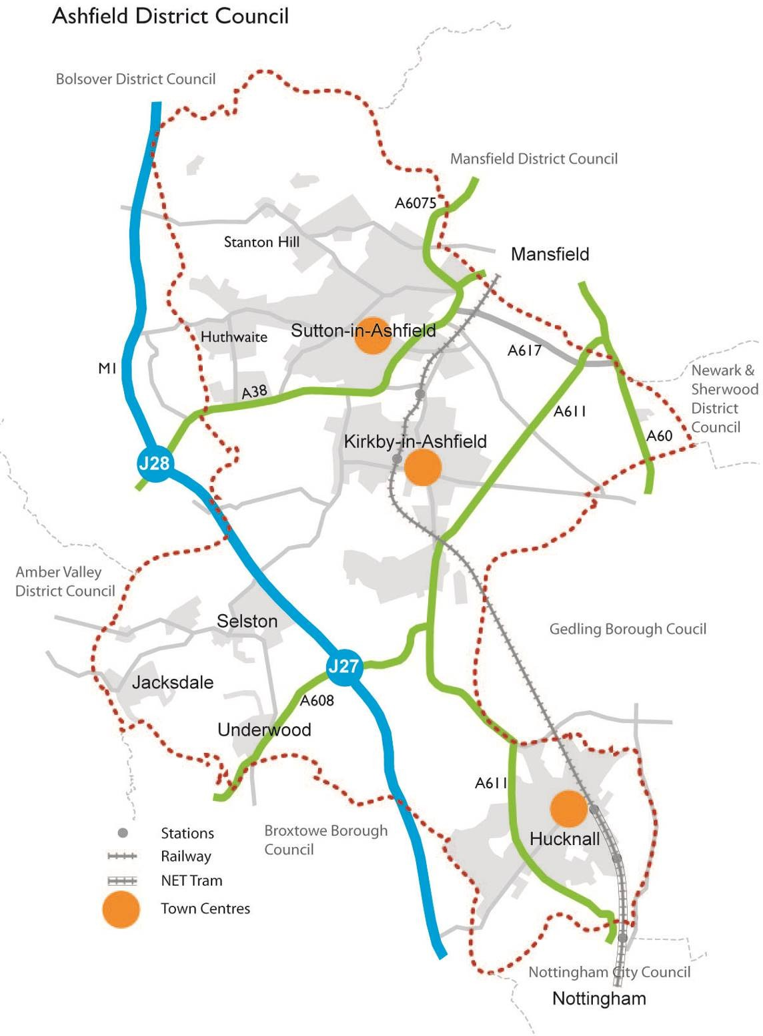

Plan 3: Context Plan for the District of Ashfield
Source: Ashfield District Council

POPULATION
  - The population together with population predictions is set out in Figures 1 and 2.

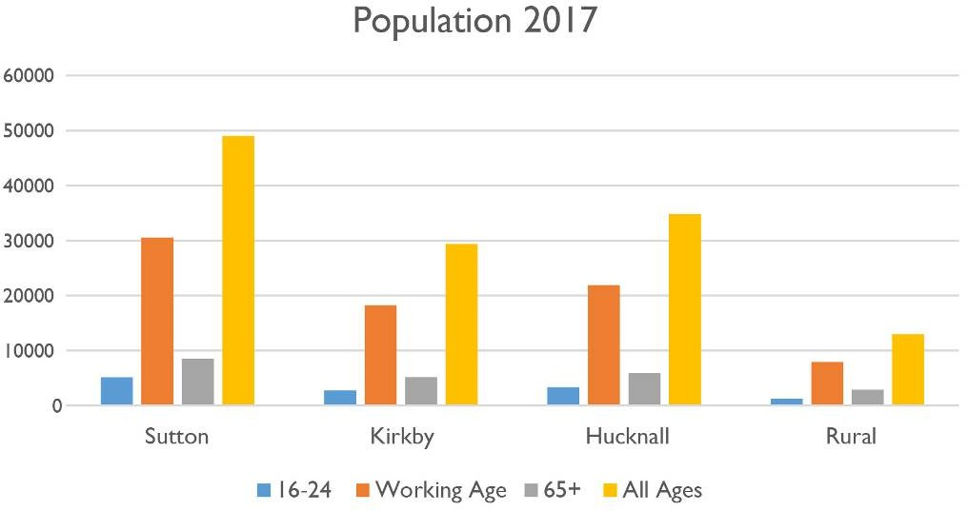

Figure 1: Ashfield Areas Population breakdown
Source: Ashfield DC/ONS

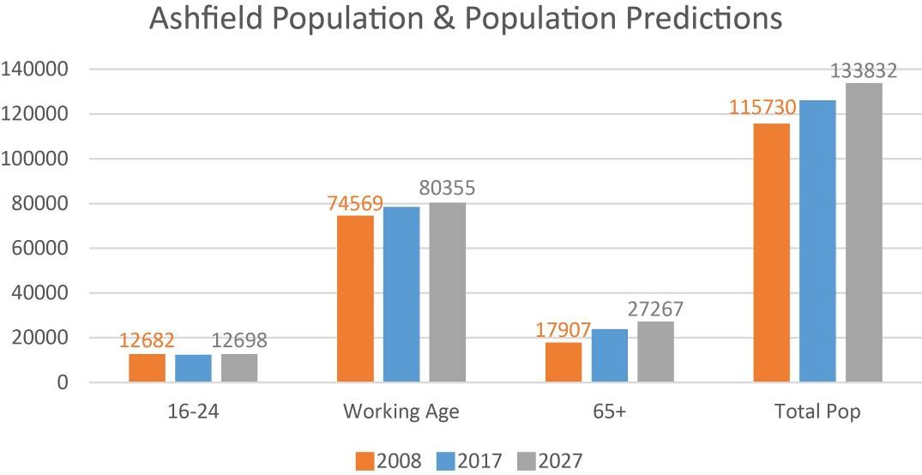

Figure 2: Ashfield Population breakdown
Source: Ashfield DC/ONS

  - The population of Ashfield is anticipated to continue to increase into the future with an increasingly older population. Figures 3 and 4 and Table 7
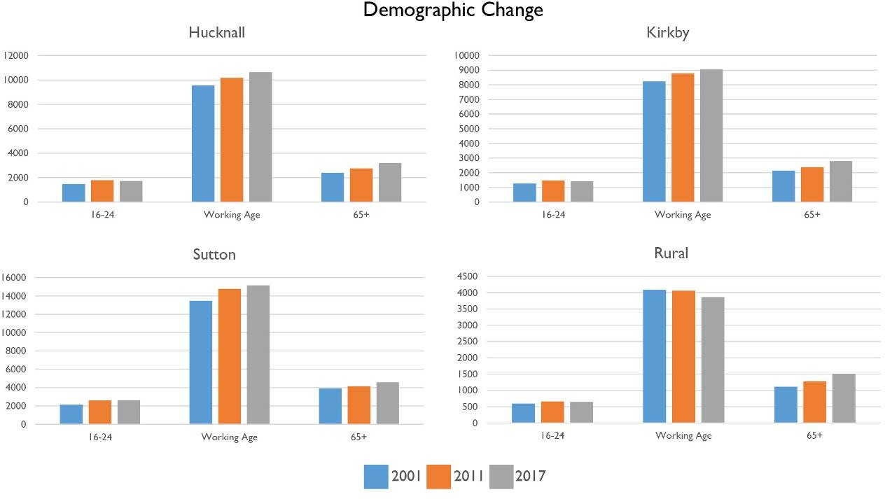

Figure 3 Demographic Change by Area in Ashfield
Source: Census 2001, Census 2011 & ONS Mid Year Population Estimates

 | 2008 | 2017 | 2027
16‐24 as proportion of total pop | 11.0% | 9.8% | 9.5%
Working Age as proportion of total pop | 64.4% | 62.2% | 60.0%
65+ as proportion of total pop | 15.5% | 18.9% | 20.4%

Table 7: Population breakdown
Source: Ashfield DC/ONS

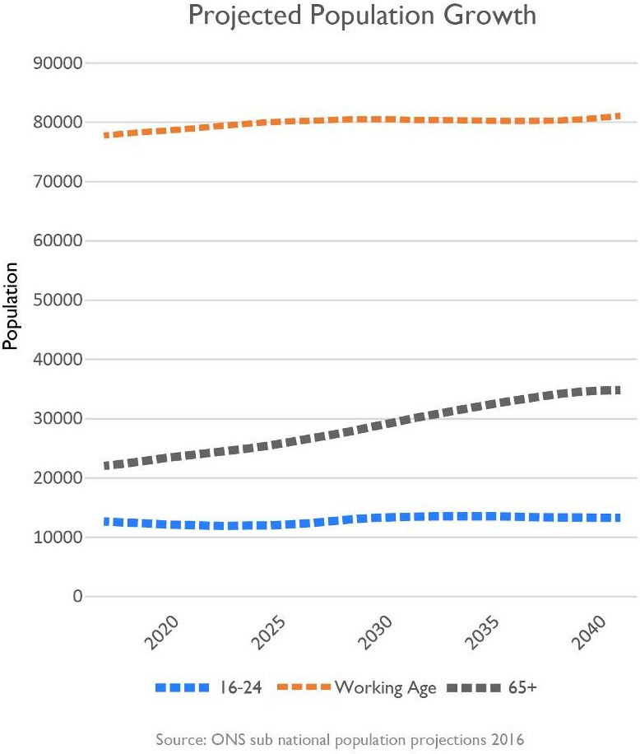

Figure 4: Projected Population Growth
Source: ONS subnational Population Projections

  - The population of Ashfield forms part of the Nottingham Outer Housing Market Area¹⁵ together with the Districts of Mansfield and Newark and Sherwood. Plan 1. Three sub areas were identified in Ashfield comprising Hucknall, Sutton in Ashfield /Kirkby-in-Ashfield and the Villages to the west of the M1. Plan 4

¹⁵ In simple terms the HMA is a geographic area in which the majority of people, who move, will move within. It also reflects the functional relationships between where people live and work.

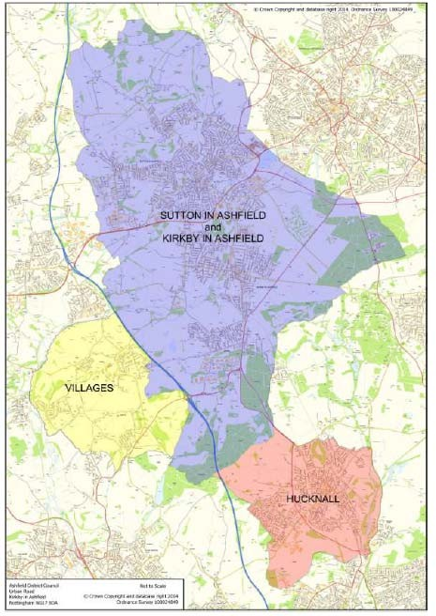

Plan 4: Sub Area in Ashfield
Source: GL Hearn Nottingham Outer Strategic Housing Market Assessment 2015

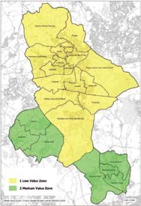
  - The Ashfield Whole Plan & Community Infrastructure Levy Viability Assessment, July 2016 concluded that in terms of viability there were two sub markets Low Value (Yellow) corresponding to Hucknall and the Villages and Medium Value (Green) Kirkby-in-Ashfield and Sutton in Ashfield.

  - Evidence from the SHMA¹⁶ and the ELF Study¹⁷ identifies that Ashfield has a modest level of workforce containment with strong links to Nottingham, which is a large employment centre. In 2017, Ashfield had a jobs density of 0.74¹⁸.

¹⁶ Nottingham Outer 2015 Strategic Housing Market Assessment 2015, Para 2.52 and Table 11.
¹⁷ Employment Land Forecasting Study 2015 Nathaniel Litchfield & Partners (page 30).
¹⁸ NOMIS official labour market statistics – Ashfield local authority profile 28th August 2019.

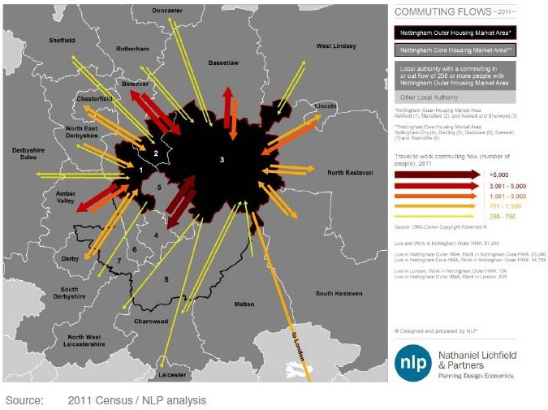

Plan 5: 2011 Commuting Data & commuting flows
Source: Employment Land Forecasting Study 2015 Nathaniel Litchfield & Partners

  - In terms of migration, based on the Census of 2011, Ashfield has a net inflow into the District with a strong relationship between Ashfield and Mansfield and Ashfield and Nottingham¹⁹, Plan 6.

¹⁹ Nottingham Outer 2015 Strategic Housing Market Assessment 2015 Paragraphs 2.25 to 2.43

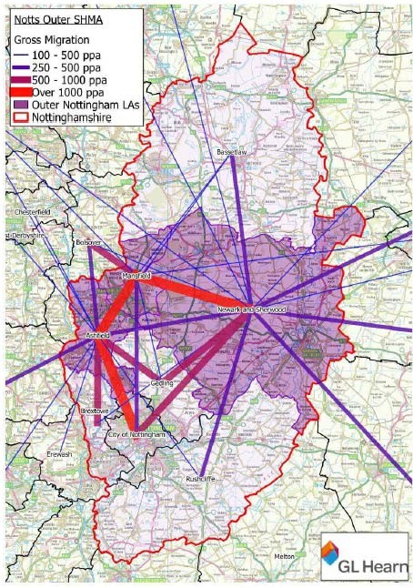

Plan 6: Major Gross Migration Flows (2011)
Source: Nottingham Outer 2015 Strategic Housing Market Assessment 2015/ONS2011

  - Across the Housing Market Area, Ashfield has the highest population of the three authorities, with the population rising by 5.5% to 126,164 between 2011- 2017. Of this, there is an above national average of people between the ages of 40 and 65. Ashfield also has the highest percentage of households with dependent children in the HMA, but has also seen a significant growth in single person households. The population of the District is due to rise by around 11% to 136,350 by 2033.

Issues & problems

- Population growth will increase the demand for housing and services and put additional requirements on local infrastructure.
- An increasing percentage of the population is anticipate to be over 65, this will have implications for service provision.

Potential Implications of not having a new Local Plan

- Relevant policies in the Ashfield Local Plan 2002, saved policies will continue. However, they will become increasing dated and inconsistent with changes in national planning policy.
- Decisions would increasing reflect material considerations set out in national planning policy with a lack of any vision or framework for the future development of Ashfield.
- Population growth would continue with ad hoc housing developments.
- Requirements for services would increase but with the potential lack of infrastructure provision through S106 contributions/CIL contributed identified through an adopted planning framework.

DELIVERING A SUFFICIENT SUPPLY OF NEW HOMES
  - In Ashfield, house prices are still amongst the lowest in the region although prices have continued to rise in recent years with the average price now
£138,425.
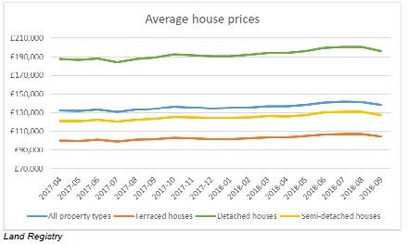

Figure 5: Average House Prices
Source: Land Registry

  - There are 6,790 (December 2018) council owned properties, down from 6,866 in 2015 and a further 2,182 owned by other Registered Housing Providers (at March 2017).

  - Under the NPPF’s standard method, the housing need for Ashfield at 2019 is 475 dwellings. The NPPF²⁰ also requires that the Council should identify and update annual a supply of specific deliverable sites sufficient to provide a minimum of five years’ worth of housing against their housing requirement. Figure 6 sets out the position for the period from 2019 to 2037.
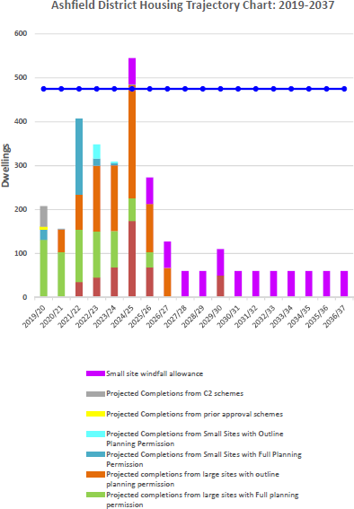

Figure 6: Ashfield Housing Trajectory 2019-2037
Source: Ashfield DC Housing Land Monitoring Report April 2019.

20 National Planning Policy Framework, Paragraph 73

  - The Housing Land Monitoring Report identifies that completion rates for new build have been falling in recent years.

Period completed (1st April ‐ 31st March) | New Build |  |  | Net Additions through Conversion/ Change of  Use | Net additions through permitted  development | Demolitions | Total Net Completions
 | Small | Large | Total
TOTAL ASHFIELD
2011 -  2012 | 43 | 356 | 399 | 15 | n/a | 2 | 412
2012 -  2013 | 37 | 386 | 423 | 13 | n/a | 2 | 434
2013 -  2014 | 34 | 404 | 438 | 17 | n/a | 1 | 454
2014 -  2015 | 41 | 407 | 448 | 19 | n/a | 42 | 425
2015 -  2016 | 103 | 437 | 540 | 23 | n/a | 5 | 558
2016 -  2017 | 57 | 453 | 510 | 34 | n/a | 0 | 544
2017 -  2018 | 35 | 313 | 348 | 48 | 4 | 3 | 397
2018 -  2019 | 63 | 205 | 268 | 28 | 5 | 1 | 300
2011 to  2019 | 413 | 2961 | 3374 | 198 | 8 | 56 | 3524
Average per year | 52 | 370 | 422 | 25 | 5 | 7 | 441

Table 8: Housing Completion Rates 1st April 2011 to 31st March 2019
Source: Ashfield Housing land Monitoring Report 2019

  - The overall average (median) income for Ashfield was £22,044 with a mean income of £28,983. Using a 25% affordability threshold just under two-thirds of households with a current need are estimated to be likely to have insufficient income to afford market housing. (See SHMA on Affordable Housing Need).

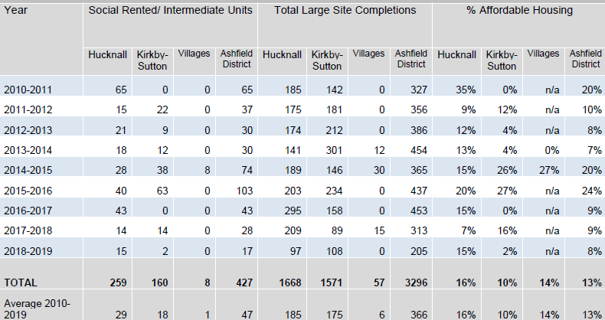

Table 9: Ashfield Affordable Housing Completions 2010 to 2019
Source: Ashfield DC Housing Land Monitoring Report April 2019. NB: Large site completion comprises sites of 10 or more dwellings

  - The SHMA indicates there is a need for more 2 and 3 bed dwellings to cater for the predicted increase in smaller family units and older people in the Nottingham Outer HMA.

Indicative Property Size Guide | Market Sector Housing % | Affordable Sector Housing %
1 bedroom | 4% | 39%
2 bedrooms | 35% | 36%
3 bedrooms | 53% | 24%
4+ bedrooms | 8% | 1%
Total | 100% | 100%

Table 10: Estimated percentage of dwellings required by number of bedrooms 2013 to 2033.
Source: Nottingham Outer 2015 Strategic Housing Market Assessment October 2015 GL Hearn Limited Table 68: Estimated dwelling requirement by number of bedrooms (2013 to 2033) - Market Sector and Table 69: Estimated dwelling requirement by number of bedrooms (2013 to 2033) – Affordable Sector.

  - Both Neighbourhood Plans place an emphasis on smaller market dwellings²¹.

²¹ JUS-T Neighbourhood Plan Policy NP4; Housing Type. Teversl, Stanton Hill & Skegby Neighbourhood Plan NP3; Housing Types.

Issues & problems
    - Understand the level of housing required in Ashfield and the interaction between different areas of the District and the relationship with the Greater Nottingham Area.
    - To provide sufficient housing of a type and tenure to meet specific needs.
    - Housing in terms of new build has declined in recent years and is not meeting the housing need identified by the NPPF Standard Method.
    - While the District is perceived as an area of affordable housing, when income levels in Ashfield are taken into account, housing affordability is an issue in the District.

    - Changing demographic structure, including an aging population, will impact future household characteristics and will have implications for the provision of housing requirements, employment opportunities and services.
    - Given that substantial parts of the District are in Green Belt, there are issues in balancing the housing needs of specific areas against the impact on the Green Belt and the countryside.
    - A substantial number of brownfield sites have been developed in Ashfield. The consequence is that limited brownfield sites are available necessitating the utilisation of greenfield sites to meet housing needs.
    - Reduce the potential impacts on the environment and social infrastructure of Ashfield whilst allocating land to provide for housing requirements.
    - Improving the quality of the existing housing stock.

Potential implications of not having a new Local Plan

    - Relevant policies in the Ashfield Local Plan 2002, saved policies will continue. However, they will become increasing dated and inconsistent with changes in national planning policy.
    - Decisions would increasing reflect material considerations set out in national planning policy with a lack of any vision or framework for the future development of Ashfield
    - The Council has a limited supply of land for housing. This will reduce over time until there are very limited allocated sites to meet housing need. While sites will come forward through individual planning applications this may be insufficient to meet a 5 year housing supply and is less efficient and cost effective.

      - Fewer opportunities to take a strategic joined up approach to the provision of housing and infrastructure across the district.
      - Housing would come forward through ad hoc planning applications within the countryside as the allocations within the Ashfield Local Plan Review 2002 have been substantial developed.
      - The supply of housing through ad hoc development would be unlikely to meet the identified housing needs, including affordable housing. Changes to the population structure with an aging population is likely to create specific needs for housing and services which are unlikely to be met without allocation of sites to meet housing and community needs and specific local policy considerations in the Local Plan.
      - The housing mix may well not reflect current and future needs due to the lack of local policy on this aspect unless it is located with the Neighbourhood Plan areas.
      - Population will increase as new homes through planning applications are delivered.
      - Without a coordinated approach to infrastructure provision, it is likely that S106 planning contributions will not meet the requirement of the Section 122 of The Community Infrastructure Levy Regulations 2010, as amended.
      - Provision of affordable housing is unlikely to be maximised given the lack of an up to date Local Plan policy reflecting viability and the ad hoc development of housing sites not meet the anticipated housing need.
      - There is likely to be continued pressure for housing development on green open spaces rather than brownfield sites.
      - Potential for house prices to rise relative to earnings given the lack of supply.
      - Inability to bring forward rural exceptions sites, particularly in the Green Belt as there is no policy basis for this in the Ashfield Local Plan Review 2002.

      - No specific provision to meet any demand for self build or custom build properties in the District.

BUILDING A STRONGER COMPETATIVE ECONOMY & SUPPORTING HIGH QUALITY COMMUNICATIONS
  - Jobs within Ashfield are dominated by the manufacturing sector comprising 18.2% of jobs at 2018²². This compares to 12.9% for the East Midlands and 8.1% for Great Britain. Ashfield faces a number of issues as:

    - The unemployment rate in Ashfield is in line with the national average although there are local high concentrations at a ward level within Hucknall, Kirkby in Ashfield and Sutton in Ashfield.
    - A disproportionate number of people in the District work in semi-skilled and unskilled occupations and furthermore, the District has a low educational base. There is a need to increase the skills and education in the labour market as low level skills creates a barrier to higher tech and higher value business locating in the area.
    - The economic activity rate (16-64), are lower than average in Ashfield when compared to the England average.
    - The socio-economic profile of the District is weighted towards skilled and unskilled manual trades such as manufacturing and construction (evolving as a natural progression of a post coalmining community). As a result of historical, cultural and socio-economic factors some areas of Ashfield demonstrate income levels that are significantly lower than average compared to neighbouring areas or regional figures.
    - The District’s working age population has grown over the period 2001 to 2017. However, whilst the working population is growing, it is also becoming older. Consequently, over time there needs to be a greater focus on retaining older workers in the labour market to ensure that a shortfall in the supply of workers does not prevent the District from realising its economic potential.
    - With regard to education, levels of GCSE achievement in Ashfield are lower than the national average. The District also has a higher proportion of residents with no qualifications than the national average. In terms of the ‘very well qualified’, those qualified to NVQ level 4 or above. There are issues in retaining graduates in Ashfield. The concern is that too many residents currently lack skills at the right level to respond to these labour market changes and will thus struggle to compete effectively.
Further information on these aspects is available from Ashfield Annual Monitoring Report 2017/18 and the State of Ashfield Report 2019.

  - The Employment Land Forecasting Study 2015 anticipates that under Scenario 2: Job Growth reflecting D2N2 LEP Policy On requirements for Ashfield will

²²Office for National Statistics NOMIS – Labour Market Profile Ashfield Employee Jobs (2017)

result in 10,724 new jobs in all sectors between 2011 and 2033. Of these jobs, 2,099 are anticipated to be in offices, factories and distribution this requires 59 hectares of employment land²³. Plan 7 sets out significant employment estates.

  - The employment land requirements and the current supply of land is set out in detail in the Ashfield Employment Land Monitoring Report. Figure 7 sets out the current position. However, this should be seen in the context that planning permission has been granted for additional development on various sites including a substantial distribution unit on South West Oakham which will requirement most of the site allocation for the development (162,791 sq m of space).
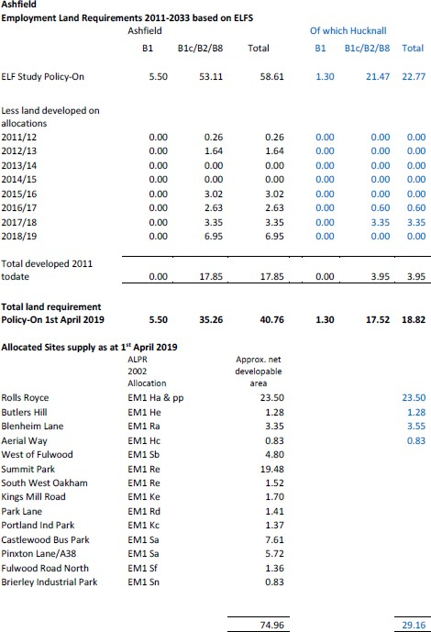
Figure 7: Ashfield Employment Land Requirements 2011-2033
Source Ashfield District Council/Employment Land Forecasting Study 2015 Nathaniel Litchfield & Partners and Ashfield Employment Land Monitoring Report 2019

²³ Employment land is considered to be land falling with Class B1, B2 or B8 of the Town and Country Planning (Use Classes) Order,198y. The Ashfield Local Plan Review 2002 identifies that sui generis employment outside these categories may also be appropriate, subject to normal site planning considerations.

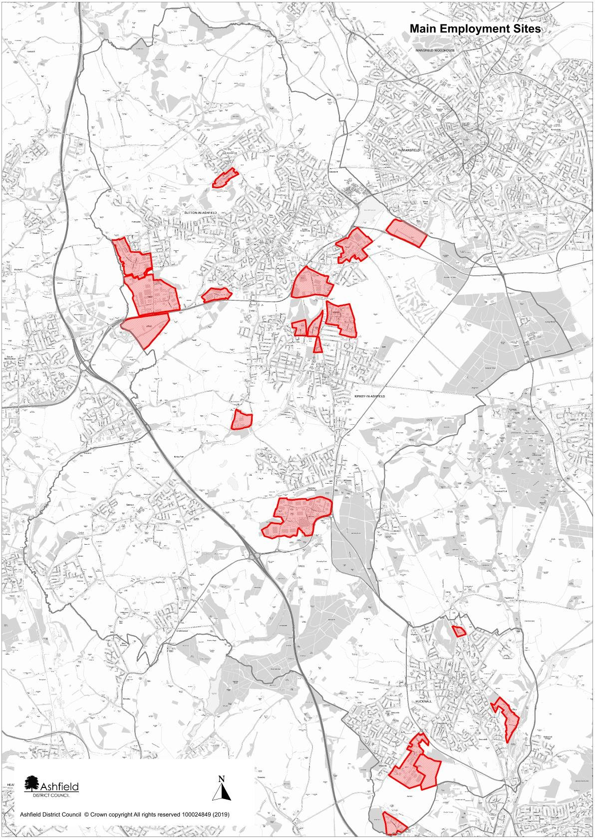

Plan 7: Ashfield Significant Employment Areas (Use Classes B1, B2 and B8).
Source: Ashfield District Council.

Issues & problems
- Meeting the needs of all current and future populations in terms of business and job opportunities.

- Overreliance on the manufacturing sector where employment levels have declined over time.

- Accommodating any employment land and other development opportunities as far as possible within an urban area so as to minimise the impact on greenfield sites.

- Facilitate digital infrastructure to maximise growth opportunities.

- Providing the necessary infrastructure to accommodate current and future development needs in terms of physical green and social infrastructure.

- The need to encourage and accommodate both indigenous and inward investment particularly in relation to identified sectors, which have the potential for growth.

- Creating an environment that is attractive to future growth sectors to improve performance in comparison with other locations.

- Identifying opportunities for heritage led regeneration.

- There are pockets of deprivation particularly within the urban area. Economic regeneration is particularly important in these areas of the towns to help alleviate poverty.

- To increase incomes and skill levels, particularly in those communities suffering high levels of deprivation.

- The concern is that too many residents currently lack skills at the right level to respond to these labour market changes and will thus struggle to compete effectively.
- With the predicted increase in households there is likely to be a need to expand schools or provide new schools as a significant number of schools in Hucknall, Kirkby-in-Ashfield and Sutton in Ashfield are currently at or near capacity.
- To supporting the provision of appropriate sized schools/colleges and other skill learning facilities at a local level to help improve skills and opportunities.

- Potentially, using planning to improving employment prospects and training for local residents.

  - The District’s working population has grown over the period 2001 to 2011 but is now showing signs of declining as the population ages.

  - Responding to future trends in employment and supporting the growth of self-employment.

Potential implications of not having a new Local Plan
- Relevant policies in the Ashfield Local Plan 2002, saved policies will continue. However, they will become increasing dated and inconsistent with changes in national planning policy.
- Decisions would increasing reflect material considerations set out in national planning policy with a lack of any vision or framework for the future development of Ashfield.
- In continuing the Ashfield Local Plan Review 2002, employment land allocation may meet short term demand for sites. However, there are likely to be future issues on the requirement of growing sectors, such as logistics.
- An increase in the population is likely to increase the demands for jobs in the District but there may not be sufficient land to meet these needs leading to additional out commuting from Ashfield. These has potential implications for congestion on roads as well as air quality is greater traffic is generated.
- Out-commuting from the District is likely to continue give the geographic location of Nottingham and its function as a major source of employment.
- Some new schools such as at the Royce Royce development Hucknall have been brought forward. This reflects the size of the proposed development. However, ad hoc applications are more likely to be of a more limited number of dwellings. (1,000 dwellings generates a requirement for a new single form primary school1). This raises issues of how new schools and particularly land for new schools will come forward.

1 Nottinghamshire County Council Planning Obligations Strategy 2018 - Education

ENSURING THE VITALITY OF TOWN CENTRES
  - The Ashfield Retail & Leisure Study 2016 identifies that the Javelin Venue score’s index ranks 2,711 retail venues within the UK. The three centres in Ashfield remain relatively low in the rankings compared to traditionally competing regional and sub-regional centres with Nottingham being located approximately six miles from the Ashfield District boundary by road. Nevertheless, the Retail Study 2016 concluded that the majority of the centres are fulfilling their designated roles and functions as expected for their position the District retail hierarchy. Of note, each of the key town centres (Sutton, Hucknall and Kirkby) has a large format multi-channel supermarket either in, or in close proximity to, the core of the centre.

Hucknall
  - The Hucknall Town Centre Masterplan²⁴ was formally adopted by the Council in November 2009 following public consultation. The Masterplan sets out a vision and strategy for the future development of Hucknall Town Centre based on five themes:
    - to discover the roots of Hucknall as a market town;
    - to create a range of uses and activities where people can work, rest and play as well as shop, by encouraging leisure uses, civic functions, cultural uses and community uses;
    - to extend the visits of those seeking Lord Byron’s grave to stay longer and spend more money in the town;
    - to create a bustling High Street by strengthening the traditional retail offer of the town centre;
    - to transform the environment of the town, particularly on the edges of the centre and when arriving from the station.
  - The Masterplan develops these themes by identifying three main areas for change:
    - the Piggins Croft area;
    - the new relief road and associated potential development land;
    - the land around the station and the NET car park.
The relief road and pedestrianisation of the High Street has been undertaken and improved the shopping environment.

  - The current vacancy rate in Hucknall is much higher than it has been in the past (13.1%). However, the significant amount of rebuilding and redevelopment within the town centre is attributable for a number of these vacancies. Figure 8 sets out the changes in Hucknall’s town centre since 2006.

²⁴ URBED with Gordon Hood Regeneration & Simon Fenton Partnership (2009) Hucknall Town Centre Masterplan

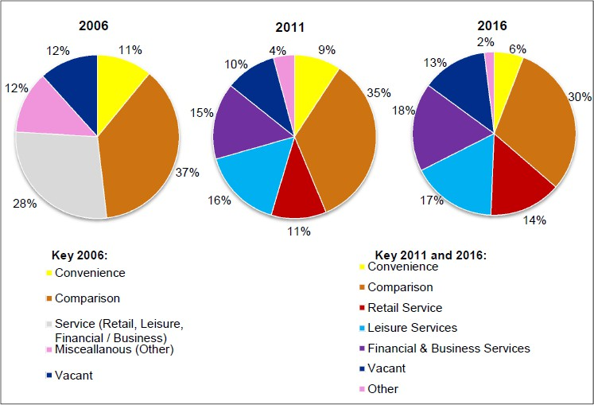
Figure 8: Hucknall Town Centre Composition in 2006, 2011 and 2016 Sources: GVA Grimley 2006 Ashfield Retail Study, WYG 2011 Ashfield Retail Study and Nexus Retail Survey January 2016

N.B. The 2006 GVA Grimley Study does not breakdown service retail units by type – leisure, retail service, or financial / business service.

Sutton in Ashfield
  - The Sutton Town Centre spatial Master Plan 2019 sets out a vision and key opportunities for the town centre. It includes a concept plan identifying key gateways, primary and secondary streets and civic space. Opportunities for eight different areas of the town centre are set out being delivered by a mix of private, sector, public sector and partnership delivery.
  - The retail and Leisure Study, 2016²⁵ identified that generally a healthy town centre, key multiple retailers are present in proportion to the centre’s size, with Asda serving as the key retailer within the centre. The Idlewells Centre was covered in 1994 to provide a substantially improved shopping environment and along with the pedestrianised Low Street it forms the anchor shopping area. The town is performing moderately well, with the number of vacant units being slightly below the UK average figure – 10.8% compared to 11.3%. The amount of vacant floorspace is aligned with the national average – 9.1% compared to 9.2%.

²⁵ Ashfield District Retail & Leisure Study May 2016 Nexus Planning.

  - Ease of access and parking are key factors in influencing visitation rates. The town centre has car parking situated at various points around the centre, including Asda, Priestsic Road, The Idlewells multi-storey and the Market Place. The bus station on Devonshire Square links closely with the Town Centre Core retail area.

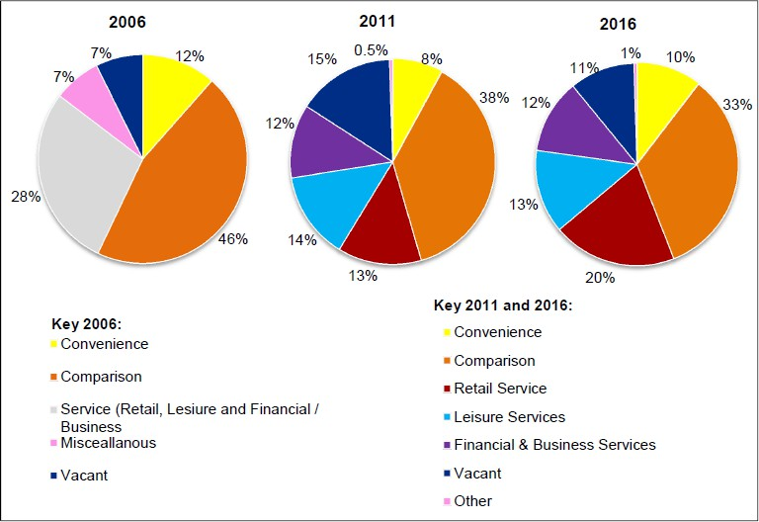

Figure 9: Sutton Town Centre Composition in 2006, 2011 and 2016 Sources: GVA Grimley 2006 Ashfield Retail Study, WYG 2011 Ashfield Retail Study and Nexus Retail Survey January 2016

N.B. The 2006 GVA Grimley Study does not breakdown service retail units by type – leisure, retail service, or financial / business service.

Kirkby-in-Ashfield
  - Kirkby-in-Ashfield is identified as the smallest of the three main settlements in Ashfield District, and is designated as a ‘District Centre’ in the Retail & Leisure Study 2016. Morrisons supermarket, which has its frontage and car park facing onto Lowmoor Road, provides a strong anchor store within the centre. Lowmoor Road is pedestrianised and the redevelopment of the new Civic Square in 2014 has enhanced the overall shopping environment.
  - Kirkby-in-Ashfield has experienced a significant reduction in the number of vacant units in the past ten years aided by the Morrisons development. (The 2006 Retail Study identified a vacancy rate of 22.6%). Since the recession the vacancy rate has continued to decrease and now sits below the UK average of 11.3%, at 9.6%. The attraction of the new large format Morrisons is evident when reviewing the Retail Study results, as 10.2% of total respondents and 10.2% of Zone 2 respondents said their main reasons for visiting Kirkby is the strength of the supermarket.

  - Figure 10 sets out the changes in Kirkby in Ashfield town centre since 2006.
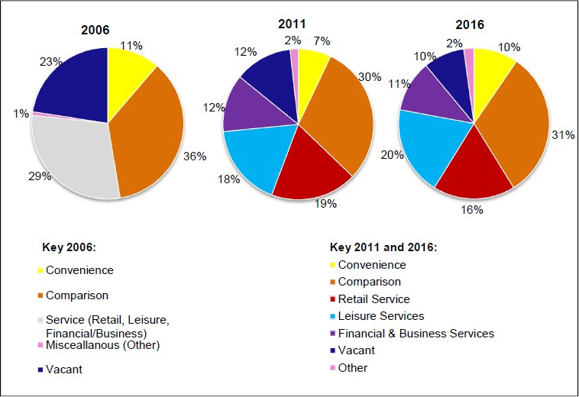

Figure 10: Kirkby-in-Ashfield Town Centre Composition in 2006, 2011
and 2016
Sources: GVA Grimley 2006 Ashfield Retail Study, WYG 2011 Ashfield Retail Study and Nexus Retail Survey January 2016

N.B. The 2006 GVA Grimley Study does not breakdown service retail units by type – leisure, retail service, or financial / business service.

  - The town centre provides an important central hub for social, leisure and transport facilities in the area. People are drawn into the town centre by a number of leisure, community and health facilities including the Ashfield Community Hospital, Post Office, doctors and dentists, a library, the Festival Hall Leisure Centre and community facilities.

Issues & problems

    - The District has three shopping centres that need to be supported in order to keep them vital and viable.

    - Bring forward key opportunities identified in the town centre masterplans within an appropriate timescale.

    - Meeting the needs of all current and future populations in terms of business and job opportunities within town centres.

    - Providing the necessary infrastructure to accommodate current and future development.

    - Creating an environment that is attractive to future growth sectors to improve performance in comparison with other centres.

    - Identifying opportunities for heritage led regeneration Potential implications of not having a new Local Plan
    - Relevant policies in the Ashfield Local Plan 2002, saved policies will continue. However, they will become increasing dated and inconsistent with changes in national planning policy.
    - Decisions would increasing reflect material considerations set out in national planning policy with a lack of any vision or framework for the future development of Ashfield.
    - Lack of Section 106/CIL support for town centre improvements and opportunities.
    - Lack of up-to-date policy town centre policies for the spatial masterplans for the town centre.
    - Lack of an up-to-date Plan may impact on bidding for funding opportunities.

PROMOTE HEALTHY & SAFE COMMUNITIES
  - Figure 11 sets out the potential influence the Council can have in relation to the social aspects of health and wellbeing.
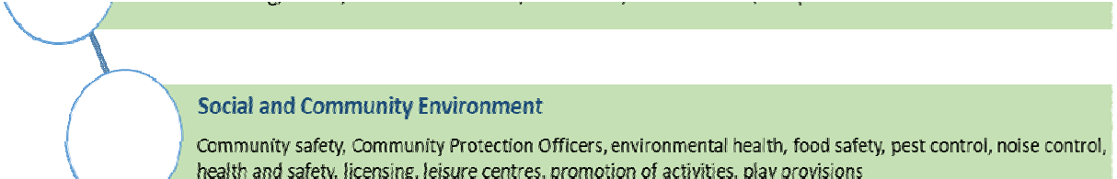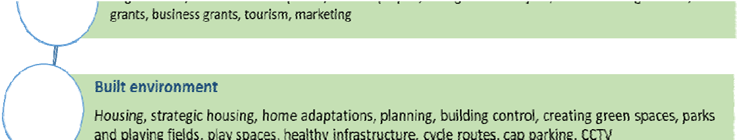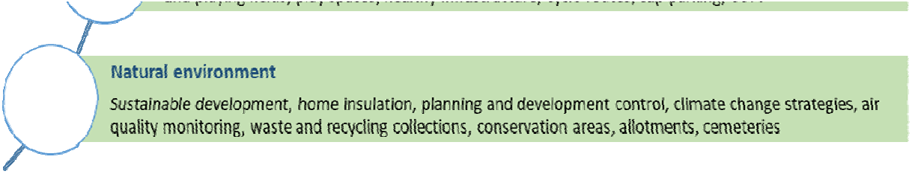

Figure 11: Ashfield District Council impact on the social determinants of Health and Wellbeing
Source: Ashfield District Council

  - The health of people in Ashfield is generally worse than the England average. This can be seen in a number of areas:
    - Life expectancy is lower in Ashfield that the English average with the difference in life expectancy between the most and the least deprived areas of Ashfield is 10.4 years for men and 8.3 years for women (based on death rates from 2014-2016).
    - Over the last ten years life expectancy has increased for men and women in Ashfield; 1 year for men and 1.5 years for women, the improvement is in line with the England average rates although they remain below average for England. Over the most recent period, life expectancy for both men and women has fallen slightly.
    - There are less people over the age of 18 diagnosed with diabetes than the England average.

    - Obesity in children aged 4-5 is lower than the England average but obesity amongst 10-11 years is above average.
    - Excess weight in adults at 74% is higher than the England average (61.3%). The Regional average is 63.3%.
  - The average life expectancy in Ashfield for men and women is set out in the Plan below.
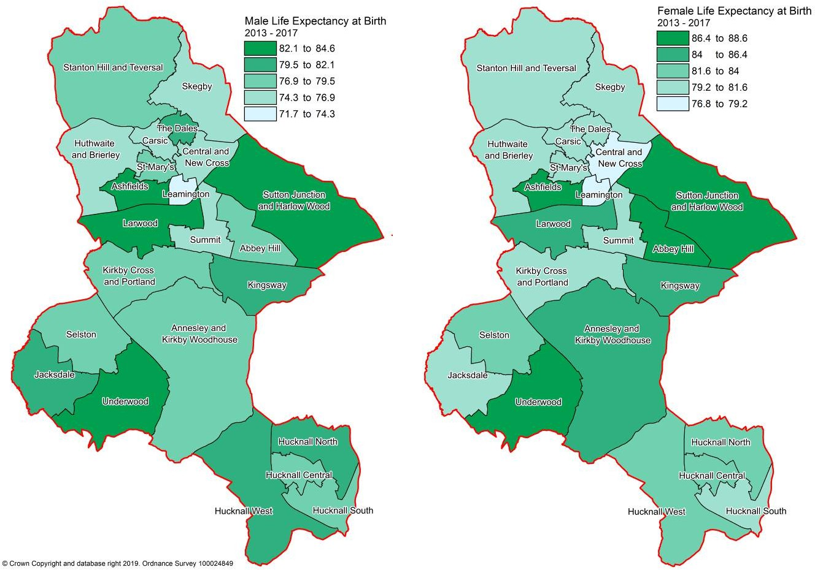

Plan 8: Ashfield Life Expectancy

  - The physical activity of adults over the age of 19 has fallen in the District and is now below the average for the East Midlands. (The activity is 150 or more moderate intensity active minutes per week.²⁶). Priority areas for directing resources to achieve improvements are identified in the Lifestyle Strategy Active Ashfield 2017-2021. These include:
    - Leamington Estate, Sutton in Ashfield;
    - Stanton Hill (brand Lane, Wharf Road, Fackley Road, Victoria Street);
    - Broomhill, Hucknall,
    - Coxmoor Estate and Southwell Lane, Kirkby-in-Ashfield;

²⁶ Ashfield Annual Monitoring Report 2017/18

    - New Cross and surrounding area, Sutton in Ashfield.
  - The English Indices of Deprivation measure relative levels of deprivation in 32,844 small areas or neighbourhoods, called Lower-layer Super Output Areas (LSOA). It is the official measure of relative deprivation in England and is part of a suite of outputs that form the Indices of Deprivation (IoD). The level of deprivation in Ashfield is relatively high as set out on the indicators below. In 2015 Ashfield was ranked as the 70th most deprived district out of 326 according to the IMD. In 2019 Ashfield ranking was 63 out of 317 districts. The two LSOA below are in the 2% most deprived in England:
    - E01027974 Leamington Rank of IMP score (1 most deprived) 438
    - E01027951 Coxmoor Rank of IMP score (1 most deprived) 985
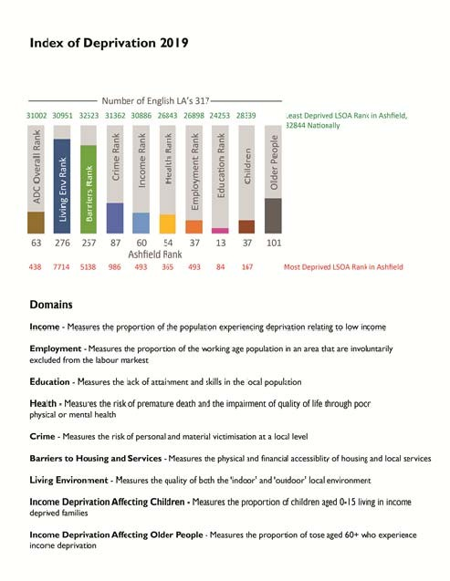

Figure12: Ashfield Index of Deprivation 2019.

  - Green infrastructure has a multi-functional role including improvement to health and well being, improved flood risk management, enhancing biodiversity and adaption to climate change.

  - The local approach to green infrastructure and biodiversity is set out in the Council’s Green Infrastructure and Biodiversity Technical Paper 2013. This examines the connectivity of green spaces at a local level and identifies green infrastructure network opportunities and ensures that the Green Infrastructure network is protected and enhanced. The Technical Paper includes a number of maps which set out various aspects including Key Habitat Linkages; Accessibility; Community facilities; Green Infrastructure Networks.

  - Ashfield’s Green Space Strategy provides evidence on the existing green space network and its recreational values. It provides a basis for improving the quality and potential uses of green spaces to cater for increasing future demand arising from growth and the changing needs of the community. The Strategy sets out locally-derived standards for the provision of green spaces and identifies deficiencies in the quantity, quality or accessibility of green spaces.
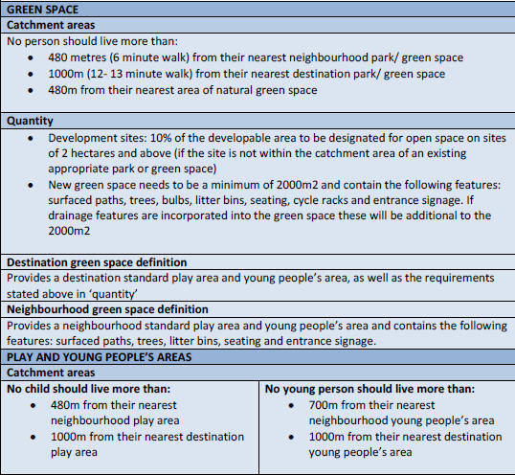

Table 11: Ashfield Public Open Space Strategy 2016-2026
Source: Ashfield District Council

85

  - The Ashfield Playing Pitch Strategy 2017-2020 includes provisions for new facilities through the development process. It sets out anticipated requirements for various sport on an area basis up to 2026. (Part 3 Supply & Demand)

  - Recorded crime is on the increase in Ashfield with many categories higher than last year.
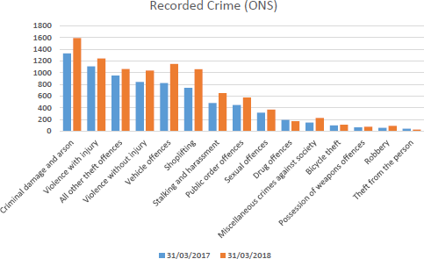

Figure 13: Recorded Crime
Source ONS & Ashfield DC Annual Monitoring Report 2018
Issues & problems

- Residents of Ashfield have a shorter life expectancy than averages for England.

- To improve health and wellbeing, and to prevent ill health (e.g. through healthy eating and exercise).
- Health inequalities exist between the most and least deprived areas of the District.
- To provision health services and facilities in relation to the demands arising from new development.
- The Health and Wellbeing Board has identified priority areas which they believe will have the biggest impact to help improve health and wellbeing. This includes including ‘losing the gap in educational attainment.’
- Lifestyle indicators are generally worse than the average for England.
- Ashfield performs poorly in the Indices of Multiple Deprivation. Ranked

at 79th out of 326 local authority areas (IMD 2015).

    - New health, sporting, leisure and recreational facilities should be provided encouraging walking, cycling and more active lifestyles.
    - The development of a high quality multifunctional green infrastructure network should be promoted identifying any opportunities for links with and enhancement of cultural heritage.
    - Potential issue in meeting the needs of an aging population.
    - The development of accessible cycle networks to facilitate alternative modes of transport.
    - The development of quality green infrastructure should be promoted as part of development, linking to a green infrastructure network.
    - Adult participation in sport has decreased in Ashfield in recent years.
    - New health, sporting, leisure and recreational facilities should be provided and should encourage walking, cycling and more active lifestyles.
    - Recent evidence indicates that crime rates are increasing in the District.
    - To improve safety and security for people and property (e.g. through design intervention) and to reduce fear of crime.
Potential implications of not having a new Local Plan
    - Relevant policies in the Ashfield Local Plan 2002, saved policies will continue. However, they will become increasing dated and inconsistent with changes in national planning policy.
    - Decisions would increasing reflect material considerations set out in national planning policy with a lack of any vision or framework for the future development of Ashfield.
    - There are national, regional and countywide initiatives to consideration and improve healthy lifestyles, however, it is likely to result in fewer opportunities for systematic improvements in health service provision.
    - Without relevant policies inappropriate housing mixes to meet future needs are unlikely to come forward as part of ad hoc development.
    - Health issues identified in the issues and problems are likely to continue into the future without the opportunity to maximise the opportunities to tackle these issues.
    - A lack of strategic planning through the Ashfield Local Plan to meet the housing needs means that new housing will not be required to be accessible or adaptable for future occupation by the elderly or people with disabilities.
86

- Ad hoc housing development could put increased pressure on Ashfield’s green spaces, with a risk of degradation from increased use if no additional spaces are created, or even the possible loss of some green areas to development.
- The NPPF requires good design that creates safe places (paragraph 91) but without a more detailed local policy there is more limited opportunity to influence the best outcome.
- Opportunities for the improvement of community facilities are likely to be more opportunistic. Sites may be progressed that are acceptable in policy terms but not the best possible option in light of all the evidence available.

PROMOTING SUSTAINABLE TRANSPORT
  - The District has excellent road links to much of the country due to its location beside the M1 motorway. Junction 26 of the M1, which is outside the District, provides a good link to Hucknall. Junction 27 of the M1 lies within the District and provides a major link to Ashfield’s three towns and Junction 28 can be easily accessed via the A38. Other major routes include the A617, Mansfield- Ashfield Regeneration Route (MARR) and A611 between Mansfield and Nottingham via Hucknall. A’ roads in the District are the A38, A611, A6617, A60, A6075 and A608. The County Council is considering the case for seeking additional funding to improve junctions on the A611 between Mansfield and the M1, Junction 27 and the widening of the A617 from the A38 to the Rainworth Bypass. It is also understood that Highways England are examining the possibilities of improving Junction 27 of the M1.

  - The Robin Hood railway line (which runs from Nottingham to Worksop) has stations at Hucknall, Kirkby-in- Ashfield and Sutton Parkway.
Trains runs from Ashfield to Nottingham, typically twice every hour during the day. On an average week day there are 58 trains travelling from these stations to Nottingham.
  - Hucknall is a terminus for the Nottingham Express Transport (NET) tram route to Nottingham. A peak times trams run every 7 minutes with a tram every 15 minutes early in the morning and late at night.

  - The Nottinghamshire Local Transport Plan sets out the transport strategy for the whole of Nottinghamshire (LTP3) to 2016. It is anticipated that the Local Plan will be closely linked to the objectives of LTP3 in seeking to promote

smarter choices of transport. A third implementation plan covers the period from 2018 to 2021. Nottinghamshire County Council, identifies that 99% of residents in Ashfield are less than a 10 minute walk from a bus stop with an hourly service.
  - Information on traffic flows and the potential impact on junctions of development in Ashfield and neighbouring authorities is set out in the Ashfield Transport Study 2016²⁷. The evidence identifies that there is congestion between Mansfield, Ashfield and Nottingham resulting in slower vehicular speeds, particularly during the AM and PM peak periods.

Issues and Problems

    - Embed accessibility into locational requirements for development and decision making and the access to services (such as health, education and leisure).
    - The need to improve the quality and range of services available within communities.
    - Ensure that new development has good access to facilities and alternative means of travel.
    - Reducing the dependency on the private car.
    - Traffic congestion is an issue in Ashfield reflecting the new development proposed.
    - Improvements will be required to specific junctions as part of development as otherwise there will be an adverse impact on congestion and journey times.
    - Development close to the M1 motorway at Junction 27 has the potential to encourage car use and increase congestion, particularly around Sherwood Business Park.
    - To facilitate alternative forms of transport including encouraging more people to walk and cycle.
    - Significant new development will need to facilitate bus services to gives choice of transport mode.
    - To work with partners to provide an integrated and efficient transport system including public transport, walking and cycling network in Ashfield.
    - Ensure that new development has good access to facilities and alternative

²⁷ Ashfield Transport Study Final Report 2016. Systra

means of travel, reducing the dependency on the private car.

- To facilitate alternative forms of transport including encouraging more people to walk and cycle.
- A new Transport Study will be required to identify the implications of development.
- The implications that over the life of the Plan combustion engines are likely to be increasingly phased out and replaced by ultra-low emission and electric vehicles.
Potential implications of not having a new Local Plan

- Relevant policies in the Ashfield Local Plan 2002, saved policies will continue. However, they will become increasing dated and inconsistent with changes in national planning policy.
- Decisions would increasing reflect material considerations set out in national planning policy with a lack of any vision or framework for the future development of Ashfield.
- Traffic flows are likely to increase with the increased population unless there is less reliance on the car as a means of transport.
- The implementation of the Nottinghamshire Local Transport Plan will lead to improvements in sustainable transport in the area encouraging alternative modes of transport from the car.
- Potential improvements to the A611 and A617 and the M1 Junction 27 if taken forward will offset congestion. However, it is possible that these improvements may need some financial support from development.
- Housing development will come forward on an ad hoc basis through planning applications, which means it is substantially more difficult to plan for improvements to the wider highway network.
- Existing patterns of transport are likely to be reinforced, with high levels of car dependency and less opportunities to tackle social exclusion and resolve strategic matters.
- Poorly located development would result in a lack of travel choice and high levels of dependency on the car.

MAKING EFFECTIVE USE OF LAND & ACHIEVING WELL DESIGNED PLACES
  - Land use involves decisions on crosscutting and multi-layered issues that affect a wider variety of aspects including brownfield land, recreation, biodiversity, flooding, an, density of housing development. It is anticipated that these aspects are covered in the various other section of the baseline.

  - Similarly design potential has an impact on all aspects of place making. and cross into the issues and problems identified in the other sections of the baseline.

  - Plan 9 sets out in broad terms the existing Land Use in Ashfield. The District covers an area of 10,956 hectares and the percentage figures are based against this total area.
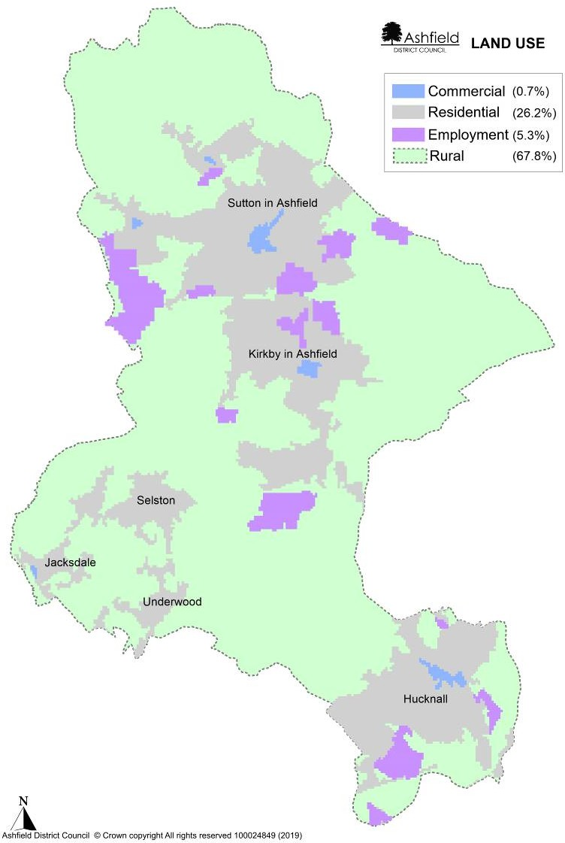

Plan 9: Ashfield Broad Land Uses

Source: Ashfield District Council

Brownfield Land
  - Brownfield' (previously developed) land is defined in Annex 2 of the National Planning Policy Framework as: Land which is or was occupied by a permanent structure, including the curtilage of the developed land (although it should not be assumed that the whole of the curtilage should be developed) and any associated fixed surface infrastructure. This excludes:
    - land that is or was last occupied by agricultural or forestry buildings;
    - land that has been developed for minerals extraction or waste disposal by landfill, where provision for restoration has been made through development management procedures;
    - land in built-up areas such as residential gardens, parks, recreation grounds and allotments; and land that was previously developed but where the remains of the
    - permanent structure or fixed surface structure have blended into the landscape.
However, this is a very broad definition and (apart from the exclusions) covers all land in England where there are or have been buildings or other development. Much of this land is already in productive use and would not be suitable for new housing.

  - Government Land Use Change Statistics in England 2017-18 identify that national for 2017-18
    - 53 per cent of new residential addresses were created on previously developed land.
    - The average density of residential addresses surrounding a newly created residential address was 31, a decrease from 32 in 2016-17.
However, the proportion of new address on previously development land can vary significantly, between authorities. To a substantial degree this will dependent on the nature of the authority. For example a city would be anticipated to have a substantial degree of development on brownfield land. Plan 10 identifies Ashfield falling within the 21% to 40% category for the period from 2013 -2018.

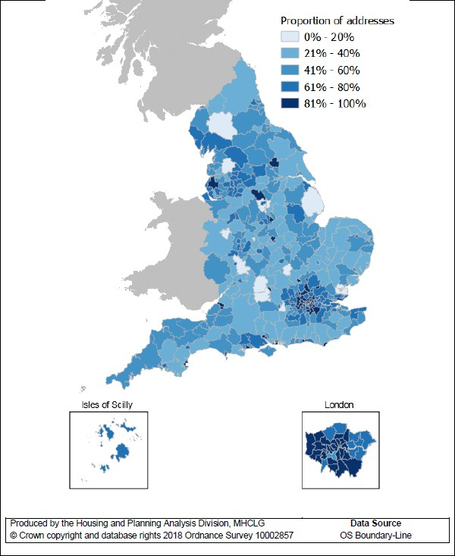

Plan 10: Proportion of new addresses on previously developed land, England 2013 -18
Source: Ministry of Housing Communities & Local Government Land Use Change Statistics in England 2017-18.

  - For a brownfield site to be allocated it must be deliverable. This will be a site not in current use, or a site in use (though not for housing) or under utilised where the local authority has evidence that the owner would be willing to make the land or buildings available for new housing, provided planning permission can be obtained. The site also needs to be free of constraints. In this context:

    - It will not be suitable for housing if any land has severe physical, environmental or policy constraints, unless the constraints can realistically be mitigated while retaining the viability of redevelopment.
    - Contaminated land should also be excluded if there is clear evidence that the cost of remediation would be out of proportion to its potential value, making re-development unviable.
    - Land in the Green Belt is subject to a national policy to keep land permanently open. Consequently exceptional circumstances will be necessary to justify changes to the Green Belt.
  - The Ashfield Employment Land Monitoring Report 2019, identifies that substantial areas of former employment land has been developed for none employment purposes between 2001 and 2019 (Table 12) with the majority of that land being developed for housing. Former coal mines and textiles factory sites have been redeveloped or greened over. Consequently, it is not anticipated that substantial brownfield land will be available for future development.

 | 2001/14 | 2014/15 | 2015/16 | 2016/17 | 2017/18 | 2018/19 | Total
Hucknall | 6.78 | 0.00 | 0.00 | 0.00 | 0.51 | 0.12 | 7.41
Kirkby in
Ashfield | 6.22 | 3.15 | 0.09 | 0.00 | 0.00 | 0.00 | 9.46
Sutton in
Ashfield | 11.64 | 0.00 | 1.76 | 0.00 | 0.00 | 0.26 | 13.66
Rural | 2.69 | 0.00 | 0.00 | 0.00 | 0.00 | 0.00 | 2.69
Total Area
loss for
each year | 27.33 | 3.15 | 1.85 | 0.00 | 0.51 | 0.38 | 33.22

Table 12: Employment Land Losses to residential development 1st April 2001 to 31st March 2019.
Source: Ashfield District Council Employment land Monitoring Report 2019

  - Where ever possible, the opportunity should be taken to take forward brownfield sites within urban areas. However, for Ashfield this needs to be seen in the context that:

- A large number of brownfield sites, typically used for coal production or textile manufacturing, have already been developed for housing or employment or have been green over as part of the District’s green infrastructure. For example, the former site and spoil heap to Silverhill Colliery.

- An industrial building or warehouse and the associated land will only be put forward by landowners for redevelopment when the building reaches the end of its economic life. The timing of redevelopment will depend on the relationship between:
  - The capital value of the existing use (the value of the existing use plus the cleared value of the site in its existing use);
  - The capital value of the best alternative use;
  - The cost of rebuilding.
A building will continue in its existing use until the value of the cleared site for the new development (housing) exceeds the value of the site and building in its existing use (industrial or warehouse).
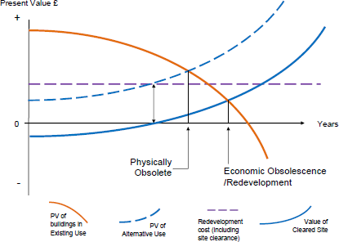

Figure 14: The Timing of Redevelopment
Source: Based on J.Harvey “The Economics of Real Property”

- For Ashfield there are no significant areas identified of derelict land within the urban areas that is available for housing.

- There are a limited number of small sites identified on the Council’s Brownfield Register.
  - Given these circumstances and reflecting that sites must be based on their potentially suitability and deliverability, it is not anticipated that there is a significant supply of brownfield site available for housing in Ashfield.

Density
  - The residential address statistics can be used to create an estimate of the density of new residential development. This is derived by calculating the density of all residences in the hectare surrounding a newly created residential address. In 2017-18, the average density of residential addresses surrounding a newly created residential address was 31 addresses per hectare. Plan 11.

  - The Ashfield Local Plan Review 2002, saved policies sets out a policy²⁸ requirement for Ashfield, on sites of 0.4 ha or more within walking distances of district shopping centres, Robin Hood Line Stations or Nottingham Express Transit rail stops of
    - 40 dwellings per ha within 400 m.
    - 34 dwellings per ha within 1 km.
    - 30 dwellings per ha elsewhere.
  - Planning application within the District have been considered against these requirements. However, it is stressed these are minimum net requirements and individual housing developments will excess these requirements. Information is set out in the Council’s Housing Monitoring Repot 2019²⁹ identifies that for large sites (10 dwellings or more) between 2010 to 2019:

    - 16% of completions fell below 30 dwellings per ha,
    - 74% of completions fell between 30 -50 dwellings per ha, and
    - 9% of completions fell above 50 dwellings per ha.
This information is broken down in the Monitoring Report into the three areas of Hucknall, Kirkby-in-Ashfield/Sutton in Ashfield and Villages (Selston Parish).
Design
  - National planning policy puts a substantial emphasis on achieving well design places both in the NPPF and in Planning Practice Guidance. This has been supported at a national level by National Design Guidance.

  - At a local level the Ashfield Local Plan Review 2002, saved policies set out broad design principles in various policies including: Policy ST1, HG5 new residential development, HG7 residential extensions, HG8 residential care homes, houses in multiple occupation, bedsit, flats and hostels, SH8

²⁸ Ashfield Local Plan Review 2002, Saved Policies – Policy HG3.
²⁹ Ashfield Housing Land Monitoring Report 2019, Table 10

commercial/retail development, Policy SH9, hot food shops. It is supported by supplementary planning documents on residential design and residential extensions.
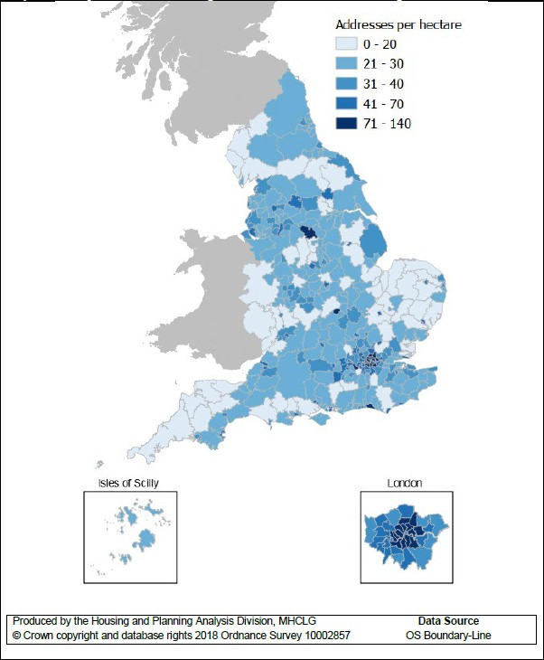

Plan 11: Density of area surrounding new residential addresses, England 2013 -18
Source: Ministry of Housing Communities & Local Government Land Use Change Statistics in England 2017-18.

Issues and Problems
- While there are extensive employment sites in Ashfield these are largely currently occupied.
- The traditional factory sites related to textiles and the coal industry have been redeveloped or green over as part of country parks. Sites that have not been developed, such as North Street, already have planning permission for re- development. Consequently, there is likely to be a very limited supply of brownfield sites of the nature in the future.
- There are extensive ‘modern’ industrial estates but buildings have not reached the end of their economic life. Consequently, they are no suitable or deliverable in terms of national planning policy.
- There is limited brownfield land available for development in Ashfield with the consequence that development is likely to be predominantly on greenfield sites.
- Minimum densities are set out by the Ashfield Local Plan Review, saved policies but these do not fully reflect national policy.
- Design policies will not reflect latest national planning policy & guidance.
- Well-designed places can be achieved by taking a proactive and collaborative approach at all stages of the planning process, from policy and plan formulation to development but Local Plan design and density policies are increasing out of date in relation to national guidance.
Potential implications of not having a new Local Plan

- Relevant policies in the Ashfield Local Plan 2002, saved policies will continue. However, they will become increasing dated and inconsistent with changes in national planning policy.
- Decisions would increasing reflect material considerations set out in national planning policy with a lack of any vision or framework for the future development of Ashfield.
- Brownfield land has to be seen in the context of a limited supply. However, greenfield sites are more likely to be priorities by developers as the Ashfield Local Plan Review 2002, saved policies does not reflect a brownfield first approach.
- Minimum densities will reflect the relevant policy in the Ashfield Local plan Review 2002, saved policies.
- There would be a reliance on national design guidance rather than local guidance, although this could be off set by local supplementary planning documents on design under the more dated design policies in the current local plan..

MEETING THE CHALLENGE OF CLIMATE CHANGE AND FLOODING (INCLUDING WATER QUALITY)
Climate Change
  - Climate change is the greatest environmental challenge facing the world today. Rising global temperatures will bring changes in weather patterns, rising sea levels and increased frequency and intensity of extreme weather events, the effects will be felt here in the UK and internationally. Current projections indicate that the Midlands will experience hotter, drier summers and warmer, wetter winters. Potentially, this could result in more frequent drought and flood events.

  - It is emphasised that in relation to climate change there are a number of cross overs with different sections of the SA Report. The local plan has a role in tackling climate change through a range of measures including the location and layout of development, reuse of waste materials, a move towards zero carbon, multi-functional green infrastructure, protecting and enhancing habitats that provide carbon sinks reduce and reduce demand on water resources.

  - The Low Carbon Energy Opportunities and Heat Mapping for Local Planning Areas Across the East Midlands’ Study³⁰ sets out an evidence base of the technical potential for renewable and low carbon energy technologies within the East Midlands. The results indicate that Ashfield has considerable potential for microgeneration; in particular, heat pumps, solar thermal and solar photo voltaics and these uses are particularly encouraged. The study also highlighted that, whilst Ashfield District has good average wind speeds, the potential for commercial scale wind energy developments is limited by constraints relating to the presence of existing infrastructure, properties and bird sensitivity issues.

  - No Air Quality Management Areas (AQMA) have been declared within the District.

Water
  - Severn Trent Water forecasts a shortfall of water supply against demand if no interventions are made. Their Water Resources Management Plan 2019 identifies various demand management and supply side measures together with additional investment to ensure water resources are maintained. Supply and demand forecasts are made for the next 25 years to enable Severn Trent Water to determine whether they have enough water to meet customer requirements. The plan takes into account various aspects including climate change scenarios, demand scenarios for population changes and protecting the environment in the long-term by not putting at risk the future ecological status of the water bodies. Severn Trent identifies that this should not constrain growth but there may be time implications for developments in upgrading water infrastructure. The Plan emphasises that the plan protects

³⁰ Low Carbon Energy Opportunities and Heat Mapping for Local Planning Areas Across the East Midlands’ study Land Use Consultants, Centre for Sustainable Energy and SQW on behalf of East Midlands Councils in 2011

the environment in the long-term by not putting at risk the future ecological status of the water bodies in our region (as defined by the Water Framework Directive).

  - The Watercycle Study for Greater Nottingham and Ashfield³¹ indicates that the water resource situation in the East Midlands is significantly constrained with little opportunity to develop new water resource schemes. The Environment Agency’s Catchment Abstraction Management Strategies (CAMS) identifies that water is either not available for extraction or is restricted dependent on the CAMS area.

  - Foul water service provision is provided through a number of Wastewater Treatment Works. In the past issues have been identified at Huthwaite but there has been an increase in hydraulic limit so that immediate capacity issues have been alleviated. The ‘no deterioration’ policy of the Water Framework Directive³² requires that current environmental conditions are maintained or improved
  - Ashfield is located upstream of the Trent Valley with a number of the River Trent’s tributaries rising in the District. Plan12 identified Flood Zone 2 and 3 in Ashfield. The Strategic Flood Risk Assessment 2009³³ identifies that while the risk of flooding from watercourses is relatively low compared with some neighbouring authorities, properties at Hucknall and Jacksdale are particularly at risk from watercourses. Additional water into the River Leen raises potentially significant flood issues in Nottingham. The impact of climate change and the topography is anticipated to result in an increasing risk from surface water flooding in the District.

  - The proactive protection of groundwater resources is key to providing improvements to the aquatic environment and protecting water resources for future use. Under the Water Framework Directive, the environmental objectives for groundwater and surface water bodies are:-
    - To prevent deterioration in the status of water bodies, improve their ecological and chemical status and prevent further pollution.
    - Aim to achieve good quantitative and good groundwater chemical status by 2015 in all water bodies. For a groundwater water body to be in overall 'good' status, both its quantitative and chemical status must be 'good'
    - Implement actions to reverse any significant and sustained upward trends in pollutant concentrations in groundwater
    - Comply with the objectives and standards for protected areas where relevant.
    - Hazardous substances must be prevented from entry into groundwater and the entry into groundwater of all other pollutants must be limited to prevent pollution.

³¹ Entec (2010) Greater Nottingham and Ashfield Outline Water Cycle Study
32 Directive 2000/60/EC of the European Parliament and of the Council of 23 October 2000
³³ Strategic Flood Risk Assessment 2009 Ashfield District Council

This approach is important for Ashfield as the District is situated on principal and secondary aquifers. These are layers of rock or drift deposits that provide a high level of water storage. They may support water supply and/or river base flow on a strategic scale. Secondary aquifers are permeable layers capable of supporting water supplies at a local rather than strategic scale, and in some cases forming an important source of base flow to rivers.

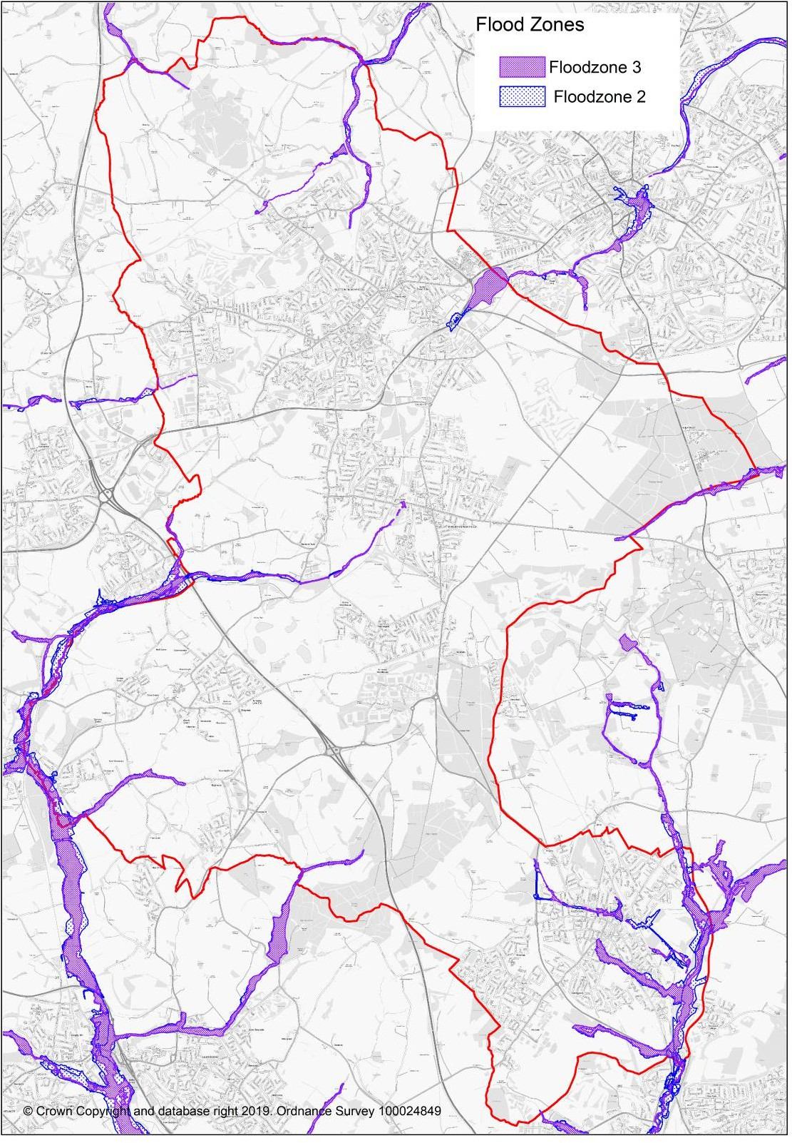

Plan 12: Ashfield Flood Zones 2 and 3
Source Environment Agency Flood Maps for Planning

Issues and Problem

- Planning for the adaptation of and long-term resilience of Ashfield in relation to all aspects of climate change.
- The Local Plan policies provide opportunities to support adaptation to climate change through appropriate design and layout and incorporation of features to facilitate resilience to the effects of climate change.
- Improving energy efficiency and increasing use of low-carbon and renewable energy.
- Balancing the potential amenity and landscape impacts and the need for alternative sources of energy.
- Ensure that new development has good access to facilities and alternative means of travel.
- Reducing the dependency on the private car.
- To facilitate alternative forms of transport including encouraging more people to walk and cycle.
- To take account of the impact of development on water in relation to water quality and flood risk.
- To avoid development within Flood Zones 2 and 3 unless exceptional reasons arise.
- While the risk of flooding from watercourses is relatively low there is a risk from flooding is specific area, in particular, Hucknall and Jacksdale.
- The River Leen flows into the City from Ashfield and is identified as responding rapidly in the urban area to rainfall, giving less time for community response. Additional water into the River Leen raises significant flood issues in Nottingham. It is important that neighbouring authorities work in partnership to ensure that activities upstream do not increase flood risk within the City of Nottingham.
- To the south and west of Nottinghamshire there are relatively steep areas, including heavily urbanised areas, such as Sutton-in-Ashfield and Mansfield.
- Water supply will need to be considered and consideration should be given to reducing water consumption below Part G of Building Regulations which specifies that new homes must consume no more than 125 litres of water per person per day.
- Waste water will need to be effectively managed through development and infrastructure planning.

Potential implications of not having a new Local Plan

- Relevant policies in the Ashfield Local Plan 2002, saved policies will continue. However, they will become increasing dated and inconsistent with changes in national planning policy.
- Decisions would increasing reflect material considerations set out in national planning policy with a lack of any vision or framework for the future development of Ashfield.
- Baseline trends relevant to climate change will continue.
- Emissions from road transport and households are likely to continue to be the two largest inputs to greenhouse gas emissions. Road traffic use in and around the District is likely to increase may with population increases.
- New developments is anticipated to include some features which will help to facilitate resilience to the effects of climate change, such as sustainable drainage systems. However, lack of policy up-to-date policy provision is likely to mean that the Council has a more limited response to these aspects.
- Population growth will increase water demand for the area placing increasing pressure on water resources. Severn Trent Water has planned for increases for a period of 25 years from 2020. The Water Management Plan places an emphasis on saving water, however, without a Local Plan and relevant policies there are more limited opportunity to reduce water consumption below Part G of the Building Regulations.
- No policies were saved relating to flood in the Ashfield Local Plan Review 2002. Nevertheless, the NPPF would provide a material consideration to reduce the possibility of housing development within Flood Zones 2 or 3. It is also anticipated that surface water risk would still need to be mitigated through Sustainable Urban Drainage Schemes. However, the absence of up-to-date Local Plan Policies means that these scheme may not maximise the biodiversity benefits and there is less flexibility to incorporate this with a blue and green infrastructure network.

CONSERVING AND ENHANCING THE NATURAL ENVIRONMENT & PROTECTING THE GREEN BELT
Biodiversity & Geological Significance

  - Ashfield is recognised as one of the most biodiverse areas in Nottinghamshire, due largely to its varied geological context of magnesian limestone, triassic sandstone (to the east) and coal measures (to the west). The District supports a broad range of habitats, including heathland, ancient woodland dumbles, calcareous grasslands (often on post-industrial sites) and fields rich in wild flowers. The east is characterised by small fields and streams, while the west and south contains large blocks of tree planting. The rivers and streams within the District provide habitat for significant populations of water vole and native crayfish.

  - Ashfield has nine Sites of Special Scientific Interest (SSSI), representing some of the County’s richest habitats, see Table below.

Ashfield - SSSI | Area ha | Interest
Annesley Woodhouse Quarries | 34.6031 | Biological
Bagthorpe Meadows | 6.3072 | Biological
Bogs Farm Quarry | 4.8971 | Biological
Bulwell Wood, Hucknall | 16.8741 | Biological
Dovedale Wood | 13.4252 | Biological
Friezeland Grassland | 3.6781 | Biological
Kirkby Grives | 22.0184 | Biological
Teversal Pastures | 17.9162 | Biological
Teversal – Pleasely Railway | 5.0122 | Biological

Table 13: Sites of Special Scientific Interest in Ashfield District Council
Source: Natural England

  - Ancient Woodland have been identified by Natural England within Ashfield at:

    - Healds Wood, Stanton Hill/Skegby;
    - Bloomer Wood, Kirkby-in-Ashfield;
    - Bulwell Wood, Hucknall;
    - Dawgates Wood, Skegby;
    - Dawgates Wood 1, Skegby
    - Dovedale Wood, Stanley
    - High Park Wood, Underwood.
    - Little Oak Plantation, Annesley;
    - Millington Springs, Underwood;

    - Normanshill/Thieves Wood; Sutton in Ashfield
    - The Dumbles. Kirkby-in-Ashfield.

In addition, Starth Wood, Elhole Wood and Watnall Coppice are on the western district boundary of Ashfield, close to the urban edge of Hucknall.

  - Sherwood Forest possible potential Special Protection Area (ppSPA) – Natural England has confirmed that Sherwood Forest satisfies Stage 1 of the RSPA Selection Guidelines for breeding nightjar and woodlark. Natural England therefore advocates that further consideration of Sherwood Forest against Stage 2 of the SPA Selection Guidelines at the appropriate stage during the UK SPA Review process. Accordingly, Natural England advocates that a risk-based approach or similar be adopted until such a time that the full SPA Review process has been completed³⁴, Plan 13.
  - Local Wildlife Sites (formerly “Sites of Importance for Nature Conservation’) are locally designated wildlife sites incorporated into the planning system for protection. They represent sites that are of at least County-wide importance, and form a crucial framework of ‘stepping stones’ for the migration and dispersal of species. These sites are identified and surveyed by the local Biological and Geological Records Centre, based on criteria set by the Nottinghamshire SINC panel, and are subject to regular review. Plan 14. Local Nature Reserves (LNR) are sites mainly under the control of the local authority, designated in consultation with Natural England to encourage public access and enjoyment of the natural environment. Ashfield currently has four LNR identified below.

Ashfield – Local Nature Reserves | Area ha | LNR Type
Brierley Forest Park, Sutton in Ashfield | 80.6 | Urban
Kingsmill Reservoir, Sutton in Ashfield
Portland Park, Kirkby | 9.43 | Urban
Teversal to Pleasley Railway | 21.49 | Urban

³⁴ Advice Note to Local Planning Authorities regarding the consideration of the likely effects on the breeding population of nightjar and woodlark in the Sherwood Forest Region, Natural England, March 2014.

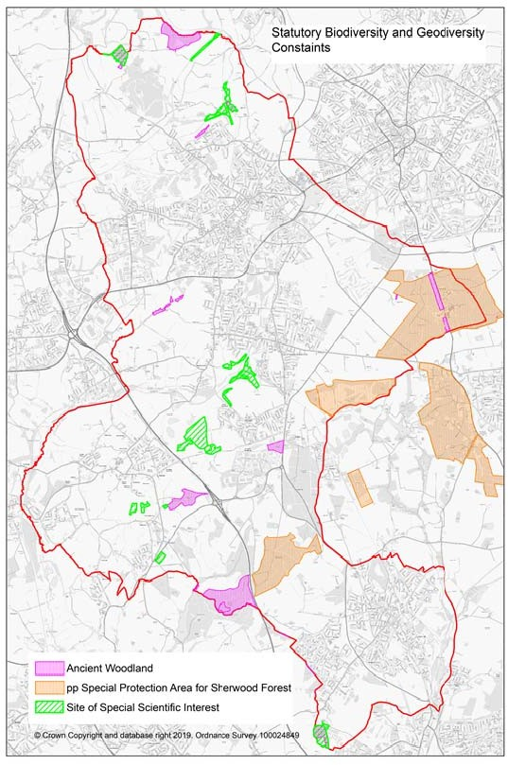

Plan 13: Designated Natural Assets in Ashfield but including the ppSpecial Protection Area for Sherwood Forest.
Source: Natural England & Natural England Advice Note to Local Planning Authorities regarding the consideration of the likely effects on the breeding population of nightjar and woodlark in the Sherwood Forest Region, Natural England, March 2014.

  - The evidence base for the Local Plan and planning applications includes The Nottingham Biodiversity Opportunity Mapping Project for Ashfield 2016³⁵. The NPPF stresses the need to enhance biodiversity³⁶ these maps identify opportunities for improving habitat condition and connectivity across Ashfield. The maps identify the following:

    - Woodland Biodiversity Opportunities with associated Table;
    - Heathland & Acid Grassland Biodiversity Opportunities with associated Table;
    - Grassland Biodiversity Opportunities with associated Table;
    - Wetland Opportunities with associated Table.
  - The Sherwood Biodiversity Opportunities Mapping Report includes parts of Ashfield and mapping has also been undertaken for Broxtowe. The maps and Tables in these and any future Biodiversity Opportunities for neighbouring districts to Ashfield will need to be considered as part of the Local Plan and planning applications. They link to biodiversity opportunities beyond Ashfield District boundary but which may be crucial for enhancing biodiversity and the natural environment. Further information is available on Nottinghamshire Biodiversity Action Group website.

  - The whole of Ashfield lies within the Greenwood Community Forest. The Greenwood Partnership works with communities to create, improve and enjoy woodlands and other high quality accessible green spaces in a sustainable way that benefits the environment, landscape and the local economy. The Council has carried out numerous schemes contributing to the Greenwood Community Forest including Brierley Forest Park, a major public open space between Sutton-in-Ashfield, Huthwaite and Stanton Hill. This parkland includes extensive areas of tree planting, wetlands and wildflower meadow together with a large trail network and visitor centre. The Government’s independent ‘Landscape Review’ of National Parks an AONBS³⁷ recommends that Sherwood Forest is given the status as a national forest. If taken forward this will give increased emphasis on tree planting and improvements to biodiversity.

  - As well as facilitating nature and biodiversity, there are nature based solutions to address the adverse impact of climate change. The Government and other organisations such as the National Trust have put a substantial emphasis on tree planting as part of carbon sequestration. The Agricultural Bill also places an emphasis on future agriculture schemes being orientated farmers being paid for ‘public goods’. It is proposed under the Bill that farmers will be paid for creation of new and expanded habitats for wildlife and public access.

³⁵ The Nottingham Biodiversity Opportunity Mapping Project Ashfield District Final Report, November 2016. Chris Jackson Nottingham Biodiversity Action Group
³⁶ National Planning Policy Framework 2019 Paragraph 170.
³⁷ Landscapes Review 2008 Department for Environment, Food& Rural AffairsPage 122 New National Status for Sherwood Forest.

  - UK BAP priority habitats cover a wide range of semi-natural habitat types, identified as being the most threatened and requiring conservation action under the UK Biodiversity Action Plan (UK BAP). As a result of devolution, and new country-level and international drivers and requirements, much of the work previously carried out by the UK BAP is now focused at a country-level rather than a UK-level, and the UK BAP was succeeded by the 'UK Post-2010 Biodiversity Framework' in July 2012.

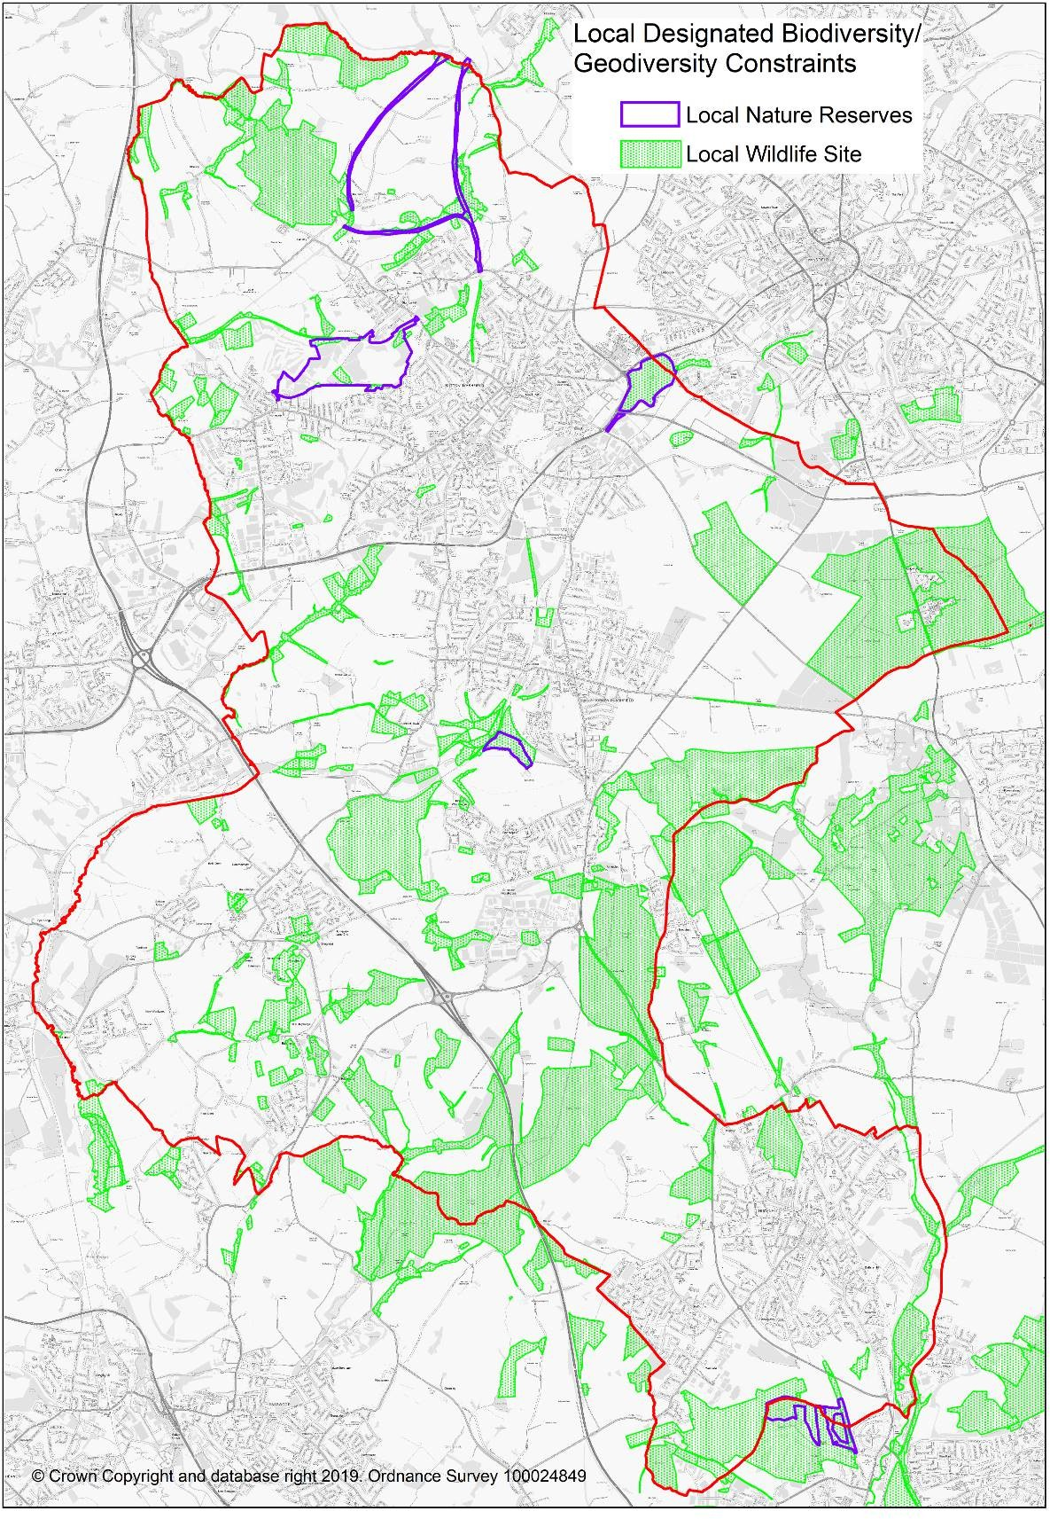

Plan 14: Local Designated Biodiversity Sites in Ashfield
Source: Ashfield District Council & Nottinghamshire Biological and Geological Records Centre

Best & most versatile Agricultural Land

  - Table 14 sets out the grades of agricultural land. The NPPF identifies ‘Best and most versatile agricultural land’ as land in grades 1, 2, and 3a of the Agricultural Land Classification³⁸. There is no Grade 1 land in Ashfield. Plans 15 and 16 set out locations of Grade 2 and 3a land in

  - The Town and Country Planning (Development Management Procedure) (England) Order 2015 require local planning authorities to consult Natural England on development which is not for agricultural purposes and is not in accordance with the provisions of a development land where there is the loss of not less than 20 hectares of grades 1, 2 and 3a agricultural land³⁹

Grade | Description
1 | Land with no or very minor limitations. A very wide range of agricultural and horticultural crops can be grown and commonly includes: top fruit, soft fruit, salad crops and inter harvested vegetables. Yields are high and less variable than on land of lower quality. (Excellent quality agricultural  land with no or very minor limitations to agricultural use.)
2 | Land with minor limitations which affect crop yield, cultivations or harvesting. A wide range of agricultural and horticultural crops can usually be grown. On some land in the grade there may be reduced flexibility due to difficulties with the production of the more demanding crops, such as winter harvested vegetables and arable root crops. The level of yield is generally high but may be lower or more variable than grade 1.  (Very good quality agricultural land with minor limitations, which affect crop yield, cultivation or harvesting.)
3  Subgrade 3a  Subgrade 3b | Land with moderate limitations which affect the choice of crops, timing and type of cultivation, harvesting or the level of yield. Where more demanding crops are grown yields are generally lower or more variable than on land in grades 1 and 2.  Land capable of consistently producing moderate to high yields of a narrow range of arable crops, especially cereals, or moderate yields of crops including: cereals, grass, oilseed rape, potatoes, sugar beet and less demanding horticultural crops  Land capable of producing moderate yields of a narrow range of crops, principally: cereals and grass, lower yields of a wider range of crops, high yields of grass which can be grazed or harvested over most of the year
4 | Land with severe limitations which significantly restrict the range of crops and/or level of yields. It is mainly suited to grass with occasional arable crops (for example cereals and forage crops) the yields of which are variable. In moist climates, yields of grass may be moderate to high but there may be difficulties using the land. The grade also includes arable  land that is very dry because of drought.
5 | Land with very severe limitations which restrict use to permanent pasture or rough grazing, except for occasional pioneer forage crops.

Table 14: Agricultural Land Classification
Source: Guide to assessing development proposals on agricultural land HM Government

³⁸ National Planning Policy Framework, Annex 2: Glossary, page 65
³⁹ Schedule 4 Consultations before the grant of permission, Articles18,19 and 20

https://www.gov.uk/government/publications/agricultural-land-assess-proposals-for-development/guide-to-assessing- development-proposals-on-agricultural-land
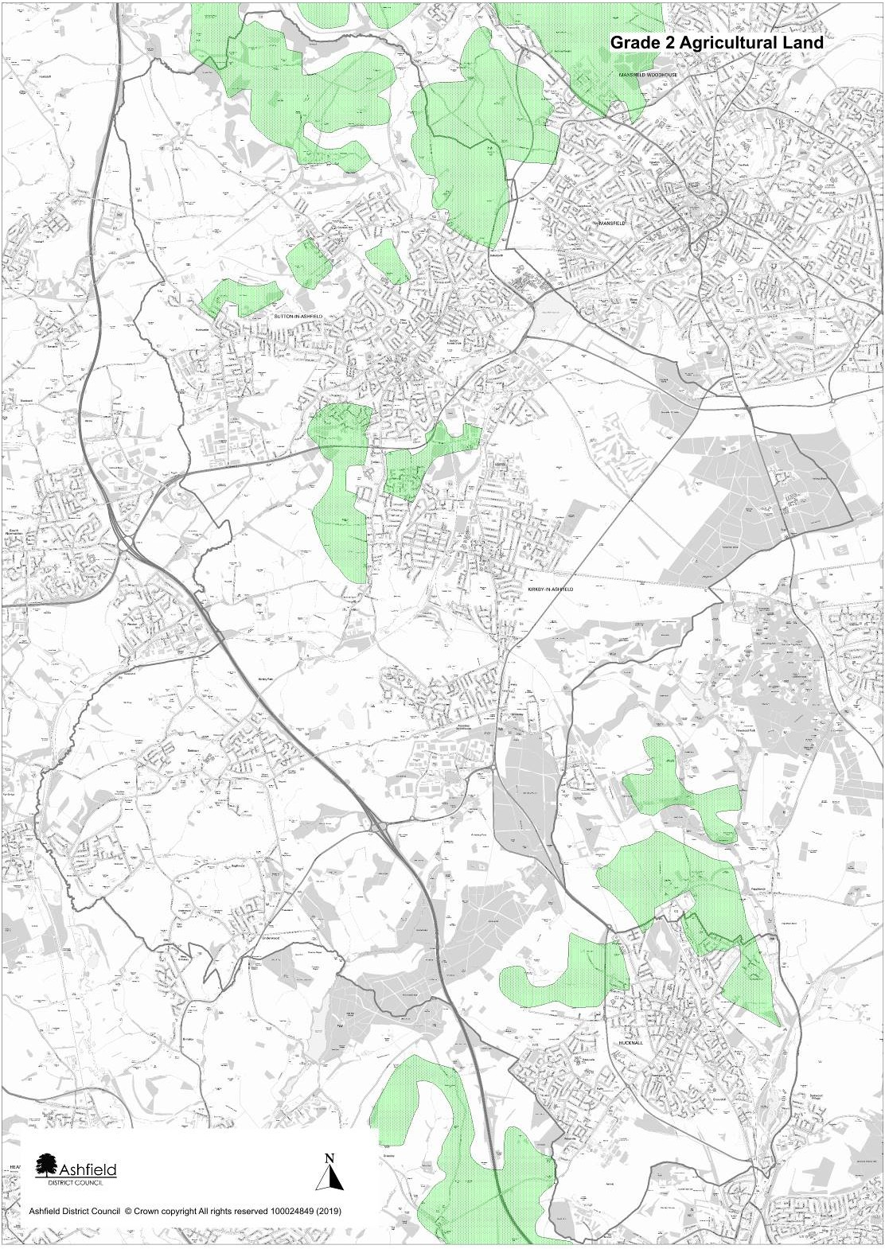

Plan 15: Agricultural Land Grade Two Approximate Location
Source: Natural England – Agricultural Land Classifications Provisional (England)

N.B. The map does not subdivide Grade 3 land into sub classifications. It is stressed by Natural England that these maps are not sufficiently accurate for use in assessment of individual fields or sites.

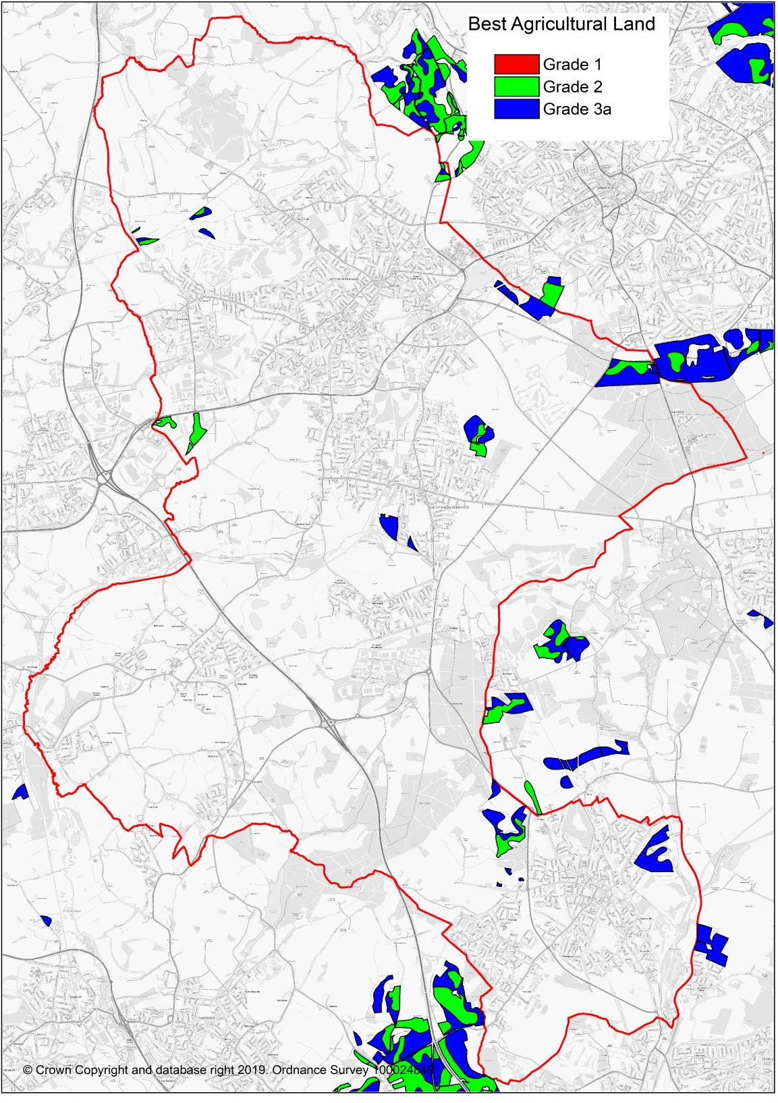

Plan 16: Best Agricultural Land based on Agricultural Land Classification (ALC) Grades - Post 1988 Survey.
Source: Natural England (magic). Reflects scanned original paper maps and survey reports for individual sites surveyed in detail between 1989 and 1999 by the Ministry of Agriculture Fisheries and Food.

Landscape

  - The Landscape Character Assessment for Ashfield (2009) sets out three landscape character areas which broadly influence the scale and form of development across the District. These are:
    - Magnesium Limestone Ridge,
    - Nottinghamshire Coalfields and
    - Sherwood.
Each of these areas has been further sub-divided into component landscape character areas know as Draft Policy Zones (DPZ). Each DPZ identifies and lists the key features which make it special and provides a judgement on the condition of the landscape and its strength of character.

  - There are no national designated landscapes in Ashfield Air Quality
  - The area no Air Quality Management Areas in Ashfield District Council.
  - The Local Air Quality Update identifies that a review of air quality measurement during 2014 has demonstrated that all the air quality objectives continue to be achieved across Ashfield.

Green Belt

  - Approximately 41% of Ashfield is within the Nottingham - Derby Green Belt. This including land around Hucknall, land to the south and east of Kirkby-in- Ashfield and land surrounding the rural villages of Selston, Jacksdale, Underwood and part of Brinsley. Bagthorpe is ‘wash over’ by the Green Belt. Plan

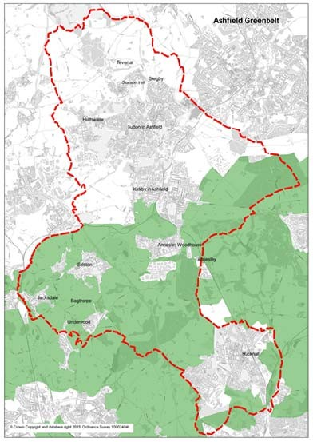

Plan 17: Green Belt Ashfield & surrounding districts
Source: Ashfield DC

Issues & problems

    - The protection and enhancement of biodiversity, particularly statutory and non statutory sites of nature conservation interest in Ashfield.
    - Ensuring that the plan proposals have no adverse effect upon the South Pennines Special Area of Conservation (SAC), the Birklands & Bilhaugh SPC and the Sherwood Forest possible potential Special Protection Area.
    - Safeguarding nationally and locally valued species/habitats.
    - Enhancing biodiversity and the natural environment potentially through Biodiversity Opportunity Mapping.
    - Identifying opportunities for tree planting facilitating Green wood Community Forest and facilitating zero carbon targets.
    - Uncontrolled development could harm local landscape and settlement character.
    - Protect and enhance landscapes that contribute to the distinctive local character of areas within the District;
    - Maximise the benefits from the landscape character assessment by using landscape character to make choices about the locations for development and the design of proposals.
    - Improving the public realm and promoting high standards of design where regeneration is required.
    - Potential effects on landscape quality from poor design and layout of new development areas.
    - Balancing the needs for protecting better quality agriculture land and development requirements.
    - Providing a framework within which to manage protection of existing habitats and creation of new ones.
    - The need to safeguard and improve soil resources.
    - Addressing contamination issues relating to previous land uses.
    - Past development of brownfield sites means that currently there are limited stocks of vacant brownfield land. By implication, this means that there will be a loss of greenfield sites and agricultural land.

    - Maintaining and improving air quality in accordance with National Air Quality Standards and best practice.
    - Seeking to secure a reduction in emissions from sources which contribute to

poor air quality.

    - A substantial part of the District of Ashfield is identified as being within the Green Belt where exception circumstances are require to justify changes to the Green Belt boundaries.
Potential implications of not having a new Local Plan

    - Relevant policies in the Ashfield Local Plan 2002, saved policies will continue. However, they will become increasing dated and inconsistent with changes in national planning policy.
    - Decisions would increasing reflect material considerations set out in national planning policy with a lack of any vision or framework for the future development of Ashfield.
    - Biodiversity and geodiversity will still be protected under the Ashfield Local Plan Review 2002. However, the lack of up-to-date Local Plan policies and a lack of a 5 year housing supply for Ashfield means that local designated sites are more vulnerable to development. This reflects that locally designated sites are not identified within protected areas or assets set out in NPPF paragraph 11 and the supporting footnote.
    - Without an up-to-date Local Plan with housing allocations and infrastructure provision, housing pressure will put countryside area at risk from unmanaged development. It could result in the loss of locally valued landscapes and possible coalescence of settlements. In addition, there may be the loss of high quality agricultural land and soil resources.
    - A fragmented, piecemeal approach reflected in individual planning application is likely to result in a lack of protection of the best landscapes.
    - Without a strategic approach to housing and employment requirements this could result in piece meal development in areas sensitive to noise and air pollution and potentially exacerbate these factors.

CONSERVING AND ENHANCING THE HISTORIC ENVIRONMENT
  - The Council is committed to protecting, conserving and where opportunities arise, enhancing the historic environment of the District. The historic environment is all aspects of the environment which have resulted from the interaction between people and places through time, including all surviving physical remains of past human activity, whether visible, buried or submerged, and landscaped planted or managed flora. Those elements of the historic environment that hold significance are called heritage assets.

  - Ashfield benefits from a variety of formally designated historic assets including:

    - 6 Conservation Areas;
    - 80 Listed Buildings;
    - 9 Scheduled Ancient Monuments;
    - 2 Registered Historic Parks and Gardens
  - Ashfield’s six designated Conservation Areas are Kirkby Cross, Lower Bagthorpe, Teversal, New Annesley, Sutton in Ashfield Church and Market Place and Hucknall Town Centre.

  - Listed Buildings are buildings that appear on the Secretary of State's 'List of Buildings of Special Architectural or Historic Interest', prepared by the Department of Culture, Media and Sport. Listed buildings are graded to show their relative architectural or historic interest, as follows
    - Grade I buildings are of exceptional interest (there are two in Ashfield);
    - Grade II* buildings are particularly important buildings of more than special interest (four in Ashfield);
    - Grade II buildings are of special interest, warranting every effort to preserve them.
  - Harwick Hall, a Grade 1 listed building and Old Hall, a Grade1 listed building and Schedule Monument is located just over the district boundary with Bolsover District Council to the north of the District. The two Hall are located on the edge of an elevated scarp and are prominent in the landscape. The National Trust has commission a Hardwick Setting Study⁴⁰, which sets out detailed information on the setting of these buildings. It sets out a characterisation of the Landscape around Hardwick into 14 areas.

  - Four historic assets are identified on the Heritage at Risk Register (August 2016) Annesley Conservation Area, Annesley Hall, Annesley, Church of St Mary Magdalene, Market Place, Hucknall, and Wansley Hall manorial site, Selston.

  - Ashfield has a limited stock of statutorily listed buildings. This puts an increased emphasis on non-designated heritage assets. The Council has introduced a scheme by which historic assets of local importance are identified, using local selection criteria. In addition, there is a locally protected Historic Park and Gardens at Skegby Hall Gardens.

  - Archaeological remains are important for their historical and educational interest and may also be important features in the landscape. The Nottinghamshire Historic Environment Records (HERs) is maintained and updated by the County Council and contains details of all known sites, structures, landscapes or other areas of archaeological interest in Ashfield.

⁴⁰ Hardwick Setting Study 2016, Atkins for National Trust.

Nine sites within the District are currently scheduled as Ancient Monuments under the Ancient Monuments and Archaeological Areas Act, 1979.

  - Registered Historic Parks and Gardens are important in historical and landscape terms and may also be of wildlife and recreational value. Ashfield has two designed landscapes on the Historic England Heritage Register of Parks and Gardens of Special Historic Interest, including Hardwick Hall Grounds (that part within Ashfield) which is Grade I of international importance and Annesley Hall which is Grade II* of exceptional interest.

  - Plans of the constraints are set out in Plans 18 and 19.

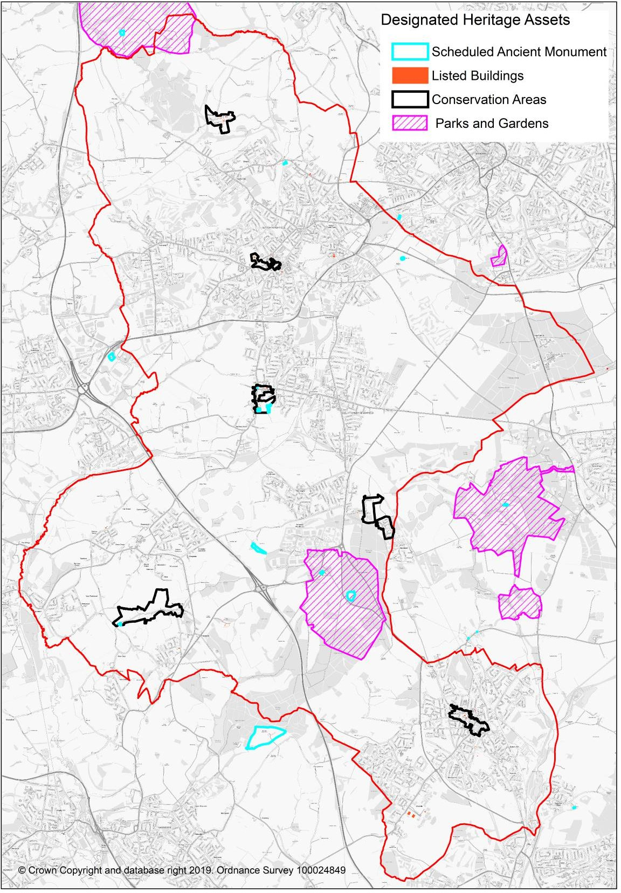

Plan 18: Designated Heritage Assets in Ashfield
Source: Historic England

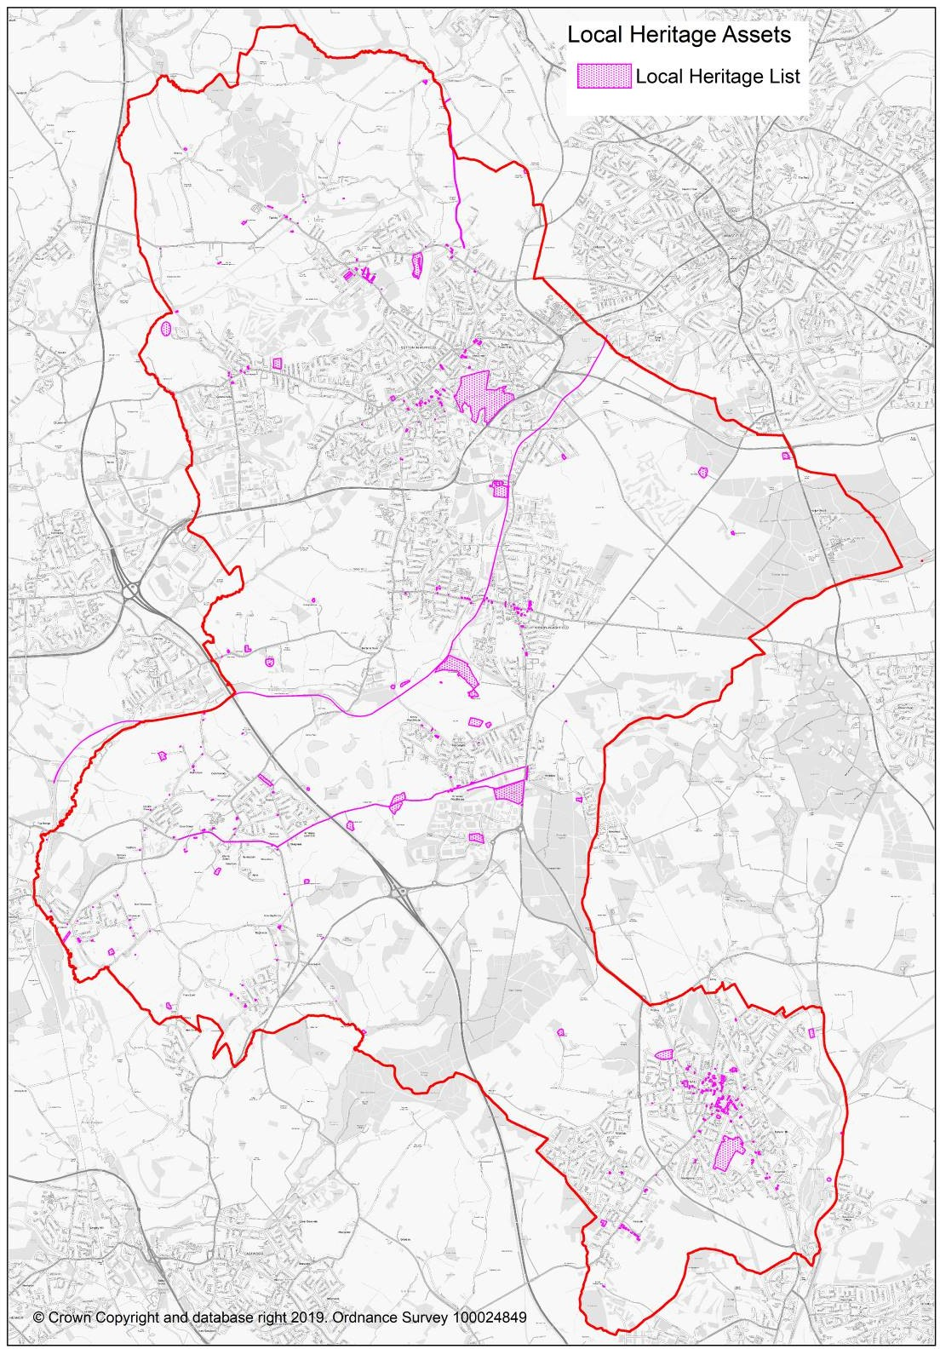

Plan 19: Ashfield Local Heritage Assets.
Source: Ashfield District Council

Issues and Problems

- The conservation and enhancement of Ashfield’s historical and archaeological assets and their setting.
- Four heritage assets are identified on the Heritage at Risk Register (August 2016) Annesley Conservation Area, Annesley Hall, Annesley, Church of St Mary Magdalene, Market Place, Hucknall, and Wansley Hall manorial site, Selston.
- The protection of non-designated heritage assets within Ashfield.
- There is a need to actively promote the character and distinctiveness of the Conservation Areas.
- Promote the conservation and enhance of the heritage assets within the District town centres to support the local economy.
- Using the Conservation Area appraisals, to inform choices about development and the design of proposals within and adjacent to those areas.

Potential implications of not having a new Local Plan

- Relevant policies in the Ashfield Local Plan 2002, saved policies will continue. However, they will become increasing dated and inconsistent with changes in national planning policy.
- Decisions would increasing reflect material considerations set out in national planning policy with a lack of any vision or framework for the future development of Ashfield so there would be no opportunity to identify possibilities to enhance the historic environment, heritage assets or their setting.
- National policy emphasises the importance of designated heritage assets which are irreplaceable. However, opportunities to plan across the district in terms of protecting and enhancing the historic environment will be reduced as development would come forward on an ad hoc basis.
- Potential for harm to heritage assets and setting as a result of development coming forward outside the Local Plan. Local historic assets are particularly at risk given Ashfield’s lack of a five year housing supply and the likely application of NPPF paragraph 11 on a planning application for housing development.

MINERALS & WASTE
  - Minerals and Waste Local Plans are brought forward by Nottinghamshire County Council. Nevertheless, there are some implications for Ashfield’s Local Plan.

  - The Waste Core Strategy by Nottinghamshire County Council sets out the importance of the Waste Hierarchy. It identifies that existing landfill sites have only a limited life and stresses the importance of waste prevention, re-use, recycling and recovery to minimise what goes to landfill.

  - The NPPF stresses the importance of safeguarding mineral resources by defining Minerals Safeguarding Areas so that specific minerals are not sterilised by non-mineral development where this should be avoided⁴¹.

Issues and Problems
    - To follow the ‘waste hierarchy’ and in particular to reduce the growth in waste and increase the amount of waste which is re-used and recycled.
    - New development needs to include provision for waste recycling facilities.
    - Existing landfill sites have only a limited life (Nottinghamshire Waste Core Strategy).
    - The Waste Core Strategy identifies a 70% recycling target for all wastes by 2025.
    - Avoiding development on safeguarded mineral resources where this needlessly sterilises the minerals resource.
Potential implications of not having a new Local Plan

    - Relevant policies in the Ashfield Local Plan 2002, saved policies will continue. However, they will become increasing dated and inconsistent with changes in national planning policy.
    - Decisions would increasing reflect material considerations set out in national planning policy with a lack of any vision or framework for the future development of Ashfield.
    - The requirements of the latest Nottinghamshire County Council produced Mineral and Waste plans would become increasingly difficult to achieve.
    - More waste to be generated and less waste potentially recycled.

⁴¹ National Planning Policy Framework, 2019, paragraph 204 c).

Section 5: Developing the SA framework (Stage A4)

(Stage A4 - Table 4 Sustainability Appraisal and the Local Plan)

SA Objectives
  - This section looks at developing the Sustainability Appraisal Framework which contains a list of objectives based on the review of other relevant plans, policies and programmes (stage A1), the analysis of the baseline data (stage A2) and the identification of sustainability issues (stage A3).

  - The SA Framework will be used to test the sustainability of the emerging Local Plan including assess the reasonable alternative options for the policies, potential sites and policies.
  - The objectives build on the objectives set out in the 2009 scoping report and the review of the scoping report 2015. The SA Report in 2009 was brought forward before the National Planning Policy Framework (NPPF) replaced the majority of Planning Policy Guidance and Planning Policy Statements in 2012. The NPPF emphasis that the role of planning is to bring forward sustainable development.

  - Following the review of plans, policies and programmes, taking into account the analysis of the baseline data and the identification of sustainability issues, it is considered that the objectives set out in the Scoping Report of 2015 remain appropriate.
  - The SA objectives are based on the principles in the NPPF but have been adapted to address the key sustainability issues most relevant to Ashfield. The NPPF identifies that there are three dimensions to sustainable development: economic, social and environment. In Table 15 the objectives have been identified as falling into one of these three dimensions. However, it should be recognised that in practice these objectives will cross over the dimensions. For example, Objective 6 Biodiversity is identified as environmental but it can be seen that it will have health impact (social) and economic impact such as in relation to tourism or agricultural production. House development is identified as social but it also has an economic impact in relation to the construction industry and to the creation of jobs.

Sustainable appraisal objectives | SA/SEA Theme | SA Dimension
1. To ensure that the housing stock meets the housing needs of Ashfield. | Population/ Human health/ Material assets | Social.
2. To improve health and wellbeing and reduce health inequalities. | Population/ Human health/ Material assets. | Social.
3. To conserve and enhance  Ashfield’s historic environment, heritage assets and their settings. | Cultural Heritage/ Human health/ Material assets | Environmental.
4. To improve community safety, reduce crime and the fear of crime. | Population/ Human health. | Social.
5. To improve social inclusion and to close the gap between the most deprived areas and the rest of Ashfield. | Population/ Human health/ Material assets. | Social.
6. To conserve, enhance and increase biodiversity levels and Green & Blue Infrastructure. | Biodiversity/ Human health/ Fauna/ Flora/ Climatic factors/ Landscape/ Material assets. | Environmental.
7. To protect enhance and manage the character and appearance of Ashfield’s landscape/townscape, maintaining and strengthening local distinctiveness and sense of place. | Biodiversity/ Human health/ Fauna/ Flora/ Landscape/ Cultural heritage/ Material assets. | Environmental.
8. To minimise the loss of natural resources including soils, greenfield land and the best quality agricultural land. | Soil/ Fauna/ Flora/ Material assets | Environmental.
9. To reduce air pollution and the proportion of the local population  subject to noise pollution. | Air/ Human health/ Material assets. | Environmental.
10. To conserve and improve water quality and quantity. | Water/ Climatic factors. | Environmental
11. To minimise waste and increase the re-use and recycling of waste materials. | Climatic factors/ Landscape/ Material assets. | Environmental.
12. To adapt to climate change by reducing and manage the risk of flooding and the resulting detriment to people, property and the  environment. | Water/ Climatic factors/ Material assets | Environmental.
13. To adapt to climate change by minimise energy usage and to develop Ashfield’s renewable energy resource, reducing dependency on non-renewable sources. | Climatic factors/ Material assets | Environmental.

Sustainable appraisal objectives | SA/SEA Theme | SA Dimension
14. To improve travel choice and accessibility, reduce the need for  travel by car and shorten the length and duration of journeys. | Population/ Human health/ Climatic factors/Landscape/ Material assets | Social.
15. To create high quality employment opportunities including opportunities for increased learning  and skills to meet the needs of the District. | Population/ Human Health/ Material assets. | Economic
16. To improve the efficiency,  competitiveness and adaptability of the local economy. | Population/ Human Health/ Material assets. | Economic.
17. Increase the vitality and viability of Ashfield’s town centres. | Population/ Material assets. | Economic.

Table 15: Sustainability appraisal objectives and SEA Theme
Source: Ashfield District Council

SA Assessment
  - Table 17 sets out the relationship between the following:
    - SEA link – Identifies the relationship between the SEA themes and the SA Objectives.
    - Objective – The Objective derived from the analysis of plans programmes and policies and the baseline issues set out in Table Five. Table 15 sets the Sustainability Objectives and their relationship with the EAPP issues and the NPPF objectives.
    - Decision Making Criteria - Assessment questions provide a systematic way of interrogating plan options. Relevant topics can be used to develop an appropriately focused assessment. Questions can be developed on the basis of the analysis of relevant objectives. Table 17 includes decision making criteria linked to specific objectives. These criteria comprise the key questions that will be asked to ascertain whether or not a proposal or option works towards the SA objective.
    - Land Allocation Appraisal – This identifies potential means of identify the impact of a specific site in relation to the Objectives and decision making criteria. In this context major development is identified as follows:

      - NPPF paragraph 68 defines small sites as being 1 ha or less. Therefore, major sites have been identified as sites that are larger than 1 ha.

      - Employment the provision of a building or buildings where the floor space to be created by the development of 10 ha or more.

The scoring will also take account of any secondary, cumulative and synergistic effects.

    - Open Space –The National Planning Policy Framework identifies that all open space of public value, including not just land, but also areas of water (such as rivers, canals, lakes and reservoirs) which offer important opportunities for sport and recreation and can act as a visual amenity. The following typology illustrates the broad range of open space of public value:
      - Parks and gardens – including urban parks, country parks, forest parks and formal gardens;
      - Outdoor sports facilities;
      - Amenity green space including play areas, kickabout areas, skateboard parks etc;
      - Green corridors – including river and canal banks, amenity footpaths and cycleways;
      - natural and semi-natural urban green spaces – including woodlands, urban forestry, grasslands (eg. meadows),
      - Allotments and community gardens;
    - Indicators – Identifies potential indicators for monitoring purpose.
It is stressed that other ‘Decision Making Criteria’ and ‘Land Allocation Appraisal’ to those set out in Table 17 may be incorporate within the SA as it moves forward.

Definitions of Significance
  - The Planning Advisory Service undertook a “Sustainability Appraisal Report Review” of Ashfield’s SA in 2013. It included a recommendation that the Council adopt topic-specific definitions which constitutes a significant effect, a minor effect or a neutral effect for each of the SA objectives. These definitions of significance will help to ensure a consistent approach to interpreting the significance of effects and will help in understand the decisions made by the assessor.

  - The matrix provides an assessment ranging from a significance 'score' ++ (significant positive effect) to - - (significantly negative effect). However, the significance of any effect is a matter of judgement, making best use of available evidence and requires no more than a clear and reasonable justification. Where uncertainties exist or where it is considered that insufficient information exists to enable an accurate assessment to be made this will be reflected in the assessment.
  - Each option for the Local Plan will be assessed against each SA objective, and a judgement made with regards to the likely effect that the option would have on that objective. These judgements will be recorded using the as a

colour coded symbol, as set out below. The scores will be presented in a matrix, along with a brief justification of the judgement made.

Key
Significant positive effect Minor Positive effect Neutral
Uncertain effects
Minor negative effect
Significant negative effect
No relationship
++
+
0
?
‐
‐‐
~

Table 16: Proposed matrix to be utilised by the Sustainability Appraisal

  - During Stage B of the SA (appraising the effects of the Plan), the SA framework will allow the potential impacts of each of the options for the Local Plan to be assessed against the SA objectives.

  - Secondary, Cumulative and Synergistic effects - In undertaking assessments there will be significant direct effect related to alternatives. However, there also may be cumulative or synergistic effects and there will also be interrelationships between effects. The SEA Directive, and its implementing regulations, requires that secondary, cumulative and synergistic effects are considered as part of the assessment. Table 18.

  - Uncertainty - The SA will also identify technical difficulties in undertaking the SEA such as uncertain encountered during the completion of the report which has influenced the findings of the assessment.

  - Mitigation - Identifying effective mitigation measures is also a fundamental part of the SEA. Where significant negative effects have been identified, appropriate mitigation measures should be identified.

Type of Effect | Definition
Secondary (or indirect) | Effects may be interrelated. For example, pollution in an area will not only impact on water quality but will also impact on biodiversity.
Cumulative | Effects that occur where several individual activities which each may have an insignificant effect, combine to have a significant effect.  Cumulative effects can occur from different actions within a plan and can arise over space or time. It may only be possible to take a comprehensive overview of cumulative effects once all aspects of a plan have been assessed.
Synergistic | Effects that interact to produce a total effect that is greater than the sum of the individual effects. For example, this can occur where the toxicity of two chemicals is greatly increased when they are combined.

  - Trends - As part of any assessment it will also be necessary to take into account trends and their impacts. For example climate change is predicted to increase flooding over time and needs to be taken into account in any assessment. However, this has to be seen in the context that some interactions arising from external factors, are beyond the control of the plan, and consequently it is not realistic to take these into taken into account in looking at the effects of the plan.

Alternatives
  - Planning Practice Guidance makes it clear that the sustainability appraisal must consider all reasonable alternatives and assess them in the same level of detail as the option the plan-maker proposes to take forward in the Local Plan (the preferred approach). It also identifies that reasonable alternatives are the different realistic options considered by the plan-maker in developing the policies in its plan.

  - The SA should report the social, environmental and economic effects of the Local Plan options predicting and evaluated their significance. Prediction of effects involves identifying what changes might occur to the sustainability baseline over time – these changes will need to be evaluated for their likely significance, in terms of their probability, duration, frequency, and the geographical area likely to be affected.

  - An important element of Sustainability Appraisal is monitoring the significant social, economic and environmental effects for any unforeseen adverse effects. Ideally there should be a clear link between the significant effects predicted within an Appraisal and the indicators selected to monitor the likely effects. The detail within the monitoring programme should reflect the severity and likelihood of the predicted effects. In some cases this may involve a series of specific or targeted measures to monitor a particularly significant issue e.g. erosion of green space. Other potential effects could be monitored in existing monitoring mechanisms e.g. effects of planning policies within development plan monitoring. Further information is set out in Table 18.

  - The SA Framework has been matched with:
    - Policy criteria questions which comprise the key questions that will be asked to ascertain whether or not a reasonable alternative option or a proposed policy works towards the SA objective.
    - Site allocation criteria questions and includes a scoring system as shown. These criteria comprise the key questions that will be asked to ascertain whether or not a reasonable alternative option or a proposed site allocation works towards the SA.
  - The SA Framework set out in Tables 17 will be used to appraise the key components of the Plan. This can be seen to have a number of broad aspects:
    - The Local Plan will set out the spatial strategy for the District in terms of the quantum and broad distribution of future development. The spatial strategy, including considering reasonable alternatives, which will be appraised against the SA objectives that comprise the SA Framework using as a basis the appraisal matrix. Commentary will be provided.
    - The plan policies (including strategic and detailed development management policies) will be appraised using the SA Framework and the matrix. The definitions of significance outlined in Table 18 will be used to guide the assessment of the strategic options and the policies. Commentary will be provided including any mitigation or enhancements measures to enhance the performance of the policies.
    - In relation to sites, it is anticipated that the Council will review and screen out those sites, based on constraints and on the identification of those sites that do not generally support its chosen preferred options for the spatial strategy of the Local Plan. The remaining potential site allocation options will then be appraised against the SA objectives that comprise the SA Framework using tailored appraisal criteria with associated thresholds of significance to determine the type and magnitude of effect against each SA objective.

Table 17: The Sustainability Framework

SA/SEA Theme | Objective | Decision making criteria | Land Allocation Appraisal | Potential Indicators
SA: Social Dimension  SEA Theme - Population, Human health, Material assets | 1. Housing  To ensure that the housing stock meets the housing needs of Ashfield. | - Will it provide sufficient new homes taking into account need and demand?  - Will it support the range of housing types and sizes, including affordable, to meet the needs of all sectors in the community?  - Will it create sustainable, inclusive and mixed communities?  - Will it promote high standards of design and construction?  - Will it reduce the number of unfit homes?  - For a heritage asset will it help to reduce the number of vacant buildings through adaptive re-use?  - Will it meet the needs of the travelling community? | The development of houses is anticipated to have a positive effect in relation to this Objective. Major site offer the potential opportunity to bring forward affordable housing.  - Major sites (>1 ha) with have a significant positive effect (++ ).  - Small sites (≤ 1 ha) will have a minor positive effect (+).  - The allocation of a gypsy and traveller sites will have a significant positive effect (++ ). | - Average property price against average workplace earnings  - Household size and composition  - Household projections  - Number of Affordable housing completions per annum  - Average property price against average workplace earnings  - Number of Housing completions (type and size) per annum  - Local Authority stock declared non decent  - Vacant dwellings by tenure  Number of households on the housing register
 |  |  | Major development is identified as :
 |  |  | - Small sites are defined in paragraph 68(a) of the 2019 NPPF as being 1 ha or less. Therefore, major sites have been identified as sites that are larger than 1 ha.
 |  |  | - Employment the provision of a site of 10 ha or more
Mitigation – Considered whether constraints such as power lines, mines shaft, topography which impact on housing can potentially be
mitigated against.
SA : Social Dimension  SEA Theme: Population/ Human health/ Material | 2. Health  To improve health and wellbeing and reduce health inequalities. | - Will it increase life expectancy?  - Will it reduce health inequalities  - Will it improve access to services? | Access  Access to both services and open space has positive health impact. In this context:  - :If the site within 800 m of a GP Facilities and open space this will have a significant | - Adults taking part in sport  - Health inequalities  - Life expectancy

SA/SEA Theme | Objective | Decision making criteria | Land Allocation Appraisal | Potential Indicators
assets. |  | - Will it protect and enhance open spaces of amenity and recreational value?  - Will it increase the opportunities for recreational physical activity?  - Will it encourage healthy lifestyles, including travel and food choices? | positive effect (++).  - If the site within 800 m or 10 minutes walking of a GP Facilities this will have a minor positive effect (+).  - If the site within 800 m of an open space this will have a minor positive effect (+).  - If the site is within 2,000m of a GP facility and/or open space (0).  - If the site is in excess of 2,000m and less than 5,000m from a GP Facility and/or open space (-).  - If the site is 5,000m or greater from a GP Facility and/or open space (- -)  NB 800m distance is based off guidance provided in IHT (2000) Guidelines for Providing for Journeys and CIHT (2015) Foot and Planning for Walking.  2,000m – Originally Planning Policy Guidance 13: Transport (PPG13) (DETR, 2001, para 75) provided basis of 2km distance. However, in 2012 PPG13 was withdrawn and replaced with the NPPF. WYG (2015) provided updated analysis - 85th percentile analysis of walking distances National Travel Survey data (2002 – 2012) confirms 2km for East Midlands.  5,000m – PPG13 cited 5km as a trip distance where some substitution of car journey with public transport could be made. Repeated in NCC (2010) Guidance on the Preparation of Travel Plans.  Suitability  - If the site is located in proximity to suitable neighbour uses which could have a significant positive effect on human health | - Access to open space  - Access to sports facilities  - New/enhanced health facilities

SA/SEA Theme | Objective | Decision making criteria | Land Allocation Appraisal | Potential Indicators
(++).
- If the site is located in proximity to suitable neighbour uses which could have a positive effect on human health (+).
- If site is not located in close proximity to either suitable or unsuitable neighbour uses (0).
- Development located in close proximity to an unsuitable neighbour use, which has a potentially negative effect on health ( - ).
- Development located in close proximity to an unsuitable neighbour use, which has a potentially significant negative effect on health (- - ).
If the proposal results in a loss of open space this will have a minor or significant negative impact.
Open space is anticipated to include: urban parks, country parks, formal gardens, outdoor sport facilities, amenity green space, green corridors (including river banks,
footpaths, woodlands, allotments and community gardens
SA: Environmental Dimension  SEA Theme: Cultural Heritage/ Human health/ Material assets. | 3.Historic Environment  To conserve and enhance Ashfield’s historic environment, heritage assets and their settings. | - Will it conserve and/or enhance designated heritage assets and none designated heritage assets, the historic environment and the setting of heritage assets?  - Will it respect, maintain and strengthen local character and distinctiveness?  - Lead to the repair and adaptive reuse of a heritage asset?  - Will it increase social benefit | The NPPF identifies that significance derives not only from a heritage asset’s physical presence, but also from its setting. It is acknowledged that the potential effects on the setting of an individual heritage asset will vary dependent on the nature of the asset or what mitigation can be achieved to avoid adverse effects or even achieve positive effects. Professional judgement will be required in assessments in relation to the nature of the heritage asset with the following criteria being utilised as a basis to assess sites: | - Museums & local heritage – number and attendance?  - Historic Parks and Gardens – number.  - Listed Buildings/Buildings at risk/locally listed building.  - Scheduled ancient monuments –number and % at risk  - Percentage of

SA/SEA Theme | Objective | Decision making criteria | Land Allocation Appraisal | Potential Indicators
 |  | (e.g. education, participation, citizenship, health and wellbeing) derived from the historic environment?  - Will it provide better opportunities for people to access and understand local heritage and to participate in cultural activities?  - Will it increase the economic benefit from the historic environment?  - Will it ensure that repair/ maintenance is sympathetic to local character? | - Sites that have potential for a designated heritage asset(s) (or its setting) to be enhanced or its significance better revealed will have a significant positive effect (++) (e.g. through removal from an ‘at risk’ register or reuse of a redundant building). Sites that have this potential but to a lesser degree will have a minor positive effect (+)  - Sites which have potential for a non- designated heritage asset(s) or its setting to be enhanced will have a minor positive effect (+).  - Sites which are unlikely to impact on a designated or non-designated heritage asset or its setting (0).  - Sites with potential for less than substantial harm to a designated heritage asset(s), including development in its setting, will have a minor negative effect (-)  - Sites which include a non-designated heritage asset or part of its setting that cannot be enhanced will have a minor negative impact( - )  - Sites which may have the potential for substantial harm or loss to a designated heritage asset(s), including development in its setting, will have a significant negative effect (- -). | conservation areas where appraisals have been completed.
SA: Social Dimension  SEA Theme: Population/ Human health. | 4.Community Safety  To improve community safety, reduce crime and | - Will it help to create a safe environment?  - Will it reduce crime and the fear of crime?  - Will it contribute to a safe secure environment? | This is not anticipated to be applicable at site level as it is not dependent on location but the design of the development. It will reflect layout, lighting etc and these issues will not be influenced by the location of development sites. It is anticipated that all sites will have a | - Number of fatalities / serious injuries from road accidents  - Secure by design schemes  - General crime levels in

SA/SEA Theme | Objective | Decision making criteria | Land Allocation Appraisal | Potential Indicators
 | the fear of crime. | - Does it design out crime? | neutral effect (N) | the area
SA: Social Dimension  SEA Theme: Population/ Human health/ Material assets. | 5.Social Inclusion Deprivation  To improve social inclusion and to close the gap between the most deprived areas and the rest of Ashfield. | - Will it address the Indices of Multiple Deprivation and the underlying indicators?  - Promote effective integration with existing communities?  - Provide for affordable housing?  - Provide for an appropriate housing mix?  - Will it improve accessibility to key local services and facilities, including health, education and leisure?  - Will it improve accessibility to shopping facilities? | - If the site meets any two of the following requirements it will result in a significant positive effect ( ++ ). Otherwise a single element will result in a minor positive effect:  - If the site within 800 m or 10 minutes walking of Access to Services” comprising a primary school, or GP surgery, or bus stop or post office it will have a minor positive effect ( + ).  - Housing sites that result in affordable housing will have a minor positive effect ( + ).  - The employment land studies identify benefits from employments sites being located close to deprived areas. Where employment sources are within 800 metres or 10 minutes walk of a deprived area this will have a minor positive effect (+).  - If the site is in excess of 2,000m but within 5,000m from all services/a town centre (-).  - If the site is in excess of 5,000m or greater from all services/town centre (- -).  - If the development would contribute to the provision of key services and facilities (++).  - If the development would contribute to the provision of additional services and facilities (+).  - Development which would not provide additional services or facilities will have a neutral score. (0).  - Development that reduces any of these services will have a negative score. (-). | - Average score for Indices of Multiple Deprivation  - Number of Jobseeker’s Allowance claimants  - Percentage of people of working age that are economically active

SA/SEA Theme | Objective | Decision making criteria | Land Allocation Appraisal | Potential Indicators
Whilst sites being within close proximity of a range of services is beneficial, sites being out of range of services would have clear negatives. Sites can be located away from existing services; however can also provide new services and facilities, which would provide positives depending on the number, nature and need for the new local services to
be provided.
SA: Environmental Dimension  SEA Theme: Biodiversity/ Human health/ Fauna/ Flora/ Climatic factors/ Landscape/ Material assets. | 6. Biodiversity & Green Infrastructure  To conserve, enhance and increase biodiversity levels and Green & Blue Infrastructure | - Will it protect SPAs SAC and SSSI?  - Will it protect, maintain and enhance or provide mitigation for sites designated for their local nature conservation interest?  - Does the plan seek to prevent habitat & wildlife corridor fragmentation?  - Does it provide opportunities for provision & enhancement of priority habitat or species?  - Does it provide opportunities for provision & enhancement of green space / green infrastructure?  - Will it lead to a loss of or damage to a designated geological site?  - Will it provide opportunities for people to access the natural environment?  - Will it conserve and enhance biodiversity taking into  account the impacts of climate change? | The potential effects on the interest feature of a SSSI or a local designated biodiversity site will vary dependent on the nature of the biodiversity site or what mitigation can be achieved to avoid adverse effects or even achieve positive effects. Therefore, this will need to take into account why the site is designated. In broad terms the following will be used in relation to sites:  - Does the site include a SSSI or Local Wildlife Site with an anticipated negative impact - a significant negative effect (- - )  - Is the site within Impact Risk Zones for SSSI:  •  - Within the Impact Risk Zone for all planning applications significant negative effect (- - ).  - Within the Impact Risk Zone for residential development between 10 & 49 dwellings outside existing settlements minor negative impact  ( - ).  - Within the Impact Risk Zone for residential development between 50 & 99 dwellings outside existing | - Net loss/gain Local/National nature reserves  - Net loss/gain Local wildlife sites (Biological SINCs)  - Net loss/gain SSSIs  - Open space managed to green flag award standard  - New and enhanced open space  - Species at risk by development  - Number of sites with mitigation work included in the project?

SA/SEA Theme | Objective | Decision making criteria | Land Allocation Appraisal | Potential Indicators
 |  | - Will it promote carbon sequestration?  N.B. International or European designated site will be informed by a screening and, if necessary, a Habitat Regulations Assessment of their potential effects. | settlements minor negative impact( -).  - Within the Impact Risk Zone for residential development of 100 dwellings or more outside existing settlements minor negative impact. ( - ).  - Is the site next to a local wildlife site and anticipated to have a negative impact - it will have a minor negative impact ( - ).  - Any proposal that impacts on ancient woodland, aged or veteran trees will have a significant negative effect (- - )  - If it involves the loss of a Biodiversity Action Plan Priority Habitat or Priority Species then it may have either a minor or significant negative impact. ( - ) or (- - ).  - Will it enhance or inhibit connectivity of habitats. This will have either a minor or a significant positive or negative effect. ( - ) or (- - ).  - If the site is within 400 m of an exclusion zone around the Sherwood Forest ‘possible potential’ SPA (ppSPA) it will have a significant negative effect (- - ).  - Will the site have an adverse effect on the South Pennines Special Area of Conservation (SAC), the Birklands & Bilhaugh SAC and/or the Sherwood Forest possible potential Special Protection Area (SPA) (- -).  Mitigation – Potential mitigations may include proposals to enhance a site for biodiversity
SA: Environmental Dimension | 7.Landscape  To protect enhance | - Will it maintain and/or enhance the local  distinctiveness and character | The Nottinghamshire Landscape Assessment identifies the Strength of Landscape Character and the Landscape | - Landscape Character Assessment  - Local Landscape

SA/SEA Theme | Objective | Decision making criteria | Land Allocation Appraisal | Potential Indicators
SEA Theme: Biodiversity/ Human health/ Fauna/ Flora/ Landscape/ Cultural heritage/ Material assets. | and manage the character and appearance of Ashfield’s landscape  /townscape, maintaining and strengthening local distinctiveness and sense of place. | of landscape?  - Will it recognise and protect the intrinsic character and beauty of the countryside?  - Will it promote development that is in scale and proportionate to host settlement?  - Will it promote sites that are well planned or soft landscaped in such a way as to positively enhance the environment?  - Will it protect the strategic function of the Green Belt? | Condition. This Assessment together with specific site appraisals, where appropriate, will be utilised in assessing the landscape quality.  - If development will have a significant adverse effect on landscape/townscape character, and/or designated landscape and/or site is located in the Green Belt (- -).  - If development will have a minor adverse effect on landscape/townscape character  - (-).  - If the proposal will protect and enhance the landscape quality it will have either a minor (+) or significant positive (++) effect.  Green Belt – Approximately 41% of land within Ashfield is designated as Green Belt land and the 2019 NPPF places considerable importance on the Green Belt (para 137 and 138).  (N.B. The Notts Character Assessments are undertaken in broad terms. Therefore, these assessments may be modified by individual  site assessments). | Character Assessment
SA: Environmental Dimension  SEA Theme: Soil/ Fauna/ Flora/ Material assets | 8.Natural Resources  To minimise the loss of natural resources including soils, greenfield land and the best quality agricultural land. | - Will it use land that has been previously developed (brownfield land)?  - Will it protect and enhance the best and most versatile agricultural land?  - Will it prevent soil degradation & contamination?  - Will it impact on a minerals safeguarded area? | The emphasis is on the development of brown field sites and avoiding the loss of best quality agricultural land.  - Major sites (> 1 ha) on brownfield land will have a significant positive effect (++).  - Small sites (≤ 1 ha) on brownfield land will have a minor positive effect (+).  Major/Small Sites – In accordance with the NPPF para 68 and to keep internally | - Greenfield land lost  - Employment and housing developed on PDL  - Loss of high quality agricultural land.

SA/SEA Theme | Objective | Decision making criteria | Land Allocation Appraisal | Potential Indicators
consistent within the SA Framework.
- If the site meets any two of the following requirements it will result in a significant negative effect ( - - ). Otherwise a single element will result in a minor negative effect:
- Development is on greenfield land ( - ).
- Development will result in the loss of the best quality agricultural (where known)
( - ).
- Development is within a Minerals Safeguarded Area, excluding urban areas identified by the Ashfield Local Plan
Review 2002 ( - ).
SA: Environmental Dimension  SEA Theme: Air/ Human health/ Material assets | 9.Air & noise pollution  To reduce air pollution and the proportion of the local population subject to noise pollution. | - Will it limit or reduce emissions of air pollutants & improve air quality?  - Will it limit or reduce noise pollution? | The Council does not currently have any Air Quality Management Areas identified. If development sites result in increased vehicle traffic and are anticipated to result in an AQMA being designated the site will be regarded as having a significant negative effect (- - ).  Assumed that any development will have a  minor negative effect ( - ) unless there is evidence to the contrary. | - Carbon dioxide emissions  - Households in Air Quality Management Areas  - Number of days moderate/high air pollution
SA: Environmental Dimension  SEA Theme: Water/ Climatic factors | 10.Water Quality  To conserve and improve water quality and quantity. | - Will it reduce water consumption?  - Will it maintain or enhance water quality?  - Will it implement SUDs, where appropriate, to avoid run off of polluted water to water courses or aquifers? | This is not anticipated to be applicable at site level as it is not dependent on location but the design of the development.  All sites will have potentially have an effect but the effect cannot be typically determined. However, if it is identified that the proposed site will harm a protected aquifer, river quality or other water resources it could have a minor or significant negative effect. | - Biological/chemistry levels in rivers, canals and freshwater bodies – water bodies classified as having a good ecological status under Water Framework Directive.  - Water usage in the district.  - Proportionate of

SA/SEA Theme | Objective | Decision making criteria | Land Allocation Appraisal | Potential Indicators
 |  |  | If it is identified that a development will specifically improve water quality this would be scored as a minor or significant positive  effect. | schemes that have SUDs incorporated.
SA: Environmental Dimension  SEA Theme: Climatic factors/ Landscape/ Material assets. | 11.Waste  To minimise waste and increase the re-use and recycling of waste materials. | - Will it move management of waste up the waste hierarchy?  - Will it help in increase waste recovery and recycling?  - Will it reduce waste in the construction industry? | All new development may offer opportunities for incorporating sustainable waste management practices. Consequently, this is not anticipated to be applicable at site level as it is not dependent on location but the design of the development.  It is anticipated that all sites will have a neutral effect (N). However, if a site does offer additional opportunities or waste management then it may be regarded as  have a minor or significant positive effect. | - Recycling rates in the area?  - Tonnage of the household waste going to landfill.  - Recycling levels of construction industry.
SA: Environmental Dimension  SEA Theme: Water/ Climatic factors/ Material assets | 12. Climate Change and Flood Risk  To adapt to climate change by reducing and manage the risk of flooding and the resulting detriment to people, property and the environment. | - Will it manage or reduce flooding?  - Will it attenuate the flow and run off of water?  - Does it avoid locations within Flood Zones 2 and 3?  - Will it promote Sustainable Drainage systems?  - Will it impact on of ground and surface water flooding?  - In relation to heritage assets does it integrate climate change mitigation and adaptation measures into the historic environment sensitively?  - Will it support mitigation and adaption measures that increase biodiversity resilience? | Developments in certain locations may be more vulnerable to flooding. The Council’s Strategic Flood Risk Assessment identifies that in general terms there is no requirement for development in Flood Zones 2 or 3. An additional factor that needs to be taken into account is the risk of flooding from other sources such as surface water or reservoirs.  - Sites that are entirely or partly within Flood Zones 2 or 3 will have a significant negative effect ( - - ).  - Site where there is surface water flooding with have a minor negative effect ( - ) unless the majority of the site is flooded, which will have a significant negative effect ( - - ).  - Sites at risk of flooding from other sources may have a minor or significant negative effect dependent on their anticipate  impact. ( - ) or (- - ). | - Flood risk house numbers in area.  - Developments incorporating SUDS into their design.  - Planning applications granted contrary to advice of EA or Lead Local Flood Authority.

SA/SEA Theme | Objective | Decision making criteria | Land Allocation Appraisal | Potential Indicators
Mitigation:
- It is not anticipated that surface water flood will prevent development unless this is specifically identified by the Local Flood Authority.
- Does development enable opportunities to reduce flood risk.
SA: Environmental Dimension  SEA Theme: Climatic factors/ Material assets | 13.Climate Change and Energy Efficiency  To adapt to climate change by minimise energy usage and to develop Ashfield’s renewable energy resource, reducing dependency on non-renewable  sources. | - Will it improve energy efficiency of new buildings?  - Will it support the generation and use of renewable energy?  - Will it increase carbon admissions.  - Will it encourage the use of clean, low carbon, energy efficient technologies? | This is not anticipated to be applicable at site level as it is not dependent on location but the design of the development.  It is anticipated that all sites will have a neutral effect (N) | - Energy use – renewables and non- renewable products  - Renewable energy capacity installed by type and KW  - Energy trends at LA level.
SA: Social Dimension  SEA Theme: Population/ Human health/ Climatic factors/  Landscape/ Material assets | 14.Travel and Accessibility  To improve travel choice and accessibility, reduce the need for travel by car and shorten the length and duration of journeys. | - Will it utilise and enhance existing transport infrastructure?  - Will it help to develop a transport network that minimises the impact on the environment?  - Will it potentially reduce journeys undertaken by car by encouraging alternative modes of transport?  - Will it give rise to a significant  net increase in private car journeys? | Good access and access to public transport as key aspects of travel choice and accessibility particularly for housing sites.  - If the site within 800 m or 10 minutes walk of a bus stop/railway station together with any one from a primary school, GP surgery and post office being within 800 m or 10 minutes walk it will have a significant positive effect ( ++ ).  - If the site within 800 m or 10 minutes walk of a bus stop/railway station it will have a minor positive effect ( + ).  - If the site is not within 800 m or 10 minutes | - Percentage of major residential developments located within 30 mins public transport time of health, education, retail and employment facilities  - Development of transport infrastructure that assists car use reduction  - Levels of bus and light rail patronage

SA/SEA Theme | Objective | Decision making criteria | Land Allocation Appraisal | Potential Indicators
 |  | - Will it have access to pedestrian & cycle routes for localised leisure opportunities? | walking of a bus stop/railway station it will have a minor negative effect ( - ).  - If the site is not within 800 m or 10 minutes walking of a bus stop or any other services comprising a primary school, GP surgery and Post Office it will have a significant negative effect ( - - )  For employment sites there is less emphasis on access to local services. The emphasis is on alternative forms of transport. Sites with access to a bus stop will have a minor positive effect those without access will have a minor negative effect.  Mitigation may include that the site is of a sufficient size to justify new/changed bus route or includes new facilities such as  school, retail outlets, health facilities | - New major non- residential development with travel plans  - People using car and non-car modes of travel to work  - Robin Hood Line railway usage  - Congestion – average journey time per mile during the morning peak
SA: Economic Dimension  SEA Theme: Population/ Human Health/ Material assets | 15.Employment To create high  quality employment opportunities including opportunities for increased learn and skills to meet the needs of the District. | - Will it provide employment opportunities for local people?  - Will it provide land and buildings of a type required by businesses?  - Will it support and improve education/training facilities to meet local needs?  - Will it contribute towards meeting skill shortages?  - Will it improve access to employment by means other than single occupancy car? | It is recognised that there is some cross over between this Objective and Objective 16, Economy. The effect of both these objectives will be to increase employment opportunities.  The allocation of employments sites in relation to this option is anticipated to be positive (+). However, if the employment site is within 800 m or 10 minutes walking distance of a residential area it will have a significant positive effect (++).  Development of housing sites facilitates the local economy, but this is not the main emphasis of this Objective. Therefore housing site will have a minor positive effect (+). However, the loss of an active exiting | - Average gross weekly pay (male and female)  - Benefit claimants  - Shops vacancies  - Unemployment rate  - Businesses per 1000 population  - 15 year olds achieving 5 or more GCSEs at Grade A* - C  - 19 year olds qualified to NVQ level 2 or equivalent  - 21 year olds qualified to NVQ level 3 or equivalent  - Working age population

SA/SEA Theme | Objective | Decision making criteria | Land Allocation Appraisal | Potential Indicators
 |  |  | employment sites or employment allocation will have a significant negative impact ( - - ). | qualifications
SA: Economic Dimension  SEA Theme: Population/ Human Health/ Material assets | 16. Economy  To Improve the efficiency, competitiveness and adaptability of the local economy. | - Will it improve business development and enhance competitiveness?  - Will it make land and property available to encourage investment and enterprise taking into account current and future working environments?  - Will it provide supporting infrastructure?  - Will it provide business clusters?  - For a heritage asset will it promote heritage-led regeneration? | In general it is anticipated that larger employment sites will provide more opportunities:  - Large sites (10 ha or more) may have a significant positive effect (++).  - Small sites (less than 10 ha) will have a minor positive effect. (+).  The loss of active employment sites is anticipated to have a negative impact on the economy as follows:  - Large active exiting employment sites (10 ha or more) will have a significant negative effect ( - - )  - The loss of a small exiting employment sites (less than 10 ha) will have a minor negative effect ( - ). | - Employment land available  - Completed business development floorspace  - Land developed for employment  - Employment land lost  - Profile of employment by sector  - Percentage of vacant employment floorspace
SA: Economic Dimension  SEA Theme: Population/ Material assets | 17. Town Centres  Increase the vitality and viability of Ashfield’s town centres. | - Will it improve the vitality of existing town?  - Will it improve the viability of existing town centres?  - Will it provide for the needs of the local community?  - Will it make the town centre a place to attract visitors? | The emphasis is upon encouraging development of Ashfield town centres. Development that are identified as ‘main town centre uses’ in the NPPF (Annex Two: Glossary) will:  - Have a significant positive effect if within the town centre (++).  - Have a minor positive effect if within the edge of the town centre as set out in the NPPF Appendix Two: Glossary. (+).  - Main town centre uses outside the town centre or edge of centre will have a minor negative effect ( - ).  - Large main town centre uses (as defined | - Residential development in town centres  - New floor space developed in town centres  - Vacancy rates in town centres  - Changes to retail, food, drink and entertainment uses  - Expansion of retail units.

SA/SEA Theme | Objective | Decision making criteria | Land Allocation Appraisal | Potential Indicators
by the Ashfield Retail Study) outside the town centre or edge of centre will have a significant negative effect ( - - ).
The NPPF identifies main town centre uses. In addition, the town centre masterplans identify that housing development is considered to facilitate the town centres:

- If housing development is within the town centre or edge of centre it will have a significant positive effect. (++).
- If the retail study identifies that the housing development is located in an area where the largest percentage share for main food shop is a specific town
centre this will have a minor positive effect on the town centre. (+).

Table 18: Consideration of Significance for Strategic Options and Policies

SA Objective | Guide Questions | Effect | Description | Illustrative Guidance
1. Housing  To ensure that the housing stock meets the housing needs of Ashfield. | - Will it provide sufficient new homes taking into account need and demand?  - Will it support the range of housing types and sizes, including affordable, to meet the needs of all sectors in the community?  - Will it create sustainable, inclusive and mixed communities?  - Will it promote high standards of design and construction?  - Will it reduce the number of unfit homes?  - For a heritage asset will it help to reduce the number of vacant buildings through adaptive re- use?  - Will it meet the needs of the travelling community? | ++ | Significant Positive | The policy/proposal would provide a significant increase to housing supply and would provide access to decent, affordable housing for residents with different needs.  The policy/proposal would deliver sufficient pitches to meet the requirements for Gypsies and Travellers and Showpeople.
 |  | + | Positive | The policy/proposal would provide an increase to housing supply and would provide access to decent, affordable housing for residents with different needs.
 |  |  |  | The policy/proposal would make use of/improve existing buildings or unfit, empty homes.
 |  |  |  | The policy/proposal would promote high quality design.
 |  |  |  | The policy/proposal would promote a range of housing types.
 |  |  |  | The policy/proposal would deliver pitches to meet the requirements for Gypsies and Travellers and Showpeople.
 |  | 0 | Neutral | The policy/proposal would not have any effect on the achievement of the objective.
 |  | - | Negative | The policy/proposal would reduce the amount of affordable, decent housing available.
 |  | -- | Significant Negative | The policy/proposal would significantly reduce the amount of affordable, decent housing available.
 |  | ~ | No Relationship | There is no clear relationship between the policy/proposal and the achievement of the objective or the relationship is negligible.
 |  | ? | Uncertain | The policy/proposal has an uncertain relationship to the objective or the relationship is dependent on the way in which the aspect is managed. In addition, insufficient information may be available to enable an assessment to be made.
2. Health  To improve health and wellbeing and reduce health inequalities. | - Will it increase life expectancy?  - Will it reduce health inequalities?  - Will it improve access to services?  - Will it protect and enhance open spaces of amenity and | ++ | Significant Positive | The policy/proposal would have strong and sustained impacts on healthy lifestyles and improve well-being through physical activity, recreational activity, improved environmental quality, etc. Different groups within the society are taken into consideration.  The policy/proposal would significantly help to ensure sites are located in close proximity to a range of important health services and suitable neighbouring uses.
 |  |  |  | The policy/proposal would provide a significant amount of new health services, open space and/or other physical activity.

SA Objective | Guide Questions | Effect | Description | Illustrative Guidance
 | recreational value?  - Will it increase the opportunities for recreational physical activity?  - Will it encourage healthy lifestyles, including travel and food choices? | + | Positive | The policy/proposal would promote healthy lifestyles and improve well-being through physical activity, recreational activity, improved environmental quality, etc. Different groups within the society are taken into consideration.
 |  |  |  | The policy/proposal would aid in ensuring sites that would be within close proximity to a GP’s facility and/or open space.
 |  |  |  | The policy/proposal would aid in the creation of sites that have suitable neighbouring uses.
 |  |  |  | The policy/proposal would provide a health facility and/or some amount of open space.
 |  |  |  | The policy/proposal would encourage physical activity by supporting the creation of other, physical recreational activities besides open space.
 |  | 0 | Neutral | The policy/proposal would not have any effect on the achievement of the objective. It is anticipated that the policy/proposal will neither cause nor prevent the delivery of healthier communities.
 |  | - | Negative | The policy/proposal would encourage unhealthy lifestyles and/or potentially reduce life expectancy.
 |  |  |  | The policy/proposal would reduce the accessibility of services, health services and open space.
 |  | -- | Significant Negative | The policy/proposal would result in a significant loss in services, health services and/or open space.
 |  |  |  | The policy/proposal would result in the creation of a development that has the potential to significantly negatively affect its surroundings.
 |  | ~ | No Relationship | There is no clear relationship between the policy/proposal and the achievement of the objective or the relationship is negligible.
 |  | ? | Uncertain | The policy/proposal has an uncertain relationship to the objective or the relationship is dependent on the way in which the aspect is managed. In addition, insufficient information may be available to enable an assessment to be made.
3.Historic Environment  To conserve and enhance Ashfield’s historic environment, heritage assets and their settings. | - Will it conserve and/or enhance designated heritage assets and none designated heritage assets, the historic environment and the setting of heritage assets?  - Will it respect, maintain and strengthen local character and distinctiveness?  - Lead to the repair and adaptive reuse of a heritage asset?  - Will it increase social benefit (e.g. education, participation, citizenship, health and wellbeing) | ++ | Significant Positive | The policy/proposal would protect and enhance the sites, areas and features of historic, cultural, archaeological and architectural interest with national designations (including their setting).  The policy/proposal will make use of historic buildings, spaces and places through sensitive adaption and re-use allowing these distinctive assets to be accessed.
 |  | + | Positive | The policy/proposal would protect and enhance the sites, areas and features of historic, cultural, archaeological and architectural interest with regional or local designations (including their setting).
 |  |  |  | The policy/proposal will increase access of historical/cultural/archaeological/architectural buildings/spaces/places.
 |  | 0 | Neutral | The policy/proposal would not have any effect on the achievement of the objective.

SA Objective | Guide Questions | Effect | Description | Illustrative Guidance
 | derived from the historic environment?  - Will it provide better opportunities for people to access and understand local heritage and to participate in cultural activities?  - Will it increase the economic benefit from the historic environment?  - Will it ensure that repair/ maintenance is sympathetic to local character? | - | Negative | The policy/proposal would lead to deterioration of the sites, areas and features of historic, cultural, archaeological and architectural interest with regional or local designation.  The policy/proposal would temporarily restrict access to historical/cultural/archaeological/architectural buildings/spaces/places.
 |  | -- | Significant Negative | The policy/proposal would lead to deterioration of the sites, areas and features of historic, cultural, archaeological and architectural interest with national designation or result in the destruction of heritage assets (national, regional, local).  The policy/proposal would permanently restrict access to historical/cultural/archaeological/architectural buildings/spaces/places.
 |  | ~ | No Relationship | There is no clear relationship between the policy/proposal and the achievement of the objective or the relationship is negligible.
 |  | ? | Uncertain | The policy/proposal has an uncertain relationship to the objective or the relationship is dependent on the way in which the aspect is managed. In addition, insufficient information may be available to enable an assessment to be made.
4.Community Safety To improve community safety, reduce crime and the fear of crime. | - Will it help to create a safe environment?  - Will it reduce crime and the fear of crime?  - Will it contribute to a safe secure environment? | ++ | Significant Positive | The policy/proposal would significantly help to reduce crime/fear of crime and anti-social behaviour.  The policy/proposal would significantly help to encourage social inclusion.  The policy/proposal would significantly contribute towards road safety for all users.
 |  | + | Positive | The policy/proposal would help to reduce crime/fear of crime and anti-social behaviour.
 | - Does it design out crime? |  |  | The policy/proposal would help to encourage social inclusion.
 |  | 0 | Neutral | The policy/proposal would not have any effect on the achievement of the objective. It is anticipated that the policy will neither cause nor prevent the delivery of safer communities.
 |  | - | Negative | The policy/proposal would increase crime/fear of crime and anti-social behaviour.
 |  |  |  | The policy/proposal would reduce social inclusion and road safety.
 |  | -- | Significant Negative | The policy/proposal would significantly increase crime/fear of crime and anti-social behaviour.
 |  |  |  | The policy/proposal would significantly reduce social cohesion and road safety.
 |  | ~ | No Relationship | There is no clear relationship between the policy/proposal and the achievement of the objective or the relationship is negligible.
 |  | ? | Uncertain | The policy/proposal has an uncertain relationship to the objective or the relationship is dependent on the way in which the aspect is managed. In addition, insufficient information may be available to enable an assessment to be made.
5.Social Inclusion Deprivation  To improve social inclusion and to close  the gap between the most deprived areas | - Will it address the Indices of Multiple Deprivation and the underlying indicators?  - Promote effective integration with existing communities?  - Provide for affordable housing?  - Provide for an appropriate | ++ | Significant Positive | The policy/proposal would provide a significant amount of affordable housing.  The policy/proposal would provide a significant amount of housing that is comprised of various housing types.  The policy/proposal would contribute to the creation of new key services and/or facilities (e.g. health, educational and/or leisure).
 |  |  |  | The policy/proposal would significantly improve social and environmental conditions within

SA Objective | Guide Questions | Effect | Description | Illustrative Guidance
and the rest of Ashfield. | housing mix?  - Will it improve accessibility to key local services and facilities, including health, education and leisure?  - Will it improve accessibility to shopping facilities? |  |  | deprived areas and support regeneration.
 |  | + | Positive | The policy/proposal would contribute to the creation of additional services (e.g. shopping/commercial facilities).  The policy/proposal would provide an amount of affordable housing.
 |  |  |  | The policy/proposal would provide an amount of housing that is comprised of various housing types.
 |  |  |  | The policy/proposal would improve social and environmental conditions within deprived areas.
 |  | 0 | Neutral | The policy/proposal would not have any effect on the achievement of the objective. It is anticipated that the policy will neither cause nor prevent the delivery of safer communities.
 |  | - | Negative | The policy/proposal would result in the loss of affordable housing and/or a reduction in the variety of housing types available.
 |  |  |  | The policy/proposal would result in a loss of additional services (e.g. shopping/commercial facilities).
 |  |  |  | The policy/proposal would reduce the accessibility, availability and quality of existing community facilities and services.
 |  | -- | Significant Negative | The policy/proposal would result in a significant loss of affordable housing and/or a reduction in the variety of housing types available.
 |  |  |  | The policy/proposal would result in the loss of key services (e.g. health, educational and/or leisure).
 |  |  |  | The policy/proposal would result in new residential development being inaccessible to existing services and facilities.
 |  | ~ | No Relationship | There is no clear relationship between the policy/proposal and the achievement of the objective or the relationship is negligible.
 |  | ? | Uncertain | The policy/proposal has an uncertain relationship to the objective or the relationship is dependent on the way in which the aspect is managed. In addition, insufficient information may be available to enable an assessment to be made.
6. Biodiversity & Green Infrastructure  To conserve, enhance and increase biodiversity levels and Green & Blue Infrastructure | - Will it protect SPAs SAC and SSSI?  - Will it protect, maintain and enhance or provide mitigation for sites designated for their local nature conservation interest?  - Does the plan seek to prevent habitat & wildlife corridor fragmentation? | ++ | Significant Positive | The policy/proposal would have a positive effect on European or national designated sites, habitats or species e.g. enhancing habitats, creating additional habitat or increasing protected species population.  The policy/proposal would create new habitat and link it with existing habitats or significantly improve existing habitats to support local biodiversity.  The policy/proposal would have major positive effects on protected geologically important sites.
 |  |  |  | The policy/proposal would significantly enhance the County’s green infrastructure network.

SA Objective | Guide Questions | Effect | Description | Illustrative Guidance
 | - Does it provide opportunities for provision & enhancement of priority habitat or species?  - Does it provide opportunities for provision & enhancement of green space / green infrastructure?  - Will it lead to a loss of or damage to a designated geological site?  - Will it conserve and enhance biodiversity taking into account the impacts of climate change?  - Will it promote carbon sequestration? | + | Positive | The policy/proposal would have a positive effect on regional or local designated sites, habitats or species.  The policy/proposal would improve existing habitats to support local biodiversity.  The policy/proposal would have positive effects on protected geologically important sites. The policy/proposal would enhance the County’s green infrastructure network.
 |  | 0 | Neutral | The policy/proposal would not have any effect on the achievement of the objective.
 |  | - | Negative | The policy/proposal would have negative effects on regional or local designated sites, habitats or species e.g. short term loss of habitats, loss of species and temporary effects on the functioning of ecosystems.  The proposed policy would lead to short-term disturbance of existing habitat but would not have long-term effects on local biodiversity.  The proposed policy would have minor negative effects on protected geologically important sites.  The policy/proposal would adversely affect the County’s green infrastructure network.
 |  | -- | Significant Negative | The policy/proposal would have negative effects on European or national designated sites, habitats and/or protected species (i.e. on the interest features and integrity of the site, by preventing any of the conservation objectives from being achieved or resulting in a long term decreases in the population of a priority species). These effects could not be reasonably mitigated.  The policy/proposal would result in significant, long term negative effects on non-designated sites (e.g. through significant loss of habitat leading to a long term loss of ecosystem structure and function).  The policy/proposal would have significant negative effects on protected geologically important sites.  The policy/proposal would have a significant adverse effect on the County’s green infrastructure network.
 |  | ~ | No Relationship | There is no clear relationship between the policy/proposal and the achievement of the objective or the relationship is negligible.
 |  | ? | Uncertain | The policy/proposal has an uncertain relationship to the objective or the relationship is dependent on the way in which the aspect is managed. In addition, insufficient information may be available to enable an assessment to be made.
7.Landscape  To protect enhance and manage the character and appearance of Ashfield’s landscape  /townscape, | - Will it maintain and/or enhance the local distinctiveness and character of landscape?  - Will it recognise and protect the intrinsic character and beauty of the countryside?  - Will it promote development that | ++ | Significant Positive | The policy/proposal would offer potential to significantly enhance landscape/townscape character.  The policy/proposal would ensure the long term protection of the Green Belt.
 |  | + | Positive | The policy/proposal would offer potential to enhance landscape/townscape character.
 |  | 0 | Neutral | The policy/proposal would not have any effect on the achievement of the objective.

SA Objective | Guide Questions | Effect | Description | Illustrative Guidance
maintaining and strengthening local distinctiveness and sense of place. | is in scale and proportionate to host settlement?  - Will it promote sites that are well planned or soft landscaped in such a way as to positively enhance the environment?  - Will it protect the strategic function of the Green Belt? | - | Negative | The policy/proposal would have an adverse effect on landscape/townscape character.
 |  | -- | Significant Negative | The policy/proposal would have a significant adverse effect on landscape/townscape character.  The policy/proposal would result in inappropriate development in the Green Belt or affect the permanence of the Green Belt boundary.
 |  | ~ | No Relationship | There is no clear relationship between the policy/proposal and the achievement of the objective or the relationship is negligible.
 |  | ? | Uncertain | The policy/proposal has an uncertain relationship to the objective or the relationship is dependent on the way in which the aspect is managed. In addition, insufficient information may be available to enable an assessment to be made.
8.Natural Resources To minimise the loss of natural resources including soils, greenfield land and the best quality agricultural land. | - Will it use land that has been previously developed (brownfield land)?  - Will it protect and enhance the best and most versatile agricultural land?  - Will it prevent soil degradation & contamination?  - Will it impact on a minerals safeguarded area? | ++ | Significant Positive | The policy/proposal would encourage significant development on previously developed land (PDL).  The policy/proposal would result in existing land / soil contamination being removed. The policy/proposal would avoid the sterilisation of mineral resources.  The policy/proposal would ensure a sufficient supply of minerals.
 |  | + | Positive | The policy/proposal would encourage development on PDL.
 |  | 0 | Neutral | The policy/proposal would not have any effect on the achievement of the objective.
 |  | - | Negative | The policy/proposal would result in development on greenfield land or would create conflicts in land-use.  The policy/proposal would result in the loss of agricultural land.  The policy/proposal would increase the demand for local resources.
 |  | -- | Significant Negative | The policy/proposal would result in the loss of best and most versatile agricultural land. The policy/proposal would result in significant development on greenfield land.  The policy/proposal would result in land contamination.  The policy/proposal would result in the sterilisation of mineral resources.  The policy/proposal would significantly increase the demand for local resources.  The policy/proposal would result in inappropriate development within a Minerals Safeguarding Area.
 |  | ~ | No Relationship | There is no clear relationship between the policy/proposal and the achievement of the objective or the relationship is negligible.
 |  | ? | Uncertain | The policy/proposal has an uncertain relationship to the objective or the relationship is dependent on the way in which the aspect is managed. In addition, insufficient information may be available to enable an assessment to be made.
9.Air & noise pollution | - Will it limit or reduce emissions of air pollutants & improve air | ++ | Significant Positive | The policy/proposal would significantly improve air quality. The policy/proposal would significantly reduce noise pollution.

SA Objective | Guide Questions | Effect | Description | Illustrative Guidance
To reduce air pollution and the proportion of the local population subject to noise pollution. | quality?  - Will it limit or reduce noise pollution? | + | Positive | The policy/proposal would improve air quality. The policy/proposal would reduce noise pollution.
 |  | 0 | Neutral | The policy/proposal would not have any effect on the achievement of the objective.
 |  | - | Negative | The policy/proposal would reduce air quality.  The policy/proposal would increase noise pollution.
 |  | -- | Significant Negative | The policy/proposal would significantly reduce air quality.  The policy/proposal would significantly increase noise pollution.
 |  | ~ | No Relationship | There is no clear relationship between the policy/proposal and the achievement of the objective or the relationship is negligible.
 |  | ? | Uncertain | The policy/proposal has an uncertain relationship to the objective or the relationship is dependent on the way in which the aspect is managed. In addition, insufficient information may be available to enable an assessment to be made.
10.Water Quality To conserve and  improve water quality and quantity. | - Will it reduce water consumption?  - Will it maintain or enhance water quality?  - Will it implement SUDs, where appropriate, to avoid run off of polluted water to water courses or aquifers? | ++ | Significant Positive | The policy/proposal would significantly aid in reducing water consumption.  The policy/proposal would significantly enhance water quality (by reducing wastewater, surface water runoff and pollutant discharge so that the quality) and enable all WFD targets to be met.
 |  | + | Positive | The policy/proposal encourages the use of SUDs.  The policy/proposal would aid in reducing water consumption. The policy/proposal would enhance water quality.
 |  | 0 | Neutral | The policy/proposal would not have any effect on the achievement of the objective.
 |  | - | Negative | The policy/proposal would lead to an increase in water consumption.  The policy/proposal would decrease water quality by for example, increasing the amount of waste water, surface water runoff and pollutant discharge.
 |  | -- | Significant Negative | The policy/proposal would significantly increase water consumption. The policy/proposal would significantly negatively affect water quality.  The policy/proposal would lead to deterioration of the current WFD classification.
 |  | ~ | No Relationship | There is no clear relationship between the policy/proposal and the achievement of the objective or the relationship is negligible.
 |  | ? | Uncertain | The policy/proposal has an uncertain relationship to the objective or the relationship is dependent on the way in which the aspect is managed. In addition, insufficient information may be available to enable an assessment to be made.
11.Waste  To minimise waste and increase the re- use and recycling of | - Will it move management of waste up the waste hierarchy?  - Will it help in increase waste recovery and recycling? | ++ | Significant Positive | The policy/proposal would reduce the amount of waste generated through prevention, minimisation and re-use.  The policy/proposal would significantly reduce the amount of waste going to landfill through recycling and energy recovery.

SA Objective | Guide Questions | Effect | Description | Illustrative Guidance
waste materials. | - Will it reduce waste in the construction industry? | + | Positive | The policy/proposal would reduce the amount of waste going to landfill through recycling and energy recovery.  The policy/proposal would encourage the use of sustainable materials.
 |  | 0 | Neutral | The policy/proposal would not have any effect on the achievement of the objective.
 |  | - | Negative | The policy/proposal would result in an increased amount of waste going to landfill.
 |  | -- | Significant Negative | The policy/proposal would result in a significantly increased amount of waste going to landfill.
 |  | ~ | No Relationship | There is no clear relationship between the policy/proposal and the achievement of the objective or the relationship is negligible.
 |  | ? | Uncertain | The policy/proposal has an uncertain relationship to the objective or the relationship is dependent on the way in which the aspect is managed. In addition, insufficient information may be available to enable an assessment to be made.
12. Climate Change and Flood Risk  To adapt to climate change by reducing and manage the risk of flooding and the resulting detriment to people, property and the environment. | - Will it manage or reduce flooding?  - Will it attenuate the flow and run off of water?  - Does it avoid locations within Flood Zones 2 and 3?  - Will it promote Sustainable Drainage systems?  - Will it impact on of ground and surface water flooding?  - In relation to heritage assets does it integrate climate change mitigation and adaptation measures into the historic environment sensitively?  - Will it support mitigation and adaption measures that increase biodiversity resilience? | ++ | Significant Positive | The policy/proposal would significantly reduce flood risk to new or existing infrastructure or communities (currently located within the 1 in 100 year floodplain).
 |  | + | Positive | The policy/proposal would reduce flood risk to new or existing infrastructure or communities (currently located 1 in 1000 year floodplain).
 |  | 0 | Neutral | The policy/proposal would not have any effect on the achievement of the objective.
 |  | - | Negative | The policy/proposal would result in an increased flood risk within the 1 to 1000 year floodplain.  The policy/proposal would result in development being located within Flood Zone 2.
 |  | -- | Significant Negative | The policy/proposal would result in an increased flood risk within the 1 to 100 year floodplain. The policy/proposal would result in development being located within Flood Zone 3.
 |  | ~ | No Relationship | There is no clear relationship between the policy/proposal and the achievement of the objective or the relationship is negligible.
 |  | ? | Uncertain | The policy/proposal has an uncertain relationship to the objective or the relationship is dependent on the way in which the aspect is managed. In addition, insufficient information may be available to enable an assessment to be made.
13.Climate Change and Energy Efficiency  To adapt to climate change by minimise energy usage and to develop Ashfield’s  renewable energy  resource, reducing dependency on non- renewable sources. | - Will it improve energy efficiency of new buildings?  - Will it support the generation and use of renewable energy?  - Will it increase carbon admissions.  - Will it encourage the use of clean, low carbon, energy efficient technologies? | ++ | Significant Positive | The policy/proposal would significantly reduce energy consumption or increase the amount of renewable energy being used/generated.  The policy/proposal would significantly encourage the use of clean, low carbon forms of energy.  The policy/proposal would significantly reduce greenhouse gas emissions from Ashfield.
 |  | + | Positive | The policy/proposal would reduce energy consumption or increase the amount of renewable energy being used/generated.  The policy/proposal would encourage the use of clean, low carbon forms of energy. The policy/proposal would reduce greenhouse gas emissions from Ashfield.

SA Objective | Guide Questions | Effect | Description | Illustrative Guidance
 |  | 0 | Neutral | The policy/proposal would not have any effect on the achievement of the objective.
 |  | - | Negative | The policy/proposal would result in developments that increase unsustainable energy use. The policy/proposal would increase greenhouse gas emissions from Ashfield.
 |  | -- | Significant Negative | The policy/proposal would result developments that significantly increase unsustainable energy use.  The policy/proposal would significantly increase greenhouse gas emissions from Ashfield.
 |  | ~ | No Relationship | There is no clear relationship between the policy/proposal and the achievement of the objective or the relationship is negligible.
 |  | ? | Uncertain | The policy/proposal has an uncertain relationship to the objective or the relationship is dependent on the way in which the aspect is managed. In addition, insufficient information may be available to enable an assessment to be made.
14.Travel and Accessibility  To improve travel choice and  accessibility, reduce the need for travel by car and shorten the length and duration of journeys. | - Will it utilise and enhance existing transport infrastructure?  - Will it help to develop a transport network that minimises the impact on the environment?  - Will it potentially reduce journeys undertaken by car by encouraging alternative modes of transport?  - Will it give rise to a significant net increase in private car journeys?  - Will it have access to pedestrian & cycle routes for localised leisure opportunities? | ++ | Significant Positive | The policy/proposal would significantly improve existing transport infrastructure and/or create new, high quality and sustainable infrastructure (i.e. cycle routes, bus routes etc).  The policy/proposal would significantly reduce need for travel.  The policy/proposal would create opportunities/incentives for the use of sustainable travel/transport of people/goods.
 |  | + | Positive | The policy/proposal would improve existing transport infrastructure and/or create new, high quality and sustainable infrastructure (i.e. cycle routes, bus routes etc).  The policy/proposal would reduce need for travel.  The policy/proposal would encourage the use of sustainable travel/transport of people/goods.
 |  | 0 | Neutral | The policy/proposal would not have any effect on the achievement of the objective.
 |  | - | Negative | The policy/proposal would negatively affect existing transport infrastructure and/or encourage the use of the car.  The policy/proposal would increase the need to travel by less sustainable forms of transport, increasing road traffic and congestion.
 |  | -- | Significant Negative | The policy/proposal would significantly negative affect existing transport infrastructure e.g. loss of public transport facilities.  The policy/proposal would significantly increase the need to travel by less sustainable forms of transport.
 |  | ~ | No Relationship | There is no clear relationship between the policy/proposal and the achievement of the objective or the relationship is negligible.
 |  | ? | Uncertain | The policy/proposal has an uncertain relationship to the objective or the relationship is dependent on the way in which the aspect is managed. In addition, insufficient information may be available to enable an assessment to be made.
15.Employment  To create high quality | - Will it provide employment opportunities for local people? | ++ | Significant Positive | The policy/proposal would significantly encourage investment in businesses, people and infrastructure which would lead to a more diversified economy, maximising viability of the

SA Objective | Guide Questions | Effect | Description | Illustrative Guidance
employment opportunities including opportunities for increased learn and skills to meet the needs of the District. | - Will it provide land and buildings of a type required by businesses?  - Will it support and improve education/training facilities to meet local needs?  - Will it contribute towards meeting skill shortages?  - Will it improve access to employment by means other than single occupancy car? |  |  | economy in the County and reducing out-commuting (e.g. it would deliver over 1ha of employment land).  The policy/proposal would significantly encourage education/training related development to allow for skill shortages/local needs to be addressed.
 |  | + | Positive | The policy/proposal would encourage investment in businesses, people and infrastructure which would lead to a more diversified economy, maximising viability of the economy in the County and reducing out-commuting (e.g. it would deliver under 1ha of employment land).  The policy/proposal would provide an amount of education/training related development to allow for skill shortages/local needs to be addressed.
 |  | 0 | Neutral | The policy/proposal would not have any effect on the achievement of the objective.
 |  | - | Negative | The policy/proposal would result in a loss of employment land (e.g. it would result in under 1ha of employment land being lost).  The policy/proposal would result in the loss of an amount of education/training related development, allowing for skill shortages/local needs to be exacerbated.
 |  | -- | Significant Negative | The policy/proposal would result in a significant loss of employment land (e.g. it would result in over 1ha of employment land being lost).  The policy/proposal would result in a significant loss of an amount of education/training related development, allowing for skill shortages/local needs to be exacerbated.
 |  | ~ | No Relationship | There is no clear relationship between the policy/proposal and the achievement of the objective or the relationship is negligible.
 |  | ? | Uncertain | The policy/proposal has an uncertain relationship to the objective or the relationship is dependent on the way in which the aspect is managed. In addition, insufficient information may be available to enable an assessment to be made.
16. Economy  To Improve the efficiency, competitiveness and adaptability of the local economy. | - Will it improve business development and enhance competitiveness?  - Will it make land and property available to encourage investment and enterprise taking into account current and future working environments?  - Will it provide supporting infrastructure?  - Will it provide business clusters?  - For a heritage asset will it promote heritage-led regeneration? | ++ | Significant Positive | The policy/proposal would encourage a significant amount of employment land that is enhanced by supporting infrastructure.
 |  | + | Positive | The policy/proposal would encourage an amount of employment land that is enhanced by supporting infrastructure.
 |  | 0 | Neutral | The policy/proposal would not have any effect on the achievement of the objective.
 |  | - | Negative | The policy/proposal would result in the loss of a small amount of employment land and/or deliver employment land that is not supported by necessary infrastructure.
 |  | -- | Significant Negative | The policy/proposal would result in a significant loss of employment land and deliver employment land that is not supported by necessary infrastructure.
 |  | ~ | No Relationship | There is no clear relationship between the policy/proposal and the achievement of the objective or the relationship is negligible.
 |  | ? | Uncertain | The policy/proposal has an uncertain relationship to the objective or the relationship is dependent on the way in which the aspect is managed. In addition, insufficient information may be available to enable an assessment to be made.

SA Objective | Guide Questions | Effect | Description | Illustrative Guidance
17. Town Centres  Increase the vitality and viability of Ashfield’s town centres. | - Will it improve the vitality of existing town?  - Will it improve the viability of existing town centres?  - Will it provide for the needs of the local community?  - Will it make the town centre a place to attract visitors? | ++ | Significant Positive | The policy/proposal would significantly improve the vitality of town centres and/or make them more attractive to potential tourists.
 |  | + | Positive | The policy/proposal would improve the vitality of town centres and/or make them more attractive to potential tourists.
 |  | 0 | Neutral | The policy/proposal would not have any effect on the achievement of the objective.
 |  | - | Negative | The policy/proposal would reduce the vitality of town centres and/or make them less attractive to potential tourists.
 |  | -- | Significant Negative | The policy/proposal would significantly reduce the vitality of town centres and/or make them significantly less attractive to potential tourists.
 |  | ~ | No Relationship | There is no clear relationship between the policy/proposal and the achievement of the objective or the relationship is negligible.
 |  | ? | Uncertain | The policy/proposal has an uncertain relationship to the objective or the relationship is dependent on the way in which the aspect is managed. In addition, insufficient information may be available to enable an assessment to be made.

  - Table 19 identifies the relationship between the SEA Topics set out in the EAPP 2004 Regulations the SA Objectives.

Table 19: Relationship between the SEA Topics and the Sustainability Appraisal Objectives.

SEA Topic | Sustainability Appraisal Objective
Biodiversity | 6,7,
Population | 1,2,4,5,14,15,16,17
Human Health | 1,2,3,4,5,6,7,9,14,15,16
Fauna | 6,7,8
Flora | 6,7,8
Soils | 8,
Water | 10,12
Air | 9
Climatic Factors | 6,10,11,12,13,14
Material Assets | 1,2,3,5,6,7,8,9,11,12,13,14,15,16,17
Cultural heritage, including | 3,7,
architectural and archaeological
heritage
Landscape | 6,7,11,14

Note - The SEA addresses a number of topics but there is no definition in the Directive as to what they encompass. Appendix Three sets out how various SEA topics have been defined in the context of the Scoping Report Review.

Compatibility
  - A number of SA objectives have been identified as having a potential impact on each other. Even though potential incompatibilities exist, it is not necessary to re-write the SA objectives on these grounds. It is recognised that there may be tensions between objectives that cannot be resolved; the compatibility assessment should clarify these so that subsequent decisions are well based, and mitigation can be considered.
  - Even though potential incompatibilities exist, it is not necessary to re-write the SA objectives on these grounds. As stated in the ODPM SEA guidance of September 2005⁴² “There may be tensions between objectives that cannot be

⁴² A Practical Guide to the Strategic Environmental Assessment Directive, Office of the Deputy Prime Minister September 2005 (Appendix 5 page 67)

resolved; the compatibility assessment should clarify these so that subsequent decisions are well based, and mitigation can be considered”

  - The Council has undertaken a Strategic Housing and Employment Land Availability Assessment (SHELAA). There is a crossover between the SHELAA and the SA objectives as illustrated in Table 20.

SA Objective | Issues taken into account in the SHELAA
SA Objective - Housing | - Specifically examines the sites and its potential suitability for housing against a number of criteria.
SA Objective - Health | - Potential loss of existing recreation and open space (e.g. amenity greenspace, allotments, playing fields etc.).  - Access to open space.  - Access to services including a GP.
SA Objective – Historic Environment | - Potential for adverse effects on listing buildings, archaeology and scheduled monuments.
SA Objective - Community Safety | - Not a focus of the SHELAA.
SA Objective - Social Inclusion and Deprivation. | - Not a focus of the SHELAA
SA Objective Biodiversity & Green Infrastructure | - Potential effects on local wildlife sites, hedgerows, designated European wildlife sites, UK BAP habitat sites.  - Proximity and potential for effects on SSSI.  - Presence of natural features including trees.
SA Objective - Landscape | - Potential effects on landscape character or quality of undesignated landscapes.  - Potential effects on conservation areas.  - Potential effect on built heritage.  - The ability of a landscape to absorb change, informed by the Council’s landscape assessments.
SA Objective - Natural Resources | - Topography constraints.  - The risk of ground contamination on the potential development site.  - Agricultural land quality.
SA Objective – Air and noise pollution. | - Not a focus of the SHELAA.

SA Objective | Issues taken into account in the SHELAA
SA - Water Quality | - Not a focus of the SHELAA.
SA Objective - Waste | - Not a focus of the SHELAA.
SA Objective – Climate Change and Flood Risk | - Examines the potential flood risk.
SA - Climate Change and Energy Efficiency | - Not a focus of the SHELAA.
SA Objective- Transport and Accessibility | - The distance of the site to keys amenities (for example Primary School, GP, Bus stop).  - The physical accessibility of the site.  - The proximity of sites to transport nodes and to district shopping.
SA Objective - Employment and SA Objective Economy | - Takes into account whether the site is within 30 minutes by public transport of employment.
SA Objective – Town Centres | - The proximity of sites to district shopping centres.

Table 20: The interaction between the SA of Housing Sites and the SHELAA
Source: Ashfield District Council
N.B. Population is reflected across a number of these SA objectives but is not a focus of the SHLAA.

Section 6: Consultation
  - A consultation on the Review of the SA Scoping Report was undertaken from 20th December 2019 to 3rd February 2020.

  - In accordance with the requirements of the Environmental Assessment of Plans and Programmes Regulations 2004 the Review was sent to the Environment Agency, Natural England and Historic England. Under Regulation 12 (6) “Where a consultation body wishes to respond to a consultation under paragraph (5), it shall do so within the period of 5 weeks beginning with the date on which it receives the responsible authority’s invitation to engage in the consultation.

  - In addition to the statutory consultees, the Review was sent to other relevant authorities and stakeholders.

  - The Review of the Local Plan Sustainability Appraisal Scoping Report Consultation Statement sets outs a summary of the responses received to the consultation. Where appropriate, the consultation responses have been integrated into the Review of the SA Scoping Report. The Consultation Statement is available on the Council’s website.

Next steps
  - The Review of the SA Scoping Report will be utilised to undertake an appraisal of the policy options and the potential development sites set out in the Local Plan. An SA Report will be produced (which will include an assessment of the options appraised) alongside the preferred options for the Local Plan, which will then be subject to public consultation. The Final SA Report will be published alongside the (pre-submission) version of the Local Plan. It will detail how the initial options were refined as part of the SA process.

  - It is anticipated that the SA questions and indicators will be refined as the Sustainable Appraisal progresses to take into account the latest information.

  - The Council will simplify the outcomes of the appraisal by producing non- technical summaries.

Appendix 1: Review of Plans, Policies and Programmes

Appendix 2: The requirements of SEA in relation to the SA Scoping Report Review
Definitions
The SEA addresses a number of topics but there is no definition in the Directive as to what they encompass. In the context of the Scoping Report Review, it is taken the various topics include the following:
    - Biodiversity - Biodiversity includes all species of plants and animals and the natural systems that support them. The viability and productivity of soils, waters, the climate and other life support systems depends upon the interactions between complex groups of species and their environment. Biodiversity is important in its own right with national and international responsibilities and procedures in place to protect and enhance it. It plays an important role in underpinning our quality of life and giving a ‘sense of place’. Biodiversity can be seen as underpinning economic development and prosperity.
    - Population - In the absence of detailed SEA guidance on the content of the population topic, ‘population’ is considered too includes information on demographics and generic socio-economic issues.
    - Human health; - Human health is taken to include a state of physical, mental and social well-being and not merely the absence of disease or infirmity. However, human health also has to be considered in relation to other issues such as biodiversity, fauna, flora, soil, water, air and climatic factors as well as environmentally related health issues such as exposure to traffic noise or air pollutants.
    - Fauna & flora - Fauna is all of the animal life of any particular region or time while flora is the plant life occurring in a particular region or time. Flora and fauna are building blocks of biodiversity.
    - Soil - Soil is a fundamental and essentially non-renewable natural resource. It provides many essential roles including food production, water management and support for valuable biodiversity and ecosystems. It is also a large store of carbon
    - Water - There are a variety of issues that comes within water. These include water and biodiversity, landscape and cultural heritage, water resources and quantity, water quality and quantity, flooding and flood risk, and recreation.
    - Air - In relation to air, the emphasis is on the impacts of poor air quality in relation to health, biodiversity, landscape, and water quality.
    - Climatic factors - Climate Change encompasses the causes and impacts of climate change. The emission of greenhouse gases contributes significantly to climate change through the greenhouse effect.

    - Material assets - Material Assets includes housing and infrastructure relating to areas such as energy, water and transport networks. It is also taken to include social infrastructure such as schools, hospitals and other public buildings.
    - Cultural heritage, including architectural and archaeological heritage; - Heritage can be defined as building structures and artefacts of cultural importance handed down from the past. However, cultural heritage will encompass a variety of different types of sites, buildings, landscapes as well as non-tangible elements of heritage. There is a cross over with natural heritage as natural feature forms part of both the cultural heritage and natural heritage.
    - Landscape - The European Landscape Convention 2005 sets out “‘Landscape’ means an area, as perceived by people, whose character is the result of the action and interaction of natural and/or human factors. The term ‘landscape’ is defined as a zone or area as perceived by local people or visitors, whose visual features and characters are the result of the action of natural and/or cultural (that is, human) factors. This definition reflects the idea that landscapes evolve through time, as a result of being acted upon by natural forces and human beings. It also underlies that a landscape forms a whole, whose natural and cultural components are taken together, not separately”. Landscape extends beyond terms such as quality, character and tranquillity as it should also, in the context of the Local Plan, reflects access to natural areas for recreational purposes and the effects of human activity on the landscape.

How the requirements of SEA are met in the SA Scoping Report Review

Requirements of the SEA Directive  (As referred to in Article 5 (1) | Where requirement is met in this SA scoping report
Preparation of an SEA report in which the likely significant effects on the environment of implementing the plan or programme, and reasonable alternatives taking into account the objectives and geographical scope of the plan or programme, are identified, described and evaluated. | This will be reflected in the Sustainability Appraisal Reports for the various stages of the Local Plan, which will include the SEA Report.
(a) An outline of the contents, main objectives of the plan or programme, and relationship with other relevant plans and programmes | Section 1, Section 2, Section 3, Section 4,  Appendix 1.
(b) The relevant aspects of the current state of the environment and the likely evolution thereof without implementation of the plan or programme | Section 4,
(c) The environmental characteristics of areas likely to be significantly affected | Section 4.
(d) Any existing environmental problems which are relevant to the plan or programme including, in particular, those relating to any areas of a particular environmental importance, such as areas designated pursuant to Directives 79/409/EEC and 92/43/EEC | Section 4.
(e) The environmental protection objectives established at international, Community or national level, which are relevant to the plan or programme and the way those objectives and any environmental considerations have been taken into account during its preparation | Section 3, Section 4 and Appendix 1.
(f) The key likely significant effects on the environment, including on issues such as biodiversity, population, human health, fauna, flora, soil, water, air, climatic factors, material assets, cultural heritage including architectural and archaeological heritage, landscape and the interrelationship between the above factors. (Footnote: These effects should include secondary, cumulative, synergistic, short, medium and long-term permanent and temporary, positive and negative effects). | Section 4, Section 5, Appendix 1, and subsequent SAs of the Local Plan going forward.
(g) The measures envisaged to prevent, reduce and as fully as possible offset any significant adverse effects on the environment of implementing the plan or programme | SAs of the Local Plan going forward.
(h) An outline of the reasons for selecting the alternatives dealt with, and a description of how the assessment was undertaken including any difficulties (such as technical deficiencies or lack of know- how) encountered in compiling the required information | SAs of the Local Plan going forward.
(i) A description of measures envisaged concerning monitoring in accordance with Article 10 | SAs of the Local Plan going forward.
(j) A non-technical summary of the information provided under the above headings | SAs of the Local Plan going forward.

SEA Quality Assurance Checklist
The Practice Guidance to the Strategic Assessment Directive⁴³ sets out a checklist based on the guidance. It is intended to help to test whether the requirements of the SEA Directive are met, identify any problems in the Environmental Report, and show how effectively the SEA has integrated environmental considerations into the plan‐making process.

SEA Quality Assurance Checklist
Objectives and context
The plan’s or programme’s purpose and objectives are made clear. | Section and Section 2 sets out the background to the requirement for the Sustainability Appraisal including the SEA. It identify the SA is undertaken in relation to the Local Plan. It sets out the plan period, the area cover and the purpose of the plan. It includes a brief history of  the withdrawn local plan and the sub regional context of Ashfield.
Environmental issues and constraints, including international and EC environmental protection objectives, are considered in developing objectives and targets. | Sustainability issues have been considered through:  - A review of Plans, Policies and Programmes set out in Appendix 1,  - Section 3 identification of relevant Plan, Policies and Programmes and sustainability objectives, summarized in Table 5: Key messages arising out of the review of Plans, Policies and Programmes.  An analysis of baseline conditions set out in Section 4 has informed the development of the Sustainability Framework.
SEA objectives, where used, are clearly set out and linked to indicators and targets where appropriate. | Section 5 and Table 17, The Sustainability Framework and Table 18, Consideration of Significance for Strategic Options and Policies links the SA/SEA themes with objectives, decision-making criteria and potential indicators.
Links with other related plans, programmes and policies are identified and explained. | Key messages, the source of messages and implications for the SA Framework are set out in Section 3, Table 5 and Appendix 1.
Conflicts that exist between SEA objectives, between SEA and plan objectives and between SEA objectives  and other plan objectives are identified and described. | Potential conflicts between SA objectives have been identified in Section 5 and will be identified in the on-going SA analysis and reports.

43 The Practice Guidance to the Strategic Assessment Directive. Office of the Deputy Prime Minister, 2005

Scoping
Consultation Bodies are consulted in appropriate ways and at appropriate times on the content and scope of the Environmental Report. | The Environmental Agency, Natural England and Historic England together with other parties will be consulted. The Consultation Statement will identifies a summary of the response and changes made to the Scoping Report Review as a result of the Sustainability Appraisal Scoping Report consultation.
The assessment focuses on significant issues. | Sustainable issues have been identifies in Section 4, Baseline data and characteristics of Ashfield and identifies sustainability issues and the consequences of not having a Local Plan. Section 3, Table Five identifies key messages and sets out in the Table the sustainability issues and problems.
Technical, procedural and other difficulties encountered are discussed; assumptions and  uncertainties are made explicit. | At this stage no difficulties have been experienced in this context.
Reasons are given for eliminating issues from further consideration. | The Council is not aware of any issues that have been eliminated from the Scoping Review.
Baseline information
Relevant aspects of the current state of the  environment and their likely evolution without the plan or programme are described. | Section 4 identifies the baseline data including identify sustainability issues and the implication of no plan being taken forward.
Environmental characteristics of areas likely to be significantly affected are described, including areas wider than the physical boundary of the plan area where it is likely to be affected by the plan. | Section 4 identifies baseline data, where appropriate identifying their wider implications.  At this stage, the implications, in terms of the growth in development in the District, have not been identified. While the Local Plan builds on previous work on the Local Plan, elements of the evidence base are being updated. Therefore, the impact both on the District and on the wider area will be identified as the Local Plan and its SA progress.
Difficulties such as deficiencies in information or methods are explained. | No specific difficulties have been experience in the preparation of the SA Scoping Review.

Appendix 3: Glossary of Terms and Abbreviations
Affordable Housing: Affordable housing is used to encompass both low-cost market housing and subsidised housing, irrespective of tenure, ownership (whether exclusive or shared) or financial arrangements, that will be available to people who cannot afford to buy or rent housing generally available on the open market.
Annual Monitoring Report (AMR): A report which is produced annually to establish what is happening now and what may happen in the future and compare trends against existing LDF policies to determine if changes need to be made.
Biodiversity: The range of life forms that constitute the living world, from microscopic organisms to the largest tree or animal, and the habitat and ecosystem in which they live.
Brownfield Land: A general term used to define land, which has been previously developed.
Census of Population: A survey of the entire population of the United Kingdom, undertaken on a ten- yearly basis.
Conservation Area: An area designated by Local Planning Authority under Section 69 of the Planning (Listed Buildings and Conservation Areas) Act, 1990, regarded as being an area of special architectural or historic interest, the character or appearance of which is desirable to preserve or enhance.
Countryside: The rural parts of the District lying outside the defined Main Urban Areas and Named Settlements
Density: The intensity of development in a given area. Usually measured, for housing, in terms of number of dwellings per hectare.
Development Plan Document (DPD): A Spatial planning document, which is part of the Local Development Framework, subject to extensive consultation and independent examination.
Green Belt: An area of land surrounding a City having five distinct purposes:

- To check the unrestricted sprawl of large built up areas;
- to prevent neighbouring towns from merging into one another;
- to assist in safeguarding the countryside from encroachment;
- to preserve the setting and special character of historic towns, and;
- to assist in urban regeneration by encouraging the recycling of derelict and other urban land. as set out in NPPF 2019 paragraph 134.
Green Infrastructure: the network of protected sites, green spaces and linkages, which provide for multi-functional uses relating to ecological services, quality of life and economic value.

Green Space: A subset of open space, consisting of any vegetated land or structure, water or geological feature within urban areas.
Green Wedge: Strategic corridors in the countryside which are locally designated and which perform a lesser degree of restraint than Green Belts.
Ha/ha (Hectare): An area 10,000 sq. metres or 2.471 acres.
Knowledge Economy: Classification of a particular individual industry, if 25% of its workforce is qualified to graduate standard.
Listed Buildings: A building or structure of special architectural or historic interest included on a list prepared by the Secretary of State for Culture, Media and Sport under Section 1 of the Planning (Listed Buildings and Conservation Areas) Act, 1990. Consent is normally required for its demolition in whole or part, and for any works of alteration or extension (both internal and external) which would affect its special interest.

Local Development Document (LDD): A Document that forms part of the Local Development Framework and can be either a Development Plan Document or a Supplementary Planning Document.
Local Development Framework (LDF): A portfolio of Local Development Documents, which set out the spatial strategy for the development of the District.
Local Development Scheme (LDS): A document setting out the timescales for the production of the Local Development Documents.
Local Nature Reserve (LNR): Established by a Local Authority under the powers of the National Parks and Access to the Countryside Act 1949.
Local Plan: Comprises a Written Statement and a Proposals Map. The Written Statement includes the Authority’s detailed policies and proposals for the development and use of land together with reasoned justification for these proposals.
Local Wildlife Sites: Site of local importance for nature conservation or geology identified by the Nottinghamshire Wildlife Audit Steering Group. They are now know as Local Wildlife Sites. They were formally known as Site of Importance for Nature Conservation (SINC).
Main Urban Areas: For the purposes of this document, the three towns of Hucknall, Kirkby-in-Ashfield and Sutton-in-Ashfield. Sutton-in-Ashfield includes Huthwaite, Stanton Hill and Skegby and Kirkby-in- Ashfield includes Annesley.
Mature Landscape Areas: Areas identified by the County Council as being of landscape importance on the basis that they represent those areas least affected by intensive arable production, mineral extraction, commercial forestry, housing, industry, roads etc.
Ministry of Housing Communities and Local Government Department for Communities and Local Government (DCLG): The Government Department responsible for planning and local government, formerly Department for Communities and Local Government and the Office of the Deputy Prime Minister (ODPM).
Nottingham Express Transit (NET): The light rail system for Greater Nottingham. The route runs from Hucknall in Ashfield to Nottingham Railway Station.
Open Space: Any un-built land within the boundary of a village, town or city, which provides, or has the potential to provide, environmental, social and/or economic benefits to communities, whether direct or indirect.
Planning and Compulsory Purchase Act 2004: Government legislation, which sets out the changes to the planning system.
Planning Policy Guidance: On 6 March 2014 the Department for Communities and Local Government (DCLG) launched planning practice guidance web-based resource, which should be seen in relation to the provisions of the National Planning Policy Framework.
Renewable Energy: The term ‘renewable energy’ covers those resources, which occur and recur naturally in the environment. Such resources include heat from the earth or sun, power from the wind and from water and energy from plant material and from the recycling of domestic, industrial or agricultural waste, and from recovering energy from domestic, industrial or agricultural waste.
Robin Hood Line: The passenger railway line developed to connect Nottingham, Hucknall, Kirkby-in- Ashfield, Mansfield and Worksop.
Rural Area: Those parts of the District identified as Green Belt or Countryside.
Saved Policies: Policies in the current Local Plan, which have been safeguarded and then reused in other documents.
SEA Directive: The European Directive 2001/42/EC (commonly referred to as Strategic Environmental Assessment or SEA) was translated into legislation in the UK on the 21st July 2004. It requires that local authorities undertake an ‘environmental assessment’ of any plans and programmes they prepare that are likely to have a significant effect upon the environment. See Section 1; Strategic Environmental Assessment.
Section 106 agreement (s106): Planning obligations (or “section 106 agreements”) are an established and valuable mechanism for securing necessary infrastructure arising from a development

proposal. They are commonly used to bring development in line with the objectives of sustainable development as outlined through the relevant local, regional and national planning policies.
Site of Importance for Nature Conservation (SINC): Site of local importance for nature conservation or geology identified by the Nottinghamshire Wildlife Audit Steering Group. They are now know as Local Wildlife Sites
Site of Special Scientific Interest (SSSI): The designation under Section 28 of the Wildlife and Countryside Act, 1981, of an area of land of special interest because of its flora, fauna, geological or physiological features.
Social Capital: defined by the OECD as “networks together with shared norms, values and understandings that facilitate co-operation within or among groups”. In the widest sense, it includes collective and economic benefits derived from cooperation between individuals and groups.
Social Rented Housing: Rented housing owned and managed by local authorities and registered social landlords, for which guideline target rents are determined through the national rent regime. It may also include rented housing owned or managed by other persons and provided under equivalent rental arrangements to the above, as agreed with the local authority or with the Housing Corporation as a condition of grant.
Statement of Community Involvement (SCI): This document informs of how the Council intends to engage the community on all major planning applications and in the preparation of the new Local Development Framework an important planning document that replaces the current Local Plan Review.
Strategic Environmental Assessment: See ‘SEA Directive’.
Supplementary Planning Document (SPD): Provide supplementary information in respect of the policies in Development Plan Documents. They do not form part of the Development Plan and are not subject to independent examination.
Sustainability Appraisal (SA): Examines the social, environmental and economic effects of strategies and policies in a Local Development Document from the outset of preparation. See Section 1; Sustainability Appraisal.
Sustainable Communities: Places in which people want to live, now and in the future. They embody the principles of sustainable development at the local level. This means they improve quality of life for all whilst safeguarding the environment for future generations. (Source DCLG)
Sustainable Development: A guiding principle for all activities in their relationship with the environment. One of the most popular definitions is that “sustainable development meets the needs of the present without compromising the ability of future generations to meet their own needs”. (Source: DCLG)
White Land: Land outside of Main Urban Areas and Named Settlements specifically excluded from Green Belt but safeguarded from development.
Waste Local Plan: Prepared by the County Council acting as the Authority responsible for waste related issues including disposal, treatment, and transfer and recycling within the County.
Worklessness: Worklessness refers to people who are unemployed or economically inactive, and who are in receipt of working age benefits.’ (Social Exclusion Unit, 2004).

Appendix 4: Consultation Questions
A consultation on The Review of the Local Plan Sustainability Appraisal Scoping Report was undertaken from 20th December 2019 to 3rd February 2020. The Consultation Statement sets out the responses to the consultation and is available on the Council’s website.

Section 1: Introduction

- Is the background information on the SA and SEA in too much or insufficient detail?
- Is the background information on the Local Plan history and previous SAs in too much or insufficient detail?

Section 3: Identification of other relevant Plans, Policies and Programmes and sustainability objectives (Stage A1)
- Do you think that this Scoping Report sets out sufficient information to establish the context for the SA of the Local Plan in terms of the review of plans and programmes and baseline evidence and analysis? If not, which areas do you think have been missed and where is information on these topics available from?

- Have the objectives of the various plans, polices and programmes in Appendix One been accurately identified? If not, what other objectives should be identified?

Section 4: Baseline data and characteristics of Ashfield District & Identifying sustainability issues (Stage A2 and Stage A3)

- Do you agree that the main economic, social and environmental issues identified are relevant to the SA of the Local Plan? If not, which issues do you think need to be included or excluded?

- Have the implications for the Local Plan or SA of the various plans, policies or programmes been properly identified? If not, what other implications are there for the Local Plan or SA?

- Are there any errors in the baseline data?

Section 5: Developing the SA framework (Stage A4)

- Do you agree with the proposed approach to the SA of the Local Plan? Do the SA objectives and guide questions that comprise the SA Framework cover a sufficient range of environmental, social and economic topics? If not, which objectives

should be amended and which other objectives do you believe should be included?

Section 6: Consultation
- Does this review of the SA objectives and the revised SA Framework meet the requirements of the SEA Directive and the National Planning Practice Guidance?

Other
- Do you have any other comments about the Review of the SA Scoping Report?

