Maid Marian Rail Extension Economic Impact Analysis

Ashfield Benefits Report
Ashfield District Council and Mansfield District Council

February 2020

© 2020 Nathaniel Lichfield & Partners Ltd, trading as Lichfields. All Rights Reserved. Registered in England, no. 2778116. 14 Regent’s Wharf, All Saints Street, London N1 9RL
Formatted for double sided printing.
Plans based upon Ordnance Survey mapping with the permission of Her Majesty’s Stationery Office.
© Crown Copyright reserved. Licence number AL50684A 60963/01/CGJ/ADav
18196319v2

Executive Summary
- This study considers the potential overall economic impact of the new Maid Marian passenger route through Ashfield and Mansfield, with particular regard to the economic benefits and development potential of the four stations in the two districts and the surrounding areas.
- The proposed method of improving connectivity involves the existing freight-only line between the Robin Hood Line to the West and Erewash Valley Line to the East be reopened to passenger trains. This would connect the four stations in Ashfield and Mansfield directly to the proposed HS2 EMH at Toton with an approximate journey time of 40 minutes. These four stations are Kirkby in Ashfield, Sutton Parkway, Mansfield and Mansfield Woodhouse.
- The proposed new line would bring new and quick connections to a range of major cities and Europe; and is expected to bring a range of economic, social and environmental benefits to local residents and businesses, as well as stimulating development activity. The existing four stations presently offer limited facilities and are in need of upgrading, with increased patronage due to the new routes providing the catalyst for wider development opportunities.
- The necessary upgrades to the line itself are expected to cost in the region of £12m - £19m over the course of 3 years; supporting 50 – 80 gross direct FTE construction jobs, 59 – 94 indirect and induced FTE jobs and generating between £7.3m and £11.3m in direct and indirect GVA in each year of construction.
- The increased capacity, connectivity and accessibility brought by the Maid Marian Rail Extension will support the delivery of residential and commercial development within the catchments of the four enhanced stations at Mansfield Woodhouse, Mansfield Town, Sutton Parkway and Kirkby in Ashfield. It will also benefit employees by allowing them to access a wider range of job opportunities and housing choices; employers by giving them access to a wider labour pool and more accessible locations; and will make the two Districts more attractive to operators through improved services and facilities, and improved retail and leisure offers.
- Using data from the Council’s latest housing and employment monitoring reports, as well as a review of current applications relating to potential sites in the vicinity of the four stations, a ‘reference case’ of those developments likely to come forward over the 19-year appraisal period even without the re- opening of the Maid Marian line has been identified. The combined reference case for both Districts includes over 10,000 dwellings, 2,400 sqm of retail space, over 580,000 sqm of office and small business floorspace; 2,800 sqm of community floorspace; and 2 hotels totalling 143 bedrooms.
- The combined reference case for both Districts includes a total capital investment of almost £2.7bn; which could support over 6,000 direct and indirect FTE construction jobs in each year of construction; and will generate over £411 million in direct and indirect GVA per annum. Once operational, the developments in the reference case could support over 23,000 direct and indirect FTE jobs within the local area, generating c£1.4bn in GVA per annum. The residents of the proposed dwellings are estimated to spend around £178m each year, supporting a further 2,900 local jobs. The reference case developments could generate additional Council Tax revenues of over £15m annually, business rates of over £18.5m annually and up to £53m in New Homes Bonus payments. The full economic effects of the reference case are set out in full in Table ES1.1Table 1.1.
- Through the master planning process, a total of 23 sites were identified for potential development across both Districts, the proposals for 16 of which were determined to be in part or fully additional to the reference case. In total, the combined masterplan case proposals for both Districts includes 1,380 dwellings; around 12,000 sqm of retail floorspace; over 50,000 sqm of office and small business floorspace; and over 19,000 sqm of community floorspace.
- The masterplan proposals could add up to a total capital investment of £375m, supporting over 1,900 direct and indirect FTE construction jobs and generating over £133.4m in GVA in each year of

construction. Once operational, over 3,900 jobs could be supported in the local area generating
£212.8m in GVA. New residents supported by the schemes could spend around £24.2m in the local economy, supporting a further 403 local jobs. The proposed masterplan developments could also generate an additional £2.1m in Council Tax annually, additional business rates of £2.6m annually and around £7.3m in New Homes Bonus payments. The full economic effects of the masterplan case are set out in full in Table ES1.1Table ES1.1.
- Investment in the areas surrounding each station provides an opportunity to improve visibility of and access to local amenities such as colleges, leisure centres and local business. This could include improvements to waking and cycling infrastructure, transport links via other modes away from the stations, and address issues such as car parking at peak times. The route would also result in reduced journey times for users, increasing the number of journeys by between 1.1m and 1,4m annually.
- The potential scale of wider economic impacts to the masterplan case also underlines the important catalytic role that the Maid Marian Rail extension is anticipated to play in bringing a number of key sites forward for development by enhancing the viability and attractiveness of key locations and sites along the corridor to developers and investors.

Table ES1.1 Total Economic Impacts in Ashfield and Mansfield Districts over and above the Reference Case Scenario

 | Reference  Case | Net Additional Maid Marian Masterplan  sites | Total Net Additional growth with Maid  Marian Extension
QUANTUM OF DEVELOPMENT
Number of dwellings | 10,098 | 1,380 | 11,478
B1/B2/B8 floorspace (sqm) | 586,230 | 50,100 | 636,330
Retail/Leisure floorspace (sqm) | 2,407 | 11,850 | 14,257
Community floorspace (sqm) | 2,801 | 19,300 | 22,101
CONSTRUCTION IMPACTS
Capital Investment | £2.70bn | £375.50m | £3.07bn
Direct Construction FTE Jobs (p.a.) | 2,421 | 786 | 3,207
Indirect & Induced FTE Jobs Supported (p.a.) | 3,656 | 1,972 | 4,842
Total Direct & Indirect GVA (p.a.) | £411.20bn | £133.5m | £544.6m
OPERATIONAL IMPACTS
Total Direct FTE Jobs | 18,886 | 3,178 | 22,065
Direct GVA | £1.4bn | £212.9m | £1.60bn
Indirect & Induced FTE Jobs Supported (Local) | 4,722 | 795 | 5,516
Indirect & Induced FTE Jobs Supported (Region) | 8,499 | 1,430 | 9,929
Total Direct and Indirect FTE Jobs | 27,385 | 4,609 | 31,994
RESIDENT EXPENDITURE IMPACTS
Total First Occupation Expenditure | £55.5m | £7.6m | £63.1m
Local FTE Jobs supported by First Occupation Expenditure | 489 | 66 | 555
Net Resident Expenditure | £178.3mm | £24.2m | £202.5m
Indirect FTE Jobs Supported | 2,976 | 403 | 3,380
FISCAL IMPACTS
Council Tax Receipts (annual payment) | £15.3m | £2.1m | £17.3m
Business Rates Payable (gross annual) | £18.6m | £2.6m | £21.1m
New Homes Bonus (4-year payment) | £53.5m | £7.3m | £60.8m
Source: Lichfields

Contents

1.0 Introduction 1
Structure of Report 1
2.0 Background to Proposals 2
The Proposed Route 2
The Economic and Regeneration Case 3
3.0 Study Framework and Approach 5
Study Area 5
Approach 6
Framework for Assessing Impacts 7
Consultation 8
4.0 Baseline Economic Conditions 9
Population and Labour Supply 9
Socio-Economic Groups 10
Housing Market Indicators 11
Employment and Labour Demand 12
Commuting Flows 13
Deprivation 15
Development Patterns 17
5.0 Capital Investment and Construction Impacts 19
Introduction 19
Direct Employment 20
Indirect and Induced Employment 20
Economic Output 21
6.0 Operational Impacts 22
Development and Regeneration Opportunities 22
Economic Impacts 25
On-going Resident Expenditure 29
Net Additional Expenditure 29
7.0 Wider Impacts 32
User Benefits 32
Improving Access to Employment and Supporting Industry 33
Revitalising Town Centres 34

1.0 Introduction
  - This study has been commissioned by Ashfield District Council [ADC] in partnership with Mansfield District Council [MDC] to assess and quantify the scale and scope of economic impacts associated with the proposed opening up of the existing freight-only line between the Robin Hood Line and Erewash Valley Line to passenger use. The study considers the overall economic impact of the new passenger route along the impact corridor through Mansfield and Ashfield, with particular regard to the economic benefits and development potential of the four stations in the two districts and the surrounding areas.
  - The outputs from this study are intended to complement the separate Masterplan being developed by Ryder Architects by identifying and quantifying some of the more tangible economic and local growth-orientated benefits associated with a new piece of infrastructure including the benefits associated with the development value that it unlocks or enhances and associated economic outcomes that this supports.

Structure of Report
  - The report is structured as follows:
    - Section 2.0 sets out the background to the new passenger line proposals;
    - Section 3.0 summarises the approach and methodology for the study;
    - Section 4.0 provides an overview of current economic conditions and recent trends across the study area;
    - Section 5.0 examines the economic impacts generated by the construction phase of new developments at each of the four stations within the study area;
    - Section 6.0 details the potential operational benefits in terms of user benefits, development uplift and strategic site opportunities, and the economic impacts generated by these; and
    - Section 7.0 considers the wider impacts associated with the new line.
  - The appendices contain a schedule of stakeholders that have been consulted as part of the study (Appendix XX) and details of key assumptions (Appendix XX).

2.0 Background to Proposals
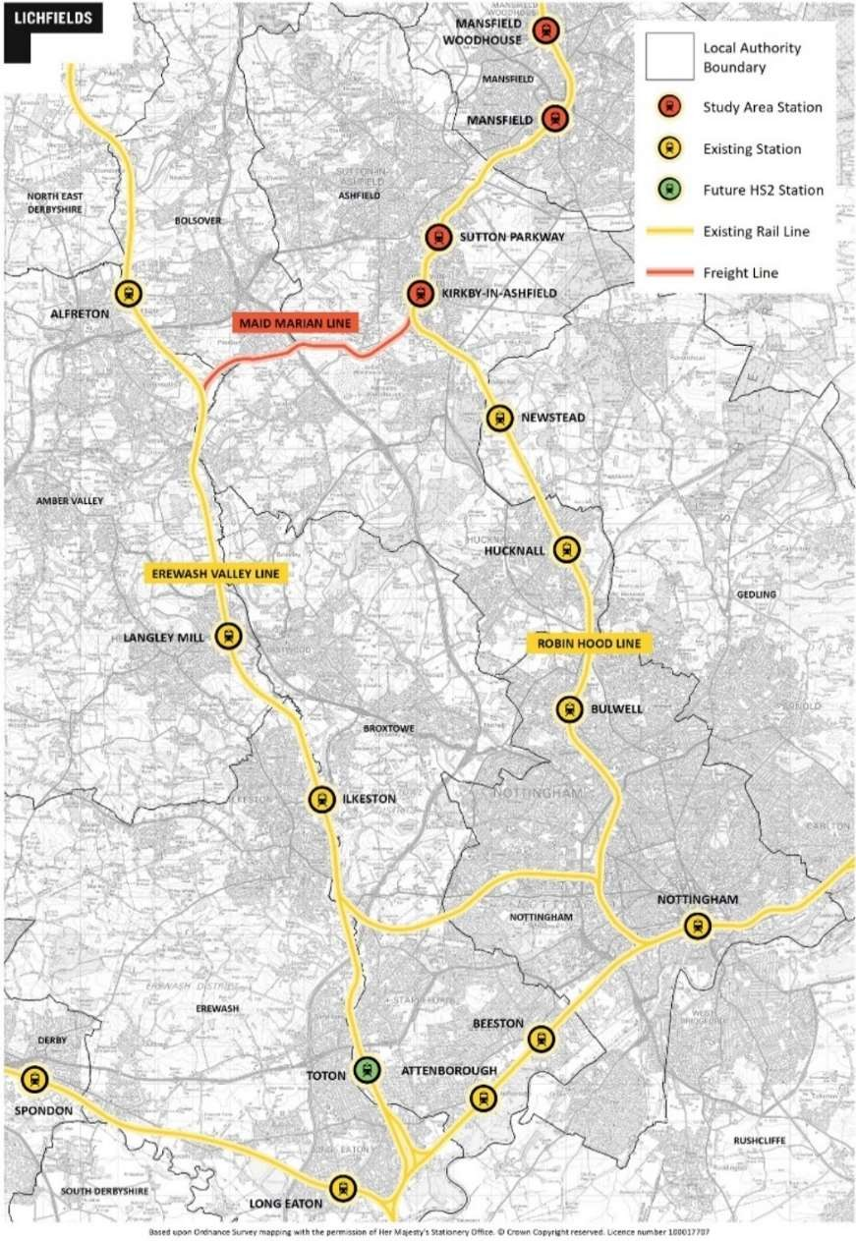
  - As identified in the East Midlands HS2 Growth Strategy, the future HS2 hub at Toton, referred to as the East Midlands Hub [EMH], presents an opportunity to improve connectivity between Mansfield and Ashfield, the EMH and the wider HS2 network. A Strategic Outline Business Case [SOBC] prepared for Nottingham County Council [NCC] in July 2018 appraised three possible options, two rail-based and one bus, and ultimately concluded that the two rail options should proceed through to Outline Business Case [OBC].

The Proposed Route
  - The proposed method of improving connectivity involves the existing freight-only line between the Robin Hood Line to the West and Erewash Valley Line to the East be reopened to passenger trains. This would connect the four stations in Ashfield and Mansfield directly to the proposed EMH at Toton with an approximate journey time of 40 minutes. These four stations are Kirkby in Ashfield, Sutton Parkway, Mansfield and Mansfield Woodhouse. The proposed route is shown in Figure 2.1:
Figure 2.1 Proposed Maid Marian Line

The Economic and Regeneration Case
  - Rail connectivity is widely recognised as a driver of economic activity and development, in particular where it can open up access to new markets for products, services and labour. Evidence points to where investment in rail leads to productivity enhancements to a local economy, as a function of additional destinations, capacity and reliability of service provision.
  - The potential to connect locations in Ashfield and Mansfield via the proposed Maid Marian Line to the High Speed 2 (HS2) station at Toton is therefore significant, particularly against the backdrop of relatively limited local rail services that serve these locations at present. Via connecting services at Toton, the proposed new line would bring new and quick connections to a range of major cities including Birmingham, Leeds and London, as well as Europe. This can be expected to bring a range of economic, social and environmental benefits to local residents and businesses, for example access to a wider labour catchment area, job opportunities and improved attractiveness for larger employers. Typically, these benefits can stimulate development activity and improve viability, for both residential and commercial uses, through land value uplift and making an area more attractive to live, work and visit which in turn drives market demand. These factors are core to the economic appraisal methodologies adopted by Government for the purposes of business cases for major investments, particularly when the wider economic impacts of transport investment are fully considered (i.e. not just transport economic impacts such as journey time savings).
  - The current stations at Kirkby-in-Ashfield, Sutton Parkway, Mansfield and Mansfield Woodhouse presently offer limited facilities and are in need of upgrading and access improvements. Increased patronage associated with new routes and passenger services could provide justification for significant improvements to the stations in themselves, and specifically in the case of Mansfield, assist with the renewal of the Grade II listed station house building to complement the Public Transport Interchange works completed in 2013. In this way, the stations will become more welcoming and prominent points of arrival which, in turn, can provide the catalyst for wider development opportunities which can be framed through the masterplanning process that is envisaged.
  - A bespoke approach to each station will be required reflecting their different location characteristics, and the type and scale of local interventions and proximate development sites that can help to maximise the impact of the proposed link to HS2. Kirkby-in-Ashfield and Mansfield stations are located centrally within each town, with residential, commercial and town centre areas within walking distance and interchange with other public transport services. Sutton Parkway is located outside of the town, but close to commercial areas and important local employers, as well as the A38. Mansfield Woodhouse station is located on the edge of the village, close to industrial areas which accommodate small businesses as well as some residential areas.
  - In each location, the masterplanning process needs to carefully consider the situation and connections to/from the station, the relationship with other routes and opportunities to promote walking and public transport use, as well as the existing land typologies within the immediate vicinity. It will be important to have regard to site allocations and other land use policies identified within the emerging local plans for each area (Ashfield now withdrawn, Mansfield currently at Examination), in particular where an upgraded station can provide a focal point and catalyst in support of land use change and regeneration, as well as act as a driver for delivery of new commercial and residential development.
  - Sutton and Kirkby-in-Ashfield are two of the largest towns in Ashfield, and development in these areas will help sustain and grow new jobs, services, and facilities, as well as potentially helping to attract inward investment. Mansfield urban area (including Mansfield and Mansfield

Woodhouse) is identified by the Submission Local Plan as the most sustainable location for the development needed to deliver the local plan vision and meet growth needs. Therefore, a key part of the economic impact case will be the extent to which the HS2 link can support and uplift economic, social and environmental outcomes across both districts as a result of investment in the proposed Maid Marian Line.
  - It should be noted that several of the sites identified may not come forward without the support of HS2, or at least the scale of development that could be viably developed may be diminished. If the HS2 project does not proceed as currently planned through to Toton, it is possible that the viability of many of the identified schemes may be compromised, hence this work should be subject to review as and when the HS2 position becomes clearer.

3.0 Study Framework and Approach
3.1 This report summarises the results of an economic impact assessment of the scale and scope of economic impacts associated with the proposed Maid Marian line. The study methodology and approach are summarised below.

Study Area

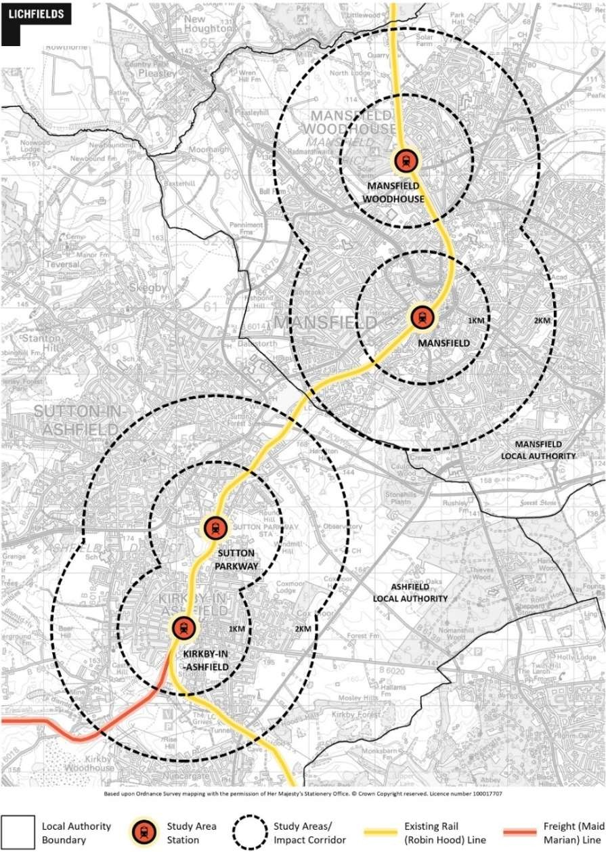
3.2
This report focusses specifically on the economic benefits of the proposed rail line and subsequent development opportunities at the four stations of Kirkby in Ashfield, Sutton Parkway, Mansfield and Mansfield Woodhouse, as well as benefits that will accrue to the wider areas around these stations. For the purposes of analysis, the study considers the economic impacts within a two-kilometre radius from each of the four stations, encompassing parts of the Ashfield and Mansfield District areas, referred to herewith as the ‘study area’. The spatial extent of the study area is shown in Figure 3.1.
Figure 3.1 Impact Corridor and Station Study Areas

  - This ‘impact corridor’ represents a feasible walking and cycling distance from each Metro station and is comparable with equivalent assessments undertaken as part of the West Midlands

Combined Authority’s Dynamic Economic Impact Model (DEIM). These distances have been used in other similar assessments carried out by Lichfields and are judged to be reasonable for this application.
  - It should be noted that smaller impact corridors (such as one kilometre from a station) have been used elsewhere in similar economic impact assessments of transport infrastructure projects although this tends to reflect the generally higher density urban locations associated with the area of analysis (such as Greater London). By comparison, the population within this study area suffers from an existing lack of alternative or competing public transport options, and it is therefore likely that the introduction of the Maid Marian Line will influence travel mode choices over a wider geographical area.
  - The assessment covers the overall economic impact of the proposed extension at a local level as well as the direct and indirect benefits on the wider economy where relevant.

Approach
  - The assessment in this report follows widely accepted approaches to economic impact assessment. It takes account of Government guidance including the Department for Transport’s Transport Analysis Guidance (WebTAG) where relevant. For the purposes of the latter, the methodology and impacts considered here most closely align to wider economic and regeneration impact typologies. The analysis also utilises Lichfields’ eVALUATE economic assessment tool to estimate the scale of impacts generated by new development. Some impacts cannot be quantified and in this instance are presented in qualitative terms.
  - The study is based on the following approach:
    - Baseline review of current and recent socio-economic conditions along the impact corridor and surrounding Ashfield/Mansfield.
    - In liaison with the District Councils, Ryder Architects and other partners, define working assumptions for the timetable changes arising from the new line, as well as improvements to the four stations and surrounding areas, costs and phasing.
    - Assess construction phase impacts arising from development of new station infrastructure and associated development along the impact corridor.
    - Assess operational benefits based on defined impact corridor and projected development trajectory.
    - Consider wider socio-economic and transport user benefits that could be supported by the new line and related development, including journey time savings.

Figure 3.2 Maid Marian Line Overall Methodology and Approach

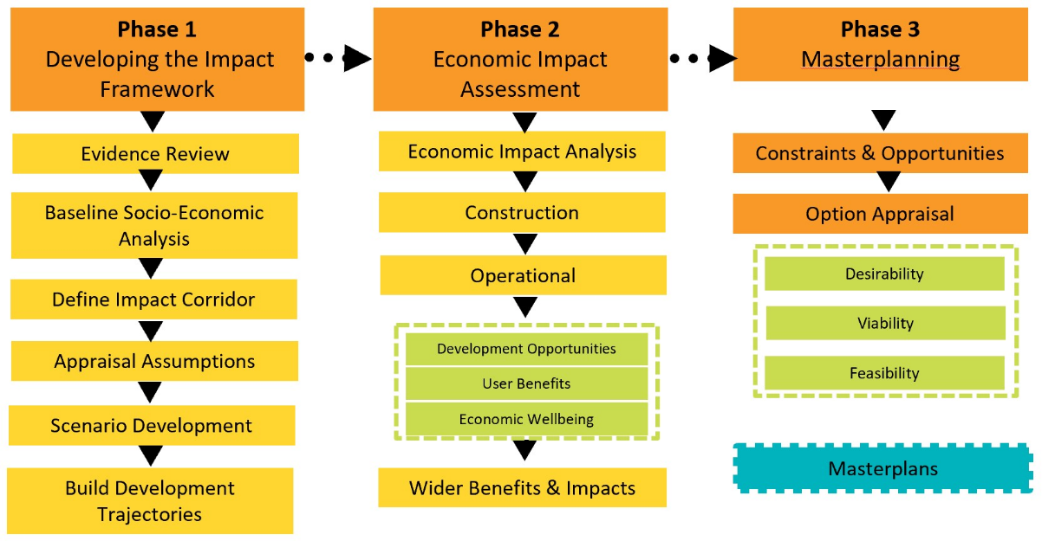
  - An important consideration for any work of this type is that it is inevitably a point-in-time assessment. The analysis has incorporated the latest data and other evidence available at the time of preparation, whilst recognising the continually evolving nature of development and wider regeneration schemes that are underway across the study area. The accuracy of data derived from third party sources has not been checked or verified by Lichfields.

Framework for Assessing Impacts
  - Economic impacts are considered under the following broad categories:
- Capital Investment & Construction Impacts: this relates to the impacts of the planned capital investment on construction employment and associated income generation and economic output during the construction phase;
- Permanent Employment Impacts: this examines the level of operational jobs created directly and indirectly in the local areas arising from the enhanced development potential as a result of the investment, as well as the levels of economic output generated by such jobs;
- Resident Impacts: this assesses the levels of local expenditure and jobs supported, as well as the potential role of the capacity enhancements in improving access of residents to services and employment, in turn helping reduce worklessness;
- Fiscal Benefits: the benefits that development would bring in terms of local authority financial receipts from business rates and Council Tax;
- Development and Property impacts: impacts on demand for property in the local areas along the route, reflecting housing demand and labour market factors and commercial demand and business location decisions;
- User and operator benefits: these are primarily benefits linked to journey time savings for residents and business users along the route, improved connectivity, and environmental benefits;
- Other qualitative benefits: these would be other benefits that are difficult to quantify such as improvements to local competitiveness and business location perceptions.
  - The analytical framework for the study is summarised in Figure 3.3.

Figure 3.3 Maid Marian Line Analytical Framework

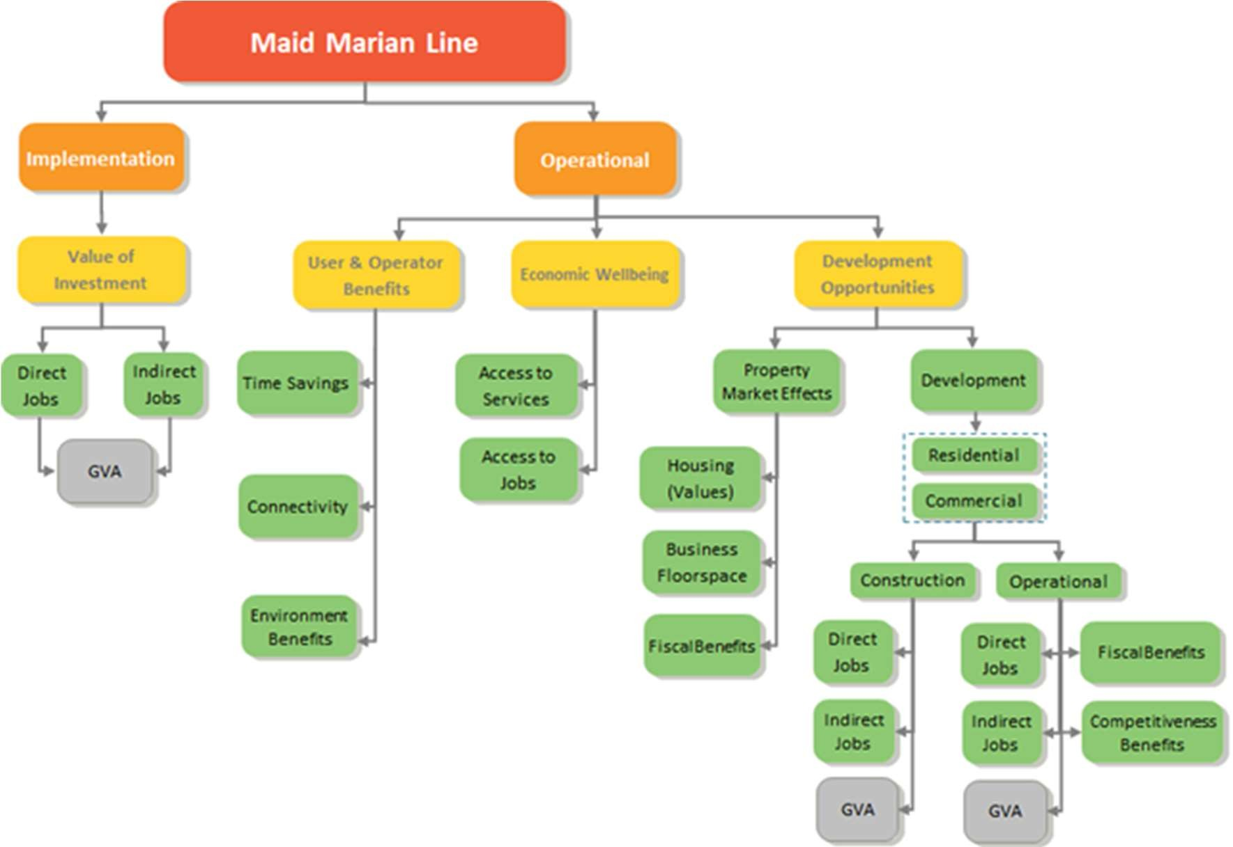
Consultation
  - As part of the study, consultation has been undertaken with a range of local and project stakeholders, including local public sector stakeholders and education providers. A list of the consultees is provided in Appendix 1. Key messages included the following:
- Vision West Nottinghamshire College stated its intention to triple the numbers at its Ashfield Campus in 3 years and therefore had a clear interest in working with the Council to deliver student accommodation, with opportunities on sites in close proximity to some of the study rail stations, even though at present comparatively few students used the train, with the bus being the preferred form of public transport. Cycling to the main campus was not considered ideal due to the congested roads, challenging topography and lack of formal cycle paths. Students use Sutton rather than Mansfield station – Path over track and parking should be improved.
- Kirkby College is growing, but representatives stated that they have no current plans to expand premises. A very small number of the College’s students come by train – most arrive into Kirkby by car, cycling, or on foot. Because the student catchment area is small and very tightly defined, the College was keen to ensure that masterplan proposals in the vicinity of the College focused on improvements to cycle infrastructure and bus services.
- NHS Nottingham West CCG, Ashfield & Mansfield CCG stated that local GP Practices have capacity, but some are not fit for purpose. Representatives were very interested in the concept of a Civic Hub in Kirkby in Ashfield Town Centre, which would provide them with an opportunity to centralise their administrative functions. Whilst the CCG considered that the three existing GP practices currently based in Kirkby could potentially be consolidated onto one Hub site, there was a concern that doctors/residents could be reluctant to move from their current facility.

4.0 Baseline Economic Conditions
4.1 The section presents an overview of socio-economic conditions along the Metro extension corridor across Ashfield and Mansfield. It covers population and labour supply, employment and labour demand, business performance and competitiveness, education and skills, social inclusion and patterns of recent development.

Population and Labour Supply

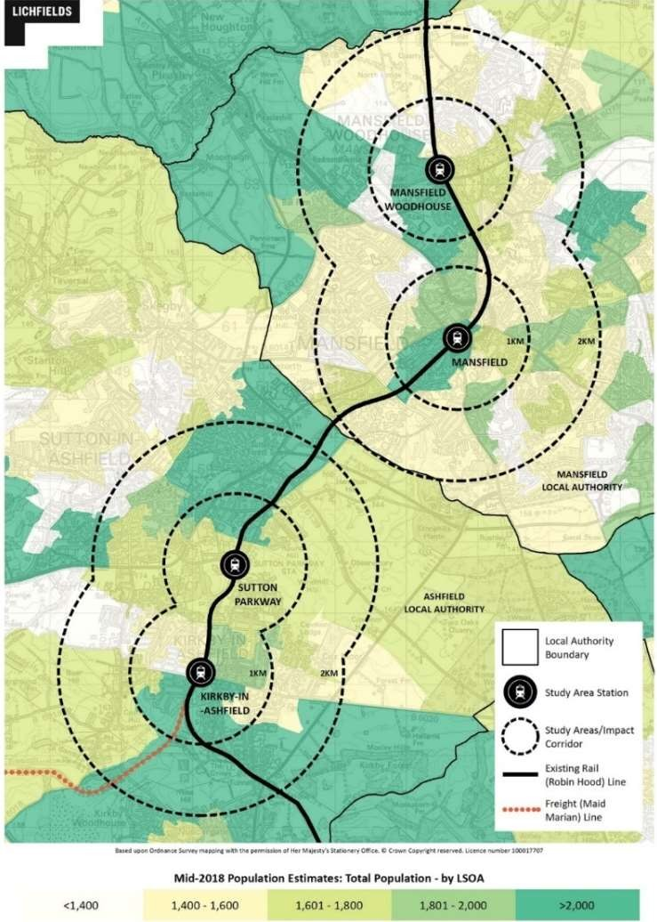
4.2
In 2018, 109,337 people lived within the 2km impact corridor around the four stations1, representing 46% of the 235,992 residents of Ashfield and Mansfield2. Figure 4.1 shows the number of people living in the lower super output areas [LSOAs] in the vicinity of the impact corridor. Notable concentrations along the rail line include the area to the south of Kirkby-in- Ashfield; the urban area to the north of Sutton Parkway bordering Mansfield; the area around and immediately south-west of Mansfield station; and the area to the south-west of Mansfield Woodhouse. The population of the two Districts is expected to grow by 10% to 259,533 in 2039, with Ashfield and Mansfield experiencing growth of 11% and 8.8% respectively3.
Figure 4.1 Impact Corridor Population

Source: ONS (2019), Mid-Year Population Estimates 2018 / Lichfields analysis

¹ Based on the 66 Lower Super Output Layers [LSOAs] that fall within the 2km impact corridor on a best-fit basis
² Office of National Statistics [ONS] (2019), Mid-Year Population Estimates 2018
³ ONS (2019), Sub-National Population Projections 2039

4.3 62% of the population or 146,336 of residents in Ashfield and Mansfield are of working age (aged between 16 and 64), the same as the proportion of the total East Midlands population and just below the national average of 62.6%. In 2018, 72.6% of the working age residents of Ashfield and Mansfield were in employment, slightly lower than the East Midlands rate of 73.6% and higher than the national rate of 72.2%.

Socio-Economic Groups

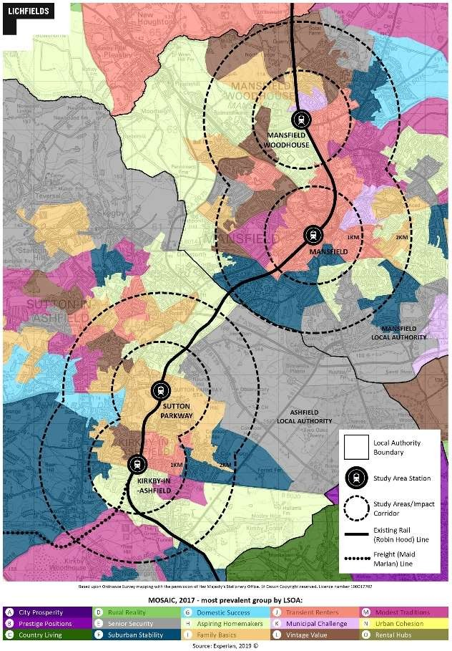
4.4
Analysis of Experian Mosaic data (2019) in Figure 4.2 shows the most prevalent socio-economic groups around each of the four stations. Mansfield station is surrounded by Transient Renters – typically younger singles and couples living in low-cost rented properties. To the north and west of Mansfield Woodhouse there is also the presence of Aspiring Homemakers – typically younger couples occupying new-build homes or families with children in modest homes; and Family Basics – stable families in lower-value houses.
In Ashfield, around the Kirkby station there are Transient Renters and Aspiring Homemakers as well as some Vintage Value – typically pensioners in long-term rented flats, social and retirement homes. The area around Sutton Parkway is dominated by Family Basics. Overall, Mansfield town centre looks to have a higher presence of young, single and couple renters than Ashfield town centre, which tends more towards families.
Figure 4.2 Mosaic Groups in the Impact Corridor

4.5

Source: Experian (2019) / Lichfields analysis

Housing Market Indicators
4.6 In terms of house prices, these tend to be significantly lower in both Ashfield and Mansfield than elsewhere. For example, the latest house price data4 (March 2019) suggests that Median prices are £143,950 in Ashfield District and £138,000 in Mansfield District, with both figures considerably lower than the equivalent regional (£190,000) and national (£235,000) prices. The picture is just as stark for lower quartile [LQ] house prices, with Ashfield and Mansfield’s LQ prices being just £108,000 and £100,000 respectively, compared to £140,000 across the East Midlands and £154,160 in England and Wales more generally.

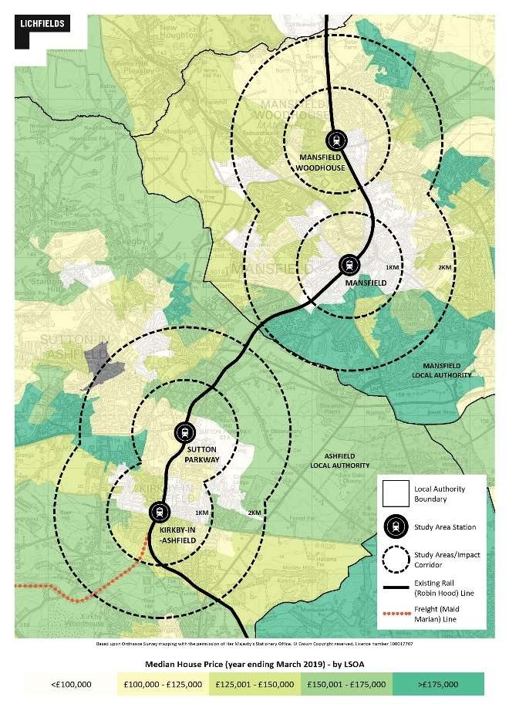
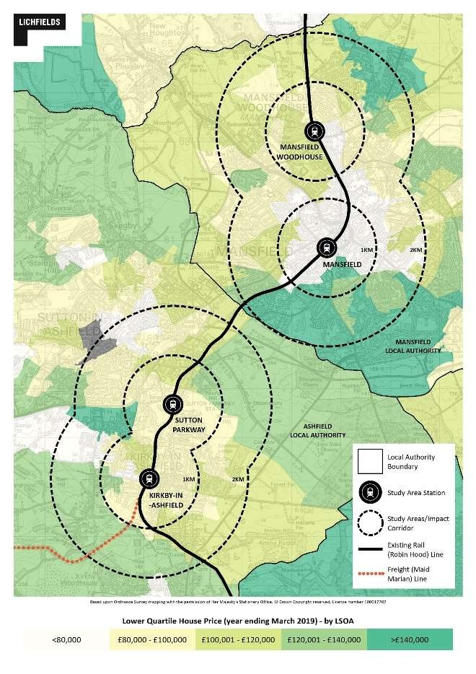
4.7
The situation is arguable even more pronounced in the Impact Corridor. As can be seen in Figure 4.3, both Median and LQ house prices in and around the Maid Marian Impact Area tend to be lower than the surrounding areas, with many parts of Mansfield Town and Kirkby-in- Sutton in particular seeing house prices that are well below the District averages. The impact these lower house prices are likely to have on land values is likely to mean that the viability of housing sites in these areas may be particularly challenging.
Figure 4.3 Median / Lower Quartile House Price Paid Data (Year ending March 2019) within the Impact Corridor

Source: ONS (2019): HPSSA Dataset 46: Median price paid for residential properties by LSOA

⁴ ONS (2019): HPSSA Dataset 9. Median price paid for administrative geographies, year ending Dec 1995 to year ending Mar 2019

Employment and Labour Demand
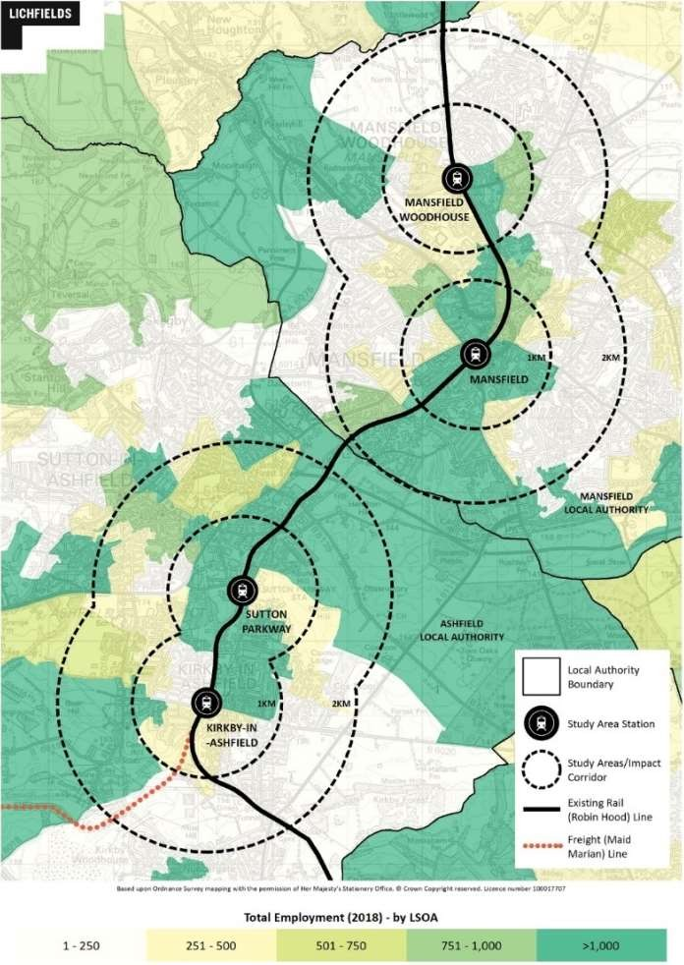
  - Figure 4.4 shows the number of people employed in the LSOAs within and near to the impact corridor. In total, 47,960 people were employed in the impact corridor in 2018, accounting for 50% of all employment in the two Districts5. Areas of high employment include the area surrounding Sutton Parkway to the north of Kirkby-in-Ashfield station, and the areas surrounding Mansfield station extending to the east of Mansfield Woodhouse. There are large employment areas outside of the urban centres, including the area to the south east of the line between Sutton Parkway and Mansfield station, the area to the west of Kirkby-in-Ashfield and to the west of Mansfield Woodhouse.
Figure 4.4 Impact Corridor Employment

Source: ONS (2019), Business Register and Employment Survey 2018

  - Employment in Ashfield and Mansfield has grown by 5.8% and 2.5% respectively since 2015, compared to 2.9% across the East Midlands6. This suggests that demand for labour in Ashfield has increased quicker over recent years than Mansfield and the wider region.

⁵ ONS (2019), Business Register and Employment Survey
⁶ BRES (2019)

Table 4.1 Employment Share by Industry

 | Impact  Corridor | Ashfield | Mansfield | East Midlands
Agriculture, forestry & fishing | 0.1% | 0.5% | 0.3% | 1.8%
Mining, quarrying & utilities | 0.7% | 1.5% | 0.6% | 1.6%
Manufacturing | 13.6% | 18.2% | 9.8% | 12.5%
Construction | 7.1% | 9.1% | 6.1% | 4.7%
Motor trades | 2.3% | 4.5% | 3.0% | 2.5%
Wholesale | 5.3% | 5.5% | 4.9% | 4.9%
Retail | 11.2% | 7.3% | 12.2% | 9.3%
Transport & storage | 2.9% | 4.1% | 2.2% | 5.4%
Accommodation & food services | 6.1% | 4.5% | 5.5% | 6.8%
Information & communication | 1.1% | 2.7% | 1.7% | 2.7%
Financial & insurance | 1.3% | 0.5% | 1.7% | 1.7%
Property | 1.1% | 0.5% | 1.2% | 1.4%
Professional, scientific & technical | 4.0% | 4.5% | 3.7% | 6.3%
Business administration & support services | 12.2% | 5.5% | 14.6% | 8.4%
Public administration & defence | 3.6% | 1.8% | 3.7% | 3.5%
Education | 8.3% | 6.4% | 9.8% | 8.8%
Health | 14.3% | 20.0% | 14.6% | 12.7%
Arts, entertainment, recreation & other services | 4.7% | 2.7% | 5.5% | 4.8%
Source: BRES (2019)

  - Table 4.1 shows a breakdown of employment by industry. The largest employment sectors in the impact corridor are health (14.3%), manufacturing (13.6%), Business administration (12.2%) and retail (11.2%). Comparing the two Boroughs, Ashfield has stronger representation particularly in manufacturing and health, whereas Mansfield has more employment in retail and business administration.

Commuting Flows
  - Figure 4.5 shows in and out commuting patterns for the impact corridor with the rest of Ashfield and Mansfield and neighbouring authorities, based on Census 2011 data, still the latest data on commuting flows available. In total, 46,152 commuted into the impact corridor to work from elsewhere in Ashfield and Mansfield or from other areas, compared to 42,439 people who commuted out of the impact corridor to work. This means that the impact corridor is a net importer of 3,713 workers. For those commuting in, 39.8% live elsewhere in Ashfield and 27.7% elsewhere in Mansfield. For those commuting out, 29% work elsewhere in Ashfield and 33.2% elsewhere in Mansfield. The strongest linkages to other authorities include Nottingham (2.9% of in-commuters, 6.8% of out-commuters), Newark and Sherwood (6.9% of in-commuters, 5.6% of out commuters) and Bolsover (5.9% of in-commuters, 5.5% of out-commuters).

Figure 4.5 Study Area Commuting Flows

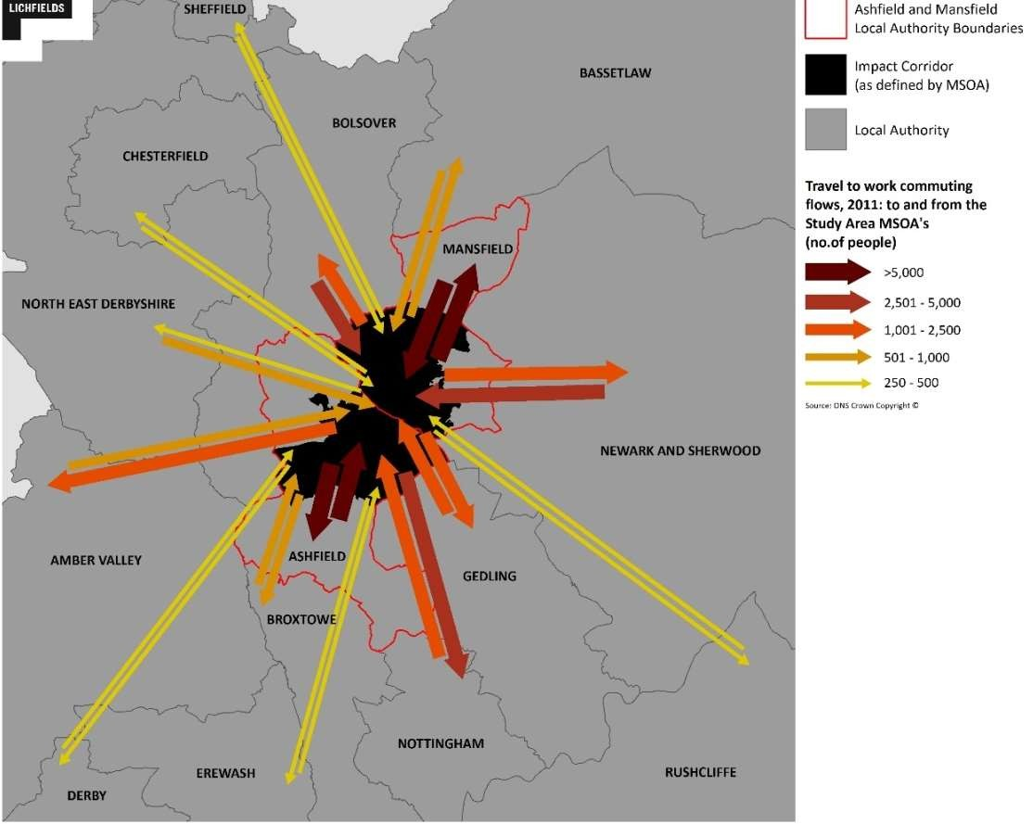
Source: ONS (2011), Census Origin and Destination / Lichfields analysis

  - Figure 4.6 illustrates in-and-out commuting patterns by train only. 253 people living outside the impact corridor commuted in to work by train, whereas 469 people living inside the impact corridor commuted to work elsewhere by train. Of those commuting in, 41% live elsewhere in Ashfield and Mansfield, 21% in Nottingham, 9.5% in Bolsover and 8.3% from Bassetlaw. Of those commuting out, 20.7% work elsewhere in Ashfield and Mansfield, whereas 51% commuted to work in Nottingham. 15 people (3.2%) commuted to the City of Westminster – more than Bassetlaw (2.6%) or Gedling (2.1%).

Figure 4.6 Study Area Commuting Flows by Train

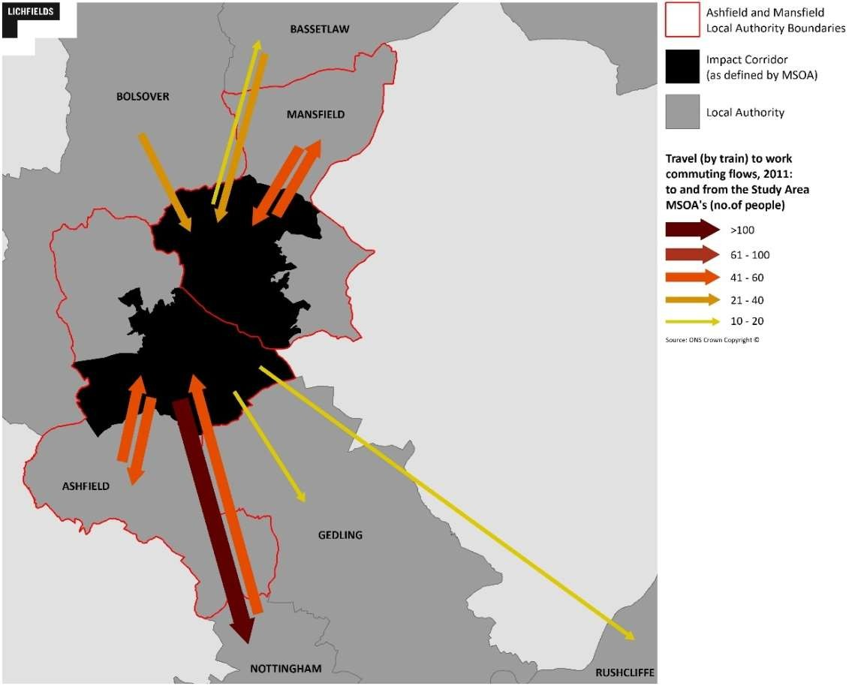
Source: ONS (2011), Census Origin and Destination by Mode of Transport / Lichfields analysis

Deprivation
  - The area along the impact corridor has a high proportion of LSOAs within the top 20% most deprived in England7. Table 4.2 shows that 48.5% of the 66 LSOAs along the corridor fall within these two groups, higher than in Ashfield and Mansfield overall (28.4% and 40.3% respectively). High levels of crime and a poor-quality living environment can negatively affect social inclusion in a community. In terms of crime, 28.8% fall within the top 20% most deprived nationally, compared to 17.6% and 19.4% in Ashfield and Mansfield respectively. In terms of the quality of the living environment however, just 6.1% of the LSOAs in the impact corridor fall within this range. In fact, 77.3% are in the 50% least deprived and almost half (48.5%) are within the top 30% in this respect nationally.

⁷ MHCLG (2019), Indices of Multiple Deprivation

Table 4.2 Indices of Multiple Deprivation within the Impact Corridor

Most Deprived Decile | Overall IMD | Crime | Living Environment
10% | 21.2% | 16.7% | 0.0%
20% | 27.3% | 12.1% | 6.1%
30% | 9.1% | 12.1% | 3.0%
40% | 12.1% | 15.2% | 7.6%
50% | 6.1% | 18.2% | 6.1%
60% | 9.1% | 10.6% | 22.7%
70% | 1.5% | 7.6% | 6.1%
80% | 9.1% | 4.5% | 22.7%
90% | 3.0% | 1.5% | 24.2%
100% | 1.5% | 1.5% | 1.5%

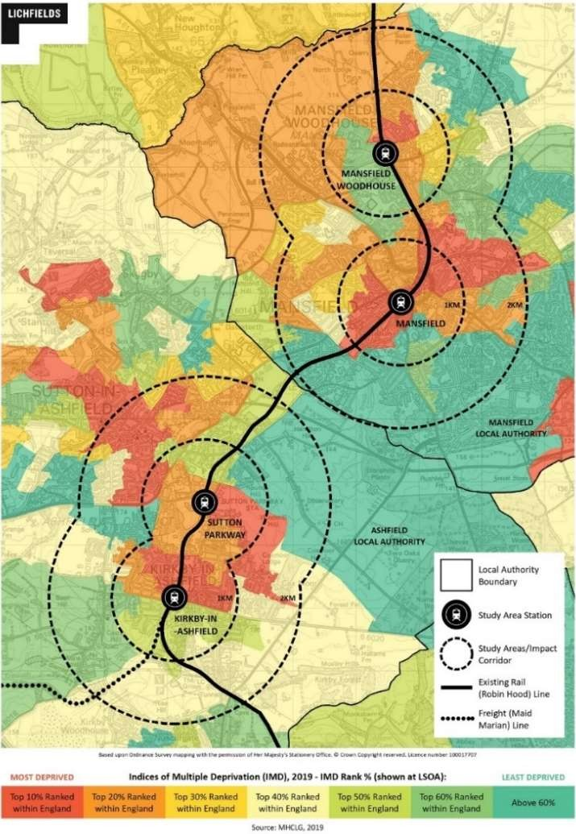
  - 4.14

Source: MHCLG (2019); Indices of Multiple Deprivation / Lichfields analysis

Table 4.2 shows which overall IMD deciles the LSOAs within and around the impact corridor fall into. The most deprived areas are typically within the urban centres, with all four stations being within or next to an area that falls within the 20% most deprived nationally. Many of these areas border directly with areas that are within the 40% least deprived, indicating that there is potential to positively affect these areas through investment close to the stations and improved transport access for residents.
Figure 4.7 Impact Corridor Indices of Multiple Deprivation

Source: MHCLG (2019): Indices of Multiple Deprivation / Lichfields analysis

Development Patterns
  - The Valuations Office Agency [VOA] data in Table 4.3 show that from 2008/09 to 2018/19 retail stock increased by 7,000 sq.m in Ashfield and 8,000 sq.m in Mansfield; office space increased by 20,000 sq.m in Ashfield and decreased by 4,000 sq.m in Mansfield; and industrial space increased by 39,000 sq.m in Ashfield but decreased by 29,000 in Mansfield.
Table 4.3 Business Floorspace

Floorspace | Variable | Ashfield | Mansfield
Retail | Floorspace sq.m (2018/19) | 181,000 | 263,000
 | Net Change (2008/09-2018/19) | 7,000 | 8,000
 | CAGR % (2008/09-2018/19) | 0.4% | 0.3%
Office | Floorspace sq.m (2018/19) | 105,000 | 88,000
 | Net Change (2008/09-2018/19) | 20,000 | -4,000
 | CAGR % (2008/09-2018/19) | 2.1% | -0.4%
Industrial | Floorspace sq.m (2018/19) | 1,214,000 | 564,000
 | Net Change (2008/09-2018/19) | 39,000 | -29,000
 | CAGR % (2008/09-2018/19) | 0.3% | -0.5%

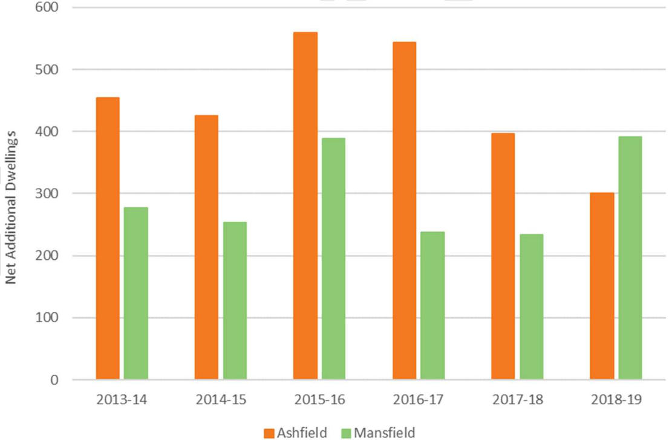
  - 4.16

Source: VOA (2019, Business Floorspace

Figure 4.8 presents the number of net additional dwellings in Ashfield and Mansfield over the period 2013/14 to 2018/19. Over this time period the two Districts gained 4,460 dwellings at average rates of 447 dwellings per annum [dpa] and 264 dpa respectively.
Figure 4.8 Net Additional Dwellings

Source: MHCLG (2019), Net Additional Dwellings / Lichfields analysis

  - Figure 4.9 shows the site allocations in the two Borough’s respective Local Plans. Comparatively, Ashfield has a large quantum of housing allocations, with relatively little employment land allocated within the impact corridor.

Figure 4.9 Local Plan Allocations
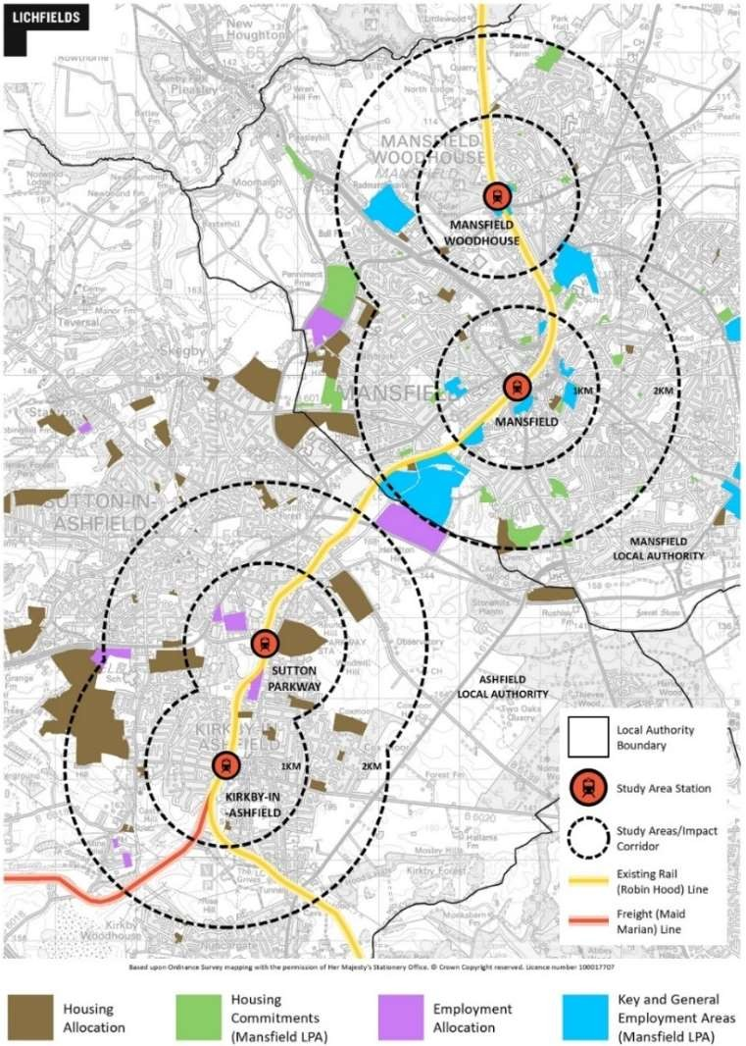
Source: ADC (2016) / MDC (2018)

5.0 Capital Investment and Construction Impacts

Introduction
  - This section sets out the potential economic impacts arising from the construction phase of the Mansfield to East Midlands Hub. The key impacts arising from the construction phase focus on direct employment, indirect and induced jobs from the supply chain and the generation of economic output.
  - This analysis has been based on the Financial Case presented in Aecom’s Mansfield to East Midlands Hub Strategic Outline Business Case (July 2018). It is based on Option A1 of that document, which relates to enhanced connectivity between Mansfield Woodhouse and Toton (East Midlands Hub) with a new half-hourly rail service between those stations and an approximate journey time of 40 minutes. Of the other options examined, Option A2 comprised the same rail option, but with an hourly rather than half-hourly service, whilst Option A3 comprised a half-hourly express bus service between the stations.
  - The qualitative assessment of the three options in Aecom’s report found that Option 1 had the strongest alignment owing to the faster journey time by rail and the frequency of services, resulting in this option being expected to have the most significant impact on accessibility and modal shift from private car [page 6].
  - Both Option A1 and A2 were estimated to have an indicative capital cost of between £12.0 million and £19.0 million, at 2017 prices. According to Aecom, both rail options require capital investment to upgrade the section of line between Kirkby Lane End and Ironville Junctions to regular passenger standards. The levels of investment required to deliver the timetables modelled (assuming line speeds are upgraded to 40 mph) will vary based upon the underlying quality of the assets and associated interventions required, with Aecom assuming the following Capex items between Kirkby Lane End and Ironville8:
    - Re-building of two under-track culverts of 4ft diameter within the 30mph restriction;
    - Track upgrade equivalent to renewal of 25% or 50% (4.55 km) of track on the 20mph section;
    - Upgrade of Upper Portland level crossing from automatic to manual with obstacle detection;
    - Provision of 4 signals and associated train detection;
    - Re-location of 3 signals on the 20mph section to give adequate signal spacing for 40mph, and of associated train detection equipment.
  - Both Option A1 and A2 assume an opening year of 2033, with construction having commenced in 2031.
  - Aecom notes that the levels of investment required to deliver the timetables modelled (assuming line speeds are upgraded to 40 mph) will vary based upon the underlying quality of assets and associated interventions required. As such, a range of potential values were produced reflecting the minimum level of infrastructure investment required to operate scheme services, through to a more pessimistic value inclusive of additional investment in infrastructure (page 76).

⁸Aecom (July 2018): Mansfield to East Midlands Hub Strategic Outline Business Case, Appendix B: Capex Buildup

Based on 25% track renewal, total base costs were estimated at £7.3m, rising to

£11.6m with 50% of track renewal. Including contingency or optimism bias, these figures increase to between £12.0m and £19.0m.
  - No upgrade measures were considered necessary for the remainder of the route by Aecom.
  - For the purposes of this section, Lichfields’ analysis relates to the capital costs involved in upgrading the Maid Marian line between Kirkby Lane End and Ironville for the enhanced rail service to the EMH. It does not include indicative costs for upgrading the stations in Ashfield and Mansfield themselves (i.e. the provision of DDA-compliant lifts or new ramps, which are a component part of the masterplans for the four stations).

Direct Employment
  - The Maid Marian Line Capital Cost buildup can be used to estimate the amount of construction employment that could be generated over the construction phase.
  - Using labour coefficients from the HCA Calculating Cost per Job Best Practice Note (2015), it is possible to calculate the number of direct construction jobs supported by the proposed development over the course of the 3-year construction phase. Taking account of the composition of the proposed development, an Infrastructure coefficient of is considered as the most appropriate for calculating the number of direct construction jobs. This coefficient assumes that 13.9 direct FTE jobs per £1 million of construction value in 2011 prices will be supported over a year.
  - To use the coefficient, the construction cost of £19.0m has been deflated from the 2017 price year to 2011 prices using the latest UK Government GDP Deflator (2019). Applying the 13.9 coefficient to the £19m construction cost of £17.235m and then dividing the result by the length of the construction phase (3 years), leads to the proposed development supporting 80 gross direct FTE jobs annually over the construction phase.
  - At the lower end of the scale, if the track renewal is 25% rather than 50%, then capex costs are reduced from £19m to £12.0m. Following the same methodological approach as set out above, and based on using labour co-efficients, then a reduction in the estimated construction cost of
£7m equates to the proposed development supporting 50 gross direct FTE jobs annually over the construction phase.

Indirect and Induced Employment
  - The scale of capital investment needed to upgrade the section of the Maid Marian line between Kirkby Lane End and Ironville junctions will require purchasing goods and materials from the supply chain, thereby creating a ‘multiplier effect’ which supports additional jobs and generates indirect economic output across the wider economy. It is expected that businesses in Mansfield and Ashfield as well as within the wider East Midlands region will form part of the Maid Marian supply chain, helping to create and support local jobs indirectly linked to upgrading the line.
  - In addition, businesses not directly linked to the Maid Marian line upgrade supply chain can also benefit from the ‘multiplier effect’. While these other businesses may not act directly as suppliers, they can benefit from factors such as construction workers spending wages on goods and services in local shops, in turn supporting employment and economic activity.
  - To calculate the number of indirect and induced jobs generated by upgrading the Maid Marian line, a multiplier of 2.17 has been used from the latest ONS detailed Input-Output Tables, 2015 (published 2018) for Construction and applied to the average number of direct FTE construction jobs. This suggests that at the lower end of the range, 59 induced and indirect FTE jobs will be

supported during the 3-year construction phase. This is in addition to the 50 direct FTE jobs referred to above. At the upper end of the range, 94 induced and indirect FTE jobs will be supported during the 3-year construction phase in addition to the 80 direct FTE jobs associated with the £19m construction cost of the 50% rail renewal option.

Economic Output
  - The construction upgrade of the section of line between Kirkby Lane End and Ironville will also make a major contribution to local economic output, as measured by Gross Value Added [GVA]. GVA measures the difference between what is produced as an output (e.g. goods and services) and the inputs (e.g. raw materials and semi-finished products) needed to generate the output. This represents the additional value create by economic activity.
  - Based upon the latest Experian GVA figures by sector, it is estimated that the Maid Marian line upgrade will directly generate between £3.55m and £5.63m each year during the construction period, depending on the scenario followed.
  - A further £3.7m could be generated through indirect and induced activities, based on applying a multiplier of 2.049 to the total amount of direct GVA generated at the lower end of the capex range, and £5.86m at the upper end of the range. It should be noted that not all of this GVA will be retained locally or within the wider region.

⁹ ONS detailed Input-Output Table 2015 (Published 2018), Construction GVA Multiplier

6.0 Operational Impacts
  - This section considers the scale and type of economic impacts that could arise from future residential and commercial development along the Maid Marian extension route, at both construction and operational phases. Results are shown in gross and net terms across the two main scenarios (‘With Maid Marian Rail Extension’ and ‘Reference Case Without Extension’).

Development and Regeneration Opportunities
  - The increased capacity, connectivity and accessibility brought by the Maid Marian Rail Extension will support the delivery of residential and commercial development within the catchments of the 4 improved stations at Mansfield Woodhouse, Mansfield Town, Sutton Parkway and Kirkby in Ashfield. Evidence from comparative studies points to changes in commercial and residential property values resulting from investment in new transport infrastructure. Such infrastructure improves accessibility levels, particularly journey time savings, increased quality of service and improved reliability. This provides benefits across a range of different groups:
    - Employees benefit from access to a wider range of job opportunities and housing choices with no commensurate increase in commuting times;
    - Employers gain access to a wider labour catchment area, and businesses are attracted to locate at the most accessible locations; and
    - Increased catchment areas support increased services and facilities, including retail and leisure, making locations more attractive to operators.
  - Enhanced accessibility and wider catchments support increased levels of demand and development values, and in turn, potential for increased development activity and intensification of sites in close proximity to the 4 stations.

Development Opportunities Within the Impact Corridor
  - As noted in Section 3.0, an ‘impact corridor’ has been defined based on a two kilometre radius or isochrone from each of the 4 station locations. This corridor incorporates parts of Ashfield and Mansfield Districts and a number of key development and regeneration areas as well as a number of allocated development sites identified in both adopted and (in the case of Mansfield) emerging Local Plans. The areas around each of the four stations summarising all of the development opportunities assessed is illustrated in Section xx of the Masterplan.
  - This report focuses on the economic benefits specifically arising in Ashfield District, in the vicinity of Sutton Parkway and Kirkby in Ashfield stations. A similar exercise has been undertaken in a separate report for the two Maid Marian line rail stations in Mansfield District (Mansfield Woodhouse and Mansfield Town Centre).

Reference Case
  - Using data from Ashfield District Council’s Housing Land Monitoring Report10 (2019-2037) and Employment Land Monitoring Report11 (2019-2037) and specific assumptions agreed with the client group regarding anticipated rates of development, a development schedule has been compiled comprising a range of housing, commercial and other development sites and regeneration opportunities that fall within the impact corridor in Ashfield District.
¹⁰ Ashfield District Council (April 2019): Ashfield Housing Land Monitoring Report
¹¹ Ashfield District Council (April 2019): Ashfield Employment Land Monitoring Report

  - This equates to:
    - 3,023 dwellings over 18 years (based on the total amount of sites Table 2, Ashfield Housing Trajectory 2019-2037), comprising:
- 440 dwellings from projected completions on large sites without planning permission;
- 630 Projected completions from large sites with Full planning permission;
- 864 Projected completions from large sites with outline planning permission;
- 219 Projected Completions from Small Sites with Full Planning Permission;
- 35 Projected Completions from Small Sites with Outline Planning Permission;
- 6 Projected Completions from prior approval schemes;
- 47 Projected Completions from C2 schemes;
- 780 Small site windfall allowance.
    - Following discussions with ADC Officers, Lichfields has assumed that around 10% of these homes will be affordable.
    - 105.63 ha of B-Class employment land (based on the Ashfield Employment Land Availability April 2019 Schedule B), with 69.19 ha being available immediately. The status of each allocated employment site is as follows:
- Local Plan allocation: The Ashfield Local Plan Review was adopted in November 2002. The site areas shown in this column are either the total area of land allocated in the Adopted Local Plan Review or the remainder of the allocated site which has either not been developed or does not have the benefit of a planning permission.
- Sites with permission: Many sites have the benefit of an outline or full planning permission with specified uses proposed.
- Other sites: A small number of sites, usually on existing industrial estates do not fall into the categories above. These are generally plots where permission has either lapsed, or an area previously held for expansion has become available.
  - It has been assumed that for the B-Class employment land, a plot ratio of 40% and standard employment density of 1 FTE job per 37 sqm (equivalent to Mixed B-Class workspace, using the HCA’s 2015 Employment Densities Guide, 3rd edition), the employment land could potentially accommodate 11,419 FTE jobs. This is very much an upper estimate of the number of Reference Case jobs that could be sustained across the Council’s committed employment land portfolio, as some land is likely to be lost to alternative, non B-Class uses over the next 14 years.
  - This provides the baseline (or ‘reference case’) position that is assumed to take place with the construction and operation of the Maid Marian Rail Extension under the direction of current and potential future Ashfield District Council planning policy.

Potential Development Uplift from Maid Marian Extension
  - In discussion with ADC Officers, we have identified a number of potential development sites as part of the masterplanning process in the vicinity of the Sutton Parkway and Kirkby in Ashfield stations. Where it is considered that these sites are unlikely to come forward without the land value uplift associated with the Maid Marian rail extension, these have been included as being ‘net additional’ to the Reference Case. Where the site is sufficiently advanced (i.e. a planning application is being considered for the proposed use), and where it has not already been included in either ADC’s Housing Land or Employment Land Monitoring Reports, then we have included the site within the District’s Reference Case position.

Table 6.1 Development Schedule for Ashfield

Location | Proposed Use | Approximate  Dwellings | Employment Use | Phasing | Likely to be Additional  to Reference Case?
SUTTON PARKWAY STATION MASTERPLAN
Site A: Sutton Parkway Station Site | Improved access to the station and increased car parking plus small-scale commercial offer. Potential  for residential in longer term. | 40 dwellings  at 4-5 stories | 450 sqm (small scale commercial) | Short term for station improvements/commercial; Long term for residential | Yes
Site D: Penny Emma Way (SHLAA Site  K26) | B-Class Employment | 0 | 3,600 sqm B-Class offices | Medium Term | Yes
Site E: Penny Emma Way / A38 | Residential | Approximately 175 (based on  5 storey apartments  and housing) | 0 sqm | Medium Term | Yes
KIRKBY-IN-ASHFIELD STATION MASTERPLAN
Site A: Kirkby-in- Ashfield Station | Improved access to the station and increased car parking. Potential for small commercial use in new station building. New community  facilities. | 0 | 50 sqm café, plus 100 sqm community facility | Short term | Yes
Site B: Miller's Way  / football pitch (SHLAA Site K116) | Residential | 59 | 0 sqm | Short term | No – site currently in for planning, decision pending. Not included in the HLMR,  so added to the RC.
Site C: Southwell Lane | Residential | 60 | 0 sqm | Short term | No – site currently in for RM, decision pending. Not included in the HLMR as Outline Permission was thought to have lapsed. Site added to  the RC
Site D: Lowmoor Road (Patco site) | Mixed use (residential and employment). Potential for longer term residential to  south off Portland Street. | 90 | 1,050 sqm B1a  office; 3,150 small business  workspace | Short - medium term | Yes
Site E: Lowmoor Road / Ellis Street (Civic Hub) | Mixed use (healthcare, local services, residential, commercial) | 60 | 2,100 sqm (1 floor of B1a workspace above healthcare); 3,000 sqm (2 storey community uses); 4,200sqm (2 floors of  healthcare use) | Medium-long term | Yes – current extant planning permission is for the Creation of a Civic Square Incorporating New Landscaping, Seating, Lighting and other  Associated Works.
Site G: Lane End (opposite Kirkby  Station) | Residential (plus some potential for small ground  floor café / retail use) | 128 | 200 sqm cafe | Medium-long term | Yes

  - In summary, the 3 sites in the Sutton Parkway station masterplan have the potential to provide 215 dwellings, of which 22 (c.10%) would be affordable. It could also provide 450 sqm of A1/A3 retail floorspace and up to 3,600 sqm of B1a office floorspace. It is considered that all of this would be net additional.

  - As for the 6 potential development sites in the vicinity of Kirkby in Ashfield, these have the potential to provide 397 dwellings (of which 40 would be affordable); 250 sqm of A1/A3 retail floorspace; 6,300 sqm of B1 employment floorspace; a 4,200 sqm Health Centre; and 3,100 sqm of community facilities. However, two of these sites are currently at various stages of the planning approval process (Site B: Miller’s Way and Site C: Southwell Lane) and it is considered that they would be net additional to the Reference Case position. As neither site is included in ADC’s Housing Land Monitoring Report, the 119 dwellings proposed for these two sites has been added on to the Reference Case for Ashfield District, raising the housing delivery over the period from 3,023 dwellings to 3,142 between 2019-2037.
  - A series of adjustment factors have then been applied as part of the ‘With Maid Marian Extension’ scenario to reflect the increase in development activity that might be associated with this alternative scenario, profiled over a 19-year appraisal period.

Economic Impacts
  - Analysis undertaken as part of this study indicates that the Maid Marian Rail extension provides significant opportunities to enhance the development potential of currently identified sites along the proposed route in Ashfield District.
  - The rate of development broadly envisaged by ADC’s Housing and Employment Land Monitoring Reports (plus the 2 housing sites at Miller’s Way and Southwell Lane) could deliver approximately 3,142 dwellings and around 420,000 sqm of commercial and community floorspace over a 19-year appraisal period to 2037 (Table 6.1). Including the remaining masterplan sites around the two rail stations, this could increase to 3,635 dwellings and 440,420 sqm of commercial/community floorspace.
  - The economic impacts associated with the scale of development activity under each scenario are summarised in Table 6.2. This presents the net additional economic benefits that the rail extension along the Maid Marian line could deliver over the 19-year appraisal period, over and above the Reference Case (i.e. ‘Without Maid Marian Extension’). The figures in the Table below do not include the direct and indirect construction jobs or GVA generated by the extension of the Maid Marian Line itself, which is set out in Section 5.0 above.

Table 6.2 Total Economic Impacts in Ashfield District over and above the Reference Case Scenario

 | Reference  Case | Net Additional Maid Marian Masterplan  sites | Total Net Additional growth with Maid  Marian Extension
QUANTUM OF DEVELOPMENT
Number of dwellings | 3,142 | 493 | 3,635
B1/B2/B8 floorspace (sqm) | 422,520 | 9,900 | 432,420
Retail/Leisure floorspace (sqm) | 0 | 700 | 700
Community floorspace (sqm) | 0 | 7,300 | 7,300
CONSTRUCTION IMPACTS
Capital Investment | £1.3 bn | £117m | £1.4bn
Direct Construction FTE Jobs | 1,179 | 269 | 1,448
Indirect & Induced FTE Jobs Supported | 1,781 | 406 | 2,187
Total Direct & Indirect GVA | £200m | £46m | £246m
OPERATIONAL IMPACTS
Total Direct FTE Jobs | 11,419 | 722 | 12,141
Direct GVA | £814m | £52m | £866m
Indirect & Induced FTE Jobs Supported (Local) | 2,855 | 180 | 3,035
Indirect & Induced FTE Jobs Supported (Region) | 5,139 | 325 | 5,464
Total Direct and Indirect FTE Jobs | 16,558 | 1,047 | 17,605
RESIDENT EXPENDITURE IMPACTS
Total First Occupation Expenditure | £17.3m | £2.7m | £20.0m
Local FTE Jobs supported by First Occupation Expenditure | 134 | 21 | 155
Net Resident Expenditure | £49m | £8m | £57m
Indirect FTE Jobs Supported | 682 | 107 | 789
FISCAL IMPACTS
Council Tax Receipts (annual payment) | £4.8m | £745,000 | £5.5m
Business Rates Payable (gross annual) | £13.7m | £379,000 | £14.1m
New Homes Bonus (4-year payment) | £16.6m | £2.6m | £19.2m
Source: Lichfields analysis (‘total direct and indirect’ includes indirect impacts supported at the regional level where applicable) Note figures may not sum due to rounding.

Construction Impacts

Direct Employment during Construction
  - Based on HCA Labour Coefficients that estimate the number of FTE years of construction employment per £1m investment, it is projected that the construction of the proposed masterplan sites will require around 269 FTE construction workers annually, in addition to the 11,419 FTE construction jobs under the Reference Case.
  - Although national and regional construction firms often use their own labour on schemes, it is typical that a share of the contractors employed would be drawn locally. However, it is difficult

to estimate the likely source of labour to fill these jobs before contracts have been let. Based on past experience, it is reasonable to expect a proportion of the remaining construction jobs to be taken-up by local workers, particularly if measures were put in place to increase local skill levels and promote local recruitment (e.g. local trainee / apprenticeship schemes).
  - Following the uplift in construction activity nationally in recent years, it is likely there will now be a sufficient supply of local workers with construction skills and businesses which have developed to support/supply this activity.

Indirect and Induced Employment during Construction
  - Construction also involves acquisitions from a number of suppliers, who in turn purchase from their own suppliers through the supply chain. The relationship between the initial direct spending and total economic effects is known as the ‘multiplier effect’, which demonstrates that an initial investment can have much greater indirect effects as this spending is diffused through the economy. The construction sector is recognised to be a part of the UK economy where there is a particularly large domestic benefit in the supply chain.
  - In this context, it is anticipated that businesses in the local and wider impact area would benefit from trade connections established over the construction phase of the masterplan schemes. As a result, additional indirect jobs would be supported in the economy through local suppliers of construction materials and equipment.
  - In addition, local businesses would be expected to benefit to some extent from a temporary increase in expenditure from the direct and indirect employment effects of the construction phases. Although only a proportion of these benefits would be felt in the 2km local impact area surrounding the two stations, it would be expected that the local economy would gain a sizeable temporary boost from the wage spending of workers in shops, bars and restaurants, and other services and facilities. Such effects are typically referred to as ‘induced effects.’
  - Data from the National Housing Federation indicates that the construction industry has an indirect and induced employment multiplier of 2.5112. Applying this multiplier to the 269 direct construction FTE jobs indicates an additional 406 FTE jobs would be supported by the proposed masterplan developments in sectors across the UK economy. This is in addition to the direct construction FTE jobs discussed earlier. The equivalent reference case figure is 1,781 FTEs.

Economic Output during Construction
  - The construction phase of the masterplan developments could also make a contribution to local economic output, as measured by Gross Value Added [GVA]. GVA is a measure of the difference between what is produced as output (goods and services) and the inputs (raw materials, semi- finished products etc.) used in the production of those outputs. It represents the additional value that is added through economic activity.
  - Based on 2019 Experian data, the construction sector generates an average GVA per FTE worker of £70,473 per annum in the East Midlands 13. Applying this to the direct employment impact of the masterplan schemes (as derived above), it is estimated the direct construction activity could generate £18.9 million of direct GVA and an additional £26.7 million of indirect GVA. It should be noted that not all of this would be retained locally.

¹² Source: CEBR report for National Housing Federation 2013
¹³ Experian, Gross Value Added (2019)

Operational Impacts

Direct Employment During Operation
  - In order to estimate the likely employment supported by the B-Class, retail, leisure and community spaces in the Masterplan, the Employment Densities Guide (2015), produced by the HCA, can be used by applying an average job ratio to their floorspace. On this basis, and as set out in Table 6.2, it is estimated that around 722 FTE jobs could be directly supported by the proposed masterplan development sites, in addition to the 11,419 jobs estimated from the B- Class employment land in Ashfield District’s reference case.

Indirect and Induced Employment
  - The proposed masterplan developments will also support indirect and induced jobs through the expenditure of the firms occupying the commercial floorspace in the supply chain, and the expenditure of employee wages on goods and services in local businesses (e.g. shops and restaurants). Where detailed expenditure data is not available, these employment effects are typically estimated using employment multipliers derived from research on similar operations elsewhere, with adjustments made to reflect: the specific characteristics of the development; and the local economic and labour market conditions.
  - Based on the characteristics of the proposed development sites, their local context and labour market, a combined employment multiplier of 1.25 is considered appropriate to estimate both indirect and induced employment for the local area, and a higher multiplier of 1.45 for the East Midlands14.
  - Applying the local area multiplier to the estimated net additional direct FTE jobs results in a further 180 ‘spin off’ FTE jobs within the local area and 325 FTE jobs within the wider region from the masterplan sites, in addition to the potential 2,855 / 5,139 local/regional indirect/induced jobs likely to be generated by the Reference Case.
  - On the basis of the above, the operational phase of the proposed development sites is estimated to support – directly and indirectly – approximately 902 FTE jobs15 in total within Ashfield, and 1,047 FTE jobs within the wider region.

Economic Output
  - The operational phase of the masterplan developments will also contribute to local economic output measured by GVA. Based on 2019 Experian data (which provides data on the GVA per worker in different sectors) and the proposed uses of the employment floorspace, it is estimated that the proposed masterplan developments could generate a further £52m GVA per annum once complete and operational in addition to the £814m in the Reference Case.16. As with the construction GVA, not all the additional economic output will be retained locally.

¹⁴ This broadly aligns with the composite multiplier effect by type of area ‘ready reckoners’ as set out in Table 4.12 of the HCA’s Additionality Guide Fourth Edition (2014).
¹⁵ This is a sum of the net additional FTE jobs resulting from the employment uses within the proposed development, in addition to the ‘spin off’ indirect jobs within the local impact area.
¹⁶ Experian, Gross Value Added (2019)

Resident Expenditure Impacts

‘First Occupation’ Expenditure
  - Research suggests that the average homeowner spends approximately £5,500 to make their house ‘feel like home’17. This money is generally spent on furnishing and decorating a property. This expenditure on goods and services will generate a range of economic benefits for the local economy, by supporting indirect and induced jobs within local businesses.
  - By applying this average level of one-off spending on household products and services, it is estimated that the new residents of the 493 masterplan dwellings could generate £2.7 million of first occupation expenditure. This injection of resident spending within the local economy will help to support local businesses and could support 21 additional FTE jobs in the local area, thereby increasing employment prospects. This would be in addition to the Reference Case potentially generating £17.3 million first occupation expenditure, which could sustain 134 local FTE jobs.

On-going Resident Expenditure
  - Analysis of Output Area Classifications data indicates that housing areas within the areas surrounding the two station sites in Ashfield site are predominantly households in the ‘suburbanites’, ‘urbanites’ and ‘hard-pressed living’ socio-economic classification group18. It is anticipated that the new households accommodated within the proposed market housing on the masterplan development sites would broadly be within the ‘suburbanites’ type of household group, albeit tenants of the affordable housing element may fall within a different socio- economic classification.
  - The ONS Family Spending Survey 2018 (2019 edition) provides data on household spending by socio-economic classification19. This indicates UK average spending levels of £656 per week for households in the ‘suburbanites group. Spending by East Midlands households is 3% lower than the UK average, resulting in an average household expenditure figure of £635 per week. Similarly, average expenditure levels amongst the ‘Hard-pressed living’ group (i.e. comprising those occupying the scheme’s affordable housing) amounts to £480 per week across the UK and
£464 per week in the North West.
  - Based on these assumptions, it is estimated that residents of the masterplan development sites could generate total gross expenditure of £16 million per annum, in addition to an estimated £101 million under the Reference Case.

Net Additional Expenditure
  - It is recognised that not all residents of the proposed development will be ‘new’ to the local area, as some will move from elsewhere in the Ashfield District. National research provides standards on the average distance moved between a head of the household’s present and previous residential address, which can be used to estimate the share of residents of the scheme that may be new to the locality20.
  - In addition, only a proportion of the gross expenditure by new residents of the proposed housing will be retained within the local area and the wider District. However, it is likely that

¹⁷ Research carried out by OnePoll surveying around 2,000 UK adults in August 2014: http://www.barratthomes.co.uk/the-buying- process/home-buying-advice/10-Year-Warranty-Terms -andConditions/
¹⁸ONS (2011) Area Classification for Output Areas
¹⁹ONS (2019) Family Spending Financial Year Ending 2018
²⁰ DTLR, Survey of English Housing, Tenure by Distance Moved (2013/14)

some leakage will occur from the local area to other retail destinations in the District. As a result, it is assumed that in the order of 70% of total (i.e. both convenience and comparison retail) resident expenditure could be retained within the local catchment area.
  - Taking these factors into account, it is estimated that total net additional spending of just over
£8 million per annum will be created by new residents of the masterplan developments and be retained within the local economy (in addition to £49m under the Reference Case). This additional spending will support the vitality and viability of local firms and could encourage other businesses to move to the local market as well as supporting the functioning of town centres. It is also estimated that this additional expenditure could support a further 107 FTE jobs in retail, leisure, hospitality, catering and other service sectors, plus a further 682 FTE jobs under the Reference Case.

Fiscal Benefits

New Homes Bonus
  - In 2010, the Coalition Government introduced an incentive-based scheme to support the delivery of new housing. The New Homes Bonus [NHB] matched for a six-year period the increase in Council Tax income from new homes, or homes brought back into use. However, in December 2016, a number of changes to the scheme were announced. Since 2017, a national baseline for housing growth of 0.4% has applied. Below this, the NHB will not be paid to local authorities. Furthermore, the number of years for which payments are made was reduced from six to five years in 2017-18 and reduced further to four years from 2018-19.
  - Since 2018-19, the Government has stated that it will consider withholding NHB payments from local authorities that are not planning effectively and delivering housing growth.
  - The proposed masterplan developments in the vicinity of the 2 rail stations in Ashfield District could deliver 493 new dwellings across a variety of sizes and therefore Council tax bands (of which 49 would be affordable, at a rate of 10%). Using the standard methods of calculation as contained within the MHCLG New Homes Bonus calculator21, it is estimated that the new masterplan could generate c.£653,000 per year, or c.£2.6m during a set 4-year period (i.e. albeit profiled to reflect the build period for the development schemes) should the Council meet the baseline growth threshold. This would be in addition to the £16.6m that could potentially be generated over 4 years by the Reference Case.

Council Tax Payments
  - In addition, the masterplan developments would generate an increase in Council Tax receipts. This would provide an additional boost to the revenue base of Ashfield District Council, over and above the impact of the NHB payments. Drawing upon the assumptions and analysis presented in relation to NHB (and having regard to levels of Council Tax levied by the local authority in the 2019/20 financial year22), it is estimated that the developments could generate around
£745,000 pa in additional Council Tax payments in perpetuity, notwithstanding the very significant £13.7m equivalent annual payments in the Reference Case.

Business Rates Revenues
  - Business rates are charged on non-domestic properties including office, industrial, retail and some community uses. To accurately estimate the average charge for each floorspace type in the

²¹ MHCLG, New Homes Bonus Calculator
²² Council Tax payments applicable in Ashfield District have been used

proposed development, a review of existing charges near to the proposed development site was completed using the Valuation Office Agency (VOA) website23.
  - Applying the average charge rates selected from the VOA search and a business rates multiplier of 0.504 results in the proposed masterplan developments generating an estimated £379,000 of business rates per annum, in addition to the £13.7m annual payments generated under the Reference Case.

²³ https://www.tax.service.gov.uk/business-rates-find/search

7.0 Wider Impacts
  - This section considers a number of less quantifiable economic, social and environmental impacts of the Maid Marian line. These more qualitative impacts are equally as important as the more quantifiable impacts presented in the preceding sections and directly support the strategic economic case for the new line and investment in Ashfield and Mansfield’s town centres.
  - The potential scale of wider economic impacts set out in Section 6.0 also underlines the important catalytic role that the Maid Marian Rail extension is anticipated to play in bringing a number of key sites forward for development; without the rail extension, much of the development that Ashfield needs to accommodate its growth potential and enhance its economic competitiveness may not happen in the impact corridor along the proposed route, instead becoming displaced elsewhere.
  - The introduction of the Maid Marian Rail extension also has an important role to play in enhancing the viability and attractiveness of key locations and sites along the corridor to developers and investors. Proximity to public transport (in this case the rail extension and connectivity to HS2) can also enable a higher density of development, particularly residential development, whereby boosting the overall scale of housing requirement that can be met within this part of Nottinghamshire. This dynamic also applies to commercial development, with the success of industrial estates and business parks also reliant upon enhanced connectivity to key centres of population and suppliers. The introduction of the Maid Marian rail extension (as currently planned) is expected to facilitate a much greater level of commercial development in the vicinity of the two rail stations and more quickly, compared with the other Reference Case.
  - Furthermore, a wealth of evidence and literature supports the notion that the benefits of transport schemes can be capitalised into higher land values, including within the catchment area of public infrastructure projects. For example, recent research published by Transport for London24 points to evidence from Nationwide (using mortgage data) of the existence of a ‘transport premium’ of up to 10.5 % around Tube and rail stations in London.

User Benefits
  - People implicitly place a value on their own time in that they will, in general, trade a cheaper, slower journey against a faster, more expensive one. Businesses benefit from reduced travel times in a number of ways, including improved access to suppliers or customers, which increase productivity by lowering the cost or raising the quality of inputs and widening the market which a business can serve. Accordingly, time savings for business users tend to be valued highest.
  - However, the majority of journeys do not take place during working hours, but in the traveller’s own time, i.e. for ‘commuting’ (travelling to and from the normal place of work) and ‘other’ (all other non-work trips, e.g. for leisure) journey purposes.
  - The AECOM Mansfield to East Midlands Hub Strategic Outline Business Case Report (July 2018) concluded that the 2 rail options (running either a half-hourly or hourly service) would take approximately 40 minutes to travel between Mansfield Woodhouse and Toton (EMH), stopping at Mansfield, Sutton Parkway, Kirkby-in-Ashfield, Langley Mill and Ilkeston on the way. The Express Bus option would not stop at Sutton Parkway (stopping at Sutton in Ashfield Town centre instead), nor Langley Mill or Ilkeston, and would take one and a half hours to do so.

²⁴ Transport for London, Land value capture, February 2017

  - The AECOM report concludes that the introduction of a new rail service between Mansfield and the EMH via Langley Mill/Ilkeston has the potential to generate between 0.9m and 1.4m incremental journeys per annum in 2037, depending on the option selected:
“Whilst there is a small element of new demand generated across existing rail flows (e.g. Langley Mill to Ilkeston or Sutton Parkway to Mansfield Woodhouse), the majority of the new demand is estimated to be sourced from new local direct journey opportunities by rail (e.g.
Ilkeston to Mansfield or EMH to Kirkby-in-Ashfield) or from providing direct connectivity into longer distance HS2 travel (e.g. Mansfield to London). The analysis suggests that a half- hourly rail service would generate circa 20% to 30% more demand than an hourly service – with most of this additional growth being sourced from local movements. The express bus option generates a significantly lower demand –between 0.1m and 0.2m journeys (in 2037), reflecting the fact that it doesn’t serve the Ilkeston/Langley Mill market and the journey times are considerably less attractive between Mansfield and the EMH.” [AECOM, page 68]
  - This indicates that with the introduction of the Maid Marian extension, it is expected that journey times by rail along the route could increase by between 1.1m and 1.4m journeys annually, which will significantly reduce the number of car journeys in Ashfield and Mansfield. This would also have a positive benefit from the perspective of air pollution and the climate change agenda. Furthermore, Rail passengers will not be subjected to the journey time reliability issues and car parking charges that deter the use of the car and will therefore provide greater opportunity for residents to access employment in Nottingham City Centre.

Improving Access to Employment and Supporting Industry
  - There has been significant investment by private companies into the two Districts over recent years in the form of a number of large logistics sites close to junction 28 of the M1, new employment sites near Sutton Parkway, and expansion of a number of business parks such as Oakham south of Mansfield and Millennium west of Mansfield Woodhouse. This investment has come from the likes of Capita, Bombardier, Pendragon, Midland Aerospace and Co- Operative Food.
  - Through enhanced transport links and journey time savings, the Maid Marian line has the opportunity to improve local access to employment opportunities as well as wider services for local residents residing in the catchment area.
  - Key benefits are expected to include:
    - Better access and flexibility for local people to a wider labour market and employment opportunities, reducing unemployment by removing key barriers to labour market participation/entry;
    - Improved local access to higher value, higher paid employment opportunities, particularly within the East Midlands’ key employment locations such as Nottingham;
    - Increasing effective labour market catchments, providing employers with improved access to skills and labour, reducing costs of recruitment and supporting business expansion;
    - Enhanced accessibility to local shops, services and facilities, expanding choice, convenience and supporting social/community networks;
    - Encouraging more sustainable commuting by improving access to public transport and minimising the need for car usage; and
    - Improved passenger and freight access to the Midland Main Line, the South of England and Europe via HS2.

  - These benefits should not be considered in isolation; in reality they will in turn support a wide range of catalytic effects such as supporting the regeneration of town centres and enabling Nottinghamshire to achieve its full growth potential over the coming years.

Revitalising Town Centres
  - Town centre re-vitalisation represents another key opportunity afforded by the re-opening of the Maid Marian line. Kirkby, Sutton and Mansfield town centres will benefit from improved transport links to destinations on the Robin Hood line and northwards during peak times, as well as to further afield via the EMH and through new development to the four stations. The new connections will help to bring more people into both centres, providing additional footfall and expenditure to support local businesses and expand each centre’s respective retail and leisure bases.
  - Investment in the areas surrounding each station provides an opportunity to improve visibility of and access to local amenities such as colleges, leisure centres and local business. This could include improvements to waking and cycling infrastructure, transport links via other modes away from the stations, and address issues such as car parking at peak times. These improvements will complement other significant investments in the town centres in recent years and those planned for the near future, such as the Mansfield Transport Interchange, Kirkby Plaza and Ashfield Health Village. The remodelling of the main campus and creation of new facilities at West Nottinghamshire College is one of a number of forthcoming projects that are expected to boost economic performance in Mansfield and re-vitalise the area. The new students will help to create additional demand for retail and leisure provision within the centre, in turn increasing the vibrancy of Mansfield and helping to develop the local night-time economy.

