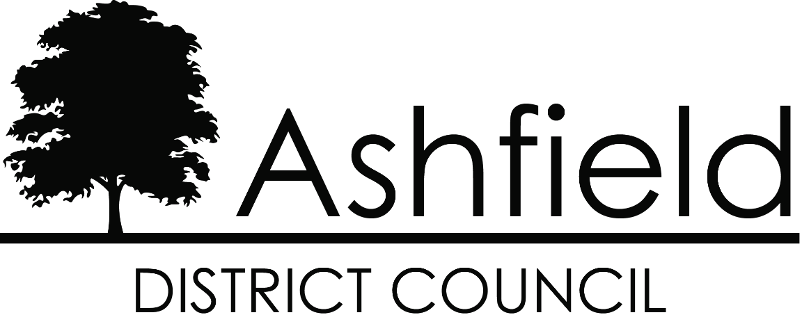

Reasonable Adjustments Policy

December 2020

Reasonable Adjustments Policy

1. Introduction
  - The Council is fully committed to ensuring that disabled people are not disadvantaged in accessing its services and that we will make reasonable adjustments for disabled people. This policy does not seek to outline how we will approach every situation though is intended to act as a general statement of our policy and:
- Outlines our commitment to improving accessibility for all our customers.
- Sets out some of the basic principles of our commitment to provide reasonable adjustments for disabled people.
- Outlines the considerations that we will take into account in dealing with requests for reasonable adjustments.
- States contact details for requesting further details or to raise any matter relating to reasonable adjustments and improving accessibility.
- Outlines the monitoring and review process for the policy.
1.2 The policy applies to all Ashfield District Council customers and tenants.

2. Equality Act 2010 and Public Sector Equality Duty
2.1 The Equality Act 2010 provides a legislative framework to protect the rights of individuals and to advance equality of opportunity for all. As a Public Authority, the Council must also comply with the Public Sector Equality Duty. The Duty aims to make sure public authorities think about things like discrimination and the needs of people who are disadvantaged or suffer inequality, when they make decisions about how they provide their services and implement policies.
2.2 The Council must remove the barriers people face because of their disability so they can access and use provided goods and services in the same way, as far as this possible, as someone who's not disabled. The Equality Act 2010 calls this the duty to make reasonable adjustments.

2.3 Under the Equality Act, the duty to make reasonable adjustments applies where:
- There is a provision, criteria or practice which puts a disabled person at a substantial disadvantage in regard to a relevant matter in comparison with persons who are not disabled.
- Where physical features put a disabled person at a substantial disadvantage in comparison with persons who are not disabled.
- Where a disabled person would but for provision of an auxiliary aid and services be put at a substantial disadvantage in comparison with persons who are not disabled.
2.3 The Council must make adjustments if:
- A person is disadvantaged by something because of their disability, and
- It’s reasonable to make the changes to remove the disadvantage.
2.4 The duty to make reasonable adjustments in goods and services is anticipatory. This means the Council mustn’t wait to be asked to do something and should consider in advance (and on an ongoing basis) what they need to do to make their services accessible to all their disabled customers.

3. What is a Reasonable Adjustment?
3.1 An adjustment means to make a physical change to premises or to change service provision or work practices to avoid or correct the disadvantage to a person with a disability. Examples include:
- Providing additional support such as a British Sign Language interpreter
- Extra staff assistance - for example, taking extra time to explain something or provide face to face services for people who can’t use the internet or phone
- Provision of aids and adaptions to assist with use of computers provided in public areas e.g., for persons with dyslexia.

4. Requesting Reasonable Adjustments
4.1 We will ensure people know that we can provide reasonable adjustments through a variety of means including:
- Statement on all correspondence giving contact details for requesting reasonable adjustments.
- By asking whether a reasonable adjustment may be required over the telephone
- By publicising our policy on our website.
- By working with key stakeholders and representative groups to raise awareness of the policy.

5. Reasonable Adjustments we can offer
5.1 Whilst we will consider in advance (and on an ongoing basis) what we need to do to make our services accessible to all disabled customers, specific adjustments provided depend on each individual’s needs which involves a discussion with the person concerned to identify and aim to reach agreement on what is deemed reasonable in the circumstances. Examples of adjustments Council staff can provide include:
- Provision of auxiliary aids such as hearing loops and adapted computer software and devices.
- Communication through a suitable representative.
- Print off and provision of documents in large print.
- Personal interviews at home or office.
- Arranging for residents to provide required details over the phone rather than via an on-line or paper copy of a form.
- Adaptive formats and accessibility to the Council’s website.

6. Responding to requests for reasonable adjustments
  - Wherever possible we will be able to agree and provide the required reasonable adjustment with the minimum of delay. In some cases, we may need to consider in more detail how best to overcome the difficulty of a disabled person is experiencing including taking advice from disability organisations that can assist with advice, sign posting and identifying other forms of support.

7. What is deemed as a reasonable adjustment?
7.1 What's a reasonable step to ask for can vary and will depend on things like:
- The disability
- The type of services wanted to be accessed
- How practicable the changes and adjustments are
- Whether the change asked for would overcome the disadvantage that is being experienced.
- If the change is what's needed or is more than necessary
7.2 Effectiveness: The adjustment provided should look to fully address the identified disadvantage. For example, arranging a home visit may not fully overcome the barriers faced by the disabled person if there are other requirements that need to be overcome such as documents provide din large font.

7.3 Practicality: It may, for example, not be possible for additional time to customers to be provided if there are legislative deadlines to meet.

7.4 Resources: For an adjustment to be reasonable it needs to be effective. However, an adjustment that is deemed effective may not be considered reasonable. Resources covers more than costs. For example, it can include other factors such as recruitment of additional staff with specific skills. The reasonableness of an adjustment is evaluated against the resources available to our services. For example, it is not reasonable for an adviser to devote all of their time to one person if the service to other persons significantly suffers-the amount of additional time provided must therefore be reasonable in all circumstances.

8. Monitoring & Review
8.1 The Council will record and monitor the reasonable adjustments that have been provided and requested and be subject to review as part of ongoing service reviews to identify where further improvements can be made.

9. Contact Details
9.1 For further details or to raise any matter relating to reasonable adjustments and improving accessibility please contact:
- Rosie Taylor-Caddy, Service Manager-Customer Services
- Telephone: 01623 457370
- Email: rosie.taylor-caddy@ashfield.gov.uk

