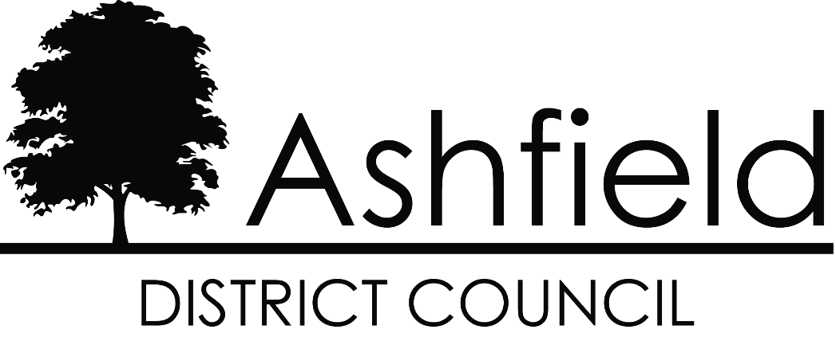

Business Rates
Explanatory Leaflet
Financial Year 2024-2025

Non-Domestic Rates
Non-Domestic Rates, or business rates, collected by local authorities are the way that those who occupy non-domestic property contribute towards the cost of local services. Under the business rates retention arrangements introduced from 1st April 2013, authorities keep a proportion of the business rates paid locally. The money, together with revenue from council taxpayers, locally generated income, and grants from central government, is used to pay for the services provided by local authorities in your area. Further information about the business rates system, may be obtained at Introduction to business rates - GOV.UK, at the website of your local council which is normally shown on your rate bill, or by contacting your local authority.

Business Rates instalments
Payment of business rate bills is automatically set on a 10-monthly cycle. However, the Government has put in place regulations that allow ratepayers to require their local authority to enable payments to be made through 12 monthly instalments. If you wish to take up this offer, you should contact your local authority as soon as possible.

National Non-Domestic rating multiplier
The local authority works out the business rates bill for a property by multiplying the rateable value of the property by the appropriate non-domestic multiplier. There are two multipliers: the standard non-domestic rating multiplier and the small business non-domestic rating multiplier. The Government sets the multipliers for each financial year, except in the City of London where special arrangements apply.
All ratepayers who occupy a property with a rateable value which does not exceed £50,999 will have their bills calculated using the lower small business non-domestic rating multiplier, rather than the standard non-domestic rating multiplier.
Both multipliers for a financial year are based on the previous year’s multiplier adjusted to reflect the Consumer Price Index (CPI) inflation figure for the September prior to the billing year, unless a lower multiplier is set by the Government. The current multipliers are shown on the front of your bill.

Rateable value
Apart from properties that are exempt from business rates, each non-domestic property has a rateable value which is set by the Valuation Office Agency (VOA), an agency of Her Majesty's Revenue and Customs. They compile and maintain a full list of all rateable values, available at Valuation Office Agency - GOV.UK. The rateable value of your property is shown on the front of your bill. This broadly represents the yearly rent the property could have been let for on the open market on a particular date specified in legislation. For the current rating list, this date was set as 1st April 2021.
The VOA may alter the valuation if circumstances change. The ratepayer (and certain others who have an interest in the property) can also check and challenge the valuation shown in the list if they believe it is wrong.
Further information about the grounds on which challenges may be made and the process for doing so can be obtained by contacting the VOA or by consulting the VOA website - Check and challenge step by step

Revaluations
All non-domestic property rateable values are reassessed at revaluations. The most recent revaluation took effect from 1st April 2023. Revaluations ensure that business rates bills are up to date, more accurately reflect current rental values and relative changes in rents. Frequent revaluations ensure the system continues to be responsive to changing economic conditions.

Business Rates reliefs
Depending on individual circumstances, a ratepayer may be eligible for a rate relief (i.e. a reduction in their business rates bill). There are a range of available reliefs. Further details are provided below and at Introduction to business rates - GOV.UK, at the website of your local council which is normally shown on your rates bill or by contacting your local authority.

Temporary reliefs
Some of the permanent reliefs are set out below but temporary reliefs are often introduced by the Government at a fiscal event. Further detail on current temporary reliefs is available at Business rate relief - GOV.UK. You should contact your local authority for details on the latest availability of business rates reliefs and advice on whether you may qualify.

Small Business Rates relief
If a ratepayer’s sole or main property has a rateable value which does not exceed a set threshold, the ratepayer may receive a percentage reduction in their rates bill for the property of up to a maximum of 100% while eligible properties above the lower threshold and below a specified upper threshold may receive partial relief. The level of reduction will depend on the rateable value of the property. For example, eligible properties with a rateable value below a specified lower threshold will receive 100% relief. The relevant thresholds for relief are set by the Government by order and can be obtained from your local authority or at Business rates - GOV.UK.
Generally, these percentage reductions (reliefs) are only available to ratepayers who occupy either—
(a) one property, or
(b) one main property and other additional properties providing those additional properties each have a rateable value which does not exceed the limit set by order.
The aggregate rateable value of all the properties mentioned in (b), must also not exceed an amount set by order. For those businesses that take on an additional property which would normally have meant the loss of small business rate relief, they will be allowed to keep that relief for a fixed additional period. Full details on the relevant limits in relation to second properties and the current period for which a ratepayer may continue to receive relief after taking on an additional property can be obtained from your local authority or at Business rates - GOV.UK.
Certain changes in circumstances will need to be notified to the local authority by the ratepayer who is in receipt of relief (other changes will be picked up by the local authority). The changes which should be notified are—
(a) the property falling vacant,
(b) the ratepayer taking up occupation of an additional property, or
(c) an increase in the rateable value of a property occupied by the ratepayer in an area other than the area of the local authority which granted the relief.

Charity and community amateur sports club relief
Charities and registered Community Amateur Sports Clubs are entitled to 80% relief where the property is occupied by the charity or the club and is wholly or mainly used for the charitable purposes of the charity (or of that and other charities), or for the purposes of the club (or of that and other clubs).
The local authority has discretion to give further relief on the remaining bill. Full details can be obtained from the local authority.

Transition rate relief
At a revaluation, some ratepayers will see reductions or no change in their bill whereas some ratepayers will see increases.
Transitional relief schemes are introduced at each revaluation to help those facing increases. Transitional relief is applied automatically to bills. Further information about transitional arrangements and other reliefs may be obtained from the local authority or the website Business rates - GOV.UK

Rate Relief for Businesses in Rural Areas
Certain types of properties in a rural settlement with a population below 3,000 may be entitled to relief. The property must be the only general store, the only post office or a food shop and have a rateable value of less than £8,500, or the only public house or the only petrol station and have a rateable value of less than £12,500. The property has to be occupied. An eligible ratepayer is entitled to relief at 100% of the full charge. The local authority also has discretion to give relief to certain other business types within the rural settlement. Full details can be obtained from the local authority.

Local Discounts and Hardship relief
Local authorities have a general power to grant discretionary local discounts and to give hardship relief in specific circumstances. Full details can be obtained from the local authority.

Unoccupied property rating
Business rates are generally payable in respect of unoccupied non-domestic property. However, they are generally not payable for the first three months that a property is empty. This is extended to six months in the case of certain industrial premises, whilst certain other properties such as vacant listed buildings are not liable for business rates until they are reoccupied. Full details on exemptions can be obtained from your local authority or from gov.uk at Business rates relief - GOV.UK.

Subsidy control (formerly known as State Aid)
The new UK subsidy control regime commenced from 4th January 2023. The new regime enables public authorities, including devolved administrations and local authorities, to deliver subsidies that are tailored for local needs. Public authorities giving subsidies must comply with the UK’s international subsidy control commitments.
The subsidy control legislation provides the framework for a new, UK-wide subsidy control regime. Further information about subsidy control can be found on the gov.uk website at: Subsidy control regime - GOV.UK.

Rating advisers
Ratepayers do not have to be represented in discussions about their rateable value or their rates bill. However, ratepayers who do wish to be represented should be aware that members of the Royal Institution of Chartered Surveyors (RICS - website www.rics.org) and the Institute of Revenues, Rating and Valuation (IRRV - website www.irrv.org.uk) are qualified and are regulated by rules of professional conduct designed to protect the public from misconduct. Before you employ a rating adviser or company you should check that they have the necessary knowledge and expertise, as well as appropriate indemnity insurance. Take great care and, if necessary, seek further advice before entering into any contract.

Information supplied with demand notices
Information relating to the relevant and previous financial years in regard to the gross expenditure of the local authority is available at
Statement of accounts and audit reports - Ashfield District Council
A hard copy is available on request by writing to the council or at 01623 457200.

Paying Business Rates – Made easy
SEE THE REVERSE OF YOUR RATE DEMAND FOR DETAILS

Where to get more information
If you would like more information on any of the above, please contact us:
- telephone 01623 457200
- email businessrates@ashfield.gov.uk.
- write to:
Ashfield District Council
Urban Road
Kirkby in Ashfield
Nottingham
NG17 8DA

