ASHFIELD DISTRICT COUNCIL

BROWNFIELD LAND CAPACITY ASSESSMENT

November 2022

THIS PAGE IS INTENTIONALLY BLANK

Contents

Section |  | Page
1 | Introduction | 1
2 | Background | 1
3 | Methodology | 3
4 | Results | 5
5 | Conclusion | 14
Appendix 1 | Permissioned Site Maps | 16
Appendix 2 | Draft Local Plan 2021 Proposed Site Allocations Maps | 21
Appendix 3 | Other Site Maps | 26
Appendix 4 | Greenfield/Brownfield Sites Maps | 36

THIS PAGE IS INTENTIONALLY BLANK

Introduction

  - The purpose of this Assessment is to review the supply of brownfield land within the district that could feasibly be brought forward for residential development or other development purposes within the period of the Draft Ashfield Local Plan 2020-2038.

  - The inclusion of a site in this document does not amount to a commitment that the site will be allocated for development in the Local Plan or to grant planning permission following submission of a detailed planning proposal.

  - All references to the National Planning Policy Framework (NPPF) reflect the 2021 version in place at the time the Assessment was drafted.

  - The results within this study reflect the potential brownfield land supply as at 30th November 2022. Brownfield sites currently being developed or already completed have not been identified as the focus is on the degree to which remaining brownfield sites can accommodate future housing and development requirements.

  - The analysis did not involve an in-depth study of every site. This reflects that such details would be addressed through any future planning application or through the site being identifies as a potential housing or other development sites and considered through the Strategic Housing Land Availability Assessment (SHELAA).

Background

  - The NPPF refers to ‘brownfield land’ which is defined in the glossary as being interchangeable with the term ‘previously developed land’:

‘’Land which is or was occupied by a permanent structure, including the curtilage of the developed land (although it should not be assumed that the whole of the curtilage should be developed) and any associated fixed surface infrastructure.’’

The NPPF also specifies the following as being excluded from the definition of brownfield land:

- land that is or has been occupied by agricultural or forestry buildings.
- land that has been developed by waste extraction by landfill where provision for restoration has been made through development management procedures.
- land in built-up areas such as residential gardens, parks, recreation grounds and allotments.
- land that was previously developed but where the remains of the permanent structure or fixed surface structure have blended into the landscape.

  - The NPPF attaches substantial weight to using suitable brownfield land within settlements for homes and other identified needs and support appropriate opportunities to remediate despoiled, degraded, derelict, contaminated or unstable land. (NPPF Paragraph 120 c). Brownfield land within settlements offer opportunities for contributing towards development needs and the regeneration of an area. Consequently, Local Planning Authorities (LPAs) should take a proactive role in identifying and bringing forward suitable brownfield sites.

  - Ashfield District Council has been successful within recent years in bringing forward brownfield land for development, with 64% of residential completions within the 2020-21 monitoring period being on brownfield sites. The Council Employment Land Monitoring Report 2022 identifies that between 2021 and 31st March 2022, 37.55 ha of land former utilised for employment purposes has been redeveloped for housing. These sites substantial comprise former traditional textile factories sites and colliery sites. Very limited sites of this nature remain in an employment use within Ashfield.
 | 2001/17 | 2017/18 | 2018/19 | 2019/20 | 2020/21 | 2021/22 | Total
Hucknall | 6.78 | 0.51 | 0.12 | 0.32 | 1.06 | 0.00 | 8.79
Kirkby in Ashfield | 9.46 | 0.00 | 0.00 | 0.00 | 0.00 | 0.00 | 9.46
Sutton in Ashfield | 13.40 | 0.00 | 0.26 | 2.95 | 0.00 | 0.00 | 16.61
Rural | 2.69 | 0.00 | 0.00 | 0.00 | 0.00 | 0.00 | 2.69
Total Area loss for each year | 32.33 | 0.51 | 0.38 | 3.27 | 1.06 | 0.00 | 37.55
Table 1: Employment Land Losses to residential development 1st April 2001 to 31st March 2022.
Source: Ashfield District Council Employment Land Monitoring Report 2022, Table 23.

  - The Government’s website identifies the total land area of the district of Ashfield is 10,960 ha. At 31st March 2021 4,525 ha (rounded up) are designated as Green Belt, which means that 41.29% of Ashfield is designated as Green Belt. Land can only be taken out of the Green Belt through a Local Plan and it must be demonstrated there are exceptional circumstances to justify changes to the Green Belt boundaries. The Local Plan must consider the availability of brownfield sites before making changes to the Green Belt boundaries. In this context, this Assessment contribute to the evidence on the availability of brownfield sites in the district of Ashfield.

Methodology

  - A search of potential brownfield sites was undertaken for the purposes of this review. This included the following sources:

- The ‘Call for Sites’ process and resulting Strategic Housing and Economic Land Availability Assessment (SHELAA), using the 2021 figures which are the most up to date.
- The Ashfield Draft Local Plan 2020-2038, specifically sites allocated under policy H1: Housing Allocations.
- Relevant entries on the Council’s Brownfield Land Register.
- GIS and aerial photography data available cross referenced with layers on the Council’s online interactive mapping system.
- Information on Ashfield District Council’s planning applications database.
- Where appropriate site visits.

  - Sites have been considered in the context of the NPPF definition of ‘deliverable’ in determining their inclusion within this document. As such, it differentiates between sites where there is a realistic assumption of new development within five years, where development is likely within the plan period, and where the overall availability of the site is less certain. Sites submitted to the Council through the Strategic Housing and Economic Land Available Assessment (SHELAA) have not been included in the Brownfield Review when they have been identified as not being available, and/or not suitable for proposed use without substantial mitigation, and/or unlikely to be achievable.

  - Brownfield sites have been grouped into three broad categories corresponding to this.

Permissioned Sites – Sites with extant planning permission, with a realistic expectation that works will be carried out within the next five years. An exception being major sites with outline permission only, as it not strictly the case that completion would occur with five years in accordance with the NPPF definition of deliverable.

Allocated Sites – Sites that have been assessed and allocated within the Draft Ashfield Local Plan 2020-2038 and/or are included on the Council’s brownfield land register. It is anticipated that these sites will be developed over the period of the Draft Local Plan. When allocated site may come forward is considered by the emerging Local Plan Trajectory.

Other Sites – Sites which have been identified from other sources but where the availability is less certain. For instance, where the planning permission has lapsed, and the potential developer’s intentions are not known.

  - Using the data available, land within the district was analysed to identify potential brownfield sites and consideration given to their location, use and size. Only sites which met the definition of brownfield land were considered. Sites excluded from the definition of previously development land in the NPPF have not been considered. In some cases, a parcel of land is identified as having both greenfield and brownfield elements within the site area. These sites are identified later in the document.

  - The Assessment is focused on areas within the boundaries of the Main Urban Areas and Named Settlements where opportunities for redevelopment of brownfield land is likely to arise and where sites are likely to have supporting infrastructure.

  - Proposed housing yields are indicative and will vary depending on which category each site has been assigned to:

- For permissioned sites this will reflect the number of units that the most recent active permission has been granted for.
- For allocated sites this is derived from the proposed yields provided in the Draft Local Plan and/or the brownfield land register.
- For other sites the proposed yield is derived from the minimum density requirements as set out in Policy H7: Housing Density in the Draft Local Plan.
The Policy identifies that for residential sites of 0.4 hectares or greater, within distances indicated below from district shopping centres and major public transport nodes the following minimum density requirements are:
- Within 400m - 40 dwellings per hectare
- Within 1,000m - 34 dwellings per hectare
- Over 1,000m - 30 dwellings per hectare

Results

  - The Tables below set out the analysis of the brownfield sites which are or may be available for development.

  - It should be noted that there may be some cross over between sites with planning permission and sites, which are identified in the Draft Local Plan 2021 as proposed allocated sites.

  - Permissioned Sites are set out in Table 2.

Table 2: Sites with Planning Permission
Permissioned Sites Site Name | Total Site Area | Proposed Housing Yield | Description
Former Romans Public House, Annesley Road, Hucknall  (See Appendix 1, Map 1) | 0.3ha | 9 | The site lies within the Hucknall Town Centre Conservation Area. It currently consists of the demolished remains of a public house that was once on the site.  Permission exists for the erection of a three-storey block containing 9 apartments (reference V/2018/0330), which also included the demolition of the former building.
Sunbeam House, West Street, Hucknall (See Appendix 1, Map 2) | 0.14ha | 9 | This site lies within Hucknall Town Centre Conservation Area and was previously occupied by a factory/bakery that was demolished in 2021.  An outline application to demolish the factory and redevelop the site for a maximum of 9 dwellings was refused permission but allowed on appeal (ref V/2018/0734).
Rolls Royce Phase 5, Watnall Road, Hucknall (See Appendix 1, Map 3) | 3.2ha | 100 | This forms part of a wider site consisting of a former aerodrome. Several phases have already been completed or are under construction.  Reserved matters have been agreed to develop phase 5 for 100 dwellings (ref V/2020/0563)
Former garage site, Spruce Grove, Kirkby in Ashfield (See Appendix 1, Map 4) | 0.15ha | 5 | This is a council-owned site that was formerly occupied by garages but is now vacant.  Planning permission has been granted for 5 dwellings (ref V/2022/0198).
Garage site, Darley Avenue, Kirkby in Ashfield (See Appendix 1, Map 5) | 0.09ha | 3 | This is a council-owned site occupied by a block of garages.  Planning permission has been granted for 3 dwellings (ref V/2022/0195).
Land off Southwell Lane, Kirkby in Ashfield (See Appendix 1, Map 6) | 2.0ha | 60 | This consists of vacant land formerly occupied by a factory that was demolished in 2013.
Land at Junction of Outram Street/Park Street, Sutton in Ashfield (See Appendix 1, Map 7) | 0.12ha | 24 | This previously developed site is currently overgrown and vacant and benefits from reserved matters consent for 24 apartments (ref V/2020/0411)
Former garage site, Elder Street, Sutton in Ashfield (See Appendix 1, Map 8) | 0.047ha | 2 | This vacant parcel of land was previously occupied by rented garages that have since been demolished.  Extant permission exists for the erection of 2 dwellings (ref V/2019/0771)
The Quarry, 57 Stoneyford Road, Sutton in Ashfield (See Appendix 1, Map 9) | 1.29ha | 47 | The site is a former quarry with buildings also used for general commercial uses. The southern part of the site (approx. 0.62ha) is less developed and has been previously used for the grazing of animals.  Reserved matters have been agreed for a residential development of up to 47 dwellings (ref V/2020/0832).
Market View, Market Place, Sutton in Ashfield (See Appendix 1, Map 10) | 0.07ha | 8 | The site includes a vacant building previously used as solicitors’ offices as well as an associated private car park.  The site has been given outline consent to demolish the former solicitor’s office and to build a maximum of 8 town houses (ref V/2020/0546).

  - Draft Local Plan 2021 Proposed Site Allocations are identified in Table 3.

Table 3: Draft Local Plan Proposed Site Allocations
Site Name | Total Site Area | Potential Housing Yield | Description
Former Seven Stars, West Street, Hucknall (See Appendix 2, Map 1) | 0.66ha | 24 | The site includes a dwelling at 32 West Street as well as a vacant public house.  It has been allocated for housing under policy HG1 of the Draft Local Plan (ref H1Ha) with a potential yield of 24 dwellings.
Phases 5 (part) and 9, land at Rolls Royce, Watnall Road, Hucknall (See Appendix 2, Map 2) | 5.3ha | 105 | H1He
Phases 10,11,12, land at Rolls Royce, Watnall Road, Hucknall (See Appendix 2, Map 3) | 4.44ha | 100 | H1Hf
Hucknall Town Football Club, Watnall Road, Hucknall (See Appendix 2, Map 4) | 3.5ha | 100 | This is the site of Hucknall Town Football Club and primarily consists of a stadium, car park and associated club buildings. There are also two grassed pitches which form a significant part of the site area.  The football club are currently in the process of relocating to a newly built stadium off Aerial Way in Hucknall. The site at Watnall Road has been allocated for housing in the Draft Local Plan (ref H1Hg).  Part of the site has been granted planning permission for a new food store (ref V/2020/0306), with the remaining site area now expected to be utilised for housing. A reserved matters application proposing 82 dwellings is currently being assessed (V/2022/0816).
Land at Doles Lane, Kirkby-In Ashfield (See Appendix 2, Map 5) |  | 54 | H1Kc
Land off Fox Street, Sutton in Ashfield (See Appendix 2, Map 6) | 0.2ha | 8 | This council-owned site is currently vacant and was previously occupied by a social club that was demolished in 2013.  The site is listed on the Council’s brownfield land register. This site has been proposed for redevelopment as a car park in a pending application (V/2022/0852), as part of a Council-led suite of wider public realm improvements around the nearby Portland Square. It is probable housing will not be developed on this site.
Land at Junction of Priestic Road/ Northern View, Sutton in Ashfield (See Appendix 2, Map 7) | 0.54ha | 19 | This parcel of land was historically used as a railway cutting and landfill.  It is listed on the Council’s brownfield land register but is also noted as greenfield in the Draft Local Plan (ref H1Se). An application for outline consent for 19 dwellings is currently being assessed (V/2022/0133).
Pattern House, Crossley Avenue, Huthwaite (Appendix 2, Map 8) | 0.68ha | 23 | This is the site of a former textile factory that was demolished following outline consent for a residential development (ref V/2018/0212).  It is listed within the Council’s brownfield land register and allocated within the Draft Local Plan for housing (H1Sad).
Station House, Outram Street, Sutton in Ashfield (Appendix 2, Map 9) | 0.15ha | 28 | This site consists of a derelict house and surrounding disused and overgrown land. Outline consent for 28 apartments and 2 retail units was granted in 2018 (ref V/2016/0098) but was not implemented and has lapsed.  The site is listed on the Council’s brownfield land register and allocated for housing in the Draft Local Plan (H1Sv).

  - A number of brownfield sites set out in the Draft Local Plan 2021 Policy H1 have subsequently been developed or are under development and consequently are not identified in the Table below.

  - Other Brownfield Sites which do not have planning permission or are proposed site allocations under the Draft Local Plan 2021 are identified in Table 4.

Table 4: Other Brownfield Sites
Site Name | Total Site Area | Potential Housing Yield | Description
Garage site, Oak Grove, Hucknall (See Appendix 3, Map 1) | 0.1ha | 3 | This is a Council-owned garage site. It was included in the SHELLA 2021 (ref HK038), which concluded that the site was available, potentially suitable and potentially achievable. However, highway improvements would be required on Oak Grove.
Hucknall Police Station, Watnall Road, Hucknall (See Appendix 3, Map 2) | 0.57ha | 23 | This site consists of a building formerly used as a police station and associated car park that is currently vacant.  There are 2 planning applications to re-develop the land which are both pending a decision. V/2020/0608 seeks outline consent for a residential development. V/2021/0748 seeks full permission for the erection of a 73-bed extra care home (use class C2).
Land adjacent 11 Belvoir Street, Hucknall (See Appendix 3, Map 3) | 0.04ha | 2 | This site presently consists of a vacant plot of land formerly occupied by outbuildings associated with an allotment use. A proposal to develop the site for 2 dwellings was granted approval in 2018 (ref V/2018/0395) but was not implemented and has since lapsed.
Former Kirklands Home Day Centre, Fairhaven, Kirkby in Ashfield. (See Appendix 3, Map 4) | 0.55ha | 19 | This site was formerly occupied by a care home before being demolished in 2020, leaving the site vacant with visible concrete slabs remaining.
Garage site off Abbey Road, Kirkby in Ashfield (See Appendix 3, Map 5) | 0.08ha | 3 | This is a Council-owned garage site. It was included in the SHELLA 2021 (ref KA031) which concluded that the garages are used by neighbouring properties and the site is not available or suitable.
Garage site off Central Avenue, Kirkby in Ashfield (See Appendix 3, Map 6) | 0.09ha | 3 | This is a Council-owned garage site although most of the garages have been removed, leaving only the hardstanding’s behind. It was included in the 2021 SHELLA (ref KA032) which concluded that the site is available, suitable and achievable.
Garage site off Minster Close, Kirkby in Ashfield (See Appendix 3, Map 7) | 0.07ha | 2 | This is a Council-owned garage site. It was included in the SHELLA 2021 (ref KA034) which concluded that there were significant access constraints so was available but not suitable.
Land adjacent No.2 The Promenade, Kirkby in Ashfield (See Appendix 3, Map 8) | 0.1ha | 2 | This site comprises a parcel of hard-surfaced land used for storage purposes. It was included in the 2021 SHELLA (ref KA036) which concluded it was available, potentially suitable and potentially achievable. However, it also noted the site should not be developed in isolation and requires master planning with other SHELLA sites to the north.
Land at Lane End, Kirkby in Ashfield (See Appendix 3, Map 9) | 0.43ha | 17 | This is a vacant piece of land covered by remnants of hardstanding as evidence from its former use as a factory. A significant part of the site is identified as being in Flood Zones 2 and 3 from the River Erewash. There is no recent planning history of note, although the site is identified as a potential medium-term opportunity for a mixed-use development in the Kirkby Town Centre Spatial Masterplan 2021.
Land between Alexandra and Edward Street, Kirkby in Ashfield (See Appendix 3, Map 10) | 0.4ha | 14 | This was formerly the site of the East Kirkby Miner’s Welfare, which was demolished in 2014. Since then, the land has been vacant.
Land off Hornbeam Way/Grives Lane, Kirkby in Ashfield (See Appendix 3, Map 11) | 0.13ha | 5 | This is a former garage site which is currently vacant of any buildings. A proposal to develop the site for 5 dwellings was granted permission (ref V/2019/0619) but was not implemented and has now lapsed.
Patco, Lowmoor Road, Kirkby in Ashfield (See Appendix 3, Map 12) | 2.6ha | 104 | This was previously the site of a textile manufacturer which has since relocated, leaving the site vacant. It comprises a single large building, remnant hardstanding’s from demolished buildings, a car park and grassed areas.  An outline application for a mixed-use development incorporating residential and commercial uses (ref V/2021/0234) is currently being assessed.
Wagon & Horses, 22 Chapel Street, Kirkby in Ashfield (Appendix 3, Map 13) | 0.16ha | 5 | This is the site of a vacant public house that lies within the Kirkby Cross Conservation Area. There is no recent planning history for the site.
Former Richard’s Garage, 89-91 Preistic Road, Sutton in Ashfield (See Appendix 3, Map 14) | 0.31ha | 12 | This site is currently vacant and overgrown. It was previously occupied by a commercial garage. There is no recent planning history for the site.
Garage site, Martyn Avenue, Sutton in Ashfield (See Appendix 3, Map 15) | 0.17ha | 5 | This is a Council-owned garage site. It is included in the 2021 SHELLA (ref SA051) which concluded that the site is available, potentially suitable and potentially achievable. However, there are access constraints and existing parking impacts that would need considering.
Land adjacent no.208 Mansfield Road, Sutton in Ashfield (See Appendix 3, Map 16) | 1.0ha | 34 | This is a former factory site that is currently vacant with remnant slabs/hardstanding. There have been 2 recent applications to develop the site as a retail store, which were refused (V/2017/0318 & V/2018/0221). An application for the erection of 36 dwellings is currently being assessed (ref V/2022/0347).
Rear of 37-41 Jubilee Road, Sutton in Ashfield (See Appendix 3, Map 17) | 0.06ha | 2 | This site is a hard-surfaced parking area to the rear of residential properties. It is included in the 2021 SHELLA (ref SA049) which concluded that the site is available, potentially suitable and potentially achievable. However, there are potential right of access issues, access width constraints and impact on existing parking that would need considering.
Rear of 67-71 Jubilee Road, Sutton in Ashfield (See Appendix 3, Map 18) | 0.07ha | 2 | This site is a hard-surfaced parking area to the rear of residential properties. It is included in the 2021 SHELLA (ref SA050) which concluded that the site is available, potentially suitable and potentially achievable. However, there are potential right of access issues, access width constraints and impact on existing parking that would need considering.
Land off North Street, Huthwaite (See Appendix 3, Map 19) | 2.2ha | 90 | This site was formerly occupied by a textiles factory that was demolished in 2016.  It is listed within the Council’s brownfield land register with a proposed net yield of 90 dwellings. A variety of applications have been submitted to re-develop the site for housing within the last 10 years. These have either lapsed or were refused. The most recent application proposes 71 dwellings (V/2022/0109) and is still being assessed.
Shakespeare Inn, High Pavement, Sutton in Ashfield (Appendix 3, Map 20) | 0.05ha | 5 | This site includes a vacant public house. It is listed within the brownfield land register. Permission for a change of use to form 5 apartments was granted in 2018 but the permission was not implemented and has since lapsed (ref V/2018/0352).

  - Table 5 below identifies sites which comprise areas of greenfield and brownfield land of varying areas. The majority of these sites have been proposed as allocations in the Draft Local Plan 2021.

Table 5: Greenfield/Brownfield Sites
Site Name | Total Site Area | Potential Housing Yield | Description
Linby Boarding Kennels, East of Church Lane, Hucknall |  | 43 | The site is included in the Draft Local Plan 2021 under Policy H1Hb.  The site location is identified on the Draft Local Plan 2021 Policy Map.
H1Ka Beacon Farm, Derby Road, Kirkby-In Ashfield |  | 41 | Site is included in the Draft Local Plan 2021 under Policy H1Ka.  The site location is identified on the Draft Local Plan 2021 Policy Map.
Annesley Miners Welfare Institute, Derby Road |  | 45 | Site is included in the Draft Local Plan 2021 under Policy H1Ki.  The site location is identified on the Draft Local Plan 2021 Policy Map.
Rear of Lime Avenue, Huthwaite (See Appendix 4, Map 1) | 0.6ha | 18 | The northern portion of this site is approximately 0.16ha in area and is occupied by privately rented garages and hardstanding. The southern part is an approximately 0.44ha area comprising a set of disused allotments.  An outline application for a residential development (ref V/2022/0087) is currently pending a decision.
Adj 149 Stoney Lane, Selston |  | 6 | Site is included in the Draft Local Plan 2021 under Policy H1Vd.  The site location is identified on the Draft Local Plan 2021 Policy Map.
Land North of Larch Close, Underwood |  | 37 | Site is included in the Draft Local Plan 2021 under Policy H1Vg.  The site location is identified on the Draft Local Plan 2021 Policy Map.

Conclusion

- The Tables in Section 4 identify the brownfield sites which are or may be available for development. As highlighted in Tables 2 and 3, the vast majority of larger sites have planning permission or have been identified as potential allocations in the emerging Local Plan.

Table 6: Analysis of ‘Other Brownfield Sites’

 | Potential Housing Yield
Table 4 ‘Other Brownfield Site’ | 352
Broken down as:
- Sites subject to planning applications
- Hucknall Police Station, Watnall Road, Hucknall | 23
- Patco, Lowmoor Road, Kirkby in Ashfield | 104
- Land adjacent no.208 Mansfield Road, Sutton in Ashfield | 34
- Land off North Street, Huthwaite | 90
Sub Total | 251
- Site of 5 or less dwellings | 39
- Other Sites
- Former Kirklands Home Day Centre, Fairhaven, Kirkby in Ashfield. | 19
- Land at Lane End, Kirkby in Ashfield | 17
- Land between Alexandra and Edward Street, Kirkby in Ashfield | 14
- Former Richard’s Garage, 89-91 Priestic Road, Sutton in Ashfield | 12
Sub Total | 62

- Table 6 provides an analysis of the ‘Other Brownfield Sites’ identified in Table 4 which could potential be available for meeting future housing needs. It identifies that:

- The larger sites are subject to current planning applications which, if all were granted permission, could deliver 251 dwellings. Any sites granted permission would be anticipated to be allocated within the emerging Local Plan. A number of these site were not put forward as part of the SHELAA but have subsequently been brought forward seeking planning consent for residential development.

- The sites anticipated to deliver five or less dwellings would not be allocated in the emerging Plan but may well contribute to the windfall allowance.

- Four other sites are identified which could potentially deliver 62 dwellings. The site at Lane End, Kirkby in Ashfield is currently being investigated by the Council in relation to its potential future use and the utilisation of grant funding to bring it forward. Following this Review, the three other sites are being consider in relation to whether they could come forward as part of an update SHELAA.

- There is not always clarity whether a site is a greenfield or brownfield. Table 5 identifies sites whether there is a mix of these two aspects. However, all but one of the sites have been identified as proposed site allocations in the Draft Local Plan 2021.

- The evidence from the Brownfield Land Review illustrated that the vast majority of brownfield sites have planning permission, have been put forward for planning permission or are proposed allocations in the emerging Local Plan. Consequently, brownfield sites can contribute towards meeting the future housing needs for Ashfield. However, there is no option but to utilise greenfield sites based on the requirements set out through the standard method of determining the minimum number of homes required in national planning policy and guidance.

Appendix 1: Permissioned Site Maps

Map 1: Former Romans Public House, Annesley Road, Hucknall

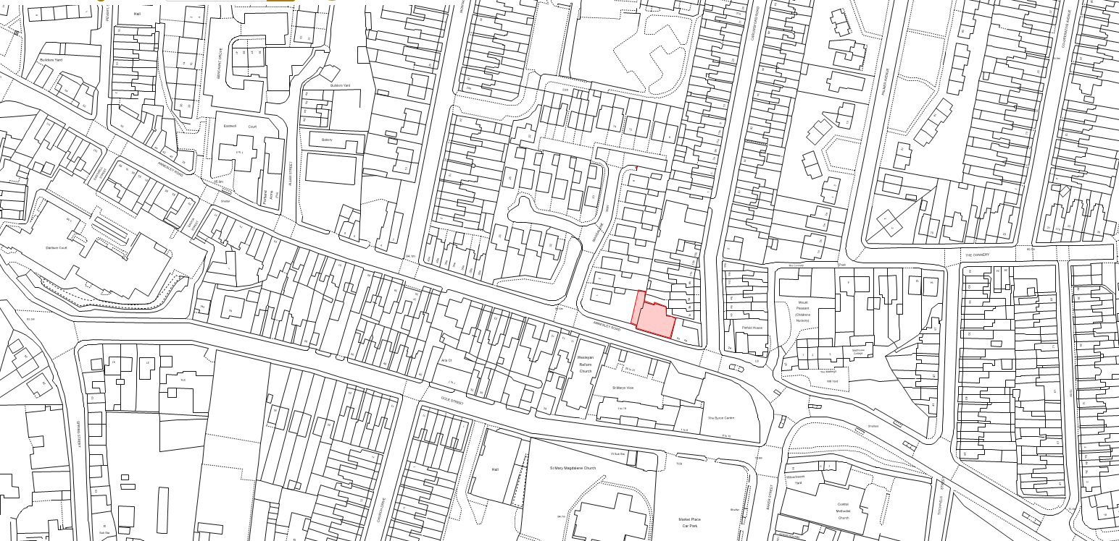

Map 2: Sunbeam House, West Street, Hucknall

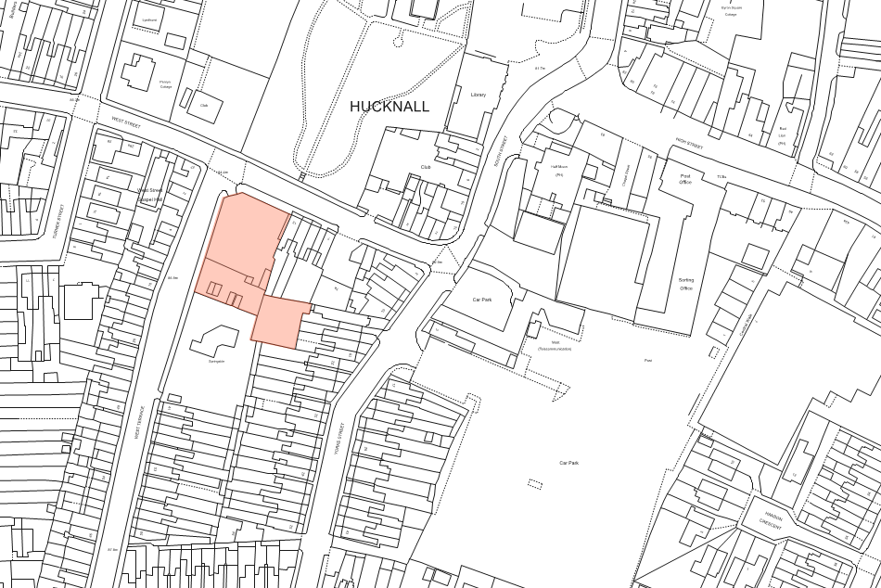

Map 3: Rolls Royce Phase 5, Watnall Road, Hucknall

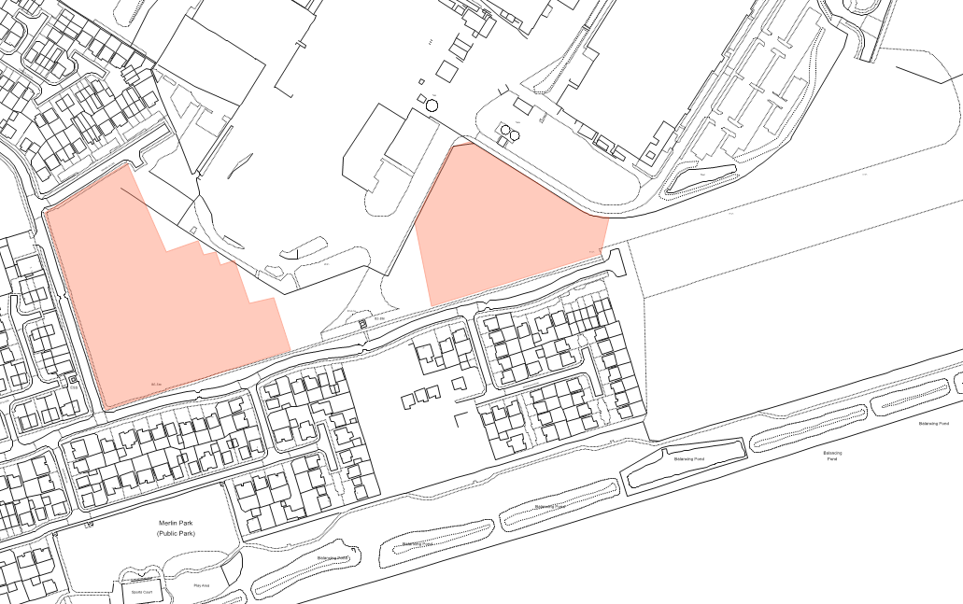

Map 4: Former garage site, Spruce Grove, Kirkby in Ashfield

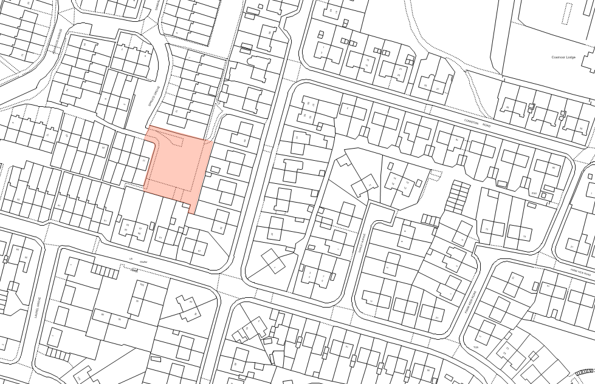

Map 5: Garage site, Darley Avenue, Kirkby in Ashfield

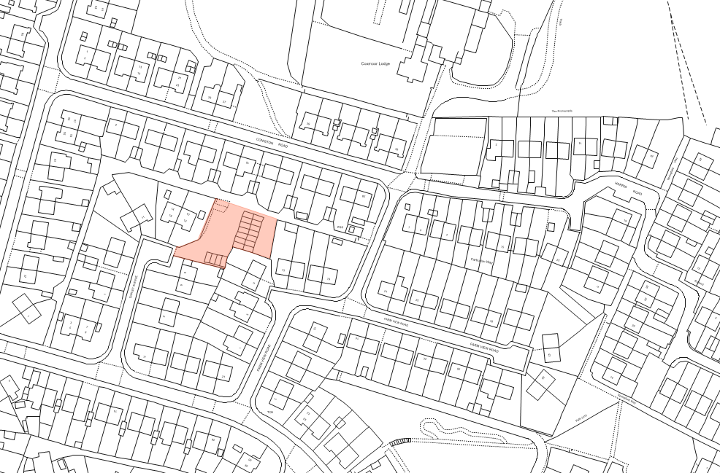

Map 6: Land off Southwell Lane, Kirkby in Ashfield

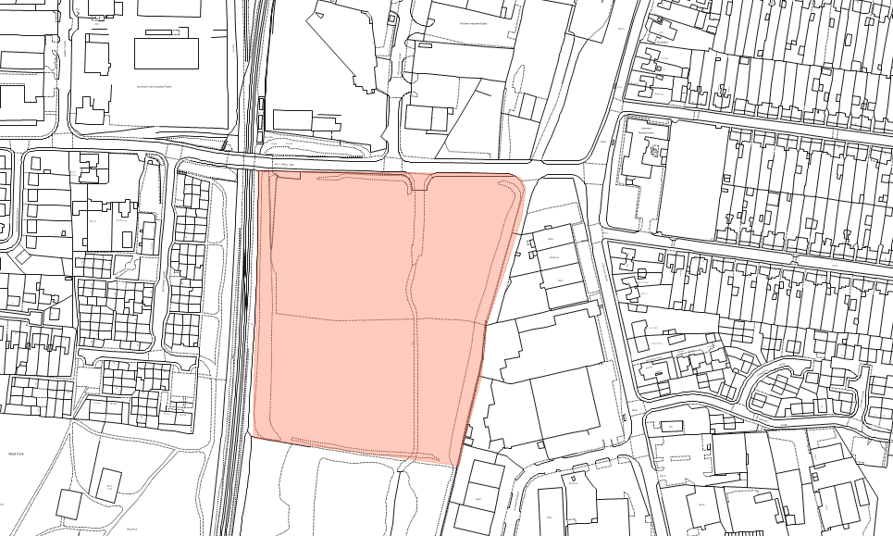

Map 7: Land at Junction of Outram Street/Park Street, Sutton in Ashfield
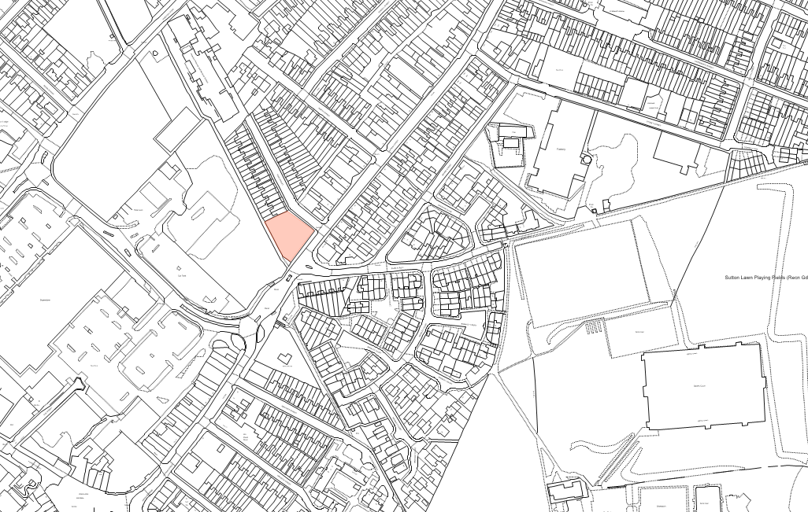

Map 8: Former garage site, Elder Street, Sutton in Ashfield

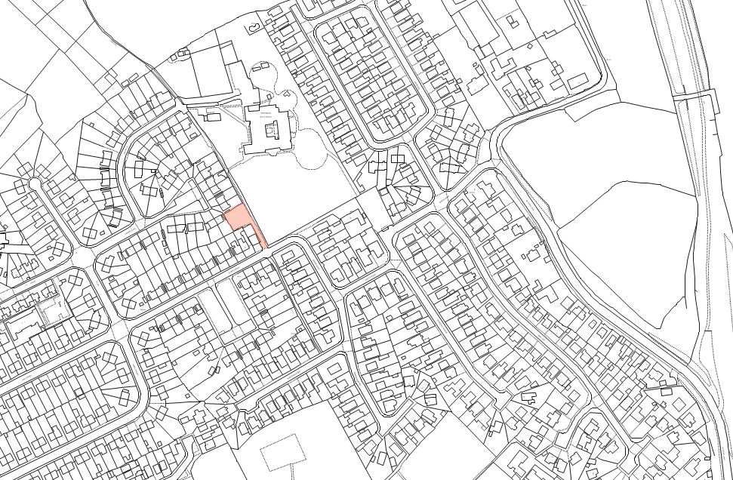
Map 9: The Quarry, 57 Stoneyford Road, Sutton in Ashfield

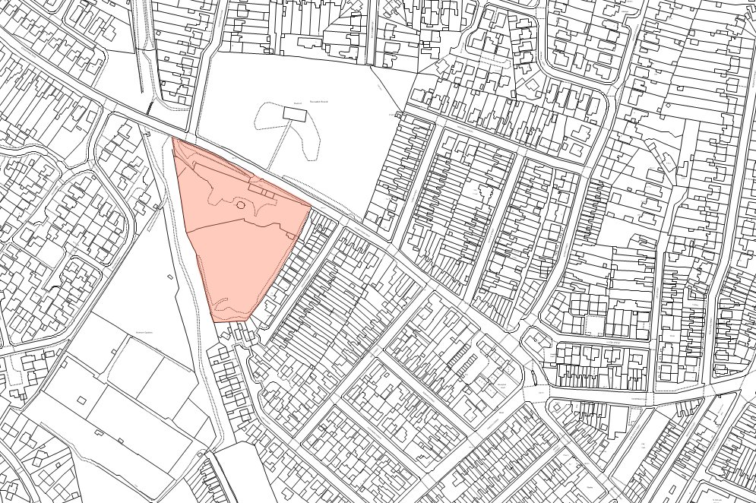

Map 10: Market View, Market Place, Sutton in Ashfield

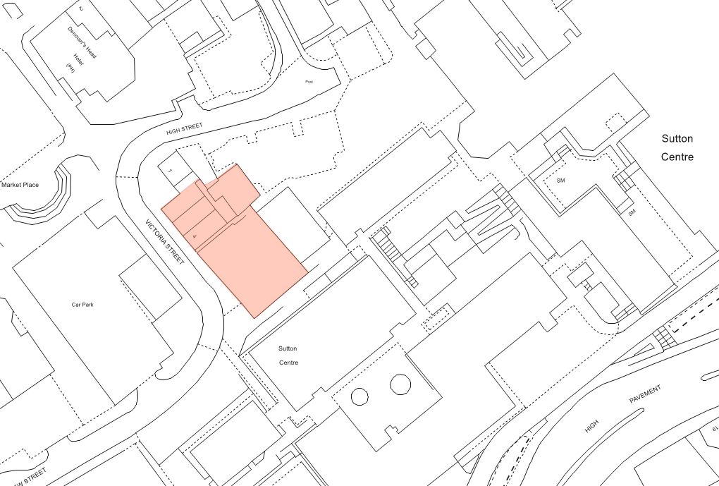

Appendix 2: Draft Local Plan 2021 Proposed Site Allocations

Map 1: Former Seven Stars, West Street, Hucknall
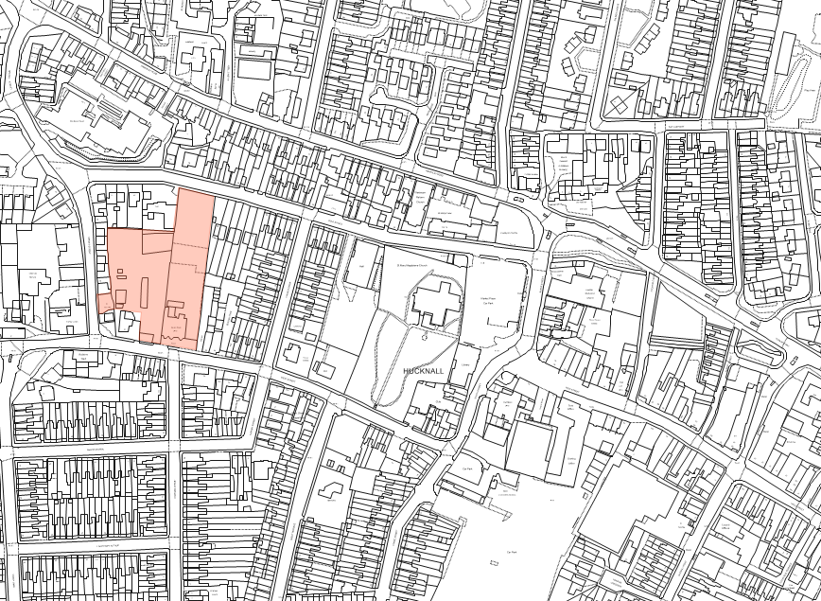

Map 2: Phases 5 (part) and 9, land at Rolls Royce, Watnall Road, Hucknall

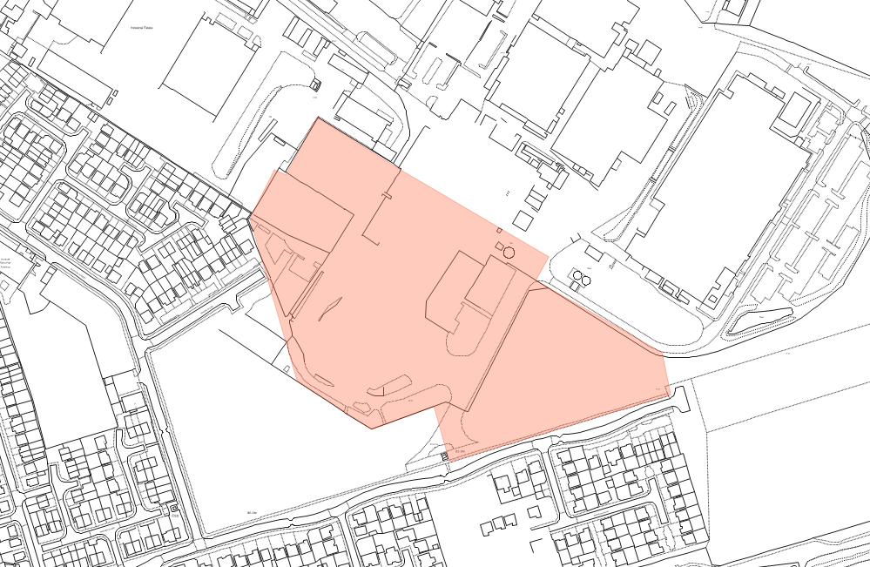

Map 3: Phases 10,11,12, land at Rolls Royce, Watnall Road, Hucknall

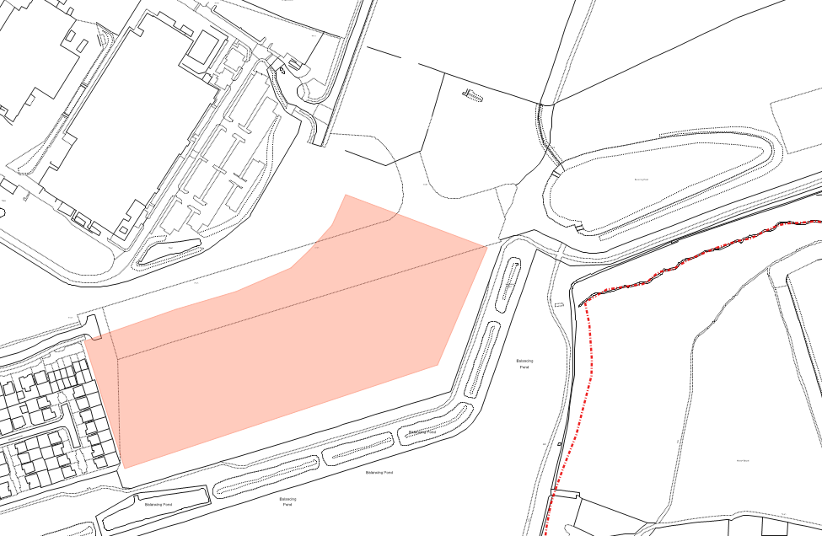

Map 4: Hucknall Town Football Club, Watnall Road, Hucknall

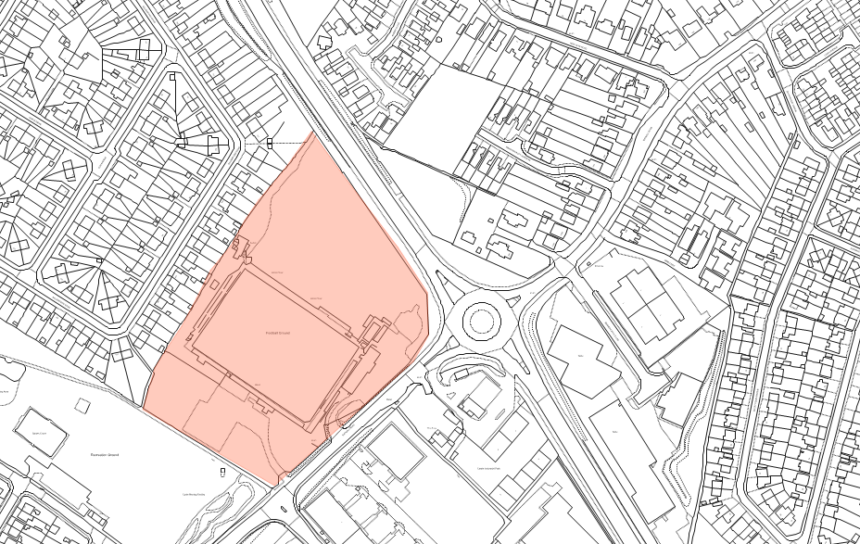

Map 5 Land at Doles Lane, Kirkby-In Ashfield

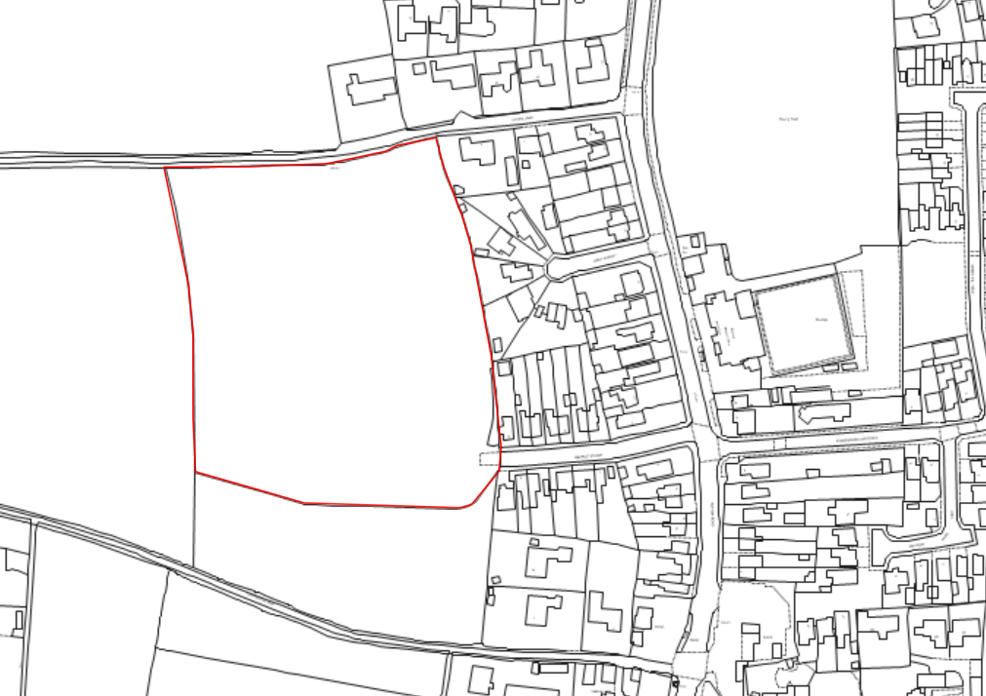

Map 6: Land off Fox Street, Sutton in Ashfield

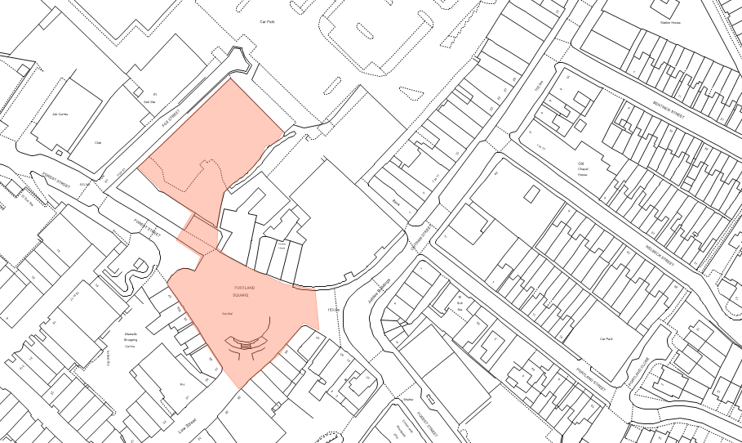

Map 7: Land at Junction of Priestic Road/Northern View, Sutton in Ashfield
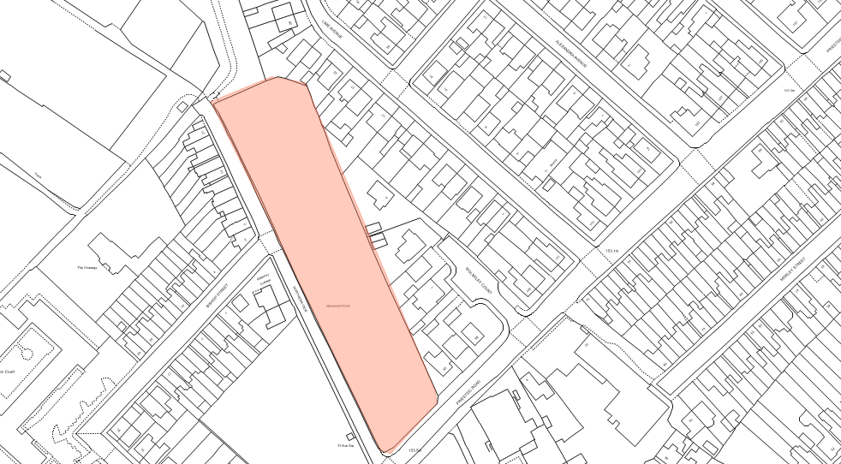

Map 8: Pattern House, Crossley Avenue, Huthwaite

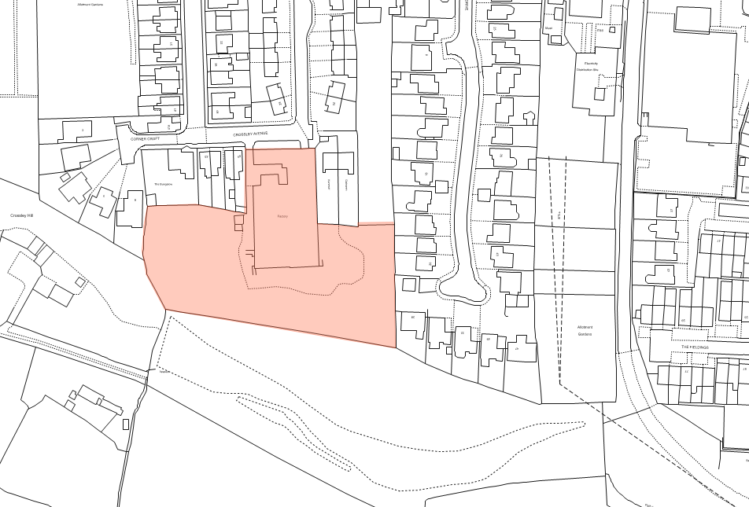

Map 9: Station House, Outram Street, Sutton in Ashfield

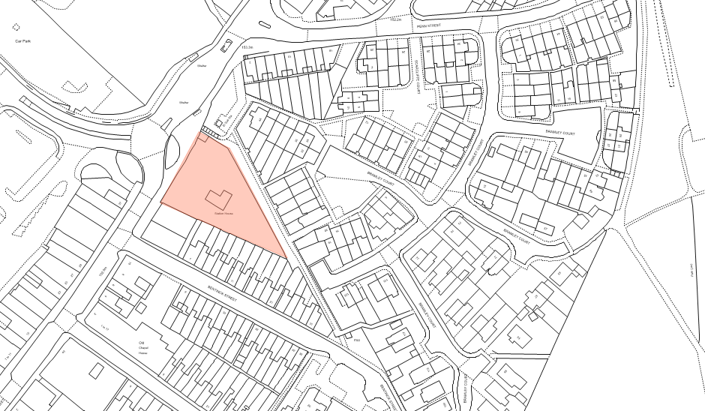

Appendix 3: Other Brownfield Site Maps

Map 1: Garage site, Oak Grove, Hucknall

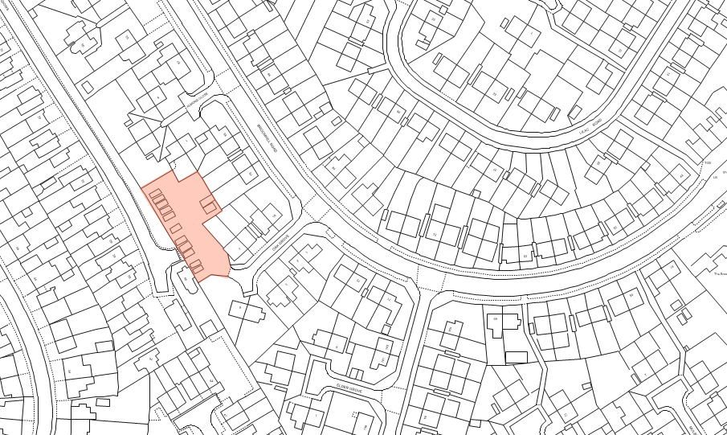

Map 2: Hucknall Police Station, Watnall Road, Hucknall

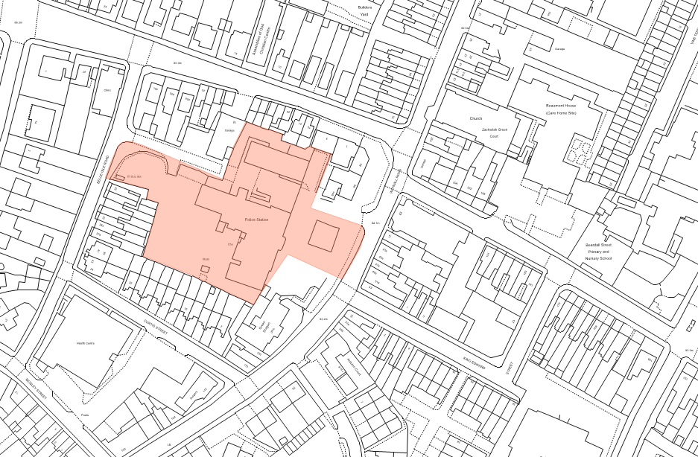

Map 3: Land adjacent 11 Belvoir Street, Hucknall
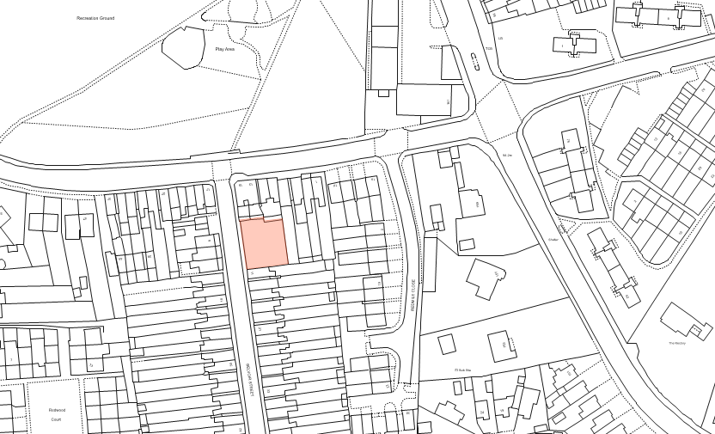

Map 4: Former Kirklands Home Day Centre, Fairhaven, Kirkby in Ashfield

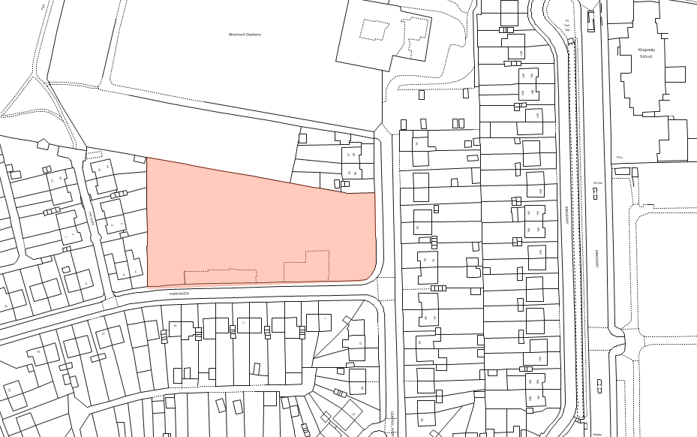

Map 5: Garage site off Abbey Road, Kirkby in Ashfield

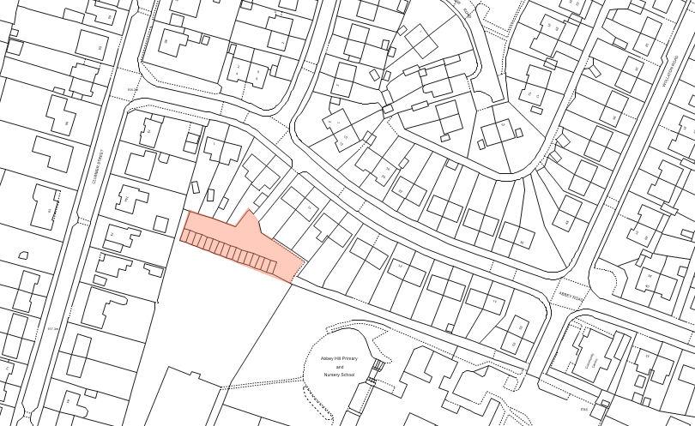

Map 6: Garage site off Central Avenue, Kirkby in Ashfield

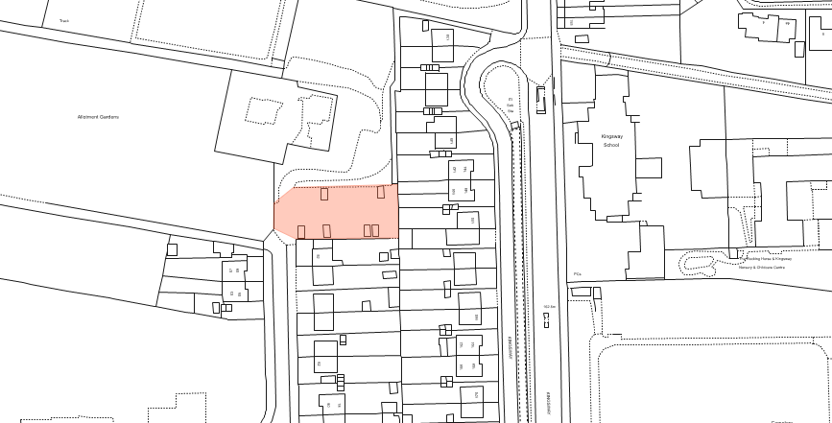

Map 7: Garage site off Minster Close, Kirkby in Ashfield

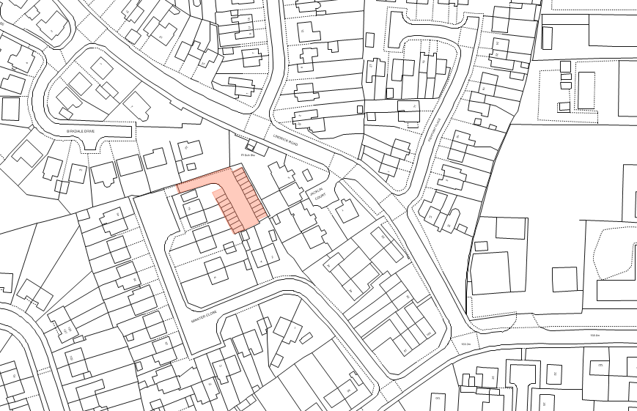

Map 8: Land adjacent No.2 The Promenade, Kirkby in Ashfield

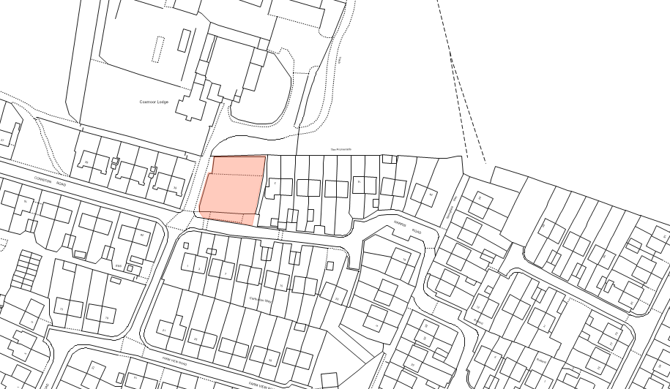

Map 9: Land at Lane End, Kirkby in Ashfield
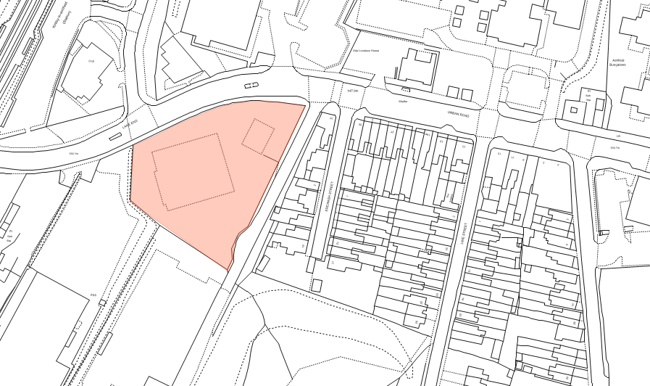

Map 10: Land between Alexandra and Edward Street, Kirkby in Ashfield

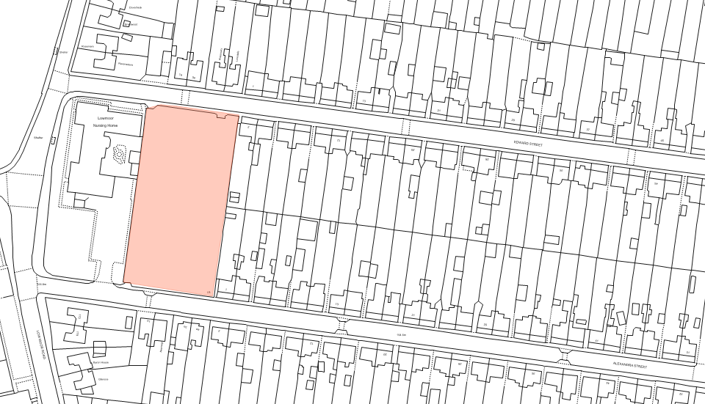

Map 11: Land off Hornbeam Way/Grives Lane, Kirkby in Ashfield

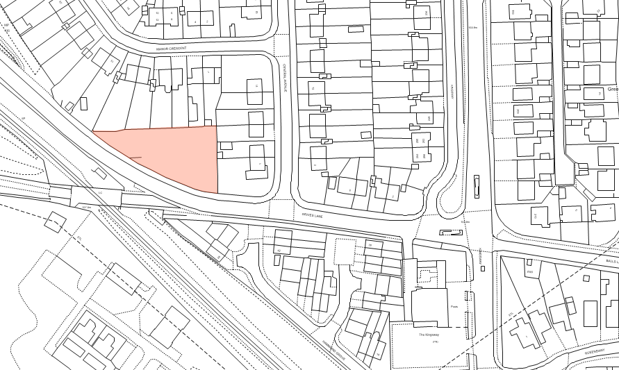

Map 12: Patco, Lowmoor Road, Kirkby in Ashfield

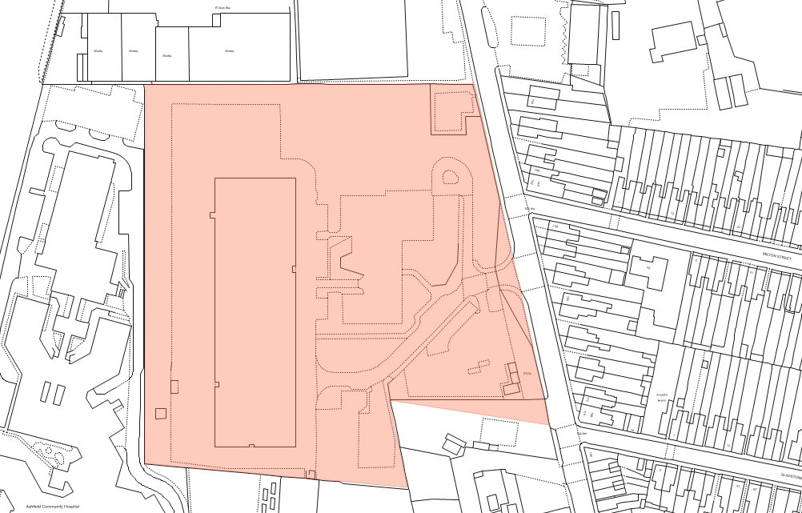

Map 13: Wagon & Horses, 22 Chapel Street, Kirkby in Ashfield

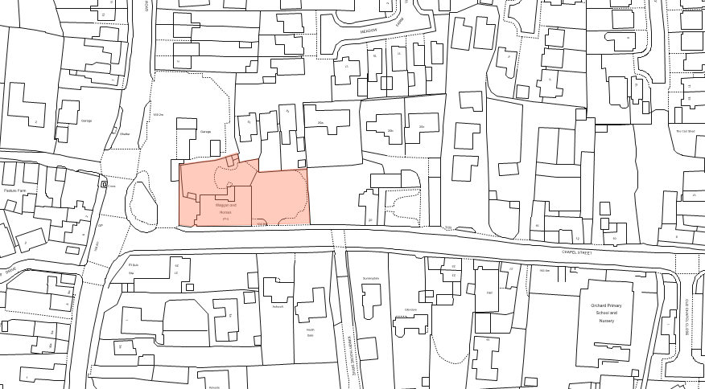

Map 14: Former Richard’s Garage, 89-91 Priestic Road, Sutton in Ashfield
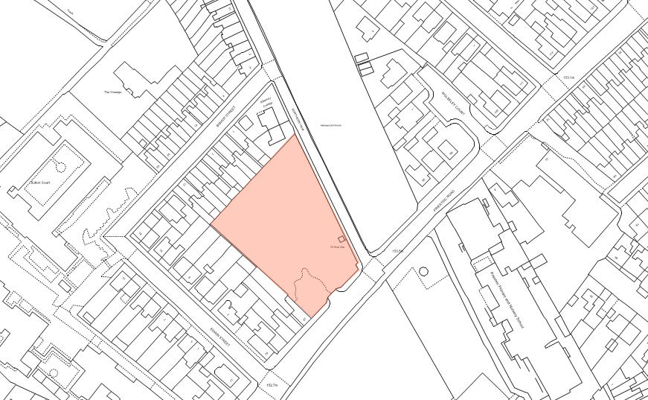

Map 15: Garage site, Martyn Avenue, Sutton in Ashfield

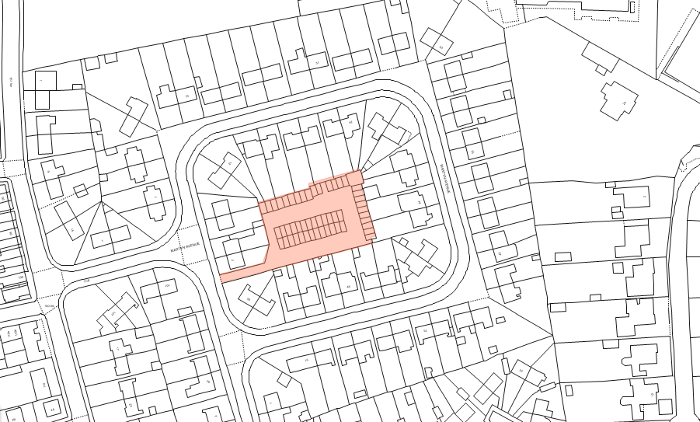

Map 16: Land adjacent no.208 Mansfield Road, Sutton in Ashfield
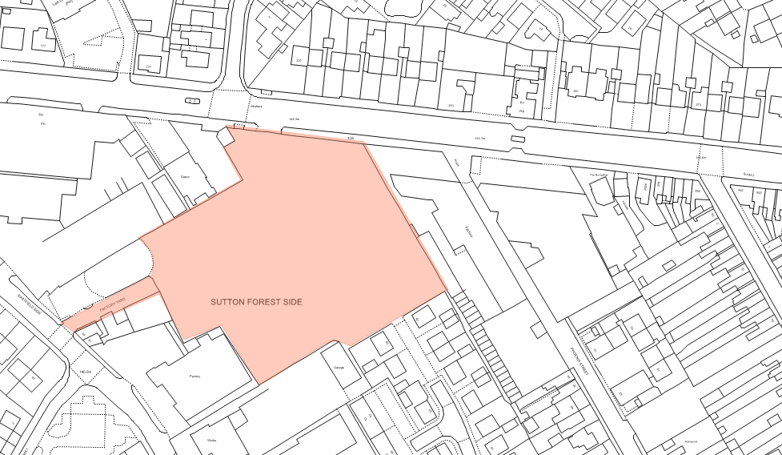

Map 17: Rear of 37-41 Jubilee Road, Sutton in Ashfield

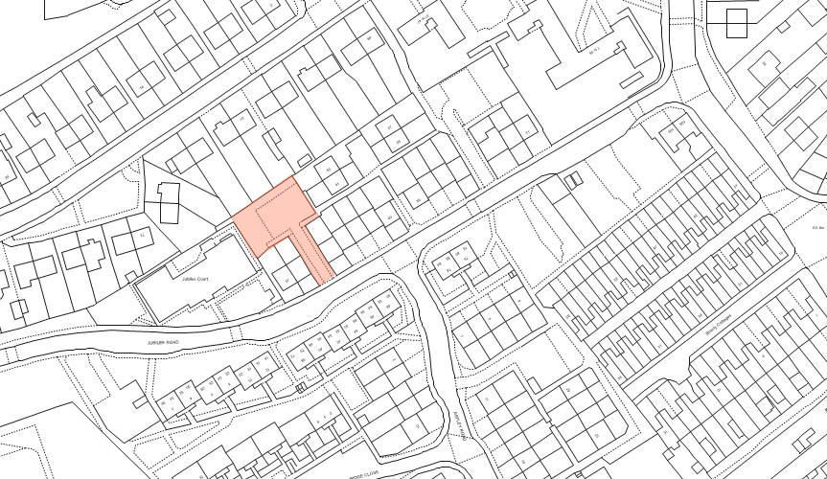

Map 18: Rear of 67-71 Jubilee Road, Sutton in Ashfield

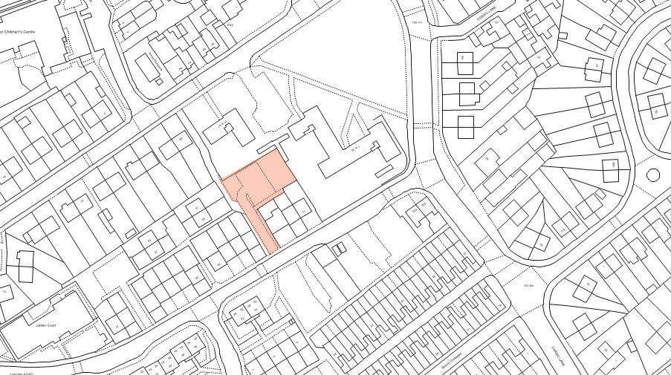

Map 19: Land off North Street, Huthwaite

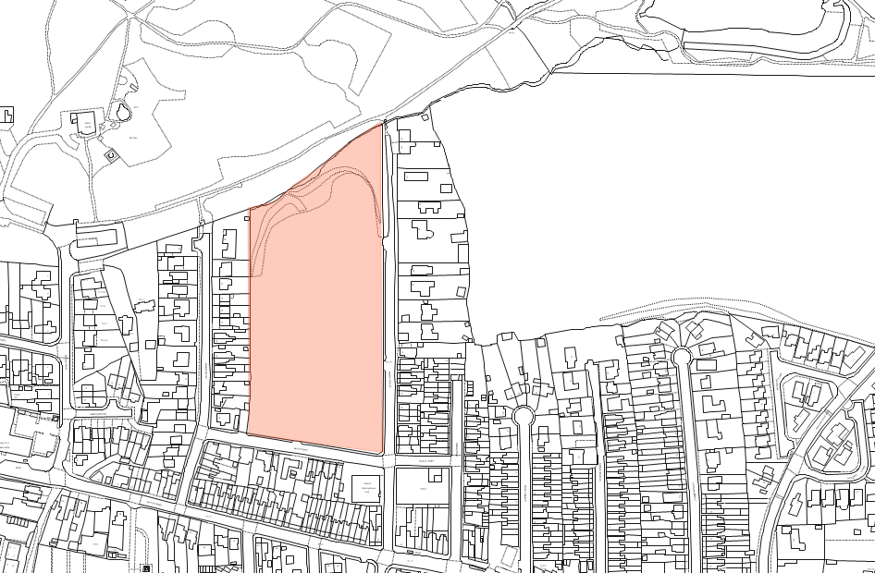

Map 20: Shakespeare Inn, High Pavement, Sutton in Ashfield

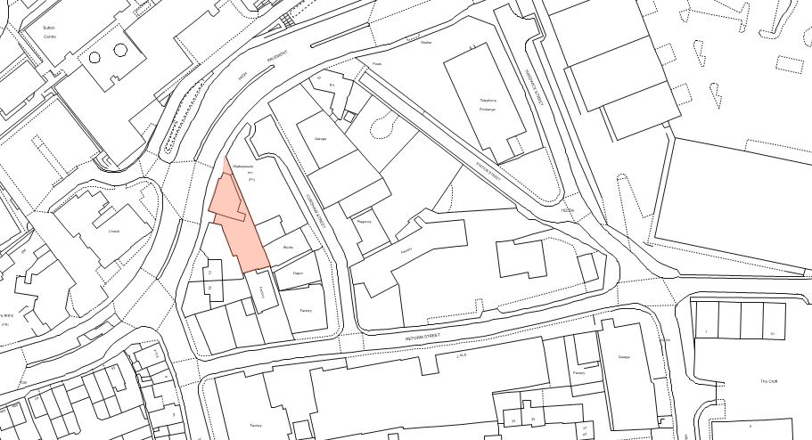

Appendix 4: Greenfield/Brownfield Sites

Map 1: Rear of Lime Avenue, Huthwaite

