TEVERSAL, STANTON HILL AND SKEGBY NEIGHBOURHOOD FORUM CONSTITUTION

# NAME

The name of the Forum shall be the Teversal, Stanton Hill and Skegby Neighbourhood Forum, referred to in the rest of this constitution as ‘the Forum’.

# AREA OF BENEFIT

The Forum will pursue its objectives in the settlements of Teversal, Stanton Hill and Skegby that are within the red line on the map appearing on Page 7 and which is submitted by the Forum and subsequently designated by the local planning authority for the purpose of the preparation of a Neighbourhood Plan under the Neighbourhood Planning (General Regulations) 2012, as amended (hereafter referred to as ‘the Neighbourhood’).

# OBJECTIVES

The objectives of the Forum shall be:

1. to maintain, monitor and if necessary amend the Teversal, Stanton Hill and Skegby Neighbourhood Plan (the Plan),
2. as a result, to prepare a new or amended Neighbourhood Plan, if appropriate in partnership with the local planning authority under the Neighbourhood Planning (General Regulations) 2012, as amended, if considered necessary,
3. to protect, preserve, improve, regenerate and revitalise the built environment,
4. to protect, conserve and enhance the Neighbourhood’s countryside and heritage together with access to it,
5. to promote or improve the social, economic and environmental well being of the Neighbourhood including the provision or improvement of public amenities, open spaces and recreational facilities for the public at large or those who have need of them by reason of their youth, age, infirmity or disablement, financial hardship or social and economic circumstances,
6. to increase the Neighbourhood’s biodiversity by protecting and, where possible, enhancing its parks, Sites of Special Scientific Interest, Local Wildlife Sites and wildlife corridors and other areas of open space,
7. to pursue policies and objectives that reduce the Neighbourhood’s greenhouse gas emissions to a verifiably sustainable level.
8. Where possible to encourage the participation of residents and businesses in Forum activities

4. **POWERS**

In furtherance of the objects, but not otherwise the Forum and its Management Committee may exercise the power to:

1. Carry out the functions of a neighbourhood forum in accordance with the provision of the Town and Country Planning Act 1990 and the Localism Act 2011 or any other statutory requirements.
2. Invite and receive contributions and raise funds where appropriate, to finance the work of the Forum, and to open a bank account to manage such funds.
3. Publicise and promote the work of the Forum and organise meetings, training courses, events or seminars.
4. Work with groups of a similar nature and exchange information, advice and knowledge with them, including cooperation with other voluntary bodies, charities, statutory and non-statutory organisations.
5. Employ staff and volunteers as are necessary to conduct activities to meet the objectives.
6. Take any form of action that is lawful, which is necessary to achieve the objectives of the Forum, including taking out any contracts which it may see fit.

# 5. MEMBERSHIP

1. Membership will comprise at least 21 individuals; members will apply for membership and the Management Committee shall have the power to accept members.
2. The Management Committee may refuse membership, or may terminate or suspend the membership of any member by resolution passed at a Management Committee meeting where it is considered membership would be detrimental to the objectives and activities of the Forum or where a member is in breach of the principles set out in Clause 8 of this section.
3. Membership is open to all who live or work in the Neighbourhood.
4. Membership is open to all business operators in the Neighbourhood who shall nominate up to two people in their membership application to exercise one voting right at Forum meetings as set out in clause 6 of this constitution.
5. Membership is open to all constituted voluntary and community groups which operate in the Neighbourhood who shall nominate up to two people in their membership application to exercise one voting right at Forum meetings as set out in clause 6 of this constitution.
6. Membership is open to elected Council members who represent wards in the Neighbourhood.
7. Membership shall be drawn from different places and different sections of the community in the Neighbourhood as far as reasonably possible irrespective of age, disability, gender reassignment, marriage or civil partnership, pregnancy and maternity, race, religion or belief, sex or sexual orientation.
8. Members of the Forum:
   * Will act solely in terms of the public interest so as not to gain financial or other benefits for themselves, their family or their friends **(Selflessness)**.
   * Will not place themselves under any financial or other obligation to outside individuals or organisations that might seek to influence them in the performance of their duties **(Integrity)**.
   * Will make choices on merit in carrying out the Forum’s business, including making appointments, awarding contracts, or recommending individuals for rewards and benefits **(Objectivity)**.
   * Are accountable for their decisions and actions to the public and must submit themselves to whatever scrutiny is appropriate **(Accountability)**.
   * Will be as open as possible about all the decisions and actions that they take, give reasons for their decisions and restrict information only when the wider public interest clearly demands it **(Openness)**.
   * Will declare any private interests relating to decisions taken by the Forum and take steps to resolve any possible conflicts **(Honesty)**.
   * Promote and support these principles by leadership and example **(Leadership)**.
9. Any member of the Forum may resign his/her membership by providing the Secretary with written notice.
10. The Forum shall have a minimum of eleven of its members before any decision on neighbourhood planning may be made. The Secretary shall maintain and make available for inspection a register of members.

# 6. MEETINGS

All members shall be given at least fourteen (14) days notice of when a meeting is due to take place by e-mail and on any Forum website and notices of meetings shall be displayed in the Neighbourhood.

1. General meetings
2. All the members of the Forum shall be invited to general meetings at least four times per year.
3. For general meeting business to be conducted a quorum of at least eleven members must be present at the meeting.
4. Annual General Meetings/Special meetings
5. One of the general meetings of the forum held shall be its annual general meeting (AGM) where the Management Committee will be elected in accordance with paragraph 8 and a report of activities in relation to each of the Forums objectives given by the Chairperson together with a statement of income and expenditure presented by the Treasurer.
6. For AGM business to be conducted a quorum of at least eleven Forum members must be present at the meeting.
7. All members are entitled to vote at the AGM. Voting shall be by a show of hands on a majority basis. In the case of a tied vote, the Chairperson or an appointed deputy shall make the final decision.
8. Special Meetings

Special Meetings may be called from time to time by the Management Committee solely to consider amendments to the constitution or dissolution of the Forum. These shall be subject to the same rules as for conduct of Annual General Meetings.

1. Management Committee Meetings
2. The Management Committee shall meet as often as business demands. Meetings shall enable the Committee members to discuss actions and monitor progress to date, and to consider future developments.
3. At least fifty per sent of committee members must be present in order for a meeting to take place.

# 7. MANAGEMENT COMMITTEE

1. The Forum shall be administered by a management committee of no less than five people and no more than fifteen (15), who must be at least 16 years of age.
2. Members of the Management Committee will be elected for a period of up to two years and will stand for re-election at a Forum AGM.

# 8. OFFICERS OF THE MANAGEMENT COMMITTEE

The Forum Management Committee shall be elected at the inaugural meeting of the Forum and will be re-elected every two years at Annual General Meetings of the Forum. It will elect officers consisting of:

1. **The Chair.** It shall be the responsibility of the Chairperson to chair all meetings with a casting vote in any tie of votes only and to ensure that meetings are held in accordance with the provisions of the Forum constitution
2. **The Vice Chair.** It shall be the responsibility of the Vice Chairperson to chair all meetings in the Chair’s absence with all the duties and responsibilities of the Chair.
3. **The Treasurer.** It shall be the responsibility of the Treasurer to ensure that the financial provisions of the constitution are carried out.
4. **The Secretary.** It shall be the responsibility of the Secretary to keep a register of members, ensure that minutes are taken of all Management Committee, Special General and Annual General meetings, ensure that the minutes are accessible to all members by whatever means members of the Forum agree and publicise meetings.

# 9. THE FINANCES OF THE FORUM

1. Any money acquired by the Forum, including donations, contributions and bequests shall be paid into an account operated by the Management Committee in the name of the Forum.
2. All funds must be applied to the objectives of the Forum and for no other purpose.
3. Bank accounts shall be opened in the name of the Forum with at least two signatories drawn from the Management Committee.
4. Any income/expenditure shall be the responsibility of the Treasurer who will ensure that funds are utilised effectively and that the Forum stays within budget.
5. Official accounts shall be maintained and will be examined annually by an independent accountant who is not a member of the Forum.
6. An annual financial report shall be presented at the AGM. The Forum’s accounting year shall run from 01 October to 30 September.

# 10. NEIGHBOURHOOD PLANNING

1. Any decision to undertake, consult on or submit the Plan to the local planning authority for approval in accordance with Regulations 14 and 15 of the Neighbourhood Planning Regulations 2012 as amended shall be subject to a vote at a general meeting of the Forum.
2. Residents and businesses whether members of the Forum or not will be regularly consulted during the preparation of the Plan.
3. The Management Committee shall be delegated (a) to work with the local planning authority and any independent experts and advisors on the Plan as they see fit and (b) to initiate informal consultations as the plan progresses.
4. The Forum will be at liberty to create such sub-committees as it deems necessary to which tasks required in the preparation of the Plan can be delegated. Such sub-committees shall regularly report to the Forum or the Management Committee as required.

**11. SAFEGUARDING**

In carrying out Forum activities Forum members will avoid unsupervised contact with children or vulnerable adults unless they are appropriately and separately accredited for that purpose. Lacking such accreditation every Forum member will ensure that contact only occurs in the presence of an appropriate adult throughout, such as an accredited member of staff of the establishment visited or a relative of the individual concerned.

**11. ALTERATION OF THE CONSTITUTION**

1. Any changes to this constitution must be agreed by a majority at a special general meeting, called specifically for the purpose under the same conditions that apply to Annual General meetings specified above.

2. Proposed amendments to this Constitution or dissolution of the Forum must be conveyed to the Secretary formally in writing. The Secretary and other officers shall then decide whether to put the proposed amendments to a special general meeting of the Forum for discussion.

**12. DISSOLUTION**

The Forum may be dissolved if deemed necessary by the members in a majority vote at a special meeting. Any assets or remaining funds after debts have been paid shall be returned to their providers or transferred to local charities or similar groups at the discretion of the Management Committee.

This constitution was adopted at the Annual General Meeting of the Forum held on 9th October 2019.

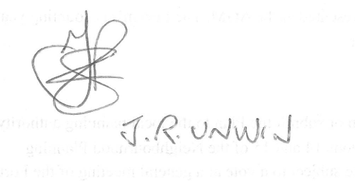Signed, Chairperson

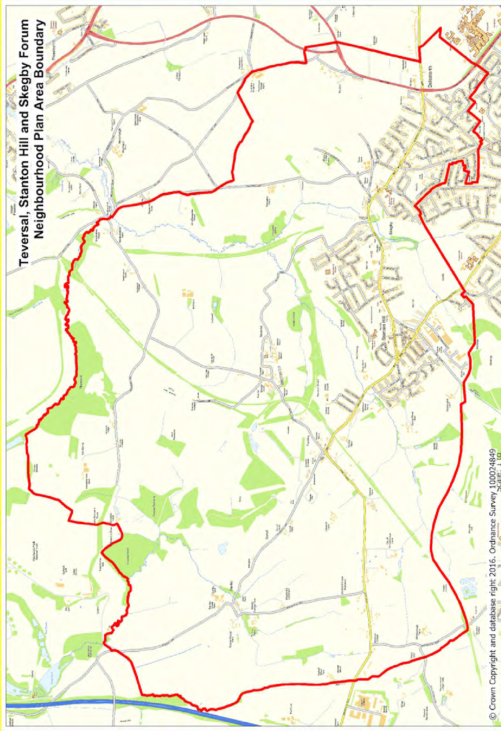

7