CEMETERIES STRATEGY

FOR ASHFIELD

(Including closed churchyard) 2015-2020

- Vision

  - A priority aim for Ashfield District Council is to make the Environment Clean, Safe and Accessible. For the local cemeteries this means creating a pleasant, friendly and sympathetic resting place for the interment of relatives of the people of Ashfield.

  - The Council will endeavour to maintain all cemeteries so as to create a pleasant, peaceful and tranquil environment that is also safe and free from crime or anti- social behaviour.

  - All burials shall be managed with compassion, competency and efficiency, to ensure the entire bereavement experience occurs without error or insensitivity and meets the religious, secular, ethnic, and cultural needs of the bereaved and their relatives.

 | CONTENTS
Section | Title | Page
1 | Vision | I
 | Contents | II
 | Appendices | III
2 | Introduction | 4
3 | Cemetery Maintenance and Inspections | 5
4 | Rules and Regulations | 6
5 | Health and Safety | 6
6 | Testing of Memorials, Headstones and Kerb Sets | 6
- Introduction
- Managing risks from memorials
- Timeline
- Risk Assessments
- Precautions
7 | Burials and Graves  - Non-Christian Burials  - Green/Eco-friendly Burials  - Children’s Graves  - Welfare Burials  - Exhumations  - Pre-purchased Graves  - Burial of Cremated Remains | 10
8 | Closed Churchyards | 11
9 | Cemetery Fees and Charges | 12
10 | Customer Care  - Charter for Cemeteries and Closed Churchyards  - Standards for Memorial Masons  - Standards for Funeral Directors | 12
11 | Respect for and Anti-Social Behaviour in Cemeteries and Closed Churchyards  - Measures to combat Anti-Social Behaviour | 10  14
12 | Future Demands and Development | 16
13 | Consultation and Liaison | 17

APPENDICES

Number Title Page

    - Cemetery and Closed Churchyard Inspections Site 18
    - Cemetery Rules and Regulations 19
      - Aim
      - Contents
- Memorial types 35
- Examples of action following topple testing 36
- Code of Practice for the National Association of 37
Funeral Director
  - Code of Practice
  - General
  - Marketing and Advertising
  - Dealing with Clients
  - Price information
  - Estimates and Confirmations
  - Final Accounts
  - Publicity
  - Monitoring
  - Professional conduct
  - Complaints
  - Definitions
- Code of Practice Principles 43
- Acknowledgement of Receipt of Summary of the 44
Regulations Relating to Memorials
- Extract from the Minutes of the Council Meeting on 45
22nd February 2007
- Introduction
  - This Cemeteries Strategy is a strategic document for the Authority in maintaining and promoting its stewardship of cemeteries and closed churchyards which local residents have a right to enjoy. It advocates that cemeteries should be a place of peace and tranquillity for the public to visit, to pay respect to their interred relatives and / or friends. Cemeteries must be protected from anti-social behaviour, and should be a place where people feel no ‘fear of crime’ when visiting.

  - It advocates they are places for contemplation, to be treated with respect and be seen as key parts of the districts open spaces.

  - This document includes all aspects of good management and operation of the Authority’s cemeteries including closed churchyards. These aspects range from maintenance, health and safety and memorial testing, to pre purchased graves, promoting respect to meeting future land demands for the interment of the dead and the burial of minority groups within our communities.

  - The strategy is a dynamic document and will be updated periodically as societal, legislative and environmental changes present themselves to the Authority.

- Cemetery Maintenance

  - There are 6 cemeteries in the Ashfield District and 7 closed churchyards. These are:
- Sutton Cemetery – 63,217 square metres
- Kingsway Old Cemetery – 12,561 square metres
- Kingsway New Cemetery – 30,936 square metres
- Hucknall Cemetery, Broomhill – 47,458 square metres
- Annesley Woodhouse Cemetery – 10,343 square metres
- Huthwaite Cemetery – 16, 236 square metres
- St. Mary’s, Hucknall closed churchyard – 5,339 square metres
- St. Andrew’s, Skegby closed churchyard – 15,079 square metres
- St. Mary’s, Sutton closed churchyard – 11,814 square metres
- St. Wilfred’s, Kirkby closed churchyard – 2,982 square metres
- All Saints, Annesley, closed churchyard – 2,578 square metres
- St. Helens, Selston, closed churchyard – 12,250 square metres
- St. Michael’s, Underwood, closed churchyard – 6,582 square metres This equates to 237,375 square metres of land area under maintenance.
  - The Authority maintains all the buildings, (except churches), trees, paths, roads, site boundaries, drainage, water services and grass cutting, waste disposal and ground maintenance.

  - Annual stock condition surveys are undertaken of all buildings which the Authority control and form part of the Council’s Asset Management plan and appropriate budgets.

  - To improve security, health and safety and the visual appearance of the cemeteries a programme of inspections has been developed to report defects and potential hazards for maintenance and repair. For the main cemeteries the paths and boundaries are to be inspected once every 6 months, minor cemeteries are to be inspected once every 12 months.

The inspectors will highlight any works required. Response times are variable and are dependant upon the assessed risk. Potential defects monitored are potholes, poor road and pavement surface, damaged boundaries and gates.
For a copy of the Cemetery Inspection Form see Appendix 1

As technology develops it is anticipated that inspections will be carried out using hand held devices which will enable inspection data to be stored and shared electronically.

  - Water supplies and waste disposal facilities will be made available in all cemeteries.

  - As per the Corporate and Waste and Environmental Services structure, Cemetery Keepers are employed in the main cemeteries in the district and in addition a mobile cemetery service is employed to ensure safe burial operations alongside static cemetery keepers, and maintenance of closed churchyards.

  - Cemetery Keepers, with responsibility to maintenance and ensuring the burial ceremony is undertaken correctly, oversee the four main cemeteries – Sutton

Cemetery, Huthwaite Cemetery, Kingsway Cemetery, and Hucknall Cemetery (Broomhill).

- Rules and Regulations

  - The Cemetery Rules and Regulations are an integral part of this strategy and basis for the management of the Cemeteries.

They enable the public, funeral directors and memorial masons to understand the rules that the Authority require to be applied within the cemeteries. In addition, officers of the Authority apply these rules and regulations to ensure the cemeteries are managed and operated on a common sense, practical and sympathetic manner. They also enable consistency to be achieved across the district.

  - The particular areas covered within the rules and regulations include:
- General details
- Interment
- Requirements of Funeral Directors or Companies
- Monuments, memorials and vaults
- Conduct in Cemeteries
- Definitions

  - The current approved cemetery rules and regulations are detailed in appendix 2.

- Health And Safety

  - Health and Safety is a major concern to the Council and through its procedures and risk assessments it minimises the risk to staff and visitors as far as reasonably practicable.

  - Ongoing risk assessments are carried out to identify hazards encountered in excavation of graves by both manual and mechanical means, and risks that may be encountered by other maintenance operations and by the visiting public.

  - Cemeteries staff are trained in safety awareness, with specific staff being trained and certificated in the safe use of mini excavators, grave shoring techniques and other mechanical means which may be used.

  - The Authority will strike a balance between public safety and the need to remain sensitive and minimise public outrage when it applies health and safety requirements when managing and operating the cemeteries.

- Testing of Memorials and Headstones

  - Introduction
6.1.1 In recent years, a number of local communities throughout the country have been shocked and aggrieved by the actions of councils making safe grave stones by laying them flat as a result of health and safety inspections. To people visiting

after the event it has looked as though vandalism on a large scale has desecrated their cemeteries.

In the light of this, Ashfield District Council intends to make sure that any remedial work to reduce the risk of serious injury to those visiting and working in the immediate vicinity of defective memorials, will be via a testing programme which takes an appropriate approach to managing the risks. This will be based on good practice and undertake a proportionate response to the problem at hand so that no unnecessary distress is caused to bereaved families and health and safety guidance is adhered to.

  - Risk Assessing Headstone Safety

We will undertake:

- A visual check for obvious signs that a memorial is likely to be unstable.

- Where a visual check suggests stability defects, a hand test can confirm that assessment and identify stability problems.

- Where there is significant risk from large memorials arrangements for more detailed inspections by a structural engineer or memorial mason will be undertaken.

- Maintain records of the inspection and results.

The frequency of the risk assessment will depend on whether an area is High Risk or Low Risk areas.

High Risk

  - Areas which are regularly visited
  - With graves from 0-8 years old
  - Areas which border a main thoroughfare
  - Areas with a high level of foot traffic

Low Risk

- Areas over 8 years old
- Rarely Visited
- Away from main thoroughfares
- Low level of foot traffic

High Risk Areas have a visual and hand test (where appropriate) every 12 months Low Risk Areas have a visual and hand test (where appropriate) every 5 years
These timescales do not override the principle that the assessment of risk is an ongoing process and action may be required on an ad-hoc basis to resolve individual issues if a headstone becomes unstable outside of the programmed risk assessment.

  - Precautionary Procedure:

If a headstone is found to be unstable but not imminently dangerous, the Council will notify the grave owner to rectify the situation. If no action has been taken after 12 months the council will make safe the headstone by burying it up to one third its height or laying flat whichever is the most appropriate for the headstone.

If a headstone is found to be unstable and imminently dangerous, the headstone will be laid flat immediately for the safety of the general public and Council operatives. The grave owner can then decide to leave it laying flat, repair at their cost or request that the council bury the headstone up to one third of it height to secure, which the council will do at their cost, if it is feasible to do so.

Under these guidelines Ashfield District Council will not be “staking” any headstones. Instead, the owners are given notice to rectify any problems encountered and provide a long term solution to any potential health and safety risks to the public and operatives alike.

The safety of individual headstones and ultimate liability remains with the grave owner however efforts will be made to contact them directly so they have an opportunity to repair the headstone if necessary.

The flow chart below details this procedure:-

Flow Chart Procedure for Cemetery Gravestone Testing

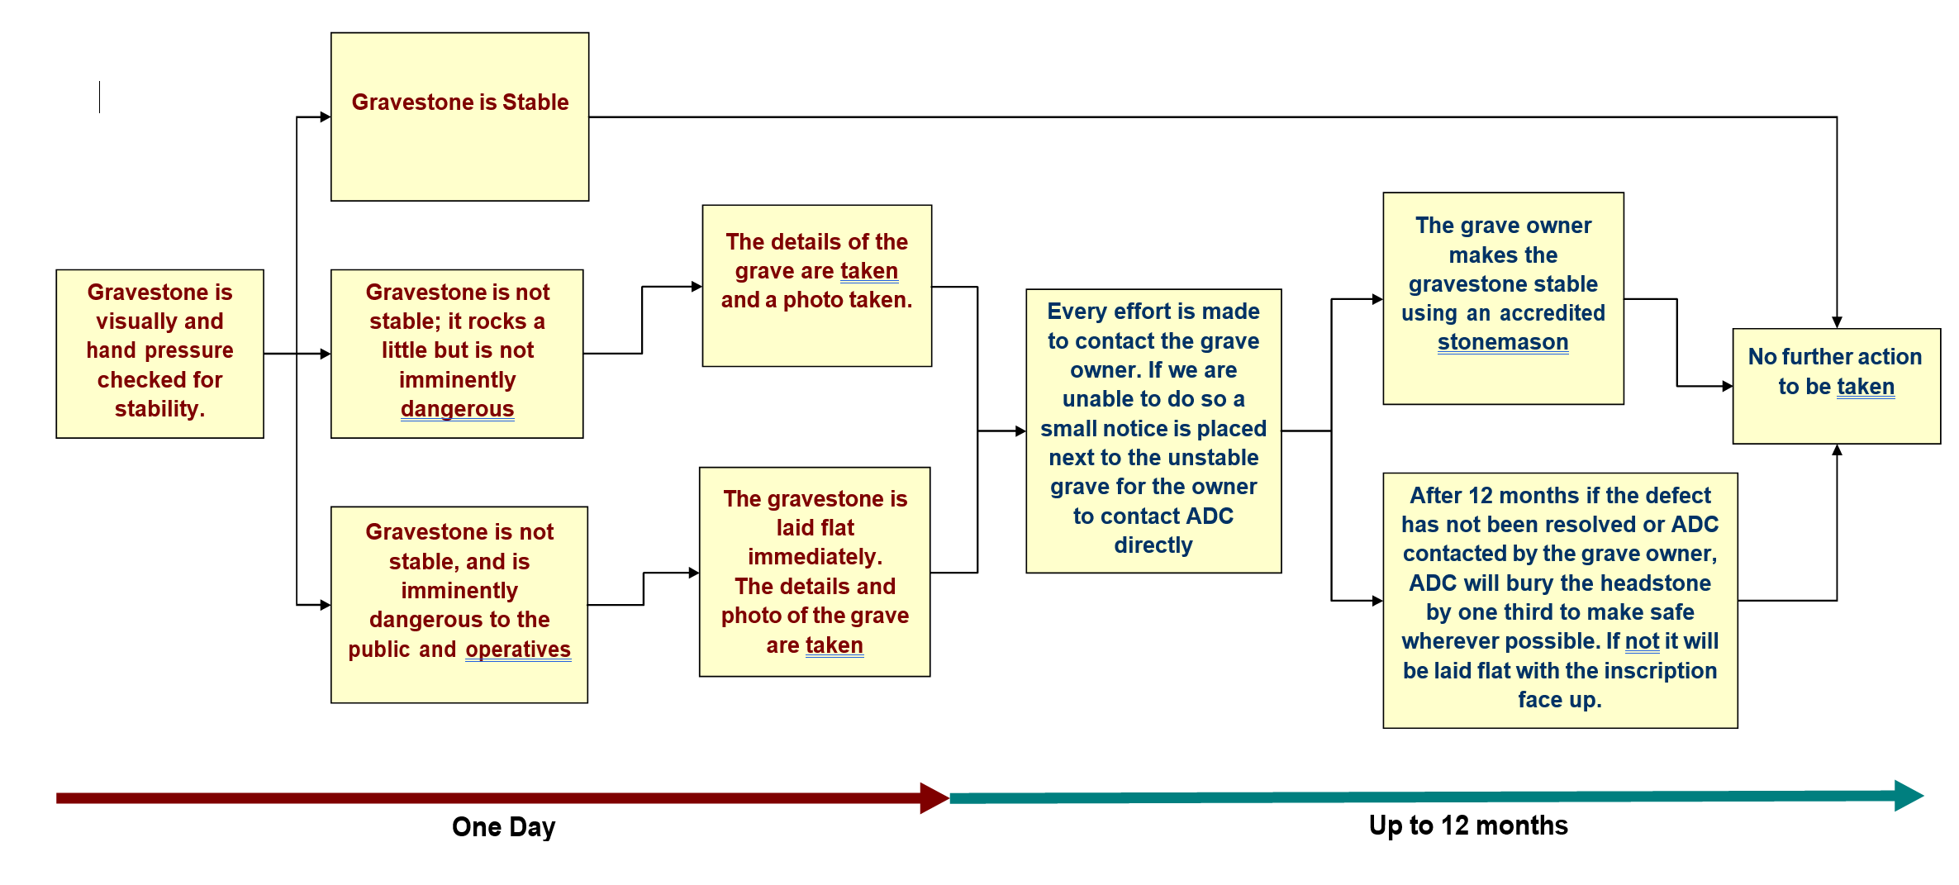

  - Risk Assessments

The risk assessment for testing will follow the general principle for risk assessments as set out below:

- Identify the hazard - e.g. a potentially unstable memorial
- Identify who might be harmed – employees, contractors, visitors, public.
- Evaluate the risk of a memorial falling and harming someone and decide on precautions needed to control this.
- Record the significant findings of the risk assessment and take steps to implement the precautions needed.
- Review the risk assessment periodically.

- Burials and Graves

  - It is recognised that the appearance of cemeteries is enhanced by well kept and presentable graves which are in keeping with the philosophy of a peaceful and pleasant environment of the cemetery. Graves play an important part in the ambiance of the cemetery and the Authority wishes to promote a good standard of ground maintenance and well kept graves.

It is appreciated that graves and burials may not be of a traditional type and therefore the sections below indicate the policies which the Authority will adhere to.

  - Non-Christian Burials

7.2.1. The Authority understands that communities within Ashfield may not require the traditional burial and where possible will try and facilitate and accommodate non- Christian burials i.e. minority religions etc. Where the Authority can not accommodate such burials it will advise relatives and families of neighbouring Authorities or partnering organisations who provide alternative burials to meet the wishes of the bereaving families and relatives.

  - Green/Eco-friendly Burials

7.3.1 The Authority recognises that environmentally friendly burials are a matter of degree and personal belief. Regretfully, due to space constraints in some of our cemeteries, a full 'green' interment cannot be achieved. However, the authority will allow the use of wicker or cardboard coffins. Also, we can offer to supply plant and maintain a suitable tree, at a reasonable cost to the bereaved in one of the district’s country parks.

Where possible we fully support the use of environmentally friendly materials and practices within our cemeteries.

  - Children's' Graves

7.4.1 A designated area within Hucknall, Kingsway New, Huthwaite, Annesley Woodhouse and Sutton cemeteries will be provided and kept for children's' graves.

  - Welfare Burials

    - The authority treats welfare burials with the greatest of dignity, sympathy and respect as it does for all other categories of burials. Where the deceased person has no relatives or relatives cannot be traced or the family cannot afford the burial and funeral costs, the authority will make the funeral arrangements. These burials will be provided in un-purchased or public graves otherwise known as 'Common Graves'. Space for further burials cannot be reserved in these common graves and the erection of a fixed memorial is not permitted. However, the common graves can be purchased at a later date if a relative decides that they want to fit a memorial to the grave.

    - This authority will comply with its statutory duties detailed in Section 46(1) of the Public Health (Control of Disease) Act 1984 regarding welfare burials.

  - Exhumations

    - The exhumation of the deceased is a high risk health and safety issue with hazards during the excavation work and the potential risk of infectious disease. Therefore all exhumations will be carried out in accordance with the Institute of Cemetery and Cremation Management 'Code of Safe Working Practice for Cemeteries', and the Health and Safety Executive (HSE) guidance 'Controlling Risks of Infection at Work from Human Resources'.

    - Exhumation will always be the last resort the Authority will undertake. It will try to resolve issues by alternative means before embarking upon an exhumation. However, where an exhumation is required then the exhumation of the deceased will be undertaken with sensitivity, respect and dignity.

  - Pre-purchased Graves

7.7.1 The authority no longer allows the pre-purchase of grave plots in all its cemeteries as from 1st April 2007.

  - Burial of Cremated Remains

A designated area within Hucknall, Kingsway New, Huthwaite, Annesley Woodhouse and Sutton cemeteries will be provided and kept for the burial of cremated remains.

- Closed Churchyards

  - The authority will endeavour to maintain closed churchyards to the same standard as cemeteries and ensure the environment is presentable to visitors.

  - There are presently 7 closed churchyards which the authority manages. With additional resources and engaging youth offenders on community work we aim to continue improving the standards of closed churchyards.

- Cemetery Fees and Charges

  - Fees and charges will be set annually by the Council unless otherwise agreed (such as over a 3 year period).

  - The Authority in setting its fees and charges will consider and compare other local authority charges. All fees and charges will be determined by balancing what is a reasonable cost, comparison with other authorities and the expenditure for managing and operating the cemeteries and closed churchyards.

The cemetery fees will include a charge for recovering the cost to make safe the memorials buried to the depth of one third.

- Customer Care

  - A Charter for Cemeteries and Closed Churchyards in Ashfield

    - While it is the Authority's intention to adhere to recognised standards for the bereaved the following guiding principles are used:

      - Caring for the Community

All burials shall be managed with competence and efficiency, to ensure that the entire bereavement experience occurs without error or insensitivity and meets the religious, secular, ethnic and cultural needs of the bereaved.

      - Health and Safety

The service shall comply with all statutory duties and Health and Safety requirements including good practice.

      - Service Sensitivity

The cemeteries will be managed to create and maintain an atmosphere of solace and respect throughout the entire proceedings. This sensitivity will extend to all staff and contractors working on site during a funeral.

      - Staff

Management must emphasise the need for proper conduct and demeanour, as well as technical expertise. Staff will speak in a manner that recognises the sensitivity of bereavement, both during and outside working hours.

      - Environment

The Authority will endeavour to minimise the impact of bereavement upon the environment and encourage the greater use of environmentally friendly materials and practices.

      - Responses

Cemetery Keepers operate from the four main sites and are able to speak to residents who have queries, this can often resolve issues immediately, however where problems occur the Authority will respond in a timely manner in line with customer service procedures.

      - Crime and Vandalism

The Authority will actively pursue with enforcement agencies any person wilfully or intentionally committing crimes or acts of vandalism within its cemeteries and closed churchyards. It will work in partnership with the police, fire service, youth offending teams, probation services and other partners to highlight and raise awareness of the need for respect within its cemeteries and closed churchyards.

  - Standards for Memorial Masons working in Ashfield Cemeteries

    - To ensure uniform, comprehensive and consistent standards for memorial erection in its cemeteries, the Authority will apply the British Register of Accredited Memorial Masons (BRAMM). The reasons for applying this scheme are as follows:

      - The purpose of the Scheme is to establish a network of nationally accredited businesses and registered fixers. The scheme aims to establish a recognised standard of workmanship and business practice throughout the UK.

      - The Scheme also aims to promote a recognised standard of service to the public by ensuring that adequate public liability insurance is provided. It is also essential that an accredited business and registered fixer follow current health and safety guidelines to protect both the public and their employees.

      - The Scheme is administered by the National Association of Memorial Masons. However, it is NOT a requirement that anyone wishing to register with BRAMM must also be a member of NAMM. The Scheme has been developed to provide benefits to everyone involved. These being:

    - For the Public

      - BRAMM businesses will have adequate level of public liability insurance.

      - BRAMM businesses will give a guarantee of the stability of their memorial.

      - BRAMM fixers will be able to prove that they have been accredited to safely fix memorials.

    - For the Mason

      - BRAMM businesses will have certificates to show that their business is registered and their fixers will be issued with a BRAMM Fixer Licence and a certificate showing they are a registered fixer and have obtained a BRAMM Fixer Licence.

      - Ultimately BRAMM businesses will only need to maintain their BRAMM registration instead of joining separate registration schemes.

      - Masons can be assured that they are working on a 'level playing field'.

      - The Scheme will be effectively policed to ensure that recognised standards of fixing are maintained.

    - For the Authority

      - The Authority will no longer need to spend time and money administering individual registration schemes.

      - They can be assured that any BRAMM business has adequate insurance, a risk assessment and a current Health and Safety policy etc.

      - The Authority can be assured that a BRAMM fixer has the skill and knowledge of the correct trade practices and procedures in order to erect a safe and stable memorial. BRAMM fixers will have to attain a BRAMM Fixer Licence and present it when required.

The Scheme ensures that the Business is registered and has had practical assessments.

  - Standards for Funeral Directors working in Ashfield Cemeteries

The Authority expects Funeral Directors to adhere to the Code of Practice for the National Association of Funeral Directors as detailed at Appendix 9.

In general terms, funeral directors shall:

- Act in a courteous, sensitive, dignified and professional manner and must not pressurise or exploit clients in the difficult circumstances following bereavement.

- At all times offer the best advice and provide the best possible service commensurate with the charges made.

- Respect the confidential nature of the information given to them and only use that information for its proper purposes.

- Respect for and Anti-Social Behaviour in Cemeteries and Closed Churchyards

  - The Authority wishes to promote respect for our cemeteries and closed churchyards within its communities. It will work in partnership with external agencies such as the Youth Services, Police, Community Protection Officer to engender an attitude of respect for the deceased and our cemeteries.

  - Examples of anti-social behaviour that have been experienced in Ashfield are as follows:

- Theft of personal mementos from graves.

- Vandalism to headstones.
- Dog fouling on graves.
- Vandalism to Chapels and other buildings.
- Nuisance caused by youths congregating.
- Playing games in cemeteries.
- Bicycle and motorcycle riding.
- Entering premises outside opening hours.
- Under age drinking.
- Drug-taking and substance misuse.
- Theft of lead from Chapel roofs.
- Destruction of floral tributes on graves.

Many of these have the potential to cause distress to families and relatives of the deceased, especially if occurring at childrens' graves.

  - Measures to Combat Anti-Social Behaviour and the Fear of Crime

The Authority will:

- Actively pursue by legal means any person caught wilfully damaging, committing vandalism or carrying out anti-social behaviour and enforce the law or seek other agencies to enforce laws against perpetrators.

- Apply the Anti-Social Behaviour Strategy of the Ashfield Crime and Disorder Partnership to our cemeteries and closed churchyards.

- Improve boundary security and gate locking routines.

- Community Protection Officers will be asked to carry out patrols during and outside opening hours, as needed.

- Inter-agency action to curb alcohol sales to juveniles and reduce substance nuisance in cemeteries via the Ashfield and Mansfield Respect Tasking Group.

- Erect signage and interpretation boards to promote the heritage value of cemeteries, and publish this information on the Authority’s website.

- Outreach to local schools, youth and community groups to educate and increase awareness of and respect for cemeteries and the bereaved.

- Employ Cemetery Keepers to bring a staff presence to the three main cemeteries during working hours and mobile keepers for other cemeteries and closed churchyards.

- Develop closer links with other agencies such as the Probation Service, Police etc., to engender the appreciation of cemeteries and where possible engage young people to enhance the cemeteries environment.

- Future Demands and Development

  - The Authority recognises that the capacity of the existing cemeteries is finite and is therefore planning for additional land for burials. This in line with the population demographic profile. Potential need for new sites has been raised within the Authority and will be part of the Local Development Framework (previously the Local Plan).

  - The existing capacity of cemeteries at the present rate of interment (April 2015) are as follows:

Hucknall - 10 years
Sutton - 10 years
Kirkby (New) - 50+ years
Annesley - 50+ years
Huthwaite - 50+ years

Cemetery extension investigation projects are currently underway in Hucknall and Sutton. Cemetery capacity will be included in the Waste and Environment Business plans annually to ensure the Authority is able to maintain adequate succession planning.

  - Reinforced concrete rafts will continue to be installed in all cemeteries sections, were practicable, to facilitate secure headstone fixings to reduce the likelihood of unstable memorials in the future.

  - The design and construction of kerbed sets for graves result in high maintenance costs and inherent health and safety risks due to their potential instability. The Authority for the adoption of this strategy will cease to allow kerbed graves in all its cemeteries. Any unauthorised or home made structures placed on graves within cemeteries will continued to be removed. See Appendix 11

  - Any established unauthorised or home made kerbed sets will be required to be removed by the owner following 4 weeks written notice from the Authority. If the owner does not remove the kerbed sets, the Authority will remove them and store for a 12 month period after which they will be destroyed.

  - Developments which will enhance the amenity and use of cemeteries such as ashes scattering areas and gardens of rest etc., will be incorporated where land availability and funding allows, as will non-Christian and eco-friendly burial plots.

- Consultation and Liaison

  - The Authority fully appreciates the need for consultation and has liaised with the public, funeral directors, diocesan representatives, memorial masons and other partnership agencies in developing this strategy.

  - This strategy underwent a 4 week consultation period. Comments received were duly considered by the Authority's Scrutiny Panel, and Cabinet, before it was recommended to Council for approval.

  - Consultees were as follows:
- All Councillors for Ashfield District Council and County Councillors.
- The Public.
- The Diocese.
- Local Churches.
- Other Council divisions and sections.
- Local Funeral Directors.
- Local Memorial Masons.
- Police.
- Youth Service.
- Any other agency identified during the consultation period.
  - Comments on this Cemeteries Strategy should be returned to: Service Lead – Waste and Environment,
Ashfield District Council, Northern Depot,
Station Road, Sutton-in-Ashfield, Nottinghamshire, East Midlands NG17 5HB

Appendix 1

Ashfield District Council Construction Services
Cemetery and Closed Churchyard Inspection Sheet

Please note any hazards or risks in the following areas, noting the exact location of the problem so it can be found again, the seriousness of the issue and date. If applicable take a photo of the issue.

Location Date

Area to check | Problem | Tick | Exact Location | Risk |  |  | Comments / Action
 |  |  |  | High | Med | Low
Gates / Locks | Damaged
 | Missing
Signage | Missing
 | Damaged
 | Grafitti
 | Wrong / out of date
Footpaths | Pot Holes
 | Root lift
 | Surface
 | Dog Fouling
 | Litter
Road | Pot Holes
 | Root lift
 | Surface
 | Manhole covers / grates
Car Park | Pot Holes
 | Root lift
 | Surface
 | Manhole covers / grates
 | Litter
Perimeter | Damage to fence
 | Damage to walls
 | Grafitti
Turf | Holes in turf
 | Dog Fouling
 | Litter
Trees / Shrubs | Dead or Dying
 | Overhanging branches
 | Crowding
Other

Signature of Inspecting Officer

Appendix 2

Cemetery Rules and Regulations
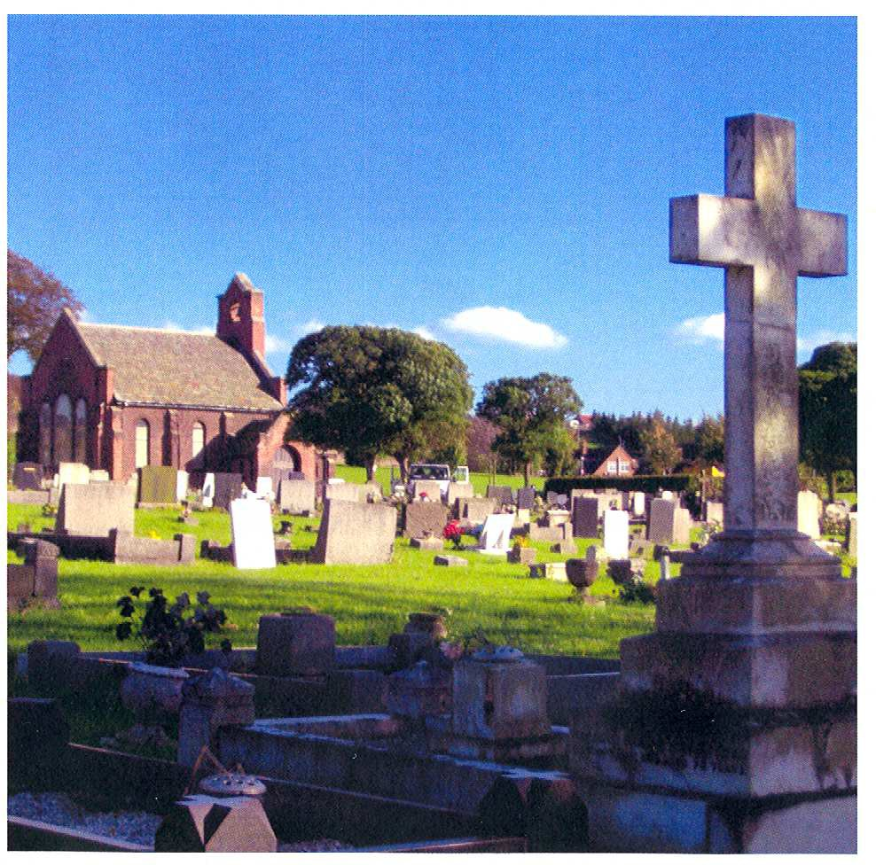
Kingsway New Cemetery, Kirkby in Ashfield

March 2006 [Updated May 2015]

Aim

Ashfield District Council is committed to providing the best possible service to everyone at a time of sadness and change in their lives

The Authority strives to be recognised as a Council providing services and outcomes as expected and necessary from a good Council.

Our cemeteries are managed within regulation and resources to maintain dignified and welcoming places as befits their purpose.

.

 | Contents
Aim |  | Page No.  20
1. | General | 22
1.1 | Addresses and Contact | 22
1.2 | Opening and Closing Times | 22
2. | Interments | 23
2.1 | Burial Procedure | 23
2.2 | Exclusive Right of Burial | 24
2.3 | Transfer of Deed Ownership | 25
2.4 | Cremated Remains | 25
2.5 | Fees and Payments | 25
2.6 | Requirements of Funeral Directors and Companies | 26
3. | Monuments, Memorials and Vaults | 26
3.1 | Monuments and Memorials – General | 26
3.2 | Duty of Care | 29
3.3 | Requirements of Monumental Masons | 30
3.4 | Vault Construction | 31
3.5 | Floral Tributes | 31
4. | Conduct in Cemeteries | 31
4.1 | General Conduct | 31
4.2 | Vehicles Access | 32
5. | Definitions | 32
 | Contact Details | 33

General

- Cemeteries and Burial Grounds Regulations for:

Annesley Woodhouse Hucknall
Huthwaite
Kirkby-in-Ashfield (Kingsway New and Old Cemeteries) Sutton-in-Ashfield

  - Addresses and Contacts
The Cemeteries and Allotments Coordinator Ashfield District Council
Northern Depot Sutton in Ashfield Nottinghamshire NG17 5HB

Telephone: 01623 457462 between 08.30 - 16.30 Monday to Thursday and
08.30 -16.00 Friday (out of hours answerphone)

E-mail: environment@ashfield-dc.gov.uk or telephone 0800 183 8484 to register any questions or comments about our service. Complaints must be in writing and sent to the contact at the above address.

Website for the Authority: www.ashfield-dc.gov.uk

In order to help inform the public of these regulations, funeral directors and monumental masons are asked to assist the Council by talking to the public, if possible, when giving them this leaflet and help them to understand the procedures. A summary sheet is available from the Cemetery Office.

  - Opening and Closing Times

The cemeteries will be open to the public during the following hours:

 | Open | Closed
November - February | 6.00am | 6.00pm
March - April | 6.00am | 8.00pm
May - August | 6.00am | 10.00pm
September - October | 6.00am | 8.00pm

Open every day including Sundays and Bank Holidays at the above stated times.

Funerals may take place between Monday and Friday from 9am - 2.30pm, excluding bank holidays and the Tuesday following a bank holiday Monday.
Stonemason’s may carry out works from 8-30am – 3-30pm Monday to Friday excluding bank holidays and the Tuesday following a bank holiday Monday.

- Interments

Burial Procedure

    - Notices of interment including scattering of ashes and all associated works orders must be forwarded to the Cemetery Officer on the Council’s official forms provided by the undertaker when a funeral is booked. These forms must be received 2 clear working days prior to any interment. In the case of vault construction, five clear working days notice is required.

    - All bookings are provisional until the Cemetery Officer receives the appropriate forms as described in 2.1.1. Telephone messages must be confirmed with the appropriate paperwork. The Council will not accept responsibility for information that has not been forwarded on the appropriate forms. The Council will not accept responsibility for paperwork lost in the post. Documents sent by fax or e- mail will only be accepted as temporary notifications and must be confirmed by the submission of the original paperwork.

    - The notice of interment, as described in 2.1.1, must be completed and contain the following details:
      - Name of cemetery
      - Grave number where known
      - Day and hour of funeral service
      - Full name and home address of the deceased
      - Date of death and age of the deceased
      - Full particulars and description of the grave to be used
      - Overall length and width of coffin including handles and other additions
      - Name of clergyman or other person officiating
      - Full name and address of the funeral director
      - Full name and address of the applicant

    - NB: Funerals will not be allowed to proceed if the Registrar’s Certificate of Disposal or a Coroner’s Order for Burial or the Cremation Certificate is not presented to the Council’s representative at the time of interment.

    - The Council’s workforce or their nominated contractor will undertake all excavation work at the Cemeteries. Back filling of graves is permitted with the Cemetery Officer’s consent.

    - Turfing or seeding a grave, as appropriate, will take place as soon as practicable after the interment, by the Council’s workforce.

    - No kerb sets, trenches or means of marking the boundary of a grave are permitted.

    - Only coffins of wood, other environmentally friendly materials and of traditional type (no glass or metal) are to be used in all graves, name plates and handles must be provided for all coffins. Any special detail must be approved by the Cemetery Officer at the time when the initial request for service is made.

    - The responsibility for making the necessary arrangements for the attendance of priests, ministers, or other persons to officiate at a service rests upon the Funeral Director or the person(s) arranging the burial.

    - The time fixed for a funeral must be the time when the procession is to arrive at the Cemetery. It is requested that the time be strictly adhered to, in order to prevent inconvenience and one funeral interfering with another. In the event of a funeral arriving late the cortege must wait as and where directed by the Cemetery Officer or a delegated representative. The service will take place as soon as possible thereafter at the direction of the Cemetery Officer or a delegated representative.

    - In the case of a public or military funeral, or one at which in excess of
50 mourners may be expected, notice must be given at the time of the booking.

    - The time allowed for a service in the Cemetery Chapel shall not exceed
30 minutes unless prior approval has been obtained from the Cemetery Officer.

    - Generally no coffin shall be opened within the Cemetery Chapel or grounds for any purpose whatsoever, however requests will be considered on an individual basis.

    - Memorials including headstones and monuments will be removed by a nominated stonemason in all cases where a grave is to be re-opened. This will be organised by the funeral director booking the funeral and arranged within one hour of the booking being confirmed. Removal of memorials requires the prior approval of the grave deed owner.

Exclusive Right of Burial

    - Whilst ownership of an Exclusive Right of Burial for a grave does not give any ownership whatsoever in respect of actual land, it does give the owner of the Deed the right to:-

Be buried in the grave.

Authorise further burial(s) in that grave (where space is available), or the interment or scattering of cremated remains in or over that grave.

Erect or place a memorial on that grave subject to the Rules and Regulations of the Council relating to memorials.

Have inscriptions/additional inscriptions placed on a memorial on that grave subject to the Rules and Regulations of the Council relating to this matter, see 3.1.6

    - Possession of a Deed does not necessarily give the person in possession ownership of Exclusive Right of Burial. Where the owner is deceased, subsequent ownership depends upon whether or not the deceased person left a valid Will. The law concerning this matter can be very complex. It is strongly advised that a solicitor be consulted to establish new ownership.

    - Where the Deed is lost or mislaid, a person entitled to open the grave, may do so, as long as they have made a statutory declaration giving indemnity to Ashfield District Council. It is advised that a solicitor should be consulted in this case.

    - On the purchase of the Exclusive Right of Burial in a grave, a Deed of Grant shall be issued to the purchaser whose name shall be registered on the form. The Exclusive Right of Burial shall extend 75 years from the date of purchase. Owners of a Deed may not select the position of a grave or vault, except in exceptional circumstances, when the owner’s wishes will be considered as far as is practicable by the Cemetery Officer.

    - Persons arranging for a burial in a non-private grave, (where the right to bury has not been purchased), acquire no rights other than that of making a single interment in the grave. The Cemetery Officer will determine the location of non-private graves.

Transfer of Deed Ownership

    - Ownership of a Deed may be transferred or assigned by use of the form of Declaration, Indemnity and Application in respect of the transfer or Assignment of an Exclusive Right of Burial. See 2.2.2 above.

    - The Cemetery Officer must be notified of any transfer or assignment in order to update the Purchase Register.

    - Where no interment has taken place in a purchased grave the Council may agree to repurchase the grave. In such cases the Council will pay the original purchase price.

Cremated Remains

    - A cremated remains plot will be 1350mm (4ft) x 1350mm (4ft), to accommodate up to four caskets. Notice for the interment and the Certificate issued by the Crematorium where the cremation took place must accompany the burial and or scattering of cremated remains.

    - Scattering of Cremated Remains is not permitted without the prior consent of the Deed Owner and Cemetery Officer.

    - The interment or scattering of cremated remains in or over a grave is not permitted without the prior consent of the grave deed owner. This requires the owner to complete and sign a Notice of Interment Form, see 2.4.1

Fees and Payment

    - No grave spaces or cremation plots can be pre-purchased in any of the Authority’s cemeteries after April 2007.

    - Normal fees and charges will be paid by those who live within Ashfield District as set out in the annual review as undertaken by the Portfolio for Environment and Service Lead - Waste and Environment

    - All burial fees shall be tripled or as applicable at the time of interment, where the person to be interred was not an inhabitant of the District of Ashfield at the time of death

    - All purchase fees shall be tripled or as applicable at the time of interment, where the person who wishes to purchase a grave space for exclusive right of burial is not an inhabitant of the District of Ashfield at the time of purchase

    - Multiple fees do not apply to headstones or additional inscription charges. Ashfield District Council’s decision in these matters is final.

    - Any person who dies in a state aided hospital, care or nursing home outside the District of Ashfield but who was an Ashfield resident immediately prior to this move will be charged at single fees irrespective of how long they have lived outside the district when they died. The Ashfield District Council decision is final.

    - At the time of death, anyone who lived in Ashfield and then moved into a residential home outside of the district will be able to receive a burial at single fees within two years after they moved out. After this time, triple fees will be applied or as applicable at the time. The Ashfield District Council decision is final.

    - Deeds will not be released to the purchaser until full payment is received.
    - Funeral directors/companies normally will be permitted to make payment after the Council has provided services and the payment must be made within
28 days from the date when the invoice was issued.

Requirements of Funeral Directors or Companies
    - Initially every funeral director or company will be required if asked, to provide to the Council the following documentation:-
      - A copy of their Health and Safety policy and codes of practice.
      - A copy of up to date Public and Employee Liability insurance certificate with at least £5 million cover. Copies to be provided to the Council upon the annual policy renewal.
Guidance on the completion of a) can be obtained from The Association of Burial Authorities, The National Association of Funeral Directors (NAFD), Independent Funeral Directors (SAIF), the Ashfield District Council’s Safety Officer or the Health and Safety Executive (HSE).

Failure to provide the documentation will result in access to the cemeteries being denied till the matter is resolved between the funeral director or company and the Authority.

- Monuments, Memorials and Vaults
  - Monuments and Memorials – General
    - Prior permission to place or erect any form of memorial in any of the Cemetery grounds must be obtained from the Cemetery Officer. All graves in new sections will have headstones fixed to a raft where applicable.

    - Monuments, memorials, stones or tablets may only be placed or erected over vaults or graves where an Exclusive Right of Burial has been purchased. Monuments, memorials, stones or tablets shall not be placed or erected without the prior written consent of the owner of the Exclusive Right of Burial, and without the express approval of the Council.
    - Any monument, memorial, stone, shrub, plant or items such as kerb edgings erected or placed in the cemetery in contravention of these Regulations may be removed by the Council at any time without notice.
    - All memorials including monuments, headstones and stone vases over 200mm (8ins) in height shall be fixed in accordance with the National Association of Memorial Masons Code of Working Practice (NAMM). All work will be undertaken to the absolute satisfaction of the Cemetery Officer. If this is not the case the stonemason will be notified and the work will be rectified within one working day of the notification. If this time limit is lapsed the Council will remove the monument, memorial or stone vase and the stonemason or deed owner will be charged for this work. At this point the responsible stonemason may be refused future entry into the Council’s cemeteries for breach of these regulations.

Memorials must be of a material approved by the Cemetery Officer.

    - Before the erection of a monument, memorial, or stone vase, a drawing with any proposed inscription must be sent to the Cemetery Officer for approval. The drawing and inscription must be in duplicate on the Council’s forms, which are provided by the monumental mason. The type(s) of material to be used shall be stated, together with exact dimensions and all associated details, please see 3.1.11, 3.1.13 and 3.1.14. The application forms must be duly signed and dated by the registered owner of the Exclusive Right of Burial or, in the event of the death of the owner, an indemnity must be fully completed and submitted.

NB: The following materials are not acceptable: wood, metal, glass, concrete and shall not be painted.

    - No memorial may be fixed until the Council gives formal written approval see Appendix 10 handout leaflet.

    - No monument or other memorial shall be altered or interfered with after it has been erected in the cemetery in accordance with the designs submitted to and approved by the Council.

    - No inscription may be cut or work of any kind undertaken to any monument or memorial within the cemetery without the prior written consent of the Cemetery Officer, see 3.1.6.

    - In the circumstance of a memorial requiring additional inscriptions, the application form is obtained from the monumental mason, see 3.1.6 No memorial shall be removed from a cemetery for the purpose of cutting an additional inscription until the formal written approval of the Cemetery Officer has been given in respect of the proposed addition(s). Any person contravening this Regulation will not be allowed to carry out any further work within a cemetery.

    - Vases of a material approved by the Cemetery Officer up to a height of 200mm (8ins) are permitted. Only two vases are permitted at the head end of a grave space, next to the headstone.

    - All work shall be subject to the directions of the Cemetery Officer and any person carrying out works must adequately protect grass, borders and adjoining memorials. On completion of works all surplus materials and resulting debris must be removed and the whole site cleaned and left in a satisfactory condition.

    - No headstone placed in the traditional section of a cemetery shall exceed 900mm (3ft) in height, 900mm (3ft in the lawn section) or 750mm (2ft 6ins) in width. The headstones for babies and cremated remains, 600mm (2ft) in height and 750mm (2ft 6ins) in width. A technical drawing of all memorials and fixings must be submitted to the Cemetery Officer for prior approval and the name and specification of the material proposed, height, breadth and thickness will be described on the headstone application form, see 3.1.6.

    - The name of the stonemason must be discreetly inscribed on the back of the memorial, 50mm (2ins) above ground level, along with, the year the stone was erected, the stonemason’s town of residence and the grave section and number

i.e. Section A Row G No. 235
ACE MASONS LTD. Kirkby 2005

    - All monuments and materials must be conveyed into the cemetery in such a manner as not to cause any damage to roads, walks or turf. Any resulting reinstatement costs for damage, will be assessed by the Senior Grounds Maintenance Supervisor on behalf of the Cemeteries Officer and the stonemason will be informed and invoiced on the completion of the work.

    - No monuments, memorials or materials may be taken into a cemetery before 8.30am on any working day or on Good Friday, Christmas Day, Saturdays and Sundays or bank holidays and the Tuesday following a bank holiday Monday without the prior consent of the Cemetery Officer. All persons employed in fixing, painting or restoring memorials, etc. must leave the cemetery 30 minutes prior to the cemetery closing time, see 1.2.

    - All dressing or working of stone or other materials to be used in or about any grave, vault, monument or memorial shall be undertaken outside the cemetery, except such work which cannot be carried out elsewhere, then the consent of the Cemeteries Officer will be required.

    - All materials shall be carefully removed from the vehicles conveying them and neatly piled or placed in or near the place where they are to be used. No working is permitted on roads, walks or adjoining graves and all surplus materials must be removed from the cemetery.

    - A memorial removed for the purpose of a further interment shall be transported from the cemetery grounds, otherwise the Council, may dispose of any memorial left in the Cemetery grounds.

    - Every coffin interred in a vault shall be covered in an appropriate manner. Vaults shall not be opened otherwise than from the top except with the prior consent of the Cemetery Officer.

    - A 300mm (1ft) area in front of headstones will be allowed for the planting of flowers and bulbs only, no shrubs.

    - No shrubs shall be cut down or carried away without the consent of the Cemetery Officer. The Council reserves the right to prune, cut down or remove any shrub, plant or flowers where, in their opinion, they have become unsightly, overgrown or dangerous.

    - No kerb sets, bell glasses, ornaments, wind chimes nor decorations of any kind will be permitted from April 2007.

    - Memorials in the form of donation of seats will be allocated in a location designated by Ashfield District Council. The Council will accept no responsibility for the upkeep of the seats installed, including dilapidations caused by wear and tear, vandalism and age.

Duty of Care

    - Ashfield District Council takes its responsibility for health and safety very seriously and this is combined with its aim of ensuring that all the cemeteries are welcoming and maintained to a high standard.

    - Responsibility for safe conditions in the cemeteries rests upon four main parties:-

- Ashfield District Council – This Council has a responsibility to ensure the cemeteries are safe for all users and Council employees. This includes the inspection of memorials to ensure they are safe. A programme of memorial inspections was begun by the Council in 2004 and is ongoing.

- Funeral Directors - Have a duty of care for their employees and bereaved families attending funerals.

- Monumental Masons – Stonemasons have a duty to ensure all work on memorials is carried out in a safe manner and that memorials are left secure and safe at the time of and after installation.

- Owners of Memorials – In the case of memorials the primary responsibility for ensuring they are safe rests upon the owner of the grave or memorial. It is their responsibility to ensure the memorials are maintained to a safe standard. (see 3.2.3 and 3.2.4)

    - If a memorial is found to be unsafe the Council has a duty to minimise the risk to cemetery users and its employees by:

- Lying down of imminently dangerous memorials. This action may be taken immediately following inspection.

- If not imminently dangerous but unstable we will inform the grave owner to make safe the memorial or after 12 months the council will bury up to one third or lay flat which ever is most suitable.

- To take detailed records and photos of our actions. In each instance a warning note will be fixed to the memorial with a Council contact number.

    - NB: Concern is expressed by the Council about children’s graves found to be unsafe. Therefore any child’s grave created after 1960 that is found to be unsafe, will be reinstated at the Council’s expense in the event of the owner not coming forward for whatever reason.

    - Only approved test methods are used by the Council to establish memorial safety. This duty also applies to kerbs, vaults and any other memorial within the cemeteries. Safety tests for memorials will be carried out every year or five years dependant upon if the areas are deemed High or Low risk( see Council Strategy Document)

    - The Council is not responsible for repairs to any monument or memorial due to storm damage or vandalism; this is the responsibility of the owner. Insurance can be obtained to cover the event of these occurrences.

Requirements of Monumental Mason

Initially every Monumental Mason will be required to provide to the Council the following documentation, see 2.6.1:
- Required to be a member of BRAMM.

- A detailed method statement showing how work will be undertaken and what measures will be taken to minimise the risk of personal injury or damage to property. This must cover every aspect of work the Monumental Mason is likely to undertake in the Cemetery during the forthcoming year, including vehicle access and movement within the Cemeteries.

- A copy of their Health and Safety policy and codes of practice.

- A copy of up to date Public and Employee Liability insurance with at least
£5 million cover. Copies to be provided for the Council upon the policy renewal.

- A copy of their incident reporting mechanisms and procedures in accordance with The Reporting of Injuries, Diseases and Dangerous Occurrence Regulations 1995 (RIDDOR).

Guidance on the completion of b) can be obtained from The Association of Burial Authorities (ABA), The National Association of Memorial Masons (NAMM), Ashfield District Council’s Safety Officer or the Health and Safety Executive (HSE).

Failure to provide the documentation will result in permits being withheld and access to the Cemeteries being denied.

    - All stonemasons will adhere to all requirements of section 4 of these regulations, in addition they will be required to:-

- Inform the Cemetery Officer when they require entry into the cemeteries giving two clear working days notice.

- When written approval is given for the acceptance of the memorial into the cemetery, a permit will be issued in the form of an invoice from the Authority to the stone mason. Work may take place between 08.30 and 15.30, please see 1.2 and 3.1.16.

- Stonemasons are reminded that failure to comply with these regulations may result in future entry being denied to the Council’s cemeteries.

Vault Construction

    - Vaults may be constructed from brick, pre-cast concrete units or cast on site in concrete.

    - Memorials can be fixed without delay for ground settlement if a headstone containment box is used as a foundation. See 3.1.6, approval will be required from the Cemetery Officer.

  - Floral Tribute

Christmas wreaths will be removed by the end of February.

Dead flowers in vases will be removed at the discretion of the Cemetery Officer to enhance the appearance of the cemetery.

Artificial flowers that have been affected by the weather will be removed at the discretion of the Cemetery Officer to enhance the appearance of the cemetery.

- Conduct in Cemeteries

General Conduct

    - All visitors must conduct themselves in a quiet and orderly manner at all times Council representatives have the right to exclude any member of the
public at their discretion.

    - Under the provision of the Local Authorities Cemeteries Order 1977, it is an offence for a person to wilfully:-

- Create any disturbance in a cemetery.

- Commit a nuisance in a cemetery.

- Interfere with any burial taking place in a cemetery.

- Interfere with any grave or vault, any tombstone or other memorial or any flowers or plants in any such manner.

- Play at any game or sport in a cemetery.

- Enter or remain in a cemetery when it is closed to the public, unless authorised by the Council to do so.

    - No pedal bicycles, skateboards, skates, scooters may be ridden in the cemeteries.

Smoking in the cemetery buildings is not permitted.

    - No animals will be allowed in the cemeteries (excluding guide dogs or hearing dogs) without prior permission of the Cemetery Officer.
    - Children under the age of 12 years shall not be permitted to enter the cemeteries unless accompanied by an adult.

    - No religious services or ceremonies are allowed other than the service at the time of interment.

    - No musical instrument or other sound-producing device will be allowed into the cemeteries except when used as an integral part of a funeral service.

Persons who contravene these provisions will be liable upon conviction to a fine; the cost of rectifying any damages caused which incur Council costs.

Vehicle Access

    - Vehicle access is not permitted without the consent of the Cemetery Officer. Vehicles are permitted for those attending funerals or interments at the discretion of the Cemetery Officer.

    - Disabled vehicle access is permitted with as much notice as possible forwarded to the Cemeteries Officer.

    - No vehicle access will be allowed 30 minutes prior to or during a funeral or interment.

- Definitions

The following are defined in this document as:-

The Cemetery or Cemeteries
Kingsway (Old and New), Hucknall, Sutton, Huthwaite, Annesley Woodhouse

The Council or Council’s Ashfield District Council

The Cemetery Officer
The Council’s Officer or their deputy responsible for Cemetery Administration.

Stonemason or Mason Monumental Masons

Cremation Plot
Which will hold up to four interments, or cremated remains scattering.

Lawn Section Grave Plot
Which will accommodate three interments (with the exception of Hucknall) and three cremated remains caskets. The installation of an approved headstone, vase or memorial is also permitted.

Cemeteries Team
Tel: 01623 457462

Email: environment@ashfield-dc.gov.uk

If you require translation or interpretation into sign language, Braille, other languages or large print
please telephone 01623 457462
between 8.30am – 4pm Monday to Friday

(Answerphone out of hours)

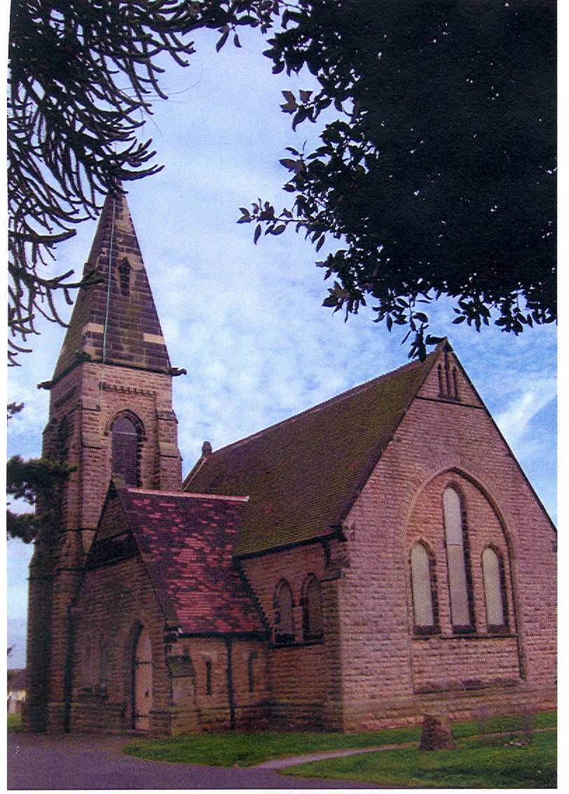
Hucknall Cemetery Chapel

Appendix 3 Memorial types
Type 1 Memorial – Over 2 metres high Type 2 Memorial – Lawn Memorial
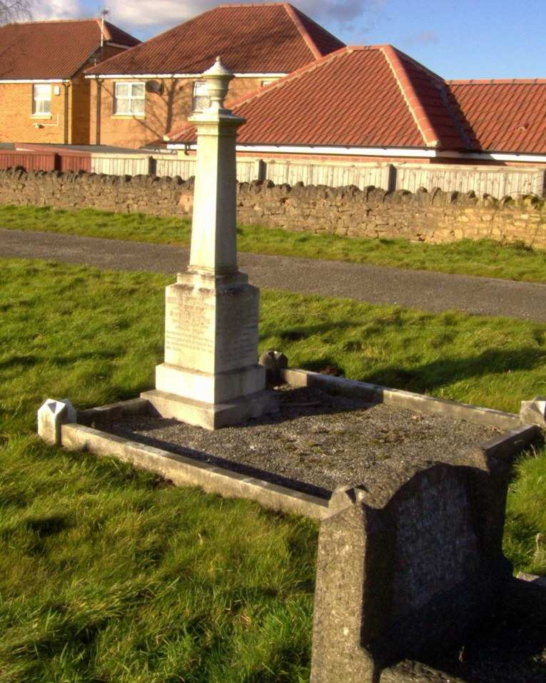
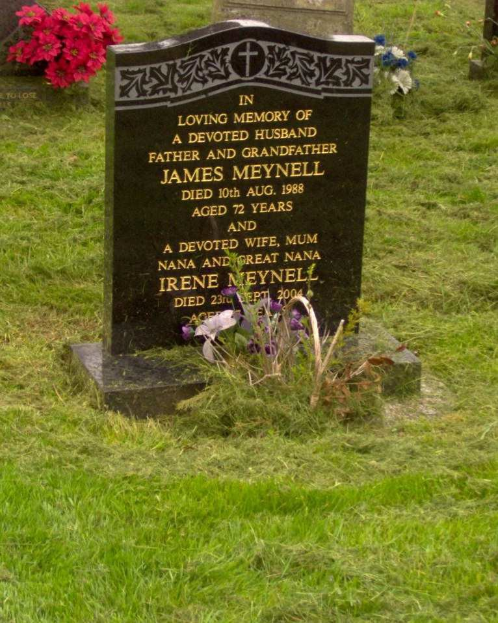
Type 2 Memorial – Monolith Headstone Type 3 – Kerbed Grave with Headstone
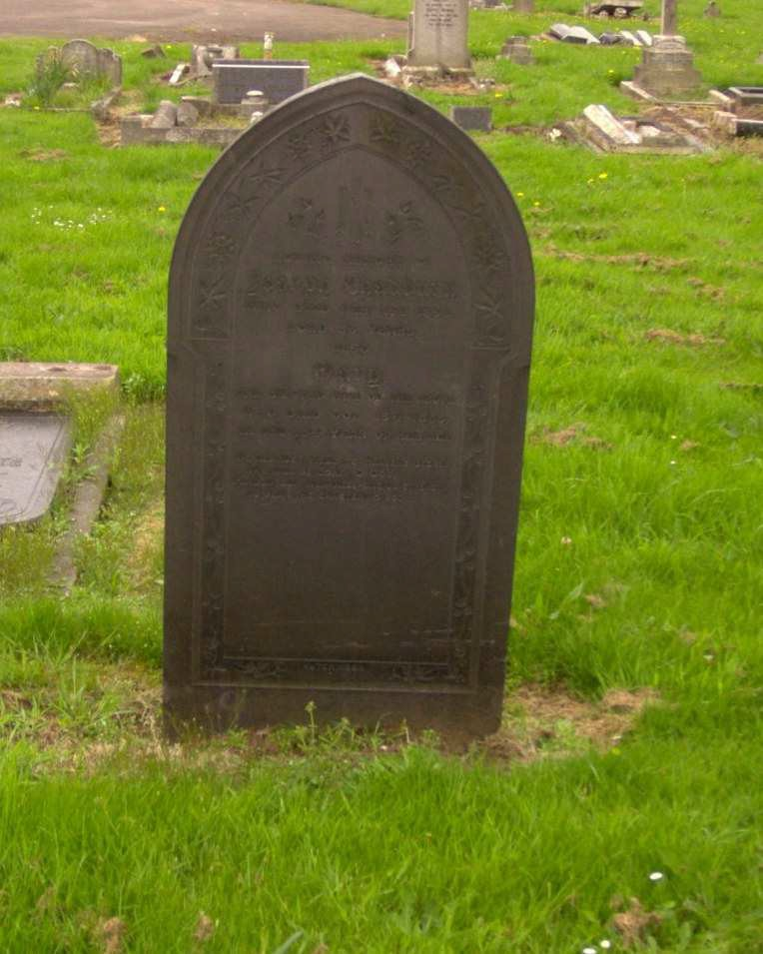
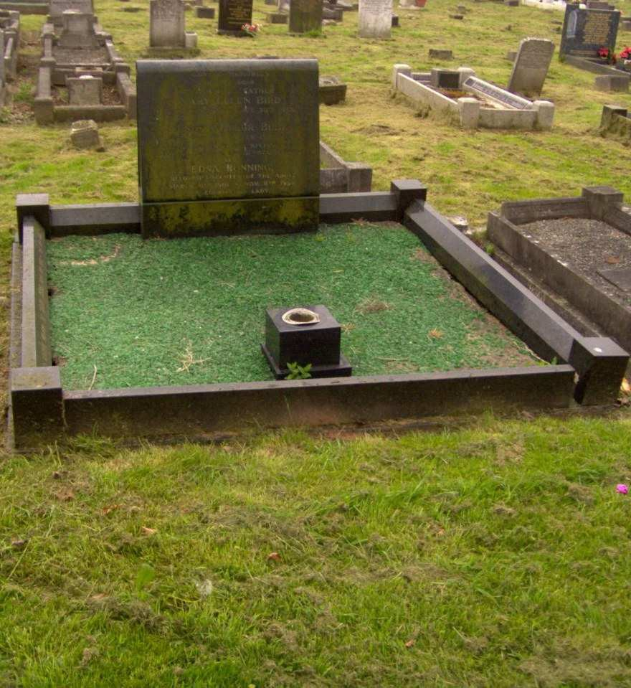

Appendix 4

Examples of action following topple testing

Headstones Laid after Failing Test Cemetery with Staked Headstones

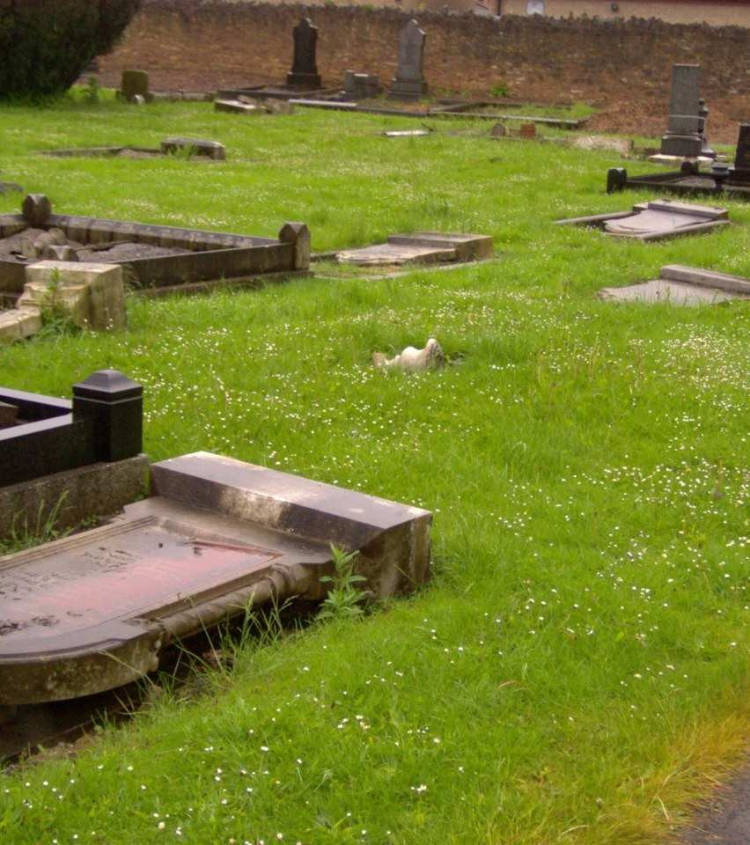
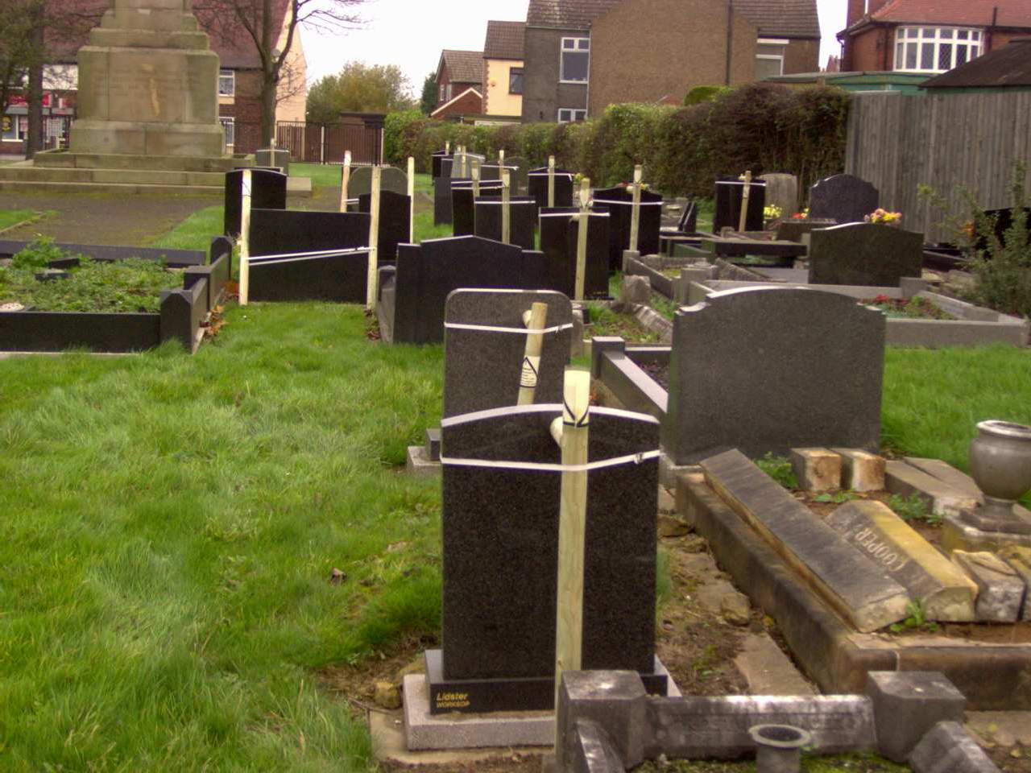

Permanent Make-safe by burying to One Third (Courtesy of Gedling BC)

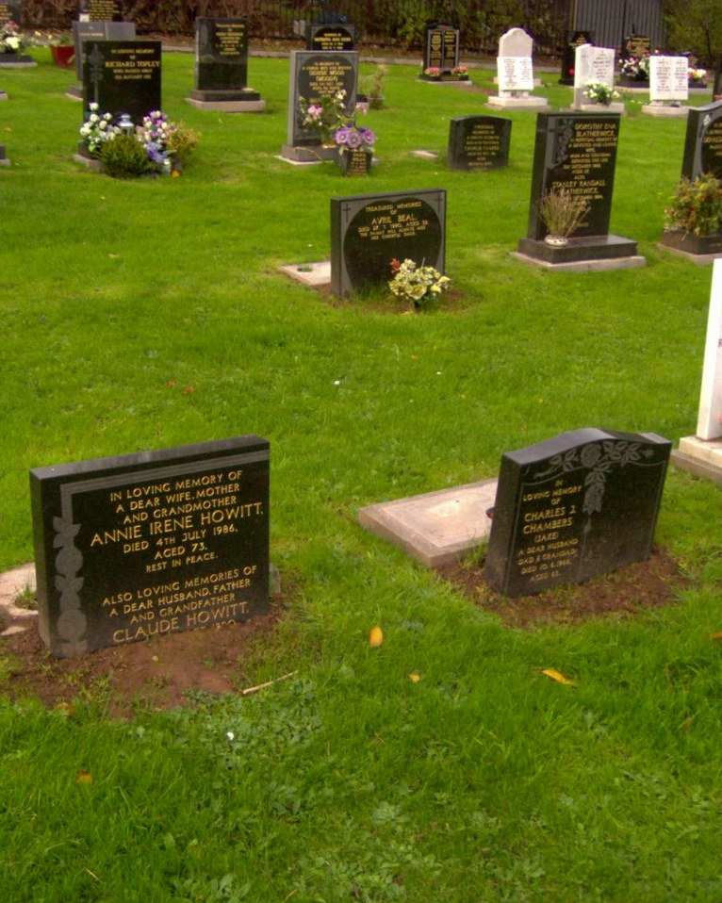

Appendix 5

CODE OF PRACTICE
FOR NATIONAL ASSOCIATION OF FUNERAL DIRECTORS

National Association of Funeral Directors
618 Warwick Road, Solihull, West Midlands, B91 1AA Tel: 0845 2301343 Fax 0121 711 1351
Email: info@nafd.org.uk website www.nafd.org.uk

CODE OF PRACTICE

This code of Practice sets out the high level of service that clients may expect in their dealings with a Member of the National Association of Funeral Directors.

Members of the Association, by virtue of their Membership, are bound by the terms of this Code of Practice, which gives effect to the Code of Practice Principles set out in the Appendix.

GENERAL

The Funeral Director:

  - Shall act in a courteous, sensitive, dignified and professional manner and must not pressurise or exploit clients in the difficult circumstances following bereavement.

  - Shall at all times offer the best advice and provide the best possible service commensurate with the charges made.

  - Shall respect the confidential nature of the information given to them and only use that information for its proper purposes.

MARKETING AND ADVERTISING

The Funeral Director shall ensure that any marketing or advertising which they undertake does not bring the Association or the funeral profession into disrepute and that such advertising:

  - Is always in good taste.

  - Is legal, decent, honest and truthful and complies with all requirements of the British Code of Advertising Practice and any other relevant legislation and Codes of Practice.

  - Includes only third party endorsements or sponsorship which have been specifically approved by that third party.

DEALINGS WITH CLIENTS

The Funeral Director:

  - Shall explain to the client the type of funerals available, the nature of the various services provided and their costs, and shall provide clients with full and details information about their services.

  - Shall have available and on public display in the premises price lists and information about the services available.

  - When visiting a client’s home to make funeral arrangements, shall take details of current price lists and information about services available and make them available to the client.

  - Shall use best endeavours to ensure that the client understands the range of services offered, the prices and also any known disbursements, these being the fees to be paid out on behalf of the client to Doctors, Ministers, Cemetery or Crematorium Authorities and other third parties involved.

  - Shall inform the client in writing, either at the time of making the arrangements or with the estimate, of the terms and conditions on which services will be provided.

  - Shall give guidance on any action to be taken by the client with regard to Certification and Registration of the death, the availability of relevant Government benefits and the general requirements of Insurance Companies and such like.

  - Shall have available The Simple Funeral Service as defined within this Code.

PRICE INFORMATION

  - The Funeral Director shall have available and on display a price list of lists showing:

    - A brief description of the Simple Funeral Service

    - Itemised charges for the constituent parts of the Funeral Director’s services (other than for The Simple Funeral Service).

i.e. Professional Services; Removal Charge; Coffin or Casket; Embalming; Vehicle Charges and all other services available.

    - Descriptions of other types of funerals available

  - The Funeral Director shall make copies of the price lists available to be taken away by clients or prospective clients. The price lists shall be shown to any person authorised to monitor compliance with this Code.

  - The Funeral Director shall ensure that all literature detailing coffins and/or caskets available shall include prices, and that coffins or caskets displayed on the premises are accompanied by the price.

ESTIMATES AND CONFIRMATIONS

  - The Funeral Director

- Shall in all cases provide a written confirmation of the funeral arrangements and a written itemised estimate of all funeral charges consistent with the price list, and at disbursements known at the time of making the arrangements.

- Shall obtain a written acceptance from the client of the estimate and the proposed funeral arrangements which will complete the contracted arrangements for the funeral.

2 In circumstances where disbursements may not be known in advance of the funeral, the Funeral Director shall give a best estimate of such disbursements

on the written estimate. The actual amount of such disbursements shall be detailed and shown in the final account.

3. If the Client amends the instructions, the Funeral Director shall endeavour to inform the client of any possible changes to the original estimate and obtain written consent to any variation from the initial agreement.

FINAL ACCOUNTS

The Funeral Director shall provide the client with a detailed itemised final account. The account may be less detailed if reference is made to a written itemised estimate provided the charges levied by the Funeral Director and the disbursements have been separately identified.

PUBLICITY

  - Members shall display, so as to be clearly visible to the public from the outside of the premises, the logos of the National Association of Funeral Directors and the Funeral Arbitration Scheme.

  - Members shall prominently display in a public area of their premises the Code of Practice Principles.

MONITORING

The Association will monitor the performance of Members and their compliance with the obligations of this Code of Practice through education, inspection, independent conciliation and arbitration. The Association will publish annually a Report on Members’ compliance with this Code of Practice, and this Report will also include the Annual Report of the Independent Chairman of the Disciplinary Committee on the working of this Code of Practice.

PROFESSIONAL CONDUCT

  - The choice of Funeral Director to carry out a funeral should always be the prerogative of the family concerned. When two Funeral Directors are called at the same time to attend a bereavement, both shall show a willingness to withdraw leaving the choice with the family. When a Funeral Director is called to remove a deceased in the event of a sudden or accidental death, or in other circumstances, by a third party, the Funeral Director so called should, if the family so wish, resign the arrangement of the funeral to a Funeral Director of the family’s choice. The chosen Funeral Director should pay the other Funeral Director for services rendered.

  - The Funeral Director shall not solicit funeral instructions nor employ any person to do so, nor shall they offer or give reward for recommendation.

  - The Funeral Director shall provide employees with training and written guidance which ensures that clients are given sufficient information to make informed decisions about entering into funeral arrangements.

COMPLAINTS

  - The Funeral Director shall appoint a designated senior person to deal with complaints from clients and have a formal written procedure for handling such complaints.

  - The vast majority of funerals are carried out to the satisfaction of clients. The National Association of Funeral Directors through its Funeral Arbitration Scheme provides a dedicated procedure for clients who feel they have not received the service they desired. The first stage is for the client to contact the Funeral Director to resolve the issues they have about the service received. If the client is unable to reach a resolution of the issues with the Funeral Director, then they should contact the Funeral Arbitration Scheme at 618 Warwick Road, Solihull, West Midlands, B91 1AA, which provides independent conciliation and arbitration through the Chartered Institute of Arbitrators.

  - Members are required, by virtue of the Rules of the Association, to co-operate in the client redress procedures and to participate in the independent conciliation and arbitration scheme. Members are bound by an Arbitrator’s decision, subject to the right of the Funeral Director or the client to seek a review of the decision.

  - Members also agree to abide by the decisions of the Disciplinary Committee on any matter referred to them alleging a breach of the Rules and Guidelines of the Association and this Code of Practice.

  - The Funeral Director shall have on display and make available to clients the Funeral Arbitration Scheme leaflet which provides detailed information to guide the client through the procedures on how to make a complaint.

  - The Funeral Director, when submitting the final account, shall invite the client to offer any comments that the client may have about the service received. A contact name shall be provided for this purpose and to raise any concerns about the service.

  - A complaint under this procedure must be made within twelve months of the date of the funeral.

DEFINITIONS

  - ‘Funeral Director’ or ‘Member’ refers to businesses within Category a) Membership of the National Association of Funeral Directors.

  - ‘Estimate’ includes a quotation and is an offer to carry out the specified funeral for the specified price.

  - ‘Client’ includes a potential client.

  - The Simple Funeral Service:

- The Funeral Director’s services;
- Attending to the necessary arrangements;
- Provision of the necessary staff;

- Provision of a simple coffin suitable for cremation or burial;
- Transfer of the deceased from the place of death during normal working hours (at least ten running miles allowed);
- Care of the deceased for up to fourteen days prior to the funeral;
- Provision of a hearse direct to the nearest Crematorium or Cemetery (within ten running miles);
- If burial is specified (where this is available locally) this may involve an additional charge;
- This specification does not include the following services:-

  - Embalming
  - Viewing of the deceased
  - Provision of a limousine
  - Any fees or disbursements payable on the client’s behalf

Appendix 6

CODE OF PRACTICE PRINCIPLES
As a condition of Membership, Members of the National Association of Funeral Directors agree to comply with the principles and details of this Code of Practices.
- To observe strictly the confidence of every client at all times.
- To observe at all times the basic rights of clients as consumers.
- To render good service at all times and make fair charges in respect of services rendered and for merchandise supplied.
- To ensure that advertising and marketing is always in good taste. No sensational offensive or misleading advertising or marketing is permitted.
- To provide clients with full and fair information about services. To have readily available price lists covering The Simple Funeral Service, and itemised charges for all the constituent parts of the Funeral Director’s services and all types of coffins and caskets available.
- To display the price lists referred to in (5) above in the public area of our premises.
- To give a written estimate of the Funeral Director’s charges and disbursements to be paid on a client’s behalf, together with written confirmation of the funeral arrangements in each and every case, as soon as is practicable before the day of the funeral. No contractual agreement will have been entered into until these documents have been accepted by the client.
- To provide clients with an itemised account in a form readily comparable with the estimate.
- To refrain from soliciting funeral orders, or offering, or giving any reward for recommendations to persons or organisations such as Health Service establishments, Nursing Homes, or Coroners’ Offices, etc.
- To display to the general public the logos of the National Association of Funeral Directors and the Funeral Arbitration Scheme.
- To co-operate at all times with Trading Standards Offices, Citizens Advice Bureau, Consumer support groups, and any other organisation representing clients in the resolution of complaints or disputes.
- To partake in, and abide by, the decision of the conciliation independent arbitration and Disciplinary Committee procedures of the Association in the resolution of any complaints or disputes between client and Funeral Director(s).
This Code of Practice and adherence hereto is monitored by the National Association of Funeral Directors. Any correspondence should be addressed to:-
National Association of Funeral Directors, 618 Warwick Road, SOLIHULL, West Midlands. B91 1AA. (Rev. October 2002)

Appendix 7

ASHFIELD DISTRICT COUNCIL
Urban Road, Kirkby in Ashfield,
Nottingham, Tel: 01623 450000
East Midlands. Fax: 01623 457585
NG17 8DA www.ashfield.gov.uk

Acknowledgement of Receipt of Summary of the Regulations Relating to Memorials

THIS SECTION TO BE COMPLETED IN ALL CASES BY THE GRAVE OWNER OR

REPRESENTATIVE OF (i.e. the person making the funeral arrangements)

I
(applicant's name in full please)

of

confirm that the deceased was a resident of the Ashfield District Council during the two years prior to death/or had been moved to a Nursing Home outside of the District of Ashfield Council area after having previously been a resident of the District of Ashfield District.

I confirm that I have received a Summary of the Cemetery Regulations relating to memorials and confirm that I will comply with them.

Signature:

Date:

Name, Address and Telephone Number of Funeral Directors:

DEED NO:

Appendix 8

See below an extract from the minutes of Council meeting on 22nd February. It says the council resolved the following the Cabinet meeting on 1st Feb.

"In accordance with Minute No. CA4.14, the Cemeteries Strategy for Ashfield (including closed churchyards) is to take effect from 1st April, 2007 and subject to the following amendments being incorporated, be formally approved and adopted:-

- bury the lower third of unstable headstones following “topple testing”;

- bury the lower third of unstable kerbed graves following testing in the centre of the grave space, keeping the inscription visible where possible;

- that the existing policy which does not allow pre-purchase of grave space in Hucknall be extended to all other cemeteries in the District;

- the current policy which prevents unauthorised or home-made kerb-sets and trenches to mark the boundary of a grave, or the placement of ornaments, bell glasses or wind chimes, to be strictly enforced for both old and new graves;

- that individual comments from Members which were raised in the Consultative Policy Forum outlined in the Scrutiny Panel B report be supported and accommodated within the strategy, where appropriate;

- that representations submitted by local stakeholders be accommodated where their proposals are appropriate;

Cemetery Strategy 2015.doc

