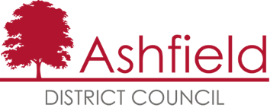

ADOPTION STATEMENT

Guide for Converting Shops to Residential
Supplementary Planning Document

Planning and Compulsory Purchase Act 2004
The Town and Country Planning (Local Planning) (England) Regulations 2012

In accordance with Regulations 14 & 35 of the Town and Country Planning (Local
Planning) (England) Regulations 2012, notice is given that Ashfield District Council
adopted its Guide for Converting Shops to Residential Supplementary Planning Document on 21st January 2019.

Title of Document: Guide for Converting Shops to Residential Supplementary Planning Document (SPD).

Subject Matter: The purpose of this SPD is to provide practical advice for developers who are considering converting a shop to a house or flat. It will help applicants understand where this change of use may be appropriate and where it will not. It will also give general and detailed design advice to help you achieve a quality conversion, and highlight the issues that the Council will look for when considering the application.

Area Covered by: The District of Ashfield.

Adoption Date: 21st January 2019.

Modifications The modifications made to the SPD are identified in the
(Changes) made: Consultation Statement, January 2019 (see below for details of where to view the document - availability of documents).

Legal Challenge: Any person with sufficient interest in the decision to adopt the
SPD may apply to the High Court for permission to apply for judicial review of that decision. Any such application must be made promptly and in any event not later than three months after the date on which the SPD was adopted.

Availability of The adopted SPD and Consultation Statement are available
Documents: on the Council’s website at www.ashfield.gov.uk or at the Council Offices, during normal office hours, at:
- Urban Road, Kirkby-in-Ashfield
- Brook Street, Sutton-in-Ashfield
- Watnall Road, Hucknall

Contact details: If you have any queries about the SPD please email lplans@ashfield.gov.uk or call 01623 457383.

