Ashfield Playing Pitch Strategy

2023-2027

Executive Summary
The Playing Pitch Strategy provides a focus for three key areas:

• Sustainable long-term management of outdoor sports facilities
• Evidence of need and priorities to support funding bids for continued improvement of facilities
• Provision of new facilities through the development process where a need has been identified.

The Strategy focuses on the following sports: Football, Cricket, Rugby Union, Hockey, Bowls Netball, and Tennis.

Preparation of the Strategy has included the following:
• Review of previous Playing Pitch Strategy (adopted 2017)
• Mapping of facilities and analysis of the current level of pitch provision within the District
• Non-technical assessments of pitches
• Consultation with clubs and schools/ colleges
• Consultation with Sport England and relevant sports’ national governing bodies (NGBs)

From analysis of the information gathered during the preparation of the Strategy the following aims have been identified:

- ACCESS & PROVISION - protect existing sports facilities and provide new facilities where there is current or future anticipated demand

- QUALITY & MANAGEMENT - improve the quality of existing facilities.

These aims will be achieved through: adoption of the Local Plan and implementation of the Strategy Action Plan with site specific projects incorporated into the Council’s Green Space Programme.

Table of Contents
1. Introduction 2
2. Methodology 4
3. Football 16
4. Rugby Union 63
5. Hockey 79
6. Cricket 93
7. Tennis 124
8. Netball 134
9. Bowls 141
10. Housing Growth 148
11. Delivery……………………………………………………………………………………………151

11.1 Vision, Key Aims and Objectives………………………………………………………150

11.2 Delivery Plan……………………………………………………………………………………151

12. Review, monitoring and updating………………………………………………………153

Definitions
3G Third generation (artificial grass pitch)
AGP Artificial grass pitch
BDA Bowls Development Alliance
CIL Community Infrastructure Levy
CFA County Football Association
EH England Hockey
FA Football Association
FC Football Club
HC Hockey Club
ECB England and Wales Cricket Board
LTA Lawn Tennis Association
MES Match Equivalent Session
NGB National Governing Body
ONS Office of National Statistics
PPS Playing Pitch Strategy
PQS Performance Quality Standard
RFU Rugby Football Union
S106 Section 106
TGR Team Generation Rate

Introduction
- Ashfield District Council has developed a new Playing Pitch Strategy (PPS) to provide evidence on the supply and demand for sport pitches arising from new development and the existing population, to ensure that suitable provision is made within new developments. Ashfield is undertaking a review of adopted planning policy looking towards the period to 2038. The Strategy will also support continued investment in existing facilities.
- The PPS has been developed to update current supply and demand information within Ashfield and covers the public, private, educational, voluntary and commercial sectors.
- It will provide an evidence base to protect existing provision and ensure that future demand is also catered for.
- The National Planning Policy Framework (NPPF) sets out the government’s planning policies for England and how these should be applied. Paragraph 98 emphasises the importance of access to high quality open spaces and opportunities for sport and physical activity for the health and wellbeing of communities. Paragraph 99 also states that such facilities shouldn’t be built on or developed unless:
- an assessment has been undertaken which has clearly shown the open space, buildings or land to be surplus to requirements; or
- the loss resulting from the proposed development would be replaced by equivalent or better provision in terms of quantity and quality in a suitable location; or
- the development is for alternative sports and recreational provision, the benefits of which clearly outweigh the loss of the current or former use.
- The Strategy has been developed in accordance with national planning guidance, in order to provide a robust evidence base for future playing pitch provision within the Local Authority area.
- Ashfield is divided into four sub analysis areas which provide a more localised assessment of supply and demand issues within the area: Hucknall, Kirkby, Sutton & Rurals.
- Figure 1.1 provides a spatial overview of Ashfield by sub area.

Figure 1.1 – Ashfield Analysis Area Map

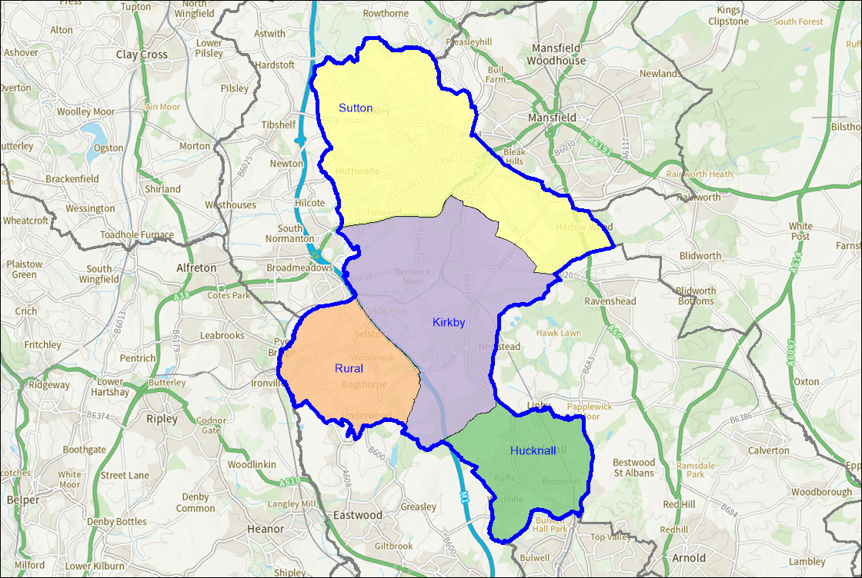

Agreed Scope
- The following outdoor sport facilities are included in the strategy:
- Football
- Rugby Union
- Cricket
- Hockey
- Tennis
- Bowls
- Netball

2. Methodology
- The PPS has been developed in line with Sport England’s ‘Playing Pitch Strategy Guidance: An approach to developing and delivering a Playing Pitch Strategy’, which was published in October 2013.
- The guidance references a 10 step, 5 stage approach:
- Stage A: Prepare and tailor the approach (Step 1);
- Stage B: Gather information and views on the supply of and demand for provision (Steps 2 & 3);
- Stage C: Assess the supply and demand information and views (Steps 4, 5 & 6);
- Stage D: Develop the Strategy (Steps 7 & 8);
- Stage E: Deliver the Strategy and keep it robust and up to date (Steps 9 & 10).
- Outdoor sports facilities that are included within the Strategy but are not covered by Sport England’s Playing Pitch Strategy Guidance, have been reviewed in accordance with Sports England’s ‘Assessing Needs and Opportunities Guide’ (ANOG). This has been applied to Tennis, Netball and Bowls. The ANOG stages are shown in Figure 2.1 overleaf.

Figure 2.1 – ANOG Stages

Stage A: Prepare and tailor the approach (Step 1)

Management Arrangements
- The project team consisted of representatives from Ashfield District Council and FMG leisure consultancy.
- A steering group of key stakeholders was created to help manage the project and to support delivery of the Strategy. This includes members of the project team and representatives from the National Governing Bodies of sport (NGBs).
- The steering group has helped to shape the strategy by providing relevant supply and demand data and supporting the consultation process. They have also reviewed all the work of the project team throughout the development.
- The steering group is vital in ensuring that recommendations identified within the Strategy are delivered and that it is kept up to date and robust.

2.1 Strategic Context

National Context

Sport England - Uniting the Movement
- The 10-year Strategy was published in 2021 and looks to transform lives and communities through sport and physical activity.
- It is the result of an 18-month consultation period with a wide range of partners and stakeholders who have helped to shape Uniting the Movement.
- There is a recognition that more investment into sport and physical activity is needed through National Governing Bodies, other bodies, sports clubs, organisations and community groups.
- It aims to remove existing barriers to sport and has 3 key objectives:
    - Advocation for movement, sport and physical activity.
    - Joining forces on 5 big issues:
- Recover and reinvent;
- Connecting communities;
- Positive experiences for children and young people;
- Connecting with health and wellbeing;
- Active environments.
    - Creating the catalyst for change.
- National Governing Bodies of Sport (NGBs) also have their own strategy documents that set out their sport’s strategic priorities nationally. An overview of these has been provided within the relevant section.

Local Context

Ashfield Draft Local Plan (2020-2038 – Consulted in October/November 2021)
- The Ashfield Draft Local Plan (2020-2038) is ADC’s planning document, setting out the vision, and creating an overarching framework, for how the identified priorities and needs of those in Ashfield will be met, and allowing for community involvement in the sustainable development of Ashfield.
- The plan’s vision is ‘Ashfield, a place to be proud of’.
- A number of key issues facing the District have been identified, relating to:
- Transport;
- Settlements;
- Town Centres;
- Housing;
- Economy;
- Employment;
- Ageing Population;
- Deprivation;
- Health;
- Infrastructure;
- Flooding and Water;
- Green Infrastructure;
- Historic Environment.

- Alongside them, 14 strategic objectives have been identified relating to the community, the economy, and the environment.
- There are also a number of overarching themes / categories under which particular policies and developments will take place, these are:
- Sustainable development in Ashfield – Spatial strategy and strategic policies
- Meeting the challenge of climate change and adapt to its effects
- Protecting and enhancing Ashfield’s character through its natural environment and heritage
- Meeting local housing needs and aspirations
- Building a strong economy which provides opportunities for local people
- Placing vibrant town and local centres at the heart of the community
- Achieving successful development through well designed places

Ashfield Corporate Plan (2019-2023)
- The Ashfield Corporate Plan 2019-2023 sets out the goals and plans for the District, and the role of the Council. The three purposes identified are:
- The Council exists to serve the communities and residents of Ashfield;
- We will provide good quality, value for money services;
- We will act strategically and plan for the future, working with others to bring about sustainable improvements in people’s lives.
- The corporate priorities, key initiatives and programmes and outcomes which the strategy supports are as follows:
- Health and Happiness - Delivering outcomes to enable residents to be physically active; Deliver Outdoor Sports Transformation Programme: new sports facilities at Kingsway Park and Sutton Lawn, service contract at Papplewick Playing Fields, rationalisation of smaller facilities; Increase participation in physical activity; Reduce adult and child obesity
- Cleaner and Greener - Parks and Open Spaces: Continue to review, improve and rationalise green space facilities; Improved public satisfaction with Ashfield’s parks and open spaces

Ashfield Health and Wellbeing Strategy (2021-2025)
- Ashfield’s Health and Wellbeing Strategy has been developed by Ashfield Health and Wellbeing partnership, which is embedded within Discover Ashfield, the District Place Board, leading the ‘Be Healthy, Be Happy’ theme. The goal of the plan is to provide opportunities for people to ‘lead a healthier and happier lifestyle’, and the overall vision is that ‘Everyone who lives in Ashfield leads a healthy and happy life’.
- The plan’s Mission is: ‘To work collaboratively to help people improve their health and wellbeing, develop pride and aspiration in our communities and promote Ashfield in a positive manner.’
- The plan has a number of priorities which define the approach to be taken:
- To give every child the best start in life;
- To promote and encourage healthy choices, improved resilience and social connection;
- To support our population to age well and reduce the gap in healthy life expectancy;
- To maximise opportunities to develop our built environment into healthy places;
- To tackle physical inactivity, by developing our understanding of barriers and motivations.

Ashfield District Council Community Engagement Strategy (CES) 2020-2023
- The purpose of the Strategy is to ensure that people have a say in how services are designed and delivered and to enable the Council to ‘plan and deliver an appropriate community engagement process that will allow us to achieve our values of being people focussed, honest, ambitious and proud’.
- The aims of the Strategy are to:
- Develop stronger relationships with people in Ashfield District Council;
- Collaborate more closely with the residents of Ashfield and create solutions to challenges we face together;
- Increase the number of staff trained in community engagement who deliver services directly impacting on residents;
- Increase the number of projects where community engagement has been utilised to help engage with the community at an appropriate level for the piece of work/service;
- Increase the number of residents who agree that Ashfield District Council puts people first.

- The Strategy’s audiences are: Customers, residents, partners and stakeholders, with particular focus on: General population, priority neighbourhoods, priority groups, complex individuals.

Public Open Space Strategy (2016-2026)
- The Council’s Public Open Space Strategy is a 10-year plan (2016-2026). It recognises the important role parks and green spaces play in improving people’s health and wellbeing, as well as wider benefits of social inclusion and regeneration alongside creating attractive places where people want to live and spend time.
- The Strategy focuses on three key themes:
- Sustainable long-term management of public open spaces;
- Continued improvement of public spaces;
- Provision of new public open space and associated facilities through the development process.

- Four key priorities are identified:

  - Appropriate distribution and linkages of green space and associated facilities across the District
  - Improving the quality of public spaces;
  - Increasing public satisfaction and use of public space;
  - Ensure sustainable and effective management of public spaces.

- As well as a number of standards to be achieved, including:

- All facilities owned by the District Council to be rated as good or excellent;
- Satisfaction levels amongst users to be at least 75%.

2.2 Assessment Findings

Stage B: Gather information and views on the supply of and demand for provision (Steps 2 & 3)
- A clear overview of the supply and demand of outdoor sports facilities for Ashfield has been established to allow for an accurate assessment of the quantity and quality of pitches. This was then informed by consultation with key stakeholders.

Gather supply information and views
- The data collection process included a full audit of pitches across Ashfield. This data was extracted from Sports England’s Active Places Power and reviewed by the steering group. For each site, the following information was collected:
- Site name, location, ownership and management type;
- Number and type of pitches and outdoor sports facilities;
- Accessibility of pitches to the community;
- Overall quality of pitches and ancillary facilities;
- Level of protection and security of tenure;
- Views of users and providers.

- Ownership of a facility can impact upon how accessible it is to the community. This assessment report categorises all sites under one of the five headings below:
- Available for community use – the pitch is available for community use and is used regardless of its management type;
- Available but unused – the pitch is available but is unused by the community. This could be due to its quality or cost of hire;
- Not available for community use – Pitches that aren’t made available for community use. Professional and semi-professional pitches that have limited use also fall under this category;
- Disused – A site that isn’t currently being used. Once a site has been disused for 5 years or more it will then be classed as lapsed;
- Lapsed – a site that hasn’t been used for 5 years or longer and now falls outside of Sport England’s statutory remit but is still assessed using the criteria within Paragraph 99 of National Planning Policy Framework and Sport England’s playing field policy.
- Sport England applies its playing field policy to any land in use as playing field or last used as playing field and which remains undeveloped, irrespective of whether that use ceased more than five years ago.

- Sport England’s Playing Pitch Strategy (PPS) guidance uses the following definitions of a playing pitch and playing field. These definitions are set out by the Government in the 2015 ‘Town and Country Planning (Development Management Procedure) (England) Order’. It should be noted that the reference to 5 years is in relation to whether Sport England should be consulted in a statutory capacity. The fact that a playing field may not have been marked out for pitch sport in the last 5 years does not mean that it is no longer a playing field, this remains its lawful planning use whether marked out or not:
- Playing pitch – a delineated area, which is used for association football, rugby, cricket, hockey, lacrosse, rounders, baseball, softball, American football, Australian football, Gaelic football, shinty, hurling, polo or cycle polo;
- Playing field – the whole of a site which encompasses at least 1 playing pitch.
- Although the statutory definition of a playing field is the whole of a site with at least 1 pitch of 0.2ha or more, this PPS considers smaller sized pitches that contribute to pitch stock, for example, 5v5 mini football pitches. This PPS counts individual grass pitches (as a delineated area) as the basic unit of supply. The definition of a playing pitch also includes artificial grass pitches (AGPs).
- The assessment report aims to capture all of the pitches within the boundary of Ashfield. However, there may be instances where a site is omitted. Where pitches have not been recorded within the report they remain as pitches and for planning purposes continue to be so. Furthermore, exclusion of a pitch does not mean that it is not required from a supply and demand point of view. The strategy document will seek to ensure that the list of sites within Ashfield is kept up to date as any changes arise.

Demand
- In order to evaluate demand for pitches within Ashfield, the following information has been collected:
- Number of sports clubs and teams including their match and training requirements;
- Casual demand;
- Educational demand;
- Displaced demand (i.e. teams wishing to play within the district but unable to);
- Latent demand (i.e. demand that exists but can’t be catered for due to lack of provision);
- Future demand (including club and team aspirations for development as well as National Governing Body (NGB) priorities and targets);
- User views and experiences, including trends and changes in demand.

- This information was collected via consultation with key stakeholders through face-to-face consultation in person and via MS Teams, together with an online survey. All the information collected has been reviewed and signed off by the steering group members.
- The quality of all sites has been captured, irrespective of their ownership type. This was achieved by completing a non-technical assessment at all sites that provide an outdoor sports pitch within the scope of the study. There may have been a small number of sites where a visit wasn’t possible due to gaining access. Relevant data on pitch quality and maintenance at specific sites has also been collected from NGBs. For example, via the Grass Pitch Improvement Programme, which is run in conjunction by the Football Foundation and Ground Management Association. The views of users about the pitches they use was also captured as part of the consultation process.

Future Demand
- The PPS also assesses whether there will be enough pitch provision to cater for future demand. This is informed by using proposed housing growth, Office of National Statistics (ONS) population projections and any significant growth identified by clubs or NGBs who are part of the consultation process.
- Team Generation Rates (TGRs) are used to provide an indication of the number of residents required to generate a team. This is provided for each age group and for both males and females. This was then used to estimate what future demand will look like for each pitch type.

Stage C: Assess the supply and demand information and views (Steps 4, 5 & 6)
- The supply and demand information gathered looks at the quantity and quality of pitch provision within Ashfield. It looks at how much use is currently taking place at a site and what level of use it can actually accommodate.

Understanding the situation at individual sites
- The qualitative pitch ratings were cross referenced with guidance provided by each NGB to determine the quality of pitches on each site. The quality of each pitch was assessed against the recommended pitch capacity to determine how many match sessions a pitch can accommodate.
- This was then compared to the number of matches that actually take place on the site to determine if there is:
- Potential spare capacity: Play is below the level the site could sustain;
- At capacity: Play is at the level the site can sustain;
- Overused: Play exceeds the level the site can sustain.
- Football Association (FA) guidance states the following for pitch capacity in the form of match equivalent sessions per week. For example, a good quality adult pitch has capacity for 3 matches per week. This is expressed in Match Equivalent Sessions (MES).
- Table 2.2 shows FA guidance for pitch capacity based upon its quality rating.

Table 2.2 – FA Guidance on Pitch Capacity
Pitch Type | Good (MES) | Standard (MES) | Poor (MES)
Adult (11v11) | 3 | 2 | 1
Youth (Y11v11 & 9v9) | 4 | 2 | 1
Mini (7v7 & 5v5) | 6 | 4 | 2

- Table 2.3 shows Rugby Football Union guidance for pitch capacity based upon its quality rating. For example, if a rugby pitch was assessed as D0/M0 it would be poor and have capacity for 0.5 matches per week.

Table 2.3 – RFU Guidance on Pitch Capacity
Drainage | M0 – Poor (MES) | M1 – Standard (MES) | M2 – Good (MES)
D0 | 0.5 | 1.5 | 2
D1 | 1.5 | 2 | 3
D2 | 1.75 | 2.5 | 3.25
D3 | 2 | 3 | 3.5

- The England and Wales Cricket Board (ECB) guidance states the following for pitch capacity in the form of match equivalent sessions (MES) per season. For example, a good quality grass wicket can facilitate 5 matches per season and a good quality Non-Turf Pitch (NTP) can facilitate 60 matches per season.
- Table 2.4 shows ECB guidance for pitch capacity based upon its quality rating.

Table 2.4 ECB Guidance on Pitch Capacity
Pitch Type | Good (MES) | Standard (MES) | Poor (MES
1 grass wicket | 5 | 0 | 0
1 NTP | 60 | 0 | 0

- AGPs used for hockey don’t have any capacity guidance associated with them due to the nature of the surface. Pitches without floodlighting are capped at 4 matches per day.
- The Lawn Tennis Association (LTA) recommend that a non-floodlit hard court can accommodate 40 members and a floodlit hard court can accommodate 60 members. Air domed courts can accommodate 100 members.
- Bowls England state that a club with more than 100 members is over capacity.
- Other non-pitch sports such as netball don’t provide any specific guidance, therefore sites were looked at on an individual basis.

Develop the current picture
- Capacity was calculated on a site-by-site basis to identify where any spare capacity existed. This was also looked at during peak times for each pitch sport to provide a more accurate reflection of where spare capacity exists in relation to demand.

Identify the key findings and issues
- Key issues and findings regarding the supply and demand of outdoor pitches within Ashfield were identified by completing this process.

Develop the future picture (scenario testing)
- Once the capacity analysis had been completed, a number of scenario tests, as agreed with the steering group were carried out. These helped to understand the impact certain scenarios would have on the supply and demand of outdoor pitch provision in Ashfield.
- In the following section each sport is reviewed for current and future demand with issues and recommendations identified.

3. Football

Introduction
- Nottinghamshire Football Association (FA) is responsible for governing and developing football within Ashfield. This includes working closely with the FA on implementation of the FA Grassroots Football Strategy 2020-2024. (FA Strategy 2020-2024: Time for Change)
- The Strategy – Survive. Revive. Thrive. – outlines 7 transformational focus areas:
- Male participation:
- Modernised opportunities to retain and re-engage millions of male participants in the game.
- Female participation:
- A sustainable model based on a world-class, modernised offer.
- Club network:
- A vibrant national club network that delivers inclusive, safe local grassroots football and meets community needs.
- Facilities:
- Enhanced access to good quality pitches across grassroots football.
- Grassroots workforce:
- A transformation in community football by inspiring, supporting and retaining volunteers in the game.
- Digital products and services:
- An efficient grassroots digital ecosystem to serve the administrative and development needs of players, parents and the workforce.
- Positive environment:
- A game that’s representative of our diverse footballing communities, played in a safe and inclusive environment.
- Nottinghamshire FA worked closely with the Football Foundation, Ashfield Council and other partners to develop a Local Football Facility Plan (LFFP) for Ashfield. (Click here for Ashfield Local Football Facility Plan)
- LFFPs provide a detailed report for a Local Authority area, mapping out key investment priorities for football across four areas:
- 3G AGPs
- Grass Pitches
- Changing rooms & pavilions
- Small-sided facilities
- The plans are aligned to the National Football Facilities Strategy to support delivery of key target areas.
- The Ashfield LFFP was developed in March 2019 and identified 21 potential projects for investment across the four target areas, these include:
- Sutton Academy/Sutton Lawn - A New 11 v 11 floodlit 3G FTP; changing pavilion and refurbishment of the existing 11 v 11 3G FTP.
- Papplewick Green – grass pitch improvements
- Rolls Royce Leisure FC – a new floodlit 11 v 11 3G FTP or Holgate School
- Kingsway Park – grass pitch improvements; a new changing pavilion and small sided MUGA
- Bentick Colliery \Miners Welfare – grass pitch improvements and a new floodlit 5 v 5 3G FTP
- Ashfield School - a new floodlit 11 v 11 3G FTP
- Selston Leisure Centre – refurbish the existing 5 v 5 3G FTP
- The Summit Centre - refurbish the existing 7 v 7 3G FTP
- Teversal FC – refurbish the existing changing pavilion
- Acacia Centre and Titchfield Park - small sided informal MUGAs
- Whilst the LFFP was based upon consultation with key stakeholders locally, it is not a supply and demand model that provides strategic guidance for football provision in Ashfield. Therefore, it should be used in tandem with the Playing Pitch Strategy (PPS). The Ashfield LFFP is due to be updated upon completion of the PPS to reflect any changes in supply and demand data and to review the priority projects and locations.

Consultation
- All clubs in Ashfield were invited to complete an online survey as part of the consultation process. This was distributed by Nottinghamshire FA.
- In total there are currently 32 football clubs in Ashfield who between them have 161 teams. Eight clubs (78 teams) responded to the consultation which represents a team response rate of 48%.

Supply
- There are currently 43 sites in Ashfield that provide grass football pitches, this equates to 98 pitches in total. There are 80 pitches available for community use across 31 sites. Table 3.1 provides a breakdown of football pitch types in Ashfield that are available for community use.

Table 3.1 Number of football pitches by type in Ashfield
Area Analysis | Adult pitches | Youth 11v11 pitches | Youth 9v9 pitches | Mini Soccer 7v7 pitches | Mini Soccer 5v5 pitches
Total | 35 | 13 | 10 | 29 | 11

- Adult football is the most dominant pitch type within Ashfield, this is partly due to the fact that they often accommodate youth 11v11 fixtures. FA pitch guidance states that under 17s and under 18s can play on adult pitches but that under 14s to under 16s should play on smaller pitches than adult teams. Table 3.2 shows FA recommended pitch sizes.
- Table 3.18 later in this section provides an overview of grass football pitch provision in Ashfield.
- Table 3.2 provides an overview of FA recommended pitch sizes for each format.

Table 3.2 FA recommended pitch sizes
Format | Age groups | Recommended pitch size (metres)
Adult | U17 + | 100 x 64
Youth 11v11 | U15s & U16s | 91 x 55
Youth 11v11 | U13s & U14s | 82 x 50
Youth 9v9 | U11s & U12s | 73 x 46
Mini Soccer 7v7 | U9s & U10s | 55 x 37
Mini Soccer 5v5 | U7s & U8s | 37 x 27

- Figure 3.1 provides a spatial overview of where operational grass football pitches, available to the community, are located in Ashfield. There is good distribution across each of the sub areas.

Figure 3.1 Map of football pitches in Ashfield
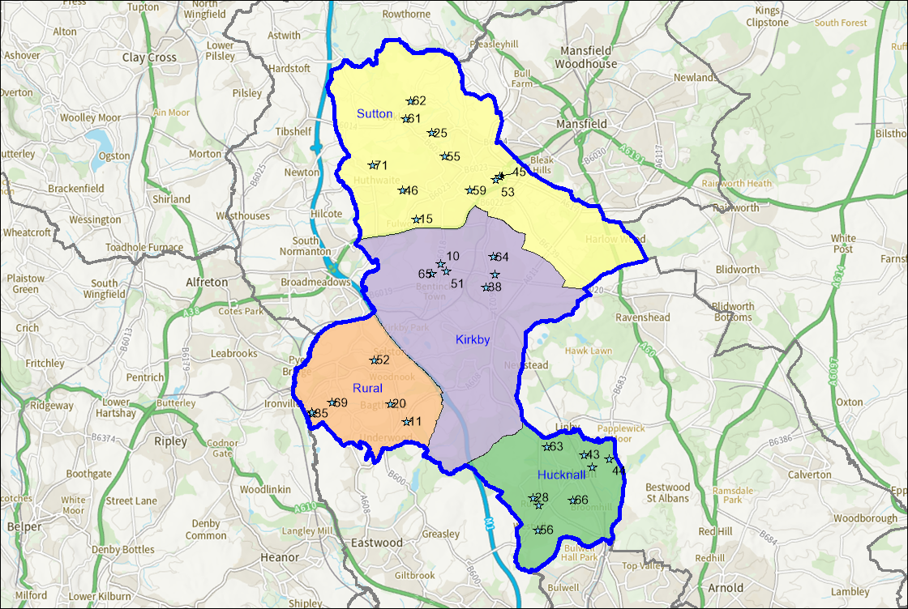

Disused and lapsed pitches
- A site that hasn’t been used for five years or longer and now falls outside of Sport England’s statutory remit but is still assessed using the criteria within Paragraph 99 of National Planning Policy Framework and Sport England’s playing field policy. Sport England applies its policy to any land in use as playing field or last used as playing field and which remains undeveloped, irrespective of whether that use ceased more than five years ago. Lack of use should not be seen as necessarily indicating an absence of need for playing fields in the locality. Such land can retain the potential to provide playing pitches to meet current or future needs.
- The following sites in Ashfield are recorded as having previously had football pitches laid out but are currently disused:
- Brierley Forest Park
- The following sites are all recorded as being lapsed. All of these sites are now closed:
- Annesley Welfare Ground
- B.R.S.A Ground
- Charnwood Street Recreation Ground
- Daneswood Junior School
- Hardwick Lane Recreation Ground
- Hucknall Town Football Club - Watnall Road (approved for Lidl development)
- Nuncargate Recreation Ground

Security of tenure
- Tenure at a site is deemed to be secured if the club has confirmed use of the site for the next 3 years. Where football pitches are located on Local Authority, Parish or Town Council sites, tenure is generally deemed to be secured.
- Tenure is generally not deemed an issue on club sites.
- Tenure is generally deemed to be unsecured at educational sites, unless known otherwise. Whilst educational sites may provide community use of their facilities, this could be stopped at short notice. The following educational sites are currently used by clubs in Ashfield:
- Holgate Academy, Hucknall
- The National C of E Academy, Hucknall
- Leen Mills Primary School, Hucknall

Quality
- All sites containing grass football pitches in Ashfield were visited and a non-technical assessment was completed to determine pitch quality, using FA non-technical assessment guidance. Pitches were then rated as Good, Standard or Poor based on the following parameters:
Good (80% or above);

Standard (50%-79.9%);

Poor (49.9% or below).

- The quality of a pitch impacts upon the carrying capacity of that site. This can be influenced by factors such as maintenance or how much pitches are used. The tables below provide an overview of pitch quality at sites with football pitches available for community use.

- Table 3.3 provides an overview of the number of good, standard and quality football pitches in the area by each pitch type.

Table 3.3 Football pitch quality in Ashfield
Quality rating | Adult pitches | Youth 11v11 pitches | Youth 9v9 pitches | Mini Soccer 7v7 pitches | Mini Soccer 5v5 pitches
Good | 8 | 1 | 2 | 4 | 1
Standard | 11 | 4 | 4 | 17 | 9
Poor | 10 | 5 | 3 | 2 | 1
Not Assessed | 7 | 3 | 1 | 6 | 0
Total | 36 | 12 | 11 | 29 | 11

FA Grass Pitch Improvement Programme
- The FA in conjunction with the Football Foundation and Ground Management Association (GMA) run a Grass Pitch Improvement Programme. This enables clubs and sites to receive advice and guidance on better pitch management and maintenance. Clubs are able to complete a self-assessment of their pitches through the Pitch Power app. This generates a report completed by a GMA Regional Pitch Advisor outlining where improvements to pitches can be made. Using this report, clubs and sites are able to apply for funding from the Football Foundation for maintenance contractor works, such as deep aeration and fertilisation via their Grass Pitch Maintenance Fund. Applications can also be submitted for funding towards maintenance kit and equipment identified within a report, such as tractors and mowers. The following sites in Ashfield have benefitted from receiving a grass pitch assessment report via this programme:
- Kingsway Park
- Sutton Lawn
- Papplewick Playing Fields
- Titchfield Park, Hucknall
- Westwood Recreation Ground
- Teversal Old Village Recreation Ground (Peartree Lane)
- Healdswood Recreation Ground
- Cowpasture Lane Recreation Ground
- Calladine Park (Bluebell Wood Way)
- Titchfield Park, Kirkby
- The Ashfield LFFP also identified a number of key grass pitch sites deemed to be strategically important for improvements. Priority was given to sites containing 3 pitches or more, however, sites with fewer pitches were included if their importance for football could be demonstrated. The following sites were identified within the Ashfield LFFP:
- Papplewick Playing Fields
- Kingsway Park, and
- Bentinck Colliery \Miners Welfare

Ancillary provision
- Ancillary provision at sites with football pitches was assessed where possible. The assessment looks at changing rooms for players and officials (including showers and toilets), provision of player and spectator toilets, catering provision and whether or not facilities are compliant with the Equalities Act. Car parking provision is also considered.
- Table 3.4 provides an overview of the quality of ancillary provision at sites containing football pitches available for community use. Sites with N/A against them have no ancillary provision available at the site.

Table 3.4 Ancillary provision at football sites available for community use
Site Name | PPS Site ID | Quality Rating
Bentinck Miners Welfare | 9 | Standard
Bracken Park (Underwood Villa FC) | 10 | Good
Calladine Park (Bluebell Wood Way) | 14 | Standard
Dixies Arms Park | 19 | Poor
Healdswood Recreation Ground | 24 | Poor
Holgate Academy | 25 | Standard
Holgate Academy | 25 | Standard
Holgate Academy | 25 | Standard
Jacksdale Miners Welfare | 34 | Good
Jacksdale Primary And Nursery School | 35 | Not Assessed
Kingsway Park | 37 | Standard
Leen Mills Primary School | 42 | Not Assessed
Papplewick Pavilion and Playing Fields | 43 | Good
Mansfield Athletic FC (Unwin Road) | 44 | N/A
Mansfield Hosiery Mills Sports & Social Club | 45 | Good
Morven Park Primary School | 47 | Not Assessed
Nabbs Lane Recreation Ground | 48 | Standard
Orchard Primary & Nursery School | 50 | N/A
Selston Parish Hall and Recreation Ground | 51 | Good
Polly Bowls Sports Ground | 52 | Standard
Quarrydale Academy | 54 | Standard
Rolls Royce Fitness Centre Hucknall (Engine Rooms) | 55 | Good
Sutton Lawn | 58 | Poor
Teversal Grange Sports and Social Centre (Teversal FC) | 60 | Not Assessed
Teversal Old Village Recreation Ground | 61 | Poor
The National C Of E Academy | 62 | Standard
The Summit Centre | 63 | Good
Titchfield Park, Kirkby | 64 | Poor
Titchfield Park, Hucknall | 65 | Standard
Westwood Recreation Ground | 67 | Standard
Wigwam Playing Fields | 68 | Good
Woodland View Primary School | 69 | Not Assessed

- There are currently eight sites in Ashfield containing ancillary provision rated as good.
- During consultation, Kirkby Colts FC, who currently play at Kingsway Park and Sutton Lawn stated that to have their own ground would be the best thing to develop the club. Ashland Rovers FC are also investing in new stands and shelters at the Kingsway Park site.

Demand
- In total there are currently 32 football clubs in Ashfield who between them have 161 teams. The two tables below provide a breakdown of these teams via the various formats of the game. There are no identifiable Disabled teams.
- Table 3.5 provides a breakdown of male teams and table 3.7 provide a breakdown of female teams who play within the area across the various age groups.

Table 3.5 Male football teams in Ashfield
Team Category | Adult teams | Youth 11v11 teams | Youth 9v9 teams | Mini Soccer 7v7 teams | Mini Soccer 5v5 teams
Total | 37 | 34 | 35 | 26 | 24

Table 3.6 Female football teams in Ashfield
Sub Analysis Area | Adult teams | Youth 11v11 teams | Youth 9v9 teams | Mini Soccer 7v7 teams | Mini Soccer 5v5 teams
Total | 3 | 1 | 1 | 0 | 0

- Whilst teams have been split by gender, it is worth noting that mixed teams are permitted up to under 18s football.

The National League System
- The National League System is a series of leagues for adult men’s teams that consists of steps (1-6) up to the Football League. Clubs can be promoted and relegated throughout the system. Each step has its own set of ground grading requirements that clubs must adhere to in order to compete. The requirements for each step are categories from A-H. (Click here for FA National League System ground grading documents)
- Table 3.7 provides an overview of teams in Ashfield who currently compete within the National League System and are therefore required to comply with ground grading requirements.

Table 3.7 National League System club in Ashfield
Club name | Step | League
Selston FC First | Step 5 | Uhlsport United Counties League
Hucknall Town FC First | Step 6 | Uhlsport United Counties League
Teversal FC First | Step 6 | East Midlands Counties Football League
Teversal FC Reserves | Step 7 | Abacus Lighting Central Midlands Football League

Women’s National League System
- The Women’s National League System is similar to the men’s but involves a series of tiers (1-7). Teams can also be promoted and relegated between the leagues. There is also a set of ground grading requirements that clubs must adhere to (A-C). table 3.9 shows women’s teams in Ashfield who currently compete in the Women’s National League System.

Table 3.8 Women’s National League System clubs in Ashfield
Club name | Tier | League
Teversal FC Ladies | Tier 7 | Nottinghamshire Girls and Ladies Football League

Imported demand
- Imported demand is demand that comes from outside of the study area to access provision due to a lack of provision where they are located.
- No Imported demand has been identified in Ashfield from football clubs.
- In total there are no teams accessing grass football pitch provision in Ashfield who come from outside the study area.

Exported demand
- Exported demand is demand that can’t be catered for within the study area and therefore takes place outside of this.
- There are currently 20 teams with exported demand outside of Ashfield. The majority of this (19 teams) is due to teams participating in the Kickstart League. This is a central venue league that uses multiple venues for different age groups. This does include venues in Ashfield as well as multiple sites in the neighbouring Local Authorities.

Latent Demand
- Latent demand refers to demand that exists but can’t be catered for due to a lack of available provision. Table 3.12 shows clubs in Ashfield who reported latent demand and if they would require additional playing pitches, training facilities or both in order to meet this.

Table 3.9 Latent demand from football clubs in Ashfield
Team Name | Demand for playing pitches | Demand for training provision
Ashland Rovers FC | Yes - Indoor/ all-weather provision | Yes
Beaufort United FC | Yes | Yes
Kirkby Colts FC | Yes | Yes
Hucknall & Linby Harriers FC | Yes - Indoor/ all-weather provision | Yes
Mansfield Hosiery FC |  | Yes
Sports Gateway Hucknall FC | Yes | Yes
Selston FC | Yes - Indoor/ all-weather provision | Yes
Hucknall Warriors FC | Ideally 3G and indoor (for younger players) | Yes

- All clubs who reported latent demand reported that access to training provision, primarily a 3G AGP was required to meet this demand.

Unmet demand
- Unmet demand refers to existing demand that can’t currently access pitch provision. This can often result in clubs having waiting lists for players or teams, because they can’t accommodate them. All clubs that responded to the club consultation reported unmet demand in Ashfield:

Future demand
- Future demand can be developed in two ways, clubs may actively try to increase their team numbers in order to grow their club. This may be supported by the relevant NGB through funded programmes or support to help deliver objectives within their strategy.
- As part of the consultation process clubs were asked about any aspirations they had to develop their exiting team numbers. Table 3.10 shows clubs who reported aspirations to increase their current team numbers during the consultation and includes anticipated growth in each category.

Table 3.10 reported future team growth
Club Name | Adult Men’s Teams | Adult Women’s Teams | Youth Boy’s Teams | Youth Girl’s Teams | Mini Soccer Teams
Ashland Rovers FC | 0 | 0 | 1 | 0 | 0
Beaufort United FC | 1 | 1 | 2 | 2 | 2
Kirkby Colts FC | 0 | 0 | 5 | 0 | 0
Hucknall & Linby Harriers FC | 0 | 0 | 1 | 1 | 1
Sports Gateway Hucknall FC | 0 | 0 | 4 | 4 | 4
Selston FC | 1 | 0 | 0 | 1 | 1
Hucknall Warriors FC | 0 | 0 | 3 | 1 | 3
Total | 2 | 1 | 16 | 9 | 11

FA Wildcats
- The FA Wildcats programme is aimed at increasing participation by girls aged 5-11. Sessions are typically run by clubs, schools or community organisations who want to develop female football. Sessions are delivered by qualified coaches with an emphasis on fun and enjoyment. There are currently 1,250 Wildcats centres around the country.
- There are currently no Wildcats centres running in Ashfield.

Team Generation Rates (TGRs)
- Another way that future demand can be calculated is by looking at population forecasts and how these impact upon Team Generation Rates (TGRs).
Future population forecasts have been developed by calculating future growth from ONS data (Click here for ONS population projections by single year of age). These have been developed to show the overall growth across Ashfield up to 2038 in line with the draft Local Plan. TGRs have been rounded down to the nearest whole number. These can be seen in table 3.11 overleaf.

Table 3.11 TGRs for football teams in Ashfield
Age groups | Number of teams in age group within the area | Current population in age group within the area | Future population in age group within the area | Current TGR | Population changes in age group | Potential increase in team numbers in age group
Football Adult Men 11v11 (16-45yrs) | 38 | 23351 | 26089 | 615 | 2738 | 4
Football Adult Women 11v11 (16-45yrs) | 3 | 24179 | 26273 | 8060 | 2094 | 0.0
Football Youth Boys11v11 (12-15yrs) | 34 | 3213 | 3259 | 94 | 46 | 0.0
Football Youth Girls 11v11 (12-15yrs) | 1 | 3156 | 3134 | 3156 | -22 | 0.0
Football Youth Boys 9v9 (10-11yrs) | 35 | 1760 | 1591 | 50 | -168 | 0.0
Football Youth Girls 9v9 (10-11yrs) | 1 | 1692 | 1561 | 1692 | -131 | 0.0
Football Mini Soccer Mixed 7v7 (8-9yrs) | 26 | 3281 | 3119 | 126 | -162 | 0.0
Football Mini Soccer Mixed 5v5 (6-7yrs) | 24 | 3179 | 3088 | 137 | -193 | 0.0

- It is worth noting that TGRs don’t take into consideration specific targeted work caried out by an NGB or individual clubs and organisations. Nationally adult male football is on the decline and the County FA’s focus is on retaining existing numbers and using other formats of the game to engage participants.

Understanding the situation at individual sites
- Capacity on football pitches is calculated by the number of matches a pitch can facilitate each week. Table 3.12 below shows FA guidance regarding grass pitch capacity and how many games each pitch type can facilitate depending on its quality. For example, a good quality adult 11v11 pitch can facilitate 3 matches per week, a standard pitch can facilitate 2 matches per week and a poor pitch just 1 match per week. This is expressed in match equivalent sessions (MES).

Table 3.12 FA pitch capacity guidance
Pitch type | Good (matches per week) | Standard (matches per week) | Poor (matches per week)
Adult (11v11) | 3 | 2 | 1
Youth (Y11v11 & 9v9) | 4 | 2 | 1
Mini (7v7 & 5v5) | 6 | 4 | 2

- Any sites that have unsecured use or that are not available for community use have been discounted if they have spare capacity.
- Educational sites are generally considered to be unsecured unless it has been evidenced otherwise. Local Authority, Town and Parish Council sites are considered to be secured. Club sites are dependent on the security of tenure a club has at that site.
- Where educational sites cater for community use the capacity ratings have been adjusted by 1 MES to take into account curricular and extra-curricular use.
- This has also been used for open access sites such as parks and playing fields to account for any informal use.

Peak Demand
- Peak demand for mini soccer and youth soccer in Ashfield is Saturday morning, Sunday morning and Sunday afternoon. Peak demand for adult football is Saturday afternoon and Sunday morning.

Match Equivalent Sessions (MES)
- Each team which uses a pitch for matches are allocated 0.5 MES. Therefore, each pitch can accommodate a maximum of 2 teams at peak times. The exception to this is teams who play in the Kickstart League. This is a central venue league where fixtures are played at the same venue each week. Table 3.13 looks at the existing capacity of a pitch based on its quality along with existing use to understand if there is any spare capacity. Spare capacity is then looked at against peak demand to assess if it is actual spare capacity.

Table 3.13 Capacity at football pitch sites in Ashfield
Site Name | Sub Area | PPS Site ID | Pitch Type | Number of Pitches | Community Use Category | Quality Rating | Initial Current Carrying Capacity  (MES) | Total Use | Balance | Spare capacity at peak times | Comment
Annesley Primary and Nursery School | Kirkby | 3 | Mini Soccer 7v7 | 1 | Not available for community use | Standard | 4 | 1 | 3 | 2 | Discounted as not available for community use
Ashfield School | Kirkby | 7 | Adult Football | 4 | Not available for community use |  | 4 | 1 | 3 | 3 | Discounted as not available for community use
Ashfield School | Kirkby | 7 | Junior Football 9v9 | 1 | Not available for community use |  | 1 | 1 | 0 | 0 | Pitch at capacity
Bagthorpe Primary School | Rural | 9 | Mini Soccer 7v7 | 1 | Not available for community use | Standard | 4 | 1 | 3 | 2 | Discounted as not available for community use
Bentinck Miners Welfare | Kirkby | 10 | Adult Football | 1 | Available for community use and used | Standard | 2 | 1.5 | 0.5 | 0.5 | Spare capacity of 0.5 MES
Bentinck Miners Welfare | Kirkby | 10 | Junior Football 11v11 | 1 | Available for community use and used | Standard | 2 | 2.5 | -0.5 | -0.5 | Pitch overplayed
Bracken Park (Underwood Villa FC) | Rural | 11 | Adult Football (overmarked with 1 x Junior 11v11. 1 x Junior 9v9 | 1 | Available for community use and used | Standard | 2 | 3 | -1 | -1 | Pitch overplayed
Brierley Forest Primary and Nursery School | Sutton | 13 | Mini Soccer 7v7 | 1 | Not available for community use | Standard | 4 | 1 | 3 | 2 | Discounted as not available for community use
Calladine Park (Bluebell Wood Way) | Sutton | 15 | Junior Football 9v9 | 1 | Available for community use and used | Poor | 1 | 2 | -1 | -1 | Pitch overplayed
Dalestorth Primary and Nursery School |  | 18 | Junior Football 11v11 | 1 | Not available for community use |  | 1 | 1 | 0 | 0 | Pitch at capacity
Dixies Arms | Rural | 20 | Adult Football | 1 | Available for community use and used | Standard | 2 | 1 | 1 | 1 | Spare capacity of 1 MES
Dixies Arms | Rural | 20 | Junior Football 11v11 (overmarked with 1 x Junior 9v9 and 1 x Mini Soccer 7v7) | 1 | Available for community use and used | Standard | 2 | 3.5 | -1.5 | -1.5 | Pitch overplayed
Greenwood Primary School | Kirkby | 23 | Junior Football 9v9 | 1 | Not available for community use | Standard | 2 | 1 | 1 | 1 | Discounted as not available for community use
Healdswood Recreation Ground | Sutton | 25 | Adult Football | 1 | Available for community use and used | Standard | 2 | 1 | 1 | 1 | Spare capacity of 1 MES
Healdswood Recreation Ground | Sutton | 25 | Junior Football 11v11 | 1 | Available for community use and used | Poor | 1 | 1 | 0 | 0 | Pitch at capacity
Hillside Primary and Nursery School | Hucknall | 27 | Mini Soccer 7v7 | 1 | Not available for community use | Standard | 4 | 1 | 3 | 2 | Discounted as not available for community use
Holgate Academy | Hucknall | 28 | Adult Football | 3 | Available for community use and used | Standard | 6 | 1 | 5 | 3 | Spare capacity of 3 MES
Holgate Academy | Hucknall | 28 | Junior Football 9v9 | 2 | Available for community use and used | Standard | 4 | 2.5 | 1.5 | 0 | Pitches at capacity
Holgate Academy | Hucknall | 28 | Mini Soccer 7v7 | 2 | Available for community use and used | Standard | 8 | 1.5 | 6.5 | 4 | Discounted as unsecured tenure
Holgate Academy | Hucknall | 28 | Mini Soccer 5v5 | 1 | Available for community use and used | Standard | 4 | 1 | 3 | 1 | Discounted as unsecured tenure
Hucknall Town Football Club | Hucknall | 72 | Adult Football | 2 | Available for community use and used | Good | 6 | 6 | 0 | 0 | Pitches at capacity
Holly Hill Primary and Nursery School | Rural | 29 | Mini Soccer 7v7 | 1 | Not available for community use | Standard | 4 | 1 | 3 | 2 | Discounted as not available for community use
Holy Cross Catholic Primary School | Hucknall | 30 | Mini Soccer 7v7 | 1 | Not available for community use | Standard | 4 | 1 | 3 | 2 | Discounted as not available for community use
Jacksdale Miners Welfare | Rural | 35 | Adult Football | 1 | Available for community use and used | Good | 3 | 2 | 1 | 1 | Spare capacity of 1 MES
Jacksdale Primary and Nursery School | Rural | 36 | Junior Football 11v11 | 1 | Available for community use and used |  | 1 | 1 | 0 | 0 | Pitch at capacity
Kingsway Park | Kirkby | 38 | Adult Football | 1 | Available for community use and used | Standard | 2 | 2 | 0 | 0 | Pitch at capacity
Kingsway Park | Kirkby | 38 | Junior Football 11v11 | 2 | Available for community use and used | Poor | 2 | 3.5 | -1.5 | -1.5 | Pitches overplayed
Kirkby Woodhouse Primary School | Kirkby | 41 | Mini Soccer 7v7 | 1 | Not available for community use | Standard | 4 | 1 | 3 | 2 | Discounted as not available for community use
Leamington Primary and Nursery Academy | Sutton | 42 | Mini Soccer 7v7 | 1 | Not available for community use | Standard | 4 | 1 | 3 | 2 | Discounted as not available for community use
Leen Mills Primary School | Hucknall | 43 | Mini Soccer 7v7 | 2 | Available for community use and used | Standard | 8 | 3 | 5 | 3 | Spare capacity of 3 MES
Leen Mills Primary School | Hucknall | 44 | Junior Football 9v9 | 1 | Available for community use and used | Standard | 2 | 3 | -1 | -1 | Pitch overplayed
Leen Pavilion and Playing Fields | Hucknall | 44 | Adult Football | 2 | Available for community use and used | Poor | 2 | 3 | -1 | -1 | Pitches overplayed
Leen Pavilion and Playing Fields | Hucknall | 44 | Junior Football 9v9 | 1 | Available for community use and used | Good | 4 | 2 | 2 | 0.5 | Spare capacity of 0.5 MES
Leen Pavilion and Playing Fields | Hucknall | 44 | Mini Soccer 7v7 | 1 | Available for community use and used | Poor | 2 | 1.5 | 0.5 | 0.5 | Spare capacity of 0.5 MES
Leen Pavilion and Playing Fields | Hucknall | 44 | Mini Soccer 5v5 | 1 | Available for community use and used | Standard | 4 | 1.5 | 2.5 | 1 | Spare capacity of 1 MES
Mansfield Athletic FC (Lane End) | Sutton | 45 | Adult Football | 1 | Available for community use and used |  | 1 | 1.5 | -0.5 | -0.5 | Pitch overplayed
Mansfield Athletic FC (Lane End) | Sutton | 45 | Junior Football 11v11 | 1 | Available for community use and used |  |  | 1 | -1
Mansfield Athletic FC (Lane End) | Sutton | 45 | Mini Soccer 7v7 | 3 | Available for community use and used |  | 2 | 1 | 1
Mansfield Hosiery Mills Sports & Social Club | Sutton | 46 | Mini Soccer 7v7 | 2 | Available for community use and used | Good | 12 | 2 | 10 | 2 | Spare capacity of 2 MES
Mansfield Hosiery Mills Sports & Social Club | Sutton | 46 | Adult Football | 1 | Available for community use and used | Good | 3 | 2.5 | 0.5 | 0.5 | Spare capacity of 0.5 MES
Morven Park Primary School | Kirkby | 48 | Mini Soccer 7v7 | 1 | Available for community use and used | Standard | 4 | 1 | 3 | 2 | Discounted as unsecured tenure
Nabbs Lane Recreation Ground | Hucknall | 49 | Adult Football | 1 | Available for community use and used | Standard | 2 | 1.5 | 0.5 | 0.5 | Spare capacity of 0.5 MES
Orchard Primary & Nursery School | Kirkby | 51 | Mini Soccer 7v7 | 1 | Available for community use and used | Standard | 4 | 1 | 3 | 2 | Discounted as unsecured tenure
Selston Parish Hall and Recreation Ground | Rural | 52 | Adult Football | 1 | Available for community use and used | Good | 3 | 3 | 0 | 0 | Pitch at capacity
Selston Parish Hall and Recreation Ground | Rural | 52 | Mini Soccer 5v5 | 1 | Available for community use and used | Good | 6 | 0.5 | 5.5 | 2 | Spare capacity of 2 MES
Polly Bowls Sports Ground | Sutton | 53 | Junior Football 11v11 | 1 | Available for community use but unused | Standard | 2 | 1 | 1
Polly Bowls Sports Ground | Sutton | 53 | Mini Soccer 5v5 | 1 | Available for community use but unused | Standard | 4 | 1 | 3
Polly Bowls Sports Ground | Sutton | 53 | Mini Soccer 7v7 | 1 | Available for community use but unused | Standard | 4 | 1 | 3
Portland College |  | 54 | Mini Soccer 7v7 | 1 | Not available for community use |  | 2 | 1 | 1 | 1 | Discounted as not available for community use
Quarrydale Academy | Sutton | 55 | Adult Football | 1 | Available for community use and used | Standard | 2 | 1 | 1 | 1 | Discounted as unsecured tenure
Quarrydale Academy | Sutton | 55 | Junior Football 9v9 | 1 | Available for community use and used | Standard | 2 | 1 | 1 | 1 | Discounted as unsecured tenure
Rolls Royce Fitness Centre Hucknall | Hucknall | 56 | Adult Football | 2 | Available for community use and used | Good | 6 | 1 | 5 | 4 | Spare capacity of 4 MES
Rolls Royce Fitness Centre Hucknall | Hucknall | 56 | Junior Football 9v9 | 1 | Available for community use and used | Good | 4 | 0.5 | 3.5 | 2 | Spare capacity of 2 MES
Rolls Royce Fitness Centre Hucknall | Hucknall | 56 | Mini Soccer 7v7 | 2 | Available for community use and used | Good | 12 | 2 | 10 | 4 | Spare capacity of 4 MES
Selston High School | Rural | 57 | Adult Football | 2 | Not available for community use | Standard | 4 | 2 | 2 | 2 | Discounted as not available for community use
Selston High School | Rural | 57 | Mini Soccer 7v7 | 1 | Not available for community use | Standard | 4 | 1 | 3 | 2 | Discounted as not available for community use
Sutton Lawn | Sutton | 59 | Adult Football | 3 | Available for community use and used | Poor | 3 | 3.5 | -0.5 | 0.5 | Pitches overplayed
Sutton Lawn | Sutton | 59 | Junior Football 11v11 | 3 | Available for community use and used | Poor | 3 | 4 | -1 | -1 | Pitches overplayed
Sutton Lawn | Sutton | 59 | Junior Football 9v9 | 2 | Available for community use and used | Poor | 2 | 5 | -3 | -3 | Pitches overplayed
Sutton Lawn | Sutton | 59 | Mini Soccer 7v7 | 1 | Available for community use and used | Poor | 2 | 1 | 1 | 1 | Spare capacity of 1 MES
Sutton Lawn | Sutton | 59 | Mini Soccer 5v5 | 1 | Available for community use and used | Poor | 2 | 1 | 1 | 1 | Spare capacity of 1 MES
Teversal Grange Sports & Social Centre (Teversal FC) | Sutton | 61 | Adult Football | 1 | Available for community use and used |  | 1 | 2 | -1 | -1 | Pitch overplayed
Teversal Grange Sports & Social Centre (Teversal FC) | Sutton | 61 | Mini Soccer 7v7 | 2 | Available for community use and used |  | 4 | 2 | 2 | 1 | Spare capacity of 1 MES
Teversal Old Village Recreation Ground | Sutton | 62 | Adult Football | 1 | Available for community use and used | Poor | 1 | 0.5 | 0.5 | 0.5 | Spare capacity of 0.5 MES
The National C of E Academy | Hucknall | 63 | Adult Football | 1 | Available for community use and used | Standard | 2 | 2 | 0 | 0 | Pitch at capacity
The National C of E Academy | Hucknall | 63 | Mini Soccer 7v7 | 1 | Available for community use and used | Standard | 4 | 1 | 3 | 2 | Discounted as unsecured tenure
The Summit Centre | Kirkby | 64 | Mini Soccer 5v5 | 4 | Available for community use and used | Standard | 16 | 8 | 8 | 4 | Spare capacity of 4 MES
Titchfield Park | Kirkby | 65 | Adult Football | 1 | Available for community use and used | Poor | 1 | 1 | 0 | 0 | Pitch at capacity
Titchfield Park Hucknall | Hucknall | 66 | Adult Football | 2 | Available for community use and used | Poor | 2 | 2.5 | -0.5 | -0.5 | Pitches overplayed
Westwood Recreation Ground | Rural | 69 | Adult Football | 1 | Available for community use and used | Poor | 1 | 2 | -1 | -1 | Pitch overplayed
Wigwam Playing Fields | Hucknall | 70 | Mini Soccer 5v5 | 1 | Available for community use and used | Standard | 4 | 0.5 | 3.5 | 2 | Spare capacity of 2 MES
Woodland View Primary School | Sutton | 71 | Mini Soccer 5v5 | 1 | Available for community use and used | Standard | 4 | 1.5 | 2.5 | 2 | Discounted as unsecured tenure

- Table 3.14 provides an overview of actual spare capacity for each pitch type in each of the sub analysis areas, this is measured in match equivalent sessions per week.

Table 3.14 Summary of actual spare capacity
Sub Analysis Area | Adult pitches with actual spare capacity (MES) | Youth 11v11 pitches with actual spare capacity (MES) | Youth 9v9 pitches with actual spare capacity (MES) | Mini Soccer 7v7 pitches with actual spare capacity (MES) | Mini Soccer 5v5 pitches with actual spare capacity (MES)
Sutton | 3 | 0 | 0 | 5 | 1
Kirkby | 1 | 0 | 0 | 0 | 4
Rural | 2 | 0 | 0 | 0 | 1
Hucknall | 6 | 0 | 2 | 5 | 2
Total | 12 | 0 | 2 | 10 | 8

- In total there is actual spare capacity across all pitch types (with the exception of youth 11v11 pitches) amounting to 32 MES in Ashfield. The greatest amount of spare capacity is currently located in Hucknall. In terms of pitch types, adult pitches currently have the greatest amount of spare capacity.

Overplay
- Overplay occurs when a pitch facilitates more use than its recommended carrying capacity. This can be a result of it having a low carrying capacity or teams simply playing more than the recommended number of fixtures on the pitch. Overplay can directly impact upon the quality of a pitch.
- Table 3.15 provides an overview of overplayed sites within Ashfield; this currently equates to 15 MES.

Table 3.15 Overplay on football pitches in Ashfield
Site Name | Sub Area | PPS Site ID | Pitch Type | Number of Pitches | Community Use Category | Quality rating | Overplay (MES)
Bentinck Miners Welfare | Kirkby | 10 | Junior Football 11v11 | 1 | Available for community use and used | Standard | -0.5
Bracken Park (Underwood Villa Fc) | Rural | 11 | Adult Football (overmarked with 1 x Junior 11v11. 1 x Junior 9v9 | 1 | Available for community use and used | Standard | -1
Calladine Park | Sutton | 15 | Junior Football 9v9 | 1 | Available for community use and used | Poor | -1
Dixies Arms Park | Rural | 20 | Junior Football 11v11 (overmarked with 1 x Junior 9v9 and 1 x Mini Soccer 7v7) | 1 | Available for community use and used | Standard | -1.5
Kingsway Park | Kirkby | 38 | Junior Football 11v11 | 2 | Available for community use and used | Poor | -1.5
Leen Mills Primary School | Hucknall | 44 | Junior Football 9v9 | 1 | Available for community use and used | Standard | -1
Leen Pavilion and Playing Fields | Hucknall | 44 | Adult Football | 2 | Available for community use and used | Poor | -1
Mansfield Athletic FC (Lane End) | Sutton | 45 | Adult Football | 1 | Available for community use and used |  | -0.5
Sutton Lawn Pleasure Ground | Sutton | 59 | Adult Football | 3 | Available for community use and used | Poor | -0.5
Sutton Lawn Pleasure Ground | Sutton | 59 | Junior Football 11v11 | 3 | Available for community use and used | Poor | -1
Sutton Lawn Pleasure Ground | Sutton | 59 | Junior Football 9v9 | 2 | Available for community use and used | Poor | -3
Teversal Grange Sports And Social Centre (Teversal FC) | Sutton | 61 | Adult Football | 1 | Available for community use and used |  | -1
Titchfield Park Hucknall | Hucknall | 66 | Adult Football | 2 | Available for community use and used | Poor | -0.5
Westwood Recreation Ground | Rural | 69 | Adult Football | 1 | Available for community use and used | Poor | -1

Key issues and findings
- The greatest amount of overplay currently exists on adult football pitches, this accounts for 5.5 MES of overplay, there is 4.5 MES of overplay on youth 11v11 pitches and 5 MES of overplay on youth 9v9 pitches. No mini soccer pitches in Ashfield are deemed to be overplayed at present.
- Table 3.16 looks at actual spare capacity and overplay along with current demand and future demand to assess the balance for each pitch type. Future demand is based on TGRs with each team generating 0.5 MES of demand.

Table 3.16 Supply and demand analysis of football pitches
Pitch Type | Actual Spare Capacity (MES) | Overplay (MES) | Total (MES) | Future Demand (MES) | Future total (MES)
Adult | 12 | 5.5 | 6.5 | 2 | 4.5
Youth 11v11 | 0 | 4.5 | -4.5 | 0 | -4.5
Youth 9v9 | 2 | 5 | -3 | 0 | -3
Mini Soccer 7v7 | 10 | 0 | 10 | 0 | 10
Mini Soccer 5v5 | 8 | 0 | 8 | 0 | 8

- There are existing shortfalls on youth 11v11 and youth 9v9 pitches in Ashfield. All other pitch types will have sufficient capacity to meet current and future demand, even when predicted growth in adult teams is taken into consideration.
- Overplay on sites is the biggest factor affecting shortfalls. This is a combination of pitch quality and supply of pitches. This could be alleviated by improving pitch quality, reconfiguring certain pitches and additional 3G AGP provision being provided.

Summary

Football
- There are currently 45 sites in Ashfield that provide grass football pitches, this equates to 98 pitches in total. 80 of these pitches are available for community use across 31 sites;
- Tenure is deemed to be unsecured on 3 football sites in Ashfield, these are Holgate Academy; The National C of E Academy; and Leen Mills Primary School;
- There are currently 16 pitches that were assessed as good in Ashfield, 45 as standard and 21 as poor. There were 17 pitches in total that weren’t assessed. All of the pitches assessed as being poor were located on Local Authority sites;
- There are currently 8 sites in Ashfield containing ancillary provision rated as good.
- There was no imported demand reported in Ashfield. There are currently 20 teams with exported demand outside of Ashfield. The majority of this (19 teams) is due to teams participating in the Kickstart League. This is a central venue league that use multiple venues for different age groups.
- Through the consultation, clubs in Ashfield reported plans to grow an additional 39 teams across all formats of the game should suitable pitch provision be available.
- Team Generation Rates (TGRs) calculate that there will be 4 new adult teams created up to 2038 in Ashfield;
- In total there is actual spare capacity across all pitch types amounting to 32 MES in Ashfield. The greatest amount of spare capacity is currently located in Hucknall. In terms of pitch types, adult pitches currently have the greatest amount of spare capacity;
- The greatest amount of overplay currently exists on adult football pitches, this accounts for 5.5 MES of overplay, there is 4.5 MES of overplay on youth 11v11 pitches and 5 MES of overplay on youth 9v9 pitches. No mini soccer pitches in Ashfield are deemed to be overplayed at present;
- There are existing shortfalls on youth 11v11 and youth 9v9 pitches in Ashfield. All other pitch types will have sufficient capacity to meet current and future demand, even when predicted growth in adult teams is taken into consideration.

3G Artificial Grass Pitches (AGPs)
- Competitive football can take place on 3G surfaces that have been FA or FIFA certified. The recommended FA dimensions for a full sized 3G pitch are 100 x 64 metres with additional run off areas of 3 metres required on each side. Minimum playing area dimensions to meet performance standard criteria for competitive football are 90 x 45 metres (or 100 x 64 metres for FIFA sanctioned international matches), with additional run off areas of 3 metres required on each side.
- FIFA 3G pitch certification is required to host competitive adult match play at Step 3 and below, teams playing at Steps 1 or 2 pitches are required to have FIFA Pro standard certification.
- Football training can also take place on sand and water-based surfaces but is not the preferred option.
- 3G AGPs fall under 3 different categories:
- Long Pile 3G (60mm with a shock pad for rugby);
- Medium Pile 3G (55mm – 60mm);
- Short Pile 3G (40mm).

Supply

- The recommended dimensions for a full size 3G artificial grass pitch for football are 100 x 64 metres. This extends to an area of 106 x 70 metres with the recommended minimum three metre run off area included. These dimensions allow for all age group match play to take place including adults, youth under 17/18 and younger age groups via overmarked pitches, e.g. the marking out of two 9v9 pitches for under 11/12s.
- If a new pitch is proposed to measure below the recommended dimensions, then justification must be provided for this in relation to the identified needs it will provide for and/or site constraints. In doing so, the impacts of a reduced pitch size in meeting current and future needs must be considered, e.g. a pitch not providing the recommended dimensions for adult match play and/or only being able to accommodate one rather than two overmarked 9v9 pitches. This justification needs to be included in the planning application details submitted to the relevant Local Planning Authority for the new pitch.
- Unless otherwise stated and justified for an individual pitch, proposals in this PPS for any new 3G artificial grass pitches are based on providing them to the recommended dimensions.

- There are currently four 3G AGPs in Ashfield across four sites. One of these pitches is deemed to be full size whilst three are considered smaller sized. There are three 3G AGPs currently available for community use in Ashfield. The 3G AGP at Ashfield School is the only one not currently available for community use. Figure 3.2 provides a spatial overview of 3G full size pitch provision within Ashfield. The numbers in the figure relate to the PPS site ID in Table 3.17.
- The overall number of full size AGP pitches is low and there is no full size pitch provision in the Rural area.

Figure 3.2 3G AGPs Full Size in Ashfield
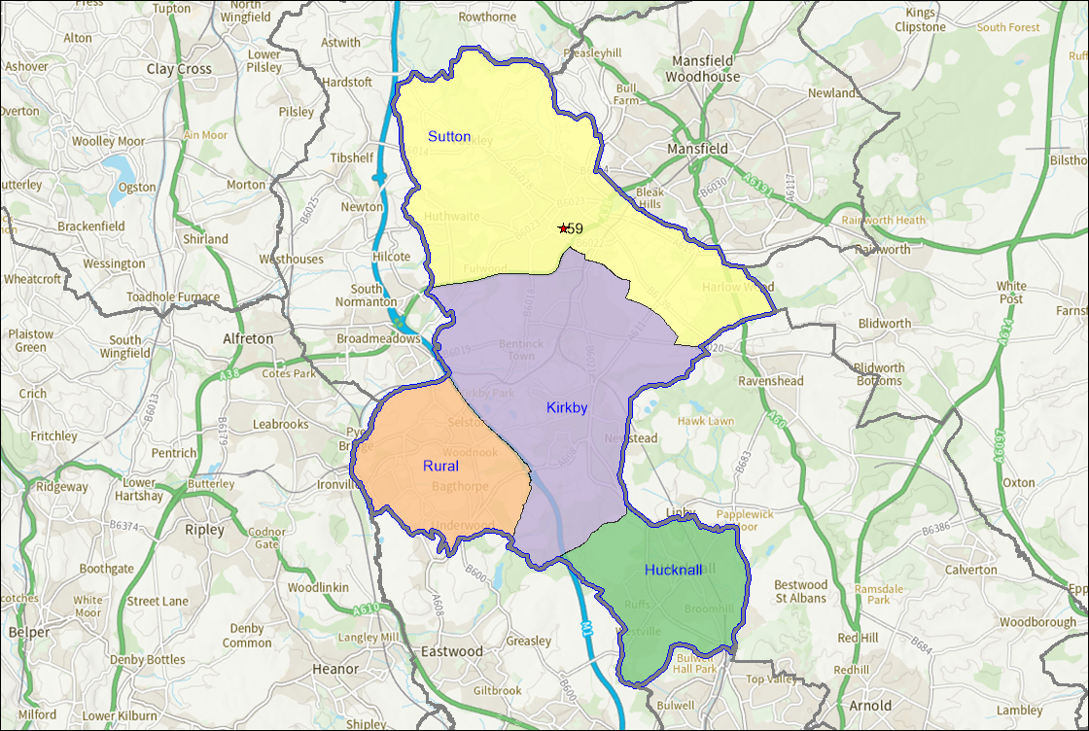

Table 3.17 Full size 3G AGP provision in Ashfield
Site Name | PPS Site ID | Sub Area | Management Type | Floodlit | Size (m) | AGP - Surface Type | Year Built/ Refurbished | Certification | AGP - Hours available to the community
Sutton Lawn | 59 | Sutton | School/ College/ University (in house) | Yes | 105x70 | Medium Pile | 2009 | FA Approved (expires 31/05/2024) | Monday-Friday 17:30 - 22:00  Weekend 08:30 - 22:00

Figure 3.3 Small Size AGP provision in Ashfield
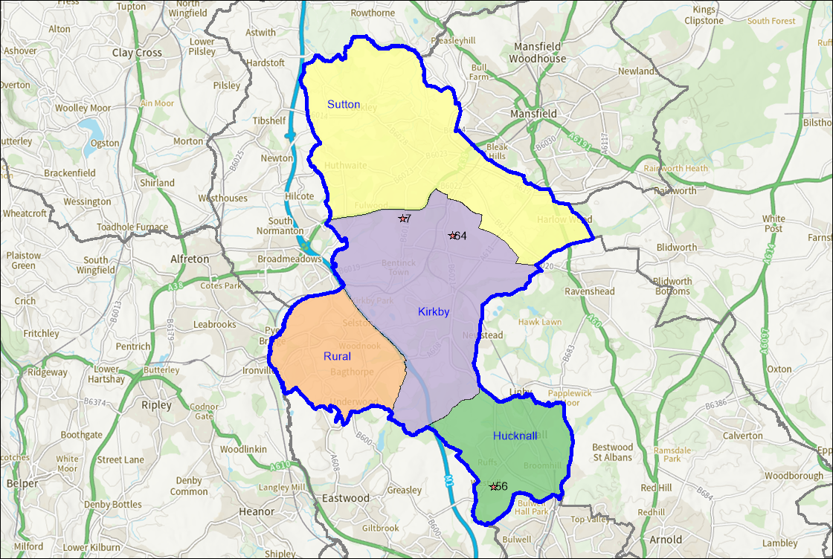

- The numbers in the figure relate to the PPS site ID in Table 3.24 provides an overview of smaller sized 3G pitches in Ashfield.

Table 3.18 Smaller Sized 3G AGP provision in Ashfield

Site Name | PPS Site ID | Sub Area | Management Type | Floodlit | Size (m) | AGP - Surface Type | Year Built/ Refurbished | Certification | AGP - Hours available to the community
Ashfield School | 7 | Kirkby | School/ College/ University (in house) | Yes | 70x50 | Medium Pile | Unknown | None | Not available for community use.
Rolls Royce Fitness Centre Hucknall | 56 | Hucknall | Commercial Management | Yes | 68x30 | Medium Pile | Unknown | None | Every day 09:00 - 22:00
The Summit Centre | 64 | Kirkby | Trust | Yes | 44x20 | Medium Pile | Unknown | None | Every day 09:00 - 22:00

Future provision
- The Ashfield LFFP identified a need for 3 additional full size floodlit adult 11 v 11 3G AGPs and 3 floodlit small sized 3G AGPs.
- As part of a development project the existing 3G AGP at Sutton Lawn will be extended and refurbished and a second full size 3G AGP will be provided. The proposal will also include the development of the changing pavilion to support this provision. Ashfield RUFC are also looking to develop a small sized 3G AGP at their Larwood Park site.

3G Pitch Register
- In order for competitive matches to be played on 3G pitches, the pitch should be FIFA or IMS tested and approved and added to the FA pitch register, which can be found at: Football Foundation | 3G Pitch Register.
- Pitches undergo testing to become a FIFA Quality pitch or a FIFA Quality Pro pitch with pitches commonly constructed, installed and tested in situ to achieve either accreditation.
- There is one full size 3G AGP in Ashfield currently on the 3G Pitch Register, which is the pitch at Sutton Lawn.

Availability of pitches
- Table 3.22 on the previous page shows the availability of full size 3G AGPs for community use.

Quality
- 3G AGPs typically have a life span of 8-12 years depending on levels of use and maintenance. It is recommended that a 3G AGP has a sinking fund in place so that it can be resurfaced when needed.
- All full size 3G AGPs in Ashfield were visited and assessed using FA guidance to determine their quality. 3G AGPs were rated as follows:
Good (81% or above);

Standard (51%-80%);

Poor (50% or below).

- Table 3.19 provides an overview of full size 3G AGP pitch quality.

Table 3.19 3G AGP pitch quality in Ashfield
Site Name | PPS Site ID | Sub Area | Year built / refurbed | Quality rating
Sutton Lawn | 59 | Sutton | 2009 | Standard
- The only full size 3G AGP in Ashfield was assessed as being of standard quality. IT is assumed that this pitch will become a good quality pitch when it is resurfaced as part of the Sutton Lawn project.

Ancillary provision
- The 3G AGP at Sutton Lawn is also supported by ancillary provision which was assessed as standard. The height of the fencing at Sutton Lawn was considered too low to effectively discourage trespassing on to the pitch.

Supply and demand of 3G AGPs
- The FA has a long-term aspiration to provide every team in the country with access to a 1 hour training slot on a 3G pitch each week.
- The FA calculate that one full size 3G AGP can support up to 38 teams. This methodology has been applied to Table 3.20 to look at current team numbers and 3G AGP requirements, along with future requirements based upon TGRs previously calculate.

Table 3.20 Supply and demand of 3G AGPs in Ashfield
Current team numbers | Current requirement for 3G AGPs | Current full size 3G AGPs | Current shortfall of 3G AGPs | Future team numbers | Future requirement for 3G AGPs | Future shortfall for 3G AGPs
161 | 4 (rounded down from 4.2) | 1 | 3 | 165 | 4 (rounded down from 4.3) | 3

- The Ashfield LFFP stated there was a need for 3 full size 3G AGPs, so nothing has changed since the LFFP was produced regarding 3G AGP demand in the area.

Summary

3G AGPs
- There are currently four 3G AGPs in Ashfield across four sites. One of these pitches is deemed to be full size whilst three are considered smaller sized. There are three 3G AGPs currently available for community use in Ashfield. The 3G AGP at Ashfield School in the only one not currently available for community use
- Sutton Community Academy are currently working with Ashfield District Council to resurface and extend the existing 3G AGP at Sutton Lawn and provide a second full size pitch on the site. These proposals also include developing the changing pavilion. Ashfield RUFC are also looking to develop a small sized 3G AGP at their Larwood Park site;
- The only 3G AGP in Ashfield that is currently on the FA 3G Pitch Register is the pitch at Sutton Lawn.
- All full 3G AGPs in Ashfield available for community use are currently at capacity;
- The full size 3G AGP was assessed as being of standard quality.
- The Sutton Lawn site providing the full size AGP also provides ancillary provision which was assessed as standard.
- There is currently demand for 3 additional 3G AGPs in Ashfield. This doesn’t increase when future demand is considered.

4. Rugby Union

Introduction
- The Rugby Football Union (RFU) is the governing body which oversees the governance and development of rugby within Ashfield. They work locally to deliver the RFU’s England Rugby Strategy. (Click here for the England Rugby Strategy)
- The vision of the Strategy is to create a successful and thriving game across England. In order to achieve this there are 3 guiding principles, Player First, Open to All and Financially Strong.
- The strategy has 4 strategic priorities under the heading of Game Objectives, these are;
- Enjoyment – enable positive player experiences on and off the field;
- Winning England – create the best possible high-performance system for England Rugby;
- Welfare – enhance player welfare to protect and support the wellbeing of players;
- Flouring Rugby Communities – support clubs to grow and sustain themselves and reflect society.
- There are a further 4 strategic priorities under the heading of Driving Objectives, these are;
- Diversity and Inclusion - Drive rugby union in England to reflect the diversity of society;
- Understand - build a deep understanding of players, volunteers and fans to shape the future of the game;
- Connect - connect with and grow the rugby community and create exceptional experiences;
- Commercial and Operational Excellence – Ensure a sustainable and efficient business model delivered by an inspired workforce.

Consultation
- There is currently one rugby club in Ashfield with a total of 16 teams. Ashfield Rugby Club responded to the consultation, which represents a 100% response rate.

Supply
- There are currently 8 rugby pitches identified within Ashfield across 6 sites. There are 3 senior rugby pitches, 4 junior rugby pitches and 1 mini pitch.
- Figure 4.1 shows a map of rugby pitch provision within Ashfield. The numbers in the figure relate to the PPS site ID in table 4.1.
- Each of the sub areas is served by at least one rugby pitch.

Figure 4.1 Supply of rugby pitches in Ashfield.
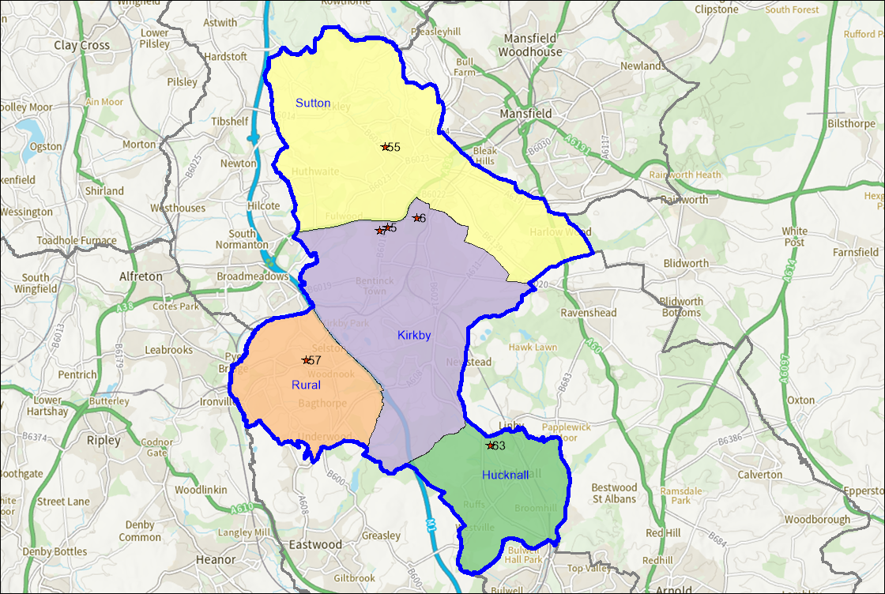
- There are currently 4 rugby pitches available for community use in Ashfield. The remaining pitches are all located on school sites.
- Table 4.1 provides an overview of rugby pitch provision in Ashfield.

Table 4.1 Overview of rugby pitch provision
Site Name | PPS  Site ID | Pitch Type | Community Use
Ashfield RUFC (Larwood Park) | 5 | Junior Rugby Union | Available for community use and used
Ashfield RUFC (Larwood Park) | 5 | Senior Rugby Union | Available for community use and used
Ashfield RUFC (Penny Emma) | 6 | Junior Rugby Union | Available for community use and used
Ashfield RUFC (Penny Emma) | 6 | Junior Rugby Union | Available for community use and used
Ashfield School | 7 | Senior Rugby Union | Not available for community use
Quarrydale Academy | 55 | Mini Rugby Union | Not available for community use
Quarrydale Academy | 55 | Junior Rugby Union | Not available for community use
Selston High School | 57 | Senior Rugby Union | Not available for community use
The National C of E Academy | 63 | Junior Rugby Union | Not available for community use

Future supply
- Ashfield RUFC has plans to improve its facilities by adding a small sized artificial grass pitch (AGP), at Larwood Park. Planning has been approved for a similar facility at the site and the club are currently securing funding. It is anticipated that the scheme will be completed during 2023-2024.

Disused and lapsed sites
- A site that hasn’t been used for five years or longer and now falls outside of Sport England’s statutory remit but is still assessed using the criteria within Paragraph 99 of National Planning Policy Framework. Sport England' applies its policy to any land in use as playing field or last used as playing field and which remains undeveloped, irrespective of whether that use ceased more than five years ago. Lack of use should not be seen as necessarily indicating an absence of need for playing fields in the locality. Such land can retain the potential to provide playing pitches to meet current or future needs.
- There is a disused junior rugby pitch at Brierly Forest Park and a disused mini rugby pitch at Woodland View Primary School.

Security of tenure
- Ashfield RFC currently own the freehold for their site; therefore, tenure is deemed secured.

Quality
- All sites that contain marked out rugby pitches in Ashfield were visited and assessed using the non-technical assessment criteria provided by the RFU.
- This criteria has two key areas, maintenance carried out on pitches and drainage that exists on pitches. These are then combined in conjunction with consultation carried out to determine the quality of the pitches, which are categorised as follows:
- Table 4.2 shows the RFU’s rugby pitch maintenance criteria.

Table 4.2 Rugby pitch maintenance criteria
Rating | Description
M0 | Action is significant improvements to maintenance programme
M1 | Action is minor improvements to maintenance programme
M2 | Action is no improvement to maintenance programme

- Table 4.3 shows the RFU’s rugby pitch drainage criteria.

Table 4.3 Rugby pitch drainage criteria
Rating | Description
D0 | Action is pipe drainage system needed on pitch
D1 | Action is pipe and slit drainage needed on pitch
D2 | Action is slit drainage needed on pitch
D3 | No action needed on pitch drainage

- Table 4.4 show how the 2 elements are combined to generate a quality rating for rugby pitches.

Table 4.4 Ruby pitch quality based on maintenance and drainage scores
Drainage | M0 – Poor (MES) | M1 – Standard (MES) | M2 – Good (MES)
D0 | 0.5 | 1.5 | 2
D1 | 1.5 | 2 | 3
D2 | 1.75 | 2.5 | 3.25
D3 | 2 | 3 | 3.5

- The RFU have developed a partnership with the Grounds Management Association (GMA). This enables clubs to complete a self-assessment of their pitches using the Pitch Power app. This provides clubs with a report completed by a GMA Regional Pitch Advisor who assesses each pitch using a performance quality standard (PQS). Clubs also receive advice on how to improve pitch quality through improved maintenance practises. This process will be used in the future to assess the quality of rugby union pitches for PPSs. There are no rugby clubs in Ashfield that have accessed this service yet, but the RFU will be supporting clubs to do so in due course.
- The RFU provides guidance on pitch sizes for the various age group who play rugby. Table 4.5 shows the relevant pitches sizes for each age group.

Table 4.5 Rugby pitch dimensions
Age group | Pitch type | Pitch Size (maximum in metres)
U7 | Mini | 20 x 12
U8 | Mini | 45 x 22
U9 | Mini | 60 x 30
U10 | Mini | 60 x 35
U11 | Mini | 60 x 43
U12 | Mini | 60 x 43
U13 | Junior | 90 x 60 (boy’s) 60 x 43 (girl’s)
U14 + | Senior | 100 x70

- Rugby pitches have been graded as follows based on the site assessments:
Good (11 - 5);

Standard (6 - 10);

Poor (0 - 5).

- Table 4.6 provides an overview of rugby pitch quality score in Ashfield on a site by site basis.

Table 4.6 Rugby pitch quality in Ashfield
Site Name | PPS Site ID | Pitch Type | Floodlights | Community Use | Quality Rating | Drainage/ Maintenance Score
Ashfield RUFC(Larwood Park) | 5 | Junior Rugby Union | No | Available for community use and used | Standard | D0/M1
Ashfield RUFC (Larwood Park) | 5 | Senior Rugby Union | No | Available for community use and used | Standard | D0/M1
Ashfield RUFC (Penny Emma) | 6 | Junior Rugby Union | No | Available for community use and used | Standard | D0/M1
Ashfield RUFC (Penny Emma) | 6 | Junior Rugby union | No | Available for community use and used | Standard | D0/M1
Ashfield School | 7 | Senior Rugby Union | No | Not available for community use | Poor | D0/M0
Quarrydale Academy | 55 | Mini Rugby Union | No | Not available for community use | Poor | D1/M0
Quarrydale Academy | 55 | Junior Rugby Union | No | Not available for community use | Poor | D1/M0
Selston High School | 57 | Senior Rugby Union | No | Not available for community use | Poor | D0/M0
The National C Of E Academy | 63 | Junior Rugby Union | No | Not available for community use | Poor | D0/M0

- Five rugby pitches in Ashfield were assessed as poor and four were assessed as standard.
- In terms of rugby pitches used by clubs, the rugby pitches used by Ashfield RUFC at Larwood Park were assessed as standard. The club reported issues with freezing and waterlogging during the winter season. The club also use the site on Penny Emma Way for training and as an overspill for matches when they have capacity issues at Larwood Park. The pitches at this site were also assessed as standard.

Ancillary provision
- An assessment of ancillary provision was only undertaken at Larwood Park. The grading criteria for Ancillary provision is as follows:
- Good;
- Standard;
- Poor.
- The assessment of ancillary provision focuses on the changing room provision provided if there are floodlit pitches available and the adequacy of car parking on site.
- Table 4.7 provides an overview of ancillary provision scores at sites that provide rugby pitches available for community use in Ashfield.

Table 4.7 Ancillary provision at rugby pitch sites
Site Name | PPS Site ID | Ancillary quality rating
Ashfield (RUFC (Larwood Park) | 5 | Good
Ashfield RUFC (Penny Emma Way) | 6 | Poor

- Half of a pitch at Ashfield RUFC (Penny Emma Way) was noted to be floodlit. The ancillary facilities at this site were assessed as poor. Ashfield RFC reported plans to upgrade the ancillary facilities at the Penny Emma Way site in the future. The ancillary facilities at Ashfield RFC Larwood Park were assessed as good.

Demand
- Ashfield RUFC is the only rugby club in Ashfield, they currently have 16 teams. Table 4.8 provides an overview of the number of teams each club has at the various age groups and if team numbers have increased, decreased or stayed the same during the last 3 years.

Table 4.8 Rugby club demand in Ashfield
Club Name | PPS Site ID | Senior Men’s teams | Senior Women’s teams | Junior Boy’s teams | Junior Girl’s teams | Mini teams | Team Trend (last 3 years)
Ashfield RUFC | 5 | 2 | 1 | 5 | 1 | 5 | Decreases in Seniors; U13-17 and U18-19s; whilst numbers in the mini/midi teams (U7-U12) have stayed the same.

- During the consultation the rugby club reported that the decrease in senior teams was as a result of Covid. Decreases in the youth and Colts section were due to a lack of coaches.

Imported demand
- Imported demand refers to demand that accesses provision within the study area from but comes from outside this. This could be due to a lack of provision, or the cost of accessing facilities within their own area.
- There is currently no imported rugby demand in Ashfield.

Exported demand
- Exported demand refers to demand from the study area that is being met within another Local Authority. This could be due to a lack of provision, or the cost of accessing facilities.
- There is currently no exported demand from Ashfield to other Local Authority areas.

Latent demand
- Latent demand refers to demand that exists, but that isn’t being met due to barriers such as a lack of facilities.
- Through the consultation Ashfield RUFC reported that they do use another club facility at Penny Emma Way, predominantly for training, although it is used as an overspill for fixtures. The club reported that the pitch and ancillary facilities there are sub-standard. They also stated that if there was more pitch capacity on site, they would look to increase the number of senior men’s teams.

Future demand
- Future demand can be developed in two ways, clubs may actively try to increase their team numbers in order to grow their club. This may be supported by the relevant NGB through funded programmes, or support to help deliver objectives within their strategy.
- As mentioned, Ashfield RUFC has plans to grow interest in the game through funded developments, with a focus on developing 2 new senior men’s teams.

Team Generation Rates
- Another way that future demand can be calculated is by looking at population forecasts and how these impact upon Team Generation Rates (TGRs).
- Future population forecasts have been developed by calculating future growth from ONS data (Click here for ONS population projections by single year of age). These have been developed to show the overall growth across Ashfield up to 2038 in line with the draft Local Plan. TGRs have been rounded down to the nearest whole number.

- Table 4.9 provides an overview of TGRs for rugby teams in Ashfield.

Table 4.9 TGRs for rugby teams in Ashfield
Sport and Age Groups | Number of teams in age group within the area | Current population in age group within the area | Future population in age group within the area | Current TGR | Population change in age group | Potential increase in Team Numbers in Age Group
Rugby Union Senior Men (19-45yrs) | 2 | 21054 | 23605 | 10527 | 2551 | 0
Rugby Union Senior Women (19-45yrs) | 1 | 22102 | 23909 | 22102 | 1807 | 0
Rugby Union Youth Boys (13-18yrs) | 5 | 4695 | 4941 | 939 | 246 | 0
Rugby Union Youth Girls (13-18yrs) | 1 | 4426 | 4715 | 4426 | 288 | 0
Rugby Union Mini/Midi Mixed (7-12yrs) | 5 | 9931 | 9403 | 1986 | -528 | 0

- In total there will be NIL new rugby teams created within Ashfield based on future population growth. It is worth noting that these figures don’t take into account specific work or programmes delivered by clubs or NGBs in order to increase participation in the sport.

Understanding the situation at individual sites
- Capacity on rugby pitches is measured in Match Equivalent Sessions (MES), which is impacted upon by the quality of the pitch. The RFU provides guidance on the number of matches per week that a pitch can accommodate based upon its quality. For example, if a pitch was assessed as D1/M0 (Poor), it would have capacity for 1.5 matches per week. This is shown in table 4.10 for senior rugby pitches.

Table 4.10 RFU pitch capacity guidance
Drainage | M0 – Poor (MES) | M1 – Standard (MES) | M2 – Good (MES)
D0 | 0.5 | 1.5 | 2
D1 | 1.5 | 2 | 3
D2 | 1.75 | 2.5 | 3.25
D3 | 2 | 3 | 3.5

- For match play 0.5 MES has been allocated to each team who use a pitch based on teams playing home and ways fixtures.
- Capacity will also be impacted by clubs using pitches for training. Where this is the case 0.5 MES has been attributed to senior and youth rugby teams and 0.25 MES for mini teams when training on senior pitches.
- Educational sites have had 1 MES applied to each pitch type to allow for the various year groups that may use the pitch in any given week during the season. This has been further adjusted if there is also known extra-curricular use of the pitches at the site. This has been factored into the analysis in table 4.11 overleaf.

Peak Demand
- Peak demand for rugby in Ashfield is deemed to be as follows:
- Senior Men’s – Saturday afternoon;
- Senior Women’s – Sunday afternoon;
- Juniors – Sunday morning;
- Minis – Sunday morning.

- Table 4.11 shows capacity analysis of rugby pitches in Ashfield based on the criteria set out above.

Table 4.11 Capacity of rugby pitches in Ashfield
Site Name | PPS Site ID | Pitch Type | Number of Pitches | Sports Lighting | Community use category | Quality Rating | Drainage/ Maintenance Score | Capacity (MES) | Match Play (MES per week) | Training (per week) | Balance (MES per week)
Ashfield RUFC (Larwood Park) | 5 | Senior Rugby Union | 2 | No | Available for community use and used | Standard | D0/M1 | 3 | 6.5 | 5 | -8.5
Ashfield RUFC (Penny Emma) | 6 | Junior Rugby Union | 2 | Half a pitch | Available for community use and used | Standard | D0/M1 | 3 | 1 | 16 | -14
Ashfield School | 7 | Senior Rugby Union | 1 | No | Not available for community use | Poor | D0/M0 | 0.5 | 1 | 1 | -1.5
Quarrydale Academy | 55 | Mini Rugby Union | 1 | No | Not available for community use | Poor | D1/M0 | 1.5 | 1 | 1 | -0.5
Quarrydale Academy | 55 | Junior Rugby Union | 1 | No | Not available for community use | Poor | D1/M0 | 1.5 | 1 | 1 | -0.5
Selston High School | 57 | Senior Rugby Union | 1 | No | Not available for community use | Poor | D0/M0 | 0.5 | 1 | 1 | -1.5
The National C of E Academy | 63 | Junior Rugby Union | 1 | No | Not available for community use | Poor | D0/M0 | 0.5 | 1 | 1 | -1.5

Actual spare capacity
- There are no sites in Ashfield that with rugby pitches with potential spare capacity. All rugby pitches in Ashfield are currently overplayed.

Overplay
- Overplay occurs when a pitch facilitates more use than its recommended carrying capacity. This can be a result of the pitch having a low carrying capacity or teams simply playing more than the recommended number of fixtures the pitch can accommodate. Overplay can directly impact upon the quality of a pitch.
- Table 4.11 shows sites containing rugby pitches in Ashfield that are overplayed and show by how many MES they are overplayed.
- There is overplay totalling 28 MES at rugby sites in Ashfield. The highest amount of overplay at present is at Ashfield RUFC which accounts for 14 MES of overplay on rugby pitches. Ashfield RUFC (Larwood Park) also has 8.5 MES of overplay per week at present. The two sites used by Ashfield RUFC account for 80% of all overplay on rugby pitches in Ashfield.

Key issues and findings
- There are current shortfalls of 11.5 MES on senior rugby pitches in Ashfield, these aren’t impacted by future demand as no growth in rugby teams was forecast when looking at TGRs.
- Table 4.12 provides an overview of the supply and demand balance of senior rugby pitches in Ashfield, taking in to account current and future demand. Future demand is based on TGRs.

Table 4.12 Supply and demand of senior rugby pitches in Ashfield
Actual spare capacity (MES) | Overplay (MES) | Current total (MES) | Future Demand (MES) | Future Total (MES)
0 | 11.5 | -11.5 | 0 | -11.5

- Given the shortfalls that exist, priority should be given to improving the capacity on existing rugby pitch sites through better maintenance and drainage of pitches. This will be supported through the RFU’s new partnership with the GMA.
- Thought could also be given to the provision of World Rugby compliant 3G AGPs, which could provide additional capacity, especially for midweek training.
- The RFU are also looking to support clubs with capacity issues by installing additional floodlighting at sites to help with midweek training.

Summary

Rugby
- There are currently 9 rugby pitches within Ashfield across 7 sites. There are 4 senior rugby pitches, 4 junior rugby pitches and 1 mini pitch;
- The pitches are split between those provided by Ashfield RFC (4 pitches) and those pitches on education sites (5 pitches);
- The 4 rugby pitches located at Ashfield RUFC sites are available for community use. The others are not and are all located on school sites;
- Of the 9 rugby pitches in Ashfield, 5 were assessed as poor quality and 4 were assessed as standard. The disused pitch at the country park site was not assessed. No pitches were assessed as good;
- Ancillary facilities at Ashfield RUFC (Larwood Park) were accessed as good quality. The ancillary at Ashfield RUFC on Penny Emma Way were assessed as poor;
- Team generation rates (TGRs) forecast no future growth for rugby teams in Ashfield based on population growth;
- Ashfield RFC reported a desire to grow 2 senior men’s teams in the future;
- There are no rugby pitch sites in Ashfield that have actual spare capacity at present;
- There is overplay totalling 28 MES at rugby sites in Ashfield. The highest amount of overplay at present is at Ashfield RUFC which accounts for 14 MES of overplay on rugby pitches. Ashfield RUFC (Larwood Park) also has 8.5 MES of overplay per week at present. The two sites used by Ashfield RUFC account for 80% of all overplay on rugby pitches in Ashfield;
- There are current shortfalls of 11.5 MES on senior rugby pitches in Ashfield, these aren’t impacted by future demand as no growth in rugby teams was forecast when looking at TGRs.

3G AGPs
- Competitive full contact (includes tackling, rucking, mauling and lineouts) rugby can be played on 3G AGPs providing they meet the World Rugby (WR) ‘Performance Specification for Artificial Grass Pitches for Rugby’, more commonly known as ‘Regulation 22’. This provides the necessary technical detail to produce pitch systems that are appropriate for rugby. The artificial surface standards identified in Regulation 22 allows matches to be played on surfaces that meet the standard. All full size World Rugby compliant 3G pitches need to be tested to feature on the RFU register. Pitches remain on the register for 2 years, after this point they need to be retested to continue to appear on the register. To meet this, standard pitches must include a shock pad as shown below in the first bullet.
- 3G AGPs fall under 3 different categories:
      - Long Pile 3G (60mm with a shock pad for rugby);
      - Medium Pile 3G (55mm – 60mm);
      - Short Pile 3G (40mm).

Supply
- There aren’t currently any 3G AGPs in Ashfield that meet the requirements for Regulation 22.

Future supply
- No future rugby 3G AGPs have been identified at present. Ashfield Rugby Club are looking to develop a small sized 3G AGP on their Larwood Park site, but this won’t be Regulation 22 compliant so will only be suitable for non-contact training.

5. Hockey

Introduction
- England Hockey is the governing body for hockey which works to develop all facets of the game within Ashfield. This includes delivering the England Hockey Strategy, entitled ‘A Nation Where Hockey Matters’. It should be noted that England Hockey are currently developing a new strategy and the previous strategy isn’t available on their website.

A Nation Where Hockey Matters
- The Strategy sets out 5 key aims:
            - Grow participation:
- Grow the number of adults playing regularly in our club network;
- Grow the number of young people playing hockey in schools and clubs;
- Grow the numbers of adults and young people playing informal hockey.
            - Deliver international success:
- Review and refine our world-class senior environment to continue to challenge for medals at world level;
- Ensure the single system continues to be an effective developmental pathway.
            - Increase visibility:
- Deliver an annual programme of events to provide opportunities to watch high quality hockey;
- Stage more international hockey matches and tournaments;
- Secure more TV coverage for our sport;
- Increase our brand equity and change the mainstream perceived view of our sport.
            - Enhance our infrastructure:
- Develop and implement strategies for clubs, facilities, volunteers and umpires;
- Develop and implement a strategy for coaching.
            - Be a strong and respected governing body:
- Grow sponsorship and non-grant income;
- Listen our members and customers to deliver improved experiences;
- Become recognised as a leading governing body both nationally and internationally.

Consultation
- There are currently 3 hockey clubs in Ashfield, Mansfield Hockey Club, Ashfield Aztecs Ladies Hockey Club and Mansfield Aztecs Juniors, who are affiliated to the Mansfield Hockey Club. Between the three clubs there are a total of 14 teams. All clubs responded to the consultation which represents a 100% response rate.

Supply
- Hockey is solely played on Artificial Grass Pitches (AGPs) for both training and match play. There are different specifications of AGP that can facilitate different levels of play.
- England Hockey Policy Guidance on AGPs (Artificial Grass Pitch Surface Policy 2016) identifies 4 categories:
- Category 1 - Water Based (suitable for international hockey fixtures and training as well as Domestic National Premier competition);
- Category 2- Sand Dressed (acceptable for Domestic National Premier competition and all other formats of the game);
- Category 3 - Sand Filled (suitable for adult and junior club training at league fixtures. Also suitable for school fixtures);
- Category 4 – Long Pile 3G (only acceptable for introductory level hockey. Often used for football).
- There are currently no AGPs in Ashfield that meet categories 1 or 2 as set out above.
- There are 3 sites that contain pitches that meet category 3, although the pitch at Quarrydale Academy doesn’t have floodlights.
- There are 3 sites within Ashfield that currently provide smaller sized AGPs.
- Figure 5.1 shows where all AGPs are located within Ashfield. The numbers in the figure relate to the PPS site ID in tables 5.1 and 5.2.
- There is no hockey provision in the Rural sub area.

Figure 5.1 Supply of hockey AGPs
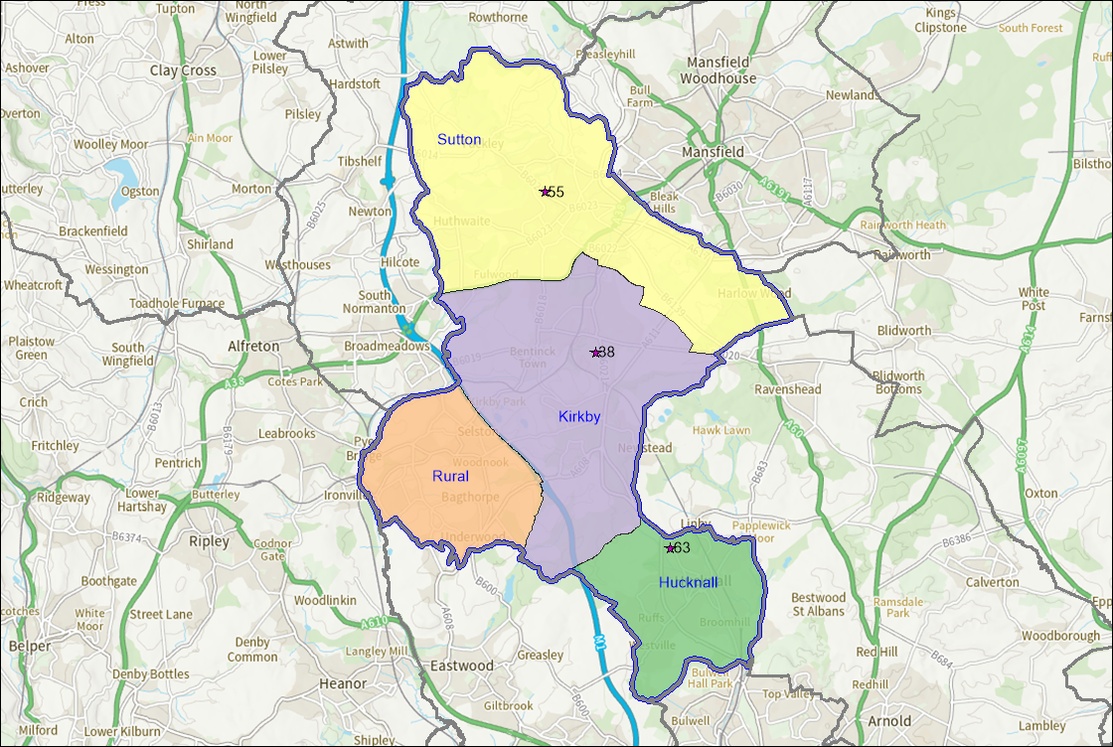

- All club hockey in Ashfield currently takes place at Kingsway Park, Kirkby.
- Table 5.1 provides an overview of full-size hockey AGP provision in Ashfield that is suitable for hockey.

Table 5.1 Full size AGPs in Ashfield
Site Name | PPS Site ID | Sub Area | Floodlights | AGP Length (m) | AGP Width (m) | Surface | Community Use Category
Kingsway Park | 38 | Kirkby | Yes | 100 | 65 | Sand filled | Available for community use and used
Quarrydale Academy | 55 | Sutton | Yes | 97 | 60 | Sand filled | Available for community use and used
The National  C of E Academy | 63 | Hucknall | Yes | 102 | 60 | Sand filled | Available for community use and used

- There are also a number of smaller sized AGPs in Ashfield, an overview of which has been provided in table 5.2.

Table 5.2 Smaller sized AGPs in Ashfield
Site Name | PPS Site ID | Sub Area | Floodlights | AGP Length (m) | AGP Width (m) | Surface | Community Use Category
Abbey Hill Primary School | 1 | Kirkby | No | 43 | 25 | Sand filled | Not available for community use
Leamington Primary And Nursery Academy | 42 | Sutton | No | 35 | 17 | Sand filled | Not available for community use
Selston High School | 58 | Rural | Yes | 35 | 19 | Sand filled | Available for community use and used

Lapsed and disused AGPs
- A site that hasn’t been used for five years or longer and now falls outside of Sport England’s statutory remit but is still assessed using the criteria within Paragraph 99 of National Planning Policy Framework. Sport England' applies its policy to any land in use as playing field or last used as playing field and which remains undeveloped, irrespective of whether that use ceased more than five years ago. Lack of use should not be seen as necessarily indicating an absence of need for playing fields in the locality. Such land can retain the potential to provide playing pitches to meet current or future needs.
- There are no lapsed AGP sites in Ashfield.

Security of tenure and management
- Tenure at a site is deemed to be secured if the club has confirmed use of the site for the next three years. Where AGPs are located on Local Authority, Parish or Town Council sites, tenure is generally deemed to be secured.
- Tenure is generally deemed to be unsecured at educational sites, unless known otherwise. Whilst educational sites may provide community use of their facilities, this could be stopped at short notice.
- All hockey provision in Ashfield takes place at Kingsway Park where tenure is deemed to be secured.

Quality
- All sites containing AGPs suitable for hockey were visited and assessed using the non-technical assessment criteria provided by England Hockey. This was overlayed with information gathered during the consultation phase.
- AGPs are rated as follows based on the assessment:
Good (80% or above);

Standard (51%-79%);

Poor (50% or below).

- Table 5.3 provides an overview of how hockey AGPs scored when they were assessed. Where known, it also states when a surface was laid or refurbished. The quality of a hockey AGP is impacted by the age of the surface, how well used it is and how robust the maintenance programme is.

Table 5.3 Quality of Hockey AGPs in Ashfield
Site Name | PPS site ID | Number of pitches | Year built / refurbished | Community use category | Rating
Abbey Hill Primary School | 1 | 1 | Unknown | Available for community use and used | Unknown
Kingsway Park | 38 | 1 | 2015 | Available for community use and used | Standard
Leamington Primary And Nursery Academy | 42 | 1 | 5-10 years | Available for community use and used | Standard
Quarrydale Academy | 55 | 1 | 1987 | Available for community use and used | Poor
Selston High School | 58 | 1 | 2011 | Available for community use | Standard
The National  C of E Academy | 63 | 1 | Unknown | Available for community use and used | Standard

- All club hockey provision currently takes place at Kingsway Park. The pitch there was assessed as standard. Some of the clubs reported evidence of moss/lichen (all surface) and rips in the pitch surface.
- There were no hockey AGPs that were assessed as good in Ashfield.

Floodlighting
- Floodlighting allows for AGPs to be used for training throughout the winter months. AGP facilities at Kingsway Park, Quarrydale Academy and Selston High School are currently floodlit. Whilst the AGP at Quarrydale Academy does have floodlights, they were out of use during the site assessment. Consultation conducted with the school identified that the floodlights won’t be repaired or replaced until the surface is re-laid. There are currently no timeframes in place for this to be completed. This impacts community use of the pitch.
- Floodlit pitches are shown in tables 5.1 and 5.2.

Ancillary provision
- Ancillary provision at hockey club sites was also assessed as part of the site visits. The assessment looks at changing rooms for players and officials (including showers and toilets), provision of player and spectator toilets, catering provision and whether or not facilities are compliant with the Equality Act. Car parking provision is also considered.

Table 5.4 Ancillary provision at Hockey Club sites
Site Name | PPS Site ID | Sub Area | Community use category | Rating
Kingsway Park | 38 | Kirkby | Available for community use and used | Standard

Demand
- There are currently three hockey clubs based in Ashfield who between them have 14 teams. An overview of their teams in the various categories has been provided in table 5.5 below. This also shows if their team numbers have increased, decreased or stayed the same in the last three years.

Table 5.5 Hockey teams in Ashfield
Club Name | Senior Men’s Teams | Senior Women’s Teams | Junior / Mini Boy’s Teams | Junior / Mini Girl’s Teams | Team Trends (Last 3 years)
Mansfield Hockey Club | 5 | 0 | 0 | 0 | Seniors increased
Ashfield Aztecs Ladies Hockey Club | 0 | 4 | 0 | 0 | Seniors stayed the same; juniors have increased
Mansfield Aztecs Juniors | 0 | 0 | 5 | 0 | Juniors increased
Total | 5 | 4 | 5 | 0

- At present senior hockey teams account for 64% of hockey demand in Ashfield.

Imported demand
- Imported demand is demand that comes from outside of the study area to access provision, because there is a lack of provision or barriers to accessing provision where they are located.
- There are no hockey clubs from outside Ashfield that currently use facilities within the Local Authority area.

Exported demand
- Exported demand is demand that can’t be catered for within the study area and therefore takes place outside of this.
- There is no exported demand from hockey clubs in Ashfield to other Local Authority areas.

Unmet demand
- Unmet demand refers to demand that exists but can’t be catered for due to a lack of available provision.
- No clubs in Ashfield reported any unmet demand through the consultation.

Future Demand
- Future demand can be developed in two ways, clubs may actively try to increase their team numbers in order to grow their club. This may be supported by the relevant NGB through funded programmes, or support to help deliver objectives within their strategy.
- Table 5.6 shows clubs who reported plans to grow their team numbers.

Table 5.6 Reported hockey club growth
Club Name | Senior Men’s Teams | Senior Women’s Teams | Junior / Mini Boy’s Teams | Junior / Mini Girl’s Teams
Mansfield Hockey Club | 1 | 1 | 1 | 1
Ashfield Aztecs Ladies Hockey Club | 0 | 0 | 0 | 1
Total | 1 | 1 | 1 | 2

- England Hockey currently run a number of programmes to help clubs engage with the local community and develop their membership.

Hockey Heroes
- Hockey Heroes is a fun and welcoming programme aimed at children aged 5-8. It offers an 8 week course for beginners, which is designed to help them develop the basic skills required for hockey such as dribbling, passing and shooting in a fun environment.
- There are currently no Hockey Heroes programmes being delivered in Ashfield.

Walking Hockey
- Walking Hockey is designed for people who still wish to take part in the game but want to play at a far less demanding pace. Walking Hockey sessions are often delivered by local clubs.
- There are no walking hockey sessions currently being delivered in Ashfield.

Back to Hockey
- Back to Hockey is aimed at people of any age or ability, who want to play hockey in a fun environment. Sessions are aimed at developing skills and providing opportunities to take part in small-sided games. There is also an emphasis on socialising and meeting new people.
- There are no Back to Hockey sessions currently being delivered in Ashfield.

Team Generation Rates (TGRs)
- Another way that future demand can be calculated is by looking at population forecasts and how these impact upon Team Generation Rates (TGRs).
- Future population forecasts have been developed by calculating future growth from ONS data (Click here for ONS population projections by single year of age) Potential changes in team numbers have been rounded down to the nearest whole number.
- Table 5.7 provides an overview of TGRs for hockey teams in Ashfield.

Table 5.7 TGRs for hockey teams in Ashfield
Sport and Age Groups | Number of teams in age group within the area | Current population in age group within the area (2022) | Future population in age group within the area (2038) | Current TGR | Population Change in Age Group | Potential Change in Team Numbers in Age Group
Hockey Senior Men (16-55yrs) | 5 | 32066 | 35414 | 6413 | 3347 | 0
Hockey Senior Women (16-55yrs) | 4 | 33223 | 36309 | 8306 | 3086 | 0
Hockey Junior Boy’s (11-15yrs) | 5 | 4072 | 4056 | 814 | -16 | 0
Hockey Junior Girl’s (11-15yrs) | 0 | 4018 | 3916 | 0 | -102 | 0

- Table 5.7 shows that there is NIL demand for additional hockey teams in Ashfield up to 2038.
- It is worth noting that these figures don’t take in to account any specific work that might be carried out by clubs or the NGB in the future to increase participation in the sport.
- TGRs for junior teams in hockey specifically relates to teams within a club playing fixtures. This doesn’t account for any recreational activity a club may deliver aimed at junior players that may also have an impact upon capacity of hockey AGPs.

Understanding the situation at individual sites
- PPS guidance states that full size AGPs for hockey can accommodate 4 match equivalent sessions (MES) on a Saturday or Sunday. Therefore, a full size AGP can accommodate up to 8 senior teams playing on a home and away basis on Saturday or Sunday. Based on this, each team requires 0.5 MES on a home AGP.

Peak Demand
- Peak demand for senior hockey in Ashfield is Saturday with junior fixtures taking place on Sunday. Training takes place midweek.
- Peak periods for access to AGPs is considered to be Monday to Thursday 17:00 – 21:00 and weekends 09:00 – 17:00, which totals 34 hours per week.
- Table 5.7 shows the availability of full size AGPs suitable for hockey in Ashfield. This includes whether or not they have any spare capacity during peak periods. The AGP at Quarrydale Academy has been omitted from the table below due to the limited amount of community use it currently has available without functioning sports lighting.

Table 5.7 Availability of full-size hockey AGPs
Site Name  (inc. any alias) | PPS Site ID | Sports Lighting | Number of Pitches | AGP - Hours available to the community | Club Use | Mid-week availability | Weekend capacity (MES) | Weekend use (MES) | Weekend balance
Kingsway Park | 37 | Yes | 1 | Monday-Friday  17:00 - 21:00  Weekend  09:00 - 21:00 | Mansfield Hockey Club; Ashfield Aztecs Ladies; Mansfield Aztecs Juniors | 1.5 hours during peak times | 8 | 7 | 1
The National C of E Academy | 63 | Yes | 1 | Monday-Friday 18:00 - 22:00  Weekend 09:00 - 18:00 | None | Unknown | Unknown | Unknown | Unknown

Actual spare capacity
- There is spare capacity of 1 MES on weekends at Kingsway Park based on the table above. There is availability of 1.5 hours during the week. It is worth noting that a number of existing bookings on the pitch are from football clubs. These bookings could reduce in the future when additional 3G AGPs are delivered.

Overplay
- No AGPs suitable for hockey in Ashfield are currently overplayed.

Key issues and findings
- There are currently 3 full size AGPs in Ashfield that are suitable for Hockey. Although it is worth noting that the floodlights on the AGP at Quarrydale Academy are currently out of use. The school reported that the floodlights won’t be repaired or replaced until a new surface is laid on the AGP. There are currently no timeframes in place for this to happen. The National C of E Academy didn’t respond to the consultation but consultation with local football clubs suggests that there is a significant amount of football training that takes place on site.
- There is no increase in hockey demand in Ashfield based on TGRs. Should future demand identified by clubs be realised there would be an additional 1 MES of demand for senior hockey teams and 1.5 MES of demand for junior/ mini hockey teams.
- It is important that existing sites are appropriately maintained and resurfaced when required so that there isn’t any impact on existing demand.
- Existing sites should also be protected to maintain existing use and should not be considered to be resurfaced to 3G AGPs.

Summary

Hockey
- There are currently 3 sites in Ashfield that provide full size Artificial Grass Pitches (AGPs) suitable for hockey;
- There are also 3 sites in Ashfield that provide small sized AGPs suitable for hockey;
- There are 3 hockey clubs in Ashfield who between them have 14 teams. There is currently no imported or exported demand in Ashfield;
- The AGP at Kingsway Park was assessed as standard, whilst the ancillary provision at this site was also assessed as standard;
- There is no increase in hockey demand in Ashfield based on TGRs. Should future demand identified by clubs be realised there would be an additional 1 MES of demand for senior hockey teams and 1.5 MES of demand for junior/ mini hockey teams;
- There is spare capacity of 1 MES on weekends at Kingsway Park. There is also availability of 1.5 hours during the week for training. It is worth noting that a number of existing bookings on the pitch are from football clubs. These bookings could reduce in the future when additional 3G AGP provision is delivered.
- The only site in use for hockey is at Kingsway Park, Kirkby - this site needs to be safeguarded for future use for hockey.

Cricket

Introduction
- Nottinghamshire County Cricket Club (NCCC) is the governing body for cricket within Ashfield. They work to sustain and increase cricket across all pillars of the game locally. This includes overseeing delivery of a number of leagues that cater for adult and junior players.
- NRC also work closely with the England and Wales Cricket Board (ECB) to deliver their Inspiring Generations Strategy throughout Ashfield. (Click here for ECB Inspiring Generations 2020 - 2024)
- Inspiring Generations is a game-wide five-year strategic plan to grow cricket in England and Wales from 2020-24. The plan seeks to unite the whole game behind a clear purpose: to connect communities and to inspire current and future generations through cricket.
- The Strategy sets out six important priorities and activities:
- Grow and nurture the core:
- Sustain and grow the role of a thriving county and club cricket network.
- Inspire through elite teams:
- Maximise the impact of winning elite teams across the whole game.
- Make cricket accessible:
- Broaden the demographic of cricket’s player and follower base Grow cricket’s digital presence to engage with more players and fans.
- Engage children and young people:
- Encourage more young people to engage with cricket on a regular basis.
- Transform women’s and girl’s cricket:
- Increase the representation of women at every level of cricket.
- Support our communities:
- Develop cricket’s role as a vehicle for delivering positive social impact.

Consultation
- There are currently six cricket clubs in Ashfield. Four of the six clubs responded to the consultation. The four clubs which responded to the consultation have a combined total of 29 teams, this represents a 76% team response rate.
- From ECB information we have identified a further 9 teams playing at Kirkby Portland Cricket Club and have assumed one adult team at Underwood Cricket Club together with an All Stars programme.

Supply
- There are currently 10 grass cricket pitches in Ashfield across 8 sites. Figure 6.1 provides a spatial overview of where grass cricket pitches are located in Ashfield.
- The numbers in the figure relate to the PPS site ID in table 6.1.
- There is a fairly even supply of grass cricket pitches in each of the sub areas.

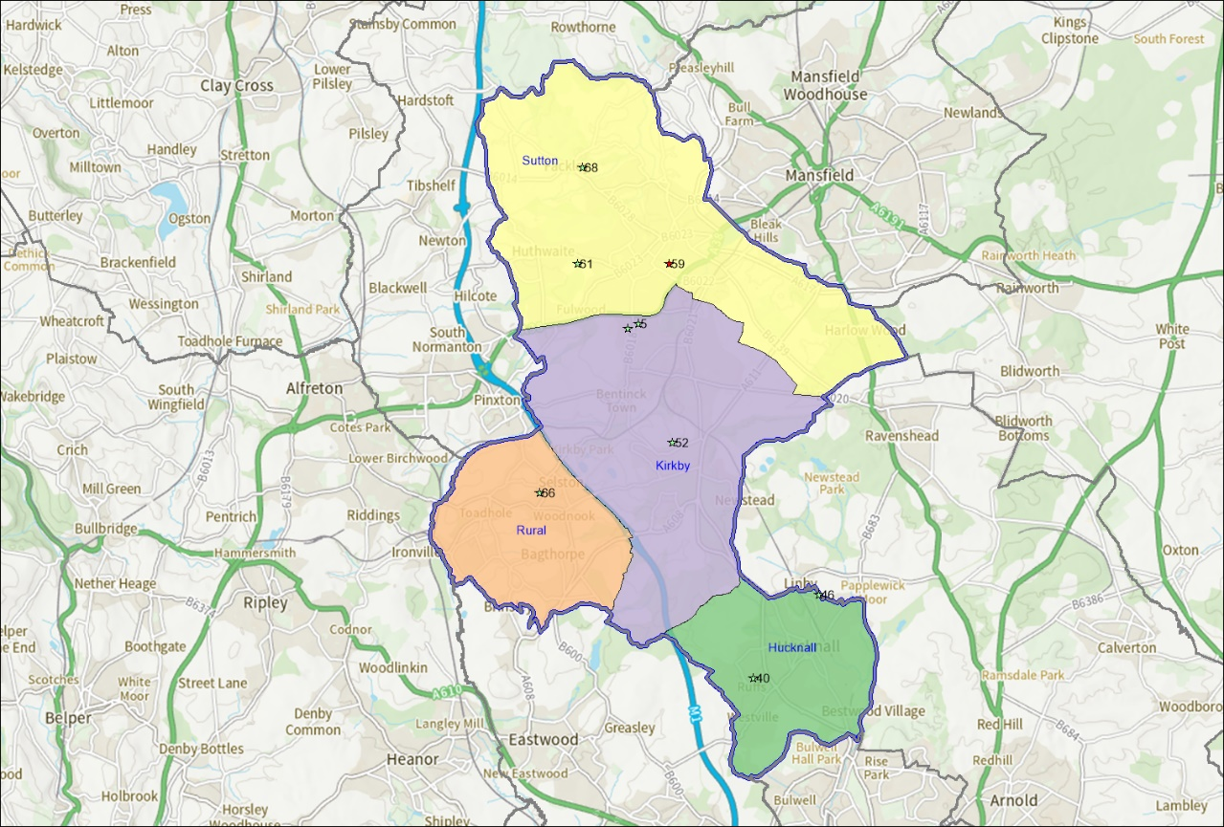
Figure 6.1 – Map of grass cricket pitches in Ashfield

- Table 6.1 provide a more detailed overview of grass cricket pitches in Ashfield.

Table 6.1 Overview of grass cricket pitches
Site Name | PPS Site ID | Sub Area | Number of wickets | Community use category
Ashfield RUFC (Larwood Park) | 5 | Kirkby | 5 | Available for community use and used
Hucknall Cricket Club | 31 | Hucknall | 7 | Available for community use and used
Kirkby Portland Cricket Club | 40 | Kirkby | 10 | Available for community use and used
Mansfield Hosiery Mills Sports & Social Club | 46 | Sutton | 14 | Available for community use and used
Selston Parish Hall and Recreation Ground | 52 | Rural | 10 | Available for community use and used
Teversal Grange Sports and Social Centre (Teversal Fc) | 61 | Sutton | 14 | Available for community use and used
Titchfield Park Hucknall | 66 | Hucknall | 5 | Available for community use and used
Underwood Cricket Club | 68 | Rural | 8 | Available for community use and used

Future proposals
- The cricket pitch at Titchfield Park was deemed not fit for purpose by the Ground Management Association (GMA) Regional Pitch Advisor during summer 2022. The Council is currently working with the GMA and NCCC to assess the pitch.

Disused and lapsed pitches
- A site that hasn’t been used for five years or longer and now falls outside of Sport England’s statutory remit but is still assessed using the criteria within Paragraph 99 of National Planning Policy Framework. Sport England' applies its policy to any land in use as playing field or last used as playing field and which remains undeveloped, irrespective of whether that use ceased more than five years ago. Lack of use should not be seen as necessarily indicating an absence of need for playing fields in the locality. Such land can retain the potential to provide playing pitches to meet current or future needs.
- There were no disused grass cricket pitches identified in Ashfield.
- The following sites in Ashfield have been identified as having lapsed cricket pitches:
- Kingsway Park;
- Rolls Royce Fitness Centre, Hucknall; and
- Quarrydale Academy.
- It is understood that the lapsed cricket pitch at Kingsway Park could be redeveloped to provide grass football pitches as part of a wider programme of development at the site.

Non-Turf Pitches (NTPs)
- NTPs that meet the ECB’s TS6 Performance Standards can be used for match play. They are also often used for training in conjunction with mobile nets. The ECB recommends that a good quality NTP can facilitate 60 matches a season.
- There are currently 9 NTPs in Ashfield across 8 sites.
- Figure 6.2 overleaf provides a spatial overview of where they are located.
- There is provision of NTP cricket wickets in each of the sub areas.
- The numbers in the figure relate to the PPS site ID in table 6.2.

Figure 6.2 Map of cricket NTPs
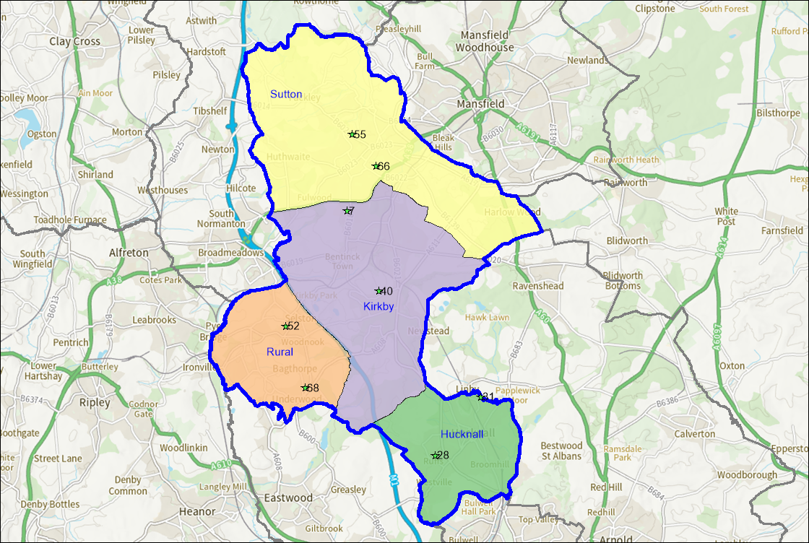

- Ashfield School has two NTPs, but neither are available for community use. Quarrydale Academy reports limited take up of its community outdoor facilities, although it accepts that it would need to arrange additional staff caretaking cover should demand increase.
- Table 6.2 provides an overview of crickets NTP provision in Ashfield.

Table 6.2 Overview of cricket NTPs
Site Name | PPS Site ID | Sub Area | Number of Wickets | Community Use Category
Ashfield School | 7 | Kirkby | 2 | Not available for community use
Holgate Academy | 28 | Hucknall | 1 | Available for community use but unused
Hucknall Cricket Club | 31 | Hucknall | 1 | Available for community use and used
Kirkby Portland Cricket Club | 40 | Kirkby | 1 | Available for community use and used
Selston Parish Hall and Recreation Ground | 52 | Rural | 1 | Available for community use and used
Quarrydale Academy | 55 | Sutton | 1 | Available for community use but not used
Titchfield Park Hucknall | 66 | Hucknall | 1 | Available for community use and used
Underwood Cricket Club | 68 | Rural | 1 | Available for community use and used

- The NTP at Sutton Lawn is considered lapsed. This NTP may be developed as part of the wider site proposal that will see an additional 3G AGP provided along with additional grass football pitches.

- The non turf wicket at Titchfield Park has also recently been assessed as poor.

Security of tenure
- Tenure at a site is deemed to be secured if the club has confirmed use of the site for the next three years. Where cricket pitches are located on Parish or Town Council sites, tenure is generally deemed to be secured. Tenure is generally deemed to be unsecured at educational sites, unless known otherwise and a club has an agreement in place. Whilst educational sites may provide community use of their facilities, this could be stopped at short notice.
- Table 6.3 shows whether tenure is deemed secured or unsecured on cricket club sites and what, if any agreement is in place.

Table 6.3 Security of tenure at club sites
Site Name | PPS Site ID | Club | Management Type | Security of Community Use | Lease Arrangements
Hucknall Cricket Club | 31 | Hucknall Cricket Club | Sports Club | Secured | Owned by Club
Kirkby Portland Cricket Club | 40 | Kirkby Portland Cricket Club | Sports Club | Secured | Appears owned by club (information gleaned from club website)
Mansfield Hosiery Mill Sports and Social Club | 46 | Mansfield Hosiery Mills CC | Sports Club | Secured | 99 year lease from ADC commencing 2001
Selston Parish Hall and Recreation Ground | 52 | Selston Town Cricket Club | Sports Club | Secured | None - ground rented from Selston Parish
Teversal Grange Sports and Social Centre (Teversal FC) | 61 | Teversal Cricket Club | Sports Club | Secured | Owned by Club
Underwood Miners Welfare | 67 | Underwood Cricket Club | Sports Club | Unknown | Merged with Heanor Town Cricket Club

- Security of community use is deemed secured at Selston Parish Hall and Recreation Ground, which is used by Selston Town CC, but the club currently pay an annual rent to Selston Parish Council for use of the ground and therefore have no long-term security in place. Arrangements at Kirkby Portland CC and Underwood CC are less clear as neither club responded to the consultation. At the time of this report, there were no cricket clubs using school sites.

Quality
- Sites in Ashfield containing grass cricket wickets and NTPs were visited and assessed using the non-technical assessment criteria provided by the ECB. This information has been overlaid with information gathered through the consultation process and provides each pitch with a quality rating.
- Cricket pitches are rated as follows based on the assessment:
Good (81% or above);

Standard (51%-80%);

Poor (50% or below).

- Table 6.4 provides an overview of the quality rating each pitch has was given after the assessments, along with comments provided by clubs from the consultation where they had been provided.

Table 6.4 Cricket pitch quality
Site Name | PPS Site ID | Pitch Type | Number of Wickets | Pitch Quality Rating | Comments from Club
Ashfield RUFC (Larwood Park) | 5 | Grass Wickets | 5 | Standard | Long grass, overgrown, weeds & wildflowers growing on the square.
Ashfield School | 7 | Grass Wickets | 2 | Good | -
Ashfield School | 7 | Non-Turf Wickets | 2 | Standard | This wicket is in very poor condition with excessive moss, overgrown with grass & has a large section of the astro turf missing.
Holgate Academy | 28 | Non-Turf Wickets | 1 | Good | -
Hucknall Cricket Club | 31 | Non-Turf Wickets | 1 | Good | -
Hucknall Cricket Club | 31 | Grass Wickets | 7 | Good | Well-kept ground. Outfield has issues with rabbits digging holes.
Kirkby Portland Cricket Club | 40 | Grass Wickets | 10 | Standard | Well-kept ground. Outfield has significant slope to it running down towards the pavilion.
Kirkby Portland Cricket Club | 40 | Non-Turf Wickets | 1 | Standard | -
Mansfield Hosiery Mills Sports & Social Club | 46 | Grass Wickets | 14 | Good | In addition to the outdoor practice nets, the club has 2 non turf practice wickets situated indoors in what is called 'the barn'.
Selston Parish Hall and Recreation Ground | 52 | Non-Turf Wickets | 1 | Standard | -
Selston Parish Hall and Recreation Ground | 52 | Grass Wickets | 10 | Standard | Outfield undersized. Lack of local indoor nets during winter months. Football ground train on the cricket pitch in the winter and damage the outfield. Outfield is uneven
Quarrydale Academy | 55 | Non-Turf Wickets | 1 | Standard | -
Teversal Grange Sports and Social Centre (Teversal FC) | 61 | Grass Wickets | 14 | Good | Damage from dogs and trespasses during winter months. Damage to square / pitch, tampering with covers.
Titchfield Park Hucknall | 66 | Non-Turf Wickets | 1 | Poor | Non-turf wicket in poor condition with rips to the playing surface & situated approximately.' 30m from the grass cricket square.
Titchfield Park Hucknall | 66 | Grass Wickets | 5 | Poor | Cricket Square barely visible & very uneven.
Underwood Cricket Club | 68 | Grass Wickets | 8 | Good | -
Underwood Cricket Club | 68 | Non-Turf Wicket | 1 | Good | -

- Table 6.5 shows the number of cricket pitches assessed as either good, standard or poor in the area.

Table 6.5 Cricket grass pitch quality
Quality Rating | Good pitches | Standard pitches | Poor pitches
Total | 5 | 3 | 1

- The poor pitch is located at Titchfield Park Hucknall. As previously mentioned, the NCCC are working with the Council to assess the quality issues of the grass cricket pitch on this site.
- The Ground Management Association (GMA) runs a Pitch Advisory Service in conjunction with the ECB. This enables clubs to have their pitches assessed and receive guidance on how to better manage and maintain them. During the summer 2022, site meetings were held between the Council, the County Pitch Advisor and the ECB regarding Titchfield Park Hucknall. The assessments indicated the need to fund renovation of approximately 6 pitches to make the grounds more suitable for cricket use.

Ancillary provision
- Ancillary provision at sites that provide community access to cricket wickets was also assessed. Ancillary provision on cricket sites relates to whether or not umpires’ changing, toilets, hot and cold water and heating are provided. It also takes into account the condition of the building.
- Seven sites were recorded as providing good quality ancillary provision, with 2 sites identified as offering standard facilities.
- Table 6.6 provides an overview of ancillary provision at cricket sites that provide community access along with their quality rating.

Table 6.6 Overview of ancillary provision
Site Name | PPS Site ID | Sub Area | Quality Rating
Ashfield RUFC (Larwood Park) | 5 | Kirkby | Good
Holgate Academy | 28 | Hucknall | Good
Hucknall Cricket Club | 31 | Hucknall | Good
Kirkby Portland Cricket Club | 40 | Kirkby | Good
Mansfield Hosiery Mills Sports & Social Club | 46 | Sutton | Good
Selston Parish Hall and Recreation Ground | 52 | Rural | Good
Teversal Grange Sports and Social Centre (Teversal FC) | 61 | Sutton | Standard
Titchfield Park Hucknall | 66 | Hucknall | Standard
Underwood Cricket Club | 68 | Rural | Good

- During the consultation no clubs raised concerns with the quality of their ancillary provision.

Training provision
- Access to practice nets enables clubs to train throughout the season and during pre-season. The following sites that are available for community use benefit from having practice nets:
- Teversal Cricket Club
- Hucknall Cricket Club
- Selston Town Cricket Club
- Mansfield Hosiery Cricket Club

Indoor Nets
- Indoor cricket nets provide an opportunity for cricket clubs to train all year round, particularly throughout the winter months. Table 6.7 shows clubs who confirmed through the consultation that they currently access indoor cricket nets, where they access them and if this is within the study area.

Table 6.7 Clubs who access indoor cricket nets
Club name | Site name | Inside the study area
Teversal Cricket Club | Tibshelf School, Alfreton DE55 5LZ | No
Hucknall Cricket Club | Nottingham Boys High School, NG7 4ED | No
Selston Town Cricket Club | Tudor Grange Samworth Academy,  Leicester  LE2 6UA | No
Mansfield Hosiery | The Fieldings NG17 2TF | Yes

- The majority of cricket clubs (3 out of 4) who responded to the survey, access indoor cricket nets, but do so outside of the study area. Selston Town Cricket Club commented through the consultation that accessing indoor cricket nets locally was an issue. Mansfield Hosiery CC reported that a number of local cricket clubs do use their indoor cricket facilities during the winter months.

Demand
- There are currently 6 cricket clubs playing in Ashfield who between them have 38 teams.
- Table 6.8 provides an overview of the number of teams each cricket club has within the various categories and also shows if their team numbers have increased, decreased or stayed the same during the last three years.

Table 6.8 Cricket teams in Ashfield
Club Name | Senior Men’s Teams | Senior Women’s Teams | Junior Boy’s Teams | Junior Girl’s Teams | Team Trends (last 3 years)
Teversal Cricket Club | 4 | 0 | 3 | 0 | Number of youth teams (boys and girls) has increased.
Hucknall Cricket Club | 5 | 0 | 2 | 2 | Stayed the same
Selston Town Cricket Club | 2 | 1 | 2 | 0 | Mens (Open age) decreased; Women (Open aged) stayed the same; Juniors (7-18 years ) has decreased no longer have an U15’s team.
Mansfield Hosiery | 4 | 0 | 3 | 1 | There has been an increase in junior teams.
Kirkby Portland Cricket Club | 4 | 1 | 3 | 0 | Data from ECB website
Underwood Cricket Club | 1 | 0 | 0 | 0 | Data from ECB website
Total | 20 | 2 | 13 | 3

- During the consultation, clubs mentioned that there has been a general increase in teams at the junior level.

Imported demand
- Imported demand is demand that comes from outside of the study area to access provision, because there is a lack of provision or barriers to accessing provision where they are located.
- There is no imported demand from cricket clubs to access facilities in Ashfield.

Exported demand
- Exported demand is demand that can’t be catered for within the study area and therefore takes place outside of this.
- Table 6.9 shows exported demand out of Ashfield and where this takes place.

Table 6.9 Exported cricket demand
Club name | Number of Teams | Site name | Exported to
Mansfield Hosiery Cricket Club | 1 | Blackwell Cricket Club Primrose Hill, DE55 5JF | Derbyshire
Hucknall Cricket Club | 2  (3rd and 4th teams) | Goosedale Lane NG6 8UJ (9 games).  Rushcliffe (3 games).  Nottingham (1 game) | Gedling Borough;  Rushcliffe Borough and Nottingham City Council

- In total there are 3 cricket teams worth of exported demand out of Ashfield.

Unmet demand
- Unmet demand refers to demand that exists but can’t be catered for due to a lack of available provision.
- During the consultation, Hucknall Cricket Club commented that they would like to see a new cricket facility constructed in the district at Titchfield Park or Papplewick Green. Mansfield Hosiery commented that they have previously used Kingsway Park but that despite numerous efforts to rectify pitch maintenance, their use of the venue had since lapsed. If possible, they would like to see a second cricket pitch made available at Mansfield Hosiery Mills Sports & Social Club.

Future demand
- Future demand can be developed in two ways, clubs may actively try to increase their team numbers in order to grow their club. This may be supported by the relevant NGB through funded programmes, or support to help deliver objectives within their strategy. As part of the consultation process, clubs were asked about any aspirations they had to develop their existing team numbers.
- Table 6.10 shows clubs who reported aspirations to grow their current team numbers and shows how many teams they would look to increase in each category.

Table 6.10 Potential team growth
Table 1 Potential future team growth
Club Name | Senior Men’s Teams | Senior Women’s Teams | Junior Boy’s Teams | Junior Girl’s Teams
Mansfield Hosiery | 1 | 0 | 0 | 0
Total | 1 | 0 | 0 | 0

- During the consultation Mansfield Hosiery CC stated that they would like to increase the number of men’s open age teams but currently do not have the ground capacity to be able to do this.
- The ECB also run a number of programmes to support clubs to increase their participation, these are:

All Stars Cricket
- All Stars cricket provides children aged between 5-8 the opportunity to learn the fundamentals of the game in a fun and inclusive environment. The sessions are generally run in tandem with existing training sessions.
- Kirkby Portland CC and Underwood CC currently have an All Stars programme running.

Dynamos Cricket
- Dynamos cricket follows on from All Stars cricket and provides 8-11 year olds with the opportunity to engage in the sport but also provides a more social element. Sessions are generally run in tandem with existing training sessions.
- Underwood CC currently run a Dynamos programme.

Softball Cricket
- Softball cricket is focused on increasing female participation. The aim of softball cricket sessions is to promote enjoyment and participation; without pads, a hardball, a heavy bat and limited rules. Sessions are played on the outfield and follow a festival format with each session running for a maximum of two and half hours, which is shorter than traditional formats.

- There are currently no Softball cricket programmes running in Ashfield.

Last Man Stands
- Last Man Stands (LMS) is a 2 hour, 8-a-side, T20 cricket game for all abilities. There is currently no LMS league running in Ashfield.

Team Generation Rates (TGRs)
- Another way that future demand can be calculated is by looking at population forecasts and how these impact upon Team Generation Rates (TGRs).
- Future population forecasts have been developed by calculating future growth from ONS data (Click here for ONS population projections by single year of age). These have been developed to show the overall growth across Ashfield up to 2038 in line with the draft Local Plan. TGRs have been rounded down to the nearest whole number. TGRs have been rounded down to the nearest whole number.
- It is worth nothing that whilst teams may be referenced as male or female teams, they may well be mixed teams, and this is fairly common.
- Table 6.11 shows TGRs for cricket teams across Ashfield.

Table 6.11 Ashfield TGRs rates based on growth up to 2038
Sport and Age Groups | Number of teams in age group within the area | Current population in age group within the area (2022) | Future population in age group within the area  (2038) | Current TGR | Population change in age group | Potential increase in team numbers in age group
Cricket Open Age Men’s (18-55yrs) | 20 | 30476 | 33743 | 1524 | 3267 | 2
Cricket Open Age Women’s  (18-55yrs) | 2 | 31806 | 34727 | 15903 | 2921 | 0
Cricket Junior Boy’s 7-18yrs) | 13 | 9741 | 9694 | 749 | -48 | 0
Cricket Junior Girl’s (7-18yrs) | 3 | 9311 | 9366 | 3104 | 55 | 0

Understanding the situation at individual sites
- Capacity on cricket wickets is measured by matches per season, rather than per week. This is because wickets are often rotated through the course of a season in order to guard against wear and tear.
- The number of matches a square can accommodate is affected by its quality and the number of wickets that are available.
- Table 6.12 shows how many games a wicket can accommodate per season based on its quality. For example, 1 good quality grass wicket can accommodate 5 matches per season.

Table 6.12 ECB pitch guidance
Pitch Type | Good (MES) | Standard (MES) | Poor (MES)
1 grass wicket | 5 | 0 | 0
1 NTP | 60 | 0 | 0

- The number of matches played by each team has been informed by consultation with the clubs. Where consultation was not possible, it has been assumed that senior teams play between 8 and 12 home matches per year and junior teams play between 4 and 8 matches per year.
- Any sites that have unsecured use, or that are not available for community use have been discounted if they have spare capacity.
- Educational sites are generally considered to be unsecured unless it has been evidenced otherwise. Local Authority and Town and Parish Council sites are considered to be secured. Club sites are dependent on the security of tenure a club has at that site.

Peak Demand
- Peak demand for cricket in Ashfield is on Saturday, Sunday and Midweek (Monday to Friday evenings).
- Senior men’s cricket tends to take place on Saturdays. The majority of men’s teams playing Saturday or Sunday compete in the following leagues:
- Bassetlaw & District Cricket League
- Mansfield & District Cricket League
- Derbyshire County Cricket League
- South Nottinghamshire Cricket League.
- Peak demand for senior women’s cricket is on Sunday with teams competing in the EMWCL (East Midlands Women’s Cricket League).
- Peak demand for junior cricket is mid-week evenings Monday to Friday, with the majority of teams competing in the Mansfield & District Youth League. Kwik Cricket also takes place on a Sunday morning.
- It should be noted that whilst competitions may be referenced as senior men’s or junior boy’s, they are also open to female participants and some teams may be mixed.
- The balance for pitches in Table 6.13 is shown as follows:
Spare capacity: | The pitch can facilitate more use than is currently taking place.
At capacity: | The pitch is facilitating as much use as it can cater for
Over capacity: | The pitch is facilitating more use it than it can cater for.

- Table 6.13 shows capacity at cricket sites based on their quality and current use and whether they have spare capacity during peak times.

Table 6.13 Cricket pitch capacity
Site Name | PPS Site ID | Sub Area | Type of Wicket | Number of Wickets | Community Use | Security of community use | Quality Rating | Carrying Capacity | Total Use | Balance | Comments
Ashfield RUFC (Larwood Park) | 5 | Kirkby | Grass Wickets | 5 | Available for community use and used | Secured | Standard | 0 | 30 | -30 | Overplayed by 30 MES per season.
Ashfield School | 7 | Kirkby | Non Turf Wickets | 2 | Not available for community use | Unsecured | Good | 10 | 0 | 10 | Spare capacity discounted as not available for community use.
Ashfield School | 7 | Kirkby | Non Turf Wickets | 2 | Not available for community use | Unsecured | Standard | 0 | 0 | 0 | At capacity.
Holgate Academy | 28 | Hucknall | Non Turf Wickets | 1 | Available for community use but unused | Unsecured | Good | 0 | 0 | 60 | Spare capacity discounted as unsecured community use.
Hucknall Cricket Club | 31 | Hucknall | Non Turf Wickets | 1 | Available for community use and used | Secured | Good | 60 | 35 | 25 | Spare capacity of 25 MES per season.
Hucknall Cricket Club | 31 | Hucknall | Grass Wickets | 7 | Available for community use and used | Secured | Good | 35 | 65 | -30 | Overplayed by 30 MES per season.
Kirkby Portland Cricket Club | 40 | Kirkby | Non Turf Wickets | 1 | Available for community use and used | Secured | Standard | 0 | 54 | -54 | Overplayed by 54 MES per season.
Kirkby Portland Cricket Club | 40 | Kirkby | Grass Wickets | 10 | Available for community use and used | Secured | Standard | 0 | 40 | -40 | Overplayed by 40 MES per season.
Mansfield Hosiery Mills Sports & Social Club | 46 | Sutton | Grass Wickets | 14 | Available for community use and used | Secured | Good | 70 | 95 | -25 | Overplayed by 25 MES per season.
Selston Parish Hall and Recreation Ground | 52 | Rural | Grass Wickets | 10 | Available for community use and used | Secured | Standard | 0 | 47 | -47 | Overplayed by 47 MES per season.
Selston Parish Hall and Recreation Ground | 52 | Rural | Non Turf Wickets | 1 | Available for community use and used | Secured | Standard | 0 | 23 | -23 | Overplayed by 23 MES per season.
Quarrydale Academy | 55 | Sutton | Non Turf Wickets | 1 | Available for community use but unused | Unsecured | Standard | 0 | 15 | -15 | Overplayed by 15 MES per season.
Teversal Grange Sports and Social Centre (Teversal FC) | 61 | Sutton | Grass Wickets | 14 | Available for community use and used | Secured | Good | 70 | 70 | 0 | At capacity.
Titchfield Park Hucknall | 66 | Hucknall | Non Turf Wickets | 1 | Available for community use and used | Secured | Standard | 0 | 0 | 0 | At capacity.
Titchfield Park Hucknall | 66 | Hucknall | Grass Wickets | 5 | Available for community use and used | Secured | Poor | 0 | 0 | 0 | Pitch at capacity. Currently out of use due to poor quality.
Underwood Cricket Club | 68 | Rural | Grass Wickets | 8 | Available for community use and used | Secured | Good | 40 | 10 | 30 | Spare capacity of 30 MES per season.
Underwood Cricket Club | 68 | Rural | Non Turf Wickets | 1 | Available for community use and used | Secured | Good | 60 | 0 | 60 | Spare capacity of 60 MES per season.

Actual spare capacity
- A square is only deemed to have actual spare capacity if it is available at peak times. Peak demand for senior men’s cricket is Saturday. As a square can only accommodate one match per Saturday it can cater for two teams playing on a home and away basis. On this basis, if a square has two senior men’s teams using it, it has no additional capacity. Sites that may have minimal spare capacity have been discounted as this wouldn’t be sufficient to enable additional teams to play throughout the course of a season. For a site to be classed as having actual spare capacity it must have at least 11 match equivalent sessions available. Sites that don’t provide community use or that have unsecured community use have also been discounted.

- Table 6.14 shows actual spare capacity for Saturday cricket.

Table 6.14 Actual spare capacity for Saturday cricket
Site Name | PPS Site ID | Sub Area | Type of Wicket | Number of Wickets | Community Use | Community Use | Quality Rating | Carrying Capacity | Total Use | Balance | Spare Capacity for Saturday Cricket
Underwood Cricket Club | 68 | Rural | Grass Wickets | 8 | Available for community use and used | Secured | Good | 100 | 10 | 90 | 2 teams
Underwood Cricket Club | 68 | Rural | Non Turf Wickets | 1 | Available for community use and used | Secured | Good | 60 | 0 | 60

- There is capacity for two additional Saturday teams at Underwood Cricket Club. Although there is a grass wicket and an NTP, they are part of the same site and therefore the site still only has capacity for two teams at peak time. For this reason, spare capacity on the NTP at Hucknall Cricket Club has been discounted.
- There is some demand in Ashfield for senior men’s cricket on Sunday’s too, as well as demand for senior women’s cricket. In terms of calculating actual spare capacity, the same principles are applied to Sunday cricket as Saturday cricket.
- Table 6.15 shows actual spare capacity for Sunday cricket.

Table 6.15 Actual spare capacity for Sunday cricket
Site Name | PPS Site ID | Sub Area | Type of Wicket | Number of Wickets | Community Use | Community Use | Quality Rating | Carrying Capacity | Total Use | Balance | Spare Capacity for Sunday Cricket
Underwood Cricket Club | 68 | Rural | Grass Wickets | 8 | Available for community use and used | Secured | Good | 100 | 10 | 90 | 1 team
Underwood Cricket Club | 68 | Rural | Non Turf Wickets | 1 | Available for community use and used | Secured | Good | 60 | 0 | 60

- As with Saturday cricket, Underwood Cricket Club is the only site with actual spare capacity. This is reduced by one team however as Underwood Cricket Club already have a senior men’s Sunday team.
- There is often more capacity during midweek as fixtures can be played across 5 evenings. Midweek is generally peak demand for junior cricket. NTPs are often used for midweek junior cricket, which provides additional capacity.
- When looking at actual spare capacity for midweek cricket, only three nights a week are taken into consideration for spare capacity for match play. This is to allow for the provision of sessions such as All Stars and Dynamos cricket.
- Table 6.16 shows actual spare capacity for midweek cricket.

Table 6.16 Actual spare capacity for midweek cricket
Site Name | PPS Site ID | Sub Area | Type of Wicket | Number of Wickets | Community Use | Community Use | Quality Rating | Carrying Capacity | Total Use | Balance | Spare Capacity for Sunday Cricket
Underwood Cricket Club | 68 | Rural | Grass Wickets | 8 | Available for community use and used | Secured | Good | 100 | 10 | 90 | 6 teams
Underwood Cricket Club | 68 | Rural | Non Turf Wickets | 1 | Available for community use and used | Secured | Good | 60 | 0 | 60

- Underwood Cricket Club is the only site with actual spare capacity. Three nights of the week are currently available at the site which would provide capacity for 6 teams playing on a home and away basis.

Overplay
- There are 6 sites in Ashfield with overplayed cricket pitches, with total overplay of 249 match equivalent sessions per season.

Table 6.17 Overplayed sites
Site Name | PPS Site ID | Sub Area | Management Type | Type of Wicket | Number of Wickets | Community Use | Quality Rating | Carrying Capacity |  | Total Use |  | Balance
Ashfield RUFC (Larwood Park) | 5 | Kirkby | Sport Club | Grass Wickets | 5 | Available for community use and used | Standard |  | 0 |  | 30 |  | -30
Hucknall Cricket Club | 31 | Hucknall | Sport Club | Grass Wickets | 7 | Available for community use and used | Good |  | 35 |  | 65 |  | -30
Kirkby Portland Cricket Club | 40 | Kirkby | Sport Club | Non- Turf Wickets | 1 | Available for community use and used | Standard |  | 0 |  | 54 |  | -54
Kirkby Portland Cricket Club | 40 | Kirkby | Sport Club | Grass Wickets | 10 | Available for community use and used | Standard |  | 0 |  | 40 |  | -40
Mansfield Hosiery Mills Sports & Social Club | 46 | Sutton | Sport Club | Grass Wickets | 14 | Available for community use and used | Good |  | 70 |  | 95 |  | -25
Selston Parish Hall and Recreation Ground | 52 | Rural | Local Authority (in house) | Grass Wickets | 10 | Available for community use and used | Standard |  | 0 |  | 47 |  | -47
Selston Parish Hall and Recreation Ground | 52 | Rural | Local Authority (in house) | Non Turf Wickets | 1 | Available for community use and used | Standard |  | 0 |  | 23 |  | -23

Key issues and findings
- It is important to understand to what extent existing provision can cater for current and future demand at peak times. Future demand based on TGRs for each sub analysis areas has been overlayed with the existing balance scores at peak times to show what level of capacity exists within each of the sub analysis areas.
- Future demand for match equivalent sessions has been based on any new adult teams generating 10 match equivalent sessions of play and junior teams generating 6 match equivalent sessions. TGRs have been rounded down to the nearest whole number. This has been shown below for each of the peak times for cricket.
- Table 6.18 shows the capacity balance for Saturday cricket in Ashfield.

Table 6.18 Capacity balance for Saturday cricket
Actual spare capacity (MES) | Overplay (MES) | Current total (MES) | Future demand (teams) | Future total (MES)
150 | 249 | -99 | 2 | -119

- Table 6.19 shows the capacity balance for Sunday cricket in Ashfield.

Table 6.19 Capacity balance for Sunday cricket
Actual spare capacity (MES) | Overplay (MES) | Current total (MES) | Future demand (teams) | Future total (MES)
150 | 249 | -99 | 2 | -119

- Table 6.20 shows the capacity balance for midweek cricket in Ashfield.

Table 6.20 Capacity balance for midweek cricket
Actual spare capacity (MES) | Overplay (MES) | Current total (MES) | Future demand (teams) | Future total (MES)
150 | 249 | -99 | 0 | -99

- There are currently shortfalls across all peak periods for cricket in Ashfield. These shortfalls increase slightly when looking at future demand for Saturday and Sunday cricket, based on TGRs. The action plan identifies how these shortfalls can be dealt with - in the form of increased pitch maintenance to improve carrying capacity at poor or standard sites. An example of this is Titchfield Park Hucknall where the Council is working with the GMA and NRC to bring the pitch up to the appropriate standard. Better use of NTPs may also be considered, especially for junior cricket where they can provide significant capacity.

Summary

Cricket
- There are currently 10 grass cricket pitches in Ashfield across 8 sites, all of which are available for community use;
- There are 3 sites that contain lapsed cricket squares, these are Kingsway Park, Rolls Royce Fitness Centre, Hucknall and Quarrydale Academy. Although not classified as disused the NTP at Sutton Lawn is also not in use.
- There are currently 6 cricket clubs within Ashfield who have a total of 38 teams.
- Security of tenure is not deemed to be an issue for the majority of clubs as they own their own grounds. Selston Cricket Club is the only club which currently rents facilities for all of its teams.
- All sites containing grass cricket squares were assessed to understand their quality. 5 were assessed as good, 3 as standard and 1 as poor. There were also 9 Non-Turf Pitches (NTPs) identified. Two have been assessed as good and 5 as standard. It is understood that the NTP at Titchfield Park has recently been assessed as in poor condition and the NTP at Quarrydale Academy has not been used for some time.
- Mansfield Hosiery CC have exported demand outside of the study area to Blackwell Cricket Club in Derbyshire. This is for their senior team; and Hucknall Cricket Club have used a mix of facilities in neighbouring Gedling; Rushcliffe and Nottingham City Council for 2nd and 3rd team matches.
- Team Generation Rates (TGRs) show future demand for an additional 2 men’s adult teams in Ashfield.
- Ancillary provision at sites containing cricket squares was also assessed. 7 sites were recorded as providing good quality ancillary provision, with 2 sites identified as offering standard facilities. No clubs raised concerns with the quality of their ancillary provision.
- The majority of clubs have access to practice nets for training sessions, Indoor nets are however in short supply. Mansfield Hosiery provide the only indoor nets in the district, and they note that these are used by a number of local clubs in the winter months. Selston Town Cricket Club state that more local indoor nets should be provided.
- There is actual spare capacity for 2 Saturday teams, 1 Sunday team and 6 midweek teams in Ashfield;
- There are 6 sites in Ashfield that contain overplayed cricket pitches, these total overplay of 249 match equivalent sessions per season.

7. Tennis

Introduction
- The governance of tennis in Ashfield is overseen by the Lawn Tennis Association (LTA).
- In order to develop tennis locally and nationally, the LTA have developed a strategy called Tennis Opened Up. A summary of the key principles behind this strategy has been provided below. (Click here for the LTA Tennis Opened Up strategy)
- The Strategy aims to grow tennis by making it more relevant, accessible, welcoming and enjoyable. The key objectives of the strategy are:
- Visibility – broaden relevance and increase viability of tennis all year round to build engagement and participation with fans and players;
- Innovation – innovate in the delivery of tennis to widen its appeal;
- Investment – support community facilities and schools to increase the opportunities to play;
- Engagement – engage and collaborate with everyone involved in the delivery of tennis in Britain, particularly coaches and volunteers, to attract and maintain more people in the game;
- Performance – create a pathway for champions that nurtures a diverse team of players, people and leaders;
- Leadership – lead tennis in Britain to the highest standard so it is a safe, welcoming, well-run sport. More players playing more often;
- Enable five new players to break into the top 100 by 2023 and inspire the tennis audience.

Consultation
- There is currently one tennis club in Ashfield – Sutton in Ashfield Tennis Club. They did not respond to the consultation, but the Council and LTA are working with the club to improve the facilities at Sutton Lawn.

Supply
- There are currently 7 sites in Ashfield that provide outdoor tennis courts. This equates to 24 tennis courts in totals, of which all are available for community use.
- The Strategy only covers outdoor tennis provision.
- Figure 7.1 shows where tennis courts are located in Ashfield. The numbers relate to the PPS site ID in table 7.1.
- There is no outdoor tennis provision in the rural sub area.

Figure 7.1 Map of Outdoor Tennis Courts in Ashfield
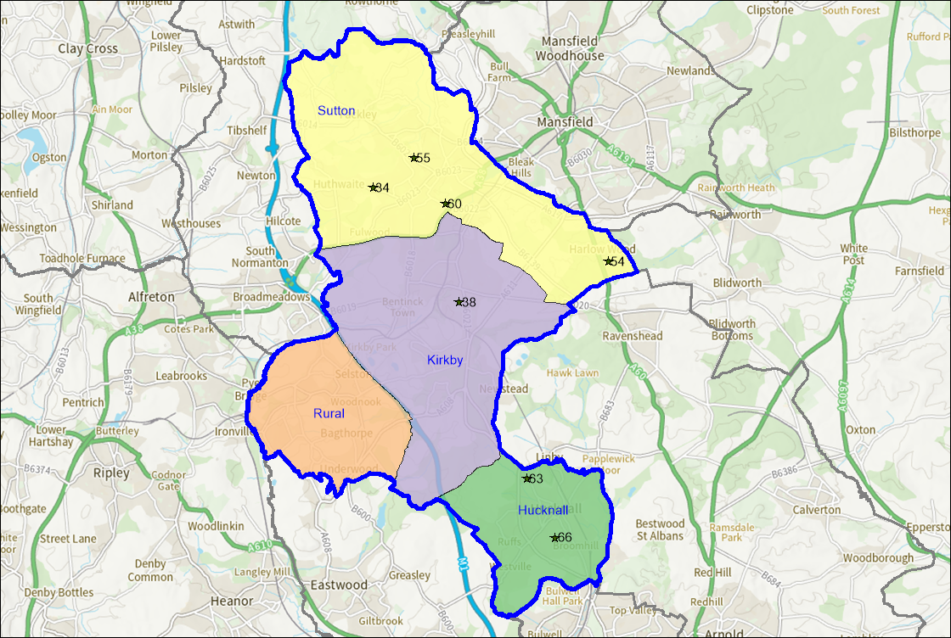
- Table 7.1 provides a more detailed look at the number of tennis courts that are provided within Ashfield.

Table 7.1 Overview of Outdoor Tennis Provision
Site Name | Management Type | PPS Site ID | Floodlights | Number of courts | Surface type | Community use category
Huthwaite Welfare Park | Local Authority (in house) | 34 | No | 2 | Macadam | Available for community use and used
Kingsway Park | Local Authority (in house) | 38 | No | 2 | Macadam | Available for community use and used
Portland College | School/ College/ University (in house) | 54 | Yes | 1 | Macadam | Available for community use and used
Quarrydale Academy | School/ College/ University (in house) | 55 | No | 6 | Macadam | Available for community use and used
Sutton in Ashfield Tennis Club – Sutton Lawn | Local Authority (in house) | 60 | Yes | 4 | Macadam | Available for community use and used
Sutton Lawn | Local Authority (in house) | 60 | No | 2 | Macadam | Available for community use and used
The National C of E Academy | School/ College/ University (in house) | 63 | No | 6 | Macadam | Available for community use and used
Holgate Academy | School/ College/ University (in house) | 25 | No | 3 | Macadam | Not available for community use
Titchfield Park, Kirkby | Local Authority (in house) | 64 | Yes | 2 | Macadam | Not available for community use – area currently fenced off
Selston High School | School/ College/ University (in house) | 57 | No | 5 | Macadam | Not available for community use

Lapsed and disused courts
- A site that hasn’t been used for five years or longer and now falls outside of Sport England’s statutory remit but is still assessed using the criteria within Paragraph 99 of National Planning Policy Framework. Sport England' applies its policy to any land in use as playing field or last used as playing field and which remains undeveloped, irrespective of whether that use ceased more than five years ago. Lack of use should not be seen as necessarily indicating an absence of need for playing fields in the locality. Such land can retain the potential to provide playing pitches to meet current or future needs.
- The tennis courts at Titchfield Park, Hucknall are lapsed, the area is a shared synthetic grass surface and is used for football training and informal use.

Ownership and management
- Tenure at a site is deemed to be secured if the club has confirmed use of the site for the next 3 years. Where tennis courts are located on Parish or Town Council sites, tenure is generally deemed to be secured unless know otherwise.
- Table 7.2 provides an overview of management arrangements and security at tennis club sites.

Table 7.2 Overview of management at club sites
Site Name | PPS Site ID | Management Type | Security of Use | Club Name | Lease Arrangements
Sutton Lawn | 59 | Local Authority (in house) | Secured | Sutton In Ashfield Tennis Club | Annual hire agreement with Ashfield DC

Surface type
- Of the 23 tennis courts available for community use in Ashfield all are a macadam surface.

Floodlighting
- Floodlights allow tennis courts to be used all year round and are seen as key to growing participation in tennis by the LTA. A floodlit hardcourt can accommodate up to 60 members whereas a non-floodlit hardcourt can only accommodate up to 40 members.
- In total there are 5 floodlit tennis courts in Ashfield that are available for community use.

Quality
- Tennis courts that are available for community use were visited and a non-technical assessment was completed to determine the quality of the courts being provided. Consultation with key stakeholders was also carried out to help inform this. It was not possible to gain access to The Holgate School in order to complete an assessment, therefore this site has been omitted from Table 7.3.
- Tennis courts are rated as follows based on the assessment:
Good (81% or above);

Standard (51%-80%);

Poor (50% or below).

- Table 7.3 Site by site Outdoor Tennis Court Quality

Site Name | PPS Site ID | Floodlights | Number of Courts | Surface Type | Quality Rating
Huthwaite Welfare Park | 34 | No | 2 | Macadam | Poor
Kingsway Park | 38 | Yes | 2 | Macadam | Standard
Portland College | 54 | No | 1 | Macadam | Standard
Quarrydale Academy | 55 | Yes | 6 | Macadam | Standard
Sutton In Ashfield Tennis Club & Sutton Lawn | 60 | Yes | 6 | Macadam | Poor
The National C of E Academy | 63 | No | 6 | Macadam | Standard
Holgate Academy | 25 | No | 3 | Macadam | Standard
Titchfield Park, Kirkby | 64 | Yes | 2 | Macadam | Standard
Selston High School | 57 | No | 5 | Macadam | Standard

- Table 7.4 shows the number of good, standard, and poor-quality tennis courts in Ashfield.

Table 7.4 Outdoor Tennis Courts: Quality by category
Sub Area | Good (courts) | Standard (courts) | Poor (courts)
Ashfield Area | 0 | 25 | 8

- The Council has secured funding from the Towns Fund for the development of a sports hub at Sutton Lawn. The project includes improvements to the existing tennis courts including re-surfacing, the installation of new fencing, LED floodlights and a gate-controlled app-based booking system. The works to the tennis courts are being primarily funded by the LTA and are due to be completed in summer 2023.

Ancillary provision
- Ancillary provision at sites with tennis courts available for community use is varied across Ashfield. Table 7.5 below provides an overview of what was recorded during the site assessments. Ancillary provision relates to the provision of a club house, toilets for players and spectators, access to refreshments and whether or not facilities are accessible for people with disabilities. Sufficient car parking is also taken into consideration.

Table 7.5 Overview of ancillary provision
Site Name | PPS Site ID | Quality Rating
Huthwaite Welfare Park | 34 | Poor (None)
Kingsway Park | 38 | Standard
Portland College | 54 | Standard
Quarrydale Academy | 55 | Standard
Sutton In Ashfield Tennis Club – Sutton Lawn & Sutton Lawn public courts | 60 | Standard
The National C of E Academy | 63 | Standard

Demand
- There is currently one tennis club based within Ashfield. Club membership numbers were provided by the LTA who reported 30 adult members at Sutton in Ashfield Tennis Club. The club is anticipating that membership will grow once the court improvements have been completed.

Table 7.6 Membership at club sites
Site Name | PPS Site ID | Club Name | Members
Sutton Lawn | 59 | Sutton In Ashfield Tennis Club | 35

Imported demand
- Imported demand is demand that comes from outside of the study area to access provision, due to a lack of provision or barriers to accessing provision where they are located.
- There is no reported imported demand for tennis within Ashfield.
- Exported demand is demand that can’t be catered for within the study area and therefore takes place outside of this.
- There is no exported demand from tennis clubs outside of Ashfield.

Latent demand
- Latent demand refers to demand that is not currently being met due to perceived barriers to participation.
- Insight provided by the LTA suggests that there is additional demand of 161 members within a 10 minute drive time and up to 666 from a 20 minute drive time of the Sutton in Ashfield Tennis Club.

Unmet demand
- Sutton in Ashfield Tennis Club have not provided any data confirming whether they have a waiting list of members.

Informal demand
- It is assumed that informal tennis takes place on sites that are available for community use where there is no venue registered. This is especially prevalent on open access sites which have no controlled entry.

Overmarked courts
- Tennis courts are often overmarked with other sport markings such as netball and basketball, which can often affect access. This is often common on school sites. There are currently 6 sites in Ashfield which have tennis courts that are overmarked. Sites with overmarked tennis courts are listed below.
    - Kingsway Park
    - Quarrydale Academy
    - The National C of E Academy
    - Holgate School
    - Titchfield Park, Kirkby
    - Selston High School
- No issues were identified regarding this through the wider consultation.

Understanding the situation at individual sites
- The LTA recommends that a non-floodlit hard court can accommodate 40 members whereas a floodlit hard court can accommodate 60 members. Air domed courts can accommodate 100 members and indoor courts 200 members. Grass tennis courts aren’t considered, due to the finite capacity that they have.
- It should be noted that whilst some courts may have spare capacity, they may service demand from rural communities that can’t access courts in other areas of the district.
- Table 7.8 shows capacity at tennis club sites based on membership numbers. It also shows what capacity clubs have to cater for additional members, or if they are at capacity or oversubscribed.

Table 7.8 Capacity at club sites
Site Name | PPS Site ID | Club Name | Floodlit Courts | Non-Floodlit Courts | Members | Capacity for Members | Spare Capacity for Members
Sutton Lawn | 59 | Sutton In Ashfield Tennis Club | 4 | 0 | 123 | 240 | 117

Key Issues and findings
- Table 7.8 shows that the only tennis courts in Ashfield that are used by a tennis club currently have spare capacity for up to 117 additional members. Once the new court provision is developed at the site it is hoped that the tennis club will increase their membership. Gated access will also make the courts more accessible to informal tennis players.
- Should the LTA’s latent demand be realised then capacity issues at club sites could increase by up to 161 members. It isn’t anticipated that this will cause any capacity issues within Ashfield.

Summary

Tennis
- There are currently 9 sites in Ashfield that provide outdoor tennis courts. This equates to 33 tennis courts in total, of which 23 are available for community use.
- Of the 23 tennis courts available for community use in Ashfield, all are a macadam surface.
- In total there are 5 floodlit tennis courts in Ashfield that are available for community use. At Sutton Lawn new LED floodlights are being installed at the existing 4 floodlit tennis courts during summer 2023.
- The only tennis club in Ashfield is Sutton in Ashfield Tennis Club. They have an annual hire agreement for use of their courts with Ashfield District Council.
- There were 25 tennis courts assessed as being standard quality and 8 as poor. No tennis courts were rated as good quality.
- Sutton in Ashfield Tennis Club did not respond to the consultation and therefore it is unclear whether they have plans to increase their current membership numbers. However the planned investment in the courts and introduction of an app-based booking system is expected to increase participation.
- Insight provided by the LTA suggests that there is additional demand of 161 members within a 10 minute drive time and up to 666 from a 20 minute drive time of the Sutton in Ashfield Tennis Club.
- As Sutton in Ashfield Tennis Club did not respond to the consultation, it is not clear whether they have a waiting list for memberships.
- The only tennis courts in Ashfield that are used by a tennis club are located at Sutton Lawn. They currently have spare capacity for up to 117 additional members

8. Netball

Introduction
- England Netball is responsible for governing Netball in England and locally. It has recently developed a new 10 year ‘Adventure Strategy’ which seeks to build on the momentum created over recent years and take netball to new heights. (Click here for England Netball Adventure Strategy 2021-2031).
- The purpose of the Strategy is to lead a movement, on and beyond the court. In order to achieve this the strategy has identified 6 aims described as ‘destinations’, that are underpinned by 14 ‘game changers’.
- The 6 destinations are:
- A game for life;
- A world leading game;
- A visible presence;
- A resonant voice;
- A thriving collective;
- An extraordinary experience.

Consultation
- There are currently 2 netball clubs playing within Ashfield, they are Hucknall Town Netball Club and Hucknall Torkard. Both clubs took part in the consultation.
- There are no registered affiliated or commercial leagues based in Ashfield.

Supply
- There are currently 5 sites in Ashfield that provide outdoor netball courts. This equates to 18 courts in total. Three sites that provide netball courts in Ashfield are available for community use, this equates to 10 netball courts. Indoor courts are not included within this strategy.

- Figure 8.1 shows the location of outdoor netball courts in Ashfield. The numbers in the figure relate to the PPS site ID in table 8.1.

- Netball provision is available in each of the sub areas.

Figure 8.1 Map of netball courts in Ashfield 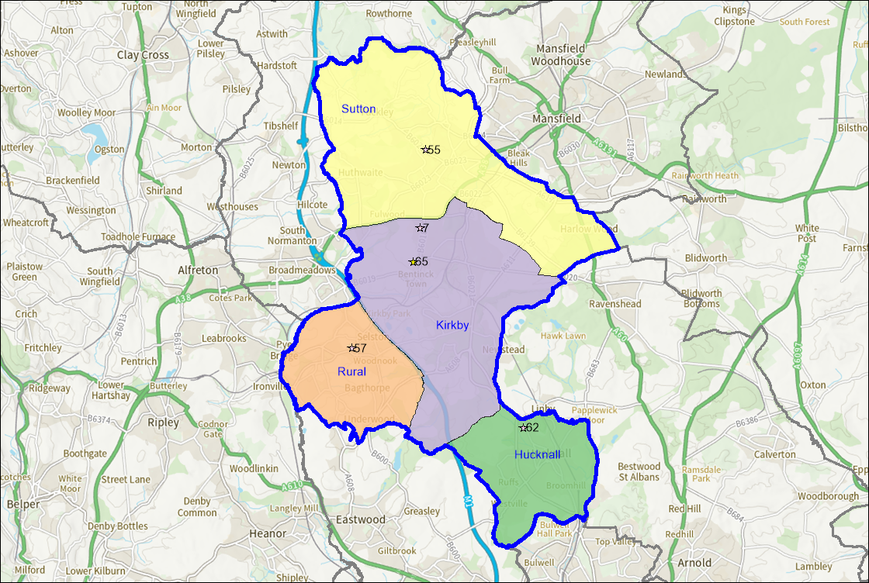

- Table 8.1 provides an overview of outdoor netball court provision in Ashfield.

Table 8.1 Overview of netball provision
Site Name | PPS Site ID | Management Type | Floodlights | Number of Courts | Surface Type | Community Use Category
Ashfield School | 7 | School/ College/ University (in house) | No | 3 | Macadam | Not available for community use
Quarrydale Academy | 55 | School/ College/ University (in house) | No | 4 | Macadam | Available for community use and used
Selston High School | 57 | School/ College/ University (in house) | No | 5 | Macadam | Not available for community use
National C of E Academy | 62 | Academy | No | 4 | Macadam | Available for community use and used
Holgate Academy | 25 | Academy | No | 2 | Macadam | Available for community use and used
Titchfield Park, Kirkby | 65 | Local Authority | Yes | 3 | Macadam | Available for community use and used
Kingsway Park, Kirkby | 37 | Local Authority | No | 2 | Macadam | Available for community use and used

Lapsed and disused courts
- A site that hasn’t been used for five years or longer and now falls outside of Sport England’s statutory remit but is still assessed using the criteria within Paragraph 99 of National Planning Policy Framework. Sport England' applies its policy to any land in use as playing field or last used as playing field and which remains undeveloped, irrespective of whether that use ceased more than five years ago. Lack of use should not be seen as necessarily indicating an absence of need for playing fields in the locality. Such land can retain the potential to provide playing pitches to meet current or future needs.
- The only site in Ashfield that has disused netball courts is at Sutton Lawn which previously provided one netball court.

Ownership and management
- The majority of netball courts in Ashfield are located on school/education sites, 11 in total. The remaining site is Local Authority managed. Community use at education sites is generally deemed unsecured unless advised otherwise, whilst community use is generally deemed secured on Local Authority and Town and Parish Council sites unless known otherwise.
- Hucknall Town Netball Club are the only club in Ashfield who hire netball courts for training. All league fixtures are coordinated by the league who also book facilities. Table 8.2 provides an overview of ownership and management at sites that provide outdoor netball courts for clubs. It also shows if tenure is deemed secured or unsecured.

Table 8.2 Overview of ownership and management
Site Name | PPS Site ID | Ownership Type | Management Type
National C of E Academy | 62 | Academy | Annual Rental payment made by Hucknall Town Netball Club

Surface
- All 18 netball courts in Ashfield are a macadam surface. There are 10 courts that are available for community use and 8 that aren’t.

Floodlighting
- The only netball courts in Ashfield that have floodlights are at Titchfield Park, Kirkby.

Quality
- Three of the sites were assessed and provided with a quality rating. It wasn’t possible to visit Selston High School to determine the quality of their netball courts.
- Netball courts are rated as follows based on the assessments:
Good (81% or above);

Standard (51%-80%);

Poor (50% or below).

- Table 8.3 provides an overview of the quality of netball courts on a site by site basis.

Table 8.3 Site by site netball court quality
Site Name | PPS Site ID | Floodlights | Number of Courts | Surface Type | Quality Rating
Ashfield School | 77 | No | 3 | Macadam | Standard
Quarrydale | 55 | No | 4 | Artificial | Standard
Selston High School | 57 | No | 5 | Macadam | Unknown
National C of E Academy | 62 | No | 4 | Macadam | Standard
Titchfield Park | 65 | Yes | 2 | Macadam | Standard

- Feedback from Hucknall Town Netball Club reported that the outdoor netball courts at the National C of E Academy had recently been re-surfaced.

Ancillary provision
- Ancillary provision was also assessed at sites that provide netball courts for community use. This assessment looks at the provision of a club house, toilets for players and spectators, access to refreshments and whether or not facilities are accessible for people with disabilities. Sufficient car parking is also taken into consideration. Details of ancillary facilities are provided in Table 8.5.

Table 8.5 Overview of Ancillary provision
Site Name | PPS Site ID | Quality Rating
Ashfield School | 7 | Good
Quarrydale Academy | 55 | Standard
Selston High School | 57 | Unknown
National C of E Academy | 63 | Standard
Titchfield Park | 65 | Poor

Demand
- There are currently 2 netball clubs based in Ashfield. Hucknall Town Netball Club have 5 senior teams and 5 junior teams. The teams play in the Ravenshead League, Notts. League & East Midlands League and Two Counties Senior League respectively. They also have a senior team that plays in a recreational league called Netball 4U which doesn’t affiliate to England Netball. Hucknall Torkard have 3 senior teams who all play in the Netball 4U league. They did previously play in leagues affiliated to England Netball but reported that they lost up to 10 players due to the pandemic resulting in them only playing recreationally now. All netball leagues local to Ashfield run on a central venue basis. None of these venues are located in Ashfield, meaning that all demand for fixtures takes place outside of the Local Authority area. Hucknall Town Netball Club train on the netball courts at The National C 0f E Academy.

Imported demand
- Imported demand is demand that comes from outside of the study area to access provision, due to a lack of provision or barriers to accessing provision where they are located.
- There is no imported demand from netball clubs into Ashfield

Exported demand
- Exported demand is demand that can’t be catered for within the study area and therefore takes place outside of this.
- All netball demand for fixtures is exported outside of Ashfield, this equates to 13 teams in total. These teams play at a variety of venues based on the league and division they compete in.

Informal demand
- England Netball also run a number of programmes locally to increase participation informally. An overview of these programmes has been provided below.

Back to Netball
- Back to Netball is designed to reintroduce people back to netball in a fun and friendly environment. To date more than 110,000 people have rediscovered netball through the programme nationally.
- Sessions are open to participants of any age, gender or skill level but are tailored around those who haven’t played for an extended period of time.
- Sessions are delivered in a 6-10 week block with a qualified coach.
- A Back to Netball programme has been delivered in Ashfield at Titchfield Park, Kirkby by Netball 4U. The sessions have moved indoors to Sutton Academy for the winter months.

Netball Now
- Netball Now is a turn up and play programme for anyone over the age of 16, who is looking to play netball without a weekly commitment.
- There is no coaching involved or league table and participants can simply turn up and play.
- There are currently no Netball Now sessions running in Ashfield.

Walking Netball
- Walking Netball is similar to the original format of the game but is played at a walking pace.
- It is open to anyone but is very popular with older participants.
- There are currently no Walking Netball programmes being delivered in Ashfield.

Summary

Netball
- There are currently 2 netball clubs playing within Ashfield, they are Hucknall Town Netball Club and Hucknall Torkard Netball Club. They have 8 senior teams and 5 junior teams between them;
- There are no affiliated leagues held in Ashfield, clubs play in central venue leagues which all take place outside of the Local Authority area;
- There are currently 5 sites in Ashfield that provide outdoor netball courts. This equates to 18 courts in total. Three sites that provide netball courts in Ashfield are available for community use, this equates to 10 netball courts;
- All 18 netball courts in Ashfield are a macadam surface. There are 10 courts that are available for community use and 8 that aren’t;
- There are 2 floodlit netball courts in Ashfield at Titchfield Park;
- Of the 13 netball courts assessed, all were rated as being of standard quality;
- There are currently no Walking Netball programmes being delivered in Ashfield, although it is understood that Netball4U currently offer Back to Netball sessions at the indoor courts at Sutton Academy.

9. Bowls
- Bowls England is the National Governing Body for Flat Green Lawn Bowls in England.
- It has recently developed a new five year strategy called Fit For The Future. The strategy aims to get more people playing and enjoying bowls, with a target of one million bowls experiences per year by 2026. (Click here for Bowls England Fit For The Future 2021 - 2026).
- In order to achieve this the Strategy has five priority areas:
- Building the brand of bowls by increasing focus on international & top domestic bowls, and utilizing opportunities such as Birmingham 2022 to achieve larger media coverage;
- Ensuring the sport is truly accessible to all by offering different formats of the game which suit all time constraints, as well as driving more people to clubs in new ways;
- Creating positive playing experiences for everyone who steps on the green, both for casual and competitive players, as well as growing our events calendar and introducing a Performance Pathway;
- Putting volunteers first, as the lifeblood of our sport, by increasing our support for clubs in order to empower them to thrive;
- Leading the sport with purpose by developing our Governance structures, diversifying our revenue streams, and work collaboratively with all the sport’s key stakeholders.
- Play Bowls is a new product designed to assist clubs in attracting more casual, pay and play participants. Clubs are now able to sign up to the scheme, with booking slots for access then able to be secured and paid for via the Play Bowls website. The aim is to help the sport become much more accessible whilst making it easy for clubs to evolve and manage the demand from the casual audience.

Bowls Bash is a shortened format to develop a recreational offer and attract new audiences.

- Currently there is no provision for Play Bowls and Bowls Bash within the Ashfield area.

- Nottinghamshire Bowls govern bowls on a local level in Ashfield.
- Bowls England has also established, in conjunction with other organisations the Bowls Development Alliance (BDA).
- The BDA works across the country with clubs and county associations to ‘sustain, grow and develop’ the sport in partnership with the bowls family.

Consultation
- There were 6 bowls clubs in Ashfield for the 2022 outdoor season. Three clubs in total responded which represents a 50% response rate.
- Consultation was also carried out with Bowls England and Federation Bowls.

Supply
- There are 8 sites providing bowling greens in Ashfield. There are two greens at Sutton Lawn and two at Kingsway Park with the remaining 6 sites having one green each.
- The numbers in the figure relate to the PPS site ID in table 9.1.
- Bowls provision is available in each of the sub areas.

Figure 9.1 Map of bowls sites in Ashfield
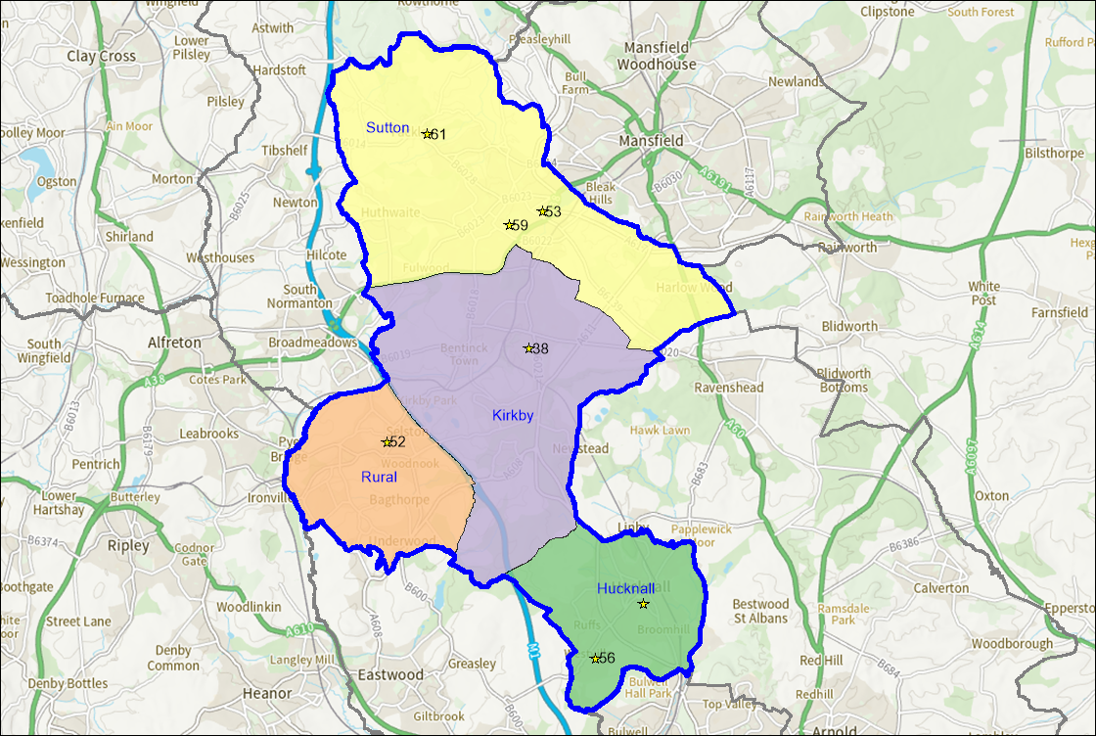

- Table 9.1 provides an overview of bowling green provision in Ashfield.

Table 9.1 Overview of bowls sites in Ashfield
Site Name | PPS Site ID | Management Type | Number of Rinks
Titchfield Park, Hucknall | 32 | Local Authority | 6
Titchfield Park, Kirkby | 65 | Local Authority | 6
Kingsway Park | 38 | Local Authority | 6
Selston Parish Hall and Recreation Ground | 52 | Local Authority | 6
Polly Bowls Sports Ground | 53 | Community Organisation | 6
Rolls Royce Fitness Centre Hucknall | 56 | Industry (for employees) | 6
Sutton Lawn | 59 | Local Authority | 12
Teversal Grange Sports and Social Centre | 61 | Sports Club | 6

Lapsed and disused greens
- A site that hasn’t been used for five years or longer and now falls outside of Sport England’s statutory remit but is still assessed using the criteria within Paragraph 99 of National Planning Policy Framework. Sport England' applies its policy to any land in use as playing field or last used as playing field and which remains undeveloped, irrespective of whether that use ceased more than five years ago. Lack of use should not be seen as necessarily indicating an absence of need for playing fields in the locality. Such land can retain the potential to provide playing pitches to meet current or future needs.

- There are two bowling greens at Huthwaite Welfare Park and one at Titchfield Park, Kirkby which are lapsed.

Ownership and management
- Bowling greens in Ashfield are either located on Parish Council, District Council sites or club sites. Security of community use on Local Authority, Town or Parish Council sites is generally deemed to be secured unless known otherwise. Tenure is deemed unsecured if use of the site cannot be guaranteed for the next three years.
- Teversal Grange and Rolls Royce were the only two sites where use by a bowls club was not secured.

Quality
- All sites containing bowling greens were visited in order to assess the quality of provision available.
- Bowling greens are rated as follows based on the assessments:
Good (81% or above)
Standard (51%-80%);

Poor (50% or below).

- Table 9.2 provides an overview of the quality of bowling greens in Ashfield.

Table 9.2 Site by site bowling green quality
Site Name | PPS Site ID | Floodlights | Quality Rating
Hucknall Titchfield Park | 32 | No | Standard
Titchfield Park, Kirkby | 65 | No | Poor
Kingsway Park | 38 | No | Standard
Selston Parish Hall and Recreation Ground | 52 | No | Standard
Polly Bowls Sports Ground | 53 | No | Standard
Rolls Royce Fitness Centre Hucknall | 56 | No | Good
Sutton Lawn | 59 | No | Standard
Sutton Lawn | 59 | No | Standard
Teversal Grange Sports and Social Centre | 61 | No | Good

- There were 2 bowling greens assessed as good in Ashfield, 6 assessed as standard and one assessed as poor.

Ancillary provision
- Ancillary provision was also assessed at bowls clubs. This assessment looks at the provision of a club house, toilets for players and spectators, access to refreshments and whether or not facilities are accessible for people with disabilities. Sufficient car parking is also taken into consideration.
- Table 9.3 provides an overview of ancillary provision at bowls clubs in Ashfield.

Table 9.3 Overview of ancillary provision
Site Name | PPS Site ID | Quality Rating
Titchfield Park, Hucknall | 32 | Good
Titchfield Park, Kirkby | 65 | Poor
Kingsway Park | 38 | Poor
Parish Hall and Recreation Ground | 52 | Standard
Polly Bowls Sports Ground | 53 | Good
Rolls Royce Fitness Centre Hucknall | 56 | Good
Sutton Lawn | 59 | Good
Teversal Grange Sports and Social Centre | 61 | Good

- A new bowls pavilion is due to be provided in Kirkby as part of the Towns Fund Sports Hub project.
- During the consultation Polly Bowls Club reported incidence of vandalism to the changing rooms with windows being broken.

Demand
- For the 2022 outdoor bowls season there were 8 bowls clubs in Ashfield. Membership numbers, where reported, have been included below.
- Bowls England state that a site with one green can accommodate up to 100 members. Table 9.4 provides an overview of membership numbers at bowls clubs in Ashfield. Where clubs didn’t respond to the consultation this data has been provided by either Bowls England or Federation Bowls where possible.

Table 9.4 Membership at bowls clubs
Site Name | PPS Site ID | Club Name | Adult Members | Junior Members
Titchfield Park, Hucknall | 32 | Hucknall Titchfield Bowls Club | 70 | 0
Titchfield Park, Kirkby | 65 |  |  | 0
Kingsway Park | 38 | Kirkby Investment Bowls Club | 40 | 0
Kingsway Park | 38 | Sutton and Kirkby Bowls Club | 18 | 0
Polly Bowls Sports Ground | 53 | Polly Bowls Club | 50 | 2
Rolls Royce Fitness Centre Hucknall | 56 | Rolls Royce Leisure | Unknown | Unknown
Sutton Lawn | 59 | Portland Bowls Club | Unknown | Unknown
Teversal Grange Sports And Social Centre | 61 | Teversal Grange | Unknown | Unknow

- There are currently 178 adult bowls members in Ashfield and 2 junior members.

Future demand
- Table 9.5 shows clubs who reported through the consultation process plans to grow their membership.

Table 9.5 Future demand
Club Name | Adult Members | Junior Members
Hucknall Titchfield Park | 10 | 10
Polly Bowls Club | 1 | 1
Total | 11 | 11

Latent demand
- Latent demand refers to demand that is not currently being met due to perceived barriers to participation.
- No bowls clubs who participated in the consultation reported any latent demand.
- Sport England’s Market Segmentation tool can be used to measure this for adults within specific sports and a defined area.
- The Market Segmentation tool currently identifies demand for 931 people wanting to take up bowls in Ashfield.
- The most dominant segment is Frank (Twilight Years Gent), which accounts for 29.6% of the potential demand.
- If this demand was realised it could create some capacity issues at bowls site in Ashfield. This would be dependent on any changes to existing membership numbers.
- Future investment should be focused on ensuring that the existing stock is fit for purpose and able to meet the requirements of members and residents.

Summary

Bowls
- There are 7 sites providing bowling greens in Ashfield. There are two greens at Sutton Lawn and at Kingsway Park with the remaining 5 sites having one green each;
- There is one disused bowling green in Ashfield at Titchfield Park, Kirkby;
- There were 2 bowling greens assessed as good in Ashfield and 7 assessed as standard. No bowling greens were assessed as poor;
- The majority of sites have access to some form of ancillary provision with 5 sites assessed as good and 2 as standard. The facilities at Kingsway Park and Titchfield Park, Kirkby were assessed as poor;
- Based on clubs who responded to the consultation, there are currently 178 adult bowls members in Ashfield and 2 junior members. With planned club growth this could increase to 189 adult members and 13 junior members;
- Future demand identified by clubs who responded to the consultation can be catered for at existing bowls sites;

10. Housing Growth
- The assessment report predicts future demand for pitch sports using TGRs which have been developed using population forecasts from ONS. Future demand is expressed in the number of teams that this population increase will create. This section of the report uses the Sport England Playing Pitch Calculator (PPC) to look at what pitch provision will be required based on known housing growth.
- As the largest known housing allocation in Ashfield is 322 dwellings (Beck Lane), the cumulative population increase from housing developments and the requirement for playing pitches that this generates has been calculated using the PPC.
- Population forecast from new dwellings have been estimated on the basis that each dwelling will generate growth of 2.4 people. The total number of new dwellings forecast for Ashfield is 2,091. On this basis a future population growth of 5,032 has been used.
- Table 10.1 shows additional demand created from known housing developments in Ashfield. Match demand is expressed in Match Equivalent Sessions per week, with the exception of cricket where they are expressed per season. Training demand is expressed in hours per week.

Table 10.1 Estimated pitch sport demand from known housing
Sport | Match Demand (MES) | Training Demand (hours per week)
Football - Adult | 0.30 | 6.23
Football - Youth | 1.35
Football - Mini | 0.95
Rugby Union - Adult (inc. youth & mini) | 0.19 | 0.22
Hockey - Adult | 0.17 | 0.51
Hockey - Junior & Mixed U10s | 0.10 | 0.10
Cricket - Open Age & Junior | 13.23 | -

- For football, the greatest amount of future match demand is on youth football pitches (youth 11v11 and youth 9v9) where there is an additional 1.35 MES per week. Training demand for all forms of football equates to 6.23 hours per week on 3G AGPs.
- There is 0.19 MES of demand created for rugby union across all formats of the game and 0.51 hours of demand per week for floodlit training.
- There is 0.17 MES of demand created for adult hockey and 0.10 MES created for junior hockey. A total of 0.61 hours of training demand will be created per week.
- An additional 13.23 MES per season will be created for cricket pitches, which cover all formats of the game.

11. Delivery

11.1 Vision, Key Aims and Objectives

Vision

To ensure adequate distribution of good quality sports facilities across the District, both now and in the future, to support and increase participation in sport and improved health and wellbeing.

The key aims and objectives of the Strategy have been developed to deliver the vision, from which sport and site-specific actions have been developed which are detailed in the Delivery Plan (5.2).

Aim 1. ACCESS & PROVISION - protect existing sports facilities and provide new facilities where there is current or future anticipated demand

Objectives
- Ensure that sports facilities are protected through planning policy.
- Secure tenure and community access to private and educational sites, including community use agreements.
- Identify opportunities to provide additional facilities to meet current and future demand 4. Maximise community use of facilities.

Aim 2. QUALITY & MANAGEMENT - improve the quality of facilities

Objectives
- Develop and improve the quality of facilities.
- Promote good design and management practice.

11.2 Delivery Plan

Objective | Action | Lead | Timescale
Aim 1: ACCESS & PROVISION - To protect existing sports facilities and provide new facilities where there is current or future anticipated demand
1. Ensure that sports pitches are protected through planning policy- where there is established need | All sites identified and protected within Ashfield Local Plan | ADC (FP) | 2023-26
2. Identify opportunities to provide additional pitches to meet current and future demand | FOOTBALL: Develop Hub sites: Papplewick, Hucknall, Kingsway Park, Kirkby and Sutton Lawn  Identify opportunities for additional youth 11v11 and youth 9v9 pitch provision | ADC  ADC | 2023-26  2023-26
 | Kingsway Park – Develop site to accommodate more pitches | ADC | 2023-25
 | Sutton Lawn – Work with ATTFE (Sutton Community Academy) to develop site to increase number of pitches/ improve changing rooms. Improve drainage and quality of existing pitches. Redevelop former shale pitch; refurbish existing 3G AGP and provide additional 3G AGP | ADC/ ATTFE | 2023-25
 | Review pitch types/ sizes annually - convert to better meet demand | ADC | 2023-26
 | 3G AGP: Hucknall – support FA/FF to identify club/ organisation to lead the development/ investment and management of a new facility. | FA/ADC | 2023-26
 | Support review of the Local Football Facilities Plan | ADC/FA/Football Foundation/ Clubs | 2023-25
 | RUGBY: Explore opportunities to increase senior provision | ADC/Ashfield RFC | 2023-24
 | CRICKET:  - Review pitch quality at Larwood Park  - Review ADC cricket provision in Hucknall; existing site at Titchfield Park and potential at Papplewick Playing Fields  - Review availability of indoor cricket nets | ADC/Ashfield RFC/RFU  ADC/Hucknall CC  ADC | 2023-24  2023-24  2023-24
3. Maximise community use of facilities | FOOTBALL: Tender a service contract for the Papplewick site and appoint operator | ADC | 2023
 | TENNIS: Introduce tennis booking platform for Sutton Lawn and Huthwaite Welfare Park | ADC/ LTA | 2023
Objective | Action | Lead | Timescale
Aim 2: QUALITY & MANAGEMENT - improve the quality of facilities and rationalise provision
1. Improve the quality of facilities and rationalise provision | FOOTBALL: Develop Hub sites at: Papplewick, Hucknall, Kingsway Park, Kirkby and Sutton Lawn. Review single pitch sites and close if no longer required.  - Let service contract for Papplewick Pavilion and pitches | ADC  ADC | 2023-26  2023
 | FOOTBALL/ BOWLS/ TENNIS: Improve the quality of pitches, greens, courts and changing rooms/ facilities at ADC sites, working with clubs to access funding:  - Implement improvements at Sutton Lawn tennis courts through Towns Fund and LTA funding  - Provide new bowls pavilion in Kirkby through Towns Fund  - Review provision of bowling greens across the District | Clubs/ ADC  ADC  ADC  ADC | 2023-26  2023-24  2024-25  2023-24
 | CRICKET: Support Focus Clubs to improve facilities  Reduce overplay through access to additional pitches | Clubs/ ADC | 2023-26
 | RUGBY: Support Ashfield Rugby Club with development plans | Club/ ADC | 2023-26
 | HOCKEY: Support clubs at Kingsway Park | Clubs/ ADC | 2023-26
 | ALL SPORTS:  - Promote leasing/ licencing of Local sites to enable clubs to access funding  - Support sports clubs to access funding to improve facilities | ADC | 2023-26
2. Support club and schools/colleges development | ALL SPORTS: Promote National Governing Body/ClubMark accreditation | ADC | 2023-26
3. Promote good design and  management practice | Work with NGBs and clubs to improve pitch maintenance | ADC | 2023-26
 | Investigate potential self-management/ leasing/licencing of Local (non-hub) sites | ADC | 2023-26

12.0 Review, monitoring and updating

A review of the action plan will be undertaken by Ashfield District Council at the mid-point of the Strategy (early 2025) which will be reported to the NGBs. The steering group will be invited to meet to agree any amendments to the action plan.

The review will highlight:
- Progress against the action plan
- Any changes to sites and/or clubs and other supply and demand information
- Any development of a specific sport or particular format of a sport
- Any new or emerging issues and opportunities.

The Council will maintain the data within the Playing Pitch Database as and when required.

