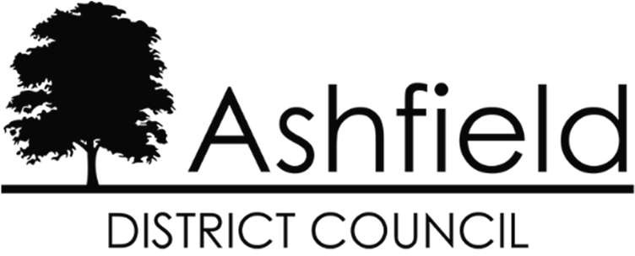

Statement of Common Ground for the Ashfield Local Plan 2023 to 2040 Regulation 19 Pre-Submission Draft

Between Ashfield District Council
and
NHS Nottingham and Nottinghamshire Integrated Care Board

April 2024

Introduction

  - This Statement of Common Ground (SoCG) has been prepared in relation to the Ashfield Local Plan 2023 to 2040: Regulation 19 Pre-Submission Draft (subsequently referred to as the ‘Local Plan’ throughout the remainder of this statement). The purpose of the SoCG is to inform the Inspector of the Ashfield Local Plan, and other interested parties, about the areas of agreement or otherwise between Ashfield District Council (ADC) and NHS Nottingham and Nottinghamshire Integrated Care Board (ICB) with regard to Strategic Planning Matters. It demonstrates that appropriate engagement is taking place between the parties and will be updated as and when required.

  - Local planning authorities, county councils and other prescribed bodies are under a duty to cooperate with each other on strategic matters that cross administrative boundaries. (Section 33A of the Planning and Compulsory Purchase Act 2004). Specific Consultees and Duty to Cooperate Bodies are identified in the Town and Country Planning (Local Planning) (England) Regulations 2012, as amended. Both parties are prescribed bodies for the purposes of the Duty to Cooperate.

  - This approach is also a requirement of the National Planning Policy Framework, 2023 (NPPF) in paragraphs 24 to 27 inclusive. Paragraph 35 of the NPPF seeks to ensure that the Local Plan is ‘Effective’ i.e., deliverable over the plan period, and is based on effective joint working on cross- boundary strategic matters that have been dealt with rather than deferred, as evidenced by the statement of common ground.

  - This SoCG sets out the areas of agreement between the parties in relation to:

    - The key strategic matters in relation to health care provision.
    - The level of financial contributions needed in order to deliver the necessary health care infrastructure to meet the housing growth and population increase proposed in the Ashfield Local Plan 2023-2040.
    - Partnership and Collaboration between ADC and NHS Nottingham and Nottinghamshire Integrated Care Board on priority spending on health care provision.

Background

  - The Health and Care Act 2022 created Integrated Care Boards (ICBs) as replacements for Clinical Commissioning Groups and establishes in law the role of Integrated Care Partnerships as the committee where health, social care, and other partners come together as an Integrated Care System (ICS).

  - The Nottingham and Nottinghamshire Integrated Care Board (ICB) is therefore a statutory NHS organisation responsible for developing a plan for meeting the health needs of the population, managing the NHS budget, and arranging for the provision of health services in the ICS area. The area covered by ICB covers the District of Ashfield, District of Bassetlaw, Borough of Broxtowe, Borough of Gedling, District of Mansfield, District of Newark and Sherwood, City of Nottingham, and Borough of Rushcliffe.

  - The ICS has four aims:

    - Improve outcomes in population health and healthcare.
    - Tackle inequalities in outcomes, experience, and access.
    - Enhance productivity and value for money.
    - Help the NHS support broader social and economic development.

  - Paragraph 20 of the NPPF requires that strategic policies when setting out the overall pattern and scale of growth to make sufficient provision for health infrastructure. Plans should also set out the level of contributions expected from development for the provision of health infrastructure (NPPF para. 34).

Requirements for Health Care provision

  - Ashfield District has 16 GP practices operating from 17 sites (Annex 1 Map). NHS Nottingham and Nottinghamshire Integrated Care Board is the NHS body overseeing the practices. All of these premises are currently under pressure from local growth. Any increase in the number of patients registered with GP practices from new housing developments will generate a higher level of need for these services.

  - There is also growing concern about areas of longstanding unmet health need and the social determinants of health are playing a bigger role than ever before. These new challenges are increasing pressure on the system to deliver for those in our communities, and to shift focus from treating those who are unwell to preventing ill health and tackling health inequalities. To help meet these

needs, GP practices are working together with community, mental health, social care, pharmacy, hospital, and voluntary services in their local areas in groups of practices known as primary care networks (PCNs).

  - PCNs build on existing primary care services and enable greater provision of proactive, personalised, coordinated and more integrated health and social care for people close to home. Health professionals will work as part of PCN community teams, under the Additional Roles and Responsibilities Scheme (ARRS). The intention of the scheme is to grow additional capacity through new roles, and by doing so, help to solve the workforce shortage in general practice. These roles include:

    - Clinical Pharmacists • Podiatrists
    - Pharmacy Technicians • Occupational Therapists
    - First contact physiotherapists • Community Paramedics
    - Physician’s Associates • Nursing Associates
    - Dieticians • Social Prescribing Link Workers
    - Care co-ordinators

  - The impact of this policy change has been an added pressure on all GP Practice premises as these teams need to be co-located to work effectively alongside their practice and PCN colleagues.

  - In terms of the ability to expand facilities to accommodate new growth, the ICB assessment is that all premises may require some form of adaptation, extension, or new buildings where there are no opportunities for further expansion and a new location is required. As a consequence, there is a need to secure contributions to improve health provision across the District.

Joint Working

  - There has been ongoing engagement between NHS Nottingham and Nottinghamshire Integrated Care Board (ICB) and ADC. The ICB has been consulted at the different stages of the Ashfield Local Plan preparation process and have provided comments and input on proposed policies and site allocations.

  - The following policies of the Publication Local Plan are relevant to the provision of health care infrastructure:

    - Strategic Policy S9: Aligning Growth and Infrastructure (S11 in Reg 18 version). The Council will work with partners, developers, and stakeholders to facilitate development that positively contributes to creating healthy communities, where appropriate contributing towards essential health care and community infrastructure.

    - Strategic Policy S12: Tackling Health Inequalities and Facilitating Healthier Lifestyles (S14 in Reg 18 version). The Policy supports development proposals designed to contribute to and improve healthy communities and wellbeing in Ashfield, thereby reducing health inequalities.

    - Policy SD13: Provision and Protection of Health and Community Facilities. Where additional facilities are needed as a result of a development proposal, the Council will require the provision of:
      - a new community facility on site or contributions towards the expansion of existing or new community provision off site; and/or
      - a new health facility on site or contributions towards the expansion of existing or new health provision off site.

  - NHS Property Services which partners with the ICB to help them plan and manage their estates commented and made representations on the above 3 policies of the Draft Local Plan 2021 (Regulation 18). These have been considered and have informed the development of Regulation 19 Local Plan.

  - A summary of the all representations received, the Councils responses, and proposed changes to the Draft Local Plan can be seen in the Council’s Regulation 18 Statement of Consultation Document at: https://www.ashfield.gov.uk/planning-building-control/local-plan/emerging-local- plan/ashfield-draft-local-plan-consultation-regulation-18/

  - There has also been collaboration and liaison on the Infrastructure Delivery Plan (IDP) in order to determine the requirements for new or expanded health care facilities to mitigate the impacts of growth arising from new housing. Discussions have sought to identify necessary financial contributions to expand existing facilities or deliver new facilities.

  - In addition to the above engagement, Ashfield Council has a Major Project Group which meets on a regular basis to discuss major planning applications and any implications that arise from the emerging Local Plan. Infrastructure providers are invited including representatives of the Highway Authority, the County Council S106 Officer (representing education) and representatives of the Integrated Care Board. Typically, the Group meets on a quarterly basis.

Areas of Common Ground

  - In order to meet the objectively assessed housing need the Publication version of the Ashfield Local Plan proposes a minimum of 7,582 dwellings to be delivered within the Plan period 2023-2040 to be dispersed across the District in accordance with the spatial strategy. This will result in a corresponding increase in population which is expected to place additional pressure on the existing health care facilities.

  - Ashfield Council undertook an Infrastructure Delivery Plan (IDP) in November 2023 which assessed the implications of the proposed housing growth in the Local Plan. This includes estimated financial contributions for healthcare for the proposed allocations based upon the generic model produced by the NHS Healthy Urban development Unit (HUDU) which generated a cost of around
£680 per dwelling.

  - However, the local health system has indicated that all practice premises are under pressure from both local growth and the introduction of additional staff. These support the medical staff by providing a wider range of services, and need to be based within the same premises to be fully integrated into the clinical teams. Consequently, the level of financial contribution normally sought by the ICB is based upon the ‘NHS Nottingham and Nottinghamshire Integrated Care Board S106 formula for contributions’ set out in the table below. This is based on a typical density of development (2.5 people per household) and applies to all developments over 25 dwellings. The formula also reflects the approach agreed between Mansfield District Council and the ICB and generates a cost of approximately £1062.50 per dwelling.

A) | x | (B) | x | (C) | x | (D) | = | (E)
Number of |  | 2.5 per |  | m2 /patient |  | Cost of |  | Requested
Dwellings |  | dwelling = |  | based on |  | extension |  | Contribution
XX |  | additional |  | total list size |  | including |  | £ZZ
 |  | new patients |  | 0.085m2 |  | fees £/m2
 |  | YY |  |  |  | £5,000

  - The indicative size of the premises requirements is compliant with Health Building Note (HBN) 11-011 and is calculated based on current typical sizes of new surgery projects factoring in a range of list sizes recognising economies of scale in larger practices. The cost per sq. m has been benchmarked and validated by NHS England.

1 https://www.england.nhs.uk/estates/health-building-notes/

  - There is some disparity between what has been previously considered for developer contributions to healthcare facilities in Ashfield, and what is now expected by the ICB. Ashfield Council will seek to secure the contribution requirement of £1062.50 per dwelling as developments are progressed through the planning application process. In accordance with Local Plan Policy SD6: Assessing Development Viability and Development Demand, development proposals that are unable to meet the policy and infrastructure requirements set out in the Local Plan must:

    - be supported by viability evidence that establishes why any departure from policy or a deficit in infrastructure contributions is necessary to make the scheme viable, and
    - demonstrate that the wider planning benefits for the development outweigh the shortfall in contributions.

  - Based upon the proposed distribution and quantity of growth and an assessment of GP practices, contributions could be spent across the District.

  - The parties have agreed that:

There will need to be improvements in health care facilities as a result of the proposed new housing within and adjacent to Ashfield District.
Additional health care provision can be delivered through the expansion of existing practices, reconfiguration, or relocation. Where necessary the feasibility of establishing new facilities will be explored.
The Infrastructure Delivery Plan (IDP) which supports the emerging Ashfield Local Plan has identified the level of demand for health care provision arising from the proposed new housing growth.
The financial requirements arising from development as identified in the IDP will be funded through s.106 planning obligations. Contributions should complement capital works identified by the NHS Nottingham and Nottinghamshire Integrated Care Board.
The formula (set out at paragraph 3.3) is agreed with Ashfield District Council and the ICB as part of their off-site financial contributions for the infrastructure liaison process.
Co-operation will continue to take place between Ashfield and NHS Nottingham and Nottinghamshire Integrated Care Board (ICB) as necessary. In order to maintain a flexible approach, at planning application stage both parties will continue to engage to identify the most appropriate solution and contributions.

Outstanding Areas of Disagreement

4.1 There are no outstanding areas of disagreement between Ashfield District Council and NHS Nottingham and Nottinghamshire Integrated Care Board.

Governance

  - Ashfield District Council and NHS Nottingham and Nottinghamshire Integrated Care Board will work together to ensure sufficient provision of health care facilities is made for the anticipated increase in population.
  - This statement will be kept under review during the preparation of the emerging Ashfield Local Plan 2023-2040, and any subsequent review.

Annex 1

Health Facilities in Ashfield District Council, 2023
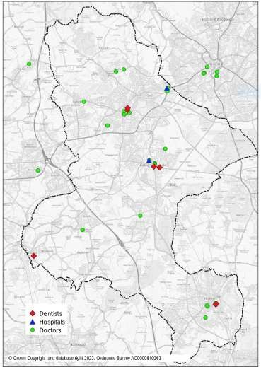
Ashfield District Council, 2023

Agreement
Both parties agree that this statement is an accurate representation of matters discussed and issues agreed upon and on this basis the requirements of the Duty-to- Co-operate have been fulfilled.

Signed on behalf of Ashfield District Council

Name: Christine Sarris
Position: Assistant Director – Planning and Regulatory Services
Dated: 25/04/2024

Signed on behalf of NHS Nottingham and Nottinghamshire Integrated Care Board

Name: Amanda Sullivan
Position: Chief Executive
Dated: 25 April 2024

