ASHFIELD

AND MANSFIELD
A PLAN FOR GROWTH

VISION

To maximise the opportunities for people and businesses to grow and prosper in Ashfield & Mansfield

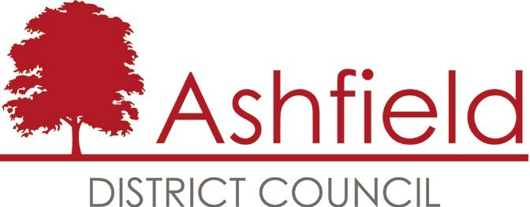
Mansfield
District Council

Background

The first iteration of the Ashfield and Mansfield Joint Economic Masterplan (JEM) was produced in 2011, following a commitment by both councils, to produce a combined economic strategy.This reflects the fact that the two districts together are effectively an integrated economic community, with many people living in one district and working in the other. This is also supported by Centre for Cities, who have recognised Mansfield principle urban area (including the Ashfield area) as one of the 64 UK “cities”.

Foreword
Since the Ashfield and Mansfield Joint Economic Masterplan (JEM) was adopted in 2011, there has been significant local progress
in addressing our key objectives to upskill, enhance employment levels, improve educational attainment and drive business growth. This is a real achievement against a very challenging context of gentle economic recovery and on-going austerity.
It is appropriate for Ashfield and Mansfield to review the

We operate in very much a changing world now to that which existed before the credit crunch of 2008 and subsequent programme of austerity thereafter. We need
to position ourselves to take advantage of all opportunities to maximise economic growth for local people. Ashfield and Mansfield District Councils remain committed to working in partnership to realise economic progress and will work hard to
achieve this for our communities.

Since the JEM was first published there have been significant changes, both in terms of the overall macro-economic performance of the economy and in terms of the local governance context within which local authorities operate.

Recently there have been significant improvements in the local economy and this is borne out by the metrics presented within the report. However, there remain key areas of poor performance within the local economy when compared to the UK average. The potential for
a Combined Authority (CA), to cover Nottinghamshire, Nottinghamshire and Derbyshire or any other geographical area, is likely to have a significant bearing on the way economic development initiatives and programmes are delivered in the future.
The strategy remains a long-term one, but one

JEM some five years on to take
which is going to be more heavily influenced by the

account changing circumstances and emerging future challenges and opportunities. We need to position the area to maximise the advantages which the economic recovery is bringing for local people and businesses. This includes working with our wider partners to ensure the area benefits from the emerging Combined Authority for Nottinghamshire and Derbyshire and the Devolution Deal emerging for the area.
This revised iteration of the JEM, now known as the ‘Plan for Growth’ (PfG), sets out our key priorities and objectives for the future and which we will continue to steer our resources towards. The PfG will
be underpinned by a more detailed delivery plan of key actions, which will be managed
and monitored by both councils.

development of the wider and emerging sub-regional governance structures. The JEM and its replacement, the PfG, are consistent with the wider Derby, Derbyshire, Nottingham, Nottinghamshire (D2N2) Local Enterprise Partnership (LEP) Growth Strategy, even though not all of the key growth sectors articulated within the D2N2 plan are relevant within the Ashfield and Mansfield area. Given the increasing competition for ever-dwindling sources of funding, to help implement key economic development priorities, it is clearly essential that the policy context for addressing local priorities is consistent and supportive of the wider and emerging CA approach.

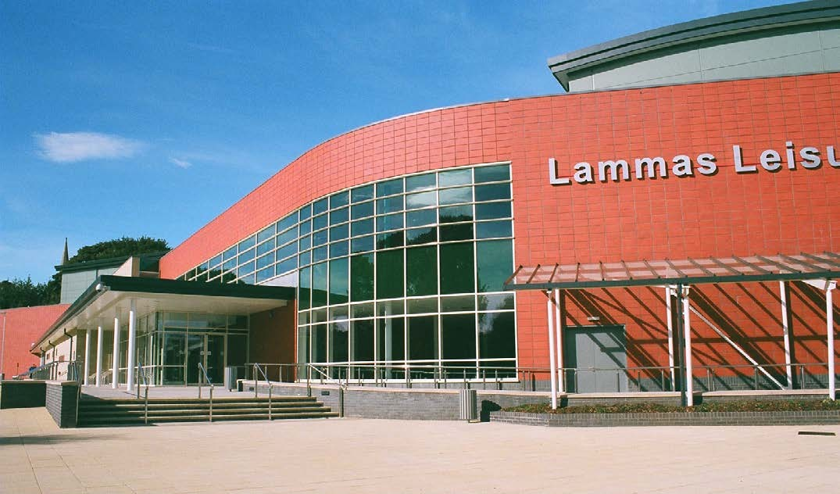
We look forward to working together and helping to make real improvements in our local communities.

For example:

THE TABLE BELOW PROVIDES A HEALTH-CHECK OF THE LOCAL ECONOMY

The case for
SIGNIFICANT INVESTMENT IN THE AREA AND
AND HOW IT COMPARES TO REGIONAL AND NATIONAL AVERAGES.

ITS TOWN CENTRES, IN THE FORM OF:-

economic
ITEM³ | ASHFIELD | MANSFIELD | EAST MIDLANDS | ENGLAND  /UK
Economic Activity Rate | 80% | 77.6% | 77.5% | 77.7%
Unemployment | 5.1% | 5.7% | 5.0% | 5.4%
Self-employment | 7.3% | ~4%² | 8.8% | 10.2%
Business Start-ups per 10,000 head of population³ | 46.22 | 56.63 | 75.42 | 87.98
Higher Occupations (SOC1-3) | 39.0% | 24.7% | 41.2% | 44.3%
Process & Elementary occupations (SOC8-9) | 19.8% | 35.3% | 20.2% | 17.2%
NVQ4 Qualification & above | 18.0% | 30.1% | 30.9% | 36.0%
NVQ2 Qualification & above | 58.4% | 73.3% | 71.4% | 73.3%
No Qualifications | 14.8% | 8.7% | 9.3% | 8.8%
Earnings by residence (Gross weekly pay) | £448.90 | £435.90 | £492.00 | £529.60
Earnings by workplace (Gross weekly pay) | £453.30 | £394.80 | £479.10 | £529.00
Employment in Manufacturing | 19.8% | 11.7% | 12.9% | 8.5%
Employment in ICT, Financial & Business Services | 16.0% | 22.1% | 22.1% | 26.3%
Large Businesses (over 250 employees) | 0.7% (20) | 0.4%(10) | 0.4%(625) | -
UKCI Competitiveness Ranking (2013) | 365(379) | 364(379) | 225(379) | 100

- The new Mansfield Transport Interchange, resulting from an

investment of around £9m and which efficiently handles as

development
many passengers, each year, as East Midlands Airport.

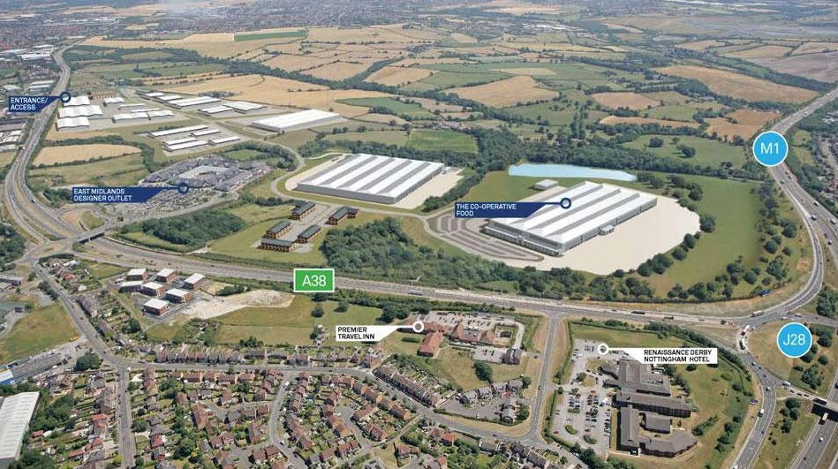

The ‘Credit Crunch’, in 2008, was preceded by a long period of
consistent economic growth for the UK. However, this masked a variety of local growth levels across the country and the Ashfield and Mansfield area was still in a period of economic recovery, from the impacts of the coalfield closures and associated loss of supply chain industries.
The recession impacted significantly on the heavily manufacturing reliant local economy. This has been further compounded by the impact on the construction industry, which has played a strong role in the local economy too.
The recession, along with the ongoing austerity has, in turn, had a major impact on the public sector employers in the area, which offer a greater proportion of the local employment than at national level. All of these impacts have collectively meant
that the Ashfield and Mansfield area has suffered a period of prolonged contraction, impacting upon wage levels, economic activity levels, enterprise activity and, in turn, social mobility.
  - The new Queen’s Place building, resulting from around £3m of investment and which now hosts high quality retail and office- based businesses.
  - The acquisition/demolition of the unsightly former General Hospital and the preparation of the site for a key housing development.
  - The creation of high quality office space, adjacent to Mansfield Woodhouse station.
  - The Hucknall Inner Relief Road, to bring around £12m of total infrastructure investment into the town.
  - The creation of a new Kirkby Plaza, resulting from a total investment of over £1m, to improve the appearance of the town centre and further improve the viability of Kirkby’s shops and market stalls.
  - Ashfield Health Village, resulting from an investment of around
£1.4m, to provide improved access to health and community services.
  - Kirkby traffic scheme, to improve the flow of traffic through the town centre.
  - The successful relocation of the outdoor market in Sutton, onto Portland Square and the acquisition/demolition of the former Conservative Club, to provide a key development site in the town centre.
  - The completion of a £300m redevelopment at Kings Mill Hospital, providing the area with a state-of-the-art health facility.
  - Significant investment in West Nottinghamshire College’s facilities, including the remodelling of their main campus, on Derby Road, and the creation of two innovative learning
facilities, as centres of educational excellence for construction and engineering. A brand-new university centre, which opened on the main campus in Autumn 2016, brings much-needed access to higher education for local residents and businesses.
  - Major mixed-use developments, at the Rolls Royce site in Hucknall and the Berry Hill site in Mansfield, to bring around 3,000 homes and a significant number of businesses and new jobs to the area.
  - Improved access to superfast broadband, for businesses and residents.
  - Significant business investment in the area, from the likes of Capita, Bombardier, Van Elle, Parker Knoll, ColdHarbour Marine, Pendragon, Meridian, Midland Aerospace and ECS Engineering Services to name but a few. This investment proves the attractiveness of the area, as an excellent place to do business, as well as providing more employment opportunities for local residents.

¹ All statistics from the Office for National Statistics (ONS), via the nomisweb Local Authority Profile
² Sample size too small for a reliable estimate
³ ONS Business Demography 2014 report dataset

However, the area has still seen some key developments, since the publication of the initial JEM, in 2011, with others on the way, and these will continue to help to improve the local economy.

Strengths, weaknesses, opportunities and threats

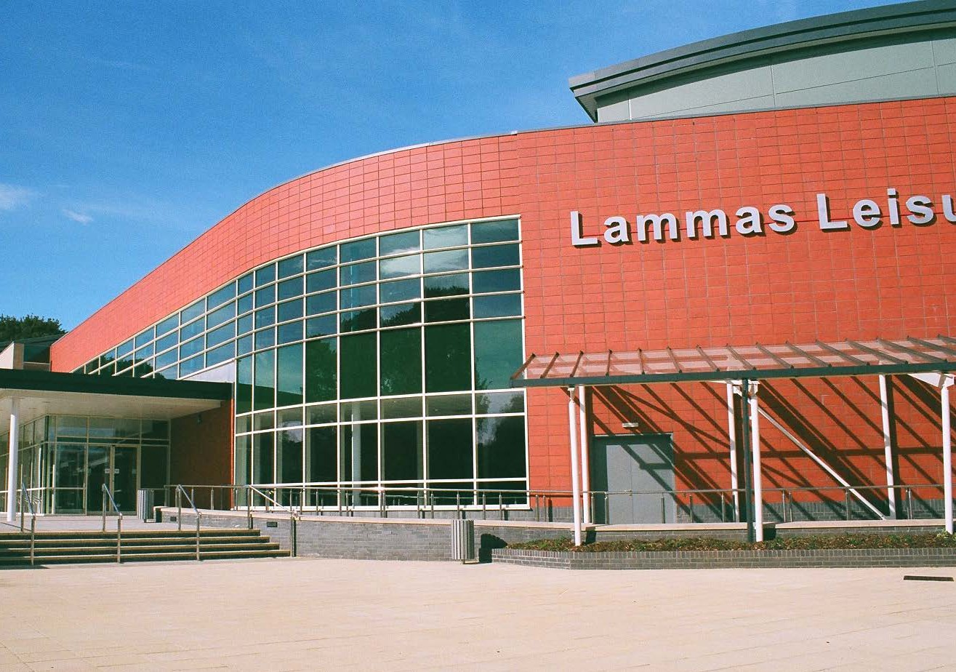
KEY GROWTH SECTORS BASED ON PREVIOUS EXPERIAN RESEARCH ARE:
THE KEY OBJECTIVES ARE TO DRIVE LOCAL PRODUCTIVITY AND GROWTH TO ENHANCE OPPORTUNITIES FOR BUSINESS AND INDIVIDUALS:
- To create a dynamic mix of productive and competitive businesses
- To attract and retain a skilled workforce to meet current
& future needs
- To provide high quality employment opportunities for all.
The key challenges for the future are clear in rebalancing the local economy.
The Plan for Growth for the area needs to address the barriers to growth and in doing so, build on the competitive advantages of the area, to maximise local opportunities.
The district councils will continue to work in partnership with Nottinghamshire County Council, D2N2 and any emerging sub-regional and regional bodies, to realise the key objectives for the future.
This will particularly focus on enhancing the resilience of the local economy, by growing private sector jobs and increasing local entrepreneurial activity, as well as enhancing local skills and aspirations.
- Business Services
- Health Services
- Wholesale
- Manufacturing
- Transport & Logistics

These are local strengths which will make a significant contribution towards realising the wider LEP Growth Strategy. There are also strong local sectors, which although not considered to be significant growth sectors for the future, will continue to play a significant role in the local economy, including retail and construction.

STRENGTHS:
- Employment rates higher than the national average
- A diverse range of businesses
- Excellent further education provision and improving local higher education provision
- Strong partnerships involving business support and employment and skills stakeholders
- Good access to the available business support (Account Management/
D2N2 Growth Hub)
- Good supply of competitively priced employment land and premises
- Supportive planning regime
- Affordable and varied housing
- Good natural environment and access to excellent leisure and amenity opportunities
- Hardworking and flexible workforce.

WEAKNESSES:
- Below average earnings, by workplace and residence
- Below average educational attainment levels, even though improving
- Weak learning culture with historical low aspirations and expectations
- Below average number of graduate-level workers/residents
- Below average business start-up and survival rates
- Below average levels of female-led business
- Some road and rail links in need of immediate improvement (M1/J27 to Ashfield/Mansfield, Robin Hood Line)
- Poor public transport connectivity, particularly between employment zones and rural areas.

OPPORTUNITIES:
- Good serviced employment land attracting new investment
- Potential growth in Advanced Manufacturing and Logisitics sectors
- Further growth in Construction sector employment
- D2N2 Combined Authority/Devolution Deal’ with ‘Emerging sub-regional governance changes
- Funding for interventions (LGF, ESIF, NCC Capital Programme, Devolution Deal)
- Work alongside the D2N2 Growth Hub to offer an enhanced Account Management Service to existing/potential businesses
- Emerging Local Plans for the two districts
- Development of HS2 within the area
- Potential improvements to rail networks (HS2, Robin Hood Line)
- Potential road improvements, particularly to those that serve local motorway junctions
- Emerging ‘Marketing Nottingham and Nottinghamshire’ PMO and D2N2 interest in investment promotion.

THREATS:
- National austerity measures could harm local FE, DWP, LA and other publicly funded provision
- End of the ERDF-funded activity in Ashfield and Mansfield and limited/no external funding to support future local direct provision
- Proposed government changes to NNDR could reduce investment in the area
- Continued weak learning culture and outward migration of highly skilled people
- Congestion on main trunk roads
- Local cities may attract investment & highest skills away from our area
- Continued lack of resilience in local economy.

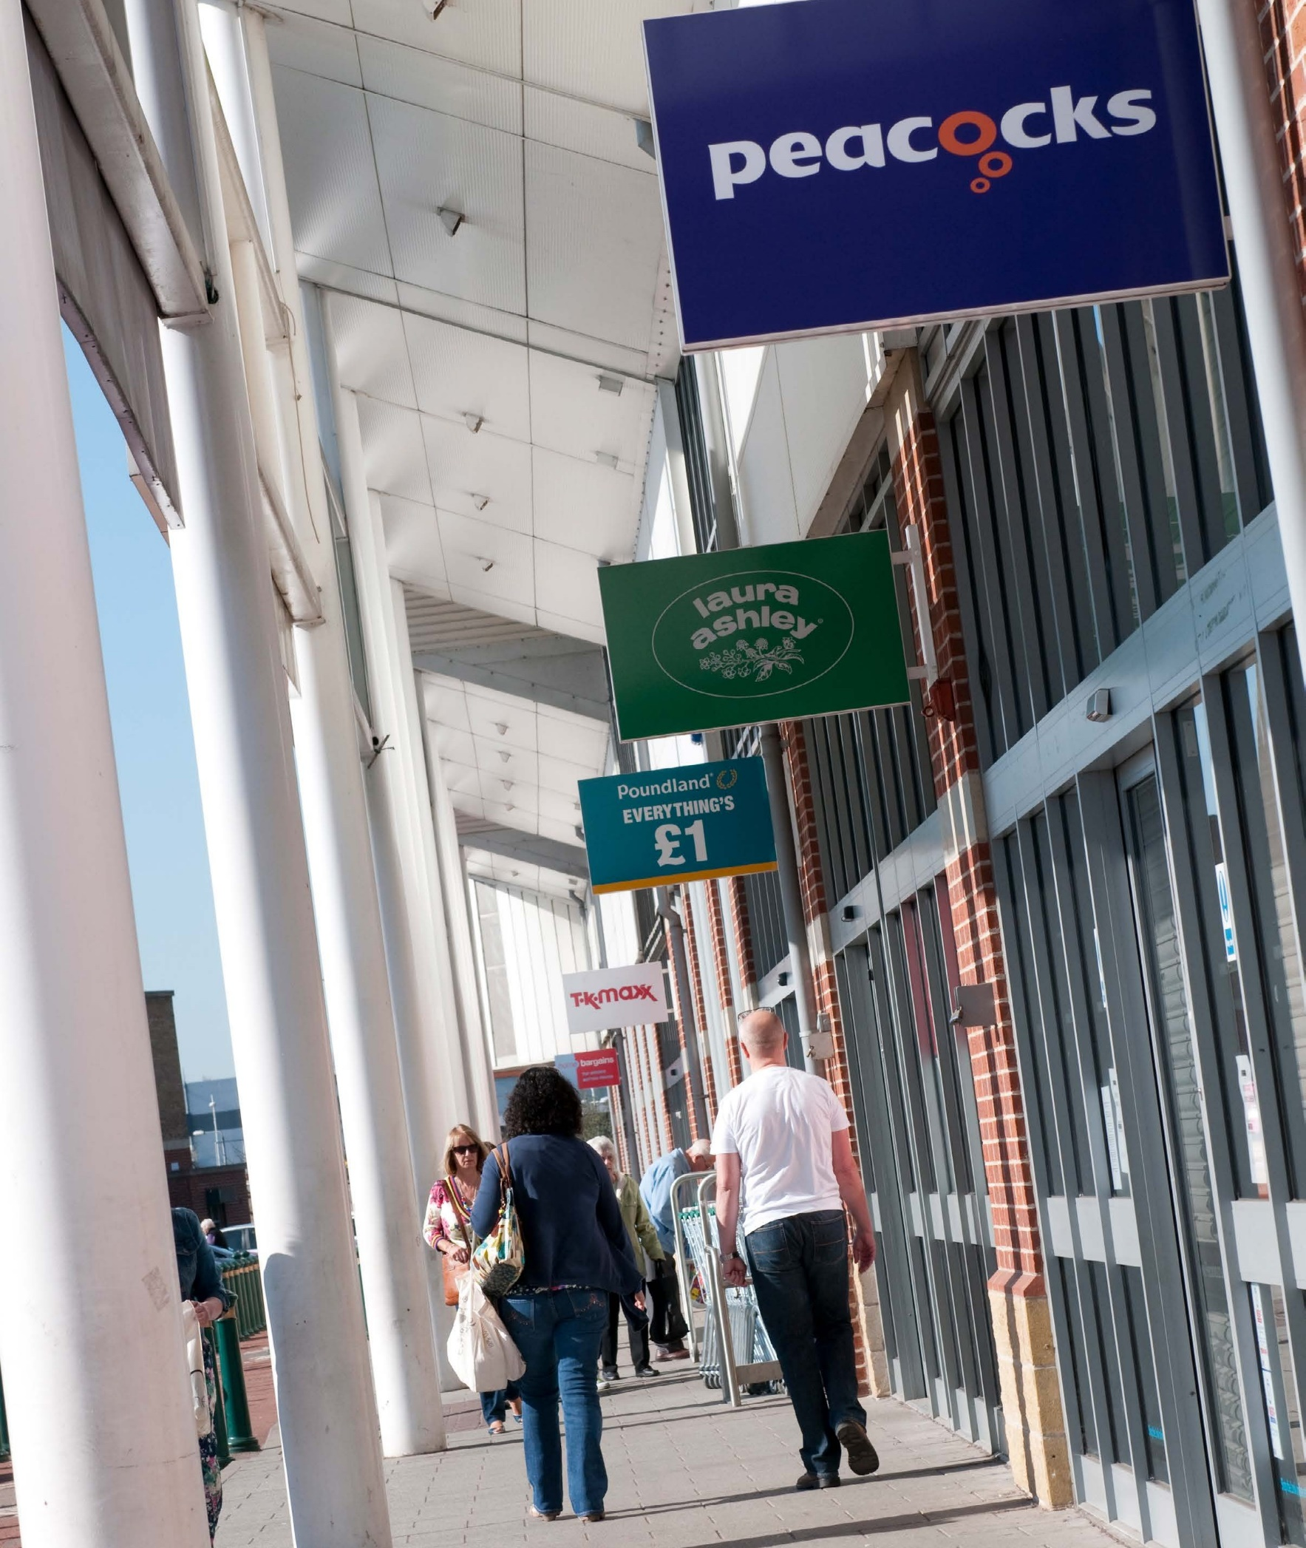
OBJECTIVES

The availability of appropriate skills for business is vital
if the local economy is to be successful and resilient.
Individuals will have greater opportunities available to them and will have more satisfying and rewarding careers if they have higher levels of skills and educational attainment. Making sure that local people have those attributes will directly benefit the local economy and make the area far more likely to attract further business investment.
Future productivity growth relies on ensuring that local people can meet changing employment needs, maximising local take-
up of jobs and encouraging those not economically active to participate effectively.
Developing the workforce to support business growth

THEME 1:
  - To develop and sustain a local workforce with the attitudes, commitment and aspirations that are essential to businesses operating in the area
  - To develop and sustain a local workforce with the required skills that will allow businesses to invest and thrive in the local area
  - Work to retain highly skilled individuals within the local economy
  - To enhance the higher-level skills of local people and encourage them to continue to live and work in the area
  - To help support and facilitate the connection between local people and new employment opportunities, resulting from business growth
  - To increase the number of apprenticeships being offered by local employers.

PRIORITY ACTIONS
- Work with schools and colleges to raise the aspirations, employment and enterprise skills of young people and provide a clear understanding of the opportunities open to them
- Establish the needs of local employers and encourage schools and colleges to match their respective offers to meet those needs and maximise opportunities for local residents
- Help businesses, including those looking to invest in the area, to recruit local residents
- Broker/facilitate access to a “job matching”, customised training service or other appropriate assistance, for employers with a high volume of hard-to-fill vacancies
- Promote the benefits and encourage the take- up of apprenticeships by local employers and employees
- Develop links to employment through activities such as procurement, planning, business engagement and supporting workforce development in schools
- Help to reduce the number of young people not in education, employment or training.

MEASURES OF SUCCESS –
AIM TO CLOSE GAP TO UK AVERAGES
Educational attainment levels Skills levels
Apprenticeship levels Wage levels
GVA per worker
Employment / unemployment / youth / economic activity rates
Number of school children supported / number of schools and colleges engaged with

OBJECTIVES

Businesses are the engine of growth and local opportunity and a varied resilient economy ensures that opportunities
are maximised. Growth is generated by new business start-ups, indigenous business expansion and new businesses locating in the area. Strong business productivity is reliant on many factors including a good supply of skilled workers, but also relies on availability
of suitable premises, efficient links with clients and suppliers, good transportation links and access to finance. Individuals committed to developing
a business will also need additional advice and support, particularly in the early stages of their development when most at risk. The Ashfield and Mansfield area must continue to offer a welcoming nurturing business environment with access to effective support.
Encouraging enterprise and business growth

THEME 2:
  - Create a climate for business and enterprise growth with an emphasis on making investment happen
  - Reduce/remove barriers to new business creation and growth within the area
  - Help to maximise business start-ups, indigenous business growth and new business investment in the area through easy access to all available business support services
  - Maintain good working relationships with significant existing and potential local employers and a problem solving attitude
  - Ensure that the councils offer regulatory and non-regulatory services in a supportive way to local businesses, in line with the principles of ‘Better Business for All’

PRIORITY ACTIONS
- Offer an Account Management service to existing businesses and those thinking of investing in the area
- Offer a one-stop-shop for businesses that are searching for appropriate premises or land in the local area
- Work alongside the D2N2 Growth Hub, to ensure that local businesses have full and efficient access to all locally available business support
- Deliver council services with an emphasis on supporting growth and development as part of strong customer services
- Encourage the creation and development of new local businesses
- Facilitate access to local procurement and supply chain opportunities
- Assist local businesses to maximise opportunities created by local developments.

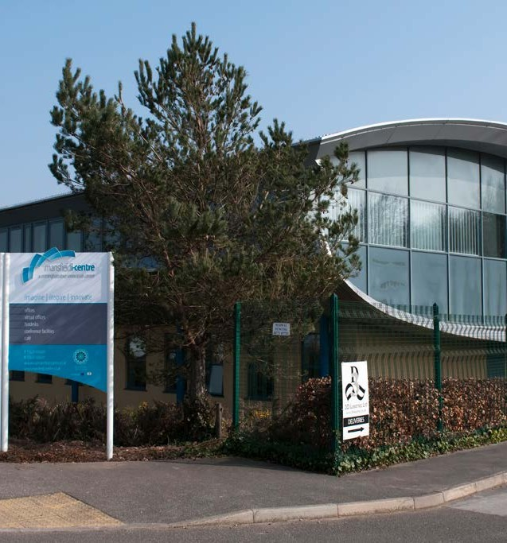

MEASURES OF SUCCESS –
AIM TO CLOSE GAP TO UK AVERAGES
Business start-up rates Business survival rates Employment land developed
Additional Business Rates value added

% Knowledge intensive businesses

Number of businesses supported, business enquiries handled, jobs created and safeguarded.

OBJECTIVES

In order to support growth, businesses require an environment that offers comprehensive and effective solutions to their infrastructure needs. The local business environment needs to offer access to suitable premises and land with good transport links, effective digital connectivity, appropriate housing provision for the workforce and access to excellent quality of life facilities including town centres, leisure facilities and open space. The quantum and choice of business development land and premises are essential in maintaining local business competitiveness and
the value of such assets needs to be affordable for business. There is a key role for the public sector in shaping and steering the adequate supply of such assets within the local economy. Public sector intervention in ensuring appropriate infrastructure provision to facilitate growth is a key expectation of the business community. Proximity to neighbouring cities is also important to the area for business development in remaining competitive.
Improving infrastructure and stimulating investment

THEME 3:
  - Present the area as an excellent place to do business and promote its full benefits, including quality of life, to potential investors
  - Work with partners to increase the provision and take-up of high quality/superfast broadband for local businesses
  - To develop and sustain the vitality of the area’s towns
  - To ensure an adequate supply of land and premises for business needs
  - To guide and support business in meeting their infrastructure needs
  - To ensure there is a clear understanding and intelligence supported approach towards future infrastructure development needs.

PRIORITY ACTIONS
- Promote the area to potential business investors, using the ‘Invest Ashfield & Mansfield’ brand, alongside higher-level investment promotion brands, such as D2N2 and ‘Marketing Nottingham & Nottinghamshire’
- Work with partners to increase the provision and take-up of superfast broadband for local businesses
- Work with partners to improve and enhance transport links within the area, including strategic links such as M1 J27, Robin Hood Line and HS2 developments as well as public transport
- Deliver regeneration projects - particularly in the area’s town centres to help sustain long term viability
- Develop and sustain education and business links to boost innovation, R&D and knowledge transfer

MEASURES OF SUCCESS – AIM TO CLOSE GAP TO UK AVERAGES
New floorspace developed/improved Land developed (m2)
Brownfield land redeveloped (Ha) Private sector investment Businesses Investing/attracted
- Ensure that business-related regulatory services are delivered in a way that encourages growth, wherever possible.
- Develop and adopt Local Plans that support economic growth
- Work with developers and landowners to maximise the growth opportunities in the area
- Maintain intelligence on understanding growth sectors and build relationships with developers and businesses in order to secure investment and jobs
- Support supply-chain activity and local inter-trading.

Vision:
Governance, monitoring

To maximise the opportunities for people and businesses to grow and prosper in Ashfield & Mansfield

and performance
management

Theme:

Developing the workforce to support business growth

Theme:
Encouraging Enterprise and Business Growth

Theme:

Improving Infrastructure and Stimulating Investment
The Plan for Growth will be underpinned by a more detailed action-focused delivery plan. This will be implemented through the regeneration Service with direction and monitoring through both councils’ respective Regeneration Portfolio Holders. Partnership interface will primarily be through the Mansfield and Ashfield Economic Development Partnership at the strategic level. There are various project governance arrangements in place to underpin specific project work such as town centre initiatives, Employment and Skills Group and Invest Ashfield Mansfield Board.

A scrutiny and review function is maintained through the respective councils’ own political governance
Present the area as an excellent place to do business and
promote its benefits to potential investors
Remove/reduce infrastructure r
elated barriers to business growth

Develop and sustain the vitality of the
area’s towns

Ensure an adequate supply of land and premises for business needs
Guide and support business in meeting their
infrastructure needs
Ensure an
intelligence-supported
approach towards future infrastructure needs
Objectives:
Create a climate for business growth with an emphasis on making investment happen

Reduce/remove barriers to new business creation and growth within
the area

Businesses looking to invest in the area will have easy access to all available business support

Have good working relationships with significant existing and potential local employers

Ensure that the Councils offer services, to local businesses, in line with ‘Better Business for All’
Objectives:
A local workforce with the attitudes, commitment and aspirations required by businesses

All members of the local workforce to have the skills that will allow businesses to invest and thrive

Enhance the higher-level skills of people living and working within the area

Make the Connection between local people and new jobs, resulting from business growth

Increased number of apprenticeships being offered by local employers
Objectives:
processes and reports can be considered throughout the administrative process.

