The Nottinghamshire Biodiversity Opportunity Mapping Project

Ashfield District

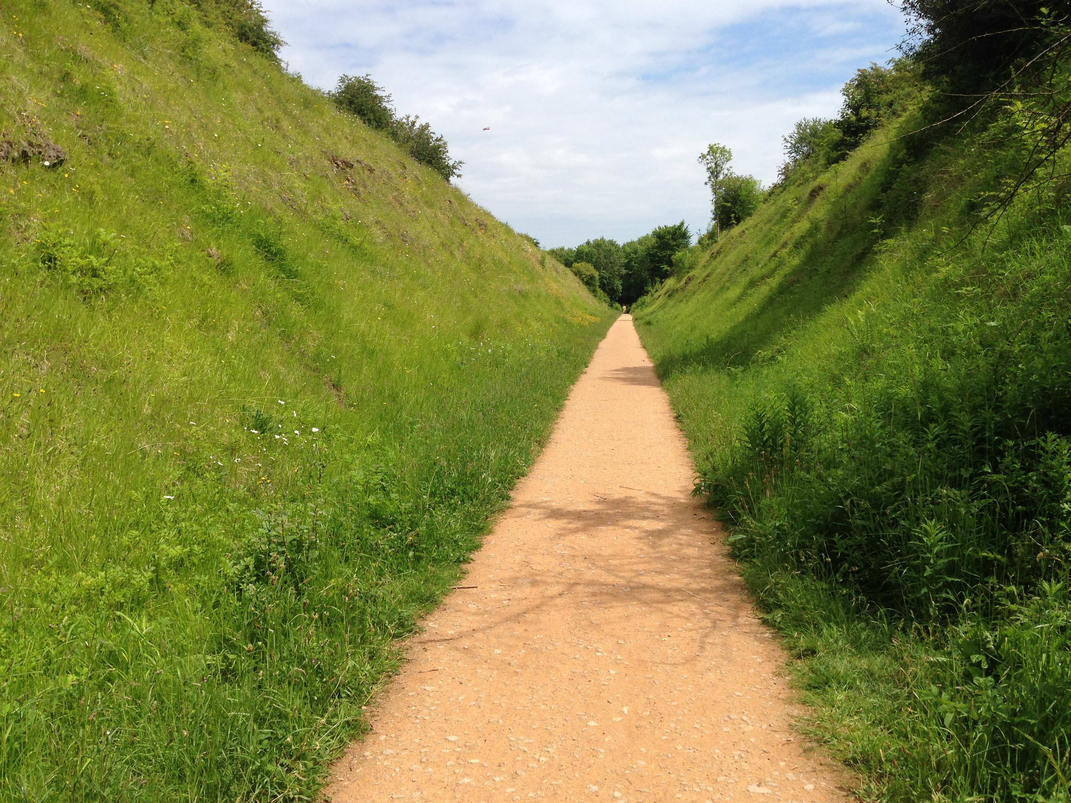

November 2016

The Nottinghamshire Biodiversity Opportunity Mapping Project
Ashfield District FINAL REPORT

Credits:
Report produced by Chris Jackson (Nottinghamshire Biodiversity Action Group, NottsBAG), with mapping and data analysis undertaken by both Chris Jackson and Karen Taylor (Nottinghamshire County Council). The production of the Ashfield BOM report was made possible due to funding by Ashfield District Council.

Aim of the Project
The aim of this project is to produce a Biodiversity Opportunity Map (BOM) for Ashfield District. This work was undertaken to support the work of Ashfield District Council but also to help to underpin the wider work of the Nottinghamshire Biodiversity Action Group (BAG), the Local Biodiversity Action Plan (LBAP) partnership for Nottinghamshire.

Background and context to the Project
In 2008 the Nottinghamshire BAG resolved to produce a Biodiversity Opportunity Map for the County, in order to:
  - Help us have a better understanding of the current distribution of biodiversity in the County
  - Provide a spatial vision for how partners want the biodiversity of the County to look in the long and medium term
  - Identify the most effective way to re-create habitat networks at a landscape-scale
  - Help to focus partners’ resources on optimising biodiversity gain
  - Help to deliver our contribution to the England Biodiversity Strategy, such as for monitoring and reporting, and target-setting for habitats and species
  - Inform spatial planning, including the delivery of Green Infrastructure
  - Inform agri-environment targeting
  - Underpin Biodiversity Offsetting
  - Guide the work of the Local Nature Partnership and Local Enterprise Partnership
  - Inform a wide range of other strategies, such as for climate change and ecosystem services
  - Provide a robust case for developing funding bids
  - Influence policy makers, landowners and land managers

Initially, the BAG intended to adapt the Regional BOM (which was under development at the time) into a County model, but over the next two years it became clear that for technical reasons this was not possible. Partners resolved to develop our own model that would best suit our needs in Nottinghamshire and would draw widely on best practice from around the UK. The availability of funds to progress the work was, however, a seriously limiting factor, particularly as the County Phase 1 mapping was only available as a hard copy and has never been digitised (due to cost).

A task and finish group of the BAG was established - the BOM Working Group (see Appendix 1) - to determine the best approach on behalf of partners, and after reviewing several models from other counties, a decision was made in 2012 to utilise the Habitat Network Model developed in the National Forest, as this was most closely correlated to what we aimed to achieve and could be run on the computer software (MapInfo) available to the partners. The National Forest Company team was willing to share both their Habitat Network Model and their considerable staff expertise, having developed their model in-house.

The opportunity then arose to bid for funds from various sources to begin the BOM process on discrete parts of the county. Initially this work took place in Sherwood during 2012/3 and this work was funded by Natural England. Subsequently funding was provided by the Trent Vale Landscape Partnership Scheme and the Nottinghamshire County Council Minerals and Waste Team, to undertake the BOM process in the Trent Valley. This process was undertaken in two phases, firstly in the Trent Vale between Newark and Gainsborough and secondly in the area between Nottingham and Newark. In 2013/14 funding was made available by two local authorities (Rushcliffe Borough Council and Broxtowe Borough Council) in conjunction with funds from the Environment Agency to undertake the BOM process within Broxtowe and Rushcliffe (west of the A46), including the final section of the Trent Valley between the eastern edge of Nottingham (Netherfield) and through the city to the county boundary with Derbyshire. Funding to undertake the BOM process in the remaining part of Rushcliffe Borough (Rushcliffe east of the A46) was made available by Rushcliffe Borough Council in 2014/15. In 2015/16, Ashfield District Council were able to provide funding to pay to undertake the BOM process across the parts of this district that fell outside of the Sherwood BOM area.
A report detailing the outputs from the Trent Valley BOM (the central and northern sections) was produced in September 2013 and this was followed by a report detailing the BOM outputs for the Borough of Broxtowe, produced in March 2014. A report for Rushcliffe, West of the A46, was produced in October 2014 and this was followed by the production of a report detailing the outputs of the BOM exercise for the East of Rushcliffe in March 2015. The two Rushcliffe reports were merged into a final report for the whole of Rushcliffe, produced in July 2015. In February 2016, a second Trent Valley BOM Report was produced that finally combined the results of the BOM process for the three sections of the Trent Valley in Nottinghamshire. In 2016 funding was found through the development stage of the Sherwood Landscape Partnership Scheme to produce a BOM report detailing the outcomes of the Sherwood BOM process that had taken place three years earlier.
This current document is the most recent BOM Report to be produced and covers Ashfield District. A draft document for this area was produced in June 2016, and feedback received after circulation of this document have, where appropriate, been incorporated into this final report.

Methodology
The following methodology has been used in undertaking the BOM process, which has been agreed by the BOM Working Group and the BAG:
  - Geo-rectification of 1997-8 Phase 1 habitat map image files within MapInfo
  - Digitisation of the Phase 1 habitat maps using MapInfo
  - Updating of the Phase 1 habitat maps using aerial photography interpretation (2007, 2009 and 2013 flights), BAG LBAP habitat mapping data, and latest Local Wildlife Site knowledge from the Nottinghamshire Biological and Geological Records Centre (NBGRC).

  - Assigning relevant habitats to one of the four broad habitat types - woodland, acid grassland & heathland, other grassland, and wetland (see Appendix 2 for details of which habitats make up the four broad habitat types).
  - Data cleaning within MapInfo to ensure that there were no gaps or overlaps in the mapped data
  - Running of the Habitat Network Modelling (see below for further details of the model)
  - Stakeholder workshops to annotate the Habitat Network maps (see below) based on the four broad habitat types (woodland, acid grassland & heathland, other grassland and wetland)
  - Collation and digitisation of the workshop outputs to produce Biodiversity Opportunity Maps for the four broad habitat types
  - Production of draft report for comment
  - Amendment of Biodiversity Opportunity Maps following feedback and production of final report

The Habitat Network Model
The Habitat Network Model developed by the National Forest Company is based on the permeability of different habitats to the movement of species. It uses a generic ‘focal’ species to represent each of the four habitat networks (i.e. woodland, heathland and acid grassland, other grassland and wetland), and every Phase 1 habitat that is mapped is assigned a permeability value for each of the four generic species. The permeability values are based on the work of Roger Catchpole at Natural England and have been slightly modified to reflect Nottinghamshire circumstances (see Appendix 3).
The Model then uses “least cost analysis” to calculate how far the focal species can move from its core habitat, with species moving further through more permeable habitats than through less permeable ones; for example, the woodland focal species can move well through habitats that are similar to woodland, such as scrub, but not through habitats which are very different to woodland, such as arable farmland or grassland. Therefore, core habitats that are surrounded by more permeable habitats will allow for stronger networks than those separated by impermeable ones. Where areas of core habitat become linked, these are referred to as Habitat Networks. To assist in the interpretation of this data, Habitat Networks have been placed into different categories depending on their size (which is the size of the Habitat Network, not the size of the core habitat contained within the Habitat Network), so that large Habitat Networks (containing areas of well connected habitats) can be distinguished from small Habitat Networks (representing isolated and fragmented areas of habitat).

Workshops
A stakeholder workshop was held during the process of gathering the information to go into this report. The workshop was held on Tuesday 29th February 2016 at Ashfield District Council’s offices in Kirkby-in-Ashfield. The workshop was attended by 31

individuals from 17 organisations. In addition, information to inform the wetland opportunity maps was obtained from staff at the regional Environment Agency’s Trentside office during March 2016.

Appendix 4 provides a list of attendees for the workshop.

During the workshops, participants were asked to annotate the Habitat Network maps for each of the four broad habitat types, for two timescales – a long term 50 year period, and a shorter term 10 year period. They were asked to resist the temptation to necessarily link together all the Habitat Networks, and to think about the size and scale of habitats to be created, and where these might be best located within the landscape. Participants were also asked to follow the principles set out in ‘Making Space for Nature’ – Better, Bigger, More, Connected, using the following definitions:
Better: Areas of existing, but degraded habitat, which need their condition improved, e.g. scrubby heathland or mixed woodland with a high proportion of non-natives. This particularly relates to those sites that are in (very) poor condition.

Bigger: Areas onto which existing habitat can be expanded, e.g. adjacent areas of conifer plantation or arable land, which help make existing areas larger and also buffer them from other land uses. For the purposes of this workshop, an arbitrary limit will be used whereby ‘bigger’ can be up to doubling of the site (after which time it becomes 'more').
More: New areas of habitat to increase the overall resource - e.g. creation of new heathland or woodland on arable land, in areas that do not abut existing habitat that can be made 'bigger' (or where the size of an existing site is more than doubled).

Connected: Enhancing existing, and creating new, connections between existing/planned areas of habitat, either through continuous corridors or by using stepping stones, so that currently isolated habitat blocks are linked up. Obviously 'bigger' and 'more' may result in the creation of new connections anyway, and 'better' may result in the enhancement of existing connections, so this relates particularly to things like narrow, linear linking strips of habitat (along road verges or disused railway lines) or very small patches of habitat that will act as stepping stones which on their own don’t deliver substantial areas of new habitat.
A range of other data was available to workshop participants to help assist in determining where activities to best deliver these principles should be located. This was:
- Agricultural Land Classification
- Environment Agency Flood Maps (Zone 2 and Zone 3)
- Environmental Stewardship and English Woodland Grant Scheme agreements

- Land owned by BAG partners (Forestry Commission, Nottinghamshire County Council, Nottinghamshire Wildlife Trust and the Woodland Trust)
- Locally designated site boundaries (Local Wildlife Sites, previously known as Sites of Importance for Nature Conservation and Local Nature Reserves)
- National Character Areas
- Phase 1 habitat maps
- Statutorily designated site boundaries (Sites of Special Scientific Interest)
- Wetland Vision map (for reedbed and floodplain grazing marsh)

Outputs

The Ashfield BOM Project has four mapping outputs:

- “The Basemap” (Appendix 5), which shows all habitats across 125.84 sq km within the project area (including a 250m buffer), based on the digitised 1997-8 Phase 1 survey, updated with reference to aerial photography, the BAG’s LBAP habitat mapping data, and knowledge of Local Wildlife Sites from the Nottinghamshire Biological and Geological Record Centre (NBGRC).
- “The Habitat Network Maps” (Appendix 6), which have been produced in MapInfo using the National Forest’s Habitat Network Model, for each of the four broad habitat types (woodland, grassland, wetland and heathland/acid grassland).

- The “Biodiversity Opportunity Maps” (see Section 9 – Maps and tables), which incorporate (i) the “Long Term 50 Year Opportunities” and (ii) the “Short Term 10 Year Opportunities”. The former are BAG partners’ shared vision and aspirations for what might be achieved over a 50 year time frame, based on the assumptions of a sympathetic funding and planning climate and guided by the current distribution of habitats and their potential for extension based primarily on geology, soils and hydrology. This map also includes details of the longer-term landscape scale visions and targets of BAG partners where they are already in place, but is moderated by permanent constraints such as large settlements and roads. The latter, which overlay the Long Term 50 Year Opportunities, show shorter-term aspirations based upon current or proposed projects and known constraints such as substantial approved development sites, new planned infrastructure and areas of highest value farmland. Each area on the maps is numbered, with a description of the opportunity contained in the accompanying table.
- The “Focal Area Maps” (see Section 9 – Maps and tables), identifying locations where there appears to be a particular concentration of opportunities, which may be for the same habitat type or across different habitat types. These can be used to prioritise activities so that they have the maximum benefit.

What the BOM shows
The following conclusions have been drawn following the workshop and the production of the Biodiversity Opportunity Maps:
- Priority habitats
The BOM maps indicate that Ashfield is a particularly important area for its biodiversity and that this part of Nottinghamshire supports a diverse range of habitat types. All four of the broad habitats are well represented within the district and concentrations of opportunities for each of these have been identified as part of the BOM process.
Woodland (see Map 1, page 13) - Opportunities for woodland are much more widespread across Ashfield, although the BOM identifies certain areas where clusters of opportunities for this habitat type occur. Woodland opportunities tend to be clustered in two main areas in the south and east of the district.

Heathland & Acid Grassland (see Map 2, page 15) - Acid grassland and heathland habitat is limited to the eastern edges of Ashfield District and these areas are very much associated with the underlying geology (Sherwood Sandstones). As a result, all the opportunities for this important broad habitat type seek to build on and reconnect the existing habitat blocks in the east of Ashfield.

Other Grassland (see Map 3, page 17) - Grassland opportunities tend to be spread across Ashfield and clusters occur in many parts of the district. Clusters of opportunity occur in Bentick/Kirkby Grives area, south of Hucknall, west of Bagthorpe, the Meden valley, around Huthwaite and at Brierley.
Wetland (see Map 4, page 20) - As to be expected, the wetland opportunities in Ashfield are associated with the main river catchments within the district - the rivers Erewash, Leen, Maun and Meden. In addition, on some areas of restored or previously worked land the potential to build on existing pond/wetland networks could be enhanced through the creation of pondscapes.
- Focal Areas
The BOM maps show that there are several areas where existing habitats and associated opportunities are concentrated, referred to here as ‘Focal Areas’. The input of the participants at the workshops has shown that there are substantial opportunities in both the short and long term to enhance and expand these habitats, to buffer them and to link them up to create a stronger habitat network across a landscape scale. These Focal Areas, shown on Map 5 in section 9, are:

  - Beauvale and Felley: this focal area (which extends into Broxtowe) is predominantly focused on improving and enhancing existing areas of woodland and grassland as well as looking to buffer these areas and establish better connections between them across the landscape. The area incorporates large blocks of existing woodland in the vicinity of Felley/Annesley with smaller blocks to the east around

Bagthorpe where there is a greater focus on improving the habitat connectivity between grasslands.
  - Erewash Catchment: an area with great potential for improving the wetland and grassland habitats (and to a lesser extent the woodland network) in this long, linear focal area stretching along the Erewash Valley from Kirkby-in-Ashfield southwards to Toton in Broxtowe (and also including land in Derbyshire). The Erewash Valley offers opportunities to improve existing core areas of habitat, the opportunity to create new areas of habitat that can buffer and protect these core areas and also the opportunity to improve habitat connectivity along the valley by creating linking pieces of habitat between the existing habitat blocks.
  - Kirkby-Bentinck-Annesley Woodhouse: potential for improving the existing habitat network across this area with a particular focus on calcareous and neutral grasslands. A number of the existing sites provide some very good areas of core habitat and the surrounding landscape offers a lot of opportunities within which habitat connectivity can be improved. The western part of this focal area also provides good opportunities for improving the existing network of ponds and wetlands.
  - Leen Catchment: this focal area has the potential for improving the existing wetland and grassland network along the River Leen and its tributaries. Opportunities to improve these habitats occur between Bestwood and Newstead and along the tributary of the River Leen that runs from the Whyburn area through Hucknall to the main river. The focal area also includes opportunities to enhance the existing network of calcareous and neutral grasslands located between Hucknall and Bulwell, where it extends into both Gedling and Nottingham City.
  - Newstead and Annesley: this Focal Area offers opportunities for improving the biodiversity resource for all four of the broad habitat types. The existing woodland resource which is widespread but very fragmented and work should look at enhancing stands of existing broad leaved woodland and buffering these as well as improving connectivity between these sites. There is also potential to enhance the existing heathland/acid grassland resource. Golf courses at Hollinwell and at Coxmoor support existing habitat patches which could be enhanced, offering good opportunities for reconnecting this resource. In addition the Focal Area offers opportunities for improving and creating better connections between existing wetland sites as well as between areas of neutral and calcareous grassland, such as is found at the former Annesley Pit Top (now Newstead and Annesley Country Park).
  - North Ashfield: potential exists to enhance and create habitats throughout this wide and varied landscape. The majority of this area sits within the Meden catchment and as a result there is a lot of potential to enhance existing wetland and grassland habitats along the river and its tributaries, as well as improving the habitat connectivity between these sites. The area also includes potential to enhance areas of calcareous and neutral grasslands along the Teversal Trails and along other disused railways in the area where they connect into existing areas of grassland around Huthwaite. In addition, there is an opportunity to enhance the existing

woodland network, with a focus on improving the existing plantation woodlands on the old pit tips at Silverhill and Brierley Forest and create better connections between these and through the wider landscape.
- Wider Landscape
It is significant that the BOM identifies a large number of smaller habitat cluster areas, scattered throughout Ashfield, but it also appears to indicate that there are parts of Ashfield where there are no opportunities. However, in these areas, opportunities do exist: improved hedgerow networks and shelterbelts can be used to improve linkages between woodlands; improving areas of commercial forestry through the creation of better links between blocks of existing broad-leaved woodland or glades; grassland strips around fields and along roads can help link up isolated grassland sites; and the improved management of ditches and other watercourses can link up wetlands. Although not specifically picked out in the BOM, such opportunities can be delivered through agri-environment schemes and by inclusion within Forest Design Plans. It should also be noted that the BOM picks out the River Valleys and their associated streams and ditches, as key features within the landscape that can be used to improve connectivity throughout the whole of Ashfield.
- Conflicts and other considerations
It is evident that some areas are appropriate for the creation of more than one type of habitat. In such instances, it may be possible to incorporate both (or all) habitats into a single location through careful planning; alternatively, it may be that one habitat is deemed to be more important than another. Similarly, there may be instances where habitat creation at one location will affect an adjacent area where habitat currently exists (or could be created). Such instances should be looked at on a case-by-case basis as and when opportunities arrive, with the help of specialist ecological input.
It should also be noted that these are ecological opportunities; no account has been taken at this time of other factors such as land ownership and current land use, or of other factors such as flood risk management or public access. These would, of course, need to be considered at the time that opportunities are taken forward.

A number of Invasive non-native species (INNS) are known to be present across the landscape within Ashfield District, however it is not the purpose of the Ashfield BOM to deal with the detail of preventing the spread and controlling the distribution of these species. It is assumed that work to control these species should be undertaken at a landscape scale and where feasible projects that seek to enhance the biodiversity of particular areas (one of the focal areas perhaps) should also look to control and eradicate INNS within these areas.

- Opportunities for species
The BOM focuses on habitats, but implicit within this is the expectation that works to make habitats better and bigger, to create more of them, and to ensure that they are

linked up, will also benefit the priority species1 which use these habitats. The species which are likely to particularly benefit from the opportunities identified in this report are:
- Birds, such as woodlark and nightjar. Breeding waders and wintering wildfowl (using wet grassland), and scrub species such as willow tit, turtle dove and grasshopper warbler
- Mammals, including bats, water vole and harvest mouse
- Herpetofauna, including common frog, common toad, common lizard and grass snake
- Invertebrates, including white-clawed crayfish
- Fish, including brown trout, bullhead and spined loach
- Lepidoptera, including habitat-specialist butterflies and moths
- Plants, including calcareous grassland specialists

Examples of simple actions for some of these species, that were identified as part of the workshop and that could be undertaken within Ashfield included; the planting of sallow in woodlands as an early nectar source for moths and other inverts, ensuring that woodland rides are mown after late September so as not to damage the larvae and foodplants of lepidoptera, and the creation of ponds within school grounds and allotments. These are just a few examples of actions that could be undertaken that would have a widespread benefit to specific species groups.

Next steps
The opportunities highlighted in this report will be quantified and used to estimate the scale of habitat creation and restoration that can be delivered across Ashfield, and used as part of the next round of target setting for the Nottinghamshire Local Biodiversity Action plan (LBAP).

However, the report should be seen as a living document that will be updated as better data becomes available or as new opportunities are identified.

¹ Species of Principal Importance for Conservation in England, as identified through Section 41 of the Natural Environment and Rural Communities Act (2006)

Maps and tables
Map 1 Woodland Biodiversity Opportunity Map
Table 1 Biodiversity Opportunity table for Woodland (W)
Map 2 Heathland and Acid Grassland Biodiversity Opportunity Map
Table 2 Biodiversity Opportunity table for Heathland and Acid Grassland (H)
Map 3 Grassland Biodiversity Opportunity Map
Table 3 Biodiversity Opportunity table for Grassland (G)
Map 4 Wetland Biodiversity Opportunity Map
Table 4 Biodiversity Opportunity table for Wetland (M) Map 5 Focal Areas

Map 1 - Woodland Biodiversity Opportunity Map
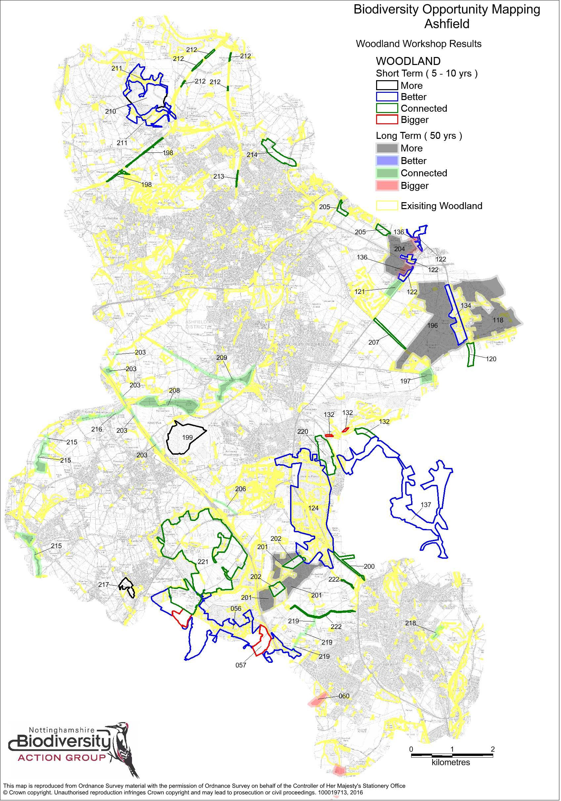

- 13 -

Table 1 - Biodiversity Opportunity table for Woodland (W)

Report ID | Map Display ID | Opportunity
Brx | 056 | Watnall Coppice, Watnall Spinney, Moor Green/Beauvale Estate. Enhance and connect these larger blocks of woodland. GJ
Brx | 057 | New woodland planting to link major woodlands near Haggs Farm. JB
Brx | 060 | Woodland planting to link New farm Wood and Seller's Wood, and Seller's Wood and Bulwell Wood. Eelhole Wood, Low Wood, Starth Wood. NK
SHER-S | 118 | Buffer existing broadleaf woodland habitat and improved linkages within existing broadleaf woodland at this site through the Forestry Design Plan.
SHER-S | 120 | Woodland Shelter Belt - target project.
SHER-S | 121 | Linking woodland block.
SHER-S | 122 | Better quality - buffering to create linkages with woodland.
SHER-S | 124 | Annesley Wood - Restore to broadleaved species mix.
SHER-S | 132 | Strengthen corridors
SHER-S | 134 | Retain as woodland - Important moths associated with the Bilberry Star which grows under the tree cover here (i.e moths needing Bilberry growing under trees).
SHER-S | 136 | Better quality - buffering to create linkages with woodland.
SHER-S | 137 | Enhance and buffer existing woodlands
Ashfield | 196 | Thieves Wood: conversion of coniferous wood to broad-leaf wood: ongoing over 50 years on felling of crop. DS & Improving broad-leaf linkages between existing coniferous compartments by  planting broad-leaved trees or by maintaining regeneration trees along rides and woodland edges. MGo
Ashfield | 197 | Create connecting woodland habitat between Thieves Wood and Newstead Abbey Park.DS
Ashfield | 198 | Improve woodland connectivity along Silverhill Trail to connect Brierley and Silverhill parks. DS
Ashfield | 199 | Bentink Tip restoration to create a golf course includes opportunities for woodland creation. MH & Golf course restoration requirement is to acid and calcareous grassland, scrub and wetlands. JB
Ashfield | 200 | Top Wighay Farm Development - opportunty to create a woodland connection along A611 to Wighay Farm Wood. JAR
Ashfield | 201 | Park Forest - change from coniferous to broad-leaf on cropping trees. JAR
Ashfield | 202 | Park Forest - create habitat connection between existing broad-leaf by creating broadleaf strips through coniferous sections. JAR
Ashfield | 203 | Woodland connections along M1 margins
Ashfield | 204 | Cauldwell Wood/Stonehills Plantation - Conversion to broad-leaf wood. MGW
Ashfield | 205 | Lower Oakham/Summit - connectivity between existing woods. MGW
Ashfield | 206 | Create/improve Woodland/Hedgerow connection alongside public footpath. MGW
Ashfield | 207 | Two Oaks sand quarry - roadside bunds already planted with woodland. DS
Ashfield | 208 | Erewash Valley - create a woodland connection between Bentink and Pinxton. DS
Ashfield | 209 | Create a woodland connection along dismantled railway to Portland Park. DS
Ashfield | 210 | Replacement of coniferous wood with broad-leaf at Silverhill. NC
Ashfield | 211 | Enhancing existing broad-leaved woodland at Silverhill, eg. through the removal of non-natives. NC
Ashfield | 212 | Existing hedgerows along Teversal Trails - improve condition if required (KB). Need to be mindful of calcareous and neutral grassland linkages - existing and potential. NC
Ashfield | 213 | Improve woodland connectivity along cycle way from Skegby Bottoms to Stoneyford Road. DS
Ashfield | 214 | Create woodland connection through new development at Beck Lane, Skegby. MGW
Ashfield | 215 | Create woodland connection along Erewash river valley by Pye Bridge.MH
Ashfield | 216 | Woodland connectivity improvements along railway corridor at Brookhill Industrial estate.NC
Ashfield | 217 | Underwood Colliery/Pit tips - NCC owned. Potential to expand existing woodland area. Opportunity to plant grazing land for woodland or wood pasture. MG
Ashfield | 218 | Leen Valley Golf Course - link planted areas with woodland and hedgerows. LS
Ashfield | 219 | Enhance/establish hedgerow/woodland connectivity between Watnall Coppice and Whyburn Farm. MGW
Ashfield | 220 | Linking by hedgerow or woodland strips through Mosley Farm and/or around new developments on the old Annesley Pit site.
Ashfield | 221 | Felley priory, Greasley estate - Small improvements to hedgerows, field overplanting, shelter belts on edges of arable fields etc - to strengthen the whole network. JB
Ashfield | 222 | Riparian woodland planting in Baker Lane brook catchment, to help reduce flood risk to Hucknall. DJW

- 14 -

Map 2 - Heathland & Acid Grassland Biodiversity Opportunity Map
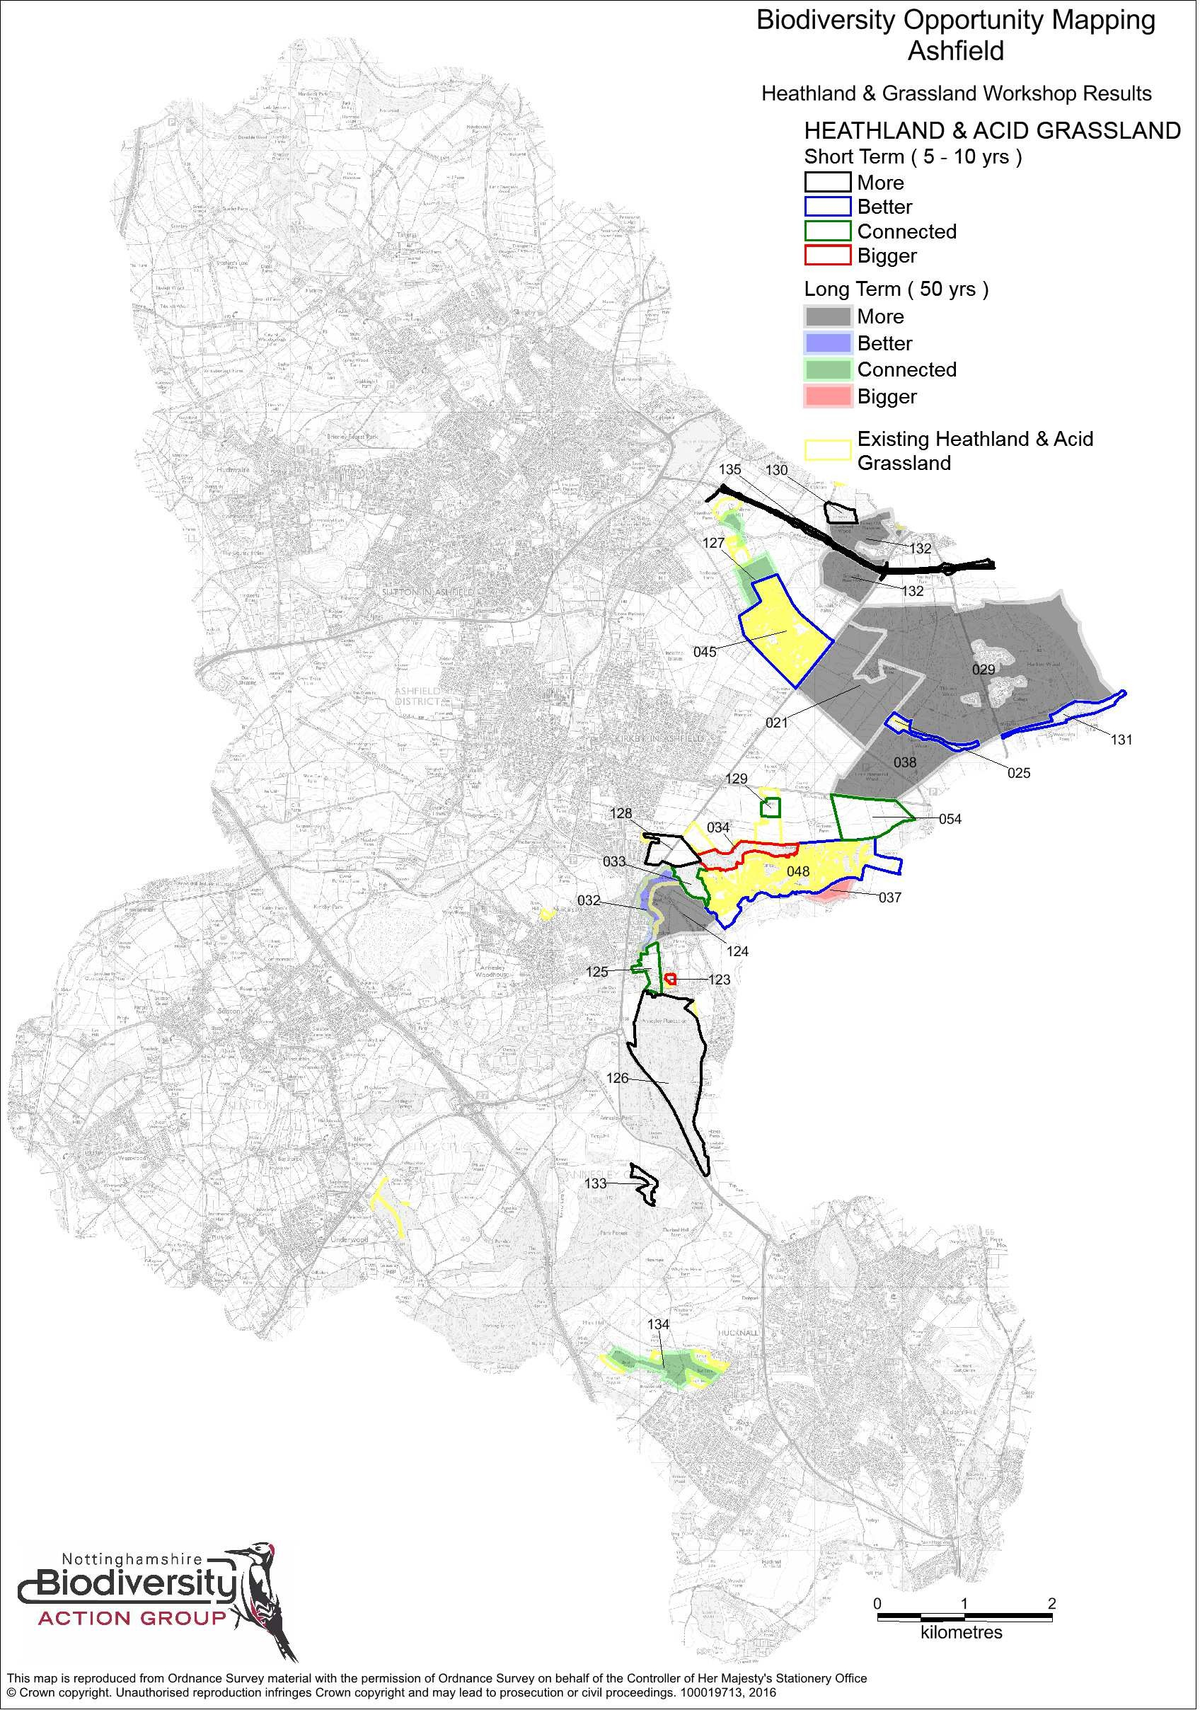

- 15 -

Table 2 - Biodiversity Opportunity table for Heathland & Acid Grassland (H)

Report ID | Map Display ID | Opportunity
SHER-S | 021 | Two Oaks Farm - Heathland restoration on mineral site. Opportunity to create wide headlands now to encourage colonisation by plants/inverts rather than 50 years from now (SHER-S) & Approved restoration scheme for- Two Oaks farm quarry is to 50% heathland and grassland. But will be subject to a ROMP within the next 10 years, and this should secure 100% acid grassland and heathland.  JB (Ashfield)
SHER-S | 025 | Open areas -acid grassland/heathland habitat needs improved management and expanding/linking with other heath/grassland habitats where possible.
SHER-S | 029 | Creation of heathland/acid grassland along rides and to replace some areas of conifer in Thieves and Harlow Woods (SHER-S) & Be aware that Thieves Wood is a moth LWS. The moths in question  are associated with bilberry growing in the shade of conifer and oak. Do not remove conifer and oak in these locations and plant more bilberry in similar locations. SW (Ashfield)
SHER-S | 032 | Robin Hood Hills - Heathland restoration (SHER-S) & Improve Heathland habitat, manage bracken and expand cover of Heather/Bilberry etc. LS (Ashfield) & Currently threatened by planning  application by landfill, which would affect lizards, nightjar, woodlark and would fragment the LWS network. JB (Ashfield)
SHER-S | 033 | Improve connectivity of heathland between Robin Hood Hills and Hollinwell.
SHER-S | 034 | Restoration to heathland & broadleaved woodland (SHER-S), & Opportunity to remove coniferous woodland in favour of acid grassland/heathland. LS (Ashfield)
SHER-S | 037 | Restoration to heathland from Arable.
SHER-S | 038 | Little Normanshill Wood - Mosaic creation, heathland & woodland.
SHER-S | 045 | Coxmoor Golf Club - Heathland course has Sherwood Forest Trust management plan but benefit from more active engagement (SHER-S) & Golf-course management. Poor management restricting  habitat quality - heather but few heathland species - change regime at Coxmoor and Hollingwell. ADL (Ashfield)
SHER-S | 048 | Hollinwell Golf Course - Existing area of heath/acid grassland (SHER-S) & Golf-course management. Poor management restricting habitat quality - heather but few heathland species - change regime  at Coxmoor and Hollingwell. ADL (Ashfield)
SHER-S | 054 | Target landowner to encourage ELS etc application to create wildlife corridor (SHER-S) &Link existing sites and Two Oaks Quarry, Coxmoor. Most habitat there of potential with quarry. Would involve  only loss of small area of arable between Hollinwell and Thieves Wood. RJ (Ashfield BOM)
Ashfield | 123 | Annesley Rows - owned by NCC and managed by Annesley Parish Council. Small, young plantation woodland could be felled to extend area of acid grassland. MGu
Ashfield | 124 | Encourage sympathetic land management practices to enhance current habitat and provide connectivity. MGW
Ashfield | 125 | Cemetery is existing LWS (Acid grassland. Steep upper slopes, potential for acid grassland creation for connecting habitat between Robin Hood Hills and Annesley Plantation. Site contains football  pitches, play area and a skate park - Parish land. RJ/WK
Ashfield | 126 | Create new Heathland/Grassland habitat through rides and possibly compartment management. LS
Ashfield | 127 | Link existing sites and Two Oaks Quarry, Coxmoor. Most habitat there of potential with quarry. Would involve only loss of small area of arable between Hollinwell and Thieves Wood. RJ
Ashfield | 128 | Grass field surrounding existing acid grassland/heath. Change of management? Could create/restore acid grassland. MGW
Ashfield | 129 | Potential to connect areas of existing habitat. SM
Ashfield | 130 | Disused pit - restore to acid grassland/heathland with FC/NWT. ADL
Ashfield | 131 | Enhance/restore wetlands and acid grassland. Requires better management/bracken control. ADL
Ashfield | 132 | Bigger and better connected networks of heathland (potential) within existing Forestry Commission woodlands. MG & Needs exploring with FC, evidence of historic heathlands in this area. KB
Ashfield | 133 | Area of open habitat that could benefit from bracken control (Exact area unknown). MGu
Ashfield | 134 | Approach landowners to connect acid grasslands (x4) through field margins etc. IW
Ashfield | 135 | Extend and enhance: land along roadside of MARR route potentially linked to development of housing and industrial to the north. DS

- 16 -

Map 3 - Grassland Biodiversity Opportunity Map
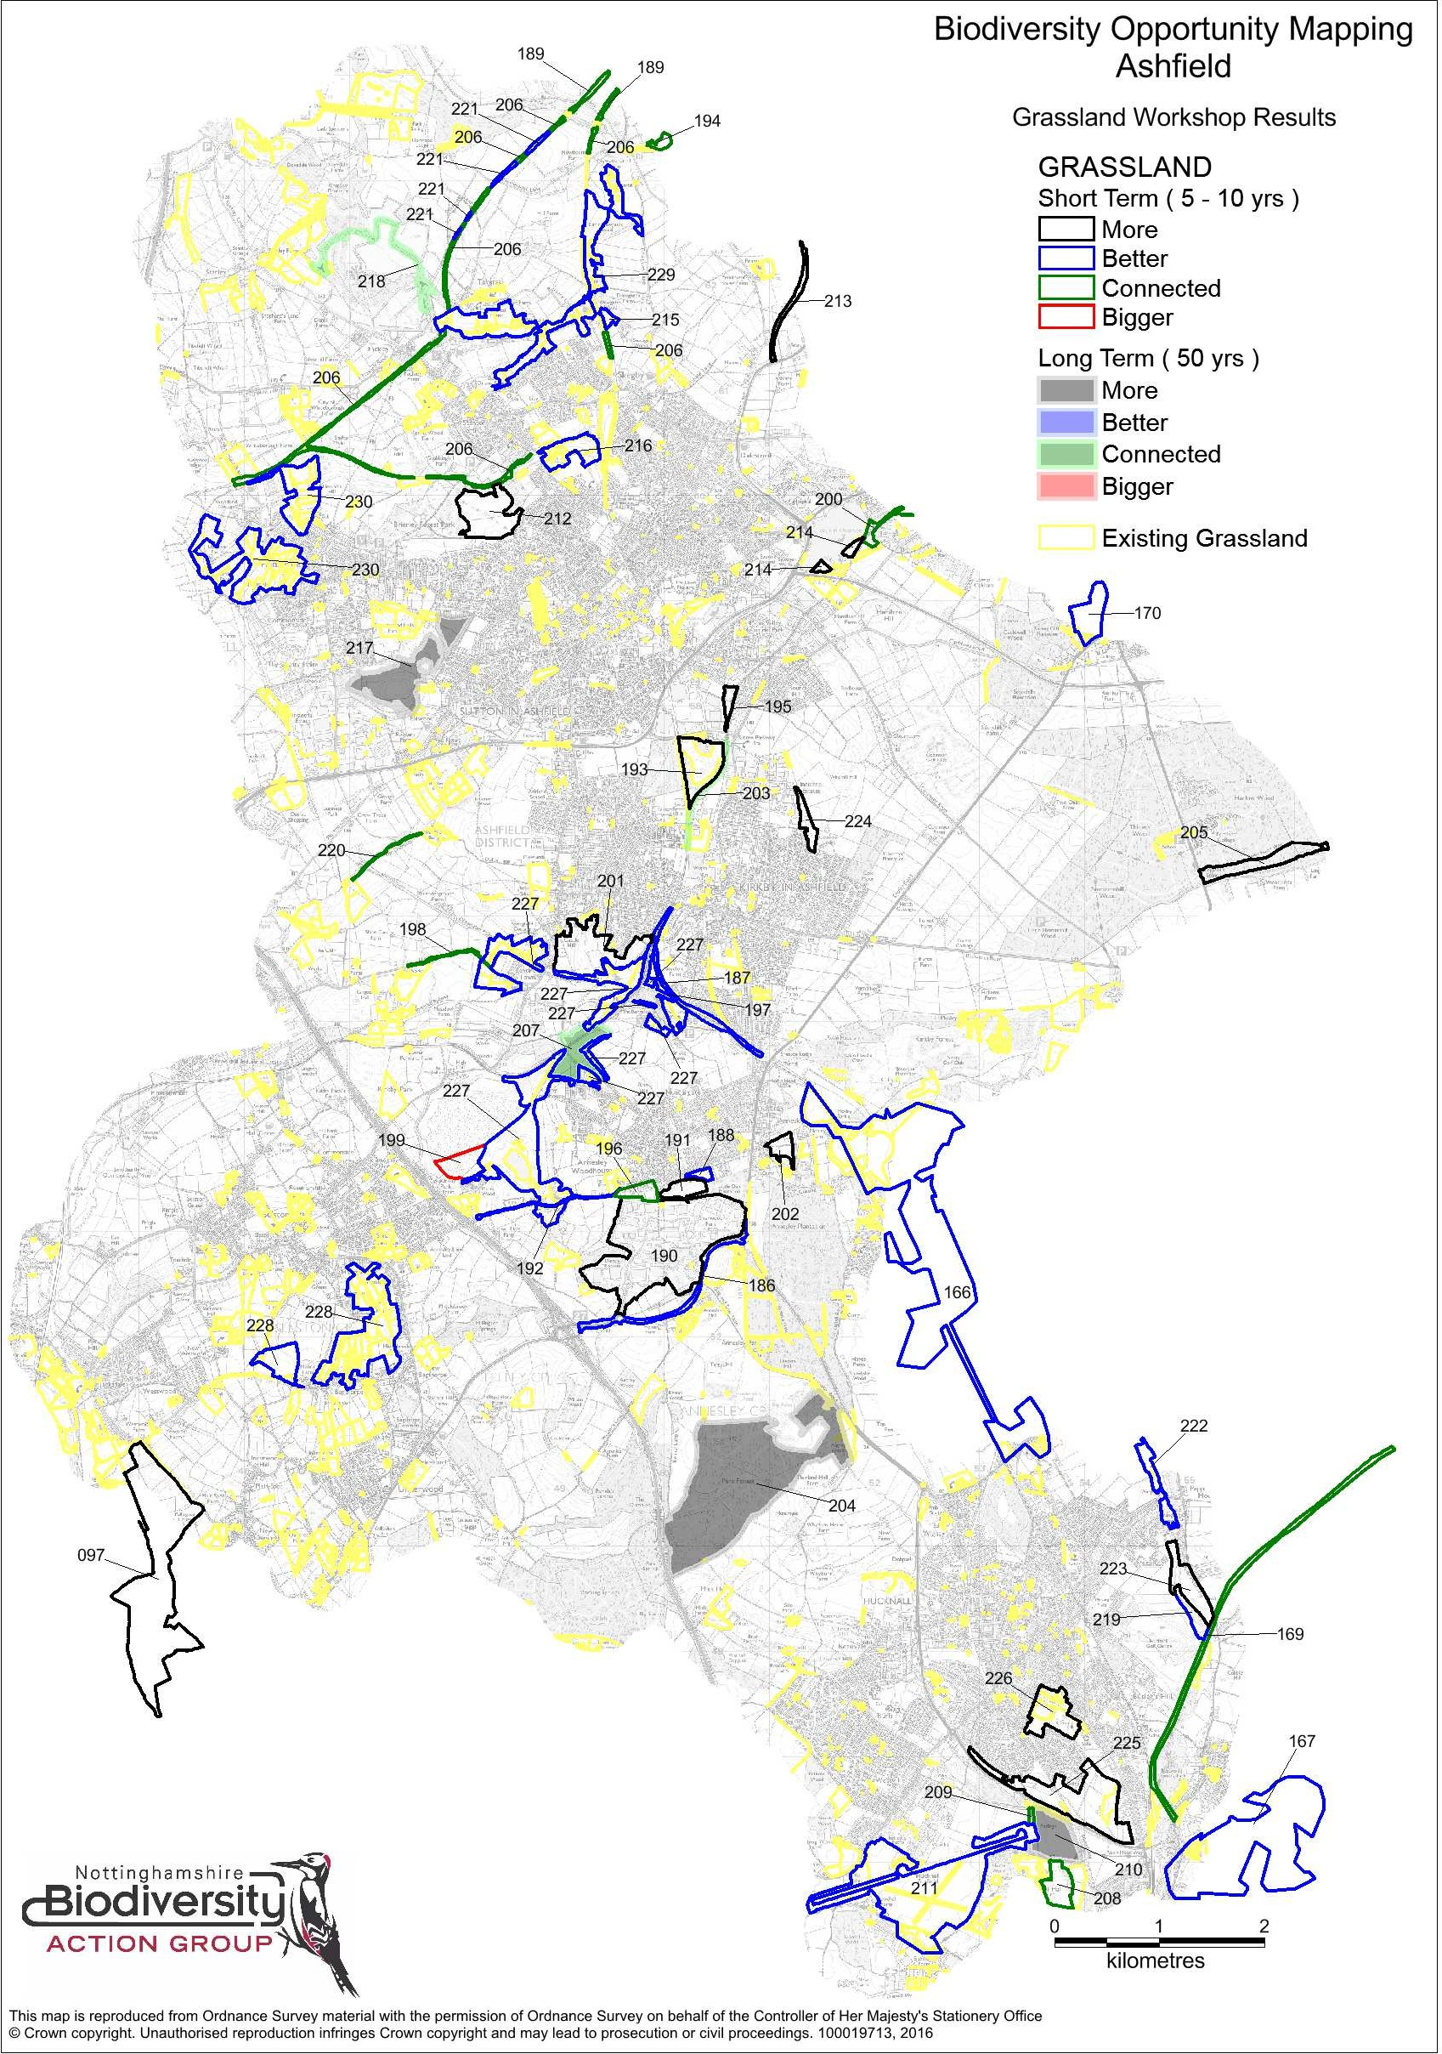

- 17 -

Table 3 - Biodiversity Opportunity table for Grassland (G)

Report ID | Map Display ID | Opportunity
Brx | 097 | Major grassland re-creation potential. Project as part of Erewash Valley LL area. JB
SHER-S | 166 | Newstead & Annesley CP, Freckland Wood & Linby Trail Area - Neutral grassland & calcareous grassland enhancement. NC
SHER-S | 167 | Bestwood Tip (NCC) - Neutral grassland. Early colliery restoration currently grazed. Potential to modify grazing regime etc to improve ecology. NC
SHER-S | 169 | Calverton Branch Line (NCC) - Recently acquired. NCC applying for funding. Verges/embankment as neutral grassland by clearing & preventing open areas from scrubbing over. NC
SHER-S | 170 | Mansfield Cemetery maintain and improve areas of grassland.
Ashfield | 186 | Road sides rich in wildflowers currently being degraded by regular maintenance and overgrowth in some areas. PO
Ashfield | 187 | Calcareous grassland, excellent quality. Robin Hood line from Newstead tunnel to Kirkby in Ashfield, Railway station - enhance by removing sapling Ash trees and Hawthorne. ADL
Ashfield | 188 | Forest road neutral grassland - designated as such around September 2015 - good habitat for Grass snakes. This site offers opportunities for enhancement. ADL
Ashfield | 189 | Better connected - connections to Pleasley Pit Country Park with existing Grasslands along disused railway lines. Consult with Friends of Pleasley Pit Country Park. KB
Ashfield | 190 | Verges and internal grasslands and woodland glades. Wildflower areas around ponds/wetness. Grass snakes etc. Better ecological management and improvement of existing Business Park  grasslands, to match the interest shown by one of two companies, would increase the number, quantity of wild flowers, grass snakes and other biodiversity etc . PO
Ashfield | 191 | ADC land - oakwood fields - work to commence to improve area to include wild flower meadows, remove pine plantations and scrub, and to enhance grass snake habitats. ADL
Ashfield | 192 | Manage and enhance the existing grass verges on Salmon Lane - Ancient Hedgerow and verges. Yellow archangel etc. PO
Ashfield | 193 | Remove tree plantations from Pit Tip. Encourage better botanical diversity - create calcareous or acid grassland depending on pH. ADL
Ashfield | 194 | There are likely existing calcareous and neutral grasslands along the river Meden into Mansfield. There is also key archaeological linkages. KB
Ashfield | 195 | North Sutton train station. Remove concrete culver to allow 'river' to cut its own course - flood grassland - requires botanical diversity in grassland. ADL
Ashfield | 196 | Improve grasslands located behind properties on Forest Road/Salmon Lane. This forms a corridor to open land to the west and an important link in the GI corridor. PO
Ashfield | 197 | Grassland and SUDS site next to Portland Park car-park - bring in to better management. ADL
Ashfield | 198 | Grassland road verges - improved management required to maintain the habitat and to ensure a good link between grasslands continues to exist. PO
Ashfield | 199 | Bentinck Void/Tip. Good calcareous grassland habitat developing. Under new management but requires ongoing management and habitat expansion on the correct substrate. Important herptile  assemblages. JB
Ashfield | 200 | Possible better connected grassland along and adjacent to the railway line. Land ownership needs investigating. From surrounding paths around Kingsmill reservoir and surrounding area - eastwards  into Mansfield. KB
Ashfield | 201 | Castle Hill - potential to work with the landowner to improve and expand grassland habitat, link to Kirkby Grives SSSI. JB
Ashfield | 202 | Create/restore grassland in pony fields and land owned by Annesley and Felley Parish Council. Overgrown, possible grass snake presence. PO
Ashfield | 203 | Use Robin Hood Line to improve connectivity between existing and potential new habitats - rail line has 'wide' unusual 'grassland'. ADL
Ashfield | 204 | Potential for increasing open habitats long term within Forest Design Plan. MGo
Ashfield | 205 | Create grassland buffer on the slope down to Rainworth Water. RT
Ashfield | 206 | Improve linkages along disused railways - Teversal, Brierley, Skegby. RT
Ashfield | 207 | Connect up existing SSSI's and Kirkby Grives and Annesley Woodhouse quarry. RT
Ashfield | 208 | Connect grassland habitats at Bulwell Hall. DJW
Ashfield | 209 | Connecting Farleys Way with Rolls Royce Grassland. DJW
Ashfield | 210 | Longterm extension/ buffer for calcareous grassland.
Ashfield | 211 | Rolls Royce site: Calcareous grassland - ensure this key site is managed appropriately after the new housing development is complete. SD
Ashfield | 212 | Rooley Tip (Brierley Park) grassland. Rough grassland that could be improved. MW
Ashfield | 213 | Better management of Road Side Verges along A617 out to Pleasley. DS
Ashfield | 214 | Kingsmill reservoir grazing - restore horse grazed land and convert to higher quality grassland.
Ashfield | 215 | Restoration of spp rich grassland which is scrubbing over. Owned by STW? NC
Ashfield | 216 | Stoneyford Quarry area - land coming into ADC control/management. Improve condition of LWS grasslands. NC
Ashfield | 217 | Rookery Park/Sutton Landfill - create spp-rich grassland (currently rough/spp-poor). NC

Report ID | Map Display ID | Opportunity
Ashfield | 218 | Improve grassland linkages through Silverhill. NC
Ashfield | 219 | Improve wet grassland along the Leen and adjacent to the golf course by creating additional wetland/scrape features. Site important for waders in winter, such as snipe and amphibians. LS
Ashfield | 220 | Coal measure grassland along top of arable. Enhance and managed. A good connection between other LWS grasslands.
Ashfield | 221 | Improve condition of existing SSSI grasslands - Build up of thatch in grassland on steep cutting sides. Possibility of burning selected areas or grazing? MGu
Ashfield | 222 | Bring relatively species rich grasslands into management - regular mowing and/or grazing required. LS
Ashfield | 223 | Opportunities for habitat development/creation along the Leen corridor with management/creation of sites owned or managed by ADC and Friends of Moor Pond Wood. Extend habitat corridor  into fields adjacent to Leen Ponds, these are currently arable. LS
Ashfield | 224 | Beacon Drive and Holidays Hill. ADC owned land, open space and play area. Scope to improve/increase grassland. WK
Ashfield | 225 | Broomhill farm. Bring wider grassland area into management. MGu
Ashfield | 226 | Improve grassland management for parts of Titchfield Park and Hucknall cemetery to benefit biodiversity.
Ashfield | 227 | Maintain and enhance these important and floristically rich areas of calcareous and neutral grassland south of Kirkby-in-Ashfield. NC
Ashfield | 228 | Maintain and enhance an important concentration of good quality neutral grasslands around Bagthorpe, between Underwood and Selston. NC
Ashfield | 229 | Maintain and enhance an important concentration of good quality neutral grasslands south of Teversal and alongside the River Meden. NC
Ashfield | 230 | Maintain and enhance an important concentration of good quality neutral grasslands in the Huthwaite area. NC

Map 4 - Wetland Biodiversity Opportunity Map
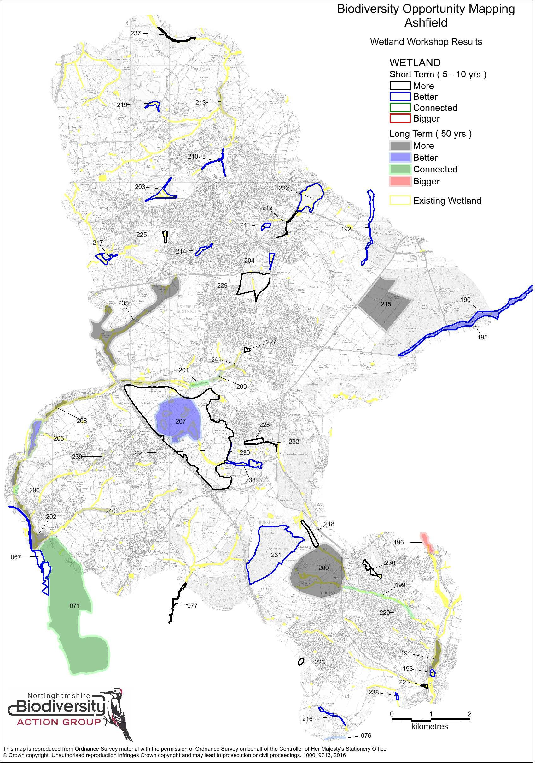

- 20 -

Table 4 - Biodiversity Opportunity table for Wetland (M)

Report ID | Map Display ID | Opportunity
Brx | 067 | Enhancement, linking and buffering of Erewash meadows/Aldercarr/Jacksdale complex. JB (Brx). & Connect Cromford Canal to existing wetland enhancement opportunity in Broxtowe. Canal and  River Trust projects -Codnor reservoir, Friends of Crompton Canal, White-clawed Crayfish. Land to east used by CRT during restorations - landowner known. IW (Ashfield).
Brx | 071 | Maintain habitat connectivity for high grass snake population. JEO
Brx | 076 | Ditch/Stream between Sellers Wood & Dismantled Railway. May feed the ponds at Sellers Wood. Possible check on OS maps/drainage plans. FA
Brx | 077 | Moorgreen Reservoir, not owned by CRT but by a fishing club who may be open to habitat creation + management along margins. RB (Brx) & Land alongside Moorgreen reservoir has opportunities  to improve habitat. IW (Ashfield).
SHER-S | 190 | Wetland habitat restoration & enhancement, over the long term (SHER - S) & Improve Rainworth Water tributary through Thieves Wood. DS (Ashfield).
SHER-S | 192 | Cauldwell Brook/River Maun - Monitor crayfish & create additional habitat to allow expansion of population into new areas. Replace culvert with wildlife friendly culvert & remove stream from  pipes.
SHER-S | 193 | Enhance Bestwood Reedbed
SHER-S | 194 | Potential to enhance wetland habitat adjacent to and within Mill lakes and Bestwood reedbed
SHER-S | 195 | Wetland habitat restoration & enhancement, over the short term (SHER - S) & Improve Rainworth Water tributary through Thieves Wood. DS (Ashfield).
SHER-S | 196 | Potential to create diverse wetland
Ashfield | 199 | Improve Baker Lane Brook through removal of culverts along its length as and when new development opportunities come forward. Could be delivered through Green Infrastructure. DJW
Ashfield | 200 | Wetland habitat creation - farmland ponds, debris, dams and marshy areas to help slow flows and reduce flood risk to Hucknall. Catchment area may be larger than shown. DJW & Potential for  habitat creation in order to create flood relief for the Hucknall Town Centre Improvements/ also creation of compensatory habitat for proposed developments in this area. KM
Ashfield | 201 | Potential culvert removal to create connecting habitat. DJW &Culverted section in danger of collapse, daylighting attempts during development failed but this is a key project area. KM
Ashfield | 202 | Improve floodplain habitats adjacent to the River Erewash e.g create floodplain grazing marsh. DJW) & Flooding problems in the Jacksdale area could be helped with habitat enhancement measures  in the floodplain that increase flood storage capacity. KM
Ashfield | 203 | Brierley Forest Park - ADC owned - scrapes and improvements to ponds etc. SD & Increase the number of ponds at Brierley Forest Park. JO
Ashfield | 204 | Maun Valley Grassland - ADC owned. Introduce more scrapes/improve habitat. Allow streams to meander. Create deeper slower moving watercourses - water vole habitat. SD & Some river channel  restoration complete but concrete drainage channels still present so more to do. Reedbed creation could help to tackle water contamination coming from upstream pit tip. KM
Ashfield | 205 | Enhance floodplain habitats adjacent to the River Erewash. DJW
Ashfield | 206 | Improve connectivity of the River Erewash through culvert removal and renaturalisation. DJW
Ashfield | 207 | Area within potential HS2 corridor - chance to enhance grasslands and ponds. IW & Improve quality of ponds around Bentinck tip and void for Great Crested Newts, grass snakes and water voles, if still present. (NC) Newly designated SSSI pond and culverted watercourse under the spoil heap. It would be costly to daylight, but combined with SSSI designates site taking out of culvert may  provide some benefits to wildlife/habitats. KM
Ashfield | 208 | Improve floodplain habitat to create grazing marsh. DJW) & area suffers from poaching adjacent to the watercourse and would benefit from creation of buffer strips alongside the River Erewash. KM
Ashfield | 209 | Reedbed habitat creation. Scrape creation in the floodplain. Improve habitat management of ponds. DJW & Landownership known of Fry's Dam Fishing Ponds. PO
Ashfield | 210 | Land due to be transferred to ADC - Skegby Hall. Some nice streams with potential to enhance these for wildlife. Also potential for wetland creation adjacent to the channels (scrapes and ponds). Habitat adjacent to LWS grassland. DJW & this area includes a series of online ponds that could be improved by taking them offline and turned into backwaters. Habitat enhancements to tackle  pollution in this area should also be considered. KM
Ashfield | 211 | Sutton Lawns, ADC owned, marginal planting around ponds. SD
Ashfield | 212 | River Maun upstream of Kings Mill Reservoir (partly owned by ADC). Remove culvert through Maun Industrial Estate and de-canalise the river directly upstream of reservoir, between Coxmoor Road  and MARR. NC
Ashfield | 213 | Potential to create floodplain grazing marsh along the River Meden corridor. Possibly scrapes and ponds. DJW
Ashfield | 214 | Enhance Calladine pond and adjacent watercourse. MW
Ashfield | 215 | Inclusion of new ponds and wetland in restoration at Two Oaks quarry. DS
Ashfield | 216 | Ponds and stream next to Bullwell wood - improve habitat quality for White-clawed crayfish present. NC
Ashfield | 217 | Nunn Brook Park - improve condition of existing Great Crested Newt ponds and create new ponds. NC
Ashfield | 218 | Enhance Wighay Brook from Big Pond - remove confers from brook side, create marsh/flood storage, halt acidification. JAR
Ashfield | 219 | East Silverhill ponds - Improvements - planting marginals and maintaining water levels. LS/MGu

Report ID | Map Display ID | Opportunity
Ashfield | 220 | De-culvert Baker Lane Brook (At Porchester Close Plantation). LS/MGu
Ashfield | 221 | Farleys brook/ Hucknall. Create siltation pond that can be cleaned out and/or reedbed filter area to reduce-prevent polluted urban-grey water and sewage from the Hucknall system entering the  main Leen. LS/Mu
Ashfield | 222 | King's Mill Res, ditch management - enhance/restore for resident water vole population. MGW & extend and enhance existing reedbed to assist with desilting proposals. KM
Ashfield | 223 | Excavate a pond or series of small ponds where tributary arises (at a spring) at the centre of Eelhole wood. This will benefit and provide a refuge for White-clawed crayfish. LS
Ashfield | 224 | Newstead stocking yard - increase number and depth of wet scrapes so that they hold water for longer in Spring/Summer. MGu
Ashfield | 225 | Rookery Park Triangle - create wet scrapes in wet grassland ajacent to the pond to extend wetland habitat and buffer pond. MGu
Ashfield | 226 | Extend pond north of Moor Pond Wood boundary by deepening and connect pond with that in Dam Banks. LS
Ashfield | 227 | Recressco Glass Recycling - As and when, make sure any SUDS schemes are designed to be beneficial to wildlife. CLI
Ashfield | 228 | Lane End Nature area. Semi-dry wetland in need or improvement and expansion. WK & Wet towards south of ADC area - create scrapes and restore pond on southern boundary and see  management plan. PO
Ashfield | 229 | Look at opening area up to increase wetland areas. JO & Pollution of stream thought to be coming from this area, potential to intercept with habitat creation - reedbed perhaps? KM
Ashfield | 230 | Wet ditch, particularly in winter. Supports frogs. This is a particularly important habitat for the local grass snake population and needs to be maintained and enhanced. PO
Ashfield | 231 | Park Forest - manage existing Ponds and wetlands to encourage GCN to move across site - open up canopy (Sycamore). ADL
Ashfield | 232 | The ditch and pond forming the southern boundary to Little Oak Plantation could benefit from restoration work to recreate a continuous wetland corridor for the local populations of grass snakes  and amphibians. PO
Ashfield | 233 | This area forms the source of the Cuttail brook and the wetlands unite various ponds, streams and marshy areas across the Sherwood Business Park. This is an important wetland complex and  should be maintained and enhanced. PO
Ashfield | 234 | Potential pondscape focus area: based around Bentinck Void SSSI - designed for GCNs. Perhaps secure if through HS2. JB
Ashfield | 235 | Dumbles Pondscape - manage existing ponds, create new ones in clusters. JB
Ashfield | 236 | Potential for habitat creation, in order to create flood relief for the Hucknall Town Centre Improvements. KM
Ashfield | 237 | Largely arable area that could benefit with greater habitat buffering of the river channel. KM
Ashfield | 238 | Control/removal of signal crayfish from fishing ponds to prevent degradation of good wetland habitats both within the ponds themselves and more widely across the Leen catchment. KM
Ashfield | 239 | Surface water flooding issues at Sleepy Hole, Selston, could be helped by the creation of habitat enhancement measures in the floodplain that increase flood storage capacity. KM
Ashfield | 240 | Poaching by livestock is a problem in this location on the Bagthorpe Brook. Measures to protect the river channel could enhance the river habitat. KM
Ashfield | 241 | River erosion in the vicinity of Portland Park SSSI caused in response to the filling in of a pond in the area (historical). Habitat enhancements could be part of measures to tackle the erosion issue. KM

Map 5 - Focal Areas
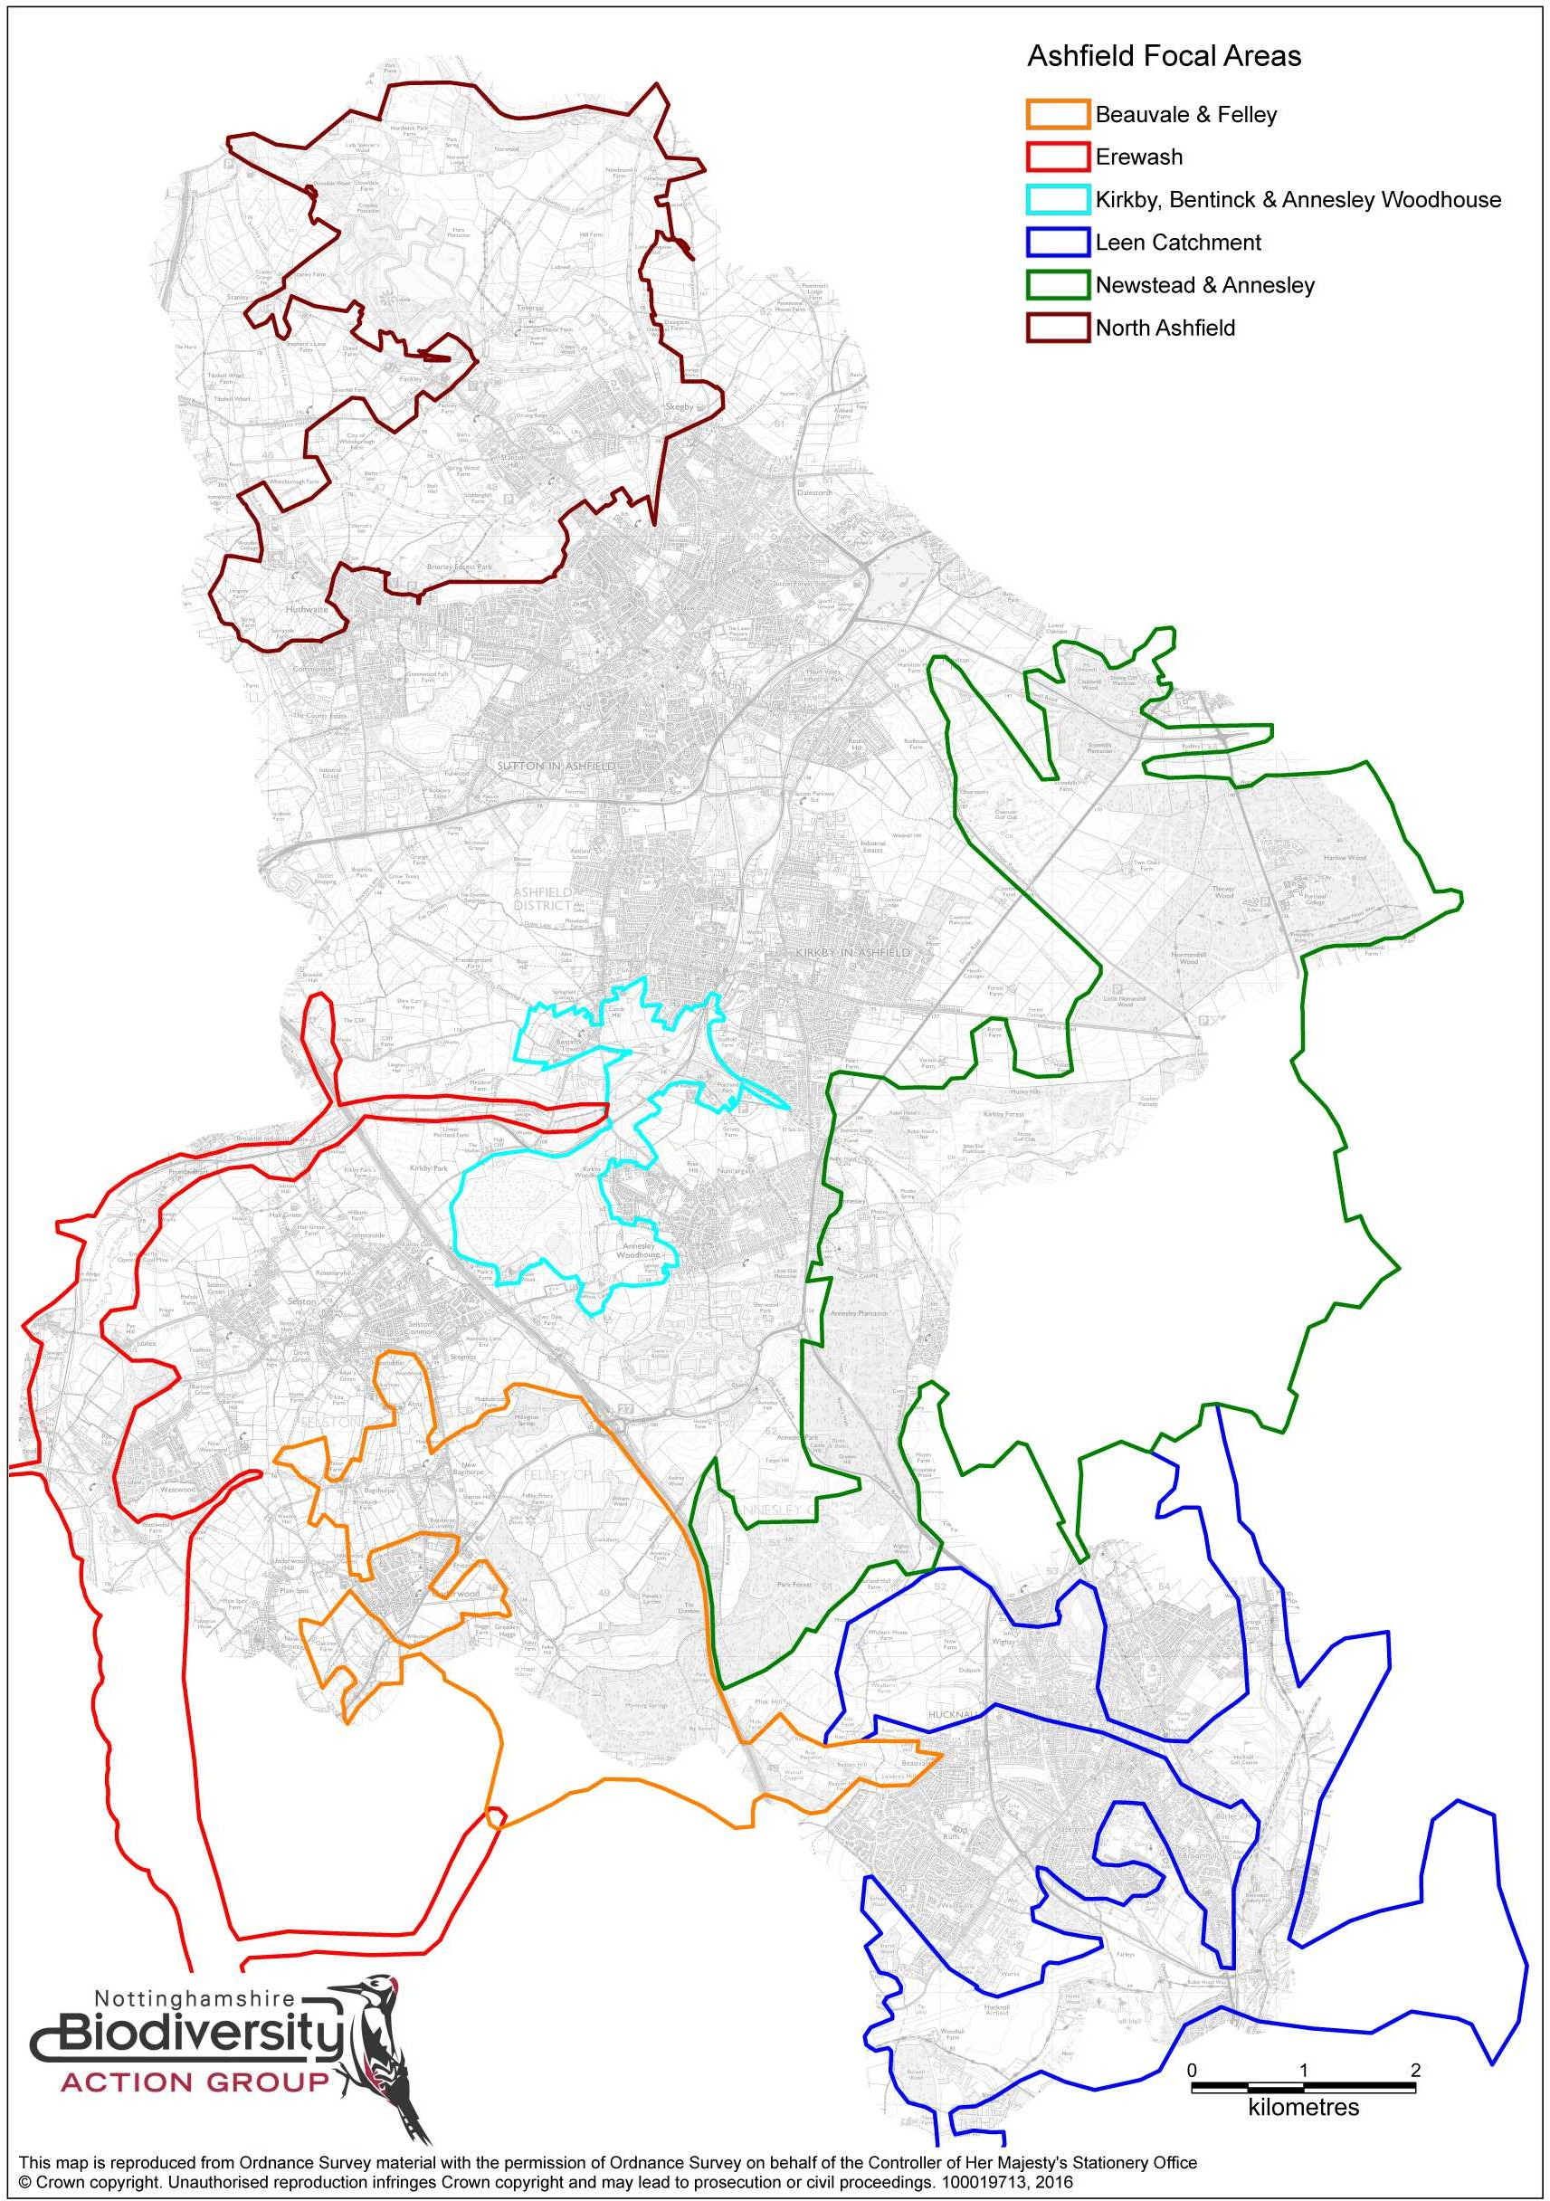

- 23 -

Appendix 1 - BOM Working Group Nottinghamshire County Council Nottinghamshire Wildlife Trust
Nottinghamshire Biological and Geological Records Centre Environment Agency
Royal Society for the Protection of Birds The National Forest Company

Appendix 2 - Composition of broad habitat types
The following table indicates the phase 1 habitats that form the four broad habitat types.

Broad habitat type - WOODLAND
PBW | Broadleaved woodland - plantation
BW | Broadleaved woodland - semi-natural
PMW | Mixed woodland - plantation
MW | Mixed woodland - semi-natural
Broad habitat type - HEATHLAND & ACID GRASSLAND
SAG | Acid grassland - semi-improved
AG | Acid grassland - unimproved
ADH | Dry dwarf shrub heath - acid
BDH | Dry dwarf shrub heath - basic
DGM | Dry heath/acid grassland mosaic
WH | Wet dwarf shrub heath
WGM | Wet heath/acid grassland mosaic
Broad habitat type - OTHER GRASSLAND
SCG | Calcareous grassland - semi-improved
CG | Calcareous grassland - unimproved
SNG | Neutral grassland - semi-improved
NG | Neutral grassland - unimproved
SBW | Parkland and scattered trees - broadleaved
Orchard | Parkland and scattered trees - broadleaved
SCW | Parkland and scattered trees - coniferous
SMW | Parkland and scattered trees - mixed
Broad habitat type - WETLAND
BB | Blanket bog
DB | Dry modified bog
BM | Fen - basin mire
FPM | Fen - flood plain mire
VM | Fen - valley mire
AF | Flush and spring - acid/neutral flush
BF | Flush and spring - basic flush
IV | Marginal/inundation - inundation
MV | Marginal/inundation - marginal
MG | Marsh/marshy grassland
RB | Raised bog
Reedbed | Reedbed
RW | Running water
RWB | Running water - brackish
RWD | Running water - dystrophic
RWE | Running water - eutrophic
RWC | Running water - marl
RWM | Running water - mesotrophic
RWO | Running water - oligotrophic
SW | Standing water
SWB | Standing water - brackish
SWD | Standing water - dystrophic
SWE | Standing water - eutrophic
SWC | Standing water - marl
SWM | Standing water - mesotrophic
SWO | Standing water - oligotrophic
SP | Swamp
WB | Wet modified bog

Appendix 3 - Permeability values
The following four tables provide a list of Phase 1 habitats and the permeability scores assigned to each of these Phase 1 habitats. The four tables correspond to one of the four broad habitat types (woodland, heathland & acid grassland, other grassland and wetland), and the permeability scores listed indicate how permeable each Phase 1 habitat is to the relevant generic ‘focal’ species associated with the broad habitat type in question.

The permeability score given for each Phase 1 habitat falls between 1 and 50. A score of 1 indicates that the habitat is a core/source habitat for the broad habitat type. A low score above 1 indicates a habitat that is very permeable to the generic focal species associated with the broad habitat type in question, whilst a score of 50 indicates that the habitat is very impermeable for that focal species.

The final column in each table indicates the source of the information. Where the source is given as JNCC the information has come directly from work by Natural England (Catchpole 2010). Where the source is given as NFC the information has come from the habitat network modelling work undertaken by the National Forest Company. The data from NFC principally relates to a variety of urban habitats not listed in the Phase 1 habitat survey handbook, such as roads, tracks, buildings, airports, railways, suburbs, gardens etc. The exception to this is orchards for which a permeability value has been given based on a similar Phase 1 habitat type (in this case parkland/scattered trees).

In addition, some of the permeability scores devised by Catchpole have been altered to best serve local biodiversity conditions, and some additional habitats have been added to the list of habitats and assigned a permeability score based on similarly structured/functioning habitats. In this case the source of the data is given as NCC. These local amendments are highlighted below:
- To reflect the importance of Open Mosaic Habitat on Previously Developed Land in Nottinghamshire this habitat has been assigned its own Phase 1 habitat code. The permeability scores have been based on similar open habitat types.
- To identify the importance of Reedbed restoration work within Nottinghamshire this habitat was assigned its own Phase 1 habitat code. The permeability scores have been based on similar habitat types.

Reference
Catchpole, R. (2010) England Habitat Network (EHN 2.0) – Metadata. Natural England

GRASSLAND | GRASSLAND
 | Phase 1 Code | Phase 1 Habitat Name | Grassland Cost | Definition Source
 | ROAD | A or B road | 50 | NFC
 | SAG | Acid grassland - semi-improved | 2 | NCC
 | AG | Acid grassland - unimproved | 2 | NCC
 | RUNWAY | Airport runway | 50 | NFC
 | BG | Bare ground | 20 | JNCC
 | P | Bare peat | 5 | JNCC
 | BB | Blanket bog | 20 | JNCC
 | X | Boundary removed | 0 | JNCC
 | CB | Bracken - continuous | 10 | JNCC
 | SB | Bracken - scattered | 10 | JNCC
 | PBW | Broadleaved woodland - plantation | 20 | JNCC
 | BW | Broadleaved woodland - semi-natural | 20 | JNCC
 | BUILD | Buildings | 20 | NFC
 | Building | Buildings | 20 | NFC
 | Buildings | Buildings | 20 | NFC
 | SCG | Calcareous grassland - semi-improved | 1 | JNCC
 | CG | Calcareous grassland - unimproved | 1 | JNCC
 | CS | Caravan site | 0 | JNCC
 | CA | Cave | 50 | JNCC
 | PCW | Coniferous woodland - plantation | 20 | JNCC
 | CW | Coniferous woodland - semi-natural | 20 | JNCC
 | AM | Cultivated/disturbed land - amenity grassland | 50 | JNCC
 | A | Cultivated/disturbed land - arable | 50 | JNCC
 | ESP | Cultivated/disturbed land - ephemeral/short perennial | 5 | JNCC
 | DD | Dry ditch | 0 | JNCC
 | ADH | Dry dwarf shrub heath - acid | 10 | JNCC
 | BDH | Dry dwarf shrub heath - basic | 10 | JNCC
 | DGM | Dry heath/acid grassland mosaic | 2 | JNCC
 | DB | Dry modified bog | 20 | JNCC
 | EB | Earth bank | 0 | JNCC
 | BM | Fen - basin mire | 5 | JNCC
 | FPM | Fen - flood plain mire | 5 | JNCC
 | VM | Fen - valley mire | 5 | JNCC
 | F | Fence | 0 | JNCC
 | AF | Flush and spring - acid/neutral flush | 5 | JNCC
 | BF | Flush and spring - basic flush | 5 | JNCC
 | PH- | Hedges - defunct - species-poor | 20 | JNCC
 | RH- | Hedges - defunct - species-rich | 20 | JNCC
 | PH | Hedges - intact - species-poor | 20 | JNCC
 | RH | Hedges - intact - species-rich | 20 | JNCC
 | PHT | Hedges - with trees - species-poor | 20 | JNCC
 | RHT | Hedges - with trees - species-rich | 20 | JNCC
 | I | Improved grassland | 50 | JNCC
 | AC | Inland cliff - acid/neutral | 50 | JNCC
 | BC | Inland cliff - basic | 50 | JNCC
 | IS | Introduced shrub | 20 | JNCC
 | LH | Lichen/bryophyte heath | 15 | JNCC
 | LP | Limestone pavement | 50 | JNCC
 | IV | Marginal/inundation - inundation | 20 | JNCC
 | MV | Marginal/inundation - marginal | 20 | JNCC
 | MG | Marsh/marshy grassland | 5 | JNCC
 | MI | Mine | 20 | JNCC
 | PMW | Mixed woodland - plantation | 20 | JNCC
 | MW | Mixed woodland - semi-natural | 20 | JNCC
 | MH | Montane heath/dwarf herb | 15 | JNCC
 | MWAY | Motorway or major dual carriageway | 50 | NFC
 | SNG | Neutral grassland - semi-improved | 1 | JNCC
 | NG | Neutral grassland - unimproved | 1 | JNCC
 | NR | Non-ruderal | 10 | JNCC
 | OMHOPDL | Open Mosaic Habitat | 5 | NCC
 | AR | Other exposure - acid/neutral | 50 | JNCC
 | BR | Other exposure - basic | 50 | JNCC
 | SBW | Parkland and scattered trees - broadleaved | 1 | JNCC
 | Orchard | Parkland and scattered trees - broadleaved | 1 | NFC
 | SCW | Parkland and scattered trees - coniferous | 1 | JNCC
 | SMW | Parkland and scattered trees - mixed | 1 | JNCC
 | SI | Poor semi-improved grassland | 2 | JNCC
 | Q | Quarry | 50 | JNCC
 | RAIL | Railway line | 50 | NFC
 | RB | Raised bog | 20 | JNCC
 | FB | Recently felled woodland - broadleaved | 20 | JNCC
 | FC | Recently felled woodland - coniferous | 20 | JNCC
 | FM | Recently felled woodland - mixed | 20 | JNCC
 | Reedbed | Reedbed | 20 | NCC
 | R | Refuse tip | 20 | JNCC
 | RW | Running water | 50 | JNCC
 | RWB | Running water - brackish | 50 | JNCC
 | RWD | Running water - dystrophic | 50 | JNCC
 | RWE | Running water - eutrophic | 50 | JNCC
 | RWC | Running water - marl | 50 | JNCC
 | RWM | Running water - mesotrophic | 50 | JNCC
 | RWO | Running water - oligotrophic | 50 | JNCC
 | AS | Scree - acid/neutral | 50 | JNCC
 | BS | Scree - basic | 50 | JNCC
 | DS | Scrub - dense/continuous | 20 | JNCC
 | SS | Scrub - scattered | 20 | JNCC
 | SWALL | Sea wall | 0 | JNCC
 | S | Spoil | 20 | JNCC
 | SW | Standing water | 50 | JNCC
 | SWB | Standing water - brackish | 50 | JNCC
 | SWD | Standing water - dystrophic | 50 | JNCC
 | SWE | Standing water - eutrophic | 50 | JNCC
 | SWC | Standing water - marl | 50 | JNCC
 | SWM | Standing water - mesotrophic | 50 | JNCC
 | SWO | Standing water - oligotrophic | 50 | JNCC
 | SUBURB | Suburban/rural development | 10 | NFC
 | Gardens | Suburban/rural development | 10 | NFC
 | Paved | Suburban/rural development | 50 | NFC
 | SP | Swamp | 20 | JNCC
 | TR | Tall ruderal | 10 | JNCC
 | TRACK | Track or minor access road | 50 | NFC
 | Path | Track or minor access road | 50 | NFC
 | ? | Unknown | 50 | NFC
 | INDUST | Urban industrial development | 30 | NFC
 | URBAN | Urban residential/commerical development | 20 | NFC
 | W | Wall | 0 | JNCC
 | WH | Wet dwarf shrub heath | 10 | JNCC
 | WGM | Wet heath/acid grassland mosaic | 2 | JNCC
 | WB | Wet modified bog | 20 | JNCC

HEATHLAND & ACID GRASSLAND
Phase 1 Code | Phase 1 Habitat Name | Heathland & Acid Grassland Cost | Definition Source
ROAD | A or B road | 50 | NFC
SAG | Acid grassland - semi-improved | 1 | NCC
AG | Acid grassland - unimproved | 1 | NCC
RUNWAY | Airport runway | 50 | NFC
BG | Bare ground | 30 | JNCC
P | Bare peat | 20 | JNCC
BB | Blanket bog | 3 | JNCC
X | Boundary removed | 0 | JNCC
CB | Bracken - continuous | 20 | JNCC
SB | Bracken - scattered | 20 | JNCC
PBW | Broadleaved woodland - plantation | 35 | JNCC
BW | Broadleaved woodland - semi-natural | 35 | JNCC
BUILD | Buildings | 50 | NFC
Building | Buildings | 50 | NFC
Buildings | Buildings | 50 | NFC
SCG | Calcareous grassland - semi-improved | 50 | JNCC
CG | Calcareous grassland - unimproved | 40 | JNCC
CS | Caravan site | 0 | JNCC
CA | Cave | 50 | JNCC
PCW | Coniferous woodland - plantation | 20 | JNCC
CW | Coniferous woodland - semi-natural | 20 | JNCC
AM | Cultivated/disturbed land - amenity grassland | 50 | JNCC
A | Cultivated/disturbed land - arable | 50 | JNCC
ESP | Cultivated/disturbed land - ephemeral/short perennial | 50 | JNCC
DD | Dry ditch | 0 | JNCC
ADH | Dry dwarf shrub heath - acid | 1 | JNCC
BDH | Dry dwarf shrub heath - basic | 1 | JNCC
DGM | Dry heath/acid grassland mosaic | 1 | JNCC
DB | Dry modified bog | 3 | JNCC
EB | Earth bank | 0 | JNCC
BM | Fen - basin mire | 30 | JNCC
FPM | Fen - flood plain mire | 30 | JNCC
VM | Fen - valley mire | 30 | JNCC
F | Fence | 0 | JNCC
AF | Flush and spring - acid/neutral flush | 30 | JNCC
BF | Flush and spring - basic flush | 30 | JNCC
PH- | Hedges - defunct - species-poor | 10 | JNCC
RH- | Hedges - defunct - species-rich | 10 | JNCC
PH | Hedges - intact - species-poor | 10 | JNCC
RH | Hedges - intact - species-rich | 10 | JNCC
PHT | Hedges - with trees - species-poor | 10 | JNCC
RHT | Hedges - with trees - species-rich | 10 | JNCC
I | Improved grassland | 50 | JNCC
AC | Inland cliff - acid/neutral | 50 | JNCC
BC | Inland cliff - basic | 50 | JNCC
IS | Introduced shrub | 10 | JNCC
LH | Lichen/bryophyte heath | 10 | JNCC
LP | Limestone pavement | 50 | JNCC
IV | Marginal/inundation - inundation | 40 | JNCC
MV | Marginal/inundation - marginal | 40 | JNCC
MG | Marsh/marshy grassland | 30 | JNCC
MI | Mine | 30 | JNCC
PMW | Mixed woodland - plantation | 35 | JNCC
MW | Mixed woodland - semi-natural | 35 | JNCC
MH | Montane heath/dwarf herb | 10 | JNCC
MWAY | Motorway or major dual carriageway | 50 | NFC
SNG | Neutral grassland - semi-improved | 30 | JNCC
NG | Neutral grassland - unimproved | 30 | JNCC
NR | Non-ruderal | 20 | JNCC
OMHOPDL | Open Mosaic Habitat | 10 | NCC
AR | Other exposure - acid/neutral | 50 | JNCC
BR | Other exposure - basic | 50 | JNCC
SBW | Parkland and scattered trees - broadleaved | 30 | JNCC
Orchard | Parkland and scattered trees - broadleaved | 30 | NFC
SCW | Parkland and scattered trees - coniferous | 30 | JNCC
SMW | Parkland and scattered trees - mixed | 30 | JNCC
SI | Poor semi-improved grassland | 30 | JNCC
Q | Quarry | 50 | JNCC
RAIL | Railway line | 50 | NFC
RB | Raised bog | 3 | JNCC
FB | Recently felled woodland - broadleaved | 10 | JNCC
FC | Recently felled woodland - coniferous | 10 | JNCC
FM | Recently felled woodland - mixed | 10 | JNCC
Reedbed | Reedbed | 40 | NCC
R | Refuse tip | 30 | JNCC
RW | Running water | 50 | JNCC
RWB | Running water - brackish | 50 | JNCC
RWD | Running water - dystrophic | 50 | JNCC
RWE | Running water - eutrophic | 50 | JNCC
RWC | Running water - marl | 50 | JNCC
RWM | Running water - mesotrophic | 50 | JNCC
RWO | Running water - oligotrophic | 50 | JNCC
AS | Scree - acid/neutral | 50 | JNCC
BS | Scree - basic | 50 | JNCC
DS | Scrub - dense/continuous | 10 | JNCC
SS | Scrub - scattered | 10 | JNCC
SWALL | Sea wall | 0 | JNCC
S | Spoil | 30 | JNCC
SW | Standing water | 50 | JNCC
SWB | Standing water - brackish | 50 | JNCC
SWD | Standing water - dystrophic | 50 | JNCC
SWE | Standing water - eutrophic | 50 | JNCC
SWC | Standing water - marl | 50 | JNCC
SWM | Standing water - mesotrophic | 50 | JNCC
SWO | Standing water - oligotrophic | 50 | JNCC
SUBURB | Suburban/rural development | 50 | NFC
Gardens | Suburban/rural development | 50 | NFC
Paved | Suburban/rural development | 50 | NFC
SP | Swamp | 40 | JNCC
TR | Tall ruderal | 20 | JNCC
TRACK | Track or minor access road | 50 | NFC
Path | Track or minor access road | 50 | NFC
? | Unknown | 50 | NFC
INDUST | Urban industrial development | 50 | NFC
URBAN | Urban residential/commercial development | 50 | NFC
W | Wall | 0 | JNCC
WH | Wet dwarf shrub heath | 1 | JNCC
WGM | Wet heath/acid grassland mosaic | 1 | JNCC
WB | Wet modified bog | 3 | JNCC
HEATHLAND & ACID GRASSLAND

WETLAND
Phase 1 Code | Phase 1 Habitat Name | Wetland Cost | Definition Source
ROAD | A or B road | 50 | NFC
SAG | Acid grassland - semi-improved | 20 | NCC
AG | Acid grassland - unimproved | 20 | NCC
RUNWAY | Airport runway | 50 | NFC
BG | Bare ground | 40 | JNCC
P | Bare peat | 20 | JNCC
BB | Blanket bog | 1 | JNCC
X | Boundary removed | 0 | JNCC
CB | Bracken - continuous | 30 | JNCC
SB | Bracken - scattered | 30 | JNCC
PBW | Broadleaved woodland - plantation | 50 | JNCC
BW | Broadleaved woodland - semi-natural | 50 | JNCC
BUILD | Buildings | 50 | NFC
Building | Buildings | 50 | NFC
Buildings | Buildings | 50 | NFC
SCG | Calcareous grassland - semi-improved | 40 | JNCC
CG | Calcareous grassland - unimproved | 50 | JNCC
CS | Caravan site | 0 | JNCC
CA | Cave | 50 | JNCC
PCW | Coniferous woodland - plantation | 40 | JNCC
CW | Coniferous woodland - semi-natural | 40 | JNCC
AM | Cultivated/disturbed land - amenity grassland | 50 | JNCC
A | Cultivated/disturbed land - arable | 50 | JNCC
ESP | Cultivated/disturbed land - ephemeral/short perennial | 40 | JNCC
DD | Dry ditch | 0 | JNCC
ADH | Dry dwarf shrub heath - acid | 5 | JNCC
BDH | Dry dwarf shrub heath - basic | 5 | JNCC
DGM | Dry heath/acid grassland mosaic | 5 | JNCC
DB | Dry modified bog | 1 | JNCC
EB | Earth bank | 0 | JNCC
BM | Fen - basin mire | 1 | JNCC
FPM | Fen - flood plain mire | 1 | JNCC
VM | Fen - valley mire | 1 | JNCC
F | Fence | 0 | JNCC
AF | Flush and spring - acid/neutral flush | 1 | JNCC
BF | Flush and spring - basic flush | 1 | JNCC
PH- | Hedges - defunct - species-poor | 30 | JNCC
RH- | Hedges - defunct - species-rich | 30 | JNCC
PH | Hedges - intact - species-poor | 30 | JNCC
RH | Hedges - intact - species-rich | 30 | JNCC
PHT | Hedges - with trees - species-poor | 30 | JNCC
RHT | Hedges - with trees - species-rich | 30 | JNCC
I | Improved grassland | 50 | JNCC
AC | Inland cliff - acid/neutral | 50 | JNCC
BC | Inland cliff - basic | 50 | JNCC
IS | Introduced shrub | 30 | JNCC
LH | Lichen/bryophyte heath | 20 | JNCC
LP | Limestone pavement | 50 | JNCC
IV | Marginal/inundation - inundation | 1 | JNCC
MV | Marginal/inundation - marginal | 1 | JNCC
MG | Marsh/marshy grassland | 1 | JNCC
MI | Mine | 40 | JNCC
PMW | Mixed woodland - plantation | 50 | JNCC
MW | Mixed woodland - semi-natural | 50 | JNCC
MH | Montane heath/dwarf herb | 20 | JNCC
MWAY | Motorway or major dual carriageway | 50 | NFC
SNG | Neutral grassland - semi-improved | 30 | JNCC
NG | Neutral grassland - unimproved | 20 | JNCC
NR | Non-ruderal | 30 | JNCC
OMHOPDL | Open Mosaic Habitat | 20 | NCC
AR | Other exposure - acid/neutral | 50 | JNCC
BR | Other exposure - basic | 50 | JNCC
SBW | Parkland and scattered trees - broadleaved | 30 | JNCC
Orchard | Parkland and scattered trees - broadleaved | 30 | NFC
SCW | Parkland and scattered trees - coniferous | 30 | JNCC
SMW | Parkland and scattered trees - mixed | 30 | JNCC
SI | Poor semi-improved grassland | 30 | JNCC
Q | Quarry | 50 | JNCC
RAIL | Railway line | 50 | NFC
RB | Raised bog | 1 | JNCC
FB | Recently felled woodland - broadleaved | 20 | JNCC
FC | Recently felled woodland - coniferous | 20 | JNCC
FM | Recently felled woodland - mixed | 20 | JNCC
Reedbed | Reedbed | 1 | NCC
R | Refuse tip | 40 | JNCC
RW | Running water | 1 | NCC
RWB | Running water - brackish | 1 | NCC
RWD | Running water - dystrophic | 1 | NCC
RWE | Running water - eutrophic | 1 | NCC
RWC | Running water - marl | 1 | NCC
RWM | Running water - mesotrophic | 1 | NCC
RWO | Running water - oligotrophic | 1 | NCC
AS | Scree - acid/neutral | 50 | JNCC
BS | Scree - basic | 50 | JNCC
DS | Scrub - dense/continuous | 30 | JNCC
SS | Scrub - scattered | 30 | JNCC
SWALL | Sea wall | 0 | JNCC
S | Spoil | 40 | JNCC
SW | Standing water | 1 | NCC
SWB | Standing water - brackish | 1 | NCC
SWD | Standing water - dystrophic | 1 | NCC
SWE | Standing water - eutrophic | 1 | JNCC
SWC | Standing water - marl | 1 | JNCC
SWM | Standing water - mesotrophic | 1 | JNCC
SWO | Standing water - oligotrophic | 1 | JNCC
SUBURB | Suburban/rural development | 50 | NFC
Gardens | Suburban/rural development | 50 | NFC
Paved | Suburban/rural development | 50 | NFC
SP | Swamp | 1 | JNCC
TR | Tall ruderal | 30 | JNCC
TRACK | Track or minor access road | 50 | NFC
Path | Track or minor access road | 50 | NFC
? | Unknown | 50 | NFC
INDUST | Urban industrial development | 50 | NFC
URBAN | Urban residential/commercial development | 50 | NFC
W | Wall | 0 | JNCC
WH | Wet dwarf shrub heath | 5 | JNCC
WGM | Wet heath/acid grassland mosaic | 5 | JNCC
WB | Wet modified bog | 1 | JNCC
WETLAND

WOODLAND | WOODLAND
 | Phase 1 Code | Phase 1 Habitat Name | Woodland Cost | Definition Source
 | ROAD | A or B road | 50 | NFC
 | SAG | Acid grassland - semi-improved | 30 | NCC
 | AG | Acid grassland - unimproved | 30 | NCC
 | RUNWAY | Airport runway | 50 | NFC
 | BG | Bare ground | 40 | JNCC
 | P | Bare peat | 25 | JNCC
 | BB | Blanket bog | 30 | JNCC
 | X | Boundary removed | 0 | JNCC
 | CB | Bracken - continuous | 20 | JNCC
 | SB | Bracken - scattered | 20 | JNCC
 | PBW | Broadleaved woodland - plantation | 1 | JNCC
 | BW | Broadleaved woodland - semi-natural | 1 | JNCC
 | BUILD | Buildings | 40 | NFC
 | Building | Buildings | 40 | NFC
 | Buildings | Buildings | 40 | NFC
 | SCG | Calcareous grassland - semi-improved | 30 | JNCC
 | CG | Calcareous grassland - unimproved | 30 | JNCC
 | CS | Caravan site | 0 | JNCC
 | CA | Cave | 50 | JNCC
 | PCW | Coniferous woodland - plantation | 20 | JNCC
 | CW | Coniferous woodland - semi-natural | 20 | JNCC
 | AM | Cultivated/disturbed land - amenity grassland | 50 | JNCC
 | A | Cultivated/disturbed land - arable | 50 | JNCC
 | ESP | Cultivated/disturbed land - ephemeral/short perennial | 40 | JNCC
 | DD | Dry ditch | 0 | JNCC
 | ADH | Dry dwarf shrub heath - acid | 25 | JNCC
 | BDH | Dry dwarf shrub heath - basic | 25 | JNCC
 | DGM | Dry heath/acid grassland mosaic | 25 | JNCC
 | DB | Dry modified bog | 30 | JNCC
 | EB | Earth bank | 0 | JNCC
 | BM | Fen - basin mire | 20 | JNCC
 | FPM | Fen - flood plain mire | 20 | JNCC
 | VM | Fen - valley mire | 20 | JNCC
 | F | Fence | 0 | JNCC
 | AF | Flush and spring - acid/neutral flush | 20 | JNCC
 | BF | Flush and spring - basic flush | 20 | JNCC
 | PH- | Hedges - defunct - species-poor | 1 | JNCC
 | RH- | Hedges - defunct - species-rich | 1 | JNCC
 | PH | Hedges - intact - species-poor | 1 | JNCC
 | RH | Hedges - intact - species-rich | 1 | JNCC
 | PHT | Hedges - with trees - species-poor | 1 | JNCC
 | RHT | Hedges - with trees - species-rich | 1 | JNCC
 | I | Improved grassland | 50 | JNCC
 | AC | Inland cliff - acid/neutral | 50 | JNCC
 | BC | Inland cliff - basic | 50 | JNCC
 | IS | Introduced shrub | 1 | JNCC
 | LH | Lichen/bryophyte heath | 40 | JNCC
 | LP | Limestone pavement | 50 | JNCC
 | IV | Marginal/inundation - inundation | 20 | JNCC
 | MV | Marginal/inundation - marginal | 20 | JNCC
 | MG | Marsh/marshy grassland | 20 | JNCC
 | MI | Mine | 40 | JNCC
 | PMW | Mixed woodland - plantation | 1 | JNCC
 | MW | Mixed woodland - semi-natural | 1 | JNCC
 | MH | Montane heath/dwarf herb | 40 | JNCC
 | MWAY | Motorway or major dual carriageway | 100 | NFC
 | SNG | Neutral grassland - semi-improved | 30 | JNCC
 | NG | Neutral grassland - unimproved | 30 | JNCC
 | NR | Non-ruderal | 20 | JNCC
 | OMHOPDL | Open Mosaic Habitat | 5 | NCC
 | AR | Other exposure - acid/neutral | 50 | JNCC
 | BR | Other exposure - basic | 50 | JNCC
 | SBW | Parkland and scattered trees - broadleaved | 5 | JNCC
 | Orchard | Parkland and scattered trees - broadleaved | 5 | NFC
 | SCW | Parkland and scattered trees - coniferous | 30 | JNCC
 | SMW | Parkland and scattered trees - mixed | 5 | JNCC
 | SI | Poor semi-improved grassland | 30 | JNCC
 | Q | Quarry | 50 | JNCC
 | RAIL | Railway line | 50 | NFC
 | RB | Raised bog | 30 | JNCC
 | FB | Recently felled woodland - broadleaved | 5 | JNCC
 | FC | Recently felled woodland - coniferous | 5 | JNCC
 | FM | Recently felled woodland - mixed | 5 | JNCC
 | Reedbed | Reedbed | 20 | NCC
 | R | Refuse tip | 40 | JNCC
 | RW | Running water | 50 | JNCC
 | RWB | Running water - brackish | 50 | JNCC
 | RWD | Running water - dystrophic | 50 | JNCC
 | RWE | Running water - eutrophic | 50 | JNCC
 | RWC | Running water - marl | 50 | JNCC
 | RWM | Running water - mesotrophic | 50 | JNCC
 | RWO | Running water - oligotrophic | 50 | JNCC
 | AS | Scree - acid/neutral | 50 | JNCC
 | BS | Scree - basic | 50 | JNCC
 | DS | Scrub - dense/continuous | 1 | JNCC
 | SS | Scrub - scattered | 1 | JNCC
 | SWALL | Sea wall | 0 | JNCC
 | S | Spoil | 40 | JNCC
 | SW | Standing water | 50 | JNCC
 | SWB | Standing water - brackish | 50 | JNCC
 | SWD | Standing water - dystrophic | 50 | JNCC
 | SWE | Standing water - eutrophic | 50 | JNCC
 | SWC | Standing water - marl | 50 | JNCC
 | SWM | Standing water - mesotrophic | 50 | JNCC
 | SWO | Standing water - oligotrophic | 50 | JNCC
 | SUBURB | Suburban/rural development | 25 | NFC
 | Gardens | Suburban/rural development | 25 | NFC
 | Paved | Suburban/rural development | 50 | NFC
 | SP | Swamp | 20 | JNCC
 | TR | Tall ruderal | 20 | JNCC
 | TRACK | Track or minor access road | 50 | NFC
 | Path | Track or minor access road | 50 | NFC
 | ? | Unknown | 50 | NFC
 | INDUST | Urban industrial development | 50 | NFC
 | URBAN | Urban residential/commerical development | 40 | NFC
 | W | Wall | 0 | JNCC
 | WH | Wet dwarf shrub heath | 25 | JNCC
 | WGM | Wet heath/acid grassland mosaic | 25 | JNCC
 | WB | Wet modified bog | 30 | JNCC

Appendix 4 - List of workshop attendees

Ashfield BOM Workshop, 29th February 2016 - list of Attendees
Name | Initials | Organisation | Position | E-mail
Kira Besh | KB | Mansfield District Council | Sustainable Planning Officer | kbesh@Mansfield.gov.uk
Dayle Bickley | DB | Nottinghamshire County Council | Student Placement | dayle.bickley@nottscc.gov.uk
Janice Bradley | JB | Nottinghamshire Wildlife Trust | Head of Conservation Policy and Planning | Jbradley@nottswt.co.uk
Sue Butler | SB | NWT (A&M LocalG) | Vice Chair
Rosy Carter | RC | Lowland Derbyshire and Nottinghamshire Local Nature Partnership | Local Nature Partnership Co-ordinator | rosy.carter@d2n2lep.org
Barbara Chalkley | BC | ACCESS | Committee member
Julie Clayton | JC | Ashfield District Council | Forward Planning Officer | J.Clayton@ashfield-dc.gov.uk
Nick Crouch | NC | Nottinghamshire County Council | Senior Practitioner Nature Conservation | nick.crouch@nottscc.gov.uk
Sarah Daniels | SD | Ashfield District Council | Locality Team Leader | S.Daniel@ashfield-dc.gov.uk
Molly Gorman | MGo | Forestry Commission | Ecologist | molly.gorman@forestry.gsi.gov.uk
Mark Guy | MGu | Nottinghamshire County Council | Countryside Officer | mark.guy@nottscc.gov.uk
Malcolm Hackett | MH | Nottinghamshire County Council | Senior Practitioner Greenwood | malcolm.hackett@nottscc.gov.uk
Jake Hill | JH | Nottinghamshire County Council | Student Placement | jake.hill@nottscc.gov.uk
Claire Install | CSI | Leicestershire & Rutland Wildlife Trust | Senior Conservation Officer | cinstall@lrwt.org.uk
Chris Jackson | CJ | Notts BAG | Biodiversity Officer | chris.jackson@nottscc.gov.uk
Rob Johnson | RJ | Nottinghamshire Biological & Geological Record Centre |  | NBGRCG@nottinghamcity.gov.uk
Wil Kent | WK | Ashfield District Council | Investment & Projects Officer (Kirkby & Woodhouse) | W.Kent@ashfield-dc.gov.uk
Andy Lowe | ADL | Nottinghamshire Wildlife Trust | Western Conservation Officer | alowe@nottswt.co.uk
Sue McDonald | SM | Nottinghamshire County Council | Community Liaison Officer | sue.mcdonald@nottscc.gov.uk
Nick Moyes | NM | Lowland Derbyshire LBAP Partnership | Biodiversity Projects Officer | Nick.Moyes@derbyshire.gov.uk
Peter Olko | PO | NWT (A&M LocalG) | Chair | peter.olko@btclick.com
John Osborne | JEO |  | County Hertile Recorder | jeosbourne@btinternet.com
Jonathan Rhodes | JAR |  | Local Amateur Naturalist | jonathan@countrysideman.com
Lee Scudder | LS | Nottinghamshire County Council | Countryside Officer | Lee scudder@nottscc.gov.uk
David Shaw | DS | NWT (A&M Local Group) & representing Butterfly Conservation East Midlands |  | dshaw.home@ntlworld.com
Ruth Tall | RT | Natural England | Lead Adviser | ruth.tall@naturalengland.org.uk
Michael Walker | MGW | Nottinghamshire Bat Group | Chair | mwalker@nottswt.co.uk
Melanie Wheelwright | MW | Ashfield District Council | Investment and Projects Officer (Sutton) | M.Wheelwright@ashfield-dc.gov.uk
Dan Widdowson | DJW | Environment Agency | Biodiversity Officer | dan.widdowson@environment- agency.gov.uk
Imogen Wilde | IW | Canal & River Trust (CRT) | Ecologist | Imogen.Wilde@canalrivertrust.org.uk
Sheila Wright | SW | Nottingham Natural History Museum |  | Sheila.Wright@nottinghamcity.gov.uk
Environment Agency – additional comments from EA teams – March 2016
Katie McNamara | KM | Environment Agency | Biodiversity Officer | katie.mcnamara@environment- agency.gov.uk

Appendix 5 - The Basemap
Map 1 - Phase 1 Habitat map for Ashfield (includes 250m buffer)

- 32 -

Map 1 - Phase 1 Habitat Map for Ashfield

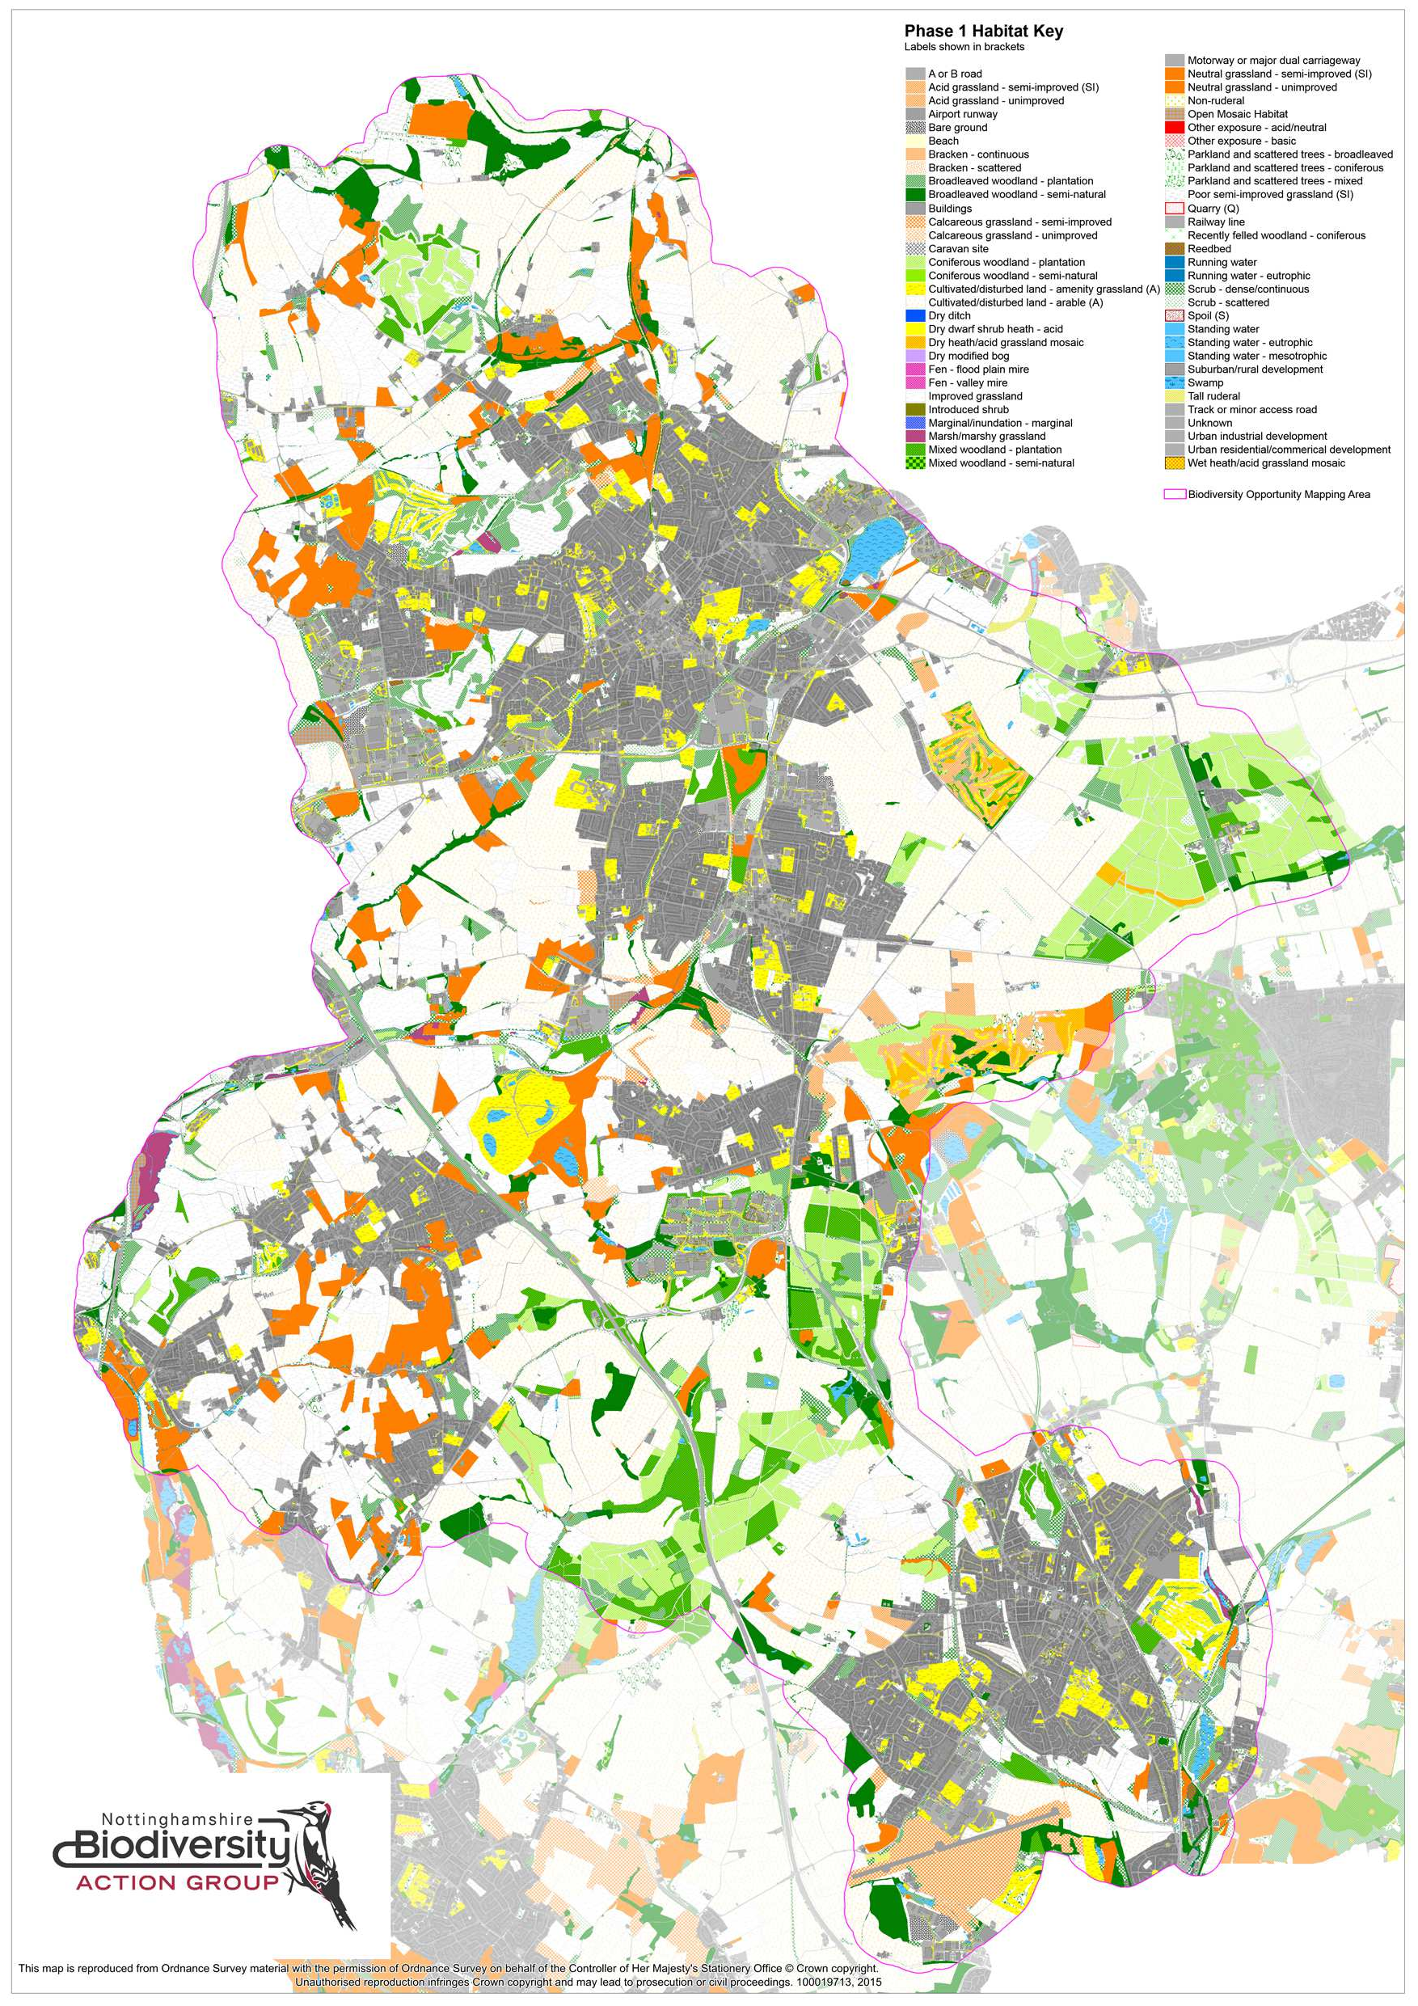

- 33 -

Appendix 6 – Habitat Network maps
Map 1 Current Woodland Connectivity
Map 2 Current Heathland & Acid Grassland Connectivity Map 3 Current Grassland Connectivity
Map 4 Current Wetland Connectivity

- 34 -

Map 1 - Current Woodland Connectivity
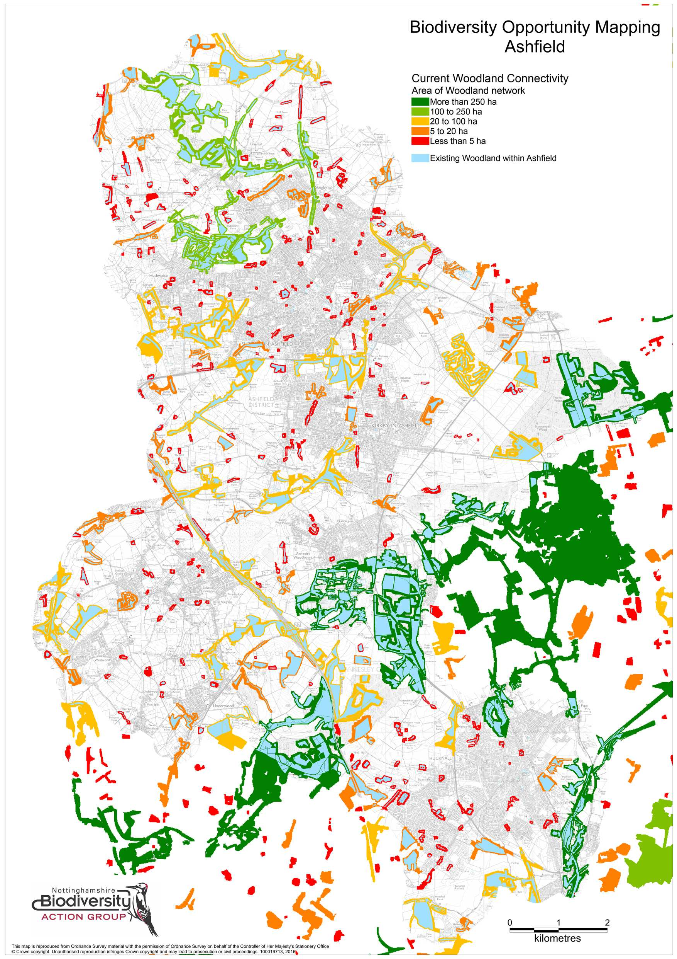

Map 2 - Current Heathland and Acid Grassland Connectivity
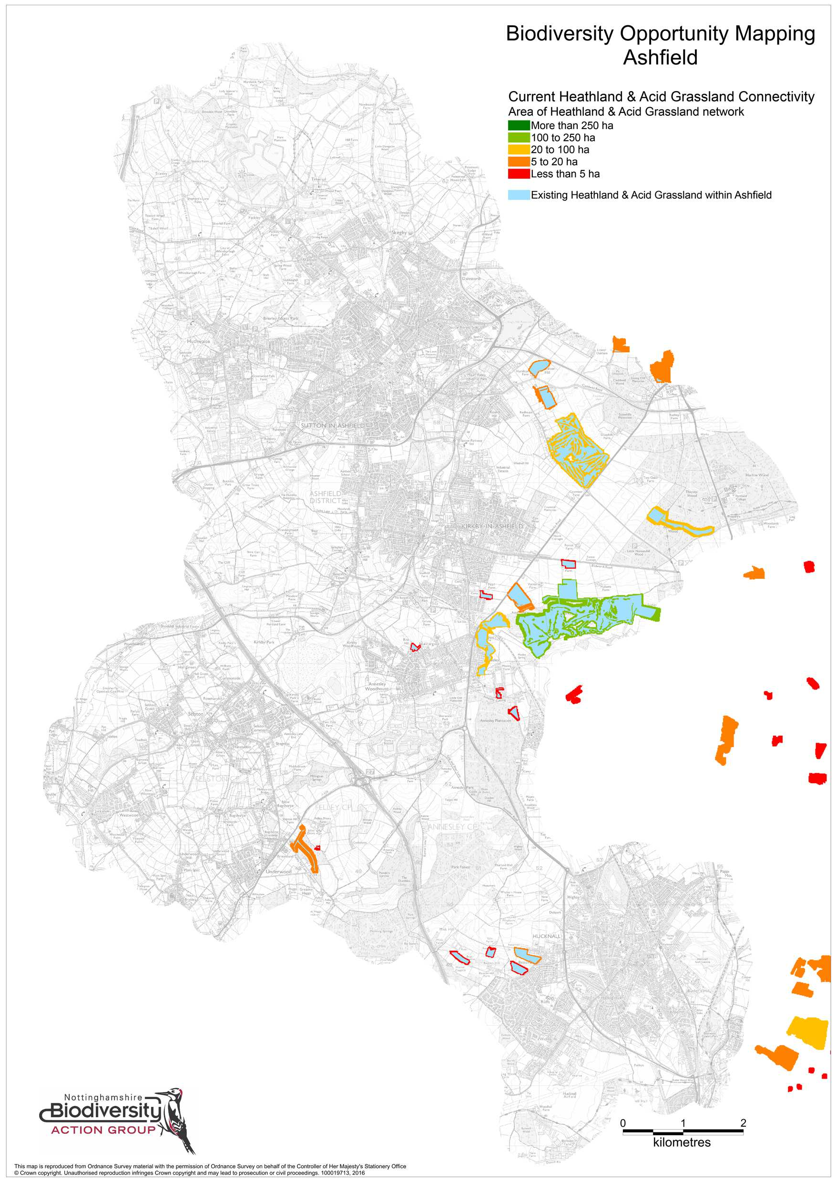

Map 3 - Current Grassland Connectivity
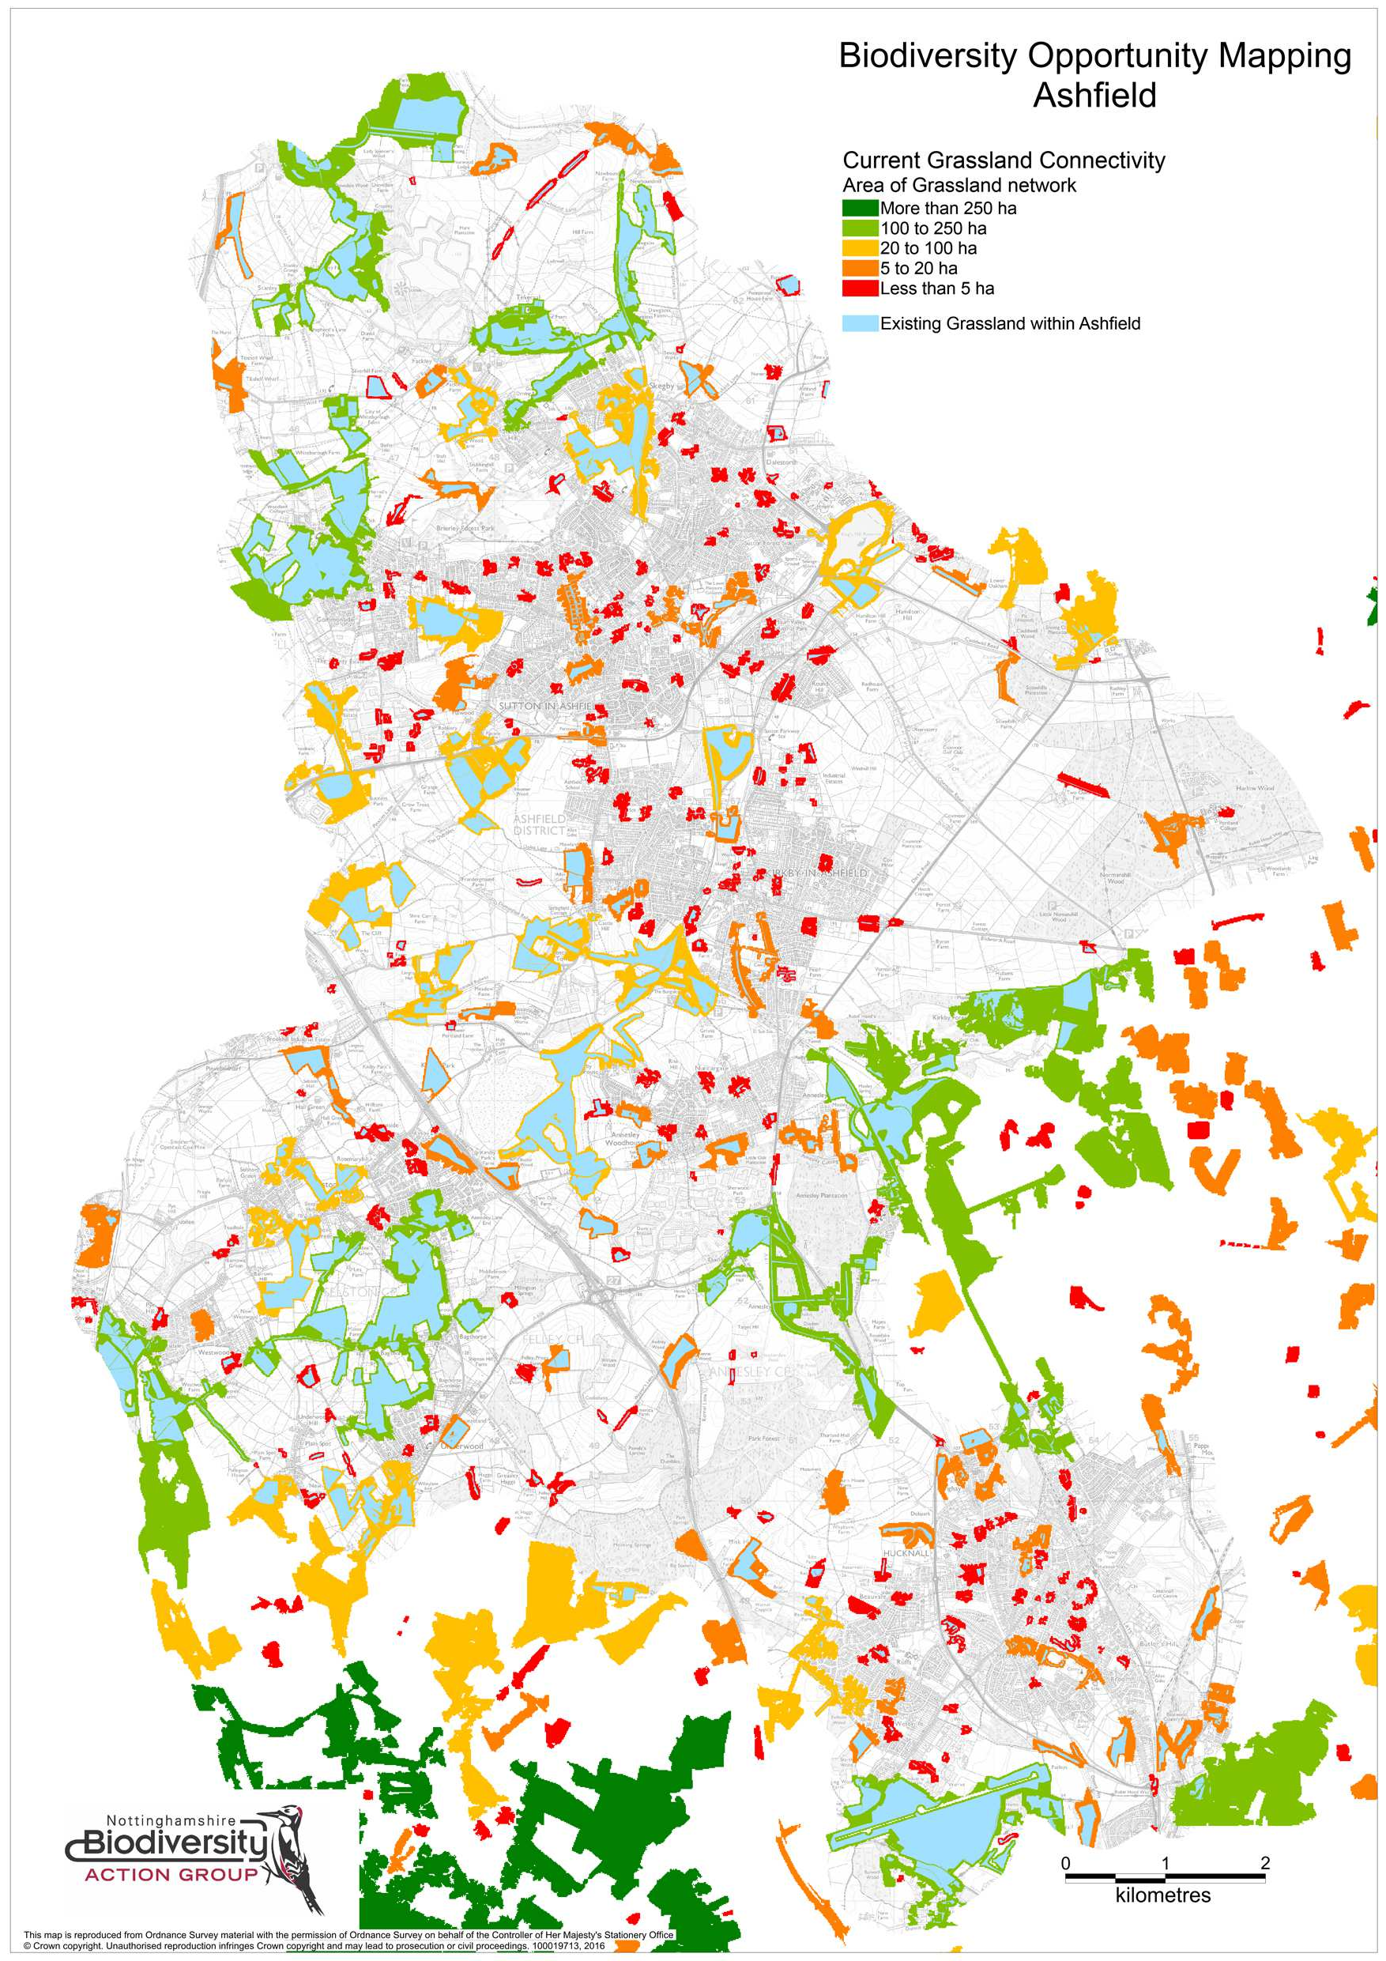

Map 4 - Current Wetland Connectivity
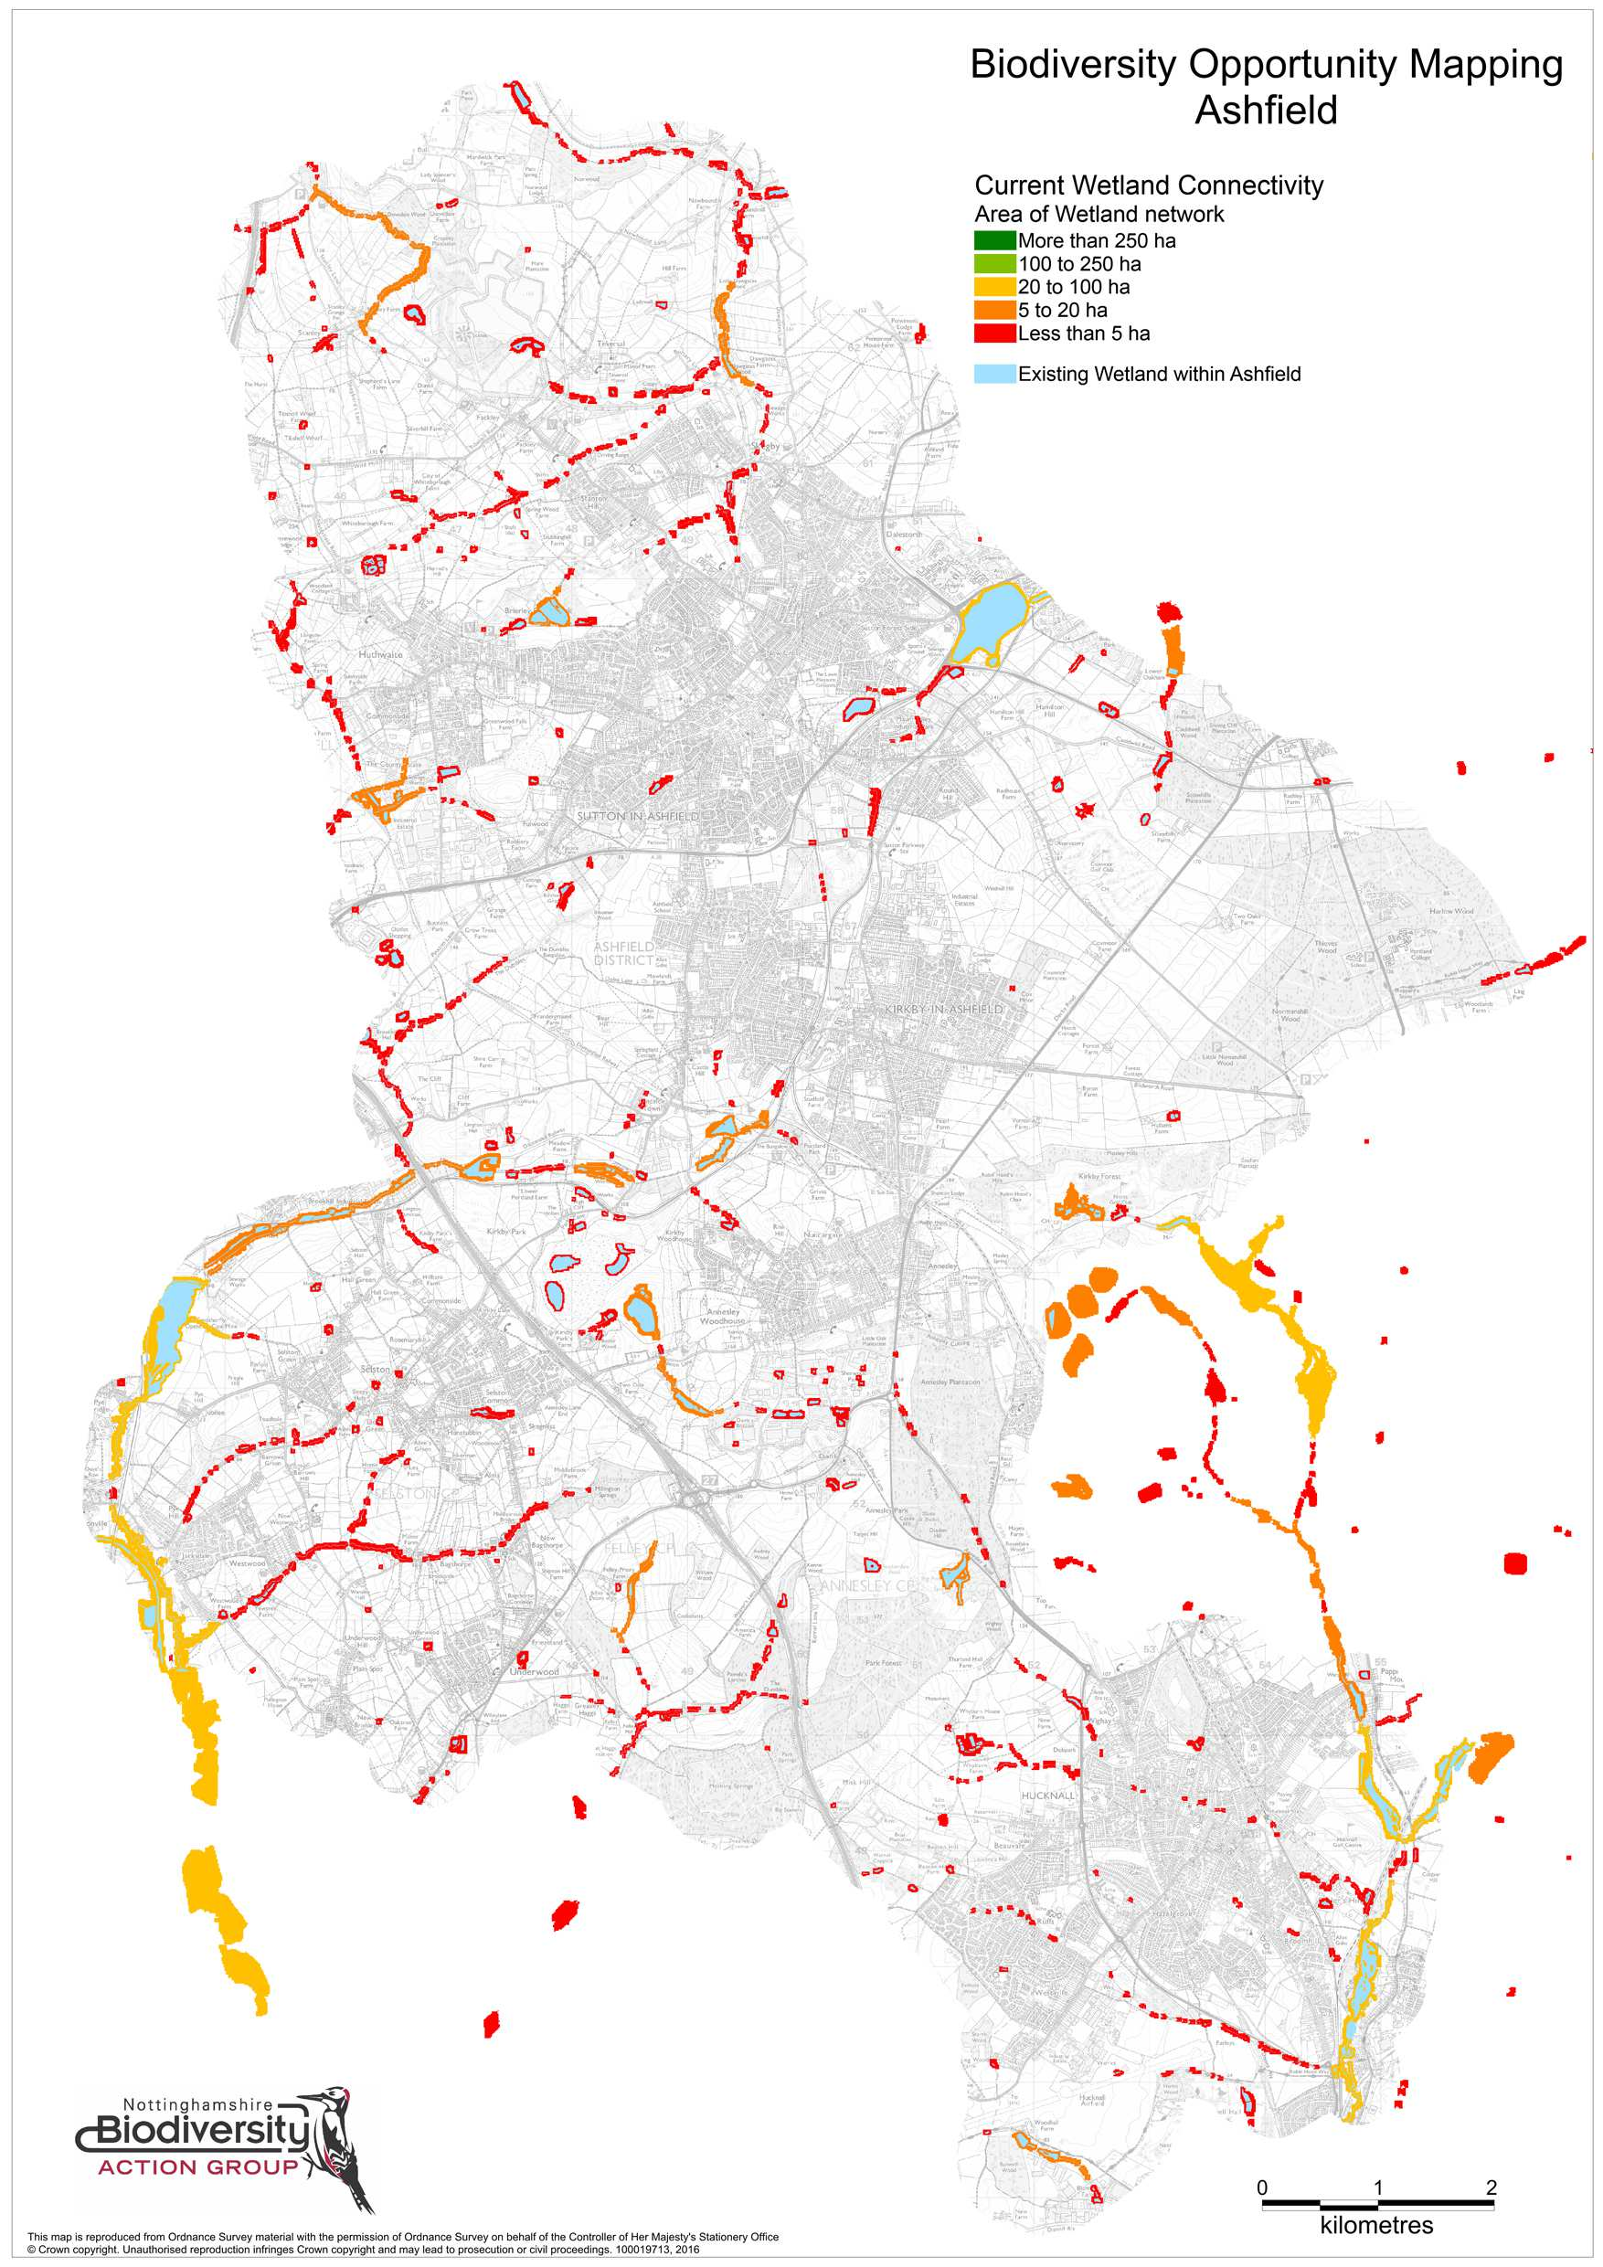

- 39 -

